SCALABILITY PROBLEM AND ITS SOLUTION IN VEHICULAR AD-HOC NETWORKS

A DISSERTATION

SUBMITTED IN PARTIAL
FULFILLMENT OF THE REQUIREMENT FOR THE
AWARD OF THE DEGREE OF

MASTER OF ENGINEERING
IN
ELECTRONICS AND COMMUNICATION
BY
RAJNI
ROLL NO. 30/E&C/04


DEPARTMENT OF ELECTRONICS AND COMMUNICATION
DELHI COLLEGE OF ENGINEERING
SHAHBAD DAULATPUR, BAWANA ROAD DELHI-110042

CERTIFICATE

This is to certify that the dissertation entitled “SCALABILITY PROBLEM AND ITS SOLUTION IN VEHICULAR AD-HOC NETWORKS” submitted by RAJNI,
ROLL NO. 30/E&C/04, is being submitted to the University of Delhi towards the partial fulfillment for the degree of Masters of Engineering in ELECTRONICS AND COMMUNICATION. To the best of my knowledge the work in this dissertation has not been submitted in part or full for any other degree or diploma in any other college or university.

Prof. P.R.CHADHA Prof. Asok Bhattacharyya
Assistant Professor Head of Department
Department of Electronics Department of Electronics
& Communication Engineering & Communication Engineering
Delhi College of Engineering Delhi College of engineering
Delhi-110042 Delhi-110042

(ii)

ACKNOWLEDGEMENT

This work was made possible by the kind supervision and guidance from Prof P.R. Chadha Assistant Professor in the Department of Electronics & Communication Engineering. I take this opportunity to express my sincere gratitude to him.

Prof Asok Bhattacharyya the Head of Department of Electronics and Communication Engineering has been constant source of inspiration. I owe special thanks to him.

I am also grateful to the kind support provided by Professor Asok De. The other faculty members and non teaching staff were very cooperative and helpful in providing support to complete the project.

RAJNI

(iii)

ABSTRACT

The field of inter-vehicular communications (IVC, also known as vehicle-to-vehicle communications, V2V, or vehicular ad hoc networks, VANETs) has been gaining momentum in recent years. Numerous emerging communications applications are unique to the vehicular setting. These applications include safety applications that will make driving safer, mobile commerce, and roadside information services that can intelligently inform drivers about congestion, businesses, and services in the vicinity of the vehicle, as well as other types of locally relevant news. These emerging services are not well supported by the limited communication options available on cars today. Appropriately, the growing importance of IVC has been recognized by governments, corporations, and the academic community. IVC is recognized as an important component of intelligent transport systems (ITS) in various national ITS plans. As such, governments have allocated spectrum for IVC and similar applications (e.g., various concepts of dedicated short-range communications, DSRC, such as wireless access in vehicle environment, WAVE). Academic conferences and workshops on IVC are beginning to grow in popularity (e.g., VANET, Auto net, and V2VCOM). However, in order to prepare for future deployment, much research remains to be conducted.
The unique requirements of inter-vehicular applications and the unique features of the vehicular network mean that new networking solutions are required for IVC. Because of rapidly changing topology due to vehicle motion, the vehicular network closely resembles an ad-hoc network. However, the constraints and optimizations are remarkably different. Vehicles in general are constrained to move within roads. Power efficiency is not as important for IVC as it is for traditional ad hoc networking, since vehicles have a powerful and rechargeable source of energy. From the network perspective, security and scalability are two significant challenges, whereas in a more local context, important questions arise regarding good medium access control (MAC) protocols for IVC, and how to design systems within a DSRC framework.
(iv)
Although power efficiency is less of a concern, scalability may still be critical for IVC as it is for traditional ad-hoc networks. One reason is that because of the nature of the vehicular applications, there might be more flooding/ broadcasting in IVC than in traditional ad hoc networking. This could easily overwhelm the limited bandwidth of the radio links if the communication protocols are not well designed.
One of the main challenges inherent to the deployment of VANETs is operability, both in very sparse and in highly overloaded networks. This scalability problem is not comprehensively addressed by existing approaches, as they only focus on parts of the problem.

- This report shows how Priority- based communication scheme helps realize scalability by optimizing the application benefit and the bandwidth usage. In-vehicle and inter vehicle message selection are based on a relevance function that makes use of the current context and the content of the messages. A novel, proprietary cross-layer architecture and an IEEE 802.11e-based architecture can be used to implement the scheme.

- The scalability problem is not relevant in the context of developing countries like India. This is because it’s not possible to handle traffic conditions in developing countries unless there is a mechanism that can handle not only the four wheelers and two wheelers but also the others which uses the road transport in India. And hence the systems used in western countries will not work here.
Hence in this report we propose a mechanism that handles the traffic problem in India not by using any off the shelf system but by decision making that affects the way traffic is driven in India. It will include taking decisions related to parking, traffic lights (timing) and restrictions for entry of certain types of vehicles for the time at which the traffic problem occurs.
That is the basic idea is to remove the bottleneck that is causing the traffic problem in India by taking decisions and checking whether the decision has helped or not.

(v)
CONTENTS

Certificate (ii)
Acknowledgement (iii)
Abstract (iv)
- Review of Vehicular Ad Hoc Networks 1-8 1.1 Introduction
1.2 Vulnerabilities and Challenges

- Security Architecture 9-16
2.1 Security Hardware
2.2 Vehicular Public Key Infrastructure
2.3 Authentication
2.4 Certificate Revocation
2.5 Privacy
2.6 Future Developments

3. Scalability Problem of Vehicular Ad Hoc Networks 17-27
3.1 Introduction
3.2 Priority Based Approach
3.3 Quantification of Information Relevance
3.4 Message Differentiation Using Information Relevance
3.5 Priority Based Protocol Architecture

4. Evaluation by Simulation 28-34

5. Traffic and Network Simulation Environment 35-41

6. Future Prospective in Indian Context 42-51

7. Conclusion 52-53

References 54-55

(vi)

CHAPTER 1

1.1 REVIEW OF VEHICULAR AD HOC-NETWORKS
Initiatives to create safer and more efficient driving conditions have recently begun to draw strong support. Vehicular communications (VC) will play a central role in this effort, enabling a variety of applications for safety, traffic efficiency, driver assistance, and infotainment. For example, warnings for environmental hazards (e.g., ice on the pavement) or abrupt vehicle kinetic changes (e.g., emergency braking), traffic and road conditions (e.g., congestion or construction sites), and tourist information downloads will be provided by these systems. Vehicular networking protocols will allow nodes, that is, vehicles or roadside infrastructure units, to communicate with each other over single or multiple hops. In other words, nodes will act both as end points and routers, with vehicular networks emerging as the first commercial instantiation of the mobile ad hoc networking technology. The self-organizing operation and the unique features of VC are a double-edged sword: a rich set of tools are offered to drivers and authorities, but a formidable set of abuses and attacks becomes possible. Hence, the security of vehicular networks is indispensable, because otherwise these systems could make antisocial and criminal behavior easier, in ways that would actually jeopardize the benefits of their deployment. What makes VC security hard to achieve is the tight coupling between applications, with rigid requirements, and the networking fabric, as well as the societal, legal, and economical considerations. Solutions to this problem involve industry, governments, and academia, and can have a broad impact. In this report we are specifically concerned with the scalability problem of vehicular ad hoc networks and how to solve it. We present an analysis of the vulnerabilities of vehicular networks and the salient challenges in securing their operation. Then we propose our architectural view of how VC can be secured.

1.2 VULNERABILITIES AND CHALLENGES
1.2.1 VULNERABILITIES
Any wireless-enabled device that runs a rogue version of the vehicular communication protocol stack poses a threat. We denote such rogue devices deviating from the defined protocols as adversaries or attackers. The adoption of a variant of the widely deployed IEEE 802.11 protocol1 by the vehicle manufacturers makes the attacker’s task easier. And even possession of credentials cannot ensure alone the correct operation of the nodes. The effects of differing types of attackers (internal or external, rational or malicious, independent or colluding, persistent or random) can clearly differ. Here, rather than analyzing specific protocols, we are after a general exploration of VC vulnerabilities.

Jamming — The jammer deliberately generates interfering transmissions that prevent communication within their reception range. As the network coverage area (e.g., along a highway) can be well-defined, at least locally, jamming is a low-effort exploit opportunity. As Fig. 1 illustrates, an attacker can relatively easily, without compromising cryptographic mechanisms and with limited transmission power, partition the vehicular network.
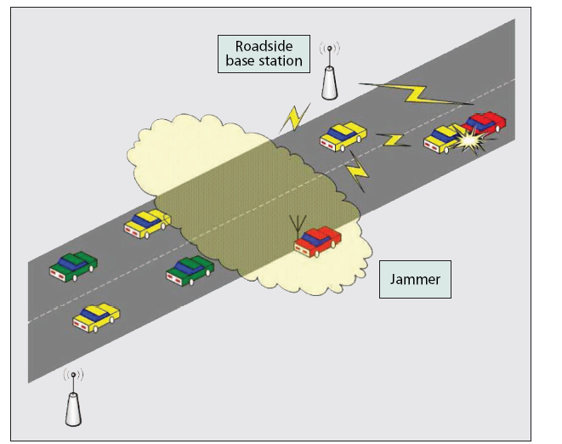
Figure 1: Spectrum jamming

Forgery — The correctness and timely receipt of application data is a major vulnerability. Figure 2 illustrates the rapid “contamination” of large portions of the vehicular network coverage area with false information where a single attacker forges and transmits false hazard warnings (e.g., ice formation on the pavement), which are taken up by all vehicles in both traffic streams.
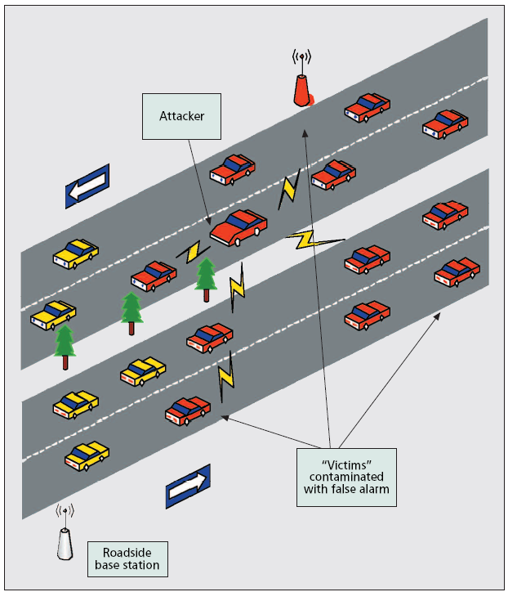
Figure 2: Message forgery

In-transit Traffic Tampering — Any node acting as a relay can disrupt communications of other nodes: it can drop or corrupt messages, or meaningfully modify messages. In this way, the reception of valuable or even critical traffic notifications or safety messages can be manipulated. Moreover, attackers can replay messages (e.g., to illegitimately obtain services such as traversing a toll check point). In fact, tampering with in-transit messages may be simpler and more powerful than forgery attacks.

Impersonation — Message fabrication, alteration, and replay can also be used towards impersonation. Arguably, the source of messages, identified at each layer of the stack, may be of secondary importance. Often, it is not the source but the content (e.g., hazard warning) and the attributes of the message (freshness, locality, relevance to the receiver) that count the most. However, an impersonator can be a threat: consider, for example, an attacker masquerading as an emergency vehicle to mislead other vehicles to slow down and yield; or an adversary impersonating roadside units, spoofing service advertisements or safety messages.

Privacy Violation — With vehicular networks deployed, the collection of vehicle-specific information from overheard vehicular communications will become particularly easy. Then inferences on the drivers’ personal data could be made, and thus violate her or his privacy. The vulnerability lies in the periodic and frequent vehicular network traffic: safety and traffic management messages, context-aware data access (e.g., maps, ferryboat schedules), transactionbased communications (e.g., automated payments, car diagnostics), or other control messages (e.g., over-the-air registration with local highway authorities). In all such occasions, messages will include, by default, information (e.g., time, location, vehicle identifier, technical description, trip details) that could precisely identify the originating node (vehicle) as well as the drivers’ actions and preferences (Fig. 3).

On-board Tampering — Beyond abuse of the communication protocols, the attacker may select to tinker with data (e.g., velocity, location, status of vehicle parts) at their source, tampering with the on-board sensing and other hardware. In fact, it may be simpler to replace or by-pass the realtime clock or the wiring of a sensor, rather than modifying the binary code implementation of the data collection and communication protocols. Any VC security architecture should achieve a trade-off between robustness and cost due to tamper-proof hardware.
1.2.2 CHALLENGES

The operational conditions, the constraints, and the user requirements for VC systems make security a challenging problem, with the most significant challenges specific to the VC discussed here.

Network Volatility — The connectivity among nodes can often be highly transient and a onetime event. For example, two vehicles (nodes) traveling on a highway may remain within their transceiver range, or within a few wireless hops, for a limited period of time. In other words, vehicular networks lack the relatively long-lived context and, possibly, the personal contact of the device users of a connection to a hot spot or the recurrent connection to an on-line service across the Internet. Hence password-based establishment of secure channels, gradual development of trust by enlarging a circle of trusted acquaintances, or secure communication only with a handful of endpoints may be impractical for securing VC.

Liability vs. Privacy — To make the problem more difficult, accountability and, eventually, liability of the vehicles and their drivers are required. Vehicular communication is envisioned as an excellent opportunity to obtain hard-to-refute data that can assist legal investigations (e.g., in the case of accidents). This implies that, to begin with, unambiguous identification of the vehicles as sources of messages should be possible. Moreover, context-specific information, such as coordinates, time intervals, and associated vehicles, should be possible to extract or reconstruct. But such requirements raise even stronger privacy concerns. This is even more so when drivers’ biometrics are considered: biometrics, useful for enhancing vehicle access and control methods, are highly private and unique data that cannot be reset or reassigned.

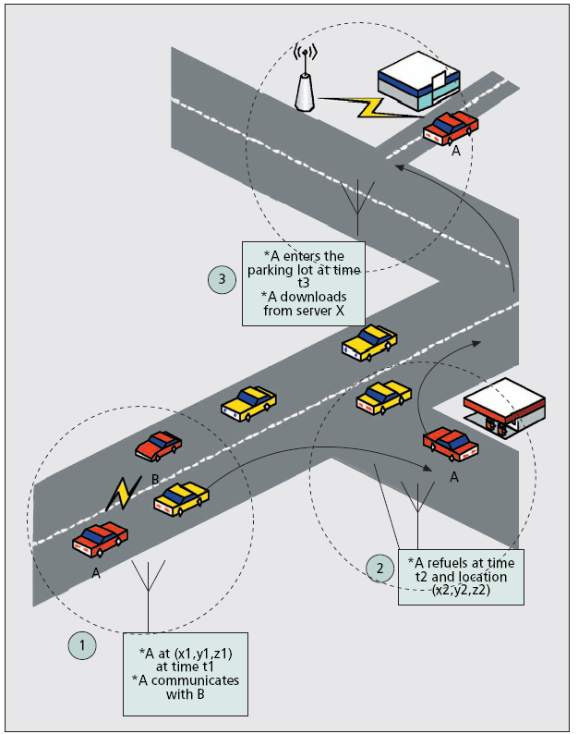
Figure 3: Vehicle tracking
Delay-Sensitive Applications — Many of the envisioned safety and driver-assistance applications pose strict deadlines for message delivery or are time-sensitive. Security mechanisms must take these constraints into consideration and impose low processing and messaging overhead. Not only must protocols be lightweight, but also robust to clogging denial-of-service attacks. Otherwise, it would suffice for an adversary to generate a high volume of bogus messages and consume resources so that message delivery is delayed beyond the application requirements and thus, in practice, denied.

Network Scale — The scale of the network, with roughly a billion vehicles around the globe, is another challenge. This, combined with the multitude of authorities governing transportation systems, makes the design of a facility to provide cryptographic keys a challenge per se. A technically and perhaps politically convincing solution is a prerequisite for any security architecture.

Heterogeneity — The heterogeneity in VC technologies and the supported applications are additional challenges, especially taking into account the gradual deployment. With nodes possibly equipped with cellular transceivers, digital audio and Global Positioning System (GPS) or Galileo receivers, reliance on such external infrastructure should not be the weakest link in achieving security. For example, if GPS signaling can be spoofed, can the correctness of node coordinates and time accuracy be assumed? Second, with a range of applications with differing requirements, security solutions must retain flexibility, yet remain efficient and interoperable.

CHAPTER 2

SECURITY ARCHITECTURE
In this section we present the components needed to protect VC against a wide range of threats, some of which are described in the previous section. We also aim at providing an authentication, authorization, accounting (AAA) framework for VC. Figure 4 depicts the general architecture, the components of which are described next.
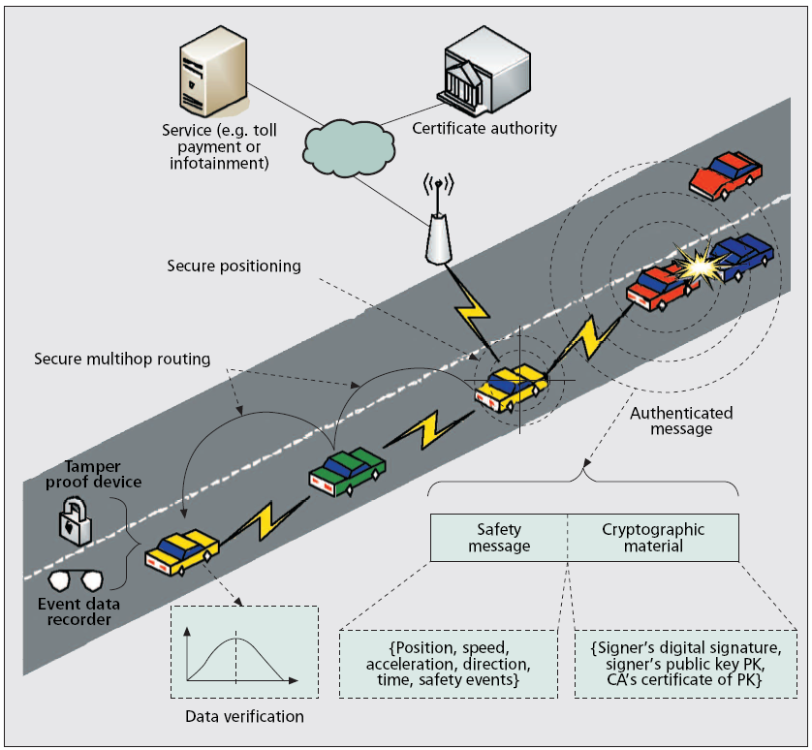
Figure 4: Overview of the security architecture

2.1 SECURITY HARDWARE
Among the vehicle onboard equipment, there should be two hardware modules needed for security, namely, the event data recorder (EDR) and the tamper-proof device (TPD). Whereas the EDR only provides tamper-proof storage, the TPD also possesses cryptographic processing capabilities. The EDR will be responsible for recording the vehicle’s critical data, such as position, speed, time, and so forth, during emergency events, and is similar to an airplane’s black box. These data will help in accident reconstruction and the attribution of liability. EDRs are already installed in many road vehicles, especially trucks. These can be extended to also record the safety messages received during critical events. The car electronics, especially the data bus system, are easily accessible by the owner or by a mechanic. Hence the cryptographic keys of a vehicle need proper hardware protection, namely, a TPD. The TPD will take care of storing all the cryptographic material and performing cryptographic operations, especially signing and verifying safety messages. By binding a set of cryptographic keys to a given vehicle, the TDP guarantees the accountability property as long as it remains inside the vehicle. The TPD has to be as independent as possible from its external environment; hence, it should include its own clock and have a battery that is periodically recharged from the vehicle’s electric circuits. Yet, despite all these “features,” the TPD will still suffer from the fact that it cannot control the correctness of the data it receives. This may result in the TPD signing messages with bogus data. The solution to this problem is briefly described in the “Authentication” subsection. A major obstacle to the adoption of TPDs is their high cost. But current products are mainly intended for computation-hungry financial applications. Hence, there are several factors that can facilitate the introduction of TPDs in vehicles:
• The creation of a “lighter” version of TPDs
• The leverage on the building-up expertise for vehicular EDRs
• The economy of scale that will drive costs significantly lower

2.2 VEHICULAR PUBLIC KEY INFRASTRUCTURE
The huge number of vehicles registered in different countries and traveling long distances, well beyond their registration regions, requires a robust and scalable key management scheme. The involvement of authorities in vehicle registration implies the need for a certain level of centralization. Communication via base stations (as in cellular networks) is not enough for VC, mainly because vehicles need to authenticate themselves not only to base stations, but also to each other (without invoking any server), which creates a problem of scalability. In addition, symmetric cryptography does not provide the non repudiation property that allows the accountability of drivers’ actions (e.g., in the case of accident reconstruction or finding the originators of forgery attack). Hence, the use of public key cryptography is a more suitable (if not the only) option for deploying VC security. This implies the need for a Vehicular Public Key Infrastructure (VPKI) where Certificate Authorities (CAs) will issue certified public/private key pairs to vehicles (with many pairs per vehicle for privacy reasons, as is explained below). Similarly to current vehicle registration authorities, there will be several CAs, each corresponding to a given region (e.g., country, state, metropolitan area, etc.). Other candidates for taking the role of CAs are car manufacturers. In any of the two cases, the different CAs will have to be cross-certified so that vehicles from different regions or different manufacturers can authenticate each other. This will require each vehicle to store the public keys of all the CAs whose certificates it may need to verify. Alternately, in the case where CAs are regional authorities, vehicles may request new public/private key pairs delivered by the foreign region3 they enter.

2.3 AUTHENTICATION
The fundamental security functions in VC will consist in authenticating the origin of a data packet. Authentication and the inherent integrity property counter the in-transit traffic tampering and impersonation vulnerabilities. In addition, authentication also helps to control the authorization levels of vehicles. To authenticate each other, vehicles will sign each message with their private key and attach the corresponding certificate. Thus, when another vehicle receives this message, it verifies the key used to sign the message and, once this is done correctly, it verifies the message. To reduce the security overhead, the common approach is to use Elliptic Curve Cryptography (ECC) — the most compact public key cryptosystem thus far. But it is possible to reduce this overhead by signing only critical messages (e.g., with accident warnings) or one in every few messages (the frequency and redundancy of messages can allow this). In addition, given the frequency of safety message broadcasts (typically, every 300 ms), a vehicle can ignore redundant messages.

2.4 CERTIFICATE REVOCATION
The advantages of using a PKI for VC are accompanied by some challenging problems, notably, certificate revocation. For example, the certificates of a detected attacker or malfunctioning device have to be revoked, that is, it should not be able to use its keys or, if it still does, vehicles verifying them should be made aware of their invalidity.
The most common way to revoke certificates is the distribution of certificate revocation lists (CRLs) that contain the most recently revoked certificates; CRLs are provided when infrastructure is available. In addition, using shortlived certificates automatically revokes keys. These are the methods proposed in the IEEE P1609.2 standard [1]. But there are several drawbacks to this approach. First, CRLs can be very long due to the enormous number of vehicles and their high mobility (meaning that a vehicle can encounter a high number of vehicles when traveling, especially over long distances). Second, the short lifetime of certificates still creates a vulnerability window. Last but not least, the availability of an infrastructure will not be pervasive, especially in the first years of deployment. To avoid the above shortcomings, we have designed a specific solution. It includes a set of revocation protocols, namely, Revocation Protocol of the Tamper-Proof Device (RTPD), Revocation protocol using Compressed Certificate Revocation Lists (RCCRL), and Distributed Revocation Protocol (DRP). In the following, we present the details of RTPD, as illustrated in Fig. 5, and only outline the main features of RCCRL and DRP (due to space constraints). In RTPD, once the CA has decided to revoke all the keys of a given vehicle M, it sends to it a revocation message encrypted with the vehicle’s public key. After the message is received and decrypted by the TPD of the vehicle, the TPD erases all the keys and stops signing safety messages. Then it sends an ACK to the CA. All the communications between the CA and the vehicle take place in this case via base stations. In fact, the CA has to know the vehicle’s location in order to select the base station through which it will send the revocation message. If it does not know the exact location, it retrieves the most ecent locations of the vehicle from a location database and defines a paging area with base stations covering these locations. Then it multicasts the revocation message to all these base stations. In the case when there are no recent location entries or the ACK is not received after a timeout, the CA broadcasts the revocation message, for example, via the low-speed FM radio on a nationwide scale or via satellite. The RCCRL protocol is used when the CA wants to revoke only a subset of a vehicle’s keys or when the TPD of the target vehicle is unreachable (e.g., by jamming or by tampering of the device). Given the expected large size of CRLs in vehicular ad hoc networks (VANETs), the key idea in RCCRL is to use Bloom filters — a probabilistic data structure used to test whether an element is a member of a set. Thus, the size of a CCRL will be only a few KB. RCCRL also relies on the availability of infrastructure that broadcasts the CCRLs once every 10 min. Compared to RTPD, RCCRL has the special feature of warning the neighbors of a revoked vehicle as they also receive the CCRLs. The DRP protocol is used in the pure ad hoc mode whereby vehicles accumulate accusations against misbehaving vehicles, evaluate them using a reputation system, and, in case misbehavior is detected, report them to the CA once a connection is available. Unlike RTPD and RCCRL, the revocation in DRP is triggered by the neighbors of a vehicle upon the detection of misbehavior. Mechanisms for the detection of malicious data [2] can be leveraged to spot vehicles generating these data (since all messages are signed).
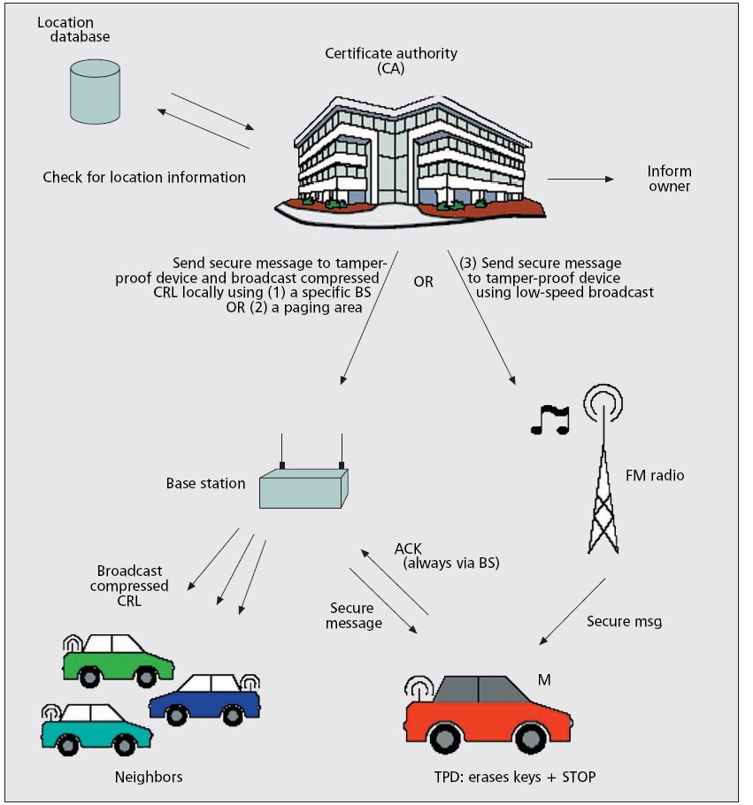
Figure 5: Revocation protocol of the tamper-proof device (RTPD)

2.5 PRIVACY
To address privacy vulnerability, we propose using a set of anonymous keys that change frequently (every couple of minutes) according to the driving speed. Each key expires after its usage; only one key can be used at a time. These keys are preloaded in the vehicle’s TPD for a long duration, e.g., until the next yearly checkup; the TPD takes care of all the operations related to key management and usage. Each key is certified by the issuing CA and has a short lifetime (e.g., a specific week of the year). In addition, it can be tracked back to the real identity of the vehicle — the Electronic License Plate (ELP) — in case law enforcement necessitates this and only after obtaining permission from a judge. This conditional anonymity will help determine the liability of drivers in the case of accidents. The downside of this approach is the necessity for storage space for all the keys for one year, but these can fit in only a few Mbytes [3]. In the case of infotainment applications in which vehicles communicate with the infrastructure, the CARAVAN scheme [4] allows vehicles to preserve their privacy by forming groups in which the group leader acts as a proxy on behalf of all group members that access the infrastructure. When the vehicles do not have to access the infrastructure, they remain silent, thus preventing eavesdroppers from tracking their pseudonyms.

2.6 FUTURE DEVELOPMENTS
Table 1 summarizes the mechanisms used to provide security features in VC and compares them with other network types that are broadly addressed in the literature. We can see that the distinctive properties of VANETs, notably scale and high mobility, justify the need for, as well as the opportunity of, using novel solutions compared to other network types.

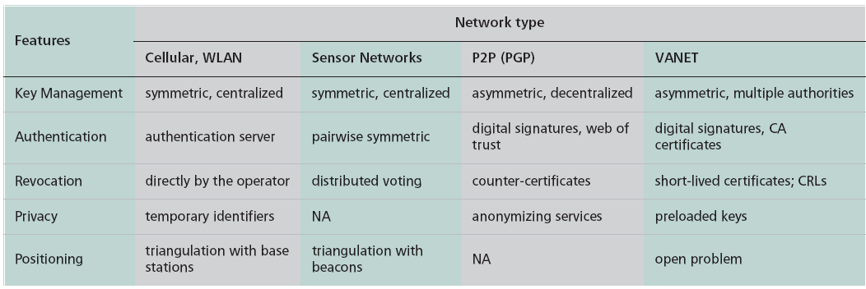
Table 1: Comparison of different network types with respect to security problems

OPEN PROBLEMS

In addition to the main building blocks presented earlier, there remains a set of unexplored problems directly related to VC security. In this section we outline the most important of these problems.

Secure Positioning — In VC, position is one of the most important data for vehicles. Each vehicle needs to know not only its own position but also those of other vehicles in its neighborhood. GPS signals are weak, can be spoofed, and are prone to jamming. Moreover, vehicles can intentionally lie about their positions. Hence, the need for a secure positioning system that will also support the accountability and authorization properties, frequently related to a vehicle’s position.

Data Verification — This helps to prevent the forging attacks illustrated in Fig. 2. This can be achieved by a data correlation mechanism that compares all collected data regarding a given event. A first example of such a mechanism is presented in [2], where the vehicle has a model to which it compares received data before classifying it as truthful, malicious, or unintentionally incorrect.

DoS Resilience — DoS attacks, and especially jamming, are relatively simple to mount, yet their effects can be devastating. Existing solutions such as frequency hopping do not completely solve the problem. The use of multiple radio transceivers, operating in disjoint frequency bands, can be a feasible approach.

CHAPTER 3

THE SCALABILITY PROBLEM OF VEHICULAR AD HOC NETWORKS AND HOW TO SOLVE IT

3.1 INTRODUCTION
Vehicular ad hoc networks (VANETs) have turned into an important research area over the last few years. Several different use-cases have been proposed and analyzed. The application area ranges from safety-related warning systems to improved navigation mechanisms as well as information and entertainment applications. In traditional IP-based wireless communication networks, uni-cast routing schemes are widely applied. Communication partners know each other via unique addresses and transmit data exclusively from one source to one or more explicitly determined destinations. The specific focus of VANETs, however, is to support foresighted driver assistance systems that can significantly decrease the number of accidents and improve the overall performance of the road network. This results in a different networking paradigm, where communication is optimized to meet the requirements imposed by active safety services. Typically, numerous, not explicitly known vehicles are interested in the same message. Due to the high mobility of network nodes resulting in frequent topology changes, routing protocols do not scale well with increasing network size.

To cope with the physical challenges inherent to VANETs and to take into account the common interest in information, messages are mostly disseminated in a broadcast fashion rather than routed to one dedicated communication partner. One very important prerequisite for the successful and also sustainable deployment of VANETs is the scalability of the applied information dissemination scheme. The autonomously acting network must ensure delivery of data to those nodes which are interested in it with low latency, while efficiently leveraging network resources. This report presents a refined perspective of scalability in the domain of VANETs. We argue why existing approaches do not provide comprehensive solutions to the problems inherent to larger VANETs and present a generic concept and possible communication protocol architectures that support sustainable operability.

THE SCALABILITY PROBLEM OF VANETS
In large and especially distributed systems or networks, scalability is a very crucial characteristic. Scalability is defined as the ability to handle the addition of nodes or objects without suffering a noticeable loss in performance or increase in administrative complexity. In the VANET scenario, scalability issues arise in several different contexts. The number of active nodes (vehicles) has an impact on network connectivity and on the likelihood of congestion on the wireless channel. In addition, protocol design has a great impact on scalability. The most crucial bottleneck is the bandwidth limitation. Due to the shared wireless channel with a CSMA/CA medium access scheme and multi hop communication between distant nodes, the limited bandwidth is further decreased by poor channel utilization. While in sparse VANETS, low connectivity must be overcome with intelligent store-and-forward algorithms, controlling the network load is the most important challenge for operability in densely populated network scenarios. The number of messages which have to be sent over the shared medium is predominantly influenced by the number of vehicles and the number of applications deployed in these vehicles. However, network load is additionally influenced by the fact that active safety messages have to be rebroadcast within their target area for the duration of their validity. This ensures the availability of the message for new vehicles entering the area after the initial broadcast.

The basic dissemination scheme used to realize broadcast-based VANETs is the so-called flooding, where each node rebroadcasts every single message it receives. The main problem inherent to the flooding mechanism is the huge amount of superfluous transmissions leading to network congestion. This effect is aggravated with an increasing node density and network size, leading to the scalability problem. Hence, the limited network resources are partially absorbed by redundant traffic, while highly relevant and time-critical messages are prevented from accessing the medium. Here it is needed to use some fundamental algorithms which can be applied to minimize the number of redundant rebroadcasts. Several approaches have been suggested to solve the scalability problem. We consider a VANET to be scalable if information is disseminated through the network in sparse as well as dense network scenarios, while optimally leveraging the available bandwidth. Therefore, methods for defining and evaluating the benefit of a certain information become important to determine the optimal network usage.

3.2 THE PRIORITY-BASED APPROACH

Figure 6 motivates the need for a relevance based data dissemination approach. The two vehicles 1 and 2 are within mutual radio range for only a short time because of shadowing effects caused by the surrounding buildings. Vehicle 2 has several messages in its message queue for transmission. Since it will not be able to transmit all messages to vehicle 1 before it leaves its transmission range, it should select the most relevant messages and thus maximize the application benefit. In order to do this, it is necessary to calculate relevance for each message and to reorganize the vehicle’s message queue accordingly. Besides the direct transmission, it is also possible to use a multi hop connection with vehicle 3. However, this leads to worse channel utilization and a higher latency.
- The MDDV approach aims at reducing overhead and message latency by sending messages along a predefined path. However, the approach cannot differentiate between message types and it does not evaluate the relevance of a piece of information while selecting the next message to be sent.
- A second approach to optimize channel utilization, which uses adaptation of transmission power to reduce interference. The scheme tries to allocate the limited resources in a fair way to improve the dissemination capabilities. To achieve this, the transmission power will be reduced to a certain threshold, depending on the number of active nodes, which ensures that the medium is not fully utilized. This enables additional nodes to access the channel.
- In our approach, however, we head for a controlled unfairness, by setting PRIORITY TO EACH MESSAGE so that resources are assigned according to information relevance. By optimizing the extent to which the local requirements of all network participants (e.g., data rate) are met (utility), a global utility maximum can be achieved. In the context of our approach, the benefit of information is quantified with more complex functions that consider the vehicle’s respective contexts. By optimizing the medium access locally also the global schedule is improved, leading to an overall benefit approaching the optimum. A global optimization scheme is not feasible in this context, due to the VANET characteristics.

Two fundamental methodologies form the basis of our concept -
  - First, the relevance data packets provided to potential recipients in the local neighborhood must be quantified.
  - Second, the messages must be prioritized according to the resulting relevance values to maximize the benefit received by all vehicles participating in the network.

The prioritization is performed in two steps.
- First, the most relevant message within the message queue of each vehicle is selected (in-vehicle message selection).
- Second, the most relevant message among all vehicles that are within mutual radio range is selected for transmission (inter vehicle message selection).

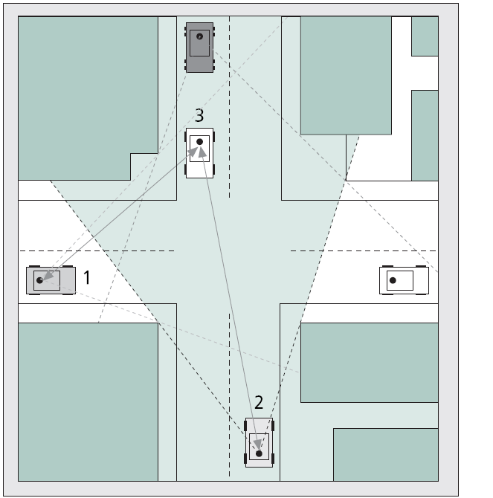
Figure 6: Exemplary vehicle-to-vehicle communication scenario

3.3 QUANTIFICATION OF INFORMATION RELEVANCE

As a basis for data traffic differentiation, we introduce the term relevance as a measure for quantifying the estimated benefit vehicles gain by a certain piece of information. Prior to broadcasting a message, each vehicle calculates a value representing the relevance of the contained data for all the adjacent vehicles based on its limited, local knowledge. This value can be determined by taking the information from three different contexts: message context (e.g., the amount of time passed since the message was created), vehicle/VANET context (e.g., the current connectivity of the VANET) and information context (e.g., the interest that other vehicles might have in the information). Based on parameters from the message (m), vehicle (v), and information (i) context parameters, a single relevance value can be computed for every message to be transmitted. A model comprising subfunctions for each of these parameters and weights for combining the results of these subfunctions has been set up in the frame of our work, based on road traffic statistics, user surveys, and other empirical observations. Equation 1 highlights the way the relevance of a specific piece of information can be quantified.
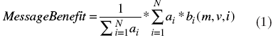
Suppose there are N parameters such as distance to information source and message age. They all have to be computed with the help of the message-, vehicle-, and information-context parameters. All these N parameters are evaluated with application-dependent sub functions bi. The resulting parameters finally have to be weighted with application-dependent factors ai. In the context of a collision warning, for example, the message age parameter is more important for the overall message relevance than the parameter evaluating the information quality .Finally; all weighted parameters have to be summed up and divided by the sum of all ai, heading to a benefit value between 0 and 1. Calculation of relevance of each message is done at the main Communication Transport Centre

3.4 MESSAGE DIFFERENTIATION USING INFORMATION RELEVANCE

In-Vehicle Message Selection — Especially in case of dense networks with a huge number of packets waiting for medium access at different vehicles, the limited network resources are not sufficient to satisfy all transmission requests immediately. The packets a node intends to transmit are passed down from the application layer to the MAC layer and are buffered in a packet queue, where queue lengths permanently change depending on the current, local network load. A so-called in-vehicle packet scheduling ensures that messages are broadcast in a sequence established according to their respective relevance values. Hence, the packet dequeuing procedure does not work according to the conventional FIFO principle any more. Instead, it takes into account the relevance of packets when deciding which packet is to be dequeued next.

Inter vehicle Message Selection — Besides in-vehicle message differentiation, the inter vehicle contention for the shared, wireless medium must be modified such that the most relevant packet of nodes within mutual communication range is granted medium access. Vehicles within mutual radio range have to share the bandwidth and therefore “contend” for medium access. If several vehicles within range wish to broadcast a message at the same time, the one with the highest relevance among the set of data packets that the vehicles selected through the in-vehicle message selection should win the inter vehicle contention process. Thereby, the benefit provided to the overall network can be considerably improved. The dynamic adaptation of the contention window (CW) within the MAC layer is considered as a major lever in our concept. Each wireless station uses its individual CW to determine both back off and defer timers, which represent a key feature of the Carrier Sense Multiple Access (CSMA) mechanism. By selecting a short CW in case a highly relevant packet requests access to the medium, its likelihood to win the contention process is increased. The smaller the CW the shorter the timers defining the period of time after a network node may try or retry to access the medium.

CHARACTERISTICS OF THE APPROACH

Altruistically Inspired Optimization of the Global Benefit— In our concept, altruism is the major overall characteristic: Nodes do not primarily aim at maximizing their own benefit, but head for transmitting information such that their neighbors are provided with the data they are most interested in. With the help of a comprehensive model, the relevance of single pieces of information can be determined, which represents the expected benefit that it adds to related applications of other nodes participating in the system. Leveraging this measure, in-vehicle and inter vehicle message differentiation help to improve the global benefit, which is the aggregated benefit that all network nodes receive over time.

Optimal Resource Utilization Through Distributed Traffic Differentiation — The
Relevance-based dissemination approach considers the resources being utilized optimally if the vehicles can satisfy their information demands as best as possible, considering the physical situation (network topology, vehicle positions, traffic density, etc.) of each vehicle. Therefore, our concept does not aim at minimizing the network load by reducing the number of messages to be sent. Instead, it optimizes the usage of available bandwidth as it schedules packet transmissions according to their actual relevance. Due to non-static transmission restrictions, for example, in the case of many existing approaches, network resources can be optimally leveraged in both sparse and dense networks. “Hard” limitations in both the local and time domain are avoided: messages are no longer subject to static ranges of propagation. In fact, they are relayed in any way, where traffic prioritization ensures that low-priority messages do not absorb the wireless medium and prevent high-priority messages from being transmitted.

Controlled Unfairness — Instead of heading for an information-agnostic, fair allocation of network resources to all vehicles, we introduce controlled unfairness as a major principle underlying our approach. The time a packet has been waiting within a queue does note decides its chance to be broadcasted, but its current relevance for the adjacent network nodes does. In this way, messages with low relevance will experience larger delays or will even be dropped if resources are highly loaded and more relevant messages wait for medium access. Thus, the dissemination of highly relevant pieces of information is accelerated at the expense of low-priority traffic.

Context-Driven Dissemination — Existing approaches to improve the performance of message dissemination in VANETs mostly rely on packet-specific data such as the geographical location of the last forwarder or the time at which the packet was generated. We, however, take into account different contexts as introduced above to allow for a benefit-oriented message dissemination scheme. Integrability: many approaches aiming at making broadcast communication in VANETs more reliable and efficient only tackle part of the challenges inherent to VANETs. Our concept works as an integrating substitute for many of these concepts.

3.5 PRIORITY-BASED PROTOCOL ARCHITECTURES

THE CROSS LAYER ARCHITECTURE
In order to implement in-vehicle and inter vehicle traffic differentiation, the cross-layer design depicted in Fig. 7 is proposed for each of the nodes participating in a VANET.
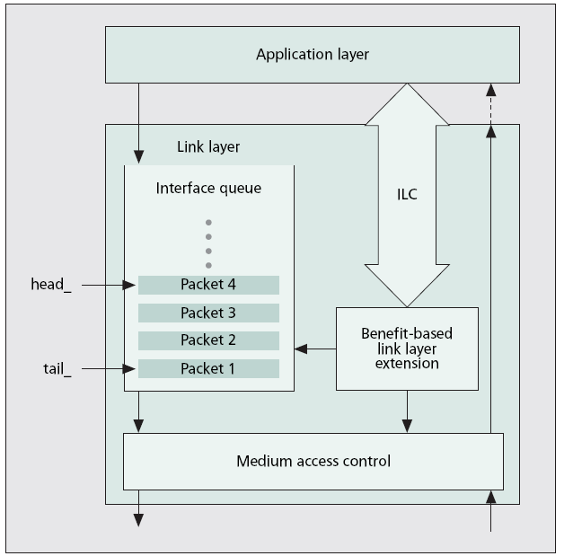
Figure 7: The cross layer architecture providing Priority-based message handling.
Within the application layer, a coordinating agent is devoted to generating, broadcasting, receiving, and storing messages. The introduction of the application layer into the communication protocol design is essential since a comprehensive evaluation of message benefit can only be conducted in case message, vehicle, and information contexts are fully available. Thus, the application layer implements the relevance function and attaches the resulting values to each of the packets’ header before passing them to the data-link layer. The so-called benefit-based extension (BBE) within the data-link layer accounts for changing the functionality of the interface queue (modified enqueuing and dequeuing behavior) and the medium access control mechanism, as described above. The extension may thereby leverage the values attached to the packets’ header or continuously reevaluate the benefit of all enqueued packets with the help of the benefit function. The interlayer communication module (ILC ) is used by the BBE to acquire all necessary, mostly application-level data to calculate up-to-date benefit values for all packets waiting for medium access.

THE IEEE 802.11E-BASED ARCHITECTURE

Deploying the so-called EDCA scheme underlying the already existing IEEE 802.11e standard for realizing benefit-oriented traffic differentiation would be a viable alternative. The standard supports different so-called traffic categories (realized with the help of up to eight packet queues), of which each is assigned a certain priority determining the degree of favoritism with respect to the access to the shared wireless medium. By categorizing data packets according to their relevance and sorting them into the priority queues respectively, the dissemination of highly relevant data can be accelerated as well. Nodes applying the EDCA scheme (Fig. 8) conduct a two-step contention process: first of all, its different queues participate in an internal contention process. Thereby, messages contained in a high-priority queue are more likely to win compared to those waiting in a low-priority queue. The packet winning internal contention has to contend with packets from other stations for the shared wireless medium. Thus, IEEE 802.11e supports our approach with regard to the existence of a prioritized in-vehicle and inter vehicle message selection scheme.
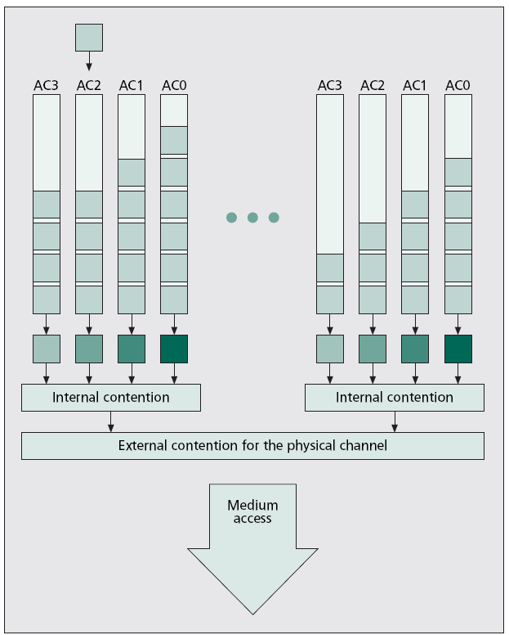

Figure 8: Internal and external message contention in IEEE 802.11e

CHAPTER 4

EVALUATION BY SIMULATION
While more and more application ideas, algorithms for data exchange and forwarding, concepts for security, and adaptations of the Wireless LAN technology have been developed to enable inter-vehicle communication (IVC), the benefits of this technology on traffic safety and efficiency has not yet been more than a mere hope. This may be due
to the fact that assessing the effects of deploying specific applications is a complex matter. Deploying a prototype and analyzing the effects is almost impossible, since dozens of prototype vehicles would have to be built, operated and observed. Thus, it is necessary to simulate this very complex system first, which is not a simple task either. Vehicle movement, radio propagation, network protocol behavior, and vehicle and driver behavior have to be simulated in the same context and simulation environment.

Here we try to

- Obtain the Global benefit using priority based message selection schemes and hence get the result from both Cross layer architecture and IEEE 802.11e and

- Enables the generation of simple vehicle movement patterns, which can be used as trace files in network simulators,

Numerous simulations have been conducted to analyze the performance of the mechanisms proposed, leveraging the environment. The basic scenario underlying all the simulations spans over 8 km2 and comprises 300 vehicles. The vehicles have a transmission range of 400 m and move based on a real road map.

To simulate highly loaded network scenarios, the nodes can only access a bandwidth between 0.1 Mb/s and 0.5 Mb/s. This trick enables the simulation of highly loaded, large networks, while reducing the number of events in the simulator to a reasonable extent. This is necessary since the simulation of large networks with numerous events is a very resource intensive task . In Fig. 9 the results for a scenario using the cross-layer architecture and a packet generation rate of 10 packets can be seen.
Graph 4 depicts the development of the global benefit, that is, the sum of the local benefit accounts of all vehicles driving through the scenario, over time. A simple, packet-relevance agnostic store-and-forward scheme is applied such that nodes try to broadcast all packets contained in their send buffers in the order they were passed down from the application layer. Graph 3, in contrast, shows that by only changing the internal broadcast sequence in a high-load scenario a huge improvement of the benefit provided to all vehicles can be achieved. Graph 2 exhibits the second additional improvement, which has been realized with the help of the modified medium access algorithm. Contention windows of the wireless nodes are continuously adjusted according to the benefit of the currently treated packet, supporting the fast dissemination of highly relevant packets. Due to the dynamic adaptation of contention windows according to message relevance, the channel utilization is slightly deteriorated (simulations have shown that net data throughput is on average reduced by about 3.2 percent due to prolonged timers). However, this is by far compensated by the gain of global benefit (Fig. 9). Although slightly less packets are granted access to the medium, the global benefit can be considerably improved due to the relevance oriented prioritization. Graph 1 shows the theoretical optimum of the benefit development. Here, each node has a bandwidth of 5.5 Mb/s available. With the network traffic applied in this example, no packets have to wait in a send buffer for an access to the medium. Queues do
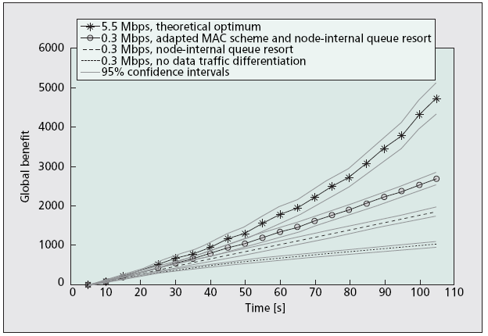
Figure 9(Graph 2): Benefit improvement potential due to message differentiation.

not emerge at all, thus a reorganization of enqueuing and dequeuing mechanisms does not show any effect at all. In order to compare benefit improvement potentials of both our cross-layer architecture and the 802.11e-based architecture, a verified implementation of the IEEE 802.11e-specific data-link layer has been incorporated into our simulation environment. As can be seen in Fig 10, the 802.11e-based node architecture cannot keep up with the abovementioned cross-layer architecture in terms of benefit improvement potential. The bars show the improvement of the global benefit when applying a benefit-based dissemination scheme compared to a non prioritized, relevance agnostic store-and-forward scheme. The left bars in each case depict global benefit improvement in percent in case the novel cross-layer architecture has been used. The larger bars at the right, in contrast, represent the improvement due to the native 802.11e-based architecture, where the smaller bars in front show additionally achieved improvement if queue resorting is conducted. The IEEE 802.11e standard falls short of some of the requirements specified by our approach: first, it does not provide a packet queue–internal resorting of the contained packets. Packets can only be sorted into one of the different priority queues once and are then dequeued according to the FIFO principle. In the cross-layer architecture, the node-internal sequence can be continuously adapted to the current relevance values of the enqueued packets, thereby enabling an improved, benefit-oriented broadcast sequence. The smaller bars in front show the potential additional global benefit improvement in case the 802.11e-based queues do adapt their dequeuing sequence to the benefit of the waiting packets. Second, the prioritization of packets is rather roughly staged. Sorting messages into only four queues is disadvantageous, because data packets of different benefit may be sorted into the same queue and thus conduct external contention processes applying the same prioritization parameters. Third, the internal contention between queues further deteriorates the IEEE 802.11e-based architecture’s performance with respect to a global benefit improvement: packets with high relevance win node-internal contention processes more often than those with low relevance due to the different parametrization of the four queues. However, there is only a certain

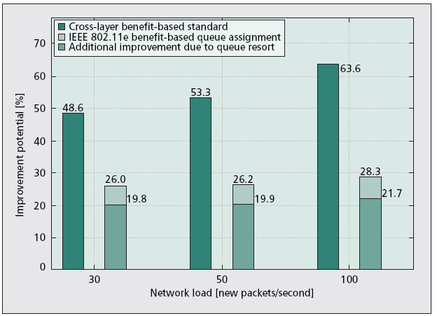
Figure 10(Graph 3): Potentials for the global benefit for different mechanisms.

Tendency to allow for a faster dissemination of highly relevant packets, depending on the
parameterization used, but packets sorted into the lowest priority queues also get the chance to access the medium to avoid their starvation. This realization of a quasi-fair packet scheduling does not perfectly meet the requirements imposed by our message dissemination approach.

To be able to simulate Vehicle-to-Vehicle messaging vehicle movement, driver behavior, and network characteristics have to be simulated in one environment, called as TraN Two components are needed: a traffic simulator, and a network simulator. The components have to be connected to be able to exchange simulation data like node positions or application events.

TraNS (Traffic and Network Simulation Environment) is a simulation environment that integrates both traffic and network simulators and aims to provide a tool to build realistic simulations of Vehicular Ad-hoc Networks (VANETs). The incorporation of the traffic simulator allows defining a network topology based on real road networks and road-side infrastructure, e.g. traffic lights. It allows generating realistic mobile traces used by the network simulator. The latter simulates wireless communication among vehicles and implements the logic of applications running on top of VANETs. Current implementation uses SUMO (traffic simulator) and Ns2 (network simulator)
With TraNS we can
- Generate REALISTIC mobility traces and prepare them to use in a network simulator
- Evaluate routing protocols for DTN-like networks in realistic mobility scenarios
- Test new applications running on top of VANETs
- Traffic Simulator SUMO: SUMO generates realistic mobile traces used by the network simulator NS2. It also randomly chooses a start and a destination point on the map for each vehicle and calculates the shortest path along the roads. Additionally it periodically receives data concerning changes in vehicle behavior from the network simulator, incorporates them, and sends new node positions and connectivity patterns back to the network simulator. In case a vehicle is warned against a local hazard, it may desire to seek a route around the danger zone. It is SUMO’s job to implement possible route changes in real-time.

- Network Simulator NS2: As network simulator the widely used NS2 simulator has been used. Its task is to simulate the mobile car-to-car network.

- Application: The warning application has been implemented into the NS2 environment as a comprehensive new ad hoc agent. It determines the network nodes’ behavior while sending, receiving or forwarding data. It basically implements the message dissemination algorithm for the whole simulation. Messages are flooded to all reachable other nodes, taking care of certain areas of relevance and time limits. And to assign relevance to each message Priority Based Message Selection Scheme is incorporated. Additionally, the agent provides the warning functionality for the driver and the full service realization.

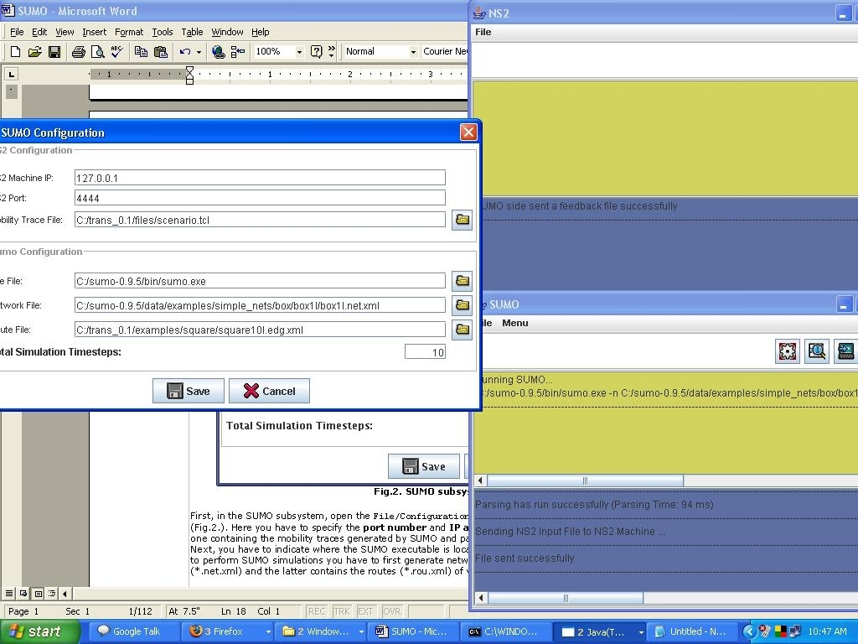
Fig 3. Final output showing the SUMO simulation, traces generated by SUMO get transferred to NS2; NS2 shows the delivery report and perform network simulation

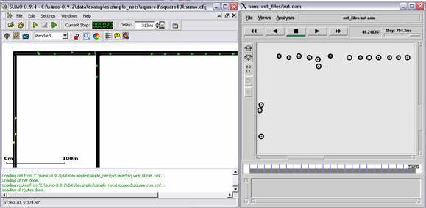
Fig.3. TraNS in action: the SUMO simulation

CHAPTER 5
TRAFFIC AND NETWORK SIMULATION ENVIRONMENT

SUMO installation
In general follow the instructions from the official SUMO web site. However while installing SUMO on Fedora Core 6 you may consider the following suggestions:
STEP1:
Install Xerces-c (XML-parser) and Proj.4 (Cartographic Projections Library) using the standard Package Manager or yum tool
STEP2:
Install FOX-Toolkit (GUI Toolkit) version 1.6.20 from sources - available here
STEP3:
Install GDAL (Geospatial Data Abstraction Library) version 1.3.2 from sources - available here
NOTE! Do not forget to put /usr/local/lib to your LD_LIBRARY_PATH enviroment, e.g. in the /etc/profile file
STEP4:
Install SUMO version 0.9.5 following the guidelines from here

NS2 installation
STEP1:
Get the all-in-one NS2 installation package (version 2.30) and follow the instructions listed here
NOTE! All the below NS2 installation steps (2-9) are optional.
STEP2:
If you want to experiment with applications designed for VANETs we propose you to use the patch for ns-2 that includes the basic message broadcast mechanism and a framework for developing VANET applications vanetrbc-ns229.tgz
STEP3:
In order to install it extract the data from the archive issue the following commands:
cd/home/myusermkdir/home/myuser/ns-allinone-2.30/ns-2.30/vanetrbc
tar -xvzf vanetrbc-ns229.tgz -C /home/myuser/ns-allinone-2.30/ns-2.30/vanetrbc
STEP 4:
Then you have to configure NS2 in order to include this new protocol:
In /home/myuser/ns-allinone-2.30/ns-2.30/common/packet.h, in the enum packet_t (line 170), insert:
PT_VANETRBC, /*NOTE: don’t forget the comma at the end!*/
Then in the same file in the class p info (line 266), insert:
name_[PT_VANETRBC]="VanetRBC";
STEP 5:
In /home/myuser/ns-allinone-2.30/ns-2.30/tcl/lib/ns-packet.tcl, in the foreach prot loop calling add-packet-header, insert (e.g., line 156):
VanetRBC #Vanet protocol
STEP 6:
In /home/myuser/ns-allinone-2.30/ns-2.30/tcl/lib/ns-default.tcl, at the end of the file, insert these lines (these are example values used to initialize the parameters, but they can always be overriden in your TCL-scripts):
Agent/VanetRBC set interval_ 1
Agent/VanetRBC set jitterFactor_ 0.005
Agent/VanetRBC set crypto_delay_ 0
STEP 7:
In /home/myuser/ns-allinone-2.30/ns-2.30/Makefile in the OBJ_CC part (e.g. line 310), insert
vanetrbc/vanetrbc.o vanetrbc/vanetrbc_rxdatadb.o \ #NOTE: don’t forget the backslash at the end
STEP 8:
The following changes are not strictly necessary, but probably you want to make them to prevent lots of messages cluttering up your screen (forcing you to search for the messages you actually want to see):
In /home/myuser/ns-allinone-2.30/ns-2.30/mobile/dumb-agent.cc (line 96), you may comment out the following line:
printf("Recvd brdcast pkt\n"); /*since in VANET, all packets are broadcast*/
STEP 9:
Finally, you can recompile ns, with the new protocol:
cd /home/myuser/ns-allinone-2.30/ns-2.30/
make clean
make

TraNS installation
TraNS is implemented in Java. We use the Sun's JDK 5.0 Update 10.
STEP 1:
Get the current version of TraNS (version 0.1)
STEP 2:
Unzip it for example under /home/myuser/ . You can find the executables under /home/myuser/TraNS-0.1/.

TraNS configuration
TraNS is divided in two subsystems (Fig.1). The first (SUMO subsystem) manages the SUMO simulator and prepares mobile traces for NS2. The second (NS2 subsystem) manages the ns2 simulator. With TraNS you can run sumo and ns2 on two different machines, since it uses TCP communication between the two.
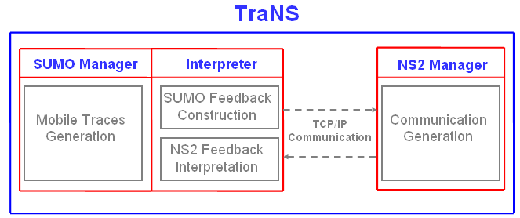
Fig.1. TraNS architecture.
If you are running SUMO, NS2 and TraNS on the same machine in order to launch TraNS go to the ./TraNS-0.1/dist/ folder and type the following:
java -jar TRANS_0.1.jar ns2 sumo
If you are running SUMO on machine A and NS2 on machine B you have to install TraNS on both machines A and B. Then to launch the simulation on machine A (running SUMO) you have to type the following:
java -jar TRANS_0.1.jar sumo
and on the machine B (running NS2):
java -jar TRANS_0.1.jar ns2
Once the TraNS is running (either on one or on two machines), you need to configure the communication between SUMO subsystem and NS2 subsystem, the filenames used during the simulation and the parameters of the simulation.
Configuring SUMO Subsystem 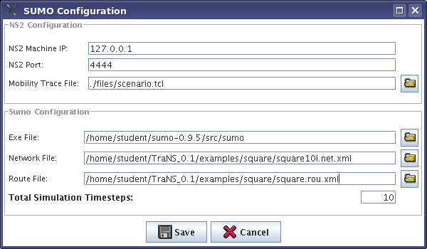
Fig.2. SUMO Subsystem Configuration
First, in the SUMO subsystem, open the File/Configuration menu, then the SUMO configuration window will pop up (Fig.2.). Here you have to specify the port number and IP address of the machine running NS2. The Input file is the one containing the mobility traces generated by SUMO and parsed by TraNS, which will be sent to the NS2 subsystem. Next, you have to indicate where the SUMO executable is located. As you already know from the SUMO tutorial in order to perform SUMO simulations you have to first generate network and routes files. The former indicates the street topology (*.net.xml) and the latter contains the routes (*.rou.xml) of vehicles.

NOTE! The current version of TraNS (0.1) does not support route files which contain flow generation. We only consider single vehicle emission routes.
Finally, you have to configure the simulation parameters. The Total Time steps field indicates the duration of the total simulation time.
Configuring NS2 subsystem
Since the current version of TraNS does not implement the feedback loop between NS2 and SUMO and provides only with the generation of mobility traces, the configuration of NS2 subsystem is straightforward.
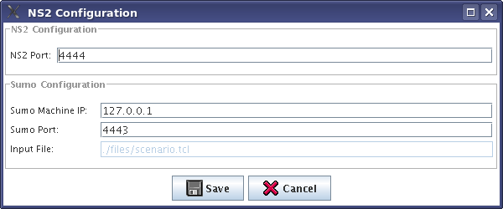
Fig.3. NS2 subsystem configuration
First, open the File/Configuration, then the NS2 configuration window will pop up (Fig.3.). Here you have to specify the NS2 Port - number of TCP port over which SUMO will communicate with NS2. Next, you have to specify the Sumo port and Sumo Machine IP of the machine running SUMO. Finally, you have to indicate where the Input file is located - it specifies the simulation scenario for the NS2.

TraNS tutorial
After saving the SUMO and NS2 configurations you can run TraNS to produce realistic mobile traces for NS2. To do so follow the steps below:
- In the SUMO window of TraNS run the SUMO simulation - click the run button
- Process the SUMO output to generate the traces readable by NS2 - click the process button
- Finally, send the processed file to NS2 - click the send button

Fig.3. TraNS in action: the SUMO simulation

CHAPTER-6
FUTURE PROSPECTIVE IN TERMS OF INDIAN CONTEXT

INTRODUCTION
Roads in India are improved in stages in view of the paucity of funds. A major portion of the roads are single-lane, bidirectional, and unpaved. Traffic is heterogeneous in character; it consists of fast-moving as well as animal-drawn vehicles. Climate and topography change across the country. Indian traffic conditions are chaotic, the drivers reckless, and the roads often in poor repair. There is a pecking order for right of way: cows are at the top, trucks and buses are second, and dogs and pedestrians are at the bottom. Two wheelers are pretty low down. You can only really lord it over bicycles.
You will not believe the crazy things other drivers are capable of until you've driven in India. People overtake on blind corners. They swerve blindly in traffic. They come off side roads at full speed and join the traffic flow without even looking. They stop on a whim in the middle of the road. They barrel down the middle of a narrow road playing chicken - forcing anyone smaller off on the shoulder. Expect anything, at any time. Nor will you believe road conditions.Pot holes and speed breaker bumps are common, and rarely marked. Rocks are commonly left on the road by a truck that has blocked its wheels while stopped to repair a tire. Pedestrians, animals, bicycles, ox carts and tractors all use the roads. Sometimes people lie down and have a nap on the edge of the road. Traffic barriers and road dividers appear suddenly and inexplicably. Road repair crews leave piles of sand, gravel, or tar on the road. During harvest times, people spread grain and other crops on the road to dry. You'll suddenly find yourself fishtailing through a 6 inch deep mound of millet seeds.Expect anything, at any time. Driving in big cities is, initially, a terrifying prospect. So much traffic, so much noise and pollution, and so much chaos. Driving in large cities is a bit like juggling chainsaws - once you get the rhythm of it you're half way there, but one small slip can be very messy. The rhythm is the key. Ease into city driving if you can. Concentrate most on what is in front of you. It seems an unwritten rule of the road that people behind you will adjust to what you are doing. Most of the drivers in front of you will assume you are watching out for them. They may pull out suddenly, swerve abruptly, or just stop because they've arrived. Do not assume lanes have any significance. Do not assume lights will be followed either. Buses are a hazard. They will suddenly swerve to the edge to drop passengers, and pull out abruptly. If they merely slow down at any point, some passengers may decide to jump off, other to jump on. Watch out for carts and rickshaws. Some carry over-sized loads or extra long loads that jut dangerously into traffic. Autoricksaws are constantly in a hurry and zip recklessly through dense traffic. Pedestrians can appear anywhere, at any time. So, of course, can cows, pigs, dogs and other animals.
Looking at what is happening you can hardly believe that some traffic control mechanism as being used in Europe, USA and other countries will work here. You can create systems that u can install in cars, buses, even two wheelers. But traffic in India is not restricted here. It consists of a large no of Rikshawalas, cyclists and pedestrians as well. And also animal driven VEHICLES.
It’s not possible to handle traffic condition in India unless there is a mechanism that can handle not only the four wheelers and two wheelers but also the others which uses the road transport in India. And hence the systems used in western countries will not work here.
Hence in this report we propose a mechanism that handles the traffic problem in India not not by using any off the shelf system but by decision making that affects the way traffic is driven in India. It will include taking decisions related to parking, traffic lights (timing) and restrictions for entry of certain types of vehicles for the time at which the traffic problem occurs.
That is the basic idea is to remove the bottleneck that is causing the traffic problem in India by taking decisions and checking whether the decision has helped or not.

TRAZER
'Traffic Analyzer & Enumerator’ is a offline video processing system to aid traffic planning by analyzing and computing useful features and data from traffic video. It is a unique product catering to the heterogeneous traffic conditions of the developing world.

FEATURES & BENEFITS
Features | Details
Vehicle Detection & Classification | 4 categories of Vehicles:-
• | Light Moving Vehicle: Cars, Jeeps etc.
• | Three wheelers
• | Two wheelers
• | Heavy Moving Vehicle: Bus, Truck etc

Count of Vehicles | Two different kinds of counts can be taken by user
• | Light Moving Vehicle: Cars, Jeeps etc.
• | Three wheelers
• | Two wheelers
• | Heavy Moving Vehicle: Bus, Truck etc

Selectively processing some parts of the video | Required portions of the video can be processed instead of the whole video for eg. This feature is useful to find the movement of vehicles at certain times like rush hour
Computation of instantaneous velocities of  each vehicle | Velocity of every detected vehicle can be used to find out about over-speeding.
Computation of Average, Minimum &  Maximum System Velocities in Km/hr: | It can help in finding out at what speed a junction is clearing up from traffic.
Flow statistics can be saved into user  friendly format | Following vehicle flow statistics are computed and can be saved into a spread sheet format
• | Vehicle flow for particular time
• | Occupancy Time
• | Velocity of the traffic

Extensive vehicle trajectory log can be  saved for analysis | It can help a user in understanding the traffic flow characteristic using following:
• | Time
• | Vehicle ID
• | Vehicle location in image
• | Vehicle's location in world
• | Vehicle velocity in Km/hr
• | Class of the vehicle

Because of uniqueness of Indian traffic condition, India poses a challenge to Traffic Planners, City Administrators and Urban development Consultants. Though there are some solutions available in Western world for Traffic Planning, the same are not applicable in India and other developing countries due to the following main factors
- Wide variety of vehicles (including human traffic)
- Vast range of vehicular velocities (pedestrian, bicycle, LMV's, HMV's)
- Poor lane discipline (partially resulting from the first two factors)
TRAZERTM has been designed keeping the above mentioned conditions in consideration and has been extensively tested. TRAZERTM can help the City Planners and Traffic consultant to analyze the offline videos, study the statistics that is being captured from the video and using the data, plan the traffic conditions for any city in a more systematic way.
TRAZERTM has the potential of making the cities safer, traffic faster and less polluted.

APPLICATIONS
Applications of TRAZERTM for City administrators, traffic consultants and highway toll auditors
- Traffic Census and Classification
- Offline Traffic Monitoring
- Velocity and Trajectory Measurement
- Customized Traffic Statistics
- Intersection Studies
Benefits
TRAZERTM is the only camera-based system which caters specifically to the heterogeneous traffic of the developing countries.
- Works well for analysis of vehicular pattern unique to the traffic in the developing world
- Use of cameras enables photographic evidence: Camera system can be used to provide a live picture (recorded) of the situation in case of any untoward happening. The installed cameras can also be used for surveillance purposes, especially useful in case of VVIP movement, sensitive areas etc
- Easy installation
- It removes the probability of Human error in analysis
- Verification can be done by going back to the stored video
- Product can be customized to specific needs of Traffic Planers
- It’s a cost effective solution for City Planners and Traffic Consultants.
Figure: Trazer- Features And Output

PARKING
Parking is a problem especially in cities like Delhi where the space available is very less as compared to what is required. Due to the fewer parking spaces the vehicles are parked on roads which cause the width of the road decrease drastically. What happens is that as the traffic increases with the day, the parked cars come into the picture. People when start to get their cars out of the parking they do so by stopping the whole traffic, resulting at time in large jams as more vehicles start to compete for the newly vacated parking space there by stopping the traffic. These continuously with time keep on increasing resulting into traffic jams.
To handle such a problem the proposed software TRAZOR can be used to measure at what time the traffic problem occurs. Similarly based on the data from the software decisions can be taken as to at what time the vehicles are allowed to park, what is the time limit for which vehicles can stop on roads, or whether the parking should be allowed at all or not. Another decision that can be taken is whether vehicles once parked are not allowed to leave the parking area at the peak time at which the traffic is high. Now the decision taken should be checked against the data again taken from the software to know what benefit has been obtained, and than the decision should be refined to increase the benefit.

ENTRY RESTRICTION ON VEHICLES
As there are not only fast moving vehicles but also slow moving Rikshawalas that make the Indian traffic, the problem occurs when there are many slow moving Rickshaws on the road. Traffic follows the principle that the maximum speed of the traffic can be the speed at which vehicles in front are moving. With so many slow moving vehicles the whole traffic starts to decrease the speed resulting in continuous increase in traffic jams as the input to the traffic keeps on coming at much higher rate as compared to the rate at which the traffic is moving. The result again is large traffic jams.
The problem is not just restricted with slow moving vehicles. It also includes long stoppage for buses in areas at which the width of the road is not large. Buses especially in cities like Delhi are the main mode of conveyance for a large population. Buses start to stop for large time resulting in other buses overtaking and covering the rest of the space available. This causes the traffic behind to stop and hence results in jams.
To handle the problem related to Rickshaws again the software TRAZOR can be used which can identify the average speed of different types of vehicles and the overall average for the whole traffic. This way decision can be taken as to which all vehicles should be allowed at different time of the day, and than comparing with TRAZOR to check what benefit has been obtained and how can it be improved.

TIMINGS FOR TRAFFIC LIGHTS
Traffic lights in India are such that they start to handle the traffic properly but as soon as the traffic gets out of control in terms of no of vehicles entering the traffic lights point it fails to handle the traffic properly. This is because the duration for which the traffic lights signal allows the vehicle to pass is not enough to pass the whole traffic through. The no of vehicles entering a point becomes more than the no of vehicles passing through, resulting in large jams. This is not restricted to vehicles on one side of the roads but happens at all four sides, especially at places where traffic from all sides is coming at large no towards the traffic junction. The result is complete chaos and large jams.
TRAZOR again can be used to identify the vehicles passing through, their average speed.
Now in this case the decision can be taken in terms of making traffic lights dynamic. That is to increase the time for allowing the traffic to pass through by a certain defined time period till either the traffic completely passes or the speed of the traffic increases.
This way when the traffic speed starts to increase or the traffic completely passes through than the time can again be decreased by the same time period with which it was increased. This will happen to all the four sides, resulting in a dynamic traffic light system which will adapt itself based on the data received from the software, in this case TRAZOR.

SIMULATION
For simulation we took a video on some road in Delhi and than used the software TRAZOR to identify the trajectory and average velocities for various vehicles.

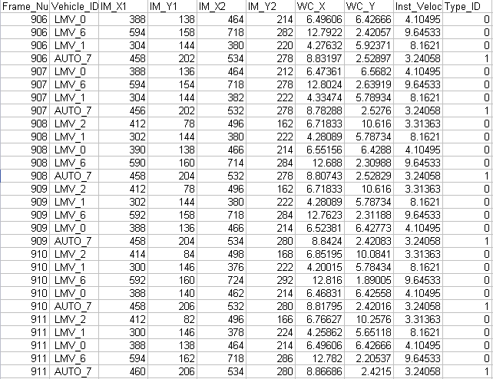
Figure: Trajectories of vehicles
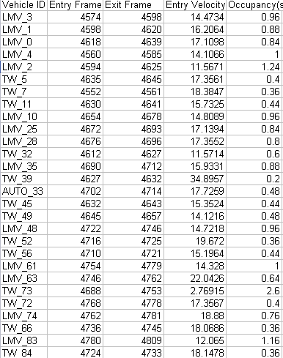
Figure: Occupancy Of vehicles within the specified frame.

Based upon the results obtained from the above simulation we can conclude that the software TRAZOR can be customized for the solutions that we gave for improving the TRAFFIC CONDITIONS in developing countries like INDIA where the Traffic is heterogeneous in character; it consists of fast-moving as well as animal-drawn vehicles.

CHAPTER 7
CONCLUSION

This repot has addressed the scalability problem of inter vehicle communication in vehicular ad hoc networks. It comprises two dimensions: connectivity and network load. While existing approaches only solve parts of the overall problem, our Priority-based approach provides a comprehensive concept that operates efficiently both in dense and sparse networks and manages to deliver information to where it is needed, independent of the current network load. With the help of a measure called message relevance, both an in-vehicle and inter vehicle message prioritization is realized, which is inevitable in the context of limited network resources. The relevance value of one specific message is determined by estimating the benefit that the receiving node will be provided on the basis of several parameters concerning current vehicle context, message content, and network situation. By implementing a methodology applying controlled unfairness in scheduling the broadcast of data packets, bandwidth can be used optimally and the benefit provided to all the vehicles participating in a VANET is optimized at the same time. Messages that add the highest application benefit will have shorter latency and a lower probability to starve. Proprietary cross layer architecture is presented as a possible realization of our concept, where the IEEE 802.11e standard may work as the basis of an adequate alternative. The results of in-depth simulative evaluations indicate that our approach provides the possibility of considerably enhancing the benefit vehicles gain from received messages, especially in heavily loaded networks. The proposed concept is flexible with regard to the deployment of different communication standards such as protocols using several channels — messages could be assigned to the various channels according to their current benefit and thus realize traffic differentiation as well. Other standards such as GSM or UTMS can be integrated as well; a cost-benefit analysis would then have to account for monetary costs.
We have also shown that how the TraNs simulator environment helps in analysis the traffic condition and hence solves the network problem, and in last we consider traffic conditions in developing countries need more decision making solutions that can help in analyzing the conditions better rather than custom made solutions that are being used in developed countries like USA and EUROPE. The results obtained from the software TRAZER were more than satisfactory and were able to measure the average velocities and trajectory of vehicles accurately.

REFERENCES
REFERENCES FOR REVIEW (CHAPTER 1-2)
[1] “IEEE P1609.2 Version 1 — Standard for Wireless Access in Vehicular Environments: Security Services for Applications and Management Messages,” in development, 2006.
[2] P. Golle, D. Greene, and J. Staddon, “Detecting and Correcting Malicious Data in VANETs,” Wksp. Vehic. Adhoc Networks (VANET), 2004.
[3] M. Raya and J.-P. Hubaux, “The Security of Vehicular Ad Hoc Networks,” Wksp. Security in Ad hoc and Sensor Networks (SASN), 2005.
[4] K. Sampigethaya et al., “CARAVAN: Providing Location Privacy for VANET,” Wksp. Embedded Security in Cars (ESCAR), 2005.
[5] J. Blum and A. Eskandarian, “The Threat of Intelligent Collisions,” IT Professional, vol. 6, no. 1, Jan.–Feb. 2004, pp. 24–29.
[6] M. Gerlach, “VaneSe: An Approach to VANET Security,” V2VCOM, 2005.
[7] J.-P. Hubaux, S. Capkun, and J. Luo, “The Security and Privacy of Smart Vehicles,” IEEE Security and Privacy Mag., vol. 2, no. 3, May–June 2004, pp. 49–55.
[8] B. Parno and A. Perrig, “Challenges in Securing Vehicular Networks,” Wksp. Hot Topics in Networks (HotNets- IV), 2005.
[9] M. El Zarki et al., “Security Issues in a Future Vehicular Network,” Euro. Wireless, 2002.

REFERENCES FOR THE SCALABILITY PROBLEM (CHAPTER 3-6)

[1] B. Clifford Neuman, “Readings in Distributed Computing Systems,” chapter Scale in Distributed Systems, IEEE Computer Society, Los Alamitos, CA, 1994, pp. 463–89.
[2] J. Li et al., “Capacity of Ad Hoc Wireless Networks,” Proc. 7th ACM Int’l. Conf. Mobile Computing and Net. (MobiCom ’01), Rome, Italy, July 2001.
[3] C. Maihöfer, W. Franz, and R. Eberhardt, “Stored Geocast,” Proc. 13, ITG/GI-Fachtagung Kommunikation in verteilten Systemen (KiVS), Feb. 2003.
[4] B. Williams and T. Camp, “Comparison of Broadcasting Techniques for Mobile Ad Hoc Networks,” Proc. ACM Int’l. Symp. Mobile Ad hoc Net. and Computing (Mobi- Hoc), June 2002.
[5] H. Wu et al., “Mddv: A Mobility-Centric Data Dissemination Algorithm for Vehicular Networks,” Proc.1st Int’l. Wksp. Vehic. Ad Hoc Networks (VANET), Oct. 2004, pp. 47–56.
[6] M. Torrent-Moreno, P. Santi, and H. Hartenstein, “Fair Sharing of Bandwidth in Vanets,” Proc. 2nd ACM Int’l. Wksp.Vehic. Ad Hoc Networks (VANET), 2005, ACM Press, pp. 49–58.
[7] R. J. La and Venkat Anantharam, “Utility-Based Rate Control in the Internet for Elastic Traffic,” IEEE/ACM Trans. Net., vol. 10, no. 2, Apr. 2002, pp. 272–86.
[8] H. Füßler et al., “Contention-based Forwarding for Mobile Ad-Hoc Networks,” Ad Hoc Networks, vol. 1, no. 4, Nov. 2003, pp. 351–69.
[9] IEEE 802.11e/D13.0, “Part 11: Wireless LAN Medium Access Control (MAC) and Physical Layer (PHY) Specifications: Medium Access Control (MAC) Enhancements for Quality of Service (QoS), draft supplement to IEEE 802.11 standard,” Tech. Rep., IEEE 802.11e Working Group, Jan. 2005.
[10] S. Eichler et al., “Simulation of Car-to-Car Messaging: Analyzing the Impact on Road Traffic,” Proc. 13th Annual Meeting of the IEEE Int’l. Symp. Modeling,
Analysis, and Simulation of Computer and Telecommunication Systems (MASCOTS), Sept. 2005.
[11] S. Krauß, “‘Microscopic Modelling of Traffic Flow: Investigation of Collision Free Vehicle Dynamics,” Ph.D. thesis, Universität Köln, Apr. 1998.
[12] R. M. Fujimoto et al., “Large-Scale Network Simulation: How Big? How Fast?,” Proc. 11th Annual Meeting of the IEEE Int’l. Symp. Modeling, Analysis, and Simulation of Computer and Telecomm. Systems (MASCOTS), Los Alamitos, CA, USA, Oct. 2003, IEEE Computer Society, pp. 116–23.

