Report
On
Annual Information Literacy Workshop
E-Resources: A Gateway for Research
9th edition (2025)
Held from
8th September to 12th September 2025
Organised by
Central Library
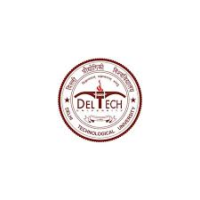
Delhi Technological University
(Formerly Delhi College of Engineering)
Shahbad Daulatpur, Bawana Road, Delhi-110042

Table of Contents

S. No. | Title | Page No.
1. | Summary | 3
2. | Annual Literacy Program Highlights | 4
3. | Minute-to-Minute Program | 4
4. | Literacy Program Introduction | 5–6
5. | Participation Profile | 7
6. | Day–Wise Proceedings | 8–17
7. | Glimpses of the Session | 18–19
8. | Valedictory Session | 19
9. | Outcomes of the Workshop | 20
10. | Participants Feedback, Reflections, Recommendations, and Way Forward | 20-21
11. | Conclusion | 21
12. | Acknowledgments | 21-22
13. | Organising Team | 22

Summary
The 9th Annual Information Literacy Workshop, themed “E-Resources: A Gateway for Research,” was successfully organized by the Central Library of Delhi Technological University (DTU) from 8th to 12th September 2025. This five-day academic event was conceived as a comprehensive training platform designed to strengthen the research competencies of students, research scholars, and faculty members by familiarizing them with globally recognized digital resources and cutting-edge research technologies.
The workshop provided participants with an in-depth orientation to a wide range of international academic databases and tools. These included Elsevier’s ScienceDirect and Scopus, Springer Nature, IEEE Xplore, Wiley Online Library, and Taylor & Francis, among others. Through these sessions, attendees gained hands-on experience in advanced literature search techniques, effective citation indexing, research evaluation methods, and academic integrity practices.
A special focus of this edition was on AI-driven research assistance, where participants were introduced to intelligent platforms such as Ask ScienceDirect, Reading Assistant, and Turnitin Clarity, which streamline academic writing, enhance precision, and support originality in scholarly work.
The event maintained a vibrant and interactive atmosphere throughout. Each session incorporated live demonstrations, hands-on practice segments, and question–answer interactions, ensuring that participants not only understood theoretical concepts but also developed practical proficiency. Engaging activities such as quizzes, participant feedback polls, and interactive challenges further enhanced learning and collaboration.
The workshop culminated in a Valedictory Ceremony, marking the successful completion of five days of intensive learning. Certificates of participation were awarded to all eligible attendees who completed the full duration of the program. The closing remarks by the coordinators and speakers emphasized the importance of continuous learning and the critical role of information literacy in modern academic and research ecosystems.
Feedback received from participants reflected exceptionally high levels of satisfaction and enthusiasm. Many appreciated the relevance of the sessions, the clarity of demonstrations, and the opportunity to engage directly with experts from reputed publishing houses. The workshop was universally recognized as a significant step forward in DTU’s mission to cultivate a culture of ethical research, scholarly excellence, and digital empowerment.

Program Highlights
- Hands-on training on leading global databases and tools including IEEE Xplore, Elsevier’s ScienceDirect and Scopus, Web of Science, Springer Nature, Wiley, Turnitin, Grammarly, DELNET, Indiastat, and Taylor & Francis.
- Interactive demonstrations, quizzes, and Q&A sessions that encouraged active participation and practical learning.
- Introduction of AI-driven tools such as Ask ScienceDirect, Reading Assistant, and Turnitin Clarity to enhance research efficiency and academic integrity.
- Exciting quiz competitions and rewards, with certificates of participation awarded to attendees maintaining 90% attendance.
- Collaborative learning environment fostering knowledge sharing among students, researchers, and faculty guided by experts from premier publishers.

Minute to Minute Program

Day | Date | Session | Speaker/Organization
Day 1 | 8 Sept 2025 | Inauguration, RemoteXS, DELNET, Indiastat | Dr. Lalita, Mr. Vaibhav, Ms. Ranjana, Mr. Kushal Giri, Mr. Bhupender
Day 2 | 9 Sept 2025 | Springer Nature, JoVE, Turnitin | Mr Prateek, Dr. Prerna, Miss. Chaitali and karishma gupta
Day 3 | 10 Sept 2025 | IEEE, EBSCO, Wiley, Web of Science, JCR | Mr. Ritesh, Ms. Arunima, Mr. Vishav Sharma
Day 4 | 11 Sept 2025 | ScienceDirect, Scopus | Ms. Shweta Sethi, Ms. Aishwarya Nayal
Day 5 | 12 Sept 2025 | Grammarly, Taylor & Francis, HBR Cases, Valedictory | Ms. Mansi, Ms. Anjuli Gupta, Mr. Amit Siddhartha

Introduction
Delhi Technological University (DTU), one of India’s leading centers of excellence in science, technology, and research, has consistently endeavored to strengthen the foundations of research, innovation, and academic excellence. The University’s Central Library serves as a vital pillar of this mission, acting not merely as a repository of books and digital resources but as an active hub of knowledge creation and scholarly empowerment.
With the exponential growth of information in the digital era, the ability to identify, evaluate, and ethically use scholarly information has become an indispensable skill for researchers and students alike. Recognizing this need, the DTU Central Library took a pioneering initiative by introducing its Annual Information Literacy Workshop Series, designed to train and equip the academic community with the essential competencies of information discovery, evaluation, and responsible utilization.
Held every year, this workshop has evolved into one of DTU’s most anticipated academic development programs, providing an essential bridge between traditional library services and modern digital scholarship. Each edition reflects the university’s continuous commitment to promoting digital literacy, research ethics, and technological advancement in academic communication.
The 9th Annual Information Literacy Workshop (2025), themed “E-Resources: A Gateway for Research,” was organized from 8th to 12th September 2025 the programme was coordinated by Dr. Lalita, Assistant Librarian, Central Library. Continuing the legacy of the previous editions, this year’s program sought to deepen participants’ understanding of global academic databases, e-resources, citation tools, plagiarism detection platforms, and AI-integrated research technologies. The workshop featured resource experts and representatives from Elsevier (ScienceDirect & Scopus), Springer Nature, IEEE, Wiley, Taylor & Francis, DELNET, Indiastat, Grammarly, and Turnitin, who shared their insights through demonstrations and interactive sessions.
The significance of the workshop lies in its ability to transform the way DTU’s students, research scholars, and faculty engage with scholarly information. It goes beyond mere database training — it cultivates a mindset of critical inquiry, research integrity, and strategic information use. By bridging the gap between access and analysis, the workshop empowers participants to become self-reliant researchers capable of leveraging digital tools to produce high-quality, ethical, and impactful research.
The annual continuity of this workshop underscores DTU’s belief that information literacy is not a one-time skill but a continuously evolving competency that must grow alongside advancements in technology and scholarly communication. Over the years, this initiative has become a benchmark for academic excellence, inspiring a culture of informed research practices across departments and disciplines.
The expectations from the 2025 edition were ambitious and multifaceted. The program aimed to:
- Provide comprehensive exposure to National, international academic databases and digital research ecosystems.
- Introduce participants to AI-enhanced tools such as Ask ScienceDirect, Reading Assistant, and Turnitin Clarity to improve efficiency and originality in academic writing.
- Strengthen participants’ understanding of ethical research conduct, citation management, and plagiarism prevention.
- Encourage collaboration and networking among faculty, researchers, and students for cross-disciplinary knowledge sharing.
- Promote lifelong learning habits essential for academic success in a rapidly changing digital landscape.
By meeting these objectives, the 9th edition of the Annual Information Literacy Workshop reaffirmed the Central Library’s mission to act as a catalyst for academic innovation. Through its immersive, hands-on format, the program did not merely introduce tools but inspired participants to adopt information literacy as a lifelong skill and mindset.
In conclusion, the workshop continues to represent DTU’s unwavering commitment to academic quality, ethical research, and technological progress. It stands as a testament to the University’s proactive approach in ensuring that its scholars are well-prepared to navigate, evaluate, and contribute meaningfully to the global landscape of digital scholarship and knowledge dissemination.

Participation Profile
A total of 123 participants, including students, research scholars, and faculty members, attended the workshop. The gender distribution of participants is presented below:
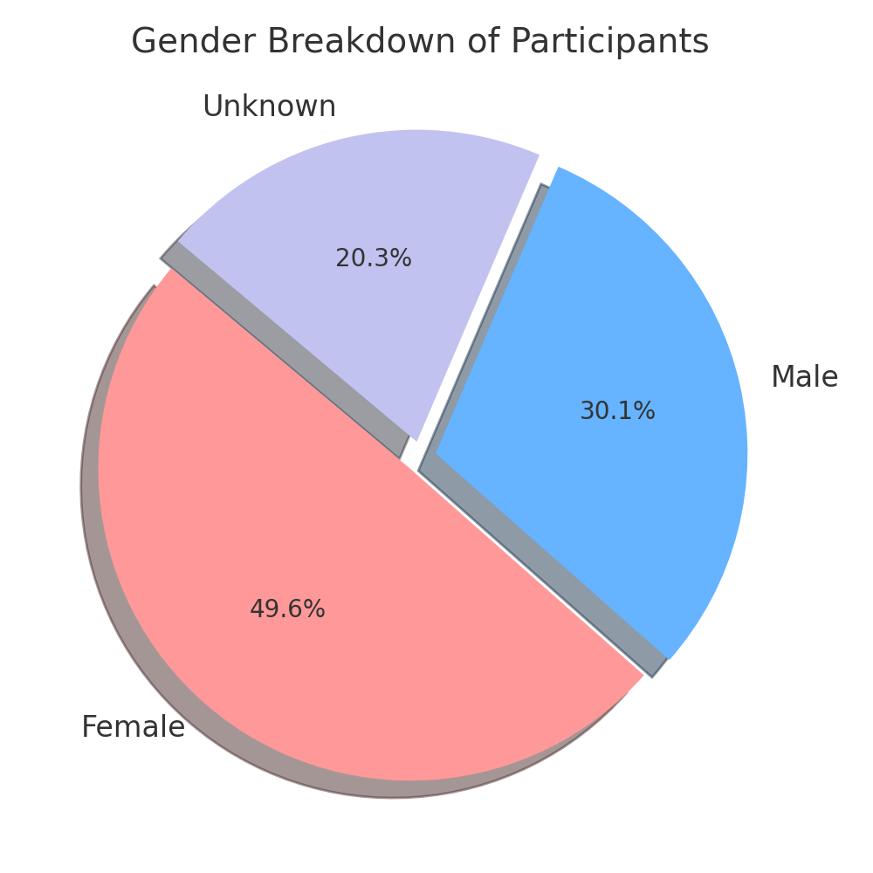
Female participation (61) exceeded male participation (37), with 25 participants opting not to disclose. This indicates growing inclusivity and engagement from women researchers in academic training initiatives.

Day – Wise Proceedings
Day 1 – 8 September 2025 The first day of the 9th Annual Information Literacy Workshop, themed “E-Resources: A Gateway for Research,” commenced on 8th September 2025 at the Central Library, Delhi Technological University (DTU). The workshop witnessed enthusiastic participation from students, research scholars, and faculty members eager to enhance their understanding of digital research tools and information retrieval techniques. The program was meticulously coordinated by Dr. Lalita, whose leadership and planning ensured a smooth and enriching start to the five-day event.
The opening day set the tone for the week’s proceedings, combining interactive demonstrations, live sessions, and participant engagement activities. The focus was on empowering attendees to efficiently utilize DTU’s subscribed e-resources, understand networked information systems, and develop a foundational awareness of academic data accessibility.

Session 1: RemoteXS
Resource Person: Mr. Vaibhav
The first technical session of the workshop was conducted by Mr. Vaibhav, who delivered an informative and practical presentation on RemoteXS — a gateway platform that enables remote access to DTU’s entire suite of digital library resources. His session provided participants with a comprehensive understanding of how RemoteXS acts as a single-point access to all e-journals, databases, and electronic subscriptions offered by the DTU Central Library.
Mr. Vaibhav began by demonstrating the login and authentication process, explaining how users can access the platform securely from any location using their institutional credentials. He then guided the audience through the platform’s interface, illustrating how researchers can explore various resources such as IEEE Xplore, Elsevier’s ScienceDirect, SpringerLink, Scopus, Wiley, and Taylor & Francis — all available under one digital umbrella.
He emphasized the advantages of remote accessibility, particularly for research scholars and faculty working off-campus, as it ensures uninterrupted access to full-text scholarly content. Participants were shown how to navigate the search options, journal lists, and database categories, and how to perform advanced searches to retrieve relevant literature efficiently.
The session concluded with an engaging question-and-answer segment, where participants raised queries about login issues, personalized access, and multi-database search techniques. Mr. Vaibhav addressed each question patiently, ensuring clarity and understanding. The session ended on an interactive note, with participants receiving small souvenirs as a token of encouragement for their active involvement.

Session 2: DELNET (Developing Library Network)
Resource Persons: Ms. Ranjana and Mr. Kushal Giri Goswami
The second session was conducted jointly by Ms. Ranjana and Mr. Kushal Giri Goswami, who introduced participants to the DELNET (Developing Library Network) platform — a national-level library consortium that connects academic institutions across India through a vast network of shared resources.
The presenters began by outlining DELNET’s mission to promote resource sharing and cooperative access among libraries, thereby expanding the scope of information available to students and researchers. They explained how DELNET provides access to union catalogues, e-journals, e-books, and databases, enabling users to borrow or request materials not available in their home library through interlibrary loan (ILL) services.
Ms. Ranjana guided participants through DELNET’s Knowledge Gainer Portal, Concour Portal, and GRIP Portal, explaining their specific utilities for academic research and professional development. She also elaborated on DELNET’s efforts to integrate AI tools and digital content discovery mechanisms that simplify the information retrieval process.
Mr. Kushal demonstrated how to perform catalogue searches, place book requests, and track ILL transactions, ensuring that participants could make the most of DELNET’s collaborative library network. The session was highly appreciated for its practical value and real-time demonstrations, which showcased how DELNET effectively complements DTU’s existing e-resource infrastructure.
Participants responded enthusiastically, acknowledging how such a platform enhances academic collaboration by connecting them to thousands of libraries across India.

Session 3: Indiastat
Resource Person: Mr. Bhupender
The final session of the day was delivered by Mr. Bhupender, who provided an in-depth exploration of Indiastat, a comprehensive statistical database that serves as a vital resource for researchers working with data-driven and policy-oriented studies.
Mr. Bhupender explained the structure and coverage of Indiastat, which compiles data from a wide range of official and government sources across sectors such as demographics, economy, agriculture, health, education, industry, and infrastructure. He highlighted how researchers could use the platform to generate tables, download reports, and analyze datasets for academic and policy research.
Through a live demonstration, he showcased the search functionalities, data visualization tools, and export options available on Indiastat. Participants were also informed about the support services offered by the platform, including direct contact with the Indiastat team for obtaining specialized datasets not readily available online.
The session was made engaging with a brief interactive activity, where participants answered short questions related to the data portal. One participant who provided a correct answer was rewarded with a surprise gift, creating an enthusiastic and lively environment. The session concluded with a sense of appreciation for how Indiastat empowers researchers to incorporate authentic data into their academic work.

Day 2 – 9 September 2025
The second day of the 9th Annual Information Literacy Workshop, themed “E-Resources: A Gateway for Research,” was held on 9th September 2025 at the Central Library, Delhi Technological University (DTU). The sessions for the day were structured to provide participants with practical exposure to three globally renowned academic and research platforms — Springer Nature, JoVE (Journal of Visualized Experiments), and Turnitin.

Session 1: Springer Nature

Resource Person: Mr. Prateek
The day commenced with an insightful session on Springer Nature, delivered by Mr. Prateek, a resource expert who introduced participants to the SpringerLink platform — one of the most comprehensive repositories of scientific literature worldwide.
The session began with an overview of Springer Nature’s role in global academic publishing, highlighting its vast collection of peer-reviewed journals, e-books, reference works, and conference proceedings spanning all major disciplines. The speaker emphasized how Springer Nature supports researchers by providing high-impact, credible, and up-to-date scientific information.
Through a live demonstration, the participants were guided step-by-step on how to navigate the SpringerLink interface, perform targeted searches, and apply advanced filters to retrieve precise research material. The speaker demonstrated how to access full-text articles, explore journal archives, and utilize the personalization features such as setting up search alerts and saving preferred reading lists.
Special attention was given to literature review strategies, enabling participants to identify the most relevant research papers and citations for their ongoing projects. The session also covered author tools and open-access options, helping researchers understand publication pathways within Springer journals.
The interactive Q&A session that followed addressed queries related to institutional access, content availability, and citation downloading. Participants found the session highly valuable, noting that it enhanced their confidence in exploring and retrieving high-quality research literature efficiently.

Session 2: JoVe(Journal of Visualized Experiments)
Resource Person: Dr. Prerna
The second session of the day featured a presentation on JoVE (Journal of Visualized Experiments), conducted by Dr. Prerna. JoVE is an innovative video-based journal designed to visualize complex experimental techniques and scientific procedures, making research more accessible and reproducible.
The session began with an engaging introduction to JoVE’s mission — to improve scientific education and reproducibility by publishing peer-reviewed videos that accompany traditional research papers. The speaker elaborated on how this platform benefits both students and faculty by integrating visual content into learning and research environments.
Participants were given a live demonstration of account creation and login procedures, after which they explored JoVE’s structured categories covering subjects such as biology, chemistry, engineering, medicine, physics, psychology, and environmental sciences. The speaker showcased how to search for specific experimental videos, use keywords and filters, and embed multimedia content into online or classroom teaching modules.
A particularly appreciated part of the session was the demonstration of JoVE’s educational modules, which combine video demonstrations with quizzes and transcripts — ideal for use in hybrid and flipped learning environments. The speaker highlighted how JoVE’s format supports self-paced learning and conceptual understanding for students while offering faculty members a valuable tool for enhancing course delivery.
Participants expressed admiration for the intuitive nature of the platform and its contribution to transforming complex laboratory concepts into easy-to-understand visual guides. The session concluded with an interactive discussion where attendees shared feedback on how JoVE could be integrated into DTU’s academic curriculum.

Session 3: Turnitin
Resource Persons: Ms. Chaitali & Ms. Karishma Gupta
The final session of Day 2 focused on Turnitin, an essential platform for ensuring academic integrity and originality in research writing. It was conducted by Ms. Chaitali and Ms. Karishma Gupta, who provided a comprehensive walkthrough of Turnitin’s features, functionality, and pedagogical applications.
The presenters began by explaining the growing global emphasis on plagiarism prevention and how Turnitin assists institutions in maintaining research ethics. They introduced participants to the platform’s core modules — including originality checking, similarity reports, feedback tools, and classroom management systems.
A detailed live demonstration was conducted, where participants observed how to:
- Create an instructor or student account under DTU’s institutional license.
- Upload assignments or research papers for originality checking.
- Interpret similarity percentages in Turnitin Reports to differentiate between properly cited references and potentially plagiarized material.
- Use the Turnitin Clarity feature to gain deeper insights into writing quality and content originality.
The session also covered administrative aspects such as managing multiple classrooms, deleting erroneous submissions, and generating student reports. The speakers emphasized Turnitin’s dual purpose — not only as a detection tool but also as an educational resource that helps students improve their writing through feedback and guidance.
Participants were encouraged to view Turnitin as a collaborative tool for developing academic writing skills, rather than merely as a policing mechanism. Faculty members appreciated the clarity provided on interpreting similarity scores, while students valued the tips shared on ethical citation practices.

Day 3 – 10 September 2025
The third day of the 9th Annual Information Literacy Workshop – “E-Resources: A Gateway for Research” was organized on 10th September 2025 at the Central Library, Delhi Technological University (DTU). The day focused on introducing participants to advanced academic databases and scientific publication tools that support high-impact research and academic writing. Coordinated by Dr. Lalita, the sessions were designed to provide hands-on exposure to globally renowned resources, including IEEE Xplore, EBSCO, Wiley Online Library, and Web of Science with Journal Citation Reports (JCR).

Session 1: IEEE Xplore – Advanced Research in Science and Technology
Resource Person: Mr. Ritesh
The day commenced with an in-depth session by Mr. Ritesh on IEEE Xplore, one of the most trusted research databases in the fields of engineering, electronics, and computer science. Mr. Ritesh demonstrated advanced search techniques, citation alerts, and personalized account features that enable users to track publications and stay informed on emerging technologies.
Participants learned how to access journal articles, conference proceedings, and standards available under DTU’s institutional subscription. The session highlighted methods to refine searches, cite accurately, and evaluate article relevance using indexing and impact metrics. Mr. Ritesh also shared valuable tips for optimizing literature searches and integrating IEEE resources into research workflows.
The session concluded with an engaging Q&A, where participants expressed appreciation for the clarity and practical orientation of the demonstration, noting that it significantly improved their understanding of IEEE’s role in research development.

Session 2: EBSCO Databases – Multidisciplinary Academic Resources
Resource Person: Mr. Ritesh
Following the IEEE session, Mr. Ritesh continued with a detailed presentation on EBSCOhost, a comprehensive academic database offering access to multidisciplinary journals, e-books, and subject-specific databases. He introduced participants to EBSCO’s intuitive search interface and demonstrated how to create personalized accounts for managing saved searches and citation lists.
Mr. Ritesh elaborated on essential features such as advanced filtering options, citation tools, and linking to full-text resources, which facilitate seamless research organization. Participants learned how to explore academic materials across disciplines, including management, social sciences, and applied sciences.
The session was well-received for its hands-on guidance, enabling participants to navigate EBSCO effectively and integrate its use into their academic and research activities.

Session 3: Wiley Online Library – Scholarly Content Across Disciplines
Resource Person: Ms. Arunima
The third session was delivered by Ms. Arunima, who presented an insightful and engaging overview of the Wiley Online Library. She emphasized Wiley’s broad subject coverage in science, medicine, management, and technology, underlining its importance for interdisciplinary research.
Through a series of step-by-step demonstrations, Ms. Arunima guided participants on how to search, access, and cite scholarly articles efficiently. She also showcased features like topic alerts, saved searches, and citation export tools, which help streamline research workflows.
The interactive nature of the session encouraged participants to ask questions and clarify doubts, transforming the session into an engaging and practical learning experience. Participants particularly appreciated Wiley’s user-friendly interface and its relevance for both academic learning and research publication.

Session 4: Web of Science & Journal Citation Reports (JCR) – Citation Analysis and Research Impact
Resource Person: Mr. Vishav Sharma
The final session of the day was conducted by Mr. Vishav Sharma, who provided an expert demonstration of Web of Science and Journal Citation Reports (JCR). He explained how these platforms serve as essential tools for citation indexing, research tracking, and impact analysis, supporting high-quality research assessment.
Mr. Sharma discussed the benefits of creating personal accounts on Web of Science, which allow researchers to save searches, set alerts, and maintain lifetime access to their profiles. He guided participants through advanced search functions, author tracking, and citation reports, enabling them to analyze research influence and scholarly trends.
In the JCR segment, he explained the process of evaluating journals using impact factors, quartile rankings, and citation indicators, which are crucial for identifying suitable journals for publication. The session was highly interactive, with participants engaging in Q&A discussions and sharing experiences related to research evaluation.
Many attendees found the session especially valuable for planning their publication strategies and understanding global research metrics.

Day 4 – 11 September 2025
The fourth day of the 9th Annual Information Literacy Workshop, themed “E-Resources: A Gateway for Research,” was held on 11th September 2025 at the Central Library, Delhi Technological University (DTU). The day’s sessions focused on two of Elsevier’s premier platforms — ScienceDirect and Scopus, which are among the world’s most powerful tools for accessing and analyzing scholarly literature.

Session 1: ScienceDirect
Resource Person: Ms. Shweta Sethi
The first session of the day was led by Ms. Shweta Sethi, who conducted an enlightening session on ScienceDirect, Elsevier’s flagship platform for accessing a vast collection of scientific journals, e-books, and reference materials.
Ms. Sethi began by providing an overview of the scope and structure of ScienceDirect, explaining that it hosts over 2,500 journals and more than 40,000 e-books spanning disciplines such as engineering, computer science, management, medicine, environmental studies, and social sciences. She emphasized that the platform serves as a cornerstone for evidence-based learning and supports both academic and applied research.
Through a live demonstration, Ms. Sethi guided participants on how to perform effective searches, refine results using filters, and access full-text materials subscribed to by DTU. She demonstrated features like topic browsing, advanced keyword searches, and cross-referencing to related articles, which help researchers discover high-quality information efficiently.
A major highlight of the session was the introduction of AI-powered tools available on ScienceDirect. Ms. Sethi introduced participants to:
- Ask ScienceDirect AI, which assists researchers in answering scientific queries with citation-backed insights;
- Reading Assistant, which provides concise article summaries and highlights key findings; and
- Compare Experiments, a cutting-edge tool that allows comparison of methodologies and results across multiple scientific studies.
Participants were impressed by how these tools could streamline research workflows and enhance comprehension of scientific literature. Ms. Sethi further elaborated on the integration of ScienceDirect with reference managers and institutional access systems, ensuring that researchers can easily save, organize, and cite resources.
The session concluded with an interactive Q&A discussion, during which participants sought guidance on customizing alerts for new publications, downloading e-books, and using ScienceDirect for collaborative research projects. The practical and forward-looking nature of the session was widely appreciated by the attendees.

Session 2: Scopus
Resource Person: Ms. Aishwarya Nayal
The second session was conducted by Ms. Aishwarya Nayal, who delivered a comprehensive and hands-on presentation on Scopus, Elsevier’s globally acclaimed abstract and citation database for academic research.
Ms. Nayal began by introducing the core structure and importance of Scopus in the academic research ecosystem. She explained that Scopus indexes over 27,000 journals and offers detailed information about articles, authors, and institutions. Its extensive citation database enables users to track global research trends, measure publication impact, and identify collaboration opportunities.
Participants were guided through a live demonstration that covered:
- Advanced literature search techniques using Boolean operators, filters, and keyword refinement.
- Author profiling, including tracking citations, analyzing author networks, and viewing the h-index.
- Source analysis and identifying top-performing journals within specific disciplines.
- Citation tracking and visualization tools that depict citation patterns and co-author connections.
Ms. Nayal also showcased AI-based recommendations that suggest related articles and trending topics, helping researchers expand their perspectives. She emphasized how these features enable scholars to identify emerging areas of research and potential collaborators, thus strengthening interdisciplinary studies.
An additional highlight of the session was the introduction to Elsevier e-books, which complement Scopus by providing deeper subject coverage. Ms. Nayal explained how Elsevier’s digital book collection integrates seamlessly with Scopus data, allowing users to move from bibliographic references to full-text learning materials within a single ecosystem.
The session was highly interactive — participants practiced real-time searches, explored personalized dashboards, and experimented with Scopus’s analytical tools. The trainer addressed queries about journal rankings, impact factors, and publication evaluation, clarifying how researchers can use Scopus analytics to inform their publication strategies.
By the end of the session, participants gained a holistic understanding of how Scopus functions not only as a citation index but as a strategic research intelligence platform for measuring academic performance and fostering global collaboration.

Day 5 – 12 September 2025
The fifth and final day of the 9th Annual Information Literacy Workshop, themed “E-Resources: A Gateway for Research,” was successfully organized on 12th September 2025 at the Central Library, Delhi Technological University (DTU). The day marked the culmination of a week-long learning journey that brought together students, research scholars, and faculty members to explore the vast landscape of global e-resources, academic publishing, and research support tools.
The concluding day focused on academic writing enhancement, publisher resources, and case-based learning methodologies, thereby integrating knowledge gained from the previous sessions into practical, research-driven applications. The day’s program, featured three highly interactive sessions on Grammarly, Taylor & Francis Online, and Harvard Business Review (HBR) Case Studies, followed by a Valedictory Ceremony and certificate distribution.

Session 1: Grammarly – Writing with Clarity and Integrity
Resource Person: Ms. Mansi
The day commenced with a comprehensive and engaging session on Grammarly, conducted by Ms. Mansi, who introduced participants to this globally recognized AI-powered writing assistant. The session aimed to equip participants with practical strategies for improving their academic and professional writing through technology-supported self-editing tools.
Ms. Mansi began by explaining Grammarly’s core functionalities, including grammar correction, sentence restructuring, vocabulary enhancement, and tone adjustment. She elaborated on how Grammarly’s real-time suggestions help writers improve clarity, coherence, and style while maintaining their unique academic voice.
Through a live demonstration, participants observed how Grammarly integrates seamlessly with web browsers, Microsoft Word, and Google Docs, offering contextual suggestions and plagiarism checks. The demonstration also highlighted the premium features, such as readability scoring, engagement tips, and citation formatting.
The speaker emphasized Grammarly’s relevance for students and researchers, particularly in ensuring linguistic accuracy and originality in theses, journal papers, and project reports. She also demonstrated how Grammarly’s plagiarism detection complements Turnitin by identifying improperly cited or paraphrased text.
Participants actively engaged in exploring Grammarly’s interface on their own devices and shared their experiences during the session. The session concluded with a short Q&A, where Ms. Mansi encouraged participants to use Grammarly as a daily writing companion to enhance their communication and scholarly output.

Session 2: Taylor & Francis Online – Accessing Global Knowledge

Resource Person: Ms. Anjuli Gupta
The second session was conducted by Ms. Anjuli Gupta from Taylor & Francis, who provided an in-depth exploration of the Taylor & Francis Online platform — a leading global resource for peer-reviewed research journals and academic books.
Ms. Gupta began with an overview of the Taylor & Francis publishing ecosystem, describing how it supports over 2,700 journals across multiple disciplines, including science, technology, social sciences, and humanities. She emphasized the importance of using trusted, peer-reviewed content for research and publication.
Through a live demonstration, participants were guided on how to navigate the Taylor & Francis Online portal, conduct advanced searches, and apply filters by subject, journal title, and publication year. Ms. Gupta also explained how users could set email alerts for new issues and research topics, enabling them to stay updated on recent developments in their areas of interest.
The session highlighted strategies to maximize DTU’s institutional subscriptions, ensuring that participants could efficiently access full-text articles and e-books. Ms. Gupta also discussed open-access publishing opportunities offered by Taylor & Francis, explaining how DTU researchers could contribute to global scholarship by publishing responsibly in reputed journals.
Participants appreciated the practical approach of the session, which combined demonstration with discussion, helping them understand not just how to use the platform, but how to integrate it into their research workflows for better information retrieval and citation management.

Session 3: Harvard Business Review (HBR) Case Studies – Applied Learning and Research
Resource Person: Mr. Amit Siddhartha
The third session of the day was led by Mr. Amit Siddhartha, who delivered an enlightening presentation on Harvard Business Review (HBR) Case Studies, one of the most renowned academic resources for business and management education.
Mr. Siddhartha began by explaining the significance of case-based learning in management studies, noting that HBR’s case collections are widely used by business schools and corporate training programs worldwide. He emphasized that case studies enable learners to analyze real-world business challenges, evaluate decision-making processes, and develop strategic thinking skills.
Participants were introduced to the structure of HBR Case Studies, which typically combine theoretical insights with practical scenarios. Mr. Siddhartha conducted a demonstration of the HBR Case portal, showing how participants can browse cases by industry, topic, or management function, and how to access teaching notes and discussion questions.
The session also underscored how HBR content can be used to enrich classroom instruction, project-based assignments, and research presentations at DTU. Mr. Siddhartha provided examples of how case studies have been successfully applied in entrepreneurship courses and management research, helping students connect theory to practice.
Participants were particularly interested in understanding how HBR resources could supplement their coursework and research, leading to lively discussions on real-world business scenarios and problem-solving frameworks.

Glimpses of the Session

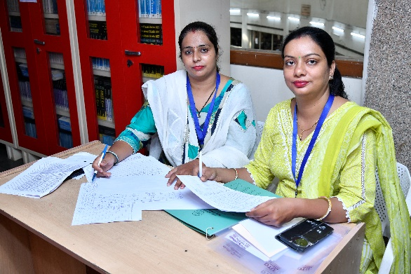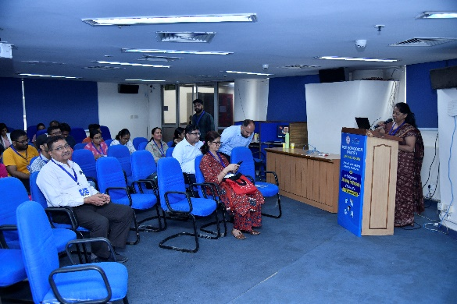
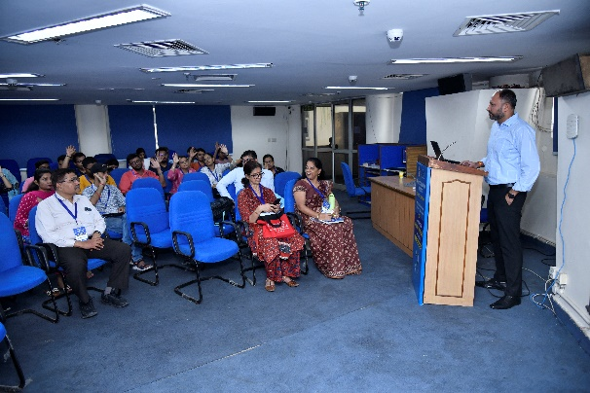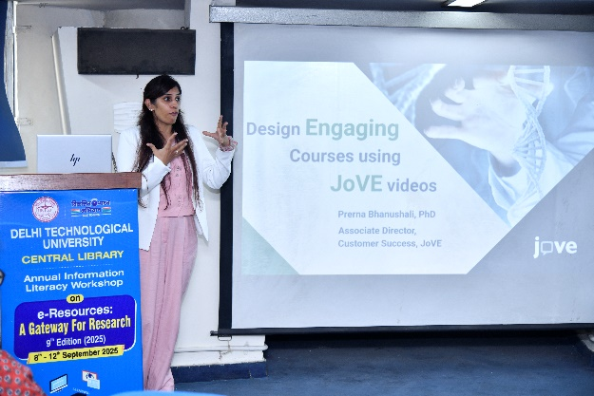
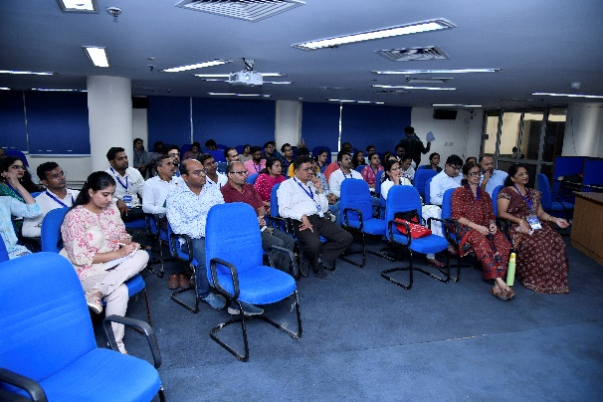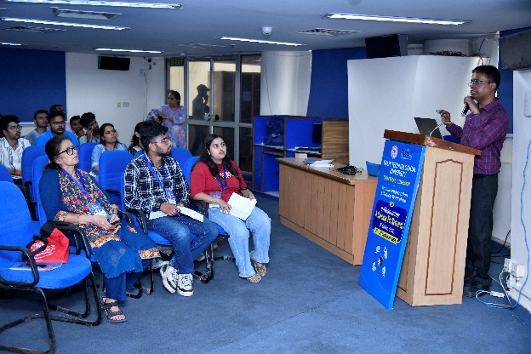
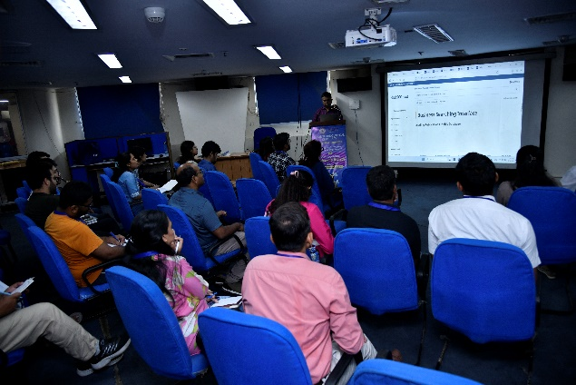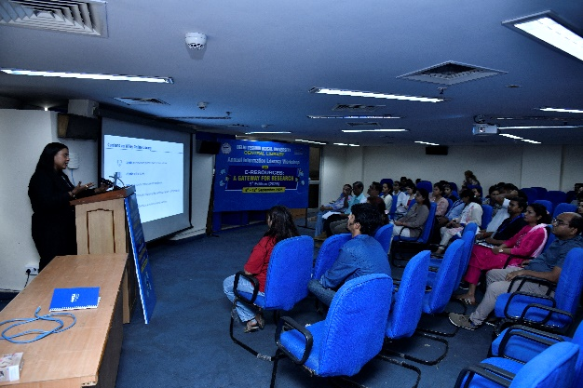

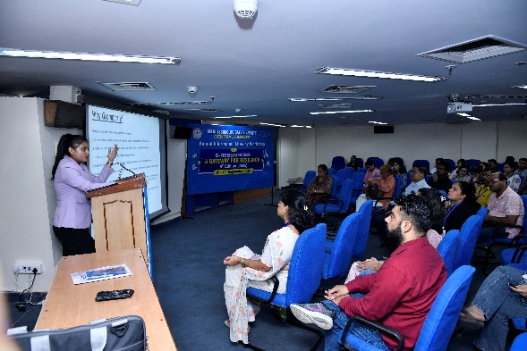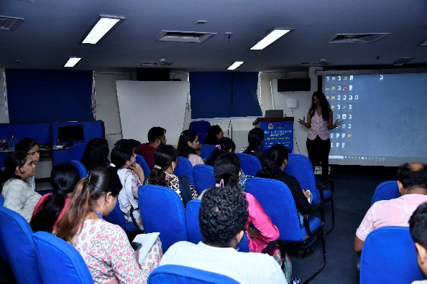
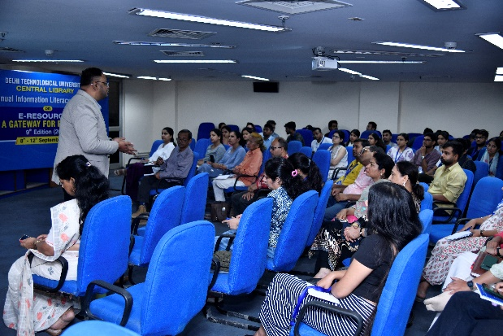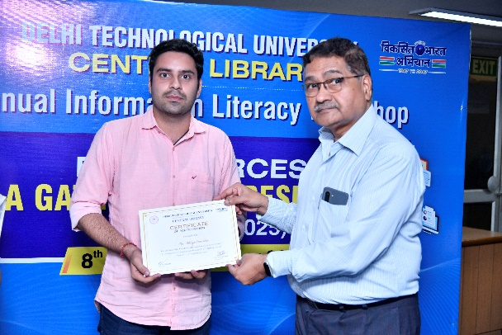
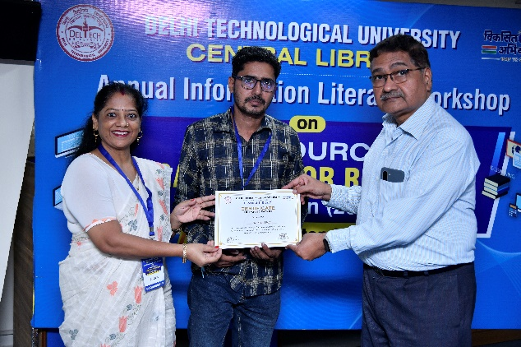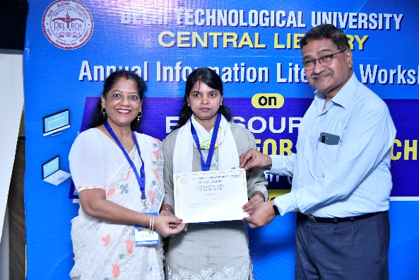

Valedictory Session
The Valedictory Session of the 9th Annual Information Literacy Workshop – “E-Resources: A Gateway for Research” was held on 12th September 2025 at the DTU Central Library. The event celebrated the workshop’s success, with Dr. Lalita expressing gratitude to all speakers, coordinators, and participants for their active involvement. Participants shared positive feedback, highlighting the workshop’s impact on enhancing research and digital literacy skills. Certificates of Participation were distributed, recognizing attendees’ commitment throughout the five-day program. In her closing remarks, Dr. Lalita emphasized the importance of academic integrity, continuous learning, and responsible use of e-resources in research excellence.

Outcomes of the Workshop
- Enhanced participants’ understanding of e-resources, academic databases, and research tools for effective literature exploration.
- Strengthened awareness of academic integrity and plagiarism prevention through detailed sessions on Turnitin and Grammarly.
- Promoted the use of AI-driven tools such as Ask ScienceDirect, Reading Assistant, and Turnitin Clarity to improve research efficiency and originality.
- Fostered academic collaboration and networking among students, researchers, and faculty members across disciplines.
- Encouraged the ethical and responsible use of information, aligning with global standards of scholarly communication.
- Cultivated a research-oriented culture within DTU, integrating technology and innovation into academic practices.
- Empowered participants to apply digital literacy skills in research writing, publication, and lifelong learning initiatives.

Participants Feedback, Reflections, Recommendations, and Way Forward
- Overall Satisfaction:
Feedback analysis revealed an average participant rating of 4.75 out of 5, indicating a very high level of satisfaction with the quality, content, and organization of the workshop.
- Session Interactivity:
Approximately 58% of participants described the sessions as “Very Interactive,” appreciating the engaging teaching style, live demonstrations, and opportunities for question–answer discussions.
- Workshop Frequency:
Around 42% of respondents suggested that similar workshops should be organized at least once per semester, emphasizing their usefulness for both students and faculty in staying updated with evolving research tools.
- Most Appreciated Sessions:
Participants specifically praised sessions on Turnitin, ScienceDirect, and Grammarly, noting that these tools directly improved their understanding of plagiarism prevention, literature search strategies, and academic writing quality.
- Learning Outcomes:
Attendees reported significant improvement in their ability to access, evaluate, and manage scholarly information, along with a stronger grasp of ethical writing practices and citation methods.
- Facilitation and Coordination:
Participants commended the coordination by Dr. Lalita and the Central Library team for their professionalism, technical support, and smooth conduct of the workshop.
- Future Recommendations:
Participants recommended incorporating new topics such as:
  - Research innovation and emerging technologies
  - AI in academic writing and publication
  - Manuscript preparation and research communication skills
  - Hands-on citation and referencing workshops
- Overall Reflection:
The feedback collectively reflected that the workshop was informative, well-organized, and highly relevant, contributing significantly to enhancing research efficiency and academic integrity among DTU’s academic community.

Conclusion
The Annual Information Literacy Workshop 2025 – “E-Resources: A Gateway for Research” successfully achieved its objectives of strengthening participants’ information literacy, research proficiency, and digital awareness. Over five days of engaging sessions, participants gained hands-on experience with global databases, plagiarism detection tools, AI-driven platforms, and advanced research techniques. The workshop provided a dynamic environment that encouraged collaboration, critical thinking, and ethical research practices. Through interactive demonstrations and expert-led discussions, it empowered students, research scholars, and faculty to utilize e-resources effectively and responsibly. The program reaffirmed Delhi Technological University’s commitment to promoting research excellence, academic integrity, and technological advancement within its academic community, ensuring that participants are well-equipped to navigate the evolving landscape of digital scholarship and innovation.

Acknowledgments
The Central Library, Delhi Technological University (DTU), extends its heartfelt gratitude to all resource persons, faculty members, coordinators, and participants for their invaluable contributions to the successful organization of the 9th Annual Information Literacy Workshop 2025 – “E-Resources: A Gateway for Research.”
The Library acknowledges with sincere appreciation the efforts of all guest speakers and experts who shared their time, knowledge, and insights throughout the five-day event:
- Mr. Vaibhav – RemoteXS
- Ms. Rranjana and Mr. Kushal Giri Goswami – DELNET
- Mr. Bhupender – Indiastat
- Mr. Prateek – Springer Nature
- Dr. Prerna – JoVE (Journal of Visualized Experiments)
- Ms. Chaitali and Ms. Karishma Gupta – Turnitin
- Mr. Ritesh – IEEE Xplore
- Ms. Arunima – Wiley Online Library
- Mr. Vishav Sharma – Web of Science & JCR
- Ms. Shweta Sethi – ScienceDirect
- Ms. Aishwarya Nayal – Scopus
- Ms. Mansi – Grammarly
- Ms. Anjuli Gupta – Taylor & Francis Online
- Mr. Amit Siddhartha – Harvard Business Review (HBR) Case Studies
The success of this workshop stands as a testament to DTU’s collective effort toward empowering its academic community with digital knowledge, research skills, and ethical scholarly practices.

Organising Team

- Dr. Lalita (Assistant Librarian)
- Vinita Joshi (Counter Assistant)
- Annu Sharma (Counter Assistant)
- Abhinav Uniyal (Counter Assistant)
- Mukul (Counter Assistant)
- Neha Parjesh ( JOA)
- Pawan Kumar Gaur (MTS)
- Sweety (MTS)
- Uma (MTS)
- Pardeep (MTS)
- Omvir Sharma (Peon)

