**Project Dissertation Report on**

### FUNDAMENTAL ANALYSIS OF HERO MOTO CORP LTD.

### Submitted By:

**Rachit Chabra**

**Roll No.: 2K19/EMBA/538**

**“Under the Guidance of**:

**Mr. Dhiraj Pal**

**Asstt. Professor”**



**“DELHI SCHOOL OF MANAGEMENT**

**Delhi Technological University**

**Bawana Road Delhi 110042”**

**“BONAFIDE CERTIFICATE**

### It is to certify that the Project work entitled “FUNDAMENTAL ANALYSIS OF HERO MOTO CORP LTD.” has been successfully completed by Rachit Chabra, EMBA 19-21 candidate, ID:- 2K19/EMBA/538.

This is further certified that this project work is a record of Bonafide work done by him under my guidance. The matter written in this report not been submitted for award of any other degree, diploma & semester examination.

Signature of Mentor

(**Mr.Dhiraj Pal )**

Asstt. Professor-DSM”

Place:- Delhi

Date:- 28th May’21

***DECLARATION***

### I hereby certify that the work which is presented in the Project Dissertation Report entitled “FUNDAMENTAL ANALYSIS OF HERO MOTO CORP LTD.” “in fulfilment of the requirement for the award of the Master of Business Management (Executive) and submitted to the Delhi School of Management, Delhi Technological University, Delhi is an authentic record of my own, carried out during a period from January to May’2021, under the supervision of Mr. Dhiraj Pal , Asstt. Professor- DSM.”

***Signature of Candidate:***

**Rachit Chabra**

**IVth Sem/ EMBA 19-21**

**Roll No.:- 2K19/EMBA/538**

**ACKNOWLEGMENT**

The project may not have been possible without support of many people. I acknowledge & extent my respect to the following persons without their support completion of this project would not be possible.

* Mr. Dhiraj Pal (Project Mentor) for guiding & encouraging me for this project work study.
* Dr. Archana Singh & Dr. PK Gupta has taught us SAPM & MACR course, which laid base for writing this project report.
* My fellow classmates, seniors, EMBA class mates and who helped me throughout the duration of this project.

I would also like to express love & gratitude to my family, for motivation & their understanding, throughout the duration of this project.

(**Rachit Chabra**)

Roll No.:- 2K19/EMBA/538

### EXECUTIVE SUMMARY

The COVID-19 virus has engulfed humankind and the world economy in a crisis unlike anything witnessed since the Great Depression . COVID-19 started from China in Jan’20 & sooner in Mar’20 it has become global threat which forces government across globe to impose the Lockdown for certain period. Lockdown has retarded the global economic wheel though it help to contain the spread of the Virus. In India complete lockdown was imposed for about 70 days duration & Unlock has started in phases wef 1st June’20. Though with Unlock economic activities has begun to start in restricted manner but not at Pre-COVID Pace amidst risk of virus.

This project is undertaken at the start of Jan’2021, been associated with Automotive Industry & Student of Finance Elective I have taken “***ECONOMY, INDUSTRY & COMPANY ANALYSIS OF HERO MOTO CORP LTD***” as Major Project for my IVth Semester, EMBA program.

The project is undertaken at a juncture when automotive Industry was already struggling in Pre-COVID period due to various factors & further due to COVID all manufacturing activities came to a halt.

The Objective is to understand the various facets of the Economy & possible effect of various macroeconomic indicators on Industry and Company’s growth & its future prospects.



### 

### CHAPTER -1

### INTRODUCTION

* 1. **Introduction**
* Fundamental analysis is a strategy for estimating a security's value by focusing on fundamental elements that influence a company's current operations and future prospects.
* A method for estimating a security's intrinsic value by considering economic, financial, and other qualitative and quantitative factors.
* Fundamental Analysis used the EIC (Economic, Industry & Company) framework as illustrated in the below figure -1.

**Source :- OWN**

**Figure-1.1**

* Fundamental Analysis used the EIC (Economic, Industry & Company) framework as illustrated in the below figure -1.
* Fundamental analysis through EIC frame work can be performed through :-
  + The Top Down Approach,
  + The Bottom Up Approach.
* In the Top Down Approach analysis start at the state of the Economy & macroeconomic indicator as a whole, then going down to Industry & Company in sequential manner as illustrated in the figure-1.
* In the Top Down Approach analysis focuses on a variety of microeconomic indicators such as a company's earnings and financial data.
* In this project we will use Top Down approach of the EIC framework.
* In this project under EIC framework Economic , Industry & Company Analysis are done and discussed in Chapter-2 , 3 & 4 respectively.

### “Objectives of the Study:

### To study & analysis various macroeconomic indicators & it effect on automotive sector,

### To study & analysis various macroeconomic indicators & it effect on company fundamentals,

### To study & analysis of Outlook & Potential of India’s Automotive Industry,

### To study & analysis company’s (HERO) Strength & weakness within Industry,

### To study & analysis last five financial reports .

### To evaluate Intrinsic value of the company’s share.

### To evaluate buying decision based upon Calculated Intrinsic Value Vs Market Price.

### 1.3 Research Methodology:

###### RESEARCH DESIGN

In this project Descriptive research design along with partially Exploratory research design methods has been used because complete project is built on the data taken from internet, journals, reports, and is provided in this project.

Therefore it’s a mix of Descriptive and Exploratory design.

MS Excel has been Extensively used working on company’s financial data, preparation of graphs & to evaluate intrinsic value of HMCL’s stock.

###### SOURCE OF DATA

The chief medium of information in this project is collected from secondary data like figures, financial data from [www.Moneycontrol.com](http://www.Moneycontrol.com), [www.ggoglefinance,com](http://www.ggoglefinance,com), [www.yahoofinance.com](http://www.yahoofinance.com), graphs, facts from internet, which will be summarized and examined in the method of this project report.

###### SCOPE OF RESEARCH

The scope of this project covers Fundamental Analysis of HMCL through Top Down approach of EIC Frame work in a structural way. In Economic Analysis Leading & Lagging Macroeconomic indicators to be analysis in details with their effect on the automotive industry & on HMCL. In Industry analysis , future outlook & potential of India’s Automotive sector will be analysis with its impact on the HMCL ‘s fundamental. In the company’s analysis , present outlook, Strengths & Weakness of the company to be examined along with analysis of key financial ratios & indicators. In Data analysis we will examine the last five year financial statements and intrinsic value of stock will be evaluate through Gordon’s Dividend Model.

### 1.4 “Limitations of the Study:

* + This study is limited from management study prospective for academic purpose.
  + The secondary data gathered may contain manipulations, which might resulting into biasing of result.
  + The lack of adequate knowledge in formulating the project report.
  + Paucity of time for further analysis of this project.
  + It is very hard to check the accurateness of the info gathered from Internet which become basis of this project report.
  + Authenticity of data collected from various source which become basis of this project report.
  + The way of measuring things may vary over the time, making historical contrasts difficult.

**“CHAPTER-2**

REVIEW OF LITERATURE”

**2.1 Introduction:-**

A research study is not regarded complete unless the researcher has conducted a thorough review of the literature. The goal of this work is to determine the research gap between previous studies and existing literature, as well as to confirm the topic of research and get an understanding of the research issue chosen for study. In this manner this exercise becomes a sort of exploratory research.

### 2.2 Review of Literature:-

# JOURNAL ARTICLE - Fundamental Analysis of Automotive Manufacturing companies

# International Research Journal for Management, IT & Social Sciences, 2016

(Shivprakash Soni, 2016)

In this article they have systematic analysis the financials report of different automotive manufacturing companies. They have compared & ranked the different financial ratios of the automotive manufacturing companies.

1. Text Book:-

**Bodie, Kane, and Mohanty (2015). INVESTMENTS (10th ed.). Chennai: McGraw-Hil/sie-bodie10e**

Have thoroughly studied the Part-V – Security Analysis which further have Chapter 17, 18, 19 on Macroeconomic & Industry Analysis, Equity Valuation Method, Financial Statement Analysis.

Some Useful formula’s learnt which will be applied in this project are as follows:-

1. The Constant-Growth DDM Or Gordons’s Model-



1. **CAPM- Capital Asset Pricing Model:-**



1. Text Book:-

**IM PANDEY (2015). FINANCIAL MANAGEMENT (11th ed.). NOIDA: Vikas Publishing.**

The study of this Text book laid basis for Corporate Finance, Financial Ratios, Discounting, FV, PV, Risk & return, Portfolio Theory, Financial & operating Leverage, CAPM & Analysis of Financial Statement.

### CHAPTER 3

#### **ECONOMIC ANALYSIS**

* 1. **ECONOMIC ANALYSIS – BRIEF:-**

The COVID-19 virus has engulfed humankind and the world economy in a crisis unlike anything witnessed since the Great Depression. Although the lockdown may have helped to stop the virus from spreading, it has had a negative impact on the economy, disrupting whole value chains in most of India's key sectors. Due to the lockdown, all companies' sales revenue has decreased to zero, with the exception of those engaged in essential services, this has given a severe dent to the global economy.

In this section, We will analysis the Indian economic through following Macroeconomics Indicators:-

1. GDP’s growth rate,
2. Unemployment rate,
3. Interest rate,
4. Inflation rate.
   1. **GDP’s GROWTH RATE:-**

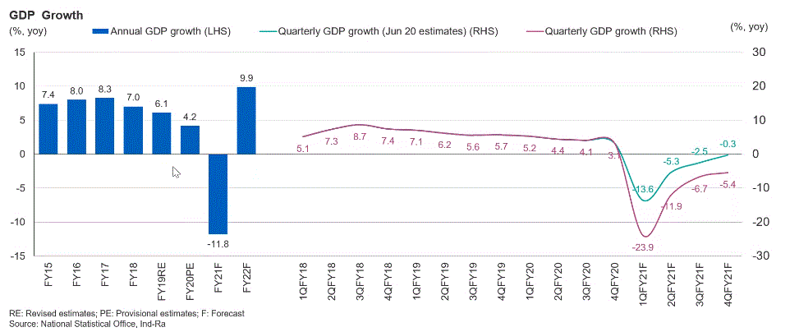

**Recovery Starts from Q2FY21**

**Growth Rate decreasing for last 4 yrs**

* Growth rate is decreasing for last four year.
* Due to ill effect of COVID-19, it is forecasted that growth rate of FY21 will be contracted by ~-12%.
* Though it is forecasted to have “V” type recovery in FY22 through growth rate of ~9.9%.
* The delay in availability of COVID-19 vaccine will adversely impact the forecasted recovery pattern.
  1. **UNEMPLOYMENT RATE:-**



UE RATE approaching to PRE-LOCKDOWN RATE **#UNLOCK1.0 – 1st June’20**

UE RATE High in start of Q1 due to LOCKDOWN

**Reverse Migration to Rural Area.**

* Due to Nationwide Lockdown from 24th Mar’20, Unemployment rate increased ~25% in April’20
* UE rate was peak in April’20 & start to decrease in subsequent months
* After Unlock 1.0 UE rate starts approaching to PRECOVID rate.
* In Q2’FY the UE Rate is almost equal to PRECOVID rate
* Here the Recovery is in “INVERTED V” Pattern,
* Hence taking into consideration of above graph in conjunction quarterly GDP growth graph, we can infer that the economic wheel has started rolling from Q2FY21.
  1. **INTEREST RATES:-**
* The Reserve Bank of India (RBI) has maintained Policy Rates steady, as expected by the market.
* Repo rate- 4%, Reverse Repo Rate-3.35%, MSF Rate- 4.25%, Bank Rate: 4.25% remain unchanged.
* This has led to one of the steps towards stabilization in economic activity & counter the ill effect in economy caused due to COVID-19.
* This together with revised CRR- (from 4% to 3%) & SLR- 18% will ensure the adequate liquidity in market.
* Lower Bank rates will encourage people to acquires New Automotive & other goods. (+VE Impact)
  1. **INFLATION RATES**:-

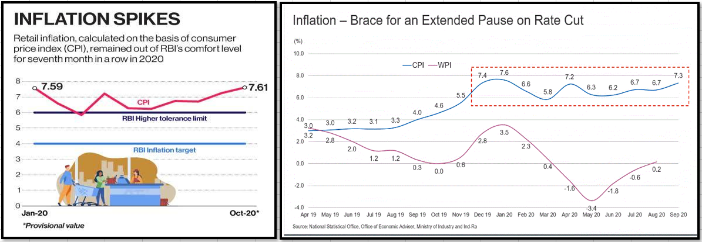

* In Oct’20, retail inflation surged to 7.61% highest since May’2014 when it reached to 8.33%,
* CPI stayed above RBI’s 2-6% rang for Six consecutive months.
* GOI should take necessary steps to keep CPI <6% .
* High inflation lead to discretionary purchasing. (-Ve)
  1. **CONCLUSION OF ECONOMIC ANALYSIS**:-
* With we can conclude that India’s has entered into the Recovery phase from Q2 & Recovery is likely to follow “V” type pattern,
* The economic forecast is the good, but Delay in availability of COVID-19 may impact the recovery pattern & rate.

**CHAPTER 4**

**INDUSTRY’S ANALYSIS**

* 1. **INDUSTRY ANALYSIS- BRIEF**:-
* **PRE COVID SITUATION**:- The Indian automotive sector had already experienced a significant slowdown over the previous 12-18 months as a result of structural changes such as the GST Implementation, , Axle-load reforms, the shift to Shared Mobility, the transition from BS-IV to BS-VI emission norms , Liquidity Crunch due to NBFC default, ambiguity on IC engine life cycle, and so on. (NOT GOOD)
* Due the COVID-19 lockdown – the industry has almost been at a complete standstill for almost two months duration with NO sales at all.
* As blessing in disguise, COVID-19 has new dimension to personal mobility as Due to safety reason people are moving from Shared mobility to personal mobility.
* This shift towards the personal mobility has given surge in requirement of 2W & Entry level passenger cars.
* As we have seen that due to the reverse migration, rural economy is recovering faster than the Urban & since 2W & Entry level passenger cars have Rural driver products hence there is surge in their demand.

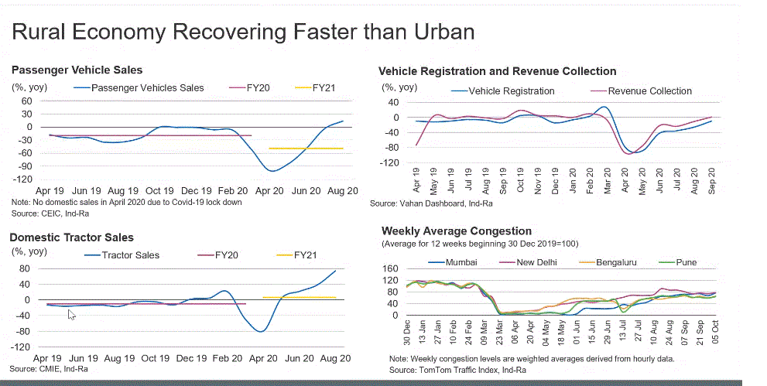

* Cumulative FDI in Auto sector: $24.2 billion (~4% of Cum FDI)
* Auto industry: - 10-25% Savings Potential on Operational Costs to Foreign players
* Industry Turnover: - 45% of Manufacturing GDP
  1. **POTENTIAL INDIA:-**



* Despite the fact that almost every global OEM has established a presence in India, only Chinese automakers have been able to significantly increase FDI in the Indian automotive market.
* GOI Recent announcement:- Performance Linked Incentives of Rs. 58K Crs in Automotive & Auto Component industry and Rs. 18K ACC Battery Industry will be game changer in coming time to make India as preferred location for sourcing automotive & component from globe.
  1. **CONCLUSION OF INDUSTRY ANALYSIS**:-
* India’s Automotive sector has got lot of potential due to 10-25% Savings Potential on Operational Costs in compare to European plant.
* With conductive policy like PLI will boast the production & further make India most competitive destination for automotive manufacturing Leading Higher Exports of CBU & SBUs to other nation.

**CHAPTER -5**

COMPANY’S ANALYSIS

* 1. **COMPANY’S ANALYSIS- BRIEF:-**
* Hero is world largest 2W manufacturing company by volume.
* Post separation from HONDA in 2011, the company has done lots of investment in R&D.
* The company is market leader in 100-150 cc bikes, with recent collaboration with Harley Davidson for Indian market operation, the company will materialize their dream of having super bikes in their portfolio.
* Company has also making advancement in electrification mobility, has acquired stakes in Emerging electrification mobility company- M/s Ather Energy.
* To supplement their R&D capabilities, the company recently established a technical centre in Germany..

Now Let’s do financial analysis, all the detailed calculations are done in Excel file Only relevant Snaps shot & graphs included in the document. (for details please refer excel Sheet)

* 1. **KEY FINANCIAL GRAPHS**:-
     1. **REVENUE VS EXPENSES VS PAT :**-



* + 1. **PAT VS PBT VS PBIT :**-



* + 1. **EPS VS DPS** **:-**



* 1. **KEY FINANCIAL RATIOS**:-

* + 1. CURRENT RATIO & QUICK RATIO:-





* + 1. PE RATIO AND DEBT TO EQUITY RATIO :-



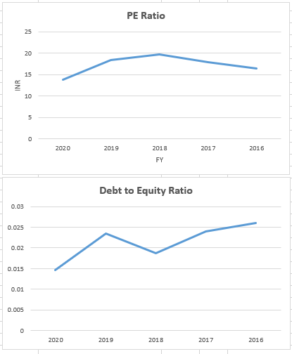

Towards Zero Debt Company

* + 1. ROCE VS ROE:-





### CHAPTER 6

#### ANALYSIS & INTERPRETATION

6.1 Last Five’s Year P&L:-



6.2 Last Five’s Year Balance Sheet :-



6.3 Last Five Years Key Financial Ratios Comparison :-



6.4 Return On Equity Calculation :-



6.5 Intrinsic Value Calculation :-



### “CHAPTER – 6

#### CONCLUSION & RECOMMENDATION”

### CONCLUSIONS & RECOMMENDATION:-

* India’s has entered into the Recovery phase from Q2 & Recovery is likely to follow “V” type pattern,
* The economic forecast is the good, but Delay in availability of COVID-19 vaccination may impact the recovery pattern & rate.
* Automotive sector in India’s has got lot of potential due to 10-25% Savings Potential on Operational Costs in compare to European plant.
* With conductive policy like PLI will boast the production & further make India most competitive destination for automotive manufacturing & Leading Higher Exports of CBU & SBUs to other nation.
* As a blessing in disguise, due to COVID-19 people are moving from Shared mobility to Personal Mobility, this has increase the sales of 2 W.
* **Due to the ongoing change in Technology from ICE to EV, Hero should consider to Restructure the organization through M&A of leading EV & Lithium ION battery manufacturer**

CHAPTER-7

### BIBLIOGRAPHY

**BIBLIOGRAPHY**

The following literature/ website has been referred while for this documents:-

# JOURNAL ARTICLE - Fundamental Analysis of Automotive Manufacturing companies

# International Research Journal for Management, IT & Social Sciences, 2016

(Shivprakash Soni, 2016).

1. Text Book:-

**Bodie, Kane, and Mohanty (2015). INVESTMENTS (10th ed.). Chennai: McGraw-Hil/sie-bodie10e**

1. Text Book:-

**IM PANDEY (2015). FINANCIAL MANAGEMENT (11th ed.). NOIDA: Vikas Publishing.**

1. [www.heromoto.com](http://www.heromoto.com)
2. [www.ibef.com](http://www.ibef.com)
3. [www.investopedia.com](http://www.investopedia.com)
4. [www.mospi.gov.in](http://www.mospi.gov.in)