Project Dissertation Report on

DIGITAL MARKETING AND POLITICAL CAMPAIGNS: A STUDY OF CHANGE IN FOCUS FOR CAMPAIGNING IN INDIA

Submitted By
Luv Kalra
2K19/EMBA/529

Under the Guidance of
Dr. Deep Shree
Assistant Professor

DELHI SCHOOL OF MANAGEMENT
Delhi Technological University
Bawana Road Delhi 11004
CERTIFICATE

This is to certify that Luv Kalra, Roll No: 2K19/EMBA/529, student of Masters of Business Administration (Executive 2019-2021) at Delhi Technological University, Delhi has accomplished the project titled “Digital Marketing and Political Campaigns: A Study of change in focus for campaigning in India” under my guidance and to the best of my knowledge completed the project successfully, for the fulfilment of the course Executive MBA.

Dr. Archana  Head of Department  Delhi School of Management  Delhi Technological University | Dr. Deep Shree  Asst. Professor  Delhi School of Management  Delhi Technological University

DECLARATION

I hereby declare that the submission is my own and that, to the best of my knowledge and belief, it contains no material previously published or written by another person nor material which to a substantial extent has been accepted for the award of any other degree or diploma from a university or other institute of higher except where due acknowledgement has been made in the text.

_______________
(Luv Kalra)
2K19/EMBA/529

ACKNOWLEDGEMENT

I Luv Kalra, wish to show my deep sense of gratitude to my project guide & mentor Dr. Deep Shree, for her support, invaluable guidance & suggestions throughout the course of project and for providing all the necessary information during the project work.

_______________
(Luv Kalra)
2K19/EMBA/529

ABSTRACT

This project report focuses on Digital Marketing and Political Campaigns and evaluates the impact of digital marketing on Political Campaigns. Case of BJP campaign of 2014 Lok Sabha elections has been taken for study. A survey of 51 respondents was taken from Delhi/NCR to analyse the impact of digital marketing on political campaigns.
From the outcomes it can be said that Social media can influence in India politics and polls. The 2014 in the elections of Lok Sabha in India is proof of social media impact and influence on India politics. How Narendra Modi campaigned for his election and how he still manages to influence the young population.
Reaching out to the common man becomes easier through social media. It also helps a politician look more human, and showcase the things they do (or pretend to do) for people.

TABLES OF CONTENTS
CHAPTER | TOPIC NAME | PAGE NO
 | CERTIFICATE | i
 | DECLARATION | ii
 | ACKNOWLEDGEMENT | iii
 | ABSTRACT | iv
 | INTRODUCTION TO THE STUDY | 7
1.1 | Political Ads Switch Screens As Habits Of Viewing Is Changing | 8
1.2. | Problem Statement | 8
1.3. | In India The Influence Of Social Marketing In Political Campaign | 9
1.4. | Social Media Role | 10
1.5. | Political Marketing By BJP Structure And Process | 10
1.6. | In 2014 Lok Sabha Elections The Digital Strategy Used By BJP | 12
1.7. | Mentions On Digital Publications | 21
1.8. | Social Media Expenditure | 24
 | LITERATURE REVIEW | 25
 | METHODLOGY | 28
3.1 | Objective | 28
3.2 | Research Process | 28
3.3 | Data Analysis | 28
3.4 | Scope of Study | 29
 | DATA ANALYSIS | 30
4.1 | Hypothesis | 42
4.2 | Findings | 43
 | CONCLUSION | 46
5.1 | Suggestions | 47
 | REFERENCES | 48
 | APPENDIX | 49

CHAPTER 1: INTRODUCTION TO THE STUDY

“Every election is determined by the people who show up” (Larry J. Sabato)

Political parties are currently recruiting political marketing organizations to win the voters mindshare, that aims on 360-degree correspondence for applicants .In 3 vertical components it can be comprehensively categorized- the very first is ‘development of content’ that incorporates, interviews and speeches, development of manifesto, creating of slogans and punchline which are to be conveyed by candidates and various media bytes communicated through standard and web-based social networking.[1]

Other one is ‘event’ that empowers on-ground emblematic movement to show quality through open gatherings (rallies), disdain through fights, availability through street appears, comprehensiveness through strict visits and supper programs.

The last one is the medium which is the most important by which the content is conveyed which comprises of outdoor activities like banners, leaflets, hoardings, posters and TV, newspaper, radio, social media and caps, badges like accessories. Throughout every possible medium the main aim is the repetition of eye catching content that will stay on top of peoples mind.

At the centre of all these 3 categories political marketing the leader remains the focus. Nowadays the elections are turning into more idol-centric and the ideologies are withering. Image of the leaders is taking over party policies. [2]

Accordingly, of a political advertising agency the essential task is to painstakingly create the picture of a pioneer, who goes about as the party brand envoy of, approach, govt. and the individuals. Shrewd methodologies are intended to censure the contenders by uncovering their shortcoming and accordingly the rival parties likewise does comparable campaigns. Apparently, this may appear to be an unassuming activity, yet it is fascinating to take note of that by different parties an incredible $5 billion was spent far and wide for political advertising in the in the most recent in general elections.

  - POLITICAL ADS SWITCH SCREENS AS HABITS OF VIEWING IS CHANGING:

Social media is becoming a significant instrument of conclusion development in this innovation driven age and showcasing directors have understood its importance. As political field carrying on similar to a client driven market, employments of promoting technology are progressively being utilized for upper hand. Digitalisation has demonstrated to a helpful device. Promoting political groups are clear in the ongoing political decision in India

(Palmer and Koening, 2009) said that Digital media is a type of "online application stage" and media which encourages cooperation, joint effort, and sharing. As indicated by Mangold and Faulds, (2009) it comprises of wide scope of on the web, word to mouth gathering comprising of journals on web, conversation and talk rooms which are supported by organizations, client to-buyer mail, purchaser merchandise or administration sites and gatherings evaluations, Online discussions, moblogs and interpersonal sites of communication of long ranges.

To communicate to the voters, the one of the most important way nowadays is Social media which political parties uses. (McNair, 2017) It is depicted as one of the channels through which candidate advance their pronouncements just as themselves. Whilst for the accomplishment of the political contenders this sort of advertising is an element, in democratic nations it is generally applied. [3]

  - PROBLEM STATEMENT:

The power of political marketing was proved in the Indian Elections of Lok Sabha 2014.
The 2014 political race would stand out forever was the very first where social digital publicly supporting assumed a main job in molding discourses. The presentation of innovation in decisions has been started by Bhartiya Janta party candidate for PM Mr. Narendra Modi who effectively utilized innovative administrations of Social Media and 3D present day instruments so as to convince the young people of the nation. The planning of the promoting campaign " Ab ki baar Modi Sarkaar” was essential on television. "Har Har Modi, Ghar Ghar Modi" was very much went with his visual posts which was pre-recorded in towns. Although the Bhartiya Janta Party crusade was unequivocal the Congress battle to the point, with the slogan "Harhath Shakti, harhath tarakki", neglected to dazzle. The current examination will investigate the ramifications of Digital Marketing Influence on Political battles by considering the connection between sum spend and vote share picked up by parties taking BJP Lok Sabha decisions crusade 2014 as an example.
How BJP tested the political customary vital rationale by defying the conventional set up guidelines of serious commitment and utilized digital media adequately to expand the vote share.

  - IN INDIA THE INFLUENCE OF SOCIAL MARKETING IN POLITICAL CAMPAIGN:

In political marketing and advertising Social media is developing as an apparatus. Indeed in a big way it was used in General Elections of India 2014. (Diwakar, 2014; Ernst and Young (2014) to speak with voters in the sixteenth parliamentary elections 2014 Social media was broadly used. [4]

(Webfluenze, 2015) In the Lok Sabha elections of 2014 social media did a significant job for BJP and it gave them upper hand in the elections. In spreading and conveying the messages to voters social media helped a lot for political parties contesting with each other. These days political race is being taken care of by agencies doing promotions (Advertising). Advertisements organizations thought about voters as client, Political gatherings as an organization and their proclamation as items. [5]

To design the political campaigns accordingly by understanding voter needs these ad agencies helps the political parties and help them understanding better about needs of voters. Ultimately a feedback loop is developed which for participative democracy acts as a tool where voters talk about their needs and priorities to the politicians.

  - SOCIAL MEDIA ROLE

These days Political parties look like a business entity. They investigate and attempt to exploit the open doors similarly in which the business firms do. To survey the return on the political venture they recruit a political master. Social networking in India is doing a generous job in. As per the most recent report of IAMAI, Twitter has almost 1.1 cr., 24.1 cr. Has FB and 37.9 cr. has Whatsapp clients in India individually which are over the age of 18 and comprise a significant piece of voters of India. [6]

For political benefits social media is considered as one of the largest platform for spreading mis info and fake news. Although many efforts have been put but it’s still not sufficient. In terms of interaction of technology, the role of social media must be analysed. [7]

  - POLITICAL MARKETING BY BJP STRUCTURE AND PROCESS

Marketing
Political showcasing is the advertising of thoughts and sentiments which identify with open or policy driven issues or to explicit applicants. It ought to be carefully overseen to get for it much better outcomes. The originators of idea of political advertising contend that there are eight regular capacities that comprise to productive political showcasing. [8] These are:

Product Function
Scholars see political advertising with regards to a marketplace where there is an item being exchanged amid the government officials and the people who vote. This item might be philosophy, pronouncements or a guarantee by the political applicants that of the electorate they will progress the vocations. The item can likewise be the political picture of a candidate. The political up-and-comer is promoted to increase positive discernment, demeanour and general society approval.
Based on changes Good governance and selling of Modi brand was the BJP product function in the 2014 elections. Concepts like ‘Sab Ka Sath, Sab Ka Vikas’, ‘Development and Change’
Were shown as a product reflecting the BJP political motive. In attracting the Indian voters both elite and general these ideas were successful.

Cost Function
Political advertising is extraordinary different not at all like in marketing of corporate, where financially savvy promoting is drilled to pull in customers and to convince them to purchase an item. Researchers contend that political promoting cost function alludes to dealing with the attitudinal and social hindrances of balloters by giving the significant data concerning the item (belief system, individual or pronouncement) as quickly as time permits, without a cost.

Distribution Function
The method of reasoning after this capacity is to convey the correct message to the correct objective marketplace via the appropriate dispersion network. It lays electorate access accentuation on giving the to all significant data about the political item. The scholars believed that political advertising includes making political conveyances as indispensable strategies of the ideological group just as different projects of the gathering, guaranteeing that the selection of media to utilize is in accordance with a gathering's philosophies, and getting the competitors via the suitable stages.

Function of News Management
This capacity oversees both the contestant publicity and the party. This incorporates the board of the media, exercises associated with advertising, and the administration of internet promoting. In the political field, there is heaps of promulgation that are spread to attack the picture of a political figure. In this manner, the administration of the news is extremely significant most definitely.

Communication Function
Communication Function centres around giving political substance or thoughts at appropriate time. It guarantees that the data accessible to the electorate is concise and easy to understand. The planning of the promoting campaign " Ab ki baar Modi Sarkaar” was essential on television. "Har Har Modi, Ghar Ghar Modi" was very much went with his video messages which was pre-recorded in towns. Although the Bhartiya Janta Party crusade was unequivocal the Congress battle to the point, with the slogan "Harhath Shakti, harhath tarakki", neglected to dazzle. It is a capacity that is at the focal point of every single other capacity. As communication is the most vital thing in political promotion all the functions must be associated with this.

Fund-raising Function
During a political campaign time this is one of the most vital function. The necessary resources needed for campaign period is raised by this function. Contestants rely on donations and support from friends and party.
Cohesion Management Function
Alongside the outside administration viewpoints, the party should likewise be overseen expertly inside. Cohesion Management Function includes making an interior domain that encourages attachment amid the individuals, protestors and talked people of a group. In politically aware promoting, in the outside world it makes inward steadiness and improves the validity of the gathering prompting developing of generosity of the party.

Parallel Campaign Management
For the sole aim of campaigning the organizations and political groups created synergy contributed to a good extent for the image of political party. Parallel campaigns were usually carried out by these two partners where the political party was endorsed by the organization which is associating. Which ultimately results in the confidence of electorate in the party. Solid background info is needed for political marketing this is clear from the above points. In the political marketing process now days in India specialists for help are being hired by the political parties in India. (Henneberg, 2003).[9]

1.6 IN 2014 LOKSABHA ELECTIONS THE DIGITAL STRATEGY USED BY BJP

Fans and Followers: On major social platforms BJP has a robust and active presence like FB, YouTube, Whatsapp and twitter. On FB as compared to its rivals BJP has the most number of fans i.e. 2.5 million as per the MTS election tracker. There were Numerous other pages like 272+, Narendra Modi) apart from the BJP official page on FB. Those other pages help party helped a lot to BJP in reaching to maximum amount of people.
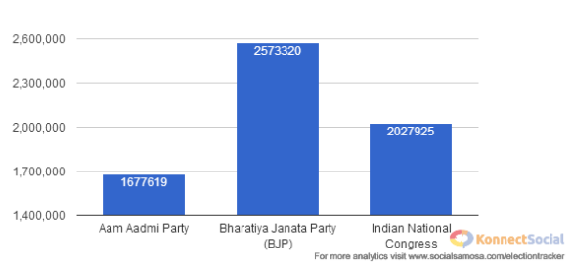
Facebook: BJP correspondences on Fb comprises a range of stuff from offering of advancement models in the country to explaining the development phony cases and blast underneath the reigning of Govt. of UPA. Post also comprises of wishes and greetings on festivals to tribute to legends and live coverage of campaigns and rallies.
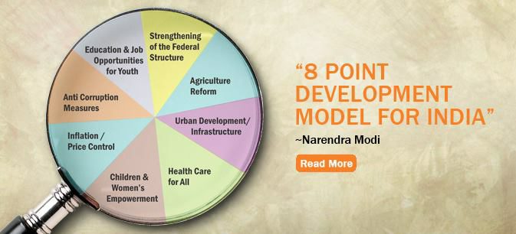
To interact with novel fans and adherents the BJP call to their current supporters the 272+ India to share strategic connection mission and convinces their companions to seam in.
Apart from this, to increase the fans numbers and in overall reach of updating BJP additionally utilizes Facebook promotions with focused socioeconomics. BJP resorts to some crusades and challenges to draw in with the current fans the best sections have a potential for success to meet Narendra Modi face to face.
On timely basis BJP additionally leads Yuva Quiz to connect with supporters on FB. Other than this, from fans on Facebook BJP likewise looks for donations, impending them to make contribution for Change. For donation The app #Modi4PM Fund is enabled all the while on the official website too on the FB page.
Twitter: The twitter space was dominated by BJP; everyday party trends on Twitter with in any city #NaMoinHP or NaMo. Everyday over thousand tweets #BJP #Namo #NaMo4PM were posted. The style and communication theme was same as it was on Fb but on twitter it was with more associates and contributors.
In all forms of messaging BJP ensures that there is a human touch as Twitter is all regarding live and real time talk or dialog. To touch the emotion instinct the pictures were shared keeping in mind the emotional target.

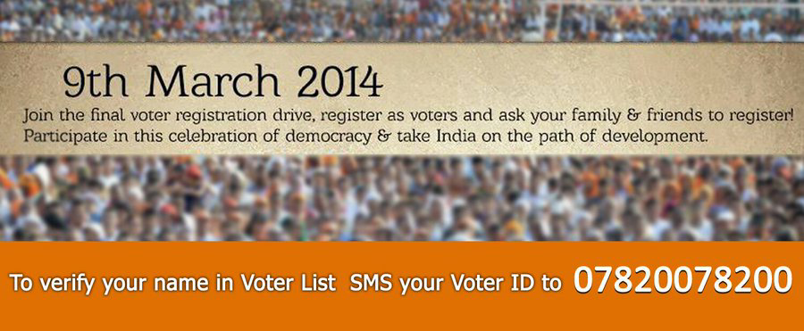
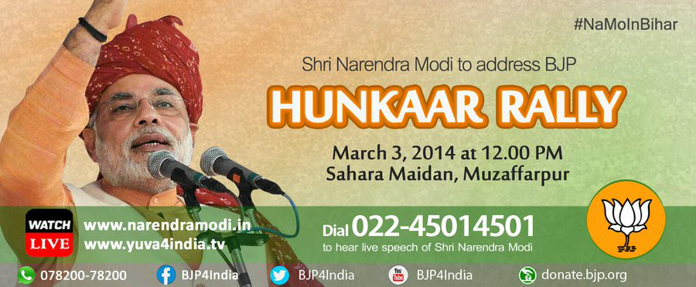
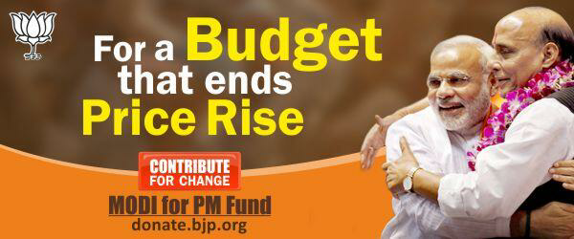

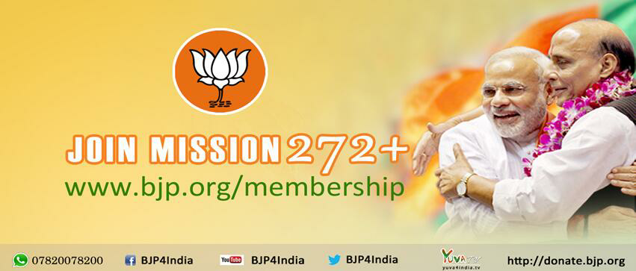

BJP drift pretty much every hash label which interfaces with Narendra Modi's meeting in a particular locale or city. Astonishingly to help the arrangement every pattern has novel supporters ; everyday with the drifting hashtag BJP acquaintances with novel people and devotees on Twitter account. One more significant factor of the BJP actions on Twitter is the content modest user-friendliness and volunteers to help the BJP stance over matters.
Apart from #Namo BJP uses campaigns like #MereSapnonKaBharat , #ChaiPeCharcha 360 degree campaigns using hash tags. Over forty thousand overwhelming tweets was recorded on these.
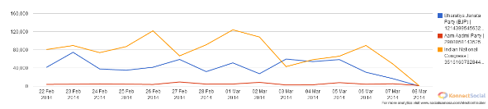

YouTube: Over 6.2 million viewers and forty four thousand six hundred eighty five BJP again rules on YouTube also. For all its activities as second screen BJP was able to use YouTube. From the Narendra Modi official channel the YouTube channel takes feed which was having over fourteen million views and over one lakh subscribers.
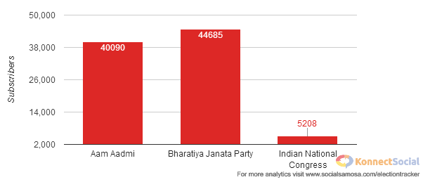
About the BJP ideology, rallies, campaigns and past it has a steadfast net Television channel which was having the videos. This internet television initiative of BJP was linked with Narendra Modi personal website and YouTube channel which received over fifty thousand tweets and over 2.5 million likes.
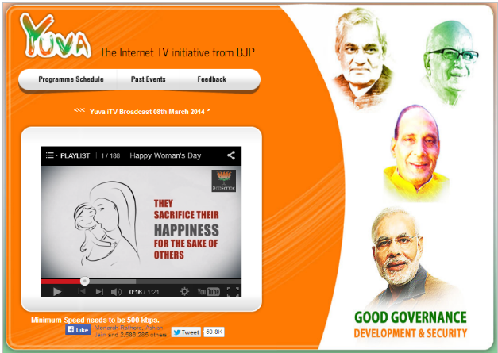
In the year 2010 the YouTube channel for the party was started having over 5000+ videos collection.
With a collection of over five thousand videos BJP YouTube channel was started in 2010. BJP makes full use of the YouTube by sharing the take outs from the powerful speeches of Narendra Modi focusing on BJP agenda of Growth, good governance and development for the 2014 Elections.
BJP was able to make an impact on people mind and memory by spreading the content like woman empowerment videos or speeches of Narendra Modi or Modi aane wala hai song. These videos connected well with the people on emotional aspect and it created an emotional connection of voters with BJP
WhatsApp: For election campaigns BJP was the first party in India to use WhatsApp. 7820078200 was a dedicated number opened in which people can show their support by giving a missed call , ask or put forward their opinions on this no By this BJP looked to target the Whatsapp 450 million users of India.
The campaign of Whatsapp
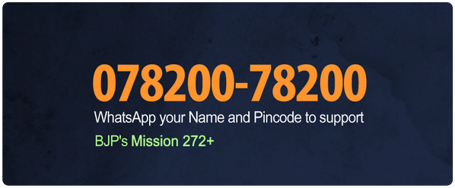

To hear the live speeches given by Modi BJP was also proactive in like ‘Dial 022-4501-4501mobile market initiatives. To connect with over 185 million people of India using internet they put their best foot forward

India 272+ Portal and App
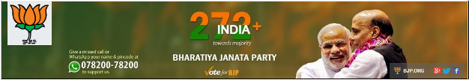
In its mission of achieving over 272 seats in the Lok Sabha elections in 2014 out of 545, India 272+ was an on ground and online volunteering platform. This idea of 272+ India was derived from the US President Barack Obama presidential campaign where to join, work together and put in the volunteers and followers were offered a control panel.
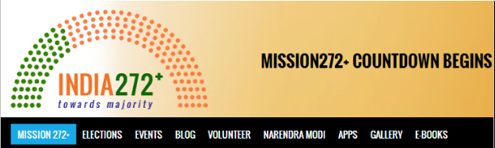
An innovative and unique initiative was also launched on the website with the name “Namo Number”. It was alike to votes means the more the numbers of NaMo, the more the figures of votes. In this election conquering all booths was very important for BJP and to reach the mission 272+ winning the booths was very important as it would have helped in winning the seats for party.
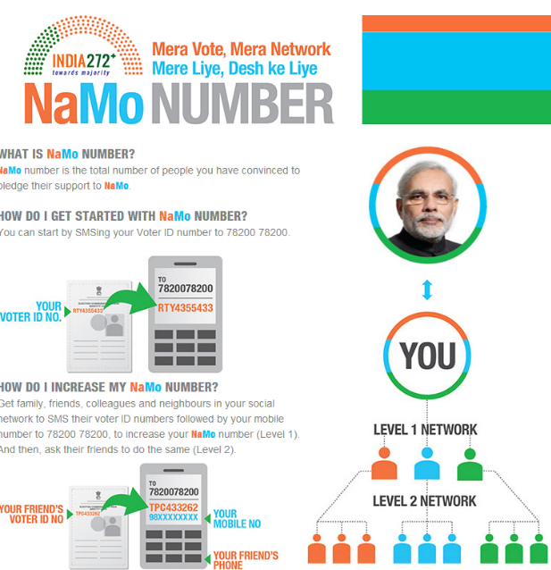
In India everyone who votes has a voter ID card. By forwarding a message through his voter id voter card can let know about its backing to party. In the election rolls as voter id is checked the voter gets benefits. One name has to be in EC rolls in India to vote. By having database of voter ID BJP got help in drawing their backing base and worked on improving their support in the areas where they were lacking. Those who registered on NaMo number by sending their voter ID received customized message about the events, rallies and campaigns of BJP.
Apart from the normal net based networks, party depends strongly on its portal of 272+ India, planned to enable the volunteers where they can team up, give in and crusade with an online medium. It consist of complete data about political decision corners and vests supporters to boot-level sorting out to meet up. Simultaneously, 272+ India boosts a coordinated correspondence medium and flinches exchanges with applicants, creators and thinkers. Apart from billet all the previously mentioned offices, the site additionally has a digital books wedge where books downloading can be done by any one which characterize the idea and strategic the gathering and of Narendra Modi. The website has a month to month traffic gauge of more than 9,14,000 peoples.
In January for expanding the reach more BJP launched a mobile app. It had over 40000 downloads initially in the very first phase and on Android play store was having a subscriber rating of 4.6 out of 5.
The BJP Mission 272+ Page in circles On Google+ was having 552 people and 2903 +1’s. The Prime Minister contender for BJP Narendra Modi here also was way forward in circles with over one lakh persons. Posts which were posted on google + were normally in lieu with the posts on Twitter and FB. By organizing live chat sessions with prominent names like Narendra Modi, Sushma Swaraj, Singh Rajnath BJP judiciously used google hangout also.
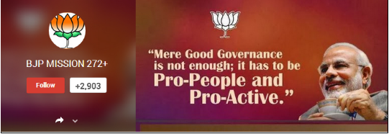
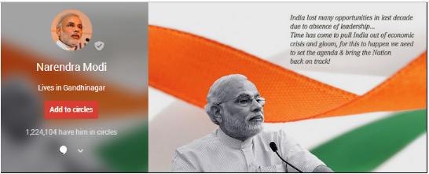
Yuva iTV , Google+ and Whatsapp and Hangouts: Across all social media medium since 2010 BJP was very active and built a massive amount of followers. By organizing live chat sessions with prominent names like Narendra Modi, Sushma Swaraj, Rajnath Singh BJP nurtured and engaged with the people more.
To expand reach by using the ads these hangout sessions by BJP were promoted to a very large extent.
1.7 MENTIONS ON DIGITAL PUBLICATIONS
From Times of India, Business Standard and Economic times top website mentions for Bhartiya Janta Party comes from. All the mentions for BJP were having either a neutral or a positive sentiment. Hindu nationalism accounted for negative sentiments for BJP by mentioning Ram Mandir issue and Godhra rights.
About BJP an unbiased opinion was given by most of the websites along with its campaigns and if Narendra Modi becomes PM of India the after effects of it. From the undaunted reputation of Modi the positive sentiments were driven from. MNC research groups like Numura, Goldman Sachs, and CLSA predicted that if BJP came into power and Narendra Modi becomes PM there would be an economic boom in Indian economy.
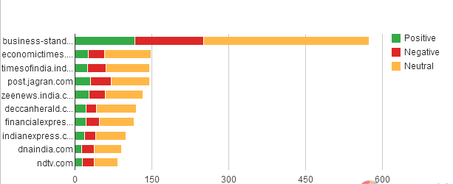

Sentiments
There was negative sentiment which was highest in the first week of March when Modi denied to meet Kejriwal which ultimately stemmed between a rift amid party supporters in Gujrat and Delhi.
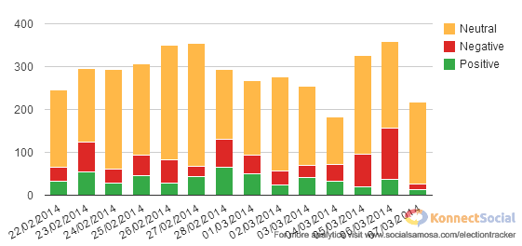

MTS election tracker predicted that overall online BJP was having either a neutral or a positive sentiment. Positive sentiments were 13.5%, 17.7% were negative and majority 68.8% accounted for neutral sentiments. 17.7% of negative supporters were accredited to the rival party followers and supporters.

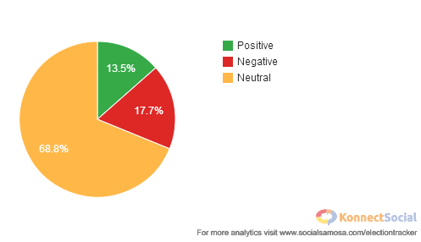

Campaign of Chai pe charcha'
Modi go to a tea stall under the drive and interacted through DTH, satellite service and social media with common people over the brew.

Through satellite service, digital and social media and DTH Modi interacted with common people under the drive Chai pe charcha campaign by visiting a tea stall. This campaign was relayed at one thousand stalls of tea which were identified by BJP in three hundred cities all over the country via video conferencing. On thirty locations direct interactions took place in which people can ask , suggest or share their views.
This was termed as out of box initiative by BJP especially against the traditional campaigns which were conducted by other parties. Congress leader Mani Shankar Aiyar's remark on humble beginnings of Narendra Modi as a tea vendor was the main factor of starting of this campaign.

1.8 SOCIAL MEDIA EXPENDITURE

As we all know that in elections Political parties left no stone unturned. According to a study by IMRB International and IAMAI which was published on 13th October 2013 BJP allocated 2-5% from their Overall budget to social media.

As per the report filled with the ECI of India on the election campaign of 2014 overall BJP spent $ 115 million( 714.28 Crore INR). This expenditure of $ 115 million( 714.28 Crore INR) was spent by its various states and central units.

From a mere few lakhs in some states to approx. $ 16 million( INR 100 crores) in other it was the central unit which spent more than one third of party poll expenditure and that too on one item i.e. media advertising.

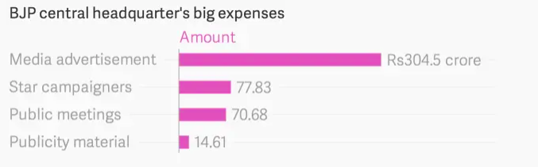
Other than mobile no other medium in India gives that amount of mass reach. In India the mobile phone users were increasing and because of this only most of the web users in country were going online. That's why to send photos, videos and messages to potential voters. WhatsApp, is being used by the likes of the BJP. BJP one of the most unique tool of communicating was allowing the users to listen on their phone Modi's rally speeches in real time. [10]

CHAPTER-2: LITERATURE REVIEW

Consumer marketing and Political marketing
As indicated by Keller and Kotler (2009) Advertising is influenced by numerous different ways and to respond helps in the improvement of different collections of information inside the administration zone. With regards to non-profit advertising, social showcasing and political promoting utilization of the speculations of buyer showcasing is an ongoing event.[11]

Product
Product is the core of promotion mix. As per the voters point of view product includes “ Policy commitment, image of party and image of leader”.

(Harrop and Shaw, 1990) Based on record in office, solidarity of direction and late history the recognitions about " image of party " are created. The utmost significant in fabricating party picture is strategies of the policies on which the party proclamation is based. (Himmelweit et al., 1985; Harrop, 1986) During most recent 3 decades analysts has begun setting more spotlight on sane decision conviction of judgment of voter of the matters and deciding for the ideological group that is in chronization with explicit approach likings.[12]

Promotion
(O’Shaughnessy, 2002) stated that one of the most critical part of political campaigns of publicizing is promotion. In 2 major groups the promotion mix can be divided. The one which comprises of all the ads be it hoarding, print, banner, broadcast social or digital marketing is paid promotion.
Free promotion is the other one which is called as publicity which political party do not pay anything but get it.[13]

Placement
(Farrell and Wortmann, 1987) Chain of retailers or wholesalers is the centre of placement or dispersion if there should be an occurrence of business advertise. In politics the indistinguishable structure is at base root level party labourers. Parties can organize their participation at nearby or local premise. During the hour of election the individuals from these gatherings give volunteer work and pivotal contributions. What's more this additionally facilitates with countrywide level system to contact nearby actions and visits by pioneers of the parties. In India, in voting process it is imperative to remember that household is significant that assumes a powerful job.[14]

Price
How political parties attract members to join and raise their funds can be viewed as price. In political marketing voting intentions or to vote directly correlates to price. For having and upkeeping the huge amount of voter base political parties require to match their communication strategy with the reaction of voters that is done by using analysis of opinions and votes.

Political marketing and Market orientation strategy
(Lees-Marshment, 2009) in political showcasing Market Orientation pulls an incredible enthusiasm as to win elections it gives probable point of view. Now and again this methodology additionally expands worries among party individuals and different partners having gigantic speculations/connections to a particular party or member of party. These members have their own points of view of strategies and might be reluctant in party changing arrangements according to the literature.[15]

The below mentioned 4 important activities will be done by marketing oriented political party as per by Marshment:

- Market Intelligence Utilization: In recognizing the needs and requirements of behaviour of voters Political parties have to invest heavily.

- Behaviour Modification: Based on the findings of marketplace research political party will then alter or modify its behaviour by development of its product. This behaviour modification comprises at all the levels of the party from slogan to poster to campaigns. To build and discriminate its product from the rival parties, party has to keep in mind the rival party weakness and strengths.

- Implementation: In the whole party or structure the modified offerings will be implemented by the political party. To get backing for the change depends on the amount of behaviour modification if more behaviour modification is required the more difficult it becomes for party leadership. To overcome such issues the party administration needed to be well informed in advance of these matters and should take the required actions well in time.

- Communication of New Behavior: Now to its voters the political party will convey their modified product. This should include that before the elections the communication to begin as fast as possible.

CHAPTER-3: METHODOLOGY

Research Methodology is an orderly method to tackle the exploration issue. When we talk research methodology, we discuss explore strategies as well as consider the rationale behind the strategies we use in the exploration study.

3.1 OBJECTIVES

- To assess the relationship between digital marketing and election campaign
- To understand the usage of digital marketing during elections in India
- To know the impact of digital marketing on BJP Lok Sabha campaign.

  - RESEARCH PROCESS: EXPLORATORY RESEARCH
The method I utilized for exploratory research was collecting:
- Primary Data
- Secondary information

3.3 DATA ANALYSIS
By using various methods, the data was obtained from Primary & secondary resources both for collection of primary data questionnaire approach is used. A custom made questionnaire was designed and output of 51 peoples have been collected through google forms. For secondary data collection net sources, researcher papers, online articles were used. The major findings will be summarized and presented using descriptive statistical tools and t-test.

3.4 SCOPE OF THE STUDY

Shaping or continuing a political party is by all accounts an endurance technique for political activists. Politics has become a professional business like anxiety. This examination will be useful to political parties as it will offer important findings from both a hypothetical and functional point of view. Hypothetically, it will add to the general comprehension of advanced promoting digital marketing and their impact on politics campaigns.
CHAPTER-4: DATA ANALYSIS

Age
 |  | Frequency | Percent | V % | C %
 | 18-25 yrs. | 11 | 21.6 | 21.6 | 21.6
 | 26-35 yrs. | 18 | 35.3 | 35.3 | 56.9
 | 36-45 yrs. | 14 | 27.5 | 27.5 | 84.3
 | 46-60 yrs. | 8 | 15.7 | 15.7 | 100.0
 | Total | 51 | 100.0 | 100.0
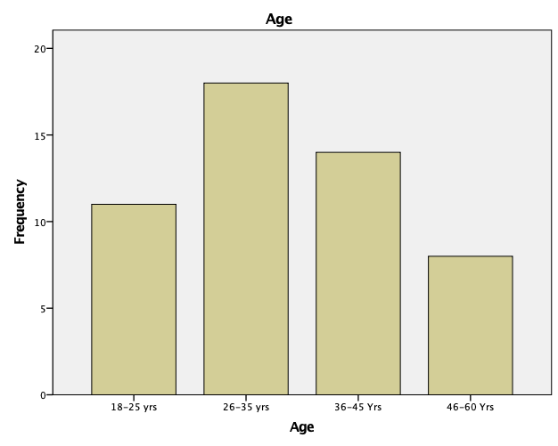

Gender
 |  | Frequency | % | V % | Cumulative %
 | Male | 41 | 80.4 | 80.4 | 80.4
 | Female | 10 | 19.6 | 19.6 | 100.0
 | Overall | 51 | 100.0 | 100.0
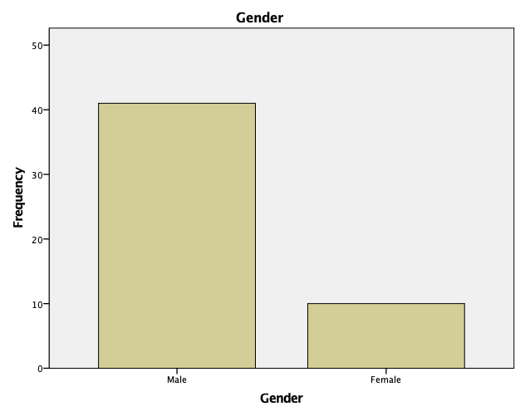

FPP (Follow any Political Party)
 |  | Frequency | % | V % | Cumulative %
 | Yes | 15 | 29.4 | 29.4 | 29.4
 | No | 36 | 70.6 | 70.6 | 100.0
 | Overall | 51 | 100.0 | 100.0
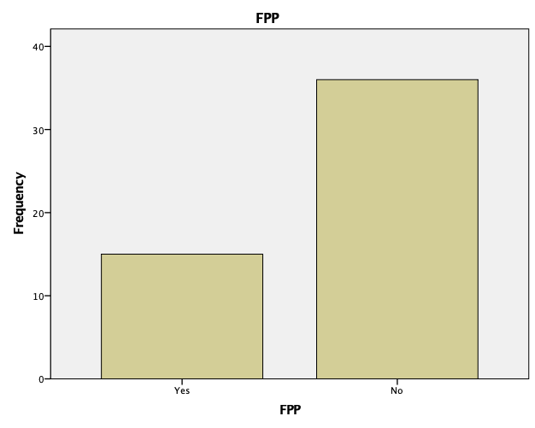
PWG (Political WhatsApp Group)
 |  | Frequency | % | V % | Cumulative %
 | Yes | 4 | 7.8 | 7.8 | 7.8
 | No | 47 | 92.2 | 92.2 | 100.0
 | Overall | 51 | 100.0 | 100.0

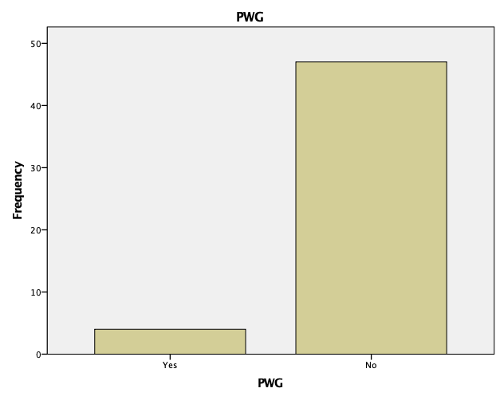

EV (Ever Voted)
 |  | Frequency | % | V % | Cumulative %
 | Yes | 48 | 94.1 | 94.1 | 94.1
 | No | 3 | 5.9 | 5.9 | 100.0
 | Overall | 51 | 100.0 | 100.0
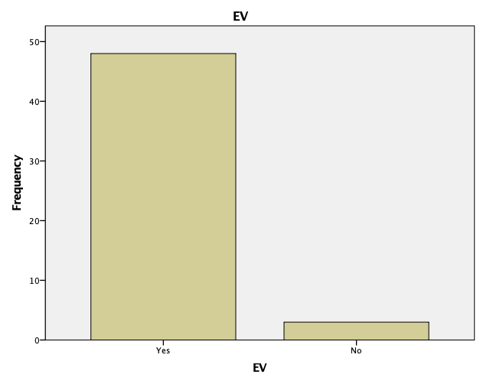

V2014 (Voted in the 2014 General Elections)
 |  | Frequency | % | V % | Cumulative %
 | Yes | 36 | 70.6 | 70.6 | 70.6
 | No | 15 | 29.4 | 29.4 | 100.0
 | Overall | 51 | 100.0 | 100.0
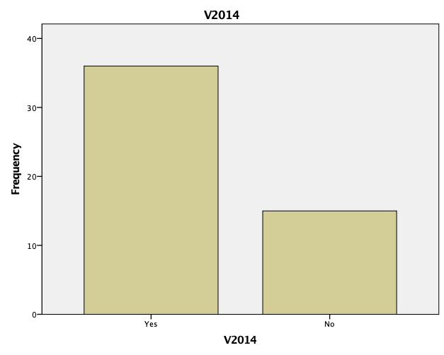

V2019 (Voted in the 2019 General Elections)
 |  | Frequency | % | V % | Cumulative %
Valid | Yes | 42 | 82.4 | 82.4 | 82.4
 | No | 9 | 17.6 | 17.6 | 100.0
 | Overall | 51 | 100.0 | 100.0

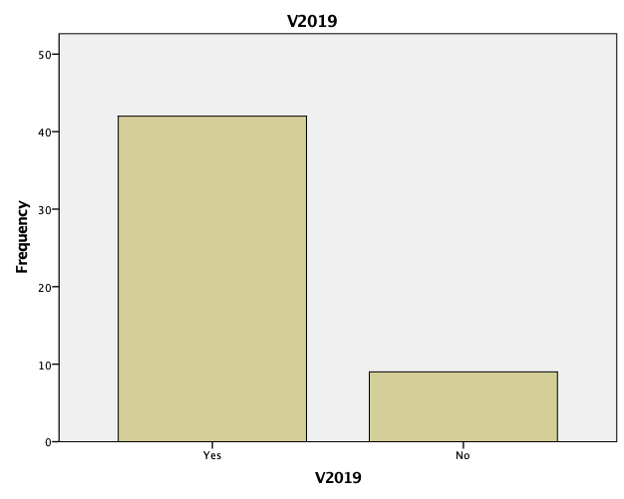
PC (Political Campaigns) on Social Media
 |  | Frequency | % | V % | Cumulative %
Valid | Yes | 14 | 27.5 | 27.5 | 27.5
 | No | 37 | 72.5 | 72.5 | 100.0
 | Overall | 51 | 100.0 | 100.0

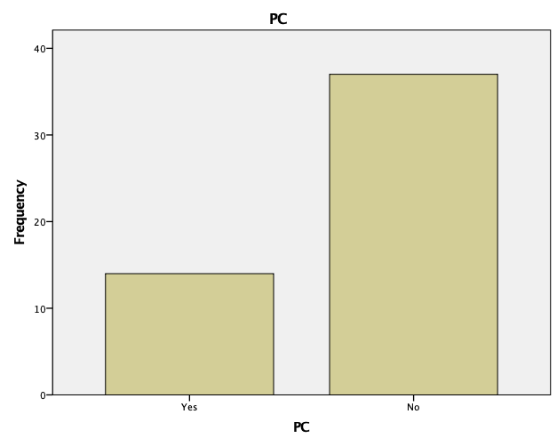

Q9
 |  | Frequency | % | V % | Cumulative %
Valid | DA | 3 | 5.9 | 5.9 | 5.9
 | Neutral | 13 | 25.5 | 25.5 | 31.4
 | Agree | 13 | 25.5 | 25.5 | 56.9
 | SA | 22 | 43.1 | 43.1 | 100.0
 | Overall | 51 | 100.0 | 100.0
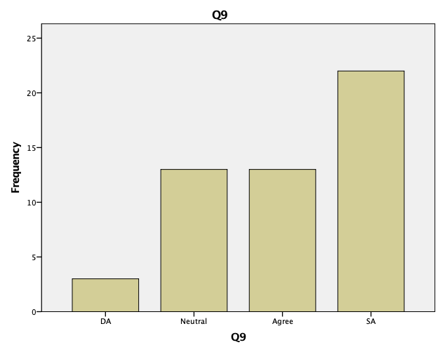

Q10
 |  | Frequency | % | V % | Cumulative %
Valid | SD | 3 | 5.9 | 5.9 | 5.9
 | DA | 4 | 7.8 | 7.8 | 13.7
 | Neutral | 24 | 47.1 | 47.1 | 60.8
 | Agree | 14 | 27.5 | 27.5 | 88.2
 | SA | 6 | 11.8 | 11.8 | 100.0
 | Overall | 51 | 100.0 | 100.0

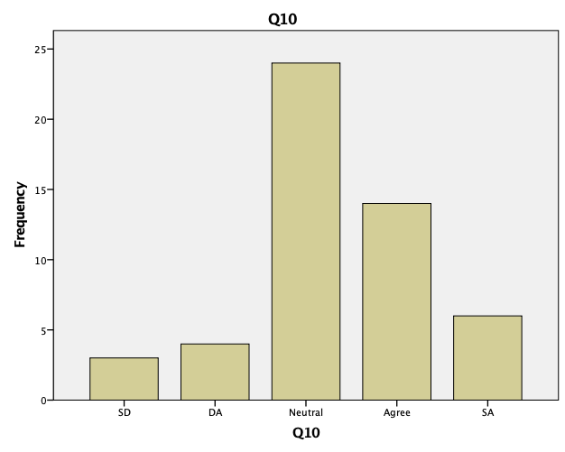
Q11
 |  | Frequency | % | V % | Cumulative %
Valid | DA | 1 | 2.0 | 2.0 | 2.0
 | Neutral | 6 | 11.8 | 11.8 | 13.7
 | Agree | 17 | 33.3 | 33.3 | 47.1
 | SA | 27 | 52.9 | 52.9 | 100.0
 | Overall | 51 | 100.0 | 100.0

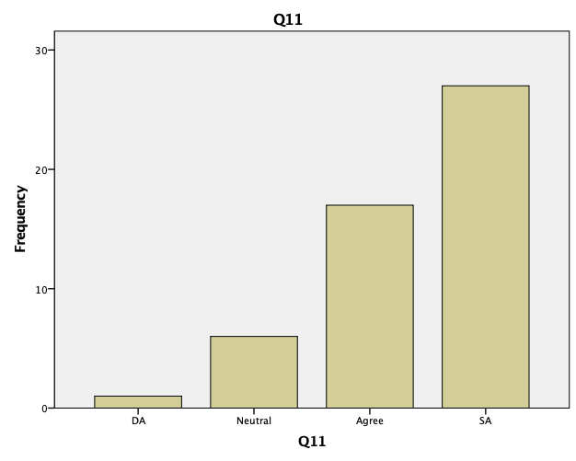

Q12
 |  | Frequency | % | V % | Cumulative %
Valid | SD | 1 | 2.0 | 2.0 | 2.0
 | DA | 2 | 3.9 | 3.9 | 5.9
 | Neutral | 10 | 19.6 | 19.6 | 25.5
 | Agree | 16 | 31.4 | 31.4 | 56.9
 | SA | 22 | 43.1 | 43.1 | 100.0
 | Overall | 51 | 100.0 | 100.0

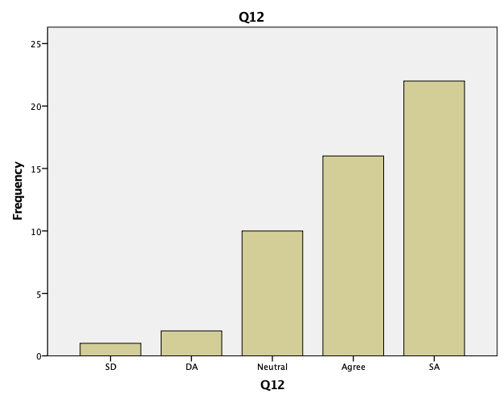

Q13
 |  | Frequency | % | V % | Cumulative %
Valid | SD | 1 | 2.0 | 2.0 | 2.0
 | Neutral | 13 | 25.5 | 25.5 | 27.5
 | Agree | 26 | 51.0 | 51.0 | 78.4
 | SA | 11 | 21.6 | 21.6 | 100.0
 | Overall | 51 | 100.0 | 100.0

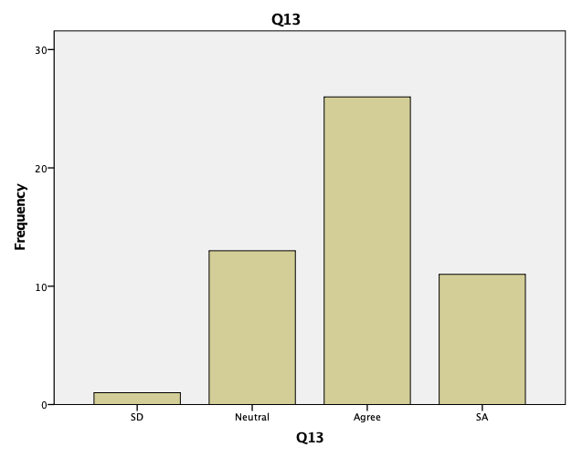

Q14
 |  | Frequency | % | V % | Cumulative %
Valid | SD | 1 | 2.0 | 2.0 | 2.0
 | DA | 5 | 9.8 | 9.8 | 11.8
 | Neutral | 14 | 27.5 | 27.5 | 39.2
 | Agree | 21 | 41.2 | 41.2 | 80.4
 | SA | 10 | 19.6 | 19.6 | 100.0
 | Overall | 51 | 100.0 | 100.0

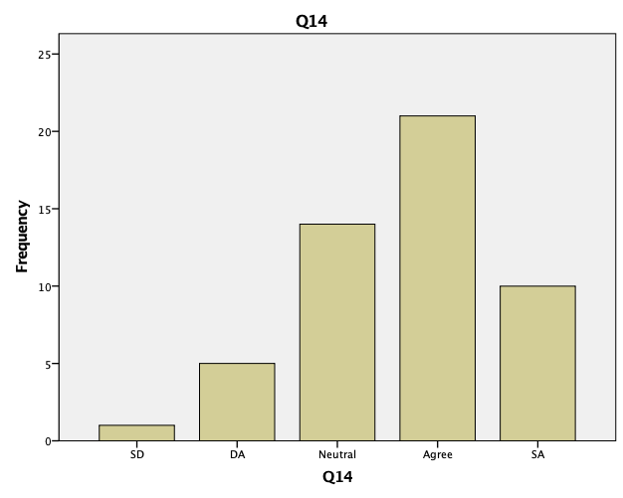

Q15
 |  | Frequency | % | V % | Cumulative %
Valid | SD | 2 | 3.9 | 3.9 | 3.9
 | DA | 10 | 19.6 | 19.6 | 23.5
 | Neutral | 18 | 35.3 | 35.3 | 58.8
 | Agree | 10 | 19.6 | 19.6 | 78.4
 | SA | 11 | 21.6 | 21.6 | 100.0
 | Overall | 51 | 100.0 | 100.0

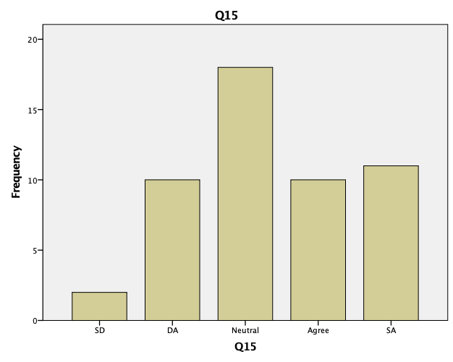

Q16
 |  | Frequency | % | V % | Cumulative %
Valid | SD | 4 | 7.8 | 7.8 | 7.8
 | DA | 10 | 19.6 | 19.6 | 27.5
 | Neutral | 23 | 45.1 | 45.1 | 72.5
 | Agree | 8 | 15.7 | 15.7 | 88.2
 | SA | 6 | 11.8 | 11.8 | 100.0
 | Overall | 51 | 100.0 | 100.0

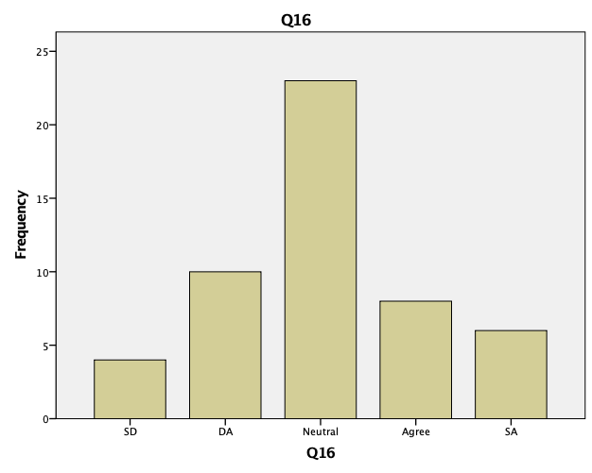

Q17
 |  | Frequency | % | V % | Cumulative %
Valid | SD | 1 | 2.0 | 2.0 | 2.0
 | DA | 3 | 5.9 | 5.9 | 7.8
 | Neutral | 19 | 37.3 | 37.3 | 45.1
 | Agree | 17 | 33.3 | 33.3 | 78.4
 | SA | 11 | 21.6 | 21.6 | 100.0
 | Overall | 51 | 100.0 | 100.0

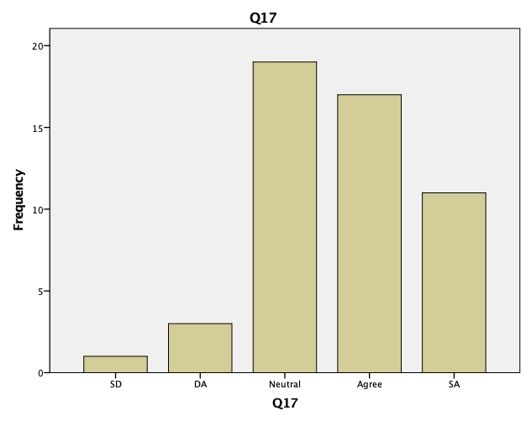

Q18
 |  | Frequency | % | V % | Cumulative %
Valid | SD | 3 | 5.9 | 5.9 | 5.9
 | DA | 10 | 19.6 | 19.6 | 25.5
 | Neutral | 20 | 39.2 | 39.2 | 64.7
 | Agree | 13 | 25.5 | 25.5 | 90.2
 | SA | 5 | 9.8 | 9.8 | 100.0
 | Overall | 51 | 100.0 | 100.0

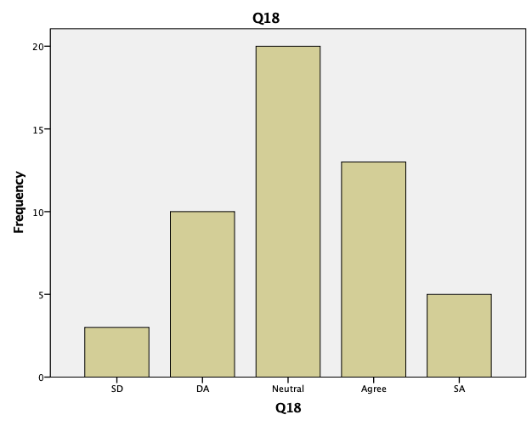

Q19
 |  | Frequency | % | V % | Cumulative %
Valid | SD | 3 | 5.9 | 5.9 | 5.9
 | DA | 10 | 19.6 | 19.6 | 25.5
 | Neutral | 17 | 33.3 | 33.3 | 58.8
 | Agree | 9 | 17.6 | 17.6 | 76.5
 | SA | 12 | 23.5 | 23.5 | 100.0
 | Overall | 51 | 100.0 | 100.0

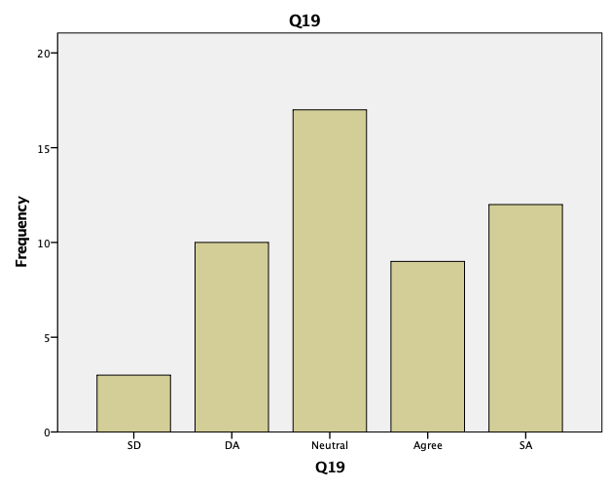

Q20
 |  | Frequency | % | V % | Cumulative %
Valid | DA | 2 | 3.9 | 3.9 | 3.9
 | Neutral | 16 | 31.4 | 31.4 | 35.3
 | Agree | 18 | 35.3 | 35.3 | 70.6
 | SA | 15 | 29.4 | 29.4 | 100.0
 | Overall | 51 | 100.0 | 100.0

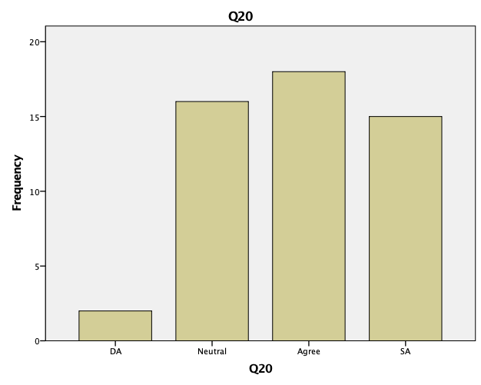
4.1 Hypothesis
H1 : Digital and social Media factors has high Influence on Political campaigns in India
H1o: Digital and social Media factors has no Influence on Political campaigns in India

T-Test

One-Sample Statistics
 | N | Mean | Std. Deviation | Std. Error Mean
Q9 | 51 | 4.0588 | .96771 | .13551
Q10 | 51 | 3.3137 | .98975 | .13859
Q11 | 51 | 4.3725 | .77358 | .10832
Q12 | 51 | 4.0980 | .98499 | .13793
Q13 | 51 | 3.9020 | .80635 | .11291
Q14 | 51 | 3.6667 | .97297 | .13624
Q15 | 51 | 3.3529 | 1.14584 | .16045
Q16 | 51 | 3.0392 | 1.07630 | .15071
Q17 | 51 | 3.6667 | .95219 | .13333
Q18 | 51 | 3.1373 | 1.03961 | .14557
Q19 | 51 | 3.3333 | 1.21106 | .16958
Q20 | 51 | 3.9020 | .87761 | .12289

One-Sample Test
 | Test Value = 0
 | t | df | Sig. (2-tailed) | Mean Difference | 95% Confidence Interval of the Difference
 |  |  |  |  | Lower | Upper
Q9 | 29.953 | 50 | .000 | 4.05882 | 3.7866 | 4.3310
Q10 | 23.910 | 50 | .000 | 3.31373 | 3.0354 | 3.5921
Q11 | 40.366 | 50 | .000 | 4.37255 | 4.1550 | 4.5901
Q12 | 29.712 | 50 | .000 | 4.09804 | 3.8210 | 4.3751
Q13 | 34.558 | 50 | .000 | 3.90196 | 3.6752 | 4.1287
Q14 | 26.913 | 50 | .000 | 3.66667 | 3.3930 | 3.9403
Q15 | 20.897 | 50 | .000 | 3.35294 | 3.0307 | 3.6752
Q16 | 20.166 | 50 | .000 | 3.03922 | 2.7365 | 3.3419
Q17 | 27.500 | 50 | .000 | 3.66667 | 3.3989 | 3.9345
Q18 | 21.551 | 50 | .000 | 3.13725 | 2.8449 | 3.4296
Q19 | 19.656 | 50 | .000 | 3.33333 | 2.9927 | 3.6739
Q20 | 31.752 | 50 | .000 | 3.90196 | 3.6551 | 4.1488

The factors having mean value less than 3 are not considered as highly affecting factors. When applied T-Test on Q9-Q20 all the factors as we can see in the table is having a mean value of above 3 valued at sig 2 tailed .000 which is less than .05.So, all the Digital and Social Media factors were highly influencing and has high Influence on Political campaigns in India and it proves our hypothesis. So hypothesis is accepted.

4.2 Findings:

Intrinsic factors
We can firmly state that social media has become a powerful tool in political processes. From local politics to high-level diplomatic relations, social media has been used to deliver different variables. No aspect of the political process is left out of social media.
As per the research findings and results it can be said that digital and social media has changed the way and strategy of the campaigns of Political parties and their way through which they interact with peoples. Research results show that above 65% of the users were engaged in online political activism. Now the politicians and parties are more accountable to the voters and this clearly influence their vote percentage. The ability to publish content and have it broadcasted to people instantaneously is leveraged by many candidates as this occurs in real time and at almost no cost and it do make an impact on voters mind. Some of the many benefits social media provides politicians include, direct contact with voters which included the promotion and knowledge of campaigns, and the use of data which can be seen from the above results.
Politicians try to capitalize on social media by putting out their beliefs, actions and opinions on certain matters. Social media tools that include Facebook, Twitter and YouTube allow politicians to speak directly to voters with no costs. Based on the above results it can be said that Politicians must engage in a more personalized and less ideological set of political communication. This means that they must engage through personal communication. For example, Narendra Modi was one of the first politicians to tap into the power of social media which made his campaigns so successful. He directly interacted with citizens through the use of innovative information and a sense of community. He defined his political image which was founded on reciprocity and encouraged popular scrutiny on his political deliberations
Engaging with people through social media results in instant feedback and criticism on policies and views. This results in people talking and as a result in the 2014 election, Over 50 percent of the users online stated that they were urged to vote via digital and social media by friends, family, friends or other social network connections, 22% posted their decision and 20% actively encouraged others when they voted.
As to the specific roles can identify the following:
- Voter manipulation
- Conduct of public diplomacy
- Political public relations
- Political branding
- Information Warfare

Well, with an increase in the popularity of social media among people, we just can’t ignore its importance not even in politics and elections.
It helps politicians run campaigns and reach the mass audience with a single click of a mouse button.
Extrinsic factors
Social media by political party has been used primarily to:
- Promote agenda
- Reach out to new voters
- Promote done by the parties
- Showcase achievements
- Communicate with voters (Hangouts)
- Engage with voters
If we see, in almost all possible departments, political parties are actively using social media and its showing its worth and making difference.

CHAPTER-5: CONCLUSION

Irrespective of whether you own a big-shot brand or a political party, everyone wants to promote their brand and market the products and services. But the question is how? The answer is via digital marketing

Social media can influence politics and elections in India. The 2014 Lok Sabha elections in India is proof of impact of social media on India politics. How Narendra Modi campaigned for his election and how he still manages to influence the young population.
Reaching out to the common man becomes easier through social media. It also helps a politician look more human, and showcase the things they do (or pretend to do) for people.
In politics one can get benefit by leveraging the digital marketing in many ways:
By advertising about political party on social media like Facebook one can get more reach to the people locally or globally, can analyze which type of people you should target and then you can do that which will turn in profit for parties.
The world is changing and the days of offline marketing is fading away, now a days people are more active on social media like Facebook and YouTube but most of the people are not changing their way of advertising and those who are doing it getting the awesome results.
Digital marketing for political campaigning has become the norm these days. Our politicians are becoming more tech and social savvy and can be seen sharing their views and establishing a connection with people. They obviously see the great value and potential of digital marketing—though they personally may only be handling social media handles, they have teams who devise, execute and manage digital campaigns for them.

Branding: Most important factor nowadays for any political party. They have to build their image by influencing the people, creating awareness among the people, Targeting to young youth.

Know your audience
A political party’s or politician’s audience includes youth, middle-aged voters, women, senior voters, well-read and educated people and activists. Social media profile should cater to audience and interact this wide spectrum to them.
For social media marketing for elections there are 3 main motives
1)Marketing
Amid the public sphere for promoting the very first motive is to highlight the position of party as well as candidate.
2)Mobilization
To boost followers the use of social media to participate typically to appear in meetings, rallies, and to steer folks to give vote.
3)Dialogue
Social media gives an opportunity to engage and connect with voters in discussion, in terms of dialogue.
Every great politician uses social media marketing and invest uncountable dime to reach every citizens of their country.

5.1 Suggestions

Social media is like a weapon to spread political issues and propaganda. A well versed social media marketing manager knows that citizens of country can be made to engage for communicating among themselves about the political issues. specially social media platforms like YouTube, FB, twitter etc. offer new ways to arouse citizens engagement to raise and spread political thoughts and issues where campaigns of electoral and elections have central role.

CHAPTER 6: REFERENCES

- https://www.researchgate.net/publication/338448051_IMPACT_OF_BRAND_ADVERTISING_IN_POLITICAL_CAMPAIGNS
- https://www.rsisinternational.org/Issue17/55-59.pdf
- https://www.researchgate.net/publication/304669696_Social_media_in_managing_political_advertising_A_study_of_India
- https://www.researchgate.net/publication/332332065_POLITICAL_ADVERTING_IN_INDIA
- http://www.aims-international.org/myconference/cd/PDF/MSD3-5022-Done.pdf
- http://isid.org.in/pdf/DN1706.pdf
- http://usir.salford.ac.uk/id/eprint/46707/1/RichaYadav_MPhil2017_Final%20Copy%20electronic.pdf
- https://cdn.ttc.io/s/ourdataourselves.tacticaltech.org/ttc-influence-industry-india.pdf
- https://thewire.in/politics/how-political-marketing-is-being-used-to-influence-voter-perception
- http://www.socialsamosa.com/tag/mts-election-tracker/
- Kotler, P. and Keller, K. (2009), Marketing Management, 13th ed., Prentice Hall, Upper SaddleRiver, NJ.
- Harrop, M. (1990), “Political marketing”, Parliamentary Affairs, Vol. 43 No. 3, pp. 277-92.
- O’Shaughnessy, N. (2001), “The marketing of political marketing”, European Journal of Marketing, Vol. 35 Nos 9/10, pp. 1047-57
- Farrell, D.M. and Wortmann, M. (1987), “Party strategies in the electoral market: political
- Lees-Marshment, J. (2009), “The marriage of politics and marketing”, Political Studies, Vol. 49,pp. 692-713.

CHAPTER 7: APPENDIX

Questionnaire:

I would be obliged if you can take some precious time of yours and fill up the below questionnaire.
The questionnaire is part of a research project which will help in assessing the relationship between Digital Marketing and Election Campaign.
The responses will be captured anonymously and will be strictly used for the educational research purpose only.

- Age Group
- 18-25 b) 26-35 c) 36-45 d) 46-60 e) 60+

- Gender
- Male b) Female

- Which all Social Media Platforms are you active on:
- FB b) WhatsApp c) Instagram d) Twitter e) All of them

- Do you follow any Political Party on these platforms?
a) Yes b) No

- Are you a member of any of the Political WhatsApp Group?
- Yes b) No

- Have you ever Voted?
- Yes b) No.

- Part A) Did you vote in the 2014 General Elections?
a) Yes b) No

Part B) Did you vote in the 2019 General Elections?
a) Yes b) No

- Do you follow Political Campaigns on Social media?
- Yes b) No

STRONGLY DISAGREE to STRONGLY AGREE

- Do you think that politicians should use social media for their campaign purpose?

- Are the advertisements on social media of the political parties Informative?

- Do you think politicians want to target the youth via social media campaign?

- Is social media now a bigger and more efficient enabler of communicating Party’s agenda in comparison to Television and Newspapers?

- Are politicians distracting attention from questions of principles and policies through personalisation in campaigning?

- Does social media presence of political leader increase their likability and trustworthiness?

- Do the memes and spoofs on digital media make you think about the political party any differently?

- Do the social media campaigns give you assurance about the political party?

- Are the social media advertisements given by the political parties always negative and offensive towards the opposite party especially during election time?

- Are the views and writings of online bloggers and celebrities are given more importance in your decision about the political party?

- Does social media play a highly influential role during your voting?

- Does Social Media help in engaging wider electorate and making politics more accessible for people who are generally not interested in politics?

PLAGIARISM REPORT:
