**Which Indian Metropolitan City Poses Highest Human Health Risk From Ambient PM2.5?**

A DISSERTATION

SUBMITTED IN PARTIAL FULFILLMENT OF THE REQUIREMENTS

FOR

THE AWARD OF THE DEGREE

OF

**MASTER OF TECHNOLOGY**

IN

**ENVIRONMENTAL ENGINEERING**

Submitted by

**DIKSHANT**

**2K19/ENE/15**

Under the supervision of

**Lovleen Gupta**

(Assistant Professor)



**ENVIRONMENTAL ENGINEERING**

DELHI TECHNOLOGICAL UNIVERSITY

(Formerly, Delhi College of Engineering) Bawana Road, Delhi-110042 June 2021

DELHI TECHNOLOGICAL UNIVERSITY

(Formerly Delhi College of Engineering)

Bawana Road, Delhi-110042

# CANDIDATE’S DECLARATION

I, Dikshant, Roll No. 2K19/ENE/15 of MTech (Department of Environmental Engineering), hereby declare that the project Dissertation titled “Which Indian Metropolitan City Poses Highest Human Health Risk From Ambient PM2.5?” which is submitted by me to the Department of Environmental Engineering, Delhi Technological University, Delhi in partial fulfillment of the requirement for the award of the degree of Master of Technology in Environmental Engineering, is original and not copied from any source without proper citation. This work has not previously formed the basis for the award of my Degree, Diploma Associateship, Fellowship, or other similar title or recognition.

Place: Delhi DIKSHANT

ENVIRONMENTAL ENGINEERING

DELHI TECHNOLOGICAL UNIVERSITY

(Formerly Delhi College of Engineering)

Bawana Road, Delhi-110042

# CERTIFICATE

I, hereby certify that the project Dissertation titled “Which Indian Metropolitan City Poses Highest Human Health Risk From Ambient PM2.5?” which is submitted by Dikshant, Roll No. 2K19/ENE/15 (Department of Environmental Engineering), Delhi Technological University, Delhi in partial fulfillment of the requirement for the award of the Degree of Master of Technology, is a record of the project carried out by the student under my supervision. To the best of my knowledge this work has not been submitted in part or full for any degree or diploma to this University or elsewhere.

**LOVLEEN GUPTA**

SUPERVISOR

# ACKNOWLEDGEMENT

I want to express my deepest gratitude to my supervisor Mrs. Lovleen Gupta (Assistant Professor, Environmental Engineering Department, Delhi Technological University, Delhi) Mrs. Lovleen Gupta for their guidance, help, useful suggestions, and supervision without which this report could not have been possible in showing a proper direction while carrying out the project. I also must acknowledge the unconditional freedom to think, plan, execute and express, that I was given in every step of my project work while keeping faith and confidence in my capabilities.

Above all, I owe it all to my Almighty God for granting me the wisdom health, and strength to undertake this research task and enabling me to completion.

DIKSHANT

2k19/ENE/15

# ABSTRACT

Ambient PM2.5 can cause far-reaching health effects in humans. Indian cities routinely experience much higher PM2.5 concentrations than the Indian National Ambient Air Quality Standards and World Health Organization standards throughout the year. The objective of the this study is to estimate the short-term and long-term health effects of PM2.5 in Indian metropolitan cities namely Delhi, Mumbai, Kolkata, and Chennai for the years 2019 and 2020. The years are chosen to evaluate whether the COVID-induced lockdown had any effect on the mortalities and morbidities associated with ambient PM2.5. Health risks were assessed using WHO’s AirQ+ v2.0 software. All-cause (natural) mortality (ACNM) and mortality from acute lower respiratory infection (ALRI), chronic obstructive pulmonary disease (COPD), ischaemic heart disease (IHD), lung cancer (LC), cerebrovascular disease (Stroke), and all-cause morbidity natural (ACM) and morbidity from cardiovascular disease(CVD) and respiratory disease (RD) were assessed. The annual mean PM2.5 concentration in all selected cities was higher than the standards of WHO (10 μgm-3) throughout 2019 and 2020. The excess number of long-term and short-term effects cases were found to be highest in Delhi for both years, which is 31592and 28688 for ACNM, 284 and 271 for ALRI, 2825 and 2674 for COPD, 3541 and 3309 for LC, 11525 and 11101 for IHD, 11082 and 10557 for Stroke and 28704 and 24643 for ACM, 1153 and 983 for CVD, 6858 and 5862 for RD for 2019 and 2020 respectively.

Table of Contents

CANDIDATE’S DECLARATION 2

CERTIFICATE 3

ACKNOWLEDGEMENT 4

ABSTRACT 5

CHAPTER 1 10

INTRODUCTION 10

1.1 How does air pollution affects respiratory health? 12

1.2 Respiratory Health Effects 14

CHAPTER 2 15

LITERATURE REVIEW 15

CHAPTER 3 20

METHODOLOGY 20

3.1 Study Area 20

3.2 Data collection and analysis 23

3.2.1 Ambient PM2.5 concentration data 23

3.2.2 Population Data 25

3.3 Human health risk assessment using WHO’s AirQ+ Software 26

3.3.1 Procedure to calculate the health effects due to PM2.5. 28

CHAPTER 4 34

Results and Discussion 34

4.1 PM2.5 trend in Indian metropolitan cities 34

4.2 Long-term effects of PM2.5 39

4.3 Short-term effects of PM2.5 43

4.4 Comparison of our results to the studies carried out in the past 44

CHAPTER 5 45

Conclusion 45

CHAPTER 6 46

Limitations 46

References 48

Fig. 1.1. The size of particulate particles with their size. 11

Fig. 1.2. PM2.5  sources, size, and health effects. 12

Fig. 1.3. Symptoms due to air pollution 13

Fig. 3.1. Study area map with the location of the metropolitan cities. 20

Fig. 3.3.1.1. AirQ+ welcome window 28

Fig. 3.3.1.2. AirQ+ toolbar for managing projects 28

Fig. 3.3.1.3. AirQ+ Create New Analysis: New Impact Assessment window 29

Fig. 3.3.1.4. AirQ+ New Impact Assessment window for ambient air pollution – PM2.5 – long-term adult mortality. 30

Fig. 3.3.1.5. AirQ+ Analysis Properties window for ambient air pollution – PM2.5 – long-term adult mortality 31

Fig. 3.3.1.6. AirQ+ Impact Evaluation window for ambient air pollution – PM2.5 – long-term – adult mortality 32

Fig. 3.3.1.7. AirQ+ results for ambient air pollution – PM2.5 – long-term – adult mortality 33

Fig. 4.2.1. The trend of PM2.5 concentration in Delhi in 2019 and 2020. 36

Fig. 4.2.2. The trend of PM2.5 concentration in Mumbai in 2019 and 2020. 37

Fig. 4.2.3. The trend of PM2.5 concentration in Chennai in 2019 and 2020. 37

Fig. 4.2.4. The trend of PM2.5 concentration in Kolkata in 2019 and 2020. 38

Fig. 4.2.5. Mortality due to long-term exposure to PM2.5 in 2019 38

Fig. 4.2.6. Mortality due to long-term exposure to PM2.5 in 2020 39

Fig. 4.3.1. Morbidity due to short-term exposure to PM2.5 in 2019. 42

Fig. 4.3.2. Morbidity due to short-term exposure to PM2.5 in 2020. 42

Table 1. Station Considered for Calculating Annual Average PM2.5 2019 and 2020. 24

Table 2. Population Census Data for the years 2019 and 2020. 25

Table 3. World Health Organisation specified default values for RR and BI. 35

Table. 4. Comparison of results between present and previous studies. 44

# CHAPTER 1

# INTRODUCTION

Air pollution is caused by the presence of pollutants in the environment that are hazardous to the health of mankind and other living creatures or that cause damage to the climate or materials. Air pollutants include gases (such as ammonia, carbon monoxide, sulphur dioxide, nitrous oxides, methane, and chlorofluorocarbons), particles (both organic and inorganic), and biomolecules. Air pollution is a major risk factor for a variety of pollution-related illnesses, such as respiratory infections, heart disease, COPD, stroke, and lung cancer (1).

Ambient PM2.5 concentrations have been related to several health effects, especially on the cardio-respiratory system, according to epidemiological studies (2). PM2.5 is described as particulate matter with an aerodynamic equivalent diameter ≤ of 2.5µm (3). A study by World Health Organisation (WHO) that indicates that7 million global deaths per year are caused due to the long exposure to PM2.5 concentration, and the regions which are affected are Southeast Asia and the Western Pacific Regions. These deaths are due to ischaemic heart disease stroke (33%), ALRI (8%), (IHD) (36%), COPD (17%), and lung cancer (LC) (6 %) (1).

India has four major metropolitan cities that are New Delhi, Kolkata, Chennai, and Mumbai where the population is more than 4 million in India (4) as per the latest census record. These areas are heavily inhabited because of heavy industrial and economic activity, which leads to high ambient PM2.5 concentrations throughout the year. India's capital city, Delhi has a population of nearly 16.5 million and the annual average concentration (AAC) of PM2.5 is always above 100 μgm-3 throughout the year in Delhi (5), which is 10 times the WHO standards. Kolkata, the city in eastern India has a population of around 4.4 million (6) and PM2.5 AAC as 86.12 μgm-3 (7), which is ~ 8 times the WHO standards. Chennai is the coastal city in southern India having a population of around 4.6 million and PM2.5 AAC as 63.15 μgm-3 (8), which is ~ 6 times the WHO standards. Mumbai is the financial capital of India, lies in the central part, and has a population of around 10.3 million and PM2.5 AAC as 46 μgm-3 (9)which is ~ 4 times the WHO standards.

Due to the COVID-19 pandemic, these four metropolitan cities were subjected to different lockdown phases during 2020 and have thus experienced lesser PM2.5 concentrations in 2020. The average reduction in PM2.5­ concentration in these metropolitan cities was Kolkata (63.4%) followed by Mumbai (56.4%), Chennai (48.5%), and New Delhi (21.3%) (10). This study aims to assess the human health risks attributed to the ambient PM2.5 during 2020 (the lockdown period) and compare the findings to those in 2019. This will assist the regulatory bodies in taking appropriate decisions looking at how the human health risks are changing with reducing/controlling PM2.5 concentrations

## 1.1 How does air pollution affects respiratory health?

Air pollution has a wide variety of effects on respiratory health, from mild upper respiratory irritation to chronic respiratory and heart disease, lung cancer, and acute respiratory infections; it can also aggravate pre-existing heart and lung disease. Long-term and short-term exposures have been associated with early death and decreased life expectancy.

PM, O3, NO2, SO2, and CO are the pollutants with the most evidence of harming respiratory health. PM is used as an indication of air pollution and is typically classified according to particle size. 1,3–5 PM10–2.5.6 refers to coarse particulate matter with an aerodynamic diameter of 10 m to 2.5 m. PM2.5 is fine particulate matter with an aerodynamic diameter of fewer than 2.5 m that can go deep into the lung (Figure 1.1).

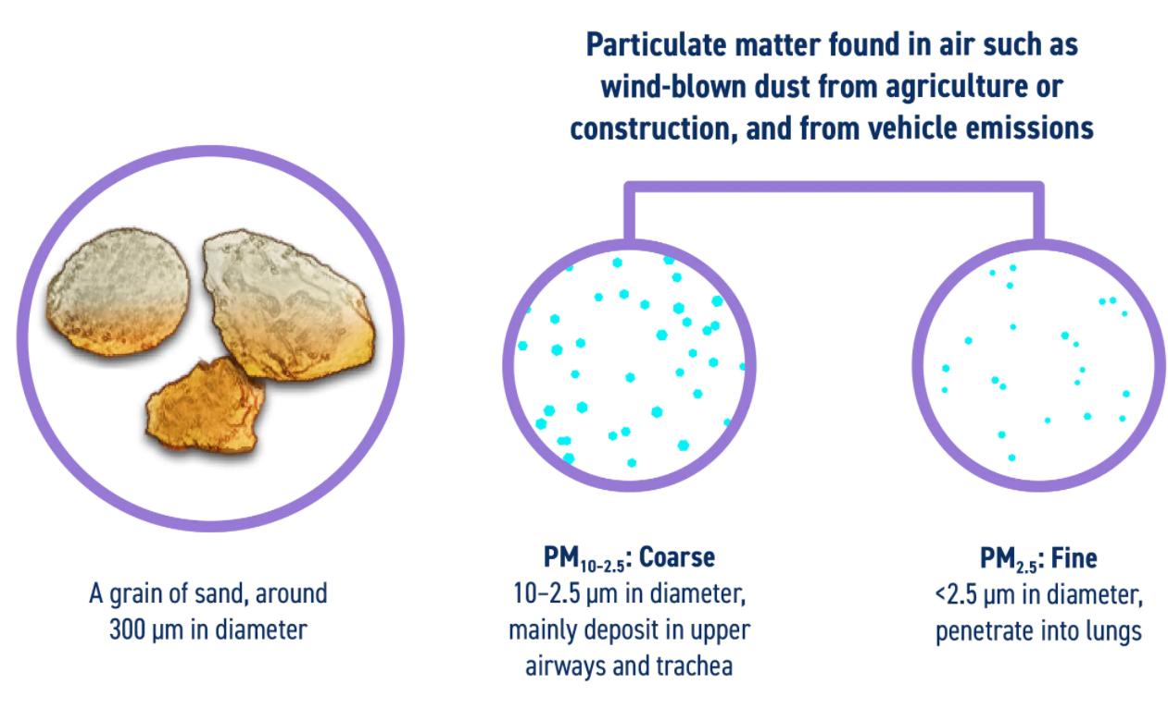

**Fig. 1.1.**  The size of particulate particles with their size.

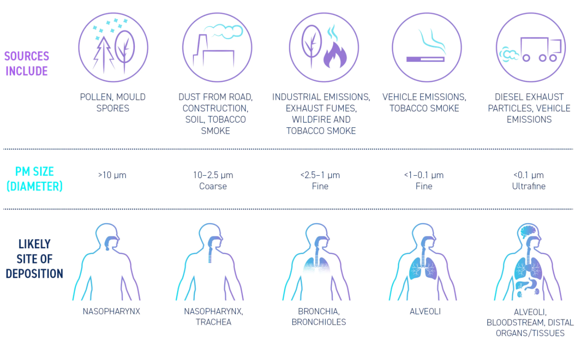

**Fig. 1.2.**PM2.5  sources, size, and health effects

## 1.2 Respiratory Health Effects

These are the respiratory symptoms that are caused due to exposure to air pollution (irritation, runny nose, cough, nasal congestion, phlegm, chest discomfort, dry or irritated throat).

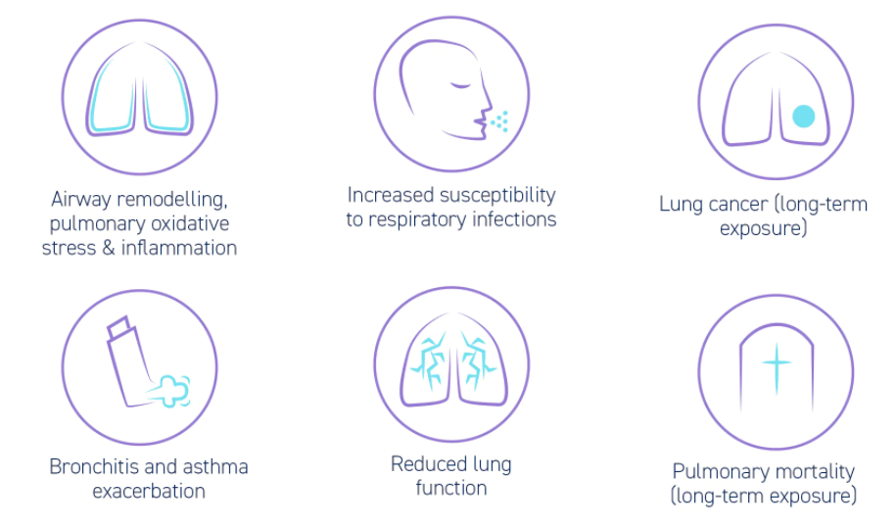

**Fig. 1.3.** Symptoms due to air pollution

# CHAPTER 2

# LITERATURE REVIEW

The threat of air pollution is determined by the pollutant's hazard and the amount of exposure to that pollutant. Air pollution exposure can be represented for an individual, certain groups (for example, neighbourhoods or children living in a country), or whole populations. Air pollution has an immediate and chronic influence on respiratory health, affecting several adverse effects on organs. Air pollutants such as PM, O3, NO2, SO2, and CO cause respiratory symptoms by affecting different sections of the respiratory tract through several processes and can cause many health effects like chronic obstructive pulmonary disease (COPD), ischaemic heart disease (IHD), lung cancer (LC), cerebrovascular disease (Stroke), and all-cause morbidity natural (ACM) and morbidity from cardiovascular disease(CVD) and respiratory disease (RD), etc. Some studies that have been conducted to calculate the human health impacts of air pollution are presented below.

**N. Manoj Kumar and B. Srimuruganandam (2019):**

PM is a dangerous air pollutant that may cause a range of health problems. In the list of most polluted cities bye WHO, Indian cities ranked top in this list. The current study aims to investigate PM trends, as well as the short- and long-term health effects of PM in major Indian cities. The AirQ+ software has been used to evaluate hospital admissions and deaths caused by PM. Most cities' annual PM concentrations surpass India's National Ambient Air Quality Standards. Trend analysis is done and found that peak PM concentrations were observed during the post-monsoon and winter seasons. The male (female) population is anticipated to have 31,307 (28,009) and 5460 (4882) hospital admissions, respectively. In 2017, PM2.5 was responsible for a total of 1,27,014 fatalities. Cities with high levels of particulate matter and a susceptible population are more likely to die or be hospitalized.

**Afghan, F. R. and Patidar, S. K. (2019)**

This study analyzed the impact of PM2.5, PM10, and NO2 on human health. Indian cities routinely experience much higher PM2.5 concentrations than the Indian National Ambient Air Quality Standards and World Health Organization standards throughout the year. The objective of this study is to estimate the short-term and long-term health effects of PM2.5 in Indian metropolitan cities namely Delhi from the years 2013 and 2018. Health risks were assessed using WHO’s AirQ+ v1.3 software tool integrated with Ri-MAP, with 80 percent of the entire population susceptible to air pollution included. All-cause (natural) mortality (ACNM) and mortality from acute lower respiratory infection (ALRI), chronic obstructive pulmonary disease (COPD), ischaemic heart disease (IHD), lung cancer (LC), cerebrovascular disease (Stroke), and all-cause morbidity natural (ACM) and morbidity from cardiovascular disease(CVD) and respiratory disease (RD) were assessed. The annual mean PM2.5 concentration in all selected cities was higher than the standards of WHO (10 μgm-3) throughout 2013 and 2018. The excess number of long-term and short-term effects cases were found to be in 2013 were 48332, 2729, 5645, 26853, 22737, 120754, 34510, 5125, 9813, 3054, 17203, and 682, respectively. It has been increased and cases were found in 2018 were 72254, 3471, 6547, 7568, 32358, 28233, 150110, 50810, 9019, 862, 29570, and 1189, respectively.

**Mohsen Ansaria, Mohammad Hassan Ehrampoush (2018)**

In this study they have assessed the mortality using AirQ+ due to exposure to particulate matter smaller than 2.5µm. They have also found the relationship between the particulate matter and metrological variables and also in Tehran estimated the all cause of mortality, ALRI, LC, IHD and COPD caused by exposure to PM2.5. The data used in this study was collected from official government departments like population, particulate matter and base line incidents rates in Tehran. Throughout the study for determining the relationship between meteorology and PM correlation analysis was used. The results are obtained from this study is that PM shows a relation with monthly temperature and humidity in Tehran and the no of cases that are obtained for the all cause of mortality, ALRI, LC, IHD and COPD are 6710, 27, 135, 3797 and 172 respectively. According to the results of the association study between PM2.5 and the no. of cases, an increase of 1µg/m3 of PM2.5 is predicted to add roughly 27 instances to air pollution mortality in Tehran.

**B.R. Gurjar, A. Jain, A. Sharma, A. Agarwal, P. Gupta, A.S. Nagpure, J. Lelieveld (2010)**

This study is done to find out the long term and short term effects due to the air pollutants in megacities. A new model called Ri-MAP  is used to predict the additional no. of fatalities and illnesses. To evaluate the health impact due to air pollutants like SO2, TSP, and NO2 concentration-response and a population attributable-risk percentage idea is used by using WHO ambient concentration. In this study, the megacity which is considered from these cities certain megacities, such as Los Angeles, New York, Osaka, Kobe, Sao Paulo, and Tokyo, have very low no. of cases for mortality from these pollutants. The highest no. of cases found in Karachi is 15,000/yr with having a high concentration of TSP which is about (w670 mgm3). Cardiovascular death rates are high in Dhaka at 7000/yr, Beijing 5500/yr, Karachi 5200/yr, Cairo 5000/yr, and Delhi 3500/yr. Dhaka and Karachi are the top most polluted cities with 2100 more cases than others per year and Osaka -Kobe and Sao Paulo are the bottom-most cities with w20/yr and 50/yr respectively. As we know air pollution is increasing day by day in megacities these figures should be considered as a minimum because the data which we have considered is limited up to 2000 and it does not contain all the pollutants like O3. So to avoid these cases of morbidity and mortality countries have to take some steps to control the levels of pollutants.

**Amrit Kumar, Rajeev Kumar Mishra (2018)**

This study is done to find out the long term and short term effects due to the air pollutants in New Delhi (NCT) and 36 transport corridors are considered. This study is based on the Ri-MAP model to evaluate the health impact due to air pollutants like PM10, PM2.5, SO2, and NO2 in 2016. They have divided the area into 4Km2 grid size near every corridor and by considering the WHO guidelines mortality and morbidity of this population are evaluated and the results which are evaluated indicate the high level of vehicular traffic in that area. ISBT Flyover (365, 1399, and 2136) had the largest number of extra instances of respiratory, cardiovascular, and total mortality, followed by Wazirabad Road (362, 1378, and 2096). These two areas have the highest no. of morbidity which is no. of people admitted in hospital with COPD and cardiovascular disease cases were 18,979 and 4762, respectively. Furthermore, it is observed that cases are high near Delhi’s megacity beside the 4Km2 area and producing a very realistic image of traffic-related human health risk in diverse residential and non-residential areas. These types of studies help not only in improving the design of transport corridors but also assist health institutions in regulating an excess of such unique patient records in the city and throughout the country.

# CHAPTER 3

# METHODOLOGY

## 3.1 Study Area

In this study, we have taken four major metropolitan cities of India that are Delhi (28.7041° N, 77.1025° E), Mumbai (19.0760° N, 72.8777° E), Chennai (13.0827° N, 80.2707° E), and Kolkata (22.5726° N, 88.3639° E) with geographic area 1483km2, 603.4 km2, 426km2 and 206.1km2 respectively that are shown in Fig. 1.

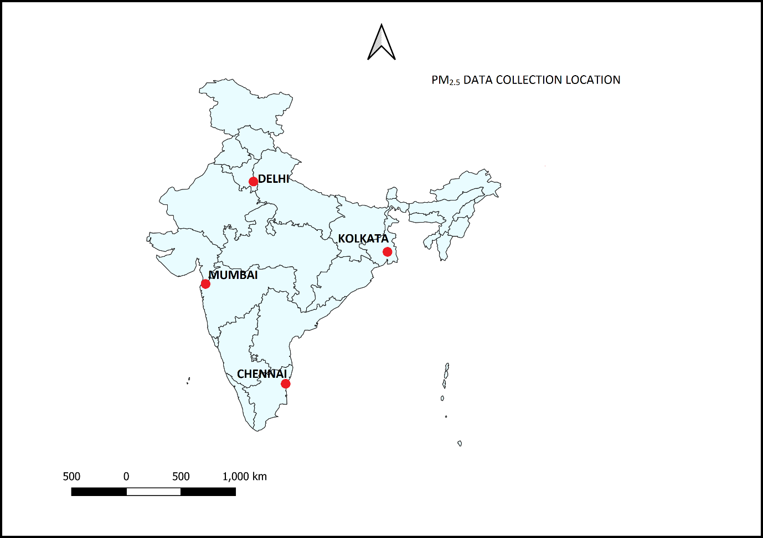

Fig. 3.1. Study area map with the location of the metropolitan cities.

According to a WHO assessment of 1,650 international cities, the air quality in Delhi, India's capital region, is the worst of any large city in the world. It also has an impact on the areas surrounding Delhi. Air pollution is projected to kill around 2 million people in India each year, making it the country's fifth leading cause of death. According to the WHO, India has the highest death rate from chronic respiratory illnesses including asthma in the world. Poor air pollution in Delhi permanently affects the lungs of 2.2 million youngsters or half of all children.

From January and September, the AQI in Delhi is typically Moderate (101–200), but it rapidly deteriorates to Very Poor (301–400), Severe (401–500), or Hazardous (500+) levels owing to a variety of causes such as stubble burning, road dust, vehicle pollution, and cold temperatures. The Great Smog of Delhi occurred in November 2017, when air pollution levels exceeded permissible limits. PM2.5 and PM10 particulate matter levels reached 999 micrograms per cubic meter, above the acceptable limits of 60 and 100, respectively.

Owing to the excessive density of cars, Mumbai and other Indian metropolitan cities are somewhat more susceptible to air pollution, which is followed by building activities, manufacturing areas, open burning, and landfill sites, all of which have degraded the air quality standard of these cities. The city's unusual climate and key geographical position contribute to air pollution.

The city's population has increased rapidly, reaching 1.24 crores, making it the world's fourth most populous metropolis. Increased population has a negative influence on natural resources and the environment. It has also resulted in a rise in the city's pollution levels. Higher traffic density leads to increased emissions in the environment. Transportation is a major source of pollution in the environment. Carbon dioxide, carbon monoxide, nitrogen oxide, unburned hydrocarbons containing lead, particulate matter, and other pollutants are emitted by these vehicles. CO is the most significant pollutant emitted by the transportation industry, accounting for about 90% of total emissions.

Chennai is one of the important coastal megacities in India. It is located on the eastern coastal side of South India. Many industries have come up in the city over the past two decades which are located near the coast. Due to changes in the roughness length and difference in land and sea temperatures, the sea breeze is developed and Thermal Internal Boundary Layer is observed. Due to this, all the pollutants released from the industries will be dispersed towards the inland and in turn, affect the environment and health. Tamil Nadu is located at the southernmost tip of the Indian peninsula. Chennai is the state's capital as well as an important district. The city is one of India's megacities and acts as a gateway to South Indian culture. Chennai is located on the shores of the Bay of Bengal in the northeast corner of Tamil Nadu. It is located on a sandy shelving breaker-washed beach between 12* 9' and 13* 9' of northern latitude and 800 12' and 800 19' of southern longitude. It continues inland in a rocky semi-circular pattern from Thiruvanmiyur in the south to Thiruvottiyur in the north for about 25.60 kilometers along the Bay shore. It is bordered on the east by the Bay of Bengal.

Kolkata, one of India's fastest expanding metropolises, is now suffering a similar issue. The migration of a huge population from rural regions is putting enormous strain on the city's infrastructure, making appropriate management difficult. As a result, the city's pollution level has been rising at an alarming rate in recent years. The amount of air pollution in Kolkata is caused by many variables. One of the most important factors is transportation. Transportation is the most polluting industry due to an abundance of badly maintained cars, the usage of gasoline fuel (although the government is working to phase out these vehicles), and inadequate regulation. Furthermore, there are three thermal power plants in and near Kolkata, which has an impact on air quality. Along with these two big contributors, other small enterprises in the city contribute to air pollution. The study also reveals the role of generators used during power outages in polluting the city's air to some extent.

## 3.2 Data collection and analysis

***3.2.1 Ambient PM2.5 concentration data***

For all the four study locations, the 24-hour PM2.5 concentration was collected from the CPCB official website (11) (https://cpcb.nic.in/) for all the stations mentioned in Table 1 for a given city. The stations chosen for this study were selected based on data availability. The stations where at least 80% of the data during the study period was available were considered. For any given day, the arithmetic average of the PM2.5 concentration at all the stations in a given city was calculated to arrive at the final PM2.5 concentration for that city. The data was collected from January 2019 – December 2020 covering the entire 2 years.

|  |  |  |  |  |  |
| --- | --- | --- | --- | --- | --- |
| City | Total number of stations | Number of stations considered | | Names of stations considered | |
|  |  | **2019** | **2020** | **2019** | **2020** |
| Delhi | 40 | 36 | 36 | Alipur, Anand Vihar, Ashok Vihar, Bawana, CRRI, Dr.Karni, DTU, Dwarka, IGI Airport, IHBAS Dilshad Garden, ITO, Jahangirpuri, JLN, Lodhi Road IMD, Major Dhaynchand, Mandir Marg, Mundka, Najafgarh, Narela, Nehru Marg, North Campus, NSIT, Okhla, Partparganj, Punjabi Bagh, PUSA DPCC, PUSA ITM, RK Puram, Rohini, Shadipur, Sirifort, Sonia Vihar, Sri Aurobindo, Vivek Vihar, Wazirpiur | |
| Mumbai | 19 | 1 | 9 | Bandra | Bandra, Borivali, Chhatrapati Shivaji Airport, Kurla, Powai, Sion, Vasai, Worli |
| Chennai | 8 | 3 | 4 | Alandur, Manali, Velachery | Alandur, Arumbakkam, Kodungiyar, Manali Village, Perungundi, Royapuram, Manali, Velachery |
| Kolkata | 7 | 2 | 7 | RBU, Victoria | Ballygunge, Bidhannagar, Fort William, Jadhavpur, Rabindra Saro, RBU, Victoria |

Table 1. Station Considered for Calculating Annual Average PM2.5 2019 and 2020.

***3.2.2 Population Data***

Population data were obtained from the Census of India 2011 (6), and age-wise population data for 2017 was collected from (12). Based on this data, the population for the years 2019 and 2020 was projected using the geometric mean method following Eq. 1:

$\{P°={P\left(1+r/100\right)}^{n}\}$ Eq. (1)

where Pº is the population at nth decade, P is present population, r is the growth rate, n is no. of the decade. The present population for these cities was taken as the 2011 population. The present population and the projected population are given in Table 2.

Table 2. Population Census Data for the years 2019 and 2020.

|  |  |  |  |
| --- | --- | --- | --- |
| City |  | Population | |
|  | **2011** | **2019** | **2020** |
| Delhi | 16,787,941 | 19,579,406 | 19,959,506 |
| Mumbai | 12,442,373 | 13,260,927 | 13,366,962 |
| Chennai | 4,646,732 | 4,904,443 | 4,937,646 |
| Kolkata | 4,496,694 | 4,273,837 | 4,255,311 |

## 3.3 Human health risk assessment using WHO’s AirQ+ Software

AirQ+ is a software tool for quantifying the health burden and impact of air pollution developed by the WHO Regional Office for Europe. AirQ+ includes in a user-friendly way methodologies to assess the effects of long-term and short-term exposure to ambient air pollution.1 It works with the following pollutants: particulate matter with a diameter of 2.5 μm or less (PM2.5) or with a diameter of 10 μm or less (PM10), nitrogen dioxide, ozone, and black carbon. AirQ+ can estimate the effects of household air pollution related to solid fuel use. Various health outcomes related to mortality and morbidity, both in terms of acute and chronic conditions can be considered in the calculations.

Further, AirQ+ is used to evaluate the extent of the effects of air pollution on human health. WHO default measures of Relative Risk (RR) per 10μgm-3 rise of 24-hr average PM2.5 and baseline incidence (BI) values per 100,000 population is assumed to be associated with the related disease and likely mortality and morbidity as seen in Table 3 (13). The values for RR and BI were taken from the literature. To find the long-term and short-term effects of air pollution certain values are needed that are air quality data (annual average PM2.5 data), population data that are at risk, and health data that are baseline rate of health outcome. A cut-off value is considered for the long term it is 10 μgm-3 and for the short term, it is 25 μgm-3 (14). The RR is evaluated by Eq-2 (15)

$RR=exp\left[βln\left(x-x°\right)\right]$ Eq. (2)

Where β is a CI (95 percent CI) that depends on the sort of health endpoint., x is the concentration of pollutants, xº is the value of counterfactual. The attributable percentage (AP) is the ascribed fraction of a health result caused by exposure in a given population during a set period, and it may be calculated using Eq-3. (15)

$AP=\left[\left(RR\left(c\right)-1\right)*p\left(c\right)\right]/\left[RR\left(c\right)*p\left(c\right)\right]$ Eq. (3)

Where RR is the relative risk and the proportion of the population in the category of exposure is denoted by p(c) (c). For a certain BI of the selected health outcome, The no. of cases per unit population (BE) in the population may be estimated using Eq. (4) (15).

$BE=B*AP$ Eq. (4)

N is the size of the population, the number of attributable cases (NE) can be estimated by Eq.(5) (15).

$NE=BE*N$ Eq. (5)

For any of the health result pairs used in the research, AirQ+ used some of the default relative risk values. To evaluate the relative risks of different concentrations, the linear log approach has been used. The excess no. of cases (ENAC) is the Estimated no. of attributable cases evaluated by the AirQ+ software.

***3.3.1 Procedure to calculate the health effects due to PM2.5.***

**Step 1** - This is the welcome window of the AirQ+ software shown in Fig.1 and then for calculating the impact assessment click on the plus sign and create a new analysis shown in Fig.2.



Fig. 3.3.1.1. AirQ+ welcome window



Fig. 3.3.1.2. AirQ+ toolbar for managing projects

**Step 2** - After creating the new impact assessment window will open shown in Fig.3 and Fig.4 from here you can select the parameters you want to calculate.



Fig. 3.3.1.3. AirQ+ Create New Analysis: New Impact Assessment window

In the New Impact Assessment window (Fig. 4), select ambient pollution, long-term effects, and the pollutant PM2.5 and click OK.

For this straightforward, straightforward assessment, only the mean value is required. Select the Input Mean Value option in the Analysis Properties window and type 27.95 g/m3 in the Mean Value field. In the Total Population field, type "1690109." (Fig. 5). Because AirQ+ does not analyze the entire population, the user can think of this as additional descriptive data.



Fig. 3.3.1.4. AirQ+ New Impact Assessment window for ambient air pollution

**Step 3 –** Insert the required data in the given fields like population, city name, years, PM2.5 values, etc.



Fig. 3.3.1.5. AirQ+ Analysis Properties window for ambient air pollution

Click the “Create new Impact Evaluation” button (Fig. 5) to go to the Impact Evaluation window (Fig. 6) and then enter the following data:

**Step 4 –** Now, select the disease in the evaluation name and enter the relative risk, cut-off values, and other values from table 3.

* evaluation name (for example: AAP7 PM2.5 long-term adult mortality);
* mortality incidence for adults (≥ 30 years), all-natural causes, per 100 000 population: 939.73;
* the total number of adults (≥ 30 years) exposed to the pollutant: 1156588; the user can either enter a number that is less than the total population previously inputted in the Analysis Properties window (Fig.5) or the percentage of the total population
* the default relative risk values for all-cause mortality: 1.062 (95% CI: 1.040–1.083);9 and
* the default cut-off value recommended by 2005 WHO AQG: 10 μg/m3; (AirQ+ calculates the burden or impact of exposure when this concentration is exceeded).



Fig. 3.3.1.6. AirQ+ Impact Evaluation window for ambient air pollution



Fig. 3.3.1.7. AirQ+ results for ambient air pollution

The Results window indicates that 1112 premature deaths (central estimate; Fig. 7) caused by long-term exposure to PM2.5 could be “avoided” if the concentration of PM2.5 would not exceed 10 μg/m3, the threshold recommended by 2005 WHO AQG. The values in the Lower and Upper columns correspond to the estimates calculated with, respectively, the lower and upper confidence interval limits of the relative risk. This range is the 95% CI based on the uncertainty in the relative risk values for all-cause mortality that the user entered when creating the Impact Evaluation and shows some of the uncertainty associated with the estimates.

# CHAPTER 4

# Results and Discussion

## 4.1 PM2.5 trend in Indian metropolitan cities

The 24-hr average PM2.5 concentration in four selected metropolitan cities is shown in Figs. 2,3,4 and 5. Highest annual average concentration was observed in Delhi (108.6 ± 84.47 μgm-3 ), (94.43 ± 79.54 μgm-3 ) followed by Kolkata (72.31 ± 58.68 μgm-3), (48.69 ± 43.77 μgm-3) and Chennai (46.27 ± 25.91 μgm-3), (30.32 ± 12.69 μgm-3) in 2019 and 2020 respectively. Mumbai has the lowest PM concentration among all the selected cities (32.73 ± 20.89 μgm-3) in 2019 and (37.11 ± 26.74 μgm-3) in 2020. While all the four cities have annual average PM2.5 concentrations exceeding the Indian NAAQS standard of 40 μgm-3 except Mumbai, but the concentrations in all the four cities exceed the WHO standard of 10 μgm-3.

Table 3. World Health Organisation specified default values for RR and BI.

|  |  |  |  |  |
| --- | --- | --- | --- | --- |
| Pollutant | Mortality/Morbidity | Relative Risk(RR)  (95%CI) per 10μg/m-3 | Baseline Incidence  Per 100000 (I) | References |
| **Long-term effects, cut-off value for PM2.5 = 10** μgm-3 | | | | |
| **PM2.5** | Mortality, all natural  cases (adults age 30+ years) | 1.062(1.04-1.083)  GBD 2015/2016 | 1013 | (16) |
| Mortality due to  ALRI for children (0-5 years) | (INTERGRATED FUNCTION 2016)  GBD 2015/2016 | 49 | (16) |
| Mortality due to  COPD for adults( 25+ year) | (INTERGRATED FUNCTION 2016)  GBD 2015/2016 | 101 | (16) |
| Mortality due to  LC for adults (25+ years) | (INTERGRATED FUNCTION 2016)  GBD 2015/2016 | 132 | (16) |
| Mortality due to  IHD for adults (25+ years) | (INTERGRATED FUNCTION 2016)  GBD 2015/2016 | 436 | (16) |
| Mortality due to  Stroke for adults (25+ years) | (INTERGRATED FUNCTION 2016)  GBD 2015/2016 | 436 | (16) |
| **Short-term effects, cut-off value for PM2.5 = 25** μgm-3 | | | |
| Hospital admission  respiratory disease | 1.019(0.9982-1.0402) | 1260 | (16) |
| Hospital admission cardiovascular  disease including stroke | 1.0091(1.007-1.0166) | 101 | (16) |
| Mortality all natural  cases 30+ years | 1.0123(1.0045-1.0201) | 1013 | (16) |
| ICD: International Classification of diseases; ALRI: Acute lower respiratory infection; COPD: Chronic obstructive pulmonary disease; IHD: Ischaemic heart disease; LC: lung cancer; BI: Baseline incidence per 100000 has been adopted as per WHO default values; GBD: Global burden disease | | | | |

As per (17) Indian Metrological Department, the seasons are divided as winter (January – February), pre-monsoon (March-May), monsoon (June – September), and post-monsoon (October – December). The order of the seasonal average PM2.5 for Chennai, Mumbai, and Kolkata followed: winter > post- monsoon > pre- monsoon > monsoon. However, for Delhi maximum average PM2.5 concentration was observed in post-monsoon followed by winter, pre-monsoon, and monsoon having the least concentration through 2019 and 2020.

Fig. 4.2.1. The trend of PM2.5 concentration in Delhi in 2019 and 2020.

Fig. 4.2.2. The trend of PM2.5 concentration in Mumbai in 2019 and 2020.

Fig. 4.2.3. The trend of PM2.5 concentration in Chennai in 2019 and 2020.

Fig. 4.2.4. The trend of PM2.5 concentration in Kolkata in 2019 and 2020.

Fig. 4.2.5. Mortality due to long-term exposure to PM2.5 in 2019

Fig. 4.2.6. Mortality due to long-term exposure to PM2.5 in 2020

## 4.2 Long-term effects of PM2.5

To determine mortality and morbidity, the annual average concentration of PM2.5 and population data of these cities for the years 2019 and 2020 were taken. The values for the BI and RR were taken from Table 3 as per WHO guidelines.

The Excess Number Of Cases (ENC’s) of mortality all (natural) causes (adults age 30+ years) in 2019 (Fig. 6) is highest in Delhi with a value of 31592 (95% confidence limit of 22647 and 38451) followed by Mumbai with a value 6119 (95% confidence limit of 4084 and 7937), Kolkata with value 4822 (95% confidence limit of 3345 and 6040) and least for Chennai with value 3470 (95% confidence limit of 2347 and 4446). ENC’s in 2020 (Fig. 7), in Delhi dropped with value 28688 (95% confidence limit of 20307 and 35264) followed by Mumbai with value 7261 (95% confidence limit of 4867 and 9380), Kolkata with value 3197 (95% confidence limit of 2168 and 4087) and least in Chennai with value 2085 (95% confidence limit of 1388 and 2709).

ENC’s of ALRI for children (0-5 years) in 2019 (Fig. 6) is highest in Delhi with value 284 (95% confidence limit of 177 and 365) followed by Mumbai with value 85 (95% confidence limit of 57 and 110), Kolkata with a value 50 (95% confidence limit of 32 and 65) and least for Chennai with value 43 (95% confidence limit of 28 and 56). ENC’s in 2020 (Fig. 7), in Delhi dropped with value 271 (95% confidence limit of 170 and 349) followed by Mumbai with value 96 (95% confidence limit of 64 and 125), Kolkata with value 39 (95% confidence limit of 25 and 50) and least in Chennai with value 30 (95% confidence limit of 20 and 39).

ENC’s of COPD for adults (25+ year) in 2019 (Fig. 6) is highest in Delhi with a value of 2825 (95% confidence limit of 1950 and 4237) followed by Mumbai with a value of 829 (95% confidence limit of 507 and 1238), Kolkata with value 490 (95% confidence limit of 324 and 734) and least in Chennai with value 413 (95% confidence limit of 263 and 608). ENC’s in 2020 (Fig. 7) in Delhi dropped with value 2674 (95% confidence limit of 1832 and 4032) followed by Mumbai with value 938 (95% confidence limit of 581 and 1393), Kolkata with value 373 (95% confidence limit of 240 and 551), and least in Chennai with value 290 (95% confidence limit of 175 and 429).

ENC’s of LC for adults (25+ years) in 2019 (Fig. 6) is highest in Delhi with a value of 3541 (95% confidence limit of 2657 and 4279) followed by Mumbai with a value of 909 (95% confidence limit of 576 and 1241), Kolkata with a value of 590 (95% confidence limit of 417 and 739) and least in Chennai with value 473 (95% confidence limit of 314 and 618). ENC’s in 2020 (Fig. 7) in Delhi dropped with value 3309 (95% confidence limit of 2425 and 4052) followed by Mumbai with value 1046 (95% confidence limit of 674 and 1404), Kolkata with value 430 (95% confidence limit of 288 and 558), and least in Chennai with value 315 (95% confidence limit of 197 and 433).

ENC’s of IHD for adults (25+ years) in 2019 (Fig. 6) is highest in Delhi with a value of 11525 (95% confidence limit of 8391 and 20287) followed by Mumbai with a value of 3990 (95% confidence limit of 2556 and 7904), Kolkata with value 2107 (95% confidence limit of 1471 and 3888) and least in Chennai with value 1889 (95% confidence limit of 1258 and 3629). ENC’s in 2020 (Fig. 7) in Delhi dropped with value 11101 (95% confidence limit of 7954 and 19869) followed by Mumbai with value 44322 (95% confidence limit of 2880 and 8660), Kolkata with value 1694 (95% confidence limit of 1135 and 3241), and least in Chennai with value 1407 (95% confidence limit of 895 and 2805).

ENC’s of Stroke for adults (25+ years) in 2019 shown in (Fig. 6) is highest in Delhi with value 11082 (95% confidence limit of 7303 and 17357) followed by Mumbai with value 3475 (95% confidence limit of 1881 and 5386), Kolkata with value 1961 (95% confidence limit of 1222 and 3137) and least in Chennai with value 1694 (95% confidence limit of 994 and 2676). ENC’s in 2020 (Fig. 7) in Delhi dropped with value 10557 (95% confidence limit of 6835 and 16628) followed by Mumbai with value 3901 (95% confidence limit of 2186 and 6108), Kolkata with value 1526 (95% confidence limit of 902 and 2419), and least in Chennai with value 1219 (95% confidence limit of 652 and 1898).

The ENC’s value is highest in Delhi due to the highest PM2.5 concentration of 108.50 μgm-3 out of all the four metropolitan cities and ENC’s values declined in 2020 due to a decline in PM concentrations. However, there is no decline in ENC noticed in Mumbai from 2019 to 2020 as the PM2.5 concentration also did not decline.

Fig. 4.3.1. Morbidity due to short-term exposure to PM2.5 in 2019.

Fig. 4.3.2. Morbidity due to short-term exposure to PM2.5 in 2020.

## 4.3 Short-term effects of PM2.5

The ENC’s of hospital admission respiratory disease in 2019 (Fig. 8) is highest in Delhi (28704 and 95% CI: 0-55347) followed by Mumbai (1933 and 95% CI: 0-4015), Kolkata (3671 and 95% CI: 0- 7329) and least in Chennai (21940 and 95% CI: 0-3975). ENC’s in 2020 (Fig. 9) in Delhi dropped with value (24643 and 95% CI: 0-48149) followed by Mumbai (3037 and 95% CI: 0-6281), Kolkata (1879 and 95% CI: 0- 3840), and least in Chennai (529 and 95% CI: 0-1102).

The ENC’s of hospital admission cardiovascular disease including stroke in 2019 (Fig. 8) is highest in Delhi (1153 and 95% CI: 223-2032) followed by Mumbai (75 and 95% CI: 14-136), Kolkata (145 and 95% CI: 28- 259) and least in Chennai (76 and 95% CI: 14-136). ENC’s in 2020 (Fig. 9) in Delhi dropped with value (983 and 95% CI: 189-1742) followed by Mumbai (118 and 95% CI: 22-213), Kolkata (73 and 95% CI: 14- 132), and least in Chennai (20 and 95% CI: 04-37).

The ENC’s of mortality all-natural cases 30+ years in 2019 shown in (Fig. 8) is highest in Delhi (6858 and 95% CI: 2601-10820) followed by Mumbai (451 and 95% CI: 166-731), Kolkata (867 and 95% CI: 324- 1386) and least in Chennai (454 and 95% CI: 168-734). ENC’s in 2020 (Fig. 9) in Delhi dropped with value (5862 and 95% CI: 2211-9296) followed by Mumbai (709 and 95% CI: 262-1149), Kolkata (440 and 95% CI: 163- 710), and least in Chennai (123 and 95% CI: 45-200).

## 4.**4** Comparison of our results to the studies carried out in the past

In comparison to the previous studies (Table 4), our results are slightly less even though at the time those respective studies were carried out, the PM2.5 concentration was higher (AAC of PM2.5 is 131.5μgm-3 in Delhi and 68.5μgm-3 in Mumbai (18), 32.62 ± 16.63μgm-3  in Chennai and 102.96 ± 85.38μgm-3 in Delhi (19), and 111.7μgm-3 in Delhi (13).). This may be attributed to the fact that has considered the total population of the city and we have considered age-wise population for more accuracy (5+, 25+, and 30+ years population). For Kolkata, however, no such study has been carried out in the past.

Table. 4. Comparison of results between present and previous studies.

|  |  |  |  |  |  |  |  |  |  |
| --- | --- | --- | --- | --- | --- | --- | --- | --- | --- |
| **S.No.** | **City** | **Results from our study** | | | | **Results from past studies** | | | |
| **Long term effects** | | **Short term effects** | | **Long term effects** | **Short term effects** | **Year of study** | **Reference** |
| **2019** | **2020** | **2019** | **2020** |
| 1. | Delhi | 31,592 | 28,688 | 28,704 | 24,643 | 9,968 | − | 2015 | (18) |
| 40,000 | 38,211 | 2017 | (19) |
| 72,254 | 45,000 | 2018 | (13) |
| 2. | Mumbai | 6,119 | 7,261 | 1,933 | 3,037 | 8,341 | − | 2015 | (18) |
| 3. | Chennai | 3,470 | 2,085 | 1,940 | 1,529 | 12,000 | 4,135 | 2015 | (19) |

# CHAPTER 5

# Conclusion

In the present analysis, human health impacts on mortality and morbidity were measured in Delhi, Mumbai, Chennai, Kolkata during 2019 and 2020, taking into account 80 percent of the total population at risk of air pollution exposure of the parameters PM2.5 pollutant using WHO’s AirQ+ v2.0 software. Delhi is the metropolitan city that poses the highest human health risk from ambient PM2.5. The ENC’s value is high in Delhi due to a high PM2.5 concentration of 108.50 µgm-3 and ENC’s values declined in 2020 due to a decline in PM concentrations in all cities except Mumbai. But there is a big gap, and the downturn is due to the lockdown in India in 2020. We may also infer that higher amounts of PM2.5 and higher demographics prone to air pollution can contribute to more cases and hospital admission. Some preventive steps should be taken by the government to monitor the rise in air pollution. Popular mitigation measures for all four cities will have a negative effect. We can take the measures according to the cities condition and level of pollution in it and that can also be efficient at enforcing and reducing PM concentrations.

# CHAPTER 6

# Limitations

The RR values used in this analysis are rationally established in the USA, but there would be a lot of uncertainty if RR values are observed in certain other countries, such as India because atmospheric conditions and the economy vary considerably. We have considered that 80% of the population is susceptible to emissions, although it may be high or low, and the degree of indoor pollution is different and can have different exposure values. In 2020 lockdown is imposed in India due to this pollution level as well the population exposure to PM might be below. There are also potential pitfalls in the precision of the data given by CPCB, such as power loss, labour unavailability, human error, error in control, and inadequacy of the air quality monitoring infrastructure.

# References

1. **WHO.** *World health organization releases 7 million premature deaths annually linked to air pollution.* 2014.

2. *Acute respiratory effects of particulate air pollution.* **Dockery, D.K. and Arden.** 1994, Annual review of public health, pp. 107-132.

3. *Apportionment of the airborne PM10 in Spain. Episodes of potential negative impact for human health.* **Callen MS, Lopez JM, Mastral AM.** 2012, Journal of Environmental Monitoring, pp. 1210-1219.

4. *Comparison of research productivity between metro and non-metro cities in a biomedical journal from India.* **Kumar, K. H., & Aravinda, K.** 2013, Annals of medical and health sciences research, pp. 182-186.

5. *Diurnal and seasonal variations of black carbon and PM2.5 over New Delhi, India: Influence of meteorology.* **Tiwari, S., et al.** 2013, Atmospheric Research, pp. 50-62.

6. **Office of the Registrar General and Census Commissioner, India. *censusindia.govt.* [Online] https://censusindia.gov.in/2011-common/censusdata2011.html.**

**7. CPCB. CPCB. *Ministry of Environment, Forest and Climate Change, Govt. of India.* [Online] 2017. https://cpcb.nic.in/manual-monitoring/.**

**8. —. CPCB. *Ministry of Environment, Forest and Climate Change, Govt. of India.* [Online] 2017. https://cpcb.nic.in/automatic-monitoring-data/.**

**9. —. CPCB. [Online] 2018. https://cpcb.nic.in/manual-monitoring/.**

**10. *Impact of COVID-19 lockdown on ambient air quality in megacities of India and implication for air pollution control strategies.* Ravindra, Khaiwal Singh, Tanbir Biswal, Akash Singh, Vikas Mor, Suman. 2021, Environmental Science and Pollution Research.**

**11. CPCB. *CPCB.* [Online] https://cpcb.nic.in/.**

**12. Evaluation, Institute for Health Metrics and. Global Health Data Exchange. [Online] 2021. http://ghdx.healthdata.org/record/ihme-data/gbd-2017-population-estimates-1950-2017.**

**13. *Health Impacts Assessment due to PM2.5, PM10 and NO2 Exposure in National Capital Territory (NCT) Delhi.* Afghan, F. R. and Patidar, S. K. 2019, pollution, pp. 115-126.**

**14. WHO. *Evolution of WHO air quality guidelines: past, present and future.* Copenhagen : Copenhagen: WHO Regional Office for Europe, 39., 2017.**

**15. *Meteorological correlates and AirQ+ health risk assessment of ambient fine Particulate Matter in Tehran, Iran.* Mohsen Ansaria, Mohammad Hassan Ehrampoush. s.l. : Environmental Research, 2018, Environmental Research, p. 10.**

**16. *Air quality modeling for health risk assessment of ambient PM10, PM2.5 and SO2 in Iran.* Omidi Khaniabadi, Yusef Sicard, Pierre Omidi Khaniabadi, Arash Mohammadinejad, Shabnam Keishams, Fariba Takdastan, Afshin Najafi, Abdolreza De Marco, Alessandra Daryanoosh, Mohammad. 2018, Human and Ecological Risk Assessment: An International Journal, pp. 1298-1310.**

**17. IMD. Indian Metrological Department,Ministry of Earth Sciences, Government Of India. *Ministry of Earth Sciences, Government Of India.* [Online] 2021. https://mausam.imd.gov.in/.**

**18. *Disability-adjusted life years and economic cost assessment of the health effects related to PM2.5 and PM10 pollution in Mumbai and Delhi, in India from 1991 to 2015.* Deshpande, Kamal Jyoti Maji & Anil Kumar Dikshit & Ashok. 2016, environmental science and pollution research.**

**19. *Health effects of particulate matter in major Indian cities.* Srimuruganandam, N. Manojkumar and B. 2019, International Journal of Environmental Health Research.**

**20. WHO. *Ambient (outdoor) air pollution in cities database 2014.* 2014.**