**INNOVATIVE PROJECT REPORT**

**Major Project**



**DELHI SCHOOL OF MANAGEMENT**

**Delhi Technological University**

**PERCEPTION OF STUDENTS CONCERNING ONLINE LEARNING**

**Submitted By:**

Anshul Chaudhary 2K19/DMBA/019

**Submitted To:**

Yashdeep Singh

Assistant Professor, DSM (DTU)

CERTIFICATE

This is to certify that the project report “Impact of Online Learning” has been prepared by Anshul Chaudhary under my supervision and guidance. The project report is submitted towards the partial fulfillment of a 3rd-semister, full-time Masters of Business Administration.

Yashdeep Singh (Date)

(Signature)

DECLARATION

I Anshul Chaudhary(019), hereby declare that the project report on the Impact of Online Learning is an original document and authenticated work done by me.

I further declare that it has not been submitted elsewhere by any other person in any of the institutes for the award of any degree or diploma.

(Signature of Student) (Date)

Anshul Chaudhary(019)

Gfd

ACKNOWLEDGMENTS

I take this opportunity to express my heartiest gratitude to Delhi School Of Management School (DTU), for permitting me to undertake this research and supporting me during this research.

“I would like to thank Dr. Yashdeep Singh who not only played the role of a guide, but also mentored and motivated me at every stage of my project work. I would like to extend my hearty thanks to the entire faculty members of MBA for their constant cooperation and support to make decisions during the course of my research. I would also like to thank my parents for their support and blessings without which this project could not have been completed. Indeed, I shall remain ever grateful to them.”

The experience I gained during this research project is of immense importance in the academically and more on professionally.

Thanking you,

TABLE OF CONTENT

|  |  |  |
| --- | --- | --- |
| S. NO. | Topic | Page No. |
| 1 | Executive Summary | 6 |
| 2 | Introduction to the Topic | 7 |
| 3 | Research Objective | 11 |
| 4 | Literature Review | 12 |
| 5 | Research Methodology | 13 |
|  | 5.1 Research Design | 13 |
|  | 5.2 Data Collection Methods | 13 |
|  | 5.3 Data Sources | 13 |
|  | 5.4 Sampling | 14 |
|  | 5.5 Data Analysis Tool | 14 |
|  | 5.6 Limitation of the Study | 15 |
| 6 | Data Analysis | 16 |
| 7 | Quality Assessment | 19 |
| 8 | Findings | 27 |
| 9 | Conclusion | 29 |
| 10 | Recommendation | 30 |
| 11 | Bibliography | 31 |

EXECUTIVE SUMMARY

“Over the past decade, the web has had a profound impact on education by enabling the exceptional growth of online learning. Moreover, just as we were getting used to fully online courses, blended courses, courses that integrate online and face-to-face instruction, seem to be growing in similar, perhaps even more spectacular, manner. Add to that a plethora of emerging digital technologies like wikis, blogs, podcasting, social software, and high gaming technologies that are increasingly being incorporated into online or online portions of courses, and one is tempted to despair of ever making sense of online learning. The altered learning environments created by web-based technologies, not only eliminate barriers of time, space and arguably learning styles, providing increased access to higher education, they challenge our traditional notions of teaching and learning, and indeed higher education itself.”

This research presents the impact of online education and differentiates an equivalent from face to face education and points out the similarities and differences between them. Discussing the obstacles to online education in India the research emphasizes the necessity for an equivalent and the way the presently conducted online education might be improved enormously through adequate and well-written reading materials, training of the teaching personnel especially for online education, providing online facilities, Internet connection, and IT facilities additionally to adequate infrastructure altogether the Educational Institutions. The article emphasizes the necessity for upgrading these institutions and providing Internet communication for interaction with the teachers and also introducing online courses. Drawing inspiration from various experiments and researches conducted on distance education in advanced countries, the article recommends rigorous and methodologically sound research in e-learning so on render the space education program best, meaningful, efficient and useful for the scholars who aspire to become more knowledgeable, more work efficient and be more productive in their jobs and occupations.

The evidence clearly demonstrates that e-learning has changed the life of many of us in getting a good job especially within the public sector including Higher Learning Institutions. This is often an honest example before women, working people and socio-economically disadvantaged people to utilize the chance of distance mode of education to enhance the standard of life.

INTRODUCTION TO THE TOPIC

Online learning or e-learning is the latest development in distance learning which is enabled with the assistance of the web. Education from these virtual classes is quite almost like that of brick-and-mortar building school education. The power to study from a distance becomes an excellent help to those students and scholars who can’t physically attend those classes. Although, online learning is nothing new lately but it hade been when the primary fully functioning online class was launched back within the 1990s.

According to history, online learning emerged in 1982 when the Western Behavioral Sciences Institute in La Jolla, California opened its School of Management and Strategic Studies. The varsity employed computer conferencing to deliver a distance education program to business executives. In 1989, the University of Phoenix began offering education schemes through the net. In 1993, with the debut of the primary Internet browser, created by the University of Illinois, online learning began to flourish. Finally, in 1998, the first fully online programs were founded: NY University Online, Western Governors University, the California Virtual University, and Trident University International. In 2000, only 8%of students enrolled for a web course which increased in 2008 making 20% followed by the year 2013 with 30%. In 2020, i.e., the present year, the worldwide coronavirus pandemic forced many universities to expeditiously shift to online learning as a substitute for conducting face to face classes.

The popularity of the e-learning mode of education is increasing across the planet since the facilities for education under regular mode is restricted compared to the necessity. e-learning mode of education is an alternate or second possible option for an outsized number of scholars to choose education, especially those that didn't get the chance for education immediately after completion of bachelor degrees for various reasons. it's also a chance for working people to accumulate additional qualifications for career growth. Therefore, this is often an honest opportunity for an outsized number of scholars to require education. this chance helps a private life in fulfilling their thirst and desire for education. Thus it results in higher self-esteem and dignity and eventually shapes their future and enables them to realize and luxuriate in a better quality of life. a number of the benefits of e-learning mode of education are flexible admission process, no age bar like regular educational programs, flexibility in terms in fact completion, timings of sophistication, and fewer cost. Thus e-learning gives an option both for study and gaining the desirable employment for one’s qualifications.

Moreover, according to Wikipedia, most online learning occurs through a college or university's learning management system LMS. An LMS is a software application for maintaining, delivering, and tracking educational resources. According to the Educause Center for Analysis and Research (ECAR), the utilization of an LMS is almost ubiquitous as 99% of schools and universities report having one in situ. Among faculty, 87% report using an LMS and find them useful for "enhancing teaching (74%) and student learning (71%)". Similarly, 83% of scholars use an LMS in their courses, with the bulk (56%) using them in most or all courses.

Online learning has emerged to an excellent extent within the following decades and therefore the year of this research when the entire world is fighting COVID-19 aka coronavirus, not only those institutions which addressed distant learning and provided virtual classes but also every educational body has adopted the mode of online learning so as to create a bridge in between of their students and social distancing which is not any more of an option but a mandate during this pandemic. Some examples of Online Learning besides the institutions who shifted from face to face lectures to the virtual ones are-

* Udemy - “It's an American online learning platform aimed toward professional adults and students, developed in May 2010. As of Jan 2020, the platform has quite 50 million students and 57,000 instructors teaching courses in over 65 languages. There are over 295 million course enrollments. Students and instructors come from 190+ countries and 2/3 of scholars are located outside of the U.S. Udemy also has over 5,000 enterprise customers and 80% of Fortune 100 companies use Udemy for employee upskilling. Students take courses largely as a way of improving job-related skills. Some courses generate credit for technical certification. Udemy has made a special effort to draw in corporate trainers seeking to make coursework for workers of their company. As of 2020, there are quite 150,000 courses on the web site. The headquarters of Udemy is found in San Francisco, CA with satellite offices in Denver, CO; Dublin, IR; Ankara, TR; São Paulo, BR; and Gurgaon, IN.”
* Shaw Academy – “Shaw Academy is a privately owned online education organization based in Dublin, Ireland. Founded in 2013, Shaw Academy provides online courses which are audio/video recorded and deliver them to students through scheduled webinar times decided by the scholar to suit their "own pace". The courses offered cover subjects including photography, health and fitness, financial trading, nutrition, web development, mobile app development, and digital marketing. Shaw Academy uses online tools to answer students' live questions.”
* BYJU’S - It is an Indian Educational Technology (edtech) and online tutoring firm founded in 2011 by Byju Ravindran at Bengaluru, India. In March 2019, it was the world’s most valued ed-tech company at $5.4 billion (which is 37,000 crores in INR), Shahrukh Khan being the brand ambassador for BYJU’S is a factor of strength to the company and increases its value. Working of this service is based on a “freemium model” which means free access to content is provided for 15 days after the registration. Their main product is a mobile app named BYJU’S - The Learning App, launched in August 2015 which provides educational content mainly to those students who are studying in schools from primary to higher secondary level education. Students enrolling or appearing for entrance examinations conducted in India such as IIT-JEE, CAT, IAS, along with international examinations such as GRE and GMAT are also trained by the company. Their primary focus is on mathematics and science. Digitized animated videos of length being 12-20 minutes are provided to elaborate concepts of these subjects. According to BYJU’S, the average student spends 53 minutes daily using BYJU’s.
* Digital Unlocked - This was an initiative taken by the tech giant Google in the partnership with the Indian School of Business and Ministry of Electronics and Information Technology to spread awareness about the digital opportunities, small and medium scale businesses can consider of. These digital platforms can help businesses and startups grow and have an online presence in order to market themselves to a larger audience and potential customers.

These were a few examples of online learning platforms in different aspects like at school level, graduation level, entrance preparation, or business level which shows the importance and advancement of online learning to date. This mode of distant learning has not only helped students to learn who can not be present physically at an institution but also have helped startups and business official pf small and medium scale to learn about their opportunities.

But as we know, there always are some sort of challenges to any kind of change and when we talk about technology, it is highly likely. The sole purpose of this research is to answer a few questions that come to mind while talking about online learning. For example, whether the online or virtual classes are better or as effective as face to face lectures if these online classes hold any credibility in the real world. The sample size of this research is residents in the regions of Delhi NCR, India.

RESEARCH OBJECTIVE

The purpose of this research is to find-

* The impact of Online Learning amongst students,
* Challenges and Benefits of Online Learning,
* Difference between online learning and the traditional method of learning with respect to students.
* Approaches for improvement with the current process, if needed.

LITERATURE REVIEW

* Linda Harasim (2017),in the second edition published of their book in, told about various theories of learning and its integration with technology. In her book, she stated that educators are not alone in confronting the paradigmatic shift but perhaps have the greatest responsibility and most powerful opportunity because this shift is, above all, one of learning, learning to function, survive and thrive in new contexts. This book offers insights into and illuminates the type of learning and communication essential for educational practitioners and researchers today and is both, a guide to and an explanation of new educational practice that considers the ubiquity of online technology in society today.
* Paula Charbonneau (2019) concluded in his journal that The trajectory towards large-scale web-based learning will only continue to accelerate. Whether the model of learning that is adopted becomes anachronistic and unresponsive to 21st century needs, as is the case for most models that continue to support traditional institutional learning, will in large part hinge on the practices and decisions of early trailblazers.
* According to Marcia E. Rapchak (2018), “metacognition and social metacognition play important roles in information literacy, online learning, and collaborative learning. This study examines how students rated themselves in both metacognitive and social metacognitive awareness after a collaborative project in an information literacy course offered face-to-face and online. Students in the face-to-face version of the course rated themselves as having higher social metacognitive awareness, though metacognitive awareness scores were similar. Because of this finding, this article makes recommendations for improving collaboration online for information literacy instruction.”

RESEARCH METHODOLOGY

Research methodology for the study of any problem refers to the methods and techniques with which the problem is to be studied. Various sources are used to collect the data regarding the problem under the study.

1. Research Design:-

The research design used in this research was Descriptive design.

2. Data Collection Methods:-

The study conducted a survey on the sampling unit in order to validate the proposed model. The study was conducted through online questionnaires.

3. Data Source:-

There are two types of sources from where data could be collected. They are-

1. Primary Data: Primary data is data that is collected by a researcher from first-hand sources, using methods like surveys, interviews, or experiments. In this research, questionnaires were used which were circulated online to the persons concerned who were expected to read and understand the questions and type down the reply in the space meant for the purpose of the questionnaire itself. The respondents answered the questionnaires on their own.
2. Secondary Data: The data that is collected and used from the existing paper. Previous conducted researches and articles were observed in order to interpret the ascending impact of online learning with time.

In this research, both primary and secondary data were used in order to achieve the best results.

4. Sampling:-

* Sampling Technique: Based on the specific objectives of the study, simple random sampling was employed to get to study participants. The use of a random sampling technique was meant to make the sample closer to represent the population. However, this purposeful sampling technique was used to capture participants for qualitative information. The sample of 60 participants was picked from all the students engaged in online learning. To achieve a more realistic picture of how students perceive the quality of online learning, it was important to question students who have participated in both conventional and online education. It was fortunate that every participant has experienced the conventional education system of face to face lectures at least once in their life.
* Sampling Design: Non-probability sampling, convenience sampling
* Sample Size: 60 students of different courses (i.e., graduation, post-graduation, online courses learners). The sample size does not belong to any particular educational institution, perhaps the consist of those people whom the researcher reached to.

5. Data Analysis Tool:-

Data from questionnaires were explored and carefully inspected to know general features of data, check for errors, and get assured that the data are correct. Then, data were analyzed using the MS-Excel. Percentages were calculated and presented in figures and other statistical presentations. Thematic analysis was employed for data from the responses of questionnaires whereby both dominant and alternative views were considered by determining which views reflect the majority opinion and those which were expressed by one or several participants.

6. Limitation of the Study

Every research report is to always perfect every research is conducted keeping in mind certain constraints and restrictions. As a student, I tried my best relevant information regarding the research but, then too, I found following limitations of this research, which are-

1. Due to time limitations, it was not possible to cover a larger and better sample size for a better result regarding the objective.
2. Respondents may not be 100% truthful with their answer, differences in understanding or interpretation, or the biased behavior of the respondent is also a limitation to this kind of research.
3. Lack of personalization.
4. The scope of the study is limited, so it can not be said that it is a true representation of the whole sector.

DATA ANALYSIS

Demographic Profile

AGE:

* 51 of the 60 respondents were above 21 years of age.
* 9 of the total sample size were between 18 to 21
* None of them were under 18 years.

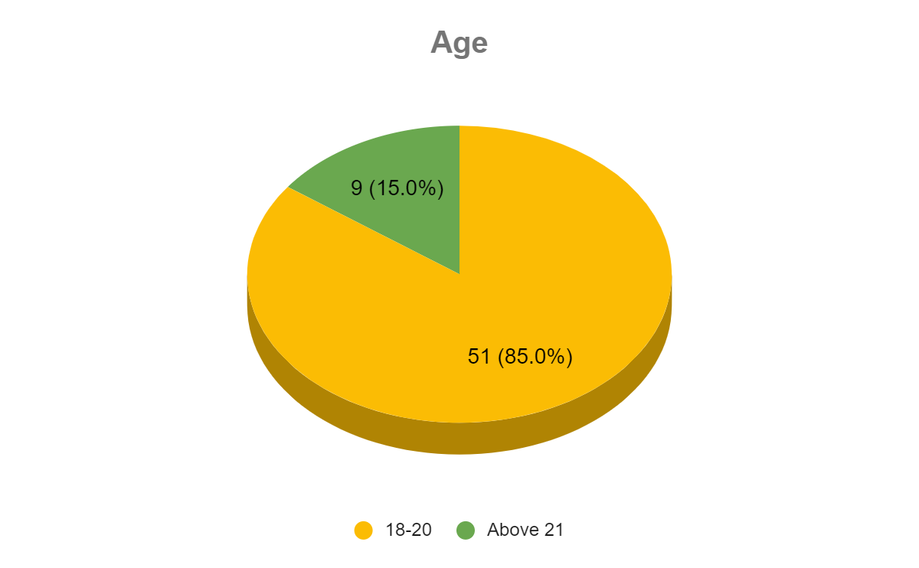

GENDER:

* 53% of the sample size was male.
* 47% of the sample size was female.

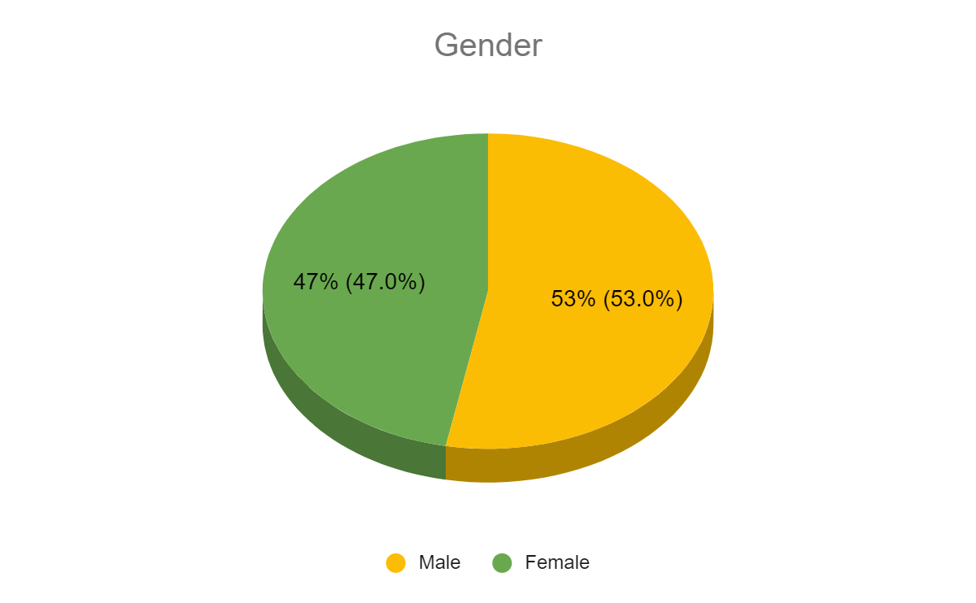

EDUCATION:

* 40 of the respondents who participated in this research were pursuing graduation.
* 7 of them were pursuing their post-graduation
* 13 were those students who enrolled themselves in the online certification courses offered by particular Ed-Tech companies to enrich their skills beyond.

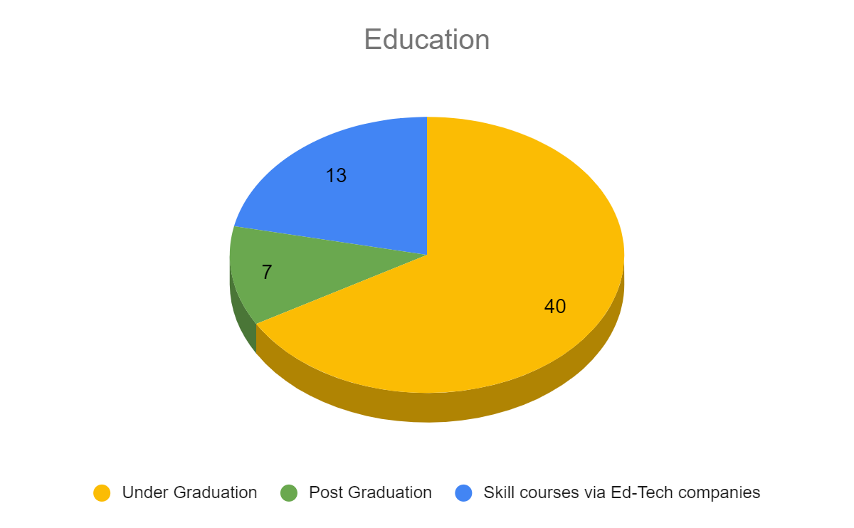

QUALITY ASSESSMENT

This section enables us to determine the impact of online learning on students.

Some of the responses to the questions asked to the respondents based on the comparison between traditional and online mode of learning are mentioned below:

Question 1:

Which of the two is a more convenient mode of education in terms of learning?

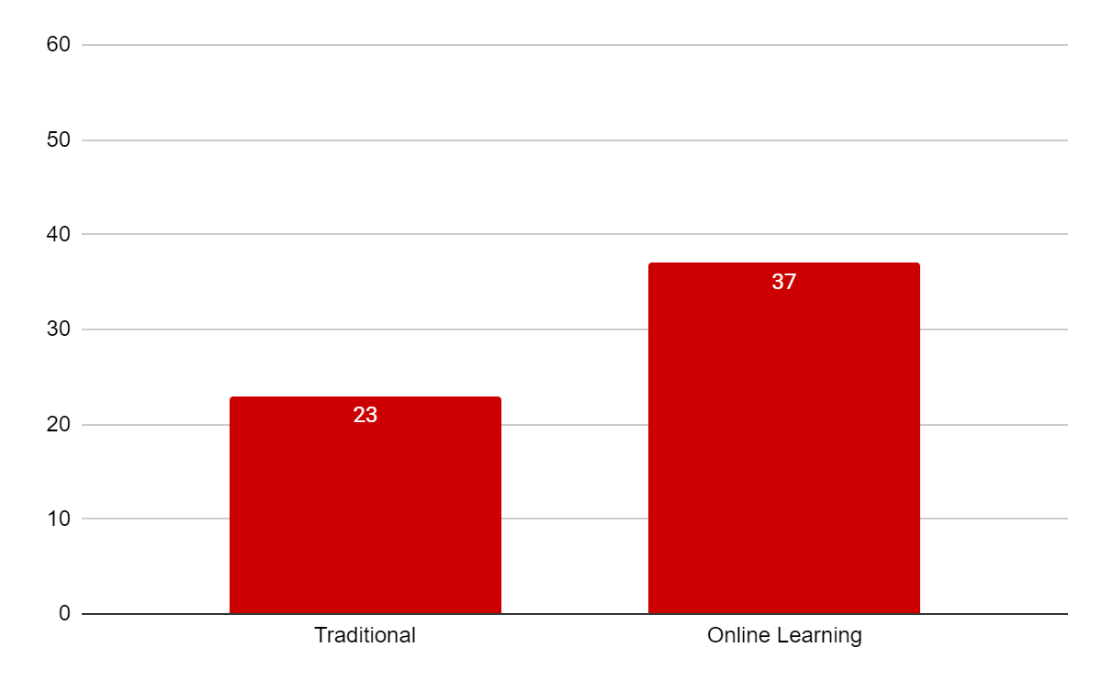

* The graph shows that 37 out of the students responded to the questionnaire found the online learning method more convenient in terms of learning than that of the traditional method.
* 23 out of the sample size still believes that the conventional method of learning is better than online learning in the terms mentioned.

Question 2:

Is the e-learning mode of distance learning better at time efficiency?

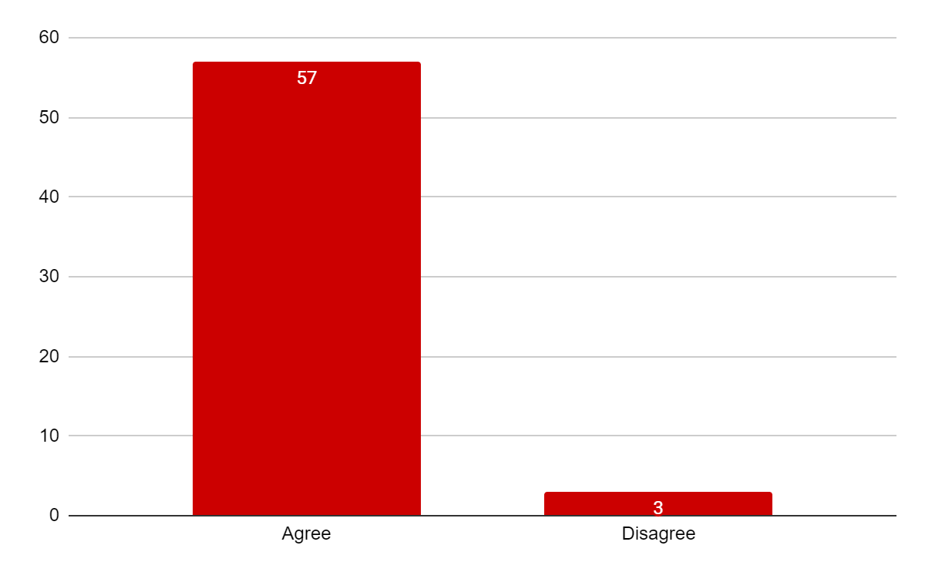

* Almost everyone agreed with the online learning being time-efficient over the conventional method.
* Still 3 people disagreed.

Question 3:

Were technical issues a concern while adapting to this paradigm shift?

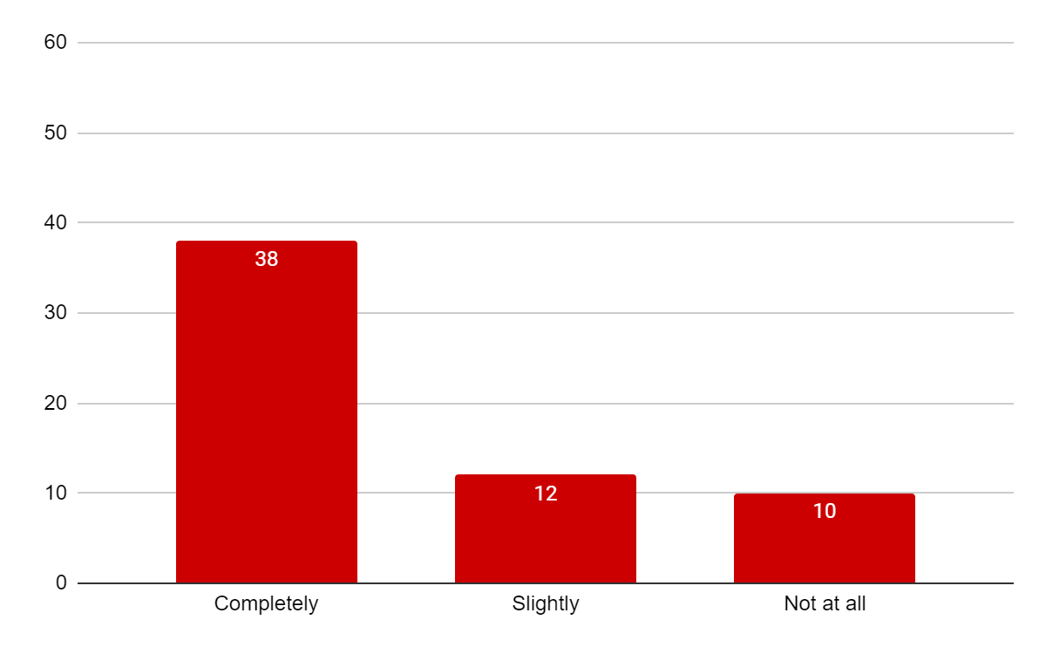

* Technical issues and problems faced by the students due to lack of advancements and updated technologies led to these statistics where most of the students went with the option of either “completely” or “slightly” while answering to this question.
* Lack and poor connectivity among various parts of the regions also made it difficult to optimize this opportunity with full durability.
* A very less population of respondents did not face any issues regarding technology that reassures that there is hope for the betterment in this field.

Question 4:

Is this mode expensive or cheaper than the older one?

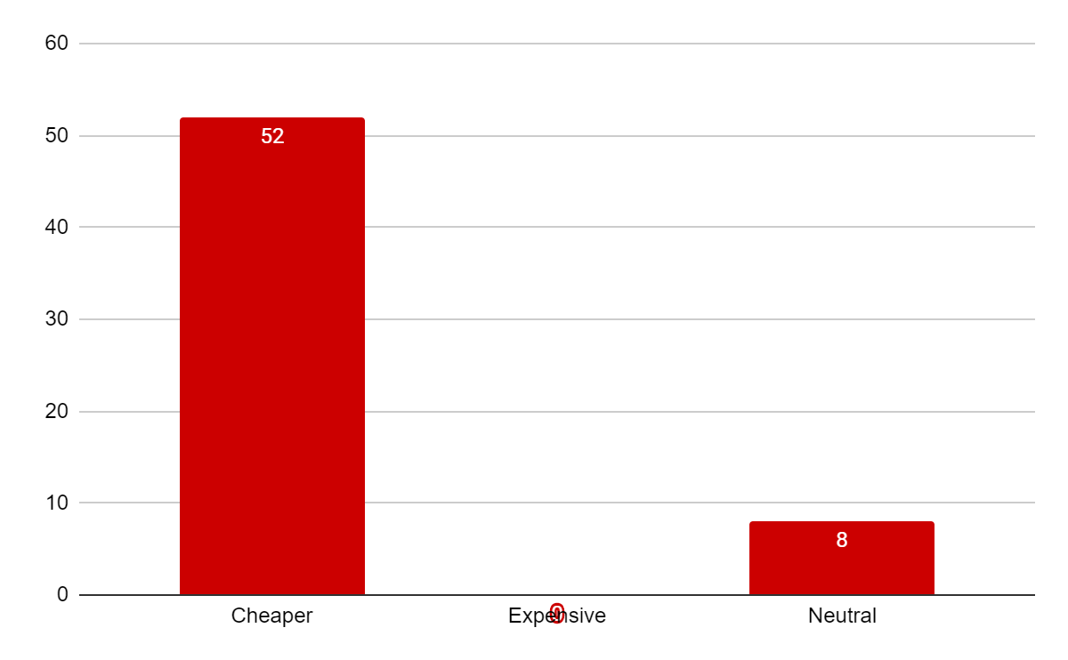

* Most of the population of the participants believed in the e-learning being cheaper than the traditional method.
* None of the participants responded that online learning is expensive.
* Although, 8 students did not notice any change in the expense and replied neutrally as they believed both the mode costs the same.

Question 5:

Which mode is better in terms of the problem-solving of students?

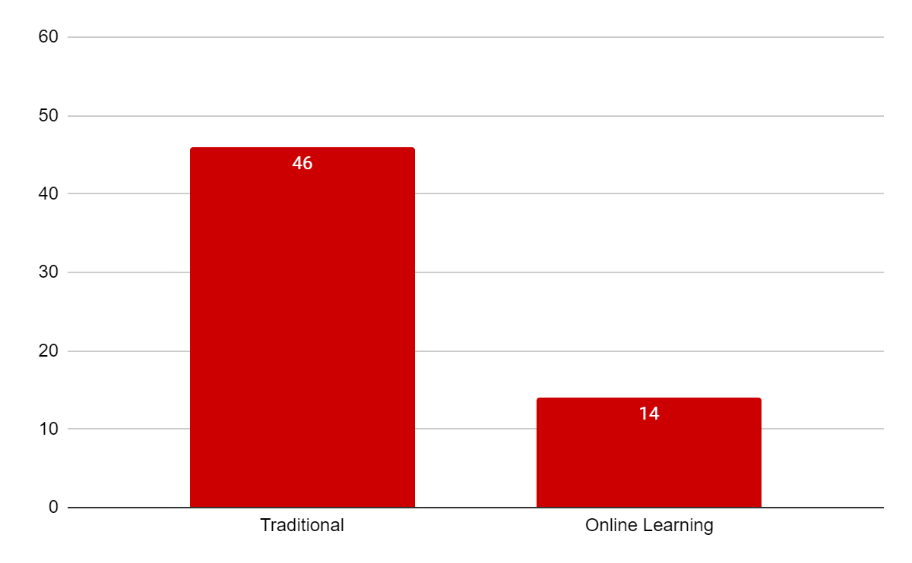

* 46 students feel that the traditional method helps them better than the e-learning method in terms of problem-solving and clarifications of doubts students do or might have.

Question 6:

Comparison in terms of accessibility:

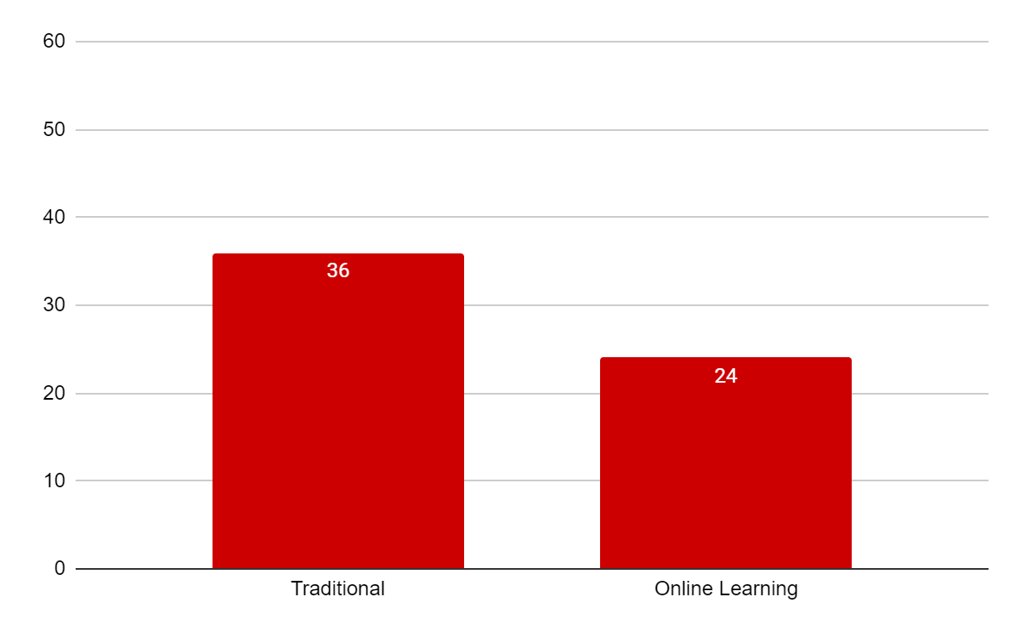

* Around 60% of the sample size believes that the accessibility to the e-learning is less accessible and they find it hard to pursue their education while choosing the online method.

Question 7:

Efficiency in giving examination:

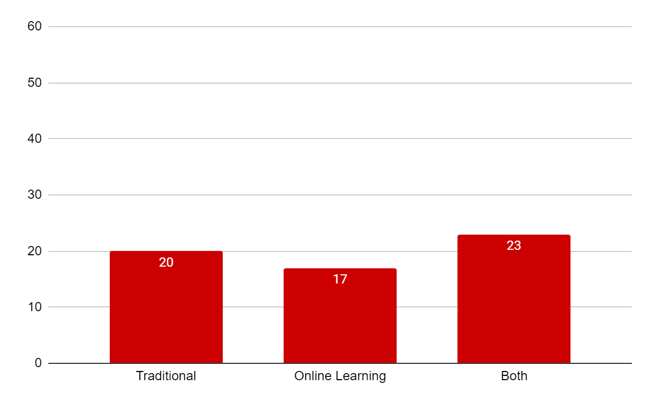

* 20 out of 60 students preferred the traditional method over an e-learning platform in order to conduct or appear for an examination.
* 23 of them found no difficulty in neither of the methods.

Question 8:

Interaction with faculties:

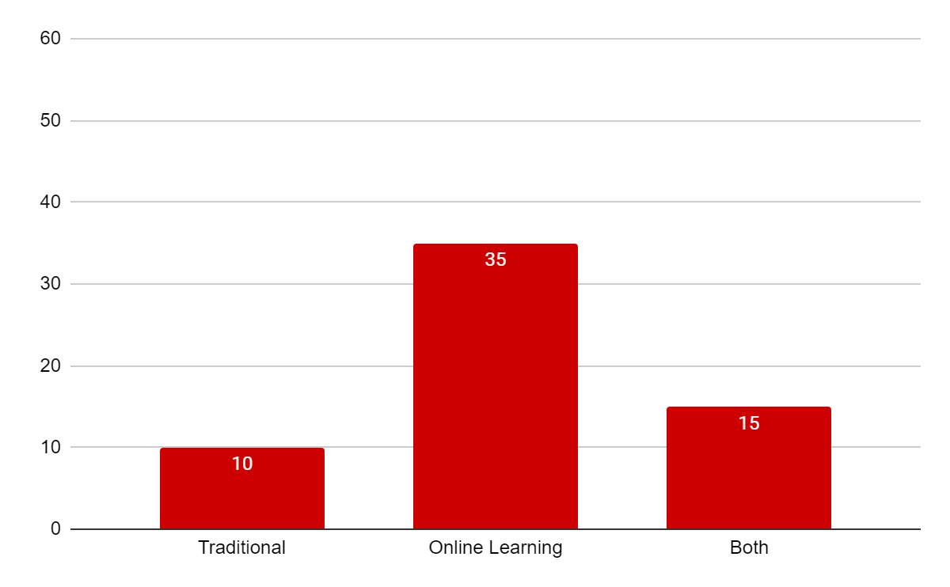

* Surprisingly, approximately 60%(58.33% to be exact) of students found online learning to be an effective alternative to learning as they believed it is a better way to help them interact with their faculties.
* 25% of the students voted for both methods to be equally effective.
* It is safe to say that around 84% of the respondents engaged in the research find it comfortable when it comes to interacting with the faculties.

FINDINGS

Following points are the observational findings by the researcher on the basis of responses provided by the participants to the questionnaire and their additional statements regarding their views:

1. E-education and classes have clearly made learning easy for a majority of the students as they find it convenient over the traditional methods.
2. This mode has enabled the students to save their time and engage the saved time into something productive while they can.
3. Despite being the fact that online learning is far less time consuming, a considerable number of the population of students find it hectic and difficult to cope up with the technology and its advancements on a regular basis and faced troubles while shifting learning through the web.
4. A great majority of students believed that e-learning is cost-friendly.
5. In addition to the technical issues, e-learning comes with another drawback which is concerned with the lack of personalization. Although it can teach a majority of students at the same time, but the students’ queries may or may not be cleared properly as it should be.
6. Although almost every student is a user of some sort of technology like a smartphone or a pc but still the connectivity issue still lies in several parts of almost every state. As this medium demands a better and working technology like internet connection, this mode can not reach out to everywhere hence creating the limitations of accessibility.
7. Several examinations have already made an online access. A few of the examples are- entrance exams, tests concerned with online courses, several universities have adopted LMS in order to conduct an online quiz for their students. It might sound easy but it can be a problem too. According to the survey, there are several technicalities that a student might face during their test or examination. For example, the connectivity issue can lead to a wrong submission of response which a student might not intend to do so, and one of the common issues which students revealed is that they could not correct or rewrite the responses to the questions in these online examinations as they need to submit a confirmed response in order to proceed further.
8. Surprisingly, online learning enabled a majority of students to interact with the faculties. Besides being less effective on the doubt clarification and faculties not able to solve each and every students’ problems, this mode has allowed many students to open up with their faculties. The biggest contribution to this percentage consists of “introverts” as this research has got the responses. Evaluating the comments of the students, what we found is that introverts finally got a chance to cope up with their fear of speaking in front of strangers or a group of people, they now can sure open up with their mentors and faculties primarily via chat messages and texts.
9. E-learning is limited and is not able to include various courses in the curriculum of academics which require personal presence like, art, games, music, sports, etc.

CONCLUSION

After food, it's education that has posed because of the second greatest challenge for contemporary India. This is a sector where the government should have pumped in more funds but unfortunately didn’t. The consequences can not be brushed aside. But, as the entire world is struggling with the coronavirus outbreak, almost every educational institution was forced to shift to online education. Poor internet connections and service in several parts of almost every region of the nation has shown the concern that this platform needs action. Comparative research on learning outcomes in distance education versus face-to-face instructional settings features a long history, reaching back to the 1920s. The findings of hundreds, perhaps thousands of studies, over the decades and through the 1990s have been consistent-there are not any significant differences in learning outcomes achieved by students engaged in face-to-face instruction compared to those participating in distance education. This holds true regardless of the technology medium used, the discipline, or the sort of student. Beginning around 2000, several studies, including meta-studies (review and analysis of many studies selected for his or her rigor), began to seek out significant differences in favor of online learning. These studies culminated in 2010 with a report from the U.S. Department of Education “Meta-Analysis and Review of Online Learning Studies.” E-learning has opened a new window of opportunities for those who craved for further studies. In a way, it's helped numerous professionals, dropouts, housewives, etc. to complete their course o education they wished to. Online learning has also helped those students who wish to go for higher studies. If one wishes to get the maximum benefits of online learning, then they must get a job and work side by side because work experience matters a lot. Online learning is flexible with context to time. Students can fix the timing of their lessons according to their schedule. This mode is a cheaper mode than that of the conventional method of learning. This research concluded that online learning has helped students in many ways and not only limited to what they were willing to learn or had an objective at the beginning of it. There are statistics showing how introverts are being helped with their fears to overcome. This might remove the very first and the most common barrier of getting a good quality of education as the lack of communication increases the chances of failure for a student at a very early stage which only increases with age. Despite being the fact that online education demands a little bit of technical knowledge but can be of great help if used correctly.

RECOMMENDATIONS

* In accordance with the research, the biggest challenge the came out in light is the technology and connectivity issue which can and should be resolved.
* More focus should be on students learning and their problem-solving. E-learning should be students oriented not the technology.
* Accessibility can be increased by using such online services that do not require much technical knowledge.
* The scope of improvement in the quality of education in online programs is considerable.
* The faculties should be more interactive with the students as it is difficult to evaluate whether the students are understanding their teachings which is much easier in the traditional method.
* Rather than focusing on theoretical concepts, more focus should be on practical knowledge.
* The study-friendly environment should be created as it is difficult to keep the students engaged while conducting online lectures.
* Creative teaching methods should be adopted in order to make e-learning better not only in terms of cost-friendly or timely but also in the context of education as well.
* Technical support, assistance, and proper guidance is one of the major responsibilities of these institutions while conducting online lectures and they should provide their students with proper assistance with these technologies.
* The use of those services that require less assistance on the technology should be encouraged like YouTube.

BIBLIOGRAPHY

* <https://en.wikipedia.org/wiki/Online_learning_in_higher_education>
* <https://books.google.co.in/books?hl=en&lr=&id=vEYlDwAAQBAJ&oi=fnd&pg=PP1&dq=Learning+theory+and+online+technologies+linda+harasim&ots=h0MvV8hZoK&sig=xshDVjq7HETTZj6SQKtV9vGSUXg#v=onepage&q&f=false>
* <https://eric.ed.gov/?id=EJ1182388>
* <https://en.wikipedia.org/wiki/Udemy>
* <https://en.wikipedia.org/wiki/BYJU%27S>
* U.S. Department of Education. (2010). Evaluation of Evidence-Based Practices in Online Learning: A Meta-Analysis and Review of Online Learning Studies. <https://www2.ed.gov/rschstat/eval/tech/evidence-based-practices/finalreport.pdf>