**MAJOR RESEARCH PROJECT**

**“Success of CRM in public and private sector banks"**

**Submitted By-**

**Himani Malhotra**

**(2K18/MBA/113)**

**Under the Guidance 0f**

**Dr. Shikha N. Khera**

**Assistant Professor**



**DELHI SCHOOL OF MANAGEMENT**

**Delhi Technological University**

**Bawana R0ad Delhi 110042**

**CERTIFICATE FROM THE INSTITUTE**

This is to certify that the project report entitled, “**Success of CRM in private and public sector banks**”, is Bonafede record of work done by **Ms. Himani Malhotra** submitted to Delhi School of Management, DTU in partial fulfillment of the requirements for the award of the degree of **MASTER OF BUSINESS ADMINISTRATION** under my supervision and guidance.

**Dr Shikha N Khera Dr. Rajan Yadav**

**Assistant Professor Professor**

**Project Guide HOD**

**STUDENT UNDERTAKING**

I hereby declare that this project work entitled **“Success of CRM in private and public sector banks”** is a record of the project work carried out by me under the guidance of **Dr. Shikha N Khera**, Assistant Professor of MBA Department of Delhi School of Management, DTU in partial fulfillment of the requirements for the award of the degree of **MASTER OF BUSINESS ADMINISTRATION**.

I also declare that this project report has not been submitted by me, fully or partially for the award of any other degree, diploma, title or recognition before.

Himani Malhotra

2K18/MBA/113

**ACKNOWLEDGEMENT**

At the outset, I express my heartfelt thanks & gratitude to those who sincerely helped and supported me throughout the project & without their active support & help it would not have been possible for me to complete the venture. As such, I once again extend my sincere thanks & gratitude to all of them.

To this effect, at first, I take the opportunity to express my profound gratitude and deep regards to my mentor Dr. Shikha N Khera for her active guidance and constant supervision together with time to time providing of necessary information connected with the project and her active support in completing the project.

Finally, I would like to express my earnest gratitude to my friends and family members for their constant support & encouragement without which the assignment would not have been completed.

## 

### LIST OF CONTENTS

|  |  |  |
| --- | --- | --- |
| S. N0. | Particular | Page  N0. |
|  | Title page |  |
|  |  |  |
|  | Certificate | i |
|  | Declaration | ii |
|  | Ackn0wledgement | iii |
|  | Executive Summary | iv |
|  |  |  |
|  | CHAPTER-I |  |
| 1.1 | Introduction | 1 |
| 1.1.1 | Literature Review | 1 |
| 1.1.2 | Objectives of the study | 2 |
| 1.1.3 | Scope of study | 2 |
| 1.1.4 | Limitations of study | 2 |
|  |  |  |
|  | CHAPTER-II |  |
| 2.1 | Research Methodology | 3 |
|  |  |  |
|  | CHAPTER-III |  |
| 3.1 | Mean ratings of CRM initiatives | 4 |
| 3.2 | Results of the observations | 4 |
|  |  |  |
|  | CHAPTER-IV |  |
| 4.1 | Analysis and Interpretation | 5 |
| 4.1.1 | Prescriptive | 7 |
| 4.1.2 | Descriptive | 12 |
|  |  |  |
|  | CHAPTER-V |  |
| 5.1 | Suggestion | 15 |
|  | Refrences | 16 |
|  | Articles | 17 |
|  | Journals | 18 |

**EXECUTIVE SUMMARY**

The CRM rehearses are received to create better comprehension of the client for item advancement, division, fitting focusing on, crusade the board and upkeep of long haul gainful and commonly helpful associations with clients. CRM is the system for building, overseeing and reinforcing faithful and enduring client connections. CRM is a client driven methodology dependent on client knowledge. Its definitive goal is towards 'Customized' treatment of clients as unmistakable elements through the recognizable proof and comprehension of their separated needs, inclinations and practices. Client Relationship Management is the joining of two foundations of Indian banking viz. innovation and relationship showcasing.

The examination will be led to perceive how effectively and productively the client relationship the executive’s apparatuses are sent in broad daylight just as the private segments bank.

Over the span of the investigation I went over different issues with the financial framework, how proficiently the banks are sending their client relationship the board devices.

What is the diverse Customer relationship the board devices that are being utilized in different open and private division banks?

As our examination center around correlation of bank type to different CRM variables of client administrations gave by the various sorts of bank, here the scientist has made an endeavor to organize and picture different tables of bank type and client related CRM factors dependent on the information accessible that was gathered through reviews. The specialist has taken perspective on respondents on CRM factors in five scales to be specific poor, beneath normal, normal, great and brilliant. It will give us immersion perspectives on respondents. For getting general impression of different components of feel the last two scales (great and fantastic) given by client to the factor are thought of.

Through this examination I will have the option to reveal insight into how a client sees private and open financial frameworks through client relationship the board factors.

Different aspects of the examination remember the client’s discernment for the upkeep of CRM through elements, for example, the simplicity of documentation, brand picture of the bank, the reliability of the bank

Discoveries will be found out on how It can possibly realize dynamic changes in advertising practices of banks in not so distant future, with the target of business development through overseeing clients as resources, efficiently gathering, breaking down and scattering client data and utilization of this client data for obtaining, holding and better overhauling clients.

## CHAPTER I

* 1. **INTRODUCTION**

Customer Relationship Management (CRM) is comprehensive business strategy. It helps business to organize its activities around the customer.

The CRM is a new technique in marketing where the marketer tries to develop long term relationship with the customers to develop them as life time customers. CRM aims to make the customer climb up the ladder of loyalty.

Customer Relationship management focuses on satisfying the customers by employing methods of customer

Satisfaction this can be done by employing a strategy of customer retention, proving rebates, coupons and premiums the main focus of customer satisfaction is that the customer should be happy and satisfied with the services the organizations are offerings.

Especially for banks as the whole process of banking is dependent upon the customers and customers satisfaction it is important for banks to employ the methods of customer satisfaction.

This in banking can be done by deploying initiatives to meet the necessary standards of customer satisfaction.

* + 1. **LITERATURE REVIEW**

**Uma Shankar Mishra(2011)** her work focuses on the successful implementation of CRM software’s in public and private sector banks, she through her analysis for which she collected samples of 242 people clubbed into different homogenous groups has indicated that private sector banks with smooth running CRM software’s are more preferred than the CRM software’s in public sector banks.

Her study also indicates that less educated customers are more inclined towards the public sector banks whereas the more educated people are more inclined towards private sector banks.

**Yevhenii Ostroverkh (2019)** he explains the importance of and need for CRM in the banking industry for 3 important reasons i.e. to retain the potential customers, to set standards that resonate with the growth of the bank, to turn the rough and raw data into meaningful and usable data. He explains the inclusion of CRM software’s into banking industry could reap many advantages to the customers also as the customers can have personalized servicers. He further explains the importance of CRM in the banking industry by taking two algorithms into account a bank with an integrated CRM software would offer personalized solutions and suggestions to the customer whereas the bank without with integrated CRM will offer a same scheme of typical answers will results in decreased loyalty and an unsatisfied customer.

**C.Rootman (2007)** He tries to attribute the success of customer relationship management to the attitude of bank employees. He through his investigation tries to explain that a positive relationship

Exists between the attitude of the bank employees and the success of CRM.

He also recommends that the banks should focus on improving both the knowledgeability and

Attitude of bank employees to ensure high levels of CRM. The more increased know legibility

Of employees will lead to more efficient implementation of CRM.

**Marko Lakita (2015)** He explains that the CRM framework can provide competitive advantage to banks if they focus on long term actors who are of great importance and the banks satisfies these actors through the framework of CRM. His work suggests that the CRM implementation tries to adjust the market needs well and cater the personalized solutions to the customer. His work also represented the possible failures of CRM implementation failures such as organizational changes, poor understanding

Of the CRM concept and employees’ poor skills were the common reasons of CRM failure but further Study of the subject showcased collection of personalized data and integration of the CRM concept with Technology can be other major reasons.

**Ahmad K. A Smoudy(2019)** He explains that different banks interpret CRM differently while some banks take it as a unit dedicated to the customers, detailing their information regarding their accounts Etc. Others may describe it as a customer service feature but not limited to opening and transaction of the accounts.

* + 1. **OBJECTIVES OF THE STUDY**

As our study focus on the basic dimensions will are helpful in meeting the customer needs, we will study how the customer react to the different factors of the customer relationship management and we will also see if any demographic factor is responsible for the selection of the bank.

* + 1. **LIMITATIONS OF THE STUDY**
* There was a lot of inconvenience in collecting the data for the survey
* As the data of only 61 respondents the research used it does not represent a true picture
* Not much information regarding the CRM tools was available online the investigator had to gain information on the above said topic from the bankers working in the concerned banks.

* + 1. **SCOPE OF THE STUDY**
* The study was focused on the implementation of CRM strategies and tools in various leading banks.
* The Study also Compares the CRM strategies deployed.

**CHAPTER II**

* 1. **RESEARCH METHODOLOGY**

The effectiveness and the challenges of the deployment of the customer relationship management

tools and the customer satisfaction towards the customer relationship management tools has been assessed on the basis of personal and group interviews of the customers of the concerned bank and the method used was the questionnaire method deployed through various mediums such as google forms and personal interviews.

The information on various CRM tools was assessed through various channels such as the bankers working with the specific bank.

**2.2 CHALLENGES FACED WHILE IMPLEMENTING CRM**

Mentioned below are some of the challenges that the organizations are facing regarding the proper employment of the CRM initiatives

* Vague understanding of the customer needs and wants
* Rolling out the CRM activities without a proper customer retention strategy
* Tough competition from the competitors
* Inefficient technological solutions
* Rude and disrespectful staff.
* Ignoring the customers complaints and suggestions.
* Complex customer database
* Changing demand of the customers
* Ever evolving technology
* Skeptical customers.
* Shortage of resources.
* Not enough attention given to the minute details regarding customer data and their satisfaction.
* Same methodologies for dealing with a diverse group of customers.

**CHAPTER III**

**3.1** **MEAN RATINGS OF CRM INITIATIVES**



**3.2 RESULTS FROM THE OBSERVATIONS**

* Out of 13 CRM factors open part banks lead in administration charges, near loan fees, adequate branches.
* factors that indicated significant contrast among private and open banks were quality programming, proficient staff,24 hr. client care.
* it was seen that there was no significant distinction for factors like adequate ATM's and Center.

**CHAPTER IV**

* 1. **PUBLIC VS PRIVATE BANKS**

Effort was made to decode the choice of bank from the customers perspective. The researcher has tried to tabulate the information obtained in the descriptive and prescriptive form of analysis.

The information was obtained through an online questionnaire the main determinants of the questionnaire were the CRM initiatives and the respondents were asked to rate the factors according to their preference

The data so calculated was inputted in the form of tables graphs and pivot diagrams in order to achieve a smooth processing in Microsoft excel and IBM spss.

* + 1. **DESCRIPTIVE ANALYSIS**

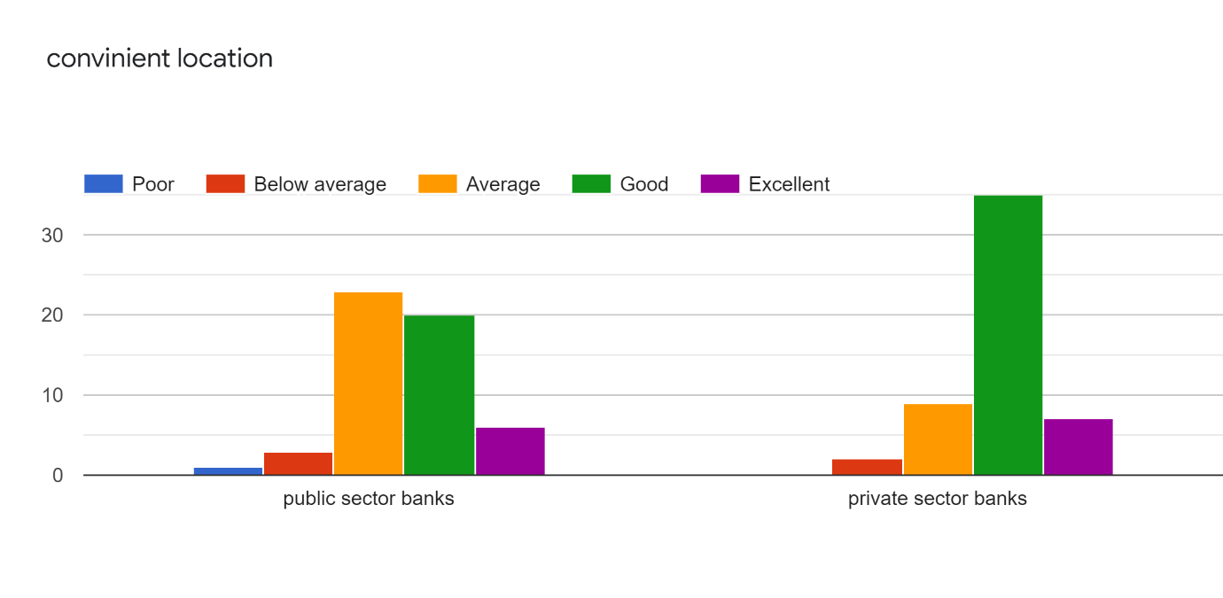

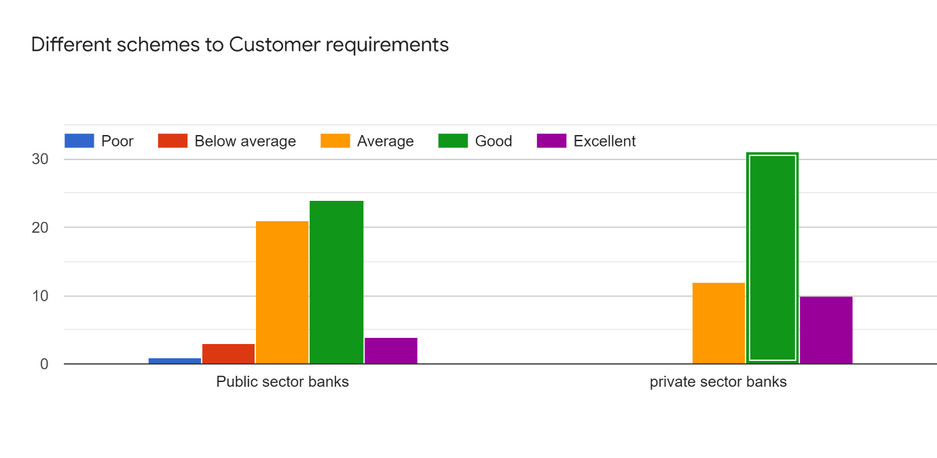

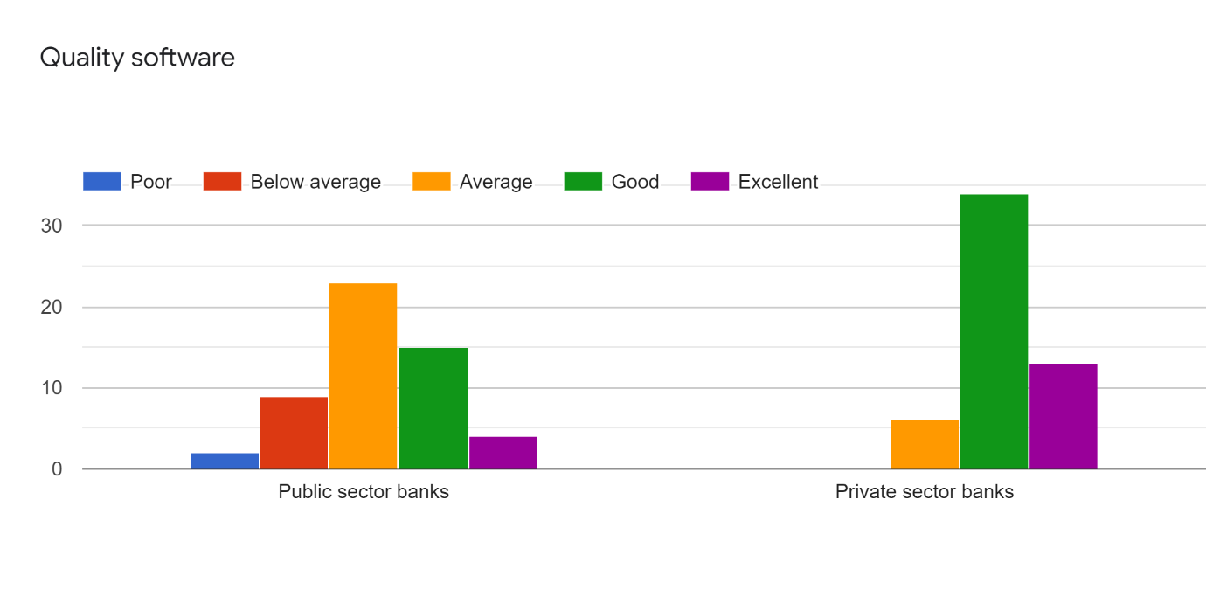

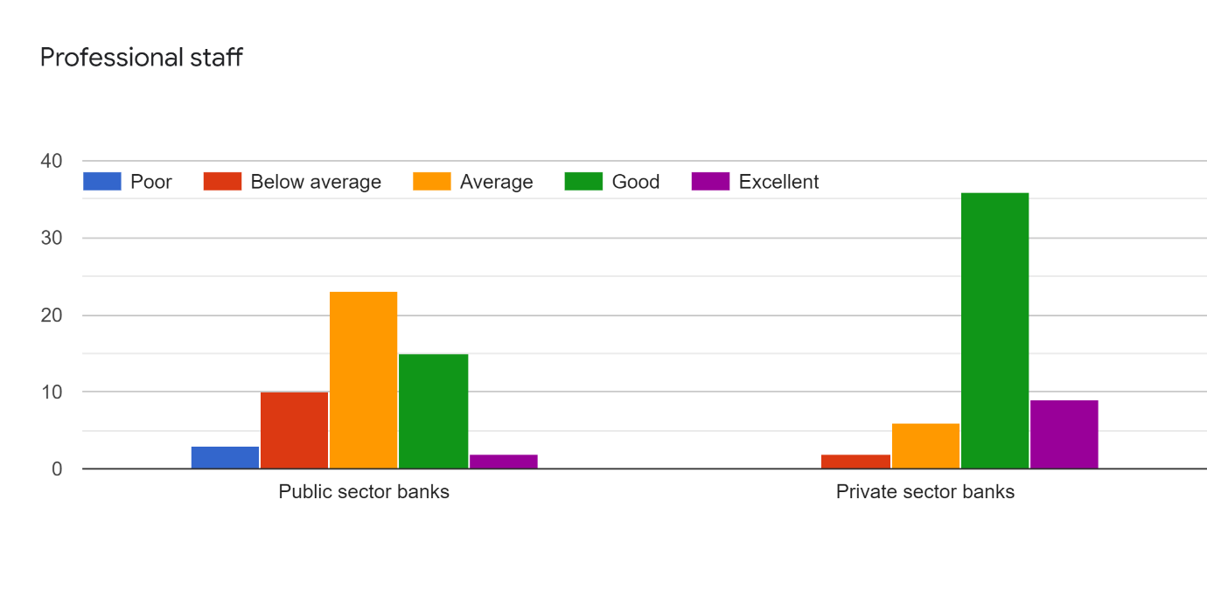

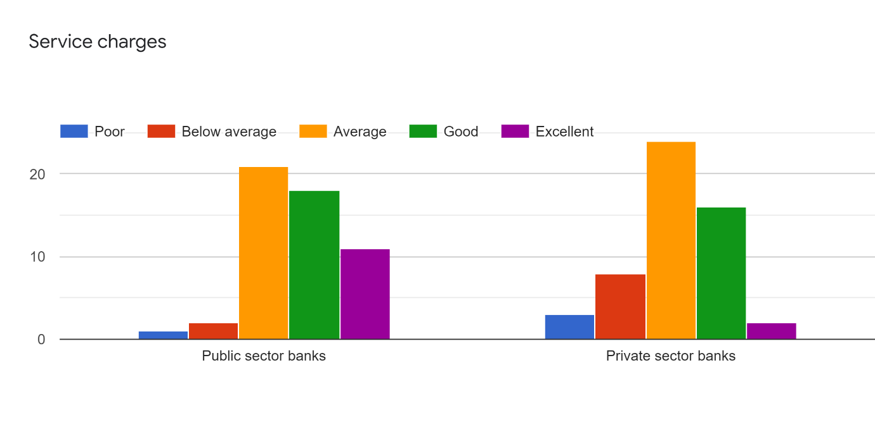

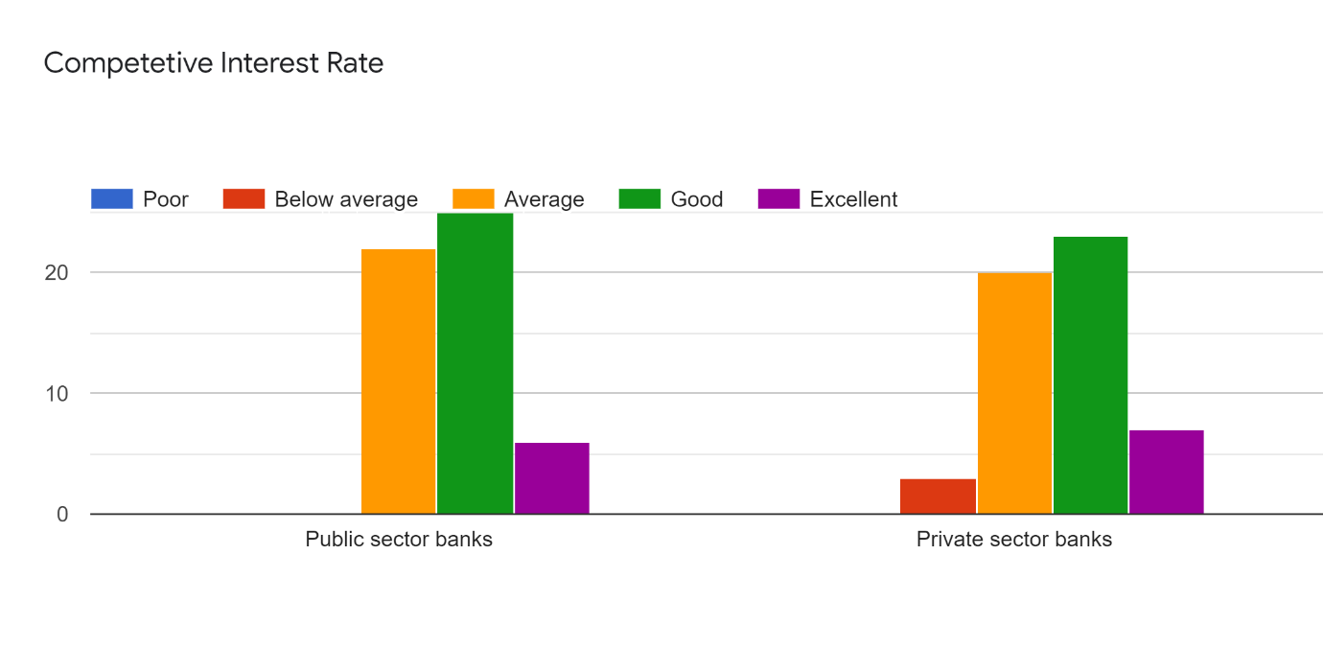

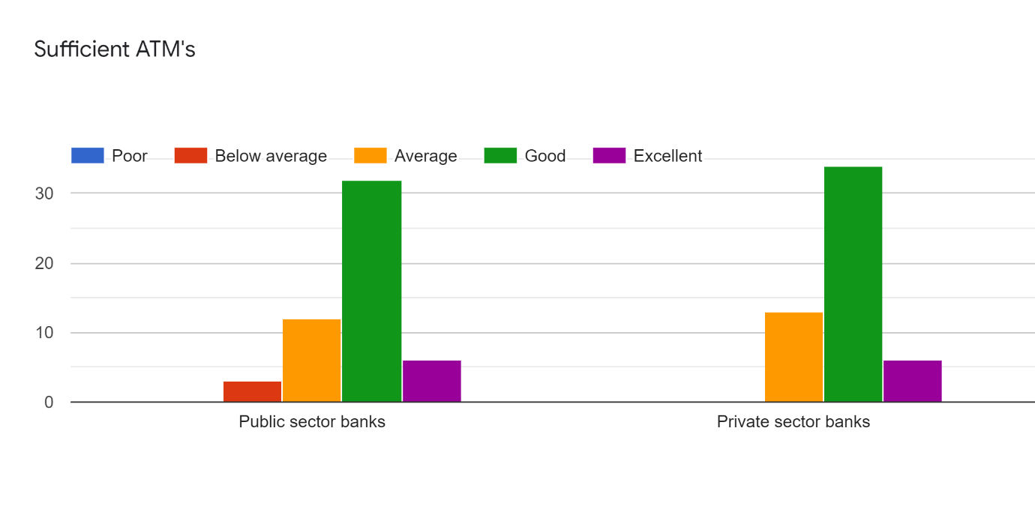

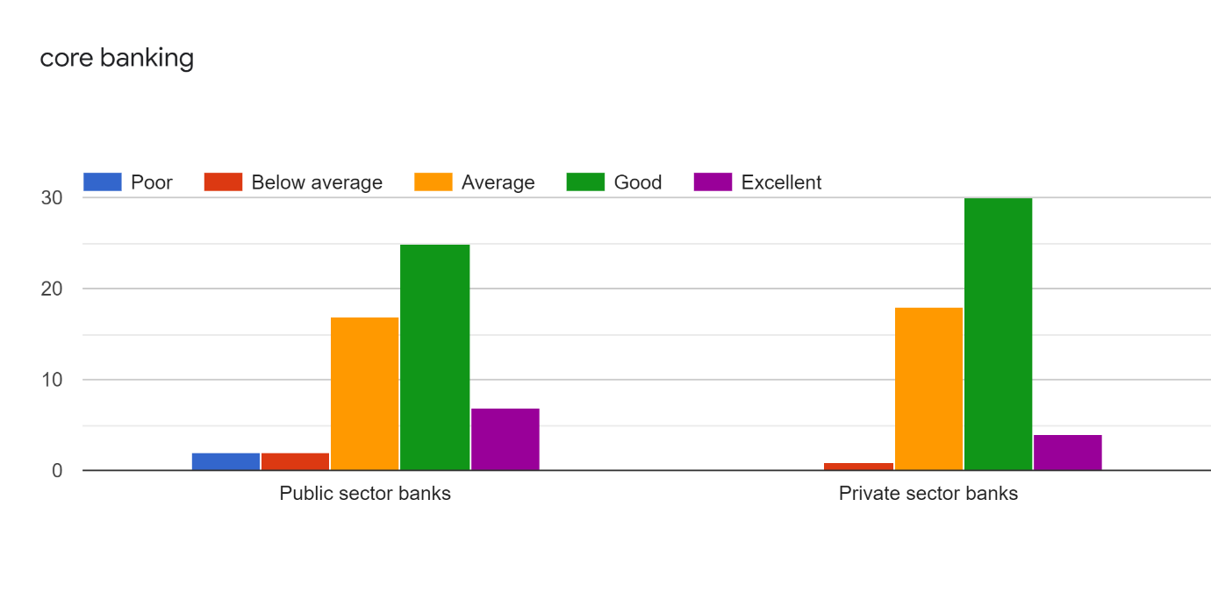

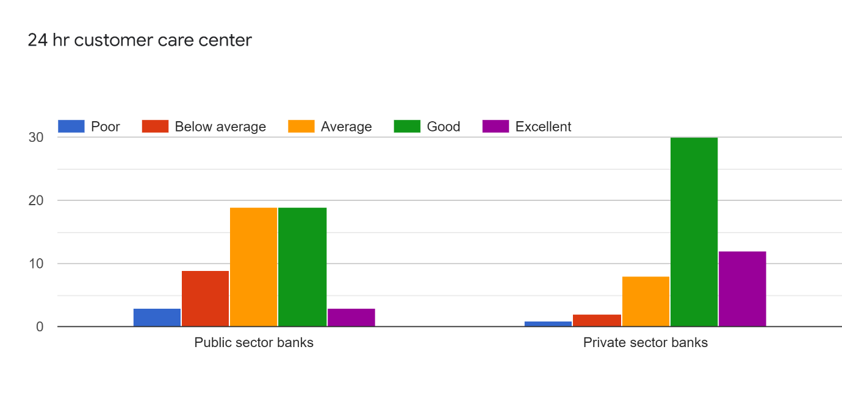

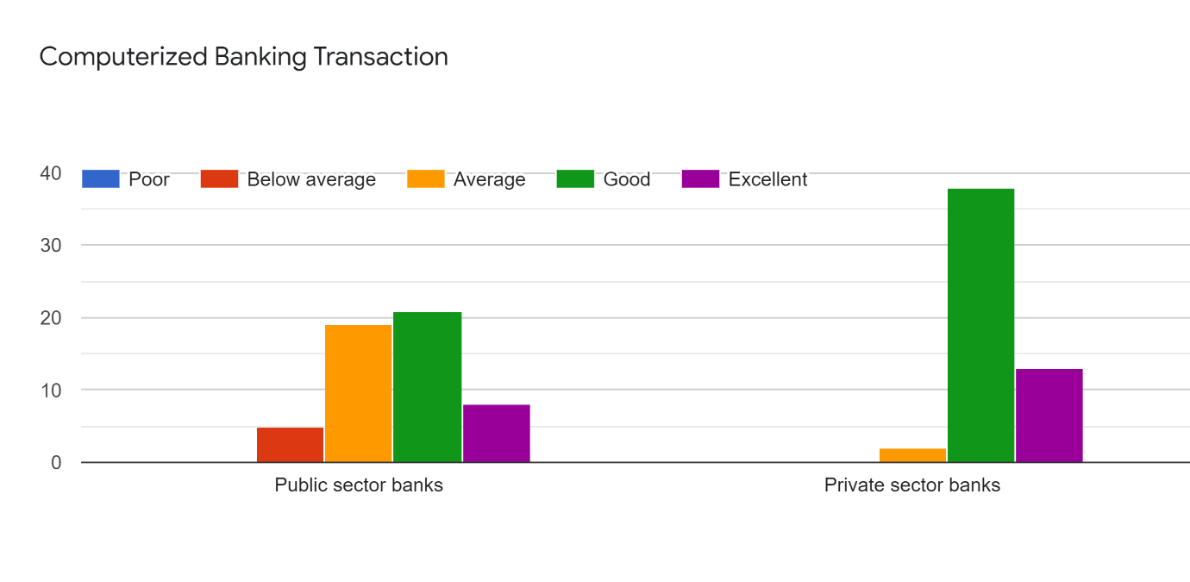

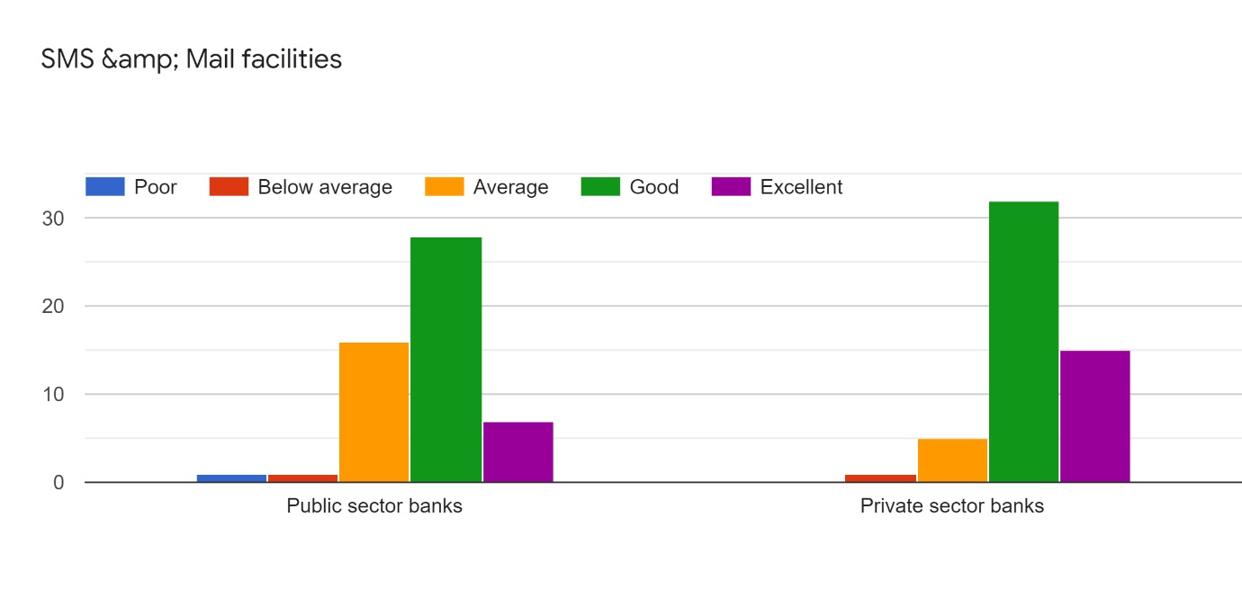

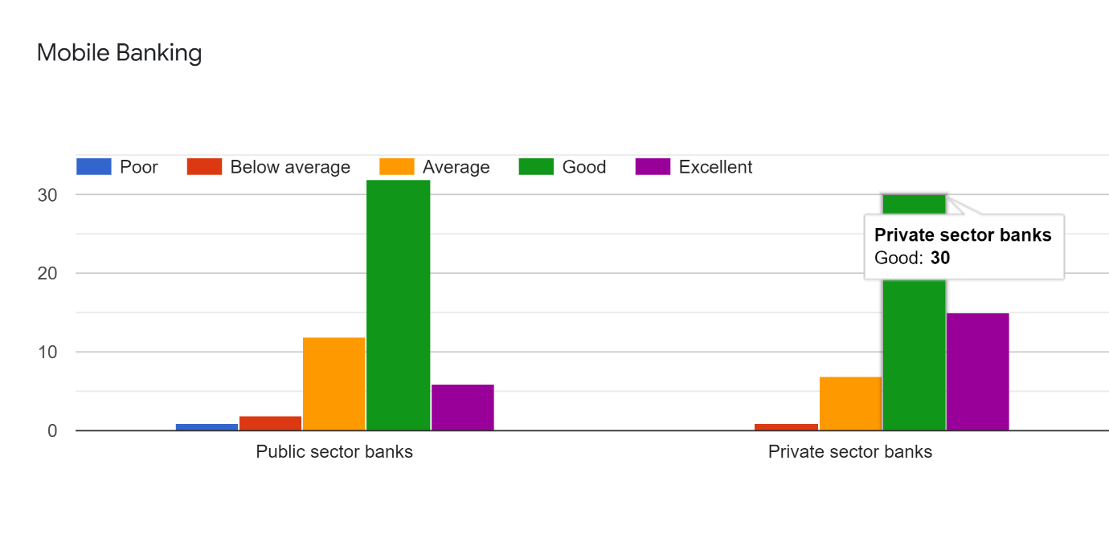

* + - 1. INTERPRETATION

Objective : To determine which type of bank has is more preferred in terms of the below listed factors

|  |  |  |
| --- | --- | --- |
| **FACTORS** | **Responses** | **Type** |
| Cooperative staff | **37** | **private** |
| Interest rates | **25** | **Public** |
| Online banking facilities | **35** | **private** |
| Branch availability | **35** | **private** |
| Security | **39** | **Private** |

Inferring the data from the Graphs and using **Descriptive analysis** we can say that private banks are more preferred in terms of professional staff, interest rates, banking facilities and branch availability.

These are some of the major factors in selecting the type of bank while private sector banks are more holistic in their functioning public sector banks are offering core beneficial services but they need to focus on factors that can improve their brand image manifold.

* + 1. **PRESCRIPTIVE ANALYSIS**

**Chi square test:** The basic format of going about a data analysis part is to determine if it is a two tailed test, one tailed test whether the information available was quantitative, qualitative etc.

|  |  |
| --- | --- |
| Type of Data | Analysis |
| One Categorical data | Graphs/ Weighted Average |
| Two Categorical data | Chi squared test |
| One Numerical | T Test |
| One numerical plus One categorical | T Test/ Annona |

Objective : To study if there is a relation between gender and the choice of bank

Ho : There is no relation between gender and the choice of bank

H1: There is a relation between gender and the choice of bank

Analysis : To analyze the above defined problem IBM SPSS software was used, the responses

Obtained through the questionnaire were exported to the data sheet.

**INPUT: Crosstabs-Statistics-Chi square- Phi & Cramer’s V**

**OUTPUT:**

GET DATA

/TYPE=XLSX

/FILE='C:\Users\Dell\Desktop\links\gender bank responses.xlsx'

/SHEET=name 'Sheet1'

/CELLRANGE=FULL

/READNAMES=ON

/DATATYPEMIN PERCENTAGE=95.0

/HIDDEN IGNORE=YES.

EXECUTE.

DATASET NAME DataSet1 WINDOW=FRONT.

CROSSTABS

/TABLES=GENDER BY PREFEREDBANK

/FORMAT=AVALUE TABLES

/STATISTICS=CHISQ PHI

/CELLS=COUNT

/COUNT ROUND CELL.

|  |  |  |  |  |  |  |
| --- | --- | --- | --- | --- | --- | --- |
| **Case Processing Summary** | | | | | | |
|  | Cases | | | | | |
| Valid | | Missing | | Total | |
| N | Percent | N | Percent | N | Percent |
| GENDER * PREFERED BANK | 53 | 100.0% | 0 | 0.0% | 53 | 100.0% |

|  |  |  |  |  |  |
| --- | --- | --- | --- | --- | --- |
| **GENDER * PREFERED BANK Crosstabulation** | | | | | |
| Count | | | | | |
|  | | PREFERED BANK | | | Total |
| private | Private | public |
| GENDER | Female | 2 | 10 | 7 | 19 |
| Male | 1 | 13 | 20 | 34 |
| Total | | 3 | 23 | 27 | 53 |

|  |  |  |  |
| --- | --- | --- | --- |
| **Chi-Square Tests** | | | |
|  | Value | df | Asymptotic Significance (2-sided) |
| Pearson Chi-Square | 2.977a | 2 | .226 |
| Likelihood Ratio | 2.955 | 2 | .228 |
| N of Valid Cases | 53 |  |  |
| a. 2 cells (33.3%) have expected count less than 5. The minimum expected count is 1.08. | | | |
|  | | | |
|  | | | |

|  |  |  |  |
| --- | --- | --- | --- |
| **Symmetric Measures** | | | |
|  | | Value | Approximate Significance |
| Nominal by Nominal | Phi | .237 | .226 |
| Cramer's V | .237 | .226 |
| N of Valid Cases | | 53 |  |

* + - 1. INTERPRETATION

P value - .226

Since our P value is more then 0.05, We accept the Ho

Ho: There is no relation between the gender and the selection of the preferred bank

H1: There is a relation between the gender and the selection of the preferred bank.

**Hence there is no relation between the gender and the preference of the type of bank**

**CHAPTER V**

**5.1 CONCLUSION**

The execution of CRM yields various advantages to the bank one of the significant advantages is cost decrease. Also, the incorporated perspective on the client gives the bank a chance to comprehend its clients well and in like manner oblige their requirements with individualized contribution. The execution of CRM has helped the bank to come nearer to its clients and the accentuation has moved from deals to clients. It might be noticed that the bank should build the no. of ATMs as the clients are expanding from every day. The bank can likewise upgrade its working hours i.e., 8 am to 8 pm six seven days Steps ought to be taken to give stopping offices at bank premises. Bank representatives should show politeness towards clients in offering ideal types of assistance at bank. CRM is to be portrayed and utilized as an endeavor wide system in the bank. It ought to be included all the zones of the bank to work in synchronization towards a shared objective of more grounded and long-haul client connections

* 1. **SUGGESTIONS**

There ought to be increasingly more accentuation given by the organization for fulfilling the client up to a peak limit and by giving the utility of each penny of his cash.

•There ought to be more utilization of data innovation.

•The organization ought to be adaptable to twist its principles and methods in the customers favour.

•The organization can convey and create more grounded client holding by giving social and budgetary advantages.

•Banks ought to give CRM preparing to all representatives

**REFRENCES**

1. https://diceus.com/crm-in-banking-choosing-best-option-for-business/
2. .https://www.researchgate.net/publication/281412147_CRM_in_banks_A_comparative_study_of_public_and_private_sectors_in_India
3. https://actacommercii.co.za/index.php/acta/article/view/28
4. http://utmsjoe.mk/files/Vol.%206%20No.%202/UTMSJOE-2015-0602-006-Laketa-Sanader-Laketa-Misic.pdf
5. https://www.econjournals.com/index.php/irmm/article/view/8151/pdf
6. https://www.sagesoftware.co.in/crm-software-for-banking-sector
7. https://www.ukessays.com/essays/marketing/customer-relationship-management-in-indian-banking-sector-marketing-essay.php
8. https://www.ibef.org/industry/banking-india.aspx
9. https://www.upet.ro/annals/economics/pdf/2014/part1/Z.%20Arora-Singh.pdf
10. http://kutaksam.karabuk.edu.tr/index.php/ilk/article/view/709
11. https://pdfs.semanticscholar.org/c5a9/70f707e1f268e52cbb656258af7bfac9b49e.pdf
12. https://www.crmnext.com/customers/hdfc_bank
13. http://www.journalijdr.com/role-e-crm-indian-banks
14. http://www.ijemr.net/ojs/index.php/ojs/article/view/249
15. https://www.slideshare.net/feroz_ahmad/crm-practices-in-banks

**JOURNALS & ARTICLES**

1. Konovalov N, Gromoff A, Vladimirova AV, Gorchakov Y. Can CRM Flexibility Raise Bank Efficiency? Global Journal of Flexible Systems Management. 2020
2. Chen Y, Li L. Deriving information from CRM for knowledge management—a note on a commercial bank. Systems Research and Behavioral Science. 2006;23(2):141-6
3. Eid R. Towards a Successful CRM Implementation in Banks: An Integrated Model. The Service Industries Journal. 2007;27(8):1021-39
4. Kaur J, Kaur B. The Influence of e‐CRM Competitive Advantage on e‐CRM Performance in the Indian Banking Industry. Strategic Change. 2016;25(5):537-50
5. Gupta MP, Shukla S. Learnings from Customer Relationship Management (CRM) Implementation in a Bank. Global Business Review. 2002;3(1):99-122.
6. Kamath KV, Kohli SS, Shenoy PS, Kumar R, Nayak RM, Kuppuswamy PT, et al. Indian Banking Sector: Challenges and Opportunities. Vikalpa: The Journal for Decision Makers. 2003;28(3):83-100.
7. Dutt H, Chauhan K. Using Flexibility in Designing CRM Solution. Global Journal of Flexible Systems Management. 2019;20(2):103-16
8. https://www.tekshapers.com/blog/Important-Role-of-CRM-in-Banking-Sector
9. <http://www.icommercecentral.com/open-access/crm-in-banking-sector-with-special-reference-to-new-age-banks-1-19.php?aid=37978>
10. <https://www.mbaknol.com/management-articles/customer-relationship-management-in-the-banking-sector/>
11. <https://us.hitachi-solutions.com/blog/importance-crm-banking/>