# Project Dissertation Report on

# A study of attributes of mobile phones with respect to the services

### Submitted by

### Ghanshyam

### Roll No: 2K19/DMBA/034

### Under the Guidance of

### Assistant prof. Deepali Malhotra

### Delhi School of Management

# 

# DELHI SCHOOL OF MANAGEMENT

# Delhi Technological University

# Bawana Road, Delhi – 110042

# 

# CERTIFICATE

This is to certify that the work titled **‘The study of attributes of mobile phones with respect to services’** as part of the final year Major Research Project submitted by Ghanshyam in the 4th Semester of MBA, Delhi School of Management, Delhi Technological University during January-May 2021 is his original work and has not been submitted anywhere else for the award of any credits/ degree whatsoever.

The project is submitted to Delhi School of Management, Delhi Technological University in partial fulfillment of the requirement for the award of the degree of Master of Business Administration.

#### Deepali Malhotra Prof. Archana

Faculty Advisor Head of Department (DSM, DTU)

# DECLARATION

I hereby declare that the work titled **‘The study of attributes of mobile phones with respect to services’** as part of the final year Major Research Project submitted by me in the 4th Semester of MBA, Delhi School of Management, Delhi Technological University, during January-May 2021 under the guidance of Assistant Prof. Deepali Malhotra. It is my original work and has not been submitted anywhere else.

The report has been written by me in my own words and not copied from elsewhere. Anything that appears in this report which is not my original work has been duly and appropriately referred/ cited/ acknowledged.

#### Ghanshyam

(Roll No 2K19/MBA/034)

**Acknowledgement**

It is a great pleasure for me to acknowledge the kind of help and guidance received during the research work. I would like to thank my faculty advisor Assistant Prof. Deepali, who helped me to take up the topic ‘**The study of attributes of mobile phones with respect to services**’ and guided me to complete this project properly. The project provided me with an excellent opportunity.

I am highly indebted to Delhi School of Management, Delhi Technological University for giving me an opportunity to work on this project. Lastly, I would like to express my gratitude to all the honorable faculty members for sharing their experience and expertise on this project.

I have put all my efforts to ensure that the project is completed in the best possible manner and ensured that the project is error-free.

**EXECUTIVE SUMMARY**

With the changes taking place in the technology, mobile phones have also evolved. A large number of phones are available in the market, each with its unique features, brand names, different prices etc. Mobile phones have replaced a number of gadgets. India is the second largest consumer of mobile phones in the Asia-pacific. Users of the phone always try to consider various essential factors that may influence their purchasing decision. In this exploratory study, the choice preferences of the respondents are considered for the study.

For making this study successful, various research papers of different scholars, related to the mobile phone attributes, consumers buying behaviour, factors they consider while making a purchase etc. were analysed and studied. All these papers paved a way for further future study and guided in the completion of the project.

The study is exploratory in nature that uses primary source of data from a sample of 50. The sampling technique used for this study is convenience sampling. The objective of the research was classified into three parts. First objective of the project is to identify the emotional considerations that are kept in mind by the buyers while making a purchase decision. The next objective is focused on uses of mobile phones for academic or occupational purposes. The third and the last objective of this study is to find out the awareness of users regarding the harmful dependencies and addiction towards mobile phones. The data were collected using questionnaire method. These questionnaires were sent to the respondents via mails and other social networking sites. After the responses were collected they were analysed and interpreted in the further chapters.

The mobile phone attributes depend upon the utilities and services offered to the users. A mobile phone has multiple functions that help the users in both personal and academic lives. Some of these features include e-books, search engines, playing games etc. Before making a purchase decision, user considers all these features.

The analysis of the collected data revealed the results that majority of respondents were students owning one or more than one phones. They are induced to buy a mobile phone by the price of the phone offered and its reviews. The role of peer and friends while making a purchase decision is of little significance. The study also draws attention on the dependency of users towards mobile phone despite having the awareness about its negative health effects. The last part of the study is conclusion and recommendation. It is suggested to the mobile manufacturers to focus more on improving the product features and providing it at affordable prices. They should also try to take advantage of the emotional considerations of buyers for increasing sales. For the students, this study suggests and recommends them to keep a check on their daily usage of mobile phones and they should try to minimize it, if needed. However the major limitation of this study is that due to the outburst of covid-19, the university was shut down. Due to which the data had to be collected online only, that lacks a personal touch. But, all the efforts are taken to keep the study free from any kind of biasness and to make it reliable for further future applicability in other institutes or places.

**CONTENTS**

SUPERVISOR’S CERTIFICATE.............................................................................................2

CANDIDATE’S DECLARATION..........................................................................................3

ACKNOWLEDGEMENT.........................................................................................................4

EXECUTIVE SUMMARY.......................................................................................................5

* 1. INTRODUCTION...........................................................................................8-11
  2. Mobile phones and its advancement over the years.............................................
  3. Features of mobile phones, as expected by user.................................................

1. REVIEW OF LITERATURE.......................................................................................12-16
2. RESEARCH METHODOLOGY..................................................................................17-18
   1. Objective of research..............................................................................................................17
   2. Scope of research..............................................................................................................17
   3. Research design.................................................................................................................17
   4. Sample design.................................................................................................................17
   5. Data collection............................................................................................................18
   6. Response rate.....................................................................................................................18
   7. Reliability and validity......................................................................................18
3. MOBILE PHONE ATTRIBUTES WITH RESPECT TO UTILITIES

AND SERVICES..........................................................................................................19-24

1. DATA ANALYSIS AND INTERPRETATION..........................................................25-30
   1. Background.........................................................................................................25
   2. General information about respondent......................................................................................................25-26
   3. Emotional considerations................................................................................................26-27
   4. Academic/ occupational uses of the mobile phones............................................................................................................28-29
   5. Harmful impacts and dependencies of mobile phones............................................................................................................29-31
2. CONCLUSIONAND SUGGESTION.........................................................................32-35
   1. Major findings of the study..............................................................................................................33-33
   2. Suggestions and recommendations...........................................................................................33-34
   3. Limitations of the study....................................................................................................................34
   4. Future implication of the study....................................................................................................................34
   5. Conclusion..........................................................................................................35
3. REFERENCES.............................................................................................................36-37

**APPENDICES**

Appendix 1: Cover letter…………………………………………………….…….38

Appendix 2: A copy of questionnaire……………….……...…..………………39-41

**A study of attributes of mobile phones with respect to the services**

**CHAPTER 1. INTRODUCTION**

With the growth in demand for mobile phones, the manufacturing companies have undergone substantial changes that have led to the advancement of mobile phone devices over the decades. Mobile phones have become a crucial part of every individual’s life. Nowadays, it is even impossible to imagine oneself without this technology around. Mobile phones are used by individuals belonging to different age groups, societies, sections, gender, income group, occupations etc. This difference in the customers is considered by the mobile phone manufacturing companies as an advantage, as this helps in production of different varieties of phones that can be offered at different prices and with specified features in the market. If we consider the use and importance of mobile phones in our life, we will find that it performs a number of tasks. For instance, morning alarms, event reminders, calculators, listening songs, watching movies, scrolling through social networking sites, newspaper reading, online video lectures, easy access to books at anytime, anywhere in form of e-books, games, online shopping, emails, maps, calendar, booking tickets, online payment, online food delivery at doorsteps etc. are some of the extra features that are used by all of us in our day to day life apart from using phones just for calling. As the technology is changing with the time, mobile phone features are also adding up. Every year, new and innovative handsets keeps launching in the market. Everyone tries to own the latest mobile phone in the industry.

The main objective behind selection of the research topic “A study of attributes of mobile phones with respect to the services: is to study how mobile phone helps in their life. It also tries to study the uses of mobile phone for teaching and non-teaching faculties of in performing their occupational duties. The study also focuses on finding out the awareness regarding the harmful impact and dependency of users towards their mobile phones

* 1. **MOBILE PHONES AND ITS ADVANCEMENT OVER THE TIME PERIOD:**

In today’s era, mobile phones are one of the most common devices owned and used in the world. A mobile phone is a device that works on cellular networks, and hence is also sometimes referred as cell phones or cellular phones. It is called mobile phone because it is a wireless device and is freely mobile, i.e., it can easily be transferred or carried from one place to another. Earlier mobile phones were used for making or receiving calls and sending or receiving messages. But with the passage of time both the mobile phone technology and uses have tremendously increased. Mobile phones that have features of a computer device are called as Smartphone. From the very first time when mobile phones were launched in the market, to the current times, mobile phones have undergone various transformations. This journey of mobile phones from being simple to smart can be explained as follows:

In the years 1983- 1990, Motorola launched world’s first portable phone that was DynaTAC8000X at cost of $4000USD. The phone soon became a status symbol in the society. After two years, UK based Vodafone company's chairman Sir Ernest Harrison received the first ever phone call. In 1989, Motorola came up with a new mobile phone, having a folding keyboard cover, called microTAC or 9800X. This phone created the market for flip phones that became very common in the 90s.

In the very next year from 1991 to 1994, Orbitel TPU 900, in Europe was the first phone having GSM and was launched in the market in the year 1991. In the year 1992, nokia came up with its first phone Nokia1011 that was a consumer friendly, cost effective handset having digital display features.

After that, in between the years 1995-1998, the world’s first coloured mobile phone was launched in the market, named as Siemens S10. The phone had only four basic colours. In this phase, customization also kicked in with the ericcson company's first ever coloured keyboard panels. Nokia also launched a series5100, first ever fashion oriented phones of the world.

In the year 1999, Nokia Company became the first to come up with a device having WAP (Wireless Application Protocol) i.e. an internet protocol, in set 7110. After a year, Japan based Sharp company launched first camera phone, named J-SH04. These phones remained limited to Japanese market only. In 2002, Sony Ericsson T68i was introduced in the market. This phone had a clip-on-camera that carved the path for phones with camera features in the future.

The phase of 2003 to 2006 is also known as mobile data revolution, as 3G with download speed of 2MBPS was available in 2003. RIM introduced Blackberry devices like 8100Pearl, through which mobile emails became popular in the masses. In the same year, Sony Ericsson launched model Z1010, having front camera that made video calling possible.

The years from 2007 to 2010 saw the transformation of mobile phones into smartphones. LG Prada was the first touchscreen phone, which was able to replace the traditional keypad phones. The phone was launched in May 2007, even before Apple Company’s iPhones came into the market. But Apple having the knowledge of touchscreens and brand loyalty acquired its own market share.

At the time of 2011 to 2014, smartphones have become the companion of masses. Now mobile phones were not just a device used for communication. Various new and innovative features were added to make the phones a central part of the modern life. In the year 2012, UK based EE company launched its first 4G services in 11cities at the speed of 12mbps. Mobile phones had now voice recognition, like Google voice. Later on, Apple Company also came up with Siri, a virtual assistant. Samsung Company introduced a mobile phone having in built heart rate monitor, that lead to a shift in the perspective of buyers, towards growth of health and fitness using mobile phones, with its Galaxy S5.

4G network had been very common and popular in the duration of 2015 to 2018, Video calling speed and quality improved with the improvement in network. Screen size continued to grow, so that the consumers could have maximum experience of these features. The very common example of change in size can be of iPhones. The 1st iPhone launched in the year 2007 was 57% smaller than iPhone 7 plus. In this phase, mobile phone payments also became very popular and were frequently used by the users of mobile phone, with the help of Apple Pay and Android Pay. Now consumers can go cashless by buying things using their smartphones.

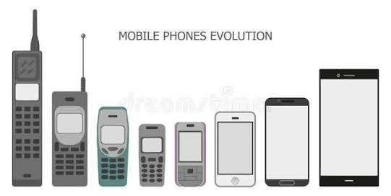EF Company in UK launched first 5G services in 6cities, in the year 2019. 5G helps in boosting ultra-resolution video streaming and has superior data speed and reliability. It has also made mobile games more fun. One-plus device, introduced pop-up selfie camera to its 7Pro device. Mobile companies are making efforts for providing the best screen experience to its users.

**Advancement and evolution of mobile phones**

Image source: <https://images.app.goo.gl/VXmU53jNu7yk24c4A>

* 1. **MOBILE PHONE FEATURES, EXPECTED BY USERS**:

Users of mobile phones have different expectations from their phones. All these expectations can be summarized in the following parts: The mobile phone should have a long lasting battery. The battery’s capacity is measured in milliamphere-hours (mAh). Before making a purchase decision, user generally considers the battery of the mobile phone. The high speed processing avoids apps lagging or hanging and thus, provides a smooth experience to user. Hence, before purchasing a mobile phone, user considers this too. The display of the mobile phone should be clear enough so that user can watch movies, play games and perform other functions. The resolution display and pixel density are usually considered at the time of purchase. The obsession with selfies and photos are very common these days. User always wants to buy such a phone that has an excellent camera quality so that better colour range and low light images can be capture efficiently. NFC stands for Near Field Communication. As the name suggests, it is a wireless transmission of data from one mobile phone to other devices within a range of 10cm distance. It is a very short range data transfer technique that is offered by many androids and Windows phone. Having plenty of storage space in the mobile phone is one of the important preferences of users before making a purchase decision. Most of the mobile phones offered in the market have 16-32 GB storage.

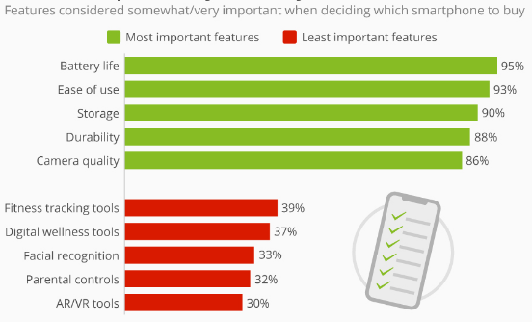

**Mobile phone features expected by users**

Image source: <https://cdn.statcdn.com/Infographic/images/normal/5995.jpeg>

Nowadays, the use of cloud storage is also very popular. Mobile phone these days has also remote controls that can be used to control TV, AC, projectors and some other devices. Although this feature is not on the list of the buyer, but it is quite popular nowadays. In today’s time, all the mobile phones have fingerprint censors that are considered to be one step ahead of the traditional lock patterns and passwords in securing the device. Also, fingerprint censors save time. Users prefer light weight mobile phones that can easily be carried and kept in pockets. The device can easily be connected to the Wi-Fi or internet. The phone should be able to download online applications and documents, books etc.

**CHAPTER 2. REVIEW OF LITERATURE**

An exploratory study was carried out in the state of Uttarakhand to find the factors that affect the buying motives of consumers before purchasing a new mobile phone along with the choice of service providers or operators company. In this research, sample size taken was 306. The results of the study stated that there is a great impact of education and income of customer on their purchase decisions. The study further suggested that price and services offered attract customers the most, in case of mobile phones. In the same way, audibility and friend’s operator act as important factor considered before deciding the operator company. The study concluded that there is a lack of awareness about the advanced of mobile phone services among customers. **Chaubey and Zafar (2010)**

**Sata (2013)** conducted a research to determine which of the six factors affect the buying decision of consumers regarding mobile phone. The research was performed in Hawassa town, on a sample of 246consumers. The sampling technique used is simple random sampling. Both primary and secondary data were used in the research study. The 6 factors include price of the phone, features, brand name, durability, affect of social group and after sale services. For selection and analysis of the factors, correlation and regression analysis was done. The research concluded that consumers value the price of a phone most, and after that they prefer features of the mobile phone, before purchasing a phone. According to the study the least considered factor by consumers at time of purchase are after sale services and affect of social group. Study further suggests mobile phone manufacturing companies to focus on brand, brand positioning, product designs etc. They should also consistently upgrade their technologies, as consumer shift from one brand to another for better technology.

**Kumar and Chaubey (2015)** carried out a research to find out the product and functional attributes of mobile phones that affects the purchase decision in Dehradun. For this study, a sample of 151consumers was taken by convenience sampling technique. They concluded that a consumer values product attributes more in comparison to functional attributes while selecting a mobile phone of a particular brand. The finding of their research was that income, education and occupational level of consumers had no significant difference on preference of a mobile phone. The suggestion of the research was that mobile phone manufacturing companies should focus on improving their technology, as consumers shift from one brand to another for better technology. Also, these companies should try to make the price of the product reasonable, so that majority can afford it.

**Gbadeyan and Akinyosoye (2012)** tried to study the correlation between customer’s loyalty and the service quality, that is provided by mobile phone companies in Sierra Leone. For this study, primary source of data was taken. The sample was taken by simple sampling method and by using questionnaire to get the response. It was found in the study that a large percentage of respondents were using more than one network. This suggests that many subscribers are loyal to not one but many service providers. Further, it was also analysed that customer value quality services and are loyal to these mobile networks. Also, according to the study, female customers give more preference to such mobile networks that cost low service charge whereas, male customer’s priority is wide network coverage. The major limitation of this study was the generalization done of the population based on a small sample.

**Reddy (2019)** conducted a survey of the use mobile phones in Vidyanjali students with the aim to know their perception about mobile phones. Primary source of data were used for the study. Data was collected using questionnaire. A sample of 271 students was taken, all belonging from 7th to 10th standard. The major objective of the study was to know the student's opinion regarding the ideal age for owning or using mobile phone and for what purpose it should be used for. The study also highlights the harmful impacts of mobile phone like headaches, dizziness, stress etc. The result revealed that most of the students used mobile phones either for social networking or for playing games. Many of the girls responded that they use phones for tik-tok or B612. Out of all the students surveyed, majority of the class 7th students owned mobile phones in comparison to other class students that show their enthusiasm for technology.

**Zhang et al. (2010)** carried out a survey to identify the latent construct of mobile phone attributes. For this they took a sample of 215mobile phone users of China. Primary source of data collection was used i.e., questionnaire survey. These questionnaires were distributed online to the respondents. The main objective of the research was to know what attributes consumers consider before purchasing a mobile phone. A seven point Likert scale was used. An exploratory factor analysis was done by identifying 8 mobile phone attributes factors like product image, connectivity, body design, common functions, appearance, multimedia functions, etc.

**MACRO (2004)** conducted a research to identify the behaviour of teenagers and youth towards mobile phone purchase. The study focused on the demographic and behavioural aspects of the target group. Study also tried to determine the perception of buyers at time of making a purchase decision. For this study, a sample of 175 respondents was taken. The sample was taken on basis of random convenience sampling. Primary study using structured questionnaire technique was used. The major limitation was the inadequacy of sample size. Also, the survey was limited to Mumbai only. Thus, the findings could vary at other places.

**Balaji and Rao** presented a case study on the preference of mobile phone attributes among B-school students. The case focused on the preference of buyers attributes of a target segment. This case used cojoint analysis for analysis of data.

**Vaidya and Pathak (2016)** carried out a research to find out the mobile phone usage among youth in Pune city. For this study a sample of 400students were taken. Out of these, 245were female and 165 were male. The students were from arts and commerce streams. The study was done on exploratory basis, and no hypothesis was taken. The main objective of the study was to identify the pattern of mobile phone use in college going students.

**D**ebasish and Mallick (2015) conducted a study to find out the buying behaviour of mobile phones among both urban and rural population. For this, price, quality, style, functions and brand are considered as important factors that acts as motivator for both the sectors in making a purchase decision of mobile phone. Primary data was collected, using a well structured questionnaire, with a five point likert scale. A sample of 400respondents was selected from both the urban and rural sectors in Ganjam district, Odisha, India. The result of the study showed that the price and style has no significant difference in the purchase decision between rural and urban consumers. But factors like quality, functions and brand are less preferred by rural consumers in comparison to the urban sector. Z - Test is used to test the Hypothesis so formulated for the study.

**Kumari (2017)** carried a study in Tirupur city located in the state of Tamil Nadu. The aim of the study is to find out the different factors that affect the consumer’s buying behaviour of mobile phones. It considers mobile phone brands like Sony Ericsson, Samsung, Microsoft, LG and HTC, to know their satisfaction level for these different brands of mobile phones and the major reasons for their dissatisfaction. The study concluded that consumers always buy a mobile phone that satisfies their wants after considering various factors. These factors affect different persons at different extent. Samsung mobile phones were highly preferred by consumers according to this study. The common factors considered by consumers before making purchase decision of mobile phones are price, operational facilities, physical attributes, size and weight of phone.

**Vishesh et al. (2018)** conducted a study to find the consumer buying behaviour regarding mobile phones in Hisar, Bhiwani and Faridabad districts of Haryana. Sample of 638users were selected for the study. Factor analysis and multiple regressions were used to analyse the collected data*.* Ten factors of consumer buying behaviour were identified using factor analysis. On these factors multiple regression analysis was applied considering consumer satisfaction as dependent variable. The result of the study showed that speed and performance are the most important factor in satisfying consumer followed by brand & advertisement and recommendations & reviews. Other factors include price advantage, battery life, camera and exchange possibility.

**Sethi (2017)** Carried out a study to identify the consumer buying behaviour of smart phone in India, particularly Delhi / NCR. It considers two main questions- first, which smartphone they should buy and secondly, from where to buy, i.e., online or offline mode. For this study Croma electronics, a store in Connaught Place, Delhi was selected. The study considered some factors that affect the consumer buying behaviour. These factors include age, income, advertisement, influence of friends, influence of brand ambassador.

**Mohankumar and Dineshkumar** conducted a descriptive study to identify the consumer buying behaviour of mobile phones like Nokia, Sony, Samsung, HTC and Micromax in Erode city. The main objective of the study is to find out the consumer satisfaction level regarding mobile phones and the reason for their dissatisfaction. A sample size of 200 respondents was selected for the study This sample was selected using convenience sampling technique, under non-probability sampling method. The data used was primary data and the data was collected through questionnaires. It was found that consumers mostly preferred Nokia mobile phones. The study recommended that companies should concentrate more on the youth by providing advanced features. Also, the mobile phone users are more in urban, as a result, mobile phone companies should work on creating awareness among rural people

**Khan et al. (2014)** administered an empirical research study to identify the factors that triggers the purchasing decision of mobile phones and their relevance. It was an image based survey held in Pune city, among the college going students. The research identified three factors that affect the purchasing decision namely, price, brand and brand ambassador. The responses were collected using both image based and text based questionnaires. The effectiveness of image based survey over the traditional text based questionnaire survey was also tried to find out in this study.

**Kumari and Kumar** conducted a study to find out the attributes that affect the purchase decision of mobile phones. It also focuses on the policies that should be followed by advertisers to increase the awareness of consumers regarding mobile phones. Primary data using questionnaires were collected from a sample of 84respondents. The findings showed that consumers preferred technical features like looks, image and resources, entertainment etc. as the most important attributes of a mobile phone. This suggests that producers should pay more importance at this factor. *.*

**Shrestha (2016)** examined and analysed the factors that affect the purchasing decision of smart phones based on consumers lifestyles. The study also tries to find out the role of social media in persuading the young consumers in making the purchase decision of mobile phone. The study targets the young consumers belonging to the age group of 18-35 years in Kathmandu, Nepal. The main objective of the study is to know the future consumption pattern in Nepal. The result of the study showed that majority of young consumers own Samsung mobile phone. The reason for this finding was the availability of better features than other similar models offered by the competitors.

**Kim (2018)** conducted a research study to measure the willingness of consumers to pay for mobile phone features. The main objective of this study was to find out a way to minimize the choice burden among consumers due to various attributes offered by mobile phones. This was done with the help of Integrated Hierarchical Survey Design (IHSD) with the Kano model. Empirical data was analysed by the researcher. These data were collected from multi-regions belonging from six Middle East and African countries, five Asia-Pacific countries and three European countries. 10200 respondents were considered for the study. It was found that brand, camera, memory and LTE are most important features of mobile phone according to majority of respondents belonging to different regions. The result of the study can be useful for mobile phone manufacturing companies to decide about product planning, product development, marketing strategies, price determination, setting up of features and designs for new product.

**Ahmad et al.** carried out a study to understand the characteristics of mobile phone in developing countries. This study is based on the subscribers of Pakistan’s largest cellular providers as the sample for the study. The different features of cell phones like cellular interface, CPU are considered by the researchers for this study. The study analyzed the potential security issues that may affect the internet access in developing countries.

**Ganlari et al. (2016)** conducted a research to identify the behaviour of consumer from adoption to post purchase behaviour of mobile phone. With the increase in consumption of mobile phone in India, it has become an essential part of business and personal life of consumers. The study focuses on the major perceptions, motivation and lifestyle that affect the buying decision of consumers. The study also tries to study the attitudes and aspiration of consumers in the market. It identifies both the internal and external factors that affects consumer while making a purchase decision. The usage of mobile phones is not confined to a particular age or gender. The research study conducted explores the quantitative factors that affect the purchasing decision of mobile phones.

**Karjaluoto et al. (2005)** in their research study identified the various factors that affect the consumer’s choice between different mobile phone brands. These factors influence the consumers to either purchase a new mobile phone or to replace the old phone with a new one. For this, two studies were conducted in Finland. In the first study, a sample size of 79graduate students was selected and for the second study, a sample size of 196 respondents was used for the survey. The result of the study revealed that the choice of mobile phone is a subjective decision made by the buyers of the phone. The study further identified technical problems as the main reason of changing the mobile phones. Factors like price of the mobile phone, brand of the phone and properties of the phone act as the most influential factor that affects the purchasing decision.

**Ladipo et al. (2018)** carried a study in Lagos State Tertiary Institutions to study the influence of attributes of mobile phones on student’s buying decision. The research design was descriptive. A sample of 362students was taken for the study, out of the total population of 3,792 students. Data were collected using primary sources like structured questionnaire. The analysis of collected data was done using multiple regression analysis. Result of the study showed that all the attributes considered for study had a positive relationship with the student’s purchasing decision of mobile phones, technical analysis being the major attribute

**CHAPTER 3. RESEARCH** **METHODOLOGY**

A research is identification of an existing problem in depth and selecting a best solution from various new and innovative alternatives available, to solve the problem. It includes a systematic and scientific process of problem identification, review of available literature on that problem, selecting the research purpose, i.e. the objective of research, collecting data either from primary or secondary source, analysis and interpretation of data and finally submission of research report with recommendations for further study by some other researchers on the same problem.

3.1 **OBJECTIVE OF THIS RESEARCH**:

With the change in time, technology has also changed tremendously. Mobile phones are no longer new to the market. In present time, each and every individual owns at least one cell phone and spend hours using it. The main objectives of this study are:

* To study the emotional considerations kept in mind while purchasing a mobile phone.
* To know the uses of mobile phones in the official/ academic/ occupational work to people.
* To examine whether people are aware about the harmful impacts of cell phones.

* 1. **SCOPE OF STUDY:**

The study is done for the research purpose. This study covers the attributes of mobile phones and its services, beacause mobile phone is the basic need for any human being. This will help to make a comparison between the choice of mobile phone device according to age, knowledge, experience, income, societal status and occupation.

* 1. **RESEARCH DESIGN:**

The research design used in the study is exploratory research design. An exploratory research design is all about exploring the research questions and does not intend to provide a solution for these questions. Such type of research provides a base for further studies

* 1. **SAMPLING DESIGN:**

Sampling design refers to a framework that describes the procedure through which the sample for the survey will be selected. It is the basic plan for selecting a sample. The sampling design used in this study is Non-probability sampling. The sample size taken for the study is 50. Questionaire is shared across different age group. In this research study, the sampling method used is convenience sampling method. The sample size of 50(students and neighbours) is considered to be sufficient for the study. The convenience sampling method under the non-probability sampling design is chosen for the study.

* 1. **DATA COLLECTION:**

The method of data collection used in this research study is primary data, and is collected using questionnaire method. The questionnaires was made on google form and shared through mail and were received within two week. All efforts are made so that the data received is accurate, reliable and relevant to the study. Secondary data were also analysed to get more realistic information. The sources of secondary data include newspapers, Internet, journal and magazines, research papers etc. Data collection procedure includes both primary and secondary data for this study. Questionnaires were sent through mails and other social networking sites.

* 1. **RESPONSE RATE:**

Response rate means the percentage of respondents who have actively filled out all the section of questionnaire as expected. These respondents include those eligible people that cooperated in the survey. For conducting a high quality research, the response rate should also be high. Therefore, the questionnaires were sent individually to all the respondents via e-mails, whatsapp, facebook and other social networking sites. The data collected is believed to be true and honest. The data is collected in 3 weeks .

* 1. **VALIDITY AND RELIABILITY:**

In order to get valid and reliable data, the questionnaire was pre-tested on 4respondents as a part of pilot survey. After which, the necessary modifications and corrections were made and the questionnaires were sent to the samples for data collection. If these improvements were ignored, it could have negatively affected the results of the study. In the questionnaire there were some questions that were considered important for the study and hence were marked as *required and could not be skipped by the respondents, while there were also some of the questions that were subjective and were linked to the other important questions and could be avoided by respondents, as they had not much affect on the purpose of the study.

The options given for the objective type questions in the questionnaire were designed by keeping in mind about all the probable answers and in case of any doubt, such questions were set as descriptive type questions. This was done so that all the responses could be collected in the best possible manner. The number of respondents selected for the study was 50.

**CHAPTER 4. MOBILE PHONE ATTRIBUTES WITH RESPECT TO SERVICES**

According to a survey it was found that in India the number of mobile phone users is equal to the total population of U.S. This user’s population in India will continue to grow more and more with the coming years. India being the second most populated country in the world has second largest market for consumption or usage of mobile phones also, after the country China. In another survey it was found that the average time spent by Indian smartphone users is second largest in Asia pacific. This clearly portraits the picture that in India approximately every individual who has an average age of 18 or more owns a mobile phone. The increased consumption of mobile phones by Indians has paved the way for many foreign mobile manufacturing companies also such as oppo, onePlus, Lenovo etc. According to India Cellular & Electronics Association (ICEA) there are 268 mobile and accessories plant in India. The example of some of the domestic industry includes major manufactures like Xolo, karbonn, Lava, intex etc. Each of these phones has unique attributes that makes it different from other phones. This attribute can be discussed by considering the utilities offered and services provided to users.

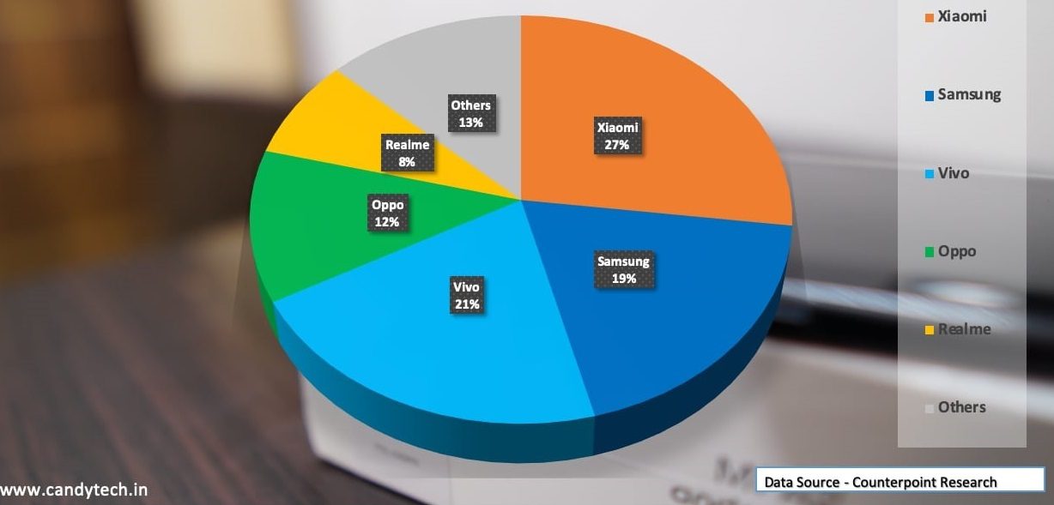

**Smartphone market share in India 2021**

Image source: <https://candytech.in/wp-content/uploads/2020/02/Smartphone-Market-Share-India-Q4-2019-2020.jpg>

The pie chart shows the market share occupied by various mobile phone brands in India. It is based on a survey conducted in the year 2021. According to this survey, 27% of the market is captured by Xiaomi, followed by Vivo and Samsung.

The following bar diagram represents the usage of mobile phones in India and draws a prediction about the future usage of 2022. This survey was conducted in 2016, and on the basis of the data future forecasting is done for all the next years.

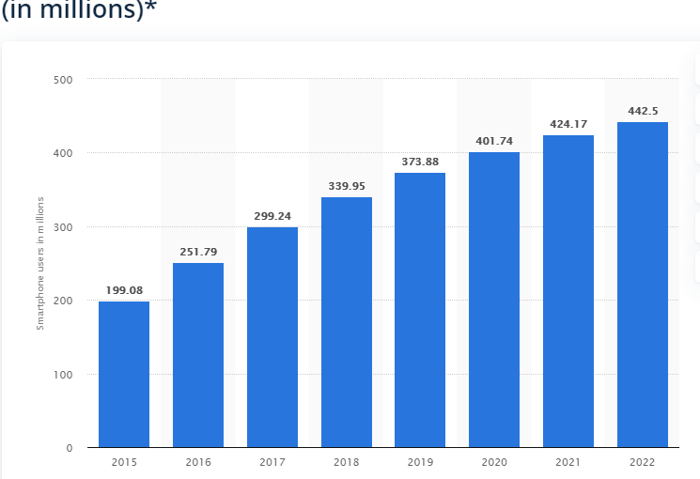

**Forecast of smartphone users in India**

Image source: <https://www.statista.com/statistics/467163/forecast-of-smartphone-users-in-india/>

In the diagram, it was estimated that the future usage of mobile phones will reach to 442million in the year 2022. It shows a tremendous growth of the users of mobile phones in the coming years. This increase in usage is the result of multitude functions performed by the mobile phone. A mobile phone is used for many purposes. Since it is portable and can easily be carried anywhere, a mobile phone has replaced so many conventional gadgets and technology. If we take certain example of this we will find that alarm clocks, calculators, camera, televisions, digital music players, GPS navigation devices, books, photo albums, flashlights, calendars and planners, scanners, voice recorders, newspapers, ATM/ debit/ credit cards etc. are replaced by mobile phones to a great extent. All these functions are consolidated in a single smartphone that makes it very important part of an individual’s life. According to another study, it was found that 21%people use their mobile phones for connecting to social networking sites, followed by 16%people who prefer to watch videos on their phones. 15%people use their phones for search engines and 4%people look for product information using the phone.

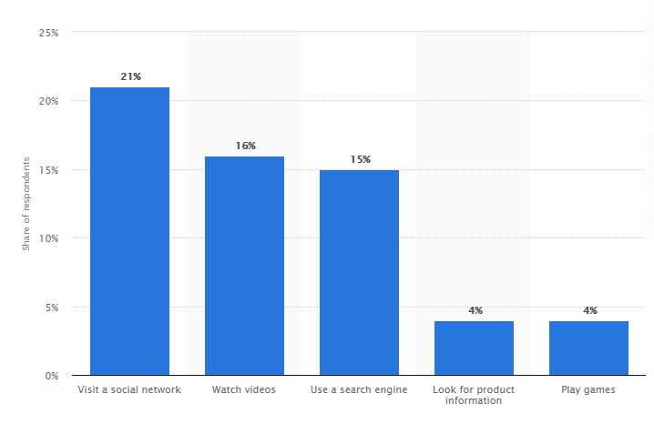 **Most popular smartphone activities in India**

Image source: <https://www.statista.com/statistics/309867/mobile-phone-activities-india/>

Some researchers have compiled these various attributes of mobile phones desired by a user into a diagrammatic representation. This representation considers comfort, ease of use, availability of handset, affordability or budget-friendliness, resale value of the phone after using it for some period, capacity, storage, durability, eco-friendliness etc.

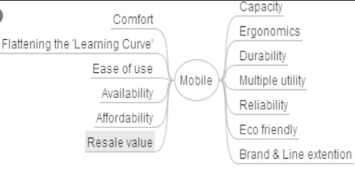

**Compilation of attributes of mobile phones**

Image source: <https://www.google.com/url?sa=i&url=https%3A%2F%2Fwww.researchgate.net%2Ffigure%2FAttributes-of-a-mobile-phone_fig10_307087645&psig=AOvVaw1FnKmwdj-abJt3uzULdm9Q&ust=1589199643196000&source=images&cd=vfe&ved=0CAIQjRxqFwoTCJidjrCjqekCFQAAAAAdAAAAABAD>

According to a study it was found that the most used and downloaded applications at global level comprises of a series of social networking applications like Facebook, Whatsapp messenger, WeChat, Instagram etc.

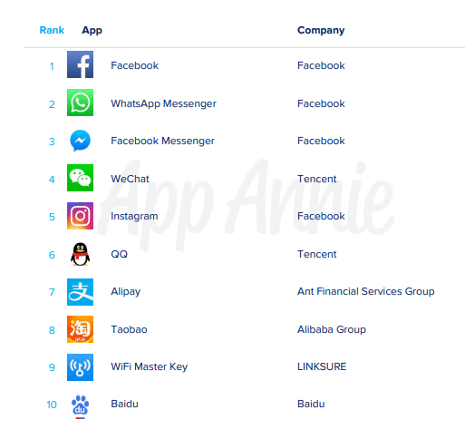

**Most popular apps globally in 2019**

Image source: <https://www.businessofapps.com/data/app-statistics/>

As in this time when due to covid-19, all the universities, colleges, schools, offices are closed down in almost all countries, mobile phones are helping students to take regular online classes and to continue their learning from home. All the study materials are availed by them with the help of mobile phones. For those people who work in organizations, mobile phone helps them too in their official work by allowing them to continue their meetings and projects via work from home using mobile phones. People are also keeping themselves updated about the corona cases, lockdown conditions, government rules and guidelines with their mobile phones. Government has launched an app named as Arogyasetu app, which prevents the spread of rumours and provides authentic information about covid-19. Not only in India, but among various other countries too, government has launched various applications to keep a check on the covid-19 cases. These applications and the permissions they require are given below:

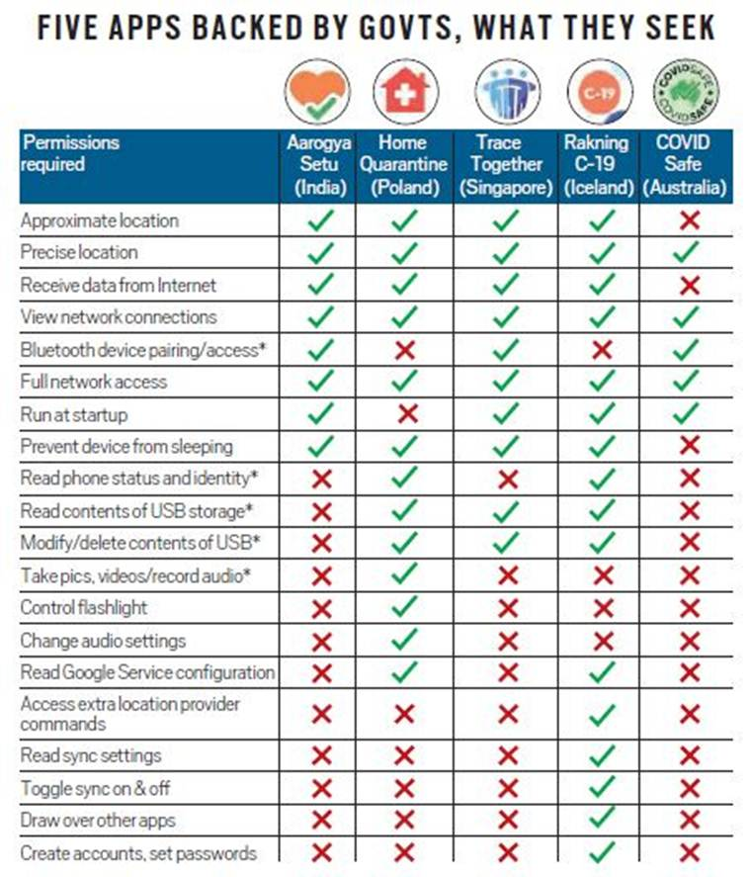

**Government apps during lockdown**

Image source: <https://images.indianexpress.com/2020/05/apps.jpg>

The app is compulsory to be installed by the Indian people having a smartphone for their protection and safety from the virus. Government is also raising fund to meet out some expenses incurred on covid-19, by asking people to willingly make contribution to PM-Cares fund. This is done by transferring the funds online by using mobile phone apps like PhonePay, GooglePay, Paytm etc. Since a long time, mobile phones have also been used for tracking trains, booking and cancellation of railways, bus, and aeroplane tickets. A large number of population uses mobile phone for online food orders and shopping.

They also use various social networking sites. There are whatsapp groups that provide students with the quick information regarding classes and assignments. Mails from administration and other essential mails can be immediately checked by using mobile phones. Some of these courses compulsorily require laptop and mobile phones, such as M.sc in Digital society, culture and media studies etc. All the shops in the campus have options for accepting online payments. Thus students can make the purchases by using mobile phone pay apps, in case when they don’t have adequate cash with them.

**CHAPTER 5. DATA ANALYSIS AND INTERPRETATION**

This chapter studies and analyses the collected data by using pie charts, graphs, tables, excel etc. It also tries to link the result with the objectives of the study.

* 1. **BACKGROUND:**

The primary study was conducted by using questionnaires. The collected responses belong to the emotional considerations, academic and occupational uses, and dependency on mobile phones. All the questions prepared revolved around these basic objectives of the study. The questionnaires were sent to the respondents via e-mails and other social networking sites. Total of 50 responses were collected.

The questionnaire was common to all, and was kept simple and to the point. It was divided into 4 sections. First section was about the general information about the respondent. Second section focused on the emotional behaviour of users. Third section considered the uses of mobile phones for official or academic purpose and the fourth and last section was all about the harmful impacts and dependency on mobile phones.

Out of 25 questions, 22 questions were marked as * required. This was done to increase the reliability of the responses and to get the necessary information without being skipped by the respondent.

In the following sections the detailed presentation of the responses collected is shown.

* 1. **GENERAL INFORMATION ABOUT THE RESPONDENTS:**

The age of the respondents belonged to all the four categories. Maximum responses were collected from the age group of 21-24 at 41.2% followed by the age group 17-20 at 17.6%, by the age group 25-28 at 33.3%, 28 and above are only 17.6%.This depicts that the responses collected belonged majorly to the youths.

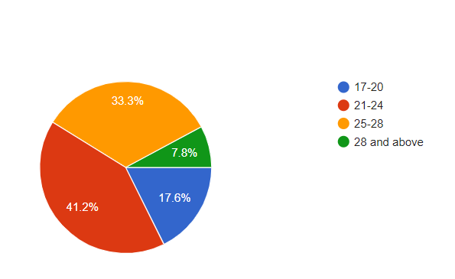

**Age group of respondents**

Since the study aimed at collecting maximum responses from students. The maximum number of responses from youth denotes that the majority of respondents were students and they use mobile phones more.

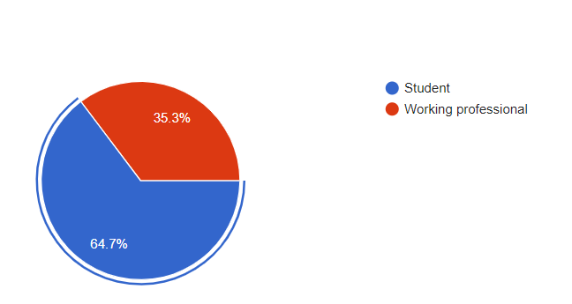

**Occupation of respondent**

The study was designed to collect more responses from students and working profesionals. This shows that this objective of the research was met successfully.

* 1. **EMOTIONAL CONSIDERATIONS**

This section of the questionnaire focused on the perception of respondent towards his mobile phone and includes factors like his satisfaction level; cost of the phone he is using, reason for using this phone, which brand phone he is using, etc.

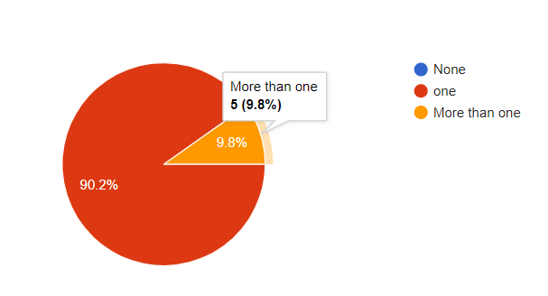

**Number of phones owned by respondents**

The survey reflects that out of the total respondents, 90.2% owned and used a single mobile phone. While 9.8% respondents owned more than one mobile phone. There were no such respondents who were not having their own mobile phones. Thus, the data collected belonged to only those respondents who are mobile phone users and own at least one phone.

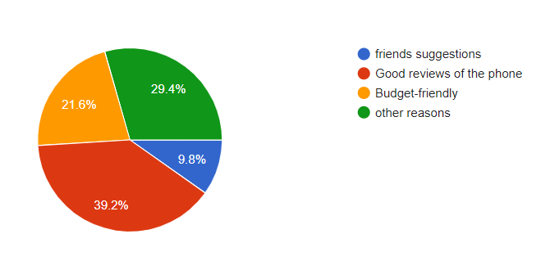

**Reason for purchasing the present mobile phone**

According to figure 13, Majority of respondents have purchased their mobile phone because of good features and reviews. 39.2% respondents purchased their mobile phone because of its good reviews, 21.6% belongs budget friendly category. 29.4% respondents had some other reasons for this purchase. Only 9.8% respondents made their purchase decision because of the suggestions of their friends. These responses depicts that behind the purchase decision the major factor that influence it is the reviews followed by budget price. Also, the suggestions of friends and peers play a very little role in the purchasing decision.

In order to find out whether there exists any relationship between the numbers of cellphone owned by respondent to his/her satisfaction level, a linear regression analysis was done, using Excel sheet of the responses of the questionnaire. Number of mobile phones owned was considered as an independent variable (X variable) and the level of satisfaction was dependent variable (Y variable). This was done to identify whether the number of mobile phones owned has an influence on level of satisfaction derived by them. The finding of this analysis is given below:

|  |  |  |  |  |  |
| --- | --- | --- | --- | --- | --- |
| SUMMARY OUTPUT | |  | | | |
|  | |  | | | |
| *Regression Statistics* | | | | | |
| Multiple R | | 0.076471911 | | | |
| R Square | | 0.005847953 | | | |
| Adjusted R Square | | -0.014863548 | | | |
| Standard Error | | 0.709720863 | | | |
| Observations | | 50 | | | |
|  | |  | | | |
| ANOVA |  | |  |  |  | |  |  |  |  |
|  | *df* | | *SS* | *MS* | *F* | | *Significance F* |  |  |  |
| Regression | 1 | | 0.142222 | 0.1422 | 0.282353 | | 0.597613698 |  |  |  |
| Residual | 48 | | 24.17778 | 0.5037 |  | |  |  |  |  |
| Total | 49 | | 24.32 |  |  | |  |  |  |  |
|  |  | |  |  |  | |  |  |  |  |
|  | *Coefficients* | | *Standard Error* | *t Stat* | *P-value* | | *Lower 95%* | *Upper 95%* | *Lower 95.0%* | *Upper 95.0%* |
|
| Intercept | 4.244444444 | | 0.381464 | 11.127 | 6.85E-15 | | 3.477460669 | 5.011428 | 3.477460669 | 5.0114282 |
| How many cellphones do you have? | 0.177777778 | | 0.334566 | 0.5314 | 0.597614 | | -0.49491149 | 0.850467 | -0.49491149 | 0.850467 |
|
|
|

R square is equal to 0.005847953, which is far away from the ideal fit 1. This suggests that variation in level of satisfaction is not much related to number of mobile phones owned by the respondent.

To look for the reliability of results, significance F should be less than 0.05. Here, the significance F is 0.597613698, which is greater than 0.05. This clearly indicates that the set of independent variable. Thus, we can say that there is no relationship between number of mobile phone users with the level of satisfaction.

* 1. **ACADEMIC/ OCCUPATIONAL USES OF MOBILE PHONES:**

This section focused on the uses of mobile phone by respondents for their official or academic purpose and from the total time they use mobile phone, how much time is used for academic purpose by them.

In figure 15, it is shown that most of the respondents use their mobile phones for academic and occupational purpose followed by 37.3% respondents who use their mobile phones for social networking. 12% respondents had their other uses and few respondents use their phones mostly for watching movies and playing games. This depicts that the respondents prefer to use their phones for official and academic purpose like for Google search, sending and receiving of e-mails, having a soft copy of study materials, online video lectures, etc.

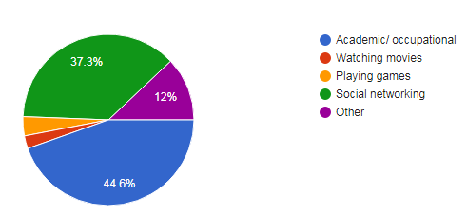

**Purpose of using mobile phone**

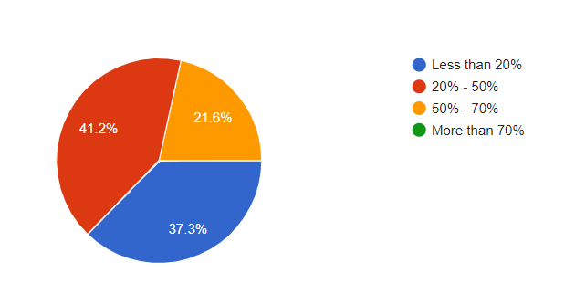

**Percentage of time, mobile phone is used for academic purpose**

According to the survey, out of total time, no respondents use the phone for more than 70%. 41.2% respondents use the mobile phone for 20-50% out of total time for occupational use. 37.3% of the respondents use their phone for less than 20% time out of total time they spend on using their phones. This shows that at an average, majority of respondents use their mobile phones are using lot of mobile phone with their time.

* 1. **HARMFUL IMPACT AND DEPENDENCY ON MOBILE PHONES:**

As with the increase in the features of mobile phone, the dependency and addiction towards mobile phone is also increasing. This section covers the harmful impacts of mobile phone on users and considers the amount of time they spend using their phone in a day, their awareness about the phone addictions etc.

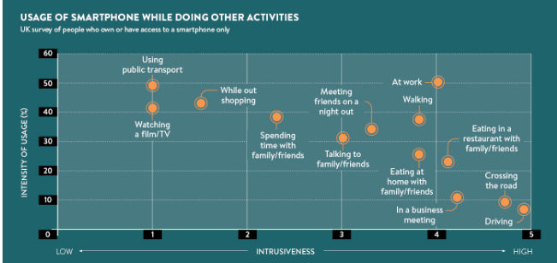

**Using smartphone while doing other activities**

Image source: <https://www.raconteur.net/wp-content/uploads/2017/04/Smartphone-useage-graph.jpg>

According to a study conducted in UK, it was found that people generally use their phones while performing some other tasks. The most popular time out of all is when they use public transport. They also use their phones while watching TV, shopping, spending time with family and friends, in business meetings etc. There are few people who use their phone while driving or crossing roads that often leads to severe accidents.

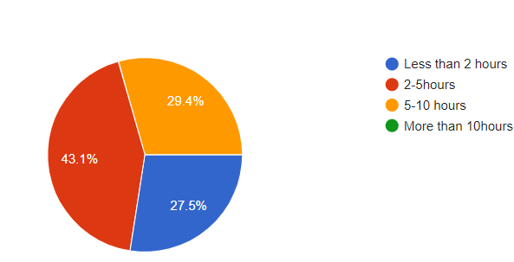

**Total amount of time spend using mobile phone in a day**

From our survey it was found that 43.1% respondents use mobile phone for about 2-5hours in a day. No respondent use their phone for more than 10 hours. 29.4% respondents use mobile phone for 5-10 hours in a day, 27.2% use their phone less than 2 hours.. These results depict that most of the time of the day is used by the respondents in using mobile phones. To know whether this response was due to lack of awareness among respondents about the harmful impact of mobile phone, they were asked a question regarding their awareness about the harmful impacts and dependency towards phones. The response of this question showed that 76.5% respondents were well aware about the addiction and adverse affect of mobile phones while 23.5% were not aware about the same. Thus, the study reflected that although a majority of respondents know about the negative effects of mobile phone usage they still continue to use the phone for longer time duration.

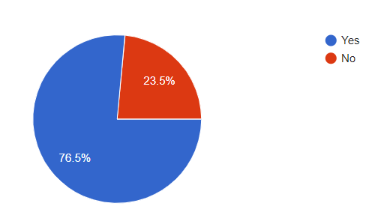

**Addiction towards phone**

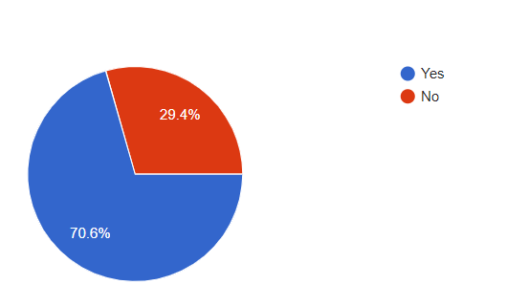

**Usage of cell phone increased**

It was also found that 70.6% respondents accepted that their usage of mobile phones have increased over the time period. 29.4% believed that with the time, their usage of mobile phone is not increased over time

|  |  |  |  |  |  |  |  |  |  |
| --- | --- | --- | --- | --- | --- | --- | --- | --- | --- |
|  |  |  |  |  |  |  |  |  |  |

**CHAPTER 6. CONCLUSION**

The main objective of this research study is subdivided into three parts. The first part was to identify the emotional considerations kept in mind while making a purchase decision. The factors that affected this decision includes which brand phone they use, why they prefer that phone, their satisfaction level regarding their phones and reasons for dissatisfaction, if any. The second part of the study laid emphasis on the usage of mobile phones for academic or occupational purpose and included factors like how the phones help them in their studies and other objectives. The third and last part of the study dealt with the harmful impacts and dependency caused by excessive use of mobile phones. These included factors like amount of time spend while using phones and self-assessment done by respondents about their usage over time and addiction towards their phones

* 1. **MAJOR FINDINGS OF THE STUDY:**

The result of the study was divided into four sections.

* First section tells about the general information about the respondents. In the survey conducted, all the respondents owned at least one mobile phone. Majority of respondents belonged to the age group of 21- 24 years; this shows that out of the total respondents, most of them are students. They all belonged to various departments like architecture, Culture and media studies, commerce, management, environmental science, mathematics, life sciences, statistics etc. The demographic characteristics of respondents also include that 60.2% were males and the remaining 39.8% were female.
* The second section of the study considers the emotional factors of respondents. The findings of the study showed that majority of respondents owned mobile phone of Xiaomi.56.6% respondents owned their first mobile phone when they were in the age group of 14-18 years. In most of the cases, the first phone was given to them by their parents, especially father. It was also found that while making a purchase decision, price acts as the most crucial factor, followed by reviews of the mobile phone. 68.6% respondents are using a mobile phone which has a price more than Rs10,000. Another factor considered was the satisfaction level of the respondents. It was found that many were satisfied with the mobile phone they owned. However there were few who would have purchased a different phone like apple, Oneplus etc. if they had enough money. It was further identified by conducting a linear regression analysis that there is no relationship between the number of mobile phones owned and the level of satisfaction of respondents.
* The third section of the study was based on how the mobile phone helps the respondents in their academic or occupational work. The survey showed that 39.2% respondents like camera the most in the phone Mmostly used their mobile phones for academic or occupational purposes. 78.4% respondents used their mobile phones for sending and receiving e-mails.
* The fourth and the last section of the study were based on the harmful impacts of mobile phones and it was tried to identify whether the respondents are aware about the addiction to the mobile phones or not. It was found in the study that 76.5% of the respondents were aware about the harmful impacts of mobile phones and 52.9% admitted that they are addicted to their mobile phones.70.6% respondent believed that their usage of mobile phone is increasing with time.
  1. **SUGGESTIONS AND RECOMMENDATIONS:**

The study has identified various suggestions towards both mobile phone manufacturing companies and users of mobile phones. It is recommended to the manufacturers of mobile phone to consider the uses and various factors that affect the purchasing decision of mobile phones. As per the survey it was found that most of the respondents had their first mobile phone purchased and given to them by their parents. The price of mobile phone was less than Rs 10,000. The criteria for selection of mobile phone were the affordability as well as reviews about the mobile phone. Thus, manufacturer should keep all these factors in mind and can attract new customers and retain old ones by providing the expected features in the budget friendly package. They can also go for advertisements that could be connected by the audience emotionally. One such example can be showed that how a parent, in order to meet the requirements of their child buys a mobile phone that will help their child in academics with a touch of some emotional drama in the advertisement. Also, the price of the phone should not be kept very high. Mobile phone manufacturers should work on providing satisfaction to the users as is said that a satisfied and happy consumer is the best source of publicity.

For the users of the mobile phone, the study suggests them to remain updated about the technology but should also be aware about the harmful impacts of the phone and should try not to develop addiction or become a slave of their phones. They should keep a regular check on their mobile phone usage, and should try to spend 2-4hours maximum on their phones. There is also a need for them to change their routines. As nowadays most of us start our day by checking our mobile phones and scrolling through social networking sites, and continue using the phones for about an hour before sleeping.

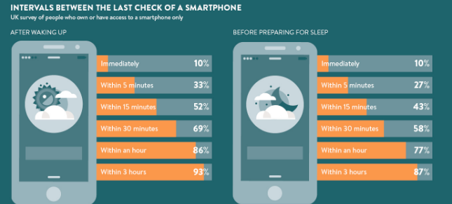

**Checking smartphone after waking up and before going to sleep**

Image source: <https://www.raconteur.net/wp-content/uploads/2017/04/Checking-phone-graph.jpg>

According to a survey conducted in UK, it was found that 10% people use their mobile phones immediately after waking up and before going to sleep. Mobile phones also cause a lot of distraction. Many students use their phones even when the lecture is going on. This severely affects their studies. There is also a tendency among most of the people to keep checking their phone after certain time period. Lack of vision is another problem caused due to excessive usage of phones. Some studies also reveal that social networking sites can lead to depression and anxiety among users, as people start comparing and copying the celebrities or models over there. Thus, it is very important for the users to keep all the harmful impacts of the phone in mind and use their mobile phones carefully and cautiously.

* 1. **LIMITATIONS OF THE STUDY:**

In the study there were certain limitations encountered.The sample sixw of the study is very less. This was done because of convenience sampling. However, this may have led to the limitation of biasness and can thus, not be applied in the outside world with 100% surety.

Students were sent the questionnaire via e-mails, whatsapp, and other online social networking sites. It was aimed to collect 100 responses overall but we managed to get only 50 responses. Only 50 respondent cannot represent the true picture of the population selected for the study. Also, majority of respondents belonged to the category of students and hence the study somewhat focuses more on this segment of the population than others.

The next limitation of this study was the lack of personal touch, as all the questionnaires were filled by the respondents online only. Due to which other related information that was not included in the questionnaire but could have served our objectives could not be fulfilled. Also, in case of doubt in any part of the questionnaire, the respondents could not get it clarified. However, despite all these limitations of the study, the data collected served the purpose of the study very well.

* 1. **FUTURE IMPLICATION OF THE STUDY:**

As the mobile industry and the users of mobile phones continue to increase, the study can further be carried out at other universities and areas by taking larger population for study. The study draws no correlation between gender, income, family background, with the purchasing behaviour as the dependent variable, and the former three as the independent variables. It could have been interesting to find out whether there is some relationship between the gender or type of family background of respondents on his purchasing decision of mobile phones or not.

Further, this study considers only the emotional considerations of the respondents towards purchasing decision, and ignores other aspects like socio-cultural, economic, psychological behaviour of consumers. All these can be used for any further study in such type of research.

* 1. **CONCLUSION:**

After analysing the factors, the results of the survey conducted showed that majority of respondents were students within the age group of 21-24 years. It was also found that 45.1% respondents owned their first mobile phone when they belonged to age group of 14-18 years only. The main feature of mobile phone that induces the consumers for making purchase decision was found to be the affordability of the phones followed by its reviews. Suggestions from friends had the least influence on purchase decision. A majority of respondents were found to be satisfied with their mobile phones.

It was also revealed in the questionnaire that most of the respondents used their phones for academic and occupational purpose like for Google search, online video games. 37.3% respondents used their phones for social networking.

According to the survey, it was found that although majority of respondents were aware about the harmful impacts of mobile phones still they continued to use their cell phones at increasing rate and spend 5-10hours in a day using their mobile phones. 52.9% respondents accepted their addiction towards their mobile phones while 47.1% were not sure about their addiction. This should be considered seriously by the users and they should try to reduce their usage over time.

1. **REFERENCES**
   1. **RESEARCH PAPERS:**

* Chaubey, D.S. and Zafar, S.M.T. (2010) ‘Consumers buying motives and perceptions of mobile phone services: A study of consumers of Uttarakhand’, Vol. 8, No. 1
* Sata, M. (2013) ‘Factors affecting consumer buying behaviour of mobile phone devices', Vol. 4, No. 12
* Kumar, S. And Chaubey, D.S. (2015) ‘Consumers preferences of product attributes of mobile phone handsets: A descriptive study'.
* Gbadeyan, R.A. and Akinyosoye, O.O. (2012) ‘Gender differences, service quality and customer loyalty in choice of mobile telecommunication industry in Sierra Leone’, Vol. 01, No. 06
* Reddy, S.R.M. (2019) 'Perception of mobile phone'
* Zhang, T., Zhou, J. and Rau, P.P. (2010) ‘Consumer perception of mobile phone attributes'
* MACRO. (2004) ‘A report on study of mobile phone usage among the teenagers and youth in Mumbai'
* Balaji, J. And Rao, U. ‘A case study on the preference of mobile phone attributes among B-school students’
* Vaidya, A. And Pathak, V. (2016) ‘Mobile phone usage among youth'
* Debasish, S. and Mallick, N. (2015) ‘Consumer buying behaviour towards mobile phone handsets – a study in Odisha’, Vol. 04, No. 01
* Kumari, K.P. (2017) ‘A study on buying behaviour in selecting mobile phones with reference to Tirupur city’, Vol. 03, No. 11
* Vishesh, Mittal, S. And Bali, S. (2018) ‘factors affecting consumer buying  
  behaviour towards mobile phones’, Vol. 05, No. 04
* Mohankumar, A. And Dineshkumar, U. ‘A study on customer purchase behaviour towards mobile phone with special reference to erode city’.
* Khan, M. ,Kulkarni, A. and Bharthi, S.V. (2014) ‘A Study on Mobile Phone Buying Behavior Using an Image based Survey’.
* Kumari, P. and Kumar, S. ‘Consumer Brand Preference towards Mobile Phone: Effect of Mobile Phone Attributes on Purchase Decision’.
* Kim, J.S. ‘Measuring willingness-to-pay for mobile phone features: a multi-region study’, Journal of Research in Marketing and Entrepreneurship.
* Ahmad, S. Haamid, A.L. and Qazi, Z.A. ‘A View from the Other Side: Understanding Mobile Phone Characteristics in the Developing World’.
* Ganlari, D. , Deka, P.K. and Dutta, C. (2016) ‘A study of consumer buying behaviour of mobile phones’, Vol. 01, No. 01
* Karjaluoto et al. (2005) ‘Factors affecting consumer choice of mobile phones: Two studies from Finland’, Vol. 14, No.03
  1. **WEBSITES**
* <https://www.tigermobiles.com/evolution/#thirdPhone>
* <https://indianexpress.com/article/explained/covid-19-phones-aarogya-setu-app-india-lockdown-6389488/>
* <https://www.statista.com/statistics/309867/mobile-phone-activities-india/>
* <https://www.businessofapps.com/data/app-statistics/>
* <https://www.raconteur.net/technology/smartphone-addiction-in-5-charts>

**APPENDICES**

**APPENDIX 1: COVER LETTER**

Greetings,

My name is Ghanshyam and I am a final year student of Delhi school of management,DTU.

My research topic is on ‘The study of attributes of mobile phones with respect to the services offered by them regarding which I need to collect the essential data about mobile phone usage, and the knowledge about mobile phones. The questionnaire consists of 25 questions, divided into 4 sections, including few descriptive type questions. Your responses are greatly appreciated and will be kept confidential.

I request you to fill the questionnaire and return it as soon as possible.

The link of the questionnaire is given below:

<https://docs.google.com/forms/d/e/1FAIpQLSefTQis8u3okFUPNany9yA2jEDLnPFdeb2cUX-_bqx8Op3toA/viewform?usp=sf_link>

Thank you very much for your time and efforts.

Best regards,

Ghanshyam

**APPENDIX 2: A COPY OF QUESTIONNAIRE**

**Section 1:**

1. Name:
2. Your Age:

* 17- 20
* 21- 24
* 25- 28
* 28 and above

1. Your Gender:

* Female
* Male

1. Occupation:

* Student
* Working profession

**Section 2:**  *Emotional considerations*

1. How many cellphones do you have?

* None
* only 1
* more than 1

1. Which brand phone do you own?
2. What was your age when you first time used a cellphone?
   * 14-18
   * 18-22
   * 22-28
   * Other
3. Who bought the mobile phone for you?
4. Why did you purchase this phone?

* friends suggestions
* Good reviews of the phone
* Budget-friendly
* other reasons

1. At what price did you purchased the phone?

* Less than Rs 10,000
* 10,000- 20,000
* 20,000- 30,000
* More than 30,000

1. If money was not a constraint, were you using the same phone? If no, then which phone you would have preferred?
2. Are you satisfied with your phone?

* Yes
* No

1. How much are you satisfied with the functionalities of your phone?

0 1 2 3 4 5

1. What are the main reasons of your dissatisfaction?

* Slow processor
* Low battery backup
* Bad display quality
* Other reasons

**Section 3:** *Use of mobile phones in occupational/ academic purpose*

1. What is the most used mobile phone functions according to you?
2. For what purpose do you use mobile phones the most?

* Academic/ occupational
* Watching movies
* Playing games
* Social networking
* Other

1. Do you use cell phones for receiving and sending of e-mails?

* Yes
* No
* Maybe

1. How your phone does help you in your academics/ occupation?
2. Out of the total time you use phone, what percentage of your time is related to professional/ academic purpose?

* Less than 20%
* 20% - 50%
* 50% - 70%
* More than 70%

**Section 4**: *Harmful impacts of cell phones*

1. Approximately how much time do you spend using phone in a day?

* Less than 2 hours
* 2-5hours
* 5-10 hours
* More than 10hours

1. How many calls you make or receive in a day?

* Less than 3
* 3- 5
* 5- 10
* More than 10

1. Are you aware about the hazards and dependency of cell phones?

* Yes
* No
* Maybe

1. Are you addicted to your phone?

* Yes
* No
* Maybe

1. Would you feel a serious handicap in functioning if you forget to carry your cell phones to class?

* Yes
* No
* Maybe

1. Do you feel your usage of cell phones is

* Increasing
* Decreasing
* Constant

**Plaguarism report**

