Project Report on

The efficacy of organic versus inorganic marketing in the digital era

Submitted By:
Naveen Rai
2K19/DMBA/56

Under the Guidance of:
Dr. Abhinav Chaudhary
Assistant Professor


DELHI SCHOOL OF MANAGEMENT
Delhi Technological University
Bawana Road Delhi 110042
January - May 2021

CERTIFICATE

This is to certify that the work titled ‘The efficacy of organic versus inorganic marketing in the digital era’ as part of the final year Major Research Project submitted by Naveen Rai in the 4thSemester of MBA, Delhi School of Management, Delhi Technological University during January-May 2021 is his original work and has not been submitted anywhere else for the award of any credits/ degree whatsoever.
The project is submitted to Delhi School of Management, Delhi Technological University
in partial fulfilment of the requirement for the award of the degree of Master of Business Administration.

Dr.AbhinavChaudhary Dr.Archana Singh
Faculty Advisor Head of Department (DSM, DTU)

DECLARATION

I hereby declare that the work titled ‘The efficacy of organic versus inorganic marketing in the digital era’ as part of the final year Major Research Project submitted by me in the 4thSemester of MBA, Delhi School of Management, Delhi Technological University, during January-May 2021 under the guidance of Dr. Abhinav Chaudhary is my original work and has not been submitted anywhere else.
The report has been written by me in my own words and not copied from elsewhere. Anything that appears in this report which is not my original work has been duly and appropriately referred/ cited/ acknowledged.

Naveen Rai
(Roll No 2K19/DMBA/56)

ACKNOWLEDGMENT

It gives me great pleasure to express my gratitude for the assistance and guidance I received during my research. I'd like to express my gratitude to Dr. Abhinav Chaudhary, my faculty adviser, who encouraged me to pursue the topic of ‘The efficacy of organic versus inorganic marketing in the digital era’ and guided me through the study.The project provided me with an excellent opportunity to explore the issue of wellbeing during the time of COVID pandemic. It also helped me in honing my research skills by allowing me to use various statistical techniques.
I am highly indebted to Delhi School of Management, Delhi Technological University for giving me an opportunity to work on this project. Lastly, I would like to express my gratitude to all the honourable faculty members for sharing their experience and expertise on this project.
I have put forth all of my efforts to guarantee that the job is finished in the most efficient and error-free manner feasible.

Naveen Rai
(Roll No 2K19/DMBA/56)

TABLE OF CONTENTS
Certificate...........................................................................................................................2Declarations........................................................................................................................3
Acknowledgement...............................................................................................................4
Table of Contents................................................................................................................5
List of Figures......................................................................................................................6
List of Tables.......................................................................................................................7
- Introduction............................................................................................................8
- Literature Review...................................................................................................10
- Research Methodology...........................................................................................11
3.1. Tools……..........................................................................................................11
3.2. Calculation……….............................................................................................11
3.3 Hypothesis..........................................................................................................11
- Results………………...............................................................................................12
- Concluding Remarks..............................................................................................18
- References………………………………………………………………………….19
- Approval Email……………………………………………………………………20
- Plagiarism Report…………………………………………………………………21

LIST OF FIGURES

Chart 4.1: Traffic over time (Source: Google Analytics)
Chart 4.2: Traffic Overview (Source: Google Data Studio)
Chart 4.3: Traffic Overview site sessions (Source: Google Data Studio)
Chart 4.4: User Acquisition and behaviour (Source: Wix Platform)
Chart 4.5: Top referring sites (Source: Wix Platform)
Chart 4.6: Competition radar (Source: Wix Platform)
Chart 4.7: Core web vitals- mobile (Source: Google Data Studio)
Chart 4.8: Core web vitals- desktop (Source: Google Data Studio)
Chart 4.9: Web user distribution (geographical) (Source: Google Analytics)
Chart 4.10: New verses returning users data (source: Google analytics)

LIST OF TABLES
Table 4.11: User traffic data (Source Google Analytics)

Chapter 1
INTRODUCTION
Inorganic marketing techniques, in contrast with organic marketing techniques, rely on paid advertisement campaigns to drive user traffic and to boost sales. In order to improve their bottom line, companies invest heavily in paid campaigns. It works for some, but for most it results in cash burn. Therefore, a pertinent question is raised: What kind of companies should invest in paid campaigns during various stages of their life cycle. This paper highlights a key observation that paid campaigns like PPC (Pay Per Click) and social media paid campaigns are not for all. The idea goes against the conventional wisdom of 'more the merrier' as propounded by the digital marketers. The decision to invest in inorganic marketing methods should be taken based on the nature of enterprise and the stage of operation it is in. This research discusses the case of Hello Study Global, an educational start up aimed at preparing students for their higher education abroad. The primary subject of the study was done on the official website of Hello Study Global [1].
In the digital era, the businesses have moved online. Education space is no exception. The advantages of going digital have outweighed the disadvantages. Online education offers not only convenience to the pupils but also cost effectiveness. Moreover, online education has created a digital web of qualified educational professionals who are accessible to almost anyone with internet connection and a device to stream the content. Students living across different continents, having different cultures are studying under the same digital roof. From the business perspective, eduprepreneurs are exploring ways and means to expand their presence, riding on the opportunities provided by the World Wide Web. One common strategy to boost sales is to opt for online paid advertisements. Among online paid advertisements, PPC is highly popular among the digital marketers. PPC is an online advertisement model in which an advertisement publisher pays for the ads when they are clicked by a user on the internet. These advertisements are used to drive user traffic on the target website. An advertiser specifies the ‘keywords’ in the ad campaign to target and various demographic parameters of the intended customers.
There is an inherent contradiction in the intended expectation and the result of a paid advertisement when it comes to certain industries. Education industry thrives on academic excellence and a proven track record. Hence, word of mouth publicity goes a much longer way in establishing trust among the intended audience than a paid campaign. This observation becomes even more strikingly appropriate and pertinent when premium services are being availed. Due to the high cost of service, the consumers rely more on organic reviews and Word Of Mouth (WOM) publicity rather than inorganic paid advertisements. Also, organic marketing techniques bring in a sustainable competitive advantage, which is critical for survival and proliferation of a start-up. The start-ups that fall into the trap of unbridled reliance on paid campaigns in their initial years of existence run a risk of depleting their cash reserves without any significant return on investment.
Also, paid campaigns, in such a scenario, are seen with scepticism by the intended consumers, who may question the sincerity of the message relayed in the campaign. Case of Hello Study Global, with its one year of operations, demonstrates the same for small scale start-ups operating in the educational domain.

Chapter 2
LITERATURE REVIEW

The academia is bereft of any substantial research on comparative analysis of organic and inorganic marketing. Moreover, there is dearth of any literature available on the limitations of inorganic marketing techniques. Dr.Hemanth Kumar S. and DittakaviRamya Sri, in their work on organic and inorganic marketing techniques, have apprised the readers of the upsides of both organic and inorganic marketing techniques in context of android mobile phones [2]. Journals are replete with research on Word of Mouth (WOM) marketing techniques. Authors Stokes and Lomax have underscored the importance of WOM marketing for small businesses, by highlighting the case of a hotelier business owner [3]. With the advent of technology, internet, google reviews, etc., the WOM marketing has become much more transparent and viral. These reviews shape the consumer buying behaviour to a great extent. Such a social buying behaviour also bolsters community solidarity where the consumers are united by a common purchase decision. Authors Jacques Bughin, Jonathan Doogan, and Ole JørgenVetvik have highlighted in a paper published in McKinsey Quarterly that word of mouth marketing, rather than inorganic marketing techniques, is responsible for 20 to 50 percent of sales [4].
About Hello Study Global:
With the onset of Covid pandemic, ‘business as usual’ became a thing of past. Like many other sectors, education sector also had come to a standstill. Universities, colleges, coaching institutions moved online in order to battle the disruption that the pandemic had ensued. With a simple objective of helping students in their studies in general and their aspiration to pursue higher studies abroad, Hello Study Global was created in March 2020 from a household in Varanasi, Uttar Pradesh. Initially began as a social initiative to help students in their preparation of GRE (Graduate Record Exam), Hello Study Global became commercially viable in a few months. The bouquet of services was expanded to cater to the students for preparation of exams like GMAT, SAT, IELTS, TOEFL, LSAT, etc. In its first six months of operations, Hello Study Global started receiving references when students of the first batch of GRE scored in top 99 percentile. Soon, Hello Study Global started helping students by offering them consulting in masters and Phd applications for the United States of America, Canada, and the United Kingdom. Within one year of operations, Hello Study Global has clients in various parts of India, the USA, UAE, New Zealand, and Mauritius. Hello Study Global is largely a student run body with interns working from premier institution of India like IITs, NITs, FMS, Delhi Technological University, and Delhi University.
Chapter 3
RESEARCH METHODOLOGY

3.1 Tools:
Free tools such as Google Analytics and Google Data Studio along with paid tools such as those of Wix platform were used to generate and access reports on user traffic and various other metrics pertaining to the website of Hello Study Global website [1]. The data generated from these tools were primarily MS excel files that were assessed and graphed in order to delve deeper into descriptive statistics.
3.2 Calculation:
The user traffic data was considered for a period of 1 year (365 days) in order to see clearly the impact of various initiatives including both organic and inorganic marketing campaigns. Different traffic sources were assessed through the data generated by the aforementioned tools.
3.3 Hypothesis:
H0: Inorganic marketing methods like Pay Per Click (PPC) are as effective in boosting sales figures for all start-ups as are organic marketing techniques.
H1: In educational start-up inorganic marketing may not be as effective as organic marketing.
The null hypothesis is that inorganic marketing methods may be as effective as the organic methods of marketing. Alternate hypothesis proves otherwise. The result can be established through various analytics report on the user traffic data.

Chapter 4
RESULTS

4.1 Analytics Reports and Assessment:
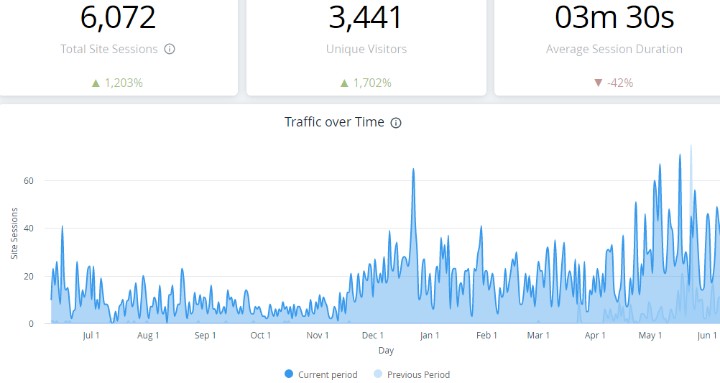
Chart 4.1: Traffic over time (Source: Google Analytics)
The above chart provides data of user traffic (measured in terms of site sessions) over a period of one year. The data highlights a steady growth in the user traffic on the website.
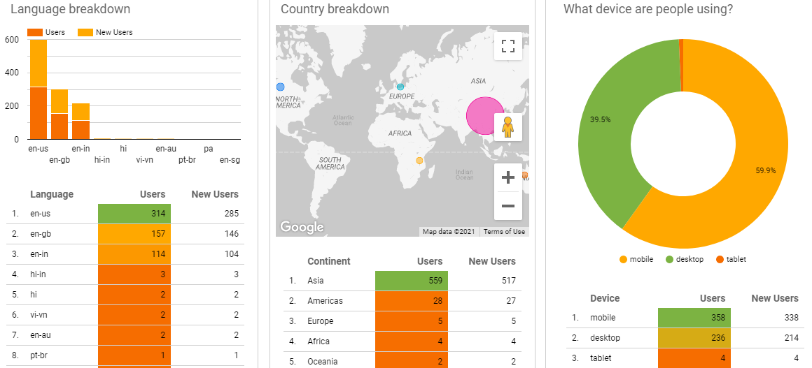
Chart 4.2: Traffic Overview (Source: Google Data Studio)
The above chart provides data of user traffic (measured in terms of geography, old verses new users, users based on device, and users based on language) over a period of one year. The data highlights that most of the users are spread across Asia and Americas. This is in line with the expected result since Hello Study Global focuses primarily on Ivy League Universities (USA based) and a majority of clientele is from India. Also, the exams that Hello Study Global helps its students with (like GRE, GMAT, SAT, LSAT, TOEFL) are widely accepted by the American Universities.
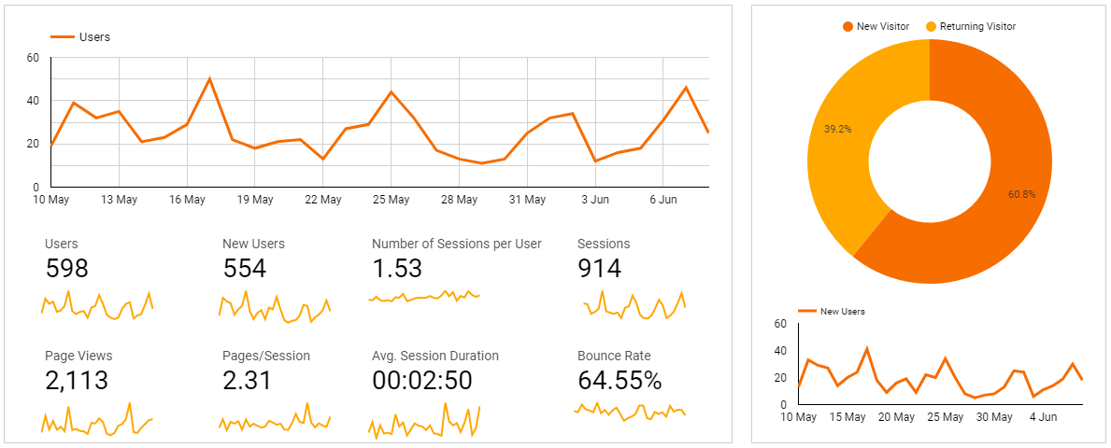
Chart 4.3: Traffic Overview site sessions (Source: Google Data Studio)
The above chart provides data of user traffic (measured in terms of site sessions and new verses old users) over a period of one month. One month data has been used to highlight the most recent performance of the website. The chart highlights a high bounce rate of 64.55%. Bounce rate is a web matric used to measure the ‘stickiness’ of the website users. A high bounce rate highlights that most of the users leave the website after visiting one page of the website.
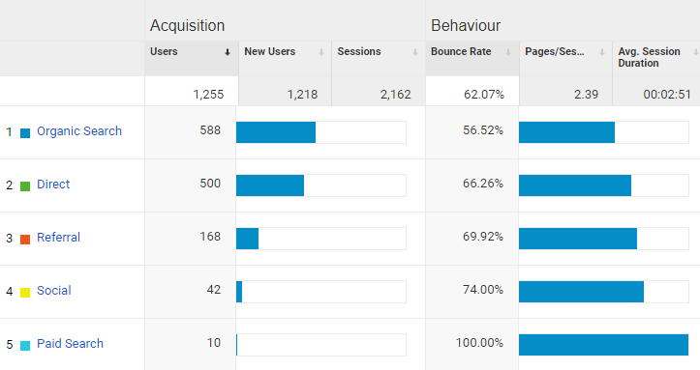
Chart 4.4: User Acquisition and behaviour (Source: Wix Platform)
The above chart provides data of user acquisition from various organic and inorganic sources. Also, the data highlights the bounce rate from these sources. A whopping 100% bounce rate was observed from paid campaigns, validating our hypothesis that inorganic marketing technique is ineffective in the given case. The user acquisition data also points to an abysmally low number of new users being acquired.

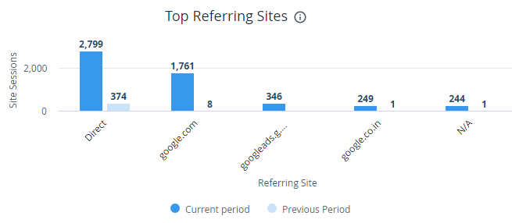
Chart 4.5: Top referring sites (Source: Wix Platform)
The above data points that most of the users on the website are generated from organic searches, confirming our alternate hypothesis that inorganic marketing is not suitable in all cases.

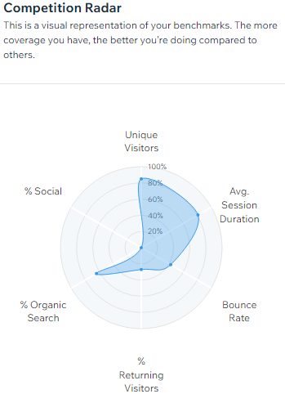
Chart 4.6: Competition radar (Source: Wix Platform)
The above web chart highlights that Hello Study Global is doing relatively better than the competitors in terms of organic web marketing. However, low social percentage highlights that the social media presence is not able to drive traffic on the website. The antidote to this problem may be to provide the web url on the social media handle and posts of HSG (back link generation). Also, the percentage of unique visitors on the website and the average session duration on the website are high confirming that the organic marketing strategies are working for Hello Study Global. A relative low bounce rate also bolsters the alternate hypothesis that organic marketing strategies result in low bounce rate. In the study abroad segment, competitors heavily rely on inorganic marketing strategies: something that may be counter-productive in a long run.

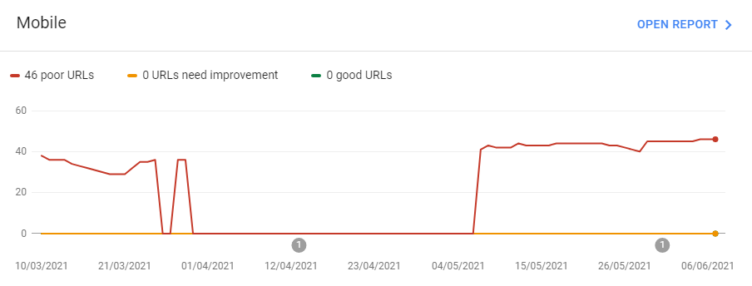
Chart 4.7: Core web vitals- mobile (Source: Google Data Studio)
The above line chart highlights a high number of poor web urls. This data is calibrated for all the request where it took the user more than 4 seconds to access the website. Since the data pertains to mobile users, the mobile version of the website is not properly optimised. This may be a threat if not rectified soon.
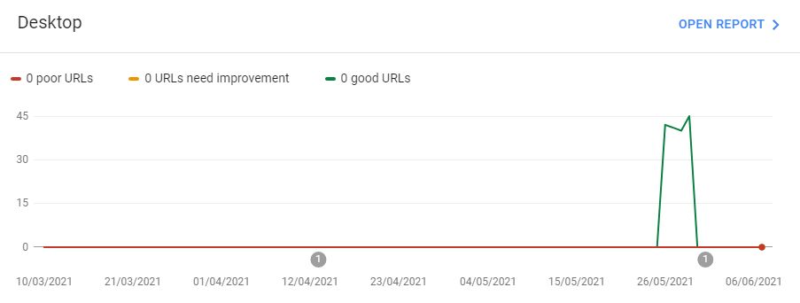
Chart 4.8: Core web vitals- desktop (Source: Google Data Studio)
The above line chart highlights that there are no poor web urls when the website is access through the desktop, which implies that the desktop version of the website is properly optimised. This data is calibrated for all requests where it took the user more than 4 seconds to access the website from their desktop.

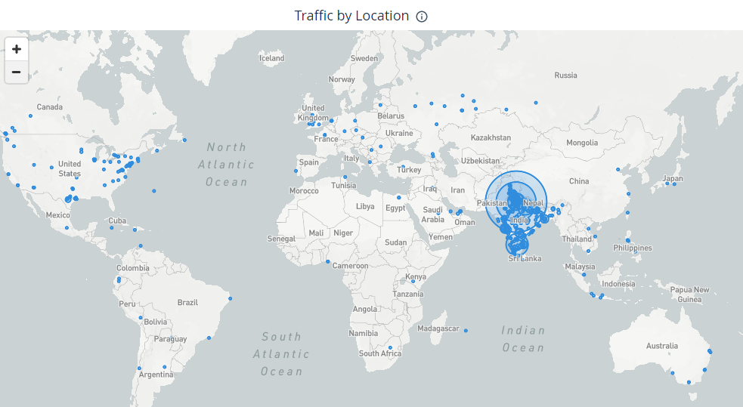
Chart 4.9: Web user distribution (geographical) (Source: Google Analytics)
The above geo-chart has been produced from Google Analytics for the user data over a period of 1 year. The data is in consonance with the nature of business that Hello Study Global has. Most number of users is from India and Americas.

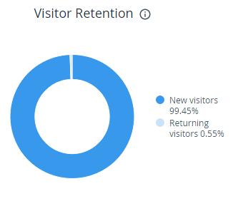
Chart 4.10: New verses returning users data (source: Google analytics)
The above data highlights that the new visitor retention on Hello Study Global website is very low. However, this is not an alarming factor because most of the users visit the website to know more about the company before availing the services. So the website serves are an information catalogue for the users who might not know about the company. After this need is fulfilled, they find no utility is revisiting the website. An antidote to this problem may be by adding the user login on the website where the existing clients would be required to login in order to avail services like test series.
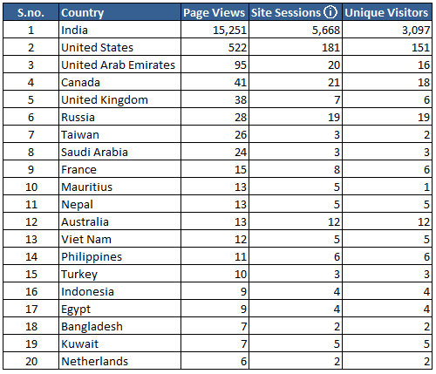
Table 4.11: User traffic data (Source Google Analytics)
The above table highlights the user traffic data on Hello Study Global website over a period of one year. The result is on expected lines.
CONCLUDING REMARKS
According to KPMC report, 2nd biggest reason why most start-ups fail is the cash burnout [5]. Start-ups should therefore be cautious in their marketing strategies. Instead of paying their way out to create brand awareness through inorganic paid campaigns, the start-ups should work on their services and strive to create the positive word of mouth promotion.

REFERENCES

- www.hellostudy.org, last accessed on 9th of June, 2021.
- Ramya Sri, D. (2017). Empirical Study of Organic and Inorganic Android Mobile Application Marketing Techniques. Singaporean Journal of Business, Economics and Management Studies, 51(5372), 1-10.
- Stokes, D., & Lomax, W. (2002). Taking control of word of mouth marketing: the case of an entrepreneurial hotelier. Journal of small business and enterprise development.
- Bughin, J., Doogan, J., &Vetvik, O. J. (2010). A new way to measure word-of-mouth marketing. McKinsey Quarterly, 2(1), 113-116.
- https://www.businessinsider.in/business/startups/news/founders-take-note-heres-why-most-startups-fail/articleshow/81981138.cms, last accessed on 9th June, 2021.

Approval Email
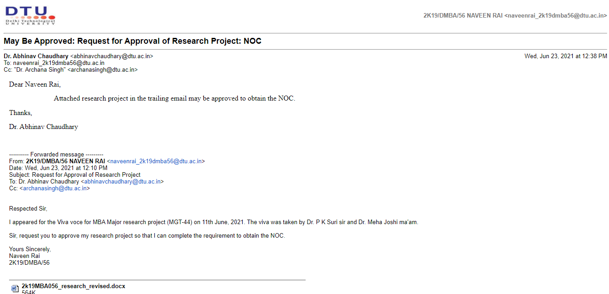

Plagiarism Report