**CHAPTER 1**

**INTRODUCTION**

**Credit analysis** is the procedure using which analysts appraise the creditworthiness of a company or an organization. In credit analysis, lending institutions evaluate the capability of a company to serve its financial obligations on time. The financial statements i.e. Income statement & Balance sheet of a firm are examined when it raises debt by issuing bonds & debentures and banks or NBFCs analyzes the financial statements of a small businesses before sanctioning or renewing a business loan. The term credit analysis is applicable to either case, whether the company is large or small.

The most important purpose of credit analysis is to look at both the company borrowing the money and the lending facility granting loan and to award a credit risk rating. The risk rating is assigned after calculating the probability of non-payment by the borrower at a given confidence level over the tenor of the facility, and by assessing the total loss that the lender would have to bear in case borrower defaults on its obligations.

Credit research includes a wide range of financial analysis techniques, together with financial ratios and trend analysis in addition to creation of projections and in depth cash flow analysis. Credit analysis also involves an assessment of security, credit history and ability of management as well as other source of repayments. Analysts try to envisage the possibility that a borrower will default on its debts or not, and if borrower defaults, to what extent the severity of losses will be. Credit spread is another important term which is the difference in interest rate between "risk-free" investments such as U.S. treasury bills and investments that bear some risk of default—disclose credit analysis report by financial market participants.

A **credit rating** is an evaluation of the credit worthiness of a borrower, mainly a business(company) or a government, but not individual consumers. The evaluation is made by a credit rating agency of the capability of debtor to pay back the debt and the possibility of default. Evaluations of individuals' credit worthiness are known as credit reporting and done by credit bureaus, or consumer credit reporting agencies, which issue credit score cards on basis of repayment history.

Credit rating agencies determine credit ratings of businesses on several parameters. The credit ratings are the outcome of evaluation of qualitative and quantitative information for a government or a company which also includes non-public information obtained by the analysts of credit rating agencies.

The credit ratings are useful for individuals, investors and entities that buy the bonds & debentures issued by governments and companies to find out the probability that the government will be able to repay its bond obligations or not.

A poor credit rating indicates a credit rating agency's opinion that the company or government has a high degree of risk of defaulting, based on the agency's scrutiny of the business history and analysis of long term economic prospects.

Credit rating is usually of a corporation's financial instruments i.e. debt security but companies sometimes themselves are also rated. Credit Rating agencies are responsible for assigning credit rating and the biggest of which are Standard & Poor's, Moody's and Fitch Ratings. Letter designations such as A, B, C are used by these agencies to indicate the risk associated with the financial instrument. Higher grade is proposed to symbolize a lower chance of default.

Rating agencies that do not assign a hard figure of probability of default risk to each grade prefer descriptive definitions such as: "the obligor's capacity to meet its financial commitment on the obligation is extremely strong," or "less vulnerable to non-payment than other speculative issues”. However, few studies have predicted the average risk and reward of bonds by rating. One study by a rating agency i.e. Moody asserted that over a "5-year time horizon" bond it gave its highest rating (Aaa) to had a "cumulative default rate" of meager 0.18%, the next highest rating of (Aa2) 0.28%, the next highest (Baa2) 2.11%, 8.82% for the next (Ba2), and 31.24% for the lowest it studied (B2). One more study as per journal of finance*,* calculated the additional interest rate or "spread" on corporate bond pays over that of "riskless" US Treasury bills.

Different rating agencies use variation of an alphabetical arrangement of upper and lower case letters accompanied by either plus or minus sign or add numbers to further adjust the rating. The S&P's rating scale makes use of upper case letters only and plus or minus signs. The Moody's rating scale uses mix of numbers and letters in lower case as well as upper case.

While roughly 95% of the credit rating business is controlled by S&P, Moody and [Fitch Ratings](http://en.wikipedia.org/wiki/Fitch_Group) but they are not the only agencies that assign credit ratings. DBRS long-term rating scale is to some extent equivalent to Standard & Poor and Fitch Rating with the letters high and low replacing the plus and minus sign. It goes from excellent to poor which follows as AAA, AA(high), AA, AA(low), A(high), A, A(low), BBB(high), BBB, BBB(low), BB(high), BB, BB(low), B(high), B, B(low), CCC(high), CCC, CCC(low), CC(high), CC, CC(low), C(high), C, C(low) and D. The rating of short term nature often maps to long term rating though there is scope for exceptions at the both high or low side of each equivalent.

European Central Bank recognizes only four credit rating agencies which are S&P, Moody's, Fitch and DBRS entrusted with the task of determining guarantee requirements for banks to borrow funds from the central bank. The [ECB](http://en.wikipedia.org/wiki/European_Central_Bank) makes use of the highest rating among the four agencies S&P, Moody's, Fitch and DBRS to conclude on haircuts and collateral requirements for lending to banks. In Europe, the highest ratings have been given to nations like Spain, Ireland and Italy and the ratings are under close scrutiny because it affects how much banks can borrow from ECB against sovereign debt they hold.

**1.1 Credit Rating Agencies as per SEBI in India**

1. CRISIL Limited
2. Fitch Ratings India Private Ltd
3. ICRA Limited
4. Credit Analysis & Research Ltd. (CARE)
5. Brickwork Ratings India Private Limited
6. SME Rating Agency of India Ltd. (SMERA)

To do the credit analysis of a company, It is advisable to do the economy and Industry analysis as well to know the driving factors of growth, inflation, demand and supply, competition, employment and other factors which impacts the business environment and the operations of a company.

Credit analysis is in depth study of financials & annual reports of the company of last 4 to 5 years and debt issued by the company is rated on several risk variables by various credit rating agencies. Credit rating agencies not only evaluates the credibility of companies but also the countries & are assign sovereign ratings depending upon the ability of the nations to service the principal as well as interest obligations within given time. Nations and companies are rated above or below investment grade which gives warning signals to investors that company or country may default on its obligation. Before lending to any company it is essential for investors to do thorough search of the company, its repayment history, number of years of operations, management team, running debt levels, profit levels, amount of debtors & creditors etc.

**1.2 Objective of the study**

The primary objective of this study is to conduct the Credit analysis & to analyze the financial health of the Mahindra & Mahindra company & assign a credit rating to the organization on the basis of various parameters like Profitability, Financial Strength, Business risk & Accounting Quality. This includes the in depth understanding the automobile & tractor industry which is followed with last three to four years annual report and financial statements analysis. The typical approach to financial analysis includes professional measures like Vertical Analysis, Horizontal Analysis, and Ratio Analysis.

Through this research work we intend to gain the following objectives:

* To gain Excel proficiency—calculations, functions, formulas, and Excel best practices.
* Getting acquainted with Financial Markets and Industry Analysis.
* To Learn structure and layout of financial reports and filings, annual report, etc.
* To learn to analyze and interpret financial statements, footnotes, and metrics like an analyst.
* To build comprehensive financial models from scratch the way it is done at major financial institutions.
* To learn to use data tables to present various sensitivities to projected financial metrics.
* To fix circularity problems, iteration, and other common modelling troubleshooting.

**Chapter 2**

**LITERATURE REVIEW**

Credit rating is assigned to companies and financial instruments like bonds & sovereign nations by credit rating agencies after evaluating the business on several parameters. Rating agencies use different parameters for companies in different sector, however, some metrics or parameters are common and are employed to appraise the general credit worthiness of the companies. Credit rating information services of India Ltd. (CRISIL) uses business risk analysis, Financial risk analysis, Management risk analysis & Project risk analysis to assign a suitable credit rating to manufacturing companies. For the same segment, ICRA i.e. Investment information & Credit rating agency of India Ltd evaluated business credit worthiness by analyzing scale of business, market share & competitive position, Product portfolio, R&D capabilities, Captive finance, Profitability, Leverage and Liquidity, Cash flow position and debt service indicators, Promoters and management quality. There may be difference in parameters used by agencies, however, criteria or framework is similar and different weights are assigned to different parameters forming the part of entire credit rating process. CARE begins its rating process by EIC analysis followed by analyzing the business specific risk factors that are attributable to company under investigation only. Parameters for auto ancillary sector using which CARE assign credit rating are Product profile, Diversification, Logistics, Supply chain and Plant location, Parentage and raw material.

Agencies generally have access to financial data as well as the information which is not made public is provided by the company to assign credit rating and may guide the companies how to improve the ratings and improve the performance of business by focussing on weak areas of company and using an efficient mix of debt and other sources of finance. The credit reports issued by rating agencies help companies to identify the parameters which require attention and their weights that impact the ratings.

**CHAPTER - 3**

**RESEARCH METHODOLOGY**

Research Methodology, also known as Research Design is the process of collection, analyzing and interpretation of the data to analyze the problem and act in response to the opportunity in such a way where the reduction in costs can be realized and the desired level of precision can be ensured to arrive at a conclusion.

**3.1 Significance of the study**

Credit research involves carrying out critical analysis to evaluate the business operations of a particular company to assess the cash generation capacity of the business & comparing it with industry average to determine the debt raising capacity of the company on various parameters like profitability, financial risk, business risk etc.

On a broader perspective, it is essential to project the financials of the company and evaluate the investing and financing activities and doing the financial ratio analysis can present the real cash generating capacity of business.

With incessant growing volatility in bond & stock markets, decision makers i.e. investors depends upon credit research analysts who stand out at preparing finest credit research reports to estimate credibility and capability of companies to meet their debt obligations of a particular company, as well as try & interpret the possible future course of its bond prices after studying trailing credit research report patterns. Along with the demand of quality credit research reports, there is also a growing demand of credit analysts who are skilled to evaluate company fundamentals thus guiding the investor on his position with the debt issuance of the company.

Hence using the tools of premium credit research reports and skills of a competent research analyst the investor is much better armed to make more prudent and informed debt related investment decisions in the debt market. Debt Investment when done in a systematic manner along with research recommendations can be considered as good calculated risk which has proven to return many fold for a good number of investors.

**3.2 Scope of Study**

The study focuses on the macroeconomic condition of India, Automotive industry analysis and finally on company overview. The project is based on tools like credit analysis and ratio analysis. Further, the study is based on information of last four years.

* The scope of the study is limited for a period of five years.
* The scope is limited to the credit analysis of the only one company i.e. Mahindra & Mahindra.

**3.3 Data Collection**

While preparing the report the use of secondary data available on website of company and stock exchanges have only been used. The research has been done on the data provided by the company for the general public. Since the company is listed on Bombay & National stock exchange it releases quarterly and annual reports. Use of these reports has been made to populate the financial model with historical financial figures & projections made based on suitable assumptions in order to perform all the calculations.

**3.4 Tools of Analysis**

The project is based on tools like ratio analysis, profitability analysis, financial strength analysis, debt repayment history analysis and MS Excel. The credit model has been developed using complex excel formula functions.

**CHAPTER 4**

**DATA ANALYSIS & INTERPRETATION**

**ECONOMY-INDUSTRY-COMPANY FRAMEWORK**

**4.1 ECONOMY**

As per IMF forecasts, India is expected to turn into the world’s fastest growing major economy by 2016 surpassing China. India is estimated to grow at 6.3 percent in 2015 & 6.5 percent in 2016 by when it is projected to cross expected growth rate of China, the IMF declared in its latest update of world’s economic outlook.

The improvement in economic fundamentals of India has accelerated in Fiscal Year 2015 with the collective impact of a strong central government mandate and central bank’s inflation focus sustained by benign international goods prices.

**4.1.1 Gross Domestic Product (GDP) Composition by Sector as per 2013 estimate**

* **Services:** 57 per cent
* **Industry:** 26 per cent
* **Agriculture:** 17 per cent

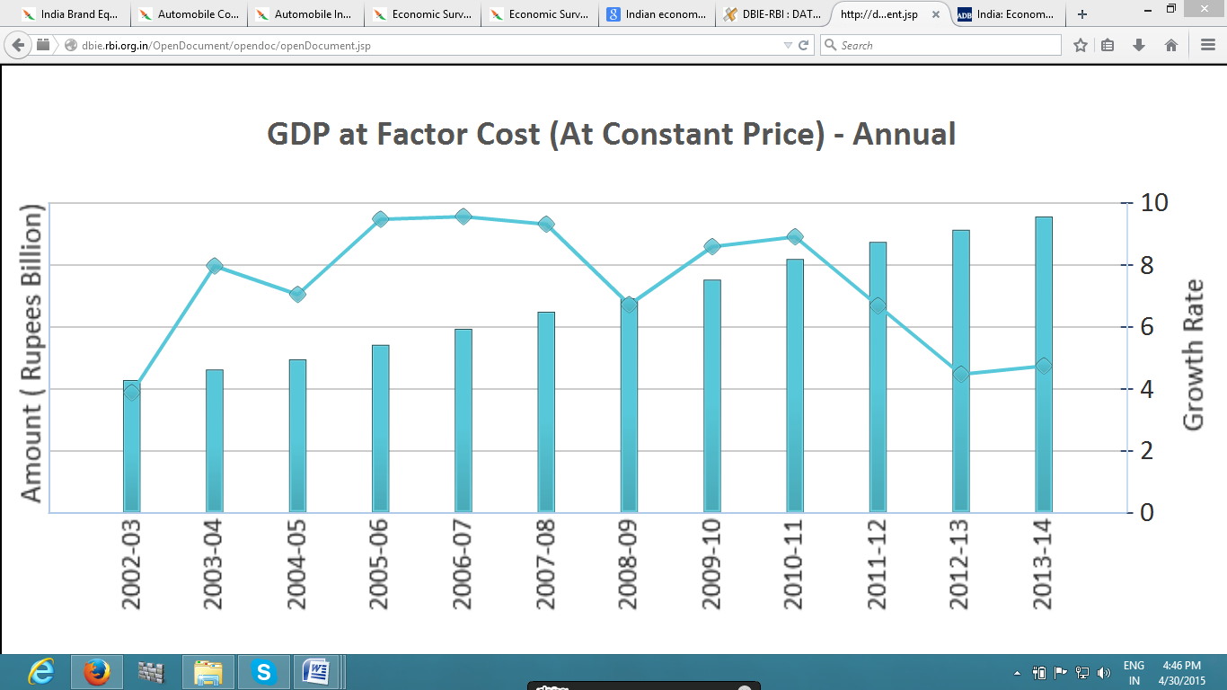

The Indian government disclosed an entirely new statistical method to assess the nationwide income with a broad framework , engineering an economic recovery with several reforms, turned up an amusing disclosure that GDP grew by 6.9 percent in the year 2013-14 instead of the former calculation of 4.7 percent.

The base year revision by India to calculate national accounts will enlarge the size of the Indian economy to US $1.8 trillion in Fiscal Year 2014, as per India Ratings. In 2012-13, the size of the Indian GDP was at about US $1.51 trillion.

India exported goods and services stood at US $23.88 billion in Jan 2015 & **Forex Reserve were** US $333.2 billion as on February 13, 2015. Having Said that, it is a great time to invest in India, Mr Jayant Sinha, Minister of State for Finance, is of the view that the Indian economy has the potential to develop into a US $4-5 trillion economy in the next 10-12 years.

**4.1.2 Key Interest Rates as per RBI website -**

**Bank rate – 8.5% Repo rate – 7.5% Reverse Repo rate – 6.5%**

**CRR – 4% SLR – 21.5%**

**4.1.3 Investments/developments**

* In the deal street across the world, India emerged as one of the strongest performers in M&A activity i.e. mergers and acquisitions and deals worth US $38.1 billion were concluded in 2014 as compared to US $28.2 billion in 2013.
* With cumulative growth of 4.6 percent, the eight core industries combined index stood at 166.2 in November 2014, 6.7 percent rise as compared to the index of November 2013.
* India and Germany entered into an agreement to put in place two working groups, one focusing on circular economy & other on the water management.
* Consumer confidence continued to stay highest all over the world & demonstrated improvement in the fourth quarter of year 2014 in the wake of optimistic economic environment and declining inflation.
* Foreign exchange reserves of India had hit a record high of US $322 billion, exceeding the earlier highest reserves of US $321 billion in Sept 2011. At present levels of Forex, reserves are assumed to be adequate to cover imports for eight & a half months.
* CAD i.e. current account deficit reduced from a high of 6.7 percent of GDP in 3rd Quarter of FY 2012-13 to an expected 1 percent in FY 15. Inflation is expected to lie in the 5 to 5.5 percent range, generating legroom for moderation of monetary situation. Indian Government has slashed subsidies and amplified taxes on conventional sources of energy like petrol and diesel to generate more revenue.
* Government of India, based on the suggestions of FIPB ( Foreign Investment Board), approved 14 FDI proposals to the tune of US $246.42 million approximately i.e. Rs 1,528 crores. Out of the 14 approved schemes, pharmaceutical sector had six of them, highest number of sanctions for any sector.

**4.1.4 PEST Analysis** - Politically stable Modi Govt. at center is driving reforms to drive up the growth by creating a conducive environment for business thereby inviting foreign investments and promoting “Make In India” Initiative. Other initiatives like “Jhan Dhan Yojana” & “Digital India” are likely to bring in more investments from overseas investors coupled with improvement in ease of doing business. Economic & Monetary policies are being framed in coherence to each other keeping in view the market volatility and exchange rate fluctuation. After cutting the lending rates, easily availability of credit is likely to spur demand and improvement in business activity maybe expected. Social environment is fairly good and conducive for business with companies taking cultural issues in perspective diligently while setting up manufacturing facilities. Technology is thriving at its best with companies spending billions of dollars in R&D activity to strive through innovation & excellence. With Make in India initiative, FDI with technology is expected to give boost to manufacturing sector with increase in technical knowhow in addition to technological advancements.

**4.2 Industry Profile**

## Distribution of Indian automotive industry by volume

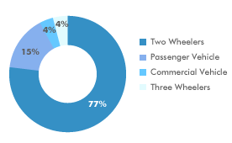

With 3.14 percent rise from the last year period, sales of cars grew for consecutive third month to 169,300 units in Jan 2015, reflecting the positive consumer sentiments prevailing in market.

Market leader Maruti Suzuki India observed 8.6 percent increase in sales at roughly 118,551 units in Feb15, out of which company exported over 10,600 units & sold around 107,892 units in domestic market.

In February 2015, Hyundai Motors India Limited (HMIL) also reported a 2.4 percent rise in total sales at 47,612 units in contrast to 46,505 units in the same month of the previous year.

In the two wheelers sector, Hero MotoCorp reported sales volume of 484,769 units in Feb15. TVS Motor Co witnessed 15 percent increase in sales at 204,565 units as compared to 177,662 units in same period last year. Bajaj Auto reported sales of roughly 2,43,000 units in two and three-wheelers segment.

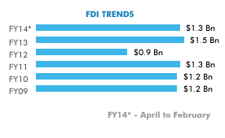

FDI in Indian Automobile sector

Key insights in Indian Automotive Industry

* Auto sales volume across different categories in domestic market increased by 3. 53 percent in Fiscal Year ending 31st March, 2014.
* Sales of passenger vehicle diminished by 6.05 percent in FY14.
* Commercial vehicles witnessed decline of 20.2 percent.
* Sales of Three wheelers also reduced by 10.9 percent in Financial year 2014.

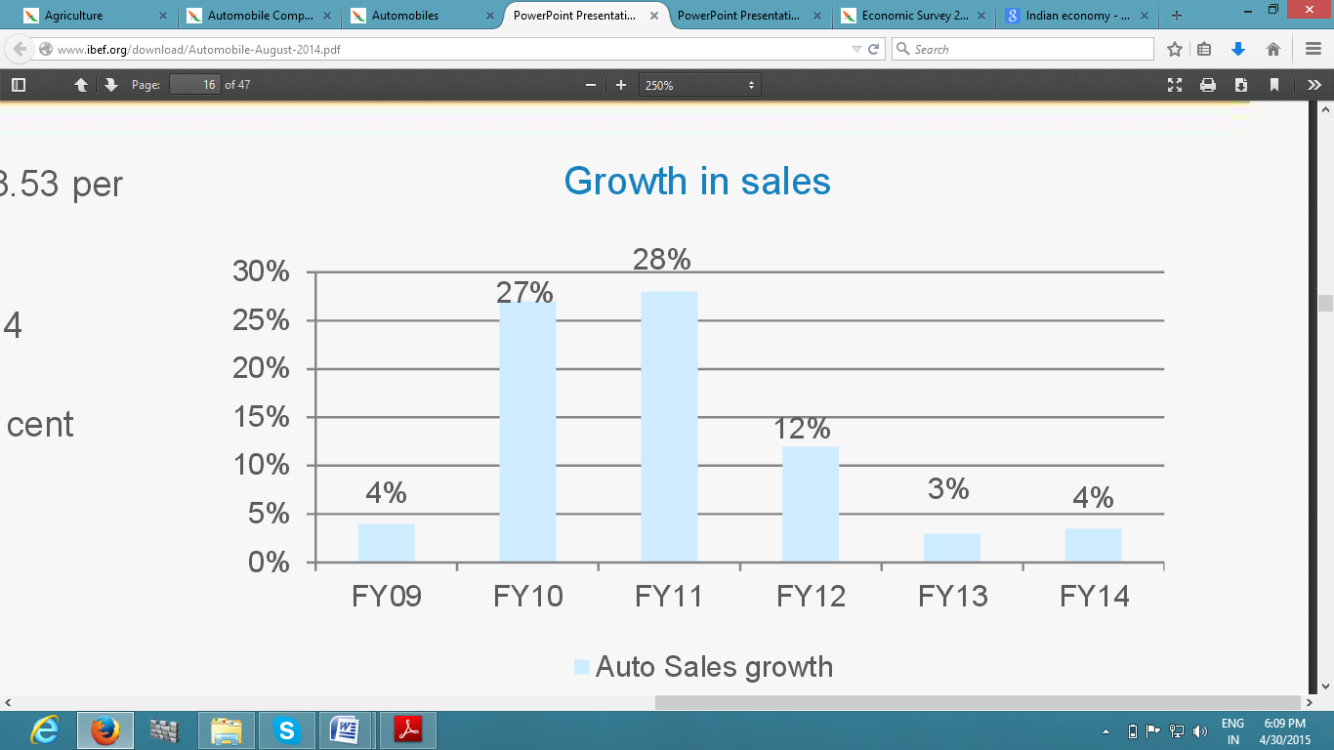

**4.2.1 Porter Five forces**

**Competitive rivalry** – The competition has increased and turned more intense post liberalization and with the entry of foreign players.

**Threat of new entrants** - Threat of new entrants is low because of the brand equity and intense capital expenditure required.

**Threat of new Substitutes** – With public transportation still under developed, threat of substitute products continues to be low.

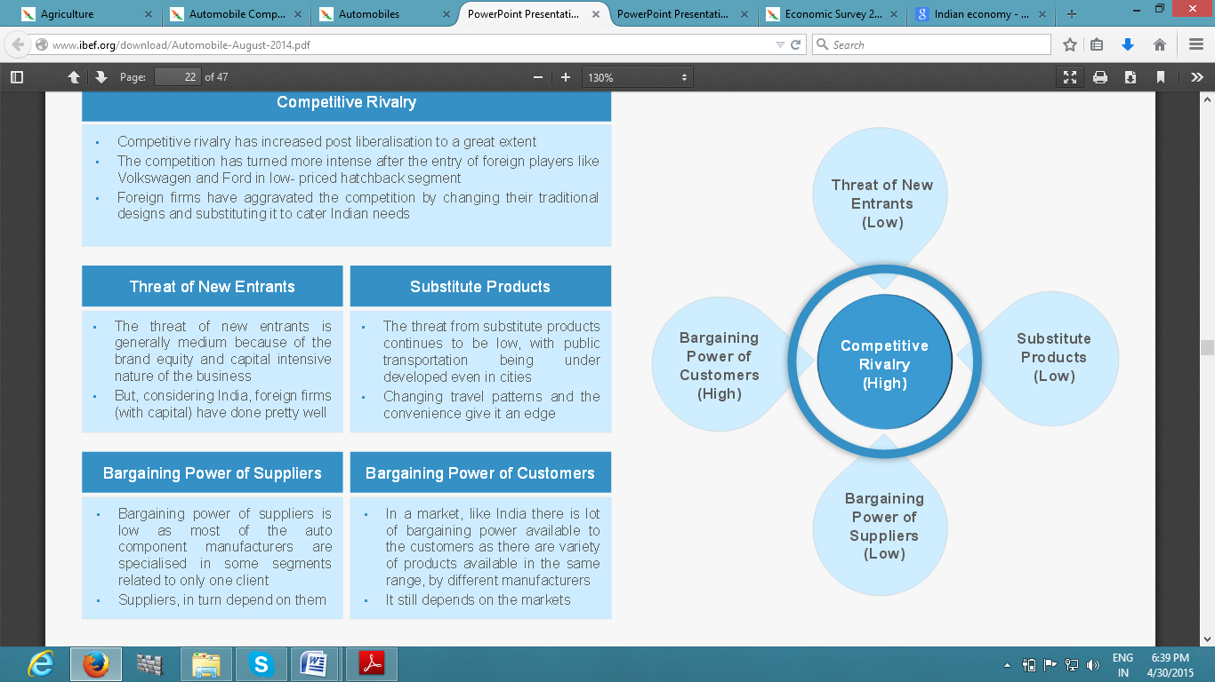

**Bargaining Power of Suppliers** – Majority of auto component manufacturers are specialized in only one segment and hence, there is low bargaining power of suppliers.

**Bargaining Power of Customers** – With variety of choices and brands available in addition to cheap sources of finance, customers exercise high bargaining power.

**4.2.2 Strategies adopted by companies**

* Addition of capacity – Most of the companies are trying to expand the scale of their operations to meet the customer’s demand by offering variety of products. Nissan & Mercedes increasing their capacity in Chennai & Chakan respectively.
* New Models – M&M introduced Verito Refresh, Quanto & Rexton in 2013 and Tata Motors launched Zest & Bolt after four years of gap. Maruti Suzuki unveiled SX4 S-Cross & Ciaz to meet the expectations of both Indian as well as Chinese customers.
* Marketing & Advertisement – Companies with hefty spending in advertising and marketing are trying to make customers brand conscious and strategically positioning themselves which gives them the differential advantage.
* Catering to the Indian needs – With Indian customers heavily dominated by middle class, companies are adapting themselves to match their products with the needs of the customers and hence dropped their traditional design and structure due to which competition within the industry has become fierce.

**4.2.3 Demand & Supply within the Industry**

Demand is expected to rise due to increasing income with rise in middle class and young population & “Make in India” which will propel India among world’s top manufacturers. With two wheelers accounting for larger portion of exports amounting to 67% , Auto export volume increased in FY05-13 at CAGR of 19.1%.Medium and Heavy commercial vehicles witnessed 25% plunge in sales due to sluggishness in industrial activity & low freight rates. In total, volumes for the overall CV industry fell by 20% YoY. Monsoon in 2013 was healthy and Tractors performed very well during the year. Unseasonal rains & EL Nino will have their effect on farm output and subsequently the demand is likely to fall for tractors which will hit the profit margins of companies like Mahindra & Mahindra. The long-term picture is striking in light of poor mechanization levels in the country’s agricultural sector and the impetus of the government on improving rural infrastructure.

**4.3 Company Profile**

Mahindra & Mahindra Ltd. is the flagship company of the Mahindra group which has its headquarters in Mumbai, state of Maharashtra and has a presence in various other sectors like the Automobile, Components, Aerospace, Agribusiness, Farm Equipment, Logistics and Defense & Energy industries. The company has a leadership position in the Indian as well as global Tractor industry and the Indian Utility Vehicles market. Through its subsidiaries& associate companies, the company participates in the Aftermarket Consulting, Industrial Equipment, Leisure & Hospitality, Financial Services, Real Estate , Information Technology and Retail industries. In 1956, Mahindra and Mahindra was listed on the Bombay Stock Exchange(BSE) and the firm by 1969 had entered the world of export market as an exporter of utility vehicles & exported spare parts also. The company and its subsidiaries employs over 155,000 employees in more than 100 countries across the globe. It is one of the largest manufacturer of tractors across the world and is one of the leading vehicle manufacturers by production in India. Recently M&M was in news to acquire 25 to 30% stake in Pipavav defence & is in talks to acquire auto design company Pininfarina SpA.

**4.3.1 History of Mahindra and Mahindra**

Mahindra & Mahindra started its operations in 1945 as steel manufacturing company with name of Mahindra & Mohammed. Founding partners of M&M were J C Mahindra, K C Mahindra & Ghulam Mohammed. After Independence, Company changed its name to Mahindra and Mahindra in 1948. Company quickly diversified its operations into MUVs & tractors and today it is a key player in Utility vehicle segment and market leader in Tractor industry.

By the year 1994, the Mahindra Group had become so diverse that it carried out a fundamental reorganization initiative into six strategic business unit(SBUs): Automotive, Infrastructure, Farm Equipment, Information Technology, Trade and Financial Services and Automotive Components and internally it was known as Systech.In year 2000,Anand Mahindra, the present chairman, pursued this reorganization with a new logo and in 2002, he launched the successful wholly indigenously designed vehicle Mahindra Scorpio. Coupled with an revamp in manufacturing & production methods, these changes facilitated the company in gaining more competence & since then the revenues & reputation of the company have grown evidently. At present, M&M is one of the top 20 major companies in India. Mahindra’s rank was among the top 200 most reputable companies in the world by Forbes in year 2009. Company forayed into two wheelers segment by acquiring Kinetic Motors and recently launched Gusto as new product. In 2011, company also acquired SsangYong Motor company & has controlling stake in Reva Electric Car company.

**4.3.2 Performance of the company**

During the FY14, the performance of the company was unfavorably impacted by the severe slowdown in the automobile industry. The automobile sector including both the Bus and Truck division achieved on the whole sales volume of 477,517 vehicles in the home market and reported a degrowth of 10.1% over the previous year.

For the FY 14, Mahindra & Mahindra is the 3rd largest passenger vehicles company by volume and the 2nd largest commercial vehicles company in India, with its total Indian Auto Industry share standing at 13.2%.

With sales over 50,000 units the Scorpio continues to reinforce its iconic status for the 3rd consecutive year & posted its highest ever sales since its launch. With its stellar performance, the Bolero crossed sales over 100,000 units for the 3rd consecutive year and for the 8th consecutive year, it continue to retain the title of India’s largest selling UV. Bolero is the fifth largest selling PV(passenger vehicle) in India & the only Utility Vehicle to feature on the list of top ten selling passenger vehicle in India.

XUV500 continued to be the choice of shoppers with average sales of 3,300 units per month in Quarter four of fiscal year 2014. The automobile division of M&M group exported over 29,600 vehicles during the FY 13-14, reporting a degrowth of 8.6% over the past year. Scorpio continued to seize the biggest share of the products exported, followed by the Maxximo. In south Africa & Chile, the XUV500 performed considerably well. Nepal, Sri Lanka, Chile and South Africa persists to be the biggest overseas markets in year 2013-14 for the exported products. While the degrowth for the FY14 was witnessed due to the change of duty structure in Sri Lanka, however, good growth was posted in Bangladesh, Nepal, Peru and Tunisia. The company continued to focus on bolstering the brand and strengthening the channels in focused markets.

The FY 2013-14 saw 31 years of M&M leadership & excellence in the domestic tractor market with a market share of 40.6%. Moreover the Swaraj and Mahindra brands enjoyed the merit of being No. 1 and No. 2 in Customer Satisfaction as per TNS survey 2013.

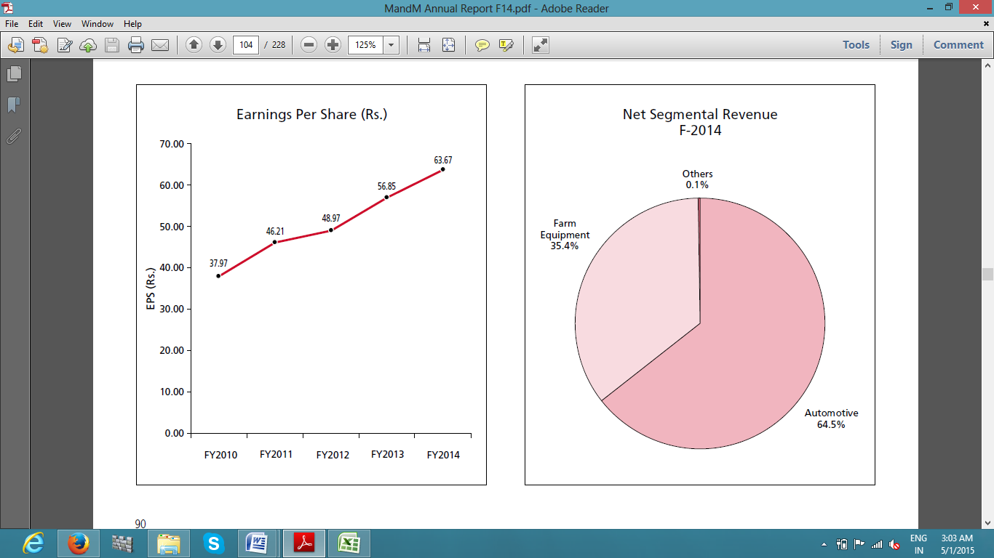

Company sold total of 268,480 tractors, (domestic as well as export), under the Mahindra and Swaraj brands in comparison to over 224,800 tractors sold in the previous year 2013, registering a growth of 19.4% over previous year. This growth was primarily driven due to selling in almost all states with Karnataka & Maharashtra leading the way. The launch of multiple tractor variants was key contributor to this growth which successfully met customer requirements across a variety of applications.

**4.3.3 Board of Directors**

Mr. Anand Mahindra is Chairman & Managing Director and Dr. Pawan Goenka was appointed as Executive Director with effect from 23rd September, 2013, are the Whole-time Directors of the Company. The board of directors consists of thirteen Directors as on 31st March, 2014.Across all the group companies, none of the directors on the board is a chairman of more than 5 committees or member of more than 10 committees in which he or she is a Director.

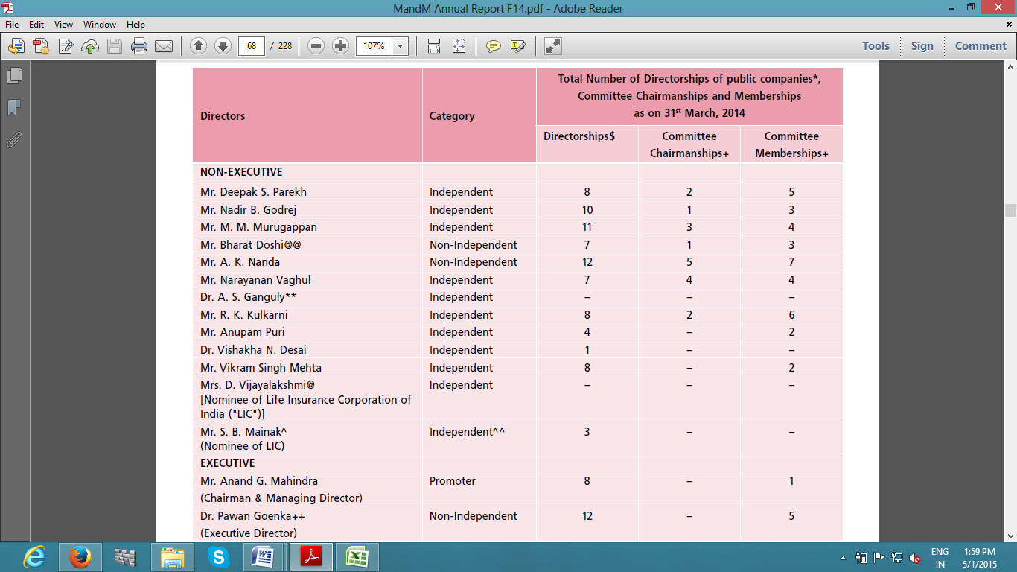

**List of Independent & Non- Independent Directors**

**4.3.4 Net Revenue & PAT**

In the wake of a good monsoon, the tractor division of the company experienced a healthy growth of 19.6% but the automobile industry witnessed difficult times which led to deceleration in the auto business to the extent of 7.88%, leading to the net revenue from operations being flat in comparison to the last year. Other income during the year under review was Rs. 718 crores which is more than Rs. 549 crores earned in the preceding year because of high interest income and higher dividend income from subsidiaries.

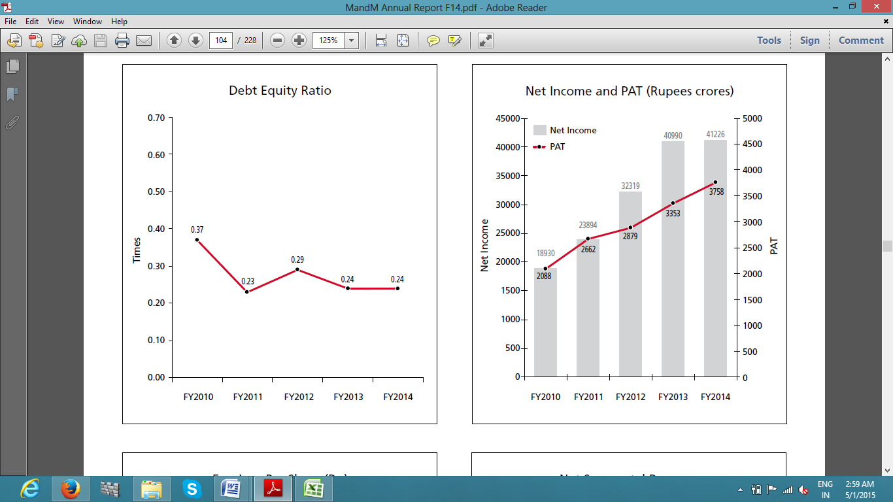

The gross sales and other income for the year ended 31st March 2014 of consolidated Mahindra Group was Rs. 78,735.72 crores as against Rs. 74,360.82 crores for the last year. The Group’s net revenue and other income grew by 7.9% to Rs. 74,506.02 crores in the current year from Rs. 69,082.43 crores in previous year. The profit before exceptional items and tax for the current year is Rs. 5,501.75 crores as compared to Rs. 5,127.87 crores in the previous year. The consolidated Group net profit for the year after deducting minority interest is Rs. 4,666.93 crores as against Rs. 4,099.20 crores earned in the previous year.

**4.3.5 Long Term & Short Term Borrowings**

Company continue to use debt to finance its operations and investment activities with borrowings which includes current maturities of long term debt and unclaimed matured deposits has increased from Rs. 3,489 crores in the previous year to Rs. 4,045 crores in the current year.



This increment is mainly on account of issue of Senior Redeemable Non-Convertible Debentures in the FY14. Company also repaid some of its debt keeping debt to equity ratio unchanged with rising interest & other income.

The interest expense was of Rs 259 Crores for the year ended 31st March, as compared to Rs. 191 crores in the previous year ending 31st March 2013. This is primarily due to new borrowing of Senior Redeemable Non-Convertible Debenture and addition of interest cost on borrowings due to merger of trucks business of Mahindra Trucks and Buses Limited.

**4.3.6 Earnings per Share**

Earnings per share reported in FY14 is Rs 63.67 posting 12% increase over the previous year of Rs 56.85. Exceptional gains and ordinary items continue to add to the net profit which results into higher EPS reported by the company.



After Economy-Industry-Company analysis, projections of financials were made using the data provided through annual reports and other disclosures made by the company and snapshot of income statement and balance sheet have been attached.

**4.4 Income statement**

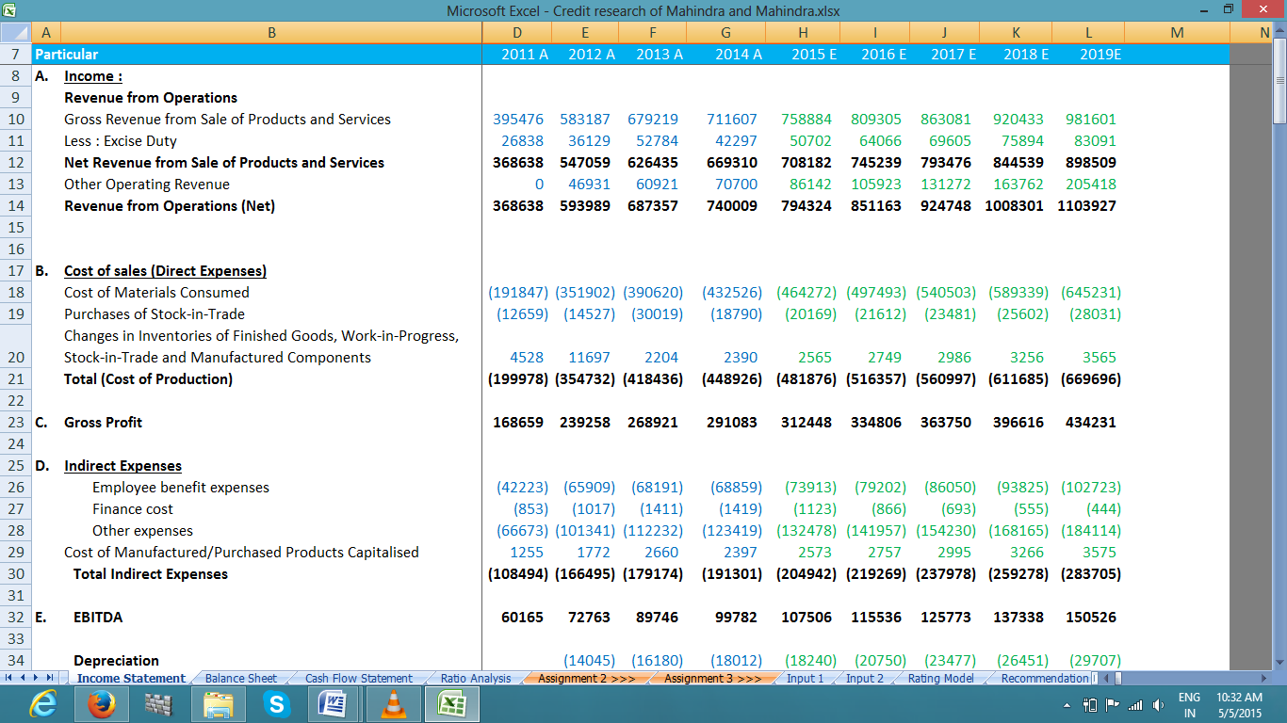

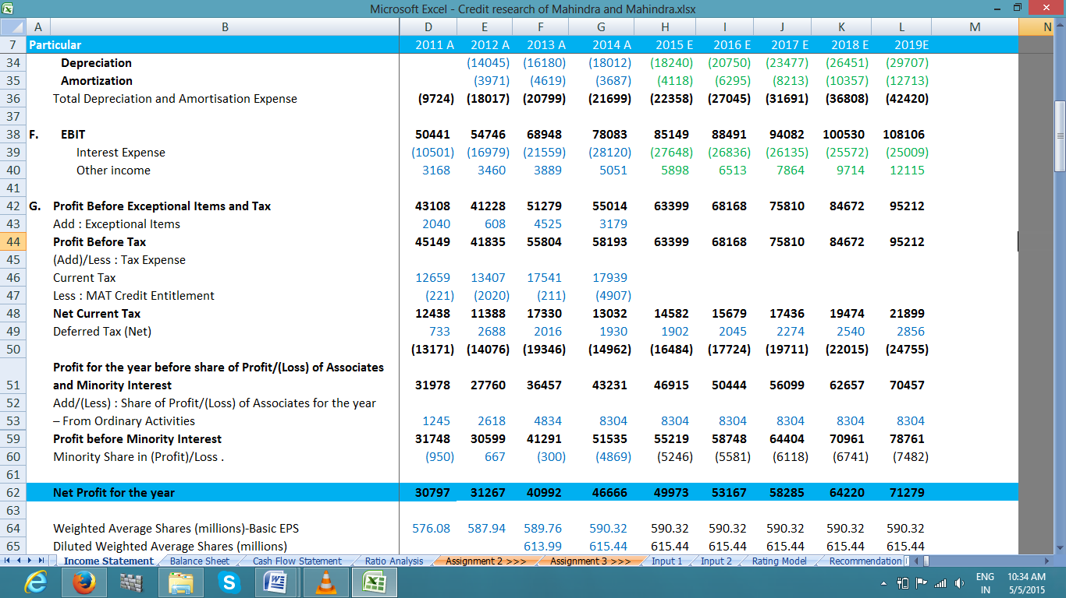

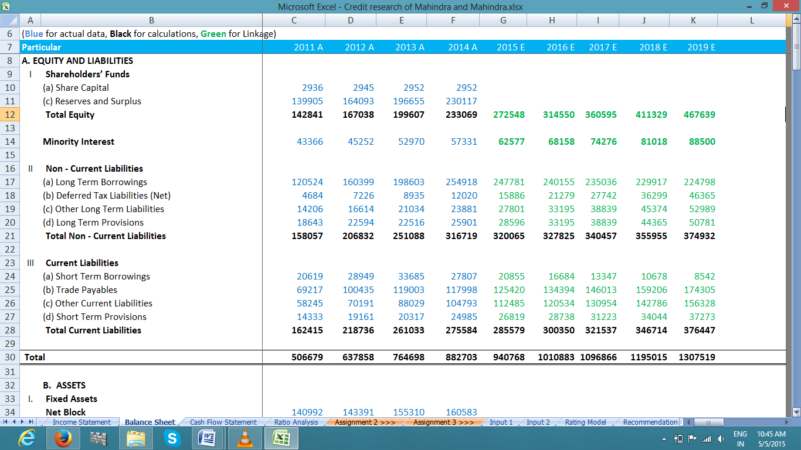**4.5 Balance Sheet**

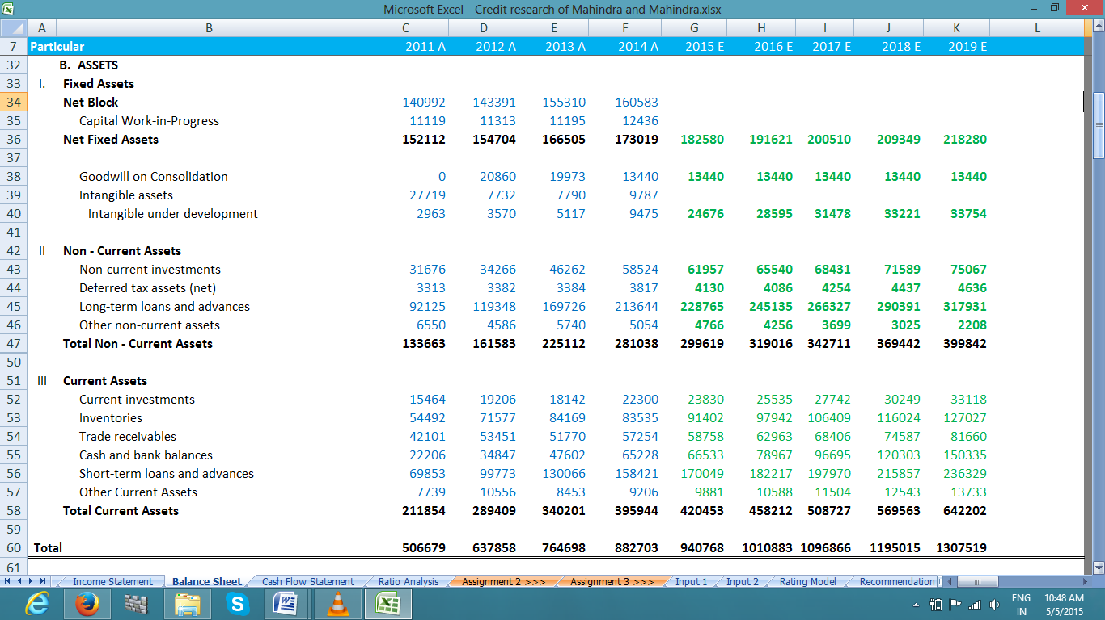

**4.6 Revenue & YoY Growth**

With global economic slowdown and high interest rates prevailing in the domestic market, automobile industry was sluggish till 3rd quarter of FY15 and given the current macro-economic factors ,net revenue of Mahindra & Mahindra is expected to grow at 7% or more in next five years as per management of the company. Mahindra & Mahindra is expected to continue with its efforts towards producing new products and technologies to serve the ever growing & changing consumer needs, meet regulatory requirements and sustain competitive pressures. Sustainable mobility solutions are a primary focus area for the company and it will carry on to chase technology development aggressively in these areas. In this direction, few of the main thrust areas are producing efficient aggregates with less frictional losses. To manufacture ‘right products first time’ and ‘right products every time’ have been the key thrust areas for the company.

IMF & World bank also projected Indian economy to grow faster than china and other developing economies over 7% in FY16. Foreign capital into manufacturing sector is expected to increase the capital expenditure into R&D and manufacturing facilities in line with “Make in India” initiative. Revenue projections for next 5 years have been made keeping in view the global automotive outlook and domestic environment.

Revenue Projections & YoY Growth

**4.7 EBITDA & Net Profit Margins**

EBITDA or the operating profit will continue to be in rising trend on account of low cost of manufacturing plus increase in prices of products which will impact the passenger vehicle sales. However, Tractor& Farm equipment segment will perform well in FY15 due to good monsoon and may post degrowth in first two quarters of FY 16 on account of EL Nino effect & unseasonal rains and in further years EBITDA is expected to grow at an average of 13.59%.

Net Profit & EBITDA margins Projection

Net profit after minority interest will fall to 6.29% from 6.31% but operating margins continue to increase over the years with expectation of turnaround in economy and increase in export sales at reduced cost of manufacturing. Net profit is expected to rise in FY16 because of reduced interest rates and profit from associates may also add to profit margins.

Net Profit is expected to touch Rs 4997 crores in FY15 up 7% YoY from previous year of Rs 4666 crores. Net profit growth is expected to touch 10% in FY17 on account of increase in sales due to reduced taxes and interest costs. Reduced cost of operations will also add huge gains and company will have good liquidity position with rising cash and cash equivalents.

PAT & YoY Growth

**4.8 Ratio Analysis**

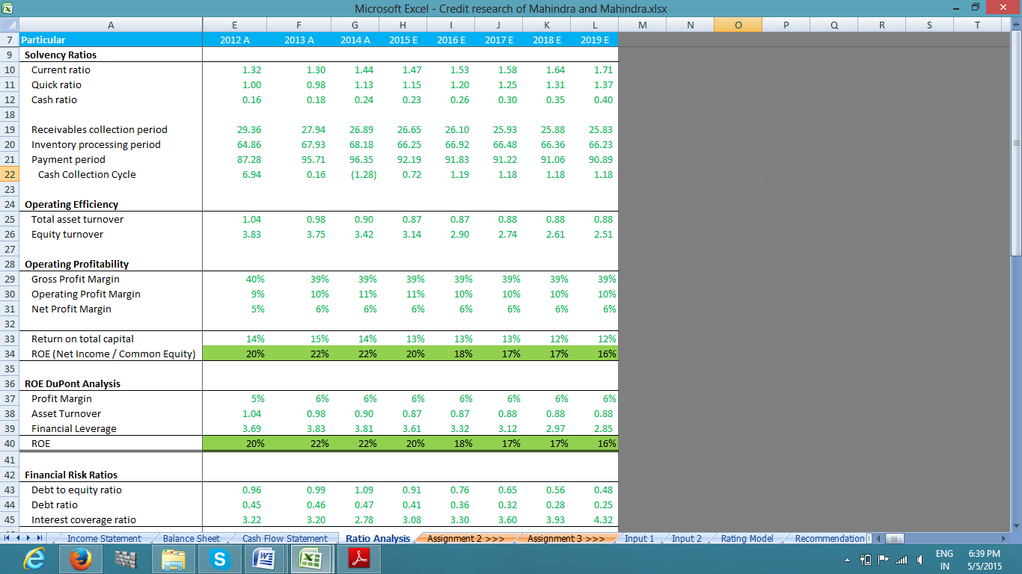

**4.8.1 Solvency Ratios** –

Current and Quick ratios are in increasing trend which indicates the healthy liquidity position of the company and company can easily meet its short term obligations. However, excess cash lying idle is not good sign but given the Quick ratio not exceeding 1.5 is fair for business operations and working capital needs.

Strict credit policy is being followed by the company and hence, cash is realized in less than 30 days from its sales and payment period is above 3 months which makes company’s operational capacity efficient. With cash conversion cycle equal to 1 day, company can make less provisions for bad debt and hence can increase profit margins. However, it takes almost 2 months for inventory to convert into sales which is fair for automobile industry given the high prices of the products and complexity in the availability of cheap credit to finance the sales.

**4.8.2 Operating Efficiency & Profitability** -

Profit margins are nearly flat over the years and operating profit margin is expected to fall to 10% from 11% due to rising depreciation and amortization expense. However, Net profit margin is increasing trend with good financing and investment policies being adopted by the company.

Equity and Asset turnover are in declining trend and possible reason could be decrease in sales in segments like infrastructure, hospitality, IT and other segments reporting losses. Overall performance of company is expected to improve with rising income of people, falling interest rates, increase in employment, declining inflation and stable oil prices which affects the major products of the company in addition to other macro-economic factors.

**4.8.3 Return on Capital Employed & Return on Equity**

Capital employed includes debt as well as equity and hence Earnings before Interest and taxes is the return on total capital invested in the business and it is average 11% for M&M investors.

ROCE & ROE Trend

After deducting the interest expense and taxes payable, left over amount is attributable to shareholders which is return for shareholders on their investments and it is in falling trend.

DuPont Analysis suggests that company has repaid loans thereby reducing the financial leverage which will lessen the interest cost and increase the net profit margins.

**4.8.4 Financial Risk or Debt ratios**

As per the financials, borrowings of Mahindra automotive division increased from Rs 3489 crores to Rs 4045 crores and this increase is largely on account of issue of Senior Redeemable Non-Convertible Debenture in the FY14. Company has been raising debt to finance the acquisitions and increase the spending in R&D activity to produce innovative and efficient products and diversify into global markets. Mahindra Research Valley, the R&D facility and Ssangyong Motor Company Acquisition are such examples where company is efficiently utilizing borrowings and excess cash available with it to diversify and produce innovative & energy efficient products. Since FY15, it is expected that company is not going to issue any debt in future to improve its credit rating and currently having long term debt amounting to Rs 25491 Crores in FY14 with maturities from 1 to 50 years. Debt to equity ratio almost equal to 1 indicates the company is financing its operations with equal mix of debt and equity.

**CHAPTER 5**

**CREDIT RATING METHODOLOGY**

To assign credit rating, company was evaluated on five parameters to assess the credit worthiness and ability of the company to repay its debt obligations without any default. Five parameters are as follows

1. Profitability
2. Financial Strength
3. Business Risk
4. Financial Policy
5. Accounting Policy

Each of these parameters also encompass a number of metrics or sub-factors which have been explained in detail.

**5.1 Profitability**

**EBITDA Margin –** A key metric in analyzing any company is to look at its operating efficiencies. To do this, analysis of a company’s cost structure is required, and that leads us to the profit and loss statement. However, EBITDA can be overstated by reclassifying regular operating expenses as extraordinary items; some companies take liberties in defining what is considered ‘extraordinary.’ Hence, before calculating EBITDA Margins, normalized recurring business income and expenses are considered.

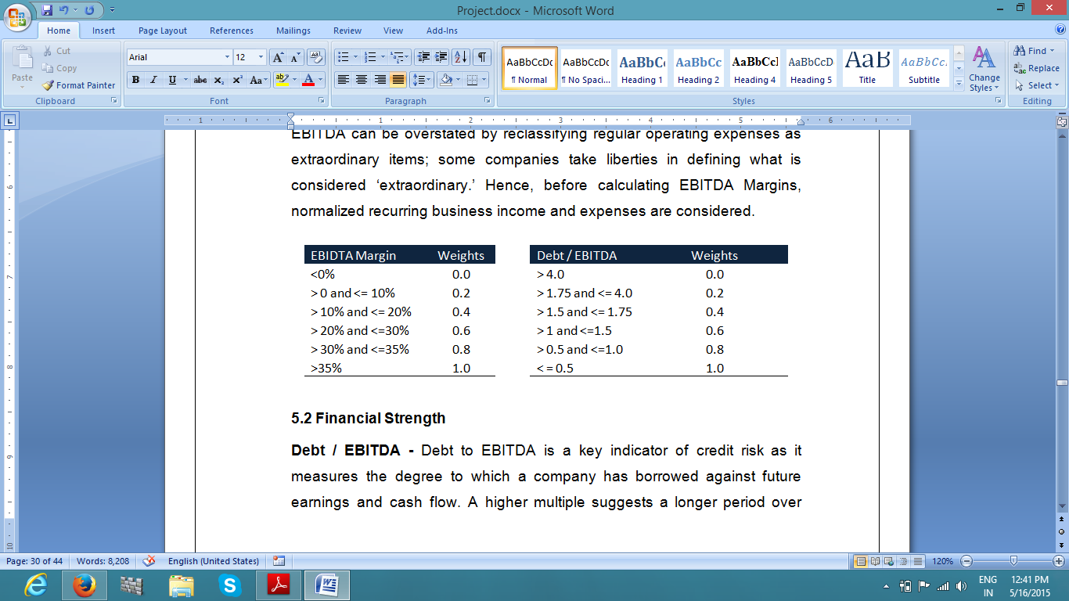

**5.2 Financial Strength**

**Debt / EBITDA –** Debt / EBITDA is an important measure of credit risk as it indicates the degree to which a firm has raised debt against future earnings and cash flows. A high debt to EBITDA multiple suggest a longer period over which profit from operations would have to be produced to pay off the debt. A low Debt to EBITDA ratio indicates greater flexibility for company to manage changes in the competitive business environment.

**Cash & Mkt. Securities / Debt -** Management’s liquidity planning and flexibility to manage cash and marketable securities are indicated by Cash & market securities to Debt ratio. The surplus of cash that company’s management selects to hold is an indicator of the cushion available to meet unknown and known liquidity requirements or provides the capability to meet particularly the needs of high volatile working capital and to pay short term debt repayment obligations. A sizeable sum of planned cash holding can also lessen the dependence on refinancing needs to payoff maturing debt payments.

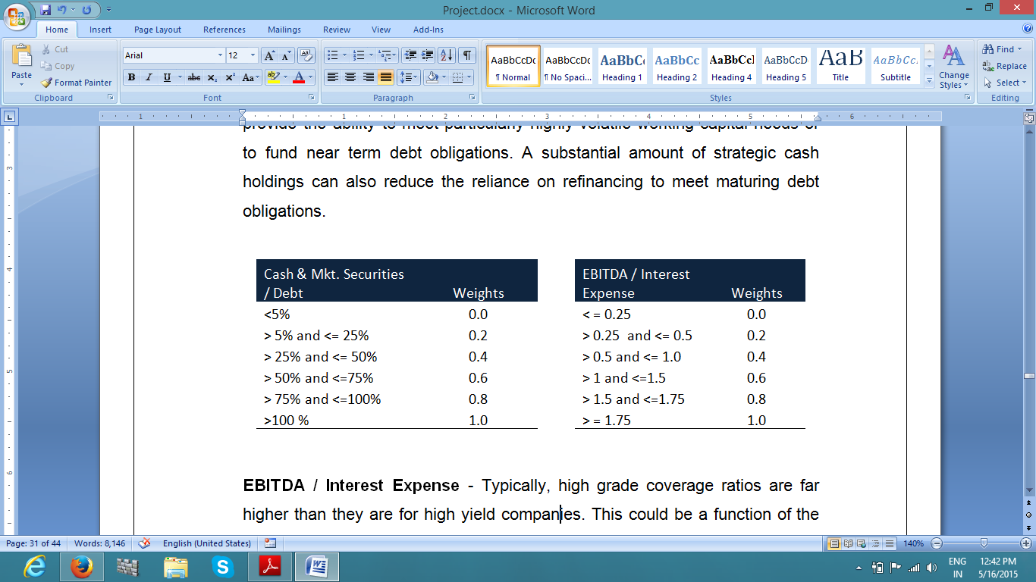

**EBITDA / Interest Expense** - Typically, high grade coverage ratios are far higher than they are for high yield companies. This could be a function of the start-up nature of high yield companies or the fact that they might be leveraged buyouts, which by definition have high leverage and low coverage.

**Operating Cash Flows / Debt -** This operating cash flows to debt ratio compares a operating cash flows of a company to its total debt. Total debt is defined as the sum of short term borrowing and long term debt. This ratio signifies the ability of a company to cover its total debt with its yearly cash flow from operations. The higher the operating cash flow to debt ratio, good is the company's ability to cover its total debt.

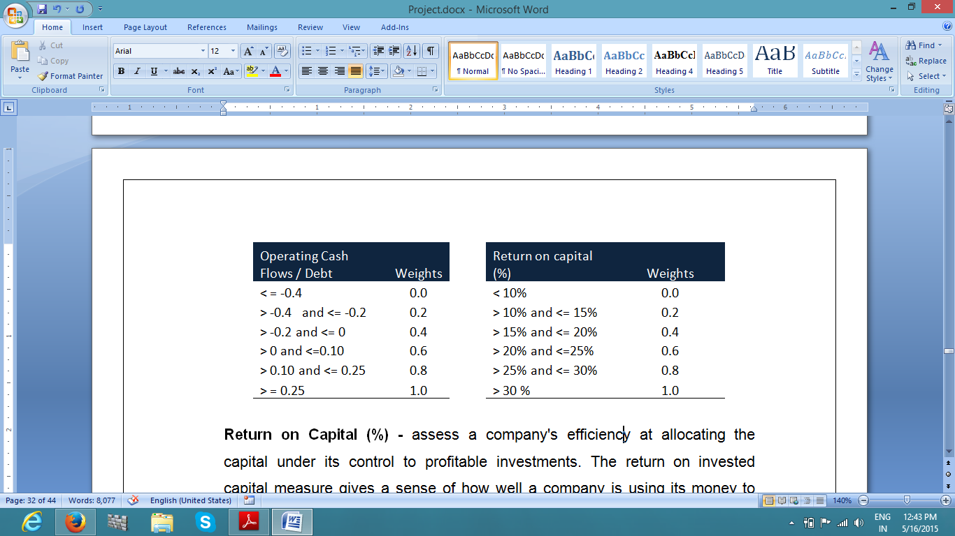

**Return on Capital (%) –** It assesses the efficiency of the company at allocating the capital under its control to lucrative investments. The return on capital invested gives an indication of how well a company is using its funds to generate high returns.

**Long-term debt/capital (%) –** Businesses usually finance their operations through either equity or debt. The debt-to-capital ratio gives investors an indication of a company's financial structure, or how it is financing its operations along with some insight into financial strength of the business.

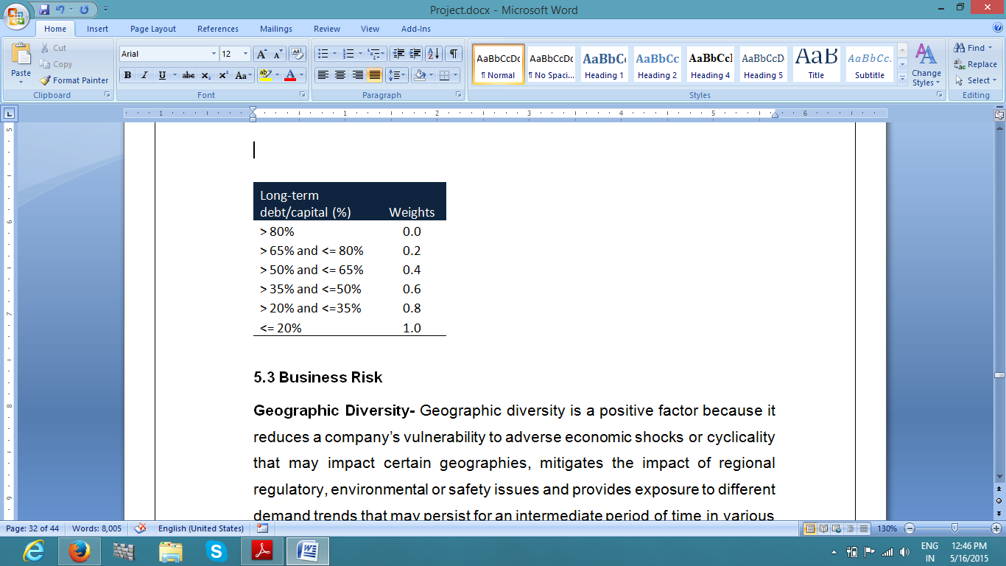

**5.3 Business Risk**

**Geographic Diversity-** Geographical diversity is a constructive factor as it trims down a company’s vulnerability to unfavorable economic shocks and cyclicality that may impact certain geographies, mitigates the blow of regional regulatory, environmental or safety matters and gives exposure to diverse demand trends that may continue for an transitional period of time in different regions. Geographical diversity is generally an advantage in that it may smoothen the volatility by balancing slower and higher growth markets, regional economic swings, and cyclic or weather-related fluctuations in operating cash flows.

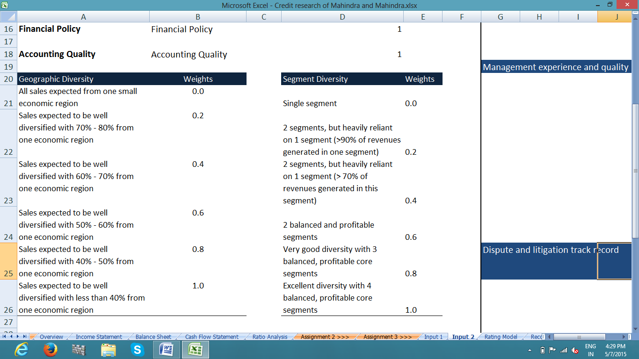

**Weights for Geographic & Segment Diversity**

**Segment Diversity -** Segment diversity moderates the impact of demand fluctuation, technological trends and price competition that can take place in particular segments. The efficacy of segment diversity is generally examined with regard to the correlation among individual segments. The classification of business segments may differ among different companies according to strategic focus of each company. Although, the quantity of business segments conversed in annual report often serves as a good sign of segment diversity, analyst may correct this measure based on the degree of correlation of the reported segments.

**Management Experience -** The excellence of management is an imperative factor underneath the credit strength of the company. Normally credit analyst meet with senior executives as part of their assessment of management’s business strategies, policies, and philosophies. However, for our research consideration, we may restrict ourselves to objectively looking at the company’s track record and follow press releases and other updates to judge Management’s experience & Quality.

**Dispute and Litigation Track Record –** It is possible that company is involved in range of disputes and litigations associated with patent, trademark, copyright, labors etc. The fiscal impact of such litigations or disputes should be evaluated and opinion should be made consequently.

**Track Record of Timely Project Execution –** On time completion of declared projects are of primary significance and the capability of the company’s management to meet targets and implement quality projects should be judged.

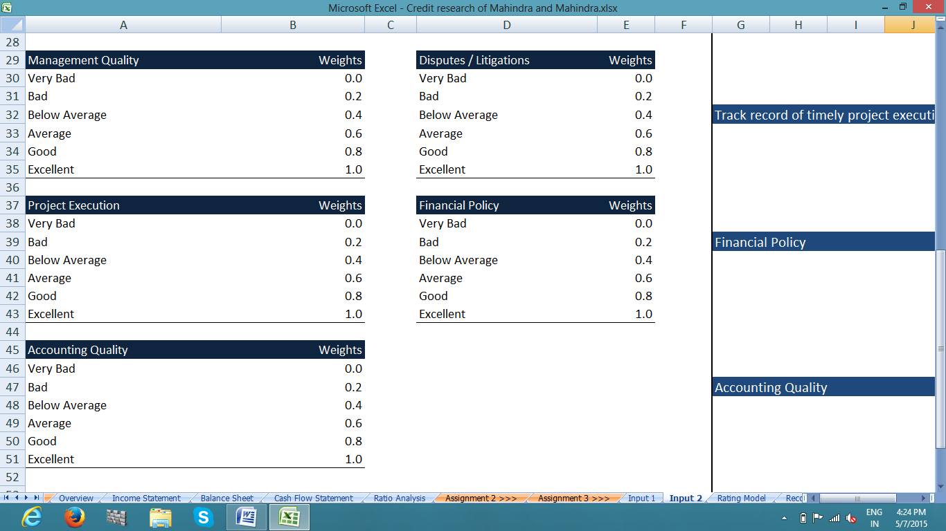

**Weights for other Parameters**

**5.4 Financial Policy -** While appraising financial policy, analysts tend to focus on ability of the company to largely safeguard the creditor and shareholder interests. Areas that are particularly focused upon in this factor comprises management’s fiscal discipline, commitment to ratings, position on capital structure changes, common approach towards dividends and share repurchasing activity, and expansion plans in addition to the financing strategy for acquisitions. Stated and transparent management’s fiscal policies supported by historical practices which also includes commitment to a given range of rating, and track record of sustaining a fiscal profile suitable for its rating category provides us some level of comfort that its financial policies will not differ extensively. Absent these we generally take a careful approach while estimating this rating factor.

**5.5 Accounting Quality –** Failure in the general financial reporting process, financial statements restatement and delay in filing quarterly or annual reports or other regulatory filings are indicators of a probable weak spot or even inefficiency in internal control.

**Weights Assigned**

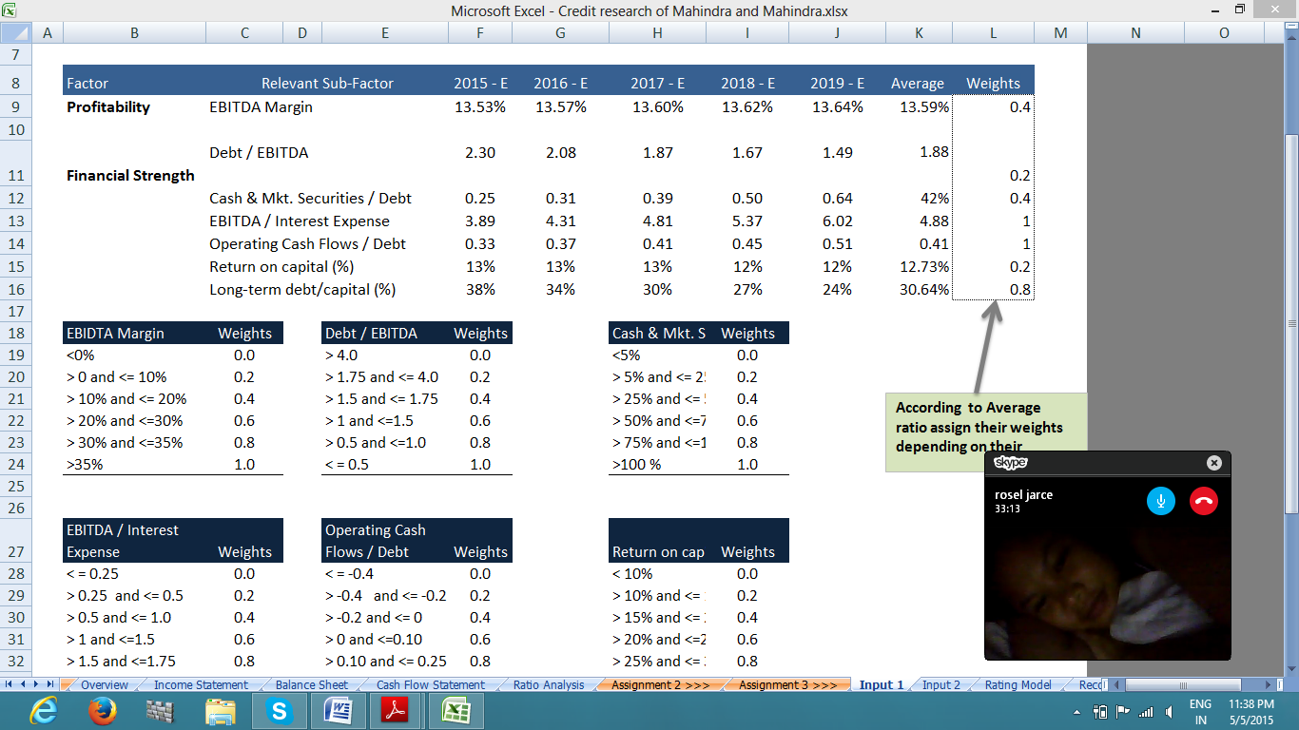

**Geographic Diversity** -

In FY 2013-14, South Africa, Chile, Sri Lanka and Nepal sustained to be the major foreign markets. Though the decline in growth for the year is mainly driven by the change of duty structure in Sri Lanka and good growth was reported from regions like Bangladesh, Peru, Nepal & Tunisia.

In US, 20 years of incorporation was celebrated by Mahindra USA. It accomplished an all time rising market share of 8% in the 0 to 80 HP segment in the USA. In china, sales from the Mahindra Yueda Tractor Company Ltd (“MYYTCL”) witnessed a marginal decline from 19622 to 19,042 units as compared to units sold in the last year.

The story of growth for the rest of the world operations was in Africa and Algeria as the largest market for Mahindra Tractors. On the other hand, the SAARC region continue to be a challenge accompanied with diminishing industry growth in Sri Lanka, Nepal & Bangladesh adversely impacting volumes. Global subsidiaries include Mahindra Europe based in Italy, Mahindra USA Inc., Mahindra South Africa and Mahindra (China) Tractor Co. Ltd.

**Segment Diversity**

Major chunk of revenue comes from Automotive & farm equipment segment contributing up to 80% and financial services segment is also highly profitable segment contributing 7% to revenue.

**Revenue Contribution of different Segments**

**Management Experience & Quality**

Chairman & Managing Director Anand Mahindra is alumni of Harvard Business School and joined Mahindra Group in 1989 and has strategically taken business to new heights. All directors on board have rich experience in their respective fields and contributed vastly towards the growth of the organization and hence, weight of 1 is assigned.

**Dispute & Litigation Track Record**

As on the end of the financial year, two cases are pending against the Company on matters alleging unfair trade practice and other matter of anti-competitive activity. There are other income tax & excise duty related disputes are pending and hence .8 weight is assigned.

**Financial & Accounting Policy**

Company follows all rules and regulations related to financial reporting & accounting standards and make all public disclosures related to stock exchanges within reasonable period of time and hence, weight of 1 is assigned to both parameters.

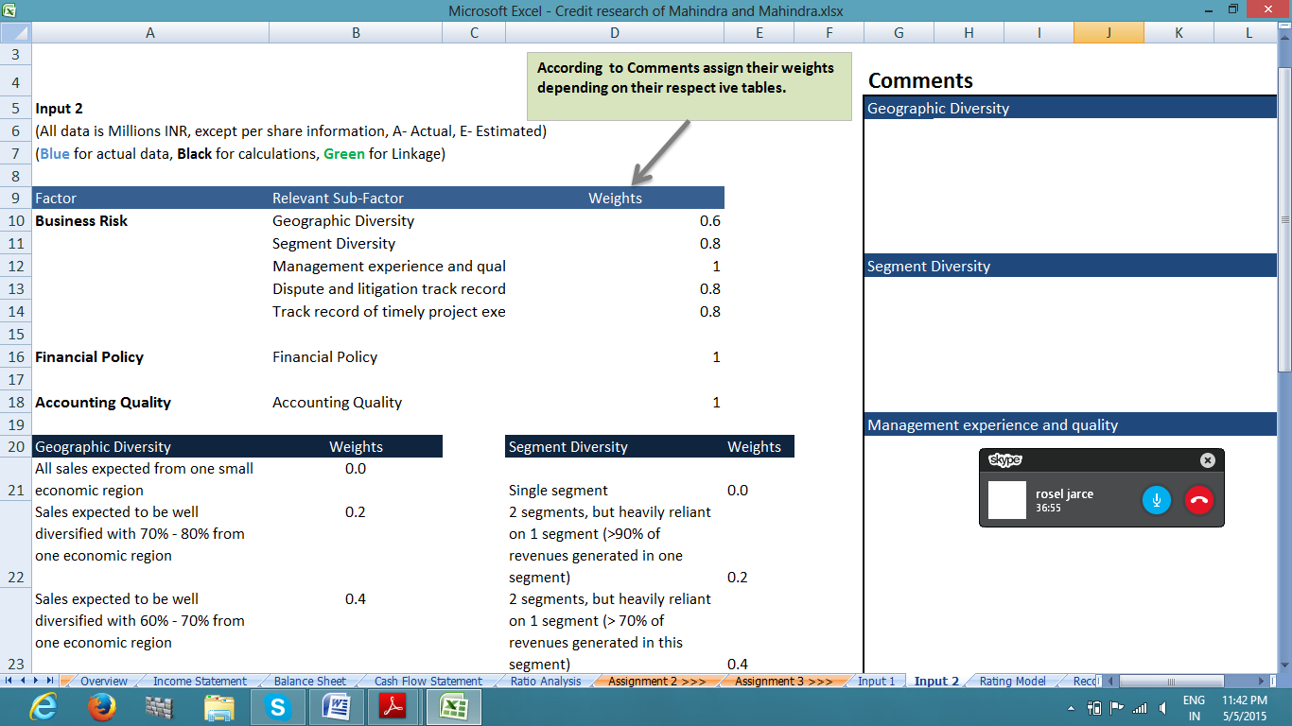

After assigning the weights to various parameters, a credit rating has been assigned to Mahindra & Mahindra following the framework provided by Corporate Bridge Academy, an online educational agency which is similar to some extent to framework being followed by credit rating agencies.

**Chapter 6**

**CONCLUSION & RECOMMENDATION**

Mahindra & Mahindra Ltd generates majority of its revenue from Automotive & Farm Equipment division and diversified its operations across various other segments to build a robust revenue model. Company’s forecasted financials indicate robust business performance in next few years despite downturn in domestic economy. Low consumer spending, depreciating rupee, scarcity of labor, rising commodity prices and high oil prices may affect the sales of company’s products. However, improving consumer sentiments and fall in interest rates will make up for loss in sales of passenger vehicles & tractors. Unseasonal rains & effect of EL Nino will continue to hover over the growth forecasts of agricultural sector forcing the company to cut the cost of producing the tractors and farm equipments thereby maintaining its market share. M&M continued with its strict cost restructuring exercise and improved efficiency consistently which resulted in considerable cost savings through persistent focus on controlling costs, processing efficiency and product innovation that match customer expectations in all areas thus facilitating the business to retain money-spinning growth in the present economic setting.

In FY16, Utility Vehicle(UV) industry is expected to grow more than cars, as more product launches and petrol options emerge in UV segment. HCV segment has seen good growth so far in FY15. However, discounts are still higher in the industry. M&M has also increased its market share to 2.7%; M&M will strive to reach a market share of 7-8% and feels that it has the products to reach the same. During 3rd quarter of FY15,Exports de-grew 23% & was affected majorly by Chile due to change in duty structure.

On financial front, company has performed fairly well reporting 8% growth in revenue and 14% in PAT in FY14 and revenue is expected to grow at average 8% over next few years on back of rising domestic as well as global demand. Company continued to focus on managing cash efficiently and ensured that it had adequate liquidity and back up lines of credit. During the FY14, Company repaid Rs. 474 crores of borrowings from internal accruals. The Banks rated M&M as a prime customer and are extending services at primary rates. M&M has been following a careful financial policy and aspires not to surpass an optimal financial risk at any given point of time.

Mahindra & Mahindra has been rated under Basel II norms by CRISIL, ICRA (“ICRA”) and Credit Analysis & Research Limited (“CARE”) for its banking facilities. While all of them have assigned the highest credit rating for M&M’s short-term facilities. Recently, CRISIL & other rating agencies promoted the credit rating of firm’s long-term Banking facilities at “AAA/Stable” from AA+, ICRA has assigned the highest rating of AAA/(stable)” and CARE sustained its positive outlook with the rating “CARE AAA+”.

**Credit Rating**

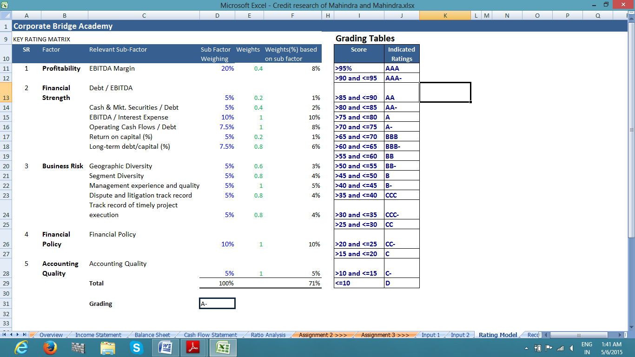

Firm has made timely repayments of previous long term borrowings and has adequate cash on their books. However, given the downturn in automotive industry, it is expected the sales of automobiles are expected to de-grow and may severely hit revenue margins of the company. After evaluating the company on five factors i.e. Profitability, Financial Strength, Business Risk, Accounting Policy and Financial Policy, we assign **A- credit rating** to M&M on its long term facilities. The downgrade in credit rating is majorly because of rising debt levels which have grown at an average of 28% for last three years & high debt increases the interest costs and affects the profit margins. On the basis of consolidated financials, Rising Debt to equity ratio is a major concern which is expected to hover around .9 in FY16 and interest coverage ratio is expected to be around at an average of 4.88.

With major repayments in FY15 & FY16, it is expected that Company will shed off most of its debt burden and may raise capital through other cheap sources of finance i.e. public deposits etc. A credit rating upgrade can be expected in 3rd quarter of FY16 given the low interest rates in economy and implementation of Good & Services Tax which will bring major relief to companies burdened with high level of state taxes.

As per annual report, Other risks & concerns associated with company which affect its credit worthiness are un-hedged foreign exchange exposure of around US $100 million. Besides that the M&M has outstanding foreign currency borrowing of **JPY 194.10 crores** and **US $ 30.00 crores** as compared to Japanese Yen 388.20 crores and US $30.00 crores in 2013. The borrowings of JPY 194.10 croreshas been fixed to US $ 1.67 crores through cross currency swap facility. Currency risk of US dollar liability has not been hedged. However, the interest rate swaps has been used to hedge US dollar interest rate risk.

**Limitation of study**

* Credit Rating has been assigned only on basis of five parameters which are expected to be generally used by rating agencies & may vary depending upon industry.
* The study is restricted to one company based on credit analysis.
* There was a constraint with regard to allocation of time for the research study i.e. for a period of 90 days.
* Suggestions and conclusions are based on the limited data of four years.

**REFERENCES**

* Annual report 2014, 2013, 2012
* http://www.mahindra.com/Investors/Mahindra-and-Mahindra/Resource#showCenter
* http://www.moneycontrol.com/
* www.ibef.org
* www.wikipedia.com
* www.**crisil**.com/
* Prince, C.J. "Extending Credit to Your Customers Can be a Boon to Your Business, but Only if You Do it Wisely." Entrepreneur. April 2004.
* http://www.icra.in/AllTypesOfReports.aspx?ReportCategory=Housing%20Finance%20Companies

**ANNEXURES**

**Other supporting schedules**

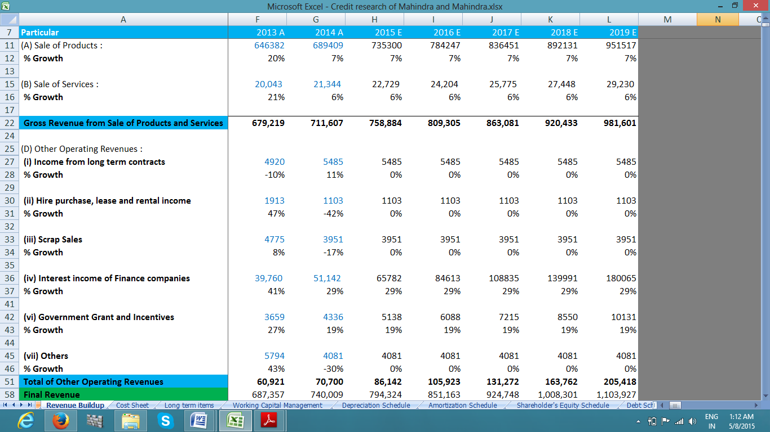Revenue Model

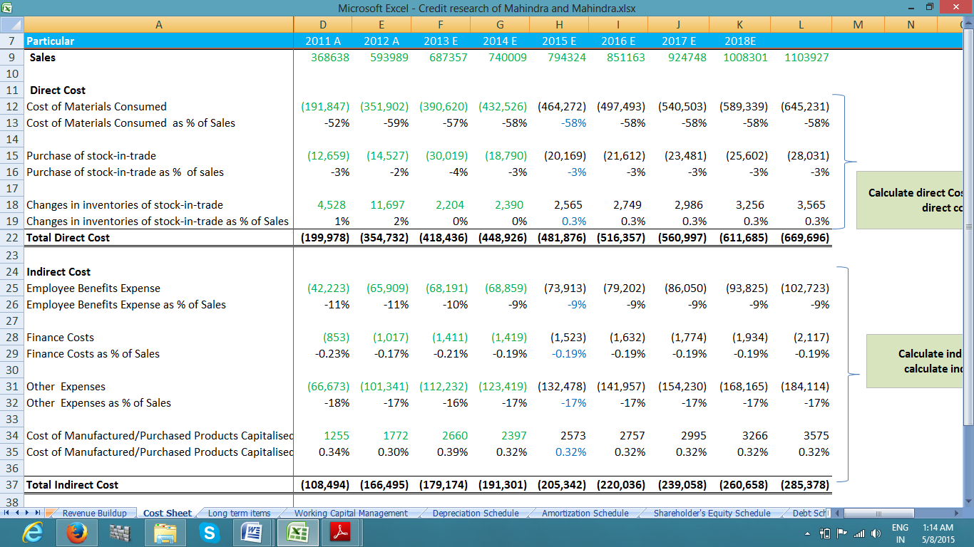Cost Sheet

Working Capital Management

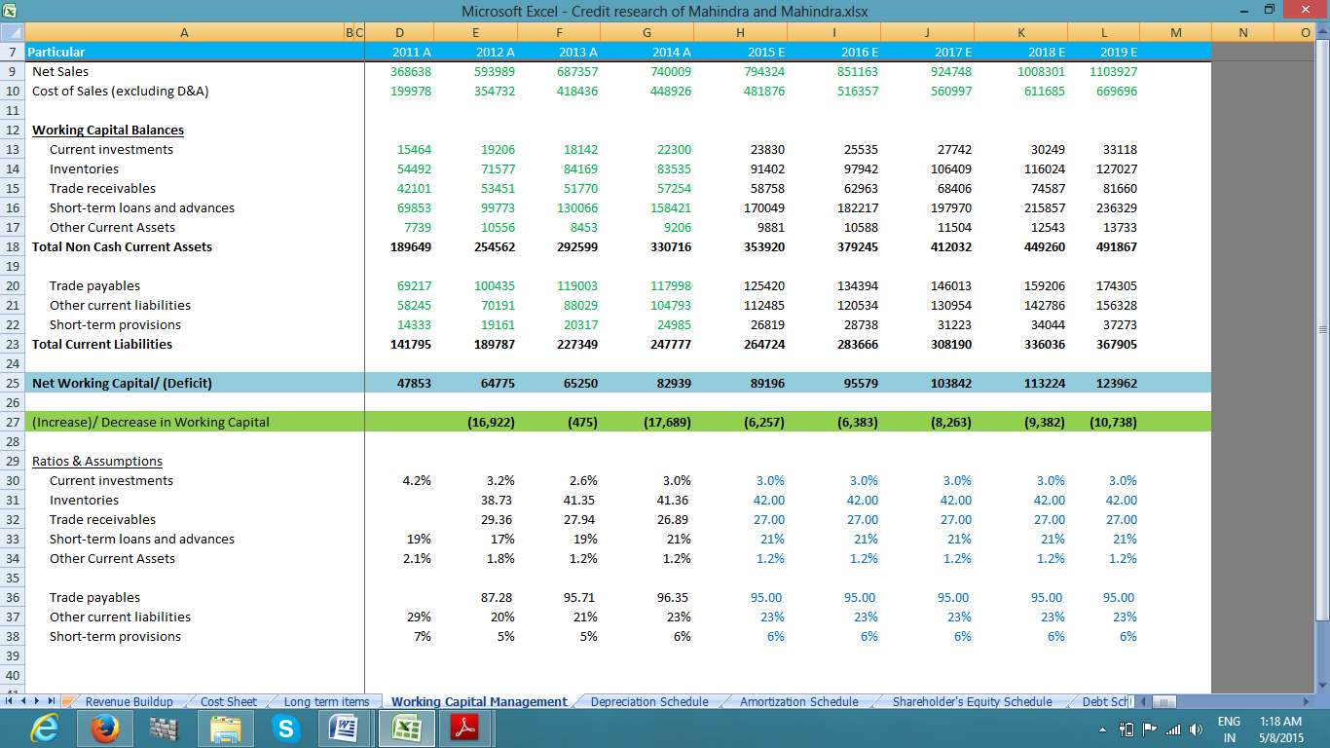

Shareholder’s Equity Schedule

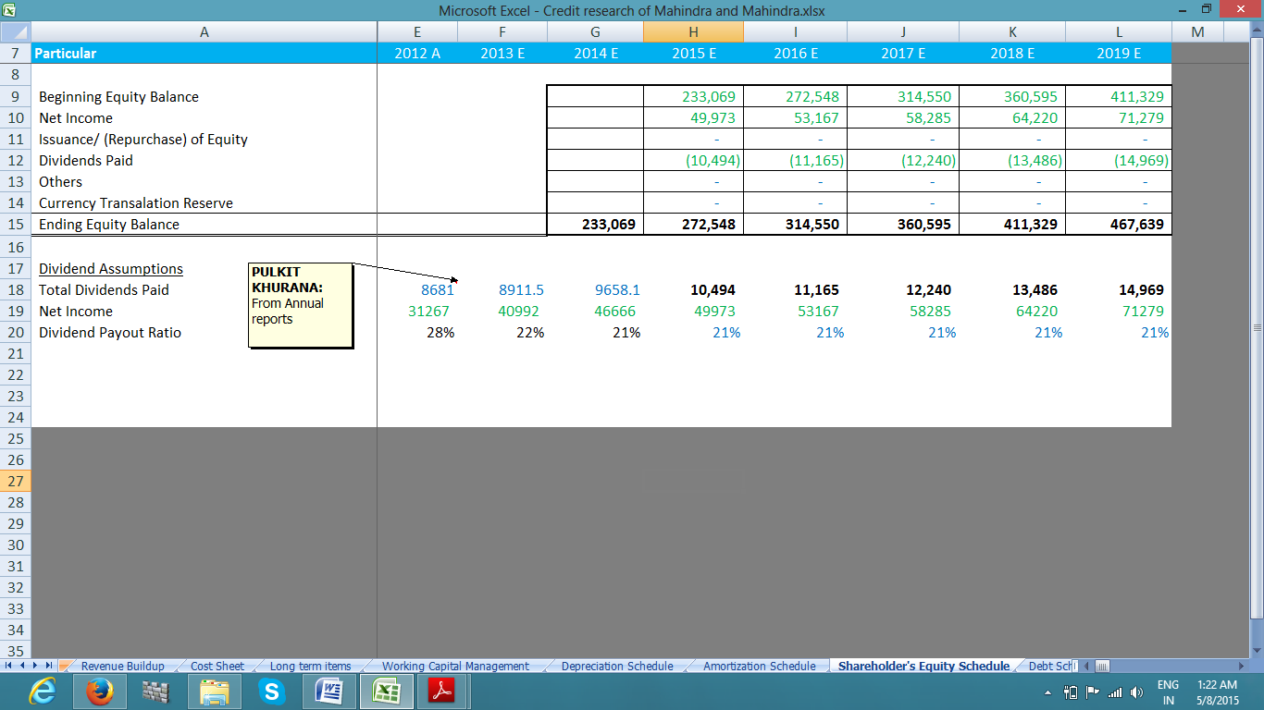

Debt Schedule

