**PROJECT DISSERTATION**

**“EMPLOYEE JOB SATISFACTION”**

**SUBMITTED BY -**

TANU YADAV

Roll No. 2K13/MBA/74

**UNDER THE GUIDANCE OF:**

Ms.MEHA JOSHI

ASSISTANT PROFESSOR



**DELHI SCHOOL OF MANAGEMENT**

**Delhi Technological University**

**Bawana Road Delhi 110042**

**Jan -May 2015**

**CERTIFICATE FROM THE INSTITUTE**

This is to certify that the Project Report titled **“EMPLOYEE JOB SATIFACTION”**, is a bonafide work carried out by Ms. Tanu Yadav of MBA 2013- 15 and submitted to Delhi School of Management, Delhi Technological University, Bawana Road, Delhi-42 in partial fulfillment of the requirement for the award of the degree of Masters of Business Administration.

**Signature of Guide Signature of Head**

**(DSM)**

**Seal of Head**

PLACE  
DATE

**DECLARATION**

I, **Tanu Yadav**, student of MBA 2013-15 of Delhi School of Management, Delhi Technological University, Bawana Road, Delhi-42 declare that Dissertation Report on **“EMPLOYEE JOB SATISFACTION”** submitted in partial fulfillment of Degree of Masters of Business Administration is the original work conducted by me. The information and data given in the report is authentic to the best of my knowledge. This report is not being submitted to any other University for award or any Degree, Diploma and Fellowship.

**TANU YADAV**

PLACE  
DATE

**ACKNOWLEDGEMENT**

I consider myself very fortunate to get the opportunity to conduct the primary research and project assignment on Job Satisfaction**.** This work is an exhaustive study on know the job satisfaction level of employees working in various organizations. This report would not have been possible without the kind support and help of many individuals. I would like to extend my sincere thanks to them.

I am highly indebted to Ms. Meha Joshi - Assistant Professor, Delhi School of Management who provided me the necessary guidance, constant supervision and valuable insights.

I am also thankful to the employees from various organizations who help me in collection of data for my survey and provided me with information that is required for my research.

I have gone through various sites, Research Books, Magazines and Newspapers to get the accurate information for analysis and tried to find the best conclusion.

**TANU YADAV**

**(2K13/MBA/54)**

**EXECUTIVE SUMMARY**

Research has been conducted in order to critically evaluate and examine the level of employee job satisfaction. The purpose of this study is also to observe and analyze the factors which motivates and demotivates employees to do a job.

Job satisfaction is perhaps the most important aspect in professional field in order to excel. As far as the recent survey held all over the world, number of job dissatisfaction has spread rapidly among people coming from all age and income brackets. The statistics were quite striking as most people are not satisfied with their jobs and the numbers are steadily rising. That’s why I have taken this project for dissertation to understand what are the most influential factors of job satisfaction and What should organization do for the job satisfaction of their employees as employees are the most important asset of every organization.

The research was conducted with the help of 6 hypotheses and was conducted on 60 employees working in various organizations. The primary data for this study was collected through questionnaire. Overall 22 factors have taken into account that effect satisfaction level of employees in an organization. By Factor Analysis 7 factor has taken into account for determining job satisfaction level of employees. Test conducted was Correlation and Regression with the help of SPSS.

**TABLE OF CONTENTS**

1. INTRODUCTION

1.1OVERVIEW 1-8

1.2OBJECTIVES OF THE STUDY 9

2. LITERATURE REVIEW 10-17

3. RESEARCH METHODOLOGY 18-20

4. DATA ANALYSIS & INTERPRETATION

4.1DATA ANALYSIS 21-37

4.2FINDINGS 38

4.3RECOMMNEDATIONS 39

4.4 LIMITATIONS 40

5. BIBLIOGRAPHY 41

6. ANNEXURE 42-45

**CHAPTER1- INTRODUCTION**

**1.1 Introduction of the Project**

It is said that satisfied employee is a productive employee. Psychological well-being of employees in any organisational set up has very pivotal role. Success of effective human resources strategies greatly rely upon how well employees are being treated in that organization. In present age of modern technology and growing transformation in organisational culture, Job satisfaction has emerged to be very significant component of management strategies.

So, every organization should give higher priority to keep their employees with satisfaction by providing several facilities which improves satisfaction and which reduces dissatisfaction. Job Satisfaction is considered as a key issue by the entrepreneur where efforts are taken and programs are initiated. If an employee is not satisfied with the job there are chances for absenteeism, low turnover, lower productivity, committing of mistakes, diverting energy for different types of conflicts. Keeping in view all organizations are trying to identify the areas where satisfaction to be improved to get out of the above dangers. In this connection a survey was conducted to identify the level of satisfaction on various job related factors.

**DEFINITIONS:**

Weiss (2002) has “argued that job satisfaction is an attitude but points out that researchers should clearly distinguish the objects of cognitive evaluation which are affect (emotion), beliefs and behaviors”.

According to pestonejee, Job satisfaction can be taken as a summation of employee’s feelings in four important areas. These are:

1. Job-nature of work (dull, dangerous, interesting), hours of work, fellow workers, opportunities on the job for promotion and advancement (prospects), overtime regulations, interest in work, physical environment, and machines and tools.
2. Management- supervisory treatment, participation, rewards and punishments, praises and blames, leaves policy and favoritism.
3. Social relations- friends and associates, neighbors, attitudes towards people in community, participation in social activity socialibility and caste barrier.
4. Personal adjustment-health and emotionality.

Job satisfaction is an important indicator of how employees feel about their job and a predictor of work behavior such as organizational citizenship, Absenteeism, Turnover.

**Determinants of Job Satisfaction:**

 In a [2012 Society for Human Resource Management survey](http://www.shrm.org/research/surveyfindings/articles/pages/2012employeejobsatisfaction.aspx), it was revealed that employees deem the following factors of the most importance in determining job satisfaction.

* **Opportunities to Use Skills and Abilities:**Employees like to feel that their talents are being appreciated, and working endlessly or performing the same tasks can start to wear on their emotional state. It is important for leaders within organizations to recognize existing talent and engage the employee in making the most of his or her abilities.

* **Job Security:**As of January 2013, the [unemployment rate was 7.9 percent](http://www.bls.gov/opub/ted/2013/ted_20130205.htm), only a short drop from the 8.3 percent it was in January of 2012. Since the recession, employees realize the uncertainty of the job market and how easy it is to fall into the unemployment pool. For this reason, job security is the second most critical factor in determining job satisfaction.

* **Compensation/Pay:**A nice compensation package can be a wonderful draw when recruiting and hiring, but once an employee has signed on with an organization, they need to feel as though their efforts are being appreciated. Raises and bonuses are powerful incentives for employees to push harder towards success, and rewarding them monetarily shows that their hard work has not gone unnoticed. A healthy compensation plan with room for bonuses and raises when appropriate can boost an employee’s job satisfaction and raise the retention rate of an organization.

* **Communication between Employees and Senior Management:**Working in an environment where communication is impossible leads to dissatisfaction and often times results in resentment on the part of the employee. Open lines of communication between management and employees instill a trust and equality that boosts company morale. Regular staff meetings and open-door policies reiterate the importance of each employee and promotes the notion that everyone’s opinion should be heard.

* **Relationship with Immediate Supervisor:** The fifth highest reported contribution to an employee’s job satisfaction is the quality of the relationship with an immediate supervisor. Stressful work conditions and long hours can be manageable if work relationships are friendly and everyone feels respected. Personalities are not always going to mesh harmoniously, but while at work it is critical to keep interactions between employees and supervisors pleasant and respectful. Regular one-on-one meetings and completely open lines of communication can be most effective in establishing a respect between employees and their immediate supervisors.

**Models of job satisfaction: -**

* **Affect Theory**: -  
  Edwin A. Locke’s Range of Affect Theory (1976) is arguably the most famous job satisfaction model. The main premise of this theory is that satisfaction is determined by a discrepancy between what one wants in a job and what one has in a job. Further, the theory states that how much one values a given facet of work (e.g. the degree of autonomy in a position) moderates how satisfied/dissatisfied one becomes when expectations are/aren’t met. When a person values a particular facet of a job, his satisfaction is more greatly impacted both positively (when expectations are met) and negatively (when expectations are not met), compared to one who doesn’t value that facet.
* **Dispositional Theory:**   
  Another well-known job satisfaction theory is the Dispositional Theory]. It is a very general theory that suggests that people have innate dispositions that cause them to have tendencies toward a certain level of satisfaction, regardless of one’s job. This approach became a notable explanation of job satisfaction in light of evidence that job satisfaction tends to be stable over time and across careers and jobs. Research also indicates that identical twins have similar levels of job satisfaction.
* **Two-Factor Theory (Motivator-Hygiene Theory)**[Frederick Herzberg](http://en.wikipedia.org/wiki/Frederick_Herzberg)’s [Two factor theory](http://en.wikipedia.org/wiki/Two_factor_theory) (also known as Motivator Hygiene Theory) attempts to explain satisfaction and motivation in the workplace. This theory states that satisfaction and dissatisfaction are driven by different factors – motivation and hygiene factors, respectively. Motivating factors are those aspects of the job that make people want to perform, and provide people with satisfaction. These motivating factors are considered to be intrinsic to the job, or the work carried out. Motivating factors include aspects of the working environment such as pay, company policies, supervisory practices, and other working conditions.
* **Job Characteristics Model**  
  Hackman & Oldham proposed the [Job Characteristics Model](http://en.wikipedia.org/wiki/Job_Characteristics_Model), which is widely used as a framework to study how particular job characteristics impact on job outcomes, including job satisfaction.

**Theories of Job Satisfaction:-**

There are numerous theories attempting to explain job satisfaction, but three conceptual frameworks seem to be more prominent: Content Theories, Process Theories and Situational Theories

* **Content Theories** suggests that job satisfaction occurs when one’s need for growth and self-actualization are met by the individual’s job. For eg. Abraham Maslow “hierarchy of needs” and Frederick Hertzberg (1974) “two factor theory”
* **Process Theories** attempt to explain job satisfaction by looking at expectancies and values. These theory of job satisfaction suggests that workers’ select their behaviors in order to meet their needs. Like Adams’ (1963) and Vroom (1982) “equity theory”

* **Situational Theory** emerged in 1992, when Quarstein, McAfee, and Glassman stated that job satisfaction is determined by two factors: situational characteristics & situational occurrences. Within this theoretical framework, job satisfaction is a product of both situational factors and situational.

**STEPS TO IMPROVE EMPLOYEE SATISFACTION**

The following measures are necessary to improve the satisfaction employees:

* **Selection of right man for the right job:**

Proper care must take while recruiting persons for various jobs. Persons without attitude and aptitude for work should not be selected.When it comes to placement of workers, they should be given jobs in tune with their educational qualification, skills, attitudes and abilities.

* **Satisfactory conditions of service**:

All those who have been appointed in the organization should be provided with job security. They should be given decent pay. Social security benefits like provident fund insurance etc. should be provided to employees as per the rules.

* **Conducive working environment:**

The working environmental should be made informal. Undue important need not be given to hierarchy. The organization should make use of both formal and informal channels of communication. The bureaucratic approach of the management should go.

* **Conducive physical conditions:**

The place of work should be neat and tidy. There should be free flow of natural light and air in any workroom. There should be proper provision for canteen. Lunchroom, etc

* **Better work methods**:

Conventional work methods and age-old practices should be given up. The enterprise should come forward to adopt the latest technology. The employees may be trained to make use of the various electronic devices in their day-to-day work. This not only simplifies their work but also makes it more interesting.

* **Proper superior-subordinate relationship:**

The relationship between the superior and the subordinates should always be cordial. The superior’s style of functioning must be democratic. He should not make an attempt to impose his ideas on his subordinates. Whenever necessary and possible, he can seek his subordinate’s viewpoints. Likewise, the subordinates, on their part, must repose faith in their superiors and come forward to accept responsibilities.

* **Good inter-personal relationship:**

The relationship between the employees should also be proper. The work done in any organization is teamwork. In the absence of proper understanding between the employees, teamwork is not possible. The employees should not give scope for their personal interest to clash with those of the organization.

* **Job rotation:**

If certain jobs are, by nature, dull and monotonous, job rotation may help to break the monotony of workers, i.e., such jobs may be assigned to operation at a certain level by rotation.

* **Provision of suitable incentives**:

Only human resources can be induced to work. Inanimate objects like machines cannot be motivated to work. The management therefore, should offer suitable incentives to motivate employees to perform better. Incentives need not be in the forms of money payment. There are also non-monetary incentives. Further, these incentives may be gives for individual performance or group performance.

* **Valuation of employee performance:**

The performance of employees needs to be assessed regular intervals. Such an assessment will level their level of efficiency. Such of thoseEmployees who are found to be highly efficient may be given suitable rewards.Those employees who are less efficient may be made to undergo training to acquire better skills. If some employees are found to be highly inefficiency, such people need not be retained. It is only these people who spoil the work atmosphere in any organization.

**Measuring Job Satisfaction**

Different methods for job satisfaction measurement include using surveys, interviewing employees and monitoring performance targets. Determining which method to use depends on the level of complexity or underlying issues the business feels could be causing the dissatisfaction.

* **Surveys are a common method of measuring job satisfaction.** A survey can assess satisfaction in the areas of pay, promotion, supervision, tasks and coworkers. While standard surveys are available for businesses, a customized survey that is tailored to a business's own needs and industry may be more effective. Surveys with the majority of questions in the multiple-choice format typically are preferred so that responses can be compared and analyzed more easily. Employees who are allowed to remain anonymous are more likely to be more open and honest with their answers since they will not feel pressure or fear of repercussion.
* **Interviewing employees** as a method of measuring job satisfaction is mostly useful in organizations that have positive relationships with employees and believe the problem is too sophisticated to be understood with a survey. If employees do not trust the organization or interviewer, however, responses may not be entirely honest. Businesses with low job satisfaction or employees who fear being let go may find the employees reluctant to discuss the situation since they may fear it could negatively affect them in the future. The questions asked should be standardized in order to compare different employee responses as well as the same employee's responses over time.
* **Monitoring performance targets** is a method of measuring job satisfaction that requires a business to be an active observer. With this method, management monitors employee satisfaction by using standard criteria, such as achieving bonuses, participating in optional programs and performance in reaching goals. This method provides indirect data on the levels of job satisfaction. While it can flag management that there is a problem with job satisfaction, combining this with a survey or interview can provide the company with a stronger analysis on the cause of low levels of job satisfaction.

Businesses with high levels of job satisfaction tend to experience a lower employee turner, higher productivity and lower overall costs. Whichever method or methods are used for measuring job satisfaction, the business should collect qualitative and quantitative data. This puts the data in a format that is easier to analyze and compare. For instance, when interviewing employees, the interviewer could mix in simple questions that result in answers of "yes" or "no," or ratings on a scale of one to five.

**1.2 Objectives of the Study**

* To measure job satisfaction level of employees in various organizations
* To determine the most influencing factors of Job Satisfaction
* To identify the factors which improves the satisfaction level of employees.
* To identify the most motivational and demotivational factors of Job Satisfaction

**CHAPTER-2 LITERATURE REVIEW**

1. **Jeanine K.andreassi, Leanna Lawter ,Martin Brockerhoff and Peter Rutigliano** (Jeanine K.andreassi, 2012) **from Scared Heart University** has written a research paper on **Job Satisfaction Determinants: A Study Across 48 Nations** :In this research they have studied cross cultural job satisfaction and it furthers the understanding of how job characteristics impact job satisfaction differently across regional cultures. The degree to which seven job determinants i.e. Equal opportunity, Teamwork, Recognition, Communication, Accomplishment, Training and Work life balance is not universal across cultures. There are significant differences across cultures in the relative importance of each of these job characteristics as relates to job satisfaction. Secondly, the findings of the study reinforce that sense of achievement is universal and is a vital component of work across all cultures.
2. **J.Dharmaraj**, Ph.D.Scholar, Presidency College, Chennai (J.Dharmaraj)has written a research paper on **Happiness and Satisfaction in IT Jobs**. Over a span of almost three decades IT sector turned out to be front runner in providing jobs for a large number of people. Therefore, it is imperative to deliberate on whether the employees working in this IT industry enjoy job satisfaction or not. And in the research it was found out that in the IT Industry the environment is quite congenial leading to motivation of employees with the result the productivity is increased and this indicates the level of their job satisfaction.
3. **Mosammod Mahamuda Parvin** (Parvin, 2011)under Australian Journal of Business and Management Research has written a research paper on **Factors Affecting Employee Job Satisfaction of Pharmaceutical Sector** : A study focuses on identifying the factors which influence job satisfaction in pharmaceutical sector nad asses the satisfaction level of employees. The study determined that work conditions, fairness ,promotion and pay are key factors affecting pharmaceuticals companies employees’ job satisfaction.
4. [**Society for Human Resource Management** has carried out a survey](http://www.shrm.org/research/surveyfindings/articles/pages/2012employeejobsatisfaction.aspx) on **Employee Job Satisfaction and Engagement** (Management, 2012).The objective of this survey is to identify and understand the factors important to overall employe job satisfaction and engagement.This knowledge helps organizations better understand and appreciate employee preferences when developing programs and ploicie sdesignated to influence job satisfaction and engagement. It was revealed that employees deem the following factors of the most importance in determining job satisfaction: Opportunities to Use Skills and Abilities,Job Security,Compensation/Pay,Communication between Employees and Senior Management,Relationship with Immediate Supervisor.
5. **Prof.S.K.Singh & Vivek Tiwari** (Tiwari, 2011) has written a research paper on **Relationship between motivation and job satisfaction of the white collar employees**. The present study investigates the relationship between Motivation and Job Satisfaction. Motivation has been treated as a dependent and Job Satisfaction as an independent variable. The respondents were the employees of one of the public sector giants of India, BSNL and the data has been colleted from 45 white color employees (supervisors and above) of BSNL, Saharanpur. Primary data has been collected by the researcher through two different standard structured questionnaires based on a five pointer likert scale.

The results show a positive correlation between motivation and job satisfaction i.e., motivation increases with increase in job satisfaction and vice-versa. The results of the study also indicate that, motivation remains unaffected of both age as well as the length of the service of the employees. It may be because of the fact that the factors responsible for motivation and satisfaction seem to be present in the working environment of the organization. The paper also finds the relative importance of different factors that contribute to the satisfaction of employees; Compensation Package emerged as the most important factor, whereas the Self Actualization appears to be the least important factor.

1. **Rizwan Saleem , Azeem Mahmood and Asif Mahmood** (Rizwan Saleem, 2010)has written a research paper on **Effect of Work Motivation on Job Satisfaction in Mobile Telecommunication Service Organizations of Pakistan under International Journal of Business and Management**. The purpose of this investigation was to determine the impact of work motivation on job satisfaction in mobile telecommunication service organizations in Pakistan. In addition, the study aimed at exploring to what extent the employees are satisfied with different dimensions of their job. There was a positive relationship between the motivation and job satisfaction. Overall the employees were quiet satisfied with their jobs and had their interest in their job. More than average employees are motivated to work for the organization. Some of employees thought that they were not on their actual path and organization hadn’t fulfilled their commitments, what they did in beginning especially regarding Promotion. They have concluded that People are always the vital resource of the organization. And at times, they are often neglected at their jobs which lead to their failure to perform. Thus here we need to understand what motivates people and how they get satisfied from their job that leads to organizational performance. Motivation could be described as a driving force that makes people willingly want to put in their best in what they do. The concept of motivation can never threaten people to work hard. Threats can create fears and resentment for the employees which are likely to be ineffective in the long run. Rather it is better that people should be motivated as it is believed that the driving force which results from motivation will compel people to put in their best out of willingness. Acknowledgment and awarding even a simple thank you may be enough which can build difference in employee’s work performance. As we believed that motivation leads to an increase employee’s performance into other level and eventually the positive effect goes toward company’s recital. Hence we should not expect a secondary school leavers to be able to do the work of a qualified engineer simply because they are highly motivates. Relatively motivation is not effective for the staff but management should make sure that the staff has the ability to do the job in the first place. By doing so management will learn who can work effectively with the ability and skills plus motivation would work. Consequently if a staff member who fails to improve in work performance even though he is clearly motivates it could be a sign of lack of ability, and a signal of training need. As we can perceive that training is a systemized progression of employee’s attitude, skill and knowledge in order to create motivation towards their job satisfaction. Beside this, researcher can examine that motivation is also an understood compliment towards employee’s job satisfaction. Job satisfaction formulates the employee more considerate and concerned for the organization. The multinational organizations always take considerable actions to improve the employee’s performance in every stage of their profession. Therefore the issues like work motivation and job satisfaction has been resolved with the creation of HRM department in the organizations. It presents significant role to drive the organization in a certain way and to explore the structural organizational behavior. If an organization have a good HRM system, subsequently it is possible to construct more loyalty, commitment and motivation to employ additional effort for the organizational objectives. Despite all the facts, job satisfaction would be achieved when an employee is motivated to do work by his/her own will. Other factors also influence on work motivation such as efficiency, productivity, absenteeism, turnover rates and intention to quit. Therefore, if organizations want to raise their profits so it must consider all aspects to improve the motivation level of employees.
2. **Muhammad Rizwan , Waqas Mehmood Khan (Corresponding Author), Hafiz Muhammad Aqeel Tariq , Abdul Ghaffar , Malik Zubair Anjum, Ehsan Ullah Bajwa** (Muhammad Rizwan, 2012)has written a research paper on **Empirical study of Employee job Satisfaction.**The main objective of this research report is to find the crucial problems, faced by the employees while working in organizations and find the ways how we make our employees loyal with their organization. The purpose of this research is to elaborate the key factors which are useful for the satisfaction of the employees i.e. workplace environment, reward and recognition, training and development and team work. These factors help to make the policies effective and through this effectiveness, efficiency takes place in the management process. This research paper is based on theoretical considerations, a model was proposed linking the employee job satisfaction (EJS) constructs. The survey was conducted in 2012 and covered 200 employees within the territory of Punjab in Pakistan. Through this survey they found a strong positive relationship between team work and all other factors.
3. **Geeta Kumari and K. M. Pandey** (Pandey, 2011)has written a research paper on **Job Satisfaction in Public Sector and Private Sector: A Comparison**. Public Sector versus Private Sector comparisons are a debate which seems to be a never ending topic. It is very difficult to take stand for either of these two forms of administration. The reason behind that is not unknown but obvious as both provide scopes in different ways. Job satisfaction describes how content an individual is with his or her job. The happier people are within their job, the more satisfied they are said to be. This paper surveys both the sectors in most of the aspects of analysis.. As the current findings show, jobholders vary regarding the extent of ambivalence experienced with respect to their attitude toward their job. The current findings also open up opportunities for further research regarding the consequences of job ambivalence. For instance, the present findings imply that job performance of individuals with high versus low job ambivalence may fluctuate such that job performance is comparatively high when positive beliefs and affective experiences are salient and thus predominate at a certain point in time but that their performance may be comparatively low at other times when negative beliefs and affective experiences are salient and predominate. In this respect, research could, for instance, collect manager perceptions of performance consistency. Future research should aim to replicate the present findings with larger and more diverse samples as well as profit from the use of multiple-item scales to measure job performance.
4. **Mosammod Mahamuda Parvin and M M Nurul Kabir** (Kabir, 2011) **has written a research paper on FACTORS AFFECTING EMPLOYEE JOB SATISFACTION OF PHARMACEUTICAL SECTOR.** This study attempts to evaluate job satisfaction of employees in different pharmaceutical companies. It focuses on the relative importance of job satisfaction factors and their impacts on the overall job satisfaction of employees. It also investigates the impacts of pharmaceutical type, work experience, age, and sex differences on the attitudes toward job Satisfaction. The result shows that salary, efficiency in work, fringe supervision, and co-worker relation are the most important factors contributing to job satisfaction. The overall job satisfaction of the employees in pharmaceutical sector is at the positive level. The nature of business operation, the work culture and the level of job satisfaction have undergone sea change for the pharmaceutical companies. As a business proposition initiated huge investment whereas majority of their stocks is going down bringing a high level of apprehension related to job security among its employees. This research paper highlights some of these problems and presents a picture of level of job satisfaction among employees of pharmaceutical companies. It also identifies unique issues of job satisfaction in the companies. Pharmaceuticals Companies are selected for the research because they are currently undergoing continued expansion. In order to gain competitive advantage and adapt to the dramatic changing environment, it is important for them to achieve management efficiency by increasing employee satisfaction in the organisation. Hence this research was mainly undertaken to investigate on the significance of factors such as working conditions, pay and promotion, job security, fairness, relationship with co-workers and supervisors in affecting the job satisfaction. This paper presents a comprehensive diagnosis of job satisfaction indices of pharmaceutical business, the factors causing the dissatisfaction & suggestions to improve them. The results suggest that the factors had satisfactorily explained job satisfaction and that the policy makers and managers should focus on the factors that affect employee job satisfaction, if they want to enhance their businesses. Based on the results for the standardized values, we are able to see that work conditions, fairness, promotion, and pay, are key factors affecting pharmaceuticals companies employees’ job satisfaction.
5. **Brikend Aziri** (Aziri, 2011) from **Faculty of Business & Economics** studied Job Satisfaction and found that Job satisfaction is influenced by series of factors such as: The nature of work, Salary, Advancement opportunities, Management, Work groups and Work conditions. It is one of the major challenges for today’s organization. Job satisfaction represents a combination of positive or negative feelings that workers have towards their work. Meanwhile, when a worker employed in a business organization, brings with it the needs, desires and experiences which determinates expectations that he has dismissed. Job satisfaction represents the extent to which expectations are and match the real awards.
6. A study was conducted on **Employee satisfaction in cement industry of Chhattisgarh** by **Daljeet Singh Wadhwa, Manoj Verghese & Dalvinder Singh Wadhwa** (Daljeet Singh Wadhwa, 2011) This study focused on three factors namely Behavioral, organizational and environmental factors. The report focused on all of these factors and attempted to find the relation between these factors and employee job satisfaction and it was found that all the three factors have a positive impact on job satisfaction. The study concluded that organizational factors are the most important aspect for job satisfaction of the employees in a company i.e. if the employees are treated equally and fairly and they are properly supervised, their level of satisfaction can be increased towards their job. The research design used in the research was descriptive. This research was used because it is a good structured instrument for collection of data. The research method used was survey method. The research technique used was Questionnaire. The data was collected using primary data with a sample size of 150.
7. **S.Md.Azash, Ramesh Safare and M.Sudheer Kumar** (S.Md.Azash) has written a research paper on T**HE MOTIVATIONAL FACTORS AND JOB SATISFACTION: A STUDY ON SELECTED PUBLIC AND PRIVATE SECTOR BANK EMPLOYEES .** In this study an investigation is made to study the motivational factors and job satisfaction of selected bank employees. This study is based on Harold Koontz Need-Want-SatisfactionModel and Herzberg’s Motivation-Hygiene Theory. These researches investigate motivational factors that affect the job satisfaction and weighting of motivational factors which are consider important at work? The collected data are tabulated, coded and analyzed with the help of SPSS (17 version).The principal statistical tools used for data analysis consist of both descriptive and inferential statistics among Mean, Standard Deviation ,T-Test were used. The investigation results reveals that there is a significance means differences exist among public and private sector bank employees with regard to various motivational factors. The results found that job satisfaction is caused by both motivation and hygiene factors.

**CHAPTER-3 RESEARCH METHODOLOGY**

Every project work is based on certain methodology, which is a way to systematically solve the problem or attain its objectives. It is a very important guideline and lead to completion of any project work through observation, data collection and data analysis .

According to Clifford Woody, **“Research Methodology comprises of defining & redefining problems, collecting, organizing &evaluating data, making deductions &researching to conclusions.”**

**Accordingly, the methodology used in the project is as follows: -**

* Defining the objectives of the study
* Framing of questionnaire keeping objectives in mind (considering the objectives)
* Analysis of results of survey
* Conclusion, findings and suggestions.

**SELECTION OF SAMPLE SIZE**

Survey was filled by **60 EMPLOYEES** from various organizations who are already working in an organization or who have prior work experience in any organization.

**SAMPLING METHOD**

Covenience Sampling

**SAMPLING TECHNIQUE USED**

The technique of **Random Sampling** has been used in the analysis of the data/Random sampling from a finite population refers to that method of sample selection, which gives each possible sample combination an equal probability of being picked up and each item in the entire population to have an equal chance of being included in the sample. This sampling is without replacement, i.e. once an item is selected for the sample, it cannot appear in the sample again.

**DATA COLLECTION**

**PRIMARY DATA**

Primary data are those, which were collected afresh & for the first time and thus happen to be original in character. However, there are many methods of collecting the primary data; all have not been used for the purpose of this project. The ones that have been used are:

* Questionnaire
* Interview with employees who are working in an organization

**SECONDARY DATA**

Secondary data is collected from previous researches and literature to fill in the respective project. The secondary data was collected through:

* Text Books
* Articles
* Journals
* Websites

**STATISTICAL TOOLS USED**

The main statistical tools used for the collection and analyses of data in this project are:

* Pie Charts
* Tables
* SPSS( Reliability Analysis, Regression Analysis, Pearson’s Correlation)

**CHAPTER-4 DATA ANALYSIS AND INTERPRETATION**

**4.1 DATA ANALYSIS**

* **PROFILE OF THE RESPONDENTS:**

|  |  |  |  |
| --- | --- | --- | --- |
| **Variable** | **Category** | **Frequency** | **Percentage** |
|  |  |  |  |
| **Gender** | **Male** | **27** | **38.3** |
|  | **Female** | **33** | **55** |
|  |  |  |  |
| **Department** | **IT** | **23** | **38.3** |
|  | **Accounting** | **6** | **10** |
|  | **Administrative** | **4** | **6.66** |
|  | **Marketing/Sales** | **10** | **16.6** |
|  | **Operations** | **6** | **10** |
|  | **HR** | **3** | **5** |
|  | **Other** | **8** | **13.3** |
|  |  |  |  |
| **Job Profile** | **Officer/Director/Manager/Supervisor** | **14** | **23.3** |
|  | **Technical** | **23** | **38.33** |
|  | **Administrative Support** | **5** | **8.33** |
|  | **Group Leader** | **11** | **18.33** |
|  | **Other** | **7** | **11.66** |
|  |  |  |  |
| **Experience** | **Less Than 6 Months** | **13** | **21.6** |
|  | **6 Months-1 Yr** | **17** | **28.3** |
|  | **1-2 Yr** | **14** | **23.3** |
|  | **More Than 2 yr** | **16** | **26.6** |
|  |  |  |  |

TABLE 4.1 DEMOGRAPHICS OF RESPONDENTS

**INTERPRETATION:** Table 4.1 depicted the frequency and percentage analysis of different demographic variables. It indicated a consolidated table of the data collected. Demographic variables were broadly categorized into three variables namely: Gender , Department , Job Profile and Experience. Among the respondents 55 % were Female and 38.3% were male. Majority of them 38.3 % are from IT Department and rest are from other departments. Most of them are having technical and manager profile 38.3% technical and23.3 % managers .49.9 % of respondents are having less than 1Year of experience and rest of them are having more than 1 year of experience.

**DATA ANALYSIS**

* **Reliability Analysis:**

Reliability test was administered to establish the goodness of data. In statistics, reliability is the consistency of set of measurements. For this study, Cronbach’s Alpha is calculated.

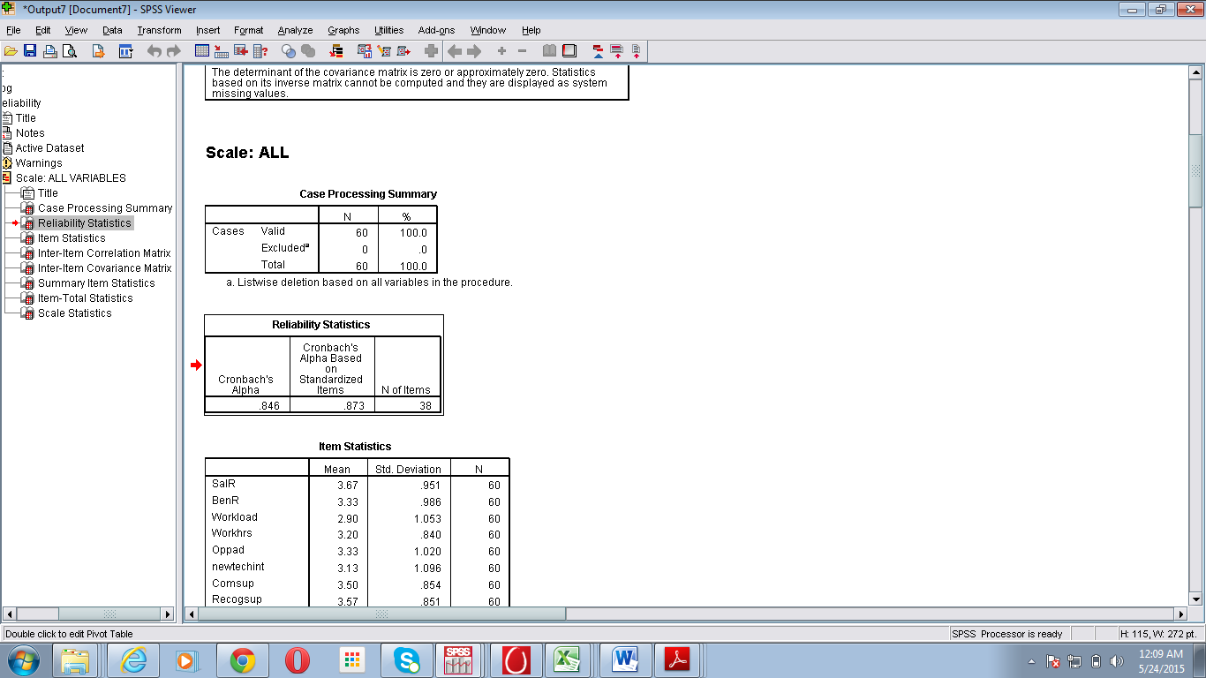

TABLE 4.2 RELIABILITY TEST OUTPUT

**INTERPRETATION:** This shows that **Cronbach’s alpha value is greater than 0.7** that means all the factors that were taken to know the level of satisfaction of employees are reliable and valid to measure the opinions of employee.

* **Hypothesis & Testing:**
* **SALARY & JOB SATISFACTION**

H0: There is no significant relationship between salary and job satisfaction

H1: There is a significant relationship between salary and job satisfaction

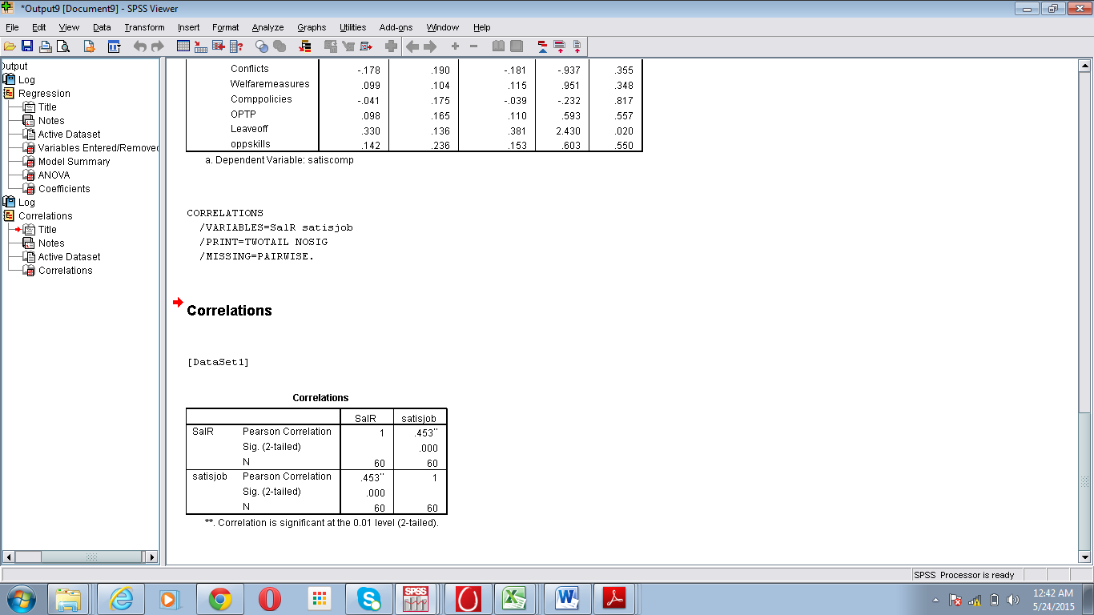

TABLE 4.3 CORRELATION TEST OUTPUT

**INTERPRETTION:** Correlation Analysis test result has proved that null hypothesis is rejected because the significant value (p) is less than 0.05 and the value of Pearson correlation coefficient is 0.453, which shows very strong level of positive correlation.

**INFERENCE:** The result indicated that there is a significant positive relationship between salary and job satisfaction. Therefore, it indicated that the increment in salary results in the increment in Job satisfaction and vice versa.

**RELIABILITY ANALYSIS:**

|  |  |  |  |
| --- | --- | --- | --- |
| R= .453  R square= .205 | Adjusted R Square =.191  Std. Error of the Estimation=.897 | F=14.945 | Significance=.000 |
| FACTOR | Beta | T | Significance |
| SALARY | .453 | 3.866 | .000 |

TABLE 4.4 RELIABILITY TEST OUTPUT

**INTERPRETATION:** Regression analysis results of F statistics with respect to salary indicates that the equation is significant as p<0.1 and hence it can be used for explanation purpose. The R square value indicates that independent variable explains a good amount of variation in the dependent variable and from the table it can be inferred that statistics for both independent and dependent variables have come out to be significant (p<0.1) in explaining the variation. Hence null hypothesis is rejected and alternative hypothesis stating that significant impact of salary on job satisfaction is accepted.

The equation thus formed is :

Job satisfaction = 1.825 + .475*salary

* **PHYSICAL ENVIRONMENT AND JOB SATISFACTION**

H0: There is no significant relationship between physical environment of organization and job satisfaction

H1: There is a significant relationship between physical environment of organization and job satisfaction

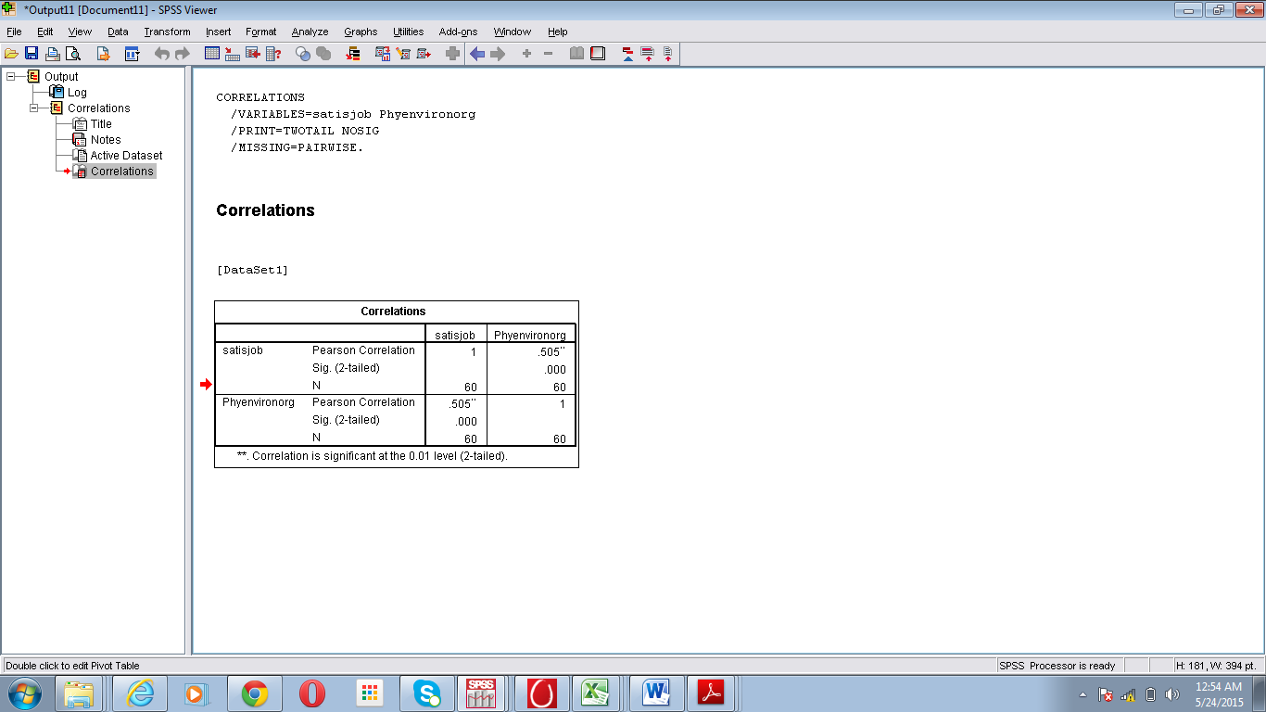

TABLE 4.5 CORRELATION TEST OUTPUT

**INTERPRETTION:** Correlation Analysis test result has proved that null hypothesis is rejected because the significant value (p) is less than 0.05 and the value of Pearson correlation coefficient is 0.505, which shows very strong level of positive correlation.

**INFERENCE:** The result indicated that there is a significant positive relationship between physical environment and job satisfaction. Therefore, it indicated that the increment in physical environment results in the increment in Job satisfaction and vice versa.

**RELIABILITY ANALYSIS:**

|  |  |  |  |
| --- | --- | --- | --- |
| R= .505  R square= .255 | Adjusted R Square =.243  Std. Error of the Estimation=..868 | F= 19.898 | Significance=.000 |
| FACTOR | Beta | t | Significance |
| PHYSICAL ENVIRONMENT | .505 | 4.461 | .000 |

TABLE 4.6 RELIABILITY TEST OUTPUT

INTERPRETATION: Regression analysis results of F statistics with respect to physical environment indicates that the equation is significant as p<0.1 and hence it can be used for explanation purpose. The R square value indicates that independent variable explains a good amount of variation in the dependent variable and from the table it can be inferred that statistics for both independent and dependent variables have come out to be significant (p<0.1) in explaining the variation. Hence null hypothesis is rejected and alternative hypothesis stating that significant impact of physical environment on job satisfaction is accepted.

The equation thus formed is :

Job satisfaction = 1.742 + .507*physical environment

* **COMMUNICATION WITH SUPERVISOR AND JOB SATISFACTION**

H0: There is no significant relationship between COMMUNICATION WITH SUPERVISOR and job satisfaction

H1: There is a significant relationship between COMMUNICATION WITH SUPERVISOR and job satisfaction

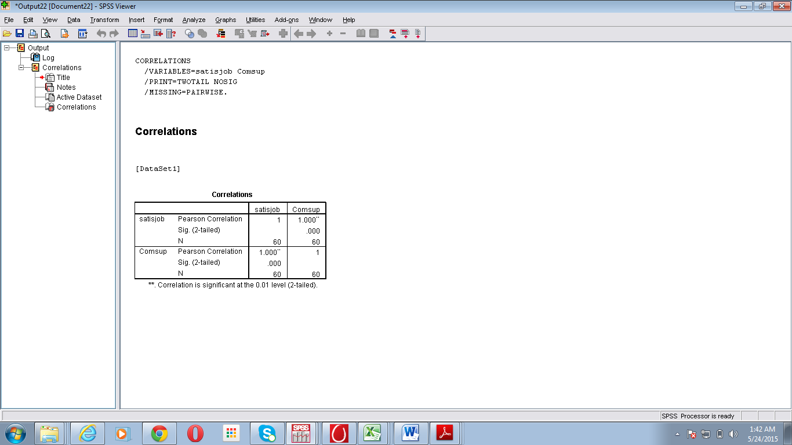

TABLE 4.7 CORRELATION TEST OUTPUT

**INTERPRETTION:** Correlation Analysis test result has proved that null hypothesis is rejected because the significant value (p) is less than 0.05 and the value of Pearson correlation coefficient is 1.000, which shows very strong level of positive correlation.

**INFERENCE:** The result indicated that there is a significant positive relationship between communication with supervisor and job satisfaction. Therefore, it indicated that the increment in communication with supervisor results in the increment in Job satisfaction and vice versa.

**RELIABILITY ANALYSIS:**

|  |  |  |  |
| --- | --- | --- | --- |
| R= .139  R square= .019 | Adjusted R Square =.002  Std. Error of the Estimation=.996 | F=1.148 | Significance=.288 |
| FACTOR | Beta | T | Significance |
| COMMUNICATION WITH SUPERVISOR | .139 | 1.071 | .000 |

TABLE 4.8 RELIABILITY TEST OUTPUT

INTERPRETATION: Regression analysis results of F statistics with respect to salary indicates that the equation is significant as p<0.1 and hence it can be used for explanation purpose. The R square value indicates that independent variable explains a good amount of variation in the dependent variable and from the table it can be inferred that statistics for both independent and dependent variables have come out to be significant (p<0.1) in explaining the variation. Hence null hypothesis is rejected and alternative hypothesis stating that significant impact of communication with supervisor on job satisfaction is accepted.

The equation thus formed is :

Job satisfaction =2.997 + .163*communication with supervisor

* **JOB SECURITY AND JOB SATISFACTION**

H0: There is no significant relationship between workload and job satisfaction

H1: There is a significant relationship between workload and job satisfaction

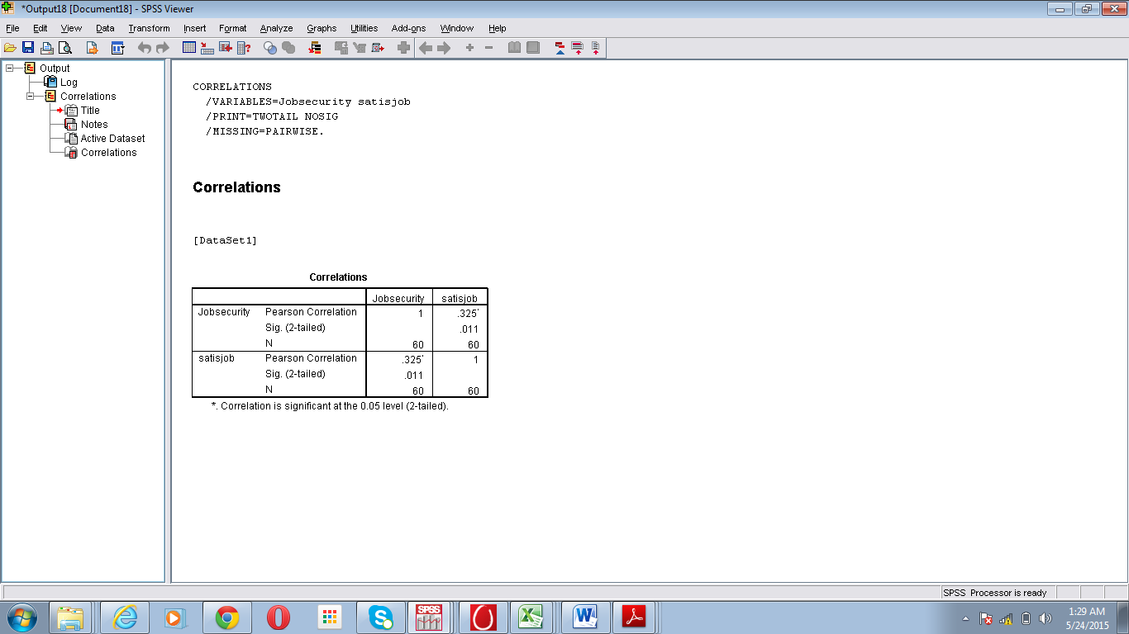

TABLE 4.9 CORRELATION TEST OUTPUT

**INTERPRETTION:** Correlation Analysis test result has proved that null hypothesis is rejected because the significant value (p) is less than 0.05 and the value of Pearson correlation coefficient is 0.325, which shows very strong level of positive correlation.

**INFERENCE:** The result indicated that there is a significant positive relationship between job security and job satisfaction. Therefore, it indicated that the increment in job security results in the increment in Job satisfaction and vice versa.

**RELIABILITY ANALYSIS:**

|  |  |  |  |
| --- | --- | --- | --- |
| R= .0.091  R square= .008 | Adjusted R Square =-0.009  Std. Error of the Estimation=.1.002 | F=0.488 | Significance=.488 |
| FACTOR | Beta | T | Significance |
| JOB SECURITY | 0.091 | 0.699 | .000 |

TABLE 4.10 RELIABILITY TEST OUTPUT

INTERPRETATION: Regression analysis results of F statistics with respect to salary indicates that the equation is significant as p<0.1 and hence it can be used for explanation purpose. The R square value indicates that independent variable explains a good amount of variation in the dependent variable and from the table it can be inferred that statistics for both independent and dependent variables have come out to be significant (p<0.1) in explaining the variation. Hence null hypothesis is rejected and alternative hypothesis stating that significant impact of job security on job satisfaction is accepted.

The equation thus formed is :

Job satisfaction = 3.224 + .098*job security

* **PROMOTION AND JOB SATISFACTION**

H0: There is no significant relationship between promotion and job satisfaction

H1: There is a significant relationship between promotion and job satisfaction

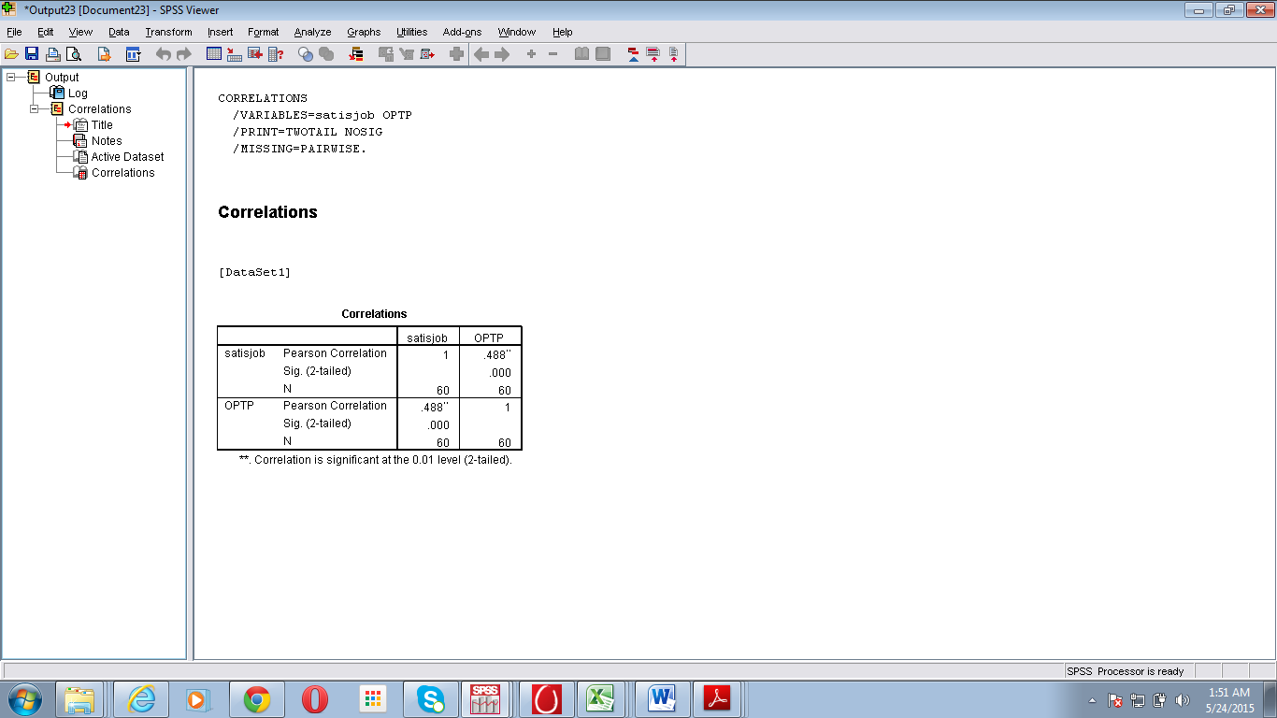

TABLE 4.11 CORRELATION TEST OUTPUT

**INTERPRETTION:** Correlation Analysis test result has proved that null hypothesis is rejected because the significant value (p) is less than 0.05 and the value of Pearson correlation coefficient is 0.488, which shows very strong level of positive correlation.

**INFERENCE:** The result indicated that there is a significant positive relationship between promotion and job satisfaction. Therefore, it indicated that the increment in promotion results in the increment in Job satisfaction and vice versa.

**RELIABILITY ANALYSIS:**

|  |  |  |  |
| --- | --- | --- | --- |
| R= .488  R square= .239 | Adjusted R Square =.225  Std. Error of the Estimation=.878 | F=18.177 | Significance=.000 |
| FACTOR | Beta | T | Significance |
| PROMOTION | .488 | 4.263 | .000 |

TABLE 4.12 RELIABILITY TEST OUTPUT

INTERPRETATION: Regression analysis results of F statistics with respect to salary indicates that the equation is significant as p<0.1 and hence it can be used for explanation purpose. The R square value indicates that independent variable explains a good amount of variation in the dependent variable and from the table it can be inferred that statistics for both independent and dependent variables have come out to be significant (p<0.1) in explaining the variation. Hence null hypothesis is rejected and alternative hypothesis stating that significant impact of promotion on job satisfaction is accepted.

The equation thus formed is :

Job satisfaction = 1.984 + .0.484*promotion

* **INTERESTING WORK AND JOB SATISFACTION**

H0: There is no significant relationship between interesting work and job satisfaction

H1: There is a significant relationship between interesting work and job satisfaction

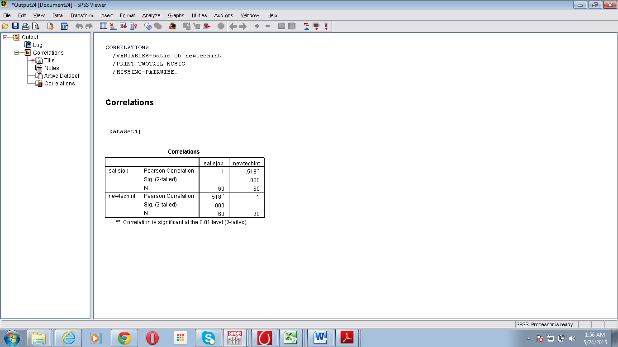

TABLE 4.13 CORRELATION TEST OUTPUT

**INTERPRETTION:** Correlation Analysis test result has proved that null hypothesis is rejected because the significant value (p) is less than 0.05 and the value of Pearson correlation coefficient is 0.518, which shows very strong level of positive correlation.

**INFERENCE:** The result indicated that there is a significant positive relationship between interesting work and job satisfaction. Therefore, it indicated that the increment in interesting work results in the increment in Job satisfaction and vice versa.

**RELIABILITY ANALYSIS:**

|  |  |  |  |
| --- | --- | --- | --- |
| R= .518  R square= .269 | Adjusted R Square =.0.256  Std. Error of the Estimation=.860 | F=21.326 | Significance=.000 |
| FACTOR | Beta | T | Significance |
| INTERESTING WORK | .518 | 4.618 | .000 |

TABLE 4.14 RELIABILITY TEST OUTPUT

INTERPRETATION: Regression analysis results of F statistics with respect to salary indicates that the equation is significant as p<0.1 and hence it can be used for explanation purpose. The R square value indicates that independent variable explains a good amount of variation in the dependent variable and from the table it can be inferred that statistics for both independent and dependent variables have come out to be significant (p<0.1) in explaining the variation. Hence null hypothesis is rejected and alternative hypothesis stating that significant impact of interesting work on job satisfaction is accepted.

The equation thus formed is :

Job satisfaction = 2.088 + .472*interesting work

* **FINANCIAL REWARDS AND JOB SATISFACTION**

H0: There is no significant relationship between financial rewards and job satisfaction

H1: There is a significant relationship between financial rewards and job satisfaction

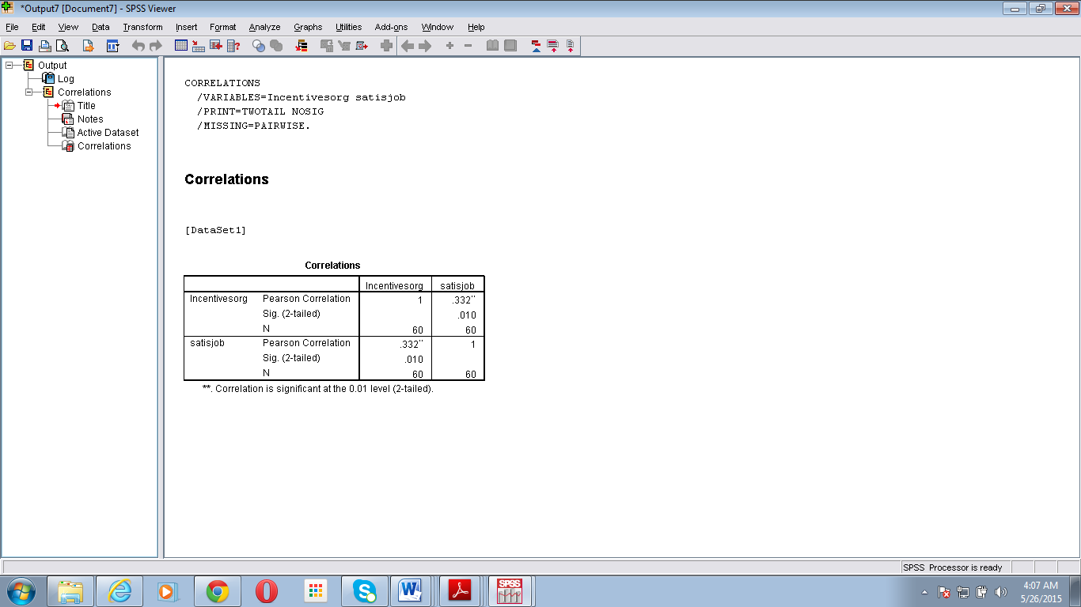

TABLE 4.15 CORRELATION TEST OUTPUT

..

**INTERPRETTION:** Correlation Analysis test result has proved that null hypothesis is rejected because the significant value (p) is less than 0.05 and the value of Pearson correlation coefficient is 0.332, which shows very strong level of positive correlation.

**INFERENCE:** The result indicated that there is a significant positive relationship between financial rewards and job satisfaction. Therefore, it indicated that the increment in financial rewards results in the increment in Job satisfaction and vice versa.

**RELIABILITY ANALYSIS:**

|  |  |  |  |
| --- | --- | --- | --- |
| R= .332  R square= .110 | Adjusted R Square =.095  Std. Error of the Estimation=.949 | F=7.179 | Significance=.010 |
| FACTOR | Beta | T | Significance |
| FINANCIAL REWARD | .332 | 2.679 | .000 |

TABLE 4.16 RELIABILITY TEST OUTPUT

INTERPRETATION: Regression analysis results of F statistics with respect to salary indicates that the equation is significant as p<0.1 and hence it can be used for explanation purpose. The R square value indicates that independent variable explains a good amount of variation in the dependent variable and from the table it can be inferred that statistics for both independent and dependent variables have come out to be significant (p<0.1) in explaining the variation. Hence null hypothesis is rejected and alternative hypothesis stating that significant impact of financial rewards on job satisfaction is accepted.

The equation thus formed is :

Job satisfaction = 2.488 + .327*financial rewards

* **MOTIVATIONAL FACTORS FOR JOB SATISFACTION**

**INTERPRETTION:** Results have shown that 36 employees considered PAY and INTERESTING WORK as the most motivational factors. Then Promotion and Good working conditions is considered as most motivational factors by 14 employees and around 7 employees considered relationship with supervisor and job security as most motivational factors .

* **DEMOTIVATIONAL FACTORS for JOB SATISFACTION**

**INTERPRETTION:** Results have shown that Low Pay considered as most demotivational factor among employees. Out of 60 employees, 10 employees considered bad working conditions and less interesting work as the demotivational factors and after that they considered no promotion ,no job security and not a good relationship with superior as other demotivational factors.

**4.2 FINDINGS:**

1. The results of survey have shown that most of the employees are satisfied with their jobs with an weighted average of 2.49 for overall job satisfaction and 2.47 for satisfaction with their organization.

2. It has been analyzed from the results that Physical environment and interesting work was found to be the most important factor on employee satisfaction with the value of its standardized regression weight being 0.508 (p , 0.000) and 0.515 (p,0.000).

3. It has been analyzed from the results that there is a significant relationship of job satisfaction with these all these factors i.e. Salary, Communication with supervisor, Interesting work, job security, working conditions, promotion and financial rewards.

4. It has been observed from the research that there is a significant positive relationship between Salary and Job Satisfaction. Therefore, it indicated that the increment in Salary results in the increment in Job Satisfaction and vice versa.

6. It has been observed from the research that there is a significant positive relationship between Physical environment and Job Satisfaction. Therefore, it indicated that the increment in Physical environment results in the increment in Job Satisfaction and vice versa.

7. It has been observed from the research that there is a significant positive relationship between Communication with supervisor and Job Satisfaction. Therefore, it indicated that the increment in communication with supervisor results in the increment in Job Satisfaction and vice versa.

8. It has been analyzed from the research that there is a significant positive relationship between job security and Job Satisfaction. Therefore, it indicated that the increment in job security results in the increment in Job Satisfaction and vice versa.

9. It has been observed from the research that there is a significant positive relationship between Finacial rewards and Job Satisfaction. Therefore, it indicated that the increment in Financial rewards results in the increment in Job Satisfaction and vice versa.

10. It has been observed from the research that there is a significant positive relationship between Promotion and Job Satisfaction. Therefore, it indicated that the increment in Promotion results in the increment in Job Satisfaction and vice versa.

11.It has been analyzed from the results that Pay and Interesting work is considered as most motivational factors for job satisfaction and it has also been analyzed from the results of survey that Appreciation, Opportunity to grow and learn new technologies, training and party events also helps to improve job satisfaction.

12. It has been observed from the results that Low Pay considered as most demotivational factor among employees. Out of 60 employees, 10 employees considered bad working conditions and less interesting work as the demotivational factors.

**4.3 RECOMMENDATIONS:**

In the organization most of employees are satisfied with all the facilities provided by company. But there are some employees also were not satisfied with company. Management should try to convert unsatisfied employees into satisfied employees. Because if employee is not satisfied than the he is not able to give his 100% to his work and the productivity of employee decrease. So management should try to satisfy his employees by improving work environment and giving them opportunity for advancement and new skills.

Management should focus on their salary policy as it is the most demotivational factor for employees and should try to focus on promotion policy and financial reward policy which can improve job satisfaction level of employees and help in increasing productivity of employees.

**4.4 LIMITATIONS:**

1. Short Span of Time: The time period to carry out the research was short due to which many facts have been left unexplored.

2. Lack of resources: Because of that it was not possible to conduct survey at large level.

3. Small no. of respondents: Only 60 employees have been chosen from various organizations which considered being very small to represent whole population.

4. Unwillingness of respondents: Many employees during collection of the data were unwilling to fill the questionnaire. They were having a feeling of wastage of time for them.

5. There were large no of factors that has to be considered for job satisfaction but due to short span of time only crucial factors have been taken account.

**CHAPTER-5 BIBLIOGRAPHY**

1. Aziri, B. (2011). *Job Satisfaction.* Faculty of Business and Economics.
2. Daljeet Singh Wadhwa, M. V. (2011). *Employee satisfaction in cement industry .* Chattisgarh.
3. J.Dharmaraj. (n.d.). *Hapiness and Satifaction in IT Jobs.* Chennai.
4. Jeanine K.andreassi, L. L. (2012). *Job Satisfaction Determinats :A study across 48 Nations.* WCOB Faculty Publications.
5. Kabir, M. M. (2011). *FACTORS AFFECTING EMPLOYEE JOB SATISFACTION OF PHARMACEUTICAL SECTOR. .* Australian Journal of Business and mnagement Research.
6. Management, S. f. (2012). *Employee Job Satisfaction and Engagement.*
7. Muhammad Rizwan, W. M. (2012). *Muhammad Rizwan , Waqas Mehmood Khan (Corresponding Author), Hafiz Muhammad Aqeel Tariq , Abdul Ghaffar , Malik Zubair Anjum, Eh Empirical study of Employee job Satisfaction.* Pakistan: IOSR Journal of Business and Management.
8. Pandey, G. K. (2011). *Job Satisfaction in Public Sector and Private Sector.* International Journal of Innovation, Management & Technology.
9. Parvin, M. M. (2011). *Factors Affecting Employee Job Satisfaction of Pharmaceutical Sector.* Dhaka: Australian Journal of Business and management Research.
10. Rizwan Saleem, A. M. (2010). *Effect of Work Motivation on Job Satisfaction in Mobile Telecommunication Service Organizations of Pakistan .* International Journal of Business and Management. .
11. S.Md.Azash, R. S. (n.d.). *THE MOTIVATIONAL FACTORS AND JOB SATISFACTION: A STUDY ON SELECTED PUBLIC AND PRIVATE SECTOR BANK EMPLOYEES .* Andhra Pradesh.
12. Tiwari, P. &. (2011). *Relationship between motivation and job satisfaction of the white collar employees.* Banaras: Faculty of Management Studies.

**ANNEXURES**

**QUESTIONNAIRE**

**What department do you work in?**\*

* +  Accounting
  +  Administrative
  +  Customer Service
  +  Marketing
  +  Operations
  +  HR
  +  Sales
  +  Finance
  +  IT
  +  Other

**What is your gender?**\*

* +  Male
  +  Female

**How long have you worked at the company?**\*

* +  Less than 6 Months
  +  6 months-1 year
  +  1-2 years
  +  More than 2 years

**What category BEST describes your job?**\*

* +  Officer/Director/Manager/Supervisor
  +  Professional (salaried non-mgt. business & technical)
  +  Technical
  +  Sales Representative
  +  Administrative Support
  +  Group Leader
  +  Customer Service
  +  Others

**Please indicate your level of satisfaction with each of the following statements:**\*

|  | Highly Dissatisfied | Dissatisfied | Neither Satisfied nor Dissatisfied | Satisfied | Highly Satisfied |
| --- | --- | --- | --- | --- | --- |
| Salary you receive |  |  |  |  |  |
| Benefits you receive |  |  |  |  |  |
| Work load within the organization |  |  |  |  |  |
| Working hours within the organization |  |  |  |  |  |
| Opportunity for advancement within the organization |  |  |  |  |  |
| Opportunity to use new technologies and to work on interesting projects |  |  |  |  |  |
| Communication level with your superior |  |  |  |  |  |
| Recognition received from your supervisor |  |  |  |  |  |
| Supervisor's active involvement in your career development |  |  |  |  |  |
| Relation with your peers |  |  |  |  |  |
| Culture of the organization |  |  |  |  |  |
| Physical environment of the organization |  |  |  |  |  |
| Incentives provided to you by the organization |  |  |  |  |  |
| Training providing to you with the organization |  |  |  |  |  |
| Job security |  |  |  |  |  |
| Canteen facilities |  |  |  |  |  |
| Conflicts are resolved in your company |  |  |  |  |  |
| Welfare measures (Medical facilities,Transportation,Housing etc) |  |  |  |  |  |
| Company policies |  |  |  |  |  |
| Organization Promotional & Transfer Policy |  |  |  |  |  |
| Amount of paid vacation time/leave offered |  |  |  |  |  |
| Opportunity to utilize your skills and talents and opportunity to learn new skills |  |  |  |  |  |
| Your overall satisfaction with your company |  |  |  |  |  |
| Overall satisfaction with your job |  |  |  |  |  |

**What motivates you to work more?**\*

(1=being highest and 7=being lowest)

|  | 1 | 2 | 3 | 4 | 5 | 6 | 7 |
| --- | --- | --- | --- | --- | --- | --- | --- |
| Pay |  |  |  |  |  |  |  |
| Promotion |  |  |  |  |  |  |  |
| Financial Rewards |  |  |  |  |  |  |  |
| Good working conditions |  |  |  |  |  |  |  |
| Job security |  |  |  |  |  |  |  |
| Interesting Work |  |  |  |  |  |  |  |
| Relationship with supervisor |  |  |  |  |  |  |  |

**Any other factor you think important for job satisfaction?**\*



**What demotivates you to work?**\*

(1=beng highest and 7=being lowest )

|  | 1 | 2 | 3 | 4 | 5 | 6 | 7 |
| --- | --- | --- | --- | --- | --- | --- | --- |
| Low Pay |  |  |  |  |  |  |  |
| No Promotion |  |  |  |  |  |  |  |
| LessFinancial Rewards |  |  |  |  |  |  |  |
| Bad working conditions |  |  |  |  |  |  |  |
| No Job security |  |  |  |  |  |  |  |
| Less interesting work |  |  |  |  |  |  |  |
| Not a good Relationship with supervisor |  |  |  |  |  |  |  |