**Project Dissertation**

**Evolution of grocery products in e-commerce**

Submitted By:

Priyam Gupta

2K13/MBA/49

Under the Guidance of:

Ms. Meha Joshi

Assistant Professor DSM, DTU



**DELHI SCHOOL OF MANAGEMENT**

**Delhi Technological University Bawana Road Delhi 110042**

**Jan -May 2015**

**CERTIFICATE FROM INSTITUTE**

This is to certify that Project Report on “**Evolution of grocery products in e-commerce.**” is a bona fide work carried out by Mr. Priyam Gupta who is a student of MBA 2013-15 Batch. The project is submitted to Delhi School of Management, Delhi Technological University in partial fulfilment of the requirement for the award of degree of Masters of Business Administration

Signature of Guide Signature of Head (DSM)

Place: Seal of Head

Date:

**DECLARATION**

I Priyam Gupta, student of MBA 2012-14 of Delhi School of Management, Delhi Technological University, hereby declare that Project report on **“Evolution of grocery products in e-commerce.”** submitted in fulfilment of Degree of Masters of Business Administration is the original work conducted by me.

The information and data given in the report is authentic to the best of my knowledge.

This report is not being submitted to any other University for award of any Degree, Diploma and Fellowship.

(Priyam Gupta)

Place:

Date:

**ACKNOWLEDGEMENT**

On the very outset of this report, I would like to extend my sincere &heartfelt obligation towards all the personages who have helped me in this endeavour. Without their active guidance, help, cooperation & encouragement, I would not have made headway in the project.

I am extremely thankful and pay my gratitude to my mentor, **Ms Meha Joshi** for her genuine concern, guidance and valuable inputs during the course of this project.

I also express my sincere thanks to **Prof. P.K.Suri**, Head of Department and all the faculty members of Delhi School of Management, DTU Delhi.

I extend my gratitude to **Delhi Technological University** for giving me this opportunity.

Priyam Gupta

**ABSTRACT**

No one likes to shop for groceries in overcrowded markets or wait endlessly for their turn at cash counters, especially after a tiring day at office. Online grocery retail is an alternative. Grocery products are those which is used in any household that includes both food and non-food items on daily basis.

This dissertation is done to understand the evolution of grocery products in e-commerce and its future prospects. Objectives of the project is to understand the consumers need with respect to grocery products, what problem they face in current online system, things they like about current system, what extra they expect from these e-commerce website.

The methodology used in this project is both primary and secondary research. Secondary research is made from various newspaper articles and blogs available online. The primary research is made through online survey so that the right segment of consumer is targeted.

**TABLE OF CONTENT**

1. Introduction…………………………………………….......01
   1. Introduction of the Project……………………………02
   2. Objectives of the study……………………………….07
2. Literature Review……………………………………........08
3. Methodology……………………………………………….19
   1. Data collection………………………………………....20
   2. Tools of analysis……………………………………….21
4. Data Analysis and conclusion……………………………22
   1. Data Analysis…………………………………………..23
   2. Conclusions…………………………………………….29
   3. Limitation of the study………………………………...30
   4. Future scope…………………………………………...30
5. Bibliography……………….………………………………..31
6. Annexure……………………………………………………33

**Chapter 1: INTRODUCTION**

**1.1 Introduction**

Groceries sell irrespective of the state of the economy. You can stop going to the cinema and restaurants, but there's no way you can live without toothpaste, soap and, well, vegetables. Caught in the city's fast pace, tedious commuting and long working hours, many consumers don't have the time to buy groceries or would like to avoid the chore.

Buyers are now quite comfortable ordering apparel, shoes, electronics, among others, online. With improving comfort with online payments, selling groceries online has become relatively easy.

RETAIL OPPORTUNITY

With a large customer base and increasing penetration of Internet connectivity (partly through smartphones) and growing popularity of online shopping, some entrepreneurs have seen the potential in creating e-stores for groceries. If you understand the retail market, a bit of creative thinking and excellent customer service can help you build a great business.

AaramShop.com, EkStop.com, BigBasket.com, AtMyDoorSteps.com, MyGrahak.com, ZopNow.com, Omart.in, LocalBanya.com, RationHut.com and SeaToHome.com are some of the online stores retailing groceries. Most of the existing e-tailors offer their service in metros and major urban centres.

"The spending on grocery and daily essentials is the largest and most consistent share of the wallet for any household. However, it is still out of the ambit of online shopping and, therefore, represents a huge opportunity," says Vijay Singh, chief executive and managing director of AaramShop.com, a network of neighbourhood retailers based in New Delhi. AaramShop.com currently operates in 30 Indian cities with more than 3,000 partner retailers.

FREQUENT BUYERS

Grocery e-tailing is challenging, but it also has the advantage of high percentage of repeat orders. All you need to do is impress a customer with the first order. Once a customer is satisfied, you can have one more regular in your clientele. "We are seeing a massive response. Almost 90% of our customers are repeating orders every seven days," says Solomon of SeaToHome.com. A growing list of loyal customers means a steady growth in business. If you have lots of households procuring all of their groceries through an e-store, it's a decent volume of sales.

Though such stores get customers throughout the month, weekends are relatively busier. "On Fridays and Saturdays, we see an increase in the number of orders. It is highest in the first weekend of the month," says Singh of AaramShop.com.

It's a similar story with SeaToHome.com. "On weekends, we do far more business than other days. We average 40-50 orders on weekdays," says Solomon.

CREATIVE NETWORKS

Given the nature of the business, online grocers are in a different league from other e-retailers. Most grocery e-stores cater to a specific city or certain areas due to the logisitic constraints.

A book or mobile phone can be easily shipped to distant locations across the country from a central warehouse, but delivering a 10kg sack of rice or 5kg pack of sugar to a different city is not commercially viable.

"The grocery category is not suited for traditional e-commerce ventures. While there have been a number of attempts in the past decade and a half, almost all have failed. The issues are related to low retailer margins, complex and expensive supply chain, ubiquitous presence of brick-and-mortar grocery stores and the prevailing consumer behaviour," says Singh.

Online retailing in India has gained success only with a robust offline operation. With grocery retail, the offline component is more ingrained. E-grocers have set up systems to accept orders over the phone, which in itself can be an independent business model.

You will also have to break away from the online medium to advertise your e-grocery business. Buyers still relate groceries with local store and malls. So, not many consumers search for online grocery stores. You would have to educate prospective customers about the opportunity and benefits of ordering groceries online.

If you wish to become successful as an online grocer, you will also require a strong understanding of the retail supply chain-from procuring the goods and delivering it to customers on time. You will also need a robust offline local network that can fulfill the orders.

In the traditional format of the delivery network, you will follow the 'hub-and-spoke' model. All goods would be procured and stocked in a warehouse, which then supplies to the hubs for the last-mile delivery. As each warehouse would be able to cater to the demand from only a certain area, you would have to invest in creating independent establishments for each city that you want to operate in. In addition, you would have to forge tie-ups with local suppliers for many items in each location.

GAUGING COMPETITION

Many e-groceries have come up, but the segment is far from saturated. Most of such ventures are catering to a few metros and many cities are yet to have such e-stores. The potential market size also ensures that there would be room for multiple players, even within cities.

Though big retailers are yet to enter the segment, there is some competition from local grocery stores that provide home-delivery services. However, smart logistics and vendor tie-ups can help e-stores gain customer favour by offering them a price advantage.

Local grocery stores can also be turned into business partners, as done by AaramShop.com. It has roped in local stores to procure the groceries to be delivered, while focusing on creating the technology platform and the online interface.

"We have created a hybrid model. When a consumer shops on AaramShop.com, she gets to choose a retailer in her neighbourhood that she wants to order from. The order goes to the retailer, who delivers the order and collects cash on delivery. This ensures that the order moves from the web to the consumers' doorstep within 45 minutes, without the need to re-invent the supply chain and with no additional costs," says Singh.

IMPROVING MARGINS

Given the low operating margin in the segment and the challenge of offering better deals, it is important for online retailers to optimise their supply network.

The simplest way to increase the margin is to purchase in bulk by going higher up the supply chain and eliminating as many intermediaries between manufacturers and the retailer as you can. Staple grains, for instance, will be cheaper when procured directly from a mill rather than the local market. Going further up the chain, buying directly from farmers would mean even lower prices.

Going the private-label way is another strategy being used by many existing e-grocery stores. Staples such as rice, pulses and spices are procured from the market and processed in-house (or by their suppliers).

WISE RISKS

Online groceries offer ample opportunities, but not without risks. Many online stores have been shuttered after operating for a few months to a few years. Taking cue from the ventures that have shut down due to lack of funds or customers, being local and less ambitious can help online grocers remain viable.

One cannot wish to have the world as its customer base for groceries because their site can be accessed globally. A frenzy to expand across multiple cities might put undue strain on finances. One should focus on exhausting the potential of one location before targeting new ones.

SeaToHome.com, for instance, is in no rush to expand despite the temptation of seizing investment offers from venture capitalists.

"For now, we are running the business on our own resources as it is picking up better than we had expected. We are currently engaged in discussions about a very exciting phase-two plan. Once it is firmed up, we might look at external funding," says Solomon.

If you have the desire to become a local online retailer, groceries and daily consumption goods could offer you some great business opportunities. You can even invent online markets for exotic products or food items that cannot be bought locally.

"Be sure of your core competence and play on it. The business will take time to break even. So, have enough cash reserves and plenty of patience. Customers can be very demanding, so be willing to deal with them," says Solomon.

Analyse the market, chart out your plan of action and be frugal with your venture. With the right business model, success might not be far away.

**1.2 Objectives**

Objective 1- To understand the consumer needs for grocery products with respect to its presence in e-commerce.

Objective 2 – To analyse the problems faced by consumers in the present system.

Objective 3- To gauge & understand customers’ expectations from these e-commerce sites.

**Chapter 2: LITERARURE REVIEW**

* 1. **Literature review**

Consider this: at $360 billion (Rs 21,60,000 crore), India is the sixth largest grocery market in the world. Within this, modern retail (led by the top eight cities) accounts for around 20 per cent. If one slices the pie further, you will find that a new kid on the block - online grocery retail - is slowly wedging itself in, and is expected to reach around 2 per cent of the expanding grocery market by 2020, creating a potential market size of around $10 billion (Rs 60,000crore).

This niche segment is expected to contribute 10-20 per cent of overall e-commerce jobs, with each warehouse of online grocery companies employing around 50 to 100 workers depending on the scale of operations, according to Randstad India. "Since this segment works with perishable items, there will be a demand for experienced supply chain management professionals, including procurement, inventory management, cold storage management, quality and logistics," says Moorthy K Uppaluri, CEO, Randstad India. Being largely localised, players will face challenges in attracting the right talent. Over and above the tough job of stocking and marketing perishables, there is the hassle of localisation. But these are small problems compared to the overwhelming task of changing consumer habits.

FUTURE TRENDS & EXPECTATIONS

|  |
| --- |
| **GOOD TIMES AHEAD?** |
| If consumers are to fully convert into online grocery shoppers, some of the key triggers could be:   * Organised grocery retail is under penetrated and unprofitable due to high rents and utility bills. As a result finding a good store, which carries all of what a customer needs is not always possible * The local kirana is too small, carrying only 1,000 SKUs, and hence does not always meet the needs of customers * Traffic, lack of parking, frequent out-of-stock situations are some of the problems customers face when shopping through physical stores * Grocery buying is typically the same month on month. Hence, customers are very familiar with the products and don’t feel the need to  touch and feel a majority of the items. For fresh produce, this is an issue but easy return policies can convert customers |

So why are new players joining the race in droves? What were the main hurdles that forced earlier entrants to throw in the towel? Above all, how easy or difficult will it be to convince consumers to switch from the local kirana and order cauliflower through a click?

FIXING THE BASKET OF OFFERINGS

The selling point for e-grocery is that it offers more convenience than the neighbourhood store; but to be sustainable they have to do this cost-effectively. And that is not the easiest job to pull off.

People are used to either picking up the phone and ordering from their local kirana store that offers credit, or making two grocery trips - one for the monthly purchase and another for top-up buys - a month at a nearby supermarket /mall. This has been the general trend for a long time. To get people to try e-groceries and to get them to believe that the products will be delivered fresh, on time and with post-purchase service if need be, pose a serious challenge. Add to that the lack of 'touch and feel' in the case of online perishables - FMCGs, by contrast, are pre-packed, cutting out the 'feel' factor - and the task of selling becomes a little more onerous.

A way out could be to other niches/ancillary products that e-grocery portals could try and service, which could rub off on the primary offering. This could involve the promotion of differentiated/under-distributed food products as opposed to undifferentiated/over-distributed food and grocery brands. Take Godrej's Naturesbasket.com. The portal realised early on that to survive, it had to go beyond aloo-gobi. "Considering that our focus is on offering premium gourmet experiences and with a growing proportion of consumers accessing the platform through their smartphones, a dynamic e-tailing site gives us an edge," says Mohit Khattar, MD, Naturesbasket.com. The target group? The time-constrained Indian residing in cities where it already has a physical presence. Another set comprises those who live in areas where gourmet foods are not available.

Or take the 2012-founded Mumbai-based LocalBanya, which has gone beyond standard groceries, fruits and vegetables, and stocks exotic vegetables, personal care/household supplies, detergents, kitchenware, breakfast items and packaged snacks.

Bigbasket.com, which operates in Bengaluru, Mumbai and Hyderabad, is set to increase its range too by adding pesticide-free/organic fruits and vegetables apart from pre-chopped vegetables. Mumbai-based EkStop has gone as far as to list stationery and art material on its portal. BigBasket also offers own-brand products that have a share of well over 40 per cent in the overall sales.

Apart from having a rub-off on traditional groceries, stocking ancillary products could also help improve margins. Groceries yield low margins even in physical stores. Typical gross margins hover around 7 per cent for e-grocers. "To boost margins, the goal has always been to sell a more profitable basket to customers that include higher margin products," says LocalBanya's co-founder Rashi Choudhary. For example, a section of the portal's customers, which is willing to pay a premium for top-quality branded products, try organic options and even opt for international ranges, all of which adds to its overall margins.

That said, the average Indian consumer is used to just-in-time purchases rather than buying in huge quantities - so more often than not, the average basket size is sub-Rs 1,000.

In effect, sustainability hinges on deriving margins, which in turn, requires a careful analysis of categories to be served, and, more importantly, smart sourcing.

GETTING A HANDLE ON SOURCING

People know what they are buying when it comes to packaged food products. But fresh produce involves a short shelf life and deft handling. That apart, e-grocery entails multiple SKUs in a single order, and unlike in the case of electronic products, single SKUs are not necessarily supplied with tamper-proof packaging to protect the contents. This essentially implies higher logistics costs to ensure there is as little damage as possible to the products.

"With fruits and vegetables, we work on a zero inventory policy and maintain a minimum inventory level in case of packaged food products," says Rajiv Tetviya, co-founder and CEO, Greencart.in. For fresh produce, Greencart goes to the vendor directly - usually the farmer or in the case of imported fruits, the agricultural middleman. At regular intervals, the online orders are checked and the farmers informed. Greencart uses cellulose films (derived from plants) for packaging to protect fresh produce from human touch and environment factors. For leafy fruits/vegetables, the company uses customised cold storage boxes during transportation. Greencart claims to have a 98.5 per cent success rate of complete fulfilment, which means it satisfies 98.5 per cent of its orders.

In the case of EkStop.com, the sourcing of perishables is done real-time through agricultural markets in Vashi (Navi Mumbai) and through wholesalers who serve as stock-points within city-limits. With 180 employees across four locations in Mumbai, EkStop uses a hub-spoke model for warehousing.

For its part, LocalBanya has set stringent hygiene and storage standards that its vendors have to meet before their produce is accepted in the warehouse. If a customer gets a product that is not up to the mark, there is a no-questions-asked return policy.

BigBasket trains its people extensively on handling fresh produce, besides investing in chilling/freezing equipment to handle storage at its hubs and in delivery vans.

The e-grocer also ensures that fresh produce spends the least possible time in storage - typically only a few hours - to ensure that it remains in top condition when it reaches the customer. "We achieve this through direct sourcing, using finely tuned inventory models and using technology to predict customer-buying patterns," says Vipul Parekh, co-founder, BigBasket.

As opposed to a traditional retailer who has to hold about 1,000 SKUs on an average at any given time, BigBasket carries more than 10,000 SKUs. Technology has been the biggest facilitator in inventory management; typical inventory turnover at BigBasket is about 40-45 times a year.

MANAGING INVENTORY AND DELIVERY

Normally, e-commerce works with a delivery promise of a certain number of days while with e-grocery, 'the deadline was yesterday' as the adage goes. Internationally, pick-up-point-based delivery models are popular but these are unlikely to work in India. The key reason is that customers order groceries online to avoid the hassle of going to the store, and a pick-up will undermine the convenience factor. Besides, India is a DIFM ('do it for against the DIY ('do it yourself') mindset prevalent in the West. But unlike the personal care category, the existing courier-delivery model cannot be used for e-grocery. At any given point, an e-grocery firm deals with 500 vendors at a time, which adds to the complexity.

EkStop brings six, two-hour, delivery timeslots and like other players, offers free same-day home delivery. The company has beefed up its delivery team four-fold since inception in 2012. Greencart goes so far as to text its customer should a delivery be made before time. For same day delivery, it takes online orders right up to 3.00 am.

Naturesbasket.com uses its offline stores to manage deliveries, minimising the need for warehousing. LocalBanya, on the other hand, tries to create differentiation by letting users enter up to three addresses as their delivery destination. In addition, the portal offers corporate programmes wherein employees of participating companies get discounts if they choose to have their orders delivered to the work place.

Based on order analysis, LocalBanya uses a mix of JIT (or just-in-time inventory that comes in at pre-fixed time slots from vendors and moves out as quickly as it arrives) and warehousing for product management. LocalBanya, which clocked in revenues of Rs 10 crore in FY13, is targeting Rs 70 crore for FY14, on the back of the 700 deliveries it makes per day through over 130 employees.

BigBasket also rides on technology for forecasting, buying and managing inventory. Picking, packing, storage at the warehouses and delivery routes are tech-assisted and deliveries are managed by using GPS-enabled devices and transport. To differentiate itself from the others, BigBasket offers customers guaranteed delivery times with built-in penalties for late or incomplete deliveries.

SCALING UP

One of the key issues with online grocery is that it is a local, city-specific operation. Every time you add a new city, it is akin to launching the business afresh. This makes grocery a more difficult category to go national with, and more challenging in terms of operations. "However, an online player who builds an efficient model can quickly scale up across cities," says Parekh of BigBasket.

EkStop's protocol and processes, teams, corporate structure, marketing, sourcing, warehousing and logistics have been built with a 'copy-paste city-capture' model. "Attacking micro-markets to scale the business and having tier-A processes to provide customer delight and drive a robust operational process is the best approach to the e-grocery business," says Sumat Chopra, co-founder and CEO, EkStop.

There are players like Aaramshop.com, who follow a near-hybrid, asset-light business model. It fulfils orders placed on the site via the preferred neighbourhood retailer closest to the customer, who will deliver at the consumer's doorstep within a couple of hours of placing an order. "We are leveraging the existing last mile strength of the independent neighbourhood retailers and integrating it with the opportunities offered by the entire digital eco-system," says Aaramshop CEO and MD Vijay Singh.

By providing contact information of the nearest retailer, isn't Aaramshop in danger of becoming a classifieds for kiranas? Not really, says Singh, as Aaramshop's revenue model is not based on specific transactions, but on premium services offered to brands (like analytics, activations, coupons, advertising etc) and subscription-based privilege services for retailers. The attempt is to enable engagement between retailers and customers, be it through walk-ins, phone-based orders, online orders or even a mobile app (to be launched in August). Aaramshop currently operates in 35 Indian cities with 3,500 retailers with an access to 2.5 million urban households.

Experts still feel that for an e-grocery company, a localised operation may be viable, but a scaled up version of the same is where the model could get stressed. Our advice: Go hyper local with e-grocery, even while thinking of acquisitions.

"Timely and fast delivery is very important for consumers especially when it comes to food or groceries, since it's an immediate need," said Pragya Singh, associate vice-president at retail consultancy Technopak.

The retail market in India is expected to hit $725 billion (about Rs 43 lakh crore) by 2017, of which online grocery is expected to contribute about 2 per cent, according to market estimates.

Mumbai-based LocalBanya.com, which sources groceries from FMCG companies and nodal vegetable markets, delivers within six hours of an order.

"Grocery delivery service has been there since the days of the telephone by your neighbourhood grocer, but what was lacking was an organised system and the ability to browse the aisles at home," said Rashi Choudhary, cofounder.

Founded in May 2012, the company offers more than 8,000 household products across categories such as fruits, vegetables, personal care, detergents and kitchenware.

"The online grocery model is a hard one to crack but with the right business model, intellectual capital and brand value there is clear room for a world-class company to thrive," said Karmvir Rajpurohit, managing partner at Karmvir Avant Infotech, an investor in LocalBanya.

LocalBanya has raised $20 million (about Rs 120 crore) from BCCL's Springboard Fund and Karmvir Avant Group and is expected to break even by July.

It has a revenue target of Rs 70 crore for next year. "We source our groceries from farmers and large suppliers, ensuring better margins and fresher stock," said Bangalore based BigBasket's cofounder Vipul Parekh.

BigBasket, which is already present in Bangalore, Mumbai and Hyderabad, delivers the same day if the order is placed before 1 pm. The e-grocer, which plans to expand to NCR, Pune and Chennai this year, expects revenues of about $100 million (about Rs 600 crore) next year.

Jiffstore, based in Bangalore and founded in June 2013, connects local kirana stores with customers through a mobile app that offers home delivery options within an hour.

"The idea came about while watching a 20-20 match," said chief executive Shameel Abdulla. "We telephoned the nearby store for home delivery for some snacks. We tried several times before the shopkeeper picked up and, when he did, it was difficult to communicate our order. We felt it was high time someone made this ordeal simpler."

Srikrishna Ramamoorthy, a partner at Unitus Seed Fund, which invested an undisclosed amount in the company in May , said there are about 10-14 million small shop retailers in India and Jiffstore is "turning an unorganised market into a process-oriented one."

Jiffstore charges a monthly fee of Rs 1,500 from mom-and-pop stores to connect them to customers. The company expects to earn Rs 5 crore in the next two years.

"All my groceries are delivered within an hour, reducing the stress of having to visit a supermarket," media professional Sakshi Sharma said about online grocery shopping.

Retailers, including Amazon, are also looking to get into the online grocery space in emerging countries like China and India. Last month, Amazon.com made its first investment in China with $20 million into Shanghai-based fresh food e-store startup Yummy77.

Amazon has its own food-shipping service AmazonFresh, which offers fresh groceries and over 500,000 different items, and Prime Pantry, a dry goods grocery delivery service, in the United States.

"We still haven't seen the big players like Tata, Reliance and Amazon get into this business," said Arvind Singhal, chairman of Technopak. "Once they do, they will disrupt the kirana store market and it will be a big boys business."

THE GLOBAL STORY

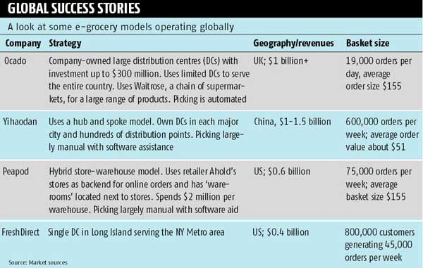

**Chapter 3: METHODOLOGY**

## 3.1 Data Collection

The data can be collected either by primary methods or secondary methods or both, and the data collected by either method is called primary and secondary data respectively.

Primary data is the new data gathered to help solve the problem at hand. It is the fresh data which is collected from field with your own questionnaire.

While secondary data is the data that is collected from other sources. Such data are cheaper and more quickly obtainable than the primary data and also may be available when primary data cannot be obtained at all.

For This Project, data collection was done mainly through the primary research which involved, gathering information about consumer behaviour on e-commerce by conducting surveys through e-mail, Linked in connections targeting only the residents of metropolitan cities where these e-commerce (grocery) companies operate.

Nominal data and likert scale are used in in questionnaire to collect data

RESPONDENTS PROFILE

Following is the profile of respondent’s that were approached for survey:

* The survey was sent to more than 100 consumers across different metropolitan cities of India and around 50% responses were received.
* Their Profiles varies from students, working professionals, house wives.

Respondents were approached through, personal e-mail contacts, Linked in connections and facebook friends.

## 3.2 Tools of Analysis

The data in the study was analysed primary by depicting it using various Pie Charts and Bar charts and basic Microsoft excel functionality. Internet surveys were conducted which consisted of mostly closed ended questions. Analysis of the same was done to understand the consumer needs for grocery products with respect to its presence in e-commerce, to analyse the problems faced by consumers in the present system, to gauge & understand customers’ expectations from these e-commerce sites.

**Chapter 4: DATA ANALYSIS &**

**CONCLUSIONS**

**4.1 Data collection**

DEMOGRAPHICS

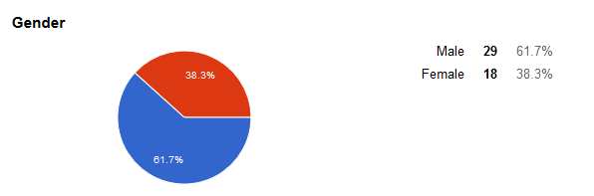

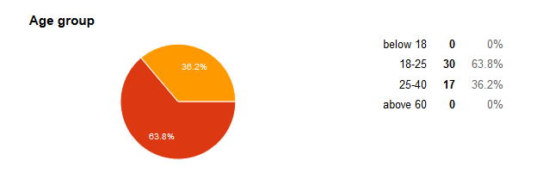

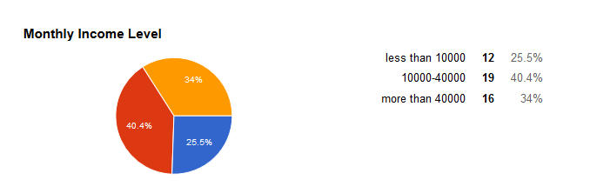

Total fourty seven responses were recorded during the data collection period. Out of which 62% are male and remaining are female respondents.

63.8% of the total respondents belongs to 18-25 age group and 36.2% respondents are between 26-40 as most of the e-commerce users young and working since only 25.5% of the respondents belong to less than Rs.10000/- per month.

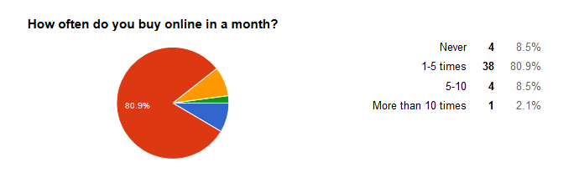

From the data collected it is also found that 89.4% of respondents use e-commerce less than five times in a month. Only 2.1% of respondents buys product online more than 10 times.

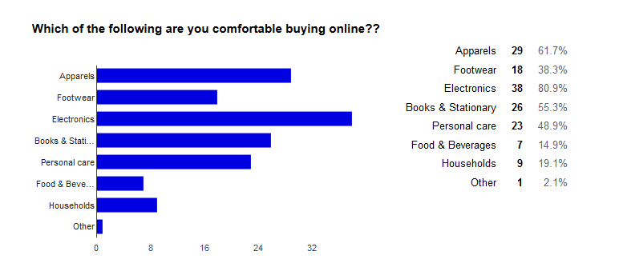

Currently online customers are more comfortable with electronics items, apparel items. Footwear, books and stationary are also preferred by online buyers. In grocery items personal care items are most preferred as 48.9% of respondents purchase these items and other grocery items are least preferred in all categories.

ANALYSIS OF SERVICE PARAMETERS OF E-COMMERCE. 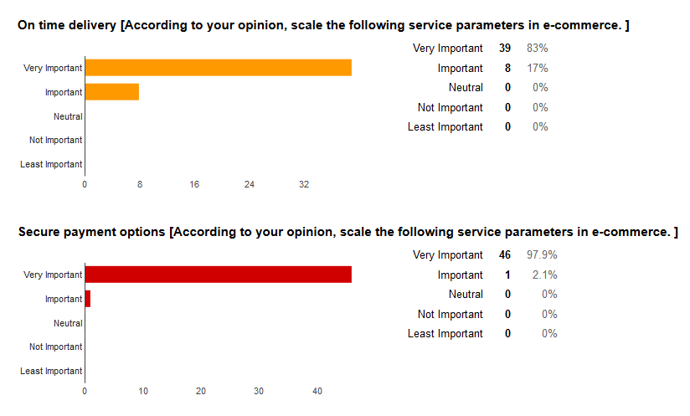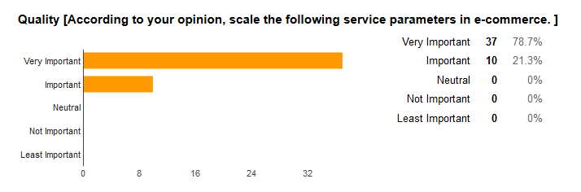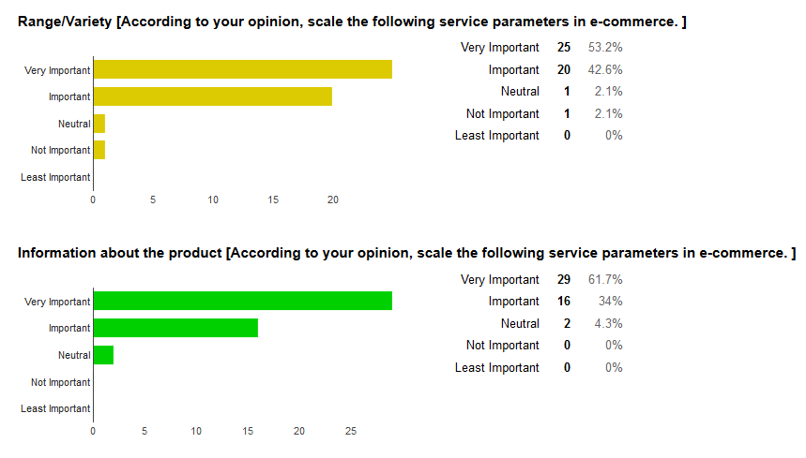

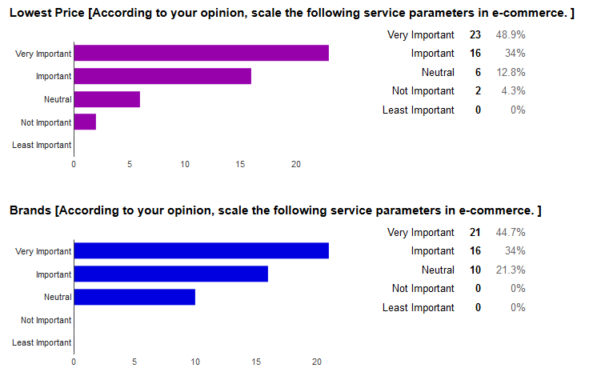

Out of these parameters secure payment option is most important for online buyers. Other then that on-time delivery is also very important for online buyers.

PAYMENT PREFERRENCE

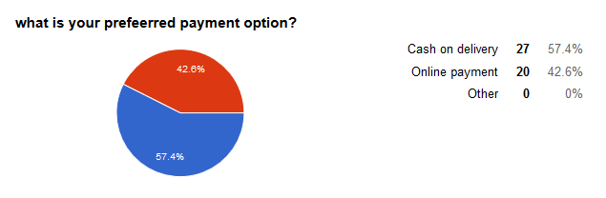

As the buyers are now familiar with the online concept and had already made few transactions they are ready for online payment. Growth on online wallet and ease of use of net banking and debit/credit card made online payment as a good secure option.

PREFERRED DELIVERY OPTION

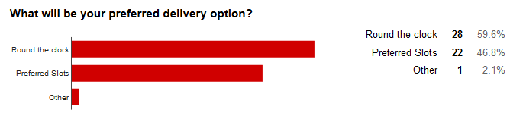

Round the clock and preferred slots both the options are equally liked by the online buyers. Round the clock delivery provide fast service and preferred slot provide the convenience to customer in their daily busy life.

PREFERRED WEBSITES FOR ONLINE PURCHASE OF GROCERY PRODUCTS

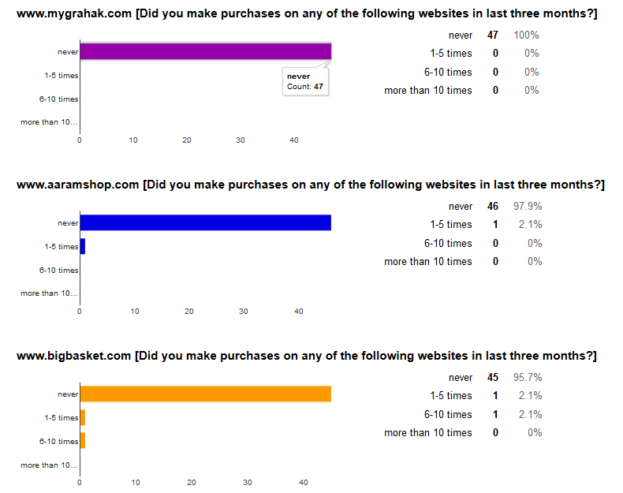

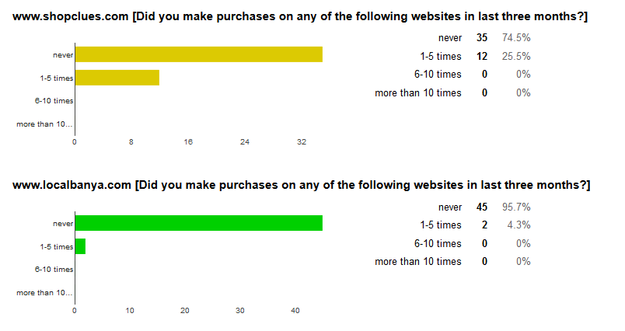

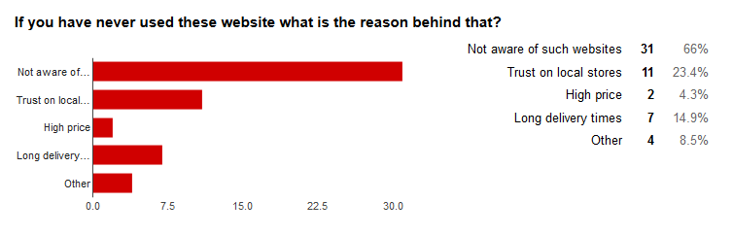

Shopclues is the most used website for grocery product purchase. Almost 66% of the respondents are even not aware of the websites. Trust on neighbourhood store is another reason to not buy grocery products online.

VALUE ADDING SERVICES EXPECTED

Better quality, verity of products, discount coupons, fast delivery and free samples are other value addition that online buyers expects.

**4.2 Conclusions**

* As the most of the respondents are not aware of the websites that offer grocery products there is a great need to create awareness. Extensive promotional campaign with advertising campaign needs to create awareness about the websites.
* Discount coupons, combo offers will help in attracting new customers.
* Delivery time is an important factor that customer expects. Round the clock delivery and preferred slots both the options should be available.
* Online payment option like online wallet, net banking, debit/credit card should be promoted as it easy to pay and return of orders is easily debited back in respective account. Cash on delivery should also be provided as new consumer don’t trust the online purchase concept.
* Complete range of products, brands and competitive brands should be available to provide a complete buying experience for buyers.
* For every purchase samples of other products should be made free for buyers. This will build the trust among the buyers for the product as well we for website services.
* Product information should be as detailed as possible as it helps buyers to make purchase decision. Also the 360‘ view of product should be made available as it provide more real feel of the product.

## 4.3 Limitations of the Study

* Tools available to search the data were limited. Hence verification of data and getting accurate data was not possible in some cases.
* Most of the target respondents are students and working people under the age of forty the conclusion cannot be generalized on the whole as grocery item is used by people of all age group.
* Small sample size thus analysis may or may not depict the actual picture.
* Some of the questions in the survey were left unanswered which decreases the accuracy of the result.
* The result of the study may not be applicable for the longer of time as the e-commerce is growing at a very fast rate and consumer behavior is also changing rapidly.

## 4.4 Future Scope

The findings of this project can be used by different e-commerce website that deal with grocery products. And also the findings can be used for nationwide survey for the same study for better understanding and thorough analysis.

**Chapter 5: BIBLIOGRAPHY**

**5.1 Bibliography**

Hans, P. P. (2013, august). Retrieved from businesstoday.intoday.in: http://businesstoday.intoday.in/story/online-grocery-shopping-vegetables-new-trend-in-india/1/197141.html

Joshi, D. (2014, july 14). Retrieved from http://www.business-standard.com: http://www.business-standard.com/article/management/long-way-to-go-114071300590_1.html

Shrivastava, A. (2014, june 5). Retrieved from http://articles.economictimes.indiatimes.com: http://articles.economictimes.indiatimes.com/2014-06-05/news/50359137_1_grocery-delivery-service-home-delivery-online-grocery-stores

**Chapter 6: ANNEXURE**

# 6.1 Questionnaire

# Evolution of grocery products on e-commerce

This survey is conducted to understand consumer behavior and expectation from grocery e-com websites. Information provided by you will be kept confidential and will not be disclosed to anyone and will be used for research work only.

(Here grocery products include FMCG products, products that are sold by local general stores.)

* Required Questions

1. Top of Form
2. Gender *
   * Male
   * Female
3. Age group *
   * below 18
   * 18-25
   * 25-40
   * above 60
4. Monthly Income Level *
   * less than 10000
   * 10000-40000
   * more than 40000
5. How often do you buy online in a month? *
   * Never
   * 1-5 times
   * 5-10
   * More than 10 times
6. Which of the following are you comfortable buying online?? *

(select all that apply)

* + Apparels
  + Footwear
  + Electronics
  + Books & Stationary
  + Personal care
  + Food & Beverages
  + Households
  + Other: 

1. According to your opinion, scale the following service parameters in e-commerce *

|  | Very Important | Important | Neutral | Not Important | Least Important |
| --- | --- | --- | --- | --- | --- |
| On time delivery |  |  |  |  |  |
| Secure payment options |  |  |  |  |  |
| Range/Variety |  |  |  |  |  |
| Information about the product |  |  |  |  |  |
| Lowest Price |  |  |  |  |  |

1. Did you make purchases on any of the following websites in April? *

|  | never | 1-2 times | 3-5 times | 6-10 times |
| --- | --- | --- | --- | --- |
| [www.shopclues.com](http://www.google.com/url?q=http%3A%2F%2Fwww.shopclues.com&sa=D&sntz=1&usg=AFQjCNET8sh1b_9vJAgz7O0wvrxhp0qLRQ) |  |  |  |  |
| [www.localbanya.com](http://www.google.com/url?q=http%3A%2F%2Fwww.localbanya.com&sa=D&sntz=1&usg=AFQjCNHqUxoCGwaZTEXm_s4CyE7-MZOzGw) |  |  |  |  |
| [www.mygrahak.com](http://www.google.com/url?q=http%3A%2F%2Fwww.mygrahak.com&sa=D&sntz=1&usg=AFQjCNE_pKd_TFbHQoJWns266B3LdLENag) |  |  |  |  |
| [www.aaramshop.com](http://www.google.com/url?q=http%3A%2F%2Fwww.aaramshop.com&sa=D&sntz=1&usg=AFQjCNGQiBYkwXmqpkODnxHmTvjw9XevwA) |  |  |  |  |
| [www.bigbasket.com](http://www.google.com/url?q=http%3A%2F%2Fwww.bigbasket.com&sa=D&sntz=1&usg=AFQjCNH8gH6h-FdTmBFCxrT_Avys6WaCGg) |  |  |  |  |

1. If you have never used these website what is the reason behind that?

(Select all that apply)

* + Not aware of such websites
  + Trust on local stores
  + High price
  + Long delivery times
  + Other: 

1. What other services you expect from these grocery products websites to make your purchase experience more delightful? *

Bottom of Form

**…………………………………………………………………………………**

**…………………………………………………………………………………**

**…………………………………………………………………………………**

**…………………………………………………………………………………**

http://articles.economictimes.indiatimes.com/images/pixel.gif **…………………………………………………………………………………**