1.2 OBJECTIVES OF THE STUDY

- Understanding the market structure and demand scenario of cut flowers in Ghazipur flower market.
- To understand the supply chain and its linkages of cut flowers in Ghazipur flower market.
- To assess the costs, returns and profitability in marketing of cut flowers in Delhi.

1.3 Scope of Study

Floriculture in India comprises both traditional and modern flower crops. Most traditional flowers are grown in open fields while modern flowers are grown under protected conditions. The traditional flowers grown in the open include chrysanthemum, jasmine, crossandra, rose,
tuberose, aster, marigold, champaka, etc. A large number of small and marginal farmers as well as small traders (forming the unorganized sector) are eking out a living in the sector compared to hi-tech floriculture. The traditional flowers are grown in all districts
of the Delhi,UP ,Haryana,Uttarakhand,HP etc. The traditional floriculture is still predominant in the state in terms of area and production. However, there are a few exceptions
to this general practice in Uttarakhand. For instance, roses (as cut flowers) are also grown by small and marginal farmers under open conditions, while traditional flowers like chrysanthemum are grown by large growers under poly-house conditions. The chief flowers grown under greenhouse conditions are rose, gerbera, carnation, bird of paradise and anthurium.
Interactions with the wholesalers were primarily aimed at understanding the market structure,
demand scenario, supply chain and its linkages etc. Retailers provided the insights into the
consumers’ choices, business aspects, local market structures, supply chain, and emerging trends in the industry. Consultants were useful to get the technology details, financing options, support institutions, and state govt. schemes and promotional efforts.

1.4 Products/Produce studied
“Flower market” gives the impression of a homogeneous segment with uniform rules and characters governing it. However, there are two distinctly different product ranges within it – cut flowers and traditional flowers. All the business attributes like production technology, investment requirement, target customers, market segments, supply chain, impact of shifting of flower market to Ghazipur etc. are very different for each of them. All these attributes are covered in this report although the details are varying on different parameters depending upon their relevance and requirement.

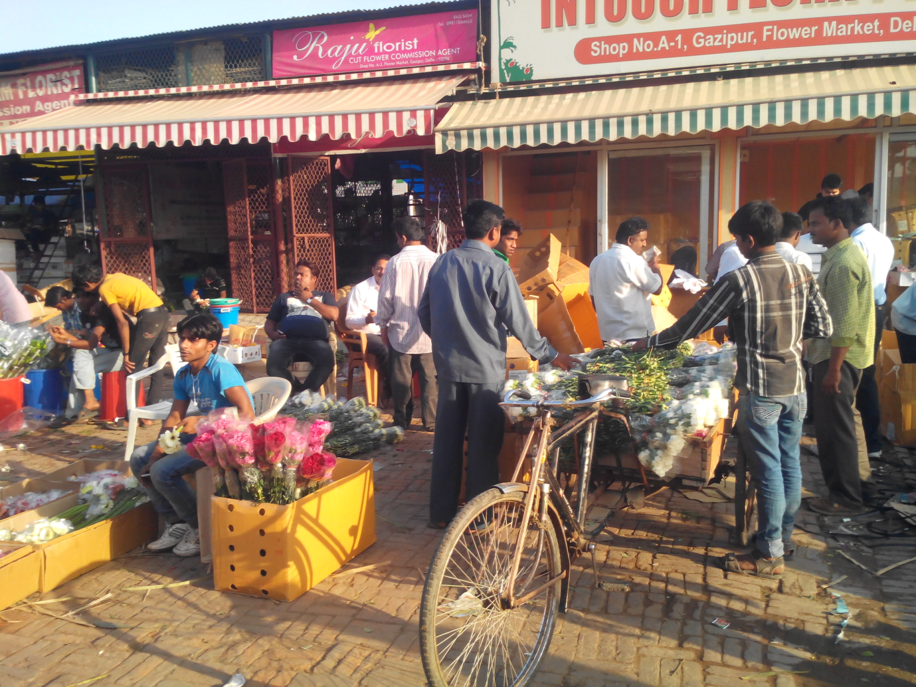
Figure 1: Snapshot of trading of cut flowers in Ghazipur Mandi

LITERATURE REVIEW
Flowers are very intimately associated with the social and religious activities in India. In social life, flowers are offered to welcome, to felicite and to greet friends or relatives and guests in functions. Flowers are needed in all the religious ceremonies functions including marriages. Garlands and wreaths are offered on dead bodies of martyars and very important persons (VIPs) and national heroes as a gratitude for the work done and sacrifice made by them. Flower is a taken of love and tenderness. They are wanted due to various attractive colours and fragrance. Flowers are also used for extracting essential oils, which are used in perfumes. Many flowers have medicinal values and hence are used in Ayurveda. In India, large number of flowers are grown in different parts according to soils and climate and also likings and preferences of the people for specific type of flowers. Important flowers are rose, marigold, chrysanthemum, jasmine, lily, tuberose, aster, zinia, carnation, gladiolus, galardia etc. Flowers are tender and hence highly perishable. They are generally used in fresh form but they have very short shelf life. This poses great problems in their marketing, particularly lone distance marketing. Therefore, flower cultivation is concentrated in the hinterland of big cities like Mumbai, Pune, Bangalore, Mysore, Chennai, Calcutta, Delhi etc. But with the development of quick transport vehicles and refrigerated or insulated vans, flowers are transported to distant markets including foreign markets

Floriculture production in India is facing good opportunity in terms of expanding domestic market, owing to the augmentation in the income levels of middle-class population and increasing penetration of cosmopolitan lifestyles in the large urban centers. One of the main drivers of this demand is again the youth segment which is becoming more refined in its tastes and fashion oriented.
It may be safely assumed that with very high proportion of young population supported by
sustained 15-20% p.a. growth in salaries in the corporate sector, the demand for flower business will increase appreciably.
Flower market in India is centered heavily upon rose ,Gladiolus and gerbera in the cut-flower
segment, along with carnation and orchid in limited supply. Most of the specialized
flowers and new varieties of existing flowers are being imported from abroad. With the easy
availability of high-end technology employed in foreign production system and supportive
government policies on this front, production of these ‘still-exotic’ flowers presents a good option. Even the new flowers which are grown domestically on a limited scale are found to command premium in the market. A simple pricing rule being observed in the flower market is the specificity and rarity of flowers because of the increasing orientation to spend for uniqueness and novelty.

2.1 Rationale of Study

Floriculture may be defined as the art, science and business of growing and marketing flowers. As an art, it refers to the cultivation of flowers; as a science it systematically studies botanical aspects of flowers and plants; and as a business it deals with the costs of production of and income from flower production and marketing. The term flowers is
used to cover flowers – both fresh and dried – as also ornamental plants and the filling material/foliage used for floral decorations.

The increasing pace of agricultural transformation in India has been characterized by widening share of commercial crops in the overall basket. Among others, floriculture has shown great promise because of the availability of high-value domestic and international market against the low production base so far. Understandably, it has received special attention of policy-makers and being termed as the sunrise industry within agriculture.
This presents an opportunity to the early movers in floriculture production in terms of harvesting latent demand in the market, simple supply chain structure, and available foreign markets. With availability of quality support structures like research institutions, financial schemes and quality consultants in the field, it presents itself as a good option for agriculture diversification.

2.2 Area of Study

Flower markets, because of their specialized nature and limited production, are concentrated in a few locations across the country. For the purpose of present study the Delhi Flower market has been selected.
The three traditional flower markets of Delhi — in Mehrauli, on Baba Kharak Singh Marg near Connaught Place, and at Fatehpuri Masjid — used to make the city the hub of the nation’s flower traffic. The one at Hanuman Mandir in Connaught Place was in fact Asia’s largest flower market.
However all these three markets have been shifted to Ghazipur on the eastern margins of Delhi where whole sellers are provided with licenses and sheds with 2*2 and 2*4 space depending upon type 1 and type 2 license.
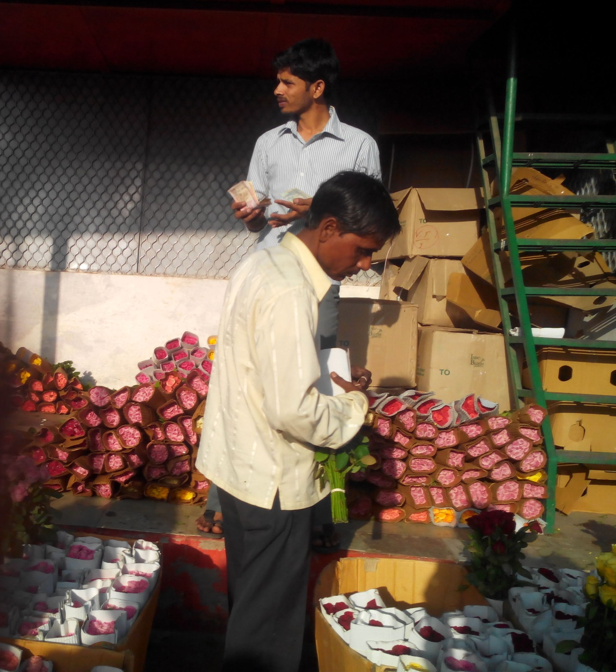
Figure 2 : A 2*2 shop of a rose whole seller in Ghazipur Mandi

2.3 Domestic Market

The three main flower markets of Delhi located at ‘Baba Kharak Singh Marg’, ‘Chandni Chowk’(Fatehpuri Masjid), and ‘Mehrauli’- near Qutub Minar

Baba Kharak Singh Marg- Established in 1995 by Shri Brij Mohan Khanagwal. It is the largest flower market in Asia for cut flowers, exotic as well as native flowers and market opens from 4 am -10 am.

Fatehpuri Masjid - Market is 75 years old market and this market owns specifically marigold flowers. Market opens from 4 am -10 am. This space used by this market transforms into the spice market after 10 am.

Mehrauli Market was established in 1998 by Flower market committee. It’s the largest market for genda/marigold flowers in Delhi, as well as exotic flowers. This market opens from 4am -11 pm and it remains open as a florist market after 10 am.
The character of market changes hour by hour in terms of consumer. For example for the first hour setting up of the retailers, vendors and unloading by different means of transport happens. For the second hour, 5:00 to 6:00 am major retailers (who purchase for selling it in another markets like Mehrauli) buying it at the wholesale prices. Also setting up of other activities happen like tea vendors, small dhabas etc. From 6:00 to 8:00 am- activities increase majorly. Small vendors are the key buyers in this time frame and at the end of it wholesalers start packing up and local consumers become the key buyers for that time frame. In the last hour market activity starts slowing down as the wholesalers starts reloading, market starts shutting down and Cleaning up of the entire active flower market area starts up where In Mehrauli market(which is open till 11pm), regular florist market sets up as the wholesalers vacate the market area after 10 am. The average cost of flowers is low early in the morning when the market is being set up but as the proceeds, with increasing number of buyers the average cost goes high.

These markets catered to a variety of consumers, weddings have the largest consumption as per annual statistics provided by the Flower Market Association. The hospitality sector is also a large consumer of flowers followed by temples and then the local consumers who buy one or two bouquets for decoration at home. Seasons play an important role in the consumption of flowers, Diwali as a festival has the maximum consumption of flowers in the entire year trailed by other regional festivals. As the flower market has such a large consumer base, it is essential to study this quaint industry of flowers.

Unnoticed by most Delhiites, the city's flower markets have been uprooted from their traditional spots and transplanted to Ghazipur on its eastern border, where sellers are operating under tarpaulin sheets from a parking area meant for the vegetable mandi .They have the slaughter-house and steaming mounds of refuse at the landfill with scavengers swirling overhead for company.

In late September 2011, just before the Navratra, the flower markets of Mehrauli, Fatehpuri and Hanuman Mandir (Baba Kharak Singh Marg) - regarded by many as part of the city's heritage - were denotified in favour of a single market. The old markets were shut down before any of the promised facilities of a "modern flower market" were even remotely operational at Ghazipur. The flower mandi currently has the abattoir and stinking mounds of refuse, with scavengers swirling overhead , for company.
The flower-sellers , 409 of them are licensed, had been promised much - a "modern flower market" with developed space and cold storage. The mandi, as it stands now in the dusty parking area, consists of tarpaulins on iron frames marking the temporary lots from where traders will operate till the actual building is ready. DDA says it's working on the plans. Clearly, any cold storage they get in the coming months will purely be thanks to the weather.

2.4 Marketing of Cut Flowers
Retail market in upcoming cities may be divided in two broad segments: Product market and Services market. Within Product market, two categories are discernible – Retail bouquet based customers and the bulk order customers. Product market is mainly catered by the road-side vendors across the city. Services market constitutes event decorations, marriage decorations and institutions servicing and it remains with a select group of florists that operates on a large scale.
As is stated elsewhere in the report, individual buyers for cut-flower are predominantly from the youth segment and the relatively affluent groups. It is mainly purchased in the form of bouquet – prepared as an assortment of flowers – to gift on special occasions. For traditional flowers, most of the individual purchase is in the form of garlands or loose flowers for religious offering. At institutional level, traditional flowers attracts high level of business from temples and a comparatively small volume from marriage halls, and traditional festivities.
Cut-flowers segment has marriage halls, hotels and corporate offices as its institutional client base. Of these, marriage halls provide the largest share of business. Hotels and corporate offices have a regular level of demand on a daily basis.
With increasing entrepreneurs in the cut-flower segment, this dependency has started to decrease. It presents an interesting opportunity to large scale floriculture
within NCR to serve these markets directly, if assured supply volume may be achieved.
As is observed in the study, two main drivers of floriculture business are modernizing culture and the traditional institutions. Hence, the markets may be classified along this parameter to determine the relative importance of traditional flowers vs. cut flowers market

2.5 Export Market
Growing at a compounded annual growth rate (CAGR) of about 30 per cent, India's floriculture industry is likely to cross the Rs 8,000-crore mark by 2015, reported by industry body Assocham .
The floriculture industry in India is poised at about Rs 3,700 crore, with just 0.61 per cent share in the global floriculture sector, which is likely to reach 0.89 per cent by 2015, said a study titled, 'Indian Floriculture Industry: The Way Ahead' released by Assocham.
Besides, the global floriculture industry is likely to cross Rs 9 lakh crore mark by 2015 from about Rs 6 lakh crore now and is growing at a CAGR of 15 per cent, it said.
With a share of about 65 per cent rose flower industry in India accounts for over Rs 2,400 crore of the overall floriculture industry and rose accounts for 75 per cent of the global floriculture industry, said the study.
Rising demand from Tier II and III cities apart from urban centres is likely to spur demand for roses this Valentines Day (February 14), as price of export quality cut rose is likely to quadruple from its current average ruling price of about Rs 15 to Rs 20 per stem, it said.
It was found that Dutch Rose is primarily being exported from India. Main export destinations are European countries & Japan. Bangalore is considered export hub with many export-oriented units in the nearby regions. Minimum area required to achieve feasible operation to serve export market is approximately 6 hectares. Peak export period is the winter season (December-February) targeting Christmas to Valentine Day festivities.
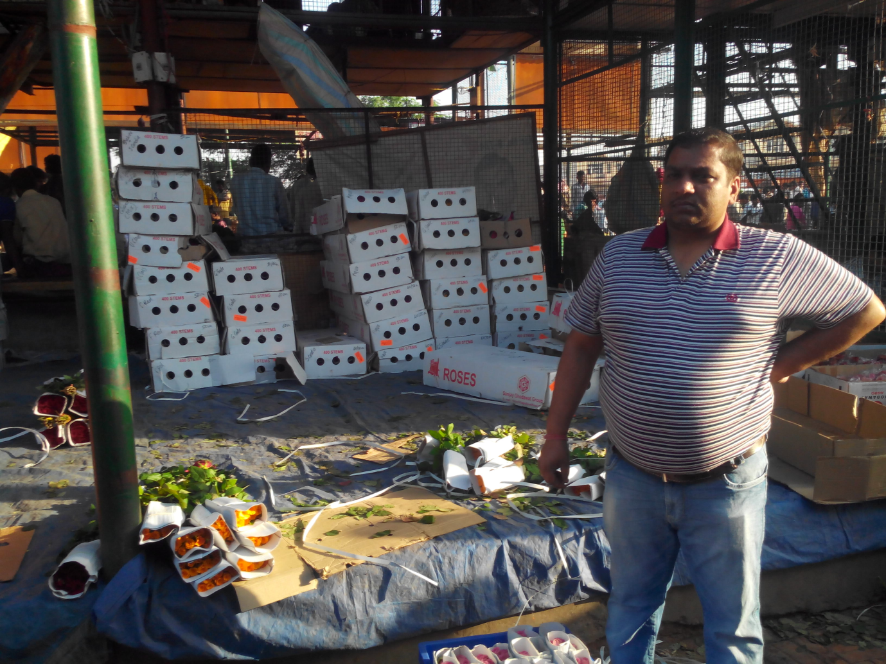
Fig 2.1: Packed Dutch roses for export purposes.
Demand for roses has spiraled upwards by over 25 per cent in domestic and about 30 per cent in international markets as Valentines Day draws closer, said over 55 per cent of all respondents.
Fall in the value of rupee against major currencies is the prime reason behind this upsurge in demand for roses in international markets of Australia, Germany, Greece, Italy, New Zealand, Netherlands, the US, UK and other countries of Europe and the Middle East.

2.5.1 Steps taken by Government to increase Flower Exports

- The Government of India is working hard at getting the European Community (EC) to reduce the high rate of import duty on Indian Cut Flowers. According to Commerce Ministry, the current rate of import duty is fixed at 20% and 15% according to season.
- To further promote the Floriculture, the Commerce Ministry is contemplating duty exemption on the import of materials for Green House and Tissue Culture Labs considering the huge capital inputs.
- The Government is also working out a Scheme to impart training to the Farmers and Entrepreneurs.
- Setting up of cold storage unit at International Airports.
- The Government is working for an air freight subsidy for export of Cut Flowers and exemption of export oriented units from requirement of customs bonding.
- APEDA is planning to step up Flower exports to West Asia and make an entry into the market in Australia and New Zealand.
- The total quarantine procedures have been simplified and made easy for the expeditious clearance, for the import of seeds and planting materials.
- Import permit for flower Seeds and Tissue Culture materials of Plant origin has been waived.
- Import duty on Floriculture planting material has been reduced from 55% to 10%.
- Import duty of Seed development machineries and specified goods for Green House has been brought down from 136% to 25%.
- Import duty on pre-cooling units and refrigerated transport unitshas been reduced to 25%.
- Floriculture units can avail of the benefits of duty free imports if they export 50% of their production.
- For export of Tissue Culture Plants, and Cut Flowers by air, subsidy on air freight has been allowed up to a maximum of 25% of the international freight rate.
- The Central Government has plans for setting up model Floriculture Regional Centres at Chennai, Bangalore,Trivandrum, Pune, Lucknow, Calcutta, Mohali, Srinagar and Gangtok to conserve important varieties of masamoth flower crops of the Region and arrange for large-scale multiplication.

2.5.2 Quality Requirements for Export-oriented Floriculture
2.5.2.1 Harvesting of flowers

For getting good quality, flowers should attain the right stage for harvest. Harvesting needs to be done in the evening or early morning with the long stem. The lower end of cut stems are immediately placed in clean plastic buckets containing a clean solution of 500 ppm citric acid or in chrysal-RVB and then they are moved to cold room where they will be stored overnight at 8 degree C temperature to make them rigid/stiffer for easy handling. The next day flowers will be moved to the grading room, where they are graded and packed. At times when large quantities are required and are not available in-house, then they are sourced externally from the other producers, especially the small-scale ones, to supply the required volume.

2.5.2.2 Grading and Packing
Flowers need to be graded into different classes according to their quality length of stem. Grading is done either on a mechanical grader or by hand grading tables. Packing process comprises three steps: bunching, wrapping and packing. The heads of the flowers are evened up and their stems are tied together with a rubber band into bunches of 10s, 20s, 30s, or 50s depending on the requirements of ultimate market. They are cut so that all the stems are of uniform length.
The bunches are placed in a preservative solution and may be shifted to cold store if they are to be shifted to the market. They are brought back to the packing hall and then flowers are wrapped. Different types of paperboard boxes are used for packing. Depending upon the market, the box is packed with either one colour of a particular grade, or mixed colours but of grade only. All these are specialized activities and require training to perform. Accordingly, labourers are trained to carry out these activities with deftness and speed. Cleaning and packing including water plugging off the flowers are the two activities that consume a lot of time.

2.5.2.3 Cold Room
Immediately after harvest, flowers should be graded, packed, and precooled
before keeping in the cold store or transportation by refrigerated vehicle. Pre-cooling reduces the heat produced by respiration, which prevents moisture from condensing on flowers and reduces the amount of ethylene inside the package. As such, it is very important for longevity of cut-flowers. After pre-cooling, flowers should be kept under continuous refrigeration during the distribution for maximum benefit. Pre-cooling is of little use if low temperature is not maintained during subsequent periods. The recommended temperature for storage is around 2 degree Celcius .

2.5.2.4 Transportation
Transportation from the farm to the airport should be in a refrigerated
van. Temperature within the box should be around 2 - 40C. In case of a delay in flight, flowers should be put in cold storage at the airport.
Some airlines have arrangements for maintaining temperature of the
flower boxes within the safe limits
2.5.2.5 Sanitary and Phyto-Sanitory norms
The export cargo is subject to sanitary and phyto-sanitory norms
requiring customs clearance, quarantine inspection and certification
about the residues of plant protection chemicals. For exports to Japan,
fumigation has to be done by a designated government agency.
Exports to Australia require dipping in a solution of water with
approved chemicals only. For exports to Singapore, no pre-shipment
fumigation is necessary. Then the flowers catch the flight for required
destination. Flowers go on the planes as perishables where the
required temperature and relative humidity specifications are to be
maintained. There have been several instances in the recent past in
which the export consignments of Indian flowers have come in for
severe scrutiny thus adversely affecting India’s cut flower exports.

2.6 Supply Chain linkages

The supply linkages are intermediated by the transporters cum commission agents in the trade. Farmers or the intermediary aggregator have direct linkage with the wholesale traders. Depending upon the supply agreement with the wholesaler, cartons, crates or bags of flowers are sent by these intermediaries with the name and the shop number of wholesaler attached to it. Mostly, transportation vans are also owned by these aggregating intermediaries only.
It is generally observed that different channel arrangement exists for the traditional flower business and the cut-flower business. The farmers involved in the traditional flowers production are grouped together for ease of interaction with the market intermediaries. This grouping is either voluntary in the form of a cooperative like structure or under an individual aggregator. These groups have direct linkages with traders in the big wholesale markets within a distance equivalent to 24 hrs of road transportation. The road transportation network is operated by the aggregating intermediary themselves which is also open to access by self-organized cooperatives against the transportation fee.

The flowers are packed in plastic and normal sacs by the aggregator with the name of the trader for whom it is targeted and his shop number pasted on it. These sacs are then transported in mini-vans (owned by aggregator-transporter) to the important wholesale markets.

Cut-flower segment normally does not see this aggregation of farmers because of the comparatively low-volume and high-value of product. Farmers are directly in touch with large wholesale players in big trading centers like Mumbai and Delhi. Flowers are first packed in polythene sheets and then are encased in carton for dispatch to target locations.

