A Project Report submitted in partial fulfillment of the requirements for the Degree of
Master of Business Administration

“Comparing the Effectiveness of Traditional and Digital Media on Consumer Buying Behavior”
-A case study on mobile hand-sets and shampoo
Submitted by:
Karan Garg
2k11/MBA/24

Under the guidance of:
Dr. Archana Singh
Project Mentor

DELHI SCHOOL OF MANAGEMENT
Delhi Technological University
Delhi – 110042

CERTIFICATE

It is to certify that the thesis entitled “Comparing the Effectiveness of Traditional and Digital Media on Consumer Buying Behavior- case study on mobile hand-sets and shampoo” is an authentic task carried out by Karan Garg, student of the MBA program at Delhi School of Management, Delhi Technological University. I further confirm that the study taken up by him has been carried out under my supervision and guidance. His efforts throughout the project were satisfactory.

Dr.Archana Singh
Assistant Professor
Delhi School Of Management

ACKNOWLEDGEMENT

I express my sincere thanks to my project guide Dr. Archana Singh, for providing me with an opportunity to work under her guidance and providing tireless support during the course of the project. Her continued cooperation, never-ending encouragement, meticulous guidance and uninhibited support at various stages helped me in preparation of this research study.

I would also like to thank the staff of the Delhi School of Management, library and administrative section for their cooperation and support.

Contents
PAGE NUMBER
Executive Summary 5
Chapter 1 6
Introduction 6
Chapter 2 9
Choices of media 9
Types of Media 11
Chapter 3 14
Literature Review 14
Chapter 4 20
Objectives of the study 20
Chapter 5 21
Research Methodology 21
Sample selection 21
Channel attributes 21
Chapter 6 24
Data Analysis 24
Conclusion 28
Limitations of the study 30
Bibliography 31
Appendix 35
Appendix A: Questionnaire 35
Appendix B: Statistical Output 40

Executive Summary

The objective of the study is to understand & compare the relative effectiveness of traditional and digital types of media on consumer buying behavior. The purchase decision-making for mobile hand-sets & shampoo is studied and the influence of television advertisements and newspaper ads (traditional media) is compared with phone, internet and mail (digital media).
To understand the effectiveness of different types of media on the purchase of these two products, these have been judged on different attributes which include trustworthiness, convenience, informative-ness and reliability.
An analysis is conducted on the basis of data-collection and analyzed by descriptive research methodology using a questionnaire-based survey conducted in Delhi. The demographics selected are highly literate and high on technical education. Most of them have cell phone, and are in between the age group of 18-30.
The findings of the study are that
- Gender has an effect in terms of which media annoys the most
- Consumers are willing to buy a mobile phone when they receive information about mobile phone from internet blogs and peer groups.
- In order to buy a shampoo, people depend upon the newspaper advertisements to make their choice.
The limitations of the study are that the sample space size is small, convenience sampling causes sampling bias. Also, only few media channels are examined hence it is not comprehensive. Also while filling the questionnaires for the field experiment; the seriousness of the individual could not be assessed.

Chapter 1

Introduction

Understanding the relative effectiveness of different media for marketing communications has always been challenging. The recent emergence of the E-mails and phone communication has further complicated decisions about how to allocate resources across media and choice of media for particular product. Thus there is an important need to learn about consumer buying behavior. Consumer buying behavior determines the logic which consumers applies in deciding for purchase of a product and what are the various factors responsible for this decision?
Out of 11000 new products introduced by 77 companies, only 56% are present after 5 years. Only 8% of new product concepts offered by 112 leading companies reached the market. Out of that 83% failed to meet marketing objectives. What we need to understand here is why consumers make the purchases that they make, what factors influence consumer purchases and changing factors in our society
One of the important sides of marketing equation is market or customer. And no marketer can afford to ignore to check how developments are affecting customer. The internet technology altered the value equation by enabling firms to deliver content (e.g. movies) directly to customers doing away with the need to buy or rent DVDs. The web seems to be recasting the concept of market that can be targeted. The term ‘market’ now needs to be separated from the concept of location. The current campaign by eBay attempts to establish that shopping can be done sitting at home with an ease, economy, and convenience. Consumer buying behavior is determined by:
- Level of Involvement in purchase decision
- Importance of product
- Intensity of interest in a product in a particular situation.
Buyer’s level of involvement determines why he/she is motivated to seek information about a certain products and brands but virtually ignores others. High involvement purchases--Motorbike, high priced goods and the higher the risk the higher the involvement.
Types of consumer buying behavior include:
- Routine Response/Programmed Behavior: This involves buying low involvement frequently purchased low cost items. These products need very little search and decision effort. These products are purchased almost automatically. Examples include soft drinks, snack foods, milk etc.
- Limited Decision Making: This involved buying product occasionally. Whenever one needs to obtain information about unfamiliar brand in a familiar product category, perhaps. This requires a moderate amount of time for information gathering. Examples include Clothes. This generally happens when one know product class but not the brand.
- Extensive Decision Making: There are products that are complex and are high involvement, unfamiliar, expensive and/or infrequently bought products. These product purchases have high degree of economic, performance and psychological risk. Examples include cars, homes, computers, education. Customers spend a lot of time seeking information & deciding about the purchase. In this kind of decision making information is gathered from the companies, or from friends or relatives or store personnel etc.
- Impulse buying: There is no conscious planning. The purchase wasn’t in mind but once customer sees it and likes it, customer makes the purchase then and there. Example of impulse buying can be chips, chocolates and chewing gums.

The central question for marketers is: How do consumers respond to various marketing efforts the company might use? The company that really understands how consumers will respond to different product features, prices, and advertising appeals has a great advantage over its competitors. The central focus of any marketing technique is the consumer. To devise good marketing plans (including costing, cost for R&D, cost for sales, packaging, advertisement cost), it is necessary to examine consumer behavioral attributes and needs, lifestyles, and purchase processes and then make proper marketing-mix decisions. What we need to understand here is why consumers make the purchases that they make, what factors influence consumer purchases and changing factors in our society. The research study is focused to compare the relative effectiveness of traditional (television and newspaper advertisements) and digital media (mobile phones, internet and mail) on various parameters like trustworthiness, convenience, informative-ness and reliability.

Chapter 2

Choices of media

Marketing managers in the new millennium face a wide and diverse choice of media through which to send marketing communications to customers. These include most recently and significantly the internet, and also mobile phone communications, such as text-messaging (SMS) and cell phone TV. The internet has spawned its own mega-firms (Amazon, Ebay, Google), its own language (URL, website, link, home page), and its own advertisements (pop-ups, banners and skyscrapers). The internet is becoming an everyday part of the workplace and home lives of millions of people around the globe. Text-messaging via mobile phones is also increasing. In the U.S., where 80% of people aged 18 and over own cell phones and about 70% of teenagers aged 13 to 17 have one, 34% of the older group and 54% of teenagers sent a text message to another phone in the past month.
With the rapid and widespread uptake of new electronic media, traditional communications media like television and newspapers are expected to decline. Evidence of this is already apparent for network television in the U.S., where average ratings are declining and this had resulted in erosion in their share of advertising revenue.
However, in the enormously populous remainder of the world, particularly in Asia, telemarketing grows unabated. Door-to-door personal selling has also been in decline in the Western world for consumers, although face-to-face selling remains important for business customers, and for both business and residential customers in the Eastern world. On the increase is another form of less explicit face-to-face personal selling known as “buzz” marketing (marketer-initiated word-of-mouth). An estimated 92% of buzz is face-to-face or on the telephone and only 8% online (Creamer 2006). Brands that have invested in creating word-of-mouth advocacy include Converse, Nike, Boeing, Google, Napster and Microsoft, and the automobile makers Cadillac, Mercedes, BMW, and Audi.
Despite the emerging challenge from new media, traditional channels of personal sales visits, voice-only telephone and mass media remain strongly in use .

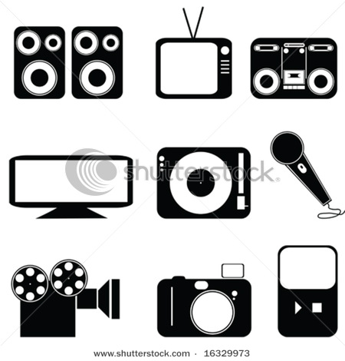
Figure 1: Different Types of Media
However, the internet is fast catching up to some media. For example, in the U.S. and U.K., the expenditure for online advertising, now exceeds that of radio, consumer magazines, and outdoor. Therefore, a “state of flux” is an apt description of the overall scene for marketing communication channels.
How do marketing managers choose from the many traditional and new channel options for marketing communications messages? Which ways of receiving these messages do customers prefer? And, bottom line, which channels, or media, is most effective in eliciting a response? We lack answers to these important questions, which are becoming more pressing as the media channel scene changes. In particular, will the scenario eventuate that e-mail will become the dominant marketing communication channel? What about mobile communications. My study is focused on the consumers and will try to find out the answers for: Which ways of receiving these messages do customers prefer? And which channels, or media, is most effective in eliciting a response?

Study of types of Media: Traditional & Digital

While just a few years ago marketers needed to be aware of only a few media outlets, today’s marketers must be well-versed in a wide range of media options. The reason for the growing number of media outlets lays with advances in communication technology, in particular, the Internet. An overview of traditional & digital advertising media:

Television Advertising
Advertising on television usually means running a TV commercial, typically between 15 and 60 seconds in length, but TV advertising can also include sponsorships and product placement within television shows. It reaches out to large numbers in a single exposure so is best for products that targeted to a broad market. It is facing numerous challenges from alternative media (e.g., Internet) and the invasion of technology devices, such as digital video recorders

Radio
Radio can be an effective advertising medium. It uses the listeners imagination. It also has the advantage of catching potential buyers in an uplifting mood. Radio stations are very helpful in creating effective ads. Announcers give the impression of implied product endorsement.

Print
A print advertisement can only be effective if people see it. When people are looking through publications, they have a tendency to be receptive to new information and observant of things of interest. One method of advertising aims to attract people to products and services as they are reading or scanning publications. Newspapers have also incorporated color advertisements, though their main advantage rests with their ability to target local markets Presently , high quality imagery (e.g., full color) , touch and scent experiences (e.g., perfume) are being used .
Internet
It narrowly targets an advertising message and tracks user response to the advertiser’s message. The Internet offers many advertising options with messages delivered through websites or by email.
- Website Advertising - For marketers, website advertising offers many options in terms of:
  - Creative Types – Internet advertising allows for a large variety of creative types including text-only, image-only, multimedia and advanced interactive,
  - Size –Can be delivered in a number of different sizes (measured in screen pixels) ranging from full screen to small square ads that are only a few pixels in size.
  - Placement
  - Delivery – When it comes to placing advertisements on websites marketers can, in some cases, negotiate with websites directly to place an ad on the site or marketers can place ads via a third-party advertising network, which has agreements to place ads on a large number of partner websites.
- Email Advertising – Using email to deliver an advertisement affords marketers the advantage of low distribution cost and potentially high reach. However, as most people are aware, there is significant downside to email advertising due to highly publicized issues related to abuse (i.e., spam).

Direct Mail
It includes postcards, letters, brochures, catalogs and flyers directed to a physical address of targeted customers. It is most effective when it is designed in a way that makes it appear to be special to the customer. It can be a very cost-effective method of advertising, especially if mailings contain printed material. This is due to cost advantages obtained by printing in high volume. The benefit of a low cost-per-contact is balanced by the actual cost-per-impression that can be quite high as large numbers of customers may discard the mailing before reading
Signage
Generally in the form of billboards, which are generally, located in high traffic areas. Other signage include sky writing where airplanes use special chemicals to form words , plane banners where large signs are pulled behind an airplane , mobile billboards where signs are placed on vehicles, such as buses and cars, or even carried by people , plastic bags used to protect newspapers delivered to homes , advertisements attached to grocery carts

Mobile Phones
Handheld devices, such as cell-phones, smart-phones, portable computers and other wireless devices, make up the growing mobile device market. Such devices allow customers to stay informed, gather information and communicate with others without being tied to a physical location. While the mobile device market is only beginning to become a viable advertising medium, it may soon offer significant opportunity for marketers to reach customers at anytime and anyplace.
Also, with geographic positioning features included in newer mobile devices, the medium has the potential to provide marketers with the ability to target customers based on their geographic location. Currently, the most popular advertising delivery method to mobile devices is through plain text messaging, however, over the next few years multimedia advertisements are expected to become the dominant message format.

Chapter 3

Literature Review
Various papers have been published comparing the effectiveness of different types of media. In the following paragraphs a brief summary of the papers reviewed, from online sources and journals, have been provided.

Peter J Danaher and John R Rossiter [2006] conducted a study that examined 11 media, including traditional mass media like television, mail and radio, as well as new digital media such as the internet and cellular phones. Initial comparisons across media were based on 14 attributes like reliability, trustworthiness and convenience. They conducted extensive exploratory qualitative phase that included focus group and depth interviews. After that they conducted qualitative research study with intentions of exploring pros and cons of a range of alternative media as potential communication channels. They conducted survey for customer segment (Home/ business people in workplace) and for media channels. They said receivers of promotional advertising communications in the consumer segment had several groupings of scores. The highest scores are for a group of mass media channels (radio, magazines and newspapers). The second highest group is for printed direct marketing (catalogs, personally addressed mail and generic mail) and television. The group with the lowest scores comprises the digital and telephone channels (phone, email, SMS), as well as door-to-door sales calls.
Patricia Sorce and Adam Dewitz [2006] studied the current landscape of audience fragmentation, Internet advertising, and required accountability for advertising expenditures is exerting great pressure on the ability of main-stream, ad-supported media to survive. How can established media such as Printed magazines, newspapers, and printed inserts survive? The desire for advertising accountability starts with this question: Does advertising affect consumer buying behavior? The impact of advertising has been measured on a variety of outcome measures such as aggregate sales for a brand, individual brand choice behavior, and the intermediate effects of awareness, beliefs and attitudes towards the advertised brand. They said in their paper that the press for accountability has stimulated a demand for the short-term effectiveness measures that have made direct marketing so attractive across a wide range of media. The ability of interactive media to deliver instant or at least direct feedback has stimulated growth rates for electronic forms of advertising such as Internet banners and Internet searching. It also has fueled the growth of printed forms such as direct mail as well. One danger in relying solely on direct, near-term response measures to advertising is the tendency it fosters to overemphasize media consumption situations where consumers are ready to buy.
The paper by James H. Pedrick and Fred S. Zufryden proposes a model to analyze the impact of advertising media plans and point-of-purchase marketing variables on a brand's market performance. Their model integrates brand choice, purchase incidence, and exposure. Moreover, it considers various aspects of consumer heterogeneity including individual differences in loyalty levels, purchase rates, and exposure probabilities for a population of consumers. The integrated model provides a relationship of advertising exposures from media plans, and other marketing variables, to measures of a brand's performance that include market share, penetration and depth of repeat patterns over time. In this paper the focus is on a multi-brand model formulation and stresses its application to the analysis of advertising media plans. In recent years, considerable research has focused on modeling the impact of marketing variables on consumer purchase and market behavior.
There has been a marked growth in the use of electronic data collection techniques. In this paper the model shows the impact of advertising media plans and other marketing variables on performance measures that relate to brand choice probabilities and market-level consumer purchase dynamics. The approach that has been followed in this paper relates advertising exposures, as well as other marketing variables, to a brand's market performance measures (e.g., market share, penetration, and depth of repeat purchase patterns) over time. On the basis of assumptions about the heterogeneity of individuals with respect to their purchase and advertising viewing behavior, the resulting integrated model permits the prediction of the brand performance measures over time as a function of alternative media schedules that are characterized by corresponding media exposure distributions.
Donald G. Morrison (1979) many surveys contain purchase intentions questions on such items as new food products, frequently purchased package goods, appliances, automobiles, and capital equipment. The time frame may range from one week to 24 months or more. Although these purchase intentions data are used, there has not been much work done on evaluating the accuracy of these data-neither at the individual nor aggregate levels. In particular, there has been little follow-up to see if individuals surveyed actually purchased the product of interest over the specified time periods. One purpose of this paper by Donaldg Morrison is to stimulate such follow-up procedures. Purchase intentions
Stated Intention

True Intention

Unadjusted Purchase Probability

Purchase Probability

Figure: The General Model for purchase decision (Paper: Purchase intention and purchase behavior)
The three-step model presented here focuses attention on a number of important issues that tend to be over-looked when stated purchase intentions are compared to actual purchase behavior.
Karen A. Machleit and R.Dale Wilson in their paper- emotional feelings and attitude toward the advertisement (1988) consider the effects of emotional feelings during advertisement exposure and the effects of attitude toward the advertisement in an experiment which used both familiar and unfamiliar brands. The findings illustrate that brand familiarity moderates the relationships between A, and brand attitude after advertisement exposure. In addition, the research provides evidence that the direct-affect-transfer hypothesis may be an adequate explanation for the effects of emotional feelings and A, on brand attitude in some situations. Research considering the role of affect in advertising has featured the attitude-toward-the-advertisement (Aad) construct. The primary focus of the literature has been on assessing the effects of A, on brand attitude (Ab), and the evidence strongly supports a positive relationship between the constructs. As evidenced by the large number of studies in the area, the Ad construct has been an interesting and useful one for scholars interested in "affective" as well as "cognitive" responses to advertisements. However, the narrow focus of examining attitude toward an advertisement is now expanding; researchers are be-ginning to consider the emotional feelings experienced during advertisement exposure as a different type of response.
The literature considering "emotional feelings" as a response to an advertisement is in its early stages of development and the construct has been given various labels such as "affect" (Allen and Madden 1988), "affective response", "feelings", "emotional response", and "emotional feelings. This paper has used the label "emotional feelings" to represent the feelings (e.g., warmhearted, happy, angry, and irritated) that an individual experiences when exposed to an advertisement. Emotional feelings experienced during advertisement exposure were measured with a scale. Within the questionnaire given after the program concluded, subjects were given a list of adjectives that completed the sentence "During the commercial did you feel." The adjectives used were: insulted, good, angry, happy, cheerful, irritated, warmhearted, pleased, re-pulsed, amused, stimulated, calm, shocked and soothed. The subjects responded on a six-point scale with end-points of "very much so" to "not at all." These items in the emotional-feelings scale were divided into the two factors of positive and negative effect. The items "amused" "stimulated" "calm" and "shocked" did not fit into either the positive or negative factor. Attitudes were measured using a seven-point, semantic-differential for-mat and included the items: dislike very much/like very much, useful/useless, valuable/worthless, unimportant/important, beneficial/not beneficial, not fond of/fond of, enjoyable/un-enjoyable.
The paper by Phyllis A. Anastasio, Karen C. Rose, and Judith Chapman takes US culture in consideration. It explores the possibility that the media may also serve as a powerful creator of the very public opinions it seeks to reflect in its news. By portraying a world in which people's opinions are based on their ethnic or demographic group membership, the media may also subtly but powerfully create the very opinions they seek to reflect. Products that the public easily lived without become necessary staples with successful advertising campaigns (e.g., look at how sales of antibacterial products have skyrocketed in recent years). What are of deeper concern, however, are the more subtle effects of media news on perceptions and opinion. Even more disturbing is the potential for such subtly conveyed impressions and opinions to shape the real world in the form of election outcomes, public policy, and agenda setting.
Cano et al. (2005) in their study found the complexity of information interchange and buyers' and sellers' communication preferences for various media types during each stage of the purchase process. Findings revealed that, overall, buyers and sellers prefer face-to-face and telephone communications over other media types. For certain aspects of the sales process, computer-mediated communications, such as e-mail, serve an important role as a low- cost medium, whereas in other phases of the sales process, richer communication media are preferred by both buyers and sellers. Research has clearly established the importance of communication in marketing channels. Studies examining the role of communication in marketing have focused on the importance of trust and commitment as well as the benefits of more collaborative communication modes. However, the choice of communication media in inter-organizational relationships has received little attention. In particular, the communication process during the stages of a buyer-seller exchange, from initiating to completing a transaction, has not yet been addressed. A wide range of electronic and computer-mediated communications (CMC) have been used in the business-to-business (B2B) sales process in an effort to enhance the effectiveness and efficiency of the buyer-seller communication process. One example of these different communication media involves e-mail, which can be used to augment transactions based in e-commerce portals and extranets or in conjunction with traditional face-to-face and paper exchanges of information. In the current business environment, buyers and sellers choose from various forms of CMC (i.e. Internet, extranet, e-mail) and decide whether to use those instead of face-to-face communication or paper-based communications for the various types of communications that take place throughout the purchase process. One reason for the high level of interest in enhancing the communication process is the flood of communications that threatens to overwhelm businesspeople.
Our findings from the literature review indicate that both buyers' and sellers' communication choices vary throughout the purchase process. The data gathered for this study do not provide much insight into the effects of social influence on the media choice. This is an issue worthy of future study. Buyers and sales- people engaged in long-term relationships utilize the Internet much more in the between-purchase stage of the sales cycle. Salespeople may use it to provide service, "touch base" with customers, or send information about new products. Social influence theory explains communication choice during the purchase process better than rational choice theory. Companies, while still in the growing stage of adopting e-mail communication, are sometimes substituting e-mail (CMC) for written communication. E-mail use may increase as younger, more computer literate people begin to work for these companies and use Internets/extranets for communication. Buyers seek a relatively rich communication (face-to-face) when searching for a supplier, whereas sellers are inclined to communicate using less rich communication media such as the Internet during the prospecting process. The situation is reversed when buyers ac-quire and analyze proposals; sellers seek the richest communication (face-to-face), whereas buyers lean toward leaner communication (written). Purchase professionals and salespeople must keep abreast of technological advances that offer potential in both the short run (i.e., cost efficiency) and long run (i.e., building relation- ships or communicating most effectively or efficiently).

Chapter 4

Objectives of the Study

The main objective of the research study is:
1) To compare many old and new media channels (traditional & digital) in terms of a range of attributes such as perceived reliability, trustworthiness and convenience.
2) To compare the effectiveness of alternative communication channels in terms of how a marketing proposition is evaluated by a recipient.
3) To understand whether some channels are better than others to act upon a promotional offer.

A detailed methodology is used to answer the research questions. Several conclusions are made after discussing the limitations of this study and directions for future research are provided.

Chapter 5

Research Methodology

Primary data collection:
In order to collect the primary data a questionnaire was prepared (Appendix A), which was then sent to the target-segment and then their responses were recorded. After collecting the responses from the respondents, the data generated was critically analyzed to find the different trends and reach a conclusion.

Sample Selection

The sample size is 87 respondents and is collected from the post graduate students of Delhi Technological University. All the respondents are between the age group 18-30. Sampling technique used is the convenience sampling. This population is selected because almost all the people belonging to this category are fully aware of both the channels of marketing i.e. Traditional as well as digital, and they are in that state of mind where they can make an informed decision. Given that respondents were expected to be reasonably knowledgeable and experienced with both traditional and digital media channels, the survey coverage was restricted to a population that is familiar with the internet and mobile phones. These questions were also asked as filter questions.

Channel Attributes

In our everyday lives we are exposed to many advertising messages, most of which are not relevant to us. However, some messages are easier to dismiss because of their delivery channel. For example, deleting an email message is much easier than turning away a 10 door-to-door salesperson. Media channels also differ in their trustworthiness or authenticity. For instance, due to the large volume of unsolicited pharmaceutical spam, email is not as credible a channel as a catalog from the local drugstore for OTC medicine.
To understand the effectiveness of different types of media on the consumer buying behavior, these Medias have been judged on different attributes which include trustworthiness, convenience, informative-ness and reliability. In the communications literature there have been several studies of the attributes of alternative media best suited for particular communication purposes, with the attributes selected in accordance with “uses and gratifications” theory. This theory posits that communication receivers have needs, such as requirements for information, knowledge and understanding. These needs can be met by different media to a varying extent. For instance, the print medium is often seen to be more informative than television, while television is more entertaining. Katz et al (1973) decompose several key media into a list of attributes and rank media on their attainment of these attributes. The attributes then become the link between receivers’ needs and how these needs can be gratified by senders of communications. There has been no comprehensive theoretical study of media for marketing communications, and no study of media attributes important to senders and receivers of marketing messages specifically. Whereas it is important to document the perceived advantages and disadvantages of traditional and new channels, managers are also interested in “bottom-line” effectiveness. Lasswell’s (1948) definition of communication is who (source or sender), says what (message), in which channel (medium), to whom (audience or receiver), with what effect.
The classic model of effective communication postulates that the sender’s message will be most effective when the sender has correctly anticipated the needs and preferences of the receiver, that is, when the sender’s encoding of the message corresponds with the receiver’s decoding of it (Shannon and Weaver 1949). Whereas the Shannon-Weaver model of effective communication is about the message, McLuhan’s (1964) insightful though extreme dictum that “the medium is the message” suggests that the correspondence recommendation should also apply to the medium or channel. Hence, for effective communication, the sender should also match the channel that the receiver prefers.
Previous research says that receivers have distinct preferences for the ways in which certain types of messages, differing in their uses, are received, and also for the ways in which they can reply to these messages. Senders of messages have their own preferences for the mode of communication. Hence, if senders go with their personal preference, they may choose a medium that diverges from the medium preferred by receivers.
If message effectiveness is the ultimate criterion, therefore, it is important to find out whether media divergence is less effective than the theoretically recommended practice of media matching. So the research study will test the effectiveness which typical marketing communication offers as delivered via few media (Like TV, internet, phone, SMS and newspaper).
In the research study tries to compare the relative effectiveness of five different traditional and digital Medias i.e.
- Newspaper advertisements
- Television Advertisements
- Internet Advertisements
- Phone/ Mobile
- Mail

Chapter 6

Data Analysis:

Since there is differing familiarity of the communication channels among people, it is possible that the outcome evaluations depend on the demographic status of the respondent. For the consumer segment, the demographic variables are age and gender. Out of the sample selected 68% of the respondents were male and rest were females. Most of the respondents lie in the age group of 20-30 years. All the respondents have access to television, newspaper, internet and mobile phones. The tool used for analyzing the collected data is Microsoft excel.

Table 1: Investigating which media annoys the consumer the most
Which Media annoys you the most??
 |  |  | Different types of media*
 |  |  | 1 | 2 | 3 | 4 | 5 | 6
Gender | Male | Count | 8 | 31 | 5 | 11 | 3 | 1
 |  | % within Gender | 13.6% | 52.5% | 8.5% | 18.6% | 5.1% | 1.7%
 | Female | Count | 1 | 14 | 0 | 13 | 0 | 0
 |  | % within Gender | 3.6% | 50.0% | .0% | 46.4% | .0% | .0%

*Legend:
1) Email
2) Phone calls
3) Internet Adds
4) SMS
5) TV ads
6) Personal selling

As shown in the table most males get annoyed with phone calls with 52.5%. Whereas females are equally irritated with phone calls and SMS. There is a significant relationship between gender and the media with which they get annoyed.

Table2: Factors that influence purchase of a phone
 |  |  | I bought my phone because?*
 |  |  | 1 | 2 | 3 | 4 | 5 | 6
Gender | Male | Count | 6 | 1 | 10 | 25 | 3 | 14
 |  | % within Gender | 10.2% | 5.7% | 16.9% | 42.4% | 5.1% | 19.7%
 | Female | Count | 1 | 1 | 7 | 9 | 3 | 7
 |  | % within Gender | 3.6% | 8.6% | 25.0% | 37.1% | 12.7% | 13.0%

*legend:
1= I saw the Television advertisement and I liked it
2= I saw the ad in newspaper and found it informative
3= My friends have the same phone
4= I read internet blogs about the phone performance
5= I saw the ad on internet
6= other
Males while buying mobile phones prefer reading internet blogs & want to explore about its features as the percentage is highest at 42.4% for this category. Females on the other hand prefer reading blogs as the percentage is highest at 37.1 and also gets influenced by friends and family as we can see the percentage in the women row is distributed at 25% for the same.

While regarding information about shampoo which medium will you prefer the most?

Table 3: Media preference for shampoos

E-mail |  | 4 | 5%
Telephone call/SMS |  | 1 | 1%
Newspaper |  | 10 | 11%
Television |  | 68 | 78%
Internet Ad |  | 4 | 5%

As it is clear from the above table that most of the people (within the sample) prefer to buy their shampoo after getting information from television. The preference for television advertisements is highest for the purchase of a shampoo at 78%.
Telephone calls and SMS are least preferred media channels to get information about a shampoo.
Which media is the most difficult to ignore, when it comes to day to day functions?

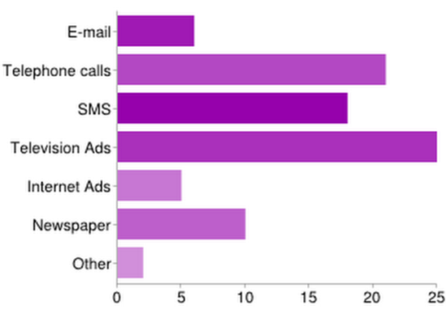
Figure A: preference of media for seeking day to day information

As it is clear from the figure that most of the people still prefer television the most to get information about any day to day functionality, with majority of the people (29%) opting for this choice.

If you want to seek information about any product, which media will you prefer the most?

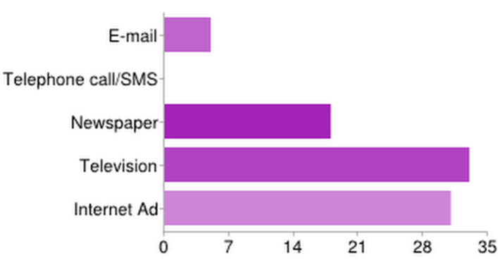
Figure B: Preference of media to get information about any product

As it is clear from the figure that in order to get information about any product in general, the most preferred media is television, followed by internet and newspaper.
Television is the most preferred media with the majority (38%) choosing it as their first choice.
This also indicates that the information that people get from television, they find it reliable and trustworthy.

If you receive an information regarding mobile phone via E-mail, you will?

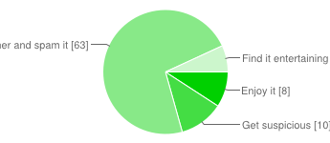
Figure : Reliability/ trustworthiness of E-mail

As it is clear from the above pie chart that when people receive information regarding mobile phones through e-mail, then majority of the people (72.5%) spam it. So it clearly indicates that people don’t find the information that they receive about mobile phones through e mail trustworthy and reliable.

Conclusion

This study shows that when it comes to buying mobile phone the first preferred medium is internet, then newspaper, email, television advertisements and then telephone call in order of highest to lowest preferred media. Other factors influencing purchase of mobile phone are getting influenced by peer influence.
When it comes to buying shampoo the most preferred media is television advertisements with 78% of the people (within the sample) going for this medium of advertisement. Most of the people watch Television advertisements because they enjoy watching it, few think that it is the convenient source of having information. When people receive information through SMS, they don’t bother to read it. Very few people get suspicious and a very small percentage of people actually enjoy it and use that information for further decision making. The most annoying media is phone calls and SMS. Most of the people don’t notice internet ads but when it comes to buying a cell phone which is a high involvement product they do consider reading internet blog to know about specifications/ product features. When asked about a product other than shampoo and mobile phone, the most preferred media is same as television, newspaper and internet blog. Whenever people receive information about any product over E-mail, they spam and don’t even bother. Very few chunks find it useful and entertaining.
From a marketing practice standpoint, no one is in any doubt that the internet has changed and will continue to change the way that marketing is conducted. However, a number of issues have continued to plague the internet, such as viruses, fraud, and invasion of privacy, spam and a proliferation of annoying and disruptive advertising messages. Hence, the preference for traditional media in the home is likely to persist (for day to day functions), even though the internet is often favorably evaluated at work as a medium for marketing communications. Given that the vast majority of marketing communications are transmitted to consumers in their homes, it is unlikely that advertising expenditures will shift significantly into the internet/email and out of mass media and printed direct media in the near future.
Despite limitations, this study has nonetheless provided a good starting point for research on marketing channel evaluation and effectiveness at a time when this is a key issue for marketing communications. Future work could use choice modeling to weigh up product/service as well as channel attributes to assess how media compare in their effectiveness. Additionally, the number of channels examined could be expanded.

Limitations of the study

- Firstly this study is limited to just Delhi Technological University. Replication of this study in other institutes and market segments will enable us to generalize the results further. The sample space size is small, owing to which it will be difficult to generalize the same for the views of a wider audience.
- Other limitation in this study is that, the study was able to examine only 5 media so it is not a comprehensive study. There are other media that the study did not consider like outdoor advertising and marketers initiates word-of-mouth, or ‘buzz’, radio, door-to-door marketing which is often very influential for purchase decisions.
- Another limitation is the survey conducted was more of a convenient sampling. Convenience sampling causes sampling bias thus this sample is not representative of the entire population.
- Also while filling the questionnaires for the field experiment, the seriousness of the individual could not be assessed as the questionnaire was sent online.

Bibliography

Ansari, Asim, Skander Essegaier and Rajeev Kohli (2000), “Internet Recommendation Systems”, Journal of Marketing Research, 37 (August), 363-375.
Axelrod, J.N. (1968), "Attitude Measures that Predict Purchase,"9 Journal of Advertising Research, 8 (March), 3-18.
Bass, F.M., E.A. Pessemier, and D.R. Lehmann (1972), "An Experimental Study of the Relationship Between Attitudes, Brand Preferences and Choice," Behavioral Science, 17 (November), 532-541.
Barwise, T. Patrick and Colin Strong (2002), “Permission-Based Mobile Advertising”, Journal of Interactive Marketing, 16, 1 (Winter), 14-24.
Barwise, T. Patrick and John U. Farley (2005), “The State of Interactive Marketing in Seven Countries: Interactive Marketing Comes of Age”, Journal of Interactive Marketing, 19, 3 (Summer), 67-80.
Carman, James M. "Correlates of Brand Loyalty: Some Positive Results," Journal of Marketing Research, 7 (Feb-ruary 1970), 67-76.
Cynthia Rodriguez Cano, James S. Boles, Cynthia J. Bean, “Communication Media Preferences in Business-to-Business Transactions: An Examination ofthe Purchase Process” , The Journal of Personal Selling and Sales Management, Vol. 25, No. 3 (Summer, 2005),pp. 283-294Published by: M.E. Sharpe, Inc.Stable URL: http://www.jstor.org/stable/40472011 .Accessed: 09/12/2011 07:33
Donald G. Morrison,” Purchase Intentions and Purchase Behavior” ,The Journal of Marketing, Vol. 43, No. 2 (Spring, 1979), pp. 65-74 Published by: American Marketing AssociationStable URL: http://www.jstor.org/stable/1250742 .Accessed: 09/12/2011 07:30
Dreze, Xavier and Francois-Xavier Hussherr (2003), “Internet Advertising: Is Anybody Watching?”, Journal of Interactive Marketing, 17, 4 (Autumn), 8-23.
Foley, Tim, Peter Engelberts and Geoff Wicken (2005), “Compose: The Art of Channel Planning”, Admap, 467 (December), 3-8.
Hugh M. Cannon and G. Russell Merz (1980), “A New Role for Psychographics in Media Selection” ,Journal of Advertising, Vol. 9, No. 2, pp. 33-36+44 Published by: M.E. Sharpe, Inc.Stable URL: http://www.jstor.org/stable/4188305 .Accessed: 09/12/2011 07:32
James H. Pedrick and Fred S. Zufryden (Spring, 1991), “Evaluating the Impact of Advertising Media Plans: A Model of Consumer Purchase DynamicsUsing Single-Source Source” Marketing Science, Vol. 10, No. 2, pp. 111-130 Published by: INFORMSStable URL: http://www.jstor.org/stable/183801 .Accessed: 09/12/2011 07:30
Joseph W. Newman and Richard Staelin (May, 1971), “Multivariate Analysis of Differences in Buyer Decision Time” ,Journal of Marketing Research, Vol. 8, No. 2, pp. 192-198 Published by: American Marketing AssociationStable URL: http://www.jstor.org/stable/3149760 .Accessed: 09/12/2011 07:31
Johnson, Bradley (2006), “Connected and Craving: Teens Hungry for latest Cellphone Technology,” Advertising Age, March 20, p. 36.
Juster, F.T. (1966), "Consumer Buying Intentions and Purchase Probability: An Experiment in Survey Design," Journal of the American Statistical Association, 61 (September), 658-696.
Karen A. Machleit and R. Dale Wilson (1988), “Emotional Feelings and Attitude toward the Advertisement: The Roles of Brand Familarity and Repetition” ,Journal of Advertising, Vol. 17, No. 3, pp. 27-35 Published by: M.E. Sharpe, Inc.Stable URL: http://www.jstor.org/stable/4188686 .Accessed: 09/12/2011 07:36
Katona, George and Eva Mueller. "A Study of Purchase Decisions," in Lincoln H. Clark, ed., Consumer Behavior. New York: New York University Press, 1954, 30-87.
Katz, Elihu, J.G. Blumler and M. Gurevitch (1974), “Utilization of Mass Communication by the Individual,” in J.G. Blumler & E. Katz (eds.), The Uses of Mass Communications: Current Perspectives on Gratifications Research, Beverly Hills, CA: Sage, pp. 19-32.
Katz, Elihu, M. Gurevitch and H. Haas (1973), “On the Use of the Mass Media for Important
Things,” American Sociological Review, 38, 164-181.
Lasswell, Harold D. (1948), “The Structure and Function of Communication in Society,” in
Lyman Bryson, ed., The Communication of Ideas, New York: Harper and Brothers, pp. 37-51.

M J Xavier (2003) “A practical guide to analyzing survey data”, 21, 5 (Winter), 4-128.
Phyllis A. Anastasio, Karen C. Rose, Judith Chapman (Oct., 1999), “Can the Media Create Public Opinion? A Social-Identity Approach” , Current Directions in Psychological Science, Vol. 8, No. 5, pp. 152-155Published by: Sage Publications, Inc. on behalf of Association for Psychological ScienceStable URL: http://www.jstor.org/stable/20182590 .Accessed: 09/12/2011 07:31
Rossiter, John R and Peter J Danaher (1998), Advanced Media Planning, Norwell, MA: Kluwer Academic Publishers
Rice, Ronald E., John D’Ambra and Elizabeth More (1998), “Cross-Cultural Comparison of Organizational Media Evaluation and Choice,” Journal of Communication, Summer, 3-26.
Simon, Julian L. (1965), "Are There Economies of Scale in Advertising," Journal of Advertising Research, 5.
Stewart,D avid and D. H. Furse (1986), EffectiveT elevisionA dvertising:A Study of l000 Commercials, Lexington, MA: Lexington Books.
Sabavala, D.J. and D.G. Morrison (1977), "A Model of TV Show Loyalty," Journal of Advertising Research, 17 (December), 35-43.
Sewall, A. (1978), "'Market Segmentation Based on Ratings of Proposed Product Designs," Journal of Marketing Research, 15 (November), 557-564.
Silk, A.J. and G.L. Urban( 1978), "Pre-Test-Market Evaluationo f New Packaged Goods: A Model and Measurement Methodol-ogy," Journal of Marketing Research, 15 (May), 171-191.
Smith, G. (1965), "How GM Measures Ad Effectiveness," Print-er's Ink, (May 14), 19-29.
Shannon, Claude E. and Warren Weaver (1949), The Mathematical Theory of Communication, Urbana, IL: University of Illinois Press.
Tellis, Gerard J. (1988), "Advertising Exposure, Loyalty and Brand Purchase: A Two-Stage Model of Choice," Journal of Marketing Research, 25 (May), 134-144.
Tauder, Arthur R. (2005), “Getting Ready for the Next Generation of Marketing Communications,” Journal of Advertising Research, 45, 1, 5-8.

Appendix

Appendix A: Questionnaire
1. Name *

2. Gender *
Male
Female

3. Age *
<20
20-25
25-30
30-35
>35
4. How many hours of TV you watch daily? *
0-1
2-4
4-6
6-above
I don't have TV

5. Which newspaper do you read? *
Economic Times
Financial Express
Hindustan Times
Times of India
Indian Express
I don't read newspaper at all
Other:

6. Do you have a mobile phone? *
Yes
No

7. I bought my phone because *
I saw the Television add and I liked it
I saw the ad in newspaper and found it informative
My friends have the same phone
I read internet blogs about the phone performance
I saw the ad on internet
Other:

8. I like TV ads because *
I like watching ads
I trust TV ads
TV ads are informative
It's convienient way to have information
Other:

9. Do you think TV ad influences buying of mobile phone? *
 | 1 | 2 | 3 | 4 | 5
Strongly Disagree |  |  |  |  |  | Strongly Agree

10. Do you think Internet ad influences buying of shampoo? *
 | 1 | 2 | 3 | 4 | 5
Strongly Disagree |  |  |  |  |  | Strongly Agree

11. If you receive a sms or call about information about a selling of a mobile phone. Will you buy it? *
 | 1 | 2 | 3 | 4 | 5
Strongly Disagree |  |  |  |  |  | Strongly Agree

12. If you receive an information regarding mobile phone via SMS, you will *
Enjoy it
Get suspicious
Will not bother
Find it entertaining

13. Do you think phone calls regarding information or sales offer about mobile phones are trustworthy? *
 | 1 | 2 | 3 | 4 | 5
Strongly Disagree |  |  |  |  |  | Strongly Agree

14. Have you ever noticed a shampoo ad in newspaper? *
Yes
No

15. I bought my shampoo because *
Shopkeeper suggested me
I noticed the brand through TV ads
I saw the ad in the newspaper
Reviews and suggestions from friends/family
I noticed the billboard
I noticed the brand on radio
Review/blogs on internet
Other:

16. Information through media that annoys you the most *
Emails
Phone calls
Internet Ads
SMS
TV ads
Radio

17. Do you notice internet ads? *
Yes
No

18. If yes, please mention the brand and the ad. Else write NA *

19. While regarding an information about a mobile phone which medium will you prefer? *1-Most preferable 5-Least preferable ( In order of your preference)
 |  | E-mail | Telephone call/SMS | Newspaper ad | Television | Internet Ad
1
2
3
4
5

20. While regarding an information about shampoo which medium will you prefer the most? *1-Most preferable 5-Least preferable ( In order of your preference)
 |  | E-mail | Telephone call/SMS | Newspaper | Television | Internet Ad
1
2
3
4
5

21. If you want to seek information about any product, which media will you prefer the most? *1-Most preferable 5-Least preferable ( In order of your preference)
 |  | E-mail | Telephone call/SMS | Newspaper | Television | Internet Ad
1
2
3
4
5

23. If you receive an information regarding mobile phone via E-mail, you will *
Enjoy it
Get suspicious
Will not bother and spam it
Find it entertaining

24.Which media is the most difficult to ignore, when it comes to day to day functions? *
E-mail
Telephone calls
SMS
Television Ads
Internet Ads
Newspaper
Other:

Appendix B: Statistical Output

Summary of responses
Gender
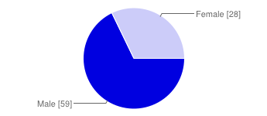
FigureD: Gender Didtribution
Male |  | 59 | 68%
Female |  | 28 | 32%

Age
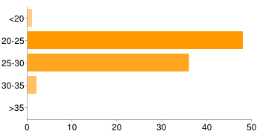
Figure E: Age

<20 |  | 1 | 1%
20-25 |  | 48 | 55%
25-30 |  | 36 | 41%
30-35 |  | 2 | 2%
>35 |  | 0 | 0%

How many hours of TV you watch daily?

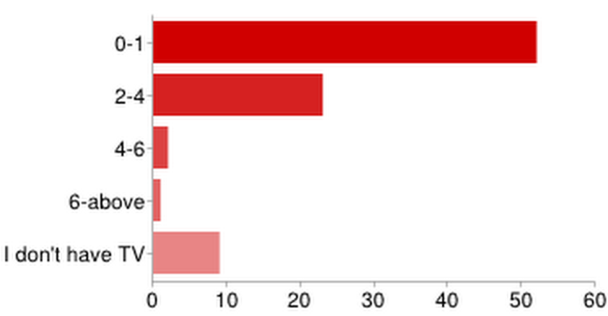
Figure F
0-1 |  | 52 | 60%
2-4 |  | 23 | 26%
4-6 |  | 2 | 2%
6-above |  | 1 | 1%
I don't have TV |  | 9 | 10%

Which newspaper do you read?

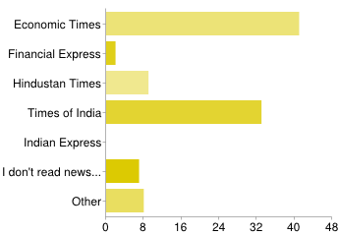
Figure G

Economic Times |  | 41 | 47%
Financial Express |  | 2 | 2%
Hindustan Times |  | 9 | 10%
Times of India |  | 33 | 38%
Indian Express |  | 0 | 0%
I don't read newspaper at all |  | 7 | 8%
Other |  | 8 | 9%
People may select more than one checkbox, so percentages may add up to more than 100%.

Do you have a mobile phone?
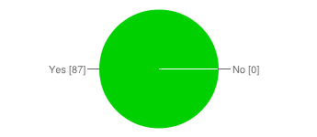
Figure H
Yes |  | 87 | 100%
No |  | 0 | 0%

I bought my phone because:

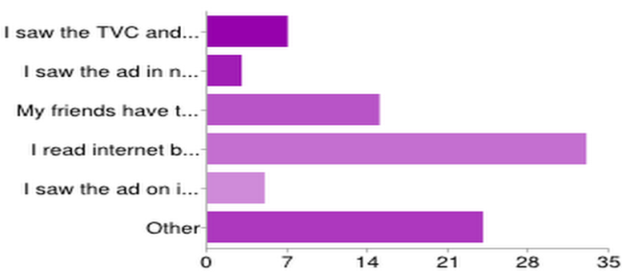
Figure I
I saw the TVC and I liked it |  | 7 | 8%
I saw the ad in newspaper and found it informative |  | 3 | 3%
My friends have the same phone |  | 15 | 17%
I read internet blogs about the phone performance |  | 33 | 38%
I saw the ad on internet |  | 5 | 6%
Other |  | 24 | 28%

I like TV ads because

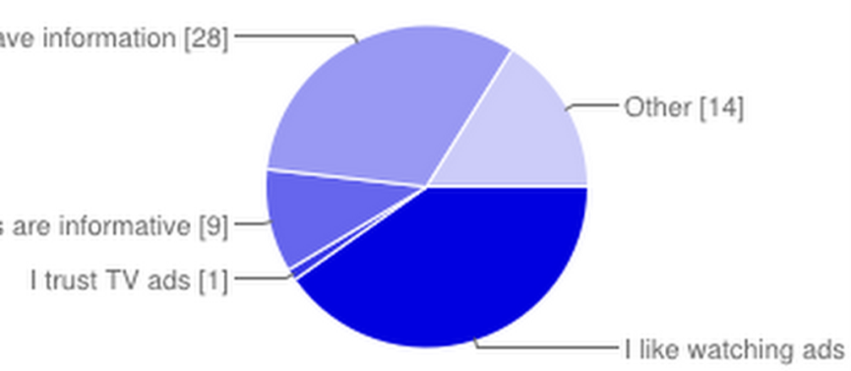

Figure J

I like watching ads |  | 35 | 40%
I trust TV ads |  | 1 | 1%
TV ads are informative |  | 9 | 10%
It's convenient way to have information |  | 28 | 32%
Other |  | 14 | 16%

If you receive an information regarding mobile phone via SMS, you will

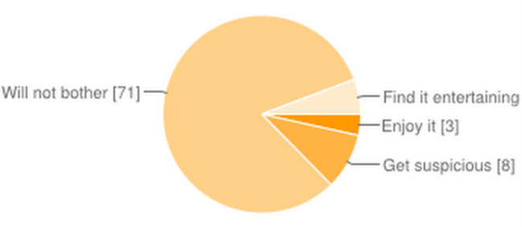
Figure K

Enjoy it |  | 3 | 3%
Get suspicious |  | 8 | 9%
Will not bother |  | 71 | 82%
Find it entertaining |  | 5 | 6%

Have you ever noticed a shampoo ad in newspaper?

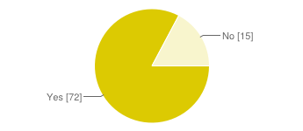
Figure L

Yes |  | 72 | 83%
No |  | 15 | 17%

I bought my shampoo because

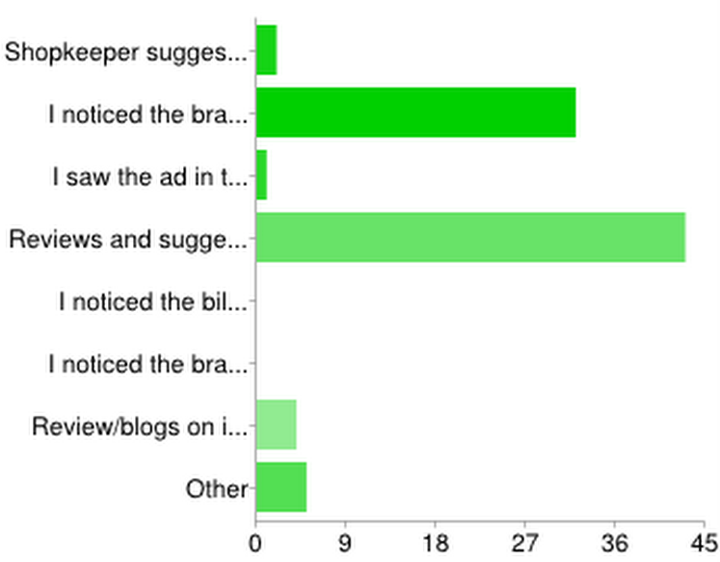
Figure M

Shopkeeper suggested me |  | 2 | 2%
I noticed the brand through TVC |  | 32 | 37%
I saw the ad in the newspaper |  | 1 | 1%
Reviews and suggestions from friends/family |  | 43 | 49%
I noticed the billboard |  | 0 | 0%
I noticed the brand on radio |  | 0 | 0%
Review/blogs on internet |  | 4 | 5%
Other |  | 5 | 6%

Information through media that annoys you the most

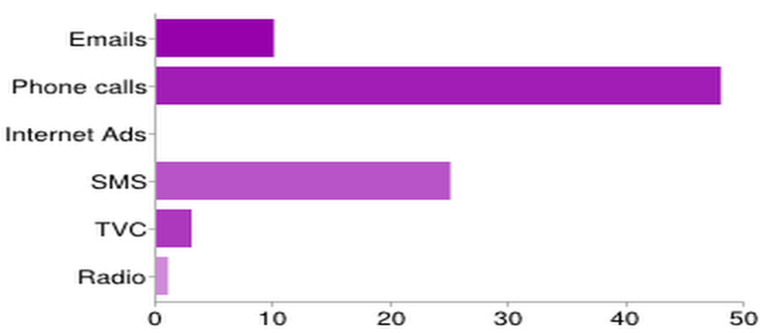
Figure N

Emails |  | 10 | 11%
Phone calls |  | 48 | 55%
Internet Ads |  | 0 | 0%
SMS |  | 25 | 29%
TVC |  | 3 | 3%
Radio |  | 1 | 1%

Do you notice internet ads?

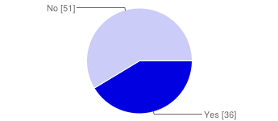
Figure O
Yes |  | 36 | 41%
No |  | 51 | 59%

While regarding an information about a mobile phone which medium will you prefer?

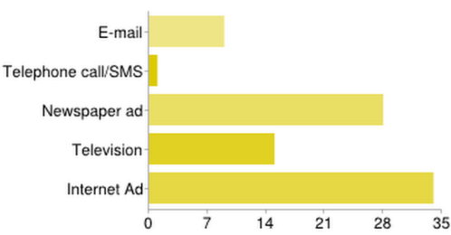
Figure P

E-mail |  | 9 | 10%
Telephone call/SMS |  | 1 | 1%
Newspaper ad |  | 28 | 32%
Television |  | 15 | 17%
Internet Ad |  | 34 | 39%

While regarding information about shampoo which medium will you prefer the most?

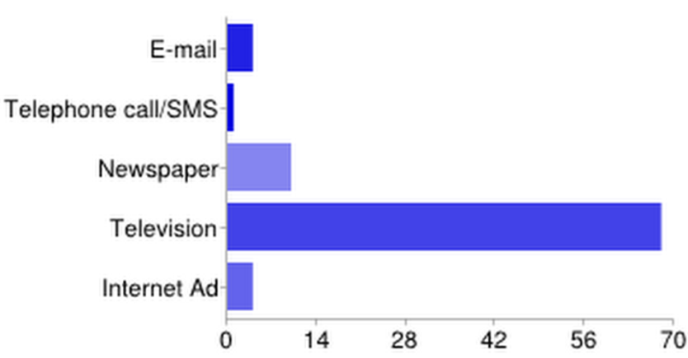
Figure P
E-mail |  | 4 | 5%
Telephone call/SMS |  | 1 | 1%
Newspaper |  | 10 | 11%
Television |  | 68 | 78%
Internet Ad |  | 4 | 5%

If you want to seek information about any product, which media will you prefer the most?
Figure Q

E-mail |  | 5 | 6%
Telephone call/SMS |  | 0 | 0%
Newspaper |  | 18 | 21%
Television |  | 33 | 38%
Internet Ad |  | 31 | 36%

If you receive an information regarding mobile phone via E-mail, you will
Figure R

Enjoy it |  | 8 | 9%
Get suspicious |  | 10 | 11%
Will not bother and spam it |  | 63 | 72%
Find it entertaining |  | 6 | 7%

Which media is the most difficult to ignore, when it comes to day to day functions?
Figure S
E-mail |  | 6 | 7%
Telephone calls |  | 21 | 24%
SMS |  | 18 | 21%
Television Ads |  | 25 | 29%
Internet Ads |  | 5 | 6%
Newspaper |  | 10 | 11%
Other |  | 2 | 2%

