**TIME FREQUENCY REPRESENTATION OF COMPLEX SIGNALS**

A DISSERTATION

SUBMITTED IN PARTIAL FULFILLMENT OF THE REQUIREMENTS FOR THE AWARD OF THE DEGREE

OF

**MASTER OF TECHNOLOGY**

**IN**

**SIGNAL PROCESSING AND DIGITAL DESIGN**

Submitted by

**HIMANSHU SAINI**

**2K13/SPD/27**

Under the supervision of

**Dr. Sudipta Majumdar**

**(Assistant Professor, ECE Department)**



**DEPARTMENT OF ELECTRONICS AND COMMUNICATION ENGINEERING**

DELHI TECHNOLOGICAL UNIVERSITY

(Formerly Delhi College of Engineering)

Bawana Road, Delhi-110042

## CERTIFICATE

This is to certify that the dissertation title “**Time Frequency Representation of Complex Signals**”submitted by Himanshu Saini**,** 2K13/SPD/27,Electronics and Communication, Delhi Technological University, Delhi in the partial fulfillment of the requirement for the award of the degree of the Master Technology is the project work carried under my supervision.

### Place: Delhi (Dr.Sudipta Majumdar)

### Date: SUPERVISOR

### M.S.CHOUDHRY

Supervisor Associate Professor(ECE)

**CANDIDATE’S DECLARATION**

I, Himanshu Saini, 2K13/SPD/27 student of M.Tech (Signal Processing and Digital Design),hereby declare that the project Dissertation titled “Time Frequency Representation of Complex Signals” which is submitted by me to the Department of ELECTRONICS AND COMMUNICATION, Delhi Technological University, Delhi in partial fulfillment of the requirement for the award of the degree of Master of Technology.

Place: Delhi Himanshu Saini

Date:

of my belief

**ACKNOWLEDGEMENT**

Firstly, I would like to express my sincere gratitude to my mentor and supervisor Dr. Sudipta Majumdar for her constant guidance, encouragement and support. I am thankful to the Electronics and Communication Engineering Department of Delhi Technological University for providing me with unparalleled facilities. I extend my gratitude to researchers and scholars whose papers and thesis have been utilized in my project. Finally, I dedicate my project report to my parents for their love, support and encouragement without which this would not have been possible.

**Himanshu Saini**

**(2K13/SPD/27)**

**ABSTRACT**

This work presents the time frequency representation (TFR) of complex signal using eigen value decomposition of Hankel matrix, in which positive and negative frequencies are decomposed using eigen value decomposition of Hankel matrix. To obtain the TFR of complex signal, the analytic signal has been obtained using wavelet transform on the decomposed signals. This presents the TFR of both, the positive and negative frequencies. This method is compared with the TFR using Hilbert transform (HT) on decomposed signals. The proposed method presents larger signal to noise ratio (SNR) as compared to HT based TFR of positive and negative frequencies.

**Table of Content**

|  |  |  |
| --- | --- | --- |
| **1** | **Introduction** | **7** |
| **1.1** | **Time Frequency Representation** | **7** |
| **1.2** | **Advantages of TFR** | **7** |
| **1.3** | **Literature Review** | **8** |
|  |  |  |
| **2.1** | **Multicomponent Nonstationary Signal Decomposition using IEVDHM** | **9** |
| **2.2** | **IEVDHM Method for Complex Signals** | **10** |
| **2.3** | **TFR for complex sigbals using IEVDHDM-HT** | **12** |
|  |  |  |
| **3.1** | **Hilbert Transform** | **13** |
| **3.2** | **HT Relationship with the Fourier transforms FT** | **13** |
| **3.3** | **Continuous wavelet transforms (CWT):** | **14** |
| **3.4** | **Analytic Signal Using Wavelet Transform:** | **15** |
| **4** | **Proposed method** | **17** |
| **5** | **Simulation Results** | **19** |
| **6** | **Conclusions** | **23** |

**CHAPTERT1**

**INTRODUCTION**

**1.1 Time Frequency Representation**

The TFR of non-stationary signals provide simultaneous information of signal in time and frequency domain. TFR analysis and decomposition of signal has various applications such as parameter estimation of non-stationary signals, radar scatters, speech signal analysis, aircraft, detection process of radar, detection of heart rate variability etc [9]-[11].These methods combine both the time domain analysis to provide temporal localization of spectral component of a signal. Various techniques are available in literature for TFR such as short term Fourier Transform (STFT), principal component analysis (PCA), analysis using independent component analysis (ICA) and empirical mode decomposition (EMD) etc. However, PCA and ICA have short comings, as they depend on statistically analysis and data case are not available. Also, short term Fourier transforms has limitations as it can be evaluated using prespecified window only. Implementation of STFT also requires convolution of window and original signal. EMD has disadvantages that it is not adaptive method.

**1.2 Advantages of TFR**

1. Communication system**:**

TFR is widely used in communication system in different modulation scheme like frequency modulation etc.

1. Musical systems**:**

TFR is also used for analysis of musical signals can. These signals consist of audio and voice signal with magnitude spectrum most widely used distribution for this purpose is Winger-Ville distribution(WVD).

1. It has advantages in tracking intermediate frequency and instantaneous bandwidth (BW).
2. Integration of time frequency distribution provides total signal energy.

**1.3 Literature Review**

Various techniques have been presented in literature for time frequency of non-stationary signal and to obtain the instantaneous parameters of non-stationary signals.

In [1], Sharma*etal.* presented the eigenvalue decomposition ofHankel Matrix of TFR of complex signal. Sun*etal.* [2]used Kaiser Windowfor time delay estimation in quadratic correlation technique of the complex signals.Gao*etal.*[3] proposed method for the extraction of instantaneous frequency (IF) of analytic signals through Wavelet Transform..Stankovic*etal.*[4] presented the analysis ofsignal inenergy density domain. Yang *etal.* [5]proposed time-frequency representation for multi-component frequency modulated signal that uses parameterized time-frequency transform.Belouchrani*etal.* [6] proposed time frequency signal representation forblind source separation that uses joint diagonalization of a T-F distribution. Hlawatsch*etal.* [7] used time frequency representation of signal estimation that uses Wiener filter and time varyingfilter. Liu *etal.* [8] used empirical WT for time frequency representation of seismic signal to obtain the geographical structure information hidden in the seismic data.

This thesis is organized as follows.Chapter2 presents time frequency analysis on non –stationary signal using IEVDHM-HT method. Chapter 3 presents analytic signal using HT and WT.Chapter 4presentsthe proposed method. Chapter 5presents the simulation results. Chapter 6 providesconclusion and the future scope.

**CHAPTER 2**

**2.1 Multi-component Nonstationary Signal Decomposition using IEVDHM**

Primarily, the iterative eigen value decomposition of Hankel matrix has been used for decomposition of multicomponent signals. Later on,ithasbeen also used for complex signals.

The IEVDHM considers the real valued signal, which is multicomponent also. In IEVDHM-HT method, the signal y having length (2N – 1) is decomposed into a number of monocomponent non-stationary signals [12]. This decompostion process uses a Hankel matrix H of size N, which is constructed using the signal y[n]. The antidiagonals of Hankel matrix consists such that the sum row indices and coulmn indices is the same.The construction of the Hankel matrix using y[n] is given in (1).

|  |  |
| --- | --- |
|  | (1) |

The matrix H is formed so thatthe condition, N ≥ $F_{m }/$ $∆f$ is satisfied. Here $F_{m}$ is the sampling rate and $∆f$ is the minimum frequency separation between components. For decomposition, only the significant Eigen values andeigen vectors of the Hankel matrix are considered [1]. The relation between Eigenvalue matrix (A) and Eigen vector matrix (V) of the Hankel matrix is:

|  |  |
| --- | --- |
|  | (2) |

The diagonal entries of the matrix ˄ contains theeigen values of the H. The significant eigen value pairs are those whose magnitude summation is equal to or more than 95%. For decomposition, each endpoint Eigen value of Hankel matrix is used. The $i^{th}$ significant decomposed component from eigen value pair is:

|  |  |
| --- | --- |
|  | (3) |

where $y^{i}$ represents the $i^{th}$ decomposed component and theoperation ‘fun ($V^{i}$)’is performed on $i^{th}$ eignvector $V^{i}$ for n= 1, 2…...The ‘fun ($V^{i}$)’ is:

|  |  |
| --- | --- |
|  | (4) |

**2.2 IEVDHM Method forComplex Signals**

The extended version of IEVDHM methodhas beenused for complex-valued signals. The complex valued signals dissatisfythe mirror image characteristic towards theDC line frequency axis [1]. Thenon- analytic signal (y[n])is filtered to obtainand  i.e. positive and negative range frequencies. They are obtained as:

|  |  |
| --- | --- |
|  | (5) |

|  |  |
| --- | --- |
|  | (6) |

whereis the real part.is the inverse Fourier transform operation and is the complex conjugate.is BPF, whichis represented as:

|  |  |
| --- | --- |
| . | (7) |

The original complex-valued signal is formed as:

|  |  |
| --- | --- |
|  | (8) |

wherethe Hilbert transform is represented byH [.] .

The decomposition procedure can be implemented separately to both $y+\left[n\right]and y_{_\left[n\right]}$ Application of IEVDHM decomposition provide:

|  |  |
| --- | --- |
|  | (9) |
|  | (10) |

The p and q values are the same for real valued signal. The complex component of the $i^{th}$ decomposed complex-valued signal y[n] is given by:

|  |  |
| --- | --- |
|  | (11) |

The IEVDHM method using (7) is shown by:

|  |  |
| --- | --- |
|  | (12) |

The Fig. 1 presents the IEVDHM method [12].

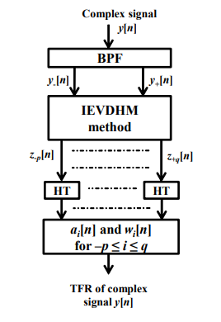

Fig.1**.** IEVDHM method for complex signal.

**2.3 TFR for complex sigbals using IEVDHDM-HT**

IEVD-HM for complex signal has following steps:

Step 1: At first, thecomponents, and  of complex-valued signal are obtained using BPF.

Step 2: In the second step, IEVDHM method has been implemented onand for decomposition as described earlier section.

Step 3: The analytic signal has been obtained using HT on each decomposed component to obtain instantaneous parameters. Theseparameters of the decomposed component have been used to represent the complex signal with time varying parameters.

|  |
| --- |
| Mono-component 1 |

|  |
| --- |
| Multi-component signal |

**IEVD-HM**

|  |
| --- |
| Mono-component 2 |



**Hilbert**

**Transform**

|  |
| --- |
| Time-Frequency representation |

|  |
| --- |
| Mono-component N |

Figure 2. IEVD-HM-HT method.

**CHAPTER 3**

**Analytic Signal**

A signal having no negative frequency components is known as analytic signal. A real sinusoidal is transformed to positive frequency complex sinusoid by creating a phase quadrature which serves as the imaginary part of the complex part of the complex signals. This imaginary part is obtained by a filter by shifting the sinusoidal component by a quarter cycle. This is known as HT filter. We used wavelet transform based analytic signal for instantaneous parameters and compared the results with HT based method.

**3.1 Hilbert Transform**

It is a linear operator. The HT of a real valued function u(t) gives another real value function H(u)(t). These functions are related as

|  |  |
| --- | --- |
|  | (13) |

|  |  |
| --- | --- |
|  | (14) |

Twice application of Hilbert transformsresults in:

|  |  |
| --- | --- |
|  | (15) |

**3.2 HT Relationship with the Fourier transforms FT**

The HT is a multiplier operator. Multiplier of iswhich is represented as



Where j is , sgn represents asignum fuction.Therefore

|  |  |
| --- | --- |
|  | (16) |

for 

Thus

|  |  |
| --- | --- |
|  | (17) |
|  | (18) |
| = | (19) |

**3.3 Continuous wavelet transforms (CWT)**

The wavelet is an oscillatory function. The average value of the wavelet function is zero. The main characteristic of wavelets is that it has finite length. The function  is the mother wavelet.  is the measurable and square-integrable Hilbert space. The wavelet has time frequency localization such that function 

where ‘S’ is the scaling parameter and ‘u’ is the translation parameter.

For a signal, the WT is

|  |  |
| --- | --- |
|  | (20) |

Mathematically, integral from may be expressed as

|  |  |
| --- | --- |
|  | (21) |

where

|  |  |  |
| --- | --- | --- |
|  | (22) | |
|  | |  |

**3.4 Analytic Signal Using Wavelet Transform:**

Supposerepresents an analytic wavelet and  is the FT of it, such that

|  |  |
| --- | --- |
|  | (23) |
|  | (24) |

Representing the wavelet transform of a signal S(t) is:

|  |  |
| --- | --- |
|  | (25) |

. Is the complex conjugate, ””, “” belong to real number, is any positive value [12].

The signal  satisfying following theorems:

**Theorem 1:** Usingas an analytic wavelet and  as finite energy signal, such that WT of  isand is complex function for all real value of and positive scaling factor. Imaginary term of  is HT of real term of the complex function [12].

**Theorem 2:** Usingevenand real part  of g(t) and  with [12]. Then for 

|  |  |
| --- | --- |
|  | (26) |

Analytic wavelets satisfying Theorem 2

Morlet wavelet is

|  |  |
| --- | --- |
| $$g\left[t\right]=e^{jmt}e^{-t2/2}(m⟩$$ | (27) |

Modified Morlet wavelet

|  |  |
| --- | --- |
|  | (28) |

|  |  |
| --- | --- |
| = | (29) |

**CHAPTER 4**

**Proposed Method:** In this work, decomposition of multicomponent component complex signal is performed using IEVDHM and instantanious parameters are obtained using wavelet transform.The following mathematical steps have been used:-

The eigen value decomposition of the Hankel matrix is:

|  |  |
| --- | --- |
|  | (30) |

whereis a diagonal matrix.

 is given in terms of the mono-components as:

|  |  |
| --- | --- |
|  | (31) |

Representing as

|  |  |
| --- | --- |
|  | (32) |

Characteristic function ofis as follows:

|  |  |
| --- | --- |
|  | (33) |

Representing the two non-zero equal and opposite sign eigenvalues as:

|  |  |
| --- | --- |
|  | (34) |

matrix represents the  non-zero eigenvalue pair is:

|  |  |
| --- | --- |
|  | (35) |

Hankel matrix formed by preserving the eigenvalue pair of  denoted is computed using  is

|  |  |
| --- | --- |
|  | (36) |

The mean of elements of skew diagonals of provides the mono-component signal of.

**CHAPTER 5**

**Simulation Results**

The signal used for simulation is, which is given by

|  |  |
| --- | --- |
|  | (37) |

having N samples.

Parameters used in the simulations are: =2V,  = 3V , = 1V , , , and sampling frequency

Significant Eigen values of are computed in first iteration. The multicomponent complex signal using IEVD-HM & WT are analyzed in MATLAB software.

Signal  is efficiently separated using IEVD-HM. Fig. 3 shows the Morletwavelet. Fig. 4 shows the multi-components signal S(t). Fig. 5 to Fig. 7 show the IF of the signal using Hilbert transform and wavelet transform. Table 1 presents SNR for WT and HT based methods.

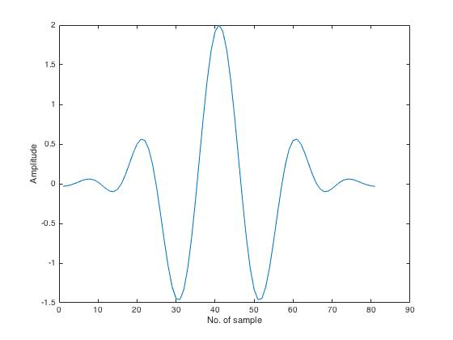

Figure 3.Morlet wavelet.

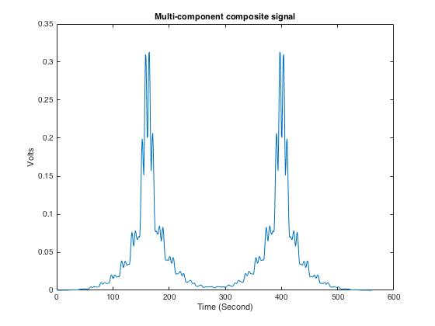

Figure 4. Multi-component signal.

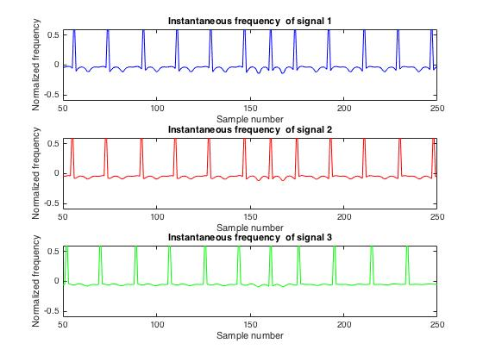

Figure 5. IF of the signals.

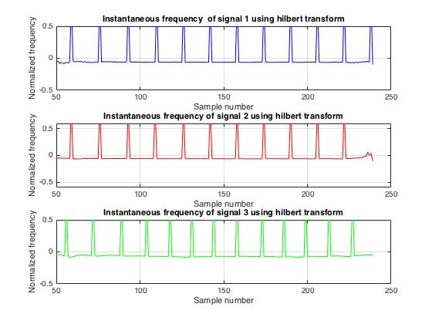

Figure 6. IF of the signal using Hilbert Transform.

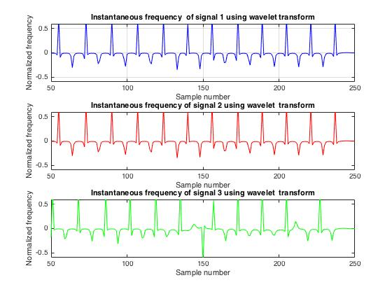

Figure 7. IF of the signals using Wavelet transform.

**Table 1: Comparison of signal to noiseratio (SNR) using various methods.**

|  |  |  |
| --- | --- | --- |
| **Parameter** | **Hilbert Transform (dB)** | **Wavelet Transform (dB)** |
| **SNR** | 67.9 | 80.7 |

**CHAPTER 6**

**Conclusions**

The proposed work contains the method for analysis of multicomponent complex signal using the IEVD-HM and WT. and compared with the IEVD-HM and HT absed method. The result shows the decomposed signal components using IEVD method then WT has been used to obtain the intantaneous frequency of that signal. This proposed method larger SNR as compared to IEVD-HM and HT based method. The time frequency localization property of the wavelet transform provides this advantage.

Future Scope:

Various WT based denoising methods can be used for practical signals.

**REFERENCES:**

[1] R. R. Sharma and R. B.Pachori, “Eigen valuedecomposition of Hankel Matrix-based time-frequency representation for complex signals”, *Circuits Systems and Signal Processing*-DOI: 10.1007/s00034-018-0834-4, 2018.

[2] C. Sun, L. Li and W. Chen, Quadratic Correlation Time Delay Estimation Algorithm Based on Kaiser Window and Hilbert Transform. *Sixth International Conference on Instrumentation & Measurement, Computer, Communication and Control (IMCCC)*, pp. 927-931, 2016.

[3] J. Gao, X. Dong, W.B. wang, Y. Li, and C. Pan, “Instantaneous Parameters Extraction via Wavelet Transform”, *IEEE Transactions on Geoscience and remote sensing*, vol. no. 2, 1999

[4] L.J.Stankovic and S.Stankovic, “An Analysis of Instantaneous Frequency Representation Using Time-Frequency Distributions-Generalized WigaerDistribution”,*IEEE Transactions on Signal Processing,* Vol. 43, No. 2, 1995

[5] Y. Yang, Z. Peng, X. Dong, W. Zhang, Member IEEE, “Application of Parameterized Time-Frequency Analysis on Multicomponent Frequency Modulated Signals”, *IEEE, and Guang Meng, “IEEE Transactions on Instrumentation and Measurement*, Vol. 63, No. 12, 2014

[6] A. Belouchrani and M. G. Amin, Senior MemberIEEE,”Blind Source Separation Based on Time–Frequency Signal Representations”, “*IEEE Transactions on Signal Processing*, Vol. 46, No. 11, 1998

[7] F. Hlawatsch, Member, IEEE, G. Matz, Student Member, IEEE, H. Kirchauer, and W.Kozek, Member, IEEE, “Time–Frequency Formulation, Design, and Implementation of Time-Varying Optimal Filters for Signal Estimation”,*IEEE Transactions on Signal Processing*, Vol. 48, No. 5, 2000

[8] W. Liu, S.Cao, and Y.Chen, “Seismic Time–Frequency Analysis via Empirical Wavelet Transform”, *IEEE Geoscience and Remote Sensing Letters*, Vol. 13, No. 1, 2016

[9] F.Sattar and G.Salomonsson, “The Use of a Filter Bank and the Wigner–Ville Distribution for Time–Frequency Representation”, *IEEE Transactions on Signal Processing* Vol. 47, No. 6, 1999

[10] F.Hlawatsch, Member, IEEE, A. P. Suppappola, Member, IEEE, and G. F. Boudreaux-Bartels, Senior Member, IEEE, “The Hyperbolic Class of Quadratic Time-Frequency Representations—Part II: Subclasses, Intersection with the Afﬁne and Power Classes, Regularity, and Unitarity”,*IEEE Transaction on signal processing,* Vol. 45, No. 2, 1997

[11] B. Aysin, L. F. Chaparro, Senior Member, IEEE,I. Gravé, and V. Shusterman, “Orthonormal-Basis Partitioning and Time-Frequency Representation of Cardiac Rhythm Dynamics”,*IEEE Transactions on Biomedical Engineering*, Vol. 52, No. 5, 20050

[12] P. Jainand R.B. Pachori, An iterative approach for decomposition of multi-component non-stationary signals based on eigenvalue decomposition of the Hankel matrix. *Journal of the Franklin Institute*, 352(10), pp.4017-4044, 2015.