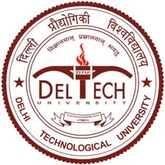

CERTIFICATE

This is to certify that the M. Tech. dissertation entitled “Prediction and Mapping of IgE Epitopes in the Allergenic Egg Proteins using Computational Approaches”, submitted by Nitish Sharma (2K11/BIO/13) in partial fulfilment of the requirement for the award of the degree of Master of Technology, Delhi Technological University (Formerly Delhi College of Engineering, University of Delhi), is an authentic record of the candidate’s own work carried out by her under my guidance.
The information and data enclosed in this dissertation is original and has not been submitted elsewhere for honouring of any other degree.

Date:

Dr. Yasha Hasija
(Project Mentor)
Assistant Professor,
Department of Biotechnology,
Delhi Technological University,
(Formerly Delhi College of Engineering, University of Delhi).

