IMPROVED APPROACH FOR INVARIANT AIRCRAFT TYPE RECOGNITION

A Dissertation submitted in partial fulfillment of the requirement for the
Award of degree of
MASTER OF TECHNOLOGY
IN
COMPUTER SCIENCE & ENGINEERING
By
ASHWINI KUMAR
Roll No. –2K11/CSE/02
Under the esteemed guidance of
Mrs. MRIDULA VERMA

Department of Computer Engineering
Delhi Technological University
2012-2013
DEDICATION

To my mother: my first and best teachers.
To my friends who encouraged me.
To my God who gives me strength, knowledge, and wisdom.

ACKNOWLEDGEMENTS

I would like to express my special gratitude and thanks to Mrs. Daya Gupta (Head of Department, CSE, DTU) for giving me such an opportunity to work on the project.
First and foremost, I feel privileged to offer sincere thanks and deep sense of gratitude to Mrs. Mridula Verma, project guide for expressing her confidence in me by letting me work on a project of this magnitude and using the latest technologies and providing their support, help & encouragement in implementing this project.
This thesis could not have been written without the help and inspiration of my parents and colleagues specially Ravi and Gaurav with whom I have had the pleasure to work.
I would like to express my gratitude towards many individuals and the staff of Delhi Technological University for their kind co-operation and encouragement which helped me in completion of this project.

(ASHWINI KUMAR)
Master of Technology,
Department of Computer Engineering,
DELHI TECHNOLOGICAL UNIVERSITY.

TABLE OF CONTENTS
TITLE PAGE NO.
CERTIFICATE ………………………………………………………... (ii)
DEDICATION ……………………………..………………………..… (iii)
ACKNOWLEDGEMENT ………………….….……………………… (iv)
ABSTRACT …………………….………………………………..……. (v)
LIST OF FIGURES …………………………………..……………….. (ix)
- Introduction .……..………………………………………. 1
  - Motivation and Objective. …….……………………………………….. 1
  - Related Work ………….……………………………………..………… 1
  - Problem Statement ……….…………………………………..………… 3
  - Scope of the Worked Approach ………….…………………..………… 4
  - Organization of the Dissertation ………………………….….………… 4
- Literature Review ………………………………………… 6
  - Pattern recognition ……………………………….…………..………… 6
    - Supervised Learning ……………………….……………….. 8
    - Unsupervised Learning ….………………………………….. 9
    - Semi-supervised Learning …..……………………..……….. 10
  - Aircraft Recognition …..……………………………………..………… 11
  - Preprocessing Techniques .………………………………….. ………… 13
    - Binarization and Noise Removing ………………...……….. 14
    - Orientation Estimation …………………………….……….. 15
    - Size Normalization ………………………………..……….. 16
  - Ring Projection ………………………………………............………… 16
    - Introduction …………………..…………………………….. 16
    - Dimensionality reduction of 2-D Pattern ………….……….. 17
  - Dual Tree Complex Wavelet Transformation ……………….…………. 20
  - Feature Extraction ……………………………………..……..………… 28
- Aircraft Recognition ……………………………………... 29
  - Reasons for automatic aircraft recognition …………………………….. 31
  - Factors that affect detection, recognition, and identification …............... 33
  - Early aircraft recognition and identification …………………………… 33
  - Development of automatic aircraft recognition system ………………… 34
- Proposed System ………………………………………… 37
  - Binarisation and Noise Removing ……………………………………… 38
  - Size Normalization ………….………………………………………….. 41
  - Ring Projection ………………………………………………………… 42
    - Dimensionality reduction of 2-D pattern …………………… 43
  - Dual Tree Complex Wavelet Transformation .……………… ………… 45
    - Dual Tree Frame Work ……………..……………..………… 45
- Result ………………………………….…………………. 51
- Conclusion and Future work …………………………….. 57
References ………………………………………………….………….. 59

LIST OF FIGURES:
FIG. NO. TITLE OF THE FIGURE PAGE NO.
Fig.1 details of preprocessing stage ….…………………... (14)
Fig. 2 Original image and result after binarisation ………... (15)
Fig. 3 An illustration of the ring-projection for letter “A” ... (19)
Fig. 4 plot to illustrate difference between DWT and CWT (23)
Fig. 5 plots to illustrate high sensitivity to
translations of the signal …………………………………… (24)
Fig. 6 Descriptor for the Patterns in the Pattern Database ... (39)
Fig. 7 Descriptor for the Recognizing the Unknown Pattern ... (40)
Fig. 8 comparing original image and result after binarisation …... (41)
Fig. 9 An illustration of how a 1-D signal is obtained using
the ring-projection for letter “A” …………………………………..... (44)
Fig.10 Analysis FB for the dual-tree discrete CWT ……….. (46)
Fig. 11 Synthesis FB for the dual-tree CWT ………………… (47)
Fig. 12 The test database used in the experiment …………... (53)
Fig. 13 The rotated images with four rotation angles ……… (53)
Fig. 14 The noisy patterns with different SNR’s …………... (54)
Fig. 15 The correct classification rates with different rotation
angles at SNR=10 …………………………………….….... (54)
Fig. 16 The correct classification rates with different rotation
angles at SNR=5 …..………………………………….…….. (55)
Fig. 17 The correct classification rates with different rotation
angles at SNR=3 ………….………………………….…….. (55)
Fig. 18 The correct classification rates with different rotation
angles at SNR=1 …………………………………….……… (56)

ABSTRACT
Despite a great deal of efforts to automate the aircraft recognition process aircraft recognition remains a challenging problem. The majority of the aircraft recognition methods assume the successful isolation of the aircraft portrait from the background, and only a few have actually addressed real world concerns, such as clutter and shadows. In this thesis, I present an automatic aircraft recognition system, which shows improved performance because of ring projection and dual tree complex wavelet. This system assumes from the start that the image could possibly be degraded, contain clutter, shadows and blurring.
Feature extraction is a crucial step in invariant pattern recognition. Among all existing feature extraction techniques, ring-projection has been selected for invariant pattern recognition in [28]. This is because it is invariant to translation and scale of the patterns. In addition, the ring-projection transforms the feature space from 2-D to 1-D, which reduces the processing time substantially. This makes it suitable practical approach in real-time applications.
The dual-tree complex wavelet transform is applied to the ring-projection signal in order to extract shift invariant features at different resolution scales. The reason why we choose the dual-tree complex wavelet transform is because it has the approximate shift-invariant property, which is very important for pattern recognition.
Figures 4-7 show the correct recognition rates of the descriptor and the Fourier transform for different rotation angles at SNR=10, 5, 3, 1, respectively. From these figures, it can be seen that this descriptor is much better than the Fourier transform especially for high noise levels. If more representative templates (not only 4 templates) are used to represent an aircraft type, the three failure cases will be tackled well.

CHAPTER 1: INTRODUCTION
1.1: MOTIVATION AND OBJECTIVE:

In air traffic safety, ability to reliably identify aircraft is an important aspect. Civilian air traffic controllers need to be constantly updated on the status of aircraft moving through the local airspace and in military aircraft systems it is very rigorous to reliably identify aircraft, since erroneous identification could easily result in a heavy damage. So objet recognition can be a crucial technique to identify an aircraft. Also we can identify two different aircrafts of same type (model).
There is quite necessary to build a system which is not only able to identify the traffic precisely, it must be efficient also. Here I am going to introduce a descriptor which can identify different vehicles in an efficient manner.
1.2: RELATED WORK:

I worked on satellite images, their great advantage that these images can be captured without any constraints by time, weather, country boundary, and other environmental factors. Because of this advantage, many researchers who shown their interest to utilize satellite images for developing different applications like water and climate observation, land cover classification, energy exploration, etc. Especially, invigilating through satellite images is another important application for military needs and environment protection. There are many different detection schemes proposed for detecting various targets from satellite images such as bridges, vehicles, airports, roads, etc. [14-17]. For example, Nevatia and Babu[14] proposed a line edge detector to detect all line-like structure s. Gruen and Li[15] used wavelet transform s to sharpen road boundaries. Moreover, Shi and Zhu[16] proposed a line matching method to extract road networks from high-resolution satellite images. In addition to line detection, Pesaresi and Benediktsson[17] used several morphologic al operations and the techniques of multi-scale analysis to segment different buildings from satellite images.

All the methods mentioned above, focus only on detecting objects and do not further recognize these objects, since these objects in satellite images are very small,. These methods described below are popular methods for recognizing objects in the past. Many techniques [18-20] are proposed for this task but they require that the target objects should be large enough for feature extraction. For example, some procedures are proposed to identify a 3-D object from 2-D images using moments and Fourier descriptors by Reeves et al[18]. and Wallace et al[19] is proposed. In addition, to recognize aircraft in images, Tien and Chai[20] utilized the characteristics of non-uniform rational B-splines and cross-ratios. However, all these methods will fail to work when recognizing the targets in satellite images, since the analyzed targets are very small and polluted by shadows, different dazzle paints, and by noise.

In this paper, I used a novel recognition system for recognizing various objects from satellite images using ring projection and dual tree complex wavelet transform. Since images of aircrafts in satellite images may have different sizes, orientations, textures, and even dazzle paints. Therefore before recognition process, I image first employed pre-processing techniques to reduce all the above variations to minimum as much as possible. The preprocessing process includes the following tasks: noise removal, image quality enhancement, and automatic binarisation. However, an aircraft may have longer wings, shadows, fragments, and other noise. The moment -based method fail due to all these factors to normalize an aircraft having a correct orientation. However, for an aircraft its symmetry still maintains whether that aircraft image has been fragmented, polluted, and occluded by shadows or noise,. Thus, the moment-based method is less robust, effective, and accurate to correct the orientation of an aircraft than the symmetry-based method. Then, the distinguishable features are extracted for aircraft recognition which are derived from the characteristics exhibited by aircraft.

Dual tree complex wavelet transform is used here for driving features. These features are used here to define the aircraft in an image. For classify aircrafts different features used. Different features of these aircrafts have different discrimination abilities. A learning scheme, in order to integrate these features together, is used to determine suitable weights from training sample s for improving the accuracy of aircraft recognition. All input aircraft can be recognized very accurately based on weights and features.

From experimental results, the proposed method indeed achieves great improvements in terms of accuracy, robustness, and effectiveness in recognizing aircraft in satellite images.
1.3. Problem Statement:
Given:
  - A satellite image from which we have to identify the aircraft images, and
  - a test database containing given aircraft images,
Our aim is to recognize and allocate the aircrafts in the query image, to their particular class.

1.4. Scope of the worked approach:
The objective of this thesis is to design a new aircraft recognition algorithm based on ring projection and dual tree complex wavelet transform that can work effectively and accurately to extract the most desirable features from the images. This approach is capable of providing efficient aircraft recognition.
This approach has been applied on the test database. The goal of aircraft recognition is to identify the images present in image against a large database of images to recognize it.
Researchers have presented a lot of techniques for aircraft recognition [28]. These techniques can be categorized into many classes. In this thesis we will focus on ring projection and dual tree complex wavelet. There are some difficulties in the odd/even filter approach for dual tree. Therefore, we used a Q-shift dual-tree [34] where all the filters beyond level 1 are even length.
The performance analysis supports our theory when compared to some already implemented face recognition technique. The scope of this work can be summarized as:
- To develop an efficient aircraft recognition system.
- This system can be used by military and civilians both.
1.5. Organization of the Dissertation:
Rest of work is organized as follows:

Chapter 2: Literature review:
This section provides literature review for aircraft recognition. It provides the evolution of aircraft recognition techniques. It also provides the classification and details of various techniques used so far for aircraft recognition.
Chapter 3: Aircraft Recognition
It explains our model for aircraft recognition problem, approaches we have used to solve aircraft recognition problem, parameters setting for the approaches and their algorithms.
Chapter 4: Proposed Approach:
This chapter deals with the strategy applied to recognizing an aircraft from a given image. It also provides the basic knowledge of various challenges associated with it and how we can overcome those challenges with the help of suitable techniques.
Chapter 5: Results:
This section talks about the experimental setup we used to tackle the aircraft recognition problem and the results we have obtained from various approaches, we developed for the problem.
Chapter 6: Conclusion and Future Scope:
In this section the conclusion of the thesis work and the future scope of the work are presented.
References:
This section gives the reference details of the thesis.

CHAPTER 2: LITERATURE REVIEW

There are many areas and applications where aircraft recognition plays tremendous role like air traffic safety, military applications and applications for Civilian air traffic controllers. It is very important to reliably identifying an aircraft in these areas because any irrelevant or wrong results can cause a serious damage and also we can prevent mishaps. The civilian air traffic controllers, they need to be constantly updated about the status of their aircrafts, so that they would be aware of their exact positions. In air traffic safety, ability to reliably identify aircraft is an important aspect and in military aircraft systems it is very rigorous to reliably identify aircraft, since erroneous identification could easily result in a heavy damage. So objet recognition can be a crucial technique to identify an aircraft. Also we would be able to identify two different aircrafts which are of same type (model).

Results for these applications must be veracious and exact. To achieve this level of accuracy an automatic system became necessary which have less or a little human interference and this automatic system must be efficient and fast. For this kind of applications, data reside as objects in images; these images are received in real time and can be captured from various sources like from radar, satellites etc. objects from these images can be extracted in a means of object recognition.
2.1 PATTERN RECOGNITION:
The precise definition of pattern recognition in machine learning is the assignment of a label to a given input value. Classification of objects is an example of pattern recognition, which attempts to assign each input value to one of a given set of classes for example, classifying an email as "spam" or "non-spam".
In pattern recognition is a general problem and it also encloses other types of output. Other examples are regression, which assigns a real-valued output to each input; sequence labeling, which assigns a class to each member of a sequence of values (for example, part of speech tagging, which assigns a part of speech to each word in an input sentence); and parsing, which assigns a parse tree to an input sentence, describing the syntactic structure of the sentence [35].
Generally the aim of pattern recognition algorithms is to provide a logical and reasonable result for all possible inputs and by taking their statistical variation in consideration, "most likely" matching of the inputs can be recognized or found. It looks for exact matches in the input with pre-existing patterns, hence it is opposit to pattern matching algorithms. regular expression matching is a common example of a pattern-matching algorithm, which looks for patterns of a given sort in textual data and is included in the search capabilities of many text editors and word processors. In contrast to pattern recognition, pattern matching is generally not considered a type of machine learning, although pattern-matching algorithms (especially with fairly general, carefully tailored patterns) can sometimes succeed in providing similar-quality output to the sort provided by pattern-recognition algorithms.
This task to spot existing or emerging patterns is one of the most (if not the most) critical skills in intelligent decision making, though we are unaware that we do it all the time. In many fields, including psychology, psychiatry, ethology, cognitive science, traffic flow and computer science, pattern recognition has its applications. Combining past experience, intuition, and common sense, the ability to recognize patterns gives us the ability to predict what will happen next with some degree of accuracy. The better able we are to predict what will happen, the more intelligent we become. So, you might say that the purpose of intelligence is prediction.
The type of learning procedure used to generate the output value is generally used to categorize different pattern recognition mechanisms. These categories are:
- Supervised learning:
In supervised learning, it is assumed that a set of training data (the training set) has been provided, which consist of a set of instances that have been properly labeled by hand with the correct output. A model is then generated by a learning procedure that attempts to meet two sometimes conflicting objectives:
- Perform as well as possible on the training data, and
- generalize as well as possible to new data.
Usually, this means being as simple as possible, for some technical definition of "simple", in accordance with Occam's Razor.
For Supervised learning some of the approaches and algorithms are:
- Artificial neural network:
Technically an artificial neural network, often just named a neural network, is a mathematical model inspired by biological neural networks. A neural network consists of an interconnected group of artificial neurons, and it processes information using a advance approach to computation.
- Decision tree learning:
Decision tree learning, used in statistics, data mining and machine learning, uses a decision tree as a predictive model which maps observations about an item to conclusions about the item's target value. More descriptive names for such tree models are classification trees or regression trees. In these tree structures, leaves represent class labels and branches represent conjunctions of features that lead to those class labels.
- Nearest Neighbor Algorithm:
In pattern recognition, the k-nearest neighbor algorithm (k-NN) is a non-parametric method for classifying objects based on closest training examples in the feature space. k-NN is a type of instance-based learning, or lazy learning where the function is only approximated locally and all computation is deferred until classification.
- Unsupervised learning:
On the other hand in the unsupervised learning, it is assumed that training data that can then be used to determine the correct output value for new data instances. Where training data has not been hand-labeled, and attempts to find inherent patterns in the data.
Approaches to unsupervised learning include:
- clustering (e.g mixture models, hierarchical clustering),
- blind signal separation using feature extraction techniques for dimensionality reduction (e.g., Principal component analysis, Independent component analysis, Non-negative matrix factorization, Singular value decomposition).
Among neural network models, the self-organizing map (SOM) and adaptive resonance theory (ART) are commonly used unsupervised learning algorithms.
The SOM is a topographic organization in which nearby locations in the map represent inputs with similar properties.
The ART model allows the number of clusters to vary with problem size and lets the user control the degree of similarity between members of the same clusters by means of a user-defined constant called the vigilance parameter.
- Semi-supervised learning:
A semi-supervised learning technique is the combination of the two techniques that have recently been explored, which uses a combination of labeled and unlabeled data (typically a small set of labeled data combined with a large amount of unlabeled data). In cases of unsupervised learning, there may be no training data at all to speak of. In other words, the data to be labeled is the training data.
Sometimes similar terms corresponding supervised and unsupervised learning procedures for the same type of output are also have different names. For example, the unsupervised equivalent of classification is normally known as clustering, based on the common perception of the task as involving no training data to speak of, and of grouping the input data into clusters based on some inherent similarity measure e.g. the distance between instances, considered as vectors in a multi-dimensional vector space, rather than assigning each input instance into one of a set of pre-defined classes. Note also that in some fields, the terminology is different: For example, in community ecology, the term "classification" is used to refer to what is commonly known as "clustering".
The piece of input data for which an output value is generated is formally termed an instance. The instance is formally described by a vector of features, which together constitute a description of all known characteristics of the instance. (These feature vectors can be seen as defining points in an appropriate multidimensional space, and methods for manipulating vectors in vector spaces can be correspondingly applied to them, such as computing the dot product or the angle between two vectors.) Typically, features are either categorical (also known as nominal, i.e., consisting of one of a set of unordered items, such as a gender of "male" or "female", or a blood type of "A", "B", "AB" or "O"), ordinal (consisting of one of a set of ordered items, e.g., "large", "medium" or "small"), integer-valued (e.g., a count of the number of occurrences of a particular word in an email) or real-valued (e.g., a measurement of blood pressure). Often, categorical and ordinal data are grouped together; likewise for integer-valued and real-valued data. Furthermore, many algorithms work only in terms of categorical data and require that real-valued or integer-valued data be discretized into groups (e.g., less than 5, between 5 and 10, or greater than 10).
2.2 AIRCRAFT RECOGNITION:
If we want to capture images with no constraint by time, weather, country boundary, and other environmental factors. We can go for satellite images, since satellites don’t have any restrictions and can reach any location in the world. Taking this as an advantage, there have been many researchers who devoted themselves to utilize satellite images for developing different applications like water and climate observation, land cover classification, energy exploration, etc. Especially, surveillance through satellite images is another important application for military needs and environment protection. Therefore, in the literature[14], there have been many different detection schemes proposed for detecting various targets from satellite images such as bridges, airports, roads, streets, buildings, etc. For example, Nevatia and Babu[14] proposed a line edge detector to detect all line-like structures. Gruen and Li[15] used wavelet transforms to sharpen road boundaries. Moreover, Shi and Zhu[16] proposed a line matching method to extract road networks from high-resolution satellite images. In addition to line detection, Pesaresi and Benediktsson[17] used several morphological operations and the technique of multi-scale analysis to segment different buildings from satellite images.
However, since the objects in satellite images are very small, all the above methods focus only on detecting objects and do not further recognize these objects. For recognizing objects, in the past, there have been many methods[18-24] proposed for this task and requiring that the targets should be large enough for feature extraction. For example, Reeveset al.[18] and Wallaceet al.[19]proposed procedures to identify a 3-D object from 2-D images using moments and Fourier descriptors. In addition, Tien and Chai [20] utilised the characteristics of non-uniform rationalB-splines and cross-ratios to recognise aircraft in images. Greenberg and Guterman[21]used multi-layer neural networks to recognize different targets from aerial images according to the features of Zernike moments. Moreover, Moldovan and Wu[23] used a symbolic approach to recognise hierarchically aeroplanes if all features of an aeroplane were well extracted. However, when recognising the targets in satellite images, all these methods will fail to work since the analysed targets are very small and polluted by different dazzle paints, shadows, and other noise. In this paper, we propose a novel recognition system for recognising various aircraft in satellite images using a hierarchical boosting algorithm. Since each aircraft in satellite images has different orientations, sizes, textures, and even dazzle paints, before recognition, image preprocessing techniques are first employed to reducing all the above variations to a minimum. The preprocessing tasks include image quality enhancement, noise removal, auto-matic binarisation, and the adjustments of aircraft scaling and translation. For rotation correction, we propose a novel method to use the symmetrical property of an aircraft to estimate its optimal orientation. In the past, the common method to estimate an object’s orientation was through a moment-based analysis[24]. However, an aircraft may have longer wings, shadows, fragments, and other noise. All these factors will make the moment-based method fail to normalise an aircraft having a correct orientation. However, for an aircraft that has been fragmented, polluted, and occluded by shadows or noise, its symmetry still maintains. Thus, the symmetry-based method can perform more robustly, effectively, and accurately to correct the orientation of an aircraft than the moment-based method. Then, distinguishable features derived from the character-istics exhibited by aircraft are extracted for aircraft recognition. Four features are used here and derived, respectively, from wavelet transform, Zernike moment, distance transform, and the bitmap itself. Different features have different discrimination abilities to classify aircrafts. In order to integrate these features together, a novel learning scheme is proposed to determine suitable weights from training samples for improving the accuracy of aircraft recognition. Based on these two ingredients, i.e. weights and features, all input aircraft can be recognised very accurately. From experimental results, the proposed method indeed achieves great improvements in terms of accuracy, robust-ness, and effectiveness in recognising aircraft in satellite images.
2.3 PREPROCESSING TECHNIQUE:
Noise may pollute each aircraft in a satellite image and has different orientations, sizes, and textures. Therefore, before recognition, image preprocessing techniques such as binarisation, orientation adjustment, and noise removing should be first applied to overcoming these variations. In what follows, details of these techniques are described. These techniques are applied in a flow as described the figure 1 below:
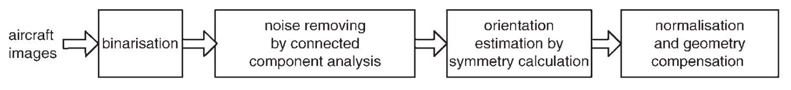
Fig. 1 Details of preprocessing stage
Following are preprocessing techniques which are used for normalizing the pattern in an image:
- Binarisation and noise removing
- Orientation estimation and normalization
  - Orientation estimation by moments
  - Orientation estimation through symmetry comparison
- Binarisation and noise removing:
To binaries each input region, a ‘minimum within-group variance’ dynamic thresholding method[24] is applied. Figure 2 shows an example of automatic binarisation using this algorithm. A conventional labeling technique is applied after binarisation to locate each connected component from the binarised aircraft image. For each connected region, if its size is less than a threshold, it will be considered as noise and then filtered out.
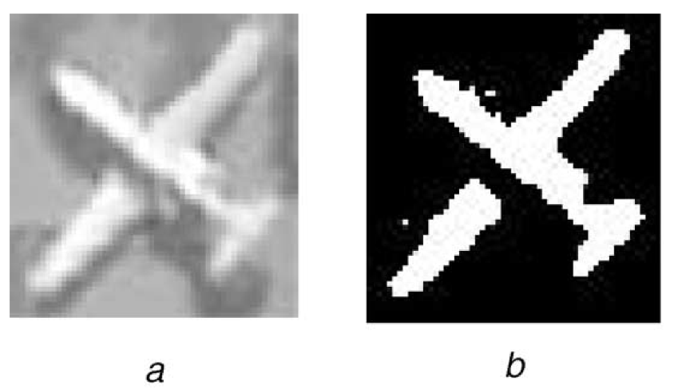
Fig. 2 Original image and result after binarisation
(a) Original aircraft image
(b) Result after binarisation
- Orientation estimation:
The orientations of different aircrafts which appears in same or different satellite images each aircraft will have different orientation. The definition of orientation can be made as a set of parameters that relates the angular position of a frame to another reference frame. Therefore it should be normalized to a fixed orientation in order to recognize this aircraft more accurately and robustly, i.e. the northern direction. There are numerous methods for describing this relation. Some are easier to visualize than others are. Each has some kind of limitations. Among the several methods there are two methods used here for orientation estimation and normalization, one is moment-based method and the other is symmetry-based method, are described for estimating an optimal orientation of an aircraft for this normalization. First method is simpler and more efficient than the second. However, when there is noise, the symmetry-based (second) method works more robustly and effectively than the first one. In what follows, details of the moment-based method are first described and then the symmetry-based one is proposed.
- Size normalization:
For all images submitted to the image enhancement process: a desired mean value of zero, and a variance of one are used for normalization. Therefore, each image is normalized to a predetermined level before proceeding on to the subsequent stages.
In addition to an orientation adjustment, before feature extraction, the size and centre of each processed aircraft also require normalising to a regular size and the original, respectively. In this paper, the regular size is defined as 24*32.
The normalization of an object is done by performing translation and scale operations on the image. Image translation is the process of redefining the co-ordinate system or reference frame for the image. It is useful when we want to define a image in reference of the other image. Image scaling is the process of resizing a digital image. Scaling is a non-trivial process that involves a trade-off between efficiency, smoothness and sharpness. As the size of an image is reduced or enlarged, the pixels which comprise the image become increasingly visible, making the image appear "soft" if pixels are averaged, or jagged if not.

2.4. RING PROJECTION:
INTRODUCTION:
One of the highly growing research areas in recent years is wavelet analysis and its applications[29]. There are numerous applications in areas like signal processing are found through advanced research[30]. As compared to the 2-D, 1-D is better. Therefore, through mathematically sound derivations, reduce the problem of 2-D patterns into that of 1-D ones [28].
When patterns are extracted from the image, they are often rotated due to experimentation constraints or errors. This raises the need of a pattern recognition method that must be invariant to rotations. In 1991, Tang [27] ﬁrst proposed a method “ring projections”. It is a method of transforming 2-D patterns into 1-D patterns. The 1-D pattern obtained from ring-projection is invariant to rotations because the projections are done in the form of rings.
DIMENSIONALITY REDUCTION OF TWO-DIMENSIONAL PATTERNS WITH A RING-PROJECTION METHOD:
First, suppose that a 2-D pattern such as an alphanumeric symbol has been represented into a binary image. Taking letter “A” as an example, its gray-scale image, p(x,y), can be discretized into binary values as follows:
$$p\left(x,y\right)=\left\{\begin{aligned}1 if \left(x,y\right)∈D \\ 0 otherwise\end{aligned}\right.………………………………….2.4.1$$
where domain D corresponds to the white region of letter “A”. From (2.4.1), it is readily noted that the corresponding density function is a uniform distribution. From this uniform mass distribution, we can derive the centroid of the mass, m(x₀,y₀ ), for the region D, and subsequently, translate the origin of our reference frame to this centroid. Next, we let
$M =\max_{N∈D}\left| N \left(x,y \right)- m(x_{0},y_{0} )\right|$
where $\left|N \left(x,y \right)- m(x_{0},y_{0} )\right|$ represents the Euclidean distance between two points, N and m, on the plane. . Further, we transform the original reference Cartesian frame into a polar frame based on the following relations:
$$\left\{\begin{aligned}x=rcosθ \\ y=rsinθ\end{aligned}\right.…………………………….……..……(2.4.2)$$
Hence,
$$p\left(x,y\right)=p(rcosθ,rsinθ)$$
where $r∈\left[0,∞\right), θ∈(0,2π ]$. For any ﬁxed $r∈[0,M ]$, we then compute the following integral:
$$f\left(r\right)=\int_{0}^{2π}{p\left(rcosθ,rsinθ\right)dθ}……………………………….(2.4.3)$$
The resulting f(r) is in fact equal to the total mass as distributed along circular rings, as shown in Fig. 1.
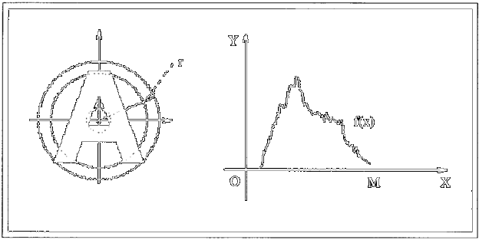
Fig. 3. An illustration of the ring-projection for letter “A”.
Hence, the derivation of f(r) is also termed as a ring-projection of the planar mass distribution. The single-variate function f (r), r∈[0,M ], sometimes also denoted as f (x), x∈[0,M], can be viewed as a 1-D pattern that is directly transformed from the original 2-D pattern through a ring-projection. Owing to the fact that the centroid of the mass distribution is invariant to rotation and that the projection is done along circular rings, the derived 1-D pattern will be invariant to the rotations of its original 2-D pattern. In other words, the ring-projection is rotation-invariant.
From a practical point of view, the images to be analyzed by a recognition system are most often stored in discrete formats. Catering to such discretized 2-D patterns, we shall modify (2.4.3) into the following expression:
$$f\left(r\right)=\sum_{k=0}^{M}{p(rcosθ_{k},rsinθ_{k})}…………………….(2.4.4)$$
Interested readers are referred to[27] for a thorough discussion on ring-projection. In the following sections, we are concerned mainly with how to extract as much information as possible from the obtained ring-projection, i.e., a 1-D pattern, by way of wavelet transformation. This, as will be described later, enables us to obtain a set of wavelet transformation sub-patterns—curves that are non self-intersecting, from which feature vectors defined over the curves’ fractal dimensions can easily be computed.
2.5 DUAL-TREE COMPLEX WAVEWLET:
In image processing, the complex wavelets can potentially offer significant performance improvements over the DWT.
THE WAVELET TRANSFORM AND MULTISCALE ANALYSIS:
The wavelet transform has been exploited with great success across the gamut of signal processing applications in last 20 years[10].
In a nutshell, the DWT replaces the infinitely oscillating sinusoidal basis functions of the Fourier transform with a set of locally oscillating basis functions called wavelets. In the classical setting, the wavelets are stretched and shifted versions of a fundamental, real-valued band-pass wavelet ψ(t). When carefully chosen and combined with shifts of a real-valued low-pass scaling function φ(t), they form an orthonormal basis expansion for one-dimensional (1-D) real-valued continuous-time signals[2]. That is, any finite-energy analog signal x(t) can be decomposed in terms of wavelets and scaling functions via:
$$x\left(t\right)=\sum_{n=-∞}^{∞}{c\left(n\right)ϕ(t-n)}+\sum_{j=0}^{∞}{\sum_{n=-∞}^{∞}{d\left(j,n\right)2^{j/2}ψ(2^{j}t-n)}}…………(2.5.1)$$
The scaling coefficients c(n)and wavelet coefficients d(j,n) are computed via the inner products:
$$c\left(n\right)=\int_{-∞}^{∞}{x\left(t\right)ϕ\left(t-n\right)dt}………………………..\left(2.5.2\right)$$
$$d\left(j,n\right)=2^{j/2}\int_{-∞}^{∞}{x\left(t\right)ψ(2^{j}t-n)dt}………(2.5.3)$$
They provide a time-frequency analysis of the signal by measuring its frequency content (controlled by the scale factor j) at different times (controlled by the time shift n). There exists a very efficient, linear time complexity algorithm to compute the coefficients c(n)and d(j,n)from a fine-scale representation of the signal (often simply N samples) and vice versa based on two octave-band, discrete-time FBs that recursively apply a discrete-time low-pass filter h₀(n), a high-pass filter h₁(n), and up-sampling and down-sampling operations (see Figure 24)[2,6]. These filters provide a convenient parameterization for designing wavelets and scaling functions with desirable properties, such as compact time support and fast frequency decay (to ensure the analysis is as local as possible in time frequency) and orthogonality to low-order polynomials (vanishing moments) [2].
Why have wavelets and multi-scale analysis proved so useful in such a wide range of applications? The primary reason is because they provide an extremely efficient representation for many types of signals that appear often in practice but are not well matched by the Fourier basis, which is ideally meant for periodic signals. In particular, wavelets provide an optimal representation for many signals containing singularities. The wavelet representation is optimally sparse for such signals, requiring an order of magnitude fewer coefficients than the Fourier basis to approximate within the same error. The key to the sparsity is that since wavelets oscillate locally, only wavelets overlapping a singularity have large wavelet coefficients; all other coefficients are small.
TROUBLE IN PARADISE: FOUR PROBLEMS WITH REAL WAVELETS:
In spite of its efficient computational algorithm and sparse representation, the wavelet trans-form suffers from four fundamental, intertwined shortcomings.
PROBLEM 1: OSCILLATIONS:
Since wavelets are band-pass functions, the wavelet coefficients tend to oscillate positive and negative around singularities (see Figures 1 and 2). This considerably complicates wavelet-based processing, making singularity extraction and signal modeling, in particular, and very challenging [1].
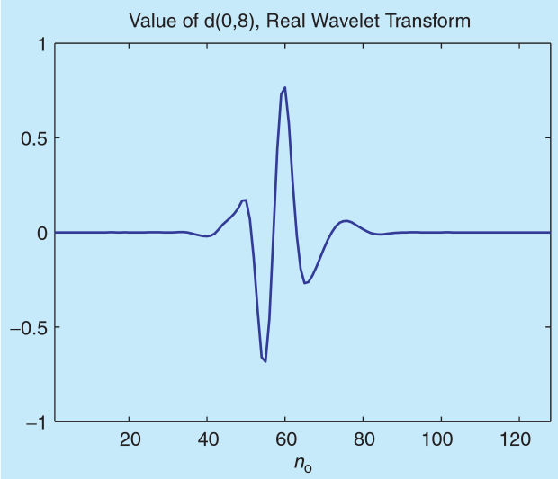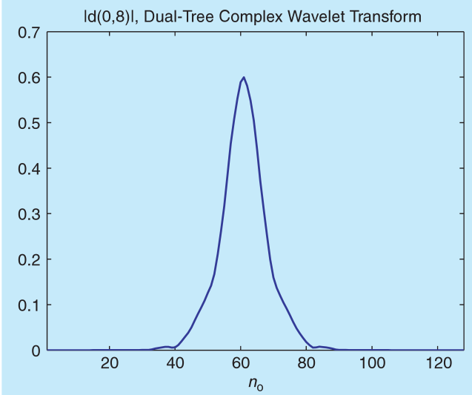
FIG 4: plot to illustrate difference between DWT and CWT.
Moreover, since an oscillating function passes often through zero, we see that the conventional wisdom that singularities yield large wavelet coefficients is overstated. Indeed, as we see in Figure 1, it is quite possible for a wavelet overlapping a singularity to have a small or even zero wavelet co-efficient.
PROBLEM 2: SHIFT VARIANCE
A small shift of the signal greatly perturbs the wavelet coefficient oscillation pattern around singularities (see Figure 2).
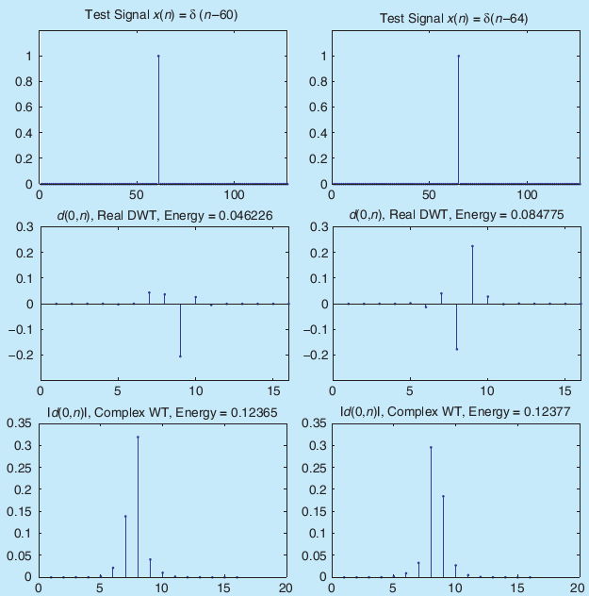
FIG 5: The wavelet coefficients of a signal x(n)are very sensitive to translations of the signal. For two impulse signals x(n)=δ(n−60)and x(n)=δ(n−64)(a), we plot the wavelet coefficients d(j,n)at a fixed scale j(b) and (c). (b) shows the real coefficients computed using the conventional real discrete wavelet transform (DWT, with Daubechies length-14 filters). (c) shows the magnitude of the complex coefficients computed using the dual-tree complex discrete wavelet transform (CWT with length-14 filters from [58]). For the dual-tree CWT the total energy at scale jis nearly constant, in contrast to the real DWT.
Shift variance also complicates wavelet-domain processing; algorithms must be made capable of coping with the wide range of possible wavelet coefficient patterns caused by shifted singularities [38], [39], [40]. To better understand wavelet coefficient oscillations and shift variance, consider a piecewise smooth signal x(t−t0) like the step function
$$u(t)=\left\{\begin{aligned}0 t<0 \\ 1 t≥0\end{aligned}\right.$$
analyzed by a wavelet basis having a sufficient number of vanishing moments. Its wavelet coefficients consist of samples of the step response of the wavelet [40].
PROBLEM 3: ALIASING:
The wide spacing of the wavelet coefficient samples, or equivalently, the fact that the wavelet coefficients are computed via iterated discrete-time down-sampling operations interspersed with non-ideal low-pass and high-pass filters, results in substantial aliasing. The inverse DWT cancels this aliasing, of course, but only if the wavelet and scaling coefficients are not changed. Any wavelet coefficient processing (thresholding, filtering, and quantization) upsets the delicate balance between the forward and inverse transforms, leading to artifacts in the reconstructed signal.
PROBLEM 4: LACK OF DIRECTIONALITY:
Finally, while Fourier sinusoids in higher dimensions correspond to highly directional plane waves, the standard tensor product construction of M-D wavelets produces a checkerboard pattern that is simultaneously oriented along several directions. This lack of directional selectivity greatly complicates modeling and processing of geometric image features like ridges and edges.
ONE SOLUTION: COMPLEX WAVELETS
Fortunately, there is a simple solution to these four DWT short-comings. The key is to note that the Fourier transform does not suffer from these problems. First, the magnitude of the Fourier transform does not oscillate positive and negative but rather provides a smooth positive envelope in the Fourier domain. Second, the magnitude of the Fourier transform is perfectly shift invariant, with a simple linear phase offset encoding the shift. Third, the Fourier coefficients are not aliased and do not rely on a complicated aliasing cancellation property to reconstruct the signal; and fourth, the sinusoids of the M-D Fourier basis are highly directional plane waves.
What is the difference? Unlike the DWT, which is based on real-valued oscillating wavelets, the Fourier transform is based on complex-valued oscillating sinusoids
$$e^{jΩt}=\cos{(Ωt)}+j\sin\left(Ωt\right)………………..(2.5.4)$$
with j=√−1. The oscillating cosine and sine components (the real and imaginary parts, respectively) form a Hilbert transform pair; i.e., they are 90◦ out of phase with each other. Together they constitute an analytic signale $e^{jΩt}$that is supported on only one-half of the frequency axis $\left(Ω>0\right)$. See “The Hilbert Transform and Analytic Signal” for more background.
Inspired by the Fourier representation, imagine a CWT as in (2.5.1)–(2.5.3) but with a complex-valued scaling function and complex-valued wavelet
$$ψ_{c}\left(t\right)=ψ_{r}\left(t\right)+{jψ}_{i}\left(t\right)$$
Here, by analogy to (2.5.4), $ψ_{r}\left(t\right)$ is real and even and ${jψ}_{i}\left(t\right)$ is imaginary and odd. Moreover, if $ψ_{r}\left(t\right)$and $ψ_{i}\left(t\right)$form a Hilbert transform pair (90◦ out of phase with each other), then $ψ_{c}\left(t\right)$is an analytic signal and supported on only one-half of the frequency axis. The complex scaling function is defined similarly. See Figure 1 for an example of a complex wavelet pair that approximately satisfies these properties.
Projecting the signal onto ${2^{j/2}ψ}_{c}\left(2^{j}t-n\right)$as in (2.5.3), we obtain the complex wavelet coefficient
$$d_{c}\left(j,n\right)=d_{r}\left(j,n\right)+jd_{i}\left(j,n\right)$$
With magnitude
$$\left|d_{c}\left(j,n\right)\right|=\sqrt{{\left[d_{r}\left(j,n\right)\right]}^{2}+{\left[d_{i}\left(j,n\right)\right]}^{2}}$$
and phase
$${∠d}_{c}\left(j,n\right)=arc\tan\left(\frac{d_{r}\left(j,n\right)}{d_{i}\left(j,n\right)}\right)$$

when $\left|d_{i}\left(j,n\right)\right|>0$. As with the Fourier transform, complex wavelets can be used to analyze and represent both real-valued signals and complex-valued signals. In either case, the CWT enables new coherent multi-scale signal processing algorithms that exploit the complex magnitude and phase. In particular, as we will see, a large magnitude indicates the presence of a singularity while the phase indicates its position within the support of the wavelet[41].
The dual-tree approach, which is another type of CWT, is based on two FB trees and thus two bases[39]. As we will see, any CWT based on wavelets of compact support can’t exactly possess the Hilbert transform/analytic signal properties, and this means that any such CWT will not perfectly overcome the four DWT shortcomings. The key challenge in dual-tree wavelet design is thus the joint design of its two FBs to yield a complex wavelet and scaling function that are as close as possible to analytic. As a result, the dual-tree CWT comes very close to mirror-ing the attractive properties of the Fourier transform, including a smooth, non-oscillating magnitude (see Figure 1); a nearly shift-invariant magnitude with a simple near-linear phase encoding of signal shifts; substantially reduced aliasing; and directional wavelets in higher dimensions. The only cost for all of this is a moderate redundancy: 2×redundancy in 1-D (2 d for d-dimensional signals, in general). This is much less than the log 2N×redundancy of a perfectly shift-invariant DWT [1], [5], which, moreover, will not offer the desirable magnitude/phase interpretation of the CWT nor the good directional properties in higher dimensions.
2.6 FEATURE EXTRACTION:
I use four features to describe the characteristics of an aircraft. Some features are used for describing its inner properties and some feature is used for its outer properties. The four features include binary map, contours, moments, and wavelet coefficients, respectively. Other features like the ratio between the lengths of wings and body axis are also good for aircraft recognition. However, the ‘ratio’ is easily affected by shadows and noise and thus not considered here.

CHAPTER 3: AIRCRAFT RECOGNITION
WHAT IS AIRCRAFT RECOGNITION?
Aircraft Recognition is about being able to distinguish between different aircrafts. Military around the world invest many resources on education in aircraft recognition, so that their pilots and soldiers know the difference between a friend and foe. It is also in the interest of many civilian spotters to be able to distinguish between different planes and helicopters.
WHY AIRCRAFT RECOGNITION?
Aircraft recognition is nothing new; it's as old as Aviation itself. For fighter pilots, Aircraft Recognition became the simple difference between shooting down quite literally, a "friend or foe". The same is true for ground personnel trying to defend against aircraft in the air, with a mix of enemy and friendly aircraft engaged in combat at the same time over the battle area. Aircraft identification mistakes have been made by all militaries, though "IFF" capability (an electronic signal to "Identify Friend or Foe") has decreased the number of incidents of accidental shoot downs due to "Friendly Fire".
During the attack on Pearl Harbor, land and sea gunners on defending US air bases and ships mistook a flight of US Navy aircraft arriving from a carrier out to sea, and shot several down. Radar has also helped, but in some situations, has hindered. Without IFF at the time when radar was new, Army observers were unable to identify the Japanese attack force inbound to Pearl Harbor. A flight of B-17 Flying Fortresses were inbound to Hawaii at the same approximate time, literally arriving in the middle of the attack, and the Japanese attacking force was mistaken for them.
In the latter day case of the U.S.S. Vincennes, which was trying to identify an aircraft not responding to IFF, the result was a missile fired in defense of the ship, and the shoot down of a civilian Iran Air Airbus A-300B2-202 on July 3, 1988, with the loss of 290 people. Though accidental, a Libyan terrorist group later retaliated with the bombing of the Pan Am Boeing 747-121A, "Clipper Maid of the Seas," over Lockerbie, Scotland, killing 270. A total 560 people died for lack of IFF and lack of visual identification.
Altitude of the airliner would certainly have played a factor. Likewise, so would weather conditions. A single layer of clouds can prevent visual ID, resulting in the need for IFF or AWACS. In the post-Desert Storm period, the pilot of an F-15 Eagle accidentally shot down two "Friendly" US Army UH-60 Blackhawk helicopters believing them to be "threat" Iraqi aircraft, possibly MI-24 Hinds. Although under guidance from a nearby AWACS, a series of errors complicated the situation, hindering the pilot's ability to identify the aircraft positively. 26 people died.
While visual recognition of aircraft cannot always be accomplished, when it can, it's important that military personnel train in Aircraft Identification (Friend and Foe), to be able to do the job. Ground personnel, for example, equipped with Stinger Missiles trying to defend their unit from aerial attack, have a need for Aircraft Identification. Army SQT (Skill Qualification Testing) includes both Aircraft and Vehicle identification. The same is true of the Air Force and Marines. For the Navy, the identification of civil and military aircraft and vessels is paramount.
Aircraft identification could be the difference between life and death for a squadron mate, and the difference between the wanton destruction of friendly aircraft and the destruction of the foe, in a hostile or unfriendly environment.
CIVIL USES FOR AIRCRAFT RECOGNITION:
The Civil World has long used aircraft identification to track type of aircraft, aircraft movements, change of owners, color schemes, newsmakers, modifications to aircraft, et al, often for News, Business, and Educational and Insurance purposes.
Commercial Aviation and Air Traffic Control (ATC) are the primary users of Aircraft Recognition guides, with pilots needing to "See and be seen", to be able to identify the type of aircraft and (when available) the airline markings of another aircraft, while Air Traffic Controllers need to be able to identify aircraft by type, performance, capacity, etc. This includes ATC in the tower and ATC in the radar room. For example, knowing an aircraft type allows a controller to assign approach and en route speeds. Civil (General and Executive Aviation) also require this as need-to-know information, and of course, going back to the military, which frequently operates in Civil Airspace, they too, must know aircraft in the Civil World beyond "friend and foe" military aircraft over the Battlefield.
3.1 REASONS FOR AUTOMATIC AIRCRAFT RECOGNITION:
Following the past, the emphasis on aircraft recognition system became required for everyone which does it manually. Causes for this are:
- The substitution of guided missiles for large antiaircraft guns.
- The assumption that US forces would continue to maintain air superiority.
- The reliance on electronic equipment for aircraft identification as hostile or friendly.
The need for this kind of system in aircraft recognition has become more critical since:
- An analysis of past military actions shows aircraft losses to air defense guns and small arms. It has reestablished that the soldier on the ground is capable of inflicting heavy losses on aircraft operating at low altitudes.
- Continued air superiority over every battlefield is not possible.
- Electronic identification has limitations and small units or individual soldiers do not always have access to these devices.
- Visual recognition and identification of specific aircraft types and timely reporting provide the S2 and G2 additional information of a passive nature in the form of early warning, threat air capability, or information on a possible new tactical situation such as supply drops, defoliation, or photographic reconnaissance.
The provision of large numbers of AD weapon systems to all divisional and some non-divisional ground combat forces generate additional emphasis on the need for visual aircraft recognition. Crew and team members of these weapon systems depend on visual recognition and identification of aircraft when making engagement decisions.

3.2 FACTORS THAT AFFECT DETECTION, RECOGNITION, AND IDENTIFICATION:
This chapter covers early recognition and identification, aircraft confusion, physical factors, and search techniques.
Every attempt made at visual aircraft recognition involves two events. First, an aircraft must be detected. Second, the aircraft must be inspected to distinguish the characteristics or shape that makes it recognizable as a particular aircraft.
Since detection, identification, and recognition are all visual processes, an aircraft must be detected, and then recognized at the farthest range possible, to make a timely engagement decision and or to report the aircraft. The task requires good, corrected if necessary, eyesight.
3.3 EARLY AIRCRAFT RECOGNITION AND IDENTIFICATION:
The farther out an aircraft can be detected, recognized, and identified, the more time a gunner has to make an engagement decision. If the gunner is not going to engage the aircraft, then early recognition and identification will allow time to seek cover and or report the aircraft. The importance of early identification is demonstrated in the following illustration.
DESCRIPTION OF AIRCRAFT:
This chapter shows the features of aircraft that make recognition and identification possible, and sorts out similar and dissimilar aircraft. Additionally, it shows examples of how aircraft are named and or numbered. All of the possible aircraft configurations are not covered in this chapter. When instructing aircraft recognition, an instructor or small unit leader can follow the descriptive methods used in the examples and derive his own descriptions for features or configurations that are not covered in the text.
AIRCRAFT RECOGNITION AND IDENTIFICATION FEATURES:
All aircraft are built with the same basic elements: wings to provide lift, engine(s) to provide motive power, a fuselage to carry the payload and controls, and a tail assembly which usually controls the direction of flight. These elements differ in shape, size, number, and position. The differences distinguish one aircraft type from another. An instructor can isolate the individual components for description and study as separate recognition and identification features, but it is the composite of these features that must be learned to recognize and identify an aircraft. The WEFT Features illustration shows wings, engine(s), fuselage, and tail features of aircraft. Allied countries may teach more or fewer features of aircraft in their recognition and identification programs.
3.4 DEVELOPMENT OF AUTOMATIC AIRCRAFT RECOGNITION SYSTEM:
If we want to capture images with no constraint by time, weather, country boundary, and other environmental factors. We can go for satellite images, since satellites don’t have any restrictions and can reach any location in the world. Taking this as an advantage, there have been many researchers who devoted themselves to utilize satellite images for developing different applications like water and climate observation, land cover classification, energy exploration, etc. Especially, surveillance through satellite images is another important application for military needs and environment protection. Therefore, in the literature[14], there have been many different detection schemes proposed for detecting various targets from satellite images such as bridges, airports, roads, streets, buildings, etc. For example, Nevatia and Babu[14] proposed a line edge detector to detect all line-like structures. Gruen and Li[15] used wavelet transforms to sharpen road boundaries. Moreover, Shi and Zhu[16] proposed a line matching method to extract road networks from high-resolution satellite mages. In addition to line detection, Pesaresi and Benediktsson[17] used several morphological operations and the technique of multi-scale analysis to segment different buildings from satellite images.
However, since the objects in satellite images are very small, all the above methods focus only on detecting objects and do not further recognize these objects. For recognizing objects, in the past, there have been many methods[18-23] proposed for this task and requiring that the targets should be large enough for feature extraction. For example, Reeveset al.[18] and Wallaceet al.[19]proposed procedures to identify a 3-D object from 2-D images using moments and Fourier descriptors. In addition, Tien and Chai [20] utilised the characteristics of non-uniform rationalB-splines and cross-ratios to recognise aircraft in images. Greenberg and Guterman[21]used multi-layer neural networks to recognize different targets from aerial images according to the features of Zernike moments. Moreover, Moldovan and Wu[23] used a symbolic approach to recognise hierarchically aeroplanes if all features of an aeroplane were well extracted. However, when recognising the targets in satellite images, all these methods will fail to work since the analysed targets are very small and polluted by different dazzle paints, shadows, and other noise. In this paper, we propose a novel recognition system for recognising various aircraft in satellite images using a hierarchical boosting algorithm. Since each aircraft in satellite images has different orientations, sizes, textures, and even dazzle paints, before recognition, image preprocessing techniques are first employed to reducing all the above variations to a minimum. The preprocessing tasks include image quality enhancement, noise removal, auto-matic binarisation, and the adjustments of aircraft scaling and translation. For rotation correction, we propose a novel method to use the symmetrical property of an aircraft to estimate its optimal orientation. In the past, the common method to estimate an object’s orientation was through a moment-based analysis[24]. However, an aircraft may have longer wings, shadows, fragments, and other noise. All these factors will make the moment-based method fail to normalise an aircraft having a correct orientation. However, for an aircraft that has been fragmented, polluted, and occluded by shadows or noise, its symmetry still maintains. Thus, the symmetry-based method can perform more robustly, effectively, and accurately to correct the orientation of an aircraft than the moment-based method. Then, distinguishable features derived from the character-istics exhibited by aircraft are extracted for aircraft recognition. Four features are used here and derived, respectively, from wavelet transform, Zernike moment, distance transform, and the bitmap itself. Different features have different discrimination abilities to classify aircrafts. In order to integrate these features together, a novel learning scheme is proposed to determine suitable weights from training samples for improving the accuracy of aircraft recognition. Based on these two ingredients, i.e. weights and features, all input aircraft can be recognised very accurately. From experimental results, the proposed method indeed achieves great improvements in terms of accuracy, robust-ness, and effectiveness in recognising aircraft in satellite images.

CHAPTER 4: PROPOSED WORK
Our proposed system identifies the aircrafts from a satellite image which may contain any number of aircrafts in it. These objects (aircrafts) may be small in size and can be faded by noise. The ring-projection transforms the feature space from 2-D to 1-D, which reduces the processing time substantially. This makes the proposed descriptor in this paper a practical approach in real-time applications. Kingsbury ([31-33]) introduced the dual-tree complex wavelet transform that exhibits approximate shift invariant property and improved angular resolution. The success of the transform is due to the use of filters in two trees, a and b. Kingsbury proposed a simple delay of one sample between the level 1 filters in each tree, and then the use of alternate odd-length and even-length linear-phase filters. He pointed out that there are some difficulties in the odd/even filter approach. Therefore, he proposed a new Q-shift dual-tree [42] where all the filters beyond level 1 are even length. The filters in the two trees are just the time-reverse of each other, as are the analysis and reconstruction filters. The new filters are shorter than before, and the new transform still satisfies the shift invariant property and good directional selectivity in multiple dimensions.
The feature extraction procedures are the same for the patterns in the pattern database and the unknown patterns.
First, we need to move the centre of the pattern to its centroid and scale it to have a fixed size. This can make the pattern translation and scale invariant.
The ring-projection is then applied to the normalized pattern so that we obtain a 1-D signal.
Since the dual-tree complex wavelet transform is approximate shift-invariant, we can extract invariant features by applying this transform to the 1-D signal for a predetermined (J) decomposition scales.
Finally, we can classify the unknown pattern to one of the known classes by using the nearest neighbor classifier.
We can also use other existing classification techniques, such as neural networks, support vector machines (SVM), k-nearest neighbor classifier, etc.
There is difference for feature extraction between the patterns in the pattern database and the unknown patterns. We need to save the extracted features for the patterns in the pattern database. However, we need to use the extracted features to classify the unknown pattern to one of the known classes.
The descriptor for the patterns in the pattern database can be summarized as follows:
1) Normalize the pattern f(x,y)so that it is translation and scale invariant.
2) Extract the ring-projection 1-D signal from the normalized pattern.
3) Apply the dual-tree complex wavelet transform to the ring-projection 1-D signal for Jscales.
4) Save the extracted features into a feature file for later use.
The descriptor for recognizing the unknown patterns can be summarized as follows:
1) Normalize the unknown pattern f(x,y)so that it is translation and scale invariant.
2) Extract the ring-projection 1-D signal from the normalized pattern.
3) Apply the dual-tree complex wavelet transform to the ring-projection 1-D signal for J scales.
4) Classify the unknown pattern to one of the known classes by using the nearest neighbor classifier.
The main contribution of this paper is that we have combined the ring-projection with the dual-tree complex wavelet transform. Unlike the wavelet transform, which does not have the shift-invariant property, the dual-tree complex wavelet transform is approximate shift-invariant.
Start

Normalize the pattern f(x,y) so that it is translation and scale invariant
Extract the ring-projection 1-D signal from the normalized pattern

Apply the dual-tree complex wavelet transform to the ring-projection 1-D signal for J scales.
Save the extracted features into a feature file for later use.

Stop

Fig. 6 Descriptor for the Patterns in the Pattern Database:
This invariant property is very important for pattern recognition. Experimental results conducted in the next section will show that the proposed descriptor is better than the Fourier transform for recognizing noisy 2D patterns.
Start
Normalize the unknown pattern f(x,y) so that it is translation and scale invariant

Extract the ring-projection 1-D signal from the normalized pattern

Apply the dual-tree complex wavelet transform to the ring-projection 1-D signal for J scales.

Save the extracted features into a feature file for later use.
.
Stop

Descriptor for Recognizing the Unknown Patterns
So I organized the work as shown in flow chart to recognize patterns in the pattern database and to recognize the unknown patterns. This process takes four steps to accomplish the task. The first step includes noise removal and normalization.

4.1 BINARISATION AND NOISE REMOVING:
In my work, a ‘minimum within-group variance’ dynamic thresholding method [12] is applied to binarising each input region. Figure shows an example of automatic binarisation using this algorithm. After binarisation, a conventional labelling technique is then applied to locate each connected component from the binarised aircraft image. For each connected region, if its size is less than a threshold, it will be considered as noise and then filtered out.
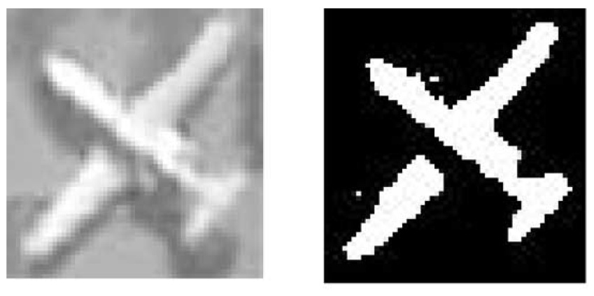
Fig. 8 Original image and result after binarisation
a Original aircraft image
b Result after binarisation
4.2 SIZE NORMALIZATION
In addition to an orientation adjustment, before feature extraction, the size and centre of each processed aircraft also require normalizing to a regular size and the original, respectively. In this paper, the regular size is defined as 24×32.
The second step in this process is to extract the ring-projection 1-D signal from the normalized pattern.

4.3 RING PROJECTION:
In invariant pattern recognition, feature extraction is a most crucial step. There are many techniques which are frequently used for feature extraction, have their corresponding advantages and disadvantages. Ring-projection, among all existing feature extraction techniques, has been selected for invariant pattern recognition in. When patterns are extracted from the image, they are often rotated due to experimentation constraints or errors. This raises the need of a pattern recognition method that must be invariant to rotations. In 1991, Tang[28] ﬁrst proposed a method “ring projections”. It is a method of transforming 2-D patterns into 1-D patterns. The 1-D pattern obtained from ring-projection is invariant to rotations because the projections are done in the form of rings. This is due to the reason it is invariant to translation and scale of the patterns, means this will give the same result if we apply ring projection to two same but having different size and position. In the ring-projection, we take the summation of all pixels that lie on the circle with radius r and centre at the centroid of the pattern:
$$Ring\left(r\right)=\int_{0}^{2π}{f(rcosθ,rsinθ)dθ}………………….(4.3.1)$$
where r is the radius of the ring. It is shown that Ring(r) is equal to the pattern mass distributed along circular rings.

4.3.1 DIMENSIONALITY REDUCTION OF TWO-DIMENSIONAL PATTERNS WITH A RING-PROJECTION METHOD:
First, suppose that a 2-D pattern such as an alphanumeric symbol has been represented into a binary image. Taking letter “A” as an example, its gray-scale image, p(x,y), can be discretized into binary values as follows:
$$p\left(x,y\right)=\left\{\begin{aligned}1 if \left(x,y\right)∈D \\ 0 otherwise\end{aligned}\right.………………………………….(4.3.2)$$
where domain D corresponds to the white region of letter “A”. From (4.3.2), it is readily noted that the corresponding density function is a uniform distribution. From this uniform mass distribution, we can derive the centroid of the mass, m(x₀,y₀ ), for the region D, and subsequently, translate the origin of our reference frame to this centroid. Next, we let:
$M =\max_{N∈D}\left| N \left(x,y \right)- m(x_{0},y_{0} )\right|$
where $\left|N \left(x,y \right)- m(x_{0},y_{0} )\right|$ represents the Euclidean distance between two points, N and m, on the plane. Further, we transform the original reference Cartesian frame into a polar frame based on the following relations:
$$\left\{\begin{aligned}x=rcosθ \\ y=rsinθ\end{aligned}\right.$$
Hence,
$$p\left(x,y\right)=p(rcosθ,rsinθ)$$
where $r∈\left[0,∞\right), θ∈(0,2π ]$. For any ﬁxed $r∈[0,M ]$, we then compute the following integral:
$$A=\int_{0}^{2π}{p(rcosθ,rsinθ)dθ}$$
The resulting f(r) is in fact equal to the total mass as distributed along circular rings, as shown in Fig. 9.
Fig. 9 An illustration of how a 1-D signal is obtained using the ring-projection for letter “A”.
Hence, the derivation of f(r) is also termed as a ring-projection of the planar mass distribution. The single variate function f (r), r∈[0,M ], sometimes also denoted as f (x), x∈[0,M], can be viewed as a 1-D pattern that is directly transformed from the original 2-D pattern through a ring-projection. Owing to the fact that the centroid of the mass distribution is invariant to rotation and that the projection is done along circular rings, the derived 1-D pattern will be invariant to the rotations of its original 2-D pattern. In other words, the ring-projection is rotation-invariant.
From a practical point of view, the images to be analyzed by a recognition system are most often stored in discrete formats. Catering to such discretized 2-D patterns, we shall modify (4.3.3) into the following expression:
$$p\left(r\right)=\sum_{k=0}^{M}{p(rcosθ_{k},rsinθ_{k})}$$
Interested readers are referred to [27] for a thorough discussion on ring-projection. In the following sections, we are concerned mainly with how to extract as much information as possible from the obtained ring-projection, i.e., a 1-D pattern, by way of wavelet transformation. This, as will be described later, enables us to obtain a set of wavelet transformation sub-patterns—curves that are non self intersecting, from which feature vectors defined over the curves’ fractal dimensions can easily be computed.
4.4 THE DUAL-TREE COMPLEX WAVELET TRANSFORM:
The development of an invertible analytic wavelet transform is not as straightforward as might be initially expected. In particular, the structure, which is usually used to implement the real DWT, does not lend itself to analytic wavelet transforms with desirable characteristics.
4.4.1 DUAL-TREE FRAMEWORK:
One effective approach for implementing an analytic wavelet transform is called the dual-tree CWT. Like the idea of positive/negative post-filtering of real sub-band signals, the idea behind the dual-tree approach is quite simple. The dual-tree CWT employs two real DWTs; the first DWT gives the real part of the transform while the second DWT gives the imaginary part. The analysis and synthesis FBs(frequency bands) used to implement the dual-tree CWT and its inverse is illustrated in Figures 10 and 11.
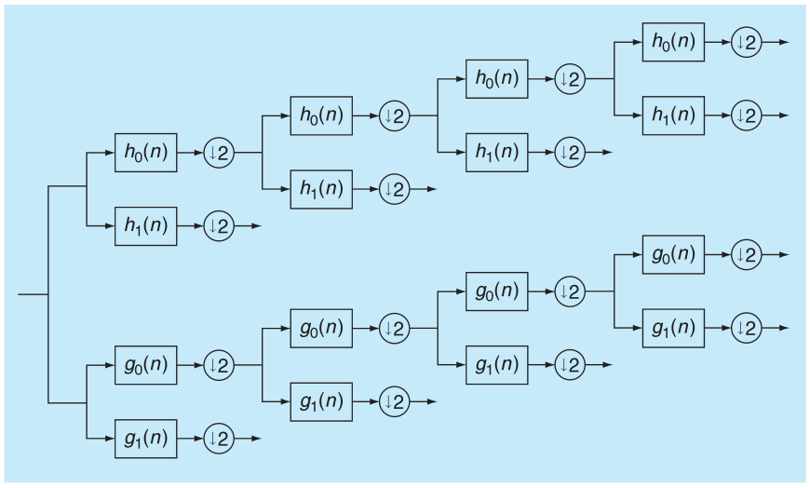
Fig.10 Analysis FB for the dual-tree discrete CWT.
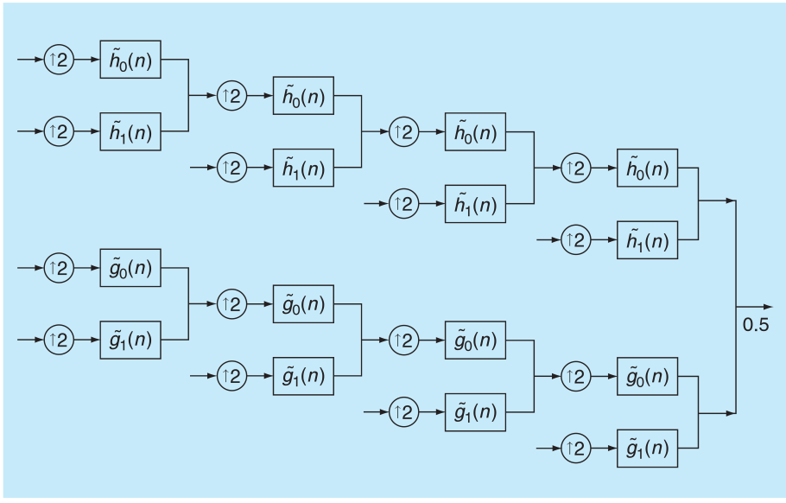
Fig. 11 Synthesis FB for the dual-tree CWT.
The two real wavelet transforms use two different sets of filters, with each satisfying the PR conditions. The two sets of filters are jointly designed so that the overall transform is approximately analytic. Let h₀(n), h₁(n)denote the low-pass/high-pass filter pair for the upper FB, and let g₀(n), g₁(n) denote the low-pass/high-pass filter pair for the lower FB. We will denote the two real wavelets associated with each of the two real wavelet transforms as ψ_{h}(t) and ψ_{g}(t). In addition to satisfying the PR conditions, the filters are designed so that the complex wavelet ψ(t):=ψ_{h}(t)+jψ_{g}(t) is approximately analytic. Equivalently, they are designed so that ψ_{g}(t) is approximately the Hilbert transform of ψ_{h}(t) [denoted ψ_{g}(t)≈H{ψ_{h}(t)}].
Note that the filters are themselves real; no complex arithmetic is required for the implementation of the dual-tree CWT. Also note that the dual-tree CWT is not a critically sampled transform; it is two times expansive in 1-D because the total output data rate is exactly twice the input data rate.
The inverse of the dual-tree CWT is as simple as the forward transform. To invert the transform, the real part and the imaginary part are each inverted—the inverse of each of the two real DWTs are used—to obtain two real signals. These two real signals are then averaged to obtain the final output. Note that the original signal x(n) can be recovered from either the real part or the imaginary part alone; however, such inverse dual-tree CWTs do not capture all the advantages an analytic wavelet transform offers.
If the two real DWTs are represented by the square matrices F_{h} and F_{g}, then the dual-tree CWT can be represented by the rectangular matrix:
$$F=\left[\begin{matrix}F_{h} \\ F_{g}\end{matrix}\right]$$
If the vector x represents a real signal, then w_{h}=F_{h}x represents the real part and w_{g}=F_{g}x represents the imaginary part of the dual-tree CWT. The complex coefficients are given by w_{h}+jw_{g}. A (left) inverse of F is then given by:
$$F^{-1}=\frac{1}{2}\left[\begin{matrix}F_{h}^{-1} & F_{g}^{-1}\end{matrix}\right]$$
As we can clarify
$$F^{-1}⋅F=\frac{1}{2}\left[\begin{matrix}F_{h}^{-1} & F_{g}^{-1}\end{matrix}\right]⋅\left[\begin{matrix}F_{h} \\ F_{g}\end{matrix}\right]=\frac{1}{2}\left[I+I\right]=I$$
We can just as well share the factor of one half between the for-ward and inverse transforms, to obtain
$$F≔\frac{1}{\sqrt{2}}\left[\begin{matrix}F_{h} \\ F_{g}\end{matrix}\right], F^{-1}≔\frac{1}{\sqrt{2}}\left[\begin{matrix}F_{h}^{-1} & F_{g}^{-1}\end{matrix}\right]……………..(4.4.1)$$
If the two real DWTs are orthonormal transforms, then the transpose of F_{h} is its inverse $F_{H}^{t}·F_{H}=I$ and similarly for F_{g}. In this case, the transpose of the rectangular matrix F is also a left inverse$F^{t}·F=I$, where we have used (4.4.1). That is, the inverse of the dual-tree CWT can be performed using the transpose of the for-ward dual-tree CWT; it is self-inverting in the terminology of [9]. The dual-tree wavelet transform defined in (4.4.1) keeps the real and imaginary parts of the complex wavelet coefficients separate. However, the complex coefficients can be explicitly computed using the following form:
$$F_{c}≔\frac{1}{2}\left[\begin{matrix}I & jI \\ I & jI\end{matrix}\right]⋅\left[\begin{matrix}F_{h} \\ F_{g}\end{matrix}\right]……………………….\left(4.4.2\right)$$
$$F_{c}^{-1}≔\frac{1}{2}\left[\begin{matrix}F_{h}^{-1} & F_{g}^{-1}\end{matrix}\right]⋅\left[\begin{matrix}I & I \\ -jI & jI\end{matrix}\right]…………….(4.4.3)$$
Note that the complex sum/difference matrix in (4.4.2) is unitary (its conjugate transpose is its inverse)
$$\frac{1}{\sqrt{2}}\left[\begin{matrix}I & jI \\ I & -jI\end{matrix}\right]⋅\frac{1}{\sqrt{2}}\left[\begin{matrix}I & I \\ -jI & jI\end{matrix}\right]=I$$
(Note that the identity matrix on the right-hand side is twice the size of those on the left-hand side). Therefore, if the two real DWTs are orthonormal transforms, then the dual-tree CWT satisfies $F_{c}^{*}⋅F_{c}=I$where ∗denotes conjugate transpose. If
$$\left[\begin{matrix}u \\ v\end{matrix}\right]=F_{c}⋅x$$
then when x is real, we have v=u∗ , so v need not be computed. When the input signal x is complex, then v≠u∗, so both u and v need to be computed.
When the dual-tree CWT is applied to a real signal, the out-put of the upper and lower FBs in Figure 10 will be the real and imaginary parts of the complex coefficients, and they can be stored separately, as represented by (4.4.1). However, if the dual-tree CWT is applied to a complex signal, then the output of both the upper and lower FBs will be complex, and it is no longer correct to label them as the real and imaginary parts. For complex input signals, the form in (4.4.2) is more appropriate. For a real N-point signal, the form in (4.4.2) yields 2Ncomplex coefficients, but N of these coefficients are the complex conjugates of the other N coefficients. For a general complex N-point signal, the form in (4.4.2) yields 2Ngeneral complex coefficients. Therefore, for both real and complex input signals, the CWT is two times expansive.
When the two real DWTs are orthonormal and the 1/√2 factor is included as in (4.4.1), the dual-tree CWT gains a Parseval’s energy theorem: the energy of the input signal is equal to the energy in the wavelet domain
$$\sum_{j,n}{\left({\left|d_{h}\left(j,n\right)\right|}^{2}+{\left|d_{g}\left(j,n\right)\right|}^{2}\right)}=\sum_{n}{{\left|x(n)\right|}^{2}}$$
The dual-tree CWT is also easy to implement. Because there is no data flow between the two real DWTs, they can each be implemented using existing DWT software and hardware. Moreover, the transform is naturally parallelized for efficient hardware implementation. In addition, because the dual-tree CWT is implemented using two real wavelet transforms, the use of the dual-tree CWT can be informed by the existing theory and practice of real wavelet transforms. For example, criteria for wavelet design (such as vanishing moments) and wavelet-based signal processing algorithms (such as thresholding of wavelet coefficients) that have been developed for real wavelet trans-forms can also be applied to the dual-tree CWT.
It should be noted, however, that the dual-tree CWT requires the design of new filters. Primarily, it requires a pair of filter sets chosen so that the corresponding wavelets form an approximate Hilbert transform pair. Existing filters for wavelet transforms should not be used to implement both trees of the dual-tree CWT. For example, pairs of Daubechies’ wavelet filters do not satisfy the requirement that ψ_{g}(t)≈H{ψ_{h}(t)}. If the dual-tree wavelet transform is implemented with filters not satisfying this requirement, then the transform will not provide the full advantages of analytic wavelets described previously.

CHAPTER 5: RESULTS
In order to analyze the performance of our proposed approach, a test database containing 48 aircraft, which come from 12 categories, was constructed. In addition, a training database containing 4 aircraft was adopted to train and learn proper weights for increasing the accuracy of aircraft recognition. Every character is represented by 64×64 pixels. During recognition, 4 aircraft per each category were used to perform the voting technique.
Figure 12 shows the 12 types of aircrafts built here for recognition. In this figure, each row includes 4 templates for enhancing the robustness and accuracy of recognition. Aircraft at different rows mean that they are from different categories.
My major concern in our experiments is the performance of the proposed descriptor on different images and different noise levels. Standard normalization techniques can be used to achieve translation invariance and scale invariance [29]. For each image, I test four images (see Figure). The nearest neighbor classifier is used in the classification stage. As the wavelet transform, the dual-tree complex wavelet transform will decompose the input signal into multi-resolution scales. In general, features in fine decomposition scales will represent the fine features in the input signal, while the coarse scale coefficients will represent coarse features in the input signal. In order to obtain high correct recognition rates, we need to select features in a few intermediate decomposition scales in the dual-tree complex transform. In this work, I have selected features in the 3rd and the 4th decomposition scales in the proposed descriptor for invariant pattern recognition. We tested the performance of our proposed descriptor on noisy data. The noisy images with different orientations are generated by adding Gaussian white noise to the noise-free images. The signal-to-noise ratio (SNR) is defined as:
$$SNR=\frac{\sqrt{\sum_{i,j}{{\left(f_{i,j}-avg(f)\right)}^{2}}}}{\sqrt{\sum_{i,j}{{\left(n_{i,j}-avg(n)\right)}^{2}}}}$$
where f is the noise-free image, n is the added white noise, and avg(f) is the average value of the image f. figure 13 shows four rotation angles of the image. Figure 14 displays a image corrupted with different noise levels at SNR=10, 5, 3, and 1. Figures 15-18 show the correct recognition rates of the descriptor and the Fourier transform for different rotation angles at SNR=10, 5, 3, 1, respectively. From these figures, it can be seen that this descriptor is much better than the Fourier transform especially for high noise levels. This confirms that the descriptor is a feasible approach in pattern recognition.
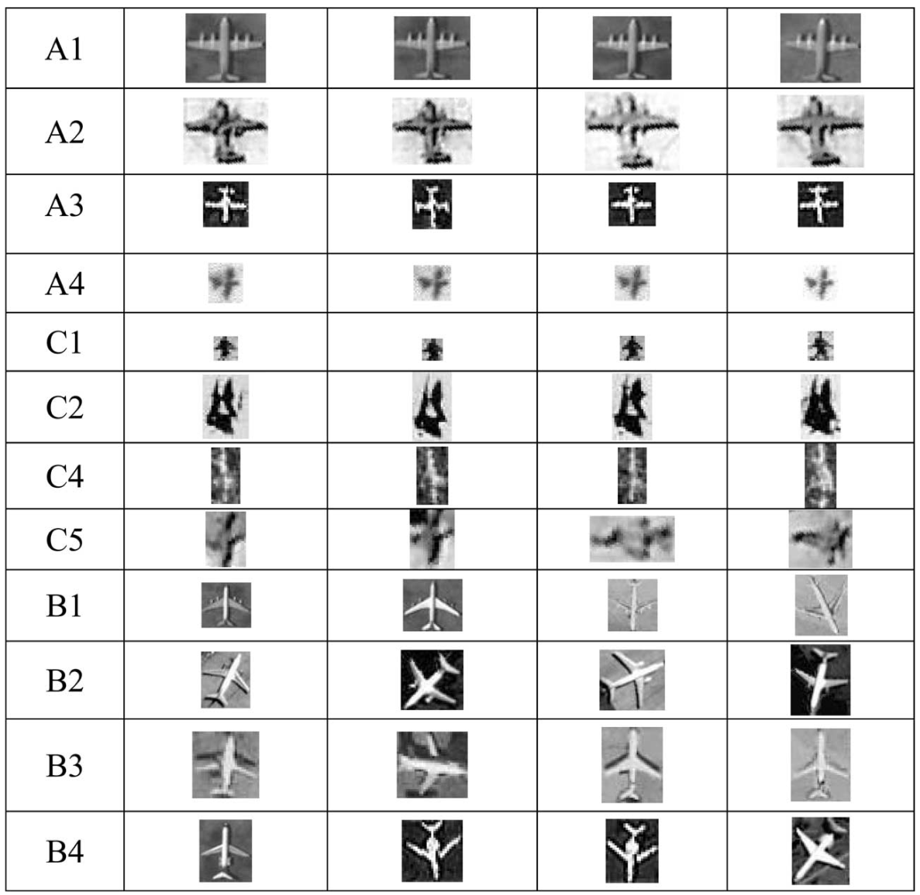
Fig. 12 The test database used in the experiment.

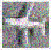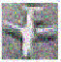
Fig. 13 The rotated images with four rotation angles.

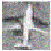
Fig. 14 The noisy patterns with different SNR’s

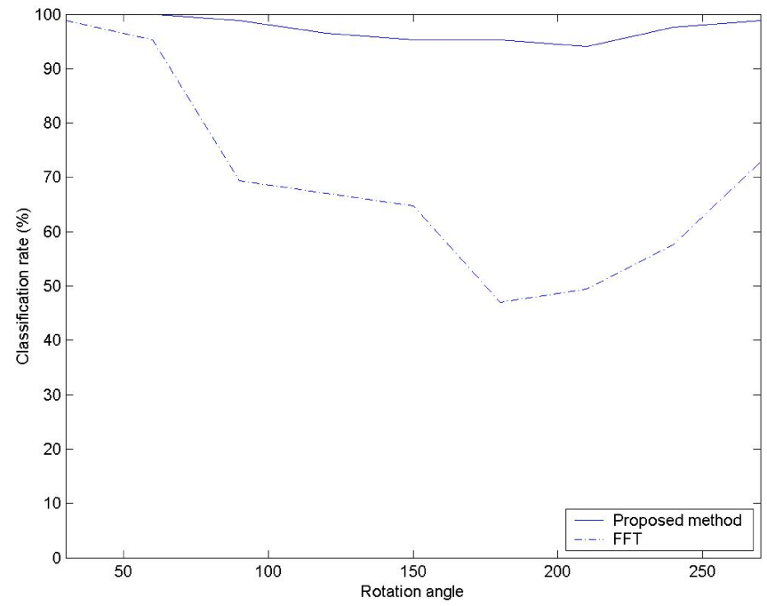
Fig. 15 The correct classification rates with different rotation angles at SNR=10

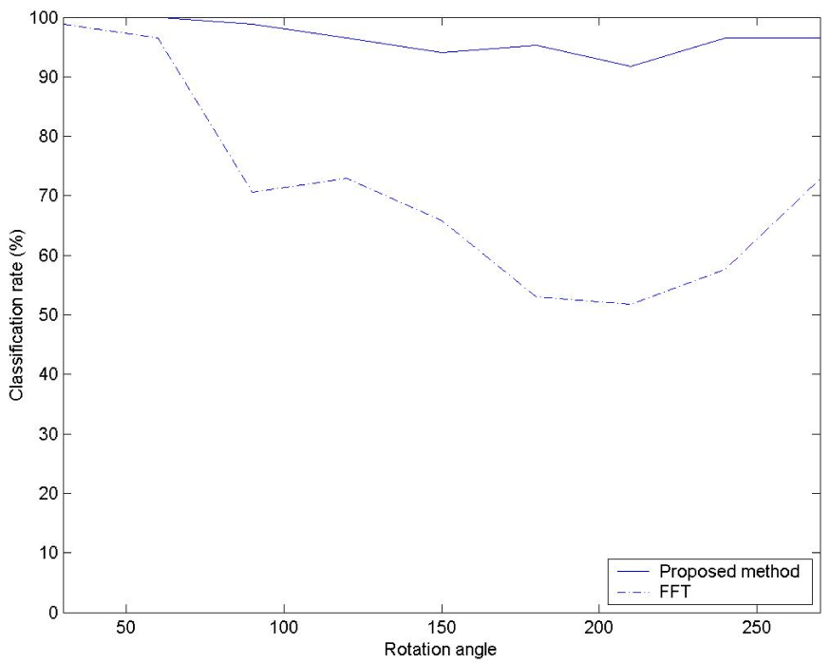
Fig. 16 The correct classification rates with different rotation angles at SNR=5

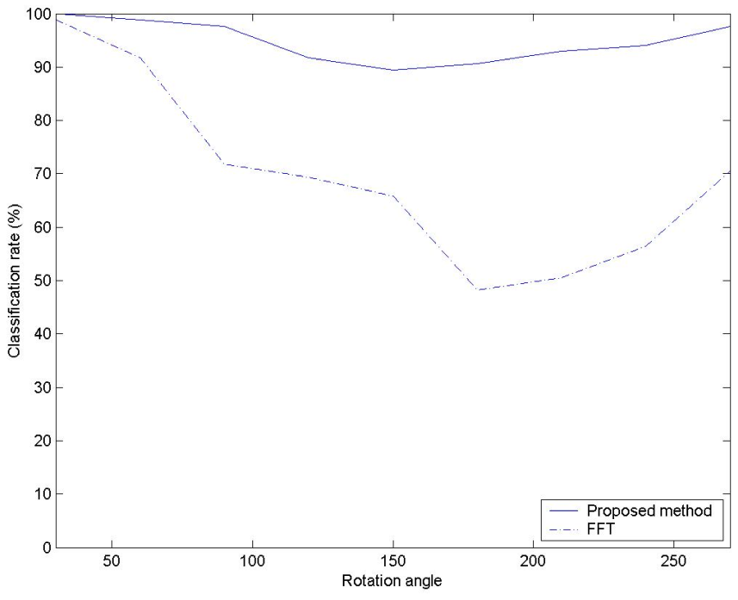
Fig. 17 The correct classification rates with different rotation angles at SNR=3
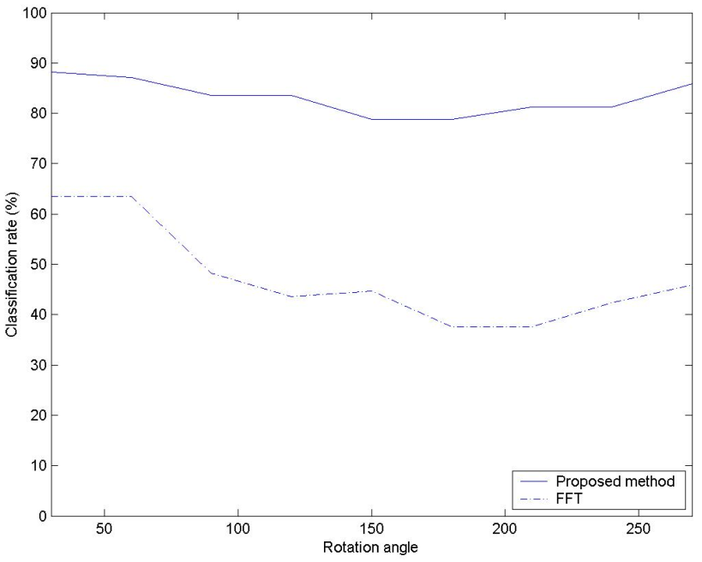
Fig. 18 The correct classification rates with different rotation angles at SNR=1
If more representative templates (not only 4 templates) are used to represent an aircraft type, the three failure cases will be tackled well. According to the above experimental results, the superiority of our method has been verified.

CHAPTER 6: CONCLUSIONS AND FUTURE WORK
The crucial step in invariant pattern recognition is feature extraction. Good features should have large inter-class variance while at the same time small intra-class variance. For the sake of good quality, features should be independent of the size, orientation, and location of the pattern. This independence can be achieved by two ways; one way is by preprocessing and another is by extracting features that are translation, rotation, and scale invariant.
In my project, I have implemented an invariant descriptor for pattern recognition by using the ring-projection and the dual-tree complex wavelet transform. The ring-projection reduces the 2-Dimentional pattern to a 1- Dimensional signal, which will make the recognizing process faster than many other descriptors. The dual-tree complex wavelet transform is selected since it has the approximate shift-invariant property. This property is very important in invariant pattern recognition. Experimental results confirm that the proposed descriptor in this paper is feasible in recognizing patterns especially when the noise level is high.
Future work will be done in the following ways. We may propose new descriptors by extracting line moments from the 2-D patterns and applying the shift-invariant wavelet transform to the line moments. We may develop multi-wavelet descriptors for 2D pattern recognition because multi-wavelets have better properties than the scalar wavelets. We may also apply these newly proposed descriptors for palm print classification, fingerprint recognition, road sign recognition, key recognition, iris recognition, aircraft recognition, etc.
More research needs to be done in order to develop better descriptors for pattern recognition and related applications.

REFFERENCES
- H. Choi, J. Romberg, R.G. Baraniuk, and N. Kingsbury, “Hidden Markov tree modeling of complex wavelet transforms,” in Proc. IEEE Int. Conf. Acoust., Speech, Signal Processing (ICASSP), June 5–9, 2000, vol. 1, pp. 133–136.
- I. Daubechies,Ten Lectures On Wavelets. Piladelphia, PA: SIAM, 1992.
- N.G. Kingsbury, “Image processing with complex wavelets,” Philos. Trans. R. Soc. London A, Math. Phys. Sci., vol. 357, no. 1760, pp. 2543–2560, Sept. 1999.
- N.G. Kingsbury, “Complex wavelets for shift invariant analysis and filtering of signals,”Appl. Comput. Harmon. Anal., vol. 10, no. 3, pp. 234–253, May 2001.
- M. Lang, H. Guo, J.E. Odegard, C.S. Burrus, and R.O. Wells, Jr., “Noise reduc-tion using an undecimated discrete wavelet transform,” IEEE Signal Processing Lett., vol. 3, no. 1, pp. 10–12, Jan. 1996.
- S. Mallat,A Wavelet Tour of Signal Processing. New York: Academic, 1998.
- J. Romberg, M. Wakin, H. Choi, and R.G. Baraniuk, “A geometric hidden Markov tree wavelet model,” in Proc. Wavelet Applications Signal Image Processing X (SPIE 5207), San Diego, 2003, pp. 80–86.
- J.K. Romberg, M. Wakin, H. Choi, N.G. Kingsbury, and R.G. Baraniuk, “A hid-den Markov tree model for the complex wavelet transform,” Rice ECE, Tech. Rep., Sept. 2002.
- E.P. Simoncelli, W.T. Freeman, E.H. Adelson, and D.J. Heeger, “Shiftable multi-scale transforms,”IEEE Trans. Inform. Theory, vol. 38, no. 2, pp. 587–607, Mar. 1992.
- J.-L. Starck and F. Murtagh, “Astronomical image and signal processing: Looking at noise, information and scale,” IEEE Signal Processing Mag., vol. 18, no. 2, pp. 30–40, Mar. 2001.
- M. Vetterli, “Wavelets, approximation, and compression,” IEEE Signal Processing Mag., vol. 18, no. 5, pp. 59–73, Sept. 2001.
- M. Wakin, “Image compression using multiscale geometric edge models,” Master’s thesis, Rice Univ., Houston, TX, 2002.
- Z. Wang and E.P. Simoncelli, “Local phase coherence and the perception of blur,” in Adv. Neural Information Processing Systems, S. Thrun, L. Saul, and B. Schölkopf, Eds. Cambridge, MA: MIT Press, May 2004, vol. 16.
- Nevatia, R., and Babu, K.R.: ‘Linear feature extraction and description’, Comput. Graph. Image Process., 1980, 13, pp. 257–269
- Gruen, A., and Li, H.: ‘Semi-automatic road extraction by dynamic programming’,Int. Arch. Photogramm. Remote Sens., 1994, 30, (3/1), pp. 324–332
- Shi, W., and Zhu, C.: ‘The line segment match method for extracting road network from high-resolution satellite images’, IEEE Trans. Geosci. Remote Sens., 2002, 40, (2), pp. 511–514
- Pesaresi, M., and Benediktsson, J.A.: ‘A new approach for the morphological segmentation of high-resolution satellite imagery’, IEEE Trans. Geosci. Remote Sens., 2001, 39, (2), pp. 309–320
- Reeves, A.P., Prokop, R.J., Andrews, S.E., and Kuhl, F.P.: ‘Three-dimensional shape analysis using moments and Fourier descriptors’,IEEE Trans. Pattern Anal. Mach. Intell., 1988, 10, (6), pp. 937–943
- Wallace, T.P., and Wintz, P.A.: ‘An efficient three-dimensional aircraft recognition algorithm using normalized Fourier descriptors’,Comput. Graph. Image Process., 1980, 13, pp. 99–126
- Tien, S.C., and Chia, T.L.: ‘Using cross-ratios to model curve data for aircraft recognition’, Pattern Recognit. Lett., 2003, 12, pp. 2047–2060
- Greenberg, and Guterman, J.: ‘Neural-network classifiers for automatic real-world aerial image recognition’, Appl. Opt., 1996, 35, (23), pp. 4598–4608
- Latecki, L., and Laka¨mper, R.: ‘Application of planar shape comparison to object retrieval in image databases’,Pattern Recognit., 2002,35, (1), pp. 15–29
- Moldovan, D.I., and Wu, C.I.: ‘A hierarchical knowledge based system for airplane classification’,IEEE Trans. Softw. Eng., 1998, 14, (12), pp. 1829–1834
- Sonka, M., Hlavac, V., and Boyle, R.: ‘Image processing, analysis and machine vision’ (Chapman & Hall, London, U. K., 1993)
- Liao, S., and Pawlak, M.: ‘Image analysis with Zernike moment descriptors’. 1997 Canadian Conf. on Electrical and Computer Engineering (CCECE), St. John’s, May 25–28, 1997, pp. 700–703
- Liao, S.X., and Pawlak, M.: ‘On the accuracy of Zernike moments for image analysis’, IEEE Trans. Pattern Anal. Mach. Intell., 1998, 20, (12), pp. 1358–1364
- Y. Y Tang, H. D. Cheng, and C. Y. Suen, “Transformation-ring-projection (TRP) algorithm and its VLSI implementation,”Int. Pattern Recogn. Artif. Intell.,vol. 5, nos. 1–2, pp. 25–56, 1991.
- [1]. Y. Y. Tang, B. Li, H. Ma and J. Liu, “Ring-projection-wavelet-fractal signatures: a novel approach to feature extraction,” IEEE Trans. Circuits Systems II: Analog and Digital Signal Processing, vol. 45, no. 8, pp. 1130-1134, 1998.
- G. Y. Chen and P. Bhattacharya, “Invariant pattern recognition using ridgelet packets and the Fourier transform,” International Journal of Wavelets, Multiresolution and Information Processing, vol. 7, no. 2, pp. 215-228, 2009.
- G. Y. Chen and T. D. Bui, “Invariant Fourier-wavelet descriptor for pattern recognition,” Pattern Recognition, vol.32, pp.1083-1088, 1999.
- N. G. Kingsbury, “The dual-tree complex wavelet transform:a new efficient tool for image restoration and enhancement,” Proc. EUSIPCO'98, pp. 319-322, Rhodes, Sept. 1998.
- N. G. Kingsbury, “Shift invariant properties of the dual-tree complex wavelet transform,” Proc. IEEE ICASSP'99, Phoenix, AZ, March, 1999.
- J. Romberg, H. Choi, R. Baraniuk and N. G. Kingsbury, “Multiscale classification using complex wavelets,” Proc. IEEE ICIP, Vancouver, Sept. 11-13, 2000.
- N. G. Kingsbury, “A dual-tree complex wavelet transform with improved orthogonality and symmetry properties,” Proc. IEEE ICIP, Vancouver, Sept. 11-13, 2000.
- http://en.wikipedia.org/
- Aircraftrecognition.com
- http://www.aircav.com/recog/chp01/ch01.html
- P.L. Dragotti and M. Vetterli, “Wavelet footprints: Theory, algorithms, and appli-cations,” IEEE Trans. Signal Processing, vol. 51, no. 5, pp. 1306–1323, May 2003.
- N.G. Kingsbury, “Image processing with complex wavelets,” Philos. Trans. R. Soc. London A, Math. Phys. Sci., vol. 357, no. 1760, pp. 2543–2560, Sept. 1999.80.
- N.G. Kingsbury, “A dual-tree complex wavelet transform with improved orthogonality and symmetry properties,” in Proc. IEEE Int. Conf. Image Processing, Vancouver, BC, Canada, Sept. 10–13, 2000, vol. 2, pp. 375–378.
- J. Romberg, H. Choi, R.G. Baraniuk, and N.G. Kingbury, “Multiscale clas-sification using complex wavelets and hidden Markov tree models, in Proc. IEEE Int. Conf. Image Processing, Vancouver, BC, Canada, Sept. 10–13, 2000, vol. 2, pp. 371–374
- J. Romberg, M. Wakin, H. Choi, and R.G. Baraniuk, “A geometric hidden Markov tree wavelet model,” in Proc. Wavelet Applications Signal Image Processing X (SPIE 5207), San Diego, 2003, pp. 80–86.
- Guang-Yi Chen, Wen-Fang Xie, “Invariant pattern recognition using ring-projection and dual-tree complex wavelets” Proceedings of the 2011 International Conference on Wavelet Analysis and Pattern Recognition, Guilin, 10-13 July, 2011.
- Ivan W. Selesnick, Richard G. Baraniuk, and Nick G. Kingsbury, “The Dual-Tree Complex Wavelet Transform”, ieee signal processing magazine november 2005.
- Yuan Y. Tang, Bing F. Li, Hong Ma, and Jiming Liu, “Ring-Projection-Wavelet-Fractal Signatures: A Novel Approach to Feature Extraction”, Ieee Transactions On Circuits And Systems—Ii: Analog And Digital Signal Processing, Vol. 45, No. 8, August 1998.
- J.-W. Hsieh, J.-M. Chen, C.-H. Chuang and K.-C. Fan, “Aircraft type recognition in satellite images”, IEE Proc.-Vis. Image Signal Process., Vol. 152, No. 3, June 2005.

