**CHAPTER-1**

# INTRODUCTION

Civil engineering structures (high-rise building and long-span bridges) becomes more light and slender when they are situated in environmental conditions where earthquakes or large wind forces are common and these structures will be subjected to serious vibrations during their lifetime. These vibrations can cause serious structural damage and potential structural failure. The traditional approach to seismic hazard mitigation is to design structures with sufficient strength capacity and the ability to deform in a ductile manner, to increase the stiffness of structures by enlarging the section of columns, beams, shear walls, or other elements, which will increase the seismic load because of the added mass to structures. Many innovative concepts for enhancing structural functionality and control against natural and manmade hazards have been developed. Structural control is a miscellaneous field of study. Structural control is one of present research that looks capable in attaining decrease structural vibration during loading such as earthquake and strong winds. The reducing of structural vibration occurs by accumulating a mechanical system that is installed in a structure.

In past devastating earthquakes around the world have underscored the tremendous importance of understanding the way in which civil engineering structures respond to natural events of earthquakes, strong winds etc. The strong earthquake in last two decades includes Loma Prieta, San Francisco Bay (1994), Northridge, California (1994), Kobe, Japan (1995), Kocaeli, Turkey (1999), Chi-Chi, Taiwan (1999), Bhuj India (2001) and Haiti, (2010), were destructive and caused large scale damage to civil structures and loss of human lives and properties. It is of utmost concern to protect structures from significant damage/failure, under such catastrophic natural events.

In recent years, considerable attention has been paid for the development of structural control and it has become an important part of designing new structures and retrofitting existing structures to resists the earthquake and wind. There have been significant efforts by researchers to investigate the possibilities of using various control methods to mitigate earthquake hazard for different structures (Datta and Jangid 1992, Soong 1997, Spencer et al. 1997, Housner et al. 1997, Soong and Spencer 2002; Shrimali and Jangid 2002, Spencer and Nagarajaiah et al 2003). The control methods can be broadly categorized as:

1. Passive control systems
2. Active control systems
3. Semi-active control system

Structural control based on various passive, active, semi-active control schemes offers attractive opportunities to lessen damage and loss of serviceability caused by natural hazards such as earthquake and hurricanes.

# 

**CHAPTER-2**

**LITERATURE SURVEY**

For the last three decades or so, the reduction of structural response caused by dynamic effect has become a subject of intensive research. Many structural control concepts have been evolved for this purpose and quite a few of them have been implemented in practice.

For convenience, the literature survey relevant to the present work is divided broadly in two parts. The first part gives a brief review of semi-active controls and the second part is related to the neural control i.e. the application of Artificial Neural Networks in the field of structural control.

**2.1 Semi-active Control**

Semi-active control systems were proposed as early as the 1920s when patents were issued for shock absorbers which utilized an elastically supported mass to activate hydraulic valving (no power required) or utilized a solenoid valve for directing fluid flow (small amount of power required) Karnopp et al. (1990). Within the field of structural engineering, the first application of semi-active structural control for systems subjected to environmental loads appears to have been proposed by Hrovat et al. (1983). A large amount of research on semi-active control systems has actually been performed in other fields of engineering for applications to automotive vibration control and vibration isolation (Ivers and Miller, 1991 and Karnopp, 1990).

In recent years, semi-active control of structures has attracted the attention of many researchers, an excellent state of the art review of this has been provided by Symans and Constantinou (1999). The close attention received in this area in recent years can be contributed to the fact that semi-active control devices offer the adaptability of active control devices without requiring the associated large power sources. In fact many can operate on battery power, which is critical during seismic events when the main power source to the structure may fail.

Dyke et al. (1996) proposed a clipped-optimal control strategy based on acceleration feedback for controlling MR dampers to reduce the structural responses due to seismic loads. The effectiveness of proposed control algorithm and the usefulness of MR dampers for structural response reduction were demonstrated through a numerical example of three story model structure. The authors used Modified Bouc-Wen model (Spencer, 1997) of MR damper to accurately predict the dynamic behavior of the damper.

Spencer et al. (1997) proposed a model to predict the dynamic behaviour of MR damper, referred as phenomenological model for MR damper, that can effectively portrays the behavior of a typical MR damper overcoming the drawbacks of previous models. The results from the model has been compared with experimental data of prototype damper and indicate that the model accurately predicts the response of the MR damper over a wide range of operating conditions and is adequate for control design and analysis. From the results it is shown that the model can effectively use to characterize the dampers intrinsic nonlinear behavior in conjunction with control algorithms. A comparison between the predicted responses and the corresponding experimental data is provided. The proposed model for the damper predicts the behavior of the damper very well in all regions, including in the region where the acceleration and velocity have opposite signs and the magnitude of the velocity is small.

Singh et al. (1997) investigated the application of semi-active and active control schemes to structures subjected to seismic excitations. The sliding mode control approach was utilized to develop the algorithms required for both control methods. A realistic 10 storey shear building, subjected to earthquake induced ground motions and controlled by active/semi-active control schemes was considered for numerical simulations. It was observed that active control scheme was quite effective in reducing the seismically induced responses but the control force requirement was much larger than that required in the tuned mass damper systems. In case of semi-active control scheme, it was observed that the passive installation of supplementary linear viscous damping devices reduced the structural responses by merely cyclic dissipation of energy but their active regulation did not produce any larger reductions.

Sadek et al. (1998) investigated the effectiveness of variable dampers for seismic response control. Authors selected three algorithms, namely, linear quadratic regulator algorithm, a generalized linear quadratic regulator algorithm with a penalty imposed on the acceleration response, and a displacement-acceleration domain algorithm. The three algorithms were used to compute the seismic response of an isolated bridge modeled as SDOF structure and a base isolated frame modeled as a MDOF structure, results indicated that unlike passive dampers variable dampers can be effective in reducing both displacement and acceleration responses of flexible structures.

Xu et al. (2000) suggested two optimal displacement control strategies for semi-active control of earthquake excited structures using ER or MR dampers and compared those with the optimal force control strategy. The stiffness of the brace system supporting the smart damper was also taken into consideration. The smart damper with the optimal displacement control strategy taking the controller structure interaction into account demonstrated the best performance in terms of structural seismic response reduction and its sensitivity to the environmental change. The performance of smart damper with control strategy was found depending on the earthquake intensity and the stiffness ratio of brace to structure. The work on the example building showed that the installation of smart dampers with proper parameters and control strategy significantly reduced the seismic response of the building structure and the performance of the smart damper was better than that of the common brace or passive device.

Jansen and Dyke (2000) evaluated several semi-active control algorithms for applications in a structural control system using multiple MR dampers. In a numerical example, a six storey structure was controlled using MR dampers on the lower two floors. The responses of the system to a scaled El-Centro earthquake excitation were found for each controller through a simulation of the system. Each algorithm was implemented using available measurements of the structural system, including device forces and absolute structural accelerations. Each semi-active algorithm resulted in an improvement in performance over the best passive controller in some way although the resulting responses varied greatly depending on the choice of control algorithm. Based on these results, three of those control algorithms were found to be most suited for use with MR dampers in a multi-input control system. The Lyapunov controller algorithm, the clipped optimal algorithm and the modulated homogeneous friction algorithm achieved significant reductions in the responses. Lyapunov controller B and clipped optimal controller-B achieved virtually identical reductions in maximum inter storey displacement (21.4%). The reduction in absolute acceleration was superior with clipped optimal controller-A (29.6%) and the reduction in relative displacement was superior with the Lyapunov controller-B (35.6%). The modulated homogeneous friction algorithm achieved significant reduction in the displacement and drifts, although an increase in the accelerations was observed.

Yang et al. (2002) designed and developed a 20 ton MR damper capable of providing semi-active damping for structural applications. For the design purposes, two quasi-static models an axisymmetric and a parallel plate model are derived for the force-velocity relationship of the MR dampers; both models present results which closely match the experimental data. The authors developed and used a mechanical model based on Bouc-Wen hysteresis model to dynamic response analysis of the MR damper.

Kurata et al. (2000) studied the effectiveness of the semi-active structural control technique in high rise buildings. A 26 storey steel framed structure, employing semi-active dampers at all floors, except the top floor, was analyzed. Seismic response analysis was utilized to compare the cases of conventional earthquake resistant design, conventional design with enhancement and the structural control technique. It was shown that the semi active structural control technique was effective in achieving high performance.

Sahasrabudhe et al. (2005) investigated the performance of ‘smart’ sliding isolation system that is, sliding isolation combined with semi-active MR dampers, experimentally and analytical under near-field ground motion. Authors found that the MR damper reduces bearing displacement further than the passive low and high cases, while maintaining the isolation forces less than the passive high-damping case.

Narasimhan and Nagarajaiah (2005) developed a short time Fourier transformation (STFT) control algorithm based on time-frequency content of ground excitation, to reduce the response of base isolated buildings with variable stiffness isolation systems subjected to near field ground motion. The simulation results showed that the controller is effective in reducing the base displacements and interstorey drifts without increasing floor accelerations.

**2.2 Neural Networks in Structural Control**

According to Chen et. al. (1995), Neural Network is a promising tool and has shown great potential for the purpose of control. . It has many attributes, such as massive parallelism, adaptability, robustness, and the inherent capability to handle nonlinear systems. In the paper, a Backpropagation-Through-Time Neural Controller (BTTNC),used in active control of structures under strong dynamic loading is presented. The BTTNC consists of two components:

(1) A neural emulator network, which is trained to represent the structure to be controlled; and

(2) A neural-action network, which is trained to determine the control action of the structure.

Results from the computer simulation of the San Jose apartment building have shown great promise for control of structures under dynamic loadings by using neurocontroller. It has also been pointed out that in order to successfully train the BTTNC it is necessary to have two components- emulator network to represent the dynamic behavior of structure and the action network to generate the control commands. In the offline training of the BTTNC, the emulator network acts not only as a gateway to backpropagate the errors, but also as the system model to compute the structural response. The computer simulation case studies show that the BTTNC trained by Morgan Hill earthquake can also be used successfully in control of the building subject to other earthquakes because, the error function Ec of the BTTNC is minimized for each time step *k* during the training process, it may not be called as optimization in the global sense. A new component called the Critical network needs to be implemented to reinforce the training process in order to guarantee the optimization in a global sense.

Masri S.F. and Chassiakos A.G. (1996) , explored the potential of using neural networks to identify the internal forces of typical systems encountered in the field of earthquake engineering and structural dynamics. After formulating the identification task as a neural network learning procedure, the method is applied to a representative chain like system under deterministic and stochastic excitations. The neural network based identification method provides very good results for general classes of multi degree of freedom structural systems. The range of validity of the approach is demonstrated, and some application issues are discussed for (a) partially known multi degree of freedom systems and (b) completely unknown systems.

Ghaboussi, J. and Joghataie, A. (1995) developed a neural-network based control algorithm and tested it in computer simulation of active control of a three story frame structure subjected to ground excitation. First, an emulator neural network was trained to forecast the future response of the structure from the immediate history of the system’s response, which consisted of structure plus an actuator. The trained emulator was then used for predicting the future responses, which also consists of the structure plus an actuator. The trained emulator was used for predicting the future responses and for evaluating the sensitivities of the control signal with respect to those responses. At each time step of the simulation, the control signal was adjusted to induce the required control force in the actuator based in a control criterion. A controller neural network was trained to learn the relation between the immediate history of response of the structure and actuator, and the adjusted control signal. The trained neuro controller has been used in controlling the structure for different dynamic loading conditions. Results of this initial study indicate that the neural-network based control algorithms have the promise of evolving in to powerful adaptive controllers after further research**.** The results of this study indicate that neural networks are potentially powerful tools in structural control problems. The learning capabilities of the neurocontrollers make them very adaptive controllers.

Nikzad Khashayar, Ghaboussi Jamshid and Paul Stanley L (1996) carried out a study that compares the performance of a conventional feedforward controller and a neurocontroller in compensating the effects of actuator dynamics and computational phase delay in simple digital vibration control system. The model of this system was based on an earlier experimental study where a two-degree-of-freedom dynamic system was constructed in the laboratory. This system consisted of two electrohydraulic, position-control actuator mass system mounted one on top of the other. Bode frequency plots were used to identify the governing parameters of the system. Based on identified model of the experimental setup, a conventional feedforward controller and a neurocontroller were designed to compensate for the adverse effects of actuator dynamics and computation phase delay. The identified model was used to generate training information for the neurocontroller in a frequency domain of interest. To accomplish this endeavor a neural network simulator is developed. This software uses a modified generalized delta rule with an adaptive momentum term for its learning mechanism and has a dynamic network topology capability.

Through experimental and simulation results, it was shown that the neurocontroller’s compensation for actuator dynamics and time delay of the controlled system is better than the conventional feedforward controller. Major reasons for this enhancement in performance over the conventional controller are identified as: elimination of higher frequency noise present in the measured quantities and better computational time delay compensation. The reason for the former is attributed to the observation that since the network is not trained beyond the frequency range of interest, it is blind to the sensitive frequencies of the controlled systems.

Bani-Hani Khaldoon and Ghaboussi Jamshid (1998), in their research, explored the possibilities of a robust structural control method that can remain effective, even when the structure suffers some damage. The previously developed neurocontrol methods were applied in nonlinear structural control problems. First, the capabilities of the linearly trained neurocontrollers were studied in nonlinear structural control. Next, a neurocontroller was trained on the nonlinear data and its capabilities were studied. These studies were done through numerical simulations, on models of a three storey steel frame structure. The control was implemented through an actuator and tendon system in the first floor. The sensor was assumed to be a single accelerometer on the first floor. The acceleration of the first floor as well as the ground acceleration was used as feedback. In the numerical simulations the actuator dynamics were considered and a coupled model of the actuator structure system had been used. A realistic sampling period and an inherent time delay in the control loop was used.

The nonlinearly trained neurocontroller was able to reduce the damage more than the linearly trained neurocontroller. However, both controllers were so effective in reducing the damage that the differences between their performances can be considered minor. The primary conclusion from the case studies presented is that the linearly trained neurocontrollers can be very effective in limiting the structural damage. This is a significant result because a nonlinearly trained neurocontroller requires the results of analysis of nonlinear response of the structure and prediction of patterns of damage that are usually associated with a higher degree of uncertainty.

A previously developed linear structural control method using neural networks has been extended and applied to control of structures that can exhibit nonlinear behavior. The source of the nonlinearity is assumed to be the material inelasticity and damage. It has been shown that the previously developed neurocontrol method can also be applied to the nonlinear structural control problems.

Bani-Hani Khaldoon, Ghaboussi Jamshid and Schneider Stephen P. (1999), had presented and evaluated the experimental verifications of neural networks based system identification. The neural network models used for the system identification were called emulator neural networks. These emulators were developed for being used in an experimental study of a then developed structural control method using neural networks. Six different emulators were trained and verified. These emulators had different architectures, prediction capabilities and sampling rates. The experiments were performed on the earthquake simulator at the University of Illinois at Urbana Champaign. First, the system was identified in the time domain and the estimated parameters were used in the frequency domain methods in a parametric identification method. In a second method, the system was modeled and identified using multiple emulator neural networks, intended to be used in the neurocontrol design. The experimental setup was fully described and presented. The experimental validation of the mathematical model was established in the time and frequency domains. The multiple emulator neural networks performance was demonstrated experimentally and shown to be independent of the training data.

The effectiveness, robustness and stability of the controllers depends on the accuracy of the dynamic system models. In conventional control methods and control, design is highly dependent on the parametric construction of the dynamic system models. Therefore, in conventional control methods, such as the optimal control method the designer must identify the controlled system accurately. In actuality, control systems are inherently non-linear, and therefore it is difficult, if not impossible, to build the real parametric non-linear system models. Consequently, in conventional control methods the non-linear systems are approximated by linear dynamic models. These methods have produced successful results in structural control to date.

In the parametric models, the system identification has been conducted in the time domain using experimentally generated data and next the estimated parameters were used to enhance the analytical model in the frequency domain. In the non-parametric identification, &black-box' model, neural networks were used to emulate the system behavior and to identify transfer functions from the experiments. To accomplish this goal, multiple emulator neural networks have been trained and designed. These emulators have different prediction capabilities with different time delays and different sampling periods.

**2.3 SCOPE AND OBJECTIVES OF THE STUDY**

The effectiveness of MR damper as seismic response control device is investigated taking numerical example of a 25-story realistic RC building modeled as linear shear building subjected to unidirectional excitation. The performance of the MR damper is evaluated for a voltage of 9 Volts and the results are compared with that of a structurally uncontrolled system by Neural Networks

The specific objectives of the present study are:

1. To study the effectiveness of MR dampers for seismic response reduction of a 25 story RC building.

2. To compare the performance of MR damper with an undamped system from Artificial Neural Network.

# CHAPTER-3

# ARTIFICIAL NEURAL NETWORKS

## 3.1 INTRODUCTION

An artificial neural network (ANN) usually called neural network (NN) have been developed as generalizations of mathematical model or computational model of biological nervous systems. Neural networks are computing techniques that are based on the operation of the brain. ANN is inspired by the structure and or functional aspects of biological neural networks. The basic processing elements of neural networks are called artificial neurons, or simply neuronsor nodeswhich are massively interconnected and operating in parallel. In most of the cases an ANN is an adaptive system that changes its structure based on external or internal information that flows through the network during the learning phase.

The field of neural networks has been practiced fast growth in recent years. The interest in neural networks is because they can learn to perform a task based on examples of suitable behavior. Modern neural networks are nonlinear arithmetical data modeling tools. They are generally used to model tricky relationships between inputs and outputs. The learning potential of an artificial neuron is achieved by adjusting the weights in accordance to the chosen learning algorithm.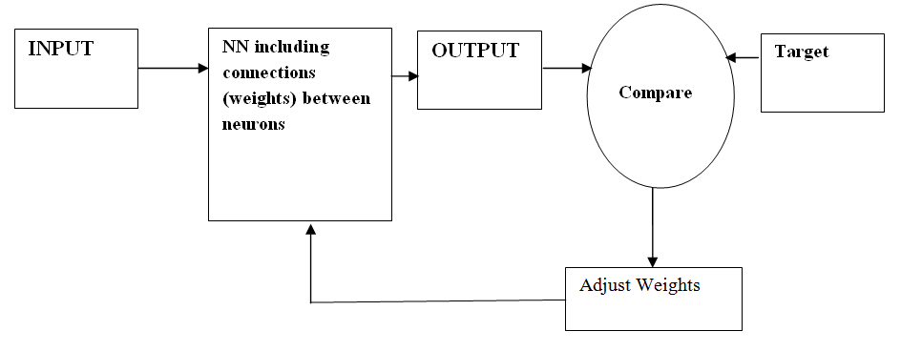

Figure 3‑1: Neural networks-input, output, adjust weights

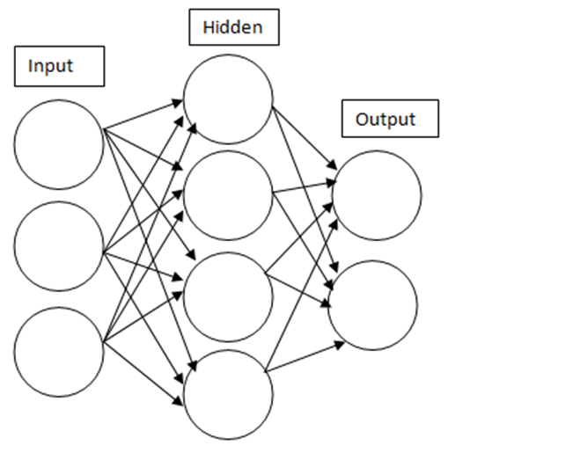

Figure 3‑2: An artificial network is an interconnected group of nodes

The difficulty of real neurons is highly abstracted when modeling artificial neurons. These basically consist of inputs(like synapses), which are multiplied by weights (strength of the respective signals), and then computed by a mathematical function which determines the activationof the neuron. Another function (which may be the identity) computes the outputof the artificial neuron (sometimes in dependence of a certain threshold). ANNs combine artificial neurons in order to process information.

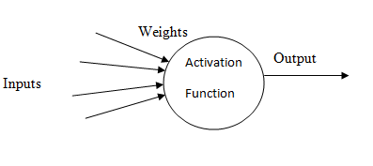

**Figure 3‑3:** An artificial Neuron

If the weight of an artificial neuron is high, than the input is also stronger which is multiplied by weight. Weights can also be negative, so the signal can be inhibitedby the negative weight. Depending on the weights, the computation of the neuron will be different. By adjusting the weights of an artificial neuron we can obtain the output we want for specific inputs. But when we have an ANN of hundreds or thousands of neurons, it would be quite complicated to find by hand all the necessary weights. But we can find algorithms which can adjust the weights of the ANN in order to obtain the desired output from the network. This process of adjusting the weights is called learning or training.

## COMPONENTS OF NEURAL NETWORKS

There are several components of ANN:-

1. **Neuron:** There are three types of neuron. They are:-

* Input neurons: Received external stimuli presented to the network.
* Output neurons: Outputs from the network are generated by the output neurons.
* Hidden neurons: Compute intermediate functions and their states are not accessible to external environment.

1. **Weight:** Weights are the connection strengths through which inputs are scaled before presented to an activation function.
2. **Activation functions:** It generates the output of a neuron. Common activation functions are binary threshold, linear threshold, sigmoid, hyperbolic tangent and Gaussian function.
3. **Pattern of Connectivity:** It determines the inter-neuron connection architecture. It is the connection together with the weights and activation functions that determine the global behavioral properties of the network.
4. **Learning Rule:** It provides a means of modifying connections strengths based on both external stimuli and network performance to improve its intended performance.

## 3.3 TYPES OF NEURAL NETWORKS AND THEIR APPLICATIONS

Neural Networks Trained to perform complex function in various fields:-

Table 3‑1: Types of network and its application

|  |  |  |
| --- | --- | --- |
| **S.No.** | **Neural Network** | **Applications** |
| 1 | General regression neural network | Function approximation |
| 2 | Adeline | Regression |
| 3 | Multi-layer perceptron | Function Approximation |
| 4 | Reinforcement learning | Control |
| 5 | Support vector machines | Classification, Regression |
| 6 | Radial basis function net | Interpolation, Regression, Classification |
| 7 | Hopfield network | CAM, Optimization |
| 8 | Boltzmann machine | Optimization |

## NEURAL NETWORK ARCHITECTURES

The basic architecture consists of three types of neuron layers: input, hidden, and output layers. ANNs can be viewed as weighted directed graphs in which artificial neurons are nodes and directed edges are connections between neuron outputs and neuron inputs.

Based on the connection pattern (architecture), ANNs can be grouped in to two categories

1. Feed-forward networks in which graphs have no loops, and
2. Recurrent (or feedback) networks, in which loops occur because of feedback connections.

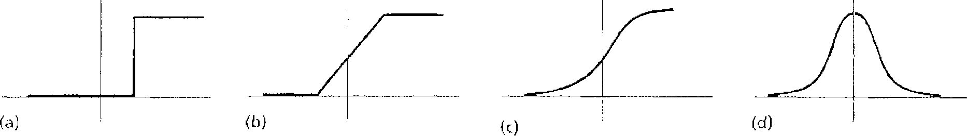

Figure 3.4: Different types of activation function – (a) threshold, (b) piecewise linear, (c) sigmoid, and (d) Gaussian.

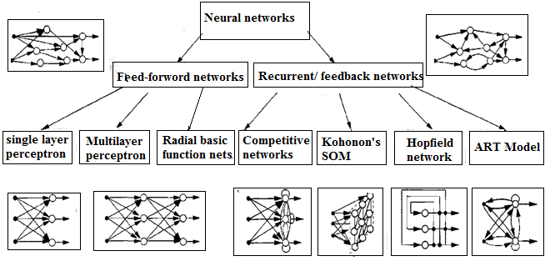

Figure 3.5: Feed-forward and recurrent feedback network architectures

In feed-forward networks, the signal flow is from input to output units, strictly in a feed-forward direction. Commonly family of feed-forward networks, are called multilayer perceptron. The data processing can extend over multiple (layers of) units, but no feedback connections are present. Feed forward networks are static, i.e. they produce only one set of output values relatively than a sequence of values from a given input. Feed forward networks are memory-less in the logic that their response to an input is independent of the previous network state.

Recurrent, or feedback, network on the other hand, are dynamic systems. When a new input pattern is presented, the neuron outputs are computed. Recurrent networks contain feedback connections. There are several other neural network architectures depending on the properties and requirement of the application. Different network architectures require appropriate learning algorithms. The learning situations in neural networks may be classified into three distinct sorts. These are supervised learning, unsupervised learning, and reinforcement learning. In supervised learning, an input vector is presented at the inputs together with a set of preferred responses, one for each node, at the output layer. The term supervised originates from the fact that the desired signals on individual output nodes are provided by an external teacher. In unsupervised learning (or self-organization), a (output) unit is trained to respond to clusters of pattern within the input.

## ADVANTAGES

Some of the advantages of ANNs are:

* The ability to extract information from incomplete and noisy data.
* Acquire experience and knowledge through self training and organization of the knowledge.
* The potential for very fast optimization.
* Their suitability for problems in which algorithmic solutions are difficult to develop or do not exist.
* Suitability of rapid application development

## **DISADVANTAGES**

The shortcomings of ANNs are:

* ANN is ‘black boxes’. They provide solutions and results without being able to explain how they arrive at their solutions.
* ANN is not very good at performing symbolic computations.
* There are no formal techniques for developing ANN applications. Therefore suitable experiments have to be conducted to determine the best ANN architecture and design.

# CHAPTER-4

# SEISMIC CONTROL OF STRUCTURES

## INTRODUCTION

It is gradually being accepted that effective means of protecting structures from earthquake forces are by way of using various methods of structural control. They are not only effective for mitigating earthquake forces, but also are equally useful in controlling undesirable vibrations of structures produced due to wind and other dynamic excitations. In addition to these, there are a number of other factors that have emerged in recent years that require the control of the structural response. These factors include increased flexibility of the structural systems, increased safety levels, performance level, and economic considerations. Structural control is the means of controlling vibration and deformations in structures caused due to earthquake and large wind forces etc acting on a structure. Structural control methods are materialized by adding special devices to the system to reduce the structural response. It gives safer and economical structural design.

## 4.2 TYPES OF CONTROL SYSTEM

Depending on the mode of operation, structural control systems can broadly be classified as:

1. Passive control systems

2 Active control systems

3 Semi-active control system

Semi-active control systems maintain the reliability of passive control systems while taking some advantage of the adjustable parameter characteristics of an active control system.

### **4.2.1 PASSIVE CONTROL SYSTEMS:**

A passive control system may be defined as a system which does not require any external power source for operation and utilizes the motion of the structure to develop the control forces i.e. these devices are inherently stable. However, the performance of optimal passive control is sometimes limited, in that they are typically designed to protect the structure from one particular dynamic loading. It is also known as passive energy dissipation systems because all vibrating structures dissipate energy due to internal stressing, rubbing, cracking, plastic deformation, and so on. Passive energy dissipation systems include a range of materials and devices for enhancing damping, stiffness and strength, and can be used both for seismic hazard improvement and for rehabilitation of aging or deficient structures. Such types of systems are characterized by their capacity to enhance energy dissipation in the structural systems in which they are installed. Passive supplemental damping systems includes frictional sliding, yielding of metals, phase transformation in metals, deformation of viscoelastic (VE) solids or fluids and fluid orificing, base isolation systems and tuned mass dampers. It includes base isolation systems. However, these passive devices methods are unable to adapt to structural changes and to varying usage patterns and loading conditions.

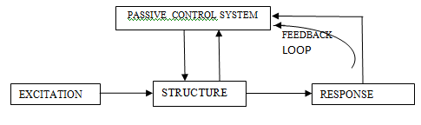

Figure 4‑1: Passive control systems

### **4.2.2 ACTIVE CONTROL SYSTEM:**

An active control system is defined as a system which requires a large power source for operation of electro hydraulic or electro mechanical actuators which supply control forces to the structure. Control forces are developed based on response from sensors that measure the excitation of the structure. These control forces can be used to both add and dissipate energy in the structure. The response from the structural response may be measured at locations remote from the location of the active control system. In an active control system, the signals sent to the control actuators are a function of the response of the system measured with physical sensors (optical, mechanical, electrical, chemical, and so on). The role of the active system is to reduce building vibration under strong winds and moderate earthquake excitations and consequently to increase comfort of occupants of the building.

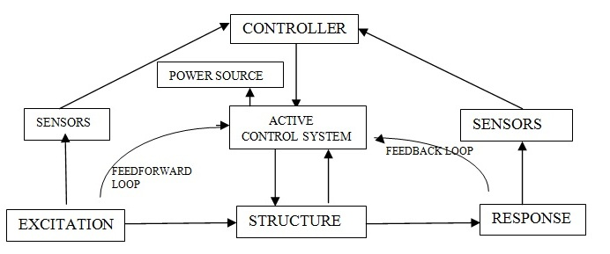

Figure 4‑2: Active control system

### 

### **4.2.3 SEMI-ACTIVE CONTROL SYSTEM :**

A semi-active control systems are a class of active control systems or it may be defined as a system which typically requires external power source of the order of magnitude smaller than typical active control system for operation (e.g. a battery) and utilizes the motion of the structure to develop the control forces, the magnitude of which can be adjusted by the external power source. Control forces are developed based on feedback from sensors that measure the excitation and the response of the structure.

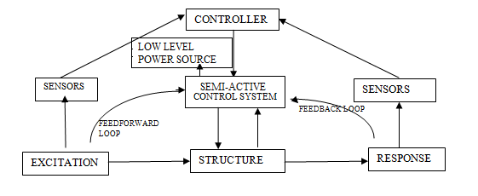

Figure 4‑3: Semi Active control system

Typically, semi-active control devices do not add mechanical energy to the structural system (including the structure and the control actuators), therefore bounded- input bounded-output stability is guaranteed. The feedback from the structural response may be measured at locations remote from the location of the semi-active control system. Semi-active control devices are frequently view as controllable passive devices.

Various types of Semi-active control system are:

**Electrorheological (ER) dampers:**

ER dampers typically consist of a hydraulic cylinder containing micron-sized dielectric particles suspended within a fluid (usually oil). In the presence of strong electric field, the particles polarize and become aligned, thus offering an increased resistance to flow. As the applied electric field increases, the behavior of ER fluids changes from that of viscous fluid to that of a yielding solid within milliseconds.

**Magneto rheological (MR) dampers:**

MR dampers are essentially magnetic analogs of ER dampers. Qualitatively, the behaviour of the two types of types of dampers is very similar except that the control effect is governed by the application of electric field in one case and by magnetic field in other. MR damper typically consists of a hydraulic cylinder containing micron-sized, magnetically polarizable particles suspended within a fluid (usually oil). MR fluid behaviour is controlled by subjecting the fluid to a magnetic field in the absence of a magnetic field, the MR fluid flows freely while in the presence of a magnetic field the fluid behaves as a semi-solid.

**Friction control devices:**

Semi-active friction dampers, also known as variable friction (VF) dampers typically consists of one or multiple friction interfaces, and also includes a clamping mechanism that produces a normal contact force on the interfaces. By regulating the clamping force applied on the friction interface in real time, a VF damper can adjust its slip force in response to structural motion and earthquake excitation, so that the damper remain activated (slip state) during the entire duration of earthquake. Because of this adaptive nature, a semi-active friction damper is expected to be more effective than a passive damper. Semi-active friction control devices are utilized either as energy dissipaters within the lateral bracing of a structure or as components within sliding isolation systems.

**Fluid viscous dampers:**

Semi-active fluid viscous dampers typically consist of a hydraulic cylinder containing a piston head which separates the two sides of the cylinder. As the piston is cycled, the fluid within the damper (usually oil) is forced to pass through small orifice at high speeds. The pressure differential across the piston head, and thus the output force, is modulated by an external control valve which connects the two sides of the cylinder. The control valve may take the form of a solenoid valve for on-off control or a servo-valve for variable control. The device behaves essentially as an adjustable force device with hysteretic-type damping.

**Tuned mass dampers (TMD) and Tuned liquid dampers (TLD):**

Tuned mass dampers essentially consist of a single degree of freedom mass-spring-damper system which is typically mounted on the top of a multi-story structure. The dynamic characteristics of the system are tuned so as to control the motion of the structure to which it is attached. Tuned liquid dampers are similar to tuned mass dampers except that the mass-spring-damper system is replaced container filled with fluids.

# CHAPTER-5

# BUILDING CONTROL USING MR DAMPER

**5.1 INTRODUCTORY REMARKS**

Magnetorhelogical (MR) damper has emerged as one of the most attractive semi-active devices that is capable of generating the magnitude of force necessary for full-scale application to civil engineering structures. Moreover the device is operated with very low power and offers highly reliable operation and its operation is relatively insensitive to temperature fluctuation or impurities in the fluid. Researchers have been investigating the effectiveness of MR damper, for earthquake hazard mitigation as applicable to civil engineering structures over last one decade through numerical and experimental studies.

Therefore, in order to examine the applicability of MR damper for full scale buildings the present study is undertaken. In this chapter, a structural model of a twenty five story realistic RC building with semi-active MR damper rigidly connected between floors is considered to investigate the effectiveness of these devices for seismic response control.

The specific objectives of the study are:

1. To study the effectiveness of MR damper for seismic response mitigation.

2. To compare the performance of MR damper with an undamped system from Artificial Neural Network.

**5.2 STRUCTURAL MODEL**

The building is idealized as a linear shear type building with lateral degrees of freedom at floor levels. The system is assumed to remain in linear elastic state and hence does not yield under excitation. It is considered that the system is subjected to unidirectional excitation and spatial variation of ground motion and any effect due to soil structure interaction is neglected. The lateral resistance of the buildings is assumed to be so large that it does not affect the dampers performance adversely. The structure model of the building with MR damper is shown in Figure 5.1 respectively. The governing equations of motion of the multi degree of freedom (MDOF) system are written as:

 (5.1)

where, *M*, *C*, and *K* are the mass, damping and stiffness matrices of the system, respectively; *fm* *is* the MR damper force vector, respectively; *D* is the damper location matrix; u is the displacement vector with respect to the ground; *r* is a influence coefficient vector; and *u*gis the earthquake ground acceleration.

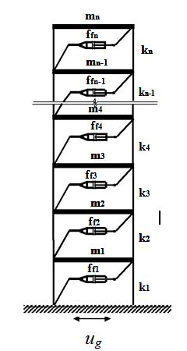

Figure 5.1: Structural Model of the building with MR Damper

The governing equations of motion Eq. (5.1) are solved using Newmark’s step-by step method assuming linear variation of acceleration over a small time interval∆ *t,* the Newmark’s algorithm used is explained below.

A lumped mass structural model of a twenty five story RC frame is considered with each floor mass and stiffness as 150 ton and 130000 kN/m, respectively and MR dampers rigidly connected between floors. The building is subjected to unidirectional excitation for which two real earthquake (Loma Prieta and ElCentro,California) ground motions are considered. The performance of MR is investigated by providing dampers at all floors. This parametric study is conducted with command voltage of 9V. A plot, comparing the results obtained was then prepared, showing the effectiveness of Neural Network as a structural control tool. A comparison of uncontrolled and controlled time response of top floor displacement, acceleration and   
normalized base shear is shown in Figures.

**5.3 NEWMARK’S TIME-STEPPING METHOD**

The equations of motion (5.3.1) are solved numerically using Newmark’s method of step-by-step integration; adopting linear variation of acceleration over a small time interval of. At each time instant, the responses, namely, acceleration, velocity and displacement are obtained at each floor of building.

 (5.3.1)

N. M. Newmark’s developed a time-stepping method in 1959 based on the following Eqs. (5.3.2) and (5.3.3)

 (5.3.2)

 (5.3.3)

Eq. (5.3.2) can be re-written as



 (5.3.4)

Using incremental response,  and  Eq. (5.3.4) becomes

 (5.3.5)

Eq. (5.3.3) can be re-written as



 (5.3.6)

Using incremental response  and  Eq. (5.3.6) becomes

 (5.3.7)

Eq. (5.3.7) can be written as

 (5.3.8)

Substituting Eq. (5.3.8) into the Eq. (5.3.5) and after simplification, we get

 (5.3.9)

The governing equations of motion in incremental form are expressed as:

 (5.3.10)

Where,  and  be the incremental earthquake and damper force respectively and are given by

 and  (5.3.11)

After, substituting the values of from the Eqs. (5.3.7), (5.3.8) and (5.3.9) respectively in equations of motion (5.3.10) and simplifying further, reduced to



The above equation may be re-formulated as



 (5.3.12)

where, 



 and



The  will be known from the system properties, similarly, algorithm parameters are known at the beginning of the time step. The incremental displacement computed from the expression (5.3.12) is given by

 (5.3.13)

Once incremental displacement  is known, the incremental velocity and acceleration is computed from the Eqs. (5.3.9) and (5.3.8), respectively. The incremental velocity and incremental acceleration is given by

 (5.3.14)

 (5.3.15)

Similarly, the displacement, velocity and acceleration over time step  are computed from the equations

 (5.3.16-18)

However, the acceleration over the time step, that is, is obtained from the governing equations of motion under equilibrium that is,

 (5.3.19)

This is to avoid the unbalanced forces generated in numerical integration scheme.

# CHAPTER-6

# GENERATION OF ARTIFICIAL NEURAL NETWORK

**6.1 For Uncontrolled Structure**

A lumped mass structural model of a twenty five story RC frame is considered with each floor mass and stiffness as 150 ton and 130000 kN/m, respectively and building is subjected to unidirectional excitation. For the generation of Artificial Neural Network We use Input data as time and ground Acceleration and Target data as Top floor displacement, Top floor acceleration and Base shear, from the given data ANN is generated then it is simulated for the input data and finally results are compared with the Controlled structure.

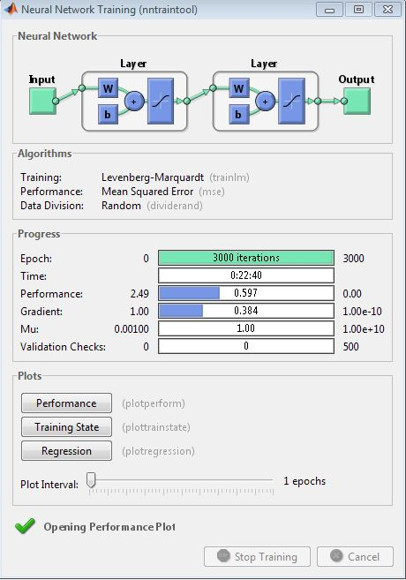

**Figure 6‑1:** Neural Network Training for Loma EQ

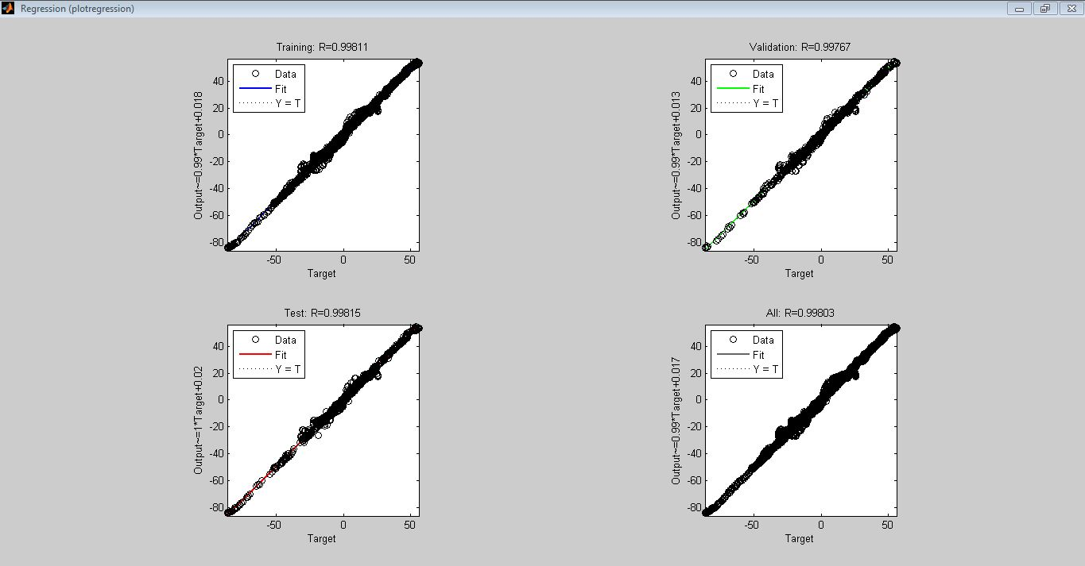

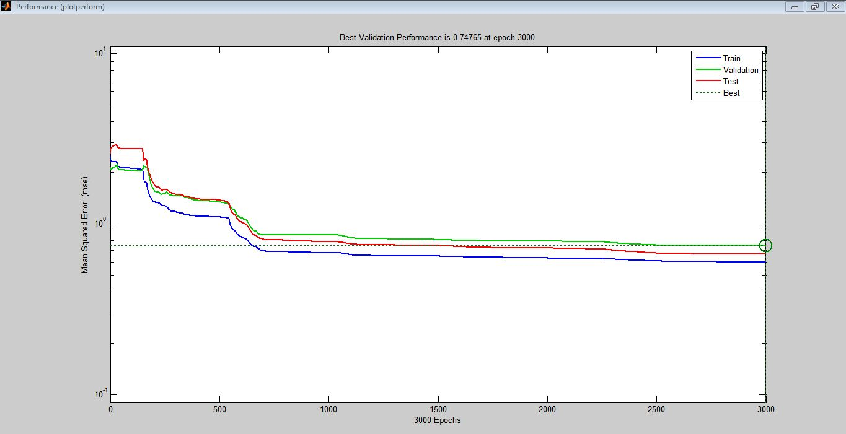

**Figure 6‑2:** Regression and Performance Curves for Loma EQ

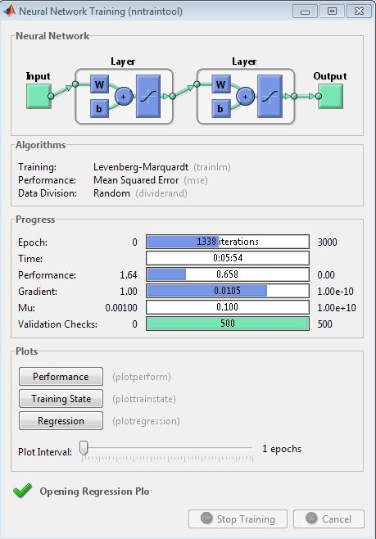

**Figure 6‑3:** Neural Network Training for El Centro EQ

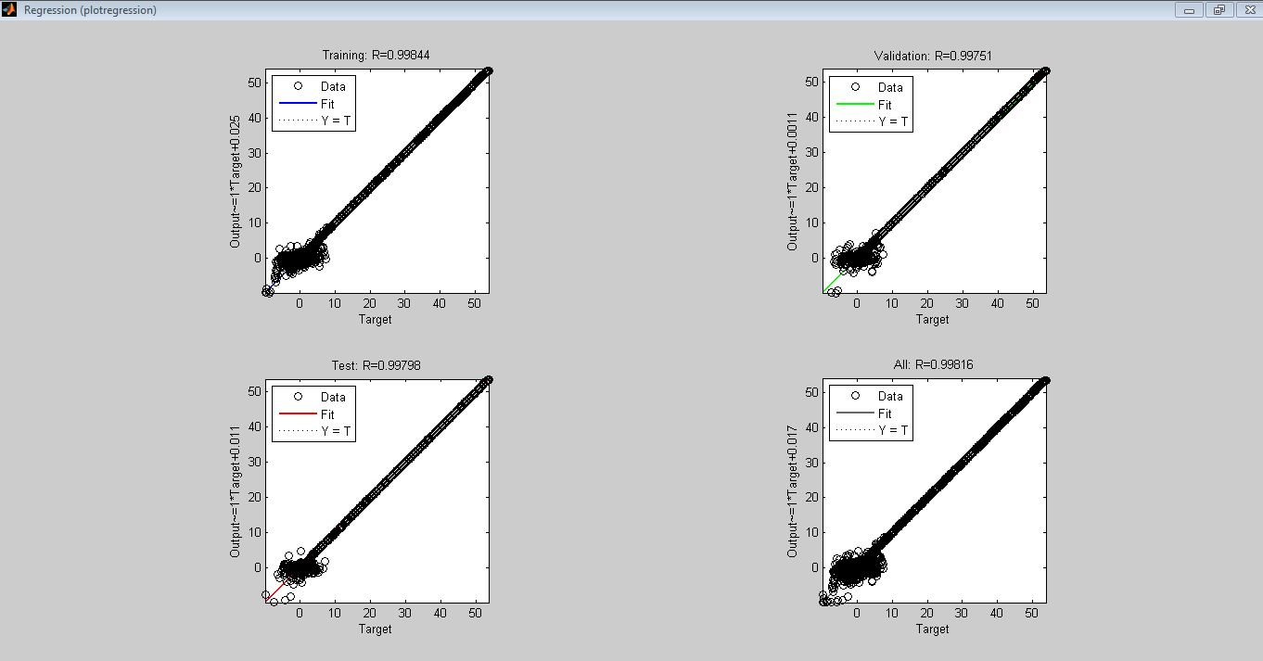

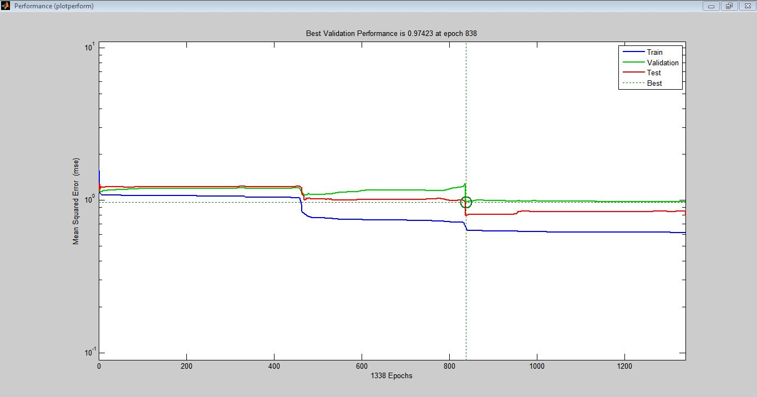

**Figure 6‑4:** Regression and Performance Curves for El Centro EQ

**6.2 For Controlled Structure:**

A lumped mass structural model of a twenty five story RC frame is considered with same mass and stiffness. The performance of structure is investigated by providing dampers at all floors.This parametric study is conducted with command voltage of 9V. MR dampers rigidly connected between floors.

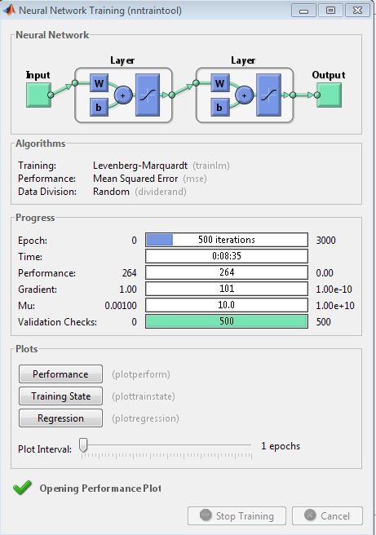

**Figure 6‑5:** Neural Network Training for Loma EQ

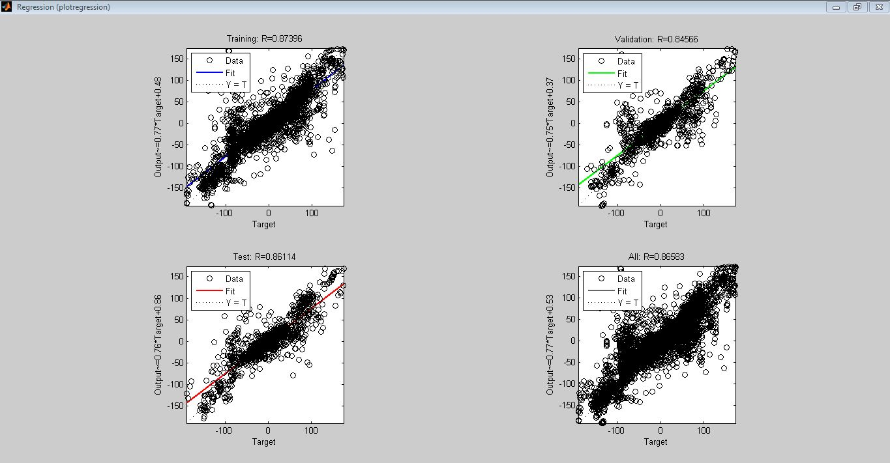

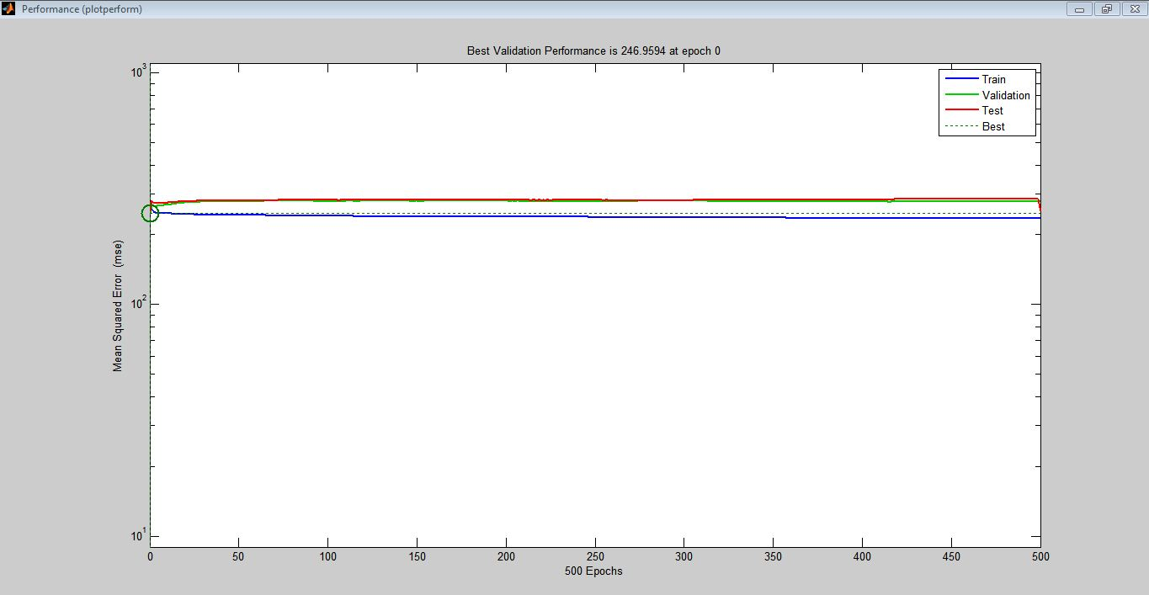

**Figure 6‑6:** Regression and Performance Curves for Loma EQ

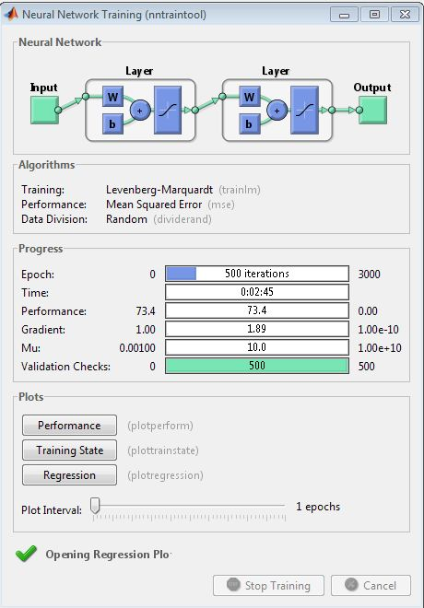

**Figure 6‑7:** Neural Network Training for El Centro EQ

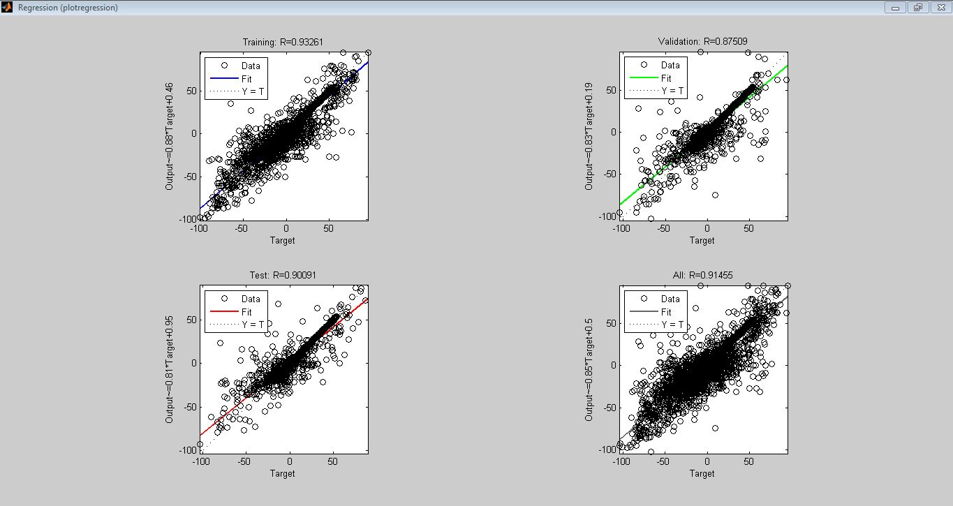

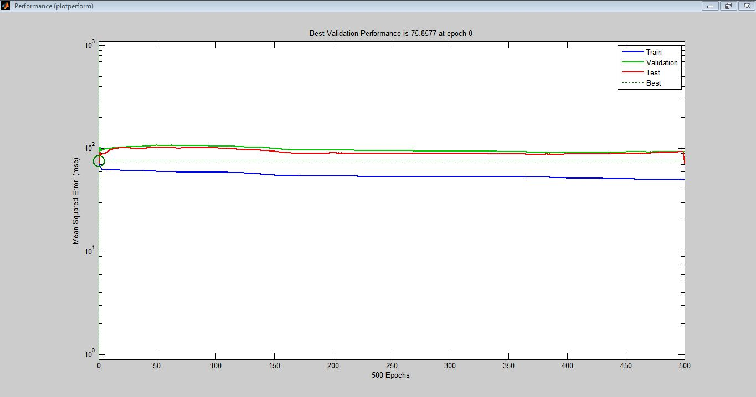

**Figure 6‑8:** Regression and Performance Curves for El Centro EQ

**6.3 Comparison of Controlled and Uncontrolled systems:**

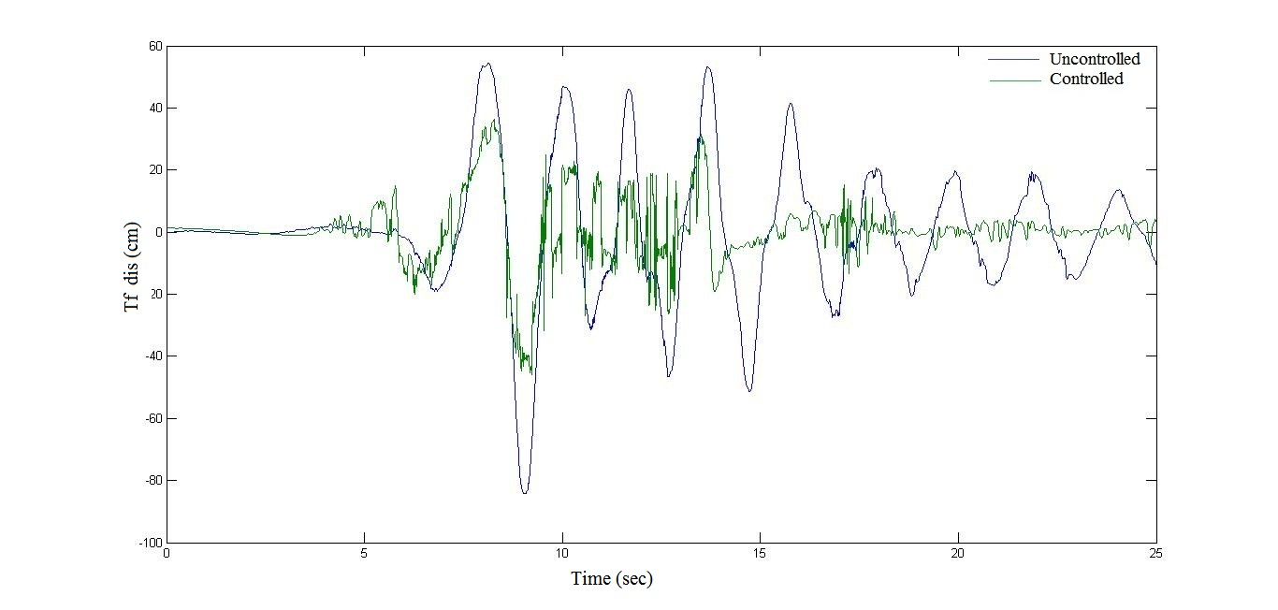

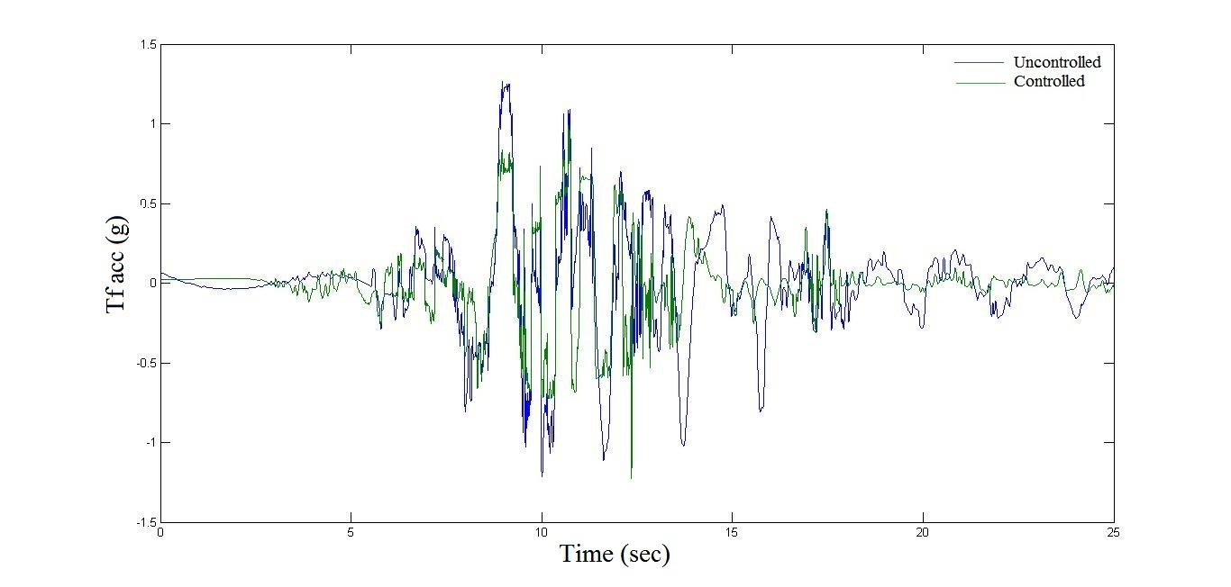

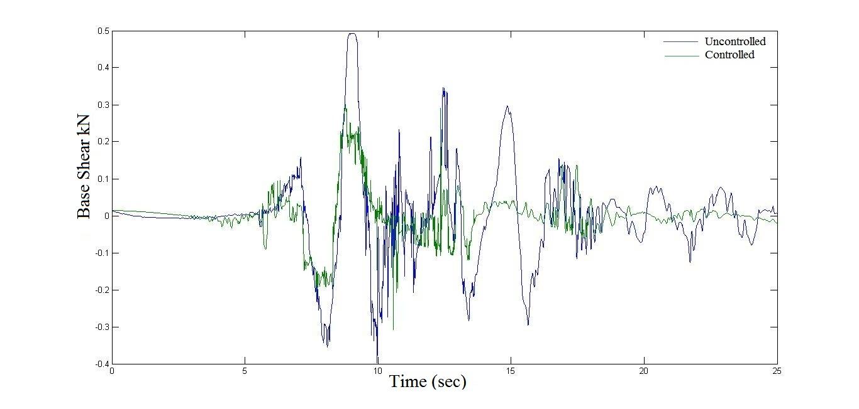

**Figure 6‑9:** Time based responses of the structure Ground Motion: Loma

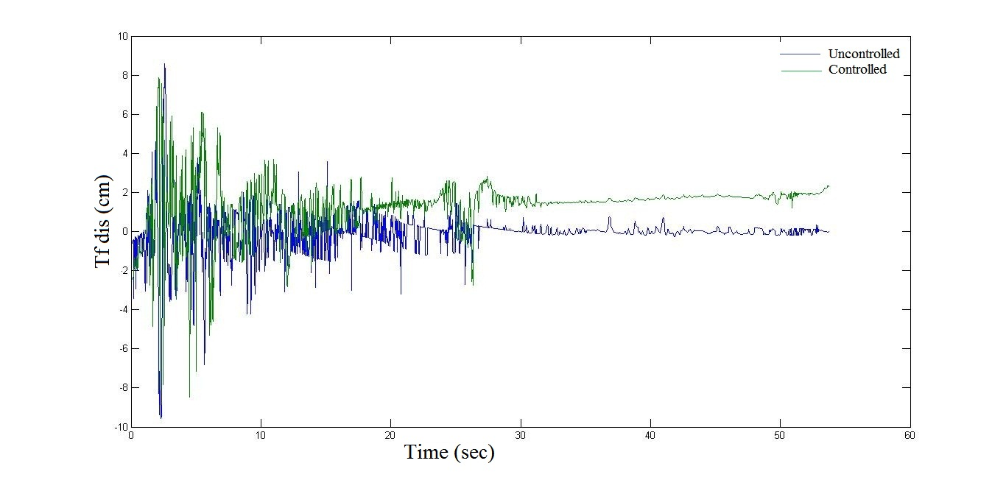

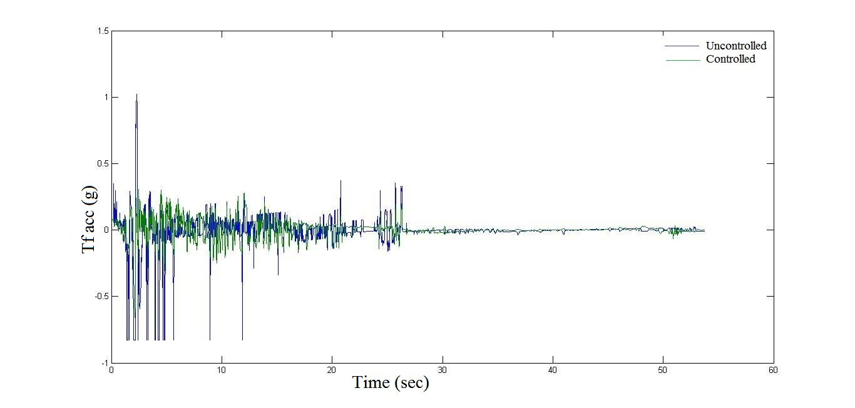

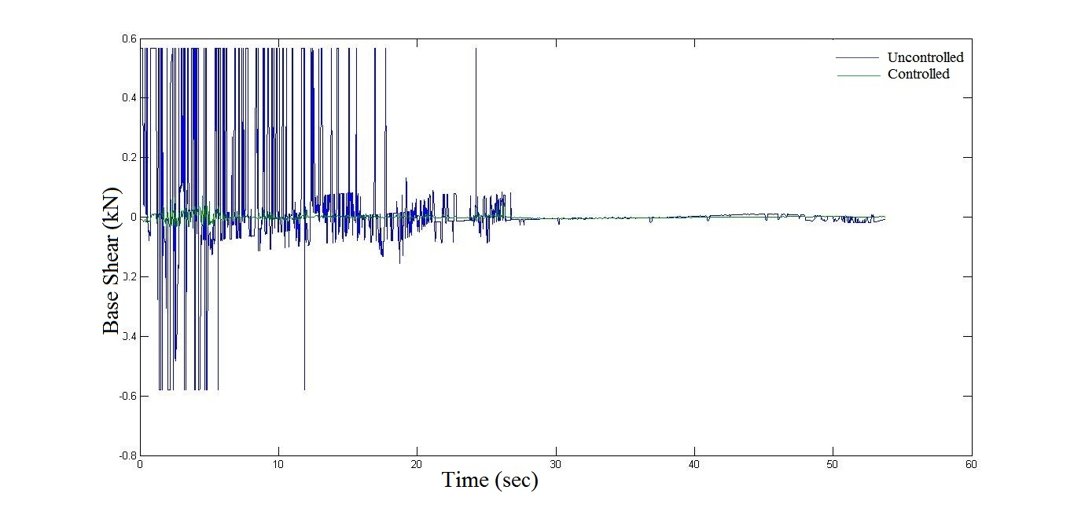

**Figure 6‑10:** Time based responses of the structure Ground Motion: El Centro

# CHAPTER-7

# RESULTS AND DISCUSSIONS

The effectiveness of semi-active dampers (MR) in response reduction for individual building frame has been investigated. It is observed from the results that the dampers are quite effective in response control for ground motion. The damper parameters must be appropriately chosen in order to attain best control performance.

Table 7‑1: Seismic Response for Loma Earth Quake

|  |  |  |  |
| --- | --- | --- | --- |
| S/No | Seismic Response (Loma EQ) | For Uncontrolled  System | For Controlled  system |
| 1 | Top Floor Displacement (cm) | 54.4481 | 36.4415 |
| 2 | Top Floor Acceleration (g) | 1.2657 | 0.9872 |
| 3 | Base Shear (kN) | 0.4926 | 0.3001 |

Table 7‑2: Seismic Response for El Centro Earth Quake

|  |  |  |  |
| --- | --- | --- | --- |
| S/No | Seismic Response (El Centro EQ) | For Uncontrolled  system | For Controlled  system |
| 1 | Top Floor Displacement (cm) | 8.5696 | 7.8571 |
| 2 | Top Floor Acceleration (g) | 1.0212 | 0.3075 |
| 3 | Base Shear (kN) | 0.5660 | 0.0721 |

The result shows the performance of MR damper for seismic response reduction is better than the uncontrolled system.

# CHAPTER-8

# CONCLUSION

**8.1 PRELIMINARY REMARKS:**

The effectiveness of MR damper as seismic response control device is investigated taking numerical example of a 25-story realistic RC building modeled as linear shear building subjected to unidirectional excitation. The performance of the MR damper is evaluated for a voltage of 9 Volts and the results are compared with that of a structurally uncontrolled system by Neural Networks.

**8.2 MAIN CONCLUSIONS:**

Based on the trends of the result obtained from the numerical study following precise conclusions are drawn.

* Control system is quite effective as compared to uncontrolled system in response control for ground motion.
* Dampers are able to dissipate significant amount of seismic energy safely.
* There exists an optimum value of command voltage for overall best control performance for a wide range of ground motion.

**8.3 SCOPE FOR FUTURE WORKS:**

The above study suggests that there is further scope to investigate the response of the structure for influence of bi-directional excitation. It can also be considered that the Magneto Rheological(MR) dampers may be provided at alternate floor.

**********************************

**REFERENCES**

1. Jangid, R. S., and Datta, T. K. (1992). “Seismic behaviour of torsionally coupled base isolated structure.” *European Earthquake Engineering (Italy)* 6, 2-13.
2. Housner, G. W., Bergman, L.A., Caughey, T. K., Chassiakos, A. G., Claus, R. O., Masri, S. F., Skelton, R. E., Soong, T. T., Spencer, B. F., and Yao, J. T. P. (1997). “Structural control: past, present and future.” *Journal of Engineering Mechanics ,ASCE,* 123(9), 897-971.
3. Soong, T.T., and Spencer Jr, B.F. (2002). “Supplemental energy dissipation: state-of-the-art and state-of-the-practice.” *Engineering Structures,* 24, 243-259.
4. Shrimali, M. K., and Jangid, R. S. (2002). “Non-linear seismic response of base-isolated liquid storage tanks to bi-directional excitation.” *Nuclear Engineering and Design,* 217, 1-20.
5. Spencer Jr, B. F., and Nagarajaiah, S. (2003). “State of the art of structural control.” *Journal of structural Engineering,* *ASCE,* 129(7), 845-856.
6. Spencer Jr, B. F., Dyke, S. J., Sain, M. K., and Carlson, J. D. (1997). “Phenomenological model for magnetorheological dampers.” *Journal of Engineering Mechanics, ASCE,* 123(3), 230-238
7. Hrovat, D., Barak, P., Rabins, M. (1983). “Semi-active versus passive or active tuned mass dampers for structural control.” *Journal of Engineering Mechanics, ASCE,* 109(3), 691-705.
8. Karnopp, D. (1990). “Design principles of vibration control systems using semi-active dampers.” *Journal of Dynamic Systems, Measurement and Control,* 112, 448-455.
9. Ivers, D. E., and Miller L. R. (1991). “Semi-active suspension technology: An evolutionary view.” *Advance Automotive Technologies, ASME,* 40, 327-346.
10. Syman, M. D., and Constantinou, M. C. (1999). “Semi-active control systems for seismic protection of structures: state-of-the-art review.” *Engineering structures,* 21, 469-487.
11. Dyke, S. J., Spencer Jr, B. F., Sain, M. K., and Carlson, J. D. (1996a). “Modeling and control of magnetorheological dampers for seismic response reduction.” *Smart Materials and Structures*, 5, 565-575.
12. Dyke, S. J., Spencer Jr, B. F., Quast, P., Sain, M. K., Kaspari Jr, D. C., and Soong, T. T. (1996b). “Acceleration feedback control of MDOF structures.” *Journal of Engineering Mechanics*, *ASCE,* 122(9), 907-918.
13. Dyke. S. J., and Spencer Jr, B. F. (1996). “Seismic response control using multiple MR dampers.” *Proceedings of the 2nd International Workshop on Structural Control.*
14. Dyke, S. J., and Spencer Jr, B. F. (1997). “A comparison of semi-active control strategies for the MR damper.” *Proceedings of the IASTED International Conference, on Intelligent Information Systems, the Bahamas, 580*-584.
15. Singh, M. P., Matheu, E. E., and Saurez, L. E. (1997). “Active and semi-active control of structures under seismic excitation.” *Earthquake Engineering and Structural Dynamics,* 26, 193-213.
16. Sadek, F., and Mohraz, B. (1998). “Semi-active control algorithms for structures with variable dampers.” *Journal of Engineering Mechanics, ASCE,* 124(9), 981-990.
17. Xu, Y. L., Qu, W. L., and Ko, J. M. (2000). “Seismic response control of frame structures using magnetorheological/electrorheological dampers.” *Earthquake Engineering and Structural Dynamics*, 29, 557-575.
18. Jansen, L. M., and Dyke, S. J. (2000). “Semi-active control strategies for MR dampers: comparative study.” *Journal of Engineering Mechanics*, *ASCE,* 126(8), 795-803.
19. Yang, G., Spencer Jr, B. F., Carlson, J. D., and Sain, M. K. (2002). “Large-scale MR fluid dampers: modeling and dynamic performance considerations.” *Engineering Structures,* 24 , 309-323.
20. Yang, G., Spencer Jr, B. F., Carlson, J. D., and Sain, M. K. (2002). “Large-scale MR fluid dampers: modeling and dynamic performance considerations.” *Engineering Structures,* 24 , 309-323.
21. Sahasrabudhe, S. S., and Nagarajaiah, S. (2005). “Semi-active control of sliding isolated bridges using MR dampers: an experimental numerical study.” *Earthquake Engineering and Structural Dynamics*, 34, 965-983.
22. Narasimhan S., and Nagarajaiah, S. (2005). “A STFT semi-active controller for base isolated buildings with variable stiffness isolation systems.*”* *Engineering Structures,* 27, 514–523.
23. Chen, H. M. , Tsai, K. H. , Qi, G. Z. , Yang, J. C. S. , and Amini, F. (1995), “Neural Network for Structural Control” *Journal of Computing in Civil Engineering*, Vol. 9, pp. 168-175
24. Masri S.F. and Chassiakos (1996)A.G. “Modelling Unknown Structural System Through the use of Neural Networks”, *Earthquake Engineering and Structural Dynamics*, vol. 25, pp. 117-128
25. Ghaboussi, J., and Joghataie, A. (1995), “Active control of Structures Using Neural Networks”, *Journal of Engineering Mechanics*, Vol. 121, pp. 555-567
26. Nikzad Khashayar, Ghaboussi Jamshid and Paul Stanley L (1996) “Actuator Dynamics and Delay Compensation using Neurocontrollers”, *Journal of Engineering Mechanics*, Vol. 122, pp. 966-975
27. Bani-Hani Khaldoon and Ghaboussi Jamshid (1998), “Nonlinear Structural Control Using Neural Networks”, *Journal of Engineering Mechanics*, Vol. 124, pp. 319-327
28. Bani-Hani Khaldoon , Ghaboussi Jamshid and Schneider Stephen P. (1999) “Experimental Study of Identification and Control of Structures Using Neural Network Part 1: Identification” *Earthquake Engineering and Structural Dynamics*, Vol. 28, pp. 995-1018
29. Abraham, A. (2004) “Meta-Learning Evolutionary Artificial Neural Networks”, *Neurocomputing Journal*, Vol. 56c, Elsevier Science, Netherlands, (1–38).