**Chapter 1**

**INTRODUCTION**

**1.1 Idealized structural unit method**

Under extreme or accidental loading, steel structures can exhibit highly nonlinear response associated with yielding, buckling, crushing and sometimes rupture of individual structural components. Quite accurate solutions of the nonlinear structural response in many such cases can be obtained by application of the conventional finite element method (FEM). However, a weak feature of the conventional FEM is that it requires enormous modelling effort and computing time for nonlinear analysis of large sized structures. Reduction in that modelling effort and the associated solution time while also providing an acceptable level of accuracy in results is the primary benefit of the **idealized structural unit method** (ISUM).

The most obvious way to reduce modelling effort and computing time in FEM applications is to reduce the number of degrees of freedom so that the number of unknowns in the finite element stiffness matrix decreases. Modelling the object structure with very large sized structural units is perhaps the best way to do that. In order to avoid the related loss of accuracy, ISUM requires the use of special purpose finite elements. Properly formulated structural units within such an approach can then be used to efficiently model the actual nonlinear behaviour of the corresponding large parts of structures. Ueda and Rashed who suggested this idea, called it the **idealized structural unit method** (ISUM).

* 1. **ISUM vs. FEM**
* FEM requires enormous modelling effort and computing time for nonlinear analysis of large sized structures. Reduction in that modelling effort and the associated solution time while also providing an acceptable level of accuracy in results is the primary benefit of the idealized structural unit method.
* In order to avoid the related loss of accuracy, ISUM requires the use of special purpose finite elements. Properly formulated structural units within such an approach can then be used to efficiently model the actual nonlinear behaviour of the corresponding large parts of structures.
* By applying ISUM, the size of numerical computations is much reduced leading to dramatic savings of modelling and computing times, compared to those of the conventional FEM.
* In conventional FEM, finer meshes are normally be used, while on the other hand a plate is modelled using a single ISUM plate unit for ISUM analysis.
* ISUM is a simplified nonlinear FEM. Unlike the conventional nonlinear FEM, ISUM idealizes a structural component making up the structure as one ISUM unit with a few nodal points.

**1.3 Progressive collapse analysis**

**1.3.1     Introduction**

Progressive collapse is the result of a localized failure of one or two structural elements that lead to a steady progression of load transfer that exceeds the capacity of other surrounding elements, thus initiating the progression that leads to a total or partial collapse of the structure.

Progressive collapse as a structural engineering point of view started taking attention when partial collapse of 22 storey Ronan Point apartment building occurred in London on May 16, 1968. This collapse generated considerable concern over the adequacy of existing building codes. After the partial collapse of Ronan Point apartment building, number of other collapses around the world took place, which could be placed in to category of progressive collapse. The collapse of Skyline Plaza in Virginia, the Civic Arena roof in Hartford, the Murrah Federal Building in Oklahoma City, the Khobar Towers - Saudi Arabia, the U.S. embassies in Kenya and Tanzania, WTC Towers in New York were important collapse events in the history of progressive collapse which changed the perspective of the structural design.

In normal design practice, the abnormal events like, gas explosions, bomb attack, vehicle impacts, foundation failure, failure due to construction or design error etc are not considered. It is not economical as well to design the structures for accidental events unless they have reasonable chance of occurrence. Considering these aspects, many government authorities and local bodies have worked on developing some design guidelines to prevent progressive collapse. Among these guidelines, U.S. General Services Administration (GSA) and Department of Defense (DoD) guidelines by United Facilities Criteria (UFC) - New York, provide detailed stepwise procedure regarding methodologies to resist the progressive collapse of structure. In this procedure, one of the important vertical structural elements in the load path i.e. column, load bearing wall etc. is removed to simulate the local damage

scenario and the remaining structure is checked for available alternate load path to resist the load.

**1.3.2 Mechanism of Progressive Collapse**

Any collapse in a way could be regarded as progressive collapse, but it should be of special concern if the collapse is disproportionate to its original cause. The disproportionality refers to the situation in which failure of one member causes a major collapse of larger magnitude compared to initial event. It is similar to fall of cycles in a cycle stand when the first one is pushed. This can also be compared with “domino” effect. Another example is “house of cards” effect [fig. below].

Based on different characteristic features, progressive collapse can be categorized in six different types as described below.



Fig.1 House of cards effect

1) **Pancake-type collapse**: failure sequence followed in this type of collapse is; initiating event, separation of structural components, release of potential energy and the occurrence of impact forces. Depending on the size of the falling components, the potential energy of falling components can far exceed the strain energy stored in the structure. The collapse of WTC towers of New York in Sept. 2001 is example of this type of collapse where collapse is said to be initiated by weakening of the floor joists due to fire that resulted from the aircraft impact. The loss of structural member was limited to the few stories but it progressively extended throughout the height of tower. The potential energy of upper part of collapsed members converted in to kinetic energy which turned in to impact force which was far beyond the resisting capacity of the lower floors and ultimately resulted in to total collapse of the tower.

2) **Zipper-type collapse:** this type of collapse is initiated by rupture of one cable and propagating by overloading & rupture of adjacent cables. Example of this type of collapse is collapse of original Tacoma Narrows Bridge. After the first hangers of that suspension bridge snapped due to wind induced vibrations of the bridge girder, the entire girder peeled off and fell. Impact force does not typically occur in this type of collapse, which is the case in pancake-type collapse.

3) **Domino-type collapse:** mechanism behind this type of collapse is, initial overturning of one element, fall off that element in angular rigid-body motion around a bottom edge, transformation of potential energy into kinetic energy, lateral impact of the upper edge of that element on the side face of an adjacent element where the horizontal pushing force transmitted by that impact is of both static and dynamic origin because of the tilting and the motion of the impacting element, overturning of the adjacent element due to the horizontal loading from the impacting element and collapse progression in the overturning direction. This type of failure can occur in row of temporary scaffolding towers. In overhead transmission line towers also, this type of collapse is common.

4) **Section-type collapse:** when a member under bending moment or axial tension is cut, the internal forces transmitted by that part are redistributed in to the remaining cross section. The corresponding increase in stress at some locations can cause the rupture of further cross sectional parts, and, in the same manner, a failure progression throughout the entire cross section. This type of failure can be termed as “fast fracture” instead of progressive failure.

5) **Instability-type collapse:** instability of structure is characterized by small imperfection which leads to large deformations or collapse. For example, the failure of a bracing element due to some small triggering event can make a system unstable and result in collapse.  Another example is failure of a plate stiffener leading to local instability and failure of the affected plate, and possibly to global collapse. Here propagating destabilization occurs when the failure of destabilized elements leads to the failure of stabilizing elements.

6) **Mixed-type collapse:** this type of collapse can be assigned to the structure where one or more possible failure reasons fall in to different category of progressive collapse. For example, the partial collapse of the Murrah Federal Building (Oklahoma City) seems to have involved features of both a pancake-type and domino-type scenario. The horizontal forces, induced by an initial failure, that lead to overturning of other elements. This horizontal tensile force could have been induced by falling components and transmitted to other elements through continuous reinforcing bars.  Another example is collapse of cable-stayed bridges which fall in to category of zipper-type and instability-type failure. The girders and towers of cable-stayed bridges are in compression. They are braced by the stay cables. Thus, the loss of one or few cables can not only lead to unzipping, but also to instability failure.

**1.4 Objectives**

The objectives of the present investigation are

1. To investigate the applicability of ISUM to the progressive collapse analysis of box columns.
2. To plot comparison of the ISUM with more refined nonlinear finite element method (FEM) computations.

**Chapter 2**

**LITERATURE REVIEW**

Thin-plated box columns are often used as main strength members of ships, ship-shaped offshore structures, and aerospace structures. It has been recognized that the limit state is a much better basis for design and strength assessment of thin-walled structures than the traditional allowable working stress, because it is not possible to determine the true margin of safety as long as the limit states remain unknown[1,2].

Limit state is meant to be a condition where the structure fails to perform its intended function which has been designed beforehand. Limit states are classified into four types, namely serviceability limit states, ultimate limit states, fatigue limit states, and accidental limit states [1-3]. The present study is focused on ultimate limit states of thin-walled box columns.

A number of useful studies related to ultimate limit state assessment and design of thin-walled box columns have previously been undertaken in the literature. In the following, the results of a brief literature survey are addressed in the order of the year of their publications.

Liew et al [4] presented an analytical method for the ultimate strength calculations of thin-walled steel box columns under eccentrically applied loads. An effective width formula to account for local buckling and residual stresses is proposed, and the formula along with the tangent stiffness method has been used to develop an analytical method for predicting the failure load of box columns.

Mahendran and Murray [5] presented theoretical and experimental results of ultimate strength behavior for box columns with varying the plate slenderness ratios. A simplified rigid–plastic analysis was performed to analyze the collapse behavior of box columns based on the plastic mechanisms observed during the experiment.

Liew et al. [6] presented a semi-analytical procedure for predicting the ultimate strength of thin-walled steel box columns under the combined action of axial thrust and biaxial bending. Simplified design equations based on the effective width concept were proposed for the analysis by taking into account the local buckling effects.

Guo [7] presented a semi-analytical method to analyze the elasto-plastic interaction buckling behavior between local and overall flexural buckling modes in thin-walled box columns. It was assumed that a beam-column could be modeled as an assemblage of locally buckled short struts, each being equal to half the local buckle wavelength of the perfect column. The moment–curvature–thrust relationships of the locally buckled short strut were derived in the elasto-plastic range.

Shanmugam et al. [8] presented an analytical method for predicting the ultimate strength of thin-walled box– beam-columns under axial loads applied at biaxial eccentricities. The effects of local buckling were taken into account applying the effective width concept.

Usami et al. [9] reviewed some ductility and strength researches on thin-walled steel bridge structures which have been undertaken at Nagoya University, Japan. Empirical formulations for the ultimate strength of box columns were presented.

Kotelko [10] reviewed the recent results in the area of ultimate limit state assessment of thin-walled beams and columns with different types of cross-sections. Theoretical analysis and experimental investigation of plastic mechanisms at the ultimate limit state of thin-walled box columns was made so as to present insights which will be useful for the application of the rigid-plastic theory.

Kiymaz [11] presented an analytical method for the analysis of buckling strength of thin-walled steel box columns under axial compression considering interaction effects between local and overall buckling. Earlier theoretical results on the optimum design of axially compressed box columns which have been validated through finite element analysis were employed.

Although a number of useful studies on ultimate limit state assessment of concrete-filled thin-walled box columns have also been undertaken in the literature [12-15], the present study is focused on thin-walled steel box columns. It is clear from the previous studies that steel box columns show geometric nonlinearity associated with the ultimate limit state is reached. Also, it is of significant importance to take into account the interacting effect between local and overall buckling of plate elements in the ultimate limit state assessment of thin-walled box columns.

It has been recognized that the progressive collapse analysis is desirable to cover all these aspects noted above so that the interaction effects between local and overall failure modes as well as geometric and material nonlinearities can be taken into account in a more refined way.

Here, a method useful for the progressive collapse analysis of thin-walled box columns is presented in terms of the resulting accuracy and the computational Efforts. As illustrative examples, short, medium and long box columns made of steel are studied until and after the ultimate limit state is reached. The applied method is based on the idealized structural unit method (ISUM), and the box columns are modeled as assemblies of large-sized plate elements.

**Chapter 3**

**MATHEMATICAL FORMULATION**

**3.1 Introduction**

**3.1.1 Effective width concept**

Slender plates can carry load substantially in excess of what is predicted by elastic theory

provided that their unloaded edges are constrained to remain straight. As a result of large lateral deflections, membrane stresses develops in the transverse direction, which tends to stabilize the plates. At this stage the distribution of stresses along the unloaded edges is no longer uniform but increases towards the stiffeners. According to the effective width method the ultimate load is obtained when the edge stress, $σ_{e}$, in fig below, approaches the yield stress. The following formula has been proposed for simply supported plates where the unloaded edges are constrained to remain straight,

$\frac{b_{e}}{b}=\frac{σ_{xm}}{σ_{y}}=\left\{\begin{aligned}\frac{2}{β}-\frac{1}{β^{2}} β≥1 \\ 1 β≤1\end{aligned}\right\}$ (1)

Where the plate slenderness parameter is given by,

$β=\frac{b}{t}\sqrt{\frac{σ_{Y}}{E}}$ (2)

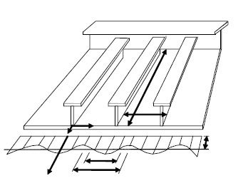

Fig.2 Actual Stress Distribution in a Compressed Stiffened Plate.

Equation (1) accounts for a reasonable degree of initial deflection in the buckling mode

$\left({d_{0}}/t\sim {b^{2}}/{25} \right)$, But not residual stresses. It appears that the effective width formula predicts considerable post-buckling reserve strength for slender plates.

The post-buckling strength is normally not taken into account when designing plates for ships and offshore structures, since this would lead to flutter the plate each time the buckling load is exceeded. This is an undesired effect. However, in the analysis of combined stiffener-plate failure, the effective plate flange is often assessed by means of Equation (1).

The expressions above hold true for a plate loaded on its short edge *b*. For compressive loads on the long edge, *a*, the following effective width formula has been proposed

$\frac{a_{e}}{a}=\frac{σ_{ym}}{σ_{Y}}=\frac{0.9}{β^{2}}+\frac{1.9}{αβ}\left(1-\frac{0.9}{β}\right)$ (3)

**3.1.2 Tangent modulus**

The tangent modulus is useful in describing the behaviour of materials that have been stressed beyond the elastic region. When a material is plastically deformed, initially the relationship between stress and strain is linear with a high slope and after the point (1)

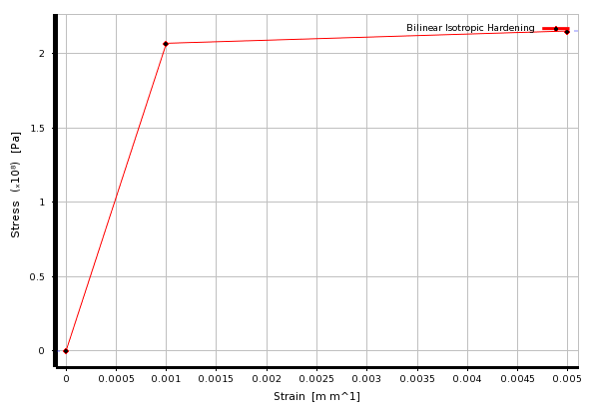

Fig.3 Stress-strain curve [17]

reached, the slope of the line changes to a smaller value. The tangent modulus quantifies the "softening" of material that generally occurs when it begins to yield. Although the material softens, it is still generally able to sustain more load before ultimate failure. Therefore, more weight efficient structure can be designed when plastic behaviour is considered, hence in structural analysis the tangent modulus is used to quantify the buckling failure.

**3.1.3 Secant modulus**

Ratio of stress to strain at any point on curve in a stress-strain diagram. It is the slope of a line from the origin to any point on a stress-strain curve.

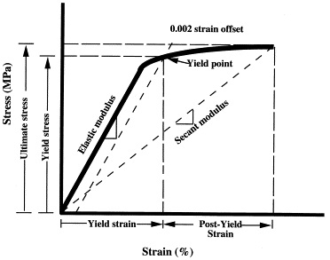

Fig. 4 Secant modulus

**3.2 Progressive collapse analysis: ISUM**

In a continuous thin-plated structure with support members, rectangular plate elements surrounded by support members (e.g., longitudinal stiffeners, transverse frames) at four edges are modeled as ISUM plate elements.

Fig. below shows the ISUM plate element used for the present progressive collapse analysis. The element has four corner nodal points. The combined in-plane and out-of plane deformation behavior for the ISUM plate element can be expressed by the nodal force vector {R} and the displacement vector {U} with 6 degrees of freedom at each corner nodal point which is taken to be located in the mid-thickness of the element as follows:

$\left\{R\right\}={\left\{R_{x1}R_{y1}R_{z1}M_{x1}M_{y1}M_{z1}…R_{x4}R_{y4}R_{z4}M_{x4}M_{y4}M_{z4}\right\}}^{T}$ (4.a)

$\left\{U\right\}={\left\{u_{1}v_{1}w_{1}ϕ_{x1}ϕ_{y1}ϕ_{z1}…u_{4}v_{4}w_{4}ϕ_{x4}ϕ_{y4}ϕ_{z4}\right\}}^{T}$, (4.b)

Where $R_{x}$, $R_{y}$ and $R_{z}$ are the translational nodal forces in the x, y and z directions, respectively. $M_{x}$ And $M_{y}$ are the out-of-plane bending moments with regard to the x and y directions, respectively. $M_{z}$ Is the torsional moment with regard to the z direction u, v and w are the translational displacements in the x, y and z directions, respectively. $ϕ_{x}$ (= - $\frac{∂w}{∂y}$), $ϕ_{y}$ (= $\frac{∂w}{∂x}$) and $ϕ_{z}$ are the rotations with regard to the x, y and z directions, respectively. ${\{ \}}^{T}$ represents the transpose of the vector. A digit in the subscript indicates the node number of the rectangular plate element.

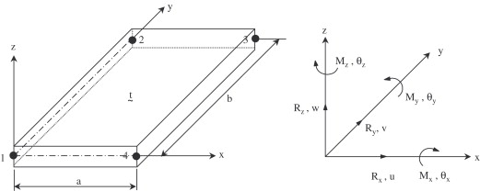

Fig.5 The local coordinate system for the ISUM plate element with its nodal forces and displacements

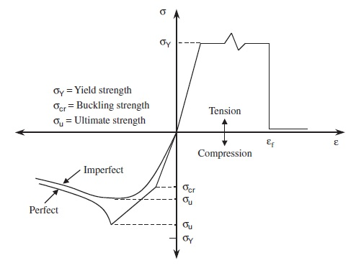

Fig.6 A schematic of the failure behavior considered for developing the present ISUM plate element

Where only the failure behavior under predominantly axial loading is shown in this figure while the present ISUM plate element can actually deal with combined stresses including longitudinal axial stress, transverse axial stress, edge shear and lateral pressure. As the elastic perfectly plastic material model, i.e., neglecting strain hardening effect is applied for developing the present ISUM plate element, the failure occurs below the yield strength.

As the axial compressive stress increases, for instance, the in-plane stiffness of the imperfect plate element, e.g., with initial deflections, decreases from the very beginning of loading and eventually reaches the ultimate limit state. In the post-ultimate strength regime, the internal compressive stress rather decreases as long as the axial compressive displacement increases. The stress versus strain relationships in the pre- and post-ultimate strength regimes can be derived by analytical approaches. The ultimate limit state criteria can also be formulated considering possible parameters of influence (e.g., geometric/material properties, combined loads, initial imperfections, and local damages) by analytical approaches.

On the other hand, when the applied action effects are predominantly tensile, the stress–strain relation may follow the typical linear elastic behavior until gross yielding is reached, as shown in Fig. 6. For practical ultimate limit state assessment, the strain-hardening effect is often neglected so that somewhat pessimistic results are obtained. In usual operational condition of ships and ship shaped offshore structures, tensile strains of structural components at gross yielding will be very small and no fracture may occur. However, for ships operating in cold waters or aged ships, the structural material is more likely to become brittle and the fracture strain of their structural components may virtually become small in average. In such cases, the considered plate element may experience fracture and thus this type of failure must be considered in the element development. In the present element formulation, it is assumed that fracture takes place if the equivalent tensile strain reaches the prescribed value of critical strain.

The formulation of the ISUM plate element stiffness equation is quite similar to that for the plate-shell element of the conventional nonlinear finite element method. By applying the principle of virtual work, the element tangent stiffness equation can be readily derived as follows:

$\left\{∆R\right\}=[K]\left\{∆U\right\}$, (5)

Where [K] is the tangent stiffness matrix, $\left\{∆R\right\}$ the increment of nodal force vectors, $\left\{∆U\right\}$ the increment of nodal displacement vectors. The tangent stiffness matrix [K] is derived by taking into account the effect of geometric nonlinearities.

The element stiffness equation is a function of the stress–strain matrix [D], among other parameters. The [D] matrix can be given as a function of the membrane stress increments $\left\{∆σ\right\}$ and strain increments $\left\{∆ε\right\}$ as follows:

$\left\{∆σ\right\}=[D]\left\{∆ε\right\}$, (6)

Where $\left\{∆σ\right\}={{\{∆σ }_{x}{∆σ }_{y}{∆τ }_{xy}\}}^{T}$ the increment of average membrane stress components inside the plate element, $\left\{∆ε \right\}={{\{∆ε}_{x}{∆ε }_{y}{∆γ}_{xy}\}}^{T}$ the increment of average strain components inside the plate element.

In contrast to the conventional nonlinear finite element formulation where the [D] matrix is likely to take into account the effect of material nonlinearities only, the ISUM formulation is made so that the stress–strain matrix [D] is determined as a function of various parameters of influence including geometric/material properties, initial imperfections (e.g., initial deflection and welding residual stresses), applied stresses, and failure status (e.g., buckling, collapse), among others.

While the details of the [D] matrix derivation for ISUM can be found in the text books, the stress–strain matrix (denoted by ${ [D] }^{B}$) in the pre-ultimate limit state regime is given by

$\left\{\begin{aligned}∆σ_{xav} \\ ∆σ_{yav} \\ ∆τ_{av}\end{aligned}\right\}={[D] }^{B}\left\{\begin{aligned}∆ε_{xav} \\ ∆ε_{yav} \\ ∆γ_{av}\end{aligned}\right\}$ (7)

Where

${\left[D\right]}^{B}$ = $\frac{1}{A_{1}B_{2}-A_{2}B_{1}}\left[\begin{aligned}B_{2} -A_{2 } 0 \\ B_{1} -A_{1 } 0 \\ 0 0 \frac{1}{C_{1}}\end{aligned}\right]$

Is stress–strain matrix of the plate in the post-buckling regime with

$A_{1}=\frac{1}{E}\frac{∂σ_{xmax}}{∂σ_{xav}}$, $A_{2}=(\frac{1}{E}\frac{∂σ_{xmax}}{∂σ_{yav}}-ϑ)$

$B_{1}=(\frac{1}{E}\frac{∂σ_{ymax}}{∂σ_{xav}}-ϑ)$, $B_{2}=\frac{1}{E}\frac{∂σ_{ymax}}{∂σ_{yav}}$

$C_{1}=\frac{1}{G_{e}}(1-\frac{τ_{av}}{G_{e}}\frac{∂G_{e}}{∂τ_{av}})$,

$G_{e}$ Is the effective shear modulus, $σ_{xmax},σ_{ymax}$ are the maximum membrane stresses in the x or y directions, $σ_{xmin}$, $σ_{ymin}$ are the minimum membrane stresses in the x or y direction, $σ_{xav}$, $σ_{yav}$, $τ_{av}$ are average stresses. The maximum or minimum membrane stresses can be determined by solving the nonlinear governing differential equations of plate elements, taking into account the effects of initial imperfections and combined actions. When no failure has occurred in the perfect plate element, i.e., without initial imperfections, the [D] matrix in Eq. (5) will of course become

${[D] }^{B}=\frac{E}{1-ϑ^{2}}\left[\begin{aligned}1 ϑ 0 \\ ϑ 1 0 \\ 0 0 \frac{1-ϑ}{2}\end{aligned}\right]$ (8)

In the post-ultimate strength regime, the stress–strain matrix denoted by ${\left[D\right]}^{u}$ is given by

$\left\{\begin{aligned}∆σ_{xav} \\ ∆σ_{yav} \\ ∆τ_{av}\end{aligned}\right\}={[D] }^{U}\left\{\begin{aligned}∆ε_{xav} \\ ∆ε_{yav} \\ ∆γ_{av}\end{aligned}\right\}$, (9)

Where

${[D] }^{U}=\left[\begin{aligned}A_{1} 0 0 \\ 0 -A_{2 } 0 \\ 0 0 A_{3 }\end{aligned}\right]$,

Is stress–strain matrix of the plate in the post-ultimate regime, with

$A_{1}=\frac{σ_{xmax}^{u}}{2}\frac{σ_{xcr}}{Eε_{xav}^{2}}$, $A_{2}=\frac{σ_{ymax}^{u}}{2}\frac{σ_{ycr}}{Eε_{yav}^{2}}$, $A_{1}=G_{e}^{*}≈0.$

**3.3 Problem statement**

The box column has a number of transverse diaphragms (floors). While the entire length L of the box column will be varied at L =500, 8000, and 21,000 mm, the dimensions, material properties and initial imperfections of the structure are as follows:

* Geometry of plate elements: a $×$ b $×$ t = 500 $×$ 500 $×$ 7.5 mm
* Thickness of transverse diaphragms =3.0mm
* Young’s modulus: E =205.8GPa
* Yield stress: $σ_{Y}$ =352.8MPa
* Poisson’s ratio: $ϑ$ =0.3
* Initial deflection function of plate elements: $w_{opl/t}$ =0.05
* Column type initial deflection function for the whole structure:

$ω_{o}=δ_{o}sin\frac{πx}{L}$ where $\frac{δ_{o}}{L}$ =.0015

Welding residual stresses $σ_{rex}=σ_{rey}$ =0.0

It is considered that the unloaded edge conditions along the corners of individual plate elements may play a role in the progressive collapse behavior of box columns. Therefore, three different conditions of unloaded plate edges are considered for the nonlinear FEA, while ISUM analysis presumes that the unloaded plate edges are always kept straight although they may move in plane of the corresponding plate elements (i.e., the unloaded edges have uniform displacement). The unloaded edge conditions along the corners of two adjacent plate elements positioned, considered for nonlinear FEA, are as follows:

Case 1: The unloaded plate edges are left free.

Case 2: The unloaded plate edges of horizontal members are kept straight in the y (horizontal) direction, while they are left free in the z (vertical) direction, although they can move in plane of the corresponding plate elements in the y direction.

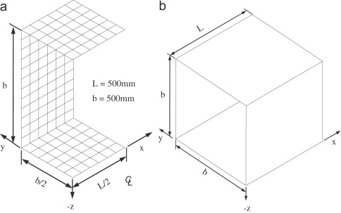

Fig. 7 Structural models used for (a) ANSYS nonlinear FEA and (b) ISUM of one bay (short) box column.

Case 3: The unloaded plate edges of horizontal members are kept straight in the y direction as it is in case 2 and the unloaded plate edges of vertical members are also kept straight in the z directions, although they can move in plane of the corresponding plate elements in the y or z directions.

It is noted that axial displacements (i.e., by displacement control) are applied uniformly over the cross section of the box columns. Also, the global deflection of the box column will occur in the z direction, and the edge condition of case 3 should not be applied when global buckling (as well as local buckling) of the box column is aimed at.

**3.3.1 Problem 1**

**A short box column with L=500mm**

A short box column with L=500mm is now considered. This structure corresponds to one bay box column that is composed of four plate elements. Fig. 6 shows the structural models used for ANSYS nonlinear FEA and ISUM. A quarter of the structure is taken as the extent of FEA considering the symmetric condition in terms of geometry and resulting behavior, while the entire structure is taken as the extent of ISUM. Although a number of plate-shell elements with fine mesh need to be used for nonlinear FEA, each plate element of the structure is modeled as one ISUM plate element for ISUM analysis, resulting in a total of four ISUM plate elements only. This implies that the computational efforts of ISUM analysis are very small compared with those of nonlinear FEA.

$$b×t=500×7.5\left(mm\right),$$

$$L=500 mm$$

$$E=205.8 Gpa, ϑ=0.3, { σ}_{Y}=352.8 MPa$$

$${w_{opl}}/t=0.05, {δ_{o}}/L=0.0015 , ε_{Y}= {σ_{Y}}/E$$

**3.3.2 Problem 2**

**A medium box column with L=8000mm**

The progressive collapse behavior of a medium box column with L =8000mm or $λ=$ column slenderness ratio = (L/ $πr$) $\sqrt{\frac{σ_{Y}}{E}}$ =0:504 with r= $\sqrt{\frac{I}{A}}=$ radius of gyration, A =cross-sectional area, and I= moment of inertia of the box column is now considered.

$$a×b×t=500×500×7.5\left(mm\right),$$

$$L=8000 mm$$

$$E=205.8 Gpa, ϑ=0.3, { σ}_{Y}=352.8 MPa$$

$${w_{opl}}/t=0.05, {δ_{o}}/L=0.0015 , ε_{Y}= {σ_{Y}}/E$$

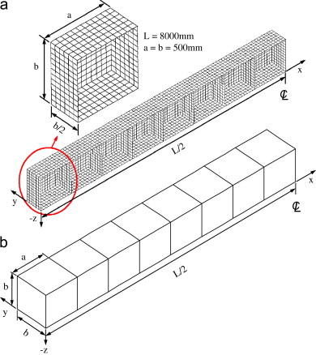

Fig. 8 Structural models used for (a) ANSYS nonlinear FEA and (b) ISUM of the medium box column with L =8000 mm.

**3.3.3 Problem 3**

**A long box column with L =21000mm**

A long box column having length (L) =21000 or $λ=$ Column slenderness ratio = (L/ $πr$) $\sqrt{\frac{σ_{Y}}{E}}$ =1:323 with r= $\sqrt{\frac{I}{A}}=$ radius of gyration, A =cross-sectional area, and I= moment of inertia of the box column is now considered.

$$a×b×t=500×500×7.5\left(mm\right),$$

$$L=21000 mm$$

$$E=205.8 Gpa, ϑ=0.3, { σ}_{Y}=352.8 MPa$$

$${w_{opl}}/t=0.05, {δ_{o}}/L=0.0015 , ε_{Y}= {σ_{Y}}/E$$

.

**Chapter 4**

**RESULTS AND DISCUSSIONS**

**4.1 A short box column with L=500mm**

Fig.9 shows deformed shape and von Mises stress distribution of the short box-column at ultimate limit state. In this case, only local failure of individual plate elements of course takes place. Fig. shows the applied load versus axial shortening curves obtained by ANSYS nonlinear FEA and ISUM. It is found that the progressive collapse behavior depends on the unloaded plate edge conditions, among others, but the ISUM results are in between cases 2and 3 of FEA in terms of ultimate strength predictions

 

Fig. 9 Deformed shape and von Mises stress distribution of the short box

Column with L= 500mm at ultimate limit state (shown for a quarter of

the structure), as obtained by ANSYS nonlinear FEA

|  |  |  |  |
| --- | --- | --- | --- |
| Case | ISUM | FEM | $${ISUM}/{FEA}$$ |
| 1 | - | 0.613 | 1.104 |
| 2 | 0.667 | 0.649 | 1.043 |
| 3 | 0.667 | 0.696 | 0.973 |

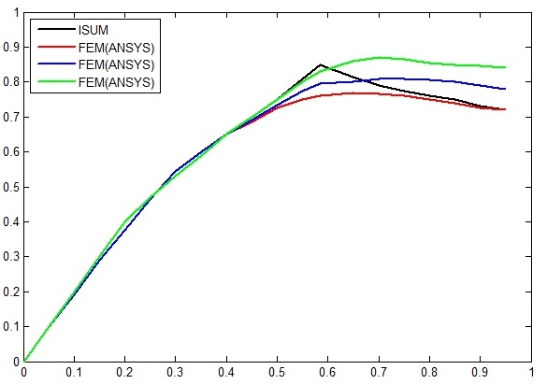

$${σ_{x}}/{σ_{y}} vs. {{ ε}_{x}}/{ε_{y}}$$

Fig.10 The progressive collapse behavior in terms of axial compressive load versus edge shortening curves for the short box column with

L =500 mm, as obtained by nonlinear FEA and ISUM.

**4.2 A medium box column with L=8000mm**

|  |  |  |  |
| --- | --- | --- | --- |
| Case | ISUM | FEM | $${ISUM}/{FEA}$$ |
| 1 | - | 0.613 | 1.054 |
| 2 | 0.665 | 0.653 | 1.018 |
| 3 | 0.665 | 0.685 | 0.971 |

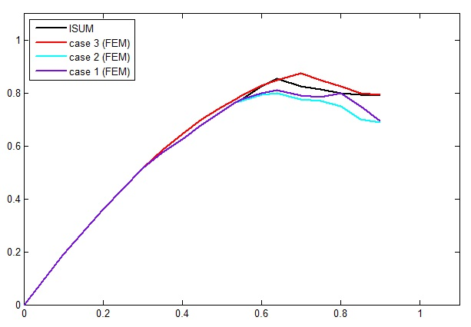

$${σ_{x}}/{σ_{y}} vs. {{ ε}_{x}}/{ε_{y}}$$

Fig.11 The progressive collapse behavior in terms of axial compressive

load versus edge shortening curves for the medium box column with

L = 8000 mm, as obtained by nonlinear FEA and ISUM.

In this case, it is presumed that the progressive collapse behavior of the box column is still governed primarily by local failure of individual plate elements, but it may also be affected by the interacting effects between local and global failure modes of the structure that seem to be small.

Fig. below shows the analysis models used for ANSYS nonlinear FEA and ISUM. Again, a quarter of the structure is taken as the extent of nonlinear FEA considering the symmetric condition, but the half structure is included in the ISUM structural modeling. Fig. below shows deformed shape and von Mises stress distribution of the structure at ultimate limit state, as obtained by ANSYS nonlinear FEA. It is found that local failure of plate elements is predominant, while the global buckling mode does not appear significantly.

It is shown the axial compressive loads versus shortening curves of the structure obtained by ANSYS nonlinear FEA and ISUM. Again, the unloaded plate edge conditions affect the progressive collapse behavior of the structure. The behavior of the structure in the post-ultimate strength regime obtained by ANSYS nonlinear FEA is very unstable for case 1 where the unloaded plate edges are left entirely free in terms of FE modeling. The ISUM solution of ultimate strength is in between cases 2 and 3 of the FEA results.

Fig. below shows the average stress versus strain curves for a plate element of compressed flange of the medium box column (with L= 8000 mm) at center and at end, respectively. While the unloaded edge conditions of course affect the plate behavior, it is found that ISUM solutions correspond to nonlinear FE results very well.





Fig. 12 Deformed shape and von Mises stress distribution of the medium

box column with L=8000mm at ultimate limit state (shown for a quarter

of the structure), obtained by ANSYS nonlinear FEA.

**4.3 A long box column with L=21000mm**

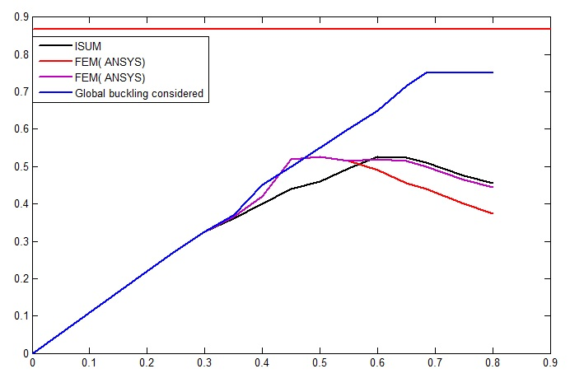

$${σ_{x}}/{σ_{y}} vs. {{ ε}_{x}}/{ε_{y}}$$

Fig. 13 The progressive collapse behavior in terms of axial compressive load versus edge shortening curves for the medium box column with L=21000 mm, as obtained by nonlinear FEA and ISUM.

|  |  |  |  |
| --- | --- | --- | --- |
| Case | ISUM | FEM | $${ISUM}/{FEA}$$ |
| 1 | - | 0.591 | 1.032 |
| 2 | 0.610 | 0.635 | 0.961 |

In this case, the progressive collapse behavior of the box column will be significantly affected by local failure of plate elements, global system failure, and their interacting effects. Therefore, the

unloaded edge condition of case 3 is not applied for FEA as previously noted, while the inception of global buckling is allowed in the z (vertical) direction.

Fig. shows the analysis models used for ANSYS nonlinear FEA and ISUM. Again, a quarter of the structure is taken as the extent of nonlinear FEA considering the symmetric condition, but the half structure is included in the ISUM structural modeling.

Fig. shows deformed shape and von Mises stress distribution of the structure at ultimate limit state, obtained by ANSYS nonlinear FEA. It is found from fig. below that both local failure of plate elements and global system buckling are predominant in this case.

Fig. shows the axial compressive loads versus shortening curves of the structure obtained by ANSYS nonlinear FEA and ISUM. Again, the unloaded plate edge conditions affect the progressive collapse behavior of the structure. The behavior of the structure in the post ultimate strength regime obtained by ANSYS nonlinear FEA is very unstable and shows ‘snap-through’ behavior for both cases 1 and 2. The ISUM solution of ultimate strength is in good agreement with more refined nonlinear FEA.

Nonlinear FEA was also carried out by considering only global buckling mode although the effect of plasticity is taken into account in this case. For this purpose, relatively coarse mesh size of finite elements was adopted so that local buckling of plate elements cannot be allowed. It is

$$a×b×t=500×500×7.5\left(mm\right),$$

$$L=8000 mm$$

$$E=205.8 Gpa, ϑ=0.3, { σ}_{Y}=352.8 MPa$$

$${w_{opl}}/t=0.05, {δ_{o}}/L=0.0015 , ε_{Y}= {σ_{Y}}/E$$

1. Compressed upper-flange at centre

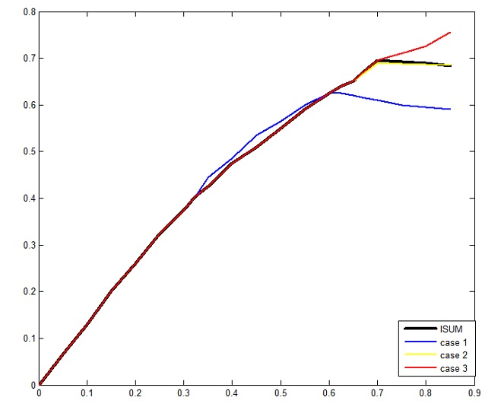

$${σ_{x}}/{σ_{y}} vs. {{ ε}_{x}}/{ε_{y}}$$

Fig. 14(a) Average stress versus strain curves for a plate element of

compressed upper-flange of the medium box column (with L=8000mm)

at center.

1. Compressed lower-flange at end

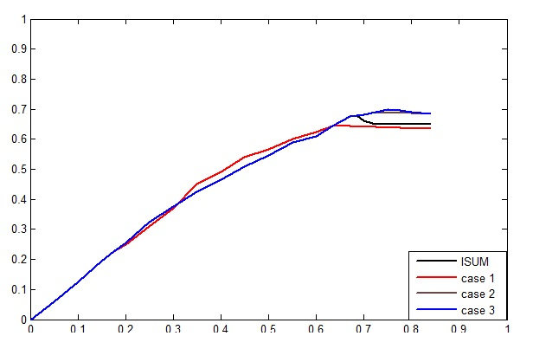

$${σ_{x}}/{σ_{y}} vs. {{ ε}_{x}}/{ε_{y}}$$

Fig 14 (b) Average stress versus strain curves for a plate element of

compressed lower-flange of the medium box column (with L= 8000mm)

at end.

Found from Fig. above that the load-carrying capacity (stress) without local failure of plate elements is 0.858sY that is much larger than the actual ultimate strength considering local buckling, global buckling, and their interacting effects.

The Euler (elastic) buckling stress of the box column clamped at both ends can be predicted by

${ σ}_{xe}=\frac{4π^{2}EI}{AL^{2}}$ (10)

Where $σ_{xe}$ is the elastic buckling stress, I the moment of inertia, A the cross-sectional area, and L the length of the box column. In fact, the clamped end condition was applied for the box column as indicated in Eq. (10). This is because the end condition of the entire box column considered is likely to be fixed through all four plate elements simply supported at both ends of the box column.

To account for the effect of plasticity, the effective width formula is often employed, which is given by equation (1)-(3).

For the box column with L=21,000 mm, $σ_{xcr}$ =0.882 $σ_{Y}$, that is very close to 0.858 $σ_{Y}$ obtained by FEA with 2.8% error.

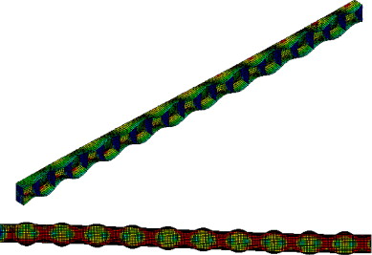

Fig. 15 Deformed shape and von Mises stress distribution of the long box column with L =21,000mm at ultimate limit state (shown for a quarter of the structure), as obtained by ANSYS nonlinear FEA.

On the other hand, the actual value of ultimate strength for the box column is smaller than the load-carrying capacity (0.858 ${ σ}_{Y}$) obtained by neglecting the effect of local buckling with an error of 31%. This implies that the effects of local failure, global failure, and their interaction must be taken into account upon calculating the ultimate strength of box columns

**Chapter 5**

**CONCLUSIONS**

* The progressive collapse analysis is desirable for the ultimate limit state assessment of thin walled complex structures because the interacting effects among various structural failure modes as well as geometric and material nonlinearities can be more precisely taken into account by the progressive collapse analysis.
* The idealized structural unit method can be successfully applied to the progressive collapse analysis of ships and offshore structures. The aim of the present study is to investigate the applicability of ISUM to the progressive collapse analysis of box columns which are typical examples of main strength members in land-based structures.
* It is evident that the effects of local failure, global failure, and their interaction are significant on the progressive collapse behavior of box columns in general. Also, the unloaded plate edge conditions along the corners of individual plate elements affect the progressive collapse behavior of box columns. It is concluded that ISUM presented is useful for the progressive collapse analysis of thin-plated box columns in terms of resulting accuracy and computational efficiency.

**REFERENCES**

[1] **Paik JK, Thayamballi AK**. *Ultimate limit state design of steel-plated structures*. Chichester, UK: Wiley; 2003.

[2] **Paik JK, Thayamballi AK**. *Ship-shaped offshore installations: design, building, and operation*. Cambridge, UK: Cambridge University Press; 2007.

[3] **ISO. ISO FDIS 18072-1** *Ships and marine technology—ship structures–Part 1: general requirements for their limit state assessment*. Geneva: International Organization for Standardization; 2006.

[4] **Liew JY, Shanmugam NC, Lee SC**. Local buckling of thin-walled box-columns. *Thin-Walled Struct* 1989;8(2):119–45.

[5] **Mahendran M, Murray NW**. Ultimate load behaviour of box-columns under combined loading of axial compression and torsion. *Thin- Walled Struct* 1990; 9(1–4):91–120.

[6] **Liew JY, Shanmugam NE, Lee SL**. Design of thin-plated steel box columns under biaxial loading. *J Constr Steel Res* 1990; 16(1):39–70.

[7] **Guo YL**. Local and overall interaction instability of thin-walled box-section columns. *J Constr Steel Res* 1992; 22(1):1–19.

[8] **Shanmugam NE, Liew JY, Lee SL.** Ultimate strength design of biaxially loaded steel box beam-columns. *J Constr Steel Res* 1993; 26(2–3):99–123.

[9] **Usami T, Zheng Y, Ge HB**. Recent research developments in stability and ductility of steel bridge structures: General report. *J Constr Steel Res* 2000;55(1–3):183–209.

[10] **Kotelko M.** Load-capacity estimation and collapse analysis of thin walled beams and columns—recent advances. *Thin-Walled Struct* 2004;42(2):153–75.

[11] **Kiymaz G**. FE based mode interaction analysis of thin-walled steel box columns under axial compression. *Thin-Walled Struct* 2005; 43(7):1051–70.

[12] **Nakanishi K, Kitada T, Nakai H**. Experimental study on ultimate strength and ductility of concrete-filled steel columns under strong earthquake. *J Constr Steel Res* 1999; 51(3):297–319.

[13] **Vrcelj Z, Uy B**. Strength of slender concrete-filled steel box columns. *J Constr Steel Res* 2002;58(2):275–300.

[14] **Mursi M, Uy B**. Strength of slender concrete-filled high strength steel box columns*. J Constr Steel Res* 2004; 60(12):1825–48.

[15] **Liang QQ, Uy B, Richard Liew JY**. Nonlinear analysis of concrete filled thin-walled steel box-columns with local buckling effects*. J Constr Steel Res* 2006;62(6):581–91.

[16] **Paik JK, Seo JK, Kim DM**. Idealized structural unit method and its application to progressive hull girder collapse analysis of ships. *Ships and Offshore Struct* 2006;1(3):235–47.

[17] **Deshpande S.** buckling and post buckling of structural components.2010