Major Project Report
On
Optimal Fuzzy System Design for Additive Noise Removal in Color Images
Submitted in partial fulfillment of the requirements
For the award of degree of
Master of Technology
In
Information Systems
Submitted By:
Sahil Raheja
Roll No. 12/ISY/2K10
Under the Guidance of
Mr. Anil Singh Parihar
(Asst. Professor, IT Department)
Department of Information Technology
DELHI TECHNOLOGICAL UNIVERSITY
Bawana Road, Delhi – 110042
2010-2012

CERTIFICATE
This is to certify that Mr. Sahil Raheja (12/IS/10) has carried out the major project titled “Optimal Fuzzy System Design for additive noise in Color Images” as a partial requirement for the award of Master of Technology degree in Information Systems by Delhi Technological University.
The major project is a bonafide piece of work carried out and completed under my supervision and guidance during the academic session 2010-2012.
The matter contained in this report has not been submitted elsewhere for the award of any other degree in the best of my knowledge.

(Project Guide)
Mr. Anil Singh Parihar
Asst. Professor
Department of Information Technology
Delhi Technological University
Bawana Road, Delhi-110042

ACKNOWLEDGEMENT
I express my gratitude to my major project guide Mr. Anil Singh Parihar, Asst. Professor, IT Dept. Delhi Technological University, for the valuable support and guidance he provided in making this project. It is my pleasure to record my sincere thanks to my respected guide for his constructive criticism and insight without which the project would not have shaped as it has.
I would like to thank Dr. O.P. Verma, HOD, IT Dept., Delhi Technological University, for his useful insights and guidance towards the project. His suggestion and advice proved very valuable throughout. I humbly extend my words of gratitude to other faculty members of this department for providing their valuable help and time whenever it was required. I am thankful to all teaching or non-teaching staff of DTU and my fellows, who have helped me in the completion of this thesis report.

Sahil Raheja
Roll No 12/IS/10
M.Tech (Information Systems)
Department of IT
E-mail: sahilraheja78@gmail.com

ABSTRACT

Image Denoising is a fundamental preprocessing task before further operations like image segmentation, feature extraction and texture analysis etc. of the image can be carried out. The purpose of denoising is to remove the noise while retaining the edges and other detailed features as much as possible. In this work, a filter to remove additive noise i.e. a combination of Gaussian noise and Salt & Pepper noise in color images is presented. Image Denoising is performed in two steps. First, an edge map is calculated on the noisy image using a modification of bacterial foraging. Bacteria’s will move on to the edge pixels thus calculating an edge map. The criterion for a pixel to be chosen as an edge pixel is described. Bacterium health is also maintained in terms of edge pixels found by that bacterium. In second step, we will apply Denoising on image pixels leaving edge pixel as it is. In Denoising technique, pixel based similarity concept is used. Pixel similarity is defined in fuzzy way since similarity is an imprecise concept. Fuzzy peer groups are constructed. Every pixel in the surrounding of the pixel in interest will belong to the peer group set of that pixel with some membership value. Membership function is defined in such a way that each member will belong to the set with its membership value between 0 and 1. Then a best no. of members is chosen among all members that are in the peer group depending on some fuzzy rules. Then we will use this fuzzy peer group to filter the noise in two cascading steps. First, an impulse noise filter is defined depending on fuzzy rules. If a pixel is detected to be corrupted by salt & pepper noise then it is corrected by taking vector median filtering of fuzzy peer group pixels. Then Gaussian noise is filtered by taking weighted averaging of fuzzy peer group members with its membership value to the fuzzy peer group. Experimental results showed that discussed technique is able to calculate edge map with high entropy value as compared to other edge detection methods. The discussed filter is able to remove a mixture of both salt and pepper noise and Gaussian noise with promising results. Edges, image details are also better preserved.

Table of Contents

Certificate………………………………………………………………...……………..………………ii
Acknowledgement…………………...……………………………………...………………………….iii
Abstract………….………………...…………………………………………..………………………..iv
Chapter 1 Introduction 1
1.1 Preview 1
1.2 Image Definition 1
1.3 Image Characterstics 2
1.4 The Problem Statement 3
1.5 Image Metrics 4
1.6 Thesis Layout 5
Chapter 2 Image Noise and Denoising Process 6
2.1 What is Noise 6
2.2 Type of Noise 6
2.3 What is Image Denoising 9
2.4 Motivation behind Image Denoising 10
2.5 Issues in Image Denoising 11
2.6 Literature Review 11
Chapter 3 Introduction to Fuzzy-Logic in Image Processing 15
3.1 A Brief Review of Fuzzy Logic 15
3.2 Why to use Fuzzy Image Processing 15
3.3 Fuzzy Set Theory 16
3.4 Fuzzy Image Processing 16
3.5 General Observations about Fuzzy Logic 17
Chapter 4 Presented Approach 18
4.1 Overview 18
4.2 Bacterial Foraging Algorithm 18
4.3 Presented method for edge detection 23
4.4 Presented method for image noise removal 28
Chapter 5 Results and Discussion 33
5.1 Preview 33
5.2 Result of Edge Detection 34
5.3 Comparison with other Techniques 41
5.4 Result of Image Denoising 43
Chapter 6 49
6.1 Conclusion 49
6.2 Future Work 50
References 51

Chapter-1
Introduction

1.1 Preview
Image Processing has a number of applications in computer vision, multimedia communication, broadcasting etc. So, all these require very good quality of images. Noise often occurs in Images during Image acquisition, transmission/ reception and image storage or retrieval processes which affects the visual quality of image and results in poor and unpleasant visual image. So it is essential to remove noise. It is not possible to remove noise completely but we can remove it up to some extent. A fundamental problem in noise removal is to remove noise while keeping the image details, features and edges as it is. Two common types of noise are Gaussian noise and impulse noise which represents most of the part of noise that has been added to image.
1.2 Image Definition
A Digital Image is a data used to represent a two-dimensional scene using digital values. A digital image is composed of pixels which form a matrix and has a particular width and height which shows the size of the matrix. Each pixel contains information, representing the brightness or intensity of the image at that point or it may be color information encoded as (RGB) triples. Images are usually captured from the real world via a digital camera, or scanner or they may be generated by computer by some software.
Digital image processing refers to processing of digital images by some digital hardware. Image processing is in which the data from an image are digitized and various mathematical operations like convolution, FFT, DFT are performed on to the input data and it is generally done with a digital computer with the help of some specialized software, in order to make an enhanced image so that is more useful or pleasing to a human being who is observing the image or to perform some of data interpretation and recognition tasks usually performed by humans. Image processing is a set of algorithms for processing of images. Some of these algorithms operate directly on image pixels (spatial domain processing) and some operate in indirect way (transform domain processing). It is a type of signal processing in which the input is an image captured by digital camera or scanned by scanner or generated by some software and the output of image processing can be an enhanced image or a set of parameters or characteristics related to the image. It is a set of computational techniques for image analyzing, image enhancement, image compression, and image reconstruction.
Image Digitization refers to the process to record an analog 2-d signal in form of intensity values. It includes sampling and quantization of continuous data. Sampling is to obtain the signal values from the continuous signal at regular fixed time spaced-intervals. In sampling, we get a sequence of numbers which can theoretically take any value on a continuous range of values. Because of this continuous range of values, there exist infinitely many possible values for a single number. So to represent this we need to convert it into discrete values.
The quantization process converts the continuous or analog values of intensity brightness into discrete data, which corresponds to the digital brightness value of each sample, ranging from black, through the grays, to white. A digitized sample is referred to as a picture element, or pixel.
Display Device
Digital Storage System
Sampler and Quantizer
Digital Computer
Imaging System

Object Observe Digitize Store Process Output
Fig 1.1: A Digital Processing System
1.3 Image characteristics

1.3.1 The Histogram
An Image Histogram is a graph between each pixel’s intensity and its relative frequency value that occurs in a grayscale image. The histogram provides a summary of the pixel’s intensities in an image. Looking at the histogram, one can easily see is the image is low contrast image or of high contrast. But histogram does not convey any information regarding spatial relationships between pixels. A high contrast image will have equal numbers of pixels of every intensity value while a low contrast image have much number of pixels of one intensity value and very few pixels of other intensity value.
Figure 1.2 shows histogram of Lena Image. In this example the image does not contain many very low or very high intensity pixels.
0
50
100
150
200
250
0
100
200
300
400
500
600
700
800
Figure 1.2: Histogram of Lena Image of resolution 256 ×256
1.3.2 The Mean
The average pixel’s intensity value of an image is referred as the image mean. For a grayscale image this is equal to the average brightness or intensity.
Let for the image f of the size M*N, the mean of this image, may be calculated using Eq. 1.1
(1.1)
1.3.2 The Variance
The Image Variancegives an estimate of the spread of pixel values around the image mean. It can be calculated using either Equation 1.2 for the image f of size. The standard deviation is simply.
= (1.2)
1.4 The Problem Statement
In the present research work, efforts are made to propose an efficient method to denoise a color image that has been corrupted by both Gaussian and Salt & Pepper Noise. Both these noise are additive in nature so noise considered here is additive noise. It is essential to reduce the noise as much as possible while at the same time retaining the fine details, sharp features of image, texture details and the edges in the image as well. Moreover, it is also required that the algorithm should have low computational complexity so that filtering operation can be done in short time. We will use pixel based similarity concept. Pixel similarity is an imprecise concept and it cannot be well handled by crisp way. So we will use fuzzy concepts to define similarity among the pixels.
Thus, the problem statement taken for this research work is “Optimal Fuzzy System Design for additive noise removal in Color Images”. The all processing will be done in spatial domain.
1.5 Image Metrics
Images are well in use in a number of applications. So images should be of high quality since it is also used in some critical applications which require that images should be of high quality. There exist a number of ways to evaluate quality of an image. The quality of an image can be evaluated by objective evaluation as well as subjective evaluation. In case of subjective evaluation, a human expert analyzes the image and evaluates the quality of it. The human visual system (HVS) is so complicated that it is not yet modeled properly. Therefore, in addition to objective evaluation, the image must be observed by a human expert to judge its quality. It is not always possible to judge quality of the image only by visualizing it. So objective evaluation of image is done.
There are various metrics used to objective evaluate an image. Some of them are mean squared error (MSE), mean absolute error (MAE), root mean squared error (RMSE), and peak signal to noise ratio (PSNR).
Let the original noise-free image is x (m, n), noisy image y (m, n) and the filtered image be represented x’ (m, n) where m and n represent the discrete spatial coordinates of the digital images.
Let the images be of size M×N pixels, i.e. m=1,2,3,…,M, and n=1,2,3,…,N. Then,
1.5.1 Mean Square Error
Mean Square Error (MSE) and Root Mean Squared Error (RMSE) are defined as
MSE = $\sum_{m=1}^{M}{\sum_{n=1}^{N}{{(x^{'}\left(m,n\right)- x \left(m, n\right))}^{2}}}$ (1.3)
RMSE = $√MSE$ (1.4)
Mean Absolute Error is defined as:
MAE = $\sum_{m=1}^{M}{\sum_{n=1}^{N}{abs(x^{'}\left(m,n\right)- x\left(m , n\right))}}$ (1.5)
1.5.2 Peak signal to noise ratio (PSNR)
Another important metric to measure image quality is Peak signal to noise ratio (PSNR). It is defined in logarithmic scale in dB. It is a ratio of peak signal power to noise power. Since the MSE represents the noise power and the peak signal power, the PSNR is defined as:
PSNR =10 * $\log_{10}\frac{1}{MSE}$ (1.6)
This image metric is well used for evaluating the quality of a filtered image and thereby it also shows the capability and efficiency of a filtering process.
1.6 Thesis Layout
The thesis is organized as follows. Chapter 2 gives an introduction to image noise, various types of noise are discussed; image denoising process, idea behind image denoising, and some basic linear and non-linear filters. Chapter 3 gives introduction to fuzzy image processing. Chapter 4 discusses the filter that is used to denoise the image. First bacterium foraging algorithm is discussed. Then an algorithm to calculate edge map using modified bacterium foraging algorithm is discussed after that a 2-stage filter to denoise a color image corrupted with Gaussian and Salt & pepper noise is given. In Chapter 5 results of the discussed edge detection technique is given and these results are compared with other edge detection algorithms. Then results of image denoising are given and compared with other filters in terms of PSNR. Chapter 6 discusses conclusion and future work to be done.

Chapter 2
Image Noise and Denoising process

2.1 What is Noise?
In general, we know noise is "unwanted signal" or it can be defined noise is a signal that is unexpected or undesired. Similarly, if when we talk about noise in context of image, then we can define image noise as random undesired variation in brightness or color information in images. In scientific terms, we can say that noise in image is the results of errors in the image acquisition or transmission process that result in changes in pixel intensity values in such a way that pixels do not reflect the real intensities of the scene being captured. Images captured by digital camera or any other image sensor gets noisy from variety of sources. Imperfect instruments, problem with data acquisition/reception process, transmission errors and compression all introduce noise and degrade the image quality. Image noise cannot be avoided. Pixel values gets disturbed by some intensities depending on the type of noise which results in that original image does not reflect the real scene.
In Digital images, noise corrupts the pixel’s intensities that are lying on smooth surface with non-uniform specks resulting in degradation of the image quality to a greater extent. Various factors produce random variation in brightness and color information of the images like lighting conditions, exposure time, sensitivity setting in the camera, and temperature.
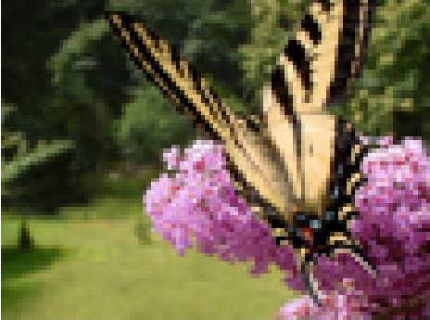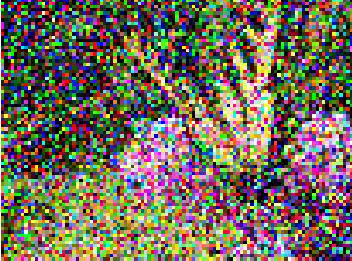
Figure 2.1: Actual Image Figure 2.2: Noisy Image

2.2 Types of Noise
There exist a number of types of noise which can occur in image acquisition. Noise that is occurred in an image can be in an additive or multiplicative form.
Let the original image is F(x, y), noise is n(x, y) and the corrupted image be Y(x, y) where (x, y) gives us the pixel location.
Then, if image is corrupted by additive noise then the corrupted image will be:
Y(x, y) = F(x, y) + n(x, y) (2.1)
Similarly if image is corrupted by multiplicative noise then the corrupted image will be
Y(x, y) = F(x, y) * n(x, y) (2.2)
The above two addition and multiplication operations will be done at pixel level.
For an efficient image Denoising algorithm, information about the type of noise in the corrupted image plays an important role. Usually maximum images are corrupted with Gaussian noise, uniform, or salt & pepper noise. Another type of noise is speckle noise. Speckle noise is multiplicative in nature.[1,2]
But two common type of noise which dominates the whole image are:
- Gaussian Noise
- Impulse Noise
2.2.1 Gaussian Noise
Gaussian noise can be defined as noise having Gaussian-Distribution. It is additive in nature. The term Gaussian means distribution of values. A Gaussian distribution depends on only two parameters -mean and variance. Gaussian noise is a noise whose frequency spectrum has a bell shaped curve as shown below:
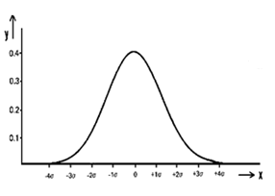
Figure 2.3: Gaussian distribution $y= \frac{1}{σ√2π}e^{-\frac{x^{2}}{2σ^{2}}}$ (2.3)
In Gaussian noise, each pixel’s intensity in the image will be changed by its original value by a small amount. If we plot a histogram of the amount of distortion of a pixel intensity value against the frequency with which it occurs, it will show a normal distribution of noise. It is independent at each pixel and independent of the signal intensity, caused primarily by thermal noise. It affects each and every pixel of the image. Image independent noise can be defined as additive noise and can be mathematically expressed as below:
O (i, j) = I (i, j) + N (i, j) (2.4)
Where O (i, j) is output image and I (i, j) is actual image and N (i, j) is the noise being added. Noise N (i, j) is often has zero-mean property and it is described by its variance
.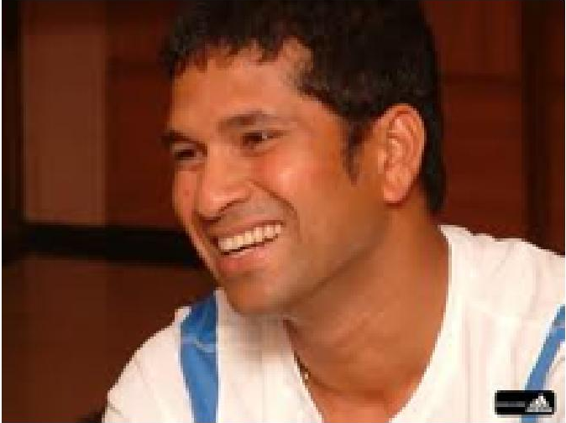 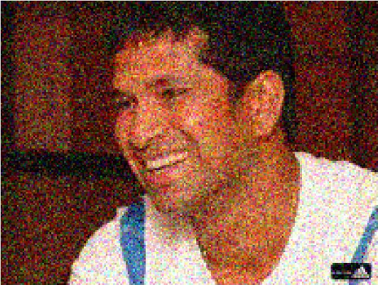
Figure 2.4: Actual Image Figure 2.5: Image Corrupted by Gaussian Noise
2.2.2 Impulse Noise
Impulse noise is a type of noise which includes unwanted, undesirable, almost instantaneous sharp sounds. Impulse noise models are of two types:
  - Fixed-Valued Impulse Noise(Salt and Pepper Noise)
  - Random-Valued Impulse Noise(Uniform Noise)
- Salt and Pepper Noise: Image corrupted with this type of noise generally has some bright pixels in dark regions and some dark pixels in bright regions. Noisy Pixels take minimum or maximum intensities. Salt and pepper noise do not disturb every pixel but it distorts some of the pixels. Some of pixels get white (salt color) and some gets black (pepper color).
- Random-Valued Impulse Noise: Image containing this type of noise has noisy pixels which can take any value within the image dynamic range.
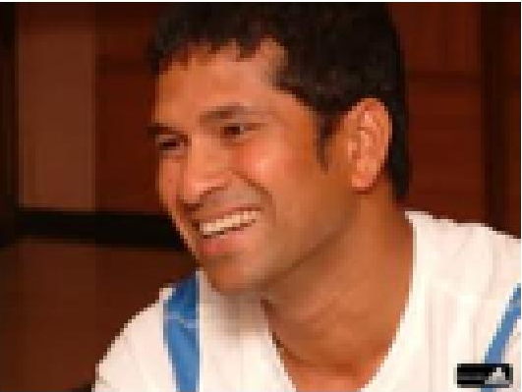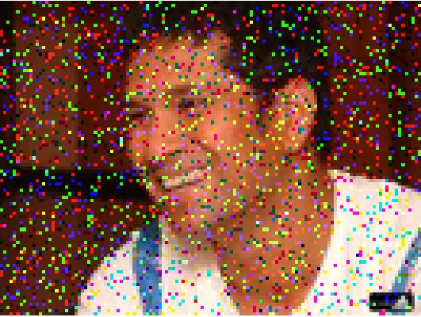
Figure 2.6: Original Image Figure 2.7: Image corrupted by salt and pepper noise
Third type of noise is speckle noise is also discussed below:
2.2.3 Speckle Noise
Speckle Noise is multiplicative in its nature. This noise usually occurs in almost every coherent imaging system such as acoustics, laser and SAR (Synthetic Aperture Radar) imagery. This noise is an intrinsic property of medical ultrasound imaging. The result of this noise on the image, the resolution and contrast of the image gets reduced. So, it is essential to reduce speckle noise in preprocessing step, whenever ultrasound imaging is being used for medical imaging.
2.3 What is Image Denoising?
Images are usually corrupted by noise which is undesirable during the image acquisition, transmission/reception process. Noise corrupts image pixel’s intensity which in turn results in a poor quality image, visually unpleasant. The brightness of the image gets disturbed by change in pixel’s intensity. Moreover, a noisy image is not suitable for further image processing technique. So image restoration is done. Image Denoising is the process of restoring original image from noisy one. Noisy can be Gaussian noise, salt and pepper noise, speckle noise etc. Mathematically if we use Y = X + N to denote the image degradation process where X is the original image and N is the noise added to the image then Image Denoising algorithm tries its best to estimate original image X given noisy image Y. However, it is not possible to exactly get original one. But we can remove noise to some extent. The optimization criteria of Image Denoising algorithm depend on MSE of filtered image with respect to original image.
Image Denoising is still a fundamental problem in the image processing field. Digital images plays a vital role in our daily life applications like magnetic resonance imaging, satellite television, computer tomography, astronomy, geographical information systems and many other research areas. While we cannot completely avoid/remove image noise, we can reduce it to a great level. The image noise is removed basically by image smoothing operation.
There are two basic approaches to denoise an image, named as spatial filtering and transform domain filtering.
In spatial filtering, spatial filters operate on directly on a set of pixels that are in the surrounding and are related to a given pixel, by using a sliding window. The sliding window also called as kernel is usually square and it can be of any size usually odd size is taken.
On the other hand, Transform domain filter, generally changes the signal space to aid more processing on the image data. First an image is transformed to frequency domain then operations are performed on that. Examples of transform domain filtering are wavelet transform and Fourier transform.
Some basic filters to remove noise are:
    - Mean Filter
    - Median Filter
2.3.1 Mean Filter
Mean filter is a simple way to reduce image noise. Mean filter is a sliding-window linear spatial filter that replaces the center pixel intensity value in the window with the average intensity of all the pixel intensity values in the window. The idea is to eliminate the pixel intensity values which are unrepresentative with their surrounding pixel’s intensities. The window size is usually 3*3 or 5*5. Sliding window with larger sizes or repeating mean filtering for a number of iterations introduce blurring, smoothness in image. It also produces other unwanted effects in the image data.
2.3.2 Median Filter
The median-filter is also uses a sliding-window and it is a non-linear spatial filter, but in this the center pixel’s intensity value in the window is replaced by median intensity value of all the pixel’s intensity values in the window. Nonlinear filtering is more robust than linear filtering because it is able to preserve the sharp edges in the image. Many variations of the median filter are proposed such as weighted median filter, adaptive median filtering and relaxed median filter, etc.
An ideal image Denoising algorithm requires a prior knowledge of noise, whereas a practical algorithm may or may not have the knowledge about the noise model. Many advanced image-Denoising algorithms have been developed and still it remains a continuous area of research in image processing field.
2.4 Motivation behind Image Denoising
Image Denoising refers to the recovery of a digital image that has been corrupted by some type of noise i.e. Gaussian noise, Salt & Pepper Noise. Image Noise disturbs the brightness of the image hence resulting in unpleasant visual quality of the image, bad for analysis. Noise decreases the accuracy of many other critical tasks. Moreover, for many applications it is required that image is of very good quality like images of electrocardiography. Image Denoising is required to be performed before further image processing tasks like object recognition, texture analysis and image segmentation etc.
2.5 Issues in Image-Denoising
Noise distorts image pixel intensity hence result in unpleasant visual image. It is difficult to perform further image processing tasks like object recognition, image segmentation on noisy images. So Image Denoising is an important pre-processing task in image-processing because it aims at improving the image quality and can increase the accuracy of the sub-sequent image processing techniques. As an example, in image-based diagnosis systems contrast enhancement can high-light important features embedded in the data and thus can reduce the uncertainties related to parameter estimation and object recognition. However, the aim of image Denoising is to remove noise from images and at the same time keeping image features, details intact. Since image pixels intensities gets distorted by noise, so it is difficult to determine which pixels to be called as original image pixel and which is noisy one. In case of salt and pepper noise, noisy pixels are very different from their neighborhood pixels and same is also true in case of true edge pixel that is also different from their surrounding pixels. Noisy pixel detection is an important and fundamental task in image Denoising.
2.6 Literature Review
Noise Filtering is a fundamental preprocessing step before further image processing techniques like image segmentation, image compression, and texture analysis can be performed. Noise often occurs in Images during Image acquisition, transmission/ reception and image storage or retrieval processes which affects the visual quality of image and results in poor and unpleasant visual image. So it is essential to remove noise.
Linear filtering techniques like averaging filter, weighted mean filter available for image de-noising tend to blur the edges [1].
In Images, Edges contains essential information. Edges are the sharp features, details of the image. So the aim of any filtering techniques is to remove noise as much as possible while preserving the edge information. Noise having distribution like Gaussian is very often encountered in acquired image. Generally, the Gaussian noise is added to every pixel of the image. In Gaussian noise, each pixel’s intensity is disturbed. Gaussian noise affects every pixel of the image. Each pixel’s intensity is changed from its original value by an amount based on noise standard deviation [2].
On the other hand, salt & pepper noise does not affect every pixel. Only the affected pixels intensity gets 0(pepper) or 255(salt). Non-Linear filtering techniques is best suited for salt & pepper noise removal but it also tend to blur edges and loss of image details [2].
Several techniques had been developed to remove Gaussian noise and salt & pepper noise.
In an image corrupted with Gaussian Noise, it is very hard to differentiate between noisy pixels and edge pixel. Van De Ville et al. [8], the effective fuzzy derivatives are used for differentiating the noise and edge pixels in images corrupted with Gaussian noise. The filter operation is divided into two stages. In first stage, a fuzzy derivative is computed for all eight different directions. Then in second stage, these fuzzy derivatives are used to perform fuzzy smoothing by weighted contributions of neighboring pixel values. Both stages depend on fuzzy rules which make use of membership functions.
Fuzzy filters to remove noise are easy to realize by usage of simple if-then fuzzy rules that characterize a particular type of noise. In Russo [9], FIRE (Fuzzy inference ruled by else sections) operators are used. A noise smoother is presented which is composed of two FIRE filters. First, FIRE filter is 5*5 basic smoother and second FIRE filter is 3*3 smoother adopting 26 fuzzy rules. The filter take advantage of modularity a property of cascaded system and able to reduce noise while preserving image details.
In F. Russo [11], a nonlinear algorithm for detail preserving smoothing of noisy pixels is combined with a technique for automatic tuning of parameter based on noise estimation. It also finds the similarity among the neighborhood pixels using some threshold parameters. Based on the similarity, weighted averaging is done. If all pixels are different then no smoothing is done. After repeating this, an image is constructed and mean square error is computed with the previous image. Then again process is applied new output image is calculated. If this result in less MSE compared with previous output image then again process is applied on new output image. This process is repeated until we get a final image that has less MSE with original image and parameter is set to its optimal value in this process.
Tuan-Anh Nguyen et al. [12] proposed spatially adaptive Denoising algorithm. This algorithm is consists of two stages; first noise detection and then noise removal filtering. Local weighted mean, local maximum and local weighted activity is defined to use local statistics of the image into Denoising process. Depending on local statistics, constraint for noise detection is specified.
K. Rank et al. [13] proposed an adaptive 2-D recursive low-pass filter with some coefficients for restoring images corrupted with Gaussian Noise. The adaptive coefficients are set with respect to three local image features that are edges, flat regions and spots. In this, first a feature detector is used then an adaptive 2-D filter is applied which is controlled by the output of feature detector.
Roman Garnett et al. [15], proposed an algorithm to remove mixed noise impulse noise as well as Gaussian noise. The statistical values show how much a pixel can be different in intensity from their most similar neighbors. This statistic is used to remove Gaussian noise. Rank-Ordered Absolute Differences are calculated then a trilateral filter is used to remove mixed noise.
Tamer Rabie [16], gave an algorithm for blind Denoising. The noise in an image is considered as a violation of assumption of spatial coherence of pixel intensities so is treated as outliers. Output denoised image is calculated by fitting a spatially coherent stationary image model to the noisy image using a regression method based on robust estimator with a optimal size adaptive window.
V.R. Vijaykumar et al. [17], proposed an algorithm, in which first amount of noise is estimated using Immerkaer’s fast method, then the pixel is replaced with average intensity value of some of the neighborhood pixels depending on some threshold value.
Yu-Mei-Huang et al. [18], proposed an algorithm for mixed noise removal. A modification of total variation minimization scheme is used to regularize the noisy image and to fill suitable values or noisy pixels which are detected by median-type filters.
Kun He et al. [19], proposed an algorithm to remove Gaussian noise based on local features of the image. In this first the location of pixels is categorized into 3-classes: on the edge, on the noise point and in the local texture. Then edge information and texture of the image is extracted using morphology, and then noise points are located. Then adaptive neighborhood is used to eliminate the other noise points.
Schulte et al. [22] considered the fuzzy distances between color pairs of the center pixel and color pairs of its surrounding pixels. These distances show the degree how much that pixel is similar to centre pixel. Then in second step the pixels whose fuzzy distance is very high comparison to their surrounding pixels are corrected using local differences between color pairs.
Om Prakash Verma, Anil Singh Parihar, Madasu Hanmandlu [23], proposed an efficient fuzzy filter for edge preservation for color images. The algorithm first detects whether the given pixel is noisy pixel, noise-free pixel or edge pixel, and then treats each pixel according to this. Noisy pixels are replaced with median of neighborhood noise free pixels. The edge pixels are considered special attention to keep image features intact. The algorithm is able to reduce salt & pepper noise with satisfactory results.
Yu Xiao et al. [24] proposed an l1–l0 minimization approach where the l1 term is used for impulse Denoising and the l0 term is used for a sparse representation over certain unknown dictionary of images patches. The main algorithm contains three phases. The first phase is to identify the outlier candidates which are likely to be corrupted by impulse noise. The second phase is to reconvert the image via dictionary learning on the free-outlier pixels. Finally, an alternating minimization algorithm is employed to solve the proposed minimization energy function, leading to an enhanced restoration based on the recovered image in the second phase.
Kenny Kal Vin Toh et al. [27] proposed a “Cluster-Based Adaptive Fuzzy Switching Median Filter for Universal Impulse Noise Reduction”. In this filter, an easy to implement impulse detector and a detail preserving noise filter are cascaded. Initially, in first step, the impulse detector classifies any possible impulsive noise pixels. After that, in filtering phase the detected noise pixels are detected with an estimation of original image pixels. In addition, the filtering phase employs fuzzy reasoning to deal with uncertainties present in local information.

Chapter 3
Introduction to Fuzzy-Logic Image Processing

3.1 A Brief Review of Fuzzy Logic
With the notion of fuzzy set theory by L. A. Zadeh in 1965, there has been a great progress in the visual and cognitive sciences domain. Fuzzy sets are being extensively used in computer vision and machine intelligence. A fuzzy set deal with the uncertainty and vagueness present in human understanding systems. A fuzzy set is able to deal with imprecise concepts. It provides a suitable framework where we can describe, understand, analyze and interpret the uncertain, imprecise and vague events. The human vision system is also a fuzzy system. Since we can describe, understand, analyze and interpret the imprecise uncertain visual world around us. Fuzzy logic is a good problem solving technique to handle uncertainty present in the problems. Fuzzy Logic provides a simple way to draw definite and correct conclusions from vague, uncertain, ambiguous or imprecise information. In a sense, fuzzy logic also resembles human decision capability with its ability to work with approximate, imprecise and uncertain data and find precise definite solutions.
In contrast with classical logic, that requires a deep understanding of the problem, exact equations, and exact numeric values, Fuzzy logic incorporates a different way of thinking, which allows one to model complex problems (that does not have exact numeric values, exact equation) using a great level of abstraction originating from our knowledge and past experiences. Fuzzy logic allows expressing the knowledge with subjective concepts such as very cold, bright red and very small weight, which are then mapped into exact numeric ranges.
3.2 Why to use Fuzzy Image Processing?
A gray-scale image processes ambiguity within its pixels due to inherent uncertainty or imprecision embedded in an image. The imprecision in an image is a result of several factors as follows:
- Ambiguity in intensity values of an image
- Spatial Ambiguity
- Uncertainty in Knowledge base
An image is a representation of two-dimensional mapping of the 3-dimensional world around us. In the process of capturing the 2-dimensional image data, a lot of ambiguity or uncertainty arises in the gray or intensity values of the image.
For example, in digital image pixels of intensity levels I and I+I’ are two different intensity levels, still they visually seems to appear the same bright pixels. There also exists ambiguity or uncertainty in describing a pixel whether it is bright or dark.
  - Fuzzy Set Theory
The crisp-set theory is based on binary memberships that are 0 or 1 which means either a member belong to a particular set or it does not. A crisp set is defined as a set whose element fully belongs to the set and they have well-defined common properties which can be measured quantitatively. In contrast with crisp sets, Fuzzy set does not have binary membership. Each element belongs to the set with some membership degree which shows the strength to which the member belongs to the set. The membership values lies between 0 and 1 where 0 means no membership to the set and 1 means fully membership to the set.
The membership of an element to the fuzzy set is calculated using a membership function ự(x) where x is the element whose membership value we want to calculate. Membership Function ự(x) maps every element x where x ɛ X (Fuzzy Set) to the interval [0, 1].
This mapping can be written as:
ự (x) : X [0:1] (3.1)
3.4 Fuzzy Image Processing
Fuzzy image processing has three stages:
- Image Fuzzification
- Modification of Membership values
- Image Defuzzification
Fuzzification means to transform crisp data sets into fuzzy data set. Fuzzification can be applied on fuzzy data sets to increase the fuzziness of the data set. While defuzzification is the reverse process. It means transforming fuzzy data set into discrete values. The strength of fuzzy image processing lies in its middle step i.e. modification of membership values. After the data is fuzzified, appropriate fuzzy techniques modifies the membership function values. It can be a fuzzy rule based approach or fuzzy clustering and a fuzzy integration approach and so on.

Expert Knowledge

Image Fuzzification
Image Defuzzification
Membership modification
Input Output
Image
Fuzzy logic fuzzy set theory

Fig 3.1: Structure of Fuzzy Image Processing
3.5 General observations about Fuzzy Logic
- Fuzzy logic is very easy to implement, use and understand. The mathematical concepts of fuzzy reasoning are very simple.
- Fuzzy logic is very much flexible for any system. Given a system, it is very easy to manage it or we can add more functionality to it without starting building system again from scratch.
- Fuzzy logic is very much tolerant of imprecise data. If we look closely enough, everything is imprecise; moreover most things are imprecise even if we do careful inspection. Fuzzy reasoning corporate this understanding into the process rather than tackling with it in the end.
- Fuzzy logic can easily model any nonlinear functions of any complexity. We can create a fuzzy system for any set of data. This process is made particularly very easy by making use of adaptive techniques like ANFIS (Adaptive Neuro-Fuzzy Inference Systems), which is available in the Fuzzy Logic Toolbox.
- Fuzzy logic can be blended with other conventional control techniques. A fuzzy system does not necessarily replace conventional control methods. It augments them to simplify their implementation.
Chapter 4
Presented Approach

4.1 Overview
In general image noise is modeled by:
O(x, y) =I(x, y) + N(x, y) (4.1)
where x, y is the image coordinates represents the pixel position, O(x, y), I(x, y), N(x, y) represents output image, input image and noise respectively.
In our discussion, Noise is additive noise i.e. a mixture of Salt and Pepper noise and Gaussian noise. The major issues in image Denoising is to remove noise while keeping image sharp features, edges as it is. So in proposed method, we will first identify edge pixels. Then we will apply Denoising technique to remove noise leaving edge pixels as it is.
- In first step, we will identify edge pixels using a modification of bacterial foraging algorithm. We will move bacteria on to edge pixels. A criterion for edge pixel is decided. Hence bacteria will make up a path consisting of edge pixels.
- In second step, we will apply a fuzzy peer group technique to remove a mixture of Gaussian and salt and pepper noise.
4.2 Bacterial Foraging Algorithm
BFA is an optimization method developed by the (Passino, 2000; Passino, 2002)[3] based on the Foraging strategy of E. coli bacteria, which live in the human Intestine.
4.2.1 Introduction
Foraging means- The way of searching for food and provisions or we can generalize it foraging is an activity of looking thoroughly in order to find something.
Foraging strategy is a method of animals for locating, handling and ingesting their food. It can be modeled as an optimization process, where bacteria search for and obtain nutrients in a way that maximize their energy E obtained per unit time spent T during foraging. In this process, the nutrient function is defined and each bacterium tries to maximize the amount of nutrient while minimizing time spent T and energy cost E by following four stages: 1) Chemo taxis, 2) Swarming, 3) Reproduction, and 4) Elimination & Dispersal. In the beginning, there are as many solutions as the number of bacteria. So, each bacterium produces a solution for set of optimal values of parameters iteratively, and gradually all the bacteria converge on the global optimum. The E.coli bacterium has a guidance system that helps it to search for nutrients and try to avoid noxious substances. An E.coli bacterium can move in two ways: It can run or swim for a period of time, or it can tumble, and it alternates between these two modes of operation its entire lifespan.
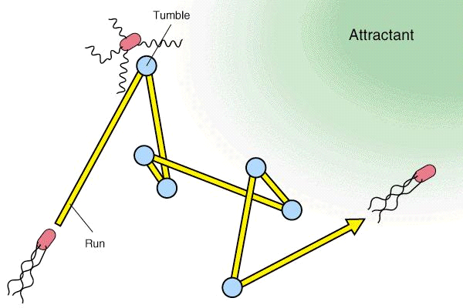

Figure 4.1: Run and Tumble of a bacterium
This movement undergoes chemo taxis step where bacteria tries to go nutrient rich location and avoid noxious environment. When bacteria get food during chemo taxis step in sufficient quantity, their length gets increased and then in presence of suitable temperature, they break themselves by half to form an exact replica of them. This inspired Passino to define an event of reproduction in BFOA. Due to sudden environmental changes or attack, the chemo tactic progress may be destroyed and a number of bacteria can move to some other places or some other bacteria may be introduced in the swarm of concerned bacteria. This introduced the event of elimination-dispersal in the real bacterial population, where all the bacteria in a particular region are killed or a group of bacteria is dispersed to a new part of the environment.
4.2.2 E.coli Bacterial Swarm foraging for optimization
Suppose that we want to find the minimum of Q (θ) where θ ɛ R^{P}, where we do not have any analytical description of the gradient ∆ Q (θ). Suppose that θ is the position of a bacterium, P denotes the dimensions of search space and Q (θ) represents the combined effects of attractants and repellants from the environment.
For example, Q (θ) < 0, Q (θ) =0, and Q (θ)> 0 representing that the bacterium at location θ is in nutrient-rich, neutral, and noxious environments respectively. Chemo taxis is a foraging behavior which implements a type of optimization where the bacteria’s try to climb up the nutrient concentration (find lower and lower values of Q (θ), search for ways out of neutral media (avoid being at positions θ where Q (θ) ≥ 0) and avoid noxious substances.
Foraging process consists of 4-stages: Chemotaxis, Swarming, Reproduction, Elimination and dispersal. Before discussing these four steps let us define some parameters used in foraging process.
Let j be the index for the chemotactic step. Let k be the index for the reproduction step. Let l be the index of the elimination-dispersal event. Let P (j, k, l) = {θ^{i} (j, k, l) | where i=1, 2……s} denotes the position of each member in the population of the S (no. of bacteria) bacteria at the j^{th} chemotactic step, k^{th} reproduction step and l^{th} elimination-dispersal event. Let Q (i, j, k, l) denote the cost at the location of the i^{th} bacterium θ^{i} (j, k, l) ɛ R^{P}. Let N_{c} be the number of chemotactic steps. Let C (i) > 0, for i=1, 2……S denote a basic chemotactic step size that we will use to define the lengths of steps during runs. Let φ (j) is generated to represent tumble and it is of unit length in random direction. φ (j) will define direction of movement after tumble. Let N_{s} denotes the maximum number of swim steps in same direction.
4.2.2.1 Chemotaxis Step
In this step, bacteria can move in two ways. Either it can swim (or run) in same direction or it can tumble to same direction. If bacteria are able to find sufficient nutrients in the direction it is moving then it continue to move in that direction upto maximum number of swim steps N_{s}. Bacteria will tumble if it is not finding enough food or after N_{s} steps. In tumble, a unit length random direction φ (j) is generated and this φ (j) will be used to decide the direction of movement after tumble. In particular we let,
θ^{i} (j+1, k, l) = θ^{i} (j, k, l) + C (i) φ (j) (4.2)
So that C (i) is the step size taken in the random direction φ (j) specified by the tumble. If at θ^{i} (j+1, k, l) the cost Q (i, j+1, k, l) is lower than at θ^{i} (j, k, l) then another step of size C (i) will be taken in this same direction, and again, cost is checked at new position with cost at previous position and if this step resulted in a position with a better cost than at the previous step, another step is taken in the same direction. This run is continued as long as it continues to reduce the cost but to a maximum number of steps N_{s}.
4.2.2.2 Swarming
While moving in a direction, bacteria could release chemical substances or release an attractant “aspertate” to attract other bacteria so that other bacteria could swarm together. Besides bacteria could release chemical substances or repellent to repel other bacteria so that other bacteria move away because two bacteria cannot be in the same location at the same time and keep a certain distance between two bacteria. This process is called cell-to-cell signaling via attractant and repellent (swarming). The swarming process for every bacterium is formulated as:
$$J_{cc}\left(θ,P\left(j,k,l\right)\right)=\sum_{i=1}^{S}{J_{cc}\left(θ,θ^{i}\left(j,k,l\right)\right)}=\sum_{i=1}^{S}{\left[-d_{attractant}\exp\left(-w_{attractant}\sum_{m=1}^{P}{{\left(θ_{m}-θ_{m}^{i}\right)}^{2}}\right)\right]+}\sum_{i=1}^{S}{\left[-h_{repellant}\exp\left(-w_{repellant}\sum_{m=1}^{P}{{\left(θ_{m}-θ_{m}^{i}\right)}^{2}}\right)\right]}$$
where:
θ = [θ_{1,} θ₂......θ_{p}]^{T} is a point on the optimization domain.
θ_{m}^{i} is the m^{th} component of i^{th} bacterium position θ^{i}
d_{attractant} is the depth of attractant released by the cell (a quantification of how much attractant is released)
w_{attractant} is a measure of the width of the attractant signal (a quantification of the diffusion rate of the chemical)
w_{repellent} is a measure of the width of the repellent.
h_{repellent} is the height of the repellent effect (magnitude of its effect)
4.2.2.3 Reproduction
The original set of bacterium, after getting evolved through several chemotactic stages reach the reproduction stage. In a rich nutrient environment, bacteria will reproduce very fast and the number of bacteria will increase significantly and in a poor nutrient environment, bacteria will die so that the population size will decrease significantly. To model the reproduction mechanism, after Nc chemotactic step size, the health of all bacteria is then sorted in ascending order based on their accumulated cost function value:
Q_{Health} = $\sum_{q=1}^{Nc+1}{Q(i,j,k,l)}$ (4.3)
In the minimization process, the highest cost function value means the least healthy bacteria and bacteria which have the lowest cost function value means the healthiest bacteria. Based on their health, the bacteria population is divided into two halves:
S_{r} = $\frac{S}{2}$ (4.4)
The S_{r} least healthy bacteria die and the other Sr healthiest bacteria reproduce (every bacterium splits into two bacteria) and placed at the same location with their mother. This reproduction mechanism keeps the bacteria population constant. After reproduction, bacteria will continue the chemotaxis process until achieve maximum chemotactic number N_{c} and then other reproduction events will be performed. The survival and elimination behavior of any bacterium is also known as its ‘motile behavior’.
4.2.2.4 Elimination and Dispersal
The population of E.coli bacteria in the nutrient environment can be reduced or replaced instantly because of external factors such as catastrophe that will make nutrient environment poisoned instantly. In the evolution process, any unforeseen event can occur at any time which can smooth the evolution and it may result in elimination of a set of bacterium and it may disperse the bacterium to the new environment. To model this event, after performing N_{re} reproduction steps there are elimination and dispersal events. Bacteria which have probability value (between 0 and 1) lower than certain threshold value (p_{ed}) are eliminated and dispersed to another location and bacteria which have probability value higher than p_{ed} keep their current position and are not dispersed. After elimination and dispersal event, bacteria will start chemo taxis until achieve reproduction steps N_{re} and then followed by other elimination and dispersal events. This routine is done until maximum elimination and dispersal events N_{ed} is achieved.
In its application to optimization it helps in reducing the behavior of stagnation, (i.e. being trapped in a premature solution point or local optima) often seen in such parallel search algorithms.
4.2.3 Bacterial Foraging Optimization Algorithm
The pseudo-code of the complete algorithm is presented below:
The BFOA Algorithm
Begin
Initialize input parameters, S, N_{c}, N_{s}, N_{re}, N_{ed}, P_{ed}, (C (i) for i=1, 2…S), $θ^{i}$
Create random initial positions of bacteria$θ^{i}(j,k,l)$, ∀i, i=1, 2….S
Evaluate Q (i, j, k, l) at$θ^{i}(j,k,l)$, ∀i, i=1, 2….S
For l=1 to N_{ed} Do
For k=1 to N_{re} Do
For j=1 to N_{c} Do
For i=1 to S Do
Perform the chemotaxis step
(tumble-swim or tumble-tumble)
for bacteria $θ^{i}\left(j,k,l\right)$
End
End
Perform the reproduction step by eliminating
The half of S worst bacteria and duplicating other best half of S bacteria
End
Perform the elimination-dispersal step for all bacteria
$θ^{i}(j,k,l)$, ∀i, i=1, 2….S with probability 0 ≤ P_{ed} ≤ 1
End
End
Table 4.1: Algorithm for Bacterial Foraging Algorithm
4.3 Presented Method for Edge Detection
Edge detection is the process of identifying and then locating sharp discontinuities or sharp changes in brightness in an image. The discontinuities are random changes in pixel intensity which characterize objects boundaries in a scene.
4.3.1 Introduction
Bacterial Foraging Algorithm [Passino 2002], briefly described above is modified here to extract edges from noisy image. In this modified bacterial foraging algorithm, a set of bacteria’s are randomly initialized to image pixel then they will try to search their nutrients which are edges in this case.
This whole process will be carried out in 3 steps: Chemotaxis, Reproduction and elimination & dispersal step. Swarming step is avoided to make the algorithm simpler and to reduce the complexity of the algorithm. Following are the steps to be followed to extract edges using modified bacterial foraging algorithm.
4.3.2 Search Space
First we need to define the search space where the bacteria will forage. In this case, since we are searching for edges in image so whole image is the search space. Image is 2-dimensional search space consisting of x-y coordinates of pixels. Image size is limited by its x y dimension so the search space is finite in our case.
4.3.3 Defining the nutrient function
Now we need to define, what will be the nutrients for the bacteria. So by definition, edges are sharp changes in image brightness. So the nutrient function is based on the difference in intensities of a bacteria placed at a pixel position with respect to pixels in the surroundings. Here we have considered neighborhood pixels which are coming in window size of 3*3. Each bacterium will try to find out edges in these neighborhood pixels depending on the difference of those with their surrounding pixels.
4.3.4 Criteria for choosing the edge pixel
For a pixel to be considered as edge pixel, it should have average intensity difference greater than a threshold value with its surrounding pixels that are 8-neighborhoods in our case. Intensity difference will be taken as component wise difference in color images. This is explained with the following example:
P1 | P2 | P3
P4 | P | P5
P6 | P7 | P8

Fig 4.2: A pixel with its neighborhood pixel in window size 3*3

Suppose we want to find whether pixel P with coordinates (x, y) is edge pixel or not, we will calculate component wise intensity difference with its neighborhood pixels in following way.

ID1=(|(x,y,1)-(x-1,y-1,1)|+|(x,y,1)–(x-1,y,1)|+|(x,y,1)–(x-1,y+1,1)|+|(x,y,1)–(x,y-1,1)|+|(x,y,1) – (x,y+1,1)|+ |(x,y,1)–(x+1,y-1,1)|+ |(x,y,1)–(x+1,y,1)|+ |(x,y,1)–(x+1,y+1,1|)/8; (4.5)

ID2=(|(x,y,2)-(x-1,y-1,2)|+|(x,y,2)–(x-1,y,2)|+|(x,y,2)–(x-1,y+1,2)|+|(x,y,2)–(x,y-1,2)|+|(x,y,2) –(x,y+1,2)|+ |(x,y,2)–(x+1,y-1,2)|+ |(x,y,2)–(x+1,y,2)|+ |(x,y,2)–(x+1,y+1,2|)/8; (4.6)
ID3=(|(x,y,3)-(x-1,y-1,3)|+|(x,y,3)–(x-1,y,3)|+|(x,y,3)–(x-1,y+1,3)|+|(x,y,3)–(x,y-1,3)|+|(x,y,3) –(x,y+1,3)|+ |(x,y,3)–(x+1,y-1,3)|+ |(x,y,3)–(x+1,y,3)|+ |(x,y,3)–(x+1,y+1,3|)/8; (4.7)
Here ID1, ID2, ID3 refers to differences corresponding to red component, green component, blue component respectively.
These component wise differences will be added say in total variable. Now if this total is greater than a threshold value, then the pixel in interest that is P will be called as edge pixel otherwise not.
4.3.5 Chemotaxis
In this step, bacteria will move to next pixel position or it will change its direction (tumble). In this case, bacteria will move on to edge pixels i.e. its nutrient in its surrounding. It will check in its surrounding if it found with some edge pixels it will move on to the pixel that is having maximum intensity difference otherwise it will be dispersed to some other location.

Consider the following example:
P1 | P2 | P3
P4 | P | P5
P6 | P7 | P8
Fig 4.3: A pixel P with its neighborhood pixels in window size 3*3
Suppose we are at pixel P and we have checked in its surrounding and we found with two pixels that satisfy the criteria to be an edge pixel then we will move to the pixel that has maximum intensity difference from its neighborhood. Suppose P3 has total intensity difference 40, P6 has 37 and threshold value is 30. Then we will move on to P3 leaving P6. So in next chemotactic step bacterium location will be at P3 and then it will check for edge pixel in its surrounding. In this way, bacteria will keep moving on to edge pixels thus making an edge-map.
4.3.6 Reproduction
In Reproduction step, least healthy bacteria die and gets replicated by healthiest bacteria. To model this situation in our case bacteria health is defined in terms of number of edge pixel it is getting in its surrounding. We will keep storing that number as health of bacteria. After N_{c} number of chemotaxis steps, the bacteria will be divided into two halves depending on S_{r} (reproduction ratio). In our case S_{r} is S/2. The last half of bacteria will gets replicated by first half bacteria positions.
4.3.7 Elimination and Dispersal
A bacterium will be assigned probability to be eliminated or dispersed to some other location depending on number of pixels it found in its surrounding. A bacterium which is very bad in health i.e. a pixel which is not getting enough edge pixels in its neighborhood will have high probability to disperse to some other random pixel position. Then it will again start in search of edge pixels from there.
4.3.8 Noise Consideration
Due to Gaussian Noise present in the colored image, some non-edge pixels can come in edge map. So we are to eliminate those pixels. The criterion chosen to avoid such pixels in edge map is “the pixel that does not have any edge pixel in its surrounding is a non-edge pixel”. It is the result of noise present in the image. In this way, the pixels that are non-edge pixels are eliminated.
4.3.9 Choosing the threshold value
The threshold value is being used to differentiate edge pixels from non-edge pixels. It decides number of edge pixels to be detected. In case of high deviation of Gaussian Noise, a high threshold value is used. Following table is the optimal suggested setting to choose proper threshold value:

Standard Deviation | Threshold Value
Low in [0,10] | 20
Medium[10,20] | 35
High[20,30] | 45

Table 4.2: Table for Threshold Value according to amount of Standard Deviation

4.3.10 Flow-Chart of Whole Process
Next
Start
If k==S
No
Input Image
Yes
If j==Nc
Define parameters N_{c}, S, N_{re}, S_{r}, N_{ed}
Initialize all bacteria’s with random positions

No
Loop for reproduction steps i=1 to Nre
Yes
Reproduce half healthiest bacteria and replace it with other half
Loop for chemotaxis steps j=1 to Nc

If i==Nre
Loop for each bacteria k=1 to S

No
Find intensity differences of each pixel in the neighborhood of current bacteria position with their surrounding neighbors

Yes
Trace the bacteria movement at each chemotactic step it will result in edge map
Find edge pixels of which intensity differences are larger than the threshold value
Remove pixels that came in edge map due to noise
Randomly disperse the bacteria to some new pixel position
Not Found
Output final edge map

Edge Pixels Found
Stop
Set bacteria health to the number of edge pixels found in the neighborhood

Set bacteria position to the pixel which has largest intensity difference

Next

Fig 4.4: Flow-Chart of the proposed Edge Detection Approach

4.4 Presented Method for image noise removal
Now we will denoise the color image which is corrupted with additive noise i.e. Gaussian noise and salt & pepper noise. In Denoising we will leave edge pixel detected in step 1 as it is and rest of pixels in image will be candidate pixels for Denoising. We will use pixel similarity based concept. We will try to find pixels that are similar to the pixel in interest. That will constitute peer group set of that pixel. Then the cardinality of set will be used to decide that the current pixel is corrupted with salt and pepper noise or not. If it corrupted then using peer group members filtering will be applied. Then the Gaussian noise will be removed by using weighted mean filtering of peer group members. This algorithm is able to remove mixed noise with satisfactory results.
4.4.1 Peer Group
The peer group of a given pixel is a set constituted by this pixel and those of its neighbors which are similar to it. The cardinality of peer group set will be used to decide the pixel in interest is free of noise or not. There are basically two ways to determine this peer group set.
- Crisp way
- Fuzzy way
Crisp way
In this way, first we will find out difference of the center pixel (the pixel in consideration) with each pixel in the neighborhood. Then we will use a threshold such that the pixel having difference less than the threshold value will come in the peer group set of the pixel in consideration otherwise it will not belong to the set. Let us understand this with an example:

P₁ | P₂ | P₃
P₄ | P₀ | P₅
P₆ | P₇ | P₈

Fig 4.5: Pixel P₀ with its neighbors in window size 3*3
Suppose the pixel in interest is pixel P₀. We will calculate difference of each pixel P_{i} in the pixel’s window with the center pixel P₀. So the peer group set of P₀ denoted PG^{P}₀(T) will be defined as follows:
PG^{P}₀(T) = {P_{i} ɛ W such that || P₀ – P_{i} <= T||} (4.8)
where || . || represents the Euclidean Norm and T is threshold value which is greater than 0 (T>0). Obviously P₀ will belong to PG^{P}₀(T).
The cardinality of PG^{P}₀(T) say m, then peer group PG^{P}₀(T) is said to be peer group of m members. This cardinality is used to decide whether pixel P₀ is free of salt & pepper noise or not. So here we are using a threshold to decide the members of the set. So this is the crisp way of defining the peer group set.
Since pixel similarity between two pixels is an imprecise concept. It cannot be correctly represented in crisp way. So in our case pixel similarity will be defined in fuzzy way and we will use fuzzy peer group set of the pixel.
Fuzzy way
If some fuzzy metrics are used to define Peer Group set then it is called Fuzzy Peer Group. We will define membership of each pixel P_{i} ɛ W in fuzzy way.
4.4.2 Construction of Fuzzy Peer Group
- We use a fuzzy similarity function M defined as:
M (P₀, P_{i)} = e ^{-|| P}₀ ^{– P}_{i}^{||/Fq} (4.9)
where || . || denotes Euclidean norm and Fq>0 is a parameter. M will take values in [0, 1]. M (P₀, P_{i}) = 1 if and only if P_{i}=P_{0.} After calculating M, the color vectors or pixels P_{i} ɛ W are sorted in descending order with respect to its similarity to P₀ which results in ordered set W’.
- Now we will define a fuzzy set C^{P}₀ considering the proposition that P_{i} is similar to P₀ on the pixels P_{i} present in the window W’ where membership function is given by:
ự (C^{P}₀(P_{i}))= M(P_{0,} P_{i}) for i=0,1,2,….n²-1 (4.10)
- Now we will define accumulated similarity AS for each pixel P_{i}.
AS^{P}₀(P_{i}) = ∑_{k=0:i} M(P₀ , P_{k}) , i=0,1,2….. n² (4.11)
Clearly AS^{P}₀(P₀)=1 and AS^{P}₀(P_{i}) takes i+1 if P₀=P₁=……P_{i.} Largest value AS^{P}₀ can take is n².
- Now we will create a fuzzy set L^{P}₀(P_{i}) by considering the vague proposition that AS^{P}₀(P_{i)} is large. Clearly the memberships value of minimum value that AS^{P}₀(P₀)=0 will be 0. Since it is the minimum value that AS^{P}₀ can take and memberships value of maximum value that is AS^{P}₀(P₈)=9 will be 1. So the membership function for the fuzzy set L^{P}₀(P_{i}) is ự(AS^{P}₀(P₀)) is defined as follows:
L^{P}₀ ( P_{i} )=ự ( AS^{P}₀ ( P_{i} ) )= - $\frac{1}{(n2-1)2}$ ( AS^{P}₀(P_{i}) - 1) )( AS^{P}₀(P_{i}) – 2n² + 1) (4.12)
where i=0, 1, 2.......n²-1
- Now we will select best number m of members among window pixels W’. We aim to determine m number of members such that fuzzy peer group is the largest set that contain only similar pixels. The best number m where m can be 0, 1, 2…..n²-1 is chosen such that it maximizes the certainty of following fuzzy rule.
Fuzzy Rule 1: If “P_{m} is similar to P₀” and “AS^{P}₀(P_{m}) is large” then “ the certainty of m to be the best number of members is high”.
“P_{m} is similar to P₀” is given by fuzzy set C^{P}₀(P_{m}), “AS^{P}₀(P_{m}) is large” is given by L^{P}₀(P_{m}).
The certainty of Fuzzy rule 1 is computed for each value of m and the value which maximizes this certainty is selected as the best number m of members for peer group on window W’
We use the product t-norm as the conjunction operator , so no de-fuzzification is needed.
C_{FR1}(m)= C^{P}₀(P_{m}) L^{P}₀(P_{m}) (4.13)
So m is chosen such that C_{FR1}(m) is maximum.
Now we will define fuzzy peer group FP^{P}₀(m) with first m members from W’ and their membership function will be defined by M(P₀,P_{i}).
4.4.3 Filtering with help of fuzzy peer group:
This filter works in 2-steps.
      - Salt and pepper noise detection and correction
4.4.3.2 Gaussian noise smoothing
To reduce Salt and Pepper Noise, a fuzzy rule based procedure is used. First with the help of fuzzy rule based procedure, it is decided that the pixel in interest is corrupted with Salt & pepper noise or not. A threshold value is used to detect corrupted pixel. If a pixel is found to be corrupted, then Vector median filtering is applied to correct those noisy pixels. For Gaussian noise smoothing, fuzzy averaging is done among the members of fuzzy peer group of the pixel under processing. In Fuzzy averaging, weights are given by the membership function which defines the similarity or how strong they are similar to the peer group of the pixel in interest.

Flow chart of the proposed Filter
Original Pixel

Construction of fuzzy peer group

Fuzzy Rule Salt and Pepper Noise Detection
Noise Detection
Vector Median Filtering

No noise
Processed Pixel
Fuzzy Averaging
Fig. 4.6: Flow-Chart for Filtration process of proposed filter
4.4.3.1 Salt and pepper noise detection and correction
A salt and pepper noise pixel can be deﬁned as a pixel which is signiﬁcantly different in intensity from its neighborhood pixels. Conversely, a salt and pepper noise-free pixel should have some neighbors quite similar to it. According to the above, we can model this condition in terms of fuzzy peer groups as follows:
A pixel P₀ is free of salt and pepper noise if for the fuzzy peer group FP^{P}₀(m) it is satisfied that AS^{P}₀(P_{m}) is large and P_{m} is similar to P₀.
Determining the certainty of the pixel P₀ to be free of salt and pepper noise.
The following fuzzy rule 2 represents this condition:
Fuzzy Rule 2:
If “AS^{P}₀(P_{m}) is large” and “P_{m} is similar to P₀” then P₀ is free of salt and pepper noise.
“P_{m} is similar to P₀ is given by fuzzy set C^{P}₀(P_{m}), “AS^{P}₀(P_{m}) is large” is given by fuzzy set L^{P}₀(P_{m}). We use the product t-norm as the conjunction operator.
C_{FR2}(P₀)= L^{P}₀(P_{m}) C^{P}₀(P_{m}) (4.14)
It is already calculated in C_{FR1}. So no more computations are required. We will use C_{FR2} to detect and replace salt and pepper noisy pixel according to threshold-based rule.
If C_{FR2}(P₀)>=F_{t} then P₀ is free of salt and pepper noise
Else P₀ is a noisy pixel and replace P₀ with VMF_{out}(Vector median Filtering)
where F_{t} is a parameter
4.4.3.2 Gaussian Noise smoothing procedure:
To remove Gaussian noise, a weighted averaging operation is performed among color vectors. So, to smooth the pixel P_{0,} we use the members of fuzzy peer group FP^{P}₀(m), where the weighting coefficient for each color vector is its membership degree to the fuzzy peer group FP^{P}₀(m) . Every pixel is smoothed by weighted averaging operation in following manner:
P_{out} = $\frac{\sum_{i=0}^{m}{FPm^{p0}\left(Pi\right)*\left( Pi\right)}}{\sum_{i=0}^{m}{FPm^{p0}\left(Pi\right)}}$ (4.15)
4.4. Suggested setting for parameters used
Following are the suggestion for proper setting of parameters that are being used in the filter that is Fq and Ft.
Table 1 Suggested setting for Ft parameter Table 2 Suggested setting for Fq parameter

Percentage of Salt and Pepper Noise | Ft
Low [in (0,10)] | 0.05
Medium [in (10,20)] | 0.15
High [in (20,30)] | 0.25
Standard Deviation of Gaussian Noise | Fq
Low [in (0,10)] | 50
Medium [in (10,20)] | 100
High [in (20,30)] | 175

Chapter 5

Results and Discussion

5.1 Preview
In method, Image Denoising is done in a way so that image sharp features that are edges can remain as it is. So Image Denoising is done in two steps:
- Edge Detection in noisy image. (To keep image features, sharp details intact)
- De-noise the image leaving edge pixels as it is. (To avoid smoothing)
It is not possible to remove noise completely, but we have tried to eliminate it as much as possible.
We tested the proposed method on color images that are corrupted with mixed noise both Gaussian and Salt & Pepper noise. Figure 5.1 shows original image of Lena, Penguins, Peppers and House. Figure 5.2 shows the noisy version of images shown in Figure 5.1 where Standard deviation of Gaussian noise is 0.01 and percentage of salt and pepper noise is 10%.
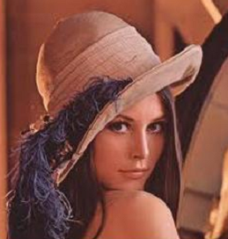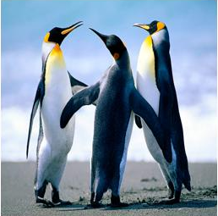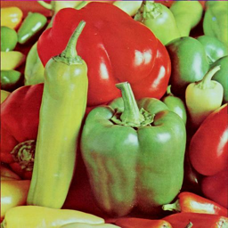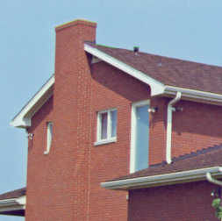
(a) Lena (b) Penguins (c) Peppers (d) House
Fig 5.1: Original Images

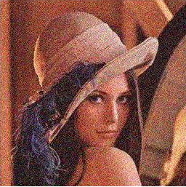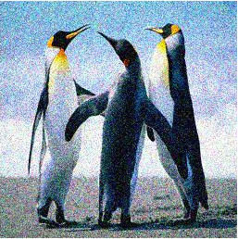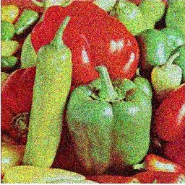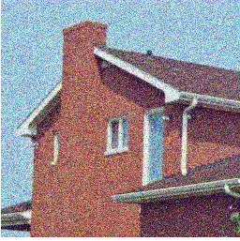
(a) Lena (b) Penguins (c) Peppers (d) House
Fig 5.2: Noisy Images

5.2 Results of Edge Detection
Edge Detection is done on noisy images using bacteria foraging. The output depends on the selection on the parameters used in bacteria foraging that are No. of initial bacteria N_{b}, no. of chemotactic steps N_{c}, no. of elimination and dispersal event N_{ed}, no. of reproduction steps N_{re} threshold value T, reproduction ratio S_{r}. The result of the proposed edge detection method is being compared against the result of three other edge detection methods: Canny, Sobel and Prewitt.
The Shannon’s entropy is used for quantitative analysis with these three edge detection methods. Image entropy is a quantity used to describe the `business' of an image, i.e. the amount of information present in the image. Low entropy means images of very low contrast many of pixels with same intensity value, very less information. An image of high entropy means an image having a great deal of contrast i.e. having high information. So we have used Shannon’s entropy function to calculate image entropy.
5.2.1 Shannon’s Entropy Function
H (I) =−$\sum_{i=1}^{n}{p\left(x_{i}\right)\log_{b}p(x_{i})}$ (5.1)

Where $I$ Image whose entropy is to be measured and $p\left(x_{i}\right)$ is the frequency of pixels with intensity$x_{i}$.
A number of parameters have been used in our proposed algorithm. These are initial number of bacteria (Nb), number of chemotactic steps (Nc) i.e. lifetime of a bacterium, no. of reproduction steps, threshold value. Depending on the value of these parameters, we got different information content of image. We will see the effect of some of these parameters on information content by calculating image entropy by above given formula. Figure 5.3 shows the variation of entropy with respect to the number of initial bacteria. Entropy comes very low for fifteen number of bacteria and thirty number of bacteria since the resultant image (Fig 5.4.a, Fig 5.4. b) have very less information and as we increase the number of bacteria the amount of information in the image i.e., entropy is also increase but it also introduces the noise in the edge-map in the form of unconnected weak edges. To reduce such type of noise in edge-map, we have eliminated the pixels that do not have any neighborhood edge pixels. To have enough amount of information while keeping the noisy pixels as small as possible, we have taken the initial number of bacteria as 60. Fig. 5.4, Fig 5.5, Fig 5.6, Fig 5.7 shows the edge map by proposed approach for different images shown in Fig 5.1 for different number of initial bacteria.
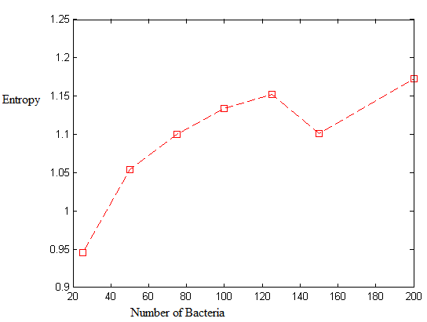
Fig. 5.3: Entropy versus initial number of bacteria

(a) (b) (c)
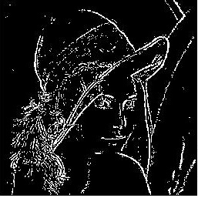
(d) (e) (f)
Fig.5.4: Result of proposed approach for Lena image taking different number of initial bacteria (Nb) (a) Nb =15, (b) Nb = 30, (c) Nb = 50, (d) Nb =75, (e) Nb = 100, (f) Nb = 150

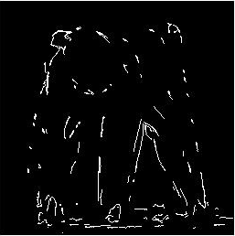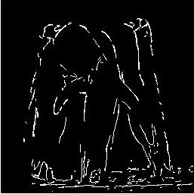
(a) (b) (c)
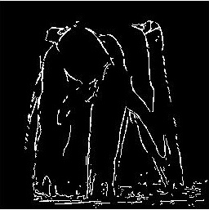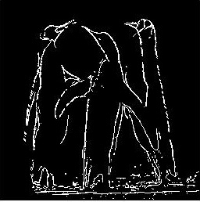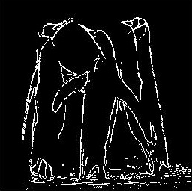
(d) (e) (f)
Fig 5.5: Result of proposed approach for Penguins image taking different number of initial bacteria (Nb) (a) Nb =15, (b) Nb = 30, (c) Nb = 50, (d) Nb =75, (e) Nb = 100, (f) Nb = 150

- (b) (c)

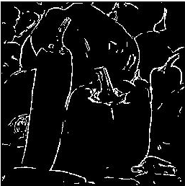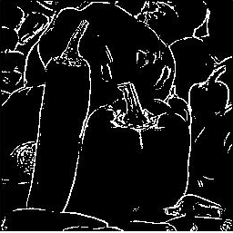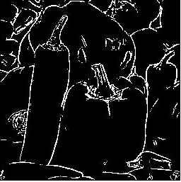
(d) (e) (f)
Figure 5.6: Result of proposed approach for peppers image taking different number of initial bacteria (Nb) (a) Nb =15, (b) Nb = 30, (c) Nb = 45, (d) Nb =70, (e) Nb = 100, (f) Nb = 120

(a) (b) (c)
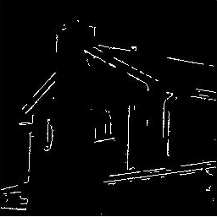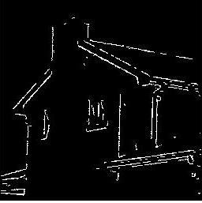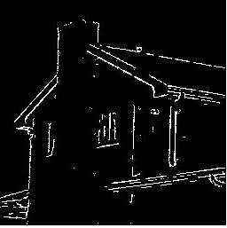
(d) (e) (f)
Figure 5.7: Result of proposed approach for house image taking different number of initial bacteria (Nb) (a) Nb =15, (b) Nb = 30, (c) Nb = 45, (d) Nb =70, (e) Nb = 100, (f) Nb = 120

Fig. 5.8 shows the variation of number of chemotactic steps (N_{c}) with respect to Entropy measure. Increasing the number of chemotactic step means increasing the lifetime of the bacteria. If bacteria are allowed to live longer then it will also try to explore more number of edges and thus requires longer time. To make bacteria to complete its life in a sufficient time with providing good number of edges and less noisy pixels, the number of chemotactic steps taken are 80. Fig. 5.8, Fig 5.9, Fig 5.10, Fig 5.11 shows result of proposed approach for different images and for different number of chemotactic steps.
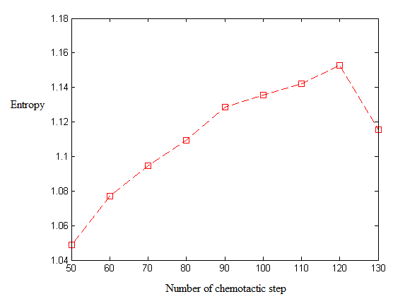
Fig. 5.8: Entropy versus number of chemotactic steps (N_{c})

(a) (b) (c)
(d) (e) (f)
Fig.5.9: Results of proposed approach for Lena image taking different number of chemotactic steps (N_{c}), (a) N_{c} = 40, (b) N_{c} = 50, (c) N_{c} = 60, (d) N_{c} = 70, (e) N_{c} = 80, (f) N_{c} = 90

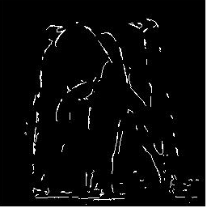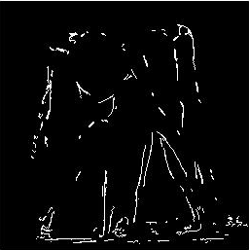
(a) (b) (c)
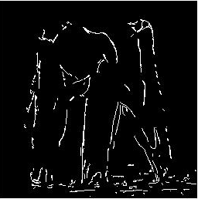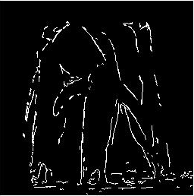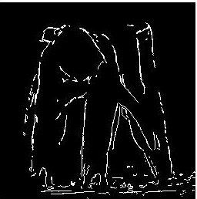
(d) (e) (f)
Fig.5.10 Results of proposed approach for Penguins image taking different number of chemotactic steps(N_{C}), (a) N_{c} = 40, (b) N_{c} = 50, (c) N_{c} = 60, (d) N_{c} = 70, (e) N_{c} =80 (f) N_{c}=90

- (b) (c)
(d) (e) (f)
Fig. 5.11: Results of proposed approach for Peppers image taking different number of chemotactic steps (N_{C}), (a) N_{c} = 40, (b) N_{c} = 50, (c) N_{c} = 60, (d) N_{c}=70,(e) N_{c}=80, (f) N_{c} = 90

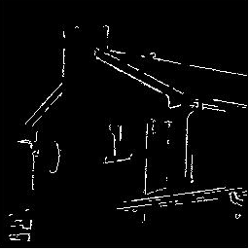
- (b) (c)
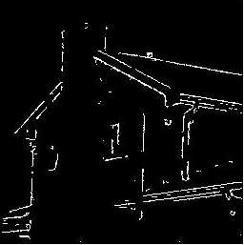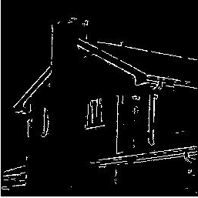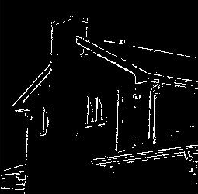
(d) (e) (f)
Fig. 5.12 Results of proposed approach for House image taking different number of chemotactic steps (N_{C}), (a) N_{c} = 40, (b) N_{c} = 50, (c) N_{c} = 60, (d) N_{c}=70, (e) N_{c}=80,(f) N_{c} = 90

The values of other parameters are chosen in way to maximize number of edge pixel while keeping noise in edge map as low as possible. Number of Reproduction steps N_{re} is set to 10, threshold value is set to 35, and reproduction ratio used is N_{b}/2.
5.3 Comparison with Other Techniques
The performance of most of the edge detectors proposed in the literature is visually analyzed. Sometimes the visual analysis is insufficient to prove that the proposed method gives more connected edges. To overcome this problem we use the entropy function for quantitative analysis. Entropy represents the amount of information present in the image.
Table 1 represents the values of entropy measure for Majority image and for the results of various approaches: Sobel, Prewitt, Canny and proposed approach. The entropy for results of Sobel and Prewitt is comes out to be smaller than the proposed approach for all the four test images, because they provide less edge information. The canny method gives very thin edges and it does not work on the color images thus there will be information loss in the result, therefore the entropy value obtained using this methods is less than the proposed method.
Table 5.1: Entropy of different methods
 | Canny | Sobel | Prewitt | Proposed method
Lena | 2.8616 | 2.2515 | 1.6566 | 2.9818
Penguins | 2.6962 | 1.6316 | 1.6502 | 2.7085
Peppers | 2.9926 | 1.8438 | 1.7062 | 2.6610
House | 2.0682 | 1.4315 | 1.4999 | 2.1286

(a) lena (b) penguins (c) peppers (d) house
Fig 5.13: Original images
(a) lena (b) penguins (c) peppers (d) house
Fig 5.14: Noisy images
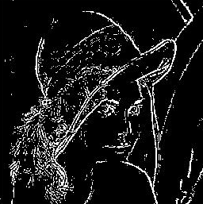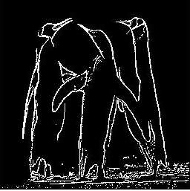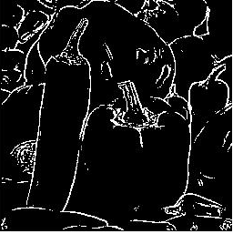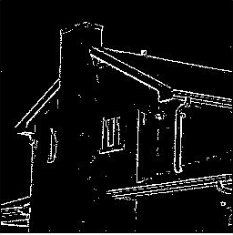
(a) lena (b) penguins (c) peppers (d) house
Fig 5.15: Result of proposed approach on noisy images
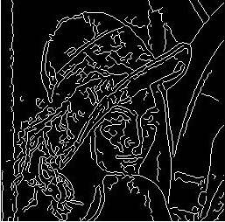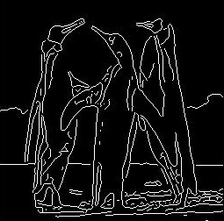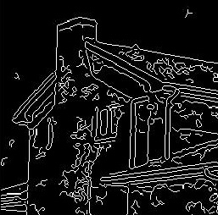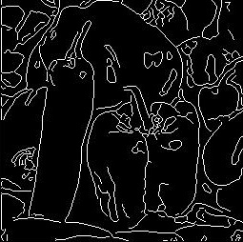
(a) lena (b) penguins (c) peppers (d) house
Fig 5.16: Result of Canny edge detector on noisy images
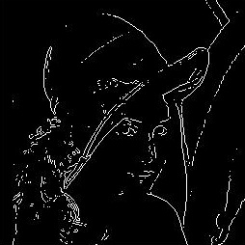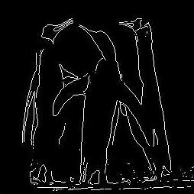
(a) lena (b) penguins (c) peppers (d) house
Fig 5.17: Result of sobel edge detector on noisy images

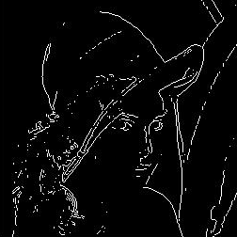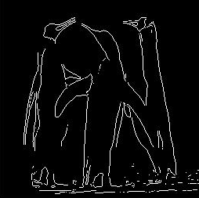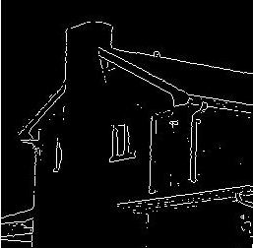
(a) lena (b) penguins (c) peppers (d) house
Fig 5.18: Result of prewitt edge detector on noisy images

5.4 Results of Image Denoising
To denoise the colored image corrupted with additive noise, we have used concept of peer groups that are defined in fuzzy way. The proposed algorithm is able to reduce mixed type of noise while preserving details.
A colour image consisting of an M × N × 3 array of pixel at locations (x, y) may be viewed as a stack of three scale images corresponding to RGB components. The colour images of Lena Peppers of size 256 * 256 corrupted with the Gaussian and Impulse noise is considered as test images. The performance of the proposed approach is evaluated on test images with density of salt & pepper noise 10% , 15%, 20% and with standard deviation 10, 20, 30. The results of the proposed approach are compared in terms of PSNR with methods “Restoration of images corrupted by mixed Gaussian-impulse noise via l1–l0 minimization” (RICMG) [24], “Spatially Adaptive Denoising Algorithm for a Single Image Corrupted by Gaussian Noise” (SADA) [24].

Table 5.2 Comparison of PSNR of Proposed filter with other filters
Standard Deviation | Density of Salt and Pepper Noise | Noisy | RICMG | SADA | Proposed
Lena Image
σ = 10 | 10% | 19.1908 | 31.0342 | 30.2316 | 31.5431
σ = 20 | 15% | 17.2428 | 29.1864 | 28.9976 | 29.7025
σ = 30 | 20% | 16.2325 | 27.4152 | 27.6519 | 28.6229
Pepper Image
σ = 10 | 10% | 18.1954 | 31.8409 | 31.2910 | 31.7332
σ = 20 | 15% | 16.3347 | 29.6981 | 28.9418 | 29.9285
σ = 30 | 20% | 15.1851 | 28.0720 | 27.3864 | 28.2531

Comparison of PSNR values resulting from applying the proposed filter and the other methods is shown in table 5.2. Looking at the table we can see the proposed filter is superior in case of PSNR with other method shown in the table. Now we will show denoised image of Lena and Peppers with the outputs of other filters.

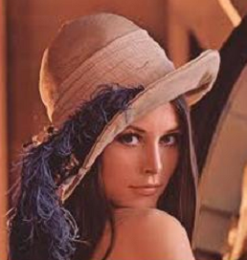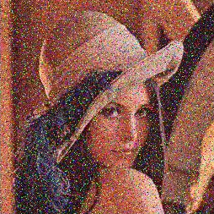

Fig. 5.19: Original Lena Image Fig. 5.20: Lena Image Corrupted with σ =10 and 10% salt and pepper noise
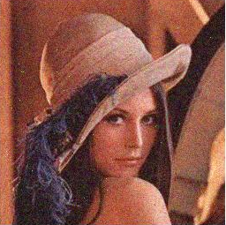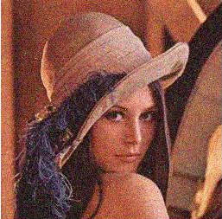
Fig. 5.21: Output of RICMG Fig. 5.22: Output of SADA
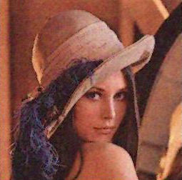
Fig. 5.23: Output of Proposed Filter
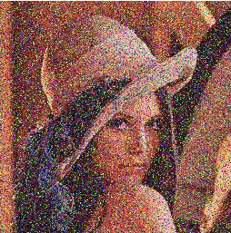

Fig. 5.24: Original Lena Image Fig. 5.25: Lena Image Corrupted with σ =20 and 20% salt and pepper noise
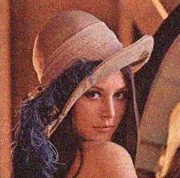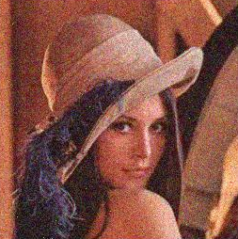
Fig. 5.26: Output of RICMG Fig. 5.27: Output of SADA
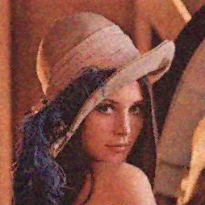
Fig. 5.28: Output of Proposed Filter
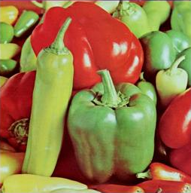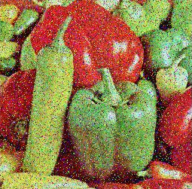

Fig. 5.29: Original Peppers Image Fig. 5.30: Peppers Image Corrupted with σ =10 and 10% salt and pepper noise
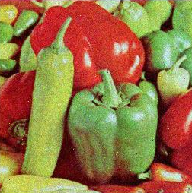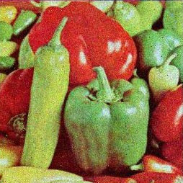
Fig. 5.31: Output of RICMG Fig. 5.32: Output of SADA

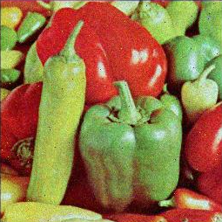
Fig. 5.33: Output of Proposed Method

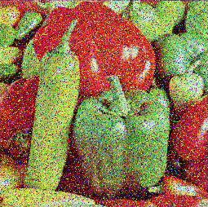

Fig. 5.34: Original Peppers Image Fig. 5.35: Peppers Image Corrupted with σ =20 and 20% salt and pepper noise

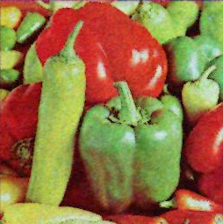
Fig. 5.36: Output of Proposed Method

Chapter 6
Conclusion and Future Work

6.1 Conclusion
Image denoising is an important pre-processing step before further operations on the image like image segmentation, image compression and texture analysis of the image is done. In this work, we have presented a new approach to denoise a colored image that is corrupted with mixed type of noise Gaussian noise and salt & pepper noise. It is not possible to remove noise completely we can only reduce it upto some extent by estimating original pixel intensity value. For denoising an image, first edge detection using modified bacterial foraging algorithm is done on noisy image. Edge map is calculated to keep image edges and sharp features intact. Experimental results showed that our calculated edge map is better in terms of quality as well as visual aspects comparing with any other technique. We have used Shannon’s entropy function to calculate quality of edge map. The entropy value of the presented method is better than any other method.
In second step, we have presented a fuzzy peer group technique to denoise the image. We have used similarity based concept between pixels. Since similarity is imprecise so it is defined in fuzzy way hence called fuzzy peer group. Edge pixels are considered as special case so as to keep image features intact and to avoid smoothing of image edges. So edge pixels are left as it is, no Denoising process is applied on to that. Presented filter works in two steps. In first step, it is checked that if the pixel in interest is corrupted by salt & pepper noise, if it is then it is replaced by an estimation of the original pixel value using Vector Median Filtering. In second step, to remove Gaussian noise fuzzy weighted averaging is done where weights are given by the membership function used to calculate pixel membership to the peer group. Experimental results showed that our method to denoise the image is better both in qualitative and quantitative measures. We are able to get a better PSNR with other techniques with good visual quality output images. The proposed filter is also able to work on high density of Gaussian and Salt & pepper noise.

6.2 Future Work
The method can be extended in other directions. For example:
- Modification of Fuzzy membership function in calculating the similarity of the pixel with the center pixel may result in better outputs.
- Modification in the method to select better number m number of members for the fuzzy peer group may produce better results.
- Instead of, Fuzzy peer group, Peer group can be defined in crisp way by selecting a proper threshold value to construct proper peer group set.
- Results can be improved by cascading number of fuzzy peer group filter upto the point where we keep getting better PSNR and visual quality of output images.

References

- A.K.Jain, Fundamentals of digital image processing, Prentice Hall, Englewood Cliffs, 1989.
- Gonzalez R.C., Woods R.E: Digital Image Processing, Addison- Wesley, 2003.
- Kevin M. Passino, “Biomimicry of Bacterial Foraging”, IEEE Control Systems Magazine IEEE, 2002.
- K. N. Plataniotis and A. N. Venetsanopoulos, “Color Image Processing and Applications”, Berlin, Germany: Springer, 2000.
- Om Prakash Verma, Madasu Hanmandlu, Anil Singh Parihar and Vamsi Krishna Madasu, “Fuzzy Filters for Noise Reduction in Color Images”, ICGST-GVIP Journal, Volume 9, Issue 5, September 2009, ISSN: 1687-398X.
- Om Prakash Verma, Madasu Hanmandlu, Puneet Kumar, Sidharth Chhabra, Akhil Jindal, “A novel bacterial foraging technique for edge detection”, ScienceDirect Pattern Recognition Letters 32 (2011) 1187–1196.
- Om Prakash Verma, Madasu Hanmandlu, Ashish Kumar Sultania, Anil Singh Parihar, “A novel fuzzy system for edge detection in noisy image using bacterial foraging”, 6 October 2011© Springer Science+Business Media, LLC 2011.
- D. Van de Ville, M. Nachtegael, D. Van der Weken, W. Philips, I.Lemahieu, and E. E. Kerre, “Noise reduction by fuzzy image ﬁltering,” IEEE Transactions on Image Processing, vol. 11, no. 4, pp. 429–436, Apr. 2001.
- F. Russo and G. Ramponi, “A noise smoother using cascaded FIRE filters”, Proc. of 4th Intl. Conf. on Fuzzy Systems, Vol.1, pp. 351-358, 1995.
- Samuel Morillas, Valentín Gregori, and Antonio Hervas, “Fuzzy peer group for reducing mixed Gaussian impulse noise from color images” IEEE Transactions on Image Processing, Vol. 18, No. 7, July 2009.
- F.Russo, “A Method for Estimation and Filtering of Gaussian Noise in Images”, IEEE Transactions on Instrumentation and Measurement, Vol. 52, No. 4, 2003.
- Tuan-Anh Nguyen, Won-Seon Song, Min-Cheol Hong, “Spatially adaptive Denoising algorithm for a single image corrupted by Gaussian noise”, Consumer Electronics, IEEE Transactions on Volume:56, Issue: 3, 2010 , Page(s): 1610 – 1615.
- Rank, K., Unbehauen, R., “An adaptive recursive 2-D filter for removal of Gaussian noise in images”, Image Processing, IEEE Transactions on Volume: 1, Issue: 3, 1992, Page 431 – 436.
- Fabrizio Russo,” A Method Based on Piecewise Linear Models for Accurate Restoration of Images Corrupted by Gaussian Noise”, IEEE Transactions on instrumentation and measurement, Vol. 55, No. 6, December 2006.
- Roman Garnett, Timothy Huegerich, Charles Chui, and Wenjie He,” A Universal Noise Removal Algorithm with an Impulse Detector”, IEEE Transactions on image processing, Vol. 14, No. 11, November 2005.
- Tamer Rabie, Senior Member, IEEE, “Robust Estimation Approach for Blind Denoising”, IEEE Transactions on image processing, Vol. 14, No. 11, November 2005.
- V.R.Vijaykumar, P.T. Vanathi, P. Kanagasabapathy, “Fast and Efficient Algorithm to Remove Gaussian Noise in Digital Images”, IAENG International Journal of Computer Science, 37:1, IJCS_37_1_09.
- Yu-Mei Huang, Michael K. Ng, and You-Wei Wen, “Fast Image Restoration Methods for Impulse and Gaussian Noises Removal”, IEEE Signal processing letters, Vol. 16, No. 6, June 2009.
- Kun He, Xin-Cheng Luan, Chun-Hua Li, Ran Liu, “Gaussian Noise Removal of Image on the Local Feature”, Second International Symposium on Intelligent Information Technology Application.
- Du-Xian Nie, You-Wei Wen, Shao-mei Fang, “Super-resolution Image Reconstruction for Gaussian plus Salt-and-Pepper Noise Removal”, Research supported in part by NSFC Grant Nos. 60702030, 10871075, IEEE 2009.
- Jian Wu, Chen Tang, “An efficient decision-based and edge-preserving method for salt & pepper noise removal”, ScienceDirect pattern recognition letters Volume 32, Issue 15, 1 November 2011, Pages 1974-1981.
- S. Schulte, V. De Witte, and E.E. Kerre, “A Fuzzy Noise Reduction Method for Color Images”, IEEE Transactions on Image Processing, Vol.16, No. 5, May 2007.
- O.P. Verma, A.S. Parihar, M. Hanmandlu, “An Edge Preserving Fuzzy Filter for Color Images”, Computational Intelligence and Communication Networks (CICN), 2010 International Conference, on page(s): 122, Print ISBN: 978-1-4244-8653-3, INSPEC Accession Number: 11776685.
- Yu Xiao, Tieyong Zeng, JianYu, Michael K.Ng, “Restoration of images corrupted by mixed Gaussian-impulse noise via l1–l0 minimization”, Pattern Recognition 44 (2011) 1708–1720.
- M. Hanmandlu, D. Jha, B. Vittal and Vivek Gera, “Image smoothing using fuzzy clustering”, Proceedings of MM International Symposium on Information and Communication Technologies (M2USIC‘ 2001) , Kaula Lumpur, Malaysia, pp.4.1(1)-4.1(5), 16-17 October 2001.
- J. G. Camarena, V.Gregori, S. Morillas and A. Sapena, “Fast detection and removal of impulsive noise using Peer Groups and Fuzzy metrics”, J. Vis. Commun. Image Represent. vol. 19, no. 1, pp. 20–29, Jan. 2008.
- Kenny Kal Vin Toh, Student Member, IEEE, and Nor Ashidi Mat Isa, Member, IEEE, “Cluster-Based Adaptive Fuzzy Switching Median Filter for Universal Impulse Noise Reduction”, IEEE Transactions on Consumer Electronics, Vol. 56, No. 4, November 2010.
- Ce Liu, Student Member, IEEE, Richard Szeliski, Fellow, IEEE, Sing Bing Kang, Senior Member, IEEE, C. Lawrence Zitnick, Member, IEEE, and William T. Freeman, Senior Member, IEEE, “Automatic Estimation and Removal of Noise from a Single Image”, IEEE Transactions on pattern analysis and machine intelligence, Vol. 30, No. 2, February, 2008.
- Liu Ying-hui, Gao Kun, Ni Guo-qiang, “An Improved Trilateral filter for Gaussian and Impulse Noise Removal”, 2010 2nd International Conference on Industrial Mechatronics and Automation.
- S.Muthukumar, ,P.Pasupathi, ,S.Deepa, Dr. N Krishnan, “An efficient Color Image Denoising method for Gaussian and Impulsive Noises with blur removal”, IEEE 2010 978-1-4244-5967-4/10.
- R. Lukac, “Adaptive vector median ﬁltering,” Pattern Recognition Letter, vol. 24, no. 12, pp. 1889–1899, Aug. 2003.
- R. H. Chan, H. Chung-Wa, and M. Nikolova, “Salt-and-pepper noise removal by median-type noise detectors and detail-preserving regularization,” IEEE Transactions on Image Processing vol. 14, no. 10, pp. 1479–1485,Oct. 2005.
- H. L. Eng and K. K.Ma, “Noise adaptive soft-switching median ﬁlter,” IEEE Transactions on Image Processing, vol. 10, no. 2, pp. 242–251, Feb. 2001.
- Kenny Kal Vin Toh, Student Member, IEEE, Haidi Ibrahim, Member, IEEE, and Muhammad Nasiruddin Mahyuddin, Member, IEEE, “Salt-and-Pepper Noise Detection and Reduction Using Fuzzy Switching Median Filter”, IEEE Transactions on Consumer Electronics, Vol. 54, No. 4, November 2008.
- Tom Melange, Mike Nachtegael, and Etienne E. Kerre, “Fuzzy Random Impulse Noise Removal from Color Image Sequences”, IEEE Transactions on Image Processing, vol. 20, No. 4, April 2011.
- E. Jebamalar Leavline, S.Sutha, “Gaussian Noise Removal in Gray Scale Images Using Fast Multi-scale Directional Filter Banks”, IEEE-International Conference on Recent Trends in Information Technology, ICRTIT 2011, MIT, Anna University, Chennai. June 3-5, 2011.
- Chih-Hsing Lin, Jia-Shiuan Tsai, and Ching-Te Chiu, “Switching Bilateral Filter With a Texture/Noise Detector for Universal Noise Removal”, IEEE transactions on image processing, Vol. 19, No. 9, September 2010.
- Tom Melange, Mike Nachtegael, and Etienne E. Kerre, “Fuzzy Random Impulse Noise Removal From Color Image Sequences”, IEEE transactions on image processing, Vol. 20, No. 4, April 2011.
- Zemin Cai, Chuliang Wei, “A Tight Framelet Algorithm for Color Image De-Noising”, SCIENCEDIRECT, International Conference on Advances in Engineering 2011.
- Rey-Sern Lin, Yung-Cheh Hsueh, “Multichannel filtering by gradient information”, SCIENCEDIRECT, Signal Processing Volume 80, Issue 2, February 2000, Pages 279–293.
- Keigo Hirakawa, Member, IEEE, and Thomas W. Parks, Fellow, IEEE, “Image Denoising Using Total Least Squares”, IEEE transactions on image processing, Vol. 15, No. 9, September 2006.
- Dongning Guo, Member, IEEE, Yihong Wu, Student Member, IEEE, Shlomo Shamai (Shitz), Fellow, IEEE, and Sergio Verdu, Fellow, IEEE, “Estimation in Gaussian Noise: Properties of the Minimum Mean-Square Error”, IEEE transactions on information theory, Vol. 57, No. 4, April 2011.
- A. V. Balakrishnan, Life Fellow, IEEE, and Ravi R. Mazumdar, Fellow, IEEE, “On Powers of Gaussian White Noise”, IEEE transactions on information theory, Vol. 57, No. 11, November 2011.
- Wenyi Zhang, Member, IEEE, and H. Vincent Poor, Fellow, IEEE , “On Mini max Robust Detection of Stationary Gaussian Signals in White Gaussian Noise”, IEEE transactions on information theory, Vol. 57, No. 6, June 2011.
- Soosan Beheshti, Senior Member, IEEE, Masoud Hashemi, Student Member, IEEE, Xiao-Ping Zhang, Senior Member, IEEE, and Nima Nikvand, Student Member, IEEE, “Noise Invalidation Denoising”, IEEE transactions on signal processing, Vol. 58, No. 12, December 2010.

