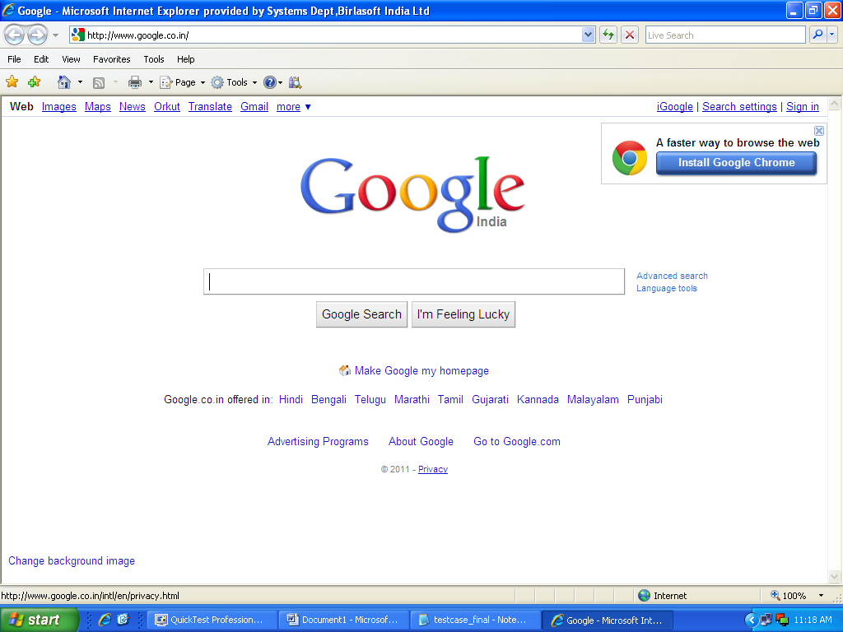
Figure 17: Google Page for Web Testing

After the Google page is opened. This page is tested by verifying the existence of search field and search button. If it exist that means the page opened is www.google.com page.

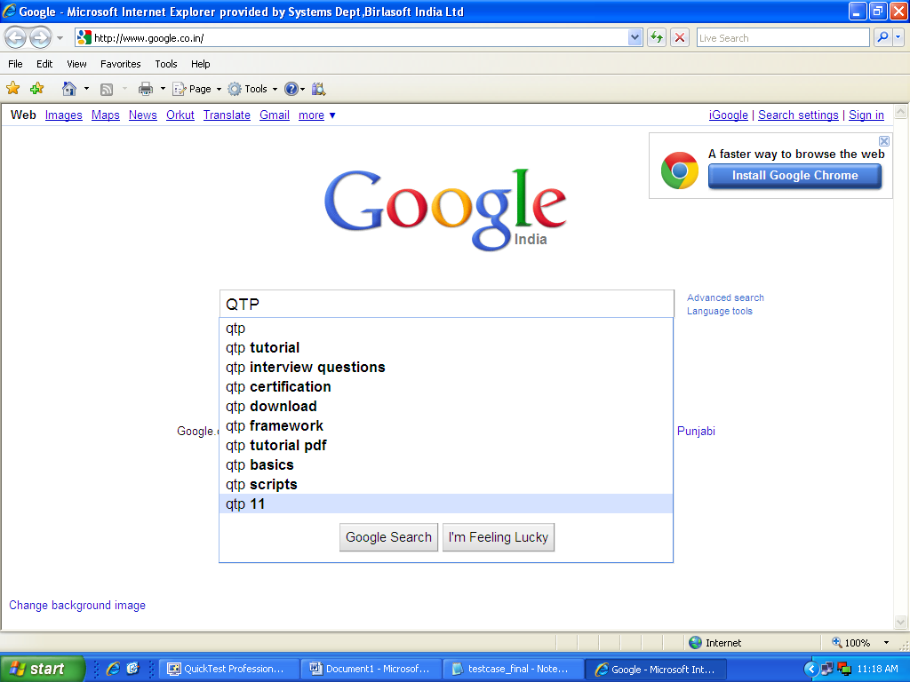

Figure 18: QTP Written in Search Field

Then we enter QTP in the search field and verify the value in the search field .This way we are testing that the search field text field is accepting the value or not.

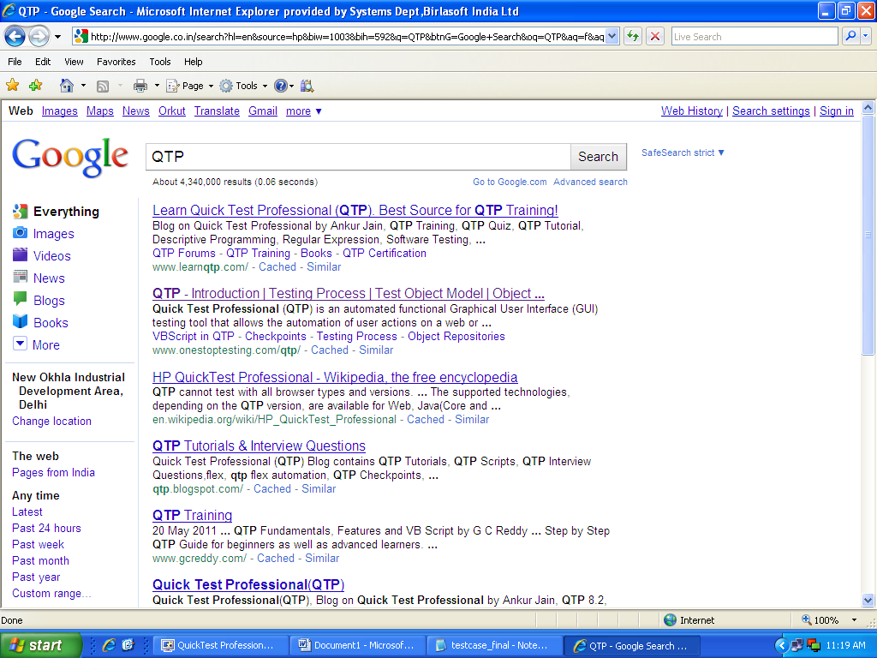

Figure 19: Search Results for QTP
Then we click on search button and verify the existence of search result.

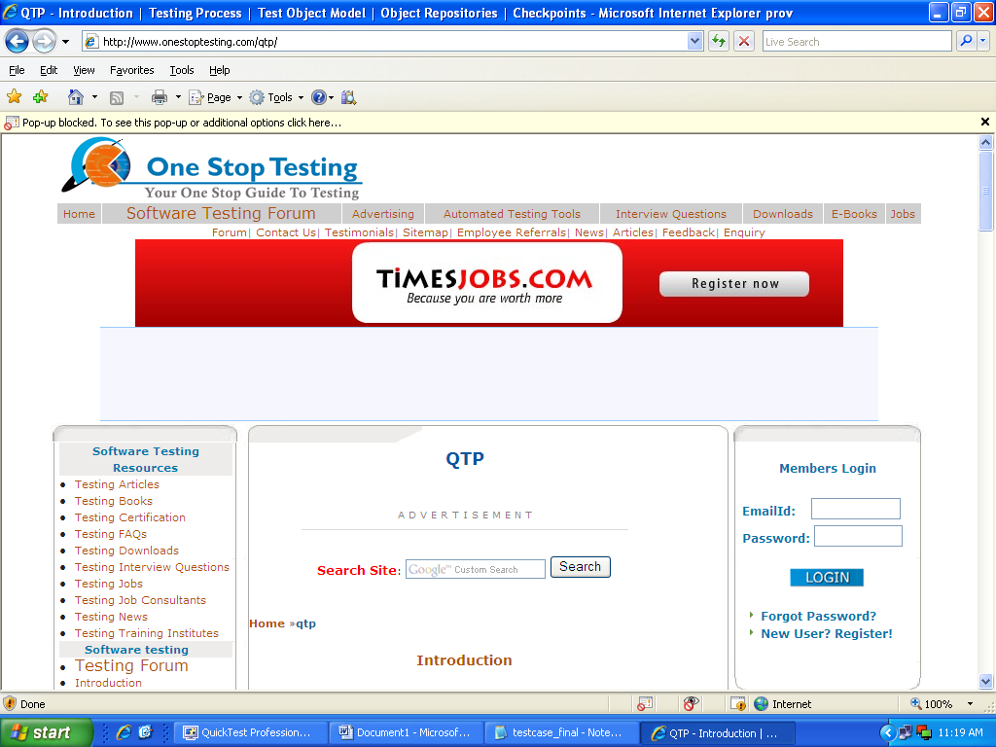

Figure 20: Page Open by Clicking on Search Result

After this by clicking on search result we verify that the new page should open which has the link on search result.
4.1.2 Our Process
First of all project manager analyze the web based application domain and prepare the budget of testing based on the cost needed in development of project and resources available for testing. According to this test manager draws a detailed plan of testing which include the details regarding the budget for testing, size of project, time left for testing and resources available. As we have discussed in generic Framework there are various types of testing activities like unit testing, integration testing, system testing , acceptance testing , regression testing and its sub testing. From these activities test manager include the details of those activities in test plan which are more essential based on domain of application. As in web based application we had considered the size of application is very small, resources available is also limited due to lack of industrial environment this make test manager to consider the unit testing and integration testing as the main testing which can be performed on these applications. Along with the activities test manager also include the approach i.e. manual or automated which should be used to perform the testing.
Once the testing activities are selected for the web based application by the test manager a proper planning of how unit testing and integration testing is carried out is done by respective stakeholders i.e. unit test plan is generated by test engineer while integration test plan is generated by test designer.
As mentioned in generic framework in chapter 3 for any of the testing activities there must be an objective and approach. The objective of any testing is to give a quality software and for this the testing should be done efficiently using the particular approach. The approach used can be manual testing or automated testing based on the type of application tested. For the web based application to perform the testing efficiently the approach selected by test manager is automated testing. Here QTP is used as a testing tool for testing the web application. For this kind of applications automated technique are adopted because these applications are very complex and by manual technique sometimes the essential features are neglected results in low quality of testing.
Now the sub process for unit testing and integration testing of previously defined application is described in next section.

4.1.3 Process for Unit Testing
As we had proposed in chapter 3 unit testing includes the steps requirement gathering, unit test plan, test case generation, test script generation and test case execution. We are Applying these sub process on the application described above.

4.1.3.1 Requirement Gathering
In this step requirements are gathered from the client which include the detail like what the project is proposed to do and based on these requirement the unit test plan is made by the test engineer.

4.1.3.2 Unit Test Plan
Test engineer makes the plan which includes the details of time involve for unit testing, cost involved, resources available and information of different forms and its important features which are to be tested . This plan is then given to the test leader to perform implement the testing.

4.1.3.3 Test Case Generation
Test Leader then give the information about this plan to the manual tester. Who will create the test cases using MS Excel which is shown as:
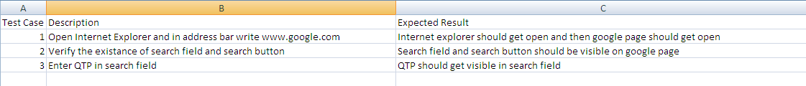
Figure 21: Test Cases for Unit Testing in Web based Application

Test Case 1,2,3 tests the individual module of the web based testing and check for the existence of individual module.

4.1.3.4 Test Script Generation
Once the test cases are generated then manual tester gives these test cases to the automation tester .According to these test cases automation tester generate the test script using QTP which are shown below. The whole script are described in Appendix B.

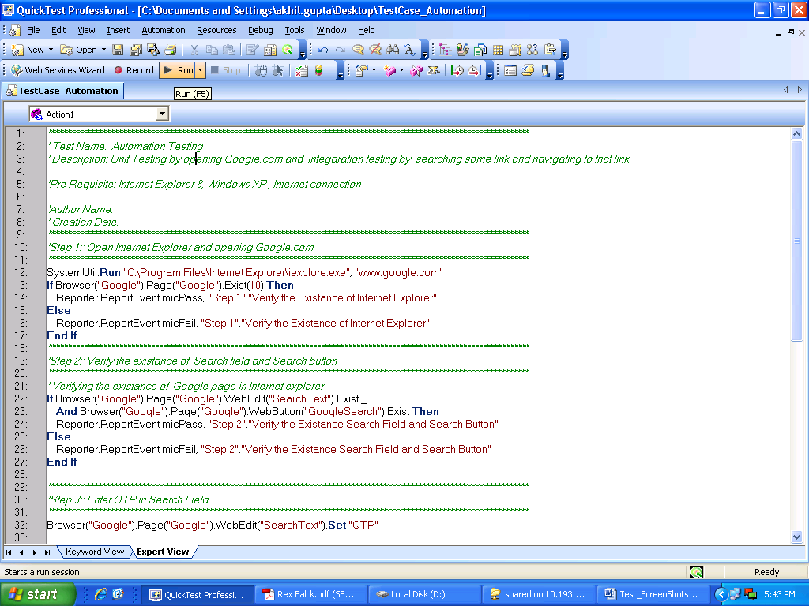
Figure 22: Test Scripts of Unit testing for web based application

4.1.3.5 Test Case Execution
After the generation of test scripts the automation tester execute the scripts using RUN command in QTP which is shown as:
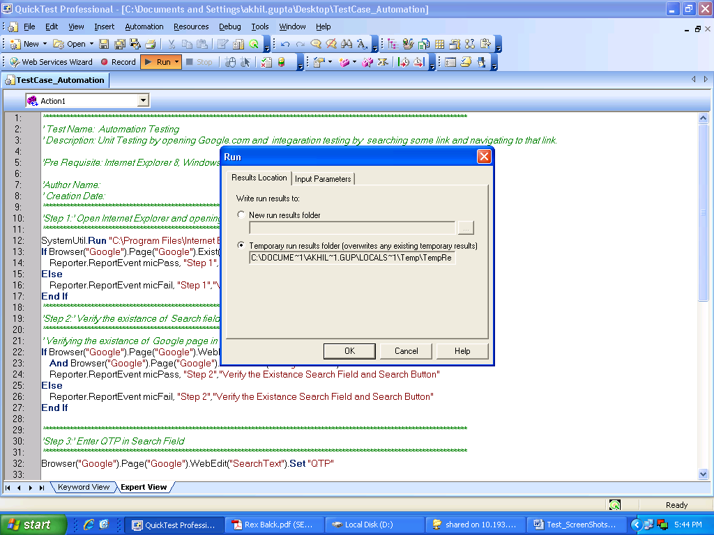
Figure 23: Running the Scripts of Unit Test Cases

4.1.4 Process for Integration Testing
As we had proposed in chapter 3 integration testing includes the steps requirement gathering, Integration test plan, test case generation, test script generation and test case execution. We are Applying these sub process on the application described above

4.1.4.1 Requirement Gathering
In this step requirements are gathered from the client which include the detail like what the project is proposed to do and based on these requirement the integration test plan is made by the test designer.

4.1.4.2 Integration Test Plan
Test designer make the plan including the details of time for integration testing, cost involved in integration testing, resources available for integration testing as well as the information of different integrated modules which are to be tested i.e. integration of two forms. In this it is tested that whether we are switching between the forms easily without any error or not. This plan is then given to test leader to implement the integration testing.

4.1.4.3 Test Case Generation
Test Leader then give the information about this plan to the manual tester. Who will create the test cases using MS Excel which is shown as:
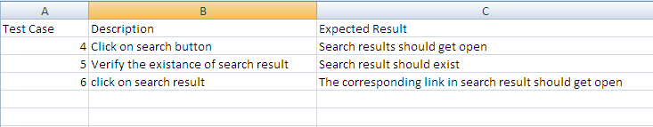
Figure 24: Test case of Integration Testing for Web based Application
The test case 4 and 6 checks the link between the two pages i.e. the navigation between two pages is error free or not and test case 5 give the integration between the application and database i.e. whether correct data is fetched by google from database or not.

4.1.4.4 Test Script Generation
The scripts are generated by the automated tester for the test cases mentioned above. These are shown in appendix B. In QTP they are formed as:
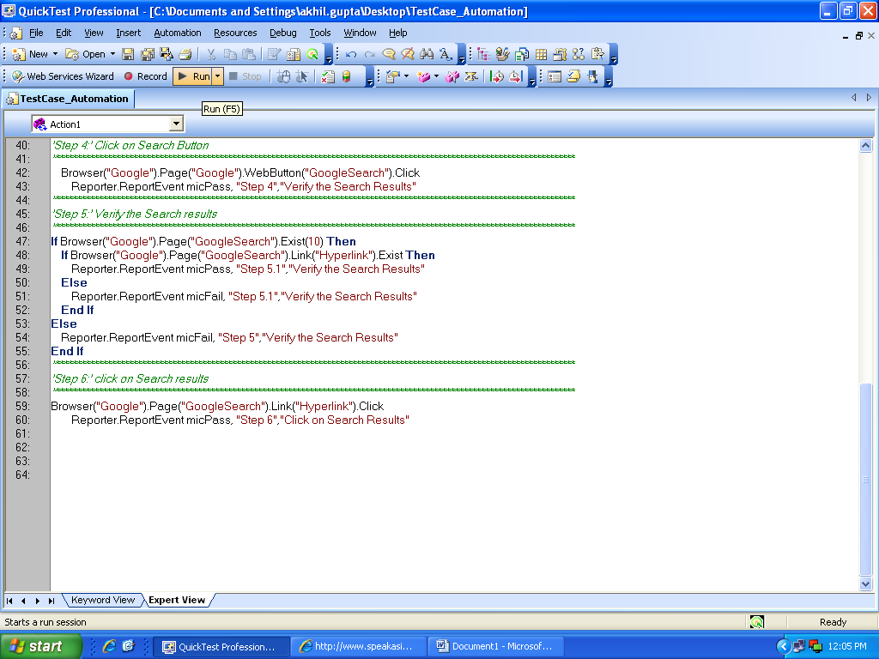
Figure 25: Scripts of Test cases for Integration Testing

4.1.4.5 Test Case Execution
After the generation of test scripts the test case are executed by automated tester using these test scripts. The execution is done using the RUN command in QTP which is shown as:
Figure 26: Running the Scripts of Integration Test Cases

4.1.5 Result Analysis
The result is analyzed by checking the result report summary in QTP. It is shown as:
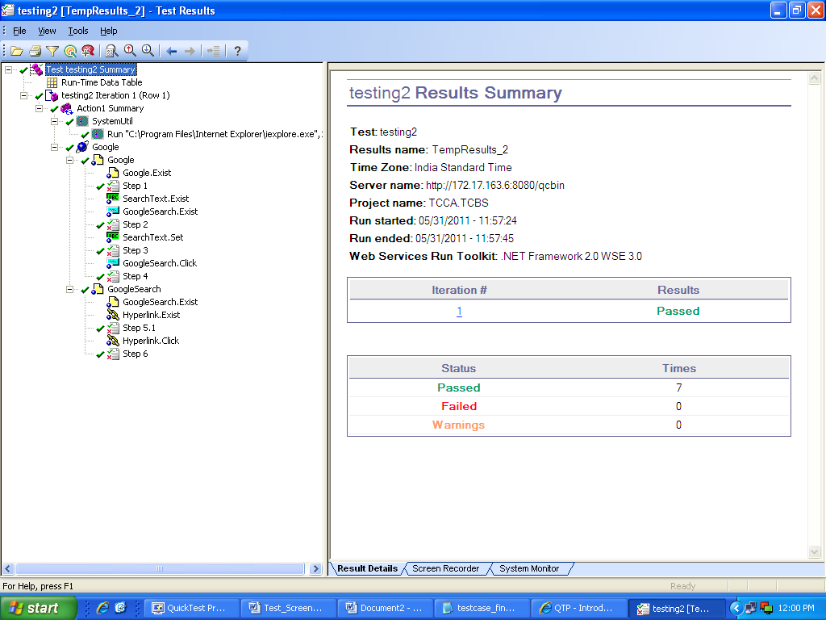
Figure 27: Result Report in QTP
QTP also generate the Quick Test Professional report according to the steps followed one by one. It is shown as:
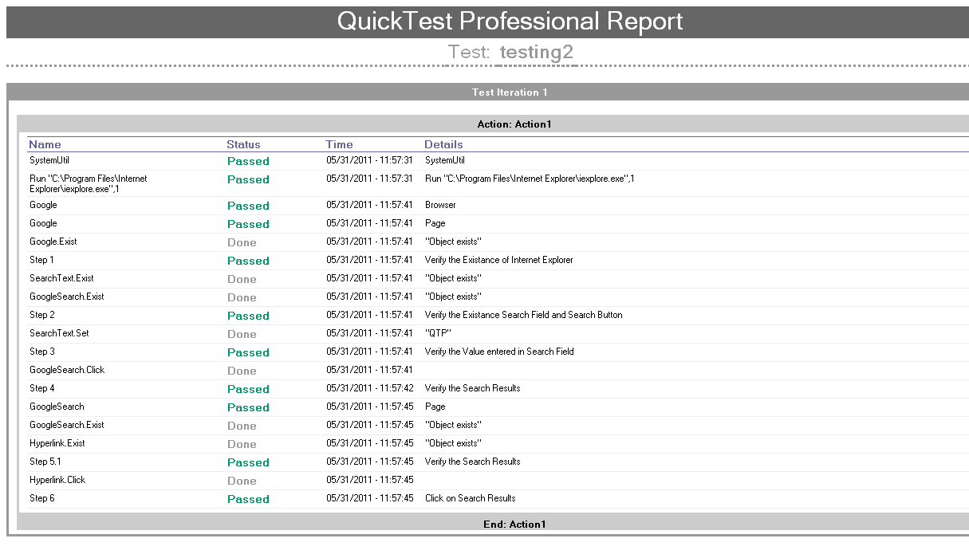
Figure 28: Quick Test Professional Report
4.2 Data Base Application Testing
In this section we will describe about the testing of data base application. It include the application which is to be tested, Process used in testing and sub process of unit testing and regression testing in data base application and at the end it describe about the result of testing.

4.2.1 Application
The database which is to be tested is shown as:
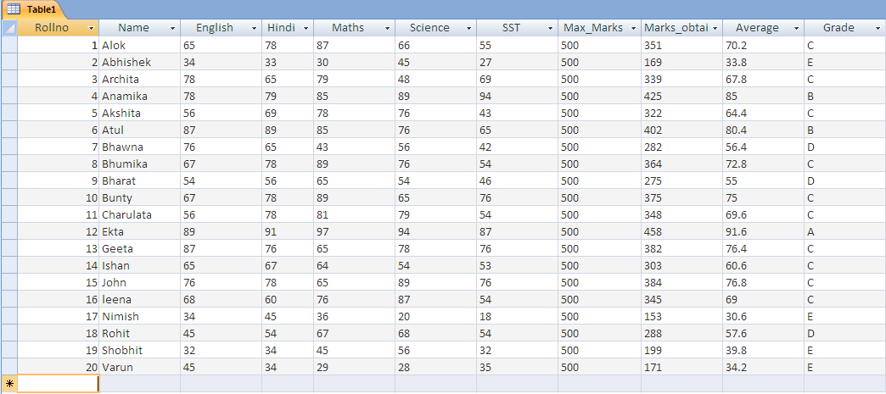
Table 1: Data Base Table1
This table shows the fields Roll no., Name, English, Hindi, Maths , Science, SST, Max_Marks, Marks_obtained, Average and grade. There are 20 records in this table which shows result of 20 students.

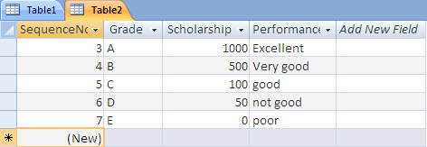
Table 2: Data Base Table 2
This is second table which is used. It shows fields like sequence no., Grade, Scholarship and performance.

4.2.2 Our Process
First of all project manager analyze the data base application and prepare the budget of testing based on the cost needed in development of project and resources available for testing. As in database application we had considered the size of application is very small, resources available is also limited due to lack of industrial environment this make test manager to consider the unit testing and regression testing as the main testing which can be performed on this applications.
Along with the activities test manager also include the approach i.e. manual or automated which should be used to perform the testing.
Once the testing activities are selected by the test manager then a proper planning for how these activities takes place is done by respective stakeholders i.e. test engineer will make unit test plan, test designer will make regression test plan.
The objective of these testing is to give Quality software and for this as database application is less complex and small so test manager will select manual approach of . This will save the tester from unnecessary complications of testing tool.
Now the sub process for unit testing and regression testing is mentioned in next sections.

4.2.3 Process for Unit Testing
As we had proposed in chapter 3 unit testing includes the steps requirement gathering, unit test plan, test case generation, test script generation and test case execution. We are Applying these sub process on the application described above.

4.2.3.1 Requirement Gathering
In this step requirements are gathered from the client which include the detail like what the project is proposed to do and based on these requirement the unit test plan is made by the test engineer.

4.2.3.2 Unit Test Plan
Test engineer makes the plan which includes the details of time involve for unit testing, cost involved, resources available and data of different tables which are to be tested . This plan is then given to the test leader to perform implement the testing.

4.2.3.3 Test Case Generation
Test Leader then give the information about this plan to the manual tester. Who will create the test cases using MS Excel which is shown as:
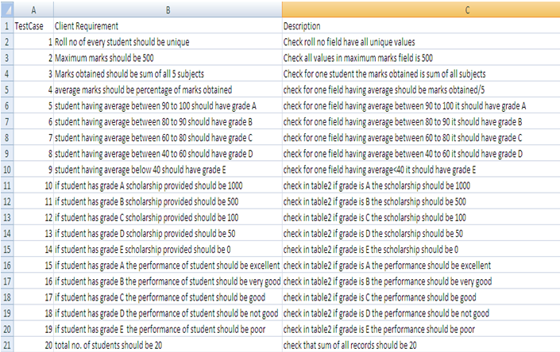
Figure 29: Test Cases of Unit Testing for Database Application

Test cases from 1 to 21 are used as unit test cases as in this the data of individual table are tested for its correctness.

4.2.3.4 Test Script Generation
Then after the test case generation , the test scripts are generates by manual tester .In the database testing SQL is used as test scripts which are described in Appendix C.

4.2.3.5 Test Case Execution
The test case execution for all the test cases shown above are shown in command prompt by executing the java program which uses SQL queries to extract the information from database. These Test Case Execution are done by manual testers.
This is shown as:
For Test Case 1: The roll number of every student should be unique. There should not any be any repetation of roll number. It is shown as:
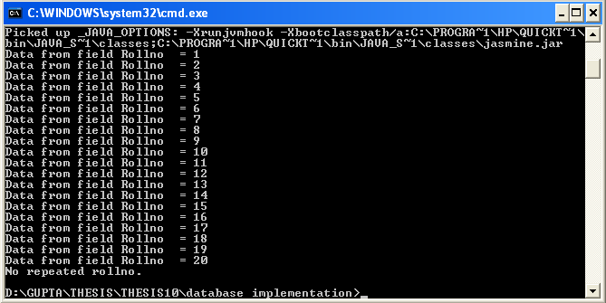
Figure 30: Execution of Test Case 1

For Test Case 2: The maximum marks should be 500. In this it is checked for all fields in table 1 that max marks should be 500. It is shown as:
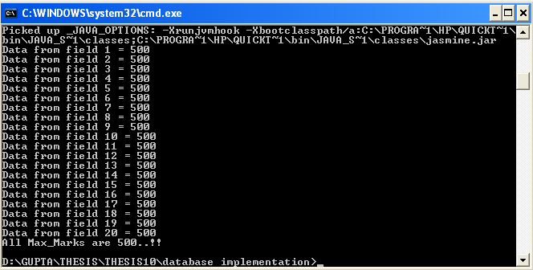
Figure 31: Execution of Test Case 2
Test Case 3: Marks obtained should be sum of all subjects marks. In this it is checked that the sum of all subjects and then compare it with the marks obtained. They must be same. 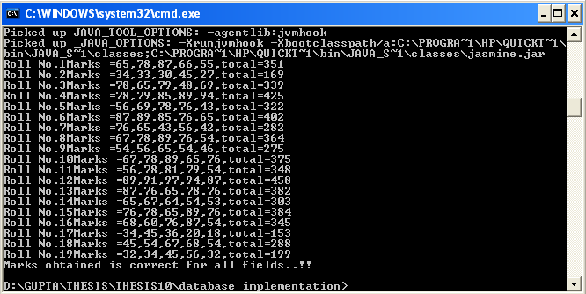
Figure 32: Execution of Test Case 3
Test Case 4: Average marks should be percentage of marks obtained. In this it is checked that for percentage of marks obtained and compare it with average marks. It is shown as:
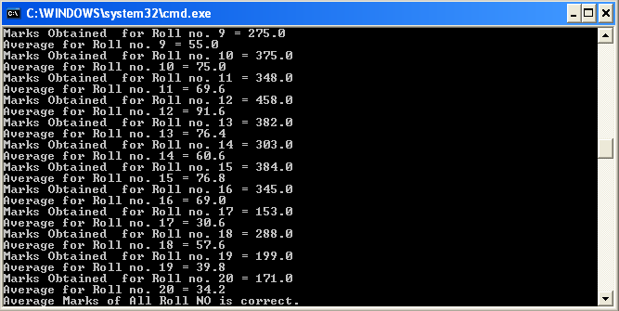
Figure 33: Execution of Test Case 4
Test Case 5-9: The grades of student are checked according to the marks obtained. Shown as:
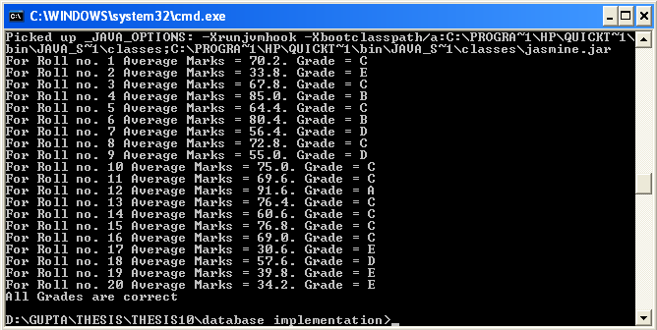
Figure 34: Execution of Test Case 5-9
Test Case 10-14: The Scholarship of students are checked according to the Grade obtained. Shown as:
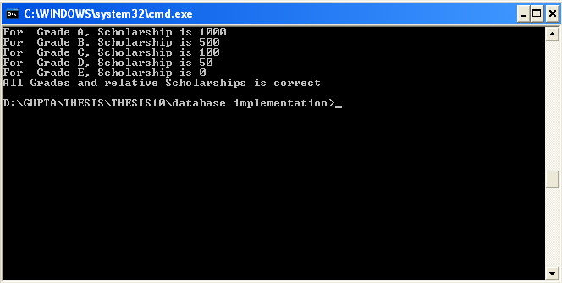
Figure 35: Execution of Test Case 10-14
Test Case 15-19: The performance of students are checked according to grade obtained .Shown as:
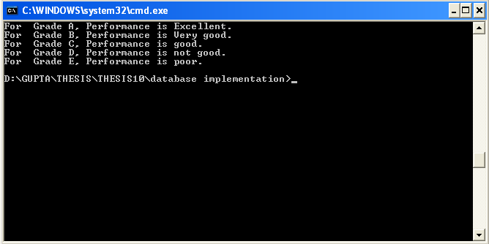
Figure 36: Execution of Test Case 15-19
Test Case 20: Total number of students should be 20. Shown as:
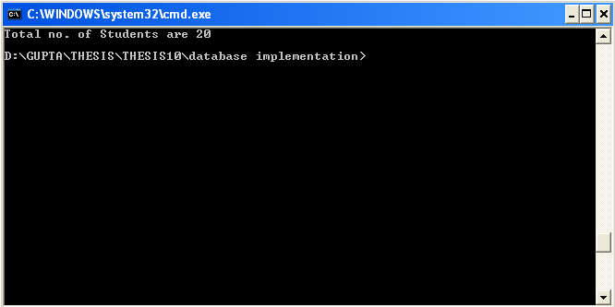
Figure 37: Execution of Test Case 20
4.2.4 Process for Regression Testing
For the regression testing let us assume that there is some error in the marks of roll no. 4. As mentioned in the process of regression testing described in previous chapter the error analyzer report the information of error to the test designer.
After the bug is reported to the test designer various sub process of regression testing includes regression test plan, modified code generation, test case generation, test script generation, test case execution which are shown as:

4.2.4.1 Regression Test Plan
Test designer after getting the error information makes the regression test plan which includes the information like cost involve in regression testing, time for regression testing, resources available and location where error occurs and which location needs to be retest. After the Plan completion Test designer handed over this plan to the Test leader and Developer.

4.2.4.2 Modified Code Generation
In this section Developer considering the Plan modified the code where the error occur. In the database application the value of field is being modified where the error occur so the correct table of marks is shown as:
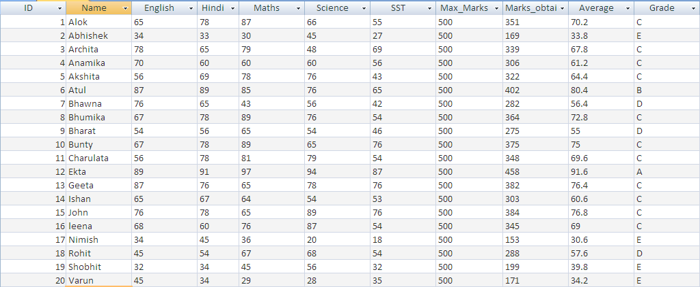
Table 3: Changed Table for Regression Testing
Once the table is modified the modification information is given to the test leader who will implement the regression test plan.

4.2.4.3 Test Case Generation
In this step when Test Leader gives change information to the manual tester he generated new test cases according to change and run new and old test cases on changed application. Here old test case are used to check the functioning of the change i.e. whether change is generating new error or not. Here MS Excel is used for the test case generation which is shown as:
Figure 38: Test Cases for regression testing

4.2.4.4 Test Script Generation
After the test case are generated test scripts are generated by the manual tester which include the java coding to fetch the data from the database . The example of such coding is shown in Appendix C.

4.2.4.5 Test Case Execution
After the scripts are generated they are executed by manual tester to find the new result using command prompt.
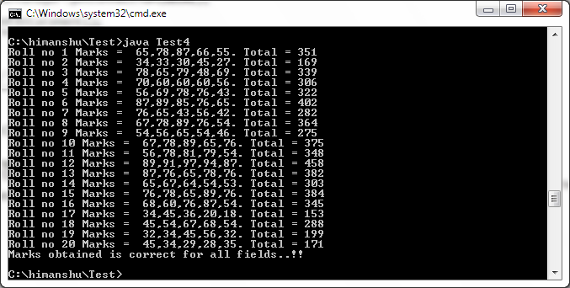
Figure 39: Execution of test case of regression testing

4.2.5 Result Analysis
In the result analysis for manual testing of database application it is just matched that result of script execution with the expected result in MS Excel are same or not. As they are same so the database is quality product and does not contain any error.

