of software activities. For example if testing activity is unit testing then the approach used can be manual testing or automated testing approach.
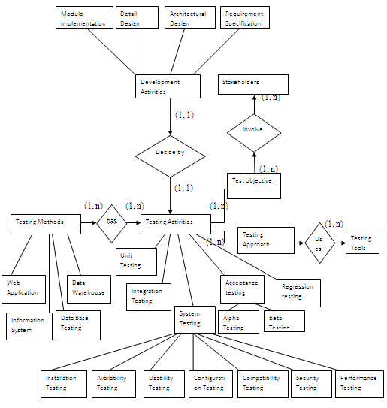
Figure 9: Generic Framework for Software Testing
Objective need to be realized .The approach identifies the manner in which it is done. An approach plays two role the availability of more than one approach for executing the testing activities gives the test engineer a choice of the way in which objective can be fulfilled and The specification of constitutes a direction to test tool designer to build specific technique in the tool.

Each testing objective involved various stakeholders who aim to achieve the objective choosing a suitable approach. This approach may be supported by various testing tools. The Various stakeholders involved to achieve objective is described in next section.

These testing activities can be unit testing, integration testing, system testing, acceptance testing and regression testing. These activities may themselves has sub activities for example acceptance testing includes alpha testing and beta testing while System testing includes Installation testing, Availability testing, Usability testing, Configuration testing, Compatibility testing, security testing and performance testing. These testing were explained in chapter 2.

Testing activities are linked with software development phases. So there is a relationship between testing activities and software development phase like module implementation, detail design, Architectural design and requirement specification

Unit testing is carried out in module implementation phase of software development life cycle. Whenever any module is implemented it is being tested individually so that if there is any sort of error occurs in the module implementation it can be easily find out.

Integration testing is carried out in detail design phase. In this phase keeping in mind the design of the project according to requirement of user integration between various modules are tested. So that it can be seen whether client requirement are fulfilled and no error occurs in the integration part of modules.

System testing is carried out in architectural design phase. Here whole system is tested according to architecture design of the system.

Acceptance testing is carried out in requirement specification phase. This testing is done mostly by the client. Client test the whole software and check whether it is performing its intended function or not. The software can be tested both by client or end user.

Regression testing is carried in every phase of software development as and when changes are occur irrespective of whether the change is in design phase, requirement phase or implementation phase the regression testing is done.

  - Stakeholders Involved in Generic Testing
There are various stakeholders involved in performing various testing activities. These are described as:
Stakeholders Involved

Client
Project Manager

Software Development Manager
Test Manager
Quality Manager

Quality Guarantee Engineer
System Analyst
Test Leader
Quality Assurance Engineer
Quality Control Engineer
Test Designer
Test Engineer
Developer
Software Architect

Program Designer
System Designer
Error Analyzer
Reviewer
Automated Tester
Manual Tester

Figure 10: Stakeholders Involved in Generic Software Testing
These Stakeholders are divided into two broad categories:
Client: These are the external stakeholders of the project. The project is developed according to the requirement of client. The client may be the organization head for which project is developed or the end user who will use the project.

Project Manager: The project manager is one who is responsible for making decisions. He analyze the domain for which testing is to be conducted and make the test plan which includes the information like budget of testing, time for testing and resources available.
Under project manager various stakeholders are there, which includes software development manager, test manager and quality manager. These are described as:

Software Development Manager: Software Development manager is responsible for leading the software development team in support of the software development life cycle process, change management, development Environments and production releases. Software development manager is further divided into software architect, system analyst and developer.

Software Architect: An architect develop the blueprint of the project. He deals with the interaction of systems using different diagram based on different models like UML etc.
It further includes the stakeholders Program designer and system designer which are described as:

Program Designer: It is Responsible for designing purpose. There work involve program designing in unit testing of project.

System Designer: Responsible for designing internal structure of the system. There work involve System designing in unit testing of project.

System Analyst: Responsible for finding and describing consisted static elements of the system and applying these elements to dynamically compound to satisfy outside functional requirements.

Developer: The primary work of developer is coding. It develop the project and if any minor error occurs while developing it also resolves the same. The developer work in various stages of testing i.e. acceptance testing and regression testing where there is the need of some change in code.

Test Manager: Test manager is responsible for making the plan which includes the information related to product. For management he gathers product information so that corporate management can decide when the product is ready for implementation.
It further include Test Engineer, Test leader and test designer. These are described as:
Test Engineer: It is responsible for carrying out software testing using various strategies of testing. He builds up test cases for different types of testing according to the test plans of the project. It involves Manual tester and Automated tester:

Manual Tester: Sometimes test cases are generated manually in the form of excel sheet or any other document. So, the work of manual tester is to generate these test case for different types of testing according to the requirement of user. Apart from generation of test case when manual testing is performed the execution of test cases and result evaluation is also done by manual tester.

Automated Tester: Automation testers came into existence when the testing is performed with the help of any tool. In this type of testing scripts generation, test case execution as well as report analysis is done by testing tool. Sometimes automation Tester also generate the test cases for different types of testing.

Test Leader: Test Leader is responsible for functional and Non Functional functionalities of system. It needs professional and organizational capabilities, strategic thinking as well as collaborative planning for tests. It basically implements the plans related to different types of testing with the involvement of other stakeholders like manual tester, Automated tester etc.

Test Designer: It is responsible for developing test strategies and test plans for integration and regression testing. It provide an assessment on the overall status of testing program. It involves reviewer and error analyzer which is described as:

Reviewer: The work of reviewer is to review the report came from client that the error they had analyzed are correct or not. Sometimes during acceptance testing client in the form of error report may include some more requirement in the project. So it is the work of reviewer to study the whole report and check for its truthfulness.

Error Analyzer: After the report of test cases execution is generated. The error analyzer analyze the negative test cases to find out the cause of error.

Quality Manager: It works towards customizing software development processes. He is responsible for creating and implementing a quality management program plan for the entire organization. It involves the stakeholders like Quality control engineer, Quality guarantee engineer and Quality Assurance engineer. Which are described as:

Quality Control Engineer: Adopted active model, actively identify potential software problems and trace the problem until the problem is resolved. It basically involve in unit testing.

Quality Guarantee Engineer: Prevention of the occurrence of software problems are major issues, he/she should understand the reasons for the problem while problem is occurred and he/she must continue preparation and audition to ensure software quality. It basically involve in integration and system testing.

Quality Assurance Engineer: It deals with the location of defect and mechanism to prevent defect.

  - Process of Generic Testing
In this section we describe our view of generic process. This process includes different types of testing i.e. unit testing, integration testing, system testing, acceptance testing and regression testing. The process is improved version of V model and showing the interaction of stakeholder involved in different testing [1]:

Feasibility Project Test Project
Study Planning Planning Manager

Requirement Acceptance Deployment Test
Analysis Testing Testing Manager
Requirement System Security Quality
Specification Testing Testing Manager
Design Specification Integration Regression Test
Testing Testing Designer
Program Specification Unit testing Test Cases Test Engineer
CODING

Figure 11: Generic Process of testing

Our process consists of following steps:
Step1: As soon as the feasibility study is over the project manager will perform project planning indicating the budget involved.
Step 2: After the requirement analysis phase test manager will draw the detail testing plan which may include the acceptance testing plan and deployment testing plan.
Step 3: After the requirement specification the quality manager decides the system testing plan and various plan for testing activities to define quality activities.
Step 4: Once the design specification is completed the test designer will plan for integration testing .
Step 5: After the completion of program specification test engineer plan unit testing
After coding these activities are carried out in bottom up manner as described in traditional V model.

In the next section we describe the detail process of testing. Here the process for all these testing are described by different sequence diagram because activities used for performing these testing are different which made it difficult to show all testing through one diagram. In these process we basically show various stakeholders and their activities to perform respective testing .
Sometimes the stakeholders involved in testing neglects some types of testing because the project may involve some remedies like cost of project, time left for completion, lack of other resources in project. These condition should also be taken care of while performing testing.
    - Process for Unit Testing
In the unit testing the individual module of the system is tested. The process proposed for unit testing includes the client, program designer, testing Engineer, Test leader, manual tester, automation tester and quality guarantees engineer .
These stakeholders communicate with each other to give an effective unit testing product. The process is described as:
First of all client or the end user give its requirement to the program designer. Program designer designs the system requirement and generate the document at the same time the requirement of client is also handled by the Test Engineer. Now test engineer according to the requirement of user and considering the document of program design generate the unit test plan. This plan includes the detail like budget for unit testing, time left, resources available, various modules which are to be tested etc.
After the unit test plan is developed it is being given to the test leader who give the information regarding unit testing to the manual testers if the testing is manual testing or to both manual and automated tester if testing is automated testing.
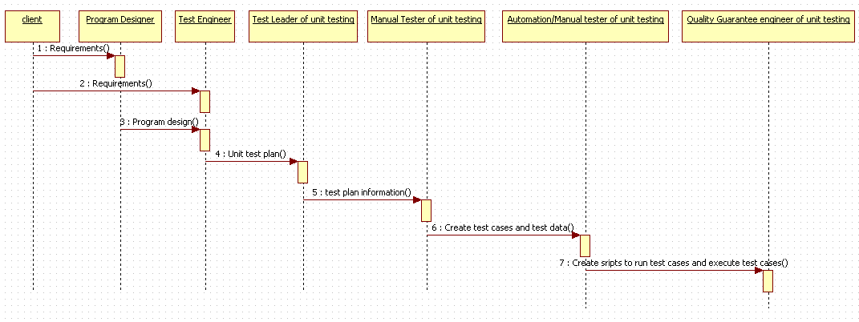
Figure 12: Testing Process for Unit Testing
Now Manual tester generate the test cases and test data according to the information provided. These test cases can be executed using scripts by using testing tool or can be executed manually. The former is done in case of automation testing and later is done in case of manual testing. At last in unit testing process the report of test case execution is given to the test guarantees engineer for further evaluation.

    - Process for Integration Testing
In the integration testing the stakeholders involved in testing process are client, system designer, test designer, test leader, manual tester, automation tester and quality control engineer.
The process is quite same as unit testing the only difference is that in unit testing all modules are tested individually while in integration testing the modules are combined together and then they are tested.
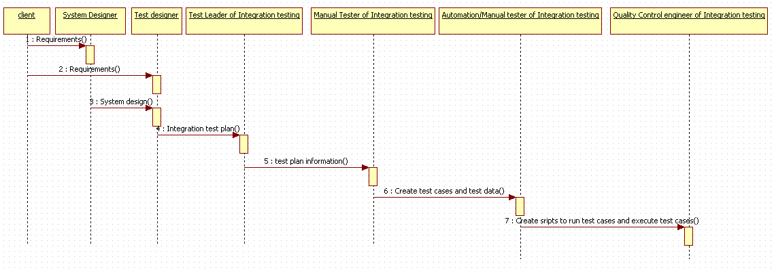
Figure 13: Testing Process for Integration Testing
In the proposed process first of all client give its requirement to the system designer as well as the testing team where system designer designs the system requirement as a design document. Test Designer makes a Integration test plan. This plan includes the detail like budget for integration testing, time left, resources available, various integrated modules which are to be tested etc. Now this Integration test plan is given to test leader .
Test leader according to system design and test management give information to the manual testers. Where manual testers generate the test cases for the integration of two modules. Basically in this case the module integration point is tested i.e. is there any error occur due to integration of modules. After the generation of test cases they are executed. These test case are executed using the test script in case of the automated testing and in case of manual testing the test cases are executed manually. In the automated testing the testing tools are used for execution. The test case execution report is being then analyzed by quality control engineer.

    - Process for System Testing
In the system testing the process involved is similar to the unit testing and integration testing process. The difference is that in this whole system is being tested while in unit and integration testing the one or integration of modules are tested.
In the system testing whole system is developed and then tested as a whole. The various stakeholders involved in the system testing are client, Quality manager, testing team, test leader, manual testers, automated testers and quality control engineer.
In this proposed process first of all client send the requirements to system analyst as well as the testing team. System analyst analyze the whole system and produce the document related to it.
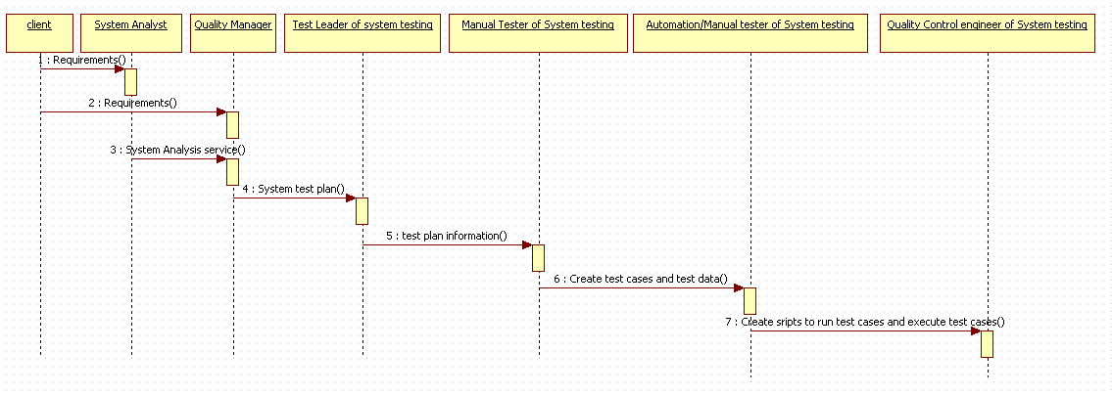
Figure 14: Testing Process for System Testing
Quality Manager makes a System test plan. This plan includes the detail like budget for system testing, time left, resources available, type of system which is to be tested etc. Now this System test plan is given to test leader . Test leader according to system analysis document and test management give information to the manual testers. Where manual testers generate the test cases for the whole system. after the generation of test cases they are executed. These test case are executed using the test script in case of the automated testing and in case of manual testing the test cases are executed manually. In the automated testing the testing tools are used for execution. The test case execution report is then analyzed by quality control engineer
    - Process for Acceptance Testing
In the acceptance testing the system is tested by the client or the end used. The whole system is installed at the development environment or at users environment. From there system is being tested according to the test cases of the client. Client test the system to ensure that all of there requirements are fulfilled and system is developed according to their need.

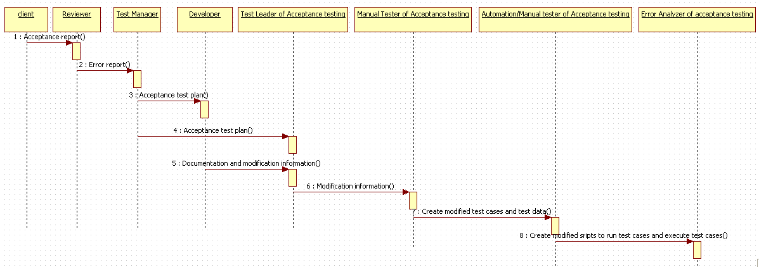
Figure 15: Testing Process for Acceptance Testing
Various stakeholders involved in acceptance testing are Client, Reviewer, Test Manager, Developer, Test leader, Manual tester, Automation tester and error analyzer.
Client after testing the whole system sends the acceptance report to the reviewer who review the report that the error found by the client are according to the requirement of user or not . The report also reviewed to check that all the errors are genuine. The reviewer then sends the error report to the test manager who will develop acceptance test plan according to the error report and give this plan to the developer and test leader. Then the developer perform change in the coding on the basis of acceptance test plan. After that the modification report is sends to the test leader so that test leader can test the new changes occur as well as the old code that no new error occur due to change.
Then the test leader sends the modification information to the Manual tester. Manual tester then generates the modified test cases for the modification information. Then these test cases are given to the automation engineer who generate the modified scripts for the modified test cases and the result of execution is given to the error analyzer for analyzing the error.

    - Process for Regression Testing
In Regression testing when any error occur in the system then to resolve that error some changes are done in the system. But sometimes due to this change new error occurs so for checking the existence of new error regression testing is used.
Various stakeholders exist in the regression testing are Error analyzer, Test designer, Developer, Test leader, Manual tester and automated tester.
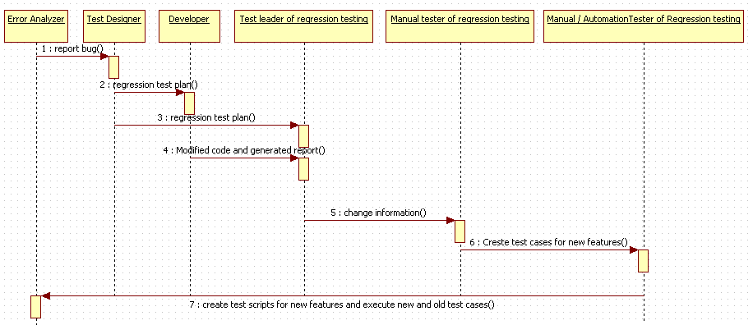
Figure 16: Testing Process for Regression Testing
In the regression testing process first of all the error analyzer find the bugs in the old code and report this bug information to the test designer. Test designer then develop the regression test plan and send it to the developer and test leader. Developer then according to the regression test plan modify the code to remove the error and sends the modified code to the test leader. Test leader also sends the bug report along with the modified code to test leader. Test leader sends the information of modified code to the manual tester as well as to the automation tester. Manual tester then create test case for the new features then automation tester create scripts for the new features and execute old and new test case to new code to find out if due to modification of code no new error occur in the system. After that result is given to the error analyzer.

