In the later part of this section the testing of database and web based system is described. We had consider these two applications because they are widely used in day to day life of every engineer or even the person who is using it. It describe in detail about the various types of testing done, how testing process is carried out and one of the method which is being used depending on the application.
These researches are the building block of this project and helped a lot in completing of this work.

  - Introduction to Testing Processes
Testing Process basically describes the “steps involved in doing any type of testing”. In these process we have to take care of the type of testing done, various stakeholders involved in performing any sort of testing and the data or documents exchanged between the stakeholders so that efficient testing is done. It describe the behavior which is followed for testing. Testing process is more or less similar for both manual as well as automated testing. The difference comes in the way testing performed. In the automated testing, tools are used while in manual most of the work or steps of testing process is carried out manually. It describes about how efficient software development is carried out and is it performed the intended function or not.
“It describe the outside environment and structural element and interaction according to time[2]”
“It is the process used to measure the quality of the developed software[5]”.
“It is the process of establishing confidence that a program does what it is supposed to do[5]”
There is no generic process which is followed for testing any application. The researchers proposed testing methods which are application dependent. This is very essential to consider a standard testing process which will help every researchers to understand there work and other’s work more clearly and which leads to high growth in this field.

    - Types of Testing
The testing is basically divided into 5 types which can be further divided.These can be described as [6, 12,16]:
- Unit Testing
- Integration Testing
- System Testing
- Acceptance Testing
- Regression Testing

Unit Testing: It is the procedure used to validate and test that individual units of source code are working properly. A unit is the smallest testable part of application which can be an individual program, function, procedure, method etc[1].

Integration testing: Testing in which modules are combined and tested as a group .Modules are typically code modules. individual applications, client and server applications on a network etc[1].
System Testing: Testing conducted on a complete, integrated system to evaluate the system’s compliance with its specified requirements. It requires no knowledge of the inner design of the code or logic[1].
It can be further divided into [14]:
- Installation Testing
- Availability Testing
- Usability Testing
- Configuration Testing
- Compatibility Testing
- Security Testing
- Performance Testing

Installation Testing: It is one of the most important part of testing activities. Installation is the first interaction of user with product and it is very important to make sure that user do not have any trouble in installing the software[7].

Availability Testing: It is necessary to test software for disaster recovery to verify its ability to recover from various levels of failure[10].

Usability Testing: It evaluates how easy a system is to learn and use. There are enormous benefits of the usability testing[9].
Configuration Testing: During this testing tester validate how well our current project is able to

supports on different types of hardware technologies like as different types of printers, n/w

interface cord(NIC),topology etc. This testing is also called as hardware testing or portable

testing[10].

Compatibility Testing: Testing how well software performance in a particular hardware/ Software / Operating system/Network environment and different combination of above.[8].

Security Testing: Evaluates the presence and appropriate functioning of the security of the application to ensure the integrity and confidentiality of the data[1].
It can be further divided into[10]:
- Volume Testing
- Load Testing
- Stress Testing
- Recovery Testing

Volume Testing: Volume testing refers to testing a software application for a certain data volume. This volume can in generic terms be the database size or it could also be the size of an interface file that is the subject of volume testing[10].

Load Testing: Load testing is the process of putting demand on a system or device and measuring its response. Load testing is performed to determine a system’s behavior under both normal and anticipated peak load conditions. It helps to identify the maximum operating capacity of an application as well as any bottlenecks and determine which element is causing degradation[8].

Stress Testing: When the load placed on the system is raised beyond normal usage patterns, in order to test the system's response at unusually high or peak loads, it is known as stress testing[9].

Recovery Testing: Recovery is ability to restart the operation after integrity of application is lost.
It includes reverting to a point where integrity of system is known , then reprocessing up until the point of failure[9].

Performance Testing: It is executed to determine how fast a system performs under a particular workload. It can also serve to validate and verify other quality attribute of the system, such as scalability, reliability and resource usage[8].

Acceptance Testing: Testing to verify a product meets customer specified requirements. A customer usually does this type of testing on a product that is developed externally[8].
I can be further divided into [9,13]:
1.Alpha Testing
2. Beta Testing
Alpha Testing: In house virtual user environment can be created for this type of testing.Testing is done at the end of development. Still minor design changes may be made as a result of such testing[9].

Beta Testing: Testing typically done by end users. Final Testing before releasing application for commercial purpose[9].

Regression Testing: It is a technique that detects spurious errors caused by software modification or correction[1].

    - Stakeholders Involved in Testing Process
The stakeholders in testing process can be divided according to phases in which they works. These stakeholders can be a stakeholders from development phase including project manager, System analyst, System designer, Program designer or from the testing phase including Test leader, Quality control engineer and Quality guarantee engineer.

System Designer
Program Designer
System Analyst
Project Manager
Quality Guarantees Engineer
Quality Control Engineer
Test Leader

Figure 1: Stakeholders Involved in Testing
These can be described as[2]:
Project Manager: responsible for the project and communication with the client, having powers and responsibilities to assign executive members to ensure project’s success.

System Analyst: responsible for finding and describing consisted static elements of the system and applying these elements to dynamically compound to satisfy outside functional requirements.

System Designer: responsible for designing internal structure of the system and design to platform specific software model depending on the domain conceptual model, and then it coordinates with empirical platform specific software models.

Program Designer: responsible for programming and finding out best solutions.
Test Leader: needs professional and organizational capabilities, strategic thinking as well as collaborative planning for tests and need practical involving and testing.
Quality Control Engineer: adopted active model, actively identify potential software problems and trace the problem until the problem is resolved.

Quality Guarantee Engineer: Prevention of the occurrence of software problems are major issues, he/she should understand the reasons for the problem while problem is occurred and he/she must continue preparation and audition to ensure software quality.

The interactions between various stakeholders in different types of testing is described as[2]:

Acceptance Test System Test Integration Test Unit Test
SYSTEM DESIGNER
PROJECT MANAGER
SYSTEM ANALYST
PROGRAM DESIGNER

TEST LEADER

QUALITY GUARANTEES ENGINEER
QUALITY CONTROL ENGINEER

Figure 2: Stakeholders Interaction in Different Types of Testing

In the unit testing Quality Guarantees Engineer ,Test leader and Program designer interact with each other to perform testing.
In Integration Testing Quality control Engineer, Test leader and system designer interact with each other to perform testing.
In System Testing Quality control Engineer, Test leader and system analyst interact with each other to perform testing.
In acceptance Testing Test leader and project manager interact with each other to perform testing.

    - Traditional Testing Model
The widely accepted traditional testing model is V-model. The V-model is a software development process which can be presumed to the extension of the waterfall model. It was first proposed by Paul Rook[3] in the late 1980s and is still use today. It basically describes the relationship between the development activities and testing activities[2].Instead of moving down in a linear way the process steps are bent upwards after the coding phase, to form typical V shape.
The V-model describes a well structured method in which each phase is implemented by the detailed documentation of the previous of previous phase. Testing activities like test designing start at the beginning of the project well before coding and therefore saves a huge amount of project time. The purpose of V model is to improve efficiency and effectiveness of software development. It can be shown as:
Acceptance Testing
Requirement Specification

Architectural Design
System Testing

Integration Testing
Detail Design
Module Implementation
Unit Testing

Coding

Figure 3: V-Model
The basic V-model development process is divided into understanding the requirement specification, designing in initial outline, designing in advanced detail and then implementation of module and described required tests in basic development process as shown in figure 1 from left tp right on each other counter part[1].
In the V-Model , the V proceeds down and then up, from left to right depicting the basic sequence of development and testing activities. The model highlights the existence of different levels of testing and depicts the way each relate to a different development phase. It illustrate that testing can be start at very beginning of the development phase. This interconnectedness lets us identify important errors, omissions and other problems[1].
Traditionally different applications adopted different methods for testing application.
Based on the analysis for web applications characters and traditional software testing process , the process for web application testing is modeled , which describe the series of testing flows such as testing requirements analysis, test case generation and selection, testing execution and testing results analysis and measurements. This process of web based testing is described in the next section named process of web application testing. But the process mentioned has some limitations i.e. it does not differentiate the testing process for different types of testing as well as it describe the whole process with respect to the web based application.
As mentioned in [27] in the database application the test cases are generated according to database design specification that are identified by testers. The process of the testing is described as Prepare design specification, Generate test cases and execute test cases. We will read this process in detail in the section process of database testing but it lacks in majority of details related to testing and also missed some of the steps of testing. Moreover the steps specified includes the features of database application.

    - Testing Process
Testing process basically describes about how testing is carried out based on stakeholders involved, documents involved and the interdependency between various stakeholders. This process depends on application for which testing is carried out and also consider the type of testing. It describe about the quality of software by showing whether the software is fulfilling the requirement of user by doing its intended function. Here in any of the methods proposed the researchers do not differentiate testing in two wide ways i.e. manual or automated. They just described about the process independent of the way testing is performed by testers .
Fu Shiau Li and Wei Ming Ma in their paper “Architecture Centric approach to enhance software testing management”[2] has described about the testing process. It includes how testing is conducted by various stakeholders. The researchers basically describe the testing process by the interaction between the stakeholders using the sequence diagram. It is described for unit testing which is shown as:

Client Program Designer Test Leader Quality Guarantees Engineer
Program Design
Test Management Plan

Unit Testing

Figure 4: Brief Process of Unit Testing
    - Testing Information Flow
Testing information flow describes the method by which testing is carried out. It can be shown by diagram as[11]:
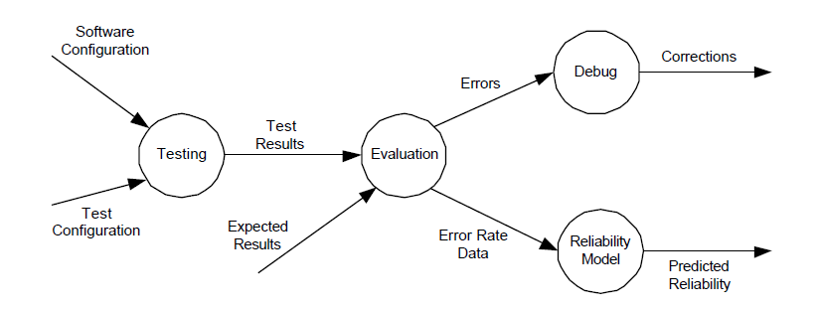
Figure 5: Testing Information Flow
The information flow of testing is shown in Figure 5. As we can see, testing involves the configuration of proper inputs, execution of the software over the input, and the analysis of the output. The “Software Configuration” includes requirements specification, design specification, source code, and so on. The “Test Configuration” includes test cases, test plan and procedures, and testing tools.
Based on the testing information flow, a testing technique specifies the strategy used in testing to select input test cases and analyze test results. After the analysis of result the error evaluated can be resolved by debugging process as well as from the error rate data the reliability of the software is predicted from the Reliability model.

  - Web Based Application Testing
A web application is an application that is accessed over a network such as the Internet or an intranet. The term may also mean a computer software application that is hosted in a browser-controlled environment. The rapid diffusion of internet and open standard technologies is producing a significant growth of demand of web sites and web applications with more and more requirements of usability, reliability interoperability and security.
The central entity in a web application is the HTML Page. An HTML page contains the information to be displayed to the user. And the navigation links toward other pages. It also include organization and interaction facilities(e.g. frames and forms).A web page can be static or dynamic. In the static web page basically the contents are fixed while in dynamic web page content is computed at runtime by the server[20].In both the static and dynamic web pages consideration should be given to the interaction between html pages, TCP/IP communications, internet connections , firewalls , applications that run in web pages and application that rum on server side.
Additionally there are wide variety of servers and browsers, various versions of each ,small but sometimes significant differences between them ,variations in connection speeds, rapidly changing technologies and multiple standards and protocols. The end result is that testing of web sites can become a major ongoing effort.

2.2.1 Introduction to Web Application Testing
As far as the testing of web applications is concerned due to very short time to market that characterizes web application development, this practice is very often neglected by the developers, and considered too time consuming and lacking a significant payoff [22].Moreover, although a variety of commercial tools are available but ,most of them offer specific functions for addressing web application usability or portability issues, but they are not able to verify other quality requirements[21].
Effective testing of web application rely on well defined test strategies, defining heuristics or algorithm to create test cases from test models; test models representing the components of the application to be tested and their interconnections; testing levels, specifying the different scopes of the tests to be run, i.e. , the collections of components to be tested; testing process, establishing the right sequence of testing activities and other decisions regarding when testing should be started , who should perform testing, how much effort should be used and similar issues[21].

2.2.2 Testing Process for Web Application
Web application testing is concerned with numerous and complicated testing objects , methods and processes. So a testing process fitting for the properties of web applications is needed to guide and organize all the testing talks. Based on the analysis for web applications characters and traditional software testing process , the process for web application testing is modeled , which describe the series of testing flows such as testing requirements analysis, test case generation and selection, testing execution and testing results analysis and measurements.
The testing process for traditional software is generally consisted of five steps firstly determine the testing objects and targets, such as required testing coverage ratio ,next generate the testing inputs and this input is generated by the specification and structure of software, then produce the expected output result , subsequently execute the test cases and validate the output and finally amend this software and carried out regression testing. This testing process should be adjusted and changed so as to have better pertinences and adaptabilities.
The testing process model is shown as[18]:
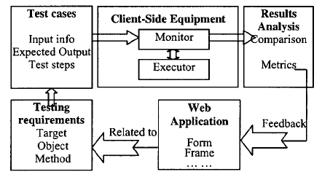
Figure 6: Testing Framework for Web Application

Analyzing Testing Requirements: In the detailed testing requirements, we should describe the testing contents with pertinence, select the test objects due to the testing targets , and choose the relevant testing methods. There are many kinds of tests for web applications, such as functionality testing, performance testing[23],safety testing, usability testing and compatibility testing and the testing methods are divided into white box testing, black box testing and grey box testing. If the testing is provided with the analysis and design documents, it can be carried out more conveniently. However, the web applications are short of necessary documents in most conditions. Thus we should analyze the web pages and models, gain the contents and relationships for testing, and present the testing requirements in the proper style.

Generating and selecting Test Cases: Since the web applications have multiple pages and loose structures, the contents and states are very complex. And when the transmitting and diffusing of the hyper links are considered, there will be combinational explosion, thus it is rather difficult to control the testing scale and guarantees the testing efficiency. Therefore in order to generate the test cases with moderate number and credible quality, we adopt the strategies such as the equivalence division, boundary analysis and combinatorial testing, combining with the web application model and testing requirements.
Furthermore, the web applications have the interactive, dynamic and uncertain characters. For example in a form page if users input different contents, the dynamic generated output pages are usually different contents. Thus during the test case generation, we must consider all the possible output and successive order of the executed actions, so as to determine the testing steps, input information, expected output and relationship among them.

Executing Testing: Since the web applications focus on the usage, we should execute the testing at the client sites so as to gain better realities. Furthermore ,the number of the test cases is very excessive, so the cost for the manual testing is too expensive .However since we have strictly defined the actions and steps of the whole testing process in advance, it is possible to carry out the testing automatically or semi automatically. Thus we can improve the testing efficiency notably.
Analyzing and Measuring Testing Results: After obtaining the testing results, we should compare them with the expected output so as to judge whether this web application passed this testing or not. But it is difficult to analyze and compare the testing result as many web pages are dynamically generated and expected output is not precise enough before executing the testing furthermore output of web application usually have graph so it become difficult to match each pixel one by one with expected output.
In order to evaluate the web application quality and the testing efficiency, the quantitative analysis for the testing results is also needed. Moreover, we should repair and maintain the web applications based on the testing results.

Realization Techniques: Based on process modeling for the web application testing, we emphasize how to realize each testing step and integrate the whole testing flow focused on the existed problems. Thus we can make the testing framework to be suitable for the internet environment and capable to guide the testing.
    - Various Types of Testing in Web Based Application
Different levels of testing can be conducted on a web application, similarly to a normal software system as[20]:
Unit Testing : Singular components are tested and stubs/drivers replace missing parts. For example, a server script is invoked by a driver which simulates the browser and receives the html page as the resulting output. Another example is a java script program which validates fields in a client side page and sends a request to a fictitious server simulated by a stub.
Integration Testing: Pages are composed and integrated with server programs. the testers can now navigate from page to page and requests can be passed from the browser to the web server via http. this testing phase is strongly based on the protocol exploited and when, this is http it can be supported by adhoc techniques.

System Testing: The system is validated as a whole in an environment as similar as possible to the real, target environment.

Acceptance Testing: The customer installs and runs the application in its own environment.

Regression Testing: During evolution the preservation of previous functionalities is checked by rerunning the test cases defined for them. exploitation of the http protocol can positively effect also this testing activity.

    - Web Testing Model
A web testing model for web application testing starts from constructing the PFD of the web application. Then from PFD, PTT is generated. From the PTT , a test translator is employed to extract the path expression, in order to generate all the test paths and then translates them into a test specification in XML syntax, which is the input of test engine. The test engine generates test cases and then executes them and finally produce test report[19].
A web application presents several different options to users, and the individual user chooses a particular sequence at the time of browsing. In addition, the user do not only browse, but also activate operations and transactions . Through hyperlinks, users can traverse among the pages of a web application. However, a dangling hyperlink or an unreachable page can bother users. Moreover , the structure of a web application is often complicated and difficult to maintain. To ensure whether or not the page flows are appropriate and meet the requirements, a PFD is employed .The PFD intuitively reflects the relationship among pages of a web application. The PFD is a graphic structure , which brings the problems that we often cannot verdict the termination of a path and the path may be cyclic , as will complicate the testing process, thus, driving the testing process using the PFD is difficult. Therefore a PTT which is based on the PFD is used. From the PTT shorter path can be generated then the PFD without the loss of page[19].
The PTT is used to establish the path expressions[24], which are then translated into the test specification by the test translators. A path expression is an algebraic representation of the paths in a tree. Variables in a path Expression are links. They can be combined through operators + and *, associate respectively with loop and selection.
From the path expressions test paths can be extracted automatically and then test cases. A test case defined by web testing model is one test path with user input values. So, a test path may be used to construct multiple test cases if only the tester provides different user input values for the test path.
A test specification is the hierarchy of test suite, test case and test step. In our test specification, a test case is defined as the tree of test step. The links on the path represents test step to be carried out successively. In other word the next link represents a test step to be taken following the test step represented by its previous one. Sibling link represent alternative test step in test paths. Specification is depicted using XML.
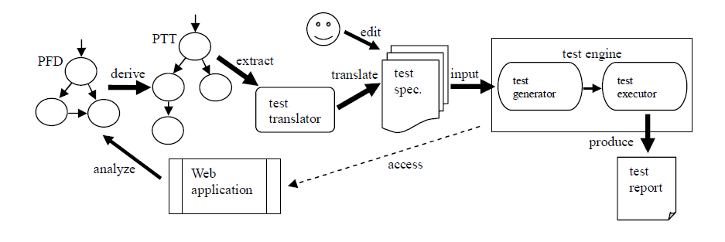
Figure 7: A Web Testing Model
The specification contains templates of the test cases. Test engine includes a test case generation engine that is able to determine the test paths from the test specification, and to generate test case from it, provided that the test criteria is specified . Generated test cases are sequence of links which once executed grant the coverage of the selected criterion. Then the test engine executes the test cases and validates its result against the test oracle specified as expected result.
After the execution ,tests engine produce the test report summarizing the results of all test cases. For such evaluation, the tester open the output pages to the web browser and check whether the output is correct for each given input[19].

  - Database Application Testing
The database component is a critical piece of any data-enabled application. Today’s intricate mix of client-server and Web-enabled database applications are extremely difficult to Test productively. Testing at the data access layer is the point at which your application communicates with the database. Tests at this level are vital to improve not only your overall Test strategy, but also your product’s quality.
Testing a database is relatively different from any traditional testing methods. Database testing is a planned activity. It starts as soon as Software Requirements Specification is baseline and continues to exist in the system until the system is going for retirement or further enhancement. In database testing, the testing continues to exist even after deployment. One example would be testing a database growth. Database growth is a situation, where the volume of data keeps on increasing day by day. When the system reaches its peak load, the system may encounter the following situation Delay in service ,Denial of service, Lost of data Testing the application with traditional functionality and performance (volume testing, load testing) testing does not give sufficient information on internals of database. The entire organizations business, transactions, good will, reputations are in stake even when any of the data is not correct. So, due importance should be given for database testing from the early stage of development.
Database testing will identify the defects and the weakness from the design which is cheaper when the same is identified after construction. As the complexity of the real time business rules are increasing, testing only the functionality and performance would not be enough to have the confidence. The overall product quality is increased when the data are safe & secure are guaranteed. Especially, database testing includes testing the backup and recovery which is very important feature of the system.

    - Introduction to Database Application Testing
Software testing is one of the essential processes in the software development lifecycle and it takes a lot of cost and effort to complete because software testing is the process of executing software with the intent of finding errors. Software testing requires test case to test the software.
Nowadays, data is an important corporate asset. Doesn’t it make sense to invest the effort required to validate the quality of data via effective testing[26]. Database applications are becoming increasingly complex. They are composed of many components and stacked in several layers. Furthermore most database applications are subject to constant change for instance business processes are reengineered, authorization rules are changed , components are replaced by other more powerful components, or optimizations are added in order to achieve better performance for a growing number of users and data. The more complex an application becomes, the more frequently the application and its configuration must be changed.
Unfortunately the most methods and testing tool for database application focus on functions of database applications but most of them have not concerned the constraint of relational database. Relational database constraint include entity integrity constraint, referential integrity constraints and domain constraints. Thus the generated test cases do not cover all possible conditions. Besides there are various testing tool that manage test result. But these tool require a great deal of manual work.
    - Testing Process for Database Application
In the database application the test cases are generated according to database design specification that are identified by testers. The process of the testing is described by the relational database constraints process which is shown as[27]:

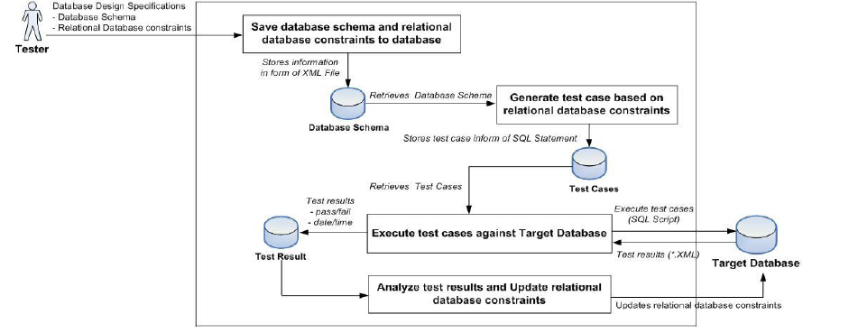
Figure 8: Relational Database Constraints Testing Process
The various steps in testing process are described as:
Preparing Database Schema from Database Design specifications: Prepares database schema to generating test cases. Database schema is identified by testers and follows database design specifications. Database schema includes tables, attributes of tables and relational database constraints. Testers could define at most ten properties for each field in each table. The properties of the field are field name, data type etc. After that the information is saved into the database. Consequently database schema is stored into the database as an XML file.

Generating Test case: It retrieve database schema to generate test cases. These cases are generated as SQL statements to validate relational database constraints. The SQL statements include insert, update and delete statements. It prepare input data to generate test cases that include random data and generic data. Finally the test cases are stored into database for later execution.

Executing Test case and updating Relational Database constraints: Test cases are generated for execution. A test cases are organized in as SQL script to execute the target database. Then the it stores test results of execution into the database for analyzing in order to correct the target database and update relational database constraints. The test result is saved as XML file which shows pass or fail of each test case, as well as running time and date.

    - Various Types of Testing in Database Application
Various types of testing in database involve[28,29,30]:
Unit Testing: Unit tests are small, fast and independent test and should be designed to verify only a “single piece” or unit of application. In database testing , the definition of the unit can vary depending on the testing context. If we have two tables, connected by referential constraints, but we're testing the results returned only from the parent table, then a unit is just the parent table. If we're testing the deletion of data from the parent table, then a unit means both tables, since we have to specify what happens to child rows when a parent is deleted.

Integration Testing: In unit testing we might use mock objects instead of connecting to a database , in integration tests we’re testing the real interaction between application and the database. While we can test each part of the system by itself, with integration testing we are testing how they are communicating with each other. Integration Testing is usually automated, and methods of automations, as part of a continuous integration process.

System Testing: Database application and system testing is used to analyze the performance of the system. It is the technique used to find the quality of the product or service analyzing.

Acceptance Testing: Acceptance testing test how the application will be used by the end user and is usually performed by QA people. The two types of testing are very similar , but whereas integration testing is automated, acceptance testing is mostly performed by hand.

Regression Testing: When re-certifying a database after a change to the application layer, most people use a regression testing approach whereby the system behavior is checked for any change due to the modification in the database. In regression testing basically it is tested that if any error occurred due to modification in the application.

    - Database Testing Model
Nowadays, web applications depend more and more on the back end database to supply with correct and legal data. A large number of web applications utilize a Database management system(DBMS) and one or more databases. Database has been widely used in Web applications and database interaction influence the navigations of web applications. Besides database interaction are among the most essential functional feature in current web applications.GFSM which are augmented FSMs are employed as a tool to model database interactions.A GFSMTT is constructed from the GFSM. From the test tree minimal test set is derived to be employed to generate test. Finally optimize the test paths by decreasing the overlap[31].
Modeling database interactions: Web applications face the short time to market ,database interactions were ignored for cost savings in modeling web applications. The problem of database interactions were left to the developers without detailed specifications. The realization of the database interactions is mainly determined by the developers technical abilities and it is unable to avoid the personal arbitrariness without the corresponding specification to hold in and guide them. Whether database interactions are successful or not is of vital importance to test web applications.
Suppose that network is free from faults during the database interactions. According to this assumption we can construct a GFSM’s state transition diagram.

Generating test paths: How to generate test is important to test web applications. According to GFSM state transition diagram we construct a GFSM-TT to avoid cycles and from GSM-TT a minimal test set is constructed by means of modified preorder tree traversal algorithm[32].Finally test paths are generated to cover each elements of minimal test set.

Optimization of test generation: According to coverage if all state transitions have been coverage at least one time we said it satisfy the state transition coverage. Consequently we construct a minimal test set of GFSM-TT. If the one’s last child is equal to the other’s first child these two elements can be joint to form a new one to substitute them . Continuing to repeating of the same operation at last we get the optimized minimal test set of FSM test tree.

Optimizing test paths to decrease the overlap: The test paths fully cover the optimized minimal test set of GFSM- TT. However there exist many overlaps between these test paths. The overlap of test path is done to decrease the length of corresponding test paths.

