**3. DESIGN OF EXPERIMENT:**

**3.1 DESIGN OF EXPERIMENT:**

Statistical methods are commonly used to improve the quality of a product or process. Such methods enable the user to define and study the effect of every single condition possible in an experiment where numerous factors (load and sliding speed) were involved in present work to study the wear behavior of the piston rings coatings. There were one parameters (Load) which were taken into consideration to determine the wear rate and coefficient of friction.There are several methods to design the experiment but we have chosen constant sliding distance (1.2Km) & Constant RPM 500 with varying load of 30N, 40N, 50N (Table3.1.2). To determine the response such as wear rate, coefficient of friction, microstructure. The significant variables on which the wear rate and the coefficient of friction depend were directly given by the software with the help of Wear test

|  |  |  |
| --- | --- | --- |
| Variables | Level 1 | Level 2 |
| Sliding speed (rpm) | 500 rpm | 500 rpm |
| Load (kg) | 3 kg | 4 kg |

Table 3.1.1 Variables for wear test

|  |  |  |  |  |
| --- | --- | --- | --- | --- |
| Std | Counter Body | Run | Load(N) | Sliding speed (rpm) |
| Anodizing Coating | WC, Mild steel | 1,2 | 30 | 500 |
| Anodizing Coating | WC, Mild steel | 3,4 | 40 | 500 |
| Tin coating | HCS,WC, MS | 5,6,7 | 30 | 500 |
| Tin coating | HCS,WC, MS | 8,9,10 | 40 | 500 |
| Aluminium soft | HCS,WC, MS | 11,12,13 | 30 | 500 |
| Aluminium soft | HCS,WC, MS | 14,15,16 | 40 | 500 |
|  |  |  |  |  |
|  |  |  |  |  |
|  |  |  |  |  |

Table-3.1.2 Design of experiment table for wear test

**3.2 IMPORTANCE OF TESTING-**

The usage of aluminium and its alloys have increased in many applications and industries over the decades. The automotive industry is the largest market for aluminium castings and cast products. Aluminium is widely used in other applications such as aerospace, marine engines and structures. Parts of small appliances, hand tools and other machinery also use thousands of different aluminium castings. The applications grow as industry seeks new ways to save weight and improve performance. However, another aspect has become of critical importance: the achievement of quality and reliability of the products.

**3.2.1**. **Material** **Composition-**

3.2.1.1 Chemical Composition

The spark emission spectrometry is used for the analyzing the exact composition of the sample prepared for the experimental purpose.

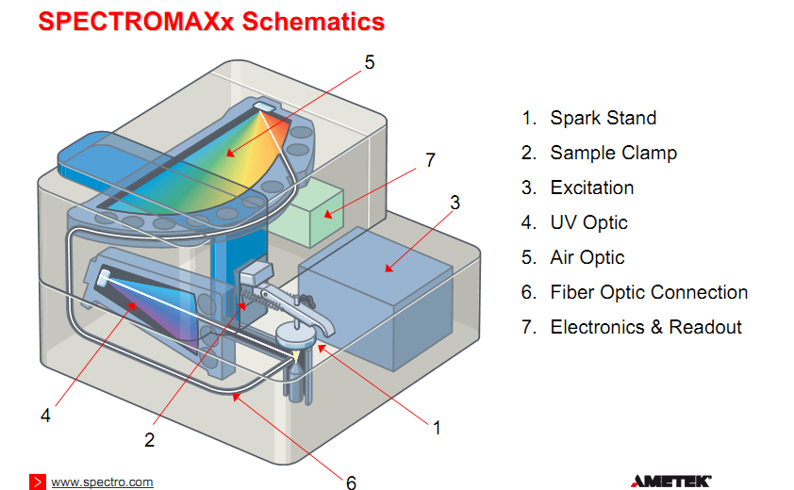

Figure 3.2.1 Spectromaxx

The **Spectromaxx** employs the very state-of-the-art optical and electronic technology. The proprietary optical design using multiple CCD detector provide complete wavelength coverage and resulting ability to select the best element and combination of analytical and reference wavelength to match perfectly the analytical requirement . A complete analysis takes about 25 Sec & Standard element selection for aluminium includes 30 elements. This report details the concentration range as well as the exceptional precision data that can be achieved at various concentration levels for these elements. The following are the main part of the Spectromaxx

1. Spectromaxx with SADAR(Spark Discharge in an Argon Atmosphere
2. Optimized & minimized argon consumption
3. 6 mm W electrode for several thousand measurements
4. ICAL(Intelligent Calibration Logik)

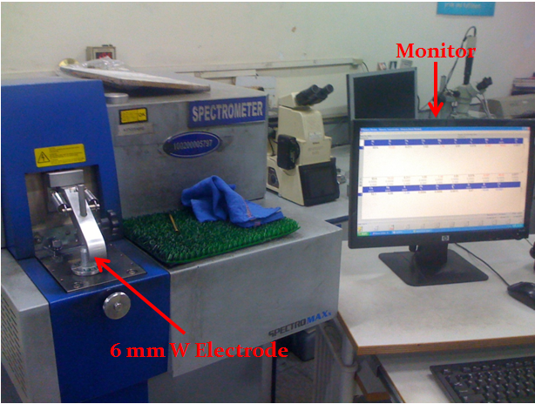

Figure 3.2.2. Spectromaxx used for the testing

Chemical composition of aluminium silicon piston alloys

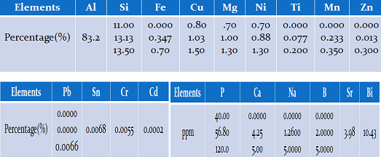

Table 3.2.1

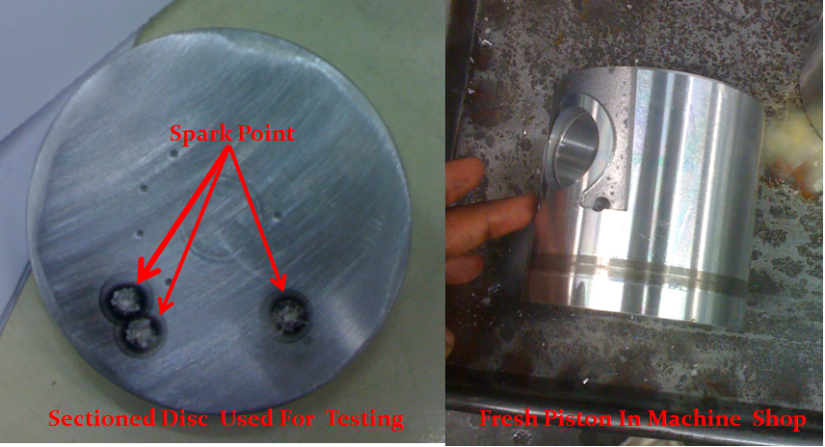

Figure 3.2.3 Specimen for testing & Parent Piston

**3.2.2. Microstructure**

Microstructure is defined as the structure of a prepared surface or thin foil of material as revealed by a microscope above 25× magnification. The microstructure of a material (which can be broadly classified into metallic, polymeric, ceramic and composite) can strongly influence physical properties such as strength, toughness, ductility, hardness, corrosion resistance, high/low temperature behavior, wear resistance, and so on, which in turn govern the application of these materials in industrial practice.

3.2.2.1 Methods

The concept of microstructure is perhaps more accessible to the casual observer through macro structural features in commonplace objects. If one ever comes across a piece of galvanized steel, such as the casing of a lamp post or road divider, one observes that the surface is not uniformly colored, but is covered with a patchwork of interlocking polygons of different shades of grey or silver. Each polygon (the most frequently occurring would be hexagons) is a single crystal of zinc adhering to the surface of the steel beneath. Zinc and lead are two common metals which form large crystals visible to the naked eye. The metallic atoms in each crystal are well-organized into one of seven crystal lattice systems possible for metals (cubic, tetrahedral, hexagonal, monoclinic, triclinic, rhombohedral, and orthorhombic); these systems dictate that the atoms are all lined up like points in a 3-D matrix. However, the direction of alignment of the matrices differ from crystal to adjacent crystal, leading to variance in the reflectivity of each presented face of the interlocked crystals on the galvanized surface. Symmetrical crystals are generally unstressed, unworked. They grow in all directions equally and were not subjected to deforming stresses either during or after. For large crystals, the ratio of crystal bulk to inter-crystal boundary (more properly, inter-granular boundary) is high. This indicates high ductility but correspondingly, lower strength (see Hall-Petch Strengthening), but a true study would take into quantitative account the relative strengths of the crystal and that of inter-crystal bonding

3.2.3 Working Principle

3.2.3.1 Optical

When a polished flat sample reveals traces of its microstructure, it is normal to capture the image using microphotography. More sophisticated microstructure examination involves higher powered instruments: optical microscopy, electron microscopy, X-ray diffraction and so on, some involving preparation of the material sample (cutting, microtomy, polishing, etching, vapor-deposition etc.). The methods are known collectively as metallography as applied to metals and alloys, and can be used in modified form for any other material, such asceramics, glasses, composites, and polymers.

Two kinds of optical microscope are generally used to examine flat, polished and etched specimens: a reflection working through the eyepiece microscope and an **inverted microscope**. Recording the image is achieved using a digital camera

#### 3.2.3.2 X-Ray microtomographic

Nondestructive testing of microstructure for biological materials is a challenge and computer microtomography is the current solution. In fact, CMT can be used for the evaluation of microstructure of many other materials also. CMT can be very expensive though, and for research purposes, it is a necessity to generate a three-dimensional microstructure from two-dimensional cross-sectional images of the material. This is an area of active research and pursued by many scientists.

#### 3.2.3.3 Electron microscopy

For high-resolution information on metallurgical microstructures, electron microscopic methods can be employed. This can allow for direct observation of atomic-scale features such as very fine precipitation reactions, dislocations or grain-boundary interfaces. Such methods may be critical in determining parameters such as solid state diffusivities.

**3.2.4 Ultimate tensile strength**

**Ultimate tensile strength** (**UTS**), often shortened to **tensile strength** (**TS**) or **ultimate strength**, is the maximum [stress](http://en.wikipedia.org/wiki/Stress_(mechanics)) that a material can withstand while being stretched or pulled before [*necking*](http://en.wikipedia.org/wiki/Necking_(engineering)), which is when the specimen's [cross-section](http://en.wikipedia.org/wiki/Cross_section_(geometry)) starts to significantly contract. Tensile strength is the opposite of [compressive strength](http://en.wikipedia.org/wiki/Compressive_strength) and the values can be quite different.

The UTS is usually found by performing a [tensile test](http://en.wikipedia.org/wiki/Tensile_test) and recording the stress versus [strain](http://en.wikipedia.org/wiki/Strain_(engineering)); the highest point of the [stress-strain curve](http://en.wikipedia.org/wiki/Stress-strain_curve) is the UTS. It is an [intensive property](http://en.wikipedia.org/wiki/Intensive_and_extensive_properties); therefore its value does not depend on the size of the test specimen. However, it is dependent on other factors, such as the preparation of the specimen, the presence or otherwise of surface defects, and the temperature of the test environment and material.

Tensile strengths are rarely used in the design of [ductile](http://en.wikipedia.org/wiki/Ductile) members, but they are important in brittle members. They are tabulated for common materials such as [alloys](http://en.wikipedia.org/wiki/Alloy), [composite materials](http://en.wikipedia.org/wiki/Composite_material), [ceramics](http://en.wikipedia.org/wiki/Ceramic), [plastics](http://en.wikipedia.org/wiki/Plastic), and [wood](http://en.wikipedia.org/wiki/Wood). Figure 4.1.1 shows stress vs. strain curve typical of aluminium alloys.

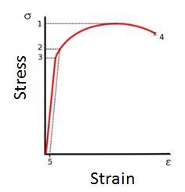

**Figure 3.2.4 Stress vs. Strain curve typical of aluminum alloys**

1. Ultimate strength  
2. Yield strength  
3. Proportional limit stress  
4. [Fracture](http://en.wikipedia.org/wiki/Fracture)  
5. Offset strain (typically 0.2%)

**3.2.5 Tensile testing**

**Tensile testing**, also known as **tension testing**, is a fundamental [materials science](http://en.wikipedia.org/wiki/Materials_science) test in which a sample is subjected to uni-axial [tension](http://en.wikipedia.org/wiki/Tension) until failure. The results from the test are commonly used to select a material for an application, for [quality control](http://en.wikipedia.org/wiki/Quality_control), and to predict how a material will react under other types of [forces](http://en.wikipedia.org/wiki/Force). Properties that are directly measured via a tensile test are [ultimate tensile strength](http://en.wikipedia.org/wiki/Ultimate_tensile_strength), maximum [elongation](http://en.wikipedia.org/wiki/Elongation_(materials_science)) and reduction in area.  From these measurements the following properties can also be determined: [Young's modulus](http://en.wikipedia.org/wiki/Young%27s_modulus), ratio, yield, and [strain-hardening](http://en.wikipedia.org/wiki/Strain-hardening) characteristics.

**3.2.6 Tensile Specimen**

A tensile specimen is a standardized sample cross-section. It has two shoulders and a gauge section in between. The shoulders are large so they can be readily gripped, whereas the gauge section has a smaller cross-section so that the deformation and failure can occur in this area.

The shoulders of the test specimen can be manufactured in various ways to mate to various grips in the testing machine (see the image below). Each system has advantages and disadvantages; for example, shoulders designed for serrated grips are easy and cheap to manufacture, but the alignment of the specimen is dependent on the skill of the technician. On the other hand, a pinned grip assures good alignment. Threaded shoulders and grips also assure good alignment, but the technician must know to thread each shoulder into the grip at least one diameter's length, otherwise the threads can strip before the specimen fractures.

Figure 3.2.4 shows the standard specimen line diagram used for the testing & Figure 3.2.5 shows the specimen prepared for the testing of tensile strength as per the **ASTM E1450 – 09** standards

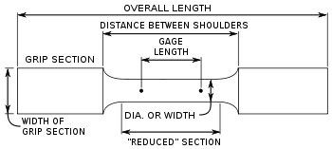

Figure 3.2.5 testing sample dimension for tensile strength

Figure 3.2.5.1 as per **ASTM E1450 – 09**

**3.2.7 Tensile Strength calculation**

Tensile test was conducted using UTM machine on the specimen prepared by the casting as per ASTM standard.

The following results were observed during the tensile testing of the specimen

Breaking Load = 23.4 kN

Area = 100.69mm2

We know that tensile strength can be defined as

Tensile Strength = $\frac{Breaking Load}{Area}$

**Tensile Strength = 232.62 MPa**

**Hardness**

**3.2.8 BHN**

The **Brinell scale** characterizes the indentation hardness of materials through the scale of penetration of an indenter, loaded on a material test-piece. It is one of several definitions of hardness in materials science, it was the first widely used and standardized hardness test in engineering and metallurgy. The large size of indentation and possible damage to test-piece limits its usefulness.

**3.2.8.1 Testing Procedure**

The typical test uses a 10 millimeters (0.39 in) diameter steel ball as an indenter with a 3,000 [kgf](http://en.wikipedia.org/wiki/Kilogram-force) (29 [kN](http://en.wikipedia.org/wiki/Newton_(unit)); 6,600 [lbf](http://en.wikipedia.org/wiki/Pound-force)) force. For softer materials, a smaller force is used; for harder materials, a tungsten carbide ball is substituted for the steel ball. The indentation is measured and hardness calculated as

\mbox{BHN}=\frac{2P}{\pi D ({D-\sqrt{(D^2-d^2)})}}

Where:

*P* = applied force ([kgf](http://en.wikipedia.org/wiki/Kgf))

*D* = diameter of indenter (mm)

*d* = diameter of indentation (mm)

The BHN can be converted into the ultimate tensile strength(UTS), although the relationship is dependent on the material, and therefore determined empirically. The relationship is based on Meyer's index (n) If Meyer's index is less than 2.2 then the ratio of UTS to BHN is 0.36. If Meyer's index is greater than 2.2, then the ratio increases.

3.2.9 HARDNESS-

For the hardness testing of aluminum alloys we use an indenter of mild steel of Ø10mm and load of 500kg. After testing we find the diameter impression of indenter Ø2.35 mm and with the help of this we find the hardness 116 BHN. We performed the same process five times and take the average of all five. Average BHN **116.32**

|  |  |  |  |  |
| --- | --- | --- | --- | --- |
| **RANGE** | **MIN** | **MAX** | **LSL** | **USL** |
| 2 | 116 | 118 | 105 | 130 |
| 1 | 117 | 118 | 105 | 130 |
| 2 | 114 | 116 | 105 | 130 |
| 3 | 115 | 118 | 105 | 130 |
| 2 | 114 | 116 | 105 | 130 |

TABLE 3.2.2 hardness

**WEAR**

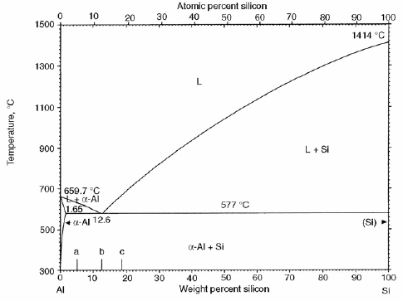 3.2.10 **Phase of Al-Si alloys**

TABLE 3.2.3

**3.2.11 Wear of Al-Si alloys in different phase**

Worn surfaces of the specimens studied in this work. The wear surface of as-cast specimen, which clearly indicates the mark of an adhesive wear with plastic deformation. The wear surface of heat treated specimen shows abrasive type of wear due to **Microcutting** or **Ploughing** of solid bodies with no plastic deformation. For material with higher hardness, abrasive wear tends to take place, while for material with lower hardness, adhesive wear is encountered In the present study, for heat treated alloy with BHN value 126, abrasive wear has been found to be the main mechanism, while for as-cast alloy with BHN value 69, adhesive wear has taken place. Thus, it can be said that the wear mechanism may also depend upon the hardness of the material.

**3.3. Pin on disc test:**

Pin on disc type wear monitor with data acquisition system was used to evaluate the wear behavior of aluminum alloys against three pin of different materials. Load was applied on pin by dead weight through pulley string arrangement. The system had maximum loading capacity of 200 N. The test was performed under dry unlubricated condition. The wear test can be performed on any wear tester, but for thin coatings pin on disc wear test is most commonly used

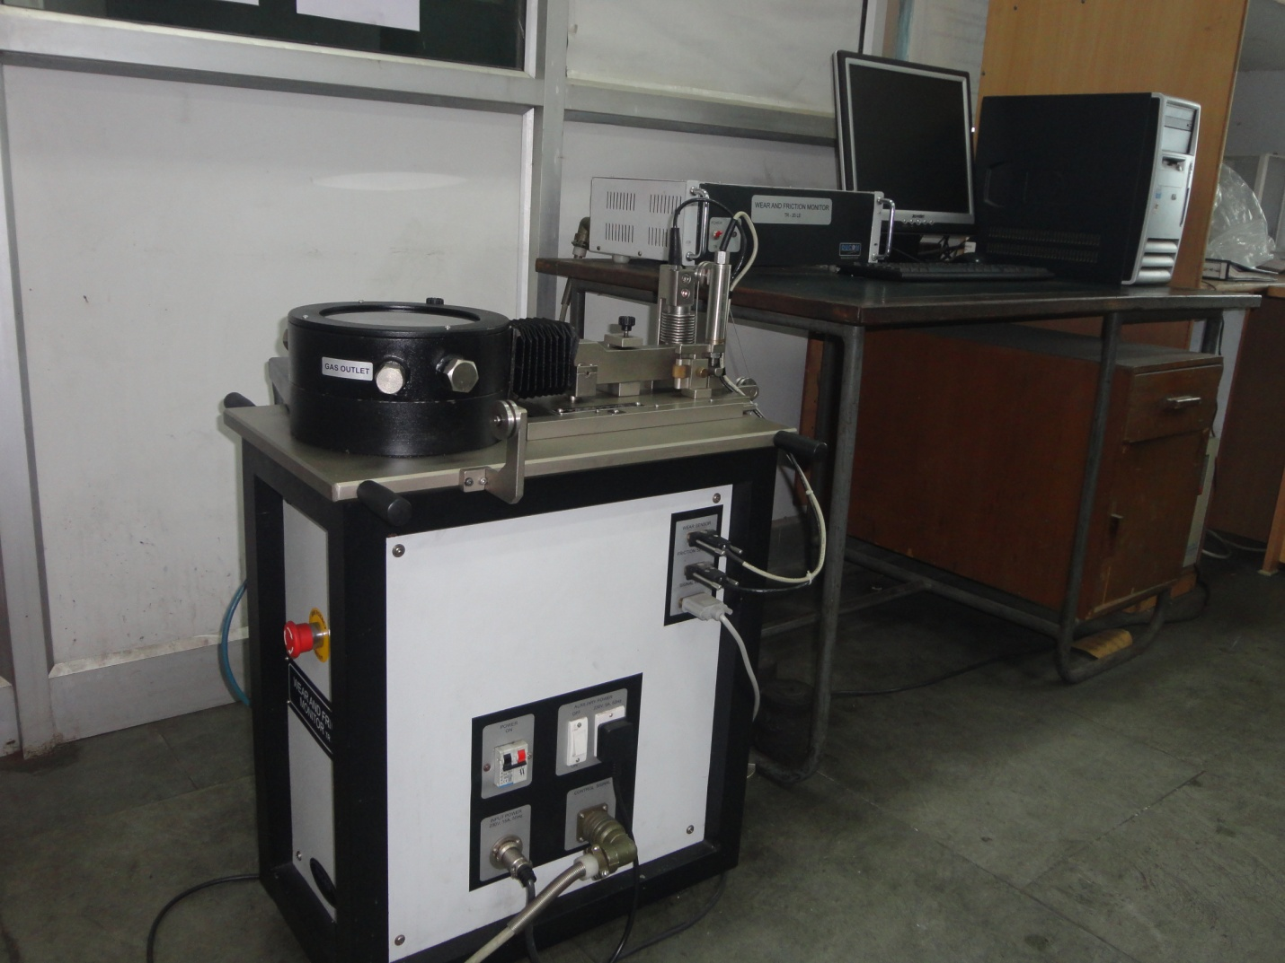

**Figure 3.3.1. Wear and friction monitor machine for pin on disc test**

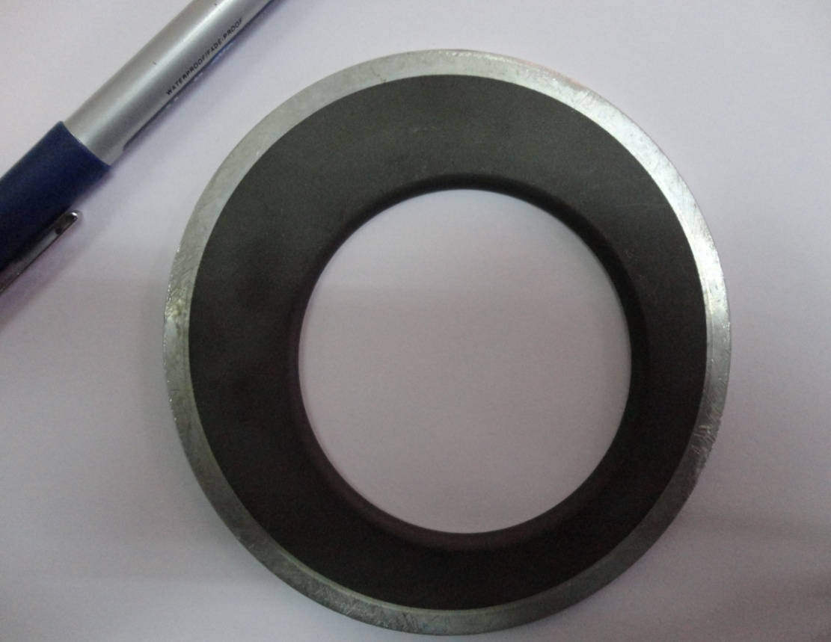

**Figure 3.3.2. anodized piston alloy before wear test**

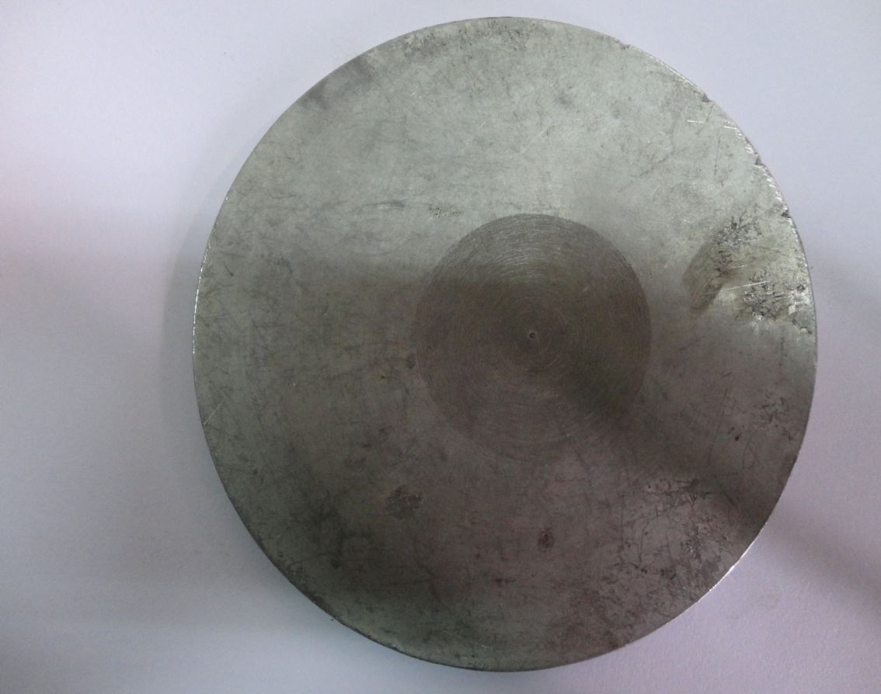

**FIGURE 3.3.2.1 TIN COATED PISTON ALLOY BEFORE WEAR TEST**

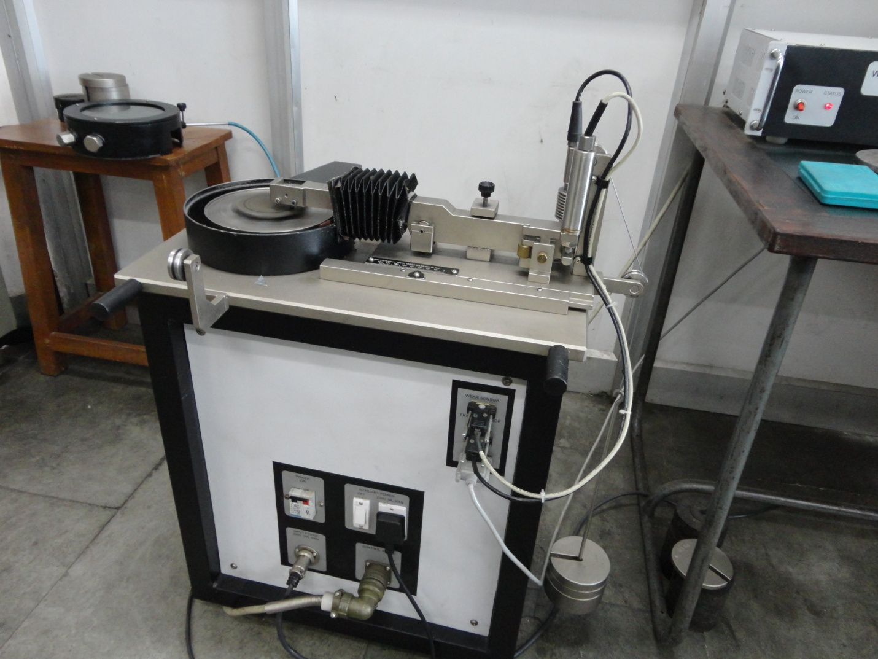

**Figure 3.3.3 . tin coated piston alloy during wear test**

The machine is attached with the computer with software WINDCUM 2008. A window is open in the software and there are options to select various loads, times, pin diameter. The machine directly gives the coefficient of friction on the selected loading and sliding conditions. In this machine basically there is a rotating disc; and a pin is fixed over stainless steel pin holder. The pin can be loaded with different loads, it can be change externally. The coating pasted disc fastened on the machine with the help of screws (figure). The load was applied on the pin through dead weight loading arrangement. The coating surface and pin was initially washed with methyl alcohol so that, moisture should not present on coating surface. Initially, the brass pin was fixed on the pin holder; the wear rate of the thermal spray coating was calculated at different loading and sliding conditions. The wear rate was calculated by weighing the disc before after the wear test in terms of grams per 1200 m sliding distance on an electronic balance of least count 0.00001g. The load was taken as 30, 40, and 50 N respectively and the sliding speed was taken as 500 rpm. The wear behaviour against three various counter pin material was analyzed that was tungsten carbide, mild steel and high carbon steel pin. The pin of diameter 3 mm was chosen for all of the three materials. The wear test carried out at room temperature of 20˚C. During the wear test some amount of material also gets deposited on the pin in the form of a tribolayer so pin was cleaned after every test. So that there was always contact between brass pin and the coating surface, and the wear mechanism was between pin and coating surface, and a wear track was formed on the coating (figure ).

**3.4. Scanning electron microscope:**

A scanning electron microscope (SEM) is a type of [electron microscope](http://en.wikipedia.org/wiki/Electron_microscope) that images a sample by scanning it with a high-energy beam of [electrons](http://en.wikipedia.org/wiki/Electron) in a [raster scan](http://en.wikipedia.org/wiki/Raster_scan) pattern (figure ). The electrons interact with the atoms that make up the sample producing signals that contain information about the sample's surface [topography](http://en.wikipedia.org/wiki/Topography), composition, and other properties such as [electrical conductivity](http://en.wikipedia.org/wiki/Electrical_conductivity).

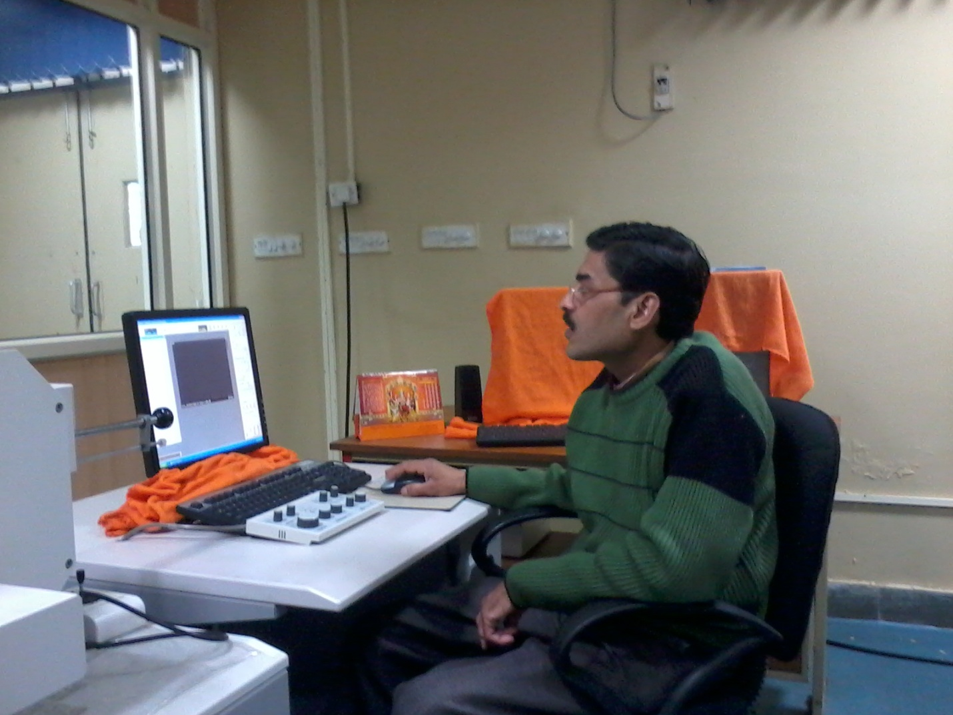

**Figure 3.4 Scanning electron microscope in DTU, Delhi**

In a typical SEM, an electron beam is [thermionically](http://en.wikipedia.org/wiki/Thermionically) emitted from an [electron gun](http://en.wikipedia.org/wiki/Electron_gun) fitted with a [tungsten](http://en.wikipedia.org/wiki/Tungsten) filament [cathode](http://en.wikipedia.org/wiki/Cathode). Tungsten is normally used in thermionic electron guns because it has the highest melting point and lowest vapour pressure of all metals, thereby allowing it to be heated for electron emission, and because of its low cost. For conventional imaging in the SEM, specimens must be [electrically conductive](http://en.wikipedia.org/wiki/Electrical_conductivity), at least at the surface, and [electrically grounded](http://en.wikipedia.org/wiki/Ground_(electricity)) to prevent the accumulation of [electrostatic charge](http://en.wikipedia.org/wiki/Static_electricity) at the surface. Metal objects require little special preparation for SEM except for cleaning and mounting on a specimen stub. Nonconductive specimens tend to charge when scanned by the electron beam, and especially in secondary electron imaging mode, this causes scanning faults and other image artifacts. They are therefore usually coated with an ultrathin coating of electrically-conducting material, commonly gold, deposited on the sample either by low vacuum [sputter coating](http://en.wikipedia.org/wiki/Sputter_coating) or by high vacuum evaporation. Conductive materials in current use for specimen coating include [gold](http://en.wikipedia.org/wiki/Gold), gold/[palladium](http://en.wikipedia.org/wiki/Palladium) alloy, [platinum](http://en.wikipedia.org/wiki/Platinum), [osmium](http://en.wikipedia.org/wiki/Osmium), [iridium](http://en.wikipedia.org/wiki/Iridium), [tungsten](http://en.wikipedia.org/wiki/Tungsten), [chromium](http://en.wikipedia.org/wiki/Chromium) and [graphite](http://en.wikipedia.org/wiki/Graphite) [47]. Coating prevents the accumulation of [static](http://en.wikipedia.org/wiki/Static_electricity) [electric charge](http://en.wikipedia.org/wiki/Electric_charge) on the specimen during electron irradiation. For SEM, a specimen is normally required to be completely dry, since the specimen chamber is at high vacuum. Hard, dry materials such as wood, bone, feathers, dried insects or shells can be examined with little further treatment, but living cells and tissues and whole, soft-bodied organisms usually require chemical [fixation](http://en.wikipedia.org/wiki/Fixation) to preserve and stabilize their structure. Fixation is usually performed by incubation in a solution of a [buffered](http://en.wikipedia.org/wiki/Buffer_solution) chemical fixative, such as [glutaraldehyde](http://en.wikipedia.org/wiki/Glutaraldehyde), sometimes in combination with [formaldehyde](http://en.wikipedia.org/wiki/Formaldehyde) [48-50]. In order to study the wear mechanism the worn surface were examined by scanning electron microscope of S-3700 series in DTU, Delhi. To see the microstructure of the wear track the coating material is coated with gold. Then it was put on job holder, the job holder was then moved inside the chamber of the scanning electron microscope. The scanning electron microscopy was used to determine the surface morphology of the wear track which gave the wear mechanism at various loading conditions and various speeds. For SEM of samples following parameters were chosen that were Accelerating Voltage=15000 Volt, Deceleration Voltage = 0 Volt, Magnification=1000, Working Distance=12600 um, Emission Current=80000 nA.

**3.5. X -Ray diffractometer:**

X ray diffractometer is a [measuring instrument](http://en.wikipedia.org/wiki/Measuring_instrument) for analyzing the structure of a material from the [scattering](http://en.wikipedia.org/wiki/Scattering) pattern produced when a beam of [radiation](http://en.wikipedia.org/wiki/Radiation) or particles (as [X rays](http://en.wikipedia.org/wiki/X_ray) or neutrons) interacts with it. A typical diffractometer consists of a source of radiation, a [monochromator](http://en.wikipedia.org/wiki/Monochromator) to choose the wavelength, [slits](http://en.wikipedia.org/wiki/Slit) to adjust the shape of the beam, a sample and a [detector](http://en.wikipedia.org/wiki/Detector) (figure 22). In a more complicated apparatus also a [Gonio meter](http://en.wikipedia.org/wiki/Goniometer) can be used for fine adjustment of the sample and the detector positions. When an area detector is used to monitor the diffracted radiation a beam stop is usually needed to stop the intense primary beam that has not been diffracted by the sample. Otherwise the detector might be damaged. Usually the beam stop can be completely impenetrable to the X-rays or it may be semitransparent. The use of semitransparent beam stop allows the possibility to determine how much the sample [absorbs](http://en.wikipedia.org/wiki/Absorption_(electromagnetic_radiation)) the radiation using the [intensity](http://en.wikipedia.org/wiki/Intensity_(physics)) observed through the beam stop. The specimen of the worn surfaces was placed on X-ray chamber. The scanning of the specimen was done from angle 20˚ to 90˚ and the scanning speed was chosen as 2 degree/min.

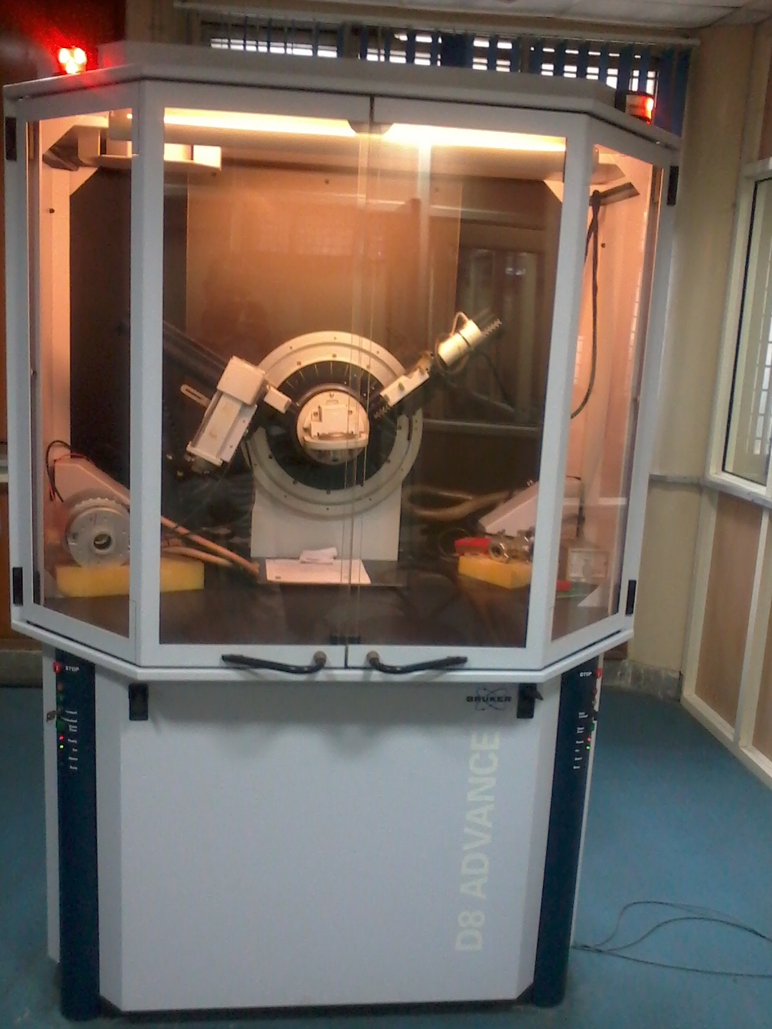

**Figure 3.5. X-Ray diffractometer in DTU, Delhi**

**3.6. Vickers micro hardness tester:**

Vickers Hardness Tester is a key piece of equipment that is indispensable to metallographic research, product quality control, and the development of product certification materials.

Vickers Microhardness test procedure as per ASTM E-384, EN ISO 6507, and ASTM E-92 standard specifies making indentation with a range of loads using a diamond indenter which is then measured and converted to a hardness value. For this purpose as long as test samples are carefully and properly prepared, the Vickers Microhardness method is considered to be very useful for testing on a wide type of materials, including metals, composites, ceramics, or applications such as testing foils, measuring surface of a part, testing individual microstructures, or measuring the depth of case hardening by sectioning a part and making a series of indentations. Two types of indenters are generally used for the Vickers test family, a square base pyramid shaped diamond for testing in a Vickers hardness tester and a narrow rhombus shaped indenter for a Knoop hardness tester.

The Vickers hardness test method requires a pyramidal diamond with square base having an angle of 136° between the opposite faces. Upon completion of indentation, the two diagonals will be measured and the average value will be considered (figure ).

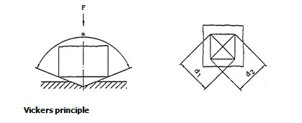

**Figure 3.6. Vickers micro hardness indentation**

The loads for Micro Vickers or Knoop hardness testing methods are typically very low, ranging from a few grams to 2 kg. The load range for Macro Vickers hardness test procedure can range up to 50kgs.Normally the prepared specimens; using metallographic mounting presses are mounted in a plastic medium to facilitate the preparation and testing. In order to enhance the resolution of measurement, the indentations should be as large as possible. The micro hardness was measured with the help of Vickers micro hardness tester. It was compatible with computer; the indentations formed by indenter can be seen. The load can be takes over the micro hardness tester was upto 100 kg. And the magnification of the indentation was 200 x and 400X. The load selected was 5 gm, because at high load the indenter would be large. The magnification chosen was 400 X, because at that low load indentation was very small.

**3.7. Optical Microscope:**

It is an [instrument](http://en.wikipedia.org/wiki/Laboratory_equipment) used to see objects too small for the naked eye. The science of investigating small objects using such an instrument is called [microscopy](http://en.wikipedia.org/wiki/Microscopy). [Microscopic](http://en.wikipedia.org/wiki/Microscopic) means invisible to the eye unless aided by a microscope.

[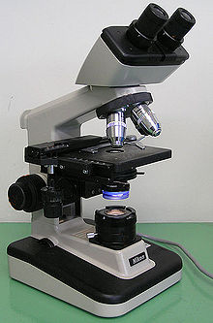](http://en.wikipedia.org/wiki/File:Optical_microscope_nikon_alphaphot_+.jpg)

**Figure3.7 . Optical microscope**

The most common type of microscope and the first invented is the [optical microscope](http://en.wikipedia.org/wiki/Optical_microscope) (figure ). This is an [optical](http://en.wikipedia.org/wiki/Optics) [instrument](http://en.wikipedia.org/wiki/Measuring_instrument) containing one or more [lenses](http://en.wikipedia.org/wiki/Lens_(optics)) producing an enlarged image of a sample placed in the focal plane. Optical microscopes have [refractive](http://en.wikipedia.org/wiki/Refraction) glass and occasionally of plastic or [quartz](http://en.wikipedia.org/wiki/Quartz), to focus light into the eye or another light detector. Mirror-based optical microscopes operate in the same manner. Typical magnification of a light microscope, assuming visible range light, is up to 1500x with a [theoretical resolution limit](http://en.wikipedia.org/wiki/Angular_resolution#Microscope_case) of around 0.2 [micrometres](http://en.wikipedia.org/wiki/Micrometres) or 200 [nanometers](http://en.wikipedia.org/wiki/Nanometres). Specialized techniques (e.g., [scanning confocal microscopy](http://en.wikipedia.org/wiki/Confocal_laser_scanning_microscopy), [Vertico SMI](http://en.wikipedia.org/wiki/Vertico_SMI)) may exceed this magnification but the resolution is [diffraction](http://en.wikipedia.org/wiki/Diffraction) limited. The use of shorter wavelengths of light, such as the ultraviolet, is one way to improve the spatial resolution of the optical microscope, as are devices such as the [near-field scanning optical microscope](http://en.wikipedia.org/wiki/Near-field_scanning_optical_microscope).

**3.8 MANUFACTURING OF PISTON-**

3.8.1 Charge Material

The powder of the entire required constituent is used for melting then cast in the shape of piston. For the experimental purpose a sectioned disc is taken out from the top side of the piston.

3.8.2 Melting & Casting

The melting operation is carried out in an induction furnace for the uniform melting of the charge material .The temperature was measured using Digital Chromel-Alumel thermocouple. The melt was super heated in an electric arc furnace to a temperature more than **750 oC** and was final poured in the die mould at a Temrature around **715 – 735** **oC.** After holding the molten metal in the die for almost 1 min we take the casting out of the die which is now about at temperature of 500-530 oC , is directly quenched in the water at 60 oC for the cooling purpose. After 5-10 min we take the casting out from the water and put it in the ambient temperature for the cooling in natural atmosphere. These are the actual industrial condition in which the piston is being manufactured. The figure 3.8.1 shows the powder used for the casting of sample.

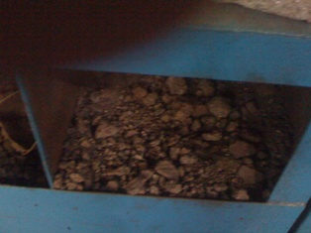

Figure 3.8.1 Nickel Crystal

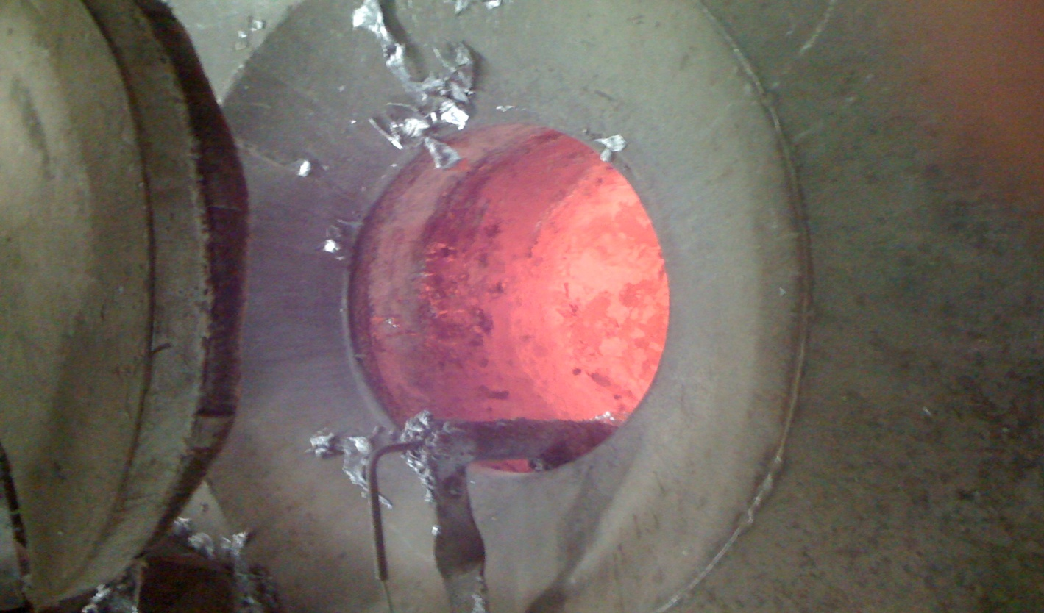

FIGURE 3.8.2 INDUCTION FURNACE

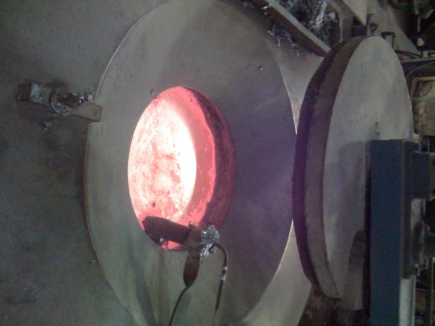

FIGURE 3.8.3 FURNACE

**3.9 CASTING OF PISTON-**

3.9.1 COLD CHAMBER PROCESS

The essential feature of this process is the independent holding and injection units. In the cold chamber process metal is transferred by ladle, manually or automatically, to the shot sleeve. Actuation of the injection piston forces the metal into the die. This is a single-shot operation. This procedure minimizes the contact time between the hot metal and the injector components, thus extending their operating life. However, the turbulence associated with high-speed injection is likely to entrain air in the metal, which can cause gas porosity in the castings. The cold chamber process is used for the production of aluminum alloys.

The mold has sections, which include the “cover” or hot side and the “movable” or ejector side. The die may also have additional moveable segments called slides or pulls, which are used to create features such as undercuts or holes which are parallel to the parting line. The machines run at required temperatures and pressures to produce a quality part to near net-shape.

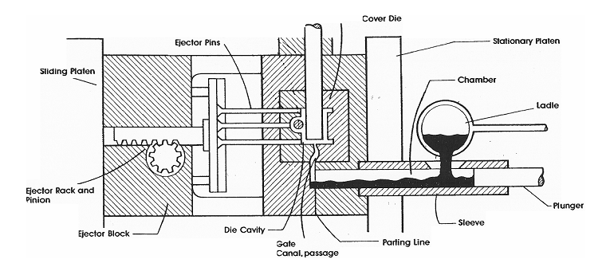

FIGURE 3.9.1 COLDCHAMBER CASTING MACHINE

COVER DIE - The stationary half of a die-casting die, which forms the exterior or appearance surfaces of the casting.

DIE CAVITY – The impression in a die into which pattern material is forced.

LADLE – Metal receptacle frequently lined with refractories used for transporting and pouring molten metal.

GATE - The passage connecting a runner or overflow with a die cavity.

GATE RUNNER - The runner in a die-casting die that is directly adjacent to the gate. The runner feeds the injected metal to the gate.

PLATEN - Portion of a casting machine against which die sections are fastened, or of trim presses against which trim dies are fastened.

PLUNGER - Ram or piston that forces molten metal into a die.

PARTING LINE - The joint between the cover and ejector portions of the die or mold. Also, the mark left on the casting at this die joint.

PARTING LINE, STEPPED - A condition on a die-casting where the parting line changes abruptly from one level to another.

SLEEVE - The molten metal chamber of a cold-chamber die-casting machine. This is a hardened steel tube through which the shot plunger moves to inject the molten metal into the die.

EJECTOR PINS - A pin actuated to force the casting out of the die cavity and off the cores.

EJECTOR PLATE - Plate to which the ejector pins are attached and which actuates them.

**HOW IT WORKS-**

• A metal tool is built and attached to a furnace of molten metal

• Then molten metal is mechanically poured or injected into the metal mold

• The mold cools for a brief time

• The mold is opened

• The parts are ejected

• The process repeats over and over again

**3.10 NEW DEVELOPMENT IN PISTON –**

Today, aluminum alloy is generally used for mass produced pistons. However, graphite has several advantages in comparison with aluminum. The most important differences are shown in the density of graphite is much lower than that of aluminum alloy. Other favorable properties of graphite are the lower coefficient of thermal expansion and the higher resistance to heat. Unfavorable 'is that the tensile strength of graphite at room temperature is comparatively low. However, considering the tensile strength as a function of temperature, strength Of aluminum alloy drops at temperatures above 160 °C. In contrast to this the tensile strength of graphite even increases slightly with temperature.

On the basis of these graphite material properties the following advantages can be expected if the material is applied to pistons:

- A reduced piston weight because of the lower material density,

- A smaller piston clearance because of the low coefficient of thermal expansion.

- Furthermore, it can be expected that the carbon piston transmits less noise because of the material's damping capacity.

- Another advantage of graphite are the excellent emergency frictional properties, which make piston scuffing impossible.

**3.11 TIN COATING-**

The tin-plating process is used extensively to protect both ferrous and nonferrous surfaces. Tin is a useful metal for the food processing industry since it is non-toxic, ductile and corrosion resistant. The excellent ductility of tin allows a tin coated base metal sheet to be formed into a variety of shapes without damage to the surface tin layer. It provides sacrificial protection for copper, nickel and other non-ferrous metals, but not for steel. Tin is also widely used in the electronics industry because of its ability to protect the base metal from oxidation thus preserving its solder ability. In electronic applications, 3% to 7% lead may be added to improve solder ability and to prevent the growth of metallic "whiskers" in compression stressed deposits, which would otherwise cause electrical shorting. However, RoHS (Restriction of Hazardous Substances) regulations enacted beginning in 2006 requires that no lead be added intentionally and that the maximum percentage not exceed 1%. Some exemptions have been issued to RoHS requirements in critical electronics applications due to failures which are known to have occurred as a result of tin whisker formation.

A systematic investigation of the immersion and electro deposition processes of thin tin coatings used as an under layer for the deposition of the multilayer system Cu/Ni/Cr on a typical aluminium alloy, applied in the automobile industry and other branches of mechanical engineering, was carried out.

To elucidate the parameters affecting the adhesion of the tin coating and the adhesion of the protective-decorative coatings, the following characteristics were studied: the thickness of the tin coating (the current efficiency for electrodeposited tin coatings); the amount of aluminium dissolved during the deposition of the coating; the over potential for the deposition of tin (for electrolytically deposited tin coatings) on pure aluminium, on the aluminium alloy and on pure zinc, magnesium, chromium, manganese and iron (the main alloying components of the alloy); the distribution of the alloying components and their influence on the initial stages of the tin deposition; the morphology of the alloy surface before and after the deposition of the tin coating.

3.11.1. **Basic principles**

An acid tin electroplating solution is a mixture of water, organic acid, and stannous tin. To this is added a number of organic constituents that serve to regulate and distribute the delivery of tin ions to the surface being plated. The two basic organic brighteners are commonly referred to as the *"brightener"* and the *"starter"*. A basic electroplating cell consists of a tank full of the above electrolyte with arrays of tin bars (or baskets of nuggets) arranged along two opposite sides. These bars are referred to as the anodes, and, as you might expect, are connected to the positive terminal of a current source. This supply *must* be capable of continuous sourcing into a near short circuit load (a typical tin/lead electroplating bath has an effective full load operating "impedance" that ranges between 0.015 Ohms and 0.035 Ohms). Situated halfway between these anode "banks" is the copper clad substrate that is to be plated. It is variously referred to as the cathode. .  
  
In the simplest terms, metal deposition occurs when an electrical potential is established between the anodes and the cathode. The resulting electrical field initiates electrophoretic migration of tin ions to the cathode where the ionic charge is neutralized as they plate out of solution. At the anode (in a properly maintained bath), sufficient tin erodes into the electrolyte, to exactly make up for the deposited material, maintaining a constant concentration of dissolved tin metal. As in all electrolytic solutions, there is a tendency of electrical charges to build up on the nearest high spot, thereby creating a higher electrical potential. This area of increased potential attracts more metal ions than the surrounding areas which in turn makes the high spot even higher. If this process were allowed to continue unchecked, the resulting plated surface would resemble a random jumble of tin instead of the smooth, bright surface needed for reliable resist action inside the etching tank. Inhibiting and controlling this nonlinear behavior is where the organic brighteners come into the play. .

**Process table- 3.11.1**

|  |  |  |  |
| --- | --- | --- | --- |
| Serial no. | Operation activity | method | Important parameter |
| 1 | Preparing acid tin plating bath | Pour 250 lt.demineralized water into tank 40 lt. sulphuric acid  & mix 50 lt. A.T.01S  In it. mix 25 lt. A.T. 02  Make the tank level up to 650 lt. by using D.M. water. |  |
| 2 | Tin plating of piston | Drown the hanger in acid tin bath tank | Temperature- 15 degree to 40 degree Celsius  Time- 150 seconds to 250 seconds |
| 3 | Cleaning of piston | using water | No chemical on piston |
| 4 | cleaning | Using hot water | 65 to 90 degree Celsius temperature |
| 5 | cleaning | Using air compressor |  |
| 6 | thickness |  | .4 to 1.2 micron |

**3.11.1 PISTON ON HANGER**

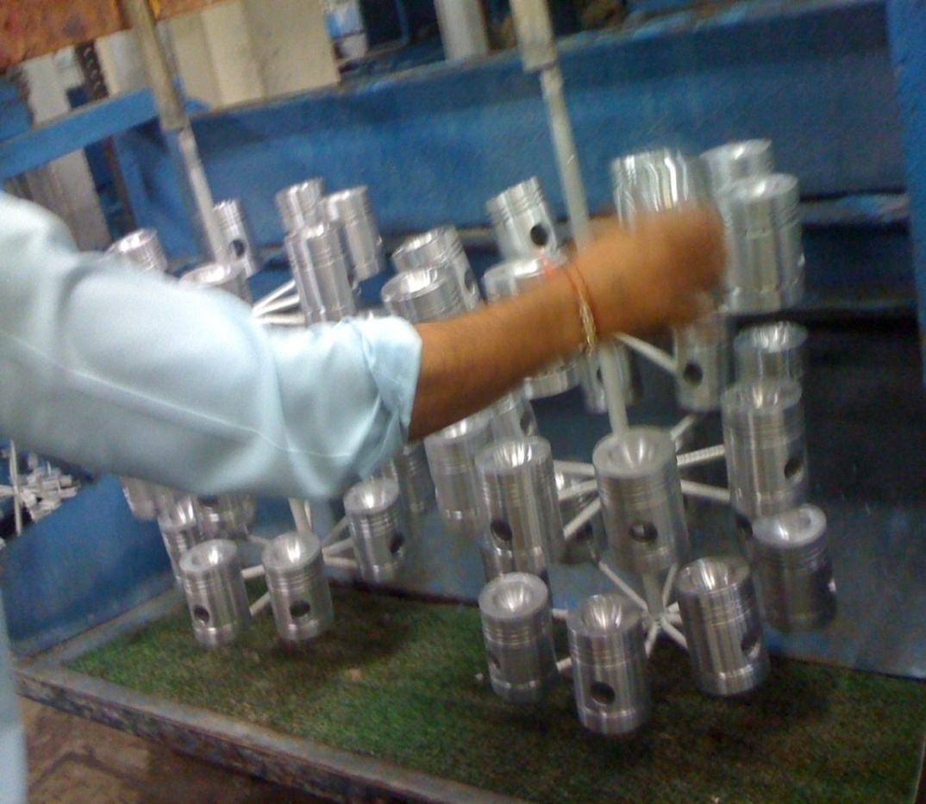

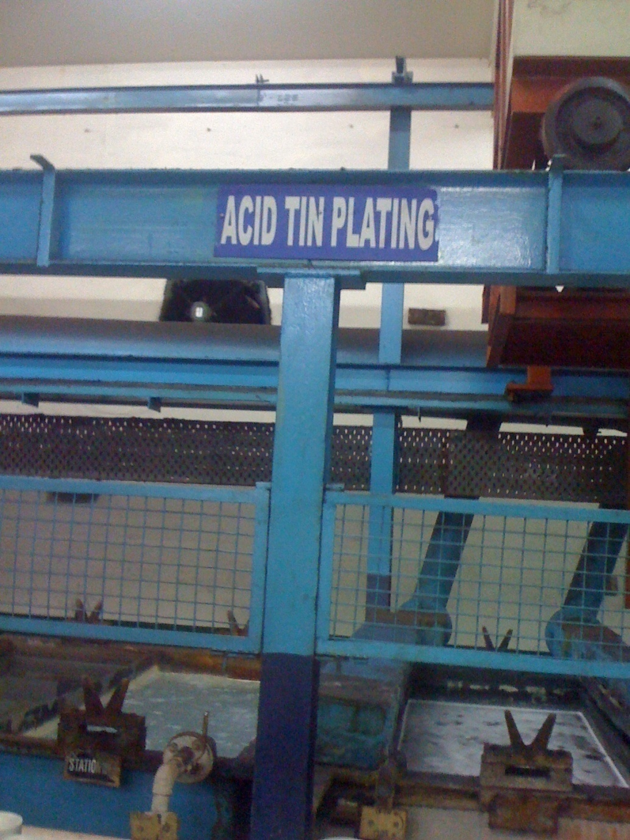

**3.11.2 ACID TIN PLANT**

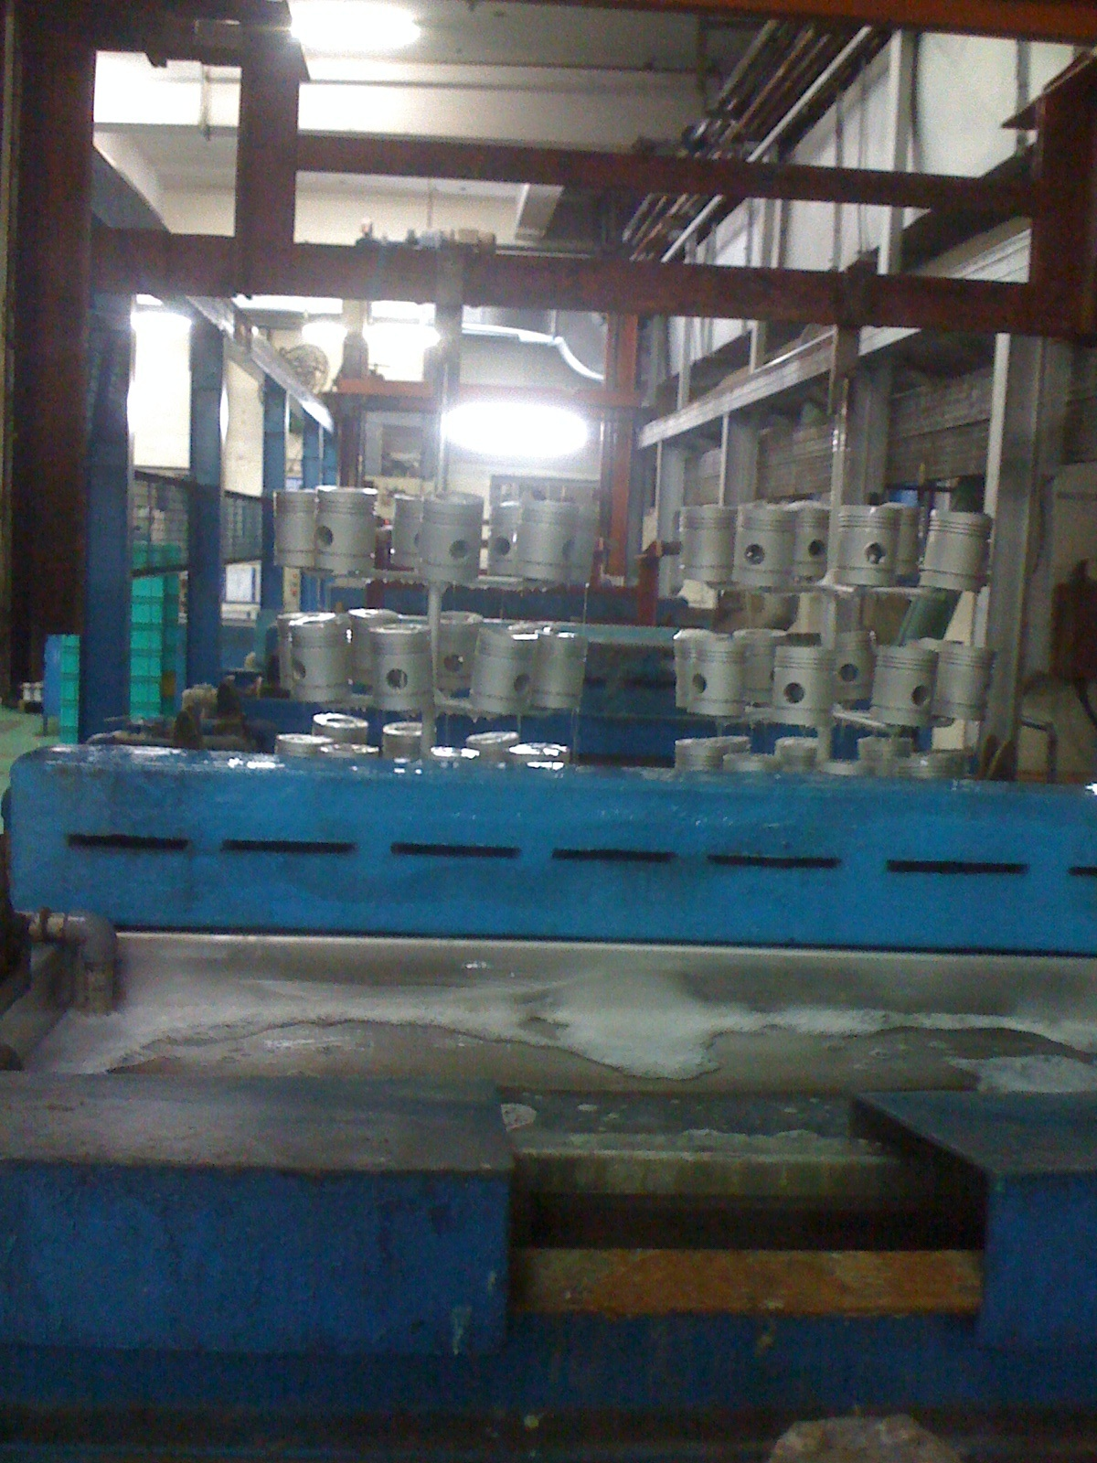

**FIGURE 3.11.3** **PISTON OVER ACID TIN BATH TANK**

**Alloy :[ P -AL-001 ] { ( LM- 13 ) ( 4658 ) ( IS-7793-1975 ) }**

**3.12 Anodizing**

Anodizing is a process that builds on the natural tendency of metals such as aluminum to spontaneously oxidize. The process can be further assisted with the incorporation of temperature, an electrolytic solution, and electrical current. Anodizing works by attaching the aluminum work piece to the positive side of a DC power supply and placing it into the bath. Another electrically conductive metal, inert in the anodizing bath, is connected to the positive side of the power supply. With the power supply activated, electrons are pulled from the aluminum into the solution causing the aluminum to

react with water to form a build-up of an oxide layer. At the cathode, hydrogen gas is formed. The chemical reaction is listed below (Equation 1) (Alwitt).

2 Al + 3 H2O _ Al2 O3 + 3 H2

**Equation 1: Oxidation Reaction of Aluminum (Kopeliovic)**

Typically the bath electrolyte is chosen so that the oxide is insoluble or at least dissolves at a slower rate than it deposits. As the oxide layer develops, the sulfuric acid in solution continues to partially dissolve the aluminum substrate and oxide layer (Alwitt). This is replaced by the volume of oxide growing on the surface in the form of hexagonal cells with hollow cores. It is this porous surface that permits the solution to access the substrate aluminum and continue to form an increasingly thick layer up to .001 inches thick for Sulfuric (Type 2) anodizing . Another benefit of the pores is that they allow the absorption or impregnation by another substance, such as dyes and/or materials like PTFE.



Figure 3.12.1: Idealized structure of anodic porous aluminum oxide (Asoh et al.)

 Figure 3.12.2: Cross-section of porous oxide in the vicinity of metal/oxide interface. (Thompson and Wood)



**Figure 3.12.3: Development of Anodized Oxide Layer from Bare Metal (Kopeliovich)**

In order to prevent unwanted absorption of particles, the oxidized layer is cleaned in fresh water and sealed. The sealing process is, at its simplest form, another bath in hot water around 200 degrees Fahrenheit. In this bath at temperature, the water reacts with the oxidized surface to form crystals of hydrated aluminum oxide that fill the pores. Once sealed, the surface is stable and impermeable in a range of temperatures and conditions. The chemical reaction for sealing in water is shown below (Equation 2) (Kopeliovich).

Al2 O3 + 3 H2O _ 2 AlOOH * H2O

**Equation 2: Sealing of the Oxide Pores by Hot Water (Kopeliovich)**

The standard spec, MIL-A-8625, covers chromic (Type 1), sulfuric (Type 2) and hard anodize (Type 3). Sulfuric acid (Type 2) is the most commonly used as compared to chromic acid (Type 1), which is less frequently used due to carcinogenic concerns. In order to achieve a thicker, denser oxide layer, known as hard anodize, the bath temperature is dropped to around 5 degrees Celsius from the 20 degrees Celsius used in Type 2 anodizing (Alwitt). There is great benefit to hard anodize for improved

wear resistance and corrosion resistance. With hard anodizing, the oxide cells are larger and have smaller pores, which results in a denser layer than regular anodizing. The hardness value is from 65 to 70 Rockwell C, much greater than that for bare aluminum. Thicknesses are generally around .002 inches thick (Alwitt).

Among the millions passenger cars and millions trucks manufactured in the world in ,

a substantial part is equipped with diesel engines. The proportion is particularly high with the trucks Compared with the gas engine, the piston of the diesel car is submitted to a higher working Temperature, between250 and 350 degree Celsius (480 and 660 degree Fahrenheit), which is going to become higher, due to the Increasing power developed by engines. The aluminum piston, generally in cast alloys AI Si 12Cu Ni Mg, Sustains important solicitations interims of thermal fatigue. For many years, the solution to minimize the Effect of temperature has been to build a thick oxide layer on the piston head by hard coat anodizing. Due to the low thermal conductivity of alumina (30 times less than the metal conductivity) this layer acts as a thermal barrier during the piston life.

Hard anodizing of aluminum piston heads for internal combustion engines Is usually Performed by immersion, with a time ranging from 70 to 75 minutes

**Process table& important parameter- TABLE 3.12.1**

|  |  |  |  |
| --- | --- | --- | --- |
| Serial no. | Operation activity | method | Important Parameter |
| 1 | Making of hard anodizing bath | Fill the 1100 lt. clean water int0 the tank.  Now pour 130 lt. sulfuric acid in tank |  |
| 2 | Put sticker on piston | Put fixture above piston put sticker on piston where coating is not required. | Sticker should on marking site |
| 3 | Starting chilling | Switch- on chilling plant | -2 to 4 degree Celsius |
| 4 | current | Set rectifier in auto condition | 2.5 to 3 amps. |
| 5 | Spray pump | On spray pump set the required pressure to get desired coating | Height of fountain appox. 50mm |
| 6 | time | Set time in rectifier | 70 minute |
| 7 | Method to do hard anodizing | According to size of piston use fixture & hang fixture over tank |  |
| 8 | Take out fixture outside | Submerged fully fixture into tank remove piston from it |  |
| 9 | cleaning | Drown fully piston in solvent(bucket) & dry using air compressor |  |

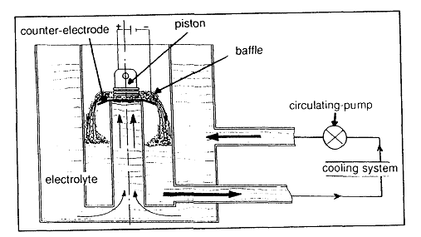

FIGURE 3.12.4 Hard anodizing process

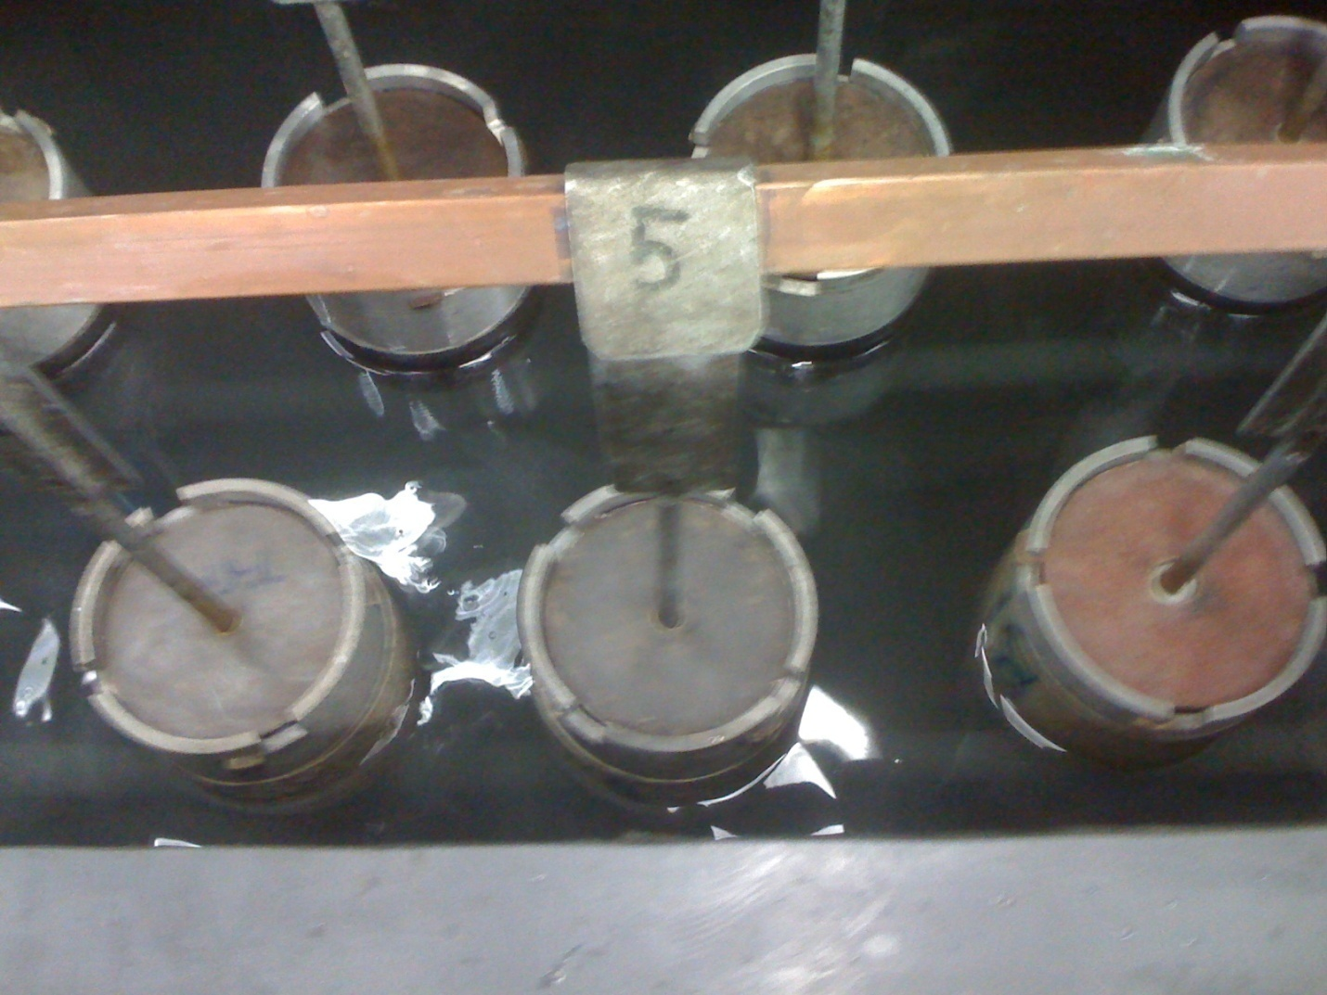

**FIGURE 3.12.5 Fixture with piston in coating material tank**

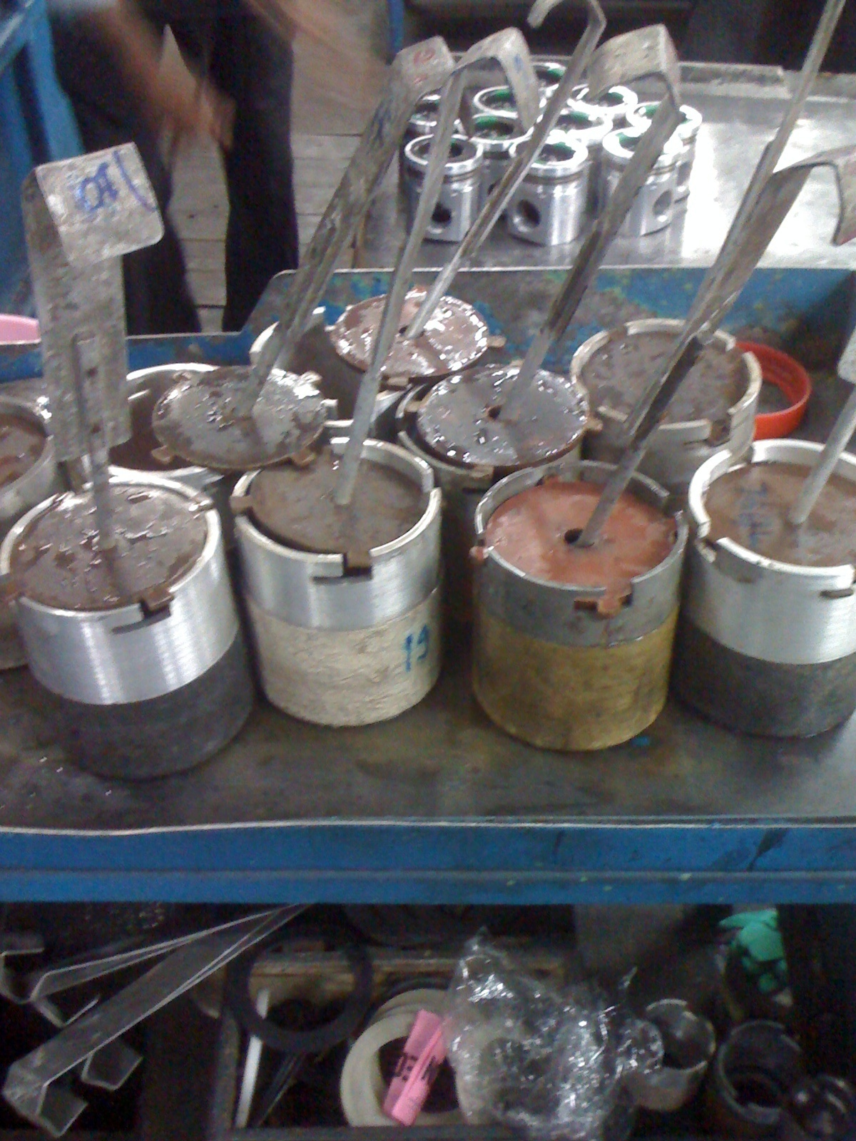

FIGURE 3.12.6 Removed piston from fixture