CHAPTER ONE- INTRODUCTION
1.1 Internal Combustion Engines
The internal combustion engine is an engine in which the combustion of a fuel (normally a fossil fuel) occurs with an oxidizer (usually air) in a combustion chamber. In an internal combustion engine, the expansion of the high-temperature and high -pressure gases produced by combustion apply direct force to some component of the engine. This force is applied typically to pistons, turbine blades, or a nozzle. This force moves the component over a distance, transforming chemical energy into useful mechanical energy. The first internal combustion engine was created by Étienne Lenoir
The term internal combustion engine usually refers to an engine in which combustion is intermittent, such as the more familiar four-stroke and two-stroke piston engines, along with variants, such as the six-stroke piston engine and the Wankel rotary engine. A second class of internal combustion engines use continuous combustion: gas turbines, jet engines and most rocket engines, each of which are internal combustion engines on the same principle as previously described
1.2 Function of Internal Combustion Engine
Functions of I.C. Engine: Engine is that kind of prime mover which converts chemical energy of fuel into mechanical energy. The fuel on burning changes to gas which impinges upon the piston and pushes it to change into reciprocating motion. The reciprocating motion of piston is then converted to rotary motion of crank shaft with the help of slider mechanism involving connecting rod and crank shaft. Several types of I.C. Engines are used on various automobiles i.e. marine, locomotive, air craft and other industrial applications.
1.3 Component of Internal Combustion Engine
1.3.1 Cylinder Block
Function- In the bore of cylinder the fresh charge of air-fuel mixture is ignited, compressed by piston and expanded to give power to piston.

1.3.2. Cylinder Head
Function-It carries inlet and valve. Fresh charge is admitted through inlet valve and burnt gases are exhausted from exhaust valve. In case of petrol engine, a spark plug and in case of diesel engine, an injector is also mounted on cylinder head.

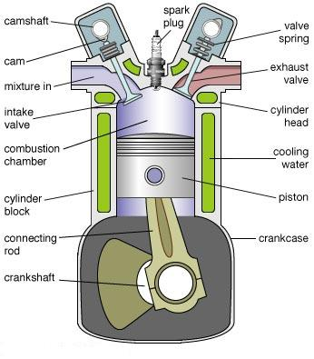
Figure 1.1 Parts of Internal combustion engine
(Ref. http://www.studyvilla.com/engines.aspx)
1.3.3. Piston
Function-During suction stroke, it sucks the fresh charge of air-fuel mixture through inlet valve and compresses during the compression stroke inside the cylinder. This way piston receives power from the expanding gases after ignition in cylinder. Also forces the burnt exhaust gases out of the cylinder through exhaust valve.
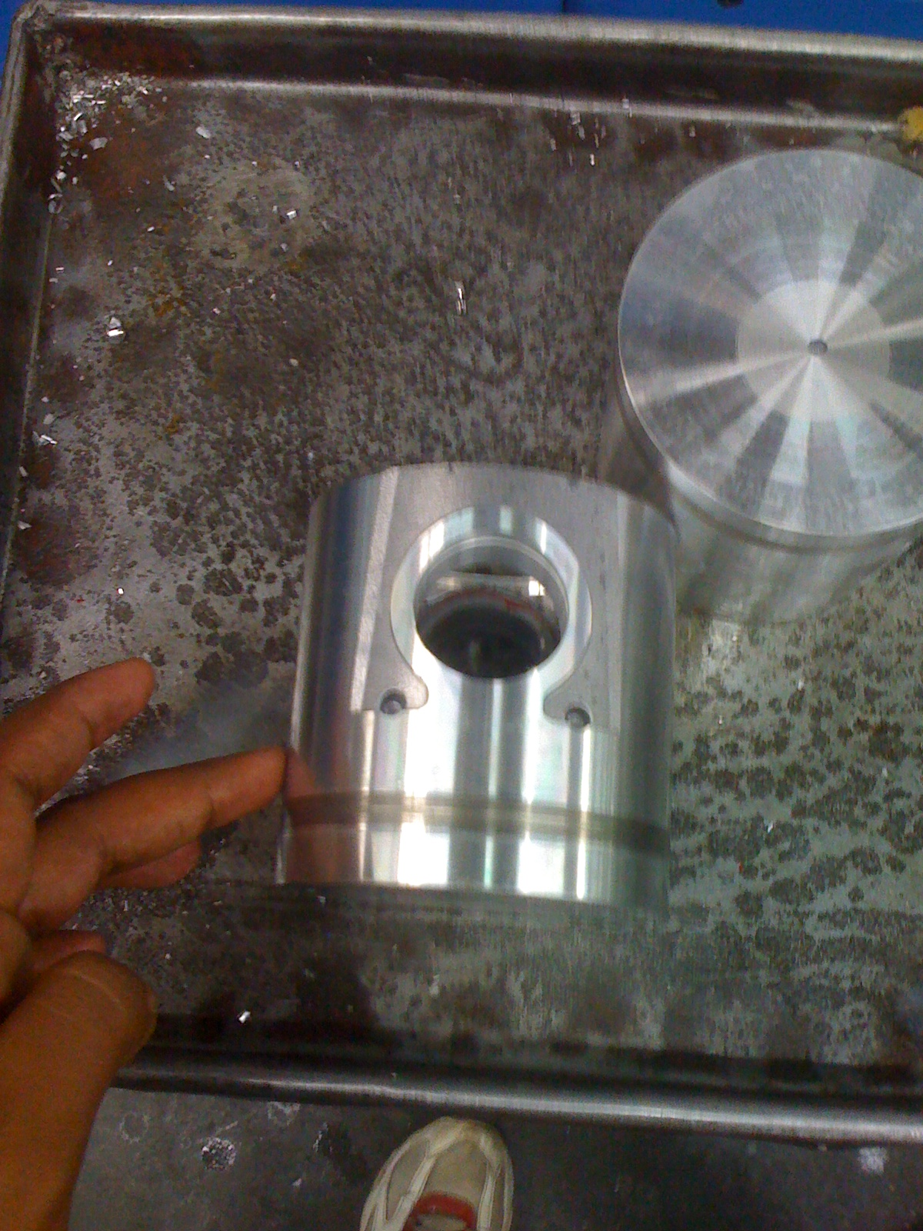
FIGURE – 1.2 PISTON

1.3.4. Piston Rings
Piston Ring Functions and Operation
The functions of a piston ring are to seal off the combustion pressure, to distribute and control the oil, to transfer heat, and to stabilize the piston. The piston is designed for thermal expansion, with a desired gap between the piston surface and liner wall. The rings and the ring grooves form a labyrinth seal, which relatively well isolates the combustion chamber from the crankcase. The position and design of the ring pack is shown in Fig 1.2 The ring face conforms to the liner wall and moves in the groove, sealing off the route down to the crankcase. The sealing ability of the ring depends on a number of factors, like ring and liner conformability, pre-tension of the ring, and gas force distribution on the ring faces. Some of the combustion chamber heat energy is transferred through the piston to the piston boundaries, i.e. the piston skirt and rings, from which heat transfers to the liner wall. Furthermore, the piston rings prevent excess lubrication oil from moving into the combustion chamber by scraping the oil from the liner wall during the down stroke. The piston rings support the piston and thus reduce the slapping motion of the piston, especially during cold starts where the clearance is greater than in running conditions. The rings are generally open at one location, at the ring gap, hence easily assembled onto the piston; see Fig1. 3.

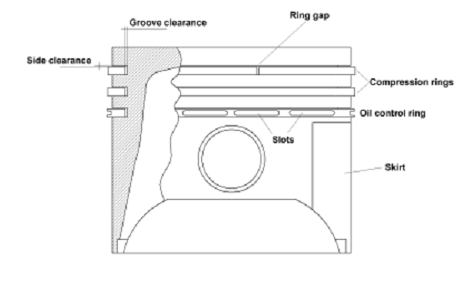
Fig 1.3 Position of different type of piston rings on piston

Function-It prevents the compressed charge of fuel-air mixture from leaking to the other side of the piston. Oil rings, is used for removing lubricating oil from the cylinder after lubrication. This ring prevents the excess oil to mix with charge.

1.3.5. Connecting Rod
Function-It changes the reciprocating motion of piston into rotary motion at crankshaft. This way connecting rod transmits the power produced at piston to crankshaft.
1.3.6. Gudgeon Pin
Function- Connects the piston with small end of connecting rod.

1.3.7. Crank Pin
Function- Hand over the power and motion to the crank shaft which come from piston through connecting rod.

1.3.8. Crank Shaft
Function-Receives oscillating motion from connecting rod and gives a rotary motion to the main shaft. It also drives the camshaft which actuates the valves of the engine.
1.3.9 Cam Shaft
Function-It takes driving force from crankshaft through gear train or chain and operates the inlet valve as well as exhaust valve with the help of cam followers, push rod and rocker arms.
1.3.10. Inlet Valve & Exhaust Valve
Function-Inlet valve allow the fresh charge of air-fuel mixture to enter the cylinder bore. Exhaust valve permits the burnt gases to escape from the cylinder bore at proper timing.
1.3.11. Governor
Function-It controls the speed of engine at a different load by regulating fuel supply in diesel engine. In petrol engine, supplying the mixture of air-petrol and controlling the speed at various load condition.
1.3.12. Carburetor
Function-It converts petrol in fine spray and mixes with air in proper ratio as per requirement of the engine.
1.3.13. Fuel Pump
Function-This device supply the petrol to the carburetor sucking from the fuel tank.
1.3.14. Spark Plug
Function-This device is used in petrol engine only and ignites the charge of fuel for combustion.
1.3.15. Fuel Injector
Function-This device is used in diesel engine only and delivers fuel in fine spray under pressure.

1.4 TYPES OF PISTON-

1.4.1 Trunk pistons
Trunk pistons are long, relative to their diameter. They act as both piston and also as a cylindrical crosshead. As the connecting rod is angled for part of its rotation, there is also a side force that reacts along the side of the piston against the cylinder wall. A longer piston helps to support this.
Trunk pistons have been a common design of piston since the early days of the reciprocating internal combustion engine. They were used for both petrol and diesel engines, although high speed engines have now adopted the lighter weight slipper piston.
A characteristic of most trunk pistons, particularly for diesel engines, is that they have a groove for an oil ring below the gudgeon pin, not just the rings between the gudgeon pin and crown. The name 'trunk piston' derives from the 'trunk engine', an early design of marine steam engine. To make these more compact, they avoided the steam engine's usual piston rod and separate crosshead and were instead the first engine design to place the gudgeon pin directly within the piston. Otherwise these trunk engine pistons bore little resemblance to the trunk piston: they were of extremely large diameter and were double-acting. Their 'trunk' was a narrow cylinder placed mounted in the centre of this piston.
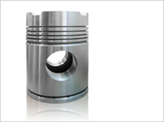

FIGURE 1.4.1 TRUNK PISTON

1.4.2 CROSSHEAD PISTON
Large slow-speed Diesel engines may require additional support for the side forces on the piston. These engines typically use crosshead pistons. The main piston has a large piston rod extending downwards from the piston to what is effectively a second smaller-diameter piston. The main piston is responsible for gas sealing and carries the piston rings. The smaller piston is purely a mechanical guide. It runs within a small cylinder as a trunk guide and also carries the gudgeon pin.
Because of the additional weight of these pistons, they are not used for high-speed engines.
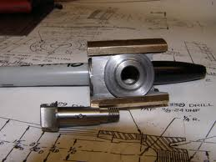
Figure 1.4.2 Cross Head Piston

1.4.3 SLIPPER PISTON-
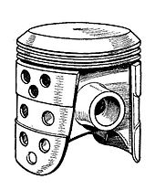
FIGURE 1.4.3 SLIPPER PISTON

A Slipper piston is a piston for a petrol engine that has been reduced in size and weight as much as possible. In the extreme case, they are reduced to the piston crown, support for the piston rings, and just enough of the piston skirt remaining to leave two lands so as to stop the piston rocking in the bore. The sides of the piston skirt around the gudgeon pin are reduced away from the cylinder wall. The purpose is mostly to reduce the reciprocating mass, thus making it easier to balance the engine and so permit high speeds. A secondary benefit may be some reduction in friction with the cylinder wall, however as most of this is due to the parts of the piston that are left behind, the benefit is minor.
1.4.4 DEFLECTOR PISTON-

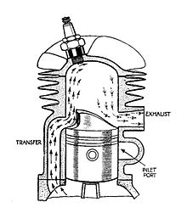

FIGURE 1.4.4 DEFLECTOR PISTON
Deflector pistons are used in two-stroke engines with crankcase compression, where the gas flow within the cylinder must be carefully directed in order to provide efficient scavenging. With cross scavenging, the transfer (inlet to the cylinder) and exhaust ports are on directly facing sides of the cylinder wall. To prevent the incoming mixture passing straight across from one port to the other, the piston has a raised rib on its crown. This is intended to deflect the incoming mixture upwards, around the combustion chamber.^{[1]} Much effort, and many different designs of piston crown, went into developing improved scavenging. The crowns developed from a simple rib to a large asymmetric bulge, usually with a steep face on the inlet side and a gentle curve on the exhaust. Despite this, cross scavenging was never as effective as hoped. Most engines today use Schnuerle porting instead. This places a pair of transfer ports in the sides of the cylinder and encourages gas flow to rotate around a vertical axis, rather than a horizontal axis
1.4.5 Steam engines
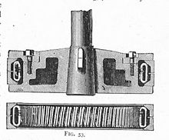
FIGURE 1.4.5 STEAM ENGINE
Steam engines are usually double-acting (i.e. steam pressure acts alternately on each side of the piston) and the admission and release of steam is controlled by slide valves, piston valves or poppet valves. Consequently, steam engine pistons are nearly always comparatively thin discs: their diameter is several times their thickness. (One exception is the trunk engine piston, shaped more like those in a modern internal-combustion engine.)
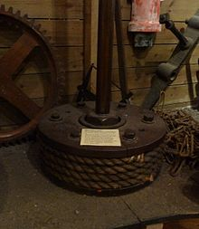
FIGURE 1.4.6 STEAM ENGINE PISTON

1.5 TYPES OF PISTON MATERIAL-
1.5.1 Depends on the kind of piston.
For a car or other engine, you normally find the piston head is made of aluminium with 2 0-ring seals along the top edge made of steel. Please remember that only the piston head is made of aluminium- the crank shaft and the rest of the cam assembly are made of high-tensile strength steel. For firearms, the piston is normally made of stainless steel or chromoly steel which allows soot to be easily wiped off.
For pumps and compressors the pistons, depending on the application, might be made of plastic, although in older designs iron or steel is much more common.

1.5.2 FOR AUTOMOBILE INDUSTRY-
- SPEED-PRO Hypereutectic pistons are cast in permanent molds, while SPEED-PRO Power Forged Pistons are extruded from aluminum bar stock. Each has advantages in certain applications, but there are Cases where the choice is not an easy one. An honest evaluation of your needs will yield the most satisfactory results.
- SPEED-PRO’S cast hypereutectic material is a relative newcomer to the performance market, and has several attractive features. Our Hypereutectic pistons operate perfectly with standard ring end gaps, and have conventional ring land locations. When compared to traditional cast pistons, which are not designed for performance use, the Hypereutectic’s are significantly stronger, particularly in the highly loaded ring land, skirt and pin bore areas. Our FM244 Alloy contains 16.5% silicon, and has excellent tensile and fatigue strength. This material’s improved thermal characteristics, it’s greater hardness, and the increased resistance to scuffing permit tight bore clearances which help minimize noise on a cold engine start up. This quiet operation, along with a lower cost, is the primary advantages over a comparable forged piston. These pistons are an excellent choice for street performance, for “claimer” oval track engines, and for bracket racing use. They will also work well in moderate supercharged applications, and are suitable for towing and marine use.
- SPEED-PRO POWERFORGED Pistons set the standard for the performance industry, with material and design superiority that has been proven in every form of racing. The forging process has inherent advantages in terms of density, ultimate strength and durability. Forging eliminates porosity in the metal, improves ductility, and will allow the piston to run cooler than a comparable cast unit. POWERFORGED Pistons start from “near net shape” forging, with a desirable horizontal grain flow and tightly controlled head thickness. This minimizes piston weight without compromising strength. These pistons are better able to withstand the high cylinder pressures and skirt loads imposed by racing use, and are more likely to survive limited detonation and valve piston contact which may occur during a race. If your vehicle is to be used for endurance racing, faster classes of drag racing, or extreme duty street performance, you should probably select a forged piston. Engines with very high compression ratios (11:1 and over), high boost superchargers, nitrous oxide, or which operate under conditions approaching detonation will benefit from the POWERFORGED piston’s characteristics.
- A hypereutectic piston is an internal combustion engine piston cast using a hypereutectic alloy–that is, a metallic alloy which has a composition beyond the eutectic point. Hypereutectic pistons are made of an aluminum alloy which has much more silicon present than is soluble in aluminum at the operating temperature. Hypereutectic aluminum has a lower coefficient of thermal expansion, which allows engine designers to specify much tighter tolerances.
The most common material used for automotive pistons is aluminum due to its light weight, low cost, and acceptable strength. Although other elements may be present in smaller amounts, the alloying element of concern in aluminum for pistons is silicon. The point at which silicon is fully and exactly soluble in aluminum at operating temperatures is around 12%. Either more or less silicon than this will result in two separate phases in the solidified crystal structure of the metal. This is very common. When significantly more silicon is added to the aluminum than 12%, the properties of the aluminum change in a way that is useful for the purposes of pistons for combustion engines. However, at a blend of 25% silicon there is a significant reduction of strength in the metal, so hypereutectic pistons commonly use a level of silicon between 16% and 19%. Special moulds, casting, and cooling techniques are required to obtain uniformly dispersed silicon particles throughout the piston material.
Hypereutectic pistons are stronger than more common cast aluminum pistons and used in many high performance applications. They are not as strong as forged pistons, but are much lower cost due to being cast.
1.6 Wear Mechanism (Types of wear)
The mechanism of wear is very complex and the theoretical treatment without the use of rather sweeping simplifications (as below) is not possible. It should be understood that the real area of contact between two solid surfaces compared with the apparent area of contact is invariably very small, being limited to points of contact between surface asperities. The load applied to the surfaces will be transferred through these points of contact and the localised forces can be very large. The material intrinsic surface properties such as hardness, strength, ductility, work hardening etc. are very important factors for wear resistance, but other factors like surface finish, lubrication, load, speed, corrosion, temperature and properties of the opposing surface etc. are equally important.

1.6.1 Abrasive Wear

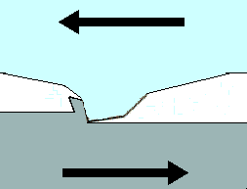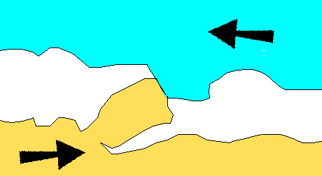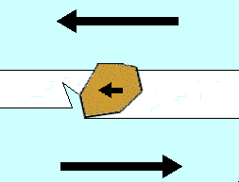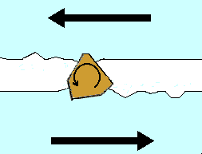

Figure 1.6.1 Abrasive wear

The abrasive wear mechanism is basically the same as machining, grinding, polishing or lapping that we use for shaping materials. Two body abrasive wear occurs when one surface (usually harder than the second) cuts material away from the second, although this mechanism very often changes to three body abrasion as the wear debris then acts as an abrasive between the two surfaces. Abrasives can act as in grinding where the abrasive is fixed relative to one surface or as in lapping where the abrasive tumbles producing a series of indentations as opposed to a scratch.

1..6.2 Adhesive Wear

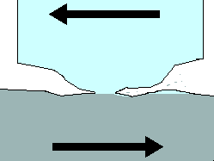

Figure 1.6.2

Adhesive wear is produced by the formation and subsequent shearing of welded junctions between two sliding surfaces. For adhesive wear to occur it is necessary for the surfaces to be in intimate contact with each other. Surfaces which are held apart by lubricating films, oxide films etc. reduce the tendency for adhesion to occur.

1.6.3 Erosion wear

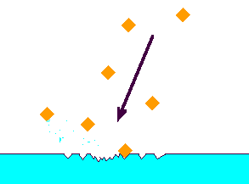

Figure 1.6.3

Erosion is caused by a gas or a liquid which may or may not carry entrained solid particles, impinging on a surface. When the angle of impingement is small, the wear produced is closely analogous to abrasion. When the angle of impingement is normal to the surface, material is displaced by plastic flow or is dislodged by brittle failure.

1.6.4 Cavitation Erosion

Cavitation is the formation and collapse, within a liquid, of cavities or bubbles that contain vapour or gas. Normally, cavitation originates from changes in pressure in the liquid brought about by turbulent flow or by vibration, but can also occur from changes in temperature (boiling). Cavitation erosion occurs when bubbles or cavities collapse on or very near the eroded surface. The mechanical shock induced by cavitation is similar to that of liquid impingement erosion causing direct localised damage of the surface or by inducing fatigue

1.6.5 Fretting Wear

Fretting is a small amplitude oscillatory motion, usually tangential, between two solid surfaces in contact. Fretting wear occurs when repeated loading and unloading causes cyclic stresses which induce surface or subsurface break-up and loss of material. Vibration is a common cause of fretting wear.

