Wear Behaviour of Aluminium Silicon Piston Alloys Using Different Coatings
A Major Project Report
Submitted in Partial Fulfillment for the Award of the Degree of
Master of Technology
In
Mechanical Engineering
With specialization in
PRODUCTION ENGINEERING
By

SUDEEP SINGH BAGHEL
(Roll No. 13/PRD/2010)
Under the guidance of
Dr.Qasim Murtaza (Associate Professor)
Department of Mechanical Engineering
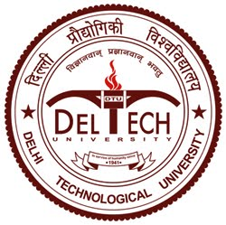
DEPARTMENT OF MECHANICAL AND PRODUCTION ENGINEERING
DELHI TECHNOLOGICAL UNIVERSITY
DELHI-110042
SESSION 2010-12

