Study of Base-Isolation Systems & Retrofitting
Submitted in Partial Fulfilment for the Award of the Degree of

Master of Engineering
in
Civil Engineering

With specialization in

STRUCTURAL ENGINEERING
By

Suresh Pal Singh
(Roll No 8848)
(19/STR/2006)
Under the guidance of

Shri G.P.Awadhiya

Assist. Professor

Civil Engineering Department
Delhi College of Engineering, Delhi

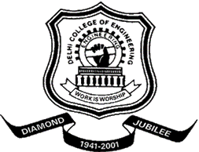

Department of Civil & Environmental Engineering
Delhi College of Engineering
University of Delhi, Delhi
2006-2010

