CHAPTER – II
LITERATURE REVIEW

2.1.1. OZONE DEPLETION POTENTIAL AND GLOBAL WARMING POTENTIAL OF CFC REFRIGERANTS:
Earth's ozone layer exists in the stratosphere. This ozone layer absorbs harmful ultraviolet rays emitted by sun. These ultraviolet rays may cause skin cancer and other deceases. The scientists were surprised to find a big hole in ozone layer above the Antarctic. CFCs are responsible for the depletion of this ozone layer. CFCs have varying degree of ozone depletion potential (ODP). CFCs also have global warming potential (GWP) because they acts as green house gases.
In Montreal protocol, an international agreement, it was decided to phase out the use of fully halogenated CFCs by 2000. These fully halogenated CFCs does not have hydrogen in the molecule, therefore CFC's having high ODP. These fully halogenated CFC's are R-11, R-12, R-113, R-114 & R-502. R-22 being the HCFCs have ODP is only 5% of R-12. Therefore R-22 can be used up to 2030 AD.
Even after taking so much of measures, a hole of around 2.7 million square kilometers area in ozone layer was detected above Antarctic in year 2008. CFCs were discovered firstly by S. Rowland, a radio chemist & one other scientist in year 1974. CFCs have a long life in lowers atmosphere and it is stable also. CFCs are heavier than Nitrogen (N) and Oxygen (O) atom, even though these migrate slowly into the upper atmosphere due to molecular diffusion caused by partial pressure difference.
Thus this ozone layer protects us from these harmful Ultraviolet rays. It is proved that chlorine atom available in CFCs & HCFCs molecule would be split off in presence of sunlight. This developed free chlorine atom reacts with ozone molecules of the ozone layer available in upper atmosphere. This can be explained with following equations.
CClF CClF + Cl
OClO + O
Thus O₃ will be depleted to O₂. The problem with CFC is that of chain reaction. A single atom of Cl released from CFC reacts taking out 100000 O₃ molecules. That is why even a small concentration of CFC also becomes important.

2. 1. 2 SUBSTITUTES FOR CFC REFRIGERANTS
CFC substitutes fall into four categories: those are based on N_{2,} HFCs and HCFCs, HCs, and inert gases.
Hydrocarbons (HCs) and hydro fluorocarbons (HFCs) are the substitute for fully halogenated CFCs refrigerant. Hydrocarbons (HCs) and hydro fluorocarbons (HFCs) contains no chlorine atom at all. So they have zero Ozone Depletion Potential (ODP). HCFCs like R-22 and R-123 contains chlorine atoms in association with H-atoms, therefore having very less ODP. This H-atoms allows them to dissociate faster in the lower atmosphere. These chlorine atoms will be absorbed by water in rain. The chlorine atom makes the rain water chlorinated. This way very less chlorine atoms reach up to the stratosphere. This way it does not deplete ozone layers much faster as by more chlorine atoms. However, HCFCs have a level of ODP in addition to GWP. Hence, these also have to be phased out by the year 2030 AD.
Due to the H atom in HFCs, it's become flammable to some extent. The degree of flammability depends on the number of H-atoms in the molecule.
The two most common refrigerants which have very high ODP are the highly chlorinated CFCs R 11 and R 12. The others are R 113 and R 502. So R 11, R 12, R 113, R 114, and R 502 have been replaced by substitutes.
Therefore the substitute for replacing R-11, R-12, R-113, R-114 and R-502 is required.
R-22 being a HCFCs refrigerant has 1/20th of the ODP of R-11 and R-12. The HCFCs have some GWP. Because of higher GWP and lower ODP R-22 will also be phased out by the year 2030.
At present time there are so many HCFCs which are would alternative for future the list of such refrigerant is given below:

Methane Series
HCFC R 22 (CHC1F₂), Monochlore difluoro methane

HFC R 32 (CH₂ F₂) difluoro methane
Ethane series

HCFC R 123 (CHCl₂ – CF₃), Dichloro trifluro ethane
HFC R 125 (CHF₂ – CF₃), Pentafluoro ethane

HFC R 134a (CH₂F – CF₃), Tetrafluoro ethane
HFC R 143a (CH₃ – CF₃), Difluoro ethane

Propane Series
HFC R 245fa (C₃H₃F₃), Pentafluoro Propane

HC R 290 (C₃H₈), Propane
Butane Series

HC R 600a (C₄H₁₀), Isobutane
Zeotropic Blends
HFC R 404A [R 125/143a/134a (44/52/4)]
HFC R 407C [R32/125/134a (23/25/52)]

HFC R 410A [R32/125 (50/50)]

Azeotropic blends
HFC R 507A [R125/143a(50/50)]

Inorganic Refrigerants
R717 (NH₃), Ammonia
R 718 (H₂O), Water
R 744 (CO₂), Carbon dioxide
R-22 is the only refrigerant of methane series is being used presently. R-123 and R-134a refrigerants are being used for ethane series. R-152a is also being currently used in Europe. Further R-600a, isobutene is also being used in domestic refrigerators.
We know that Normal Boiling Point (NBP) is the single and most important characteristics of a substance weather it can be used as a refrigerant. This also determines the type of equipment i.e. type of compressor, type of application, mass flow rate of refrigerant and the refrigerating capacity for which a particular refrigerant is to be used. Based on the NBP the substances with their NBPs range from -50⁰ C to +50⁰ C are considered suitable for use as refrigerant.
On the basis of N.B.Ps it has been observed that HCFC R-123 is a suitable alternative to R-11, HFCs R-152a and R-134a are potential alternatives to R-12, HCs R-600a and R-290 can replace the R-12, HCFC R-22 can be used to replace R-12 in some low condensing temperature applications. HFCs R-143a and R-125 are also suitable alternatives to R-502.
Devotta, Melinden and others have conducted surveys of CFC alternatives. Table 2.1 gives the historic, current and future, candidate refrigerants as possible alternatives arranged in order of their decreasing N.B.Ps. The flammability or non-flammability of these substances is also mentioned. Note that flammability may not be hazardous in small units such as refrigerators & water coolers etc. in which the amount of charge is small.
It is understood from the table that most of the substitutes are ethane series compound. It is evident that R-404A, R-407C and R-507A are nearly azeotropic blends. The first figure under their NBP column indicates dew temperature at atmospheric pressure. The second figure indicates bubble temperature. Further note that difference between dew and bubble temperatures for R-410A is only 0.08⁰ C. It is like a pure substance. The difference for R-407C is large (7⁰ C).

Table : 2.1

Common CFCs and possible alternatives with normal boiling points
Designation | Category | Chemical Formula | N.B.P., ⁰C | Flammability
R 113 | CFC | C₂ Cl₃ F₃ | 47.68 | Non-flammable
R 141b | HCFC | CH3 CCl2 F | 32.1 | Slightly flammable
R 152 | HFC | CH2 F CH2 F | 30.7 | Flammable
R 123 | HCFC | C H Cl2 CF3 | 27.82 | Non-flammable
R 11 | CFC | CCl3 F | 23.7 | Non-flammable
R 243fa | HFC |  | 14.9 | Flammable
R 600a (Isobutene) | HC | (CH₃)₃ CH | -11.67 | Flammable
R 134 | HFC | CHF₂ CHF₂ | -19.8 | Non-flammable
R 152a | HFC | CH₃ CHF₂ | -24.02 | Slightly flammable
R 134a | HFC | CF3 CH2F | -26.07 | Non-flammable
R 12 | CFC | CCl₂ F₂ | -29.8 | Non-flammable
R 717 (Ammonia) |  | NH₃ | -33.3 | Flammable
Designation | Category | Chemical Formula | N.B.P., ⁰C | Flammability
R 22 | HCFC | CHCIF₂ | -40.8 | Non-flammable
R 290 (Propane) | HC | C₃ H₈ | -42.1 | Flammable
R 407 C | HFC | - | -43.63/-36.63 | -
R 502 | CFC |  | - 45.4 | Non-flammable
R 404 A | HFC | - | -46.22/-45.47 | -
R 507 A | HFC | - | -46.74 | -
R 143a | HFC | CH₃ CF₃ | -47.35 | Slightly flammable
R 125 | HFC | CHF₂ CF₃ | -48.55 | Non-flammable
R 410A | HFC | - | -51.44/-51.36 | -
R 32 | HFC | CH₂F₂ | -52.024 | Slightly flammable

The may be noted that R-123 has 98% less ODP and GWP than R-11. R-152a and R-134a have no Cl atoms. Hence, these have zero ODP. They have 74% less GWP as compared to R 12. Hydrocarbons have zero ODP.
The difference between the boiling point of HCFC R-123 and CFC R-11 is 4.3⁰ C. The boiling point of HCFC R-123 is higher than CFC R-11. Therefore, HCFC R-123 is a lower pressure replacement for CFC R-11. But it is having more specific volume of suction vapour. In this way the use of HCFC R-123 in place of CFC R-11 results in 10-15% reduction in refrigerator capacity. Hence smaller centrifugal compressors can be employed.
HFC R-134a has 3.6⁰ C higher boiling point than CFC R-12. Therefore it is having lower suction pressure and larger suction vapour volume. Thus HFC R-134a can be replacement of CFC R-12 in the existing reciprocating compressors. With this replacement it would give advantage of either an average increase in compressor speed of 5-8% or an equivalent increase in cylinder swept volume.
Being transition refrigerant HCFC R-22 is becoming of greater importance. It is being used in screw compressors of very large capacity and in scroll compressors of package units.
Other than the pure substances, mixtures of two substances which have higher and lower boiling points can be mixed in proportion to achieve an effective boiling point nearly equal to the refrigerant which is to be replaced can also be used.
Binary mixture of R-290/R-600a i.e. propane/isobutene in 50-50% composition by mass is an example of binary mixture. This mixture is suitable alternative to R-12 in refrigeration system. Another example is R-410A which is a mixture of R-32 and R-125 in 50-50% composition by mass. This mixture has been found suitable substitute to replace R-22.
But these mixtures boil and condense over a range of temperature. This is known as a temperature glide. It might be an advantage in non-iso thermal refrigeration application. Now-a-days ternary mixtures are also being used. These are the mixtures of three refrigerants in various percentage of composition by mass. A company of Rail cars use R-404A (R-125 + R-143a + R-134a) a ternary mixture in USA.
Table : 2.2
Short term & Long term substitutes' refrigerants
Refrigerants used Before 2000 | Substitute Refrigerant
 | Short Term | Long Term
CFC 11 | HCFC 123 | HFC 245fa. Others
CFC 12 | HFC 134a | HFC 134a
HCFC 22 | HCFC 22 | HFC 134a, R 407C, R 410A
 | HFC 134a | Other blends of HFC 32, HFC 134a, and others
R 502 | HCFC 22 | HFC 124, R 507A. Other blends of HFC 32, HFC 125, HFC 134a, and others.

Above mentioned table 2.2 shows the common refrigerants used before the year 2000, viz., CFCs 11, 12 and 502 and HCFC22 and it lists the substitutes as follows :
- Short term substitutes which are currently being used.
- Long term substitutes which might be used even after 2000.
2.1.3 ATMOSPHERIC GASES AS SUBSTITUTES FOR CFC
REFRIGERANTS:
Now-a-days the main concern is to protect the environment from the ozone layer depletion and Global Warming effect. Therefore it is suggested that the atmospheric gases which are existing in nature can be used as refrigerants. There are existing gases i.e. Air, Water Vapour, Carbon-dioxide, Hydrogen and Ammonia can be used in refrigeration system.
While ammonia is already a very popular refrigerant in industrial applications such as cold storages and ice plants, its application can grow further. This has already put a stop to the replacement of ammonia by HCFC R22.
Now it is a challenge to thermal engineers to develop techniques for adopting water and other inert atmospheric gases in varied applications and high performance refrigeration systems.
Carbon dioxide was used as a refrigerant toward the end of nineteenth century. Since its critical temperature is low (31 ⁰C only), it cannot be condensed in high ambient conditions. But it can be used in a supercritical vapour compression cycle. Improving its COP, however, offers a challenge to thermodynamics engineers.
  - SELECTION OF HYDROCARBON GAS AS REFRIGERANT:
In my thesis, the hydrocarbons gases are being used as refrigerant. So now I will discuss on this issue.
2.2.1 REFRIGERATION ISSUE
When we use hydrocarbon as a refrigerant in refrigeration system, the design of the system is to be done keeping in mind the safety aspect. General refrigeration issues should also be considered. These include thermodynamic properties, material compatibility and component selection.
2.2.2 REFRIGERANT SELECTION
Most probably, refrigerant selection is done based on matching refrigerant vapour pressures to the operating conditions. Good system efficiency is the main criteria for selecting a refrigerant. Blended refrigerant should be selected when the effect of temperature glide and composition shift is not important issue.
Table 2.3 provides guidelines for selection of a refrigerant. It gives an indication for the application ranges and equivalent fluorinated refrigerants where hydro carbons could be employed.
We should use on refrigerant grade products only when hydrocarbon refrigerant are in use. Commercial grade hydrocarbons contain significant quantities of sulphur, water, and other impurities and could contribute to oil degradation, shorten the compressor life.
Table : 2.3
Application ranges for Hydrocarbon Refrigerants.
Refrigerant | Application Range | Replacement
R600a (isobutene) | high/medium temperature; domestic appliances. | (R 12, R134a)*
CARE 30 (R600a/R290 blend) | high/medium temperature; commercial, automotive, domestic. | R12, R134a
R290 (propane) | high/medium/low temperature; commercial, industrial; freezers, air-conditioning, heat pumps. | R22, R404A, R407C, R507A
R1270 (propylene or propane) | high/medium/low temperature; commercial, industrial; industrial and process refrigeration, air-conditioning, heat pumps, chillers. | R22, R404A, R407C, R507A
CARE 50 (R290/R170 blend) | high/medium/low temperature; commercial, industrial; industrial and process refrigeration, air- conditioning, heat pumps, chillers. | R22, R404A, R407C, R507A
R170 (ethane) | Low temperature cascade systems | R13, R23, R503
*R600a possesses a volumetric refrigerating capacity that is approximately half that of R12 and R134a. Therefore R600a is not a "thermodynamic" replacement for these refrigerants.
2.2.3 REFRIGERANT PROPERTIES
In a system, the refrigerant properties are very important to decide the operating characteristics of the refrigerant. Physical properties of refrigerants are useful for finding the applications of a refrigerant under design operating conditions.
Thermodynamic properties of a refrigerant are necessary for determining the system behavior and performance of components. Basic properties are provided in Table 2.4.
Table 2.4 Physical Properties of Refrigerants
Refrigerant | Mol. Mass (kg/ kmol) | Normal boiling pt. at 1 Atm. | Critical temp. (⁰C) | Critical pressure (bar, abs.) | Temp. glide at 25⁰C (K) | Latent heat at 25⁰C (kj/kg) | Saturation press at 25⁰C (bar, abs.)
R600a | 58.1 | -11.7 | 135.0 | 36.45 | 0 | 332 | 3.5
CARE 30 | 51.0 | -31.7 | 105.5 | 34.01 | 7.8 | 353 | 5.2
R290 | 44.1 | -42.1 | 96.7 | 42.48 | 0 | 342 | 9.6
R1270 | 42.1 | -47.7 | 91.8 | 46.18 | 0 | 338 | 11.5
CARE 50 | 46.8 | -49.1 | 79.3 | 33.86 | 3.9 | 348 | 10.1
R170 | 30.1 | -88.8 | 32.2 | 48.91 | 0 | 299 | 24.0

2.2.4 LUBRICANTS
Hydrocarbon refrigerants possess full chemical compatibility with nearly all lubricants commonly used within refrigeration systems. Good miscibility is maintained with most lubricants under all operating conditions.
Table 2.5 details the various lubricants and their compatibility characteristics.
Table : 2.5
Compatibility of various lubricants with HC refrigerants
Lubricant Type* | Compatibility
Mineral (M) | Fully soluble with hydrocarbons. Excessive solubility at high temperature conditions. Compensate by selection of a high viscosity grade oil.
Alkyl benzene (AB) | Fully soluble and typical viscosity grades applicable to all applicants.
Semi-synthetic (AB/M) | A blend of AB and M oils achieving desirable properties for use with hydrocarbons.
Polyolester (POE) | Generally exhibit excessive solubility with hydrocarbons. May necessitate higher viscosity grade.
Polyalkylene Glycol (PAG) | Soluble and partially soluble with hydrocarbons depending upon the conditions. Normal grades are generally satisfactory.
Poly-alpha-olefins (PAO) | Soluble with hydrocarbons but typically used for low temperature applications.
*It is recommended that the compressor manufacturer be consulted to determine the selection of the correct lubricant.

2.2.5 MATERIALS
All elastomer and plastic material used in manufacturing of refrigeration component i.e. ‘O’ rings, valve seats, seals and gaskets are suitable for hydrocarbon refrigerants. Natural rubbers, silicone rubbers and EPDM is not compatible with the hydrocarbon refrigerants therefore these should not be used in such refrigeration systems.
2.2.6 GENERAL SYSTEM COMPONENTS
All system components compatible with fluorocarbon refrigerants are also suitable when used with hydrocarbons.
2.2.7 GENERAL SAFETY ISSUES
All hydrocarbon refrigerants are highly flammable but non-toxic. This gives them an “A3” classification according to BS EN378 Part 1.
2.2.8 ALLOWABLE REFRIGERANT CHARGE
The limiting factor associated with the use of hydrocarbon refrigerants is the refrigerant charge size, the occupancy category and the room size. The charge size requirements according to Annex C of BS EN378 Part 1 are detailed in Table 2.6.
Systems with charge sizes of 0.15kg or less can be installed in any size of room. Systems with charge size of more than 0.15kg room size should be such that a sudden loss of refrigerant shall not raise the mean concentration in the room above the practical limit (approximately 0.008kg/m³).

Table : 2.6
Charge size requirements for various location categories
Category | Examples | Requirements
A (domestic/public) | Hospitals, prisons, theatres, schools, supermarkets, hotels, dwellings. | - <1.5Kg per sealed system.  - <5Kg in special machinery rooms or in the open air for indirect systems.
B (commercial/private) | Offices, small shops, restaurants, places for general manufacturing and where people work. | - <2.5Kg per sealed system.  - <10 Kg in special machinery room or open air for indirect systems.
C (industrial / restricted) | Cold stores, dairies, abattoirs, non-public areas of supermarkets, plant rooms. | - <10kg in human occupied spaces.  - <25Kg if high pressure side (except air cooled condenser) is located in a special machinery room or in the open air.  - No limit if all refrigerant is contained in a special machinery room or in the open air.

2.2.9 FLAMMABLE PROPERTIES OF HYDROCARBONS
Table 2.7 provides property data relevant to hydrocarbon refrigerants. These values are necessary in the design stage when determining maximum refrigerant charge, ventilation flow rates and maximum allowable temperatures of components.
Table 2.7
Flammability properties of selected hydrocarbon refrigerants.
Refrigerant* | Number | Lower Flammability Limit (LFL) |  | Autoignition temperature (⁰C).
 |  | By Volume (%) | By mass (kg/m³)
Ethane | R170 | 3.0 | 0.037 | 515
Propane | R290 | 2.1 | 0.038 | 470
Iso-butane | R600a | 1.8 | 0.043 | 460
Propylene | R1270 | 2.5 | 0.043 | 455
CARE 30 | - | 2.0 | 0.041 | 460
CARE 50 | - | 2.2 | 0.038 | 460
* Properties for other hydrocarbons can be found in the literature.
The practical limit as used in EN378 is defined as 20% of the LFL.

Energy is the single largest running cost of mechanical refrigeration systems, whether it is used for: Food preservation and storage; air conditioning; or other industrial uses. Many mechanical refrigeration systems installed in air conditioning, food processing and other industrial applications have been design to meet a low capital cost criterion. Many researches have worked on the modifications of such plants to lower running costs, particularly energy. Simple calculation methods based on empirical formulae for calculation of energy usage were presented. These methods allow the energy and hence the running cost and savings resulting from plant changes to be estimated.
2.2.10 REFRIGERANT CHARGE FOR VARIOUS CATEGORIES
Table-2.8
Charge Size Categories
 | Refrigerant Charge Size
Occupancy Category | <0.15 kg | 0.15-1 kg | 1-1.5 kg | 1.5-2.5 kg | 2.5-5 kg | 5-10 kg | 10-25 kg | >25 kg
A | A1 | A2 | A3 | A4 | A5 | A6 | n/a | n/a
B | B1 | B2 | B3 | B4 | B5 | B6 | n/a | n/a
C | C1 | C2 | C3 | C4 | C5 | C6 | n/a | n/a

Occupancy Category A - Rooms, parts of buildings where people may sleep, people are restricted in their movements e.g. hospitals, courts, prisons, theatres, supermarkets, schools, lecture halls, public transport termini, hotels, dwellings, restaurants.
Occupancy Category B - Rooms, parts of buildings or buildings where only a limited number of people may be assembled e.g. business or professional offices, small shops, small restaurants, laboratories, places for general manufacturing and where people work.
Occupancy Category C- Rooms, parts of buildings or buildings where only authorized persons have access.

2.3 REFRIGERATION CYCLES :

2.3.1 VAPOUR COMPRESSION CYCLE :
In vapour compression cycle with two modifications is used. Due to its high performance or efficiency, it is most widely used in commercial refrigeration system.
A complete vapour compression cycle is shown on the T-s diagram in Fig. 2.1 and on the p- v diagram in Fig. 2.2. Figure 2.1 also presents a comparison of the vapour compression cycle 1-2-3-4 with the reversed Carnot cycle 1-2”-3-4’, or 1-2”-3’-4, both operating between the same temperature limits of T_{k} and T₀.
In the vapour compression cycle:
Refrigerating effect, q_{ο} = area 1-4-d-e
Heat rejected, q_{k} = area 2-2”-3-c-e
Work done, w=q_{k} - q_{ο}= area 1-2-2’-3-c-d-4-1
It is seen that three deviations from the reversed Carnot cycle is given in the vapour compression cycle. It is shown in figure 2.1:
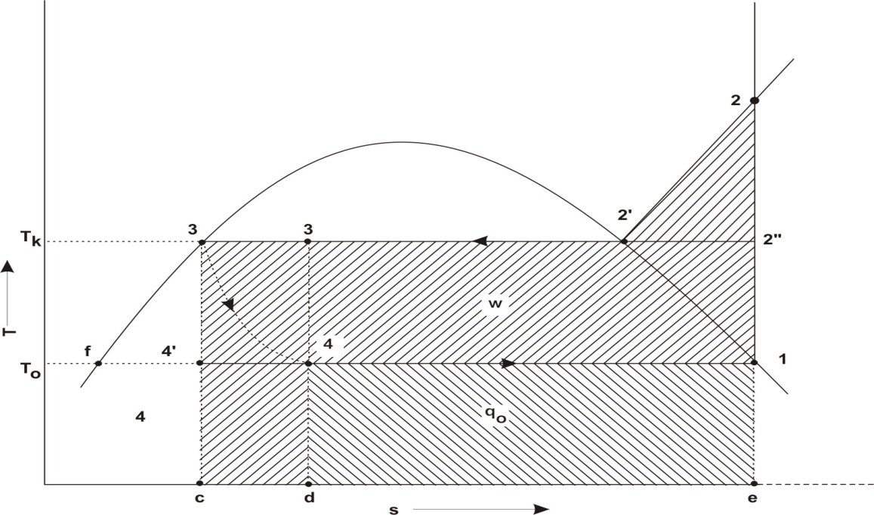
Fig:2.1 Vapour compression cycle on T-S diagram
- Area 4-4’-c-d, representing a loss of the refrigerating effect, q₀, as a result of throttling.
- Area 4-4’-c-d, also representing a loss of positive work, w₀ , resulting from the failure to recover expansion work. It can be shown that areas 4-4’-c-d and 3-f-4’ are the same.
- Area 2-2’-2” of superheat horn, representing an increase of negative work, w_{k}, as a result of dry compression.

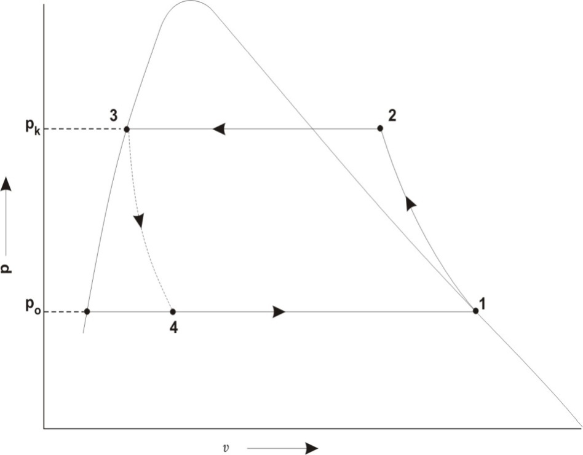
Fig 2.2 Vapour Compression cycle on P V diagram
Reversed Carnot cycle used as refrigeration cycle is having the higher theoretical coefficient of performance (COP) than other vapour compression cycle. With these two modifications, it is closed to the Carnot cycle as compared to other cycles and its COP approach nearest to the Carnot value.

2.3.2 IMPROVEMENTS IN SIMPLE SATURATION CYCLE
The simple saturation cycle may be improved by the following methods :
1. By introducing the flash chamber between the expansion valve and the evaporator.
2. By using the accumulator or pre-cooler.
3. By sub-cooling the liquid refrigerant by the vapour refrigerant.
4. By sub-cooling the liquid refrigerant leaving the condenser by liquid refrigerant from the expansion valve.

2.3.3 Simple Saturation Cycle with Flash Chamber

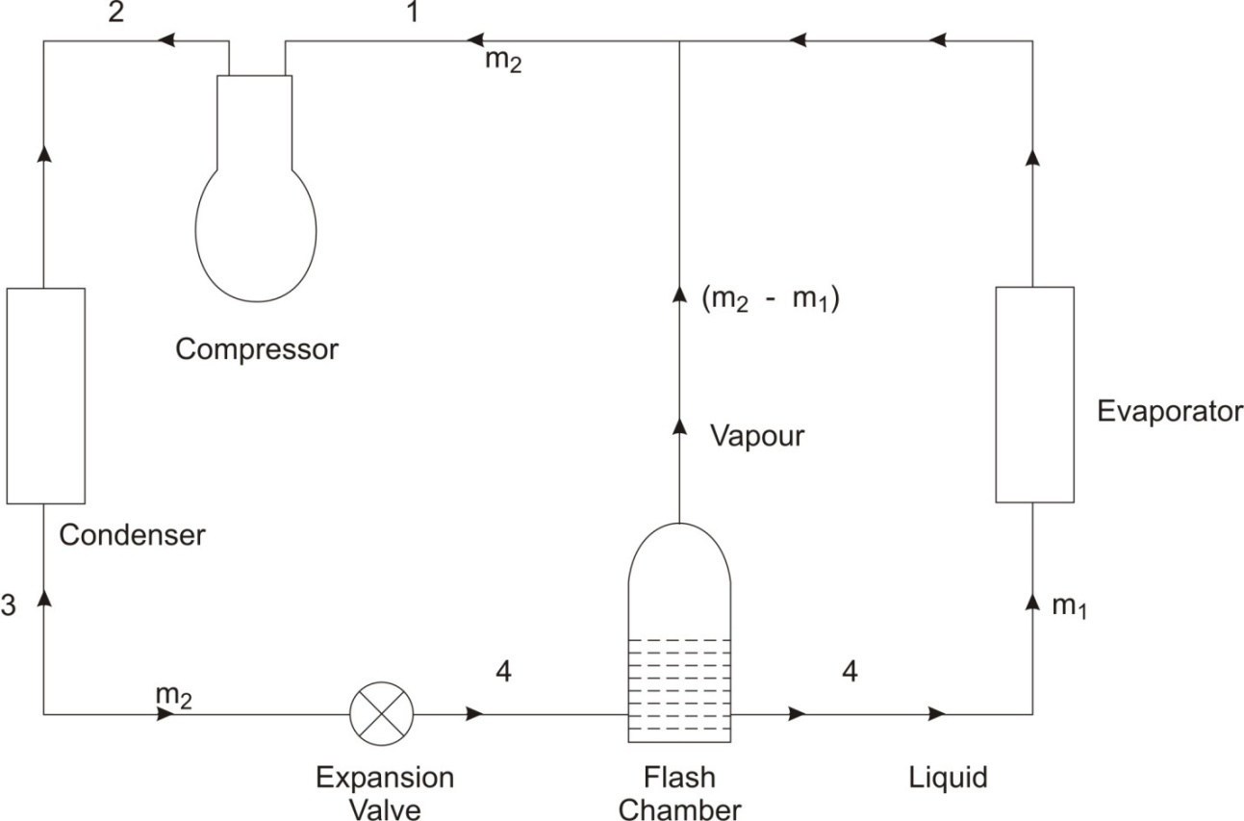
Fig. 2.3. Simple saturation cycle with flash chamber.
We know that when the high pressure liquid refrigerant from the condenser passes through the expansion valve, some refrigerant evaporates. This partial evaporation of the liquid refrigerant is known as flash. Since the vapour formed during expansion process is not participating in producing refrigerating effect. This vapour refrigerant does not carries the heat in the form of latent heat. But the liquid refrigerant has heat in the form of latent heat. This flash or vapour formed thereby is not capable to producing any refrigeration effect, can be bypass to evaporator and directly fed to the suction of the compressor. This is achieved by arranging a flash chamber between the expansion valve and the evaporator. This arrangement is shown in Fig. 2.3
The flash chamber is an insulated container and it separates the liquid and vapour due to centrifugal effect. Thus the mass of the refrigerant passing through the evaporator reduces.
Let us consider that a certain amount of refrigerant is circulating through the condenser. This refrigerant after passing through the expansion valve, is supplied to the flash chamber which separates the liquid and vapour refrigerant. The refrigerant from the flash chamber is supplied to the evaporator and the vapour refrigerant flows directly from the flash chamber to the suction of the compressor. The p-h diagram of the cycle is shown in Fig. 2.4.
Let m₁ = Mass of liquid refrigerant supplied to the evaporator, and
m₂ = Mass of refrigerant (liquid and vapour) circulating through the condenser, or leaving the expansion valve.
Mass of vapour refrigerant flowing directly from the flash chamber to the suction of the compressor = m₂ - m₁
Now considering the thermal equilibrium of the flash chamber. Since the flash chamber is an insulated vessel, therefore, there is no heat exchange between the flash chamber and the atmosphere. In other words, the heat taken and given out by the flash chamber are same. Mathematically,
Heat taken by the flash chamber = Heat given out by the flash chamber
or m₂ h₄ = m₁h_{f4}' + (m₂ - m₁) h₁
m₂ (h₁ - h₄) = m₁ (h₁ - h_{f4}')
m₁ = m₂ ... (i)
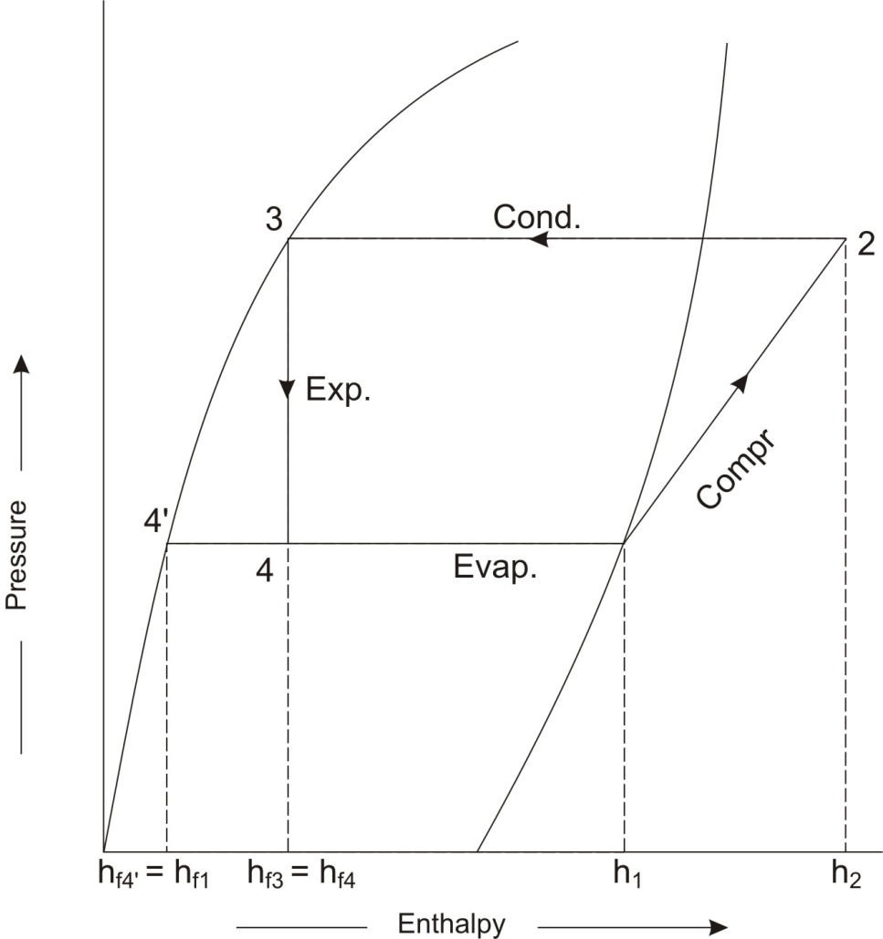
Fig. 2.4 p-h diagram of simple saturation cycle with flash chamber.
We know that the heat extracted or refrigerating effect.
R_{E} = m₁ (h₁ - h_{f4}')
= .... [From equation (ii)]
= m₂ (h₁ - h_{f3})
and workdone in compressor,
W = m₂ (h₂ - h₁)
and power required to drive the compressor,
From the above equations it is understood that refrigeration effect (RE), coefficient of performance (COP) and the power (P) required are same as that of a simple saturation cycle without flash chamber. Thus the use of flash chamber has no effect on the thermodynamic cycle. The only effect resulting from the use of flash chamber is the reduction in the mass of refrigerant flowing through the evaporator and hence the reduction in size of evaporator.

2.3.4 COMPOUND VAPOUR COMPRESSION SYSTEM:-

2.3.4.1 TYPES OF COMPOUND VAPOUR COMPRESSION WITH INTERCOOLER
In compound compression vapour refrigeration systems, the superheated vapour refrigerant leaving the first stage of compression is cooled by suitable method before being fed to the second stage of compression and so on. Such type of cooling the refrigerant is called inter-cooling. Though there are many types of compound compression with intercoolers, these are given below:
1. Two stage compression with liquid intercooler.
2. Two stage compression with water intercooler.
3. Two stage compression with water intercooler, liquid subcooler and liquid flash chamber.
4. Two stage compression with water intercooler, liquid subcooler and flash intercooler.
5. Three stage compression with flash chambers.
6. Three stage compression with water intercoolers.
7. Three stage compression with flash intercoolers.
The above mentioned types are now discussed, in detail, one by one in the following pages.

2.3.4.2 TWO STAGE COMPRESSION WITH LIQUID INTERCOOLER
The arrangement of a two stage compression with liquid intercooler is shown in Fig.2.5 (a). The corresponding p-h diagram are shown in fig. 2.5 (b) as discussed below:
Horizontal pressure line representing the evaporator pressure P_{E} (or suction pressure of low pressure compressor) which intersects the saturated vapour line at point 1. At this point, the saturated vapour is supplied to the low pressure compressor. Let, a point 1, the enthalpy of the saturated vapour is h₁ and entropy s_{v1}.

The saturated vapour refrigerant admitted at point 1 is compressed isentropically in the low pressure compressor and devlivers the refrigerant in a superheated state. The pressure rises from P_{E} to P₂. The curve 1-2 represents the isentropic compression in the low pressure compressor. In order to obtain point 2, draw a line from point 1, with entropy equal to S_{v1}, along the constant entropy line intersecting the intermediate pressure line p₂ at point 2. Let enthalpy at this point is h₂.
The superheated vapour refrigerant leaving the low pressure compressor at point 2 is cooled (or desuperheated) at constant pressure p₂ = p₃ in a liquid intercooler by the liquid refrigerant from the condenser. The refrigerant leaving the liquid intercooler is in saturated vapour state. The line 2- 3 represents the cooling or desuperheating process. Let the enthalpy and entropy at point 3 is h₃ and s_{v3} respectively.
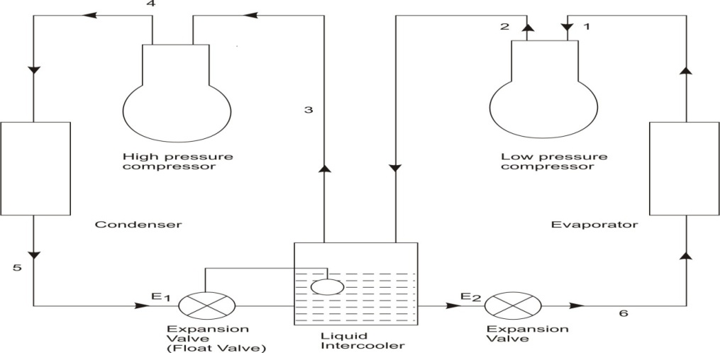
Fig 2.5 (a) Two stage compression with liquid intercooler.
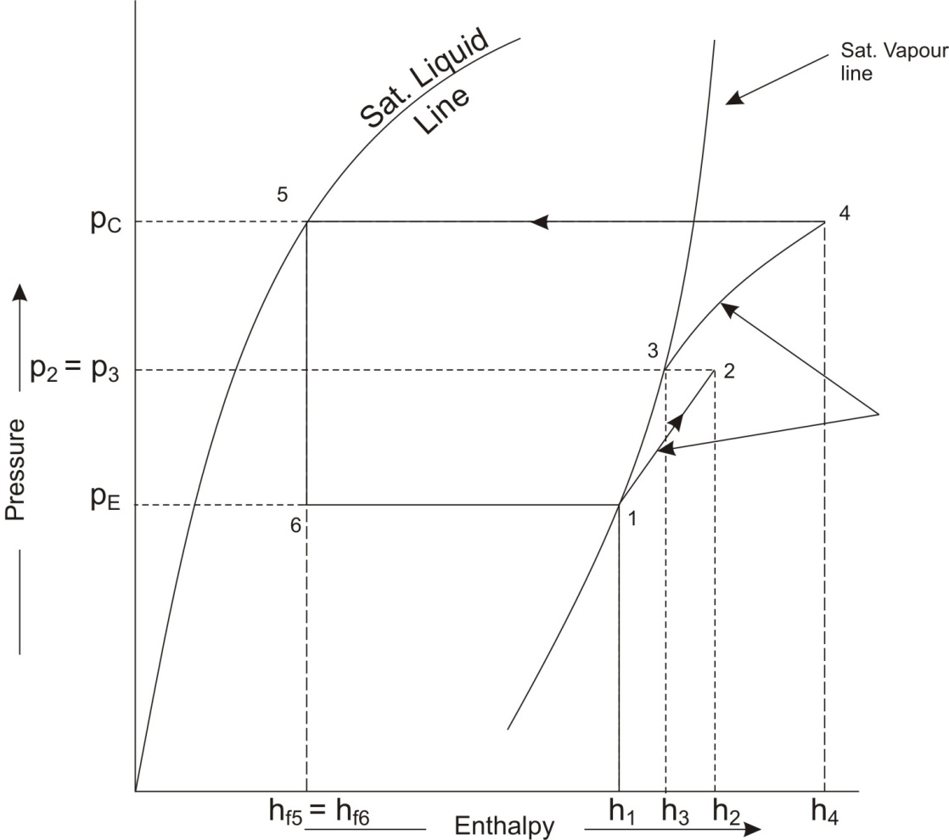
Fig 2.5 (b) p-h diagram
The dry saturated vapour refrigerant is now supplied high pressure compressor where it is compressed isentropically from intermediate or interocooler pressure p₂ to condensor pressure p_{C}. The curve 3-4 represents the isentropic compression in the high pressure compressor. The point 4 on the p-h diagram is obtained by drawing a line of entropy equal to s_{v3} along the constant entropy line as shown in Fig. 2.5 (b). Let the enthalpy of superheated vapour refrigerant at point 4 is h₄.
The superheated vapour refrigerant leaving the high pressure compressor at point 4 is now passed through the condenser at constant pressure p_{C} as shown by a horizontal line 4.5. The condensing process 4-5 changes the state of refrigerant from superheated vapour to saturated liquid.
The high pressure saturated liquid refrigerant from the condensor is passed to the intercooler where some of liquid refrigerant evaporates in desuperheating the superheated vapour refrigerant from the low pressure compressor. In order to make up for the liquid evaporated, i.e. to maintain a constant liquid level, an expansion valve E₁ which acts as a float valve, is provided.
The liquid refrigerant from the intercooler is first expanded in an expansion valve E₂ and then evaporated in the evaporator to saturated vapour condition, as shown in Fig. 2.5 (b).
Let m₁ = Mass of refrigerant passing through the evaporator (or low pressure compressor) in kg/min, and
m₂ = Mass of refrigerant passing through the condenser (or high pressure compressor) in kg/min.
The high pressure compressor in a given system will compress the mass of refrigerant from low pressure compressor (m₁) and the mass of liquid evaporated in the liquid intercooler during cooling or desuperheating of superheated vapour refrigerant from low pressure compressor. If m₃ is the mass of liquid evaporated in the intercooler, then
m₃ - m₂ - m₁

The value of m₂ may be obtained by considering the thermal equilibrium for the liquid intercooler as shown in Fig. 2.5 (a), i.e.,

Heat taken by the liquid intercooler = Heat given by the liquid intercooler
or m₂h_{f5} + m₁ h₂ = m₁ h₆ + m₂ h₃
....( h₆ = h_{f5})
and mass of liquid refrigerant evaporated in the intercooler,
We know that refrigerating effect,
Where Q is the load on the evaporator in tonne of refrigeration.
* The value of m₃ may be calculated by using the following heat balance equation :
m₃h_{f5} + m₁ h₂ = m₂ h₃
m₃ h_{f5} + m₁ h₂ = (m₁ + m₃) h₃ ... ( m₂ = m₁ + m₃)
Total work done in both the compressors,
W = m₁ (h₂ – h₁) + m₂ (h₄ – h₃)
Power required to drive the system,
and C.O.P. of the system

C.O.P. =
Two cases are given below which are special in nature.
1. In case of ammonia, when liquid refrigerant is used for inter-cooling, the total power requirement will decrease. It is due to the fact that the mass of liquid evaporated during inter-cooling is extremely small because of its high latent heat of vaporisation and the constant entropy lines of ammonia become very flat in the superheat region. Thus the inter-cooling by liquid refrigerant is commonly used in multi stage ammonia plants, because of less power requirement.
2. In case of refrigerant R-12, when liquid refrigerant is used for inter-cooling, the total power requirements may actually increase. It is due to the fact that the latent heat of vaporisation is small and the constant entropy lines of R-12 do not change very much with the temperature. Thus in R-12 systems, the saving in work by performing the compression close to the saturated vapour line does not compensate for the increased mass flow rate through the high stage compressor. Therefore, inter-cooling by liquid refrigerant in R-12 systems, is never employed.

2.3.4.3 INDIVIDUAL COMPRESSORS – MULTIPLE EXPANSION

VALVES
To reduce the requirement of total power, individual compressor for each evaporator is employed. In this system two evaporator and two expansion valves are arranged has shown in Figures 2.6 (a) and (b). This arrangement of parallel operation of evaporators with expansion valves is called sectionalizing. In this system one can use either a separate condenser for each compressor or a common condenser for the full system.
The calculations for mass flow rates are similar to those of the preceding case.
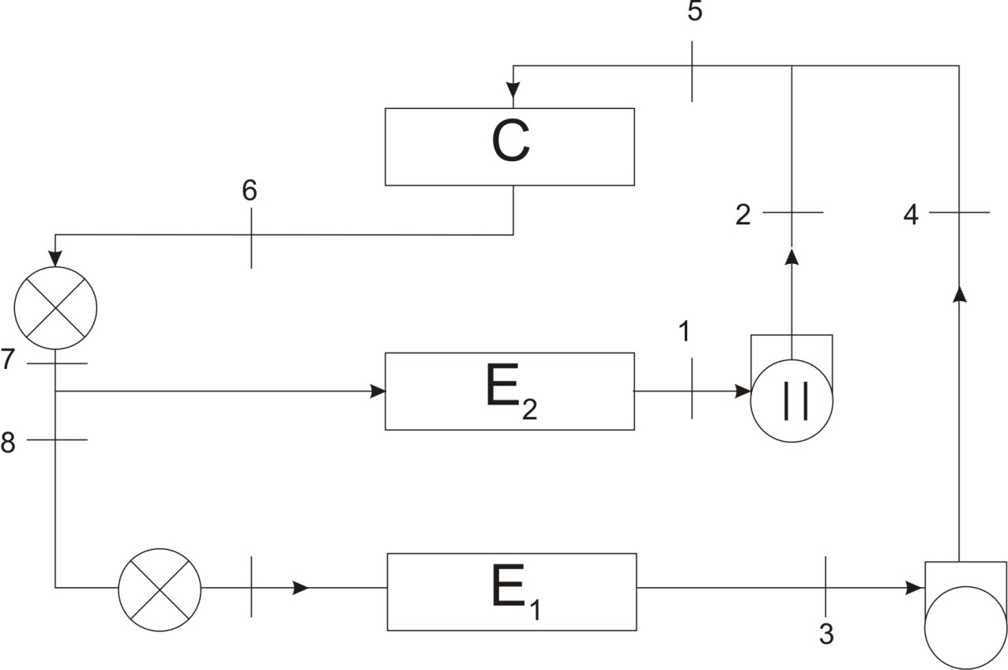
I1
9

Fig. 2.6(a) System with two evaporators, individual compressors and multiple expansion valves.
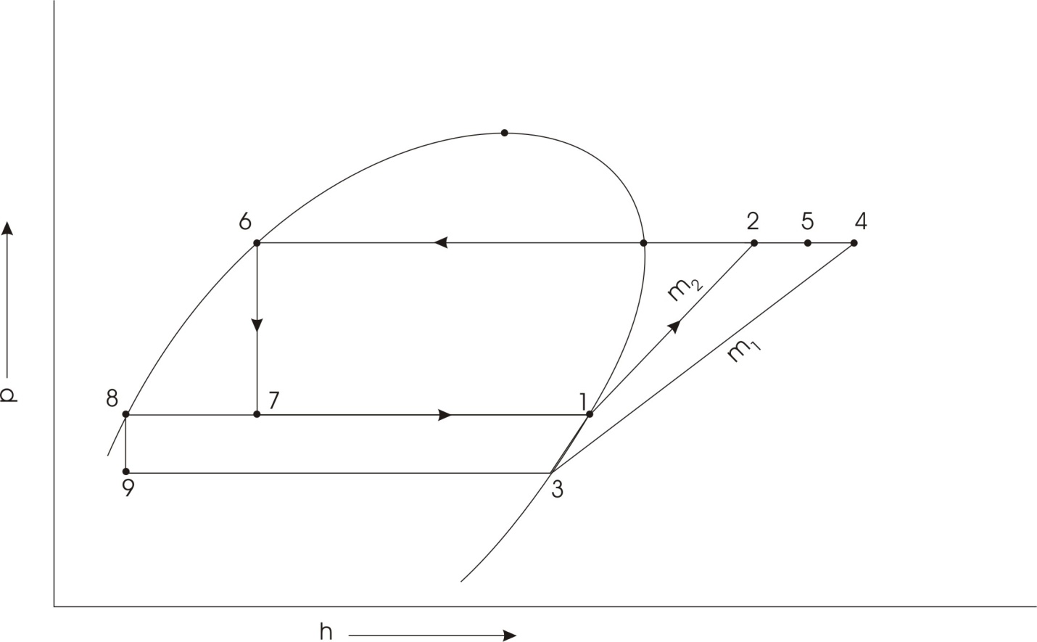

Fig. 2.6(b) Thermodynamic cycle for the system of Fig. 2.6 (a)

2.3.4.4 INDIVIDUAL COMPRESSORS WITH COMPOUND COMPRESSION AND FLASH INTER-COOLING
When very low temperature is required than one or more evaporators with individual compressors are used. By introducing flash inter-cooling and arranging multiple expansion valves, we can save power to a large extent. The flash chamber is maintained at the pressure equal to the high temperature evaporator. This arrangement of all components present in the system is shown in fig. 2.7 (a) and 2.7 (b).

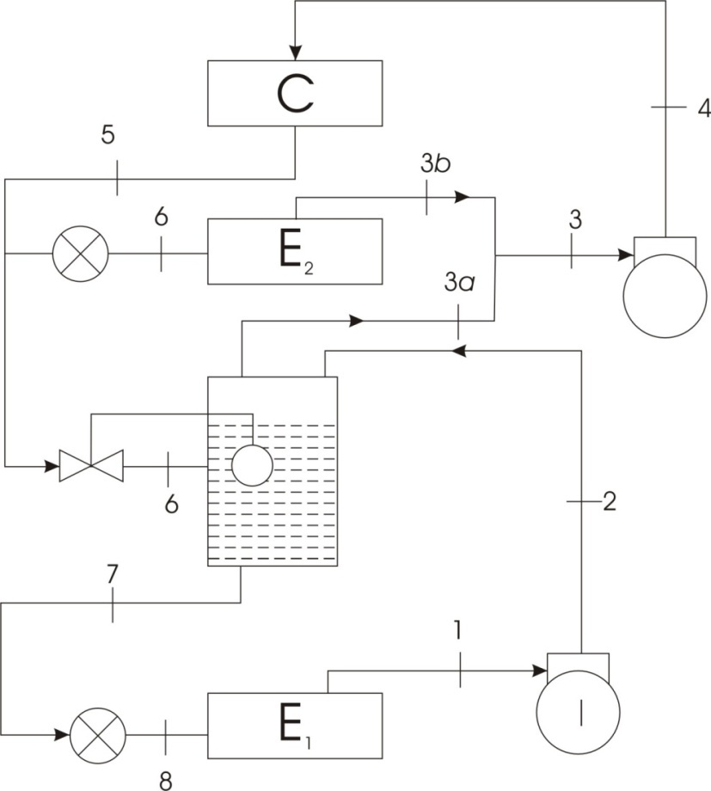
II
Fig. 2.7 (a) System with two evaporators, compound compression and flash intercooling
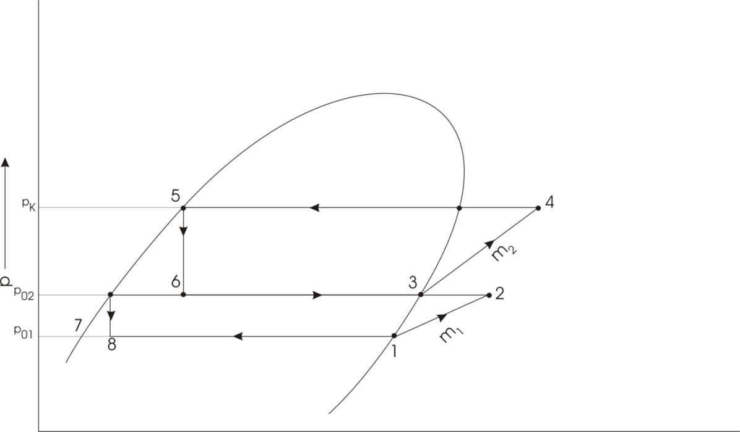
Fig. 2.7 (b) Thermodynamic cycle for the system

2.3.4.5 ADVANTAGES OF COMPOUND (OR MULTI-STAGE) VAPOUR COMPRESSION WITH INTERCOOLER
Following are the main advantages of compound or multistage compression over single stage compression :
1. The work done per kg of refrigerant is reduced in compound compression with intercooler as compared to single stage compression for the same delivery pressure.
2. It improves the volumetric efficiency for the given pressure ratio.
3. The sizes of the two cylinders (i.e., high pressure and low pressure) may be adjusted to suit the volume and pressure of the refrigerant.
4. It reduces the leakage loss considerably.
5. It gives more uniform torque, and hence a smaller size flywheel is needed.
6. It provides effective lubrication because of lower temperature range.
7. It reduces the cost of compressor.

2.4 CASCADE REFRIGERTION SYSTEM:-

2.4.1. CASCADE SYSTEMS
The use of a single refrigerant in a simple vapour compression cycle for the production of low temperatures is limited by the following reasons.
(i) Solidification temperature of the refrigerant.
(ii) Extremely low pressures in the evaporator develops and due to large suction volumes high boiling refrigerant is required.
(iii) If the refrigerant having low boiling temperature than there will be development of very high pressures in the condenser of simple vapour compression systems.
(iv) For achieving lower temperature systems should operate on very high pressure ratio p_{k}/p_{0.} This results a low coefficient of performance.
(v) At very low temperature operation of any mechanical equipment faced Difficulties due to duplication problems.
We know that multistage compression is employed when low evaporator temperatures are required and when the pressure ratio p_{k} / p₀ is high. Refrigerant 22 is used in two- stage system up to - 50⁰ C and in a three stage system up to about -65⁰ C.
For producing the low temperatures by using vapour compression system, the common alternative to stage compression is the cascade system. In cascade refrigeration system a series of two or more refrigerant is being used. These refrigerants should have progressively lower boiling points. These are used in set of two or more stages. By using cascade system all above mentioned problems can be solved except the lubrication problem in mechanical equipments.
The cascade system combines two or more vapour compression units as shown Fig. 2.8. The high temperature cascade products refrigeration at a certain low temperatures , using the refrigerating effect of high temperature cascade at temperature , using the refrigerating effect of high temperature cascade at temperature for rejecting heat in its condenser at temperature , which in the limit is equal to . In practice, however, there is a certain overlap between the temperatures, i.e. the temperature is about 5 ⁰C higher than the temperature .
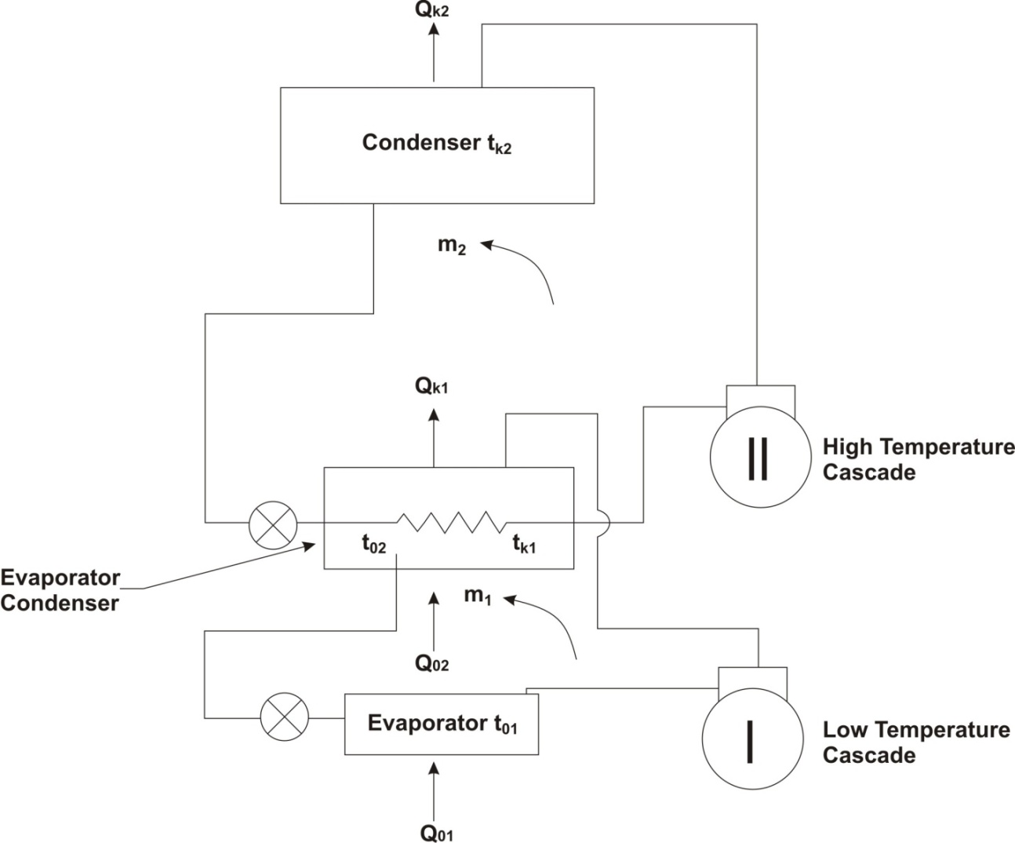

Fig. 2.8 Cascade system

In cascade refrigeration system each circuit have separate refrigerant. Each refrigerant can be selected based on its operations. It required to be operate between comparatively narrow temperature limits.
The high temperature cascade uses a high boiling refrigerant such as NH₃ or R 22, whereas the low temperature cascade uses a low boiling refrigerant such as CO₂, ethylene, methane, etc., depending on the requirements. The use of a low boiling and therefore, a high pressure refrigerant ensures a smaller compressor displacement in the low temperature cascade and a higher coefficient of performance.
Pictet was the first person who used the cascade refrigeration system in year 1877 for the liquefaction of oxygen employing SO₂ and CO₂ as intermediate refrigerant. In a three stage cascade refrigeration system, another set of refrigerants i.e. Ammonia, Ethylene and Methane is commonly used for liquefaction of gases. Ammonia is also used in the high temperature cascade circuit for the manufacture of solid carbon-dioxide.
An additional advantage of the cascade system is that oil from one compressor cannot wander to the other compressors as it generally happens in multistage systems.
In the system shown in Fig. 2.8, the high and low temperature systems have to be balanced with each other. This means that the heat absorbed in the high temperature cascade evaporator must be equal to the heat rejected in the low temperature cascade condenser. Thus, the two systems are designed such that
In operation, however, the balancing problem creates difficulty since during the pull down period, the high temperature cascade system is inadequate. Hence, it has to be slightly oversized.

2.4.2 OPTIMUM COUPLING TEMPERATURE BETWEEN CASCADE CIRCUITS
Coupling temperature is the intermediate temperature between the two cascade circuits such as . Optimization in achieving the size of refrigeration system or compressors of the two circuits, Schmidt proved that the optimum coupling temperature is the main criteria. It can be approximately represented by the square root of the condensing temperature in high temperature circuit, and evaporating temperature in cold circuit. This is based on the assumption that the Carnot COP of the two circuits is the same, as shown in Eq. (1)
(1)

So that when , we have
(2)
One another more accurate relation derived by Schmidt is in terms of the coefficients of the vapour pressure curves of the two refrigerants. This derivation is based on the condition that the pressure ratios of the compressors in each circuit are the same. Thus
(3)
Then if the pressure temperature relationships of the two substances are governed by the relation.
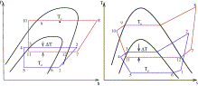

Fig 2.9 : P-h diagram and T-s diagram of two stage cascade system
Mass flow ration of refrigerant though the stage –I to stage-II can be given by equation
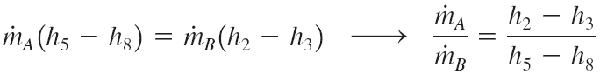
COP of the two stage cascade system can be given by equation

