Chapter-1
Introduction

  - Background
Aluminum and its alloys occupy third place among the commercially used engineering materials. In commercial aluminum casting alloys, Al–Si base alloys are perhaps most common particularly due to very attractive characteristics such as high strength to weight ratio, good workability, excellent cast ability, good thermal conductivity and corrosion resistance.
Aluminum castings have played an integral role in growth of aluminum industry since its inception in late 19th century. These are emerging as one of the most dominant materials in number of sectors like transport, military, aviation and general engineering. Use of aluminum in transport sector has increased from just 6% in 1950 to 23% in year2000. Consumption of aluminum casting has increased from85, 000 ton in 1995 to 145,000 ton in year 2000.
In addition to demand in market, research and development efforts have played an important role for dramatic growth in consumption of aluminum alloys. Aluminium–silicon alloys are popular in three different forms, i.e. hypoeutectic, eutectic and hypereutectic type, classified so depending up on the silicon content. Aluminium–silicon alloys containing 11–13% silicon are termed as eutectic alloys and those having less than 11% silicon are called hypoeutectic and those having more than 13% silicon are commonly known as hypereutectic Al–Si alloys.
Aluminium and its alloys are extensively used as the materials in transportation, engine components and structural applications .Thus it becomes all the more vital to study the tribological characteristics of Aluminium and its alloys. Addition of Silicon to Aluminium gives high strength to weight ratio, low thermal expansion coefficient, and high wear resistance. These alloys also show improved strength and wear properties as the silicon content is increased beyond eutectic composition. Such properties warrant the use of these materials as structural components in automotive industries [1].
1.2 properties of Aluminium alloys
The properties of Aluminium and its alloys that make them the most economically attractive for a wide variety of applications are:
- Light weight Aluminium weighs roughly one-third as much as most of the common metals, but is one and a half times as heavy as Magnesium. It finds application to reduce weight of components and structures, particularly connected with transport, especially with aerospace.
- High strength to weight ratio: high strength to weight ratio saves a lot commercially when dead weight is decreased and payload of transport is increased. this ratio is having particular significance in engineering design problem where stiffness is involved.
- Ease of fabrication and machinability: It can be easily cast, rolled to any desired thickness stamped, drawn, spun, forged and extruded to all shapes.
- High resistance to atmospheric corrosion: When aluminium is exposed to air, a thin oxidized film forms on the surface, protecting the metal from corrosion. When scratched, the layer rapidly reforms retaining the protection. This features utilized in construction, buildings and household utensils.
- Resilience under static and dynamic loading Aluminium products behave elastically under static and dynamic loading conditions, that is, they have the ability to resume both shape and size which is good when flexible strength is required.
- Strength at low temperature: Brittle fracture problems do not occur with aluminium. As the temperature is reduced, aluminium alloys increase in strength without loss in quality, making them particularly suitable for low temperature applications[2]
1.3 Aluminium-silicon alloys:
    - Aluminium-Silicon Eutectic and hypoeutectic alloys
Alloys with Silicon as a major alloying element are by far the most important commercial casting alloys, primarily because of their superior casting characteristics in comparison to other alloys. A wide range of physical and mechanical properties is afforded by these alloys. Binary aluminium-silicon alloys combine the advantages of high corrosion resistance, good weldability, and low specific gravity. Although castings of these alloys are somewhat more difficult to machine than the aluminium-copper or aluminium-magnesium alloys, all types of machining operations are routinely accomplished, usually using Tungsten carbide tools and appropriate coolants and lubricants.
Alloy 443 (5.3% Si) may be used for all casting processes for parts in which good ductility, good corrosion resistance, and pressure tightness are more important than strength. For die casting, alloys 413 and A 413 (12% Si) also have good corrosion resistance but are superior to alloy 443 in terms of castability and pressure tightness. Alloy A444 (7%Si-0.2% iron, maximum) also has good corrosion resistance and has especially high ductility when cast in permanent mold and heat treated to a T4 condition. This alloy has good impact resistance.
Alloys 413, 443 and 444 are important binary aluminium-silicon alloys. Another group of aluminium-silicon alloys however represents the workhorse aluminium foundry alloys. In this group, silicon provides good casting characteristics and copper imparts moderately high strength and improved machinability, at the expense of somewhat reduced ductility and lower corrosion resistance. Alloy 319(6% Si -3.5% copper) is preferred general purpose alloy for sand foundries that may also be used in permanent mold casting. The phase diagram of Al–Si alloy shows that during the solidification of liquid metal, aluminium solidifies first with hypoeutectic alloy and primary silicon particles with hypereutectic. The silicon content determines the primary phase. Eutectic point is noted from 11–13% silicon content, depending up on the casting process.
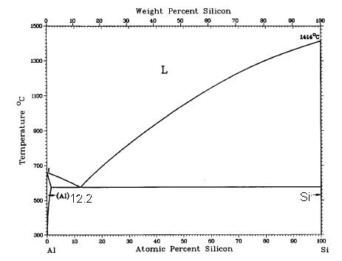
Fig.1 The Aluminium Silicon binary phase diagram. The eutectic occurs at 12.6 wt% Si [3].

    - Hypereutectic aluminium-silicon alloys
Aluminium silicon alloys with greater than 12% Silicon are called hypereutectic aluminium silicon alloys. These have outstanding wear resistance, a lower thermal expansion coefficient, and very good casting characteristics. Such alloys have limited use because the presence of the extremely hard primary Silicon phase reduces tool life during machining. Also the special foundry characteristics and requirements of this alloy system, needed to properly control microstructure and casting soundness, are not clearly as well understood as are the characteristics of conventional hypoeutectic alloys these alloys have have outstanding fluidity and excellent machinability in terms of surface finish and chip characteristics. A typical example is 390 alloys (17%silicon-4.5% copper-0.5%magnesium) whose outstanding wear characteristics have caused a rapid growth in its use. It is used in small engines, pistons for air conditioning compressors, master brake cylinders, and pumps and other components in automatic transmission .It is well known that microstructure and mechanical properties have strong correlation. Microstructure involves the phase and grain structure. Phase structure includes type of phase, relative amount of phases and their distribution. Grain structure includes the size, shape of grains and their distribution Aluminum–silicon alloys have become very important as basic material for engine blocks due to their favorable mass to performance ratio, high thermal conductivity, good corrosion and wear behaviour. The material’s high wear resistance is a direct result of the hard silicon precipitations within the aluminum matrix that brings a reinforcing effect. In this paper pieces of an aluminum silicon–copper hypereutectic alloy, which is used in state of the art car engines, are studied. Aluminum and its alloys occupy third place among the commercially used engineering material. In commercial aluminium casting alloys, Al–Si base alloys are perhaps most common particularly due to very attractive characteristics such as high strength to weight ratio, good workability, excellent castability ,good thermal conductivity and corrosion resistance . Use of Al–Si alloys has received a boost for production of aluminium castings in recent decades. Aluminum castings have played an integral role in growth of aluminium industry since its inception in late 19th century. These are emerging as one of the most dominant materials in number of sectors like transport, military, aviation and general engineering. Use of aluminum in transport sector has increased from just 6% in 1950 to 23% in year2000. Consumption of aluminium casting has increased from85,000 ton in 1995 to 145,000 ton in year 2000 . In addition to demand in market, research and development efforts have played an important role for dramatic growth in consumption of aluminium alloys. Aluminium–silicon alloys are popular in three different forms, i.e. hypoeutectic, eutectic and hyper eutectic type, classified so depending up on the silicon content. Aluminium–silicon alloys containing 11–13% silicon are termed as eutectic alloys and those having less than 11% silicon are called hypoeutectic and those having more than 13% silicon are commonly known as hypereutectic Al–Si alloys .The phase diagram of Al–Si alloy shows that during the solidification of liquid metal, aluminium solidifies first with hypoeutectic alloy and primary silicon particles with hypereutectic [3]
  - Wear
Wear is the progressive loss of material from the operating surfaces as a result of relative motion Since the world’s necessity is progressively reducing resources of material and energy therefore studies on wear are growing globally. It is hoped that an understanding of mechanism of wear will result in better understanding and specification from viewpoint of composition and surface treatment.
1.4.1Mechanisms of wear
- adhesive wear
- abrasive wear
- solid particle erosion
- Corrosive wear
- surface fatigue wear
- impact wear
Adhesive wear
This form of wear occurs when two smooth bodies slide over each other. The relative movement can be unidirectional or reciprocating. Due to this, fragments are pulled off from one of the surfaces and adhere to the other, later these fragments may come off the surface on which they are formed and be transferred back to the original surface, or else form loose wear particles .The adhesive under reciprocating sliding conditions has been reported to cause higher wear rate than the unidirectional sliding under identical conditions and the same is attributed to cyclic stresses acting on material at surface of interacting objects.
Abrasive wear
Abrasive wear occurs when a hard rough surface slides across a softer surface. ASTM (American Society for Testing and Materials) defines it as the loss of material due to hard particles or hard protuberances that are forced against and move along a solid surface. Wear, in turn, is defined as damage to a solid surface that generally involves progressive loss of material and is due to relative motion between that surface and a contacting substance or substances. The rate at which the surfaces abrade depends on the characteristics of each surface, the presence of abrasives between the first and second surface, the speed of contact and environmental conditions. In short, loss rates are not inherent to a material.
Mechanism proposed
Many mechanisms have been proposed to explain how material removal during abrasion. These mechanisms include fracture, fatigue, and melting. Due to the complexity of abrasion process, no single mechanism completely accounts for all the loss. Figure depicts some of the processes which are possible when a single abrasive tip slides across a surface. They include plowing, wedge formation, cutting, micro fatigue, and microcracking.
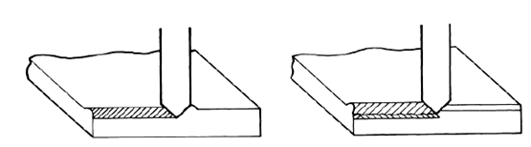
. Plowing Microfatigue
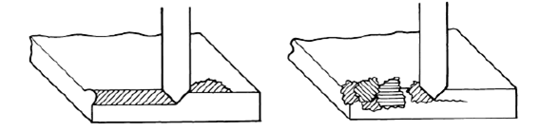

Wedge Microcracking
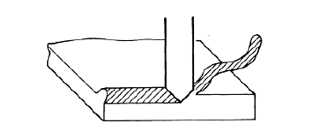
Cutting

Fig.1.2. Five processes of abrasive wear [4].
Solid particle erosion
It is the loss of material that results from repeated impact of small, solid particles. In some cases SPE is a useful phenomenon, as in sandblasting and high-speed abrasive water jet cutting, but it is a serious problem in many engineering systems, including steam and jet turbines, pipelines and valves carrying particulate matter, and fluidized bed combustion (FBC) systems. Solid particle erosion is to be expected whenever hard particles are entrained in a gas or liquid medium impinging on a solid at any significant velocity (greater than 1 m/s, or 3.3ft/s). Manifestations of SPE in service usually include thinning of components, a macroscopic scooping appearance following the gas/particle flow field, surface roughening, lack of the directional grooving characteristic of abrasion, and, in some but not all cases, the formation of ripple patterns on metals. Solid particle erosion can occur in a gaseous or liquid medium containing solid particles. In both cases, particles can be accelerated or decelerated, and their directions of motion can be changed by the fluid. This is more significant in liquid media, and slurry erosion is generally treated as a different, though related, subject. In gaseous media, at least for particles larger than about 50 m, deflection of the particles by the gas stream can often be ignored in erosion tests. The distinction between erosion and abrasion should be clarified, because the term erosion has often been used in connection with situations that might be better classed as abrasion. Solid particle erosion refers to a series of particles striking and rebounding from the surface, while abrasion results from the sliding of abrasive particles across a surface under the action of an externally applied force. The clearest distinction is that, in erosion, the force exerted by the particles on the material is due to their deceleration, while in abrasion it is externally applied and approximately constant.
Corrosive wear
This form of wear occurs when sliding takes place in corrosive environment. In the absence of sliding, the products of corrosion form a film on the surface, which tends to slow down or even arrest the corrosion. However, the formation of non-porous and adherent surface oxides such as alumina (Al2O3) and chromium oxide (Cr2O3), on the aluminium and stainless steel surface can reduce the corrosive wear.
Surface fatigue wear
The surface fatigue is caused by the repeated sliding or rolling over a track. The repeated loading and unloading cycles experienced by the material may induce the surface or subsurface cracks which eventually will result in breakup of surface with the formation of large fragments and leaving large pits in the surface.
Impact wear
It is defined as wear of a solid surface due to percussion. Percussion is a repetitive exposure to dynamic contact by another solid body. Several industries employ processes that lead to impact wear. Machine components, cams, and gears mate with a certain dynamic component. Typical applications occur in electromechanical printers; a prime example is that of typefaces, which are expected to hold definition, thus assuring high print quality, often for billions of cycles.
1.5 Mechanism of fragmentation
At the commencement of sliding, force acting on rubbing surface s transmitted to sub-surface. The ductile matrix under goes plastic deformation and develops crack in hard, brittle inter-dendrite silicon and other compounds. Even after fragmentation, the original inter-dendritic orientation is retained for some time. With an increase of force, the immediate sub-surface damage area is subjected to higher plastic deformation which in turn results in further fragmentation and dispersion of particles in the adjacent region. Sliding of metal produces very high plastic shear strain at the sliding interface and large strain gradient in materials near surface layers. Origin of cracks involved in generating debris has not been well established.
1.6 Metal transfer
Wear surface layers have a very fine structure and mixed composition. Debris particles are generated at least in a part from this layer. Because the structure of transfer layer and debris particles is found to be similar for both lubricated and dry wear conditions. An ultra fine grain structure generated from transfer layer is probably a result of deformation and fracture processes. Initially asperity contacts give rise to small transfer elements, which accumulate, on the surface until a critical condition is reached. Only then, loose particles are generated as wear debris from transfer layer. One possible condition for the formation of loose wear debris is that transfer layer should reach a critical thickness before detachment from the sliding surface for a given sliding condition (material, load and environment). As soon as transfer layer attains a critical thickness, it tends to give flake like wear debris by delamination process at or near the interface between transfer material and base metal. The transfer and back transfer of elements across the sliding interface takes place throughout the run-in wear period of the sliding. A critical number of layers build up on both the members of friction couple and then a wear particle produced as and when this critical number is exceed. Transfer and back transfer builds up to equilibrium at the end of run-in period of wear and commencement of the steady state wear. For aluminium alloys this number appears to about six. However, consensus does not still exist on how wear particles are formed. Once metal transfer has taken place, the generation of wear debris and subsequent ploughing is found to be different from when there is no metal transfer between two sliding surfaces. Depending up on which one of these two mechanisms is effective, the friction characteristics of sliding metals vary accordingly .Initial metal transfer from aluminium pin to steel disc does not affect the wear rate[5]
1.7 Effect of contact load and speed
Contact load and sliding speed are main variables of dry sliding wear as they control the degree of adhesion (metallic intimacy), sub-surface damage, thermo-mechanical effects on the sliding surface due to frictional heat and tendency to form and break the oxide film. Surface peaks are known to deform under external load. Increase in deformation increases real area of contact which in turn increases metallic intimacy. In general, an increase in normal load is known to increase the wear rate due to increased metal to metal contact between mating surfaces. Depending up on the sliding speed, composition of alloys, counter surface, and surface finish, increase in wear rate with normal load may be linear or non-linear. Usually under low load and speed conditions, linear relationship between load and wear rate is observed. Increase in wear rate with the load has been explained by various researchers on the basis of different mechanisms such as adhesion, sub-surface damage, thermo mechanical effect and oxidation. at high load, coarsening of b phase particles occurs owing to rise in temperature during the sliding of cast Al–Si alloys. Steady wear rate of metal increases with an increase of load although the relationship hypereutectic and hypoeutectic alloy has non-linear relationship between applied load and wear rate against steel beyond certain critical load at which transition from mild to severe metallic wear takes place.
Size of debris has been reported to a function of load and can be given by: The size, shape, micro-cracking tendency and thermal stability of different micro-constituents greatly control the mechanical and tribological properties of Al–Si alloys. Influence of structure on many physical and mechanical properties is well known and therefore it can be directly related to wear .Depending upon the composition, there may be number of phases in Al–Si base alloys such as a-Al, primary and eutectic silicon crystals and inter-metallic constituents as shown in .Out of these phases, silicon has profound effect on wear resistance of these alloy. Role of microstructure is reported to be of greater importance than the gross metal properties such as tensile strength and hardness in wear resistance. Influence of silicon particles on wear depends on sliding conditions, i.e. normal load, sliding speed, counter surface and environment, etc.[5]
1.8 Methods of testing
Numerous experimental devices and methods have been created and developed to study the wear and friction properties of material, additives and lubricants. These devices and methods are used to evaluate the suitability of materials or lubricant for a given application and in basic research for developing newer material sand to compare the properties of lubricants and materials. The techniques and devices used for the determination of anti-wear and anti-friction properties fall into two principal classes.
1.9 Laboratory test devices
These tests use a relatively simple test specimen configuration to study the friction and wear processes occurring in real machine sand to perform friction and wear investigation under specific conditions. Real service tests these tests are adequately equipped with measuring instruments. The testing is done under real service conditions. These tests are expensive and generally continue for long duration. Investigation cost increases substantially when passing from laboratory tests to real service tests.. Methods used for evaluation of wear the most common methods of studying the wear consists of examination of sliding material before and after the test, any difference in material is attributed to wear. The detection of wear generally uses one or the other techniques of weighing, mechanical gauging, and examination of surface and sub-surface features and wear debris.
1.10 Methods used for evaluation of wear
The most common methods of studying the wear consists of examination of sliding material before and after the test, any difference in material is attributed to wear. The detection of wear generally uses one or the other techniques of weighing, mechanical gauging, and examination of surface and sub-surface features and wear debris.
1.10.1Weighing
This is the simplest way of detecting the wear in which specimen is weighed before and after running at room temperature using sensitive weighing balances having least count of 0.001 grams and weight loss is calculated as a difference to get wear rate in close chamber.
1.10.2 Gauging
In this method, the wear is measured by decrease in dimensions, using mechanical (dial gauge) or electrical system based on linear variable displacement transducer (LVDT) principle. This has resolution limit of about 10-5 m.
1.10.3 Optical
There are number of methods for measuring wear using the optical technique. One way is to make small micro-hardness indentation on a surface and to study how its size is reduced during the sliding [5].
1.11 Friction and anti-friction
Friction is the resistance to motion experienced when: (a) surface of an object is moved tangentially with respect to another surface and an attempt is made to produce such motion. Importance of friction reflects from the fact that a very substantial part of the total energy consumption of mankind is expended in overcoming friction losses during sliding. When metal surfaces are loaded against each other the contacts are made through the tip of asperities. The high pressure developed at individual contact spot causes local welding and junctions formed at the interface are sheared off due to relative motion [5
1.12 The Microstructure
1.12.1 Primary and Eutectic Phases
Al-Si binary alloy is a eutectic system with the eutectic composition at 12.6. % Si by wt.. Silicon reduces the thermal expansion coefficient, increases corrosion and wear resistance, and improves casting and machining characteristics of the alloy. When the Al-Si alloy solidifies, the primary aluminum forms and grows in dendrites or silicon phase forms and grows in angular primary particles. When the eutectic point is reached, the eutectic Al-Si phases nucleate and grow until the end of solidification. At room temperature, hypoeutectic alloys consist of a soft and ductile primary aluminum phase and a hard and brittle eutectic silicon phase. Hypereutectic alloys usually contain coarse, angular primary silicon particles as well as a eutectic silicon phase.
    - Intermetallic precipitates
The Al-Si alloy usually has some other coexisting elements such as copper, magnesium, manganese, zinc, and iron. The solubility of these elements in aluminum usually increases with increasing temperature. This decrease from high concentrations at elevated temperatures to relatively low concentrations during solidification and heat treatment results in the formation of secondary inters metallic phases. For instance, the precipitation of Si, Mn, and Fe forms an Al12 (Fe, Mn) 3Si phase. The wide variety of inter metallic phases in aluminum alloys occur because aluminum is highly electronegative and trivalent, which has been the subject of considerable study.
  - Casting defects
Cast Al-Si alloys usually have casting defects such as porosity and inclusion, which can greatly degrade the mechanical properties of the materials. Porosity is the most common defect in Al-Si castings. In addition to the fact that a pore can not sustain external load, more seriously, it is a kind of stress concentrator, and thus can lead to microcrack initiation and propagation. Micro porosity usually results from exsolution of dissolved gas from the melt and/or failure of inter dendritic feeding. The solubility of hydrogen in Al-Si melt increases as temperature increases. When molten Al-Si alloy solidifies, the hydrogen atoms precipitate from the melt and form molecular hydrogen. If alloy solidifies faster than the molecular hydrogen escapes from the melt, gas porosity will be generated in the solid alloy. On the other hand, a lot of dendritic structures form in Al-Si alloy during its solidification. These dendrites take space in the melt, and reduce the fluidity of melt. Thus the shrinkage in theme lt between the dendrites cannot be fully filled, and micro porosity is formed along these dendrites after the melt solidification. Alloying elements greatly influence porosity formation via few mechanisms. First, an alloying element can change the freezing range of Al-Si alloy so that the porosity can be changed. When the freezing range is decreased, the “mushy zone” in the solidifying material is reduced and thus the porosity is reduced. Second, alloying element can form dendritic inter metallics during solidification. Porosity can form along these inter metallic dendrites.The mechanism is that Cu forms some inter dendrite Cu-rich phases, which solidify at a lower temperature and thus cannot be fully filled. Fourth, alloying elements can form high melting point phases in the melt, reducing the fluidity of the melt and thus helping to produce porosity. Finally, the alloying elements such as sodium, phosphorus, titanium, and boron in modifying silicon phase morphology or refining grains also have effects on porosity formation. In general, the addition of grain refiners increases the number of grain nucleation sites and reduces grain size. Accompanying this grain refinement is a decrease in volume fraction and size of pores and increase in the homogeneity of the pore distribution. Silicon refining also has an influence on the formation of the porosity. In hypereutectic alloys, phosphorus is added to form particles as the nucleation site for primary silicon. It was found that the addition of 19 ppm phosphorus noticeably reduces the percentage porosity in the Al-9%Si-3% Cu alloy. Modification in the Al-Si alloy refines the eutectic phase particles shape and improves the casting’s mechanical property, but it usually increases the porosity.
Chapter 2
Literature survey

  - Introduction
This chapter consists of literature survey which has been carried out to study and evaluate the wear properties of Al- alloys. The work of researchers in this respect has been considered.
The Adhesive wear behavior of cast aluminium–silicon alloys. author had showed the effect of copper and silicon addition on improvement in wear behavior of Al-Si alloy.Al–Si alloys containing the copper up to 4.5%, a solid solution of copper in aluminium is formed on solidification but on cooling, the inter-metallic compound of aluminium and copper (CuAl2) is precipitated from the solution. Effect of copper on corrosion resistance of these alloys has been a matter of controversy but it had been noted that up to 0.5% copper is not harmful to corrosion resistance of straight Al–Si alloys even in severe corrosive conditions Al–Si–Cu alloys with up to 4.5% copper are satisfactory for ordinary conditions of service. Addition of just 1% copper in these alloys had increased the transition load by 3–4 times by increasing the strength and stability of protective surface layer. The influence of copper on wear-friction behavior of hypereutectic Al–Si alloy (Al–18%Si–0.5%Mg) under dry sliding conditions against hardened steel En-31 counter surface over a range of sliding speed from 2.0 to 7.0 m/s and contact load from 10 to 80 N. It was observed that the wear rate is a function of contact load, sliding speed, composition and thermal softening characteristics of sliding metal. Wear of hypereutectic aluminium–silicon alloy is not appreciably affected with the addition of copper. Moreover, addition of copper increases the transition load at 2.0 m/s sliding speed. Copper addition more than 2%, did not show any effect on the transition load. Addition of silicon in aluminium improves the wear resistance. Various researchers have noted that addition of silicon up to about eutectic composition (12% silicon) increases the wear resistance there after it was adversely affected, however consensus does not exist in this matter. Increase in silicon content increased the sliding conditions corresponding to transition point (combination of contact load and sliding speed) even up to 20%.wear rate at light load is same for hypoeutectic and hypereutectic alloy. Metallic properties of these alloys are structure sensitive. Hence wear behaviour to some extent is also governed by silicon morphology. It has been noted earlier that mechanical properties of these alloy depend more on size, shape and distribution of silicon crystals rather than their amount in alloy. Small rounded evenly distributed particles of either eutectic or primary silicon results in high ductility with relatively high strength. Faceted, acicular silicon crystals may produce slight high strength but also results in much lower ductility, impact and fatigue resistance because fracture starts at silicon particles, after the matrix is deformed, due to difference in mechanical properties. Change in morphology of eutectic silicon may have some effect on mechanical properties especially ductility, impact strength, fatigue life, particularly with low Fe content in alloy. As it has been pointed out earlier that morphology morphology of silicon can be changed either by addition of modifier such as sodium, antimony, strontium. or by increase the cooling rate during the solidification. Modification produces limited increase in strength but increase in ductility and fracture toughness is substantial especially at low solidification rates. Heat treatment of alloy results in significant change in morphology of eutectic silicon from plate like to nearly spherical. Heat treatment further improves the dispersion and refinement besides spheroidization of silicon particle [5].
Tribological behavior of cast hypereutectic Al–Si–Cu alloy subjected to sliding wear. Al alloy had developed developed to eliminate the engine liners of grey cast iron liners from the engine block. The main characteristic of the new alloy is the wear resistance. The aim of this study was to determine the typological performance of the new hypereutectic Al–Si–Cu alloy using a pin-on-disk tribometer. For achieving that aim, samples had been taken from a V6aluminium engine block were tested. Metallurgical characterization was assessed using Light Optical and Scanning Electronic Microscopy. The wear performance had been evaluated had been at different loading conditions, various sliding speeds, and various sliding distances, under lubricated and unlubricated conditions. For friction and wear measurements, a pin-on-disk testing machine was used. the elements of the test rig such as the pin, in this case a steel ball sliding on the flat face of a disk rotating in a horizontal plane, with provisions for controlling load, speed, and for measuring friction. The test oil is contained in a cup in which the disk rotates. Oil is swept up into the contact area by the rotating disk. Friction force is measured by restraining the pin motion with a force transducer. Wear is measured by microscopic examination of the steel ball and the disk after test is completed. A known load is applied along the axis of the pin, and friction force is measured by the force transducer restraining pin motion. The disk is mounted on the flat end of a 1.0 in. diameter shaft of a precision spindle. Disk wobble, or run out, is 0.0002 in. The spindle shaft is connected to a reducer worm gear box arrangement and subsequently this is driven by a variable speed DC motor SKF Hard steel AISI 52100 (C 1.0 wt.%, Cr 1.5wt.%, Mg 0.4 %,Si 0.3%, P 0.2 wt.%) balls 10mm in diameter were used as pins, following ASTM G99 standard. Disks had been obtained through sectioning of the cylinder bores of an engine block of aluminium. The small and well dispersed silicon particles improve the wear resistance of the alloy avoiding the massive detachment of the particles thus diminishing the three body abrasion wear mechanism. Wear mechanism in the unlubricated condition was mainly by severing abrasive mechanism. Wear resistance of the alloy is provided for the finer primary silicon particles distributed in the Al matrix. Friction coefficients of the hypereutectic alloy present similar characteristics of grey iron when compared in the lubricated condition Lower friction coefficient was observed in the 30N load condition, it is important to mention that during this condition, friction coefficient was constant disregarding the sliding distance. In the other hand, friction coefficient tend to diminish with longer sliding distances with higher loads [6].
Wear quantification of an aluminium–silicon–copper alloy for the car industry To test the wear behaviour of such a system a model tribometer with realistic loading conditions and a very sensitive and on-line technique has to be used. For reasons of accessibility and applicability only a tracing system with radioactive isotopes turns out to be reasonable. In this paper pieces of an aluminium–silicon alloy cylinder liner were prepared by partial thin layer activation. The application of such prepared specimens to a model tribometer tests is shown. The total activity induced is below the free limit by establishing very high sensitiveness at the same time.The tests are carried out in a model tribometer system with piston ring and cylinder liner geometry to investigate the impact of motor oil and diesel fuel as lubricants and different loading conditions on the running in and steady-state wear behaviour of the cylinder liner material. It will be shown here, what is the result of using a linear wear coefficient like the one proposed by i n the version of the dimensional wear coefficient of friction, metal transfer and back transfer, metallic failure, etc. are generally held responsible for wear from these alloy depending up on the sliding conditions. The running-in and the progressive wear volume were distinguished from the total wear volume as described in .The wear coefficients connected with total wear at the test and,the running in wear, and. Each coefficient is calculated by the above formula using the related wear volume [7].
The effect of silicon on the dry sliding wear properties of Al-Si alloy. Al-12Si, Al-20Siand Al-25Si (wt %) wear synthesized by spray deposition and atomization technique. The wear resistance of alloys was studied on the pin on disc test machine under four loads. The microstructures, worn surfaces and the debris were analyzed in a scanning electron microscope. It has been found that the effect of Si content on dry sliding wear of spray-deposited Al–Si alloy was associated with applied loads. At lower load with increasing Si content, the wear rate of the alloy was decreased. At higher load, spray-deposited Al–20Si alloy exhibited superior wear resistance to the Al–12Si and Al–25Si alloys. The wear test results, which represent the wear rate as a function of the applied load. Obviously, the wear rate of the alloys increases with increasing load. It may also be noted that the tendency of the wear rate variation with the applied load is not consistent for three materials. The wear resistance of spray-deposited Al–25Si alloy was superior to the Al–12Si and Al–20Si alloys. With an increase in load of up to approximately the wear rates of the three materials are comparable [8].
The dry wear and friction properties of alumina short fiber reinforced Al-Si (LM13) alloy metal matrix composites. Present data that were obtained during the wear tests in the case of the AI-Si matrix alloy. Since volume loss-sliding distance behavior of the tempt) sites and ,reinforced alloy at loads 10 and 40 N were very similar to those observed at 5.211 and 60 N, only 10N and 40 N applied load conditions are shown it+ . For further clarity, since the variation of volume loss and coefficient of friction with sliding distance for the composites with 15 and 25% by vol, 9 fibers Showed similar trend to that obtained for 10, 20 and 30% vol. composites, the data obtained from these two composites were not included in The volume loss suffered by the pin materials, alter it very short transient period, increases linearly with increasing sliding distance. An increase in the fiber volume percent in the matrix causes a decrease of the transient period and becomes nearly linear fiber more than 20% by vol. ,fiber reinforced material, in general, the data in show that. For any given specimen, the volume loss continuously increases with increasing sliding distance with the exception of the 30% by vol. fiber reinforced composite at a 40N applied load condition.. The volume loss remained nearly constant with sliding distances up to 1200 m. Increasing the sliding distance beyond this point resulted in substantially increased volume loss. It is believed that this abnormal wear behavior caused a decrease in nominal contact area between pin sample and counter face steel disc. The pins of 30% by vol. Fiber containing composite showed non-linear behavior with increasing sliding distance at high speeds. This composite at 40 N. showed a linear volume loss incremented up to about a 600 m sliding distance the alumina fibers arc locally more concentrated between the slider and the pin after wearing out of aluminum [9].
The microstural and wear behavior of hypoeutectic aluminium alloy grain refined and modified with Al-Ti-C-Sr master alloy .the author reported the microstructure and wear behavior of grain refined and modified Al–7Si–0.3Mg (LM25) alloy. The wear resistance of LM25 alloy improves with the addition of this master alloy up to 0.5% by wt. It is observed that Al cell size and morphology of the eutectic silicon of LM25 alloy have significant effect on the wear resistance of the alloy. Combined grain refinement and modification had been achieved by inoculating LM25 melt with various inoculation levels of a novel Al base master alloy containing Ti, C and Sr at 720 ◦C. It has been reported that the combined addition of the Al–Ti–B grain refiner and aluminium - strontium master alloy results in mutual poisoning of the grain refinement and modification effects [10].
A new master alloy containing Al–Ti–B–Sr, had been synthesized by sagstad and bhondus which resulted in combined grain refinement and modification. It had also been reported that mutual poisoning effect of B and Sr, results in the formation of SrB6 compounds, which had an adverse effect on the grain refinement and modification. With these short comings of Al–Ti–B–Sr master alloy in view the present authors had developed and filed a patent for Al5Ti–2C–15Sr master alloy, which plays a dual role both as again refiner as well as a modifier in a single stage when added to Al–Si alloy melt. From Fig. it can be noticed that the castings obtained after 5 min melt holding exhibit improved wear resistance than those obtained after 120 min holding for 0.5 wt% addition of the master alloy. It can be seen that there is remarkable improvement in the wear resistance as the addition level of the master alloy increases from 0 to 0.5 wt%, after a holding time of 5 min.depicted typical wear behavior of LM25 alloy treated with Al–5Ti–2C–15Sr master alloy at various addition levels. the coefficient of friction of theAl–5Ti–2C–15Sr treated alloy decreased on increasing the addition level of the same from 0 to 1.0%, even though there is more or less same coefficient of friction at 0.2 wt% addition when compared to the untreated one .A significant change in the coefficient of friction is observed beyond an addition level of 0.2 wt%. This was obviously due to the change in the microstructure of LM25 alloy. It was observed that, the wear resistance decreased with coefficient of friction when the master alloy addition level varied from 1 to2%.Lower coefficient of friction and lower wear resistance shows the increase in the ease of removal of the layer, it was produced when the force of friction per unit area exceeded the shear strength of the sliding material. It is well known that shear strength depends on the hardness of the material. The reason for increase in the wear rate and drop in the coefficient of friction could be due to the drop in the hardness of the alloy containing fine modified eutectic silicon [11].
Dry sliding wear of Al-Si Piston alloys containing iron containing iron rich intermetallics was studied. The effect of iron-rich intermetallics on the wear behavior of Al–Si hypereutectic alloys has been studied. Dry sliding wear tests have been conducted using a pin-on-disk machine under different normal loads of 18, 51, 74 and 100 N and at a constant sliding speed of 0.3m/s.The addition of 1.2 % Fe by wt. to the LM28 alloy increased the wear rate due to the formation of needle beta intermetallics. Introducing 0.6% Mn by wt. to the iron-rich alloy changed the beta intermetallics into the modified alpha phases, and therefore reduced the detrimental effect of iron. TIG welding method as a surface melting process was applied on the iron and manganese containing alloy and led to a fine microstructure and increased the wear resistance.. Silicon as a hard material increases the wear resistance of Al–Si hypereutectic alloys. The presence of Fe and its compounds could be a problem in hypereutectic Al–Si alloys. Iron as an impurity in Al–Si alloys or as necessary element in the die-cast process left some serious detrimental effects on the mechanical properties of the casting parts. This was due mainly to the precipitation of brittle β-Al5FeSi inter metallic that appear as needles or plate-like morphologies in the microstructure. However, in Al–Si piston alloys, iron is a desirable element that helps to enhance high temperature properties and thermal stability of the alloy. Attempts have to be made to modify the negative effects of iron intermetallics, e.g., by Refining their size and by modifying them to the less deleterious morphologies [12].
The effect of grain refinement and modification on the dry sliding wear behavior of eutectic Al-Si alloys was studied. Modified eutectic Al-12Si was tested on pin on disc machine. The indigenously developed Al-1Ti-3B and Al-10sr master alloy were used as a grain refiner and modifier for the grain refinement of Al –dendrites and modification of eutectic SI respectively. Various parameters were studied such as alloy composition, sliding speed, sliding distance, normal pressure. The cast alloy , master alloys and worn surfaces were characterized by SEM microanalysis. Results suggest that, the wear resistance of eutectic of Al- Si alloys increases with the addition of grain refiner or modifier (Al-10Sr). Further worn surface shows that adhesive wear was observed in AL-12Si alloy in the absence of grain refiner and modifier are added to the same alloy. Commercially available LM-6 (12.5%) alloy was used for comparison It was clear that volume loss of Al-12Si and LM-6 alloy increases in normal pressure and the wear rate was higher in case of untreated conditions. This was due to the the fact that untreated alloy consists of unmodified plate like eutectic Si which acts as internal stress raisers due to which the alloy becomes more brittle and leads to higher wear rate [13].
The effect of Ti addition on wear properties of Al-Si eutectic alloys was studied The influence of Ti addition on wear behavior of as-cast and heat-treated Al–12% Si eutectic alloy prepared by rapid cooling has been investigated in dry sliding against a steel counter face using a pin-on-disk apparatus.. The addition of Ti to the binary Al–Si alloy led to the precipitation of Al3Ti phase. Among the Ti-containing alloys, the increase in Ti content improved wear resistance of both as-cast and heat-treated alloys. However, these alloys displayed higher wear rates, thus lower wear resistance, compared with the Al–Si binary alloy. The influence of Ti content had been shown on the micro hardness of the as-cast alloys. The increase in Ti content results in an increase in the micro hardness values. This is due to the increase in the volume fraction of the relatively hard-phase Al3Ti. Conclusively the addition of Ti to Al–Si eutectic alloy resulted in the precipitation of the intermetallics compound Al3Ti phase, which induced an increase in the micro hardness of the binary alloy. Among the Ti-containing alloys, the increase in Ti content improved their wear resistance as a result of increase in the micro hardness due to the presence of relatively hard-phase Al3Ti. However, these alloys showed higher wear rates compared with the binary alloy due to the tendency for embrittlement and micro cracking brought about by Al3Ti particles. Heat treatment of the Ti-containing alloys at 200◦C for 6 h improved further their wear resistance [14].
Tribological characteristics of Al-Fe-V-Si alloys the wear behaviour of modified and unmodified cast Al–Fe–V–Si alloys studied through pin-on-disc wear test under three loads. all the alloys showed excellent wear resistance compared to the conventional eutectic Al–Si alloy, modification with Mg imparts further enhanced resistance to wear and reduced coefficient of friction. It was observed that during dry sliding wear extensive plastic deformation, work hardening and oxidation of a-Al matrix occurred. It has been shown that the primary mode of wear is delimitation.. The Wear test of the Al–12.6% Si alloy, however, could not be carried out at the highest load of 68.6 N due to seizure of the pins. Wear test of the Al–12.6% Si alloy, however, could not be carried out at the highest load of 68.6 N due to seizure of the pins [15].
The wear behaviour of as-cast and heat treated Al-Si eutectic alloys had been investigated the Wear tests on the alloys had been performed on a pin on disk type wear testing apparatus and parameters were size and shape of the pin, load, speed and the material pairs. Increase in the rotational speed of the disk leads to the increase in the mass loss of the as -cast and heat treated alloys. The wear rate is higher for as -cast samples. High speed leads to reduction in wear rate. The reduction is pronounced in heat treated samples. This is because during sliding, heat is developed and the material becomes softer and weaker. This heat might not affect the hardness of heat treated alloys due to their inherent characteristics Increase in the applied load led to a high wear rate for both as -cast and heat treated alloys. But at higher loads, strain-hardening of the materials in contact increases, resulting in increase in the resistance to abrade or erode. At higher load, real surface area in contact is more which increases the gripping action and due to which wear rate slows down At longer sliding distances, volumetric wear rate and specific wear rate are low. This was attributed to the fact that during sliding, heat develops due to friction which makes some of the adhered materials soften and loosen. As sliding goes on, these loosened particles are thrown away showing higher loss in weight. Heat treated alloys are not much affected due to their inherent characteristics due to heat treatment cycles whereas as cast alloys show higher weight loss[16].
The tensile and wear properties of Al-Si alloys fabricated by stir-casting technique at temperatures ranging from ambient to 3500C. It is observed that the wear rate decreases with increasing temperature. This is because an oxide film is formed at high temperature which helps to avoid direct contact between alloy and the abrasive. Continuous sliding action removes this layer which facilitates direct contact of the alloy with the abrasive which results in decrement of wear rate at high temperature Another mechanism for this phenomenon has been suggested. At elevated temperatures, the agglomerated clusters of oxide formed due to tearing of oxide layers are subjected to thermal stresses and compaction by applied pressure and high temperature. At the same time sintering of the wear debris is also occurring resulting in solid smooth hard surfaces called “glazes”. These glaze layers protect the sliding surface and reduce the wear rate [17].
The effects of alloy composition, sliding distance, sliding speed and load on the wear rate of Al-Si alloys. The wear rate is strongly dependent on the applied load. It increases linearly with load in three distinct regions in all the alloys..It may be observed that the transition load at which change takes place from one region to another increases with increased Silicon content of the alloy. It is observed that wear rate initially decreases slightly with increasing sliding speed up to a certain value. Beyond this, there is a sharp rise in the wear rate, irrespective of the alloy composition. This value increases with increasing Silicon content. The wear rate of the alloy is strongly dependent on the Silicon content of the alloy. The wear rate is found to decrease with increasing Silicon content. Mild wear , Intermediate wear and Severe wear. Mild wear takes a longer duration and takes place under low loads. The intermediate wear and severe wear regions are distinguished from the mild region by higher rates of increase in the wear rate per unit weight this effect is pronounced up to 15% Si in the alloy. Thus wear rates of hypereutectic alloys are better than those of hypo eutectic alloys [18].
The effect of addition of Cerium on the wear behaviour of as cast Al-4Si-4Mg alloys. Wear test results confirm that the wear rate decreases with the addition of Cerium in the alloy. The microstructures of the alloy samples reveal that Si in the as cast alloys is finely distributed in the interdendritic region. Silicon being harder than Aluminium increases the wear resistance of the alloys. Addition of Ce resulted in the formation of intermetallic phases like Al -Ce and Al-Si-Ce which leads to hardness and wear resistance. The volume loss of the alloys increased with increasing load and sliding distance. With increase in Ce content, volume loss decreased. This was due to the strong bonding between intermetallic phases and the matrix. Wear mechanisms involved were oxidative wear, microcutting and delamination wear as shown by presence of oxides, microchips and delamination flakes. Cerium content up to 5% increased wear resistance [19].
The wear and friction properties of Al-Si alloy against itself with the lubrication of pure Ethylene glycol, ethanolamine, ethylene diamine and tri ethylene tetramine. Friction and wear tests showed that the friction coefficient for triethylene tetramine was lowest. Wear of the Al-Si alloy lubricated with ethylene glycol was the largest whereas triethylene tetramine produced the best results. This has been explained on a molecular level. In amine like compounds, there are two electrons in the Nitrogen atom which are not bonded. Thus it is easy to interact with metals. In triethylene tetramine, though Nitrogen percentage is smaller than that in diamines, it exhibits better tribological behaviour. This has been explained by the fact that triethylene tetramine has a longer molecular chain. It also oxidizes easily and the oxidation products interact with the Al -Si alloy. Oxidation products may include H2NCH2COOH and –NHCH2CH2NH2. These products interact with the surface of the Al-Si alloy generated during sliding. It may also form some kind of a friction polymer [20].
The literature review shows that the requirement of aluminium alloy is increasing due to its light weight, wear resistance, high strength and low cost. There is need of extensive study of wear of aluminium alloy with respect to pure aluminium for investigating the effect of alloying in improvement of wear behavior. Researchers have done their work on alloying and its effects. They have gone through alloying but continuous constant sliding on disk with pin was lacking. Also some researchers have done their work examining the effect of copper and silicon on wear tribological behavior but with other compositions so there is need to have more studies on this topic.

Chapter- 3
Experimental Details

  - Sample preparation
Casting of the Al-Si-cu alloys and pure Al was done by pouring the molten alloy into mould .Cylindrical samples of diameter 10 mm and length 30 mm each were machined from the as-cast Al-Si alloys. Test samples are prepared from these cast ingots after polishing. The calculated density of aluminium alloy is 2.720 kg/m3 and that of pure aluminium is 2.68 kg/m3. Mild steel disk was taken as a counter surface having the diameter of 165mm.
Image of samples
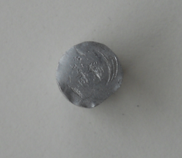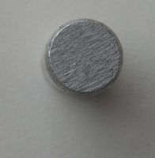
Fig. 3.1 Pins of pure aluminium and aluminium alloy
  - Wear tests
    - Abrasive wear test apparatus
Test up used in the study of wear test is capable of creating reproducible abrasive wear situation accessing the abrasive wear resistance of the prepared samples. It consists of a pin on disc, loading panel and controller.
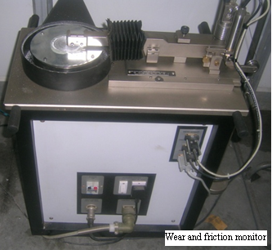
Fig 3.2.1Wear and Friction Monitor used for the wear tests

The entire test was carried out using a “pin on disk” machine with both normal and lubricated condition. The normal condition has 40-50% relative humidity and a temperature of 32-35:C. The mass loss of the specimen after each test was estimated by, measuring the height loss of the specimen due course of the experiment. The mass loss was measured on weigh balance (accuracy 0.001gm.) and after that specific wear has been calculated by using the given formula:
K = Vw / F × S
Here Vw is the wear volume, L the applied load and s the total sliding distance and K is specific wear rate care has been taken to clean up the sample before and after each test to prevent any form of corrosion on the surface. The specimen was held steady and stationary within a holder of the apparatus and the required normal load was applied through lever mechanism. The sliding distance was kept at 0.5 km for all tests concerned Al-Si-Cu alloy and 1km for pure Al.

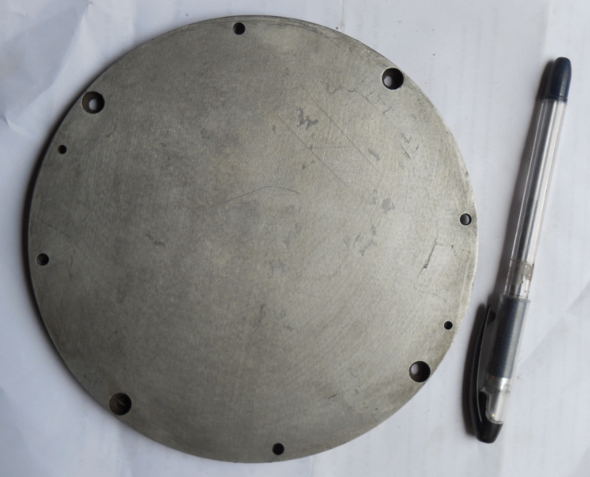
Fig. 3.2.2 Disc before test
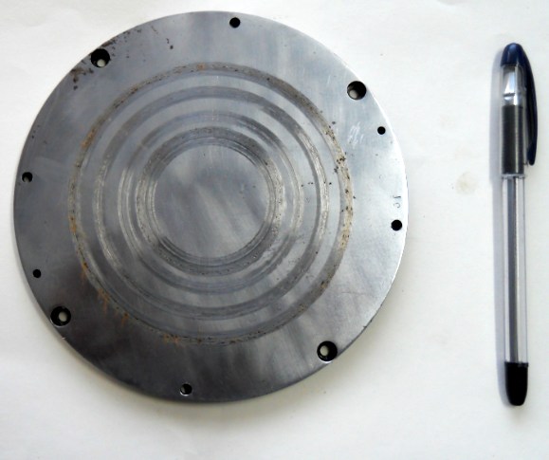
Fig. 3.2.3 Disc after test

3.3 Specification of pin on disk machine
The specification of pin on disk machine includes the parameters that are disk diameter, pin diameter, pin length, wear track diameter, normal load, friction force is given in the following table:

Table 3.3 Specifications of the pin on disk wear and friction monitor
Parameter | Unit | Minimum | Maximum
Disk speed | rpm | 200 | 2000
Pin diameter | mm | 3 | 12
Wear track dia | mm | 50 | 100
Normal load | N | 1 | 200
Frictional force | N | 0 | 200

3.4 Material composition
The composition of aluminium alloy is shown in the following table.
Table 3.4 Composition of materials
MATERIAL | Al% | Si% | Cu%
Al alloy | 84.84% | 10.6% | 2.4%
Pure Al | 98.73% | 0.496% | 0.007%

The composition of materials can be verified with the help of spectroscopy report given in appendix-1.
  - Design of experiment
Design of experiment consists of variables which are load and velocity and the values of these variables is shown in the following table
Table 3.5.1Variables for wear test for aluminium alloy
Variables | Level 1 | Level 2 | Level 3 | Level 4
Velocity(m/sec) | 3.14 | 2.61 | 2.094 | 1.57
Load (kg) | 1kg | 1.5 kg | 2 kg | - kg

The following the design of experiment for the pure aluminium
Table 3.5.2Variables for wear test for pure aluminium
Variables | Level 1 | Level 2 | Level 3 | Level 4
Velocity(m/sec) | 6.28 | 5.23 | 4.188 | 3.14
Load (kg) | 1kg | 1.5 kg | 2 kg | 2.5 kg

Chapter-4
Results and discussions

4.1 Result of pin on disk for aluminium alloy in wet condition
In the experiment r.p.m was kept constant at the value of 500 r.p.m sliding distance was kept .5km. the initial mass of the pin was 4.7465 gm. the track diameter was varied and set at the values of 120,100,80 and 60mm linear velocity was calculated using this data . Coefficient of friction was calculated by using the value of friction force given by the pin on disk machine. Mass loss was carried out by subtracting the mass after the test from the mass of sample before the test. Specific wear rate was calculated by calculating the volume loss and dividing it by friction force and sliding distance for each reading.
Table 4.1 readings obtained on pin on disk machine for Al alloy in wet condition
Load | r.  p.  m | Sliding distance | D  (mm) | V(m/s) | time | Mass loss  (gm) | Friction force  (N) | Coefficient of  friction | Specific wear rate(m3/Nm)
1 | 500 | .5 | 120 | 3.14 | 160 | .0002 | .2 | .0203 | 7.24
1.5 | 500 | .5 | 100 | 2.61 | 192 | .0003 | .3 | .02368 | 7.2
2 | 500 | .5 | 80 | 2.094 | 238 | .0005 | .5 | .0254 | 7.24
2.5 | 500 | .5 | 60 | 1.57 | 319 | .0007 | 1.1 | .044 | 4.6

4.2 Effect of variables on wear rate and coefficient of friction of Aluminium alloy in wet condition
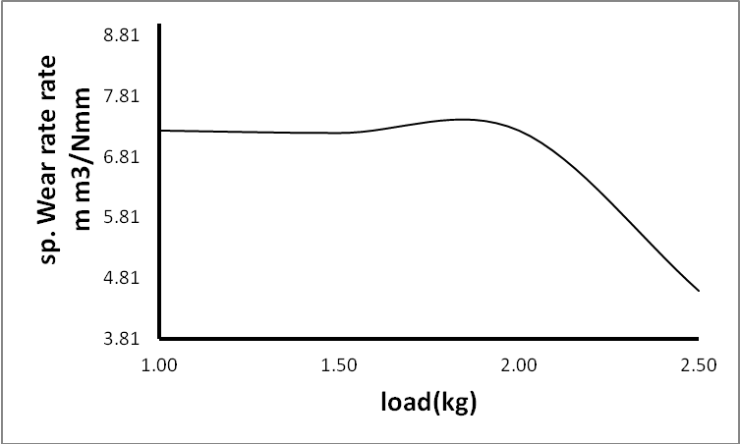
Fig. 4.2.1 Showing the variation of specific wear rate vs. load for aluminium alloy
The Fig. 4.2.1 between specific wear rate and load indiacates that wear rate is nearly copnstant upyo the load oif slight increase in wear rate upto load of 1.6 kg followed by decrease in wear rate .the reason behind the decrese in wear rate may be due to debris formed between two bodies reduces the area of contact between them and hence the amount of wear has been found to decrease beyond the load of 2kg.
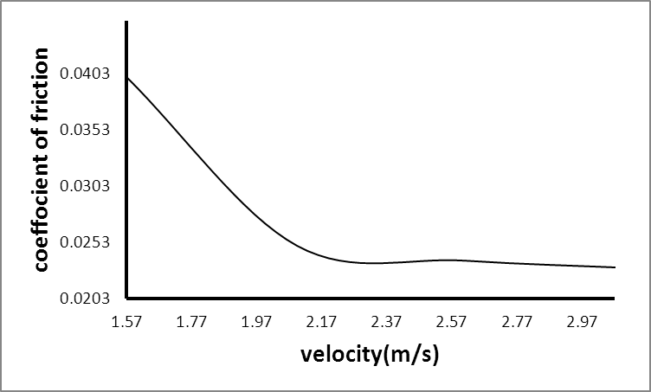
Fig. 4..2.2 Shows the variation of coefficient of friction with velocity for aluminium alloy
The Fig 4.2.2. is indicating that coefficient of friction is decreasing linearly upto velocity of 2.3m/s which may be due to the development of thick layer of lubricant between pin and disk but after this value of velocity the coefficient of friction is nearly constantupto 3.14m/s. Above fig. indicating that wear rate is decreasing with increase in velocity and is minumum at 2.09m/s it may be due to hydrodynamic lubrication due to which area of contact reduces so that wear rate decreases bt is followed by certain increase in wear rate upto 2.61 which may be due to debris formed between the surfaces increases thus area of contact betweeen pin and disk which is further followed by decrease in velocity due to further formation of lubricant film between pin and disk.

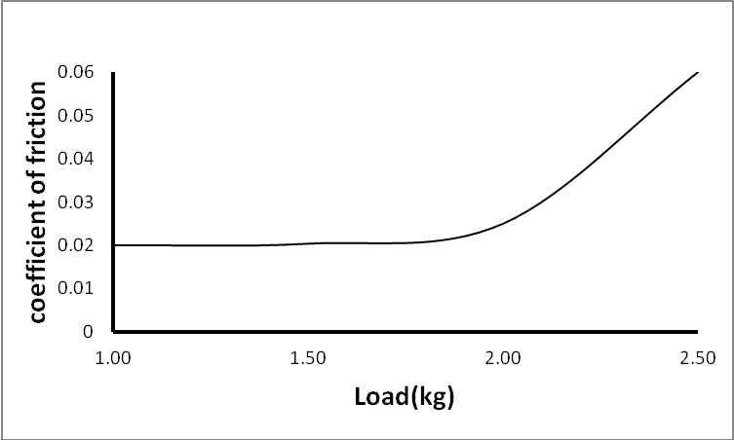
FIG. 4.2.3 Shows the variation of coefficient of friction vs. load for aluminum alloy
The Fig.4.2.3 shows the variation of coefficient of friction with the variation of load.Fig. indicates that the coefficient of friction remains nearly constant upto lad 2kg but beyond this value of load it increases which may be due to incresed metal to metal contact with increase in load beyond the value of 2kg.
4.3 Result of aluminium alloy in dry condition
Table 4.3 readings obtained on pin on disk machine for Al alloy in wet condition
Load(kg) | r.p.m | Sliding distance(km) | Track dia.(mm) | Velocity(m/s) | Time(sec) | Friction  (N) | Mass loss(gm)
2 | 500 | .5 | 140 | 3.66 | 137 | 1.9 | .0008

There was a lot noise in dry condition and the amount of mass loss was greater in dry condition. The graph showed the value of 2.5 as force of friction then reduced below 2N.

  - Result of pin on disk machine for pure aluminium
The experiment was carried out keeping the value of r.p.m constant , sliding distance of .75km. initial mass of the pin was 4.7746gm.track diameter varied as 120,100,80,60 mm.time was calculated using these values and coefficient of friction was calculated using the value of friction force givn by the machine. Specific wear was caculated by dividing volume loss by friction force and sliding distance.
TABLE 4.4 Readings obtained on pin on disk machine for pure aluminum in wet condition
Load  (kg) | r.  p.  m | Sliding distance  (Km) | Track dia.  (mm) | V  (m/s) | Time  (sec) | Mass loss  (gm) | Friction  Force(N) | Coeff.  Of  friction | Specific  Wear  Rate  (m3/Nm)
1 | 1000 | .75 | 120 | 6.28 | 120 | .0003 | .4 | .04 | 7.4
1.5 | 1000 | .75 | 100 | 5.23 | 144 | .0005 | .6 | .043 | 11.21
2 | 1000 | .75 | 80 | 4.188 | 180 | .0006 | .3 | .015 | 12.4
2.5 | 1000 | .75 | 60 | 3.14 | 239 | .0009 | .2 | .008 | 19.7

4.5 Effect of variables on wear rate and coefficient of friction of pure Aluminium
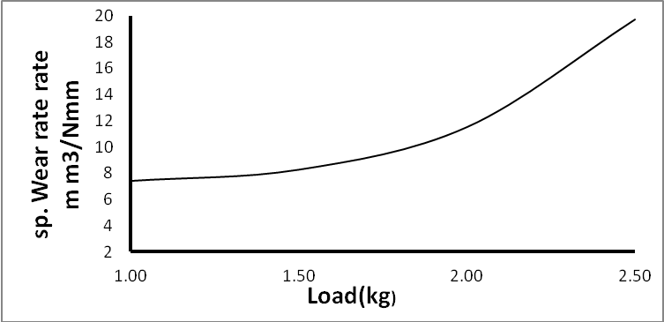
FIG 4.5.1 Shows the variation of specific wear rate vs. load for pure aluminium
The Fig 4.5.1 shows the variation of specific wear rate with variation of load the fig shows that the increase in wear rate with increase in load this increse in wear rate is low upto load of 2kg but beyond this load as the metal to metal contact increases the wear increase at a very high rate.
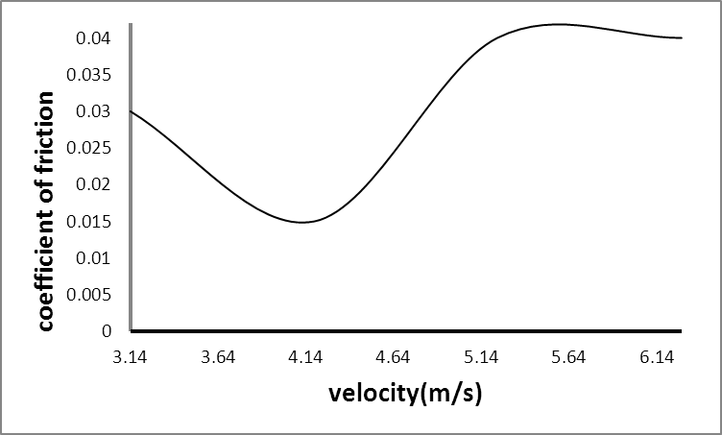
FIG. 4.5.2 Shows the variation of coefficient of friction v.s. velocity
The Fig 4.5.2. shows the variation of coefficient of friction with the variation of velocity. from the above fig. it can be seen that yhe coefficient of friction is first decreasing with increase in velocity and is minimum at 4.18m/s this decrease in value of coefficient of friction may be the hydrodynamic equilibrium but beyond that value it increase at a faster rate and then becomes contant.
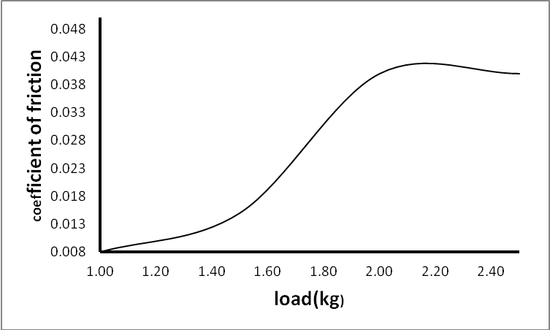
FIG. 4.5.3 Shows the variation of coefficient of friction vs. load
The Fig 4.5.3. shows the variation of coefficient of friction with the variation of load for pure aluminium. It can be seen from the fig. that the value of coeffficient of friction is increasing upto the load of 2kg this continuous increases because when the load is incerased the pure aluminium get weared and the debris of aluminium increases the value of coefficient of friction and in the end it becomes nearly constant.
4.6 Results of pure aluminium in dry condition
Table 4.5 readings obtained on pin on disk machine for Al alloy in wet condition
Load | r.p.m | Sliding distance | Track dia. | Sliding velocity | Time(sec) | Friction force | Mass loss(gm)
2kg | 1000 | .25 | 40 | 2.094 | 120 | 8.5 | 6.7

During the test in dry condition a lot of noise was obsereved and relatively great amount of wear of pure aluminium.
Conclusions

The wear rate for Al-10.6%Si-2.4%Cu is not increasing at a high rate up to the load of 1.5kg instead it is constant but beyond this value of load the it is decreasing but the wear rate for pure aluminium is first increasing slowly up to the load of 2kg. and then increases sharply with increase of load. Coefficient of friction for aluminium alloy is first decreasing with velocity up to the value of 2.61 m/s and then becomes approximately constant for pure aluminium it first decreases up to the velocity of 4.18 m/s due to hydrodynamic lubrication and then increases beyond this value of velocity. coefficient of friction for auminium alloy nearly remain constant up to load of 2kg but beyond this it increases due to increased metal to metal contact and for pure aluminium Its value increases up to load of 2kg due to more formation of debris with increase of load but beyond the load of 2kg it has been found to remain approximately constant.

Future scope

Aluminium alloy is becoming very popular in industries of all over the world. The future of aluminum is bright. Now days the light weight components with high strength are required. Aluminium alloys can be efficiently used where the light weight and high Strength is required infect in most of the industries viz it is being used in aircraft industry to make the aircraft component lighter and with high strength ,it is also being used in marine and automobile industry. In future aluminium alloys can be used to manufacture the heavy duty transport vehicles to increase the performance and to save the fuel.
The railway sector of our country can manufacture the bogies of train using aluminum alloy like Japan has made its first bullet consist of aluminium replacing the older steel body of bullet train.The researches can be further done studying the effect of different alloying element on the properties of aluminum so as to discover more application of aluminium alloy.
Automobile industries are also making the use of aluminum alloy to manufacture the engine block, bearings, alloy wheels yet it can be further extended to manufacture the whole body with aluminium alloy, though the cost will be comparatively high but it can be compensated by the performance of the light weight vehicle . This way aluminium alloys carry huge potential to be used in maximum number of products in the industries.

References

[1] V.C. Srivastava, R.K Mandal, S.N Ojha, Evolution of microstructure in spray formed Al–18%Si alloy, Materials Science and Engineering, vol. A 383, pp. 14-20, 2004.
[2] S. Havner, Physical Metallurgy, Mcgraw-hill international editions, pp. 679-680, 2008.
[3] Y. Haizhi, An overview of the development of Al-Si-alloy based material for engine applications, JMEPEG, vol.12, pp. 288-29, 2003.
[4] H Tylczak Joseph, Oregon Albany, Abrasive Wear, Wear, ASM handbook, vol.18, 2007.
[5] D.K. Dwivedi, Adhesive wear behaviour of cast aluminium–silicon alloys, Materials and Design, vol. 31, pp. 2517-2531, 2010.
[6] D.E. Lozano, Tribological behaviour of cast hypereutectic Al–Si–Cu alloy subjected to sliding wear, Wear, vol. 267, pp. 545–549, 2009.
[7] E. Corniani, TLA and wear quantification of an aluminium–silicon–copper alloy for the car industry, Wear, vol. 267, pp. 828–832, 2009.
[8] M .Harun, Effect of element additions on wear property of eutectic aluminium-silicon alloys, Wear, vol. 194, pp.54-59, 1996.
[9] F. Wang, Effect of Si content on the dry sliding wear properties of spray-deposited Al–Si alloy, Materials and Design, vol. 25, pp. 163–166, 2004.
[10] H. Akbulat, Dry wear and friction properties of delta-Al2O3 short fiber reinforced Al-Si alloy metal matrix composites, Wear vol. 215, pp. 170-179, 1998.
[11] A.K.P.Rao, The micro structural and wear behavior of hypoeutectic Al-Si alloy (LM) grain refined and modified with Al-Ti-C-Sr master alloy, Wear, vol. 261, pp. 133-139, 2006.
[12] T. Sagstad, E. Bhondus, European Patent No. EP1134299 A1 (2001).
[13] V.Abouei, Dry sliding wear behaviour of hypereutectic Al-Si piston alloys containing iron-rich intermetallics, Materials Characterization, vol. 61, Issue 11, (2010).
[14] T.M Chandrashekharaia, Studies on the dry sliding wear behavior of hypoeutectic and eutectic Al–Si alloys, Wear, vol. 263, pp. 745-755, 2007.
[15] N. saheb, Influence of titanium addition on wear properties of Al-Si eutectic alloys, Wear, vol. 249, pp. 656-662, 2001.
[16] K.L. Sahoo, Studies on wear characteristics of Al–Fe–V–Si alloys, Wear, vol. 239, pp. 211–218, 2000.
[17] Y. Tuti, K. Asad A, Haque M.M, Tribological (wear) properties of aluminum–silicon eutectic base alloy under dry sliding condition, Journal of Materials Processing Technology, vol. 153–154, pp. 833-838, 2004.
[18] H. torabian, J.P pathak and S.N tiwari, Wear characteristics of Al-Si alloys, Wear, vol. 172, pp. 49-58, 1994.
[19] A. S. Anasyida, A. R. Daud and M. J. Ghazali, Dry sliding wear behaviour of al-4si-4mg alloys by addition of cerium, International Journal of Mechanical and Materials Engineering, vol. 4, pp. 127-130, 2009.
[20] H. Litian, C. Jianmin, L. Weimin, X. Qunji, K. Czeslaw, Investigation of tribochemical behavior of Al–Si alloy against itself lubricated by amines, Wear, vol. 243, pp. 60-67, 2000.
[21] R.C.Singh, R.K.Pandey, S. Maji, Experimental studies for accessing the influence of micro–dimple area density on tribological performance of matting contacts, International Tribology Conference, Hiroshima, 2011.
[22] C.M.Taylor, Engine Tribology,The University of Leeds, U.K., pp. 198, 1993

Appendix-1

Spectroscopy report of Aluminium alloy

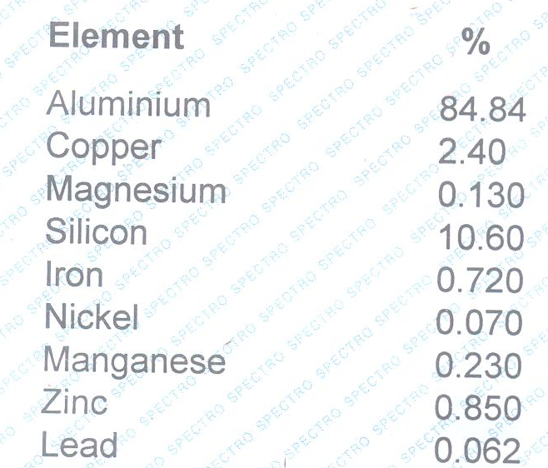

Spectroscopy report of pure aluminium
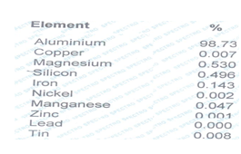

Appendix-2

Fluid Force - Shear force b/w adjacent layers consider an element of fluid.
For equilibrium

(i)
(ii)
Since pressure is constant throughout the the

from Newtons law of viscosity
Putting these values in (i) & (ii)

(iii) (Since = constant)
Now integrating equation (iii) on both side w.r.t. 'z'
Integrating again
(iv)
At z = h
u = v1
At z = 0
v = v2

Applying boundary conditions to (iv)

Putting values of c1 & c2 in equation (iv)
On simplification
Rate of flow

(v)
(vi)
Infinity Long Bearing

For Max Pressure
- (Local film thickness)

(vii)

Reynold’s equation in two & 3 dimension
From equation of continuity

For most of the bearing surface movement is zero in 'y' direction
Putting there values in continuity equation

= Constant

(Equation in 2-D)

Putting values of qx, qy & qz

(for 3-D)

Appendix-3

Variation of wear rate and coefficient of friction with different load and sliding speed in wet and dry condition shown in following graphs which have been obtained through testing.

