Chapter 1
Introduction

Surface texturing as a means for enhancing tribological properties of mechanical components is well known for many years. Perhaps the most familiar and earliest commercial application of surface texturing is that of cylinder liner honing. Today surfaces of modern magnetic storage devices are commonly textured and surface texturing is also considered as a means for overcoming adhesion and stiction in devices. Fundamental research work on various forms and shapes of surface texturing for tribological applications is carried out by several research groups worldwide and various texturing techniques are employed in these studies including machining, ion beam texturing, etching techniques and laser texturing. Interestingly almost all these fundamental works are experimental in nature and most of them are motivated by the idea that the surface texturing provides micro reservoirs to enhance lubricant retention or micro-traps to capture wear debris. Usually, optimization of the texturing dimensions is done by a trial and error approach.
Surface texturing has emerged in the last decade as a viable option of surface engineering resulting in significant improvement in load capacity, wear resistance, friction coefficient etc. of tribological mechanical components. Various techniques can be employed for surface texturing but chemical etching is probably the most advanced so far. Chemical etching produces a very large number of micro-dimples on the surface and each of these micro dimples can serve either as a micro-hydrodynamic bearing in cases of full or mixed lubrication, a micro-reservoir for lubricant in cases of starved lubrication conditions, or a micro-trap for wear debris in either lubricated or dry sliding.
1.1 The Consequences of Friction and Wear
The consequences of friction and wear are many. An arbitrary division into five categories follows, and these are neither mutually exclusive nor totally inclusive.
Friction and wear usually cost money, in the form of energy loss and material loss, as well as in the social system using the mechanical devices
An interesting economic calculation was made by Jacob Rowe of London in 1734. He advertised an invention which reduces the friction of shafts. In essence, the main axle shaft of a wagon rides on two disks that have their own axle shaft. Presumably a saving is experienced by turning the second shaft more slowly than the wheel axle. Rowe’s advertisement claimed: “All sorts of wheel carriage improved”, a much less than usual draught of horses, etc., will be required in wagons, carts, coaches, and all other wheel vehicles as likewise all water mills, windmills, and horse mills. An estimate of the advantages that will accrue to the public, by means of canceling the friction of the wheel, pulley, balance, pendulum, etc. ” (He then calculates that 40,000 horses are employed in the kingdom in wheel carriage, which number could be reduced to 20,000 because of the 2 to 1 advantage of his invention. At a cost of 15.5 shillings per day, the saving amounts to £1,095,000 per annum or £3000 per day.) In one sense, this would appear to reduce the number of horses needed, but Rowe goes on to say with enthusiasm that “great numbers of mines will be worked more than at present, and such as were not practicable before because of their remote distance from water and the poorness of the ore (so the carriage to the mills of water eats up the profit) will now be carried on wheel carriages at a vastly cheaper rate than hitherto, and consequently there will be a greater demand for horses than at present, only, I must own that there will not be occasion to employ so large and heavy horses as common, for the draught that is now required being considerably less than usual shall w ant horses for speed more than draught.” Another advantage of this new bearing, said Rowe, is that it will be far easier to carry fertilizer “and all sorts of dressing for lands so much cheaper than ordinary. Great quantities of barren land will now be made fertile, which the great charges by the common way of carriage has hitherto rendered impracticable.”
1.1. A Friction and wear can decrease national productivity
This may occur in several ways. First, if American products are less desirable than foreign products because they wear faster, our overseas markets will decline and more foreign products will be imported. Thus fewer people can be employed to make these products. Second, if products wear or break down very often, many people will be engaged in repairing the items instead of contributing to national productivity. A more insidious form of decrease in productivity comes about from the declining function of wearing devices. For example, worn tracks on track-tractors (bulldozers) cause the machine to be less useful for steep slopes and short turns. Thus, the function of the machine is diminished and the ability to carry out a mission is reduced. As another example, worn machine tool ways require a more skilled machinist to operate than do new machines.

1.1. B Friction and wear can affect national security
The down time or decreased efficiency of military hardware decreases the ability to perform a military mission. Wear of aircraft engines and the barrels of large guns are obvious examples. A less obvious problem is the noise emitted by worn bearings and gears in ships, which is easily detectable by enemy listening equipment. Finally, it is a matter of history that the development of high-speed cutting tool steel in the 1930s aided considerably in our winning World War II.
1.1. C Friction and wear can affect quality of life
Tooth fillings, artificial teeth, artificial skeletal joints, and artificial heart valves improve the quality of life when natural parts wear out. The wear of “external” materials also decreases the quality of life for many. Worn cars rattle, worn zippers cause uneasiness, worn watches make you late, worn razors leave “nubs,” and worn tires require lower driving speeds on wet roads.
1.1.D Wear causes accident
Traffic accidents are sometimes caused by worn brakes or other worn parts. Worn electrical wiring and switches expose people to electrical shock; worn cables snap; and worn drill bits cause excesses which often result in injury.
The above description of wear present worldwide shows how serious problem the wear is? So to avoid this noxious wear several methods is trying .one of the very good method is to provide micro dimples on surfaces which are in relative motion.These dimples can be effectively produced by chemical etching.
Metallographic etching encompasses all processes used to reveal particular structural characteristics of a metal that are not evident in the as-polished condition. Examination of a properly polished specimen before etching may reveal structural aspects such as porosity, cracks, and nonmetallic inclusions. Indeed, certain constituents are best measured by image analysis without etching, because etching will reveal additional, unwanted detail and make detection difficult or impossible. The classic examples are the measurement of inclusions in steels and graphite in cast iron. Of course, inclusions are present in all metals, not just steels. Many intermetallic precipitates and nitrides can be measured effectively in the as-polished condition Corrosion also damages materials under normal circumstances, but it can be applied as an efficient method for shaping materials that is named “etching”. The process is also called indifferent names such as chemical etching.
Chemical etching is a nontraditional machining process in which material removal is carried out by using strong chemical solution, called “etchant”. This is simply the “accelerated and controlled corrosion” process. The method is recently employed as micromachining process in the production. Chemical etching has a long history back to 2500 BC, used to produce jewelry from copper by citric acid in the Ancient Egypt (Harris, 1976). It has been accepted one of the important nontraditional machining method since 1950s. This machining process is widely used to machine thin and flat materials producing geometrically complex and dimensionally accurate components. It is also applied to reduce weight of the work piece materials such as aircraft wings The purpose of etching is to optically enhance micro structural features such as grain size and phase features. Etching selectively alters these micro structural features based on composition, stress, or crystal structure. The most common technique for etching is selective chemical etching and numerous formulations have been used over the years. Other techniques such as molten salt, electrolytic, thermal and plasma etching have also. Chemical etching selectively attacks specific micro structural features. It generally consists of a mixture of acids or bases with oxidizing or reducing agents. To understand the basics of chemical etching, the relationship between pH and Eh (oxidation/reduction potentials), often known as Eh-pH diagrams or Pour baix diagrams can be used.
Mild steel has a wide engineering application as a material in aircraft, aerospace, automotive industries where weight is probably the most important factor. The first chemical etchings of mild steel were mainly carried out for decorative purposes.
Corrosion resistant steels contain at least 11% chromium and are collectively known as “stainless steels“. Within this group of high alloy steels four categories can be identified: ferritic, martensitic, austenitic, and austenitic ferritic (duplex) stainless steels. These categories describe the alloy’s microstructure at room temperature, which is largely influenced by the alloy composition The main characteristic of stainless steels is their corrosion resistance. This property can be enhanced by the addition of specific alloying elements, which have a further beneficial effect on other characteristics such as toughness and oxidation resistance. For instance, niobium and titanium increase resistance against intergranular corrosion as they absorb the carbon to form carbides; nitrogen increases strength and sulphur increases machinability, because it forms small manganese sulphides which result in short machining chips. Due to their corrosion resistance and superior surface finishes stainless steels play a major part in the air.
Wear is the undesired removal of material from a component as a result of wear mechanisms (tribo-systems) such as adhesion, tribo-oxidation, abrasion and erosion. In conjunction with a corrosive environment, tribo-corrosion will occur. This synergistic effect can cause very rapid loss of material and component failure. In laboratory tests, wear are usually determined by weight loss in a material and wear resistance is characterized by the loss in weight per unit area per unit time. There are following principle types of wear as described below.
1.2. Types of wear
The study of the processes of wear of coating is part of the discipline of Tribology. The complex nature of coating wear has delayed its investigations and resulted in isolated studies towards specific wear mechanisms or processes. Some commonly referred to wear mechanisms include
- Adhesive wear
- Abrasive wear
- Surface fatigue
- Fretting wear
- Erosive wear
A number of different wear phenomena of coating are also commonly encountered and represented in literature. Impact wear, cavitations wear, diffusive wear and corrosive wear are all such examples. These wear mechanisms; however, do not necessarily act independently in many applications. Wear mechanisms of the coatings are not mutually exclusive. "Industrial Wear" is the term used to describe the incidence of multiple wear mechanisms occurring in unison. Wear mechanisms and/or sub-mechanisms frequently overlap and occur in a synergistic manner, producing a greater rate of wear than the sum of the individual wear mechanisms.
1.2.A Adhesive wear
Adhesive wear is defined as the transfer of material from one surface to another during relative motion by a process of solid-phase welding or as a result of localized bonding between contacting surfaces. Particles that are removed from one surface are either permanently or temporarily attached to the other surface [1]. Adhesive wear occurs when two body slides over each other, or are pressed into one another, which promote material transfer between the two surfaces. When either one of two surfaces of tribo-elements in sliding or rolling contact has thin soft surface layer that can partly transfer to the counter surface by adhesion, relative displacement takes place at the interface between the surfaces of coating and transfer layer with smaller shear strength of the soft material than that of the underlying element material. Low friction is obtained as a result, and wear of the tribo elements is much reduced. Soft metal coating is introduced for this purpose, and Au, Ag, Pb are representative ones [1]. However, material transfer in coating is always present when two surfaces are aligned against each other for a certain amount of time and the cause for material transfer or wear-categorization have been a source for discussion and argumentation amongst researchers for quite some time and there are frequent misinterpretations or misunderstandings due to overlaps and symbiotic relations between "wear" and physical-chemical mechanisms as previously mentioned. Having described the restriction on the subject wear, we can focus on what causes material transfer in wear of coating.
Adhesive wear can be described as plastic deformation of very small fragments within the surface layer when two surfaces slides against each other. The asperities (i.e. microscopic high points) found on the mating surfaces will penetrate the opposing surface and develop a plastic zone around the penetrating asperity [2].
Dependent on the surface roughness and depth of penetration will the asperity cause damage on the oxide surface layer or even the underlying bulk material of the coating surface. In initial asperity contact, fragments of coating are pulled off and adhere to the other, due to the strong adhesive forces between atoms. It is thereby clear that physical-chemical adhesive interaction between the surfaces plays a role in the initial build-up process but the energy absorbed in plastic deformation and relative movement is the main cause for material transfer and wear of the coating.
Adhesive wear is the most common form of wear of coating and is commonly encountered in conjunction with lubricant failures. In engineering science, some aspects of adhesive wear is commonly referred to as welding wear due to the exhibited surface characteristics and the Tribology process is usually referred to as galling and is a common fault factor in sheet metal forming (SMF) and other industrial applications.
The tendency of contacting arises from the attractive forces that exist between the surface atoms of the two materials. The type and mechanism of attraction varies between different materials. Most solids will adhere on contact to some extent, however, oxidation films and contaminants naturally occurring; generally suppress adhesion. Surfaces also generally have low energy states due to reacted and absorbed species. The mechanism of adhesive wear of coating occurs due to contact possibly producing surface plastic flow, scraping off soft surface films or breaking up and removing oxide layers. This brings clean regions into contact and introduces the possibility of strong adhesion. The removal of material from coating surface, or wear, takes the form of small particles. These small particles are usually transferred to the other surface but may come off in loose form.
1.2.B Abrasive wear
The abrasive wear of a material is defined as the progressive loss of material due to abrasive action of hard particles present between the counter surfaces. The abrasive wear depends on various factors like abrasive size, rake angle of abrasives, applied load and shape, size, volume fraction of the dispersed phases. In addition to these factors the abrasive wear rate of a material also depends on the surface hardness and materials properties like fracture toughness [3]. Abrasive wear occurs when a hard rough surface slides across a softer surface. ASTM (American Society for Testing and Materials) defines it as the loss of material due to hard particles or hard protuberances that are forced against and move along a solid surface. Abrasive wear is commonly classified according to the type of contact and the contact environment. The type of contact determines the mode of abrasive wear of coating. The two modes of abrasive wear are known as two-body and three-body abrasive wear. Two-body wear occurs when the grits, or hard particles, are rigidly mounted or adhere to a surface, when they remove the material from the surface [4]. The common analogy is that of material being removed with sand paper. Three-body wear occurs when the particles are not constrained, and are free to roll and slide down a surface.The contact environment determines whether the wear is classified as open or closed. An open contact environment occurs when the surfaces are sufficiently displaced to be independent of one another.
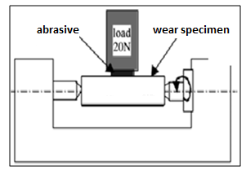
Figure 1 Abrasive wear of etched mild surface (4)
There are a number of factors which influence abrasive wear and hence the manner of material removal. Several different mechanisms have been proposed to describe the manner in which the material is removed. Three commonly identified mechanisms of abrasive wear of coatings are:
- Plowing 2. Cutting 3. Fragmentation
Plowing occurs when coating material is displaced to the side, away from the wear particles, resulting in the formation of grooves that do not involve direct material removal from the etched surface. The displaced material forms ridges adjacent to grooves, which may be removed by subsequent passage of abrasive particles. Cutting occurs when material is separated from the surface in the form of primary debris, or microchips, with little or no material displaced to the sides of the grooves. This mechanism closely resembles conventional machining. Fragmentation occurs when material is separated from a surface by a cutting process and the indenting abrasive causes localized fracture of the coating material. These cracks then freely propagate locally around the wear groove, resulting in additional material removal by spalling.
1.2.C Surface fatigue wear
Surface fatigue wear of the surface is a process by which the surface is weakened by cyclic loading, which is one type of general material fatigue. Fatigue wear is produced when the wear particles are detached by cyclic crack growth of micro cracks on the surface. These micro cracks are either superficial cracks or subsurface cracks. It is extremely important to improve the resistance of the material against fracture in aerospace applications.
In the case where this alloy is, for example, used for turbine engine blades, the fretting fatigue, which is caused by the combination of cyclic fatigue stress and frictional wear, occurs at turbine engine blade roots. As a result, many small cracks will easily initiate on the material surface. Also, it has been reported that the fretting fatigue life decreases remarkably as compared with plain fatigue life [5]. The use of high strength steels instead of tool steels brought out a new aims for material scientists - increase endurance of the tool materials in cyclic loading (cold forging, stamping and blanking). To solve the fatigue damage problems of high-speed steels (HSS) the powder metallurgy (PM) routes are used. As a result of the finer and more uniform microstructure that PM-HSSs exhibit, as compared to their conventionally produced counterparts, they also present enhanced cross-sectional hardness uniformity (wear resistance), fracture toughness and fatigue strength.
1.2.D Fretting wear
Fretting wear of the surface is the repeated cyclical rubbing between disc and another surface, which is known as fretting, over a period of time which will remove material from one or both surfaces in contact. It occurs typically in bearings, although most bearings have their surfaces hardened to resist the problem. Another problem occurs when cracks in either surface are created, known as fretting fatigue [6]. It is the more serious of the two phenomena because it can lead to catastrophic failure of the bearing. It is extremely important to improve the resistance of the material against fracture in aerospace applications. In the case where this alloy is, for example, used for turbine engine blades, the fretting fatigue, which is caused by the combination of cyclic fatigue stress and frictional wear, occurs at turbine engine blade roots [7]. As a result, many small cracks will easily initiate on the material surface. An associated problem occurs when the small particles removed by wear are oxidized in air. The oxides are usually harder than the underlying metal, so wear accelerates as the harder particles abrade the metal surfaces further. Fretting corrosion acts in the same way, especially when water is present. Torsional fretting wear tests were conducted on a flat-on-ball contact on a torsional fretting rig with a controlled environmental chamber.
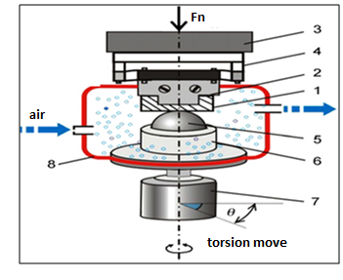
Figure 2 Fretting wear (7)
A plate specimen (1) was fixed on the upper holder (2) to link a six-axis torque/force sensor (3) (three loads of x, y and z direction; three torques of x, y and z direction) through a spring suspension (4). A ball specimen (5) was mounted on the lower holder (6), which fixed on the low-speed reciprocating rotary motor system (7). The flat specimen rotated following the motion of the motor at a constant rotary velocity (in the range of 0.01–5◦/s).
In order to ensure pure torsional fretting, the centerline the ball specimen was superposed strictly to the rotary axis of the motor system at all times [8]. Angular displacement of the contact pair was measured by a sensor in the motor system and unprotected bearings on large structures like bridges can suffer serious degradation in behavior, especially when salt is used during winter to deice the highways carried by the bridges. The problem of fretting corrosion was involved in the Silver Bridge tragedy and the Mianus River Bridge accident.

1.2.E Erosive wear
Erosive wear of the etched disc is caused by the impact of particles of solid or liquid against the surface of coating [8]. The impacting particles gradually remove material from the surface through repeated deformations and cutting actions. It is a widely encountered mechanism in industry. A common example is the erosive wear associated with the movement of slurries through piping and pumping equipment (fig.3).
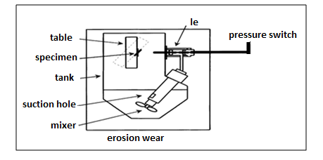
Figure 3 Erosion wear (8)
The rate of erosive wear is dependent upon a number of factors. The material characteristics of the particles, such as their shape, hardness, and impact velocity and impingement angle are primary factors along with the properties of the surface of the coating [8, 28]. The impingement angle is one of the most important factors and is widely recognized in literature. For ductile coating materials the maximum wear rate is found when the impingement angle is approximately 30°, whilst for non ductile coating materials the maximum wear rate occurs when the impingement angle is normal to the surface.
1.3 Types of wear test
Wear behavior of the can be measured on the different test and is mainly depends on the application of the coating and thickness of the coating. The test is carried out at different wear conditions and the parameter are taken into consideration on which the wear is mainly depends. These tests are such mainly divided into these categories:
1.3.A Scratch test
The scratch tester is used to test the scratch resistance of flat solid surfaces such as coatings, metals, ceramics, composites, polymers, and other material surfaces. The test is performed by sliding a stylus over the surface of the test specimen. The normal load, sliding speed, direction, stylus geometry, and stylus material can be varied. The resultant tangential force at the contact interface can be monitored using tribo data, the supplied windows-based data acquisition Software. The onset of scratch or adhesion failure of coatings can be inferred from this data. A CMOS camera is built-in to capture the scratch scar image. Y. Xie et al. [9] was investigated scratching an alumina coating, using conical diamond indenters with different tip radii under either progressively increasing or constant loading. The interaction between the disc and the indenter was studied by performing single scratching on a polished virgin surface, repeated scratching over the same track and closely-spaced, multiple parallel interacting scratching.

1.3.B Slurry Abrasion Test
The Slurry Abrasion Test is used to test the abrasive resistance of solid materials to slurry compositions. Slurry erosion problems are especially important during rainy seasons in hydroelectric power plants due to the increase in the number of solid particles impacting the surfaces, especially in systems where the installation of an exhaustive filtration process is not possible [10]. Various materials such as metals, minerals, polymers, composites, ceramics, coatings, and heat-treated materials can be tested with this instrument. The test is performed by rotating a rectangular test sample within a cup filled with abrasive slurry (fig. 4). The mass of the test sample is recorded before and after conducting a test and the difference between the two values is the resultant mass loss due to slurry abrasion [10].
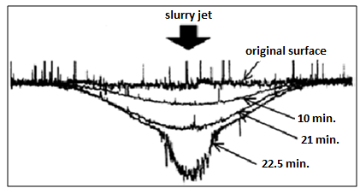
Figure 4 Slurry abrasion wear
To develop a comparison table for ranking different materials with respect to each other, it is necessary to convert this mass loss to volume loss to account for the differences in material densities. The test speed, temperature, duration, as well as test sample size and slurry composition, can be varied. The instrument is configured to run up to six test samples simultaneously at the same speed. The test temperature is maintained by immersing the slurry vessels in a water bath.
1.3.C Friction Test
The Friction Tester is used to test the frictional characteristics of materials in dry or lubricated reciprocating motion contact. A wide variety of materials including fluid lubricants, greases, cutting fluids, metals, composites, ceramics, polymers, and coatings can be tested. The test is performed by loading the test specimen against a ball, pin, or cylinder undergoing reciprocating linear motion. The frictional force developed at the contact interface is measured by a force transducer. The output signal can be captured by a storage oscilloscope or tribo data, Koehler's data acquisition software, for evaluation. The reciprocating motion of the ball results in a unique velocity profile which allows for monitoring of static and dynamic friction force over a wide range of linear sliding speeds. The test load, stroke, frequency, and temperature can be adjusted to simulate different testing conditions. Wear testing may also be performed on the test specimen by evaluating the resulting wear scar with a profilometer. Yucong Wang et al. [11] were performed with a modified Cameron Plint reciprocating machine to determine the scuffing and wear behavior of piston coatings against 390 Al engine cylinder bore. The tested piston coatings included nickel–tungsten (Ni–W).plating, electro less Ni plating, Ni–P coatings with ceramic particles such as boron nitride (BN), Sic, as well as titanium nitride physical vapor deposition (PVD) coating, diamond-like carbon (DLC) coating, and hard anodizing.
1.3.D Air Jet Erosion Test
The Air Jet Erosion Tester is used to test the erosion resistance of solid materials to a stream of gas containing abrasive particulate. The test is performed by propelling a stream of abrasive particulate gas through a small nozzle of known orifice diameter toward the test sample. Material loss, in this case, is achieved via the impingement of small abrasive particles upon the surface of the test sample. Materials such as metals, ceramics, minerals, polymers, composites, abrasives, and coatings can be tested with this instrument [12]. The test specimen, temperature, angle of incidence of the jet stream, abrasive particulate speed and flux density, can be varied to best simulate actual conditions. Special adapters are available to test various geometries and components for user-specified testing applications.
1.3.E Pin on Disc Test
The Pin-On-Disc Tester is used to test the friction and wear characteristics of dry or lubricated sliding contact of a wide variety of materials including metals, polymers, composites, ceramics, lubricants, cutting fluids, abrasive slurries, coatings, and heat-treated samples. The test is performed by rotating a counter-face test disc against a stationary test specimen pin. The advantage of a wear test, when compared to indentation or scratch testing, is that it can give a measure of the lifetime of a particular system. In many applications of etching, the resistance to wear can be more important than the load required to permanently damaging the material [13]. A spherical ended pin has the advantage that contact conditions can be relatively well controlled. No matter the degree of misalignment between pin axis and disk axis the initial apparent area of contact should be the same, for a given load. However, the apparent area of contact will then change during the test up to the maximum given by the pin-diameter [14]. The pin on disc test can be used for a variety of coatings it may be thick or thin and can be made of any material such as metals, ceramics, cermets and composites [9,13].

Chapter 2
Literature Review

Surface texturing has emerged in the last decade as a viable option of surface engineering resulting in significant improvement in load capacity, wear resistance, friction coefficient etc. of tribological mechanical components. Various techniques can be employed for surface texturing but chemical etching is probably the most advanced so far. Chemical etching produces a very large number of micro-dimples on the surface and each of these micro dimples can serve either as a micro-hydrodynamic bearing in cases of full or mixed lubrication, a micro-reservoir for lubricant in cases of starved lubrication conditions, or a micro-trap for wear debris in either lubricated or dry sliding [15].
Laser Surface texturing (LST) is an emerging effective method for improving the tribological performance of friction units lubricated with oil. In LST technology, a pulsating laser beam is used to create thousands of arranged microdimples on a surface by a material ablation process. These dimples generate hydrodynamic pressure between oil-lubricated parallel sliding surfaces. The impact of LST on lubricating regime transitions was investigated in this study. Tribological experiments were conducted with a pin-on-disk apparatus at sliding speeds in the range of 0.015–0.75 m/s and nominal contact pressures that ranged from 0.16 to 1.6 MPa. Two oils with different viscosities (54.8 and 124.7 cSt at 40 and 8C) were used as lubricants. The test results showed that laser texturing expanded the contact parameters in terms of load and speed for hydrodynamic lubrication, as indicated by friction transitions on the Stribeck curve. The beneficial effects of laser surface texturing are more pronounced at higher speeds and loads and with higher viscosity oil [16].
Introducing specific textures on a tribological surface can contribute to friction reduction in sliding contacts. In this, a pulsed Nd:YAG laser emitting at 1064 nm, was used against 100Cr6 steel samples in order to produce well-defined surface micro-pores, which can act as lubricant reservoirs, micro-hydrodynamic bearings as well as traps for wear debris. Due to the high flexibility of the laser system, structural features such as shape, size, density and depth can be varied easily by changing the laser parameters. To optimize the parameters of the laser surface texturing process, an investigation was performed using different pulse numbers, various pulse energies and two different modes (single- and multi-mode) [17].
A series of experiments is conducted to study the tribological behavior of spiral groove thrust bearings. The experimental system consists of a nominally flat upper ring mating with a stationary spiral groove lower ring in fully flooded lubrication environment. Spiral groove thrust bearings with different spiral angles subjected to different loads and speeds are tested. Stribeck-like curves are obtained and their characteristics are discussed. Transition points from mixed to hydrodynamic lubrication are experi- mentally established. In addition, a theoretical model is developed to gain further insight into the frictional characteristics of spiral grooves in both the hydrodynamic regime and the mixed lubrication regime [18].
A tools lifetime absolutely depends on the material properties and lubrication. By a lubricant absence, the direct contact between the materials might cause an increase of friction and wear, which might lead to a tool’s failure. That is why wear prediction and control are important requirements in industry. The wear prediction experiments in this study were performed for an unlubricated (dry) bushing/ shaft system of relatively high load and low sliding speed. Two different commercially available tool steels were used for tribological investigations. Normal load and temperature were considered as independent variable in the wear testing. The results showed that the extensive oxidation of metals have a positive factor on wear. When the temperature raises formation of the protective oxide layers consequently change the wear transition to the mild oxidative wear. Based on the classical wear equations and on the chemical oxidation kinetics concepts a wear prediction model was developed and statistically evaluated in the case when metallic contact wear as the predominant wear mechanism was combined with the oxidation of metals [19].
Surface texturing can be used as the storage of solid lubricant. The stainless steel was first laser surface textured and then was molybdenized by double glow plasma alloying technology to improve its tribological properties. The friction and wear properties of texturing and molybdenizing duplex-treated steel from room temperature to 600 °C were tested on a ball-on disk tribometer. The hardness of stainless steel is increased from HV196 to HV480 after molybdenizing. The friction coefficient of textured stainless steel smeared with MoS2 powders decreases from 0.40 to 0.10 at elevated temperature after molybdenizing. The wear rates of texturing and molybdenizing duplex-treated steel are much lower than those of single textured steel at elevated temperatures due to the lubrication of oxides of molybdenum [20].
Photochemical machining (PCM) was utilized to fabricate microtextures on carbon steel surfaces in this study. A series of experiments were carried out in the two stages of this process, photolithography and wet chemical etching. In the first stage, the influences of photolithography parameters, including spin coating speed, exposure time and development time, on the patterning of photoresist films were investigated, and the optimum process parameters were found. In the second stage, through a trial and error approach, it has been found that the mixture solution of HNO3: H3PO4 : H2O = 8.5% : 59.5% : 32% (mass percentage) is a suitable etchant for the wet chemical etching of carbon steel The variation of the end face profiles and etching depths of the microtextures with the etching time was studied. A prediction model of the geometry of the fabricated microtextures was proposed. Its accuracy was verified by comparison with additional experiment results, and its application scope was also discussed. It makes the precise control of microtexture profiles possible, and facilitates the use of precise microtexture profiles in the hydrodynamic lubrication analysis of textured surfaces [21].
A novel laser coating–texturing (LCT) technique was proposed to achieve appropriate surface topographies and frictional behaviour. The LCT process was realized by applying laser pulses at very high repetition rate to produce innumerable micro-craters with required shape profile on the surface of the workpiece. Moreover, surface alloying of the dimples was carried out by melting submicron WC–TiC– Co alloy powder on the substrates. Morphology and microstructures of the texturing layers were characterised using optical microscopy (OM), scanning electron microscopy (SEM), and X-ray diffraction (XRD). Mechanical properties of the textured samples were evaluated by abrasive resistance tests and microhardness measurement. Experimental results show that good fusion bonding between the texturing layers and the substrate has been formed, and the texturing layers are mainly composed of dense and hard fine-grained structures. The abrasive wear resistance of the laser coating-textured surface was 10 times higher than that of the substrates. The average surface microhardness values were as high as 830 HV [22].
By now, it is fairly well established that the layered hexagonal MAX phases are thermodynamically stable nanolaminates displaying unusual and sometimes unique properties. Some of them display a ductile–brittle transition at temperatures > 1000 ◦C, while retaining decent mechanical properties at these elevated temperatures. Moreover, their layered nature suggests they may have excellent promise as solid lubricant materials. Recently, first generation MAX Phase based composites shafts were successfully tested against Ni-based superalloy at 50,000 rpm from RT till 550 ◦C during thermal cycling in a foil bearing rig. This study further demonstrates the potential of MAX Phases and their composites in different tribological applications. The main objective of this review is to present recent progress, and consequently develop a comprehensive understanding about the tribological behavior of MAX Phases and their composites. We are also proposing a way of classifying the different tribofilms to understand the complex tribological behavior of these solids over a wide range of different experimental conditions [ 23].
The beneficial effect on lubrication achieved through microtexturing of sliding surfaces by laser ablation and polishing was investigated. The investigation was based on two independent experimental approaches with oil-lubricated smooth and laser-textured steel surfaces in oscillating sliding contact with a steel ball. Two types of laser-textured patterns of microcavities were studied. It was found that, in comparison with smooth steel surfaces, the laser-texturing significantly reduced friction and wear. The most significant improvement in the tribological performance was achieved with an oil of high viscosity combined with a texture comprising a low density of deep microcavities with a small opening [24].
A series o fexperiments is conducted to examine the frictional characteristics of laser surface textured, heat-treated17-4PH stainless steel specimens.Two dimple shapes aretested:circular and elliptical. The circular dimples aredesigned with different sizes, dimple densities and dimple depth-to-diameter ratios. It is found that the cavitation pressure (Pcav) in a circular dimple is strongly affected by the operational speed.The surface textured specimens provide low coefficient of friction compared with plain (dimple-free)surfaces. However, for the material used in the current experiments, thesurface texture decreases the surface’s resistance to wear [25].
Chemical etching is employed as micromachining manufacturing process to produce micron-size components. The process applies a strong chemical etchant solution to remove unwanted part in the work piece material. It is basically a corrosion-controlled process. Chemical etching process has a long history and accepted one of the important nontraditional machining processes during the last half century. The method is widely applied to machine geometrically complex parts from thin and flat of any material. It is also used to reduce weight of the work piece materials [26].
Chemical etching is the controlled dissolution of work piece material by contact with strong chemical solution. The process can be applied to any material. Copper is one of the extensively used engineering materials. In the fabrication of microelectronic components, micro engineered structures and precision parts by using chemical etching process. In this study, copper is chemically etched with two different etchants (ferric chloride and cupric chloride) at 50 ◦C. The effects of selected etchants and machining conditions on the depth of etch and surface roughness was investigated. The experimental study provided that ferric chloride produced the fastest chemical etch rate, but cupric chloride produced the smoothest surface quality [27].
The corrosion sensor should have high sensitivity enough to measure the corrosion rate in mild corrosive environments and the ability to detect the corrosion mechanism. Therefore, our goal is to develop and apply a steel thin film electrical resistance (TFER) sensor based on the measurement of changes in electrical resistance of the sensing elements in order to follow the corrosion of steel in a wide range of environments. The sensor with a thickness of 600 nm is fabricated by DC magnetron sputter deposition of steel on an Al2O3 substrate, followed by silk screen printing to improve the sensitivity of the sensor, especially to measure the corrosion rate in low corrosive environments such as anoxic corrosion in neutral solutions, steel protected by protective measures like a corrosion inhibitor or catholic protection, and atmospheric corrosion. The sensor also has multiple-line sensing elements to detect the localized corrosion of steel [28].
Hydrophobic Cu surfaces with tunable regular microstructure and random nanostructures were fabricated by nanosecond pulsed laser texturing and chemical etching. Wettability tests demonstrate that the Cu surface with this micro/ nana structural hierarchy, analogous to that of lotus leaves found in nature, is super hydrophobic with a water contact angle around 153◦. The random nanostructure by selective etching plays an important role for hydrophobicity. in addition to the regular microstructure by nanosecond laser texturing [29].
This study examines the influence of temperature of sub-zero treatment on the wear behavior of AISI D2 steel. A series of dry sliding wear studies have been made under constant normal load at varying sliding velocities. Emphasis has been laid to understand the operative modes and mechanisms of wear by the estimation of specific wear rates and detailed characterizations of the worn surfaces, wear debris and sub surfaces with the help of scanning electron microscope (SEM) examinations coupled with energy dispersive X-ray (EDX) microanalyses. The obtained results unambiguously infer that lower the temperature of sub-zero treatment higher is the improvement in wear resistance. Wear resistance can increase by 1.5–125 times depending on sliding velocity while hardness increases only by 4.2% at the lowest temperature of sub-zero treatment (77K) compared to the conventionally treated specimens [30].
Most machining operations require the presence of a cutting fluid in order to ensure their success due to the intensity of thermal and mechanical conditions generated on the cutting tools. In some cases of severe machining, the fluid contributes to lubrication in a physicochemical way thanks to the additives it contains. This study aims to analyze the tribe chemical mechanisms of lubrication during milling operations and subsequently at optimizing the lubricant formulation. The objective of this study is also to identify and to compare, the performance of various Extreme Pressure (EP) sulfur-containing additives, and to understand their action mechanisms in metal cutting. Physic-chemical analyses are carried out by means of Auger Electron Spectroscopy (AES) and X-ray Photoelectron Spectroscopy (XPS) with the purpose of detecting the nature of additive reaction products on the surfaces involved in cutting and correlating them with the milling results. The polysulfide additive is found to exhibit the best efficiency (decrease of specific cutting energy and tool wear) in the tested milling conditions. A correlation is found between the additive chemical reactivity and the milling test results [31].
The literature review shows that laser surface texturing is widely used in tribological analysis. This technique is much costly and it rarely used in developing countries .By this technique micro dimples can be produced fastly and too much accurately but with the help of chemical etching this work can also be obtained cost-effectively. In developing countries where resources are not sufficient chemical etching can be effective technique to produce micro structures in surfaces where relative motion is occurring. It has been observed that in chemical etching the worker should be skilled and should have very good experience in transferring the photo film on disc and application of etchant. The researchers have not gone through chemical etching and then tribological analysis on it. It has been observed that work has been carried out to pin on disc so there is requirement that test may be taken on pin on disc with dry as well as wet condition according to ASTM norms.

Chapter 3
Experimental procedure

3.1 Material
Mild steel is the most common form of steel because its price is relatively low while it provides material properties that are acceptable for many applications. Low carbon steel contains approximately 0.05–0.15% carbon and mild steel contains 0.16–0.29% carbon; making it malleable and ductile, but it cannot be hardened by heat treatment. Mild steel has a relatively low tensile strength, but it is cheap and malleable; surface hardness can be increased through carburizing. It is often used when large quantities of steel are needed, for example as structural steel. The density of mild steel is approximately 7.85 g/cm³ and the Young's modulus is 210 Gap.
Low carbon steels suffer from yield-point run out where the material has two yield points. The first yield point (or upper yield point) is higher than the second and the yield drops dramatically after the upper yield point. If a low carbon steel is only stressed to some point between the upper and lower yield point then the surface may develop Luder bands Low carbon steels contain less carbon that other steels and are easier to cold-form, making them easier to handle.

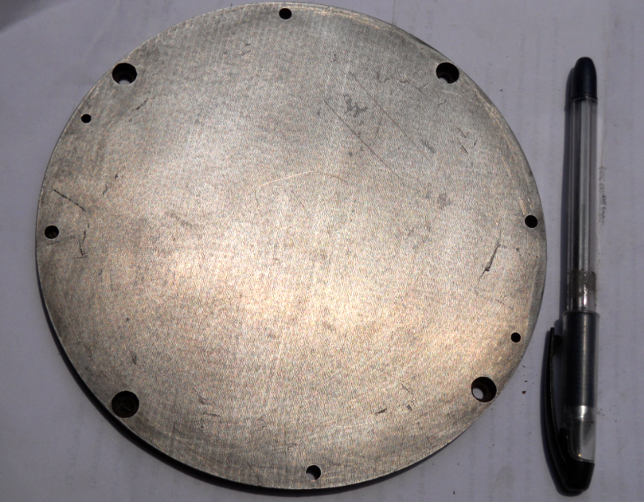
Figure 5 Mild steel disc before etching

3.2 Sample Preparation
3.2. A Etching
Image analysis work is facilitated if the etchant chosen improves the contrast between the fea ture of interest and everything else. Thousands of etchants have been developed over the years, but only a small number of these are selective in nature. Although the selection of the best etchant, and its proper use, is a very critical phase of the image analysis process, only a few publications have addressed this problem. Stansbury [15] has described how potentiostatic etching works and has listed many preferential potentiostatic etching methods. The potentiostatic offers the ultimate in control over the etching process and is an outstanding tool for this purpose. Many tint etchants act selectively in that they color either the anodic or cathodic constituent in a microstructure. tint etchants are listed and illustrated in several publications .
A classic example of the different behavior of etchants where low-carbon steel has been etched with the standard nital and picral etchants, and also a color tint etch. development of color image analyzers, this image can now be used quite effectively to provide accurate grain size measurements since all of the grains are colored. etching with 2% nital reveals the ferrite grain boundaries and cementite. Note that many of the ferrite grain boundaries are missing or quite faint, a problem that degrades the accuracy of grain size ratings.
Microscopic examination is usually limited to a maximum magnification of 1000X - the approxi- mate useful limit of the light microscope, unless oil immersion objectives are used. Many image analysis systems use relay lenses that yield higher screen magnifications that may make detection of fine structures easier. however, resolution is not improved beyond the limit of 0.2-0.3-µm for the light microscope. Microscopic examination of a properly prepared specimen will clearly re- veal structural characteristics such as grain size, segregation, and the shape, size, and distribution of the phases and inclusions that are present. Examination of the microstructure will reveal prior mechanical and thermal treatments give the metal. Many of these micro structural features are measured either according to established im- age analysis procedures, e.g., ASTM standards, or internally developed methods. Etching is done by immersion or by swabbing (or electrolytically) with a suitable chemical solution that essentially produces selective corrosion. Swabbing is preferred for those metals and alloys that form a tenacious oxide surface layer with atmospheric exposure such as stainless steels, aluminum, nickel, niobium, and titanium and their alloys. It is best to use surgical grade cotton that will not scratch the polished surface. etch time var- ies with etch strength and can only be determined by experience. In general, for high magnification examination the etch depth should be shallow; while for low magnification examination a deeper etch yields better image contrast. Some etchants produce selective results in that only one phase will be attacked or colored. A vast number of etchants have been developed etchants that reveal grain boundaries are very important for successful determination of the grain size. Measurement of grain size in austenitic or face-centered cubic metals that exhibit annealing twins is a commonly encountered problem.
The experimental study of chemical etching of mild steel was carried out in beaker, using immersion etching method. The hardness of the material was 175–200HB. The thickness of specimen was 6mm and cut at 10mm×60mm dimensions.

3.2.B Steps to etch mild steel
1- Choose the type of steel you want to etch. You can etch stainless steel, mild steel, or high-carbon steel. Which type of steel you etch will determine the best acid or chemical to use to etch it with.
2- Remove any burrs on the edges of the steel. File away any burrs on the side of the steel you plan to etch with acid. You can leave the burrs on the other side if you're etching a steel plate.
3- Scrub the steel. Use a chlorine cleanser on an abrasive sponge, a wire brush, fine steel wool, wet number 600 emery paper, or corundum paper, scrubbing in a circular motion. You want to leave the surface just gritty enough to grip the resist material, but not so scratched that you end up etching extra lines that aren't part of your design.
4- Rinse the steel with water. The water should sheet off the steel surface. Clean the steel a second time with isopropyl alcohol.
5- Choose the image you want to etch into the steel. You can either draw a freehand image or replicate an existing image onto the steel surface. Depending on which transfer method you use, you can have a fairly simple design or a complex one.
If you plan to replicate an existing design, choose something in high-contrast black and white. If you plan to make and sell prints of your etching, choose an image in the public domain or get the permission of the copyright holder, if there is one.
Transfer your design onto the steel surface. You can transfer the design in A of several ways, as described below. Be aware that however you transfer your design, it will print the reverse of the way you etch it into the steel. If you plan to use the etched steel plate solely as a decoration, not to print with, this won't matter to you.
The oldest method for transferring designs is to coat the steel surface with a liquid varnish or wax-like substance (like beeswax), or even enamel paint or nail polish. This coating is called a ground. You then scratch your design into the ground using needles or wider-bladed cutting tools. (This is similar to woodcutting.) The ground will serve as a resist to keep the etching acid off the steel it covers.
Another method is to cover the steel surface with permanent markers in those places where you want the acid not to etch the steel and leave the surface exposed where you want to etch the steel. You may need to experiment with several brands and colors of permanent marker to determine which make the best resists .
A third method is to create an iron-on stencil by either photocopying an image onto transfer paper or printing it onto glossy photo paper with an inkjet printer. Place the paper onto the steel surface, image-side down, and using a clothes iron set to "high," iron with smooth, circular strokes for 2 to 5 minutes. (Press gently if using transfer paper; press hard if using photo paper.) You can then remove the paper. (Transfer paper will peel away on its own, but photo paper requires soaking in a tray of hot water to soften it for removal.) The transferred ink becomes the resist for the etching acid. Cover the steel's edges. You can tape over the edges or paint them. Either method keeps the acid from etching the edges. Choose the acid you want to etch the steel with. Possible acids include muriatic (hydrochloric) acid (HCl), nitric acid (HNO3), or sulfuric acid (H2SO4). Certain non-acids that form acid in water, such as ferric chloride (FeCl3) or copper sulfate (CuSO4), can also be used as etching chemicals. How strong the acid is generally determines how fast the steel will be etched, or "bitten." You can obtain etching acids and chemicals through chemical supply stores or electronics supply shops.
Ferric chloride is normally mixed with water in equal parts to form hydrochloric acid in solution. It's more commonly used to etch copper, but it also works well to etch stainless steel. It also works with a wider range of resist materials than pure acids do; however, it can pit the surface if not attended to properly .Copper sulfate is better suited to etching mild steels than stainless steel. It is best mixed in a 1 to 1 ratio with sodium chloride (NaCl) to keep the copper sulfate from coating the steel with a deposit of copper that will stop the etching process. The blue solution gradually fades as the etching progresses and turns colorless when it's finished. Nitric acid is commonly mixed in a ratio of 1 part nitric acid to 3 parts water. It can also be mixed with acetic acid (vinegar), in a 1 to 1 ratio, or with hydrochloric acid. Sulfuric acid should be used only in concentrations from 10 to 25 percent. Generally, dilute solutions are more effective than concentrated ones. Acids generally take longer to etch steel than do chemicals that form acids in water, however.5Immerse the steel in a bath of the etching acid. Usually, you'll want to place the steel plate face-down in the solution so that the exposed metal flakes downward into the solution and away from the plate. This produces cleaner lines when etching the steel. If you put the plate in face up, you can sweep away the flakes as they form with a light brush or feather; this will also remove bubbles that form. (The bubbles impede the etching process, but they can also create interesting designs if left alone.) Leave the steel plate in the etching acid until the lines are cut to the depth you want.
Whether you put the steel plate in the etching acid face-up or face down, suspend it off the bottom of the container in some fashion. (This is particularly necessary when the plate is face down.)Tap the container holding the chemical bath periodically to keep the solution agitated.
6-Remove and clean the steel plate. Wash the plate with water to remove the acid. If you used a particularly strong acid, you may also need to use baking soda to neutralize it. You then need to remove the resist; depending on the resist material, use one of the following methods.
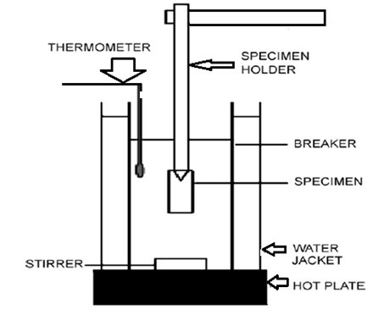
Figure 6 Experimental set up for etching
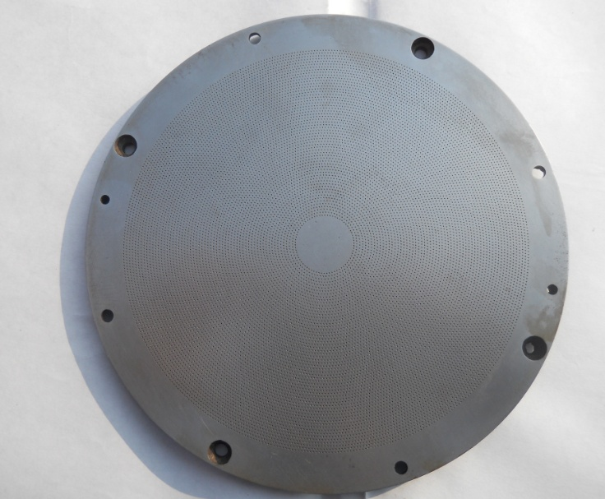
Figure 7 Hexagonal micro holes on disc by chemical etching
3.3 Design of experiment
Statistical methods are commonly used to improve the quality of a product or process. Such methods enable the user to define and study the effect of every single condition possible in an experiment where numerous factors (load and sliding speed) were involved in present work to study the wear behavior of the etched mild steel surface. There were two parameters which were taken into consideration to determine the wear rate and coefficient of friction. The design of experiment was made on the software design ease 7.1. There are several methods to design the experiment in this software but we have chosen general factorial design because it can be design the experimental variable when there are more than three levels. The both of the two variables have three levels. It was sliding speed (150, 200 and 250 rpm) and loads (29.9, 44.1 and 58.8 N) as shown in Table 1.
Table 1.Variables for wear test
Variables | Level 1 | Level 2 | Level 3 | Level 4
Velocity(m/sec) | 6.28 | 5.23 | 4.186 | 3.14
Load (kg) | 2kg | 3 kg | 4 kg | 5 kg

Table 1 shows the two variables used to determine the response such as wear rate, coefficient of friction. The significant variables on which the wear rate and the coefficient of friction depend were directly given by the software with the help of F-test.
Table 2. Specifications of the pin on disk wear and friction monitor
Parameter | Unit | Minimum | Maximum
Disk speed | rpm | 200 | 2000
Pin diameter | mm | 3 | 12
Wear track dia | mm | 50 | 100
Normal load | N | 1 | 200
Frictional force | N | 0 | 200

3.4 Pin on disc test
Pin on disc type wear monitor (DUCOM, TL-20, Bangalore, India) with data acquisition system was used to evaluate the wear behavior of mild steel against two pin of different materials. Load was applied on pin by dead weight through pulley string arrangement. The system had maximum loading capacity of 200 N. The test was performed under dry and wet condition. The wear test can be performed on any wear tester, but for etched mild steel surface, pin on disc wear test is most commonly used (fig. 8).
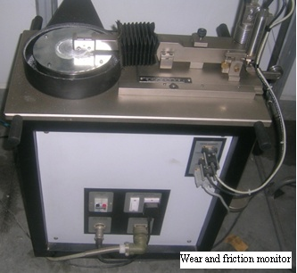
Figure 8 Wear and friction monitor machine for pin on disc test
The mass loss was measured on weight balance (accuracy) and after that specific wear rate has been calculated by using the given formula
K = Vw / L × S
Here Vw is the wear volume, L the applied load and s the total sliding distance and K is specific wear rate care has been taken to clean up the sample before and after each test to prevent any form of corrosion on the surface [33].

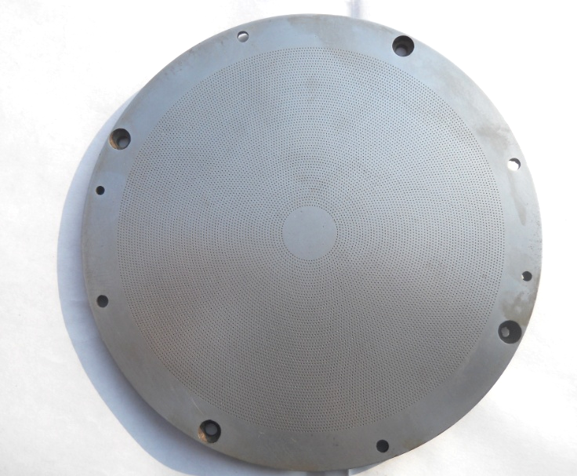
Figure 9 Etched mild disc before wear test

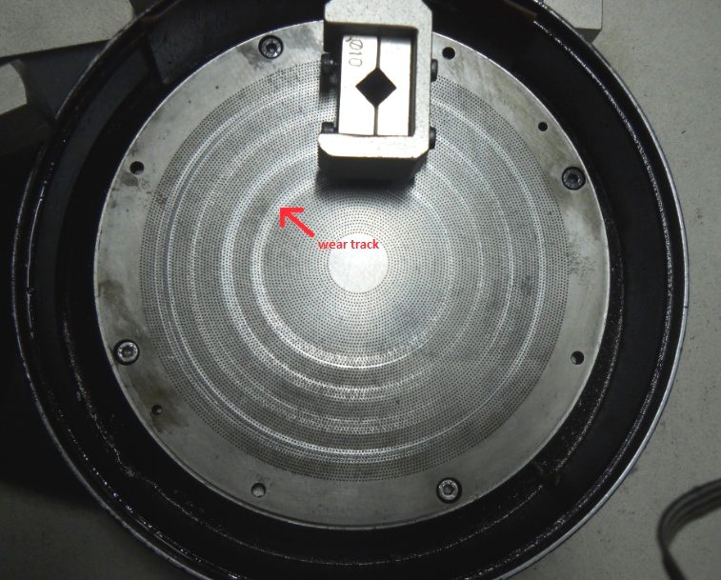
Figure 10 Etched mild disc during wear test

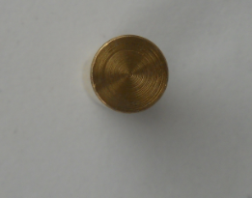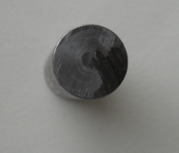
Figure 11 Pins of brass and mild steel
The machine is attached with the computer with software WINDCUM 2008. A window is open in the software and there are options to select various loads, times, pin diameter. The machine directly gives the coefficient of friction on the selected loading and sliding conditions. In this machine basically there is a rotating disc; and a pin is fixed over stainless steel pin holder. The pin can be loaded with different loads, it can be change externally. The coating pasted disc fastened on the machine with the help of screws (fig. 19). The load was applied on the pin through dead weight loading arrangement. The surface and pin was initially washed with methyl alcohol so that, moisture should not present on coating surface. Initially, the brass pin was fixed on the pin holder; the wear rate of the etched disc was calculated at different loading and sliding conditions. The wear rate was calculated by weighing the pin before after the wear test in terms of grams per 2km sliding distance on an electronic balance of least count 0.00001g. The load was taken as 19.62, 29.4, 39.24 and 49.05 N respectively and the sliding speed was taken as 1000 rpm. The wear behavior against two counter pin material was analyzed that was brass, medium carbon steel pin. The pin of diameter 3 mm was chosen for all of the three materials. The wear test carried out at 30˚C temperature (in the month of April). During the wear test some amount of material also gets deposited on the pin in the form of a tribo layer so pin was cleaned after every test. So that there was always contact between brass pin and the coating surface, and the wear mechanism was between pin and coating surface, and a wear track was formed on the surface.

Chapter 4
Results and Discussions

4.1 Wear rate with mild steel pin in wet condition
The mild steel pin taken for experiment has dimension of diameter of 9 mm and length is about 30 mm. The initial mass of pin was 19.5102 gm. The projected length beyond gripping in the clamp of the test rig is 4 mm.
The mild steel disc of diameter 165 mm is taken for testing having hexagonal etched holes with the distance 420 microns across the corners.
The experiment carried shows the variables and the results obtained during pin on disc test in table 3. Column 1 shows velocities (m/s) for different loads (kg). Column 2 shows the load applied during each run. The mean value of friction force for each run is taken from the graph showing on computer monitor attached with wear testing machine and then coefficient of friction is obtained. Coefficient of friction is shown in column 3. Disc rpm is shown in column 5.Tracking distance is taken in decreasing order from 120 to 60. Sliding distance is taken 2000m. time recorded in each run is shown in column 8. Column 9 shows mass after wear of pin by weighing in weighing machine. Last column shows specific wear rate (m²/n).

Table 3 Variables and result obtained in wet condition with mild steel pin.
Velocity  (m/sec.) | Load  (kg) | Coeff.of friction | Friction force  (N) | Disc rpm | Tracking  distance | Sliding  Distance  (km) | Time  (sec.) | Mass  After wear  (gm) | Mass loss  (gm) | Specific wear  (m²/n)×  10⁵
3.14 | 2 | .08154 | 1.6 | 1000 | 120 | 2 | 318 | 19.5101 | .0001 | 3.98
4.186 | 3 | .0645 | 1.8 | 1000 | 100 | 2 | 382.16 | 19.5100 | .0002 | 7.07
5.234 | 4 | .0739 | 2.9 | 1000 | 80 | 2 | 477.70 | 19.5099 | .0003 | 6.58
6.28 | 5 | .0672 | 3.3 | 1000 | 60 | 2 | 636.44 | 19.5098 | .0004 | 7.72

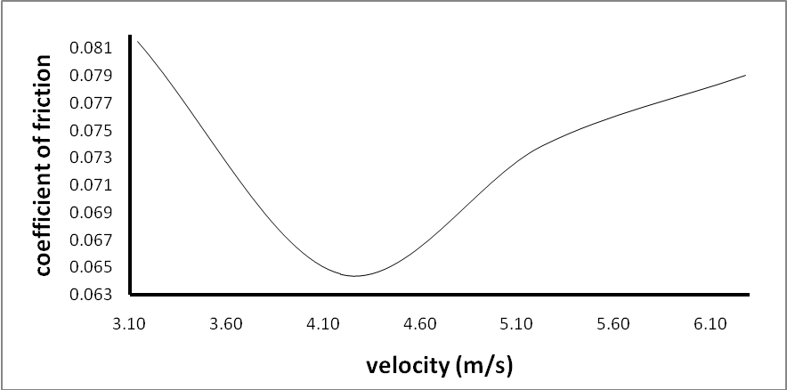
Figure 12 Coefficient of friction vs. velocity
The variation of coefficient of friction with the velocity is shown in Figure 12. Figure has 3 zones. First zone is boundry or mixed zone. In first zone, coefficient of friction decreases with velocity. In second zone, elasto hydrodynamic film is produced. Coefficient of friction decreases up to its minimum value of 0.0645 at 5.23 m/s velocity of disc. In third zone hydrodynamic condition exists. In third zone coefficient of friction increases rapidly due to debris present between pin and disc. Slope of curve in velocity range of 3.1 to 5.1 m/s. should be continuously increasing but due to insufficient lubrication and debris sticking in wear area, it is not continuously increasing. Maximum value of coefficient of friction is 0.08154.
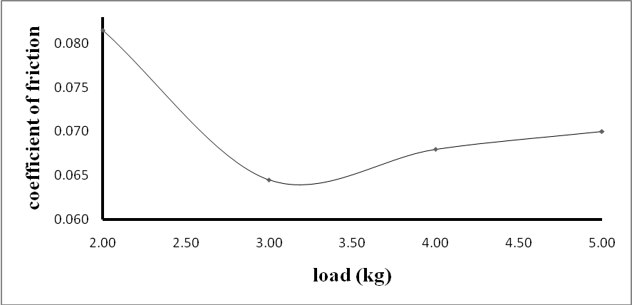
Figure 13 Coefficient of friction vs. load
The variation of coefficient of friction with the load is shown in Figure 13. Figure 13 has 3 zones. First zone is boundry or mixed zone. In first zone, coefficient of friction decreases continuously with load. In second zone, elasto hydrodynamic film is produced. In this zone, coefficient of friction attains its lowest value of 0.0645 at 3 kg. In third zone hydrodynamic condition exists. In zone 3 coefficient of friction increases slowly compare to zone 2 due to less debris present in wear area. Maximum value of Coefficient of friction is 0.08154.

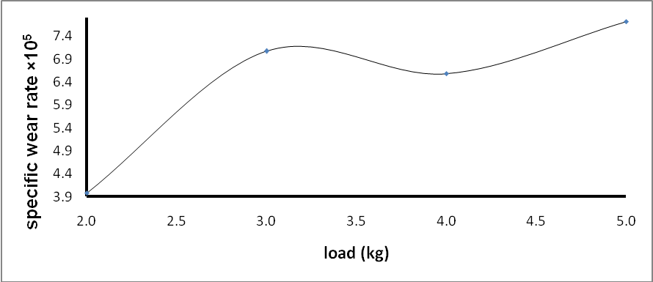
Figure 14 Specific wear rate vs. load
The variation of specific wear rate with the load is shown in Figure 14. Figure 14 shows specific wear rate is increasing up to the load of 3 kg attains the value of 7.07 and then decreases beyond this load. This may be due to formation of debris of mild steel pin which reduces the area of contact between pin and disc and finally the wear rate again increases beyond 4 kg load. Maximum value of specific wear rate is 7.72 obtained at 5 kg load.
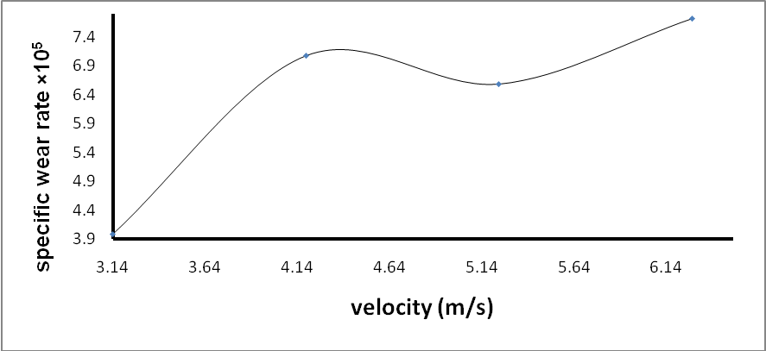
Figure 15 Specific wear rate vs. velocity
The variation of specific wear rate with the velocity is shown in Figure 15. Figure has 3 zones. In first zone specific wear rate increases with velocity. It attains value of 7.07 at 4.186 m/s. Because of formation of thick film of lubricant between pin and disc, in zone 2 specific wear rate decreases up to 6.58 at velocity of 5.234 m/s. In zone 3 specific wear rate increases up to 7.72.
4.2 Wear rate with steel pin in dry condition
The brass pin taken for experiment has dimension of diameter of 89 mm and length is about 30 mm. The initial mass of pin was 19.5098 gm. The projected length beyond gripping in the clamp of the test rig is 4 mm.
Table 4 variables and result obtained in dry condition with mild steel pin
Velocity  (M/sec.) | Load  (Kg.) | Friction force(N) | Disc rpm | Tracking  distance | Sliding  Distance  (km) | Mass  After wear  Loss (gm) | Mass loss  (gm)
6.28 | 1 | 5.6 | 1000 | 120 | 2 | 19.5094 | .0004

Friction force started from zero then rose up to 7 after that it decreased and curve become stable, its mean value 5.6 was observed. After 260 sec. again friction force rose to 7.6 and then decreased.
4.3 Wear rate with brass pin
The brass pin taken for experiment has dimension of diameter of 9 mm and length is about 30 mm. The initial mass of pin was 20.7986 gm. The projected length beyond gripping in the clamp of the test rig is 4 mm.
Table 5 shows variables and the results obtained during pin on disc test. Column 1 shows velocities (m/s) for different loads (kg).column 2 shows load applied in each run. Column 3 shows coefficient of friction. Mean value of friction force for each run is taken from the figure showing on computer monitor attached with wear testing machine and then coefficient of friction is obtained disc rpm is shown in column 5. Column 6 shows tracking distance taken in each run. Tracking distance is taken in decreasing order from 120 to 60. Column 8 shows time for each run. Column 9 shows mass after wear of pin by by weighing in weighing machine. Last column shows specific wear rate.
Table 5 variables and result obtained in wet condition with brass pin
Velocity  (M/s) | Load  (kg) | Coeff. of friction | Friction force(N) | Disc rpm | Tracking  distance | Sliding  Distance  (km) | Time  (s) | Final Mass  (gm) | Mass loss  (gm) | Specific wear  (m²/n)×  10⁵
6.28 | 2 | .04587 | 0.9 | 1000 | 120 | 2 | 318 | 20.7979 | .ooo7 | 4.57
5.23 | 3 | .0339 | 1 | 1000 | 100 | 2 | 382.16 | 20.7973 | .0013 | 7.64
4.186 | 4 | .0280 | 1.1 | 1000 | 80 | 2 | 477.70 | 20.7966 | .0020 | 10.69
3.14 | 5 | .0387 | 1.8 | 1000 | 60 | 2 | 637 | 20.7961 | .0025 | 8.16

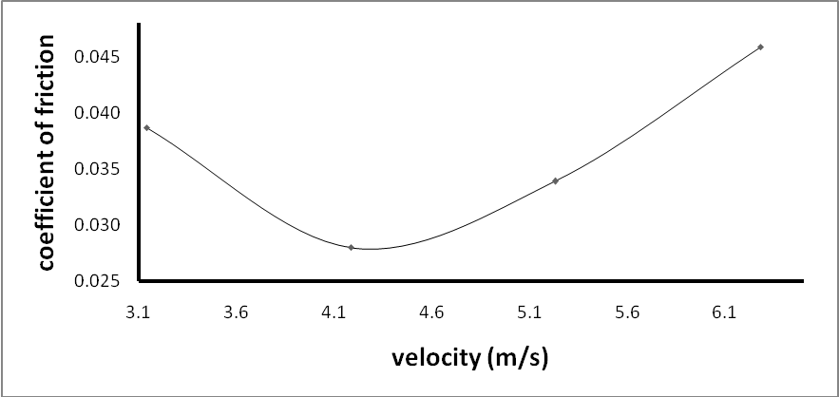
Figure 16 Coefficient of friction vs. velocity
The variation of coefficient of friction with the velocity is shown in Figure 16. The figure has 3 zones. First zone is boundry or mixed zone. In first zone Coefficient of friction decreases with velocity. In second zone, elasto hydrodynamic film is produced. In this zone Coefficient of friction decreases up to its lowest value of 0.0280 at 4.186 m/s. In zone 3, Coefficient of friction increases up to 0.04587. The reason for increasing coefficient of friction is the presence of debris between pin and disc. Curve is uniform and shows actual stribeck curve.
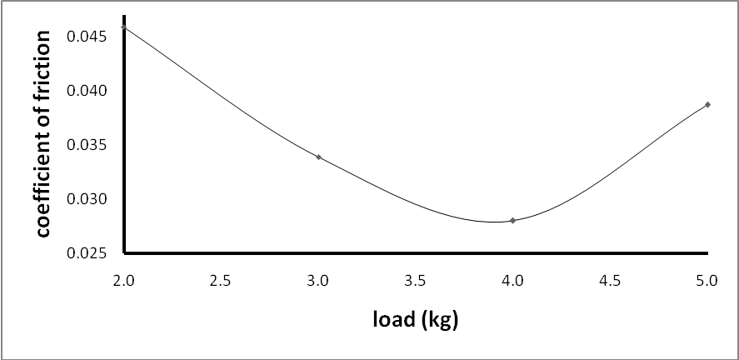
Figure 17 Coefficient of friction vs. load
The variation of coefficient of friction with the load is shown in Figure 17. The figure has 3 zones. First zone is boundry or mixed zone. In first zone, the coefficient of friction decreases with load. In second zone, elasto hydrodynamic film is produced. Coefficient of friction obtained its lowest value of 0.0280 at 4 kg. In third zone hydrodynamic condition exist. In zone 3, coefficient of friction continuously increases and attained its maximum value of 0.04587. In zone 3, coefficient of friction is increasing because of debris presence between pin and disc.
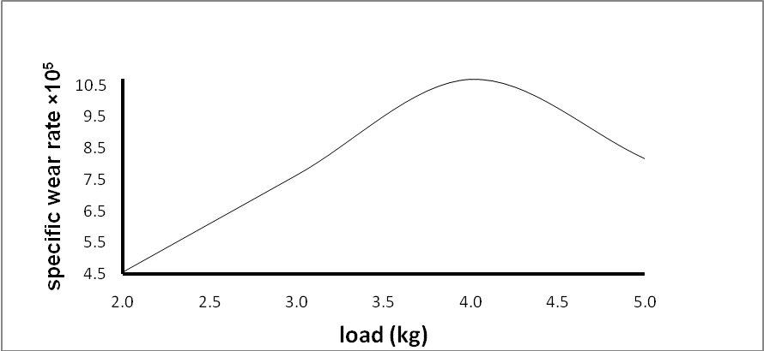
Figure 18 Specific wear rate vs. load
The variation of Specific wear rate with load is shown in Figure 18. Figure has 2 zones. In first zone, Specific wear rate continuously increases and obtained its maximum value of 10.69 at the load of 4 kg. In zone 2 Specific wear rate decreases up to 8.16 due to insufficient lubrication and debris present between pin and disc.

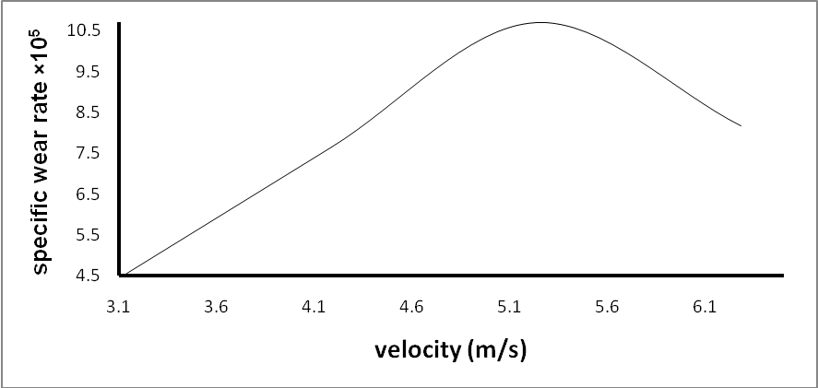
Figure 19 Specific wear rate vs. velocity
The variation of Specific wear rate with the velocity is shown in Figure 19. Figure has 2 zones. In zone 1 specific wear rate is increasing up to 5.3 m/s velocity of disc and attained it maximum value of 10.69. In zone 2 specific wear rate decreases because of thick layer of lubricant and also formation of debris. Specific wear rate decreases up to 8.16.
4.4 Wear rate with brass pin in dry condition
The brass pin taken for experiment has dimension of diameter of 9 mm and length is about 30 mm. The initial mass of pin was 20.7950 gm. The projected length beyond gripping in the clamp of the test rig is 4 mm.
Table 6 shows variables and the results obtained during pin on disc test. Column 1 shows velocity (m/s) for load (kg). Column 2 shows load applied in wear test run. Column 3 shows friction force. Mean value of friction force for each run is taken from the figure showing on computer monitor attached with wear testing machine and then coefficient of friction is obtained disc rpm is shown in column 4. Column 5 shows tracking distance taken in wear test run. Tracking distance is taken 100. Column 7 shows mass after wear of pin by weighing in weighing machine.
Table 6 variables and result obtained in dry condition with brass pin
Velocity  (M/sec.) | Load  (Kg.) | Friction force (N) | Disc rpm | Tracking  distance | Sliding  Distance  (km) | Mass  After wear  Loss (gm) | Mass loss  (gm)
5.23 | 1 | 0.7 | 1000 | 100 | 2 | 20.7938 | .0012

Friction force started from zero then raised up to 0.7 after that it decreased and curve become stable, mean value 5.6 was observed. After 260 sec. again friction force rose to 7.6 and then decreased.

Chapter 5
Conclusions

This research work presents that optimized and well-controlled micro-craters were successfully produced on the common carbon steel substrates. Microstructure and mechanical properties of the textured dimples were characterized and analyzed. The etched-dimpled hard craters present a strong metallurgical bonding with the substrate. Microstructure of the deposited regions mainly consists of fine and defect-free hard grained structures. Compositions distributed in the texturing layers are rather uniform. The comprehensive mechanical properties of the texturing layers are greatly enhanced. The hard crater on the roll surface results in substantial reductions in friction. The chemical etched work piece is demonstrated to have excellent abrasion resistance and a much longer service life.
The abrasive wear resistance was 10 times higher than that of the substrates. In wet condition with mild steel pin, coefficient of friction decreases up to 0.0645 at 5.23 m/sec. velocity of disc. Maximum value of coefficient of friction is 0.08154.The same phenomenon also occurs with load. Coefficient of friction decreases up to 0.0645 at 3 kg load. Specific wear rate also increases up to velocity of 4.2 m/sec. of disc. With brass pin coefficient of friction decreases up to 0.0280 at 4.186 m/sec. velocity of disc and then increases up to 0.04587. With load, coefficient of friction decreases up to 0.0280 at 4 kg and then increases up to 0.04587. Specific wear rate is increasing up to 4.5 kg then decreases. With brass and mild steel pins, specific wear rate increases first with velocity and load and then decreases, after this it also increases. Since specific wear rate should increased uniformly but due to debris present between pin and disc the area of contact reduces and due to this wear also reduced. One more reason is insufficient lubrication in wear area during wear testing.

Chapter 6
Future Scope

This study showed further research opportunities in the chemical etching of mild steel such as investigating various etchant concentrations on etching parameters, some chemical additives to main etchant and examining other possible etchants. Moreover, environmentally acceptable mild steel etching process should be investigated including economical regeneration of waste etchant and recovery of etch material. Depth of etch and surface finish is greatly influenced with concentration of etchant and time of application of etchant. So for future prospects these variables can be varied and result can be observed. In this research work hexagonal micro dimples is created but circular, triangular and various other shape can be generated on disc and effect can be analyzed. Pin of mild steel and brass is used in this work but pin of other material can also be tested.

References

[1] K. Kato, Wear in relation to friction - a review, Wear, vol. 241, pp. 151–157, 2000.
[2] A.P. Sannino, H.J. Rack, Dry sliding wear of discontinuously reinforced aluminum composites review and discussion, Wear, vol. 189, pp. 1-19, 1995.
[3] M. Singh, D.P. Mondal, O.P. Modi, A.K. Jha, Two-body abrasive wear behaviour of aluminum alloy-sillimanite particle reinforced composite, Wear, vol. 253, pp. 357–368, 2002.
[4] N. Kahramana, B. Gulenc¸ Abrasive wear behavior of powder flame sprayed coatings on steel Substrates, Materials and Design, vol. 23, pp. 721–725, 2002.
[5] T. Satoh , N. Koreeda , T. Hayashi , M. Nagai, Fretting fatigue properties of turbine blade/disk joints, Technical Research and Development Institute, Japan Defense Agency Technical Report No. 6687, 1999.
[6] Y. Torres, S. Rodriguez, A. Mateo, M. Anglada, and L. Llanes, Fatigue behavior of powder metallurgy high-speed steels, fatigue limits prediction using a crack growth threshold-based approach, Mater. Sci. Engg. a Structure Mater, pp. 387–389, 501–4, 2004.
[7] J. Takeda, M. Niinomi, T. Akahori, Gunawarman, Effect of microstructure on fretting fatigue and sliding wear of highly workable titanium alloy (Ti–4.5Al–3V–2Mo–2Fe), Toyohashi, Japan 19 December, 2003.
[8] Y. Iwai a, T. Honda, H. Yamadaa, T. Matsubara, M. Larsson, S. Hogmarkd, Evaluation of wear resistance of thin hard coatings by a new solid particle impact test, Wear, vol. 251, pp. 861–867, 2001.
[9] B. Xua, Z. Zhua, S. Maa, and W. Zhang, W. Liu, Sliding wear behavior of Fe–Al and Fe–Al/WC coatings prepared by high velocity arc spraying, Wear, vol. 257, pp. 1089–1095, 2004.
[10] T. Kachele, Recent research results on predicting and preventing silt erosion, Proceedings of the First International Conference on Silting Problems in Hydropower Plants, India, 1999
[11] Y. Wang, S. Tung, Scuffing and wear behavior of aluminum piston skirt coatings against aluminum cylinder bore, Wear, vol. 225–229, pp. 1100–1108, 1999.
[12] Y.Iwai, T. Honda, H. Yamadaa, T.Matsubara, M. Larsson, S. Hogmarkd, Evaluation of wear resistance of thin hard coatings by a new solid particle impact test, Wear, vol. 251, pp. 861–867, 2001.
[13] R. P. Nair, D. Griffin, N. X. Randall, The use of the pin-on-disk Tribology test method to study three unique industrial applications, Wear, vol 267, pp. 823–827, 2009.
[14] G. Prieto, M.D. Faulkner, J.R. Alcock, The influence of specimen misalignment on wear in conforming pin on disk tests, Wear, vol. 257, pp. 157–166, 2004.
[15] I.Etsion, Surface texturing and applications, In: Nikas GK, editor, Recent developments in wear prevention, friction and lubrication, Kerla, India, research signpost, pp. 137-58, 2010.
[16] A. Kovalchenkoa, O. Ajayia, A. Erdemira, G. Fenskea, I. Etsion, The effect of laser surface texturing on transitions in lubrication regimes during unidirectional sliding contact, Tribology International, pp. 219–225, 2005
[17] L.M. Vilhena, M. Sedlacek, B. Podgornik, J. Vizintin, A. Babnik, J. Mozina, Surface texturing by pulsed Nd:YAG laser, Tribology International, vol 42, pp. 1496–1504, 2009.
[18] Y. Qiu, M.M. Khonsari, Investigation of tribological behaviors of annular rings with spiral groove, Tribology International, vol. 44, pp. 1610–1619, 2011
[19] S. Ilo , A.Tomala, E. Badisch, Oxidative wear kinetics in unlubricated steel sliding contact, Tribology International, vol. 44, pp. 1208–1215, 2011.
[20] L. Jianliang, D. Xiong, H. Wu, Y. Zhang, Y. Qin, Tribological properties of laser surface texturing and molybdenizing duplex-treated stainless steel at elevated temperatures, Tribology International, pp. 203-367, 2012.
[21] J. Zhang and Y. Meng, A study of surface texturing of carbon steel by photochemical machining, State Key Laboratory of Tribology, Tsinghua University, Beijing 100084, China
[22] Da-ping Wana, Bing-kui Chen , Yi-min Shao , Shi-long Wanga, De-jin Hub, Microstructure and mechanical characteristics of laser coating–texturing alloying dimples, Applied Surface Science, vol. 255, pp. 3251–3256, 2008.
[23] S. Gupta, M.W. Barsoum, On the tribology of the MAX phases and their composites during dry sliding: A review, Wear, vol. 271, pp. 1878– 1894, 2011.
[24] P. Andersson , J. Koskinen , S. Varjus , Y. Gerbig , H. Haefke , S. Georgiou , B. Zhmudd, W. Buss, Microlubrication effect by laser-textured steel surfaces, Wear, vol. 262, pp. 369–379, 2007.
[25] Y. Qiu, M. M. Khonsari, Experimental investigation of tribological performance of laser textured stainless steel rings, Tribology International, vol. 44, pp. 635–644, 2011.
[26] O.C Akir, Chemical etching of mild steel, Dicle University, 21280 Diyarbakir, Turkey, journal of materials processing technology, Int., vol. 36(3), pp. 189–197, 2009.
[27] J.W. Dini, Fundamentals of chemical machining, American Machinist, Special Report, vol. 768, 128, pp.113–128, 2005
[28] D. Das, K.K. Ray, A.K. Dutta, Application of corrosion sensor to measure corrosion rate in mild corrosive environments and the ability to detect the corrosion mechanism, pp. 271 303, 2009.
[29] C. Donga, Y. Gua, M. Zhonga, L. Li , K. Sezerb, M Maa, Fabrication of Hydrophobic Cu surfaces with tunable regular microstructure and random nanostructures by nano second pulsed laser texturing and chemical etching, pp. 131-160, 2009.
[30] V. Brizmer , Y. Kligerma, Influence of temperature of sub-zero treatment on the wear behavior of AISI D2 steel. Tribology Transactions, vol. 46(3), pp. 397-403, 2003..
[31] R.C. Singh, R.K. Pandey, S. Maji, Experimental studies for accessing the influence of micro–dimple area density on tribological performance of matting contacts, International Tribology Conference, Hiroshima, 2011.
[32] C.M.Taylor, Engine Tribology, The University of Leeds, U.K., pp. 198, 1993
Appendix 1
Graph obtained from wear testing machine in wet condition with mild steel pin.
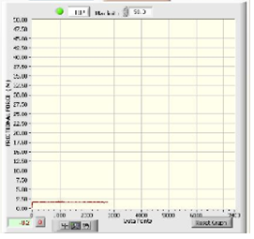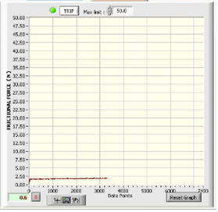

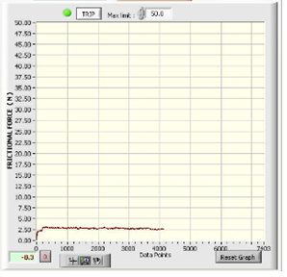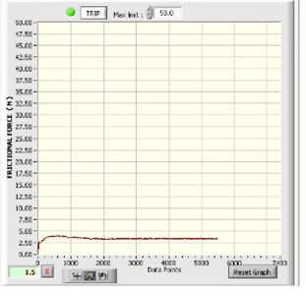

Appendix 2
Graph obtained from wear testing machine in wet condition with brass pin
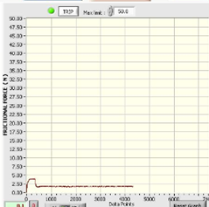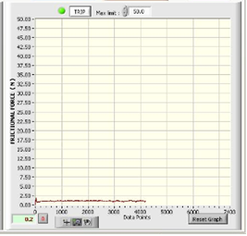

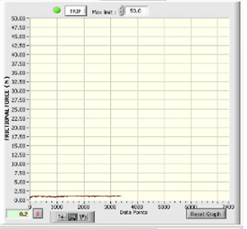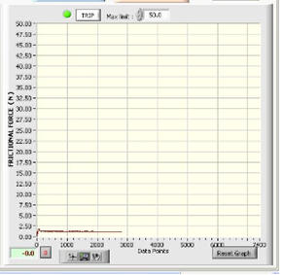

Appendix 3
Graph obtained from wear testing machine in dry condition with mild steel and brass pin.
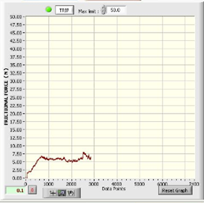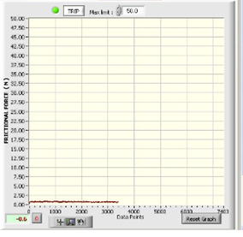

Appendix 4
Reynolds Equation
The serious appreciation of hydrodynamics in lubrication started at the end of the 19th century when Beauchamp Tower, an engineer, noticed that the oil in a journal bearing always leaked out of a hole located beneath the load. The leakage of oil was a nuisance so the hole was plugged first with a cork, which still allowed oil to ooze out, and then with a hard wooden bung. The hole was originally placed to allow oil to be supplied into the bearing to provide ‘lubrication’. When the wooden bung was slowly forced out of the hole by the oil, Tower realized that the oil was pressurized by some as yet unknown mechanism. Tower then measured the oil pressure and found that it could separate the sliding surfaces by a hydraulic force. At the time of Beauchamp Tower's discovery Osborne Reynolds and other theoreticians were working on a hydrodynamic theory of lubrication. By a most fortunate coincidence, Tower's detailed data was available to provide experimental confirmation of hydrodynamic lubrication almost at the exact time when Reynolds needed it. The result of this was a theory of hydrodynamic lubrication published in the Proceedings of the Royal Society by Reynolds in 1886 [2]. Reynolds provided the first analytical proof that a viscous liquid can physically separate two sliding surfaces by hydrodynamic pressure resulting in low friction and theoretically zero wear.
There are two conditions for the occurrence of hydrodynamic lubrication:
· two surfaces must move relatively to each other with sufficient velocity for a load carrying lubricating film to be generated an d,
· surfaces must be inclined at some angle to each other, i.e. if the surfaces are parallel a pressure field will not form in the lubricating film to support the required load.
Simplifying Assumptions
In most engineering applications the controlling processes are too complicated to be easily described by exact mathematical equations. There are many interacting factors and variables in the real processes which make such a description extremely difficult, if not impossible. For example, with fluid mechanics in the early days of modelling, the terms of internal fluid friction were ignored. The mathematician John Newman observed sarcastically that these approximations have nothing to do with real fluids. It was like trying to study the flow of ‘dry water’. The situation dramatically changed with the introduction of computers so that mechanical systems could be studied in a more detailed fashion.
The Reynolds equation can now be conveniently derived by considering the equilibrium of an element (from which the expressions for fluid velocities can be obtained) and continuity of flow in a column.
Equilibrium of an Element
The equilibrium of an element of fluid is considered. This approach is frequently used in engineering to derive formulae in stress analysis, fluid mechanics, etc. Consider a small element of fluid from a hydrodynamic film shown in Figure. For simplicity, assume that the forces on the element are acting initially in the ‘x’ direction only.
Since the element is in equilibrium, forces acting to the left must balance the forces acting to the right, so

Fluid Force - Shear force b/w adjacent layers consider an element of fluid.
For equilibrium
(i)
(ii)
Since pressure is constant throughout the the
from Newtons law of viscosity
Putting these values in (i) & (ii)
(iii) (Since = constant)
Now integrating equation (iii) on both side w.r.t. 'z'
Integrating again
(iv)
At z = h
u = v1
At z = 0
v = v2
Applying boundary conditions to (iv)
Putting values of c1 & c2 in equation (iv)
On simplification
Rate of flow
(v)
(vi)

Infinity Long Bearing
For Max Pressure
- (Local film thickness)
(vii)
Renold's equation in two & 3 dimension
from equation of continuity
For most of the bearing surface movement is zero in 'y' direction
Putting there values in continuity equation
= Constant
(Equation in 2-D)
For 3-D
Putting values of qx, qy & qz
(for 3-D)
If
On Integrating
At
,

