FOUR WAVE MIXING EFFECT IN WAVELENGTH DIVISION MULTIPLEXING FOR RADIO OVER FIBRE SYSTEM
A Dissertation Submitted towards the Partial Fulfillment of Award of Degree of
MASTER OF TECHNOLOGY
in
MICROWAVE AND OPTICAL COMMUNICATION ENGINEERING
Submitted by
PRATIMA SINGH
2K09/MOC/10
Under the Supervision of

Dr. R K Sinha
Head of Applied Physics department
Department of Electronics & Communication Engineering

DEPARTMENT OF ELECTRONICS AND COMMUNICATION ENGINEERING
IN ASSOCIATION WITH
DEPARTMENT OF APPLIED PHYSICS
DELHI TECHNOLOGICAL UNIVERSITY
(Formerly Delhi College of Engineering)
Main Bawana Road, Shahabad Daulatapur, New Delhi – 110042
June-2011
CERTIFICATE

This is to certify that the dissertation titled “Four Wave Mixing Effect In Wavelength Division Multiplexing for Radio over Fibre System” is the bonafide work of Pratima Singh (2K09/MOC/10) under our guidance and supervision in partial fulfilment of requirement towards the degree of Master of Technology in Microwave and Optical Communication Engineering from Delhi Technological University, New Delhi.

Dr. Rajiv Kapoor
Head of Department
Electronics and Communication Engineering
Delhi Technological University
Delhi
Date: /06/2011
Dr R K Sinha
Head of Applied Physics Department
Delhi Technological University
Delhi
Date: /06/2011
ACKNOWLEDGEMENT

I would like to thank my project Guide, Dr.R.K.Sinha, Head of Applied Physics Department, Delhi Technological University, Delhi, for providing me with the right balance of guidance and independence in my work. I am greatly indebted to him for his full support, constant encouragement and advice both in technical and non-technical matters, valuable suggestion, and guidance and for kind co-operation throughout the bringing up of the major project.

Not forgetting my parents and brother, who had given me their love and support throughout my stay here in Delhi, for which without, my studies here would not have been possible.

Lastly, I offer my regards and blessings to all of those who supported me in any respect during the completion of the project.

PRATIMA SINGH
2k09/MOC/10
M Tech (Microwave and Optical communication Engineering)
Department of Electronics and
Communication Engineering,
DTU, DELHI
Abstract

The integration of wireless and optical networks is the potential solution for the increasing capacity and mobility as well as decreasing costs in the access networks. Optical networks are fast, robust and error free, however, there are nonlinearity obstacles preventing them from being perfect media.
The performance of wavelength division multiplexing (WDM) in radio over fibre (RoF) system is found to be strongly influenced by nonlinearity characteristics inside the fibre. The effect of four wave mixing(FWM) as one of the influential factors in the WDM for RoF has been studies here using Virtual Photonic Incorporated (VPI) and MATLAB software.
It is the advent of the optical amplifier enabling high power and long unregenerate distance that have caused significant fibre nonlinearity that necessitated the use of numerical modelling: to calculate the cross talk due to Four wave mixing and the interplay of nonlinearity. Here numerical modelling is developed with the help of Virtual photonic Incorporated (VPI) software. For the analytic analysis MATLAB software is used.
The results obtained from both software, it is found that the FWM effects have become significant at high power levels and have become even more significant when the optical transmission line is increased, which has been done by either increasing the channel bit rate and decreasing the channel spacing, or by the combination of both process.
Numerical and analytical simulation is done through the Virtual Photonic Incorporated and MATLAB software respectively, it is found that FWM effects increases as power from the signal sources increases.

TABLE OF CONTENTS ABSRACT TABLE OF CONTENTS LIST OF FIGURES
- INTRODUCTION
  - Introduction 1
  - Problem Background 2
  - Problem Statement 3
  - Objective of Project 4
  - Scope of Project 4

- RADIO OVER FIBRE

2.1Wireless Communication System 5
2.2 Broadband Wireless Communication System 6
2.3 Challenges of Broadband Wireless Access Network 7
2.4 Radio over Fibre Technology 9
  - Applications of RoF Technology 14
  - Techniques for Transporting RF Signals over Optical Fibre 22
  - Fibre characteristics, losses and non-linear effects 29

3 METHODOLOGY

3.1 Introduction 39
3.2 Simulation using Virtual Photonic Incorporated Software 39
3.3 The Simulation Model 39
3.4 Simulation of the Four Wave Mixing effect 42
3.5 Simulation of FWM for higher number of channels 45
3.6 Modelling the Effect of FWM 45

4 RESULTS AND DISCUSSIONS
4.1 Introduction 49
4.2 Simulation of the Four Wave Mixing Effect 49
4.3 Simulation Results without the External Modulated Signal 49
4.4 Simulation Results with the External Modulated Signal 52
4.5 Simulation of Four Wave Mixing for Higher Number of Channels 57
4.5.1 Simulation Results for Four Signal Source without External Modulated 57
Signal
4.5.2 Simulation Results-Three Signal Source with External Modulated Signal 59
4.6 Discussions 62
4.7 Analytical Modelling 64
4.8 Four Wave Mixing Reduction 65

5 CONCLUSION AND RECOMMENDATIONS
5.1 Conclusion 66
5.2 Recommendations for Future Work 67

REFERENCES

LIST OF FIGURES

Fig 2.1 Global Growth of Mobile and Fixed Subscribers 5

Fig 2.2 Overview of present and future wireless communication
Systems 7
Fig 2.3 Schematic Showing the Components of a Narrowband Wireless
Access Network 8

Fig 2.4 The Radio over Fibre System Concept 10

Fig 2.5 900 MHz Fibre-Radio System 10

Fig 2.5.2.1.1 Point to point architecture 15

Fig 2.5.2.1.2 Active star architecture 15

Fig 2.5.2.1.3 Passive Star Architecture 16

Fig 2.5.3 RoF for Indoor wireless access 18

Fig 2.5.4 Evolution of various wireless networks 19

Fig 2.5.5 RoF for 3G and 4G 19

Fig 2.5.6 Block diagram of the fibre-radio link 20

Fig 2.5.7 Architecture of the control station and the base station 21

Fig 2.5.8 RoF Architecture for UWB Radio 22

Fig 2.6.1 Generating RF Signals by Direct Intensity Modulation
(a) of the Laser, (b) Using an External Modulator 23

Fig 2.6.2 Principle of Optical Coherent Mixing based on the FM Laser 25

Fig 2.6.3 Frequency Conversion Through Mixing by a Mach -Zehnder
Interferometer 27

Fig 2.6.4 Sub-Carrier Multiplexing of Mixed Digital and Analogue
Signals 28

Fig 2.6.5 WDM system using multiple wavelength channels and
optical amplifiers 29

Fig 2.7.1 The refractive index of silica versus optical power 32

Fig 2.7.2 Effects of SPM on a Pulse 34

Fig 2.7.3 FWM Products for a Three Wavelength System 38

Fig 2.7.4 FWM Products versus Channel Count 38

Fig 2.7.5 FWM Mixing Efficiency in Single-mode Fibres 39

Fig 3.1 Direct modulation 40

Fig 3.2 External modulation 40

Fig 3.3 Simulation model with external modulated signal 41

Fig 3.4 Simulation model without external modulated signal 41

Fig 3.5 Simulation model with three channels 45

Fig 3.6 Simulation model with four channels 45

Simulation Results without the External Modulated Signal

WDM analyzer input

Fig 4.3.1 Power versus Optical Frequency 49

Fig 4.3.2 Power versus Optical Wavelength 50

WDM analyzer output

Fig 4.3.3 Power versus Optical Frequency 50

Fig 4.3.4 Power versus Optical Wavelength 50

Optical Spectrum Analyzer input

Fig 4.3.5 Power versus Frequency 51

Fig 4.3.6 Power versus Time 51

Optical Spectrum Analyzer output

Fig 4.3.7 Power versus Frequency 51

Fig 4.3.8 Power versus Time 52

Simulation Results with the External Modulated Signal

WDM analyzer input

Fig 4.4.1 Power versus Optical Wavelength 52
Fig 4.4.2 Eye Diagram 52
Fig 4.4.3 Power versus Time 53
Fig 4.4.4 BER versus Received Optical Power 53

WDM analyzer output

Fig 4.4.5 Power versus Optical Wavelength 53
Fig 4.4.6 Eye Diagram 54
Fig 4.4.7 Power versus Time 54
Fig 4.4.8 BER versus Received Optical Power 54

Optical Spectrum Analyzer input

Fig 4.4.9 Power versus Frequency 55

Fig 4.4.10 Power versus Time 55

Fig 4.4.11 Eye Diagram 56

Optical Spectrum Analyzer output

Fig 4.4.12 Power versus Frequency 56

Fig 4.4.13 Power versus Time 57

Fig 4.4.14 Eye Diagram 57

Simulation of Four Wave Mixing for Higher Number of Channels
Simulation Results for Four Signal Source without
External Modulated Signal

WDM analyzer input

Fig 4.5.1 Power versus Optical Frequency 58
Fig 4.5.2 Power versus Optical Wavelength 58

WDM analyzer output

Fig 4.5.3 Power versus Optical Frequency 58
Fig 4.5.4 Power versus Optical Wavelength 59

Optical Spectrum Analyzer input

Fig 4.5.5 Power versus Frequency 59

Optical Spectrum Analyzer output

Fig 4.5.6 Power versus Frequency 59

Simulation Results for Three Signal Source with
External Modulated Signal

WDM analyzer input

Fig 4.5.7 Power versus Optical Frequency 60
Fig 4.5.8 Eye Diagram 60
Fig 4.5.9 Amplitude versus time 60
Fig 4.5.10 BER versus Received Optical Power 61

WDM analyzer output

Fig 4.5.11 Power versus Optical Frequency 61
Fig 4.5.12 Eye Diagram 61
Fig 4.5.13 Amplitude versus time 62
Fig 4.5.14 BER versus Received Optical Power 62

Optical Spectrum Analyzer input

Fig 4.5.15 Power versus Frequency 62

Fig 4.5.16 Power versus Time 63

Optical Spectrum Analyzer output

Fig 4.5.17 Power versus Frequency 63

Fig 4.5.18 Power versus Time 63

Analytical Modelling

Fig 4.7 FWM power versus power per channel 64

LIST OF TABLES
2.1 Evolution of the WLAN Standards 6
2.2 Frequencies for Broadband Wireless Communication Systems 9
3.1 Global Parameters 43
3.2 CW Laser Sources Parameters 43
3.3 WDM 2x1 Multiplexer Parameters 43
3.4 Main Tab and Dispersion Tab Parameters are Set for Optical Fibre 44

3.5 Nonlinear Tab Parameters for Optical Fibre 44
3.6 Nonlinear Tab and PMD Tab parameters of Optical fibre 44

LIST OF ABBREVIATIONS

RoF - Radio over Fibre
SPM - Self Phase Modulation
XPM - Cross Phase Modulation
FWM - Four Wave Mixing
SRS - Stimulated Raman Scattering
SBS - Stimulated Brillouin Scattering
WDM - Wavelength Division Multiplexing
DWDM - Dense Wavelength Division Multiplexing
SMF - Single Mode Fibre
nm - nanometre
E/O - Electrical-To-Optical Converter
O/E - Optical - To Electrical- Converter
RF - Radio Frequency
IF - Intermediate Frequency
CW - Continuous Wave
RAU - Radio Antenna Unit
THz - Teri hertz
OTDM - Optical Time Division Multiplexing
SCM - Sub-Carrier Multiplexing
EMI - Electromagnetic Interference
IM-DD - Intensity Modulation and Direct Detection
OFM - Optical Frequency Multiplication
GSM - Global System for Mobile communication
MVDS - Multipoint Video Distribution Service
MBS - Mobile Broadband System
CHAPTER 1
1.1 INTRODUCTION
In the past, dating to the beginning of the human civilization, communication was done through signals, voice or primitive forms of writing and gradually developed to use signalling lamps, flags, and other semaphore tools. As time passed by, the need for communication through distances to pass information from one place to another became necessary and the invention of telegraphy brought the world into the electrical communication. The major revolution that affected the world however was the invention of the telephone in 1876. This event has drastically transformed the development of communication technology. Today’s long distance communication has the ability to transmit and receive a large amount of information in a short period of time.

Since the development of the first-generation of optical fibre communication system in the early 80’s, the optical fibre communication has developed fast to achieve larger transmission capacity and longer transmission distance, to satisfy the increased demand of computer network. Since the demand on the increasing system and network capacity is expected, more bandwidth is needed because of high data rates application, such as video conference and real time image transmission, and also to achieve affordable communication for everyone, at any time and place. The communication capabilities allow not only human to human communication and contact, but also human to machine and machine to machine interaction. The communication will allow our visual, audio and touch sense, to be contacted as a virtual 3-D presence.

To keep up with the capacity increasing requirement, new devices and technologies with high bandwidth are greatly needed by using both electronic and optical technologies together to produce a new term Radio over Fibre (RoF).The progress made so far has been information rate at 1 terabits/s can be handled by a single fibre.

RoF is a technology used to distribute RF signal over analogue optical links. In such RoF system, broadband microwave data signal are modulated onto an optical carrier at a central location, and then transported to remote sites using optical fibre. The base-station then transmit the RF signals over small areas using microwave antennas and such a technology is expected to play an important role in present and future wireless networks since it provides an end user with a truly broadband access to the network while guaranteeing the increasing requirement for mobility.

In addition, since it enables the generation of millimetre-wave signals with excellent properties, and makes effective use of the broad bandwidth and low transmission loss characteristic of optical fibres, it is a very attractive, cost effective and flexible system configuration.

1.2 PROBLEM BACKGROUND

Normally light waves or photons transmitted through RoF have little interaction with each other, and are not changed by their passage through the fibre (except for absorption and scattering). However, there are However, exceptions arising from the interactions between light waves and the material transmitting them, which can affect optical signal in RoF. These processes generally are called nonlinear effects because their strength typically depends on the square (or some higher power) of intensity rather than simply on the amount of light present.

This means that nonlinear such as self phase modulation (SPM), cross phase modulation (XPM), four wave mixing (FWM), stimulated raman scattering (SRS) and stimulated brillouin scattering effects (SBS) are weak at low powers, but can become much stronger when light reaches high intensities. This can occur either when the power is increased, or when it is concentrated in a small area-such as the core of an optical fibre. Nonlinear optical devices have become common in RoF applications, such as to convert the output of lasers to shorter wavelength by doubling the frequency. The nonlinearities in RoF are small, but they accumulate as light passes through many kilometres of fibre. Nonlinear effects are comparatively small in optical fibres transmitting a single optical channel. They become much larger when wavelength division multiplexing (WDM) packs many channels into a single fibre. WDM puts many closely spaced wavelengths into the same fibre where they can interact with one another. It also multiplies the total power in the fibre. A single channel system may carry powers of 3 milliwatts near the transmitter. DWDM multiplies the total power by the number of channels, so a 40-channel system carries 120 mW. That’s a total of 2 mW per square micrometer or 200,000 watts per square centimetre. Several nonlinear effects are potentially important in RoF, although some have produce more troublesome than others. Some occurs in systems carrying only a single optical channel, but others can occur only in multichannel systems.

1.3 PROBLEM STATEMENT

The rapid development of the wireless communication networks has increased the need of the optical signal processing. The link length have grown to thousands of kilometres without need to convert optical signal back and forth to electric form, and the transmission speeds of terabits per seconds are feasible today. This ever-growing demand for the high speed communication has forced to use higher bit rates as well as transmission powers.

Nonlinear effects on communication have become significant at high optical power levels and have become even more important since the development of erbium-doped fibre amplifier (EDFA) and DWDM systems. By increasing the capacity of the optical transmission line, which can be done by increasing channel bit rate, decreasing channel spacing or the combination of the both, the fibre nonlinearities comes to play even more decisive role.

The origin of nonlinearities is the refractive index of the optical fibre, which is varies with the intensity of the optical signal. This intensity-dependent component of the refractive index includes several nonlinear effects, such as SPM, XPM, FWM, SRS, and SBS and becomes significant when high powers are used.

Although the individual power in each channel may be below the level needed to produce nonlinearities, the total power summed over all channel can quickly become significant. The combination of high total optical power and large number of channels at closely spaced wavelength is a source for many kinds of nonlinear interactions. From the above mentioned reasons, this study is aimed to gain insight into nonlinear effect caused specifically by FWM in the WDM for RoF system and measure the coefficient behind these nonlinear effects. Nonlinear coefficient of the RoF may become an important parameter, when new optical long transmission lines and networks are being deployed.

1.4 OBJECTIVE OF THE PROJECT

The main objective of this project is to evaluate the FWM in WDM for RoF technology, in order to calculate the impairments associated with long distance high bit rate optical fibre communication system. In order to achieve the objective, Virtual Photonic Incorporated (VPI) and MATLAB programming software will be used respectively in the numerical simulation and the analytical modelling, will be verified through comparison with Virtual Photonic Incorporated (VPI) simulation.

1.5 SCOPE OF THE PROJECT

To study the efficiency of the FWM in WDM for RoF optical network, two approaches were followed in this project. The first approach is the numerical simulation using Virtual Photonic Incorporated software which almost replicates a real system. The second approach is the analytical modelling, which is simple and faster to analyze its performance. MATLAB programming is used to implement the analytical model. To verify the analytical system, a comparison is made with the Virtual Photonic Incorporated software.

CHAPTER 2
RADIO OVER FIBRE

2.1 WIRELESS COMMUNICATION SYSTEMS

Wireless communication has experienced tremendous growth in the last decade. In 1991 less than 1% of the world’s population had access to a mobile phone. By the end of 2001, an estimated one in every six people had a mobile phone. During the same period the number of countries worldwide having a mobile network increased from just three to over 90%. In fact the number of mobile subscribers overtook the number of fixed-line subscribers in 2002, as shown in Figure 2.1. It is predicted that this growth will continue to rise, and by 2010 there will be more than 1700 million mobile subscribers worldwide.[2]
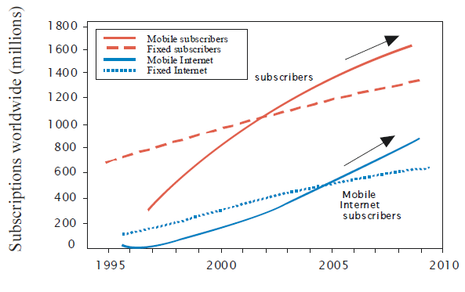

Figure2.1-Global Growth of Mobile and Fixed Subscribers [2]

Apart from mobile telephone communications, Wireless Local Area Networks (WLANs), which came on the scene less than a decade ago (1997), have also experienced phenomenal growth. In fact WLANs have now made their way into homes, riding on the back of xDSL(digital subscriber line) and cable access modems, which are now integrated with WLAN Radio Access Points (RAPs). As a result, the number of wireless Internet subscribers is expected to overtake the number of wired internet users quite soon, as shown in Figure 2.1. The growth of wireless data systems is also seen in the many new standards which have recently been developed or are currently under development.[13]
The rapid growth of wireless communications is mainly attributed to their ease of installation in comparison to fixed networks. However, technological advancement, and competition among mobile operators have also contributed to the growth. So far there have been three mobile telephone standards, launched in succession approximately every decade. The first-generation (1G) mobile systems were analogue, and were commissioned in the 1980s. In the 1990s, second-generation (2G) digital mobile systems such as the Global System for Mobile communications (GSM) came on the scene. The GSM standard has been extremely successful, providing not only national, but international coverage as well. Thus, GSM is currently the mainstream mobile communication system.[3]

Table 2.1 Evolution of the WLAN Standards [2]
Year | WLAN standard | Frequency | Modulation | Bit Rate(max)
1997 | IEEE 802.11 | 2.4 GHz | Frequency Hopping and  Direct Spread Spectrum | 2 Mbps
1998 | ETSI  Home RF | 2.4 GHz | Wideband Frequency  Hopping | 1.6 Mbps
1999 | IEEE 802.11b | 2.4 GHz | Direct Sequence Spread  Spectrum | 11 Mbps
1999 | IEEE 802.11a | 5 GHz | OFDM | 54 Mbps
2000 | ETSI  HiperLAN2 | 5 GHz | OFDM connection oriented | 54 Mbps
2003 | IEEE 802.11g | 2.4 GHz | OFDM compatible with 802.11a | 54 Mbps

2.2 BROADBAND WIRELESS COMMUNICATION SYSTEMS

The explosive growth of internet and the success of 2G system together with WLANs have a profound impact on our perception of communication. First of all, the vast majority of users now believe in the new notion of “always on” communication. We are now living in the era of ubiquitous connectivity or “communication anytime, anywhere, anytime and with anything”. Secondly, the concept of broadband communication has caught on very well. As fibre penetrates closer to the end-user environment (Fibre To The Home/Curb/X, FTTH/C/X), wired transmission speeds such at 100 Mbps (Fast Ethernet) are now beginning to reach homes. The demand to have this broadband capacity also wirelessly has put pressure on wireless communication systems to increase both their transmission capacity, as well as their coverage.
Mobility
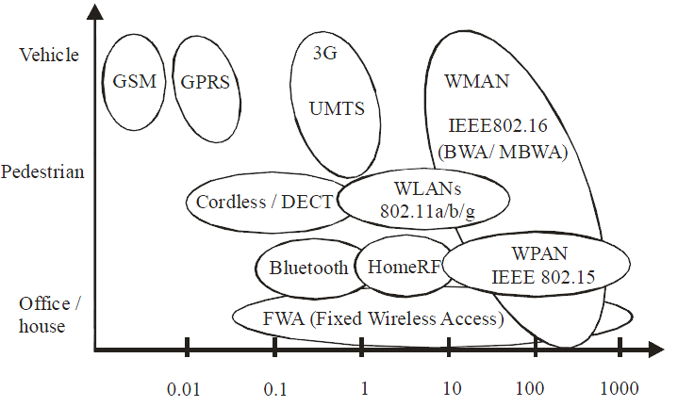
Data Rate (Mbps)
Figure 2.2-Overview of present and future wireless communication systems [2]
In general there is a trade off between coverage and capacity. Figure2.2 shows the relationship between some of the various standards (present and future), in terms of mobility (coverage), and capacity. For instance, the cell size of Wireless Personal Area Networks (WPAN) is typically a few meters (picocell), while their transmission rates may reach several tens of Mbps. On the other hand 2G (e.g. GSM) and 3G (e.g. Universal Mobile Telecommunication System (UMTS) and the International Mobile Telecommunications (IMT2000) system have cells On the other hand 2G (e.g. GSM), and 3G (e.g. Universal Mobile Telecommunication System (UMTS) and the International Mobile Telecommunications (IMT2000)) systems have cells that extend several kilometres, but have data rates limited to less than 2 Mbps. that extend several kilometres, but have data rates limited to less than 2 Mbps. Wireless data system seek to increase coverage and move towards convergences.[9]

2.3 CHALLENGES OF BROADBAND WIRELESS ACCESS NETWORKS

Figure 2.3 illustrates the configuration of narrowband wireless access systems (e.g. GSM). The central office handles call processing and switching, while the Base Stations (BS) act as the radio interfaces for the Mobile Units (MU) or Wireless Terminal Units (WTU). The BSs may be linked to the central office through either analogue microwave links or digital fibre optic links. Once the baseband signals are received at the BS, they are processed and modulated onto the appropriate carrier. The radius covered by the signal from the BS is the cell radius. All the MU/WTU within the cell, share the radio frequency spectrum. WLANs are configured in a similar fashion, with the radio interface called the Radio Access Point (RAP).[13]
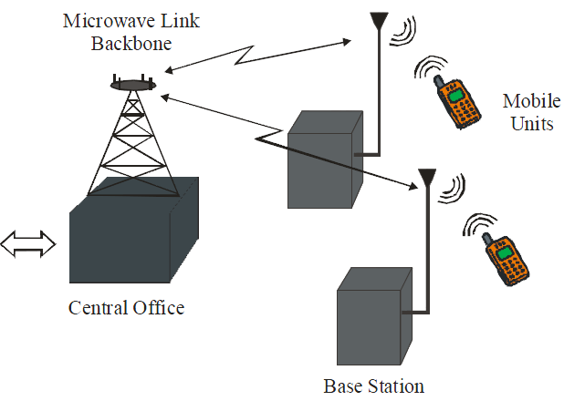
Figure2.3-Schematic Showing the Components of a Narrowband Wireless Access Network
Narrowband wireless access systems (e.g. 2G) offer limited capacity is because they operate at low frequencies. For instance GSM operates at frequencies around 900 or 1800 MHz with 200 kHz allocated frequency spectrum. UMTS operates at frequencies around 2 GHz and has 4 MHz allocated bandwidth..[13]

One natural way to increase capacity of wireless communication system is to deploy smaller cells (micro-and pico-cells). Another way to increase the capacity of wireless communication system is to increase the carrier frequencies, to avoid the congested ISM band frequencies. Higher carrier frequencies offer greater modulation bandwidth, but may lead to increased costs of radio front ends in BSs and the MUs/WTUs.

Smaller cell sizes lead to improved spectral efficiency through increased frequency reuse. But at the same time, smaller cell size mean that large numbers of BSs or RAPs are needed in order to achieve the wide coverage required of ubiquitous communication system. Furthermore, extensive feeder networks are to service the large number of BS/RAPs. Therefore, unless the cost of the BS/RAPs, and the feeder network are significantly low, the system wide installation and maintenance costs of such system would be rendered prohibitively high.

This is why Radio over Fibre (RoF) technology comes in. It achieves the simplification of the BS/RAPs (referred to as Remote Antenna Units-RAUs) through consolidation of radio system functionalities at a centralised headend, which are then shared by multiple RAUs.

Therefore, for broadband wireless communication systems to offer the needed high capacity, it appears inevitable to increase the carrier frequencies and to reduce cell sizes. This is evident from the new standards in the offing, which are aiming to use mm-waves. The IEEE 802.16 (WiMAX) standard specifies frequencies between 10 – 66 GHz for the first/last mile Fixed Wireless Access (FWA). A summary of the operating frequencies for some of the current and future (broadband) wireless systems is given in Table 2.2.[2]
Frequency | Wireless System
2GHz | UMTS / 3G Systems
2.4GHz | IEEE 802.11 b/g WLAN
5GHz | IEEE 802.11 a WLAN
2-11GHz | IEEE 802.16 WiMAX
17/19 | Indoor Wireless (Radio) LANs
28GHz | Fixed wireless access – Local point to  Multipoint (LMDS)
38GHz | Fixed wireless access, Picocellular
58GHz | Indoor wireless LANs
57-64GHz | IEEE 802.15 WPAN
10-66GHz | IEEE 802.16 – WiMAX
Table2.2-Frequencies for Broadband Wireless Communication Systems [2]

2.4 RADIO - OVER-FIBRE TECHNOLOGY
2.4.1 What is RoF?
Radio-over-Fibre (RoF) technology entails the use of optical fibre links to distribute RF signals from a central location (headend) to Remote Antenna Units (RAUs). In narrowband communication systems and WLANs, RF signal processing functions such as frequency up-conversion, carrier modulation, and multiplexing, are performed at the BS or the RAP, and immediately fed into the antenna. RoF makes it possible to centralise the RF signal processing functions in one shared location (headend), and then to use optical fibre, which offers low signal loss (0.3 dB/km for 1550 nm, and 0.5 dB/km for 1310 nm wavelengths) to distribute the RF signals to the RAUs, as shown in Figure 2.4. By so doing, RAUs are simplified significantly, as they only need to perform optoelectronic conversion and amplification functions.[4]

The centralisation of RF signal processing functions enables equipment sharing, dynamic allocation of resources, and simplified system operation and maintenance. These benefits can translate into major system installation and operational savings, especially in wide-coverage broadband wireless communication systems, where a high density of BS/RAPs is necessary.[4]
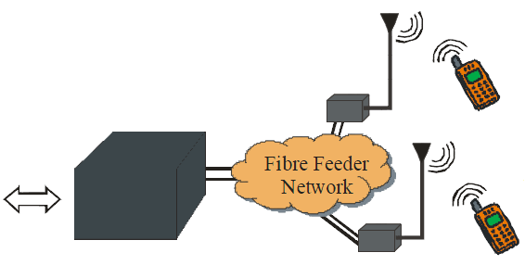
Headend Remote Antenna Units
Figure 2.4: The Radio over Fibre System Concept [4]

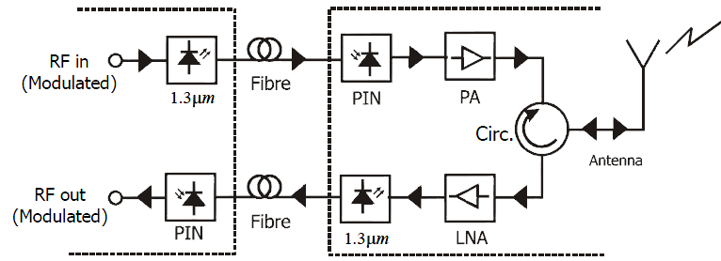
Central Site Base Station
Figure 2.5: 900 MHz Fibre-Radio System [4]
One of the pioneer RoF system implementations is depicted in Figure 2.5. Such a system may be used to distribute GSM signals, for example. The RF signal is used to directly modulate the laser diode in the central site (headend). The resulting intensity modulated optical signal is then transported over the length of the fibre to the BS (RAU). At the RAU, the transmitted RF signal is recovered by direct detection in the PIN photo detector. The signal is then amplified and radiated by the antenna. The uplink signal from the MU is transported from the RAU to the headend in the same way. This method of transporting RF signals over the fibre is called Intensity Modulation with Direct Detection (IM-DD), and is the simplest form of the RoF link.[7]While Figure 2.5 shows the transmission of the RF signal at its frequency, it is not always necessary to do that. For instance, a Local Oscillator (LO) signal, if available, may be used to down-convert the uplink carrier to an IF in the RAU. Doing so would allow for the use of low-frequency components for the up-link path in the RAU – leading to system cost savings. Instead of placing a separate LO in the RAU, it may be transported from the headend to the RAU by the RoF system. Once available at the RAU, the LO may then be used to achieve down-conversion of the uplink signals.

This results in a much simpler RAU. In this configuration, the downlink becomes the crucial part of the RoF since it has to transport high-frequency signals. The transportation of high-frequency signals is more challenging because it requires high frequency components, and large link bandwidth. This means that high-frequency signals are more susceptible to transmitter, receiver, and transmission link signal impairments.[7]

2.4.2 RoF System Architectures
There are three main radio over fibre system architectures in use in current commercial in-building wireless deployments. All use direct modulation of a laser diode rather than external modulation to reduce cost and complexity. The three types of radio over fibre are:
- RF transmission over single mode fibre directly at the radio carrier frequency (usually in the range 800-2200MHz, depending on the radio system). This is the simplest architecture.
- IF transmission over multimode or single mode fibre. The RF signal from the base station is down converted to IF and transmitted to the remote antennas where it is up converted back to the original RF. This allows pre-existing multimode Fibre cables to be used, although at the expense of a additional cost and complexity.
- Digitized IF over multimode or single mode fibre. This approach uses down conversion to IF as in previous type and then digitizes the signal for transmission over optical fibre. The analogue signal is then re constructed at IF and converted back to RF. This has the advantages of digital transmission (no impairments due to noise and distortion),but at the expense of even further complexity.

2.4.3 Benefits of RoF Technology

2.4.3.1 Low Attenuation Loss
Electrical distribution of high frequency microwave signal either in free space or through transmission lines is problematic and costly. The alternative solution to this problem is to distribute baseband signals or signals at low intermediate frequencies (IF) from the switching centre (headend) to the BS. The baseband or IF signals are up- converted to the required microwave or mm-wave frequency at each base station, amplified and then radiated.

2.4.3.2 Large Bandwidth
Optical fibres offer enormous bandwidth. There are three main transmission windows, which offer low attenuation, namely the 850 nm, 1310 nm, and 1550 nm wavelengths. For a single SMF optical fibre, the combined bandwidth of the three windows is in the excess of 50 THz. However today’s state of art commercial system utilize only a fraction of this capacity (1.6 THz).

2.4.3.3 Immunity to Radio Frequency Interference
Immunity to Electromagnetic Interference (EMI) is a very attractive property of optical fibre communications, especially for microwave transmission, because signals are transmitted in the form of light as it provides privacy and security.

2.4.3.4 Easy Installation and Maintenance
In RoF system, complex and expensive equipment is kept at the headend, thereby making the RAUs simpler. For instance, most RoF techniques eliminate the need for a LO and related equipment at the RAU. In such cases a photo detector, an RF amplifier, and an antenna make up the RAU. Modulation and switching equipment is kept in the headend and is shared by several RAUs, this will lead to smaller and lighter RAU and maintain costs.

2.4.3.5 Reduced Power Consumption
Reduced power consumption is a consequence of having simple RAUs with reduced equipment. Most of the complex equipment is kept at the centralised headend.

2.4.3.6 Multi-Operator and Multi-Service Operation
RoF offers system operational flexibility. Depending on the microwave generation technique, the RoF distribution system can be made signal format transparent. For instant the intensity Modulation and direct Detection (IM-DD) technique can be made to operate as a linear system and therefore as a transparent system. This can be achieved by using low dispersion fibre (SMF) in the combination with pre-modulated RF subcarriers (SCM). In that case, the same RoF network can be used to distribute multi-operator and multi-service traffic, resulting in huge economic savings.
.
2.4.3.7 Dynamic Resource Allocation
Since the switching, modulation and other RF functions are performed at a centralized headend, it is possible to allocate capacity dynamically. For instant in a RoF distribution system for GSM traffic, more capacity can be allocated to an area (e.g. shopping mall) during peak times and then re-allocated to other areas when off peak (e.g. to populated residential areas in the evenings). This can be achieved by allocating optical wavelength through Wavelength Division Multiplexing (WDM) as need arises.

2.4.4 Limitations of RoF Technology
Since RoF involves analogue modulation, and detection of light, it is fundamentally an analogue transmission system. Therefore, signal impairments such as noise and distortion, which are important in analogue communication systems, are important in RoF systems as well. These impairments tend to limit the Noise Figure (NF) and Dynamic Range (DR) of the RoF links. DR is a very important parameter for mobile (cellular) communication systems such as GSM because the power received at the BS from the MUs varies widely (e.g. 80 dB ).[4]
That is, the RF power received from a MU which is close to the BS can be much higher than the RF power received from a MU which is several kilometres away, but within the same cell. In Multi-Mode Fibre based RoF systems, modal dispersion severely limits the available link bandwidth and distance. It must be stated that although the RoF transmission system itself is analogue, the radio system being distributed need not be analogue as well, but it may be digital (e.g. WLAN, UMTS), using comprehensive multi-level signal modulation formats such as xQAM, or Orthogonal Frequency Division Multiplexing (OFDM).[7]

2.5 APPLICATIONS OF RoF TECHNOLOGY

2.5.1 Introduction
Since the RoF networks are going to be the backbone of the future communication systems, a glimpse into their possible applications and advantages they offer over the existing technologies need to be dealt with. In this chapter various applications of the RoF are discussed in detail. These applications are mainly intended to use the RoF technology for the next generation wireless access systems.

2.5.2 Fibre to the Home/Fibre to the Premises (FTTH/FTTP)
The conventional access network infrastructures, namely the twisted-pair telephony networks and the coaxial cable CATV networks, are having a hard time to keep up with these traffic demands. Digital subscriber line Techniques (ADSL, VDSL, etc.) and cable modem techniques are evolving into higher speeds, but at the cost of a shorter reach.
The unique properties of optical single-mode fibre being its low loss and extremely wide inherent bandwidth make it the ideal candidate to meet the capacity challenges for now and the foreseeable future.
Civil works typically may take some 85% of fibre to the home (FTTH) first installed network costs, while the fibre cable and the optical components take only 3%; the remainder is taken by other hardware, installation activities, and other services. FTTH’s operational costs may be lower, as it needs less active equipment in the field which needs maintenance. A fibre link can basically handle any kind of access traffic, so installing fibre is an insurance for the future (B future-proof, or B forecast-tolerant, investment).

2.5.2.1 Fibre Access network Architectures
Basically, three architectures may be deployed for the fibre access network.
- Point-to-point architecture, where individual fibres run from the local exchange to each home. Many fibres are needed, which entails high first installation costs, but also provides the ultimate capacity and the most flexibility to upgrade services for customers individually. In the local exchange, as many fibre terminals are needed as there are homes, so floor space and powering may become issues.
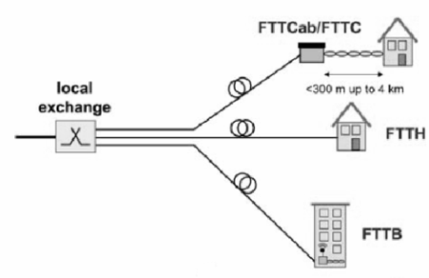
Figure 2.5.2.1.1-Point to point architecture.
- Active star architecture, where a single fibre carries all traffic to an active node close to the end users, from where individual fibres run to each cabinet/home/building. Only a single feeder fibre is needed, and a number of short branching fibres to the end users, which reduces costs; but the active node needs powering and maintenance.
The active node may be located in a cabinet at the street curb site (fibre to the cabinet (FTTCab) or FTTC), or in the basement of, e.g., a multi dwelling units building [fibre to the building (FTTB)] from where the communication traffic is run throughout the building by copper wired and wireless local area networks at 100+ Mbit/s speeds.
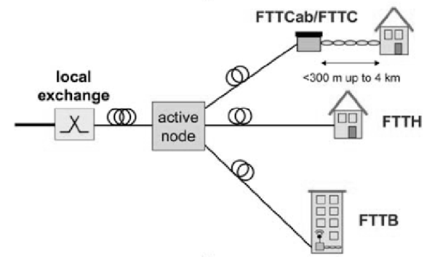
Figure2.5.2.1.2-Active star architecture
- Passive star architecture, in which the active node of the active star topology is replaced by a passive optical power splitter/combiner that feeds the individual short branching fibres to the end users. In addition to the reduced installation costs of a single fibre feeder link, the completely passive nature of the outside plant avoids the costs of powering and maintaining active equipment in the field. This topology has therefore become a very popular one for introduction of optical fibre into access networks, and is widely known as the passive optical network (PON).
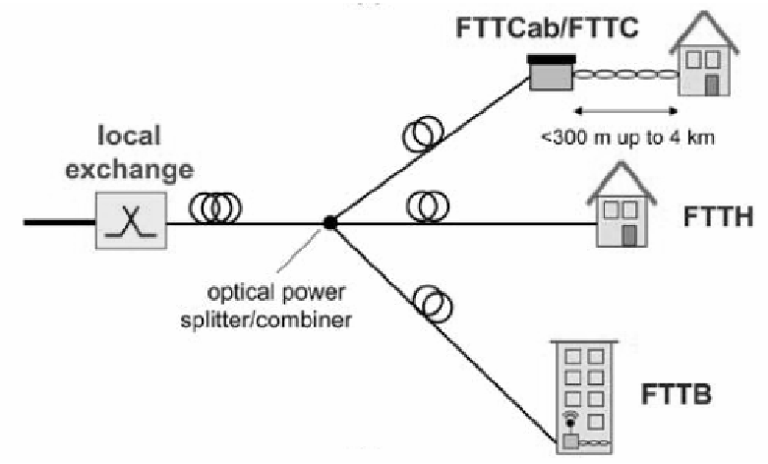
Figure 2.5.2.1.3- Passive Star Architecture.
2.5.3 Radio-over-Fibre Links for Indoor Wireless LANs
The demand for broadband services has driven research on millimetre-wave frequency band communications for wireless access networks such as picocellular mobile systems and indoor wireless local area networks (LANs). The millimetre-wave band is considered to be a promising solution owing to its spectrum availability, compact size of radio frequency (RF) devices. Especially, signals at around 60 GHz with severe atmospheric attenuation due to oxygen absorption provide the excellent frequency reusability between adjacent picocell coverage ranges. The mm-wave signals, however, suffer from severe loss along the transmission line as well as atmospheric attenuation. Low-attenuation, EMI-free optical fibre transmission is considered attractive for long-haul transport of mill metric frequency band wireless signals.[5]

The system consists of OFDM modems, baseband signal processing modules, IF modules that convert baseband signals to 2.5GHz frequency band signals, an optical single mode fibre link, mm-wave transmitter/receiver that converts the IF signals into 60GHz frequency band signals and 60GHz ones into IF ones, respectively, and mm-wave band antennas.

Generation and reconstruction algorithms for 16-QAM (quardrature amplitude modulation) OFDM signals are carried out by the OFDM modems. Digital-to-analog (D/A) and analog-to-digital (A/D) converters are remotely controlled, and IF modules correspond to a L-band up-converter from the baseband into the 2.5GHz band and an L-band down-converter with reverse band shifting.

The optical link contains optical-to-electrical (O/E) and electrical-to-optical (E/O) converters with a distributed feedback laser diode (DFB-LD) as a 2.5GHz optical signal to 2.5GHz frequency band signals, an optical single mode fibre link, mm-wave transmitter/receiver that converts the IF signals into 60GHz frequency band signals and 60GHz ones into IF ones, respectively, and mm-wave band antennas. [5]

The optical link contains optical-to-electrical (O/E) and electrical-to-optical (E/O) converters with a distributed feedback laser diode (DFB-LD) as a 2.5GHz optical signal generator with direct modulation. The 2.5 GHz IF signals are mixed in the mm-wave transmitter with 57.2GHz signals from the local oscillator (LO) and are converted to OFDM signals with a centre frequency of 59.7GHz. They are then transported to a power amplifier and an antenna. The reverse order action is performed in the mm-wave receiver. At an IF down converter, the resulting IF OFDM signal is converted to the base band signal to be sampled by an analog-to-digital converter (ADC). The sampled sequence of the received OFDM signal is processed to recover the original data generator with direct modulation.[5]
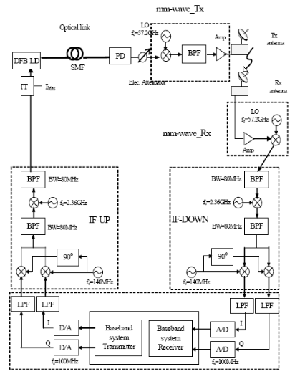
Figure2.5.3-RoF for Indoor wireless access[5]
2.5.4 Radio over Fibre for Beyond 3G and 4G
There are plenty of related technological problems on the next generation mobile communication. Due to the demand of high bandwidth of 4G and the lack of available vacant frequency band, the frequency band of 4G systems is expected to be higher than 3.0 GHz. In case of WiBro(wireless broadband), its frequency band is 2.3 GHz which is higher than 3G frequency. This increased frequency band leads to the high radio-wave propagation loss for uplink and downlink, as shown in following figure. Network operators for 4G will be having tremendous difficulties accommodating the increasing traffic, because the system should guarantee the high data rate for each user.[8]
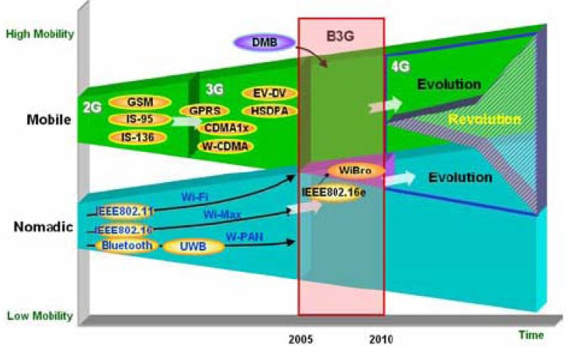
Figure2.5.4- Evolution of various wireless networks [8]
Nowadays, customers expect their mobile terminals to work whether inside or outside the building. RoF is suitable for present and future wireless services such as 4G. Therefore, we are developing RoF technologies providing multiple wireless systems including 3G, WLAN, Digital multimedia broadcasting (DMB), and B3G at the hot spot or in-building area.
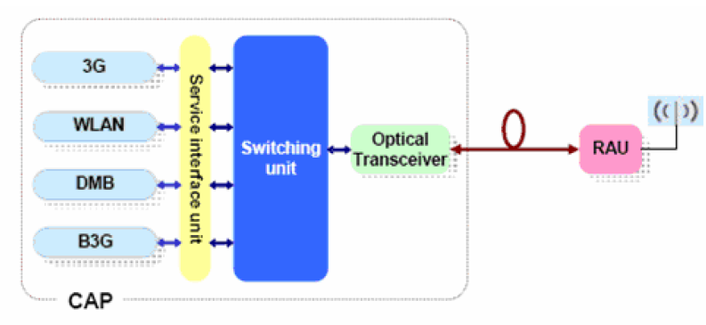
Figure2.5.5- RoF for 3G and 4G [8]

2.5.5 Radio over Fibre Network for Microcellular System
In this architecture, the traditional macro cell is divided into microcells. At BS, the output of a Nd:YAG laser is split by a 1×N₁N_{R} star coupler and externally modulated by a group of N₁N_{R}M SCM RF signals through a Mach –Zehnder Modulator. Each group contains M subcarriers. In fact N₁ groups of RF subcarriers are reused times in the whole macro cell, so the total channel number provided by this single laser is N₁N_{R}M. In following figure microcells 1A, 1B and 1C use the same frequency. Such idea is exactly same as that used in the current mobile phone system so that no additional effort is needed for the frequency planning except that the co channel interference may have to be considered due to the different power levels in the microcellular system.[17]
At RP’s, as shown in Fig2.5.6, downlink signals are detected by one photo detector with a low-noise amplifier (LNA) and then amplified by a power amplifier before transmitting through the antenna. An optical coupler with the coupling ratio C_{D}:C_{V} where C_{D}+C_{V}=1, is placed at the input of the RP to reserve some portion of the optical power for uplink transmission. The reserved optical power is demodulated by radio signals received from the antenna through an AM modulator and detected at BS with a separate PIN photo detector for each uplink. This distribution structure has the following advantages over those using two distributed feedback (DFB) lasers and direct modulation scheme at both BS’s and RP’s.
- High-power Nd:YAG lasers, suitable for a high-fan-out distribution system, are available, and their relative intensity noise (RIN) can be as low as 165 dB/Hz.
- Reduced power consumption and complexity of RP’s due to the use of external modulators.
- Excellent performance of AM modulation and its associated low IMD’s, which will increase the system dynamic range (DR) significantly.
Although the external modulator is sensitive to the polarization state of the input optical beam, one polarization controller located in front of the 1×N₁N_{R} coupler is enough to maintain the input beam of AM modulators at the BS at the desired polarization state.[17]
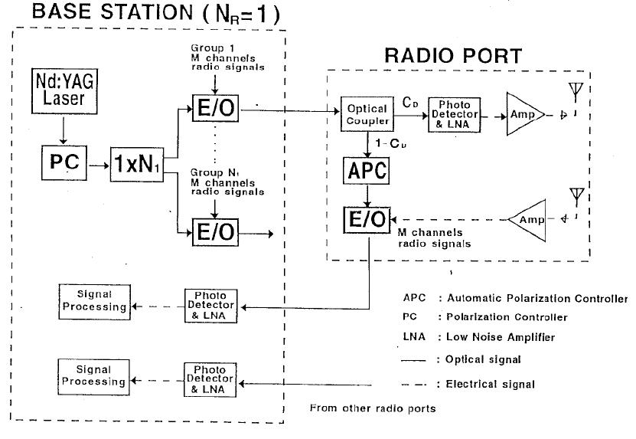
Figure2.5.6-Block diagram of the fibre-radio link [17]

2.5.6 RoF Network Architecture for Road Vehicle Communication Systems
The demand for intelligent transportation systems (ITSs) using the latest mobile communication technologies continues to increase to exchange traffic information and achieve safe, smooth, and comfortable driving.
One promising alternative to the first issue is a radio over fibre (ROF) fed network since in this network functionally simple and cost-effective BSs (in contrast to conventional wireless systems) are utilized .In particular, a large number of BSs, which are deployed along the road and serve as remote antenna units for MHs, are interconnected with a control station (CS) that performs all processing such as modulation/demodulation, routing, medium access control (MAC) and so on. This configuration leads to a centralized network architecture that could efficiently be used for resource management.
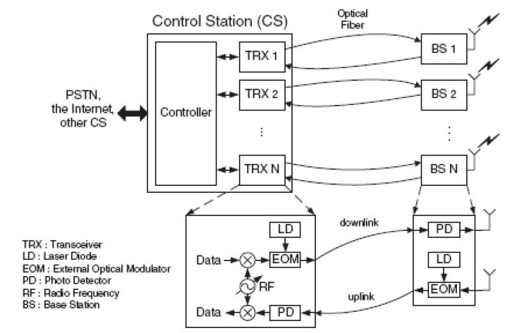
Figure2.5.7 Architecture of the control station and the base station [18]
2.5.7 Radio over Fibre For in Building Mobile Communications
In-building coverage is an important and growing market for cellular network operators, who wish to gain and retain customers in environments such as corporate office buildings, shopping malls and airports. The most effective and efficient way of providing this coverage with good service quality is to place one or more base stations at a central location inside the building and use a distributed antenna system (DAS) transmission infrastructure to distribute the wireless signals from the base stations to the various antenna locations around the building.[4]

2.5.8 RoF For Ultra Wide Band Radio
There is demand for wireless broadband services to access bandwidth intensive applications such as audio/video streaming. Pulsed Ultra Wide Band (UWB) radio is one such technology that can support these high-speed applications

Radio-over-Fibre (RoF) network is an attractive option in offering the necessary linkages between UWB radio base stations and their central office. RoF network is a cost effective way in distributing UWB signals between central office and its remote base stations. New advances in multimode fibre modal bandwidth are allowing new techniques in signal distribution for microwave photonics applications.
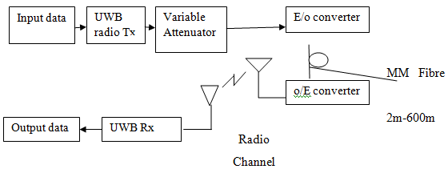
Figure2.5.8 RoF Architecture for UWB Radio
The figure above shows a typical UWB Radio employing the RoF link. Here the use data is sent to the UWB Radio transmitter. This radio signal is then sent to the E/O converter where the radio signal modulates the Laser diode and this composite signal is sent over the fibre channel.
2.6 TECHNIQUES FOR TRANSPORTING RF SIGNALS OVER OPTICAL FIBRE
2.6.1 Introduction
There are several optical techniques for generating and transporting microwave signals over fibre. By considering the frequency of the RF signal fed into the RoF link at the headend in comparison with the signal generated at the RAU the RoF techniques may be classified into three categories – namely RF-over-fibre (RFoF), IF-over- Fibre (IFoF), or baseband-over-Fibre (BBoF).

In IFoF and BBoF the desired microwave signal is generated at the RAU through up-conversion with a LO, which is either provided separately at the RAU, or is transported remotely to the RAU. Therefore, depending on the transmission method used, the RAU may be more complex or simpler.

RoF techniques may also be classified in terms of the underlying modulation/detection principles employed. In that case, the techniques may be grouped into three categories, namely Intensity Modulation – Direct Detection (IMDD), Remote Heterodyne Detection (RHD), and harmonic up-conversion techniques. RFoF systems fall under the IM-DD category. IFoF and BBoF systems, which involve the use of a LO at the RAU may also employ IM-DD to transmit the baseband data or IF to the RAU.

2.6.2 RF Signal Generation by Intensity Modulation and Direct Detection
The simplest method for optically distributing RF signals is simply to directly modulate the intensity of the light source with the RF signal itself and then to use direct detection at the photo detector to recover the RF signal. This method falls under the IM-DD, as well as the RFoF categories.

There are two ways of modulating the light source. One way is to let the RF signal directly modulate the laser diodes current. The second option is to operate the laser in continuous wave (CW) mode and then use an external modulator such as the Mach-Zehnder Modulator (MZM), to modulate the intensity of the light. The two options are shown in Figure 2.6.1. In both cases, the modulating signal is the actual RF signal to be distributed. The RF signal must be appropriately pre-modulated with data prior to transmission.
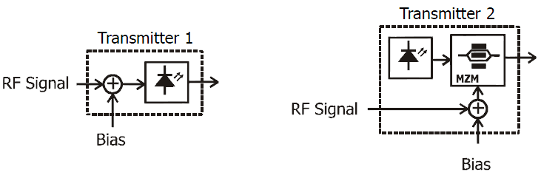
- (b)
Figure2.6.1Generating RF Signals by Direct Intensity Modulation
(a) of the Laser, (b) Using an External Modulator
After transmission through the fibre and direct detection on a photodiode, the photocurrent is a replica of the modulating RF signal, applied either directly to the laser or to the external modulator at the headend. If the RF signal used to modulate the transmitter is itself modulated with data, then the detected RF signal at the receiver will be carrying the same data. The modulation format of the data is preserved.
2.6.3 RF Signal Generation by Remote Heterodyne Detection

2.6.3.1 The Principle of Optical Heterodyning
Most RoF techniques rely on the principle of coherent mixing in the photodiode to generate the RF signal. These techniques are generally referred to as Remote Heterodyne Detection (RHD) techniques. While performing O/E conversion, the photodiode also acts as a mixer thereby making it a key component in RHD-based RoF systems. The principle of coherent mixing may be illustrated as follows. Two optical fields of angular frequencies, ω1 and ω2 can be represented as[11]
$E_{1}=E_{01}cos⁡(ω_{1}t)$ (2.6.1)
$E_{2}=E_{02}cos\left(ω_{2}t\right)$ (2.6.2)
If both fields impinge on a PIN photo detector, the resulting photocurrent on the surface will be proportional to the square of the sum of the optical fields. That is, the normalised photo current$i_{PD}$, will be:
$i_{PD}={(E_{1}+E_{2})}^{2}$ (2.6.3)
$i_{PD}=E_{01}E_{02}cos\left[\left(ω_{1}\right.\right.-\left.\left.ω_{2}\right)t\right]+E_{01}E_{02}cos\left[\left(ω_{1}\right.\right.+\left.\left.ω_{2}\right)t\right]$
+$other terms$ (2.6.4)
The term of interest is $E_{01}E_{02}cos\left[\left(ω_{1}\right.\right.-\left.\left.ω_{2}\right)t\right]$, which shows that by controlling the difference in frequency between the two optical fields, radio signals of any frequency can be generated. The only upper limit to the signal frequencies that can be generated by this method is the bandwidth limitation of the photodiode itself. If we consider optical power signals instead of optical fields, then the generated photocurrent is given by equation(2.6.5)
$i_{PD}\left(t\right)=2R\sqrt{P_{1}\left(t\right)P_{2}\left(t\right)}.cos\left[\left\{ω_{1}\left(t\right)-ω_{2}\left.\left(t\right)\right\}\right.\right.t+φ_{1}\left(t\right)-φ_{2}\left.\left(t\right)\right]$
+ $other terms$ (2.6.5)

where R is the responsivity of the photo detector, t is the time$P_{1}\left(t\right)$ and$P_{2}\left(t\right)$ are the two instantaneous optical power signals with instantaneous frequencies,$ω_{1}\left(t\right)$ and $ω_{2}\left(t\right)$, respectively. The instantaneous phases of the signals are given by $φ_{1}\left(t\right)$ and $φ_{2}\left(t\right)$ respectively.

Equation (2.6.5) shows that the stability of the instantaneous frequency of the RHD generated signal depends on the instantaneous frequency difference between the two optical carriers being mixed. Therefore, in RHD, it is necessary to control the instantaneous frequency difference accurately in order to keep the frequency of the generated signal stable.

Equation (2.6.5) shows that the phase noise of the generated signal is influenced by the optical line width of the two optical carriers (= the sum of the line widths of the optical carriers).Given that the laser emission frequency is highly sensitive to temperature variations, phase noise and other effects, techniques to maintain the required frequency offset and phase noise performance have to be used.

2.6.3.2 Optical FM-Filter System

The Optical FM-Filter technique is a single-laser technique that involves modulating the optical frequency by applying an electrical signal to one of the laser’s terminals. This generates a series of optical spectral lines (sidebands) all spaced by the drive frequency as shown in Figure 2.6.2. Two sidebands, separated by the required mm-wave are then selected. The selected sidebands subsequently impinge on the surface of the photodiode and mix coherently to generate the desired RF signal.[19]
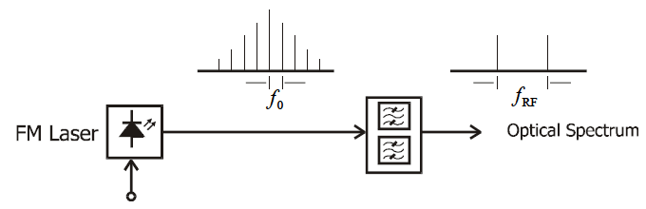
$f_{0}$ optical filtering arrangement
Figure2.6.2-Principle of Optical Coherent Mixing based on the FM Laser
Two commonly used methods for selecting the required sidebands are Optical filtering – also referred to as spectrum slicing, and Injection-locked lasers.
Using an optical filter, the required sidebands are selected while the rest are rejected.

2.6.4 Techniques Based on Harmonics Generation

2.6.4.1 The FM – IM Conversion Technique
The conversion from an FM modulated signal to an Intensity Modulated one is performed by the fibre’s chromatic dispersion itself. A laser is optically FM modulated by applying a drive signal to one of its terminals. This produces an optical spectrum that consists of spectral lines spaced by the drive frequency.

The FM optical signal then propagates over dispersive fibre. Due to chromatic dispersion effects, the relative phasing of the optical sidebands is altered leading to intensity fluctuations of light at harmonics of the drive frequency. The instantaneous optical intensity received after propagating through the fibre is given by
$i\left(t\right)=I_{0}+\sum_{p=1}^{∞}{2}|I_{p}|cos\left(pωt+φ_{p}\right)$ (2.6.6)
where Ip is the pth harmonic component of intensity variation given by equation (2.6.6), and $I_{0}$ the dc photocurrent. The parameter ω is the modulating angular frequency, and ζp is the phase of the pth harmonic. The harmonic intensity, Ip is given by ${ I}_{p}=J_{p}\left(2βsin\left(p∅\right)\right)$ (2.6.7)
where Jp(x) is the Bessel function of the first kind, β is the FM modulation index (or phase modulation index) and φ is an angle characterizing the fibre dispersion given by $∅=-\frac{ω^{2}}{4π}\frac{Dλ^{2}}{c}z$ (2.6.8)
where λ is the free space wavelength of the laser, c is the speed of light, z is the fibre length, and D is the fibre group dispersion parameter. If the modulation depth Mp of the pth harmonic is defined as the ratio of the amplitude of the alternating photocurrent at the pth harmonic to the dc photocurrent, then Mp will be given by
$M_{p}=|2J_{p}\left(2βsin\left(pφ\right)\right)|$ (2.6.9)
In demonstration experiments, the FM-IM technique was used to generate mm-waves up to 60 GHz (15th harmonic of 4 GHz drive signal). In theory, the maximum achievable modulation depth is 60% for the 10th harmonic. However, only 13% modulation depth was achieved in practice. This was attributed to inherent intensity modulation present in the laser output (i.e. optical signal was not pure FM).

2.6.4.2 Modulation Sideband Techniques
There are two modulation side band techniques dubbed 2f and 4f methods. Unlike the FM-IM technique, these techniques generate high order harmonics without the necessity for dispersive fibre, by relying on the non-linear transfer characteristic of the Mach Zehnder amplitude modulator (MZM)[11]. The output of the MZM in terms of the E-field can be described by
$E_{out}\left(t\right)=E_{in}\left(t\right)cos\left(\frac{π}{2}\right.\left.\frac{V_{mod}\left(t\right)}{V_{π}}\right)$ (2.6.10)
where $E_{in}\left(t\right)$is the optical field applied to the input of the modulator, Vmod(t) is the modulating voltage applied to the modulator, and Vπ is the modulating voltage required to totally suppress the output. If the modulating voltage Vmod(t) is sinusoidal, it can be shown that the output field may be written in the form
$E_{out}\left(t\right)=\frac{1}{2}J_{0}\left(α\frac{π}{2}\right)cos\left(\frac{π}{2}\left(1+ε\right)\right)cos\left(Ω\right.\left.t\right)$
$-\frac{1}{2}J_{1}\left(α\frac{π}{2}\right)sin\left(\frac{π}{2}\left(1+ε\right)\right)cos\left(Ωt\right.\left.±ωt\right)$
$+\frac{1}{2}J_{2}\left(α\right.\left.\frac{π}{2}\right)cos\left(\frac{π}{2}\left(1+ε\right)\right) cos\left(Ωt\right.\left.±2ωt\right)$
$-\frac{1}{2}J_{3}\left(α\right.\left.\frac{π}{2}\right)sin\left(\frac{π}{2}\left(1+ε\right)\right)cos\left(Ωt\right.\left.±3ωt\right)$ (2.6.11)
where Ji is the ith Bessel function of the first kind, ε is the normalised bias, and α is the drive level. Equation (2.6.11) shows that by adjusting the bias to appropriate levels ε=0, or ε=1, the 2nd or 4th order harmonics of the drive signal may be generated.
2.6.4.3 Interferometer based Mixing
Another harmonic up-conversion method that uses an interferometer to achieve mixing is illustrated in Figure 2.6.3. In this method a LO signal and an RF signal are used to modulate a laser diode, and then mixed in a MZI photodiode configuration. The FSR of the MZI is chosen so as to maximise the mixing product. The challenge in this approach regards the fact that both the laser wavelength and filter response must be stabilised against environmental disturbances. In addition, the system performance is very sensitive to polarisation perturbations.
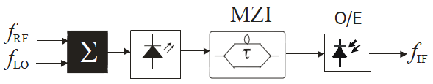
Figure2.6.3-Frequency Conversion Through Mixing by a Mach- Zehnder Interferometer
2.6.5 RoF Multiplexing Techniques

2.6.5.1 Sub-Carrier Multiplexing in RoF Systems
Subcarrier Multiplexing (SCM) is a maturing, simple, and cost effective approach for exploiting optical fibre bandwidth in analogue optical communication systems in general and in RoF systems in particular. In SCM, the RF signal (the subcarrier) is used to modulate an optical carrier at the transmitter’s side. This results in an optical spectrum consisting of the original optical carrier $f_{0}$, plus two side-tones located at $f_{0}±f_{SC}$, where $f_{SC}$ is the subcarrier frequency. If the subcarrier itself is modulated with data (analogue or digital), then sidebands centred on$f_{0}±f_{SC}$, are produced as illustrated in Figure 2.6.4.
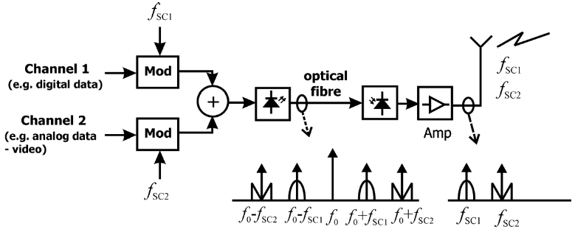
Figure2.6.4-Sub-Carrier Multiplexing of Mixed Digital and Analogue Signals
To multiplex multiple channels on to one optical carrier, multiple sub-carriers are first combined and then used to modulate the optical carrier. At the receiver’s side the sub-carriers are recovered through direct detection and then radiated. Different modulation schemes may be used on separate sub-carriers.

One sub-carrier may carry digital data, while another may be modulated with an analogue signal such as video or telephone traffic. In this way, SCM supports the multiplexing of various kinds of mixed mode broadband data. Modulation of the optical carrier may be achieved by either directly modulating the laser, or by using external modulators such as the MZM.SCM may be used in both IM-DD and RHD RoF techniques. SCM in combination with IM-DD has been used in RoF systems fed by multimode fibre.

2.6.5.2 Wavelength Division Multiplexing in RoF Systems

The use of Wavelength Division Multiplexing (WDM) for the distribution of RoF signals has gained importance recently. WDM enables the efficient exploitation of the fibre network’s bandwidth.[5]
Therefore, methods to improve the spectrum efficiency have been proposed. Carriers modulated with mm-waves are dropped from and added to a fibre ring using Optical Add-Drop Multiplexers (OADM). The OADM are placed at base stations and tuned to select the desired optical carriers to drop.[5]

WDM are passive devices that combine light signals with different wavelengths, coming from different fibres, onto a single fibre. They include dense wavelength division multiplexers (DWDM), devices that use optical (analog) multiplexing techniques to increase the carrying capacity of fibre networks beyond levels that can be accomplished via time division multiplexing (TDM). The channel spacing in WDM can be decreased to 50 GHz or even to 25 GHz and thus, it is possible to use hundreds of channels.
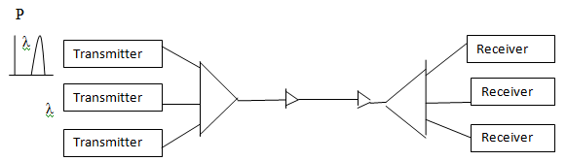 WDM multiplexer Optical amplifier Demultiplexer Figure2.6.5- WDM system using multiple wavelength channels and optical amplifiers
2.7 FIBRE CHARACTERISTICS, LOSSES AND NON-LINEAR EFFECTS
2.7.1 Overview
The fundamental component that makes the optical communication possible is the optical fibre. The phenomenon which guides the light along the optical fibre is the total internal reflection. It is an optical phenomenon which occurs when the incident light is completely reflected. Critical angle is the angle above which the total internal reflection occurs. In case of materials with different refractive indices, light will be reflected and refracted at the boundary surface.

This will occur only from higher refractive index to a lower refractive index such as light passing from glass to air. This phenomenon forms the basis of optical communication through fibres. An optical fibre is a dielectric waveguide, it is cylindrical, and guides the light parallel to the axis. The cylindrical structure is dielectric with a radius “a” and refractive index of “n1”. This is the called the core of the fibre and the layer that encompasses this structure is called the cladding. Cladding has a refractive index “n2” which is lesser than “n1”. This helps in providing mechanical strength and helps reducing scattering losses. It also prevents the core from surface contamination. Cladding doesn’t take part in light propagation.
2.7.3 Fibre Losses
For efficient recovery of the received signal, the signal to noise ratio at the receiver must be considerably high. Fibre losses will affect the received power eventually reducing the signal power at the receiver. Hence optical fibres suffered heavy loss and degradation over long distances. To overcome these losses, optical amplifiers were invented which significantly boosted the power in the spans in between the source and receiver. However, optical amplifiers introduce amplified spontaneous emission (ASE) noises which are proportional to the amount of optical amplifications they provide. Attenuation Coefficient is a fibre-loss parameter which is expressed in the units of dB/Km. The optical power travelling inside the fibre changes along the length and is governed by Beer’s law: $\frac{dp}{dz}=α.p$
“α” is the attenuation constant in Neper. If Pin and Pout are the power at the input and output of the fibre and L is the length of the fibre then the power at the output is Pat=Pin exp (-$α$ L). For short wavelengths, the loss may exceed 5dB/Km and makes it unsuitable for long Distance transmission. These losses are mainly due to material absorption and Rayleigh scattering. Material absorption is the phenomenon exhibited by fibres material. The intrinsic absorption is caused by fused silica, and extrinsic absorption is caused by impurities in silica.

2.7.4 Fibre Nonlinearities
In optical communication systems the term nonlinearity refers to the dependence of the system on power of the optical beam/s being launched into the fibre cable. Nonlinear effects in optical fibres have become an area of academic research and of great importance in the optical fibre based systems. [6] Nonlinearities in optical fibres originate due to the third order susceptibility ($χ^{3}$). The real part of the equation gives us SPM, XPM and FWM while the imaginary part of the equation gives us SBS and SRS. The nonlinear effects depend on the transmission length of the optical fibre. The longer the optical fibre, the more the light interacts with the fibre material and the greater the nonlinear effects. On the other hand, if the power decreases while the light travels along the optical fibre, the effects of nonlinearity diminish.[6]

Causes of Nonlinearities
Fibre nonlinearities arise from two basic mechanisms. The most detrimental mechanism arises from the refractive index of glass being dependent on the optical power going through the material. The general equation for the refractive index of the core in an optical fibre is $n=n_{0}+n_{2}.\frac{p}{A_{eff}}$ Where: n₀ = The refractive index of the fibre core at low optical power levels. n₂ = The nonlinear refractive index coefficient (2.35 x 10⁻²⁰ m²/W for silica). P = The optical power in Watts. A_{eff} = The effective area of the fibre core in square meters.
The equation shows that minimizing the amount of power, P, launched and maximizing the effective area of the fibre, A_{eff}, eliminates the nonlinearities produced by refractive index power dependence. Minimizing the power goes against the current approach to eliminating the detrimental effects; however, maximizing the effective area remains the most common approach in the latest fibre designs.Figure2.7.1 depicts the relationship of the refractive index of silica versus optical power. The magnitude of the change in the refractive index is relatively small; this only becomes important because the interaction length in a real fibre optical system can be hundreds of kilometres.

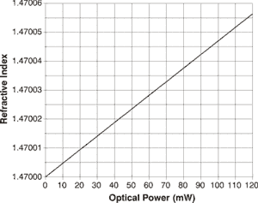

Figure2.7.1-The refractive index of silica versus optical power
2.7.4.1 Stimulated Raman Scattering (SRS)
SRS occurs when the pump power increases beyond the threshold, however SRS can happen in either direction, forward and backward. The molecular oscillations set in at the beat frequency and the amplitude of the scattering increases with the oscillations. The equation that govern the feedback process are
$\frac{dI_{p}}{dz}=-g_{R}I_{P}I_{s}-α_{P}I_{P}$ (1)
$\frac{dI_{s}}{dz}=-g_{R}I_{P}I_{s}-α_{s}I_{s}$ (2)
Where $g_{R}$ is the SRS gain. $I_{P}$ and $I_{s}$ are intensities of Pump and stokes field. In case of the threshold power, $P_{th}$ is given by
$P_{th}=16\frac{α\left(πω^{2}\right)}{g_{R}}$ (3)
Where $πω^{2}$the effective area of the fibre is core and is the spot size. Even though there are some detrimental effects posted by these two effects. SBS and SRS can also be used in a positive way. Since both deal with transferring energy to the signal from a pump, they can be used to amplify the optical signal. Raman gain is also used in compensating losses in fibre transmission.
Advantages of SRS:
a. Raman amplifiers are a boon for WDM systems.
b. Can be used in the entire 1300–1650nm range.
c. Erbium-doped fibre amplifiers limited to ~40nm.
d. Distributed nature of amplification lowers noise.
e. Likely to open new transmission bands.
Disadvantages of SRS:
a. Raman gain introduces interchannel crosstalk in WDM systems.
b. Interchannel crosstalk’s can be reduced by lowering channel powers but it limits the number of channels.

2.7.4.2 Stimulated Brillouin Scattering (SBS)

SBS falls under the category of inelastic scattering in which the frequency of the scattered light is shifted downward. This results in the loss of the transmitted power along the fibre. At low power levels, this effect will become negligible. SBS sets a threshold on the transmitted power, above which considerable amount of power is reflected. This back reflection will make the light to reverse direction and travel towards the source. This usually happens at the connector interfaces where there is a change in the refractive index. As the power level increases, more light is backscattered since the level would have crossed the SBS threshold. The parameters which decide the threshold are the wavelength and the line width of the transmitter.

Lower line width experiences lesser SBS and the increase in the spectral width of the source will reduce SBS. In the case of bit streams with shorter pulse width, no SBS will occur.
Advantages of SBS:
a. SBS provides strong nonlinear optical interaction between light and acoustic waves.
b. The temperature dependence of the Brillouin shift can be used for temperature and pressure sensing.
c. Brillouin scattering can be used for optical phase conjugation and Brillouin gain can also be used for operating a Brillouin fibre laser.
Disadvantages of SBS:
- Brillouin scattering is technically limited to the detection of quasiparticles with frequencies below about 500 GHz.SBS is a phenomenon to be avoided because it limits the amount of optical power that can be transmitted through a fibre. This is because SBS generates index gratings that reflect light in those portions of the optical signal spectrum that exceed a certain power threshold.

2.7.4.3 Self Phase Modulation (SPM)
SPM can be defined as nonlinear phase modulation of a beam caused by its own beam via the Kerr effect. While travelling in a medium, an ultra short pulse of light will produce a varying refractive index due to the Kerr effect. This variation in the refractive index of the medium induces phase shift in the pulse and hence producing change in the pulse’s frequency spectrum.[6]
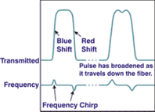
Figure2.7.2- Effects of SPM on a Pulse
Figure2.7.2 illustrates self-phase modulation. Like FWM, self-phase modulation (SPM) is due to the power dependency of the refractive index of the fibre core. It interacts with the chromatic dispersion in the fibre to change the rate at which the pulse broadens as it travels down the fibre. Whereas increasing the fibre dispersion will reduce the impact of FWM, it will increase the impact of SPM.
As an optical pulse travels down the fibre, the leading edge of the pulse causes the refractive index of the fibre to rise, resulting in a blue shift. The falling edge of the pulse decreases the refractive index of the fibre causing a red shift. These red and blue shifts introduce a frequency chirp on each edge which interacts with the fibre's dispersion to broaden the pulse.

Advantages of SPM:
a. Modulation instability can be used to produce ultra short pulses at high repetition rates and SPM can be used for fast optical switching.
b. It has been used for passive mode locking and Responsible for the formation of optical solitons.

Disadvantages of SPM:
a. SPM-induced spectral broadening can degrade performance of a light wave system.
b. Modulation instability often enhances system noise.

2.7.4.4 Cross Phase Modulation (XPM)
XPM can be defined as a process in which intensity of one beam travelling in a nonlinear medium (Kerr medium) effects the phase of another beam. An optical beam modifies not only its own phase but also of other co-propagating beams (XPM). XPM induces nonlinear coupling among overlapping optical pulses. Fibre dispersion affects the XPM considerably. Pulses belonging to different WDM channels travel at different speeds. XPM occurs only when pulses overlap. XPM leads to interaction of pulses in the medium. This allows measurement of intensity of one beam by keeping a track of phase change of other beam. XPM can be used to synchronize two mode locked lasers using the same gain medium.[6]

Cross-phase modulation (XPM) is very similar to SPM except that it involves two pulses of light, whereas SPM needs only one pulse. In XPM, two pulses travel down the fibre, each changing the refractive index as the optical power varies. If these two pulses happen to overlap, they will introduce distortion into the other pulses through XPM. Unlike, SPM, fibre dispersion has little impact on XPM. Increasing the fibre effective area will reduce XPM and all other fibre nonlinearities.
Advantages of XPM:
a. Nonlinear Pulse Compression.
b. Passive mode locking
c. Ultra fast optical switching.
d. Demultiplexing of OTDM channels.
e. Wavelength conversion of WDM channels.

Disadvantages of XPM:
a. XPM leads to interchannel crosstalk in WDM systems.
b. It can produce amplitude and timing jitter.
2.7.4.5 Four Wave Mixing (FWM)

Assuming just two input frequency components ω ₁ and ω ₂ (with ω₂>ω₁) which travel across the fibre optic cable, after interaction in a non linear medium, creates sidebands for each of the input waves. In effect, two new frequency components are generated: $ω_{3}$ = ω ₁ - (ω ₂ - ω ₁) = 2 ω ₁ - ω ₂ and $ω_{4}$ = ω ₂ + (ω ₂ - ω ₁) = 2 ω ₂ - ω ₁ as shown in Fig
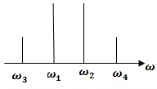
FWM components
In general, for N wavelengths launched into a fibre, the number of generated mixing products or sidebands (excluding the original wavelengths) is given as M=N^3-N^2/2 The FWM conversion efficiency is given by $η={\left[\frac{n_{2}}{{A_{eff}D\left(∆λ\right)}^{2}}\right]}^{\frac{1}{2}}$ where $n_{2}$ is the core refractive index, Aeff is the effective area, D is the dispersion, and Δλ is the channel spacing. FWM is a nonlinear effect arising from a third-order optical nonlinearity, as is described with a χ ⁽³⁾ coefficient. It can occur if at least two different frequency components propagate together in a nonlinear medium such as e.g. an optical fibre.

Assuming just two input frequency components ω ₁ and ω ₂ (with ω₂>ω₁), we obtain a refractive index modulation at the difference frequency, which again creates sidebands for each of the input waves in the figure below. In effect, two new frequency components are generated: ω ₃ = ω ₁ - (ω ₂ - ω ₁) = 2 ω ₁ - ω ₂ and ω ₄ = ω ₂ + (ω ₂ - ω ₁) = 2 ω ₂ - ω ₁ .FWM is also present if only three components interact.
FWM can have important deleterious effects in optical fibre communications, particularly in the context of wavelength division multiplexing where it can cause cross-talk between different wavelength channels, or an imbalance of channel powers. One way to suppress this is avoiding equidistant channel spacing.[6] FWM can transfer data to a different wavelength. A continuous wave pump beam is launched into the fibre together with the signal channel. Its wavelength is chosen half-way from the desired shift. FWM transfers the data from signal to the idler beam at the new wavelength. Usually only systems that carry a number of simultaneous wavelengths, such as DWDM systems, exhibit four wave mixing (FWM).Caused by the nonlinear nature of the refractive index of the optical fibre itself.[6]

Third-order distortion mechanisms generate third-order harmonics in systems with one channel. In multichannel systems, third-order mechanisms generate third-order harmonics and a gamut of cross products. These cross products cause the most problems since they often fall near or on top of the desired signals. Consider a simple three-wavelength (l₁, l₂, and l₃) system that is experiencing FWM distortion In this simple system, nine cross products are generated near l₁, l₂, and l₃ that involve two or more of the original wavelengths. Note that there are additional products generated, but they fall well away from the original input wavelengths. Let us assume that the input wavelengths are l₁ = 1551.72 nm, l₂ = 1552.52 nm, and l₃ = 1553.32 nm.

The interfering wavelengths that are of most concern in our hypothetical three wavelength system are: l₁ + l₂- l₃= 1550.92 nm l₁- l₂ +l₃= 1552.52 nm l₂+ l₃-l₁= 1554.12 nm l₁-l₂+ l₃=1552.52 nm 2l₁-l₃= 1550.12 nm 2l₃- l₁₌1554.92 nm l₂+ l₃-l₁= 1554.12 nm 2l₂- l₁= 1553.32 nm 2l₃ -l₂= 1554.12 nm It can be seen that three of the interfering products fall right on top of the original three signals.

The remaining six products fall outside of the original three signals. These six can be optically filtered out. Figure 2.7.3 shows the results graphically. The three tall solid bars are the three original signals. The shorter cross-hatched bars represent the nine interfering products. The number of interfering products increases as ½ • (N³-N²) where N is the number of signals.
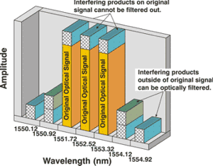
Figure2.7.3- FWM Products for a Three Wavelength System
Figure2.7.4 shows that the number of interfering products rapidly becomes a very large number. Since there is no way to eliminate products that fall on top of the original signals, the only hope is to prevent them from forming in the first place.
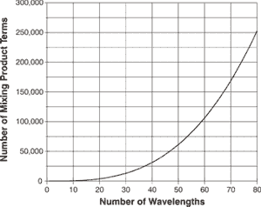
Figure2.7.4- FWM Products versus Channel Count
Two factors strongly influence the magnitude of the FWM products, referred to as the FWM mixing efficiency. The first factor is the channel spacing; mixing efficiency increases dramatically as the channel spacing becomes closer. Fibre dispersion is the second factor, and mixing efficiency is inversely proportional to the fibre dispersion, being strongest at the zero-dispersion point. In all cases, the FWM mixing efficiency is expressed in dB, and more negative values are better since they indicate a lower mixing efficiency.

Figure2.7.5 shows the magnitude of FWM mixing efficiency versus fibre dispersion and channel spacing. If a system design uses NDSF with dispersion of 17 ps/nm/km and the minimum recommended International Telecommunication Union (ITU) DWDM spacing of 0.8 nm, then the mixing efficiency is about -48 dB and will have little impact.
On the other hand, if a system design uses DSF with a dispersion of 1 ps/nm/km and a non-standard spacing of 0.4 nm, then the mixing efficiency becomes -12 dB and will have a severe impact on system performance, perhaps making recovery of the transmitted signal impossible.
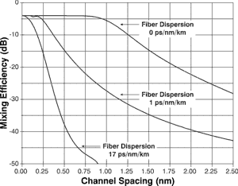
Figure2.7.5- FWM Mixing Efficiency in Single-mode Fibres
Advantages of FWM:
a. Parametric amplification.
b. Optical phase conjugation.
c. Demultiplexing of OTDM channels.
d. Wavelength conversion of WDM channels.
e. Super continuum generation.
Disadvantages of FWM:
a. FWM leads to interchannel crosstalk in WDM systems.
b. It generates additional noise and degrades system performance.

CHAPTER 3
METHODOLOGY
3.1 Introduction
In this we high-lights the techniques and methods employed to study the nonlinear effects of FWM in WDM for RoF.

3.2 Simulation using Virtual Photonic Incorporated Software
VPI software is a numerical simulation enables users to plan, test and simulate almost every type of optical link in the physical layer across the broad spectrum of optical networks. Each layout can have certain component parameters assigned to be in sweep mode. The number of sweep iterations to be performed on the selected parameters could be defined. The value of the parameter changes through each sweep iterations; which produces a series of different calculation results, based on the parameter values. These processing parameters effect on the results are channel spacing; input power, effective area and dispersion of the fibre.

3.3 The Simulation Model
There are two technologies for modulation, direct or without external modulation as shown in Figure 3.1 which the RF signal directly varies the bias of a semiconductor laser diode.
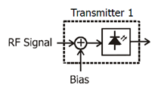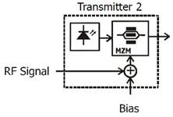
Figure3.1-Direct modulation Figure3.2-External modulation
The other technology is the external modulators are typically either integrated Mach-Zehnder interferometers or electro absorption modulators as shown in Figure 3.2 which the constant wave (CW) laser (always on bright), and the light is modulated by an external lithium-niobate electro-optic modulator. External modulation is currently preferred over any other form of modulation because it has best performance, in spite of high cost.
Using Virtual Photonic Incorporated software, two types of simulation models have been developed to study FWM effects. The two models are with external modulated signal and without external modulated signal as shown in the Figure 3.3 and 3.4, respectively.

The frequency of the phase modulator drive signal was kept at 2.4 GHz. The phase modulator has been used to sweep the optical frequency, it was necessary to first integrate the drive signal.
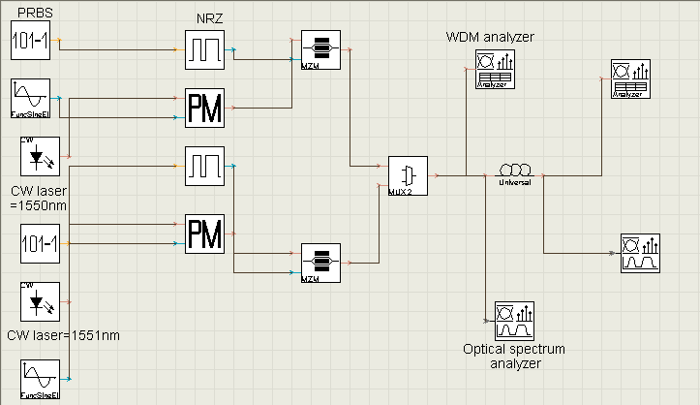
Figure 3.3-Simulation model with external modulated signal
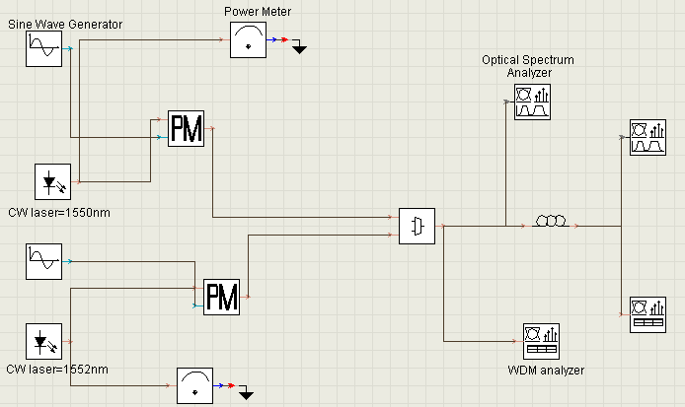
Figure 3.4-Simulation model without external modulated signal

3.4 Simulation of the Four Wave Mixing Effect
Each component in both simulation models, shown in Figures 3.3 and 3.4, has its own role, to play in the process. The Pseudo Random Bit Sequence Generator is a device or algorithm, which outputs a sequence of statistically independent and unbiased binary digits.
NRZ Pulse Generator (non-return-to-zero) refers to a form of digital data transmission in which the binary low and high states, represented by numerals 0 and 1, are transmitted by specific and constant DC (direct-current) voltages
The continuous wave (CW) Generator is a generator of continuous-wave millimetre-wave optical signals. The spectral line width of the generated millimetre-wave signals is 2 kHz. The power of the measured CW millimetre-wave signals is almost in proportion to the power multiplication of the two input optical signals.
The Mach-Zehnder Modulator is a modulator, which has two inputs, one for the laser diode and the other for the data from the channels.
The WDM Multiplexer is a method of transmitting data from different sources over the same fibre optic link at the same time whereby each data channel is carried on its own unique wavelength.
The Optical Fibre is a component, used in the simulation is a single mode fibre (SMF-28), where the dispersive and nonlinear effects are taken into account by a direct numerical integration of the modified nonlinear Schrödinger (NLS) equation.

Besides the above components there are three types of components, which used for visualizing purposes:
i. Optical Power Meter Visualizer
ii. Optical Spectrum Analysis
iii.WDM analyzer
Below are the tables for parameters setting. Table 3.1 shows the set of the global parameters; and Table 3.2 shows the parameters, set for the CW laser sources. The parameters set in the WDM MUX are shown in Table 3.3. There are many tabs for the optical fibre parameter settings, where Table 3.4 gives the setting for the main and the dispersion tabs, Table 3.5 gives the setting for the nonlinear tab, and Table 3.6 gives the setting for the numerical and PMD tabs in optical fibre respectively.

Table 3.1 Global Parameters
Name | Value | Units
Bit Rate | 2500000000 | Bits/sec
Time Window | 5.12$e^{-.008}$ | S
Sample Rate | 160000000000 | $H_{z}$
Sequence Length | 128 | Bits
Samples per bit | 64
Power unit | ${dB}_{m}$
Frequency unit | ${GH}_{z}$
Decimal places | 4
Sensitivity | -100 | ${dB}_{m}$
Resolution | .1 | Nm
Table 3.2 CW Laser Sources Parameters
Name | Value | Units
Wavelength | 1550 | nm
Power | 0 | ${dB}_{m}$
Line width | 0 | MH_{Z}
Initial phase | 0 | Deg
Noise bandwidth | 0 | TH_{Z}
Noise threshold | -100 | dB
Noise dynamic | 3 | dB
Table 3.3 WDM 2x1 Multiplexer Parameters
Name | Value | Units
Bandwidth | 10 | GHz
Insertion loss | 0 | dB
Depth | 100 | dB
Filter type | Bassel
Filter order | 2
Wavelength[0] | 1550 | nm
Wavelength[1] | 1551 | nm
Noise dynamic | 3 | dB
Noise threshold | -100 | dB

Table 3.4 Main Tab and Dispersion Tab Parameters Are Set for Optical Fibre
Name | Value | Units
Reference wavelength | 1550 | nm
Length | 75 | km
Attenuation data type | Constant
Attenuation | .2 | dB/km
Dispersion | 1 | ps/nm/km
Dispersion slope | .11 | ps/nm^2/k

Table 3.5 Nonlinear Tab Parameters for Optical Fibre
Name | Value | Units
Effective area data type | Constant
Effective area | 64 | µm^2
n2 data type | Constant
n2 | 4.3286$e^{-21}$ | m^2/W
Raman self shift time1 | 14.2 | fs
Raman self shift time 2 | 3 | fs
Fract.Raman contribution | .18
Orthogonal Raman factor | .75
Table 3.6 Numerical Tab and PMD Tab Parameters for Optical Fibre
Name | Value | Units
Number of iterations | 2
Step size | Variable
Max nonlinear phase shift | 3 | mrad
Boundary conditions | Periodic
Filter steepness | 0.05
Lower calculation limit | 1200 | nm
Upper calculation limit | 1700 | nm
Differential group delay | 3 | ps/km
PMD coefficient | .5 | ps/km^.5
Mean scattering section | 500 | m
Scattering section disperse. | 100 | m

3.5 Simulation of FWM for Higher Number of Channels
Sources in the simulation model were increased to three or four channels. Figures 3.5 and 3.6 show the sources increased in the new simulation model based on direct modulation.
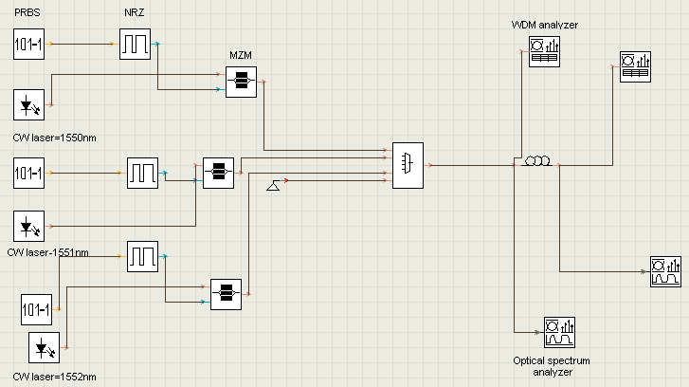
Figure 3.5 Simulation model with three channels
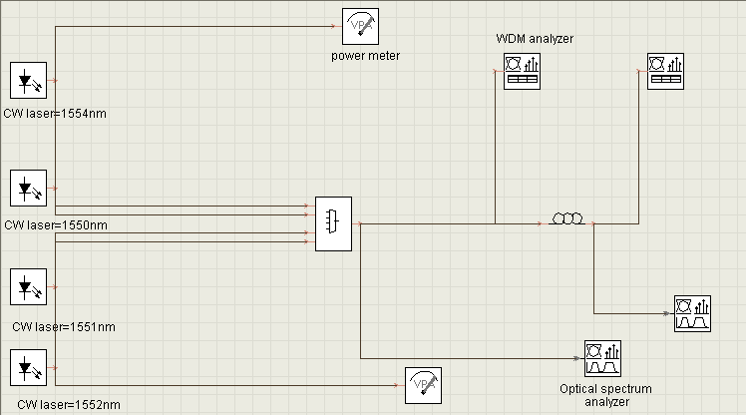
Figure 3.6 Simulation model with four channels

3.6 Modelling the Effect of FWM
MATLAB program is used to develop the analytical model of the effect of FWM in WDM for RoF. The modelling is meant to study the nonlinear effects due to the FWM in WDM for RoF when the light passing through the medium. Figure 3.6 shows the steps that will be followed in the modelling process.

The total polarization P is nonlinear with respect to the electric field E, however, it can be written as,
$P=ε_{0}\left(χ^{\left(1\right)}\right.E+χ^{\left(2\right)}E.E+χ^{\left(3\right)}E.E.E+\left..\right)$ (3.1)
Where $ε_{0}$ is the vacuum permittivity and $χ^{\left(j\right)}$ (j = 1,2,…) is jth order susceptibility.

When light propagates in a transparent medium, its electric field causes some amount of polarization in the medium. While at low light intensities the polarization is linear with the electric field, nonlinear contributions become important at high optical intensities, so the polarization equation consists linear terms as well as nonlinear terms.

The first order susceptibility $χ^{\left(1\right)}$represents the linear term, and nonlinearities can have strong effects in fibres at the third order susceptibility$χ^{(3)}$. So, only the nonlinear effects in the optical fibres, which originate from the third-order susceptibility, $χ^{(3)}$ will be considered and the other terms will be neglected. The programming will start from the third-order susceptibility $χ^{(3)}.$Thus the electric field of the signal can be written as
$E\left(r,t\right)=\sum_{i=1}^{N}{E_{i}cos\left(ω_{i}t-β_{i}z\right)}$ (3.2)
Where β is the propagation constant, and ω is angular frequencies.
Substituting Equation 3.2 into Equation 3.1, and if only the term of the third order susceptibility is taken into account, the nonlinear dielectric polarization$\left(P_{NL}\left(r,t\right.))\right.$ can be written as
$$P_{NL}\left(r,t\right.)=ε_{0}χ^{\left(3\right)}\sum_{i=1}^{n}{\sum_{j=1}^{n}{\sum_{k=1}^{n}{E_{i}}}cos\left(ω_{i}t-β_{i}z\right)}E_{j}cos\left(ω_{j}t-β_{j}z\right)$$
$E_{k}cos\left(ω_{k}t-β_{k}z\right)$
$=\frac{3ε_{0}χ^{\left(3\right)}}{4}\sum_{i=1}^{n}{\left[E_{i}^{2}+2\sum_{j=1}^{n}{E_{i}\left.E_{j}\right]}\right.}E_{i}cos\left(ω_{i}\right.t-\left.β_{i}z\right)$ (term1)

+ $\frac{ε_{0}χ^{\left(3\right)}}{4}\sum_{i=1}^{n}{E_{i}^{3}cos\left({3ω}_{i}\right.t-\left.3β_{i}z\right)}$ (term2)

$+\frac{3ε_{0}χ^{\left(3\right)}}{4}\sum_{i=1}^{n}{\sum_{j=1}^{n}{E_{i}^{2}E_{j}cos\left(\left(2ω_{i}t-3\left.β_{i}z\right)\right.\right.}}t-\left(2β_{i}-\left.β_{j}\right)\right.\left.z\right)$ (term3)

$+\frac{3ε_{0}χ^{\left(3\right)}}{4}\sum_{i=1}^{n}{\sum_{j=1}^{n}{E_{i}^{2}E_{j}cos\left(\left(2ω_{i}t-3\left.β_{i}z\right)\right.\right.}}t-\left(2β_{i}+\left.β_{j}\right)\right.\left.z\right)$ (term4)

+$\frac{3ε_{0}χ^{\left(3\right)}}{4}\sum_{i=1}^{n}{\sum_{j=1}^{n}{\sum_{k=1}^{n}{E_{i}E_{j}E_{k}}}}$

$\left(cos\left(ω_{i}\right.+ω_{j}+\left.ω_{k}\right)t-cos\left(β_{i}\right.+β_{j}+\left.β_{k}\right)z\right.$ (term5)

+$cos\left(ω_{i}\right.+ω_{j}-\left.ω_{k}\right)t-cos\left(β_{i}\right.+β_{j}-\left.β_{k}\right)z$ (term6)

+$cos\left(ω_{i}\right.-ω_{j}+\left.ω_{k}\right)t-cos\left(β_{i}\right.-β_{j}+\left.β_{k}\right)z$ (term7)
+$cos\left(ω_{i}\right.-ω_{j}-\left.ω_{k}\right)t-cos\left(β_{i}\right.-β_{j}-\left.β_{k}\right)$ ) (term8) (3.3)
The nonlinear susceptibility of the optical fibre generates new waves at the angular frequencies ωr ± ωs ± ωt (r, s, t = 1, 2,…). Term 1, in the above equation represents the effects of SPM and XPM. Terms 2, 4 and 5 can be neglected, due to lack of phase matching. The remaining terms can satisfy the phase matching condition. The power transferred due to the FWM to new frequencies after light has propagated distance L in the fibre can be estimated from equation 3.4
$P_{ijk}={\left(\frac{ω_{ijk}d_{ijk}χ^{\left(3\right)}}{{8A}_{eff}n_{eff}c}\right)}^{2}P_{i}P_{j}P_{k}L^{2}$ (3.4)

where neff is the effective index, Aeff is the effective area, Pi, Pj and Pk are the input powers at ωi, ωj and ωk. The factor dijk depends on the number of channels affecting the FWM.

The efficiency of FWM and noise performance are analyzed, taking into account the effects of difference channel spacing. Equation 6.5 is presented to evaluate the efficiency of the FWM.
$η={\left[\frac{n_{2}}{{A_{eff}D\left(∆λ\right)}^{2}}\right]}^{\frac{1}{2}}$ (3.5)
Equation 3.6 is used to investigate the relationship between the efficiency and the power of the FWM.
$P_{ijk}=\left(\frac{γ^{2}}{9}\right){\left(d_{ijk}\right)}^{2}\left(P_{i}P_{j}P_{k}\right)e^{-αL}L_{eff}^{2}η$ (3.6)

Where Leff is effective length, which can be calculated by using Equation 3.7

$L_{eff}=\frac{1-e^{-αl}}{α}$ (3.7)
where ω is the Angular frequency, d is the degeneracy factor,$χ^{\left(3\right)}$ is the third order susceptibility, Aeff is the effective Area, n2 is the nonlinear reflective index, c is the speed of light, D is the dispersion,$∆λ$ is the channel space, α is the fibre loss coefficient and L is total fibre length.

The third order susceptibility $χ^{\left(3\right)}$ which includes self-phase modulation (SPM) and cross-phase modulation (XPM) as well as four-wave mixing (FWM). Therefore, the SPM and XPM will be considered as zero, thus, their effects on FWM modelling are neglected. Term1 representing XPM and SPM will be considered as of zero effect and will be neglected too.

The four-wave mixing, require the phase matching to be efficient. Essentially this is mean to ensure a proper phase relationship between the interacting waves. FWM will be a peak at the phase matching spectrum. Equation 6.8 satisfies the condition of phase matching:

$∆β=β\left(ω_{1}\right)+β\left(ω_{2}\right)$-$β\left(ω_{3}\right)$-$β\left(ω_{4}\right)$ (3.8)

Where βj is the propagation constant. If β= 0 the phase matching condition is satisfied, otherwise mismatching occurs The model in this study will use only two wavelengths, therefore the phase matching condition will be β= β(ω2) - 2 β(ω1) =0 in order to satisfy the phase matching requirement as shown in Figure 3.7
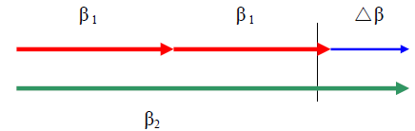
Figure 3.7- The phase matching condition of two different wavelengths

Term2, term4, and term5 in the polarization Equation 3.3 are considered as mismatching terms. After neglecting the terms representing the effects of SPM, XPM that lack phase matching, the remaining terms in the nonlinear equation, which satisfy the phase matching condition.

CHAPTER 4
RESULTS AND DISCUSSIONS
4.1 Introduction - This chapter presents and discusses the results obtained from the simulation model by using Virtual Photonic Incorporated as numerical simulation and MATLAB as analytical simulation. The numerical simulation is simulated accordingly as mentioned in the previous chapter, with and without external modulated laser.

4.2 Simulation of the Four Wave Mixing Effect - In the FWM simulation model layout, two types of visualizer tools have been used. The optical spectrum analyzer and the WDM analyzer were fixed after MUX and at the end of the fibre optic. The results obtained after the multiplexer are same as the input power level shown before the nonlinear effect. The nonlinear effect occurs only during the propagation of signals through the fibre. The optical spectrum analyzer and WDM analyzer has been used to show the waveform.

4.3 Simulation Results without the External Modulated Signal - In this simulation two CW lasers were used as signals sources, the frequencies were set at 1550 and 1552 nm, where as the power was set at 0 dBm. The line width has been set at 0 and the input signals have propagated through 25 km of nonlinear fibre.
4.3.1 WDM analyzer input-
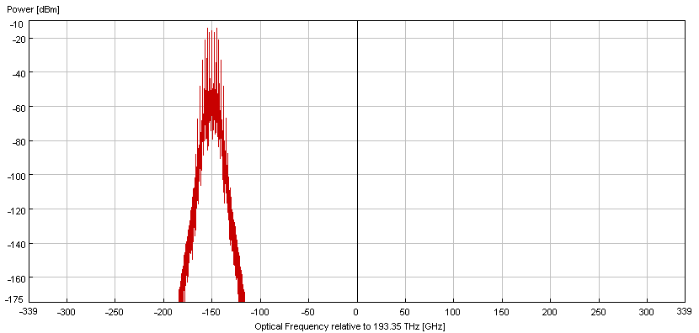
Figure 4.3.1 power versus optical frequency
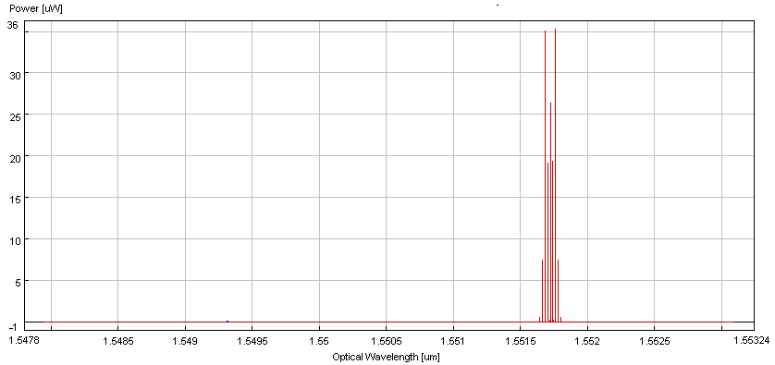Figure4.3.2 power versus optical wavelength
4.3.2 WDM analyzer output
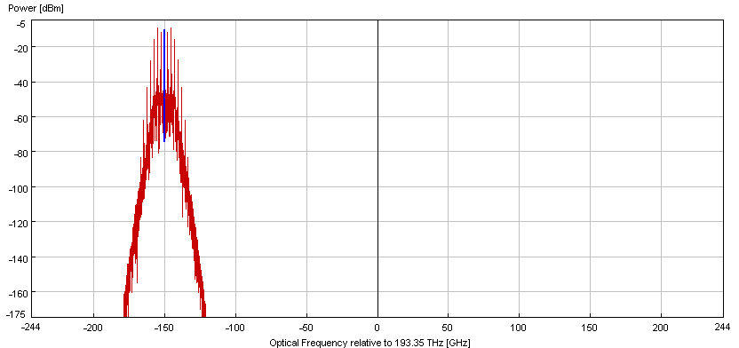
Figure 4.3.3 power versus optical frequency
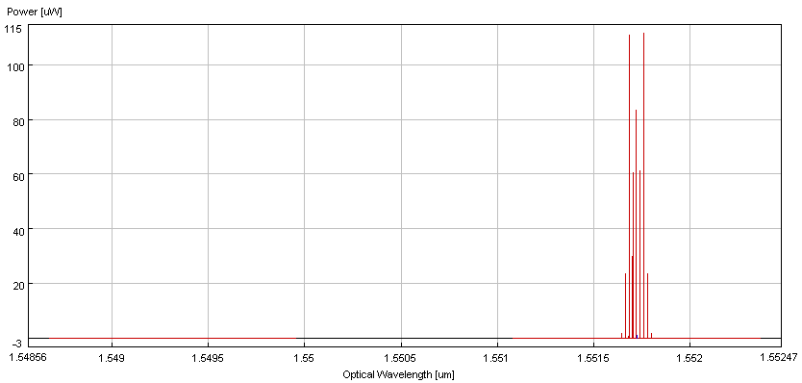
Figure 4.3.4 power versus optical wavelength
4.3.3 Optical Spectrum Analyzer input-
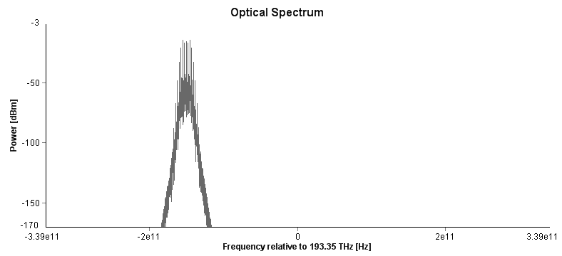
Figure4.3.5 Power versus frequency
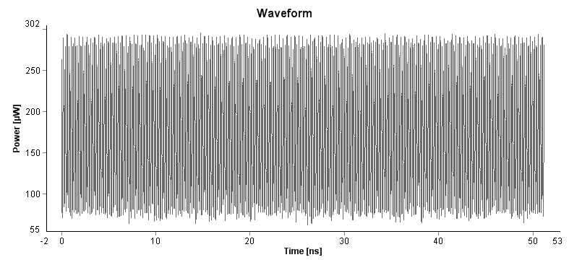Figure 4.3.6 Power versus time
4.3.4 Optical spectrum analyzer output
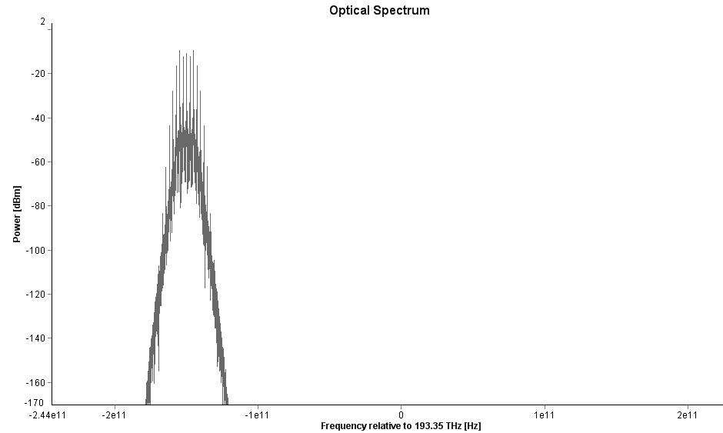
Figure 4.3.7 Power versus frequency
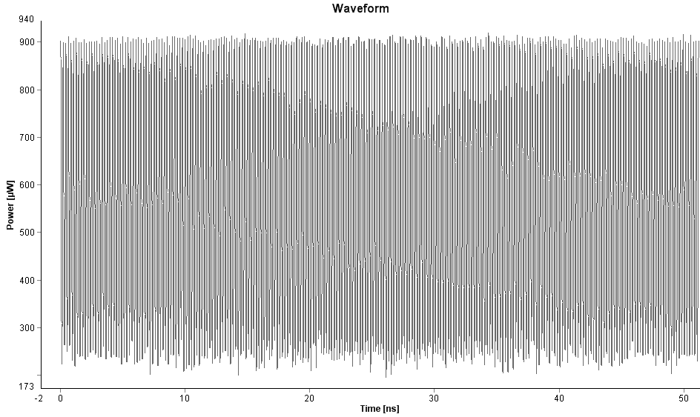
Figure 4.3.8 Power versus time
4.4 Simulation Results with the External Modulated Signal
4.4.1 WDM analyzer input
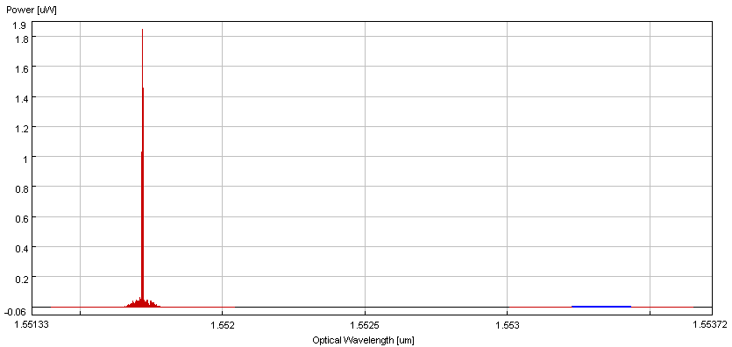
Figure 4.4.1 Power versus optical wavelength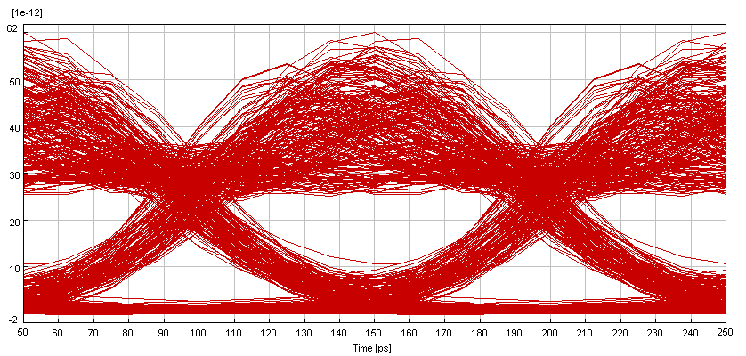
Figure 4.4.2 Eye diagram
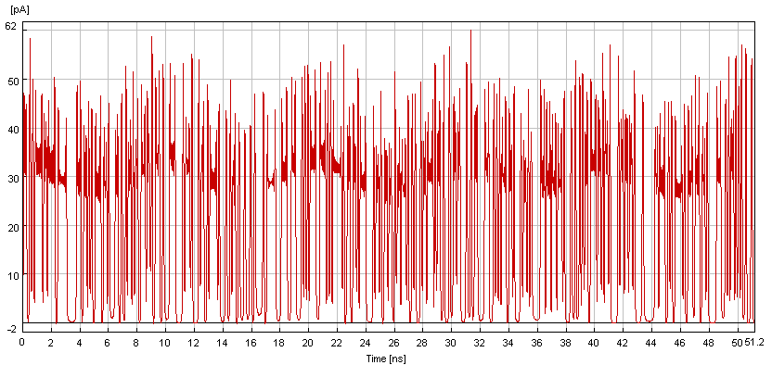Figure 4.4.3 Power versus time
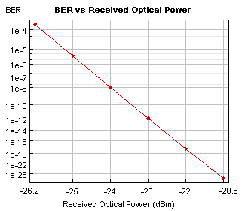
Figure 4.4.4 BER versus received optical power
4.4.2 WDM analyzer output-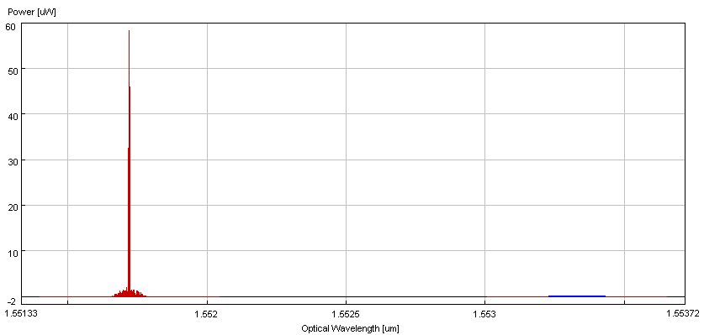
Figure 4.4.5 Power versus optical wavelength
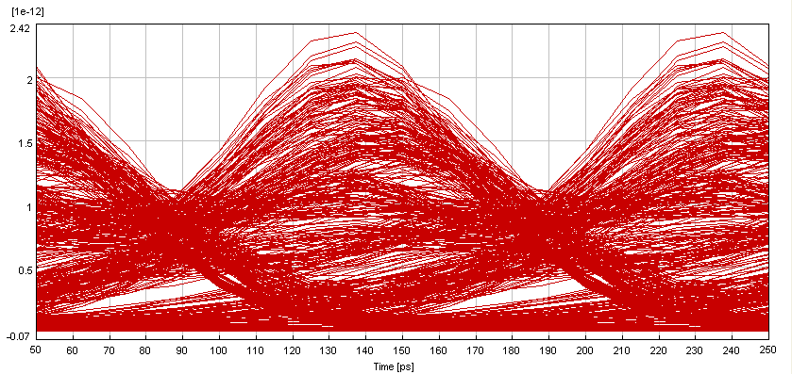
Figure 4.4.6 Eye diagram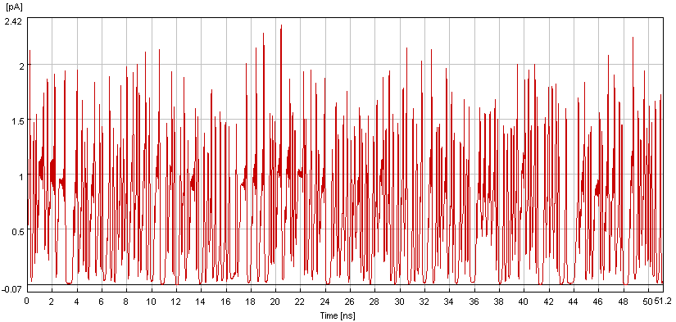
Figure 4.4.7 Power versus time
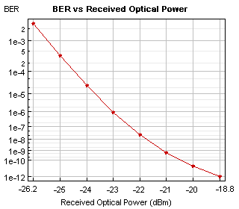
Figure 4.4.8 BER versus received power
4.4.3 Optical spectrum analyzer input
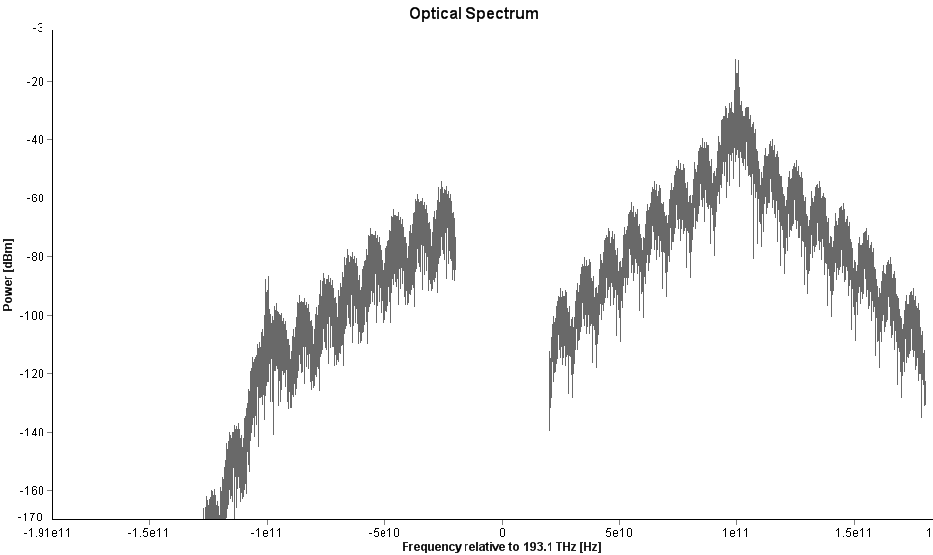
Figure 4.4.9 Power versus frequency
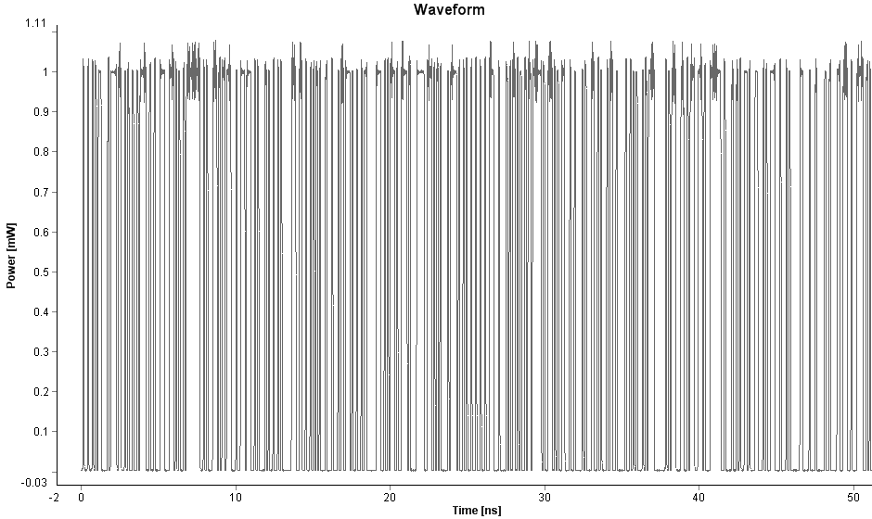
Figure 4.4.10 Power versus time

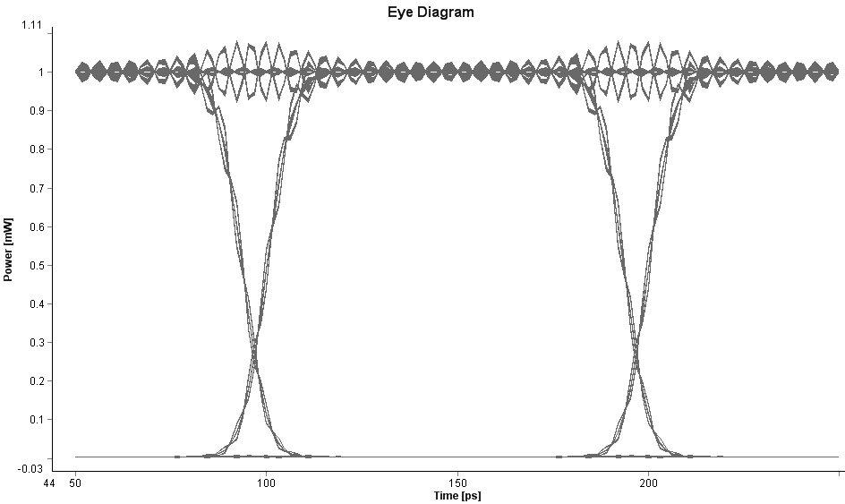
Figure 4.4.11 Eye diagram
4.4.4 Optical spectrum analyzer output
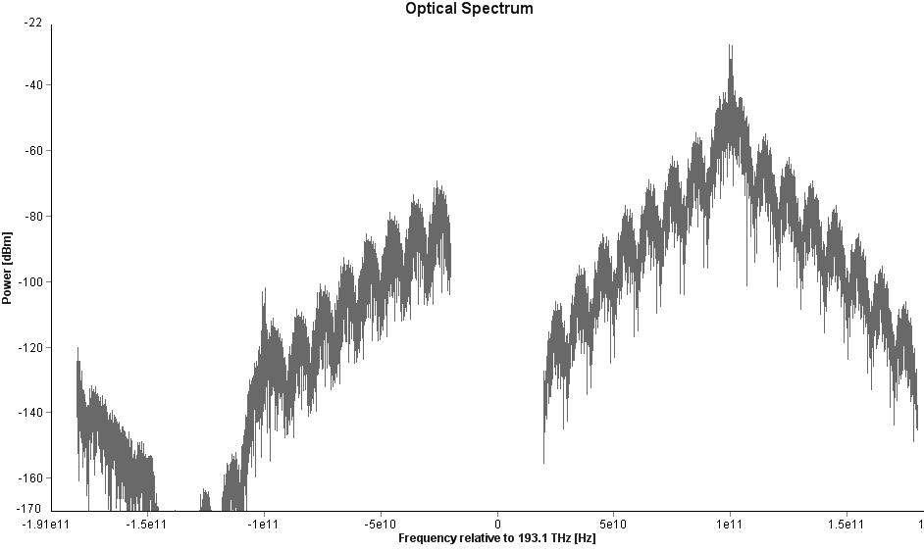
Figure 4.4.12 Power versus frequency

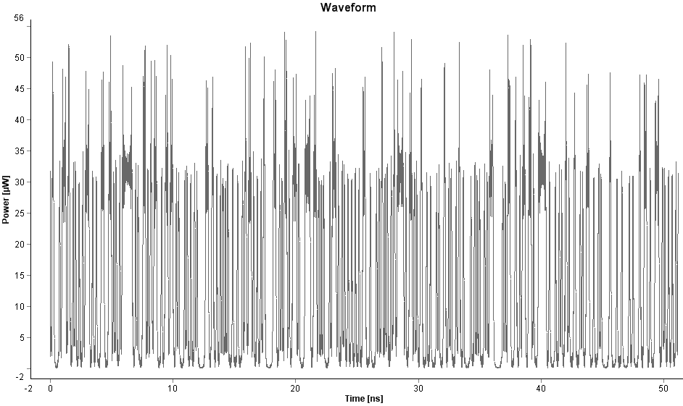
Figure 4.4.13 Power versus time

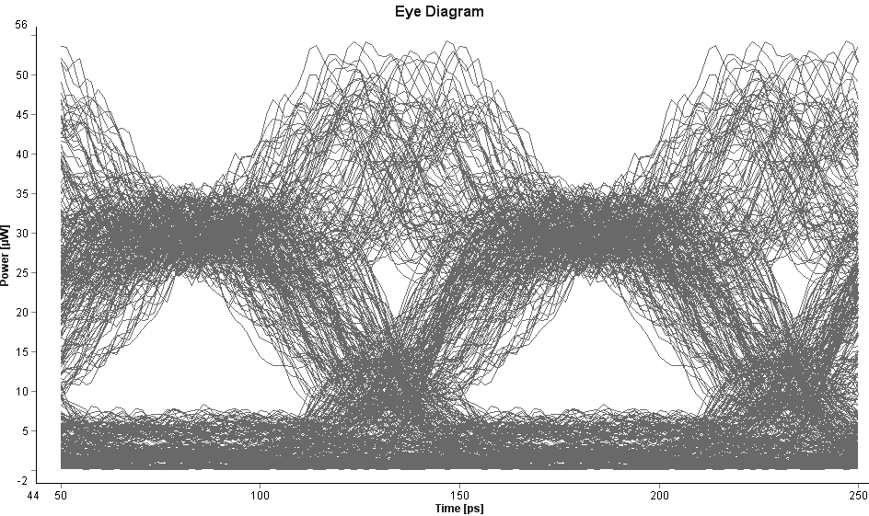

Figure 4.4.14 Eye diagram
4.5 Simulation of Four Wave Mixing for Higher Number of Channels
This section presents the simulation results as the number of channels is increased to four in the simulation model, with or without the use of external modulated laser.
4.5.1 Simulation Results for Four Signal Source without External Modulated Signal - The simulation results for four channels, without use of external modulated laser, Figure 4.5.1 shows input signal when number of channels is increased to four and the channel spacing is set at 0.1 nm.
4.5.1.1 WDM analyzer input-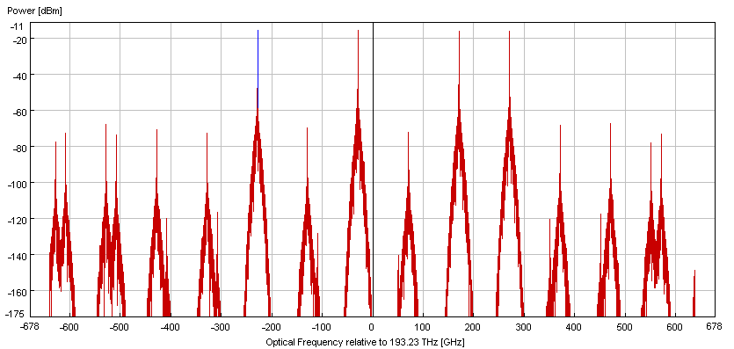
Figure 4.5.1 Power versus optical frequency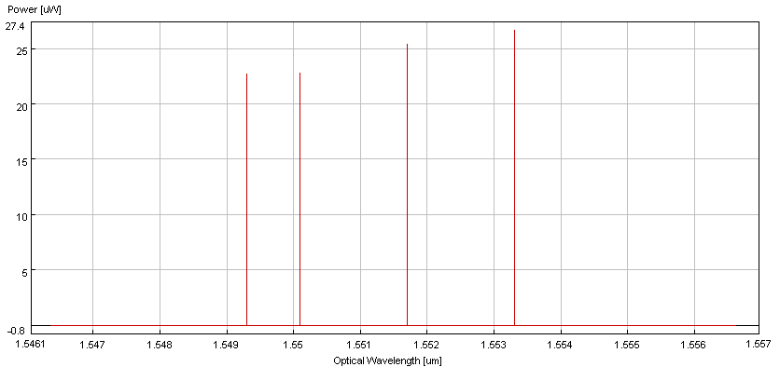
Figure 4.5.2 Power versus wavelength
4.5.1.2 WDM analyzer output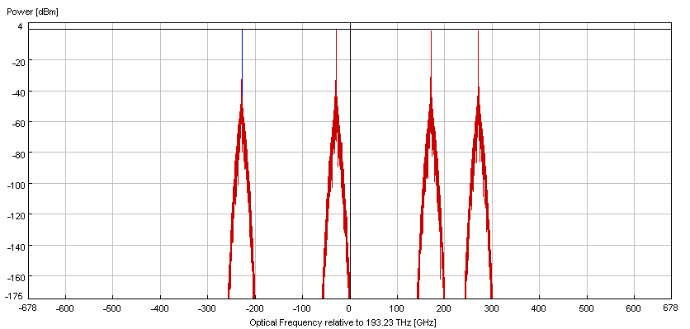
Figure 4.5.3 Power versus optical frequency
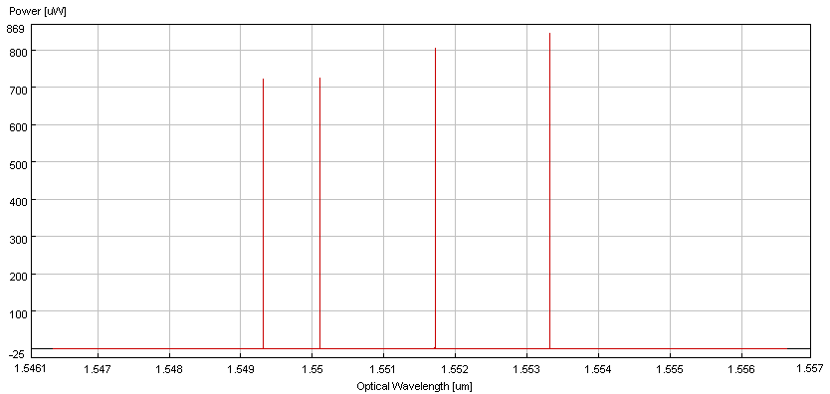
Figure 4.5.4 Power versus optical wavelength
4.5.1.3 Optical spectrum analyzer input
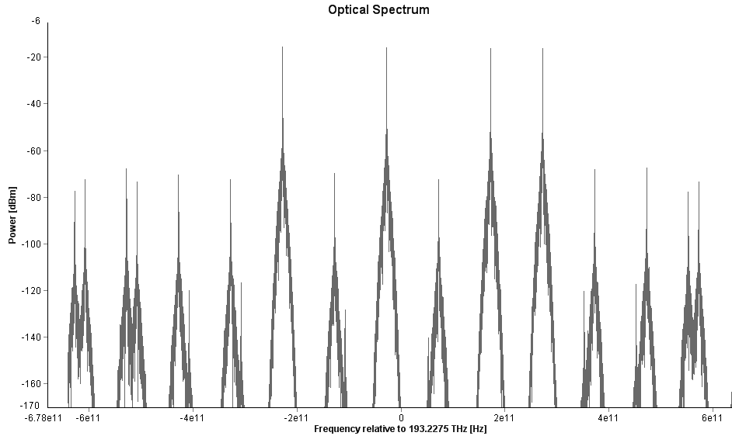
Figure 4.5.5 Power versus frequency
4.5.1.4 Optical spectrum analyzer output
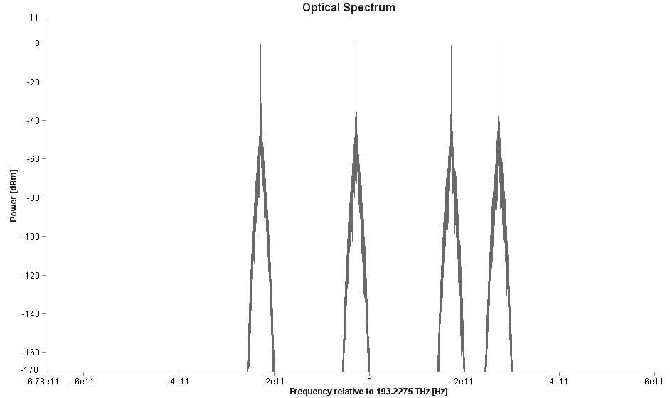
Figure 4.5.6 Power versus frequency
4.5.2 Simulation Results for Three Signal Source with External Modulated Signal
The simulation results for three channels, when using External modulated Laser, at channel spacing of .5nm.
4.5.2.1 WDM analyzer input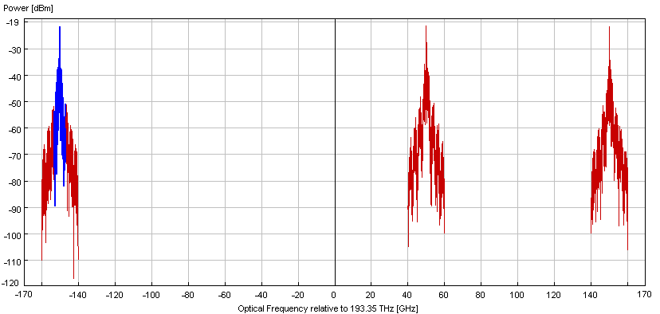
Figure 4.5.7 Power versus frequency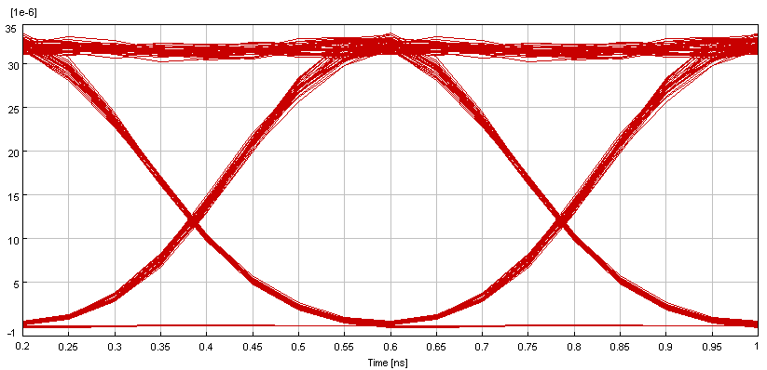
Figure 4.5.8 Eye diagram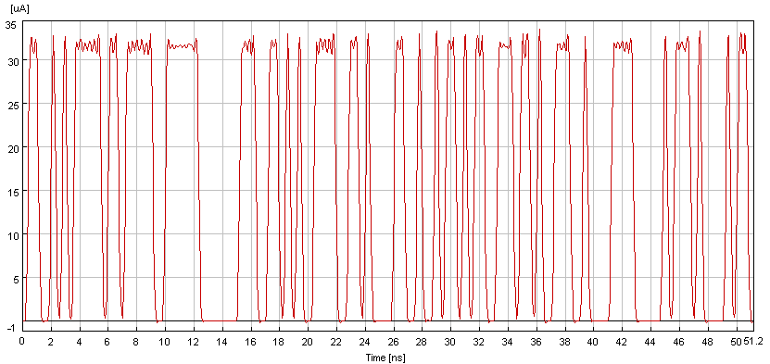
Figure 4.5.9 Amplitude versus time
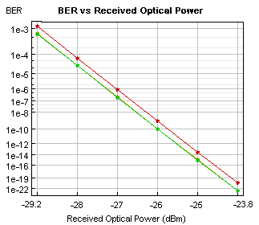
Figure 4.5.10 BER versus received optical power
4.5.2.2 WDM analyzer output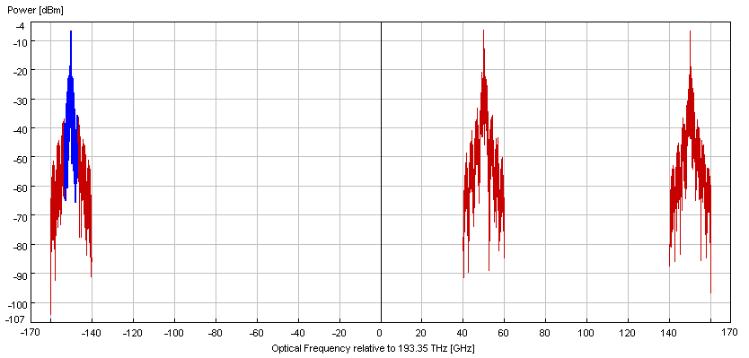
Figure 4.5.11 Power versus optical frequency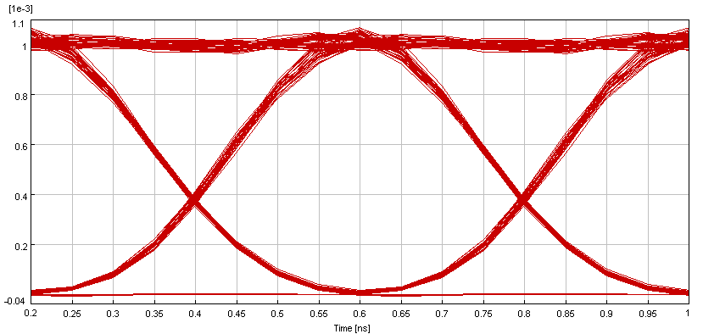
Figure 4.5.12 Eye diagram
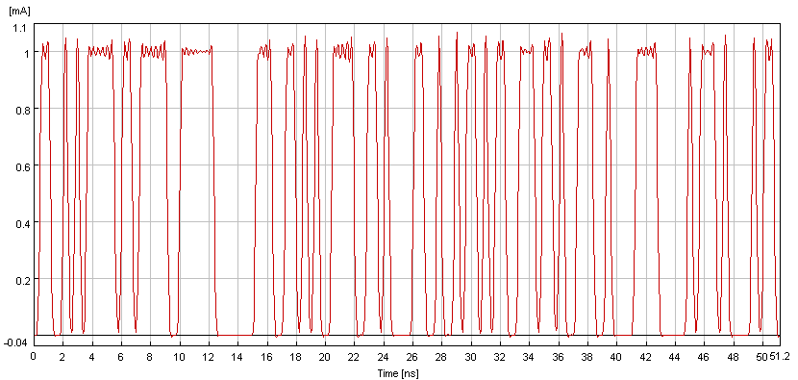
Figure 4.5.13 Amplitude versus time
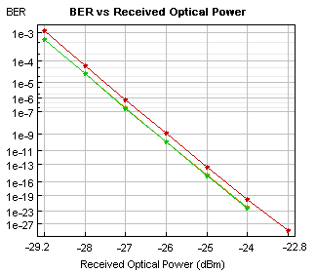
Figure 4.5.14 BER versus received optical power
4.5.2.3 Optical spectrum analyzer input
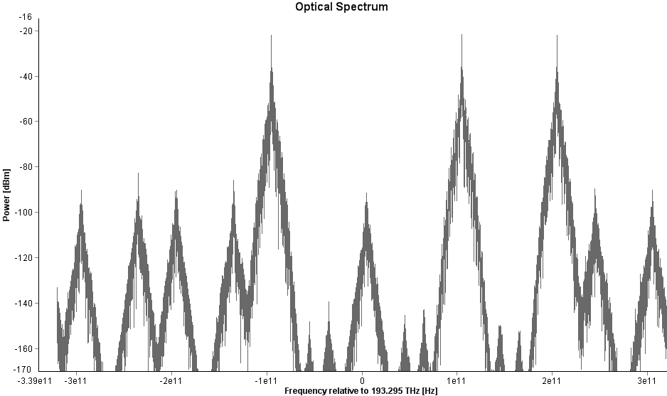
Figure 4.5.15 Power versus frequency
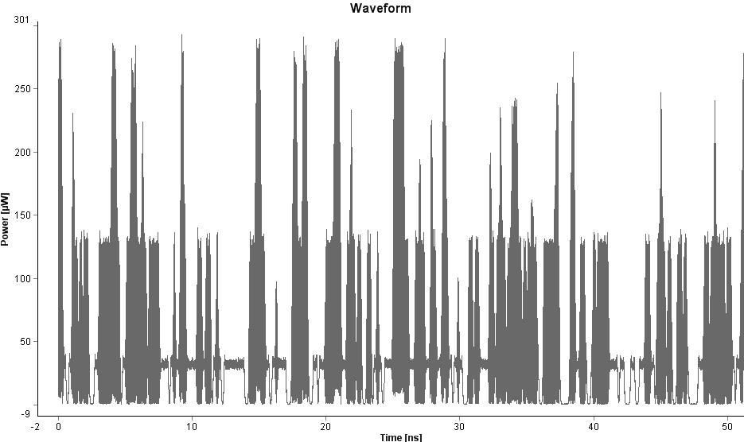
Figure 4.5.16 Power versus time
4.5.2.4 Optical analyzer output
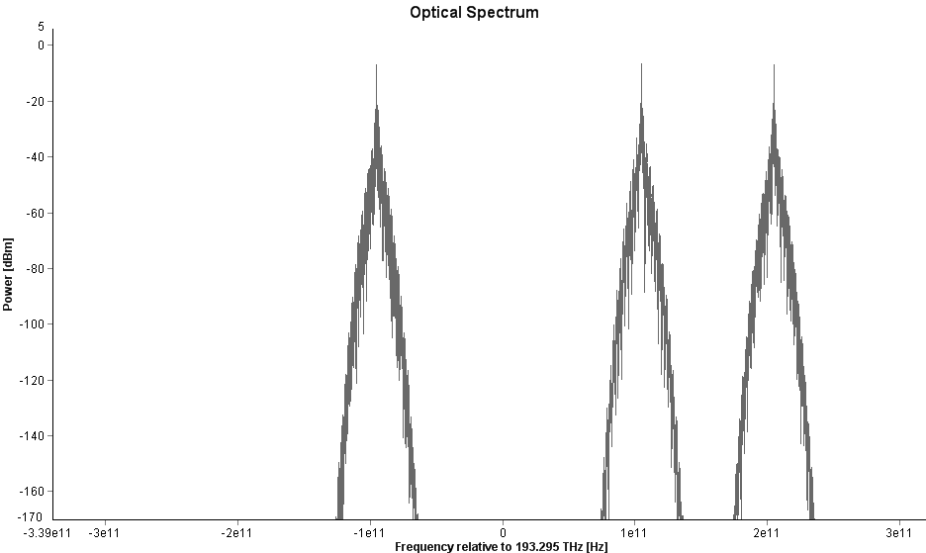
Figure 4.5.17 Power versus frequency
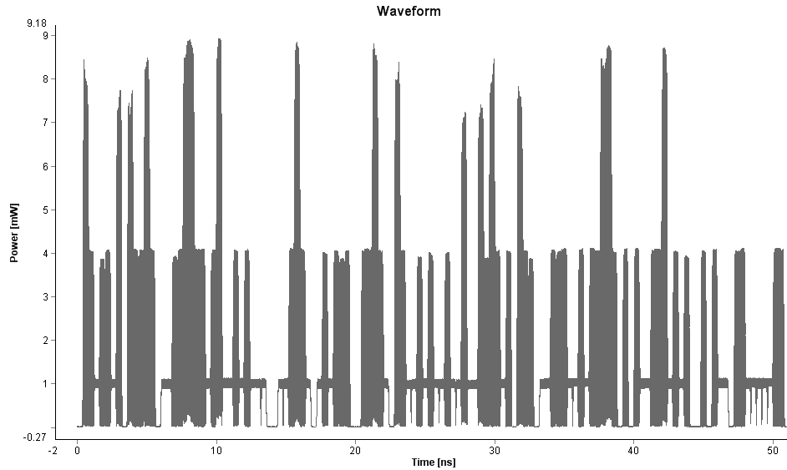
Figure 4.5.18 Power versus time
4.6 Discussions
Based on the results presented, The FWM effects increase as the number of channels is increased. The number of spurious signals due to FWM increase geometrically and given by
$M={(N}^{3}-N^{2})/2$ (4.1)
where N is the number of channels and M is the number of the newly generated sidebands. The new generated mixing products have high possibilities fall directly on the original signal, this could produce crosstalk.
Therefore, as the spacing between channels is reduced or remained equal the effect of the crosstalk is found to become greater .When the spacing between the channels is unequal, showed that the mixing products have low power level and highly possible not to falls on the original signal, which makes them easy to be filtered, and in turn improve the system performance.

4.7 Analytical Modelling

MATLAB based program has been developed using Equations 3.4 to 3.6 in order to design analytical model, which assists to predict the expected FWM power in different channel spacing. The designed model can give the expectation value of the FWM power in different input signal power level.

Analytical Results

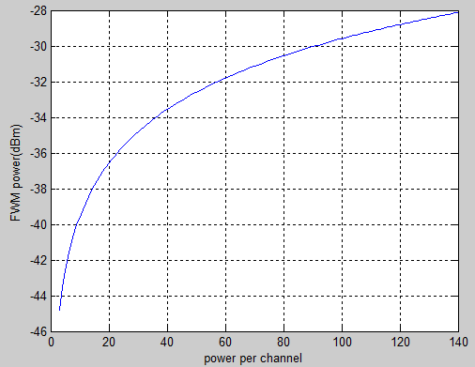

Figure 4.7 FWM power versus power per channel
The FWM effects increase exponentially as the level of the optical power from the signal sources is increased, as shown in the Figure 4.7.
In this way we can say that in both numerically and analytically simulation FWM effects increase exponentially as power from the signal sources increases.

4.8 Four Wave Mixing Reduction

One way to combat the FWM process is to use unequal channel spacing, so that the mixing products do not coincide with signal frequency, and to use low input power, or high effective area. Fibre dispersion management is a very effective way, helpful not for FWM but also is the case of other nonlinear phenomena, that degrade transmission performance in the fibre, also FWM can be mitigated by increasing the effective area of the fibre.[20]

CHAPTER 5
CONCLUSIONS AND RECOMMENDATIONS

5.1 Conclusion
Future wireless systems will be targeting towards providing broadband access and personal area multimedia services to large number of subscribers. Radio over fibre (RoF) network accompanied with wavelength division multiplexing (WDM) can provide a simple topology, easier network management, and an increased capacity by allocating different wavelengths to individual remote nodes. The performance of WDM networks is strongly influenced by nonlinearity characteristic inside the fibre. Therefore the nonlinearity effects of fibre optics pose additional limitation in WDM systems.

It is well known that FWM in WDM for RoF signals are mostly generated by non-degenerate FWM process regardless of the number of input signals. In this study only two and four input signals were launched into the optical fibre. The FWM effect has been investigated analytically and numerically simulated.

The numerical simulation results obtained have shown the spectral characteristics of the FWM in WDM for RoF where the effects of FWM are pronounced with decreased channel spacing of wavelengths. In the analytical simulation the FWM effects increase exponentially as the level of the optical power from the signal sources is increased.

It is noticed that the FWM also causes inter-channel cross talk for equally spaced WDM channels. Thus, FWM can be mitigated using unequal channel spacing. It could be concluded that results obtained from this study will provide useful information for identifying the fundamental limit of the capacity of the WDM systems.

5.2 Recommendations for Future Work

FWM in WDM for RoF effects are likely to become the main source of performance degradation in contemporary and future fibre optical communications, therefore future studies in attempt to overcome such problems, the following could be recommended.

Investigation of FWM effect using more than eight sources is essential because most technologies nowadays use DWDM in order to meet the huge capacity demands.

Crosstalk is the transfer of power from one channel to another, can occurs due to nonlinear effect. FWM can produce crosstalk between wavelength channels. This crosstalk is strongly dependent on channel separation and optical power. Therefore it is important to estimate how large the cross talk is.

References

- Mo Li, Hongwei Chen, Feifei Yin, Minghua Chen, and Shizhong Xie,“Full-Duplex 60-GHz RoF System With Optical Local Oscillating Carrier Distribution Scheme Based on FWM Effect in SOA”IEEE Photonics Technology Letters, Vol. 21, No. 22, November 15, 2009

2- Y. Kim, B. J. Jeong, J. Chung, C-S. Hwang, J. S. Ryu, K-H. Kim, and Y. K. Kim, “Beyond 3G: Vision, Requirements, and Enabling Technologies”, IEEE Communications Magazine, 120 – 124, (March 2003).

3- S. Ohmori, “The Future Generations of Mobile Communications Based on Broadband Access Technologies”, IEEE Communications Magazine, 134 - 142, (December 2000).

4- D.Wake, “Radio over Fibre Systems for Mobile Applications” in Radio over Fibre Technologies for Mobile Communications Networks”, H. Al-Raweshidy, and S. Komaki, ed. (Artech House, Inc, USA, 2002).

5- Ajung Kim, Young Hun Joo, and Yungsoo Kim, “60GHz Wireless Communication Systems with Radio-over-Fibre Links for Indoor Wireless LANs” Journal of light-wave technology, 20, (4), (2004) 517-521.

6- Govind P. Agrawal, “Fibre-Optic communication system” McGraw-Hill December 2001.

7- Hamed Al-Raweshidy, “Radio over Fibre Technologies for Mobile Communications Networks” , Artech House, 2002.

8- Kwansoo Lee ”Radio over Fibre for Beyond 3G” Telecommunication R&D Centre, Samsung Electronics Co. Suwon-city, Gyeonggi-do, Korea, 442-600.

9- H. Ogawa, D. Polifko, and S. Banba, “Millimetre-wave fibre optics systems for personal radio communication,” IEEE Trans. Microw. Theory Tech., vol. 40, no. 12, pp. 2285–2292, Dec. 1992.

10- J. Laskar, S. Pinel, D. Dawn, S. Sarkar, B. Perumana, and P. Sen, “The next wireless wave is a millimetre wave,” Microw. J., vol. 50, no. 8, pp. 22–32, Aug. 2007.

11- J. J. O’Reilly, P. M. Lane, and M. H. Capstick , “Optical Generation and Delivery of Modulated mm-waves for Mobile Communications”, in Analogue Optical Fibre Communications, B. Wilson, Z. Ghassemlooy, and I. Darwazeh, ed. (The Institute of Electrical Engineers, London, 1995).

12- T. Wang, M. Chen, H. Chen, and S. Xie, “Millimetre-wave signal generation using four-wave mixing effect in SOA,” Electron. Lett. vol. 43, no. 1, pp. 36–38, Jan. 2007.

13- A. Ng’oma, “Design of a Radio-over-Fibre System for Wireless LANs”, (MTD. Report, Eindhoven University of Technology, Eindhoven, 2002).

14- L. No¨el, D. Wake, D. G. Moodie, D. D. Marcenac, L. D. Westbrook, and D. Nesset,”Novel Techniques for High-Capacity 60-GHz Fibre-Radio Transmission Systems”, IEEE Trans. Microwave Theory Tech., vol. 45, no. 8, pp. 1416.1423, Aug. 1997.

15- Antti Lamminpää, “Measurement of nonlinearity of optical fibre.” Master thesis, Helsinki University of Technology, 2003.

16- Yannis, L. G. “New optical Microwave Up-Conversion Solution in Radio over Fibre Network” Journal of light-wave technology, 24 (3) (2006) 1277- 1282.

17- Jiunn-Shyen Wu, Student, IEEE, Jingshown Wu, Member, IEEE, and Hen-Wai Tsao, Member, IEEE” A Radio-over-Fibre Network for Microcellular System Application” IEEE Transactions On Vehicular Technology, Vol. 47, No. 1, February 1998.

18- CHEN Zhuo,YU Chongxiu,XU Daxiong,LI Anjian”RoF based Microcellular Network for Vehicle Mobile\Radio Communication System” Beijing University of Posts and Telecommunications, 2006 6th International Conference on ITS Telecommunications.

19- P. Shen, N. J. Gomes, P. A. Davies, W. P. Shillue, P. G. Huggard, and B. N. Ellison, “High-Purity Millimetre-Wave Photonic Local Oscillator Generation and Delivery”, in Proceedings of the International Topical Meeting on Microwave Photonics (MWP 2003). 2003, pp. 189 – 192.

20- Fabrizio Forghieri, R. W. Tkach, A. R. Chraplyvy, and D. Marcuse” Reduction of Four-Wave Mixing Crosstalk in WDM Systems Using Unequally Spaced Channels” IEEE Photonics Technology Letters, Vol. 6, No. 6, June 1994

21- D. Marcuse, “Effect of Fibre Nonlinearity on Long-Distance Transmission”, Journal of light wave technology, 9 (1) (1991) 121-128.

