A Dissertation
ON

“An Approach to Data compression Technique”
Submitted in partial fulfilment of the requirement of
Delhi Technological University, for the degree of
M. Tech.
In
“Software Engineering”

Guided by:
Mr. R. K. Yadav
Asst. Professor, COE Department

Submitted by
Tarun Kumar Chaudhary (12/MT/SE/FT)

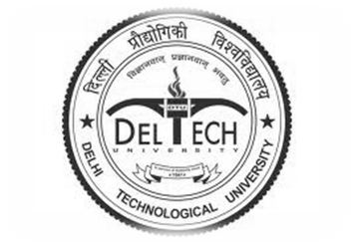
COMPUTER ENGINEERING DEPARTMENT
DELHI TECHNOLOGICAL UNIVERSITY
BAWANA ROAD, DELHI - 110042
June 2011

