ACKNOWLEDGEMENT
I am very grateful and thankful to all people who extended their support to successful completion of my project.
I express my gratitude to our esteemed guide Prof. Rajiv Kapoor H.O.D of Deptt. Of Electronics and Communication Engg. D.C.E. Delhi, who Indebted to me for valuable support, encouragement and suggestion .Without their guidance the success of this project would have been impossible.
I would be failing in my duties, if I did not thank Prof. Asok Bhattacharyya for inspiring me to strive to achieve the best.
I also take this opportunity to thank the management and the Lab assistants of DCE for permitting me and providing me the necessary facilities to carry out my project.
Ashish Chittora
University Roll No. : 8513
Class Roll. No. : 04/E&C/09

CERTIFICATE
This is to certify that Mr. ASHISH CHITTORA, University Roll No. : 8513 and Class Roll No. 04/E&C/09, have successfully carried out the project work titled “UNCONSTRAINED FACE RECOGNITION SYSTEM” as a partial requirement for the award of Degree of Master Of Engineering, in Electronics & Communications Department, by Delhi University, New Delhi and is a record of bonafide work carried out and completed under my supervision and guidance during the academic session 2009-2011. The project report has been approved as it satisfied the academic requirements in respect of thesis work prescribed for the Master of Engineering Degree.

Prof. Rajiv Kapoor
H.O.D. (Dept. of Electronics & Communication)
(Project Guide) Delhi College of Engineering
Delhi-110042

ABSTRACT

The focus of the project entitled “UNCONSTRAINED FACE RECOGNITION” is to ultimately develop a face recognition system. The novelty of the proposed method is twofold. First we have developed a fuzzy based Gaussian-like edge detector to extract features. Secondly support vector machine is used for multi-tier classification.
The main idea behind the face recognition approach is to extract the important features (which are edges) using a fuzzy edge detection method. Now there is a need to reduce the dimensions of this extracted feature space and to identify most significant features. For this Principle Component Analysis method is used. After this dimension reduction step classification is performed by using Support Vector Machine based classifier, which is a binary classifier. An algorithm “one v/s all” is applied to make the SVM work as multiclass classifier. This method is very fast and can be used in real-time. It can be applied to robotic system, access control system, security system, the human-machine interaction system and so on.

CONTENTS
Chapters |  |  | Pages
1 | Introduction |  | 8
2 | Previous Work |  | 13
 | 2.1 | Human Face Recognition | 13
 | 2.2 | Machine Recognition of Faces  2.2.1 Statistical Approaches  2.2.1.1 Face Detection and Recognition by PCA  2.2.1.2 Face Recognition by LDA  2.2.1.3 Transformation Based Systems  2.2.1.4 Feature-based Approaches  2.2.2 Neural Network Approaches  2.2.3 Hybrid Approaches  2.2.4 Other Approaches  2.2.4.1 Range Data  2.2.4.2 Infrared Scanning  2.2.4.3 Profile Images | 15  16  17  20  20  22  23  25  26  26  26  26
3 | Features Extraction  3.1 Fuzzy Image Representation |  | 28  29
4 | Dimension Reduction  4.1 Linear Discriminant Analysis (LDA)  4.2 Principal Component Analysis (PCA) |  | 33  33  34
 | 4.3 Methodology |  | 35
5 | Pattern Classification |  | 37
 | 5.1 | Pattern Classification Basics | 37
 | 5.2 | Classifiers  5.2.1 Bayesian Classifier  5.2.2 Nearest Mean Classifier  5.2.3 Support vector machine Classifier  5.2.4 Multiclass SVM classification methods  5.2.4.1 One-against-all SVM  5.2.4.2 One-against-one SVM  5.2.4.3 DAGSVM | 38  38  40  41  44  44  45  46
6 | Implementation and Results |  | 48
 | 6.1 | System Flow Diagram | 48
 | 6.2 | Utilized Face Databases | 48
 | 6.3 | Preprocessing | 49
 | 6.4 | Experimental Results | 49
 | 6.5 | Graphical User Interface | 54
7 | Conclusion  References |  | 56  57

LIST OF FIGURES
Figure |  | Pages
1 | Gaussian Membership function | 30
2 | (a) Detected edges and (b) their annotation on face | 32
3 | Three 3-dimensional distributions are projected onto 2-dimensional subspaces, described by normal vectors W1 and W2. As LDA tries to find the greatest separation among the classes, W1 is optimal for LDA | 34
4 | Linear separating hyperplanes for the separable case | 43
5 | Multiclass Classification by SVM | 44
6  7  8  9  10  11  12  13 | A DAG for four classes: each node is a pair wise classifier between two classes. A decision of rejecting one of the two class labels is made at each node.  System Flow Diagram  Pre-processed Faces  Before and after histogram equalization  (a) Face images from ORL database (b) Extracted features  Three dimensional feature space  (a) Face images from Georgiatech database (b) Extracted features  GUI for face recognition system | 46  48  49  51  51  52  53  54
CHAPTER 1
INTRODUCTION
The face is our primary focus of attention in social intercourse, playing a major role in conveying identity and emotion. Although the ability to infer intelligence or character from facial appearance is suspect, the human ability to recognize faces is remarkable. We can recognize thousands of faces learned throughout our lifetime and identify familiar faces at a glance even after years of separation. This skill is quite robust, despite large changes in the visual stimulus due to viewing conditions, expression, aging, and distractions such as glasses, beards or changes in hair style. Face recognition has been an active research area over the last 30 years. It has been studied by scientists from different areas of psychophysical sciences and those from different areas of computer sciences. Psychologists and neuroscientists mainly deal with the human perception part of the topic, whereas engineers studying on machine recognition of human faces deal with the computational aspects of face recognition.
Face recognition has become an important issue in many applications such as security systems, biometrics, access control, law enforcement, surveillance systems, credit card verification and criminal identification. For example, the ability to model a particular face and distinguish it from a large number of stored face models would make it possible to vastly improve criminal identification. Even the ability to merely detect faces, as opposed to recognizing them, can be important. Detecting faces in photographs for automating color film development can be very useful, since the effect of many enhancement and noise reduction techniques depends on the image content. Biometrics are methods to automatically verify or identify individuals using their physiological or behavioural characteristics [1]. Biometric technologies include [2]:
- Face Recognition
- Finger Print (dactylogram) Identification
- Hand Geometry Identification
- Iris Identification
- Voice Recognition
- Signature Recognition
- Retina Identification
- DNA Sequence Matching
Although it is clear that people are good at face recognition, it is not at all obvious how faces are encoded or decoded by the human brain. Developing a computational model of face recognition is quite difficult, because faces are complex, multi-dimensional visual stimuli. Therefore, face recognition is a very high level computer vision task, in which many early vision techniques can be involved.
The necessity for personal identification in the fields of private and secure systems made face recognition one of the main fields among other biometric technologies. The importance of face recognition rises from the fact that a face recognition system does not require the cooperation of the individual while the other systems need such cooperation. Thus, it should not be surprising that a face recognition system is placed in the Statue of Liberty in US.
Face recognition algorithms try to solve the problem of both verification and identification [3]. When verification is on demand, the face recognition system is given a face image and it is given a claimed identity. The system is expected to either reject or accept the claim. On the other hand, in the identification problem, the system is trained by some images of known individuals and given a test image. It decides which individual the test image belongs to.
The problem of face recognition can be stated as follows: Given still images or video of a scene, identifying one or more persons in the scene by using a stored database of faces [4]. The problem seems to be mainly a classification problem: Training the face recognition system with images from the known individuals and classifying the newly coming test images into one of the classes is the main aspect of the face recognition systems. But the major step of human face identification is to extract the relevant features from facial images. Research in the field primarily intends to generate sufficiently reasonable familiarities of human faces so that another human can correctly identify the face. The question naturally arises as to how well facial features can be quantized. If such a quantization if possible then a computer should be capable of recognizing a face given a set of features.
The topic seems to be easy for a human, where limited memory can be a main problem; whereas the problems in machine recognition are manifold. Some of possible problems for a machine face recognition system are mainly;
1) Facial expression change: A smiling face, a crying face, a face with closed eyes, even a small nuance in the facial expression can affect facial recognition system significantly.
2) Illumination change: The direction where the individual in the image has been illuminated greatly effects face recognition success. A study on illumination effects on face recognition showed that lighting the face bottom up makes face recognition a hard task [5].
3) Aging: Images taken some time apart varying from 5 minutes to 5 years changes the system accuracy seriously.
4) Rotation: Rotation of the individual’s head clockwise or counter clockwise (even if the image stays frontal with respect to the camera) affects the performance of the system.
5) Size of the image: A test image of size 20x20 may be hard to classify if original class of the image was 100x100.
6) Frontal vs. Profile: The angle in which the photo of the individual was taken with respect to the camera changes the system accuracy.
There are studies on face recognition from profile images, but this problem is out of the scope of this thesis. In this thesis, the problem of rotation stated above has been studied. All the images are assumed to be frontal with a maximum acceptable rotation of 10-25 degrees to the right or left.
Face recognition system is the next step of a face detection system. In this study, it is assumed that all the images used to train or test the system are face images. The problem of determination of the exact location of the face is out of the scope of this thesis, but some preprocessing techniques had to be applied to ensure that all the faces were oriented in the same location in all the images.
1.1 Scope of the Thesis
In this thesis, the important steps for a generic face recognition system are explained, as well as the developed system is described. The performance of the system is studied on three different face databases. Moreover, the effect of some preprocessing techniques on the performance of these face recognition systems is investigated. The results are compared with respect to the effects of changes in SVM kernel function. Also the recognition rate is compared with recently developed techniques.
1.2 Thesis Outline
In Chapter 2, a brief survey on face recognition methods is given. The approach to face recognition is mainly a classification problem of pattern recognition after extraction of the features. Hence, methods on extraction of the features (both holistic and local) and common classification methods used in pattern recognition are discussed.
In Chapter 3, feature extraction approach used in this work will be explained in detail.
In Chapter 4, dimension reduction techniques are discussed. First LDA is explained and later PCA and its methodology is described in detail, since it is used in this work.

In Chapter 5, pattern classification methods used in this thesis will be described. Classification basics, Bayesian classifiers, Euclidian distance and SVM the motivation around these topics will be covered. Multiclass SVM is also described in detail.
In Chapter 6, simulation setup, information about the common face databases, and the results of the tests done on these databases will be given.
In Chapter 7 the subject will be concluded and the results of the simulation results shall be discussed.

CHAPTER 2
SURVEY ON FACE RECOGNITION METHODS
Face Recognition has been an interesting issue for both neuroscientists and computer engineers dealing with artificial intelligence (AI). A healthy human can detect a face easily and identify that face, whereas for a computer to recognize faces, the face area should be detected and recognition comes next. Hence, for a computer to recognize faces, the photographs should be taken in a controlled environment; a uniform background and identical poses makes the problem easy to solve. These face images are called mug shots [6]. From these mug shots, canonical face images can be manually or automatically produced by some preprocessing techniques like cropping, rotating, histogram equalization and masking. The history of studies on human face perception and machine recognition of faces are given in this chapter.
2.1 Human Face Recognition
When building artificial face recognition systems, scientists try to understand the architecture of human face recognition system. Focusing on the methodology of human face recognition system may be useful to understand the basic system. However, the human face recognition system utilizes more than that of the machine recognition system which is just 2-D data. The human face recognition system uses some data obtained from some or all of the senses; visual, auditory, tactile, etc. All these data is used either individually or collectively for storage and remembering of faces. In many cases, the surroundings also play an important role in human face recognition system. It is hard for a machine recognition system to handle so much data and their combinations. However, it is also hard for a human to remember many faces due to storage limitations. A key potential advantage of a machine system is its memory capacity [5], whereas for a human face recognition system the important feature is its parallel processing capacity.
The issue “which features humans use for face recognition” has been studied and it has been argued that both global and local features are used for face recognition. It is harder for humans to recognize faces which they consider as neither “attractive” nor “unattractive”.
The low spatial frequency components are used to clarify the sex information of the individual whereas high frequency components are used to identify the individual. The low frequency components are used for the global description of the individual while the high frequency components are required for finer details needed in the identification process.
Both holistic and feature information are important for the human face recognition system. Studies suggest the possibility of global descriptions serving as a front end for better feature-based perception [5]. If there are dominant features present such as big ears, a small nose, etc. holistic descriptions may not be used. Also, recent studies show that an inverted face (i.e. all the intensity values are subtracted from 255 to obtain the inverse image in the grey scale) is much harder to recognize than a normal face.
Hair, eyes, mouth, face outline have been determined to be more important than nose for perceiving and remembering faces. It has also been found that the upper part of the face is more useful than the lower part of the face for recognition. Also, aesthetic attributes (e.g. beauty, attractiveness, pleasantness, etc.) play an important role in face recognition; the more attractive the faces are easily remembered. For humans, photographic negatives of faces are difficult to recognize. But, there is not much study on why it is difficult to recognize negative images of human faces. Also, a study on the direction of illumination [7] showed the importance of top lighting; it is easier for humans to recognize faces illuminated from top to bottom than the faces illuminated from bottom to top.
According to the neurophysicists, the analysis of facial expressions is done in parallel to face recognition in human face recogniton system. Some prosopagnosic patients, who have difficulties in identifying familiar faces, seem to recognize facial expressions due to emotions. Patients who suffer from organic brain syndrome do poorly at expression analysis but perform face recognition quite well.
2.2. Machine Recognition of Faces
Although studies on human face recognition were expected to be a reference on machine recognition of faces, research on machine recognition of faces has developed independent of studies on human face recognition. During 1970’s, typical pattern classification techniques, which use measurements between features in faces or face profiles, were used [4]. During the 1980’s, work on face recognition remained nearly stable. Since the early 1990’s, research interest on machine recognition of faces has grown tremendously. The reasons may be;
- An increase in emphasis on civilian/commercial research projects,
- The studies on neural network classifiers with emphasis on real-time computation and adaptation,
- The availability of real time hardware,
- The growing need for surveillance applications.
The basic question relevant for face classification is that; what form the structural code (for encoding the face) should take to achieve face recognition. Two major approaches are used for machine identification of human faces; geometrical local feature based methods, and holistic template matching based systems. Also, combinations of these two methods, namely hybrid methods, are used. The first approach, the geometrical local feature based one, extracts and measures discrete local features (such as eye, nose, mouth, hair, etc.) for retrieving and identifying faces. Then, standard statistical pattern recognition techniques and/or neural network approaches are employed for matching faces using these measurements [8]. One of the well known geometrical-local feature based methods is the Elastic Bunch Graph Matching (EBGM) technique.
The other approach, the holistic one, conceptually related to template matching, attempts to identify faces using global representations [2]. Holistic methods approach the face image as a whole and try to extract features from the whole face region. In this approach, as in the previous approach, the pattern classifiers are applied to classify the image after extracting the features. One of the methods to extract features in a holistic system is applying statistical methods such as Principal Component Analysis (PCA) to the whole image. PCA can also be applied to a face image locally; in that case the approach is not holistic. Whichever method is used, the most important problem in face recognition is the curse of dimensionality problem. Appropriate methods should be applied to reduce the dimension of the studied space. Working on higher dimension causes overfitting where the system starts to memorize. Also, computational complexity would be an important problem when working on large databases.
In the following sections, the main studies shall be summarized. The recognition techniques are grouped as statistical and neural based approaches.
2.2.1. Statistical Approaches
Statistical methods include template matching based systems where the training and test images are matched by measuring the correlation between them. Moreover, statistical methods include the projection based methods such as Principal Component Analysis (PCA), Linear Discriminant Analysis (LDA), etc. In fact, projection based systems came out due to the shortcomings of the straightforward template matching based approaches; that is, trying to carry out the required classification task in a space of extremely high dimensionality.
- Template Matching: Brunelli and Poggio [9] suggest that the optimal strategy for face recognition is holistic and corresponds to template matching. In their study, they compared a geometric feature based technique with a template matching based system. In the simplest form of template matching, the image (as 2-D intensity values) is compared with a single template representing the whole face using a distance metric. Although recognition by matching raw images has been successful under limited circumstances, it suffers from the usual shortcomings of straightforward correlation-based approaches, such as sensitivity to face orientation, size, variable lighting conditions, and noise. The reason for this vulnerability of direct matching methods lies in their attempt to carry out the required classification in a space of extremely high dimensionality. In order to overcome the curse of dimensionality, the connectionist equivalent of data compression methods is employed first. However, it has been successfully argued that the resulting feature dimensions do not necessarily retain the structure needed for classification, and that more general and powerful methods for feature extraction such as projection based systems are required. The basic idea behind projection based systems is to construct low dimensional projections of a high dimensional point cloud, by maximizing an objective function such as the deviation from normality.
2.2.1.1. Face Detection and Recognition by PCA
The Eigenface Method of Turk and Pentland [10] is one of the main methods applied in the literature which is based on the Karhunen- Loeve expansion. Their study is motivated by the earlier work of Sirowich and Kirby [11], [12]. It is based on the application of Principal Component Analysis to the human faces. It treats the face images as 2-D data, and classifies the face images by projecting them to the eigenface space which is composed of eigenvectors obtained by the variance of the face images. Eigenface recognition derives its name from the German prefix eigen, meaning own or individual. The Eigenface method of facial recognition is considered the first working facial recognition technology [13].
When the method was first proposed by Turk and Pentland [10], they worked on the image as a whole. Also, they used Nearest Mean classifier two classify the face images. By using the observation that the projection of a face image and non-face image are quite different, a method of detecting the face in an image is obtained. They applied the method on a database of 2500 face images of 16 subjects, digitized at all combinations of 3 head orientations, 3 head sizes and 3 lighting conditions. They conducted several experiments to test the robustness of their approach to illumination changes, variations in size, head orientation, and the differences between training and test conditions. They reported that the system was fairly robust to illumination changes, but degrades quickly as the scale changes [10]. This can be explained by the correlation between images obtained under different illumination conditions; the correlation between face images at different scales is rather low. The eigenface approach works well as long as the test image is similar to the training images used for obtaining the eigenfaces.
Later, derivations of the original PCA approach are proposed for different applications.
- PCA and Image Compression: In their study Moghaddam and Pentland [14] used the Eigenface Method for image coding of human faces for potential applications such as video telephony, database image compression and face recognition.
- Face Detection and Recognition Using PCA: Lee et al. [15] proposed a method using PCA which detects the head of an individual in a complex background and then recognize the person by comparing the characteristics of the face to those of known individuals.
- PCA Performance on Large Databases: Lee et al. [16] proposed a method for generalizing the representational capacity of available face database.
- PCA & Video: In a study by Crowley and Schwerdt [17], PCA is used for coding and compression for video streams of talking heads. They suggest that a typical video sequence of a talking head can often be coded in less than 16 dimensions.
- Bayesian PCA: Another method, which is also studied throughout this thesis, is the Bayesian PCA method suggested by Moghaddam et al. [24], [25], [26], [27], [28], [29], [30], [31]. By this system, the Eigenface Method based on simple subspace-restricted norms is extended to use a probabilistic measure of similarity. Also, another difference from the standard Eigenface approach is that this method uses the image differences in the training and test stages. The difference of each image belonging to the same individual with each other is fed into the system as intrapersonal difference, and the difference of one image with an image from different class is fed into the system as extrapersonal difference. Finally, when a test image comes, it is subtracted from each image in the database and each difference is fed into the system. For the biggest similarity (i.e. smallest difference) with one of the training images, the test image is decided to be in that class. The mathematical theory is mainly studied in [32] Also, in [33] Moghaddam introduced his study on several techniques; Principal Component Analysis (PCA), Independent Component Analysis (ICA), and nonlinear Kernel PCA (KPCA). He examined and tested these systems using the FERET database. He argued that the experimental results demonstrate the simplicity, computational economy and performance superiority of the Bayesian PCA method over other methods.
Finally, Liu and Wechsler [34], [35] worked on Bayesian approach to face recognition.
- PCA and Gabor Filters: Chung et al. [36] suggested the use of PCA and Gabor Filters together. Their method consists of two parts: In the first part, Gabor Filters are used to extract facial features from the original image on predefined fiducial points. In the second part, PCA is used to classify the facial features optimally. They suggest the use of combining these two methods in order to overcome the shortcomings of PCA. They argue that, when raw images are used as a matrix of PCA, the eigenspace cannot reflect the correlation of facial feature well, as original face images have deformation due to in-plane, in-depth rotation and illumination and contrast variation. Also they argue that, they have overcome these problems using Gabor Filters in extracting facial features.
2.2.1.2. Face Recognition by LDA
Etemad and Chellappa [19] proposed a method on appliance of Linear/Fisher Discriminant Analysis for the face recognition process. LDA is carried out via scatter matrix analysis. The aim is to find the optimal projection which maximizes between class scatter of the face
data and minimizes within class scatter of the face data. As in the case of PCA, where the eigenfaces are calculated by the eigenvalue analysis, the projections of LDA are calculated by the generalized eigenvalue equation.
- Subspace LDA: An alternative method which combines PCA and LDA is studied [20], [21], [22], [23]. This method consists of two steps; the face image is projected into the eigenface space which is constructed by PCA, and then the eigenface space projected vectors are projected into the LDA classification space to construct a linear classifier. In this method, the choice of the number of eigenfaces used for the first step is critical; the choice enables the system to generate classseparable features via LDA from the eigenface space representation. The generalization/overfitting problem can be solved in this manner. In these studies, a weighted distance metric guided by the LDA eigenvalues was also employed to improve the performance of the subspace LDA method.
2.2.1.3. Transformation Based Systems
- DCT: Podilchuk and Zang [37] proposed a method which finds the feature vectors using Discrete Cosine Transform (DCT). Their system tries to detect the critical areas of the face. The system is based on matching the image to a map of invariant facial attributes associated with specific areas of the face. They claim that this technique is quite robust, since it relies on global operations over a whole region of the face. A codebook of feature vectors or codewords is determined for each person from the training set. They examine recognition performance based on feature selection, number of features or codebook size, and feature dimensionality. For feature selection, they tried several block-based transformations and the K-means clustering algorithm [44] to generate the codewords for each codebook. They argue that the block-based DCT coefficients produce good low-dimensional feature vectors with high recognition performance. This brings the possibility of performing face recognition directly on a DCT-based compressed bitstream without having to decode the image.
- DCT & HMMs: Eickeler et al. [38] suggested a system based on Pseudo 2-D Hidden Markow Madels (HMMs) and coefficient of the 2-D DCT as the features. A major advantage of their approach is that the system works directly on JPEG-compressed face images, i.e. it uses the DCT-coefficients provided by the JPEG standard. Thus, it does not need any further decompressing of the image. Also Nefian and Hayes [39] studied on first using DCT as the feature vectors and using HMMs.
- Fourier Transform (FT): Spies and Ricketts [41] describe a face recognition system based on an analysis of faces via their Fourier spectra. Recognition is achieved by finding the closest match between feature vectors containing the Fourier coefficients at selected frequencies. This technique is based on the Fourier spectra of facial images, thus it relies on a global transformation, i.e. every pixel in the image contributes to each value of its spectrum. The Fourier spectrum is a plot of the energy against spatial frequencies, where spatial frequencies relate to the spatial relations of intensities in the image. In the case of face recognition, this translates to distances between areas of particular brightness, such as the overall size of the head, or the distance of the eyes. Higher frequencies describe finer details and they claim that these are less useful for identification of a person. They also suggest that, humans can recognize a face from a brief look without focusing on small details. They perform the recognition of faces by finding the Euclidian distance between a newly presented face and all the training faces. The distances are calculated between feature vectors with entries that are the Fourier
Transform values at specially chosen frequencies. They argue that, as few as 27 frequencies yield good results (98 %). Moreover, this small feature vector combined with the efficient Fast Fourier Transform (FFT) makes this system extremely fast. 2.2.1.4. Face Recognition by SVM Phillips [40] applied SVM to face recognition. Face recognition is a K-class problem, where K is the number of known individuals; and SVM is a binary classification method. By reformulating the face recognition problem and reinterpreting the output of the SVM classifier, they developed a SVM-based face recognition algorithm. They formulated the face recognition problem in difference space, which models dissimilarities between two facial images. In difference space, they formulated the face recognition as a two class problem. The classes are; dissimilarities between faces of the same person and dissimilarities between faces of different people. By modifying the interpretation of the decision surface generated by SVM, they generated a similarity metric between faces, learned from examples of differences between faces [40].
2.2.1.4. Feature-based Approaches
Bobis et al. [42] studied on a feature based face recognition system. They suggested that a face can be recognized by extracting the relative position and other parameters of distinctive features such as eyes, mouth, nose and chin. The system described the overall geometrical configuration of face features by a vector of numerical data representing position and size of main facial features. First, they extracted eyes coordinates. The interocular distance and eyes position is used to determine size and position of the areas of search for face features. In these areas binary thresholding is performed, system modifies threshold automatically to detect features. In order to find their coordinates, discontinuities are searched for in the binary image. They claim that, their experimental results showed that their method is robust, valid for numerous kind of facial image in real scene, works in real time with low hardware requirements and the whole process is conducted automatically.
- Feature Based PCA: Cagnoni and Poggi [18] suggested a feature-based approach instead of a holistic approach to face recognition. They applied the eigenface method to sub-images (eye, nose, and mouth). They also applied a rotation correction to the faces in order to obtain better results.
- A feature based approach using PCA vs. ICA: Guan and Szu[43] compared the performance of PCA and ICA on face images. They argue that, ICA encodes face images with statistically independent variables, which are not necessarily associated with the orthogonal axes, while PCA is always associated with orthogonal eigenvectors. While PCA seeks directions in feature space that best represent the data in a sum-squared error sense, ICA seeks directions that are most independent from each other [44]. They also argue that, both these pixel-based algorithms have the major drawback that they weight the whole face equally and therefore lack the local geometry information. Hence, Guan and Szu suggest approaching the face recognition problem with ICA or PCA applied on local features.
- A feature based approach using PCA, Bayesian Classifier, and HMMs: Martinez [45] proposed a different approach based on identifying frontal faces. Their approach divides a face image into n different regions, analyzes each region with PCA, and then uses a Bayesian approach to find the best possible global match between a probe and database image. The relationship between the n parts is modeled by using Hidden Markov Models (HMMs).
2.2.2. Neural Network Approaches
Neural Network approaches have been used in face recognition generally in a geometrical local feature based manner, but there are also some methods where neural networks are applied holistically.
- Feature based Backpropagation NN: Temdee et al. [46] presented a frontal view face recognition method by using fractal codes which are determined by a fractal encoding method from the edge pattern of the face region (covering eyebrows, eyes and nose). In their recognition system, the obtained fractal codes are fed as inputs to a Backpropagation Neural Network for identifying an individual. They tested their system performance on the ORL face database. They report their performance as 85 % correct recognition rate in the ORL face database.
- Dynamic Link Architectures (DLA): Lades et al. [47] presented an object recognition system based on Dynamic Link Architectures, which is an extension of the Artificial Neural Networks. The DLA uses correlations in the fine-scale cellular signals to group neurons dynamically into higher order entities. These entities can be used to code high-level objects, such as a 2-D face image. The face images are represented by sparse graphs, whose vertices are labeled by a multiresolution description in terms of local power spectrum, and whose edges are labeled by geometrical distance vectors. Face recognition can be formulated as elastic graph matching, which is performed in this study by stochastic optimization of a matching cost function.
- Elastic Bunch Graph Matching (EBGM): Wiskott et al. [48] presented a geometrical local feature based system for face recognition from single images out of a large database containing one image per person, which is known as Elastic Bunch Graph Matching (EBGM). In this system, faces are represented by labeled graphs, based on a Gabor Wavelet Transform (GWT). Image graphs of new faces are extracted by an Elastic Graph Matching process and can be compared by a simple similarity function. In this system, phase information is used for accurate node positioning and object-adapted graphs are used to handle large rotations in depth. The image graph extraction is based on the bunch graph, which is constructed from a small set of sample image graphs. In contrast to many neural-network systems, no extensive training for new faces or new object classes is required. Only a small number of typical examples have to be inspected to build up a bunch graph, and individuals can then be recognized after storing a single image.
The system inhibits most of the variance caused by position, size, expression and pose changes by extracting concise face descriptors in the form of image graphs. In these image graphs, some predetermined points on the face (eyes, nose, mouth, etc.) are described by sets of wavelet components (jets). The image graph extraction is based on the bunch graph, which is constructed from a small set of image graphs.
2.2.3. Hybrid Approaches
There are some other approaches which use both statistical pattern recognition techniques and Neural Network systems.
- PCA and RBF: The method by Er et al. [49] suggests the use of Radial Basis Function (RBF) Neural Networks on the data extracted by discriminant eigenfeatures. They used a hybrid learning algorithm to decrease the dimension of the search space in the gradient method, which is crucial on optimization of high dimension problem. First, they tried to extract the face features by both the PCA and LDA methods. Next, they presented a hybrid learning algorithm to train the RBF Neural Networks, so the dimension of the search space is significantly decreased in the gradient method. Thomaz et al. [50] also studied on combining PCA and RBF neural network. Their system is a face recognition system consisting of a
PCA stage which inputs the projections of a face image over the principal components into a RBF network acting as a classifier. Their main concern is to analyze how different network designs perform in a PCA+RBF face recognition system. They used a forward selection algorithm, and a Gaussian mixture model. According to the results of their experiments, the Gaussian mixture model optimization achieves the best performance even using less neurons than the forward selection algorithm. Their results also show that the Gaussian mixture model design is less sensitive to the choice of the training set.
2.2.4. Other Approaches
2.2.4.1. Range Data
One of the different methods used in face recognition task is using the range images. In this method data is obtained by scanning the individual with a laser scanner system. This system also has the depth information so the system processes 3-dimensonal data to classify face images [4].
2.2.4.2. Infrared Scanning
Another method used for face recognition is scanning the face image by an infrared light source. Yoshitomi et al. [51] used thermal sensors to detect temperature distribution of a face. In this method, the front-view face in input image is normalized in terms of location and size, followed by measuring the temperature distribution, the locally averaged temperature and the shape factors of face. The measured temperature distribution and the locally averaged temperature are separately used as input data to feed a Neural Network, while the values of shape factors are used for supervised classification. By integrating information from the Neural Network and supervised classification, the face is identified. The disadvantage of visible ray image analysis that the accuracy of face identification is strongly influenced by lighting condition including variation of shadow, reflection and darkness is overcome by this method which uses infrared rays.
2.2.4.3. Profile Images
Liposcak and Loncaric [52] worked on profile images instead of frontal images. Their method is based on the representation of the original and morphological derived profile shapes. Their aim is to use the profile outline that bounds the face and the hair. They take a grey-level profile image, threshold it to produce a binary image, representing the face region. They normalize the area and orientation of this shape using dilation and erosion. Then, they simulate hair growth and haircut and produce two new profile silhouettes. From these three profile shapes they obtain the feature vectors. After normalizing the vector components, they use the Euclidean distance measure for measuring the similarity of the feature vectors derived from different profiles.

CHAPTER 3
FEATURES EXTRACTION
Salient features are extracted from biometric images to uniquely represent the acquired image in the form of a numeric template which can be enrolled in a system database for comparison and matching purposes. Other advantages of feature extraction are dimensionality reduction, normalisation, security and faster recognition of individuals. Edge detection is one of the most important steps in image processing and forms the fundamental basis for extracting low level features such as edges, corners and intersection points in biometric image systems. Edges characterize boundaries with strong intensity contrasts from one pixel to the other. Edge detection significantly reduces the amount of data by filtering out redundant information while preserving the important structural properties of the image. Image obtained after edge detection is a skeleton of the input image. Edge detection has numerous applications in biometric image analysis ranging from iris region segmentation to minutiae detection in fingerprints and palm prints. Extraction of facial features like lips, eyes, eyebrows and hand geometry measurements are also made possible by applying edge detection algorithms on biometric images.
Many edge detection techniques are reported in the literature. Some of the earliest operators to detect edges in an image were proposed by Sobel, Prewitt and Roberts [1]. These operators use local gradient methods to detect edges under a specified direction.
One of the biggest problems in these edge detectors is that they do not perform properly under noisy conditions. Canny [2] tried to overcome this problem by convolving the image with the first order derivatives of Gaussian filter for smoothing in the local gradient direction followed by edge detection using thresholding. Marr and Hildreth [3] proposed a method that finds edges by exploiting information of the zero crossings of the image Laplacian.
Non-linear filtering techniques for edge detection also saw much advancement through the SUSAN method [4]. More recent techniques pose the edge detection as a fuzzy reasoning problem. Fuzzy logic used in [5] employs morphological edge extraction method. Ho et al. [6] have used both global and local image information for fuzzy categorization and
classification based on edges. In this thesis work, Ho’s approach is combined with concepts derived from the SUSAN corner detector. In SUSAN corner detector, each image point is associated with a local area of similar brightness. This area is known as USAN (Univalue Segment Assimilating Nucleus) and it contains a lot of information about the structure of the image.

3.1. Fuzzy image representation
USAN area is fuzzified to obtain two dimensional features and edges. The fuzzy membership function indicates the degree of contrast in each neighbourhood pixel. In fuzzy image processing, pixel grey values are treated as an array of fuzzy singleton sets [8]. The
fuzzification process transforms these grey level values into membership functions. There are a number of possible ways for doing edge detection in fuzzy image processing. The easiest way is to define a membership function indicating the degree of variation in pixel densities in each neighborhood [9]. This can be achieved by fuzzifying the relevant pixel area values
into a membership function that indicates the degree of variation constituting an edge in a particular location.
The randomness in an image can be considered as a fuzzy quantity and the best way to model this random quantity is using Gaussian membership function as following:
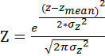
Here Z=Gaussian membership function value,
z=pixel gray level,
=mean (taken as highest probable gray level in image),
=variance
To consider only slight variation of gray level (i.e. mutually near features) in the neighbourhood of a pixel, steep Gaussian function (small variance) has to be taken. Besides that, to consider high variations of gray level (far features) in the neighbourhood of a pixel, wide Gaussian function (high variance) has to be taken. Thus mutually near features can be extracted taking a constant low variance value and mutually far features can be extracted taking a constant high variance value for Gaussian Lattice Function. Our purpose here is to extract edges present in face image, and it is found by experiments that these edges can be extracted using high variance value.
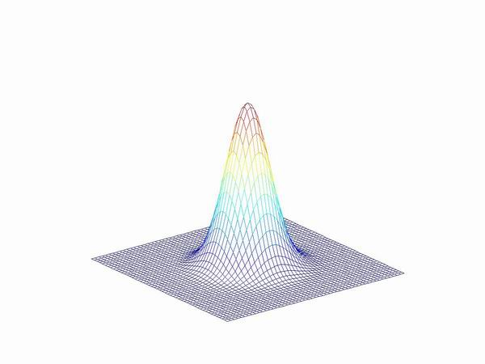
Figure 1. Gaussian Membership function

We have to find out the membership or connectivity of neighbourhood pixels corresponding to each pixel of face image, we have given as input. For this purpose we have to test the gray level of all neighbour pixels of each test pixel of the face image. We identified these connected (in terms of gray level) pixels by using a membership function. If the GMF value for neighbour’s gray level lies in the tolerance range of GMF value of testing pixel’s gray level then we are to store its location as useful information level one. Thus we can say that connectivity or membership is here dealt by following equation
Gaussian membership function for gray level
In the same way we tested all pixels of face image and stored the 8-connected neighbour pixels locations one after another. A very important point to note is that all the data in this information is independent to each other, there is no correspondence. Also there are some repetitions of pixel locations because some of pixels are connected to more than one pixel. In next step we have checked the data one by one and selected only those pixel coordinates which contain at least one neighbourhood pixel in its tolerance range of gray level. This is a very important step in terms of dimensionality reduction and space-time complexity. Because size of data to be processed is reduced significantly, and it results in decrease in processing time as well as storage cost. We have removed all the redundant (noisy or insignificant) information and size of data is reduced.
In this way, now we have complete information of pixels and their connected pixels in face image. But again, it is important to note that information of connected pixels for pixel-1, pixel-2,....pixel-(mxn) are till now not related to each other, and in the next section we will establish the connectivity between them.
Now as we have the information of connected neighbour pixels, for each pixel of face image, (as shown in fig) we can find one-to-one connectivity between those pixels. We started with first pixel as test pixel, and find its connected neighbour pixel. After this, connected neighbour pixel is considered as test pixel and its connected pixel is found. This process is repeated for complete image. In this way we got several groups of connected pixels.
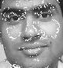
(a) (b)
Figure 2. (a) Detected edges and (b) their annotation on face
We annotated these sequence connected pixels on the face image by white pixels. It is found that these are unique to a face. If different images are taken of a same face, and these sequence connected pixels are identified and annotated, they are similar to each other and can uniquely define that face. Even it is also found by experiments that slight variation of pose (rotation of face by 10 to 20 degrees) gives slight variation in sequence connected pixels.

CHAPTER 4
Dimension Reduction
Feature selection in pattern recognition involves the derivation of certain features from the input data in order to reduce the amount of data used for classification and provide discrimination power. Due to the measurement cost and classification accuracy, the number of features should be kept as small as possible. A small and functional feature set makes the system work faster and use less memory. On the other hand, using a wide feature set may cause “curse of dimensionality” which is the need for exponentially growing number of samples.
Feature extraction methods try to reduce the feature dimensions used in the classification step. There are especially two methods used in pattern recognition to reduce the feature dimensions; Principal Component Analysis (PCA) and Linear Discriminant Analysis (LDA).
The relative places of the data between each other is never changed according to the utilized feature dimension reduction technique, PCA or LDA. Only the axes are changed to handle the data from a “better” point of view. Better point of view is simply generalization for PCA and discrimination for LDA.
4.1 Linear Discriminant Analysis (LDA)
While PCA tries to generalize the input data to extract the features, LDA tries to discriminate the input data by dimension reduction.
Figure 3 : Three 3-dimensional distributions are projected onto 2-dimensional subspaces, described by normal vectors W1 and W2. As LDA tries to find the greatest seperation
among the classes, W1 is optimal for LDA.

LDA searches for the best projection to project the input data, on a lower dimensional space, in which the patterns are discriminated as much as possible. For this purpose, LDA tries to maximize the scatter [44] between different classes and minimize the scatter between the input datas in the same class. In Figure 3.1, the selection criteria for LDA can be observed. LDA uses generalized eigenvalue equation [44] to obtain this discrimination.

4.2 Principal Component Analysis (PCA)
The advantage of PCA comes from its generalization ability. It reduces the feature space dimension by considering the variance of the input data. The method determines which projections are preferable for representing the structure of the input data. Those projections are selected in such a way that the maximum amount of information (i.e. maximum variance) is obtained in the smallest number of dimensions of feature space.
In order to obtain the best variance in the data, the data is projected to a subspace (of the image space) which is built by the eigenvectors from the data. In that sense, the eigenvalue corresponding to an eigenvector represents the amount of variance that eigenvector handles. The mathematical formulation of PCA is discussed in following subsection.
4.2 Methodology
In the proposed work, we have extracted the features of the face image. Now to reduce dimensions of feature space we have chosen to apply PCA on the extracted features. Suppose x₁, x₂,..., x_{M} are N x 1 vectors, which represents the extracted features for each face image. Then PCA can be applied according to following steps:

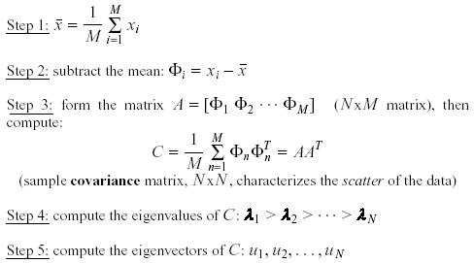

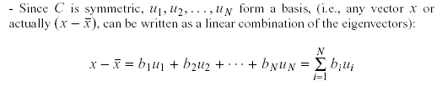

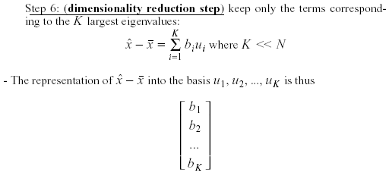

The linear transformation R^{N} → R^{K} that performs the dimensionality reduction is:
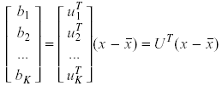
To choose K, use the following criterion:
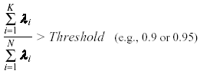

In this way we get a reduced feature space after removing the redundant features. Now next step is classification using appropriate classifier. Some recently developed classifiers are explained in next chapter. Finally SVM is used as a classifier in this work.

CHAPTER 5
PATTERN CLASSIFICATION
In this chapter, the idea behind the algorithms applied throughout the thesis study will be summarized. The pattern classification basics, the discipline behind the statistical pattern classifiers; Bayesian Classifier, Nearest Mean Classifier, and the main projection techniques; Principal Component Analysis and Linear Discriminant Analysis shall be explained.
5.1 Pattern Classification Basics
Pattern recognition is the science that concerns the description or classification of measurements. A typical pattern recognition system takes the input data, extracts the features, trains the classifier and evaluates the test pattern. The features are the representatives of the input data in the classification system used and they are obtained by directly using the input data or by applying different kinds of dimension reduction techniques on the input data. An ideal feature extractor would yield a representation that makes the job of the classifier trivial.
There are three main pattern recognition approaches [53];
- Statistical Pattern Recognition; which assumes the underlying model as a set of probabilities, but ignores the structure,
- Syntactic Pattern Recognition; which concentrates on the interrelations between primitives that build the whole pattern (which are not easy to find),
- Neural Pattern Recognition; which imitates human neural system.
Throughout this thesis study, statistical pattern classification is used. Hence, it will be the main concern to discuss in this chapter. Statistical pattern recognition is an approach of the pattern classification problem, which concentrates on developing decision or classification strategies that form classifiers [53]. In statistical pattern recognition, each pattern is represented in terms of d features or measurements and is can be viewed as a point in a d-dimensional space.
The objective of a statistical pattern recognition system is to choose features that allow the patterns belonging to different classes to occupy different regions in a d-dimensional feature space. The representation space or feature space is assumed to be effective, if the patterns from different classes are well separated and if the feature space greatly represents the general properties of the input data. Decision boundaries separate patterns belonging to different classes and they are determined by the specified probability distributions of the patterns belonging to each class.
While a heavily complex system may allow perfect classification of the training samples, it may not perform well on new patterns. This situation is known as overfitting (or memorization) [44]. One of the most important areas of research in statistical pattern classification is determining how to adjust the complexity of the model.
For the case where the training samples used to design a classifier are labeled by their category membership, the procedure is accepted as supervised. The opposite case is called unsupervised system where the training data is unlabeled.
5.2 Classifiers
5.2.1 Bayesian Classifier
Bayesian classifier is one of the most widely applied statistical approaches in the standard pattern classification. It assumes that the classification problem is posed in probabilistic terms, and that all the relevant probability values are known.
The decision process in statistical pattern recognition can be explained as follows: Given an input pattern, represented as a vector of d feature values x=(x1, x2, …, xd), assign it to one of c categories w1, w2, …, wc by taking one of the a possible actions α1, α2, …, αa. Assuming that each feature has a probability density (represented as p(.)) or mass function (represented as P(.)) conditioned on the pattern class, a pattern vector x belonging to class wi can be viewed as an observation drawn randomly from the class-conditional probability function, p(x| wi ) [54].
A loss function λ ( is simply defined as the loss for deciding the class wi where the true class is class wj [44], that is;

(5.1)

The Bayes decision rule for minimizing the risk, which is the expected value of the loss function, can be stated as follows [44]: Assign input pattern x to class wi where the conditional risk R(α i |x) is minimum.
In mathematical terms;
(5.2)
should be minimized for any i = 1, 2, …, c to classify the input pattern to the ith class.
Under these assumptions, the Bayes classifier assigns the input pattern x to class wi for which the posterior probability P(w i |x) is the maximum; that is,
(5.3)
The idea underlying Bayes classifier is very simple. In order to minimize the overall risk, the action that minimizes the conditional risk R( should be taken. In particular, in order to minimize the probability of error in a classification problem, the maximum posterior probability P(w i |x) should be chosen. Bayes formula is a way to calculate such probabilities from the prior probabilities P(and the class conditional densities P(x| [44].
(5.4)
For most of the pattern classification applications, the main problem in applying the Bayes classifier is that the class-conditional densities p(x| wj ) are not known. However, in some cases, the form of these densities can be known without exact knowledge on parameter values. In a classic case, the densities are known to be (or assumed to be) multivariate normal, but the values of the mean vector and the covariance matrix are not known [44]. In this case, the multivariate normal density in d dimensions can be written as [34];
(5.5)
Where Σ is the covariance matrix of size (d x d).

5.2.2 Nearest Mean Classifier
Nearest Mean Classifier is an analogous approach to the Nearest Neighbour Rule (NN-Rule). In the NN-Rule, after the classification system is trained by the samples, a test data is fed into the system and it is classified in the class of the nearest training sample in the data space with respect to Euclidean Distance. In the Nearest Mean Classifier, again the Euclidean distance from each class mean (in this case) is computed for the decision of the class of the test data [54].
In mathematical terms, the Euclidean distance between the test sample x, and each face class mean μi is;
(5.6)
where x is an d dimensional input data. After computing the distance to each class mean, the test data is classified into the class with minimum Euclidean Distance.

5.2.3 Support vector machine Classifier
Support vector machines (SVMs) [27] are originally designed for binary classification problem. How to effectively extend it for multi-class classification problem is still an on-going research issue. Several methods have been proposed where typically we construct a multi-class classifier by combining several binary classifiers. Some methods also have been proposed that consider all classes at once. As it is computationally more expensive to solve multi-class problems, comparisons of these methods using large-scale problems have not been seriously conducted yet.
The support vector machine [27], given labelled training data
(5.7)
constructs a maximal margin linear classifier in a high dimensional feature space, defined by a positive definite kernel function, k(x, x’), specifying an inner product in the feature space,
A common kernel is the Gaussian radial basis function (RBF),
The discriminant function implemented by a support vector machine is given by
(5.8)
To find the optimal coefficients, of this expansion it is sufficient to maximize the functional,
(5.9)
in the non-negative quadrant,
subject to the constraint,
C is a regularization parameter, controlling a compromise between maximizing the margin and minimizing the number of training set errors. The Karush-Kuhn-Tucker (KKT) conditions can be stated as follows:

Figure 4: Linear separating hyperplanes for the separable case.
The support vectors are circled.

These conditions are satisfied for the set of feasible Lagrange multipliers maximizing the objective function given by equation (9). The bias parameter, b, is selected to ensure that the second KKT condition is satisfied for all input patterns corresponding to non-bound Lagrange multipliers. Note that in general only a limited number of Lagrange multipliers, will have non-zero values; the corresponding input patterns are known as support vectors. Let I be the set of indices of patterns corresponding to non-bound Lagrange multipliers,
and similarly, let J be the set of indices of patterns with Lagrange multipliers at the upper bound C,
Equation (8) can then be written as an expansion over support vectors,
5.2.4 An overview of widely used multiclass SVM classification methods
Support vector machines are originally designed for binary pattern classification. Multi-class pattern recognition problems are commonly solved using a combination of binary SVMs and a decision strategy to decide the class of the input pattern. Each SVM is independently trained. The training data set (xi; ci) consists of N examples belonging to M classes. The class label We assume that the number of examples for each class is the same, i.e., N/M.
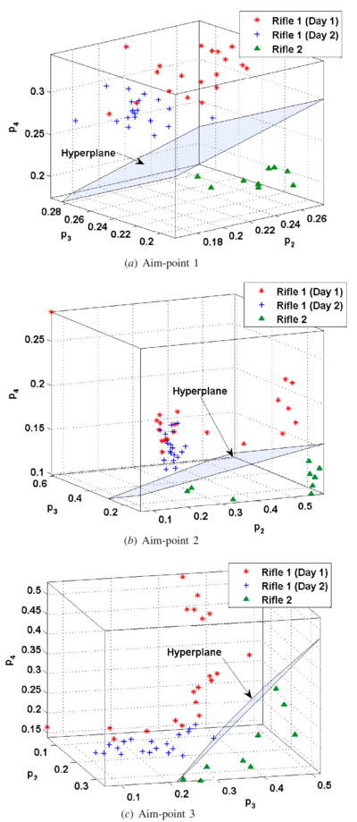
Figure 5: Multiclass classification by SVM

5.2.4.1 One-against-all SVM
The one-against-all [38] (also known as 1-v-r or one-versus-rest) is the probably earliest implementation for multi-class SVM classification. In this approach, an SVM is constructed for each class by discriminating that class against the remaining (M -1) classes. The number of SVMs used in this approach is M. A test pattern x is classified by using the winner-takes-all decision strategy, i.e., the class with the maximum value of the discriminant function f(x) is assigned to it. All the N training examples are used in constructing an SVM for a class. The SVM for class k is constructed using the set of training examples and their desired outputs, (xi, yi). The desired output yi for a training example xi is defined as follows:

The examples with the desired output yi = +1 are called positive examples and the examples with the desired output yi = -1 are called negative examples. An optimal hyperplane is constructed to separate N/M positive examples from N(M - 1)/M negative examples.

5.2.4.2 One-against-one SVM
The one-against-one [9] method is also known as 1-v-1 or one-versus-one method, and first introduced on SVM as pair wise SVM [33]. In this approach, an SVM is constructed for every pair of classes by training it to discriminate the two classes. Thus, the number of SVMs used in this approach is M(M - 1)/2. An SVM for a pair of classes (k;m) is constructed using training examples belonging to the two classes only. The desired output for a training example xi is defined as follows:
The maxwins [29] strategy is commonly used to determine the class of a test pattern x in this approach. In this strategy, a majority voting scheme is used. If , the value of the discriminant function of the SVM for a pair of classes (k,m), is positive, then class k wins a vote. Otherwise, class m wins a vote. Outputs of SVMs are used to determine the number of votes won by each class. The class with maximum number of votes is assigned to the test pattern. When there are multiple classes with the maximum number of votes, the class with maximum value of the total magnitude of discriminant functions (TMDF) is assigned. The total magnitude of discriminant functions for class k is defined as follows:
where the summation is over all m with which class k is paired.

5.2.4.3 DAGSVM
The Directed Acyclic Graph Support Vector Machines (DAGSVM) is proposed in [31]. In the training phase, it works as the one-against-one method solving M(M - 1)/2 binary SVMs. However, in the testing phase, it uses a rooted binary DAG which has M(M -1)/2 internal nodes and M leaves. Figure 6 shows the DAG scheme. Given a test sample x, starting at the root node, a pair wise SVM decision is made and either class is rejected. Then it moves to either left or right depending on the result, and continues until reaching to one of leaves which indicates the predicted class. So the DAG requires (M – 1) comparisons and hence is more efficient than the one-against-one method.
Figure 6: A DAG for four classes: each node is a pair wise classifier between two classes. A decision of rejecting one of the two class labels is made at each node.
In this thesis work SVM is used as a classifier for classification of the face images. As explained in this chapter SVM is a binary classifier, we have to apply it for multiclass classification. For this purpose we have used “One against All” technique.

CHAPTER 6
IMPLEMENTATION AND RESULT
The utilized face databases are ORL and Georgiatech and a private database. The tests are conducted via writing programs in Matlab. Another choice could be to write codes in C/C++. However, the easiness of Matlab for mathematical applications made Matlab the choice.

6.1 System Flow Diagram

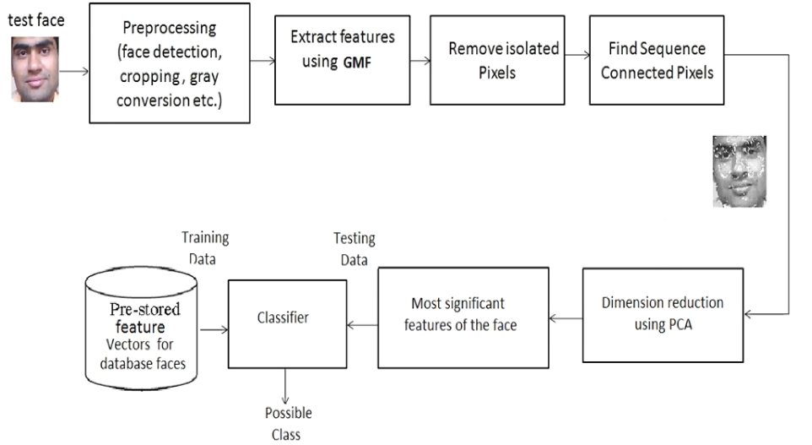
Figure 7: System Flow Diagram

6.2 Utilized Face Databases
The ORL face database is made up of a set of faces taken between April 1992 and April 1994 at the Olivetti Research Laboratory in Cambridge, UK. There are 10 different images of 40 distinct subjects. For some of the subjects, the images were taken at different times, varying lighting slightly, facial expressions (open/closed eyes, smiling/non-smiling) and facial details (glasses/no-glasses). All the images are taken against a dark homogeneous background and the subjects are in up-right, frontal position (with tolerance for some side movement). The files are in .TIF file format (Tagged Image File Format). The size of each image is 92 x 112 (width x height), 8-bit grey levels.
As there are 10 images per individual in the ORL database, first 5 of them are used to train the systems and the rest are used to test them. Moreover, different tests are conducted, such as changing the training and test images used for each individual and using less or more number of training and test images in order to test the systems reaction to these changes.

6.3 Preprocessing Techniques
In this thesis, mainly three preprocessing steps are applied: Resizing, cropping, histogram equalization. Some example images from the ORL database are given in Figure 5.4, in order to show as example. Resizing and histogram equalization are applied on ORL and Georgiatech face databases automatically, and cropping are applied on all face databases manually.
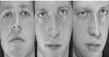
Figure 8: Pre-processed faces

There will be a need face database for training. In this process; 10 images of each person have been taken with different pose, and with similar and uniform illumination conditions. Pose may vary from frontal to 10-20 degrees. Care must be taken that this method is to be applied only on face portion, so we crop the face such that hairs are excluded and only eyebrows to chin part comes in the image. Either manual cropping methods or some automatic face detection methods can be used for this. Besides manual cropping and normalization methods, Adaboost face detection [23],[24],[25] or skin colour based face detection methods [26] are also exist. To keep some images for testing purpose the face images are chosen in ‘leaving one out’ fashion. Before applying the method we need to convert the face images (size MxN) into gray format. Face images from ORL database, Georgiatech database and private face database are used for training and testing.
Finally the initial conditions for selection and preparation of face database can be summarized for the proposed method as following:
- All images must be taken in similar and uniform illumination conditions.
- No physical obstruction.
- Camera at the same distance from face.
- We need to take only eyebrows to chin part of face.
- Images must be in gray format or changed to gray format.
- Images should be of equal size and small, for best results and fast processing.

Histogram Equalization
Histogram equalization is applied in order to improve the contrast of the images. The peaks in the image histogram, indicating the commonly used grey levels, are widened, while the valleys are compressed.
Figure 9: Before and After histogram equalization
Two histogram plots are given in Figure 5.7. The histogram on the left is before histogram equalization is applied and the one on the right is after histogram equalization is applied. Histogram equalization is applied to all the three databases automatically.

6.4 Experimental results:
The performance of the system was evaluated using the ORL and private face databases. The face database contains large-scale face images with different sources of variations from over many individuals. For our purposes, we selected only the images with pose variations described by horizontal head rotation angles ranging from 0 degree (frontal) to 20 degrees.
From the ORL face database, we randomly selected 5 individuals for the training set, and their different images for testing. There were 10 images per individual, and a total of 50 images were used in the experiments.
a)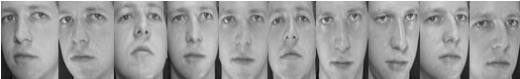

(b)
Figure 10. (a) Face images from ORL database (b) Extracted features
The private database was prepared by taking images of 5 individuals, 15 images of each in different face pose. The face angle was varied 0-25 degrees in left as well as right. The images were preprocessed and the method is applied by taking 12 images for training and 3 images for testing. Figure 10 shows the points corresponding to each face image in feature space.
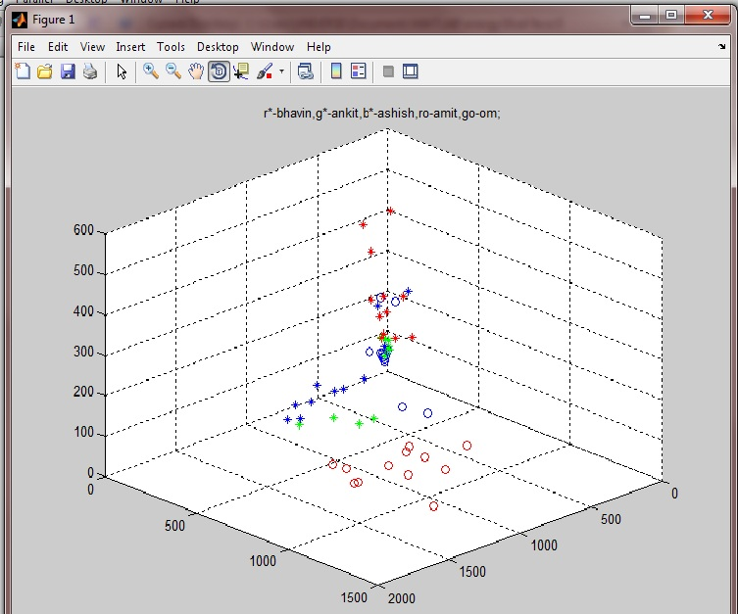
Figure 11: three dimensional feature space representation

Georgiatech face database consists of 15 different color images of each of 50 subjects of different ages. Each image contains some variation in pose, expressions, glasses/no glasses etc for each individual. Tests were also performed on this database. Example images and extracted features are shown in figure 10. The results are summarized in table 1. We observe that maximum recognition rate is obtained on private database.

(a)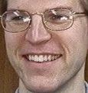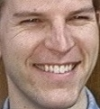
(b)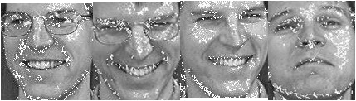
Figure 12: (a) Face images from Georgiatech database (b) Extracted features
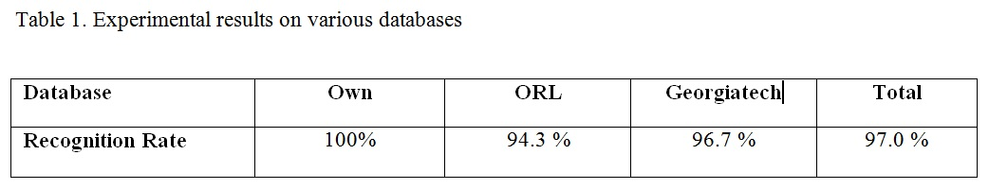
Experiments were performed to calculate the recognition accuracy of this method to compare the performance, with other existing popular methods. The results are summarized in the following table.
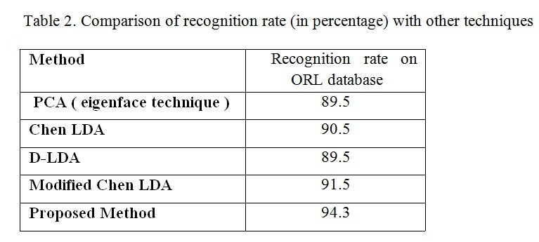
In the second part of the experiments, the effect of changing the kernel function for SVM used in the classification stage has been studied. This stage of the experiments is conducted using different kernel function, e.g. linear, quadratic, polynomial and RBF. From the tests results in Table 3, it can be easily observed that the success rate changes with respect to the utilized kernel function for SVM. Recognition rate remains least for linear kernel because in practice, data is not linearly separable always. Best recognition rate is achieved by polynomial and RBF kernel function. The results are summarized in the following table 3.

Table 3. Comparision of recognition rate taking different SVM kernel functions
SVM kernel | Linear | Quadratic | Polynomial | RBF
Recognition rate | 88.6 | 91.3 | 95.3 | 97.0

6.6 GUI (graphical user interface) of face recognition system
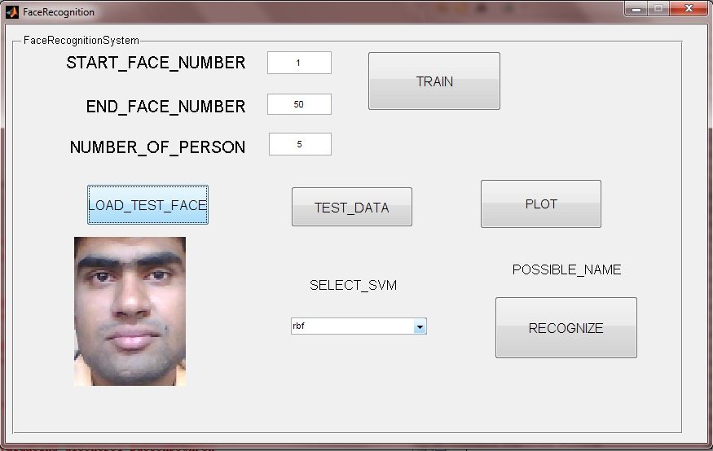
Figure 13: GUI for face recognition system

For better representation of the system, graphical user interface is developed as shown in figure. When using this system follow these steps:
(1)Input the START FACE NUMBER and END FACE NUMBER, and NUMBER OF PERSONS according to the face database.
(2)”Train” the system. We can see the clusters of training data using “PLOT“ button.
(3)After training load the test face.
(4)Calculate the similarity vector for the test face using button “TEST_DATA”
(5)Now select the kernel function for support vector machine using popup menu.
(6)Identity of the system appears on pushing “RECOGNIZE” button.

CHAPTER 7
CONCLUSION
This method implemented in this work has successfully accomplished a real time face recognition system. It could be applied to robotic system, access control system, security system, the human machine interaction system and so on. From the experimental results one can see that proposed system can fast recognize the human face even in complex background. The system also works for some tolerable out of plane rotation angle of face.
This work presented an important step of edge detection based on the local fuzzification by Gaussian membership function and scaling over gray map (0-255) to obtain the edge pixels. Results show that this edge detector is well suitable for feature extraction in face images as it does not distort the shape of the image and is able to retain the important edges unlike other well known edge detectors. Appropriate fuzzification function and image thresholds are important for the success of this algorithm.
PCA as dimension reduction technique establishes as its legacy. It reduces a lot of redundancy present in the extracted information and thus reduces the computational cost. Finally Support vector machine classifier is proved very well suitable method for classification purpose. Different kernel functions for SVM show different classification accuracy.

REFERENCES
[1] P. S. Huang, C. J. Harris, and M. S. Nixon, “Human Gait Recognition in Canonical Space using Temporal Templates”, IEE Proc.-Vis. Image Signal Process, Vol. 146, No. 2, April 1999.
[2] J. Huang, “Detection Strategies For Face Recognition Using Learning and Evolution”, PhD. Thesis, George Mason University, May 1998.
[3] S.A. Rizvi, P.J. Phillips, and H. Moon, “A verification protocol and statistical performance analysis for face recognition algorithms”, pp. 833-838, IEEE Proc. Conf. Computer Vision and Pattern Recognition (CVPR), Santa Barbara, June 1998.
[4] R. Chellappa, C. L. Wilson and S. Sirohey, “Human and Machine Recognition of Faces: A Survey”, Proceedings of the IEEE, Vol. 83, No. 5, May 1995.
[5] W. Zhao, R. Chellappa, A. Rosenfeld, and P.J. Phillips, “Face Recognition: A literature Survey”, Technical Report, Univ. Of Maryland, 2000.
[6] J. J. Weng and D. L. Swets, “Face Recognition”, in A. K. Jain, R. Bolle, and S. Pankanti (Editors), Biometrics: Personal Identification in Networked Society, Kluwer Academic Press,
1999.
[7] V. Bruce, “Identification of Human Faces”, pp. 615-619, Image Processing and Its Applications, Conference Publication No. 465, IEEE, 1999.
[8] P. Temdee, D. Khawparisuth, and K. Chamnongthai, “Face Recognition by Using Fractal Encoding and Backpropagation Neural Network”, pp. 159-161, 5th International Symposium on Signal Processing and its Applications, ISSPA ’99, Australia, August 1999.
[9] R. Brunelli, and T. Poggio, “Face Recognition: Features versus Templates”, pp. 1042-1052, IEEE Transactions, PAMI, 15(10). 1993.
[10] M. A. Turk, and A. P. Pentland, “Face Recognition using Eigenfaces”, pp. 586-591, IEEE, 1991.
[11] L. Sirovich, and M. Kirby, “Low-dimensional Procedure for the Characterization of Human Faces”, pp. 519-524, Journal of the Optical Society of America, Vol. 4, No. 3, March 1987.
[12] M. Kirby, and L. Sirovich, “Application of the Karhunen-Loeve Procedure for the Characterization of Human Faces”, pp. 103- 108, IEEE Transactions on Pattern Analysis and Machine Intelligence, Vol. 12, No. 1, January 1990.
[13] B. Kepenekci, “Face Recognition Using Gabor Wavelet Transform”, MSc. Thesis, METU, September 2001.
[14] B. Moghaddam, and A. Pentland, “An Automatic System for Model-Based Coding of Faces”, pp. 362-370, IEEE, 1995.
[15] S. J. Lee, S. B. Yung, J. W. Kwon, and S. H. Hong, “Face Detection and Recognition Using PCA”, pp. 84-87, IEEE TENCON, 1999.
[16] S. Z. Lee, and J. Lu, “Generalizing Capacity of Face Database for Face Recognition”, pp. 402-406, IEEE, 1998.
[17] J. L. Crowley, and K. Schwerdt, “Robust Tracking and Compression for Video Communication”, pp. 2-9, IEEE, 1999.
[18] S. Cagnoni, A. Poggi, “A Modified Modular Eigenspace Approach to Face Recognition”, pp. 490-495, IEEE, 1999.
[19] K. Etemad, and R. Chellappa, “Face Recognition Using Discriminant Eigenvectors”, pp. 2148-2151, IEEE, 1996.
[20] P. N. Belhumeur, J. P. Hespanha and D. J. Kriegman, “Eigenfaces vs. Fisherfaces: Recognition Using Class Spesific Linear Projection”, IEEE Transactions on Pattern Analysis and Machine Intelligence, Vol. 19, No. 7, July 1997.
[21] W. Zhao, A. Krishnaswamy, R. Chellappa, D. L. Swets, and J. Weng, “Discriminant Analysis of Principal Components for Face Recognition”, pp. 336-341, International Conference on Automatic Face and Gesture Recognition, 1998.
[22] W. Zhao, R. Chellappa, and N. Nandhakumar, “Emprical Performance Analysis of Linear Discriminant Classifiers”, pp. 164-169, IEEE, 1998.
[23] W. Zhao, “Subspace Methods in Object/Face Recognition”, pp. 3260-3264, IEEE, 1999.
[24] B. Moghaddam, “Principal Manifolds and Bayesian Subspaces
for Visual Recognition”, pp. 1131-1135, IEEE, 1999.
[25] B. Moghaddam, and A. Pentland, “Bayesian Image Retrieval in Biometric Databases”, pp. 610-615, IEEE, 1999.
[26] B. Moghaddam, T. Jebara, and A. Pentland, “Efficient MAP/ML Similarity Matching for Visual Recognition”, pp. 876-881, IEEE, 1998.
[27] B. Moghaddam, and A. Pentland, “Beyond Euclidean Eigenspaces: Bayesian Matching for Visual Recognition”, Face Recognition: From Theories to Applications, pp. 921-930,
October 1998.
[28] B. Moghaddam, T. Jebara, and A. Pentland, “Bayesian Face Recognition”, pp. 1771-1782, Pattern Recognition, Vol. 33, No. 11, November 2000.
[29] B. Moghaddam, and A. Pentland, “Probabilistic Visual Learning for Object Detection”, The 5th International Conference on Computer Vision, Cambridge, MA, June 1995.
[30] B. Moghaddam, T. Jebara, and A. Pentland, “Bayesian Modelling of Facial Similarity”, Advances in Neural Information Processing Systems 11, MIT Press, 1999.
[31] B. Moghaddam, W. Wahid, and A. Pentland, “Beyond Eigenfaces: Probabilistic Matching for Face Recognition”, The 3rd International Conference on Automatic Face & Gesture Recognition, Nara, Japan, April 1998.
[32] B. Moghaddam, and A. Pentland, “Probabilistic Visual Learning for Object Representation”, IEEE Transactions on Pattern Analysis and Machine Intelligence, Vol. 19, No. 7, July 1997.
[33] B. Moghaddam, “Principal Manifolds and Probabilistic Subspaces for Visual Recognition”, IEEE Transactions on Pattern Analysis and Machine Intelligence, Vol. 24, No. 6, June 2002.
[34] C. Liu, and H. Wechsler, “A Unified Bayesian Framework for Face Recognition”, pp. 151-155, IEEE, 1998.
[35] C. Liu, and H. Wechsler, “Probabilistic Reasoning Models for Face Recognition”, pp. 827-832, IEEE, 1998.
[36] K. C. Chung, S. C. Kee, and S. R. Kim, “Face Recognition using Principal Component Analysis of Gabor Filter Responses”, p. 53- 57, IEEE, 1999.
[37] C. Podilchuk, and X. Zhang, “Face Recognition Using DCTBased Feature Vectors”, pp. 2144-2147, IEEE, 1996.
[38] S. Eickeler, S. Müller, and G. Rigoll, “High Quality Face Recognition in JPEG Compressed Images”, pp. 672-676, IEEE, 1999.
[39] A. V. Nefian, and M. H. Hayes, “Hidden Markow Models for Face Recognition”, pp. 2721-2724, IEEE, 1998.
[40] P. J. Phillips, “Support Vector Machines Applied to Face Recognition”, pp. 803-809, Advances in Neural Information Processing Systems 11, MIT Press, 1999.
[41] H. Spies, and I. Ricketts, “Face Recognition in Fourier Space”,
Vision Interface ‘2000: 38-44, Montreal, 2000.
[42] C. S. Bobis, R. C. Gonzalez, J. A. Cancelas, I. Alvarez, and J. M. Enguita, “Face Recognition Using Binary Thresholding for Features Extraction”, pp. 1077-1080, IEEE, 1999.
[43] A. X. Guan, and H. H. Szu, “A Local Face Statistics Recognition Methodology beyond ICA and/or PCA”, pp. 1016-1027, IEEE, 1999.
[44] R. O. Duda, P. E. Hart, and D. G. Stork, “Pattern Classification”, John Wiley & Sons, 2nd Edition, 2001.
[45] A. Martinez, “Face Image Retrieval Using HMMs”, pp. 35-39, IEEE, 1999.
[46] P. Temdee, D. Khawparisuth, and K. Chamnongthai, “Face Recognition by Using Fractal Encoding and Backpropagation Neural Network”, pp. 159-161, Fifth International Symposium on Signal Processing and its Applications, ISSPA ’99, Brisbane, Australia, August 1999.
[47] M. Lades, J. C. Vorbruggen, J. Buhmann, J. Lange, C. Von der Malsburg, R. P. Wurtz, and W. Konen, “Distortion Invariant Object Recognition in the Dynamic Link Architecture”, pp. 300- 310, IEEE Transactions on Computers, Vol. 42, March 1993.
[48] L. Wiskott, J. M. Fellous, N. Krüger, and C. von der Malsburg, “Face Recognition by Elastic Bunch Graph Matching”, pp. 129- 132, IEEE, 1997.
[49] M. J. Er, S. Wu, and J. Lu, “Face Recognition Using Radial Basis Function (RBF) Neural Networks”, Proceedings of the 38th Conference on Decision & Control, Phoenix, Arizona USA, pp. 2162-2167, IEEE, 1999.
[50] C. E. Thomaz, R. Q. Feitosa, and A. Veiga, “Design of Radial Basis Function Network as Classifier in Face Recognition Using Eigenfaces”, pp. 118-123, IEEE, 1998.
[51] Y. Yoshitomi, T. Miyaura, S. Tomito, and S. Kimura, “Face Identification Using Thermal Image Processing”, pp. 374-379, IEEE International Workshop on Robot and Human Communication, IEEE, 1997.
[52] Z. Liposcak, and S. Loncaric, “Face Recognition from Profiles Using Morphological Operations”, pp. 47-52, IEEE, 1999.
[53] R. J. Schalkoff, “Pattern Recognition”, John Wiley & Sons, 1992.
[54] E. Taslidere, “Face Detection Using a Mixture of Subspaces”, MSc. Thesis, METU, September 2002.
[55] Olivetti & Oracle Research Laboratory, The Olivetti & OracleResearch Laboratory Face Database of Faces,http://www.camorl.co.uk/facedatabase.html
[56] P. J. Phillips, H. Moon, S.A. Rizvi, and P. J. Rauss, “The FERET Evaluation Methodology for Face-Recognition Algorithms”, pp. 1090-1104, IEEE Transactions on Pattern Analysis and Machine Intelligence, Vol. 22, No. 10, October 2000.
[57] P. J. Phillips, P. J. Rauss, and S. Z. Der, “FERET (Face Recognition Technology) Recognition Algorithm Development and Test Results”, Army Research Lab Technical Report 995, October 1996.
[58] P. J. Phillips, and H. Moon, “Comparison of Projection-Based Face Recognition Algorithms”, p. 4057-4062, IEEE, 1997.
[59] Jeng-Han Li, and Ming Yuan Shieh, “PCA and LDA based fuzzy face recognition system”, SICE annual congerence, 2010.
[60] Jeng-Han Li, and Ming Yuan Shieh, “Fuzzy Logic Based Digital Image Edge Detection”, p. 78-83, Global Journal of Computer Science and Technology, Nov., 2010.

