The
Major project
on
Experimental determination of mechanical properties of construction waste
Submitted in Partial Fulfillment for the Award of the Degree of
Master of Engineering
in
Civil Engineering
With specialization in
STRUCTURAL ENGINEERING
by

Yash Gupta
(Roll No. 9087)
Under the guidance of
Prof. A. Trivedi
Civil Engineering Department
Delhi College of Engineering, Delhi

Department of Civil & Environmental Engineering
Delhi College of Engineering
Now, Delhi Technological University
University of Delhi, Delhi
2011

CERTIFICATE
This is to certify that the project entitled “Experimental determination of mechanical properties of construction waste” being submitted by me, is a bona fide record of my own work carried by me under the guidance and supervision of Prof. A. Trivedi in partial fulfillment of requirements for the award of the Degree of Master of Engineering (Structural Engineering) in Civil Engineering, from University of Delhi, Delhi.
The matter embodied in this project has not been submitted for the award of any other degree.

Yash Gupta
Enroll No: 17/ME/FT/CE/STR/09
Roll No : 9087
This is to certify that the above statement made by the candidate is correct to the best of our knowledge.

Prof. A. Trivedi
DEPARTMENT OF CIVIL AND ENVIRONMENTAL ENGINEERING
DELHI COLLEGE OF ENGINEERING
NOW,DELHI TECHNOLOGICAL UNIVERSITY
UNIVERSITY OF DELHI
DELHI
2009-2011
ACKNOWLEDGEMENT
I have a great pleasure in expressing my deep sense of gratitude and indebtedness to Prof. Aashutosh Trivedi of Civil Engineering Department of Delhi College of Engineering for there continuous guidance and invaluable suggestion and time at all stages from conceptualization to experimental and final completion of this project work. They have guided me for fundamentals and provided many technical papers on the subject matter and thus inculcated the interest and quest for knowledge of this work. He provided constant support and encouragement for successful completion of this work.
I am also grateful to Prof. A.K.Gupta Head Department of Civil Engineering, for providing the experimental facilities in various labs of the Department.
I also have great respect and indebtedness for Dr.Sudhir Mathur, scientist G, CRRI and Mr. Kanwar Singh Scientist E2, CRRI for there support and facilities provided for experiments, required for the completion of this special subject.
My special thanks to Mr. Rajeev Goel for his valuable time for guiding me and given his very useful critical comment on the work and help me to do the project work on time.
I am also thankful to all the lab assistants of my college and CRRI to help me.
At the last but not the least to my friends Mr. Pradeep Hansraj, Mr. Sanket Katiyar, Mr. Dalip Kumar and my family members who always give me strength and moral support to complete the work.
YASH GUPTA
List of Notations:
A1 Plaster waste
S1 Sand
D₆₀ Diameter of particle at 60% finer
D₃₀ Diameter of particle at 30% finer
D₁₀ Diameter of particle at 10% finer
C_{u} Coefficient of uniformity
C_{c} Coefficient of curvature
O.M.C. Optimum Moisture Content
M.D.D. Maximum Dry Density
G Specific gravity
c Cohesion
φ Angle of internal friction
C.B.R. California Bearing Ration

ABSTRACT
The use of construction and demolition waste as recycled aggregates for the construction is not a new concept but due to non-availability of scientific analysis of mechanical and physical properties of these aggregates the use of such material is limited. This project has analyzed the mechanical properties of the plaster waste and compared it with the sand used for the construction.
A laboratory study was performed to assess the geotechnical parameters of a plaster waste collected from the site of Pachsheel Greens (Noida).The experimental investigations for physical properties includes particle size distribution, standard proctor test, specific gravity direct shear tests and C.B.R. test in soaked and unsoaked condition at various moisture content All the above tests were conducted according to there respective IS code.
After observing the results of various tests it was found that the particle size distribution of plaster waste was resembled with the sand. Both the material has moisture content and dry density relation ship, also resembling each other but the moisture content of plaster waste is slightly higher then that of sand and maximum dry density is lower than that of sand. The angle of friction which was observed from the direct shear test having the a very little variation of 0.22⁰ .From C.B.R. test it is observed that all the soaked specimen have lower C.B.R. value as compare to unsoaked specimen at corresponding moisture content. It is also observed that the plaster waste came out to be a better material at the places of poor quality control.
Based on the results of this study, it can be concluded that the plaster waste has similar engineering properties to those of the sand and can be used as replacement to sand where the above tests are deciding criteria for using the construction waste.

INDEX
CONTENTS | PAGE
- INRTRODUCTION:

1.1Definition of construction waste and use of different waste materials | 1
- ESTIMATE OF CONSTRUCTION WASTE:

2.1According to Ministry of Environment and Forest(MoEF) | 4
2.2According to Technology Information, Forecasting and Assessment Council | 4
2.3According to Central Pollution Control Board(C.P.C.B.) | 6
2.4 According to report of on Waste Management in China: Issues and Recommendations May 2005 | 6
- Paper review:

3.1 Margaret M.O’Mahony: An analysis of shear strength of recycle aggregates(1997) | 7
3.2 Chi Sun Poon , Dixon Chan: Feasible use of recycled concrete aggregates and crushed clay brick as unbound road sub-base(2005) | 7
3.3 Bachir Melbouci: Compaction and shearing behavior study of recycled aggregates (2009) | 8
3.4 Fabiana da Conceiçao Leite , Rosângela dos Santos Motta , Kamilla L. Vasconcelos , Liedi Bernucci : Laboratory evaluation of recycled construction and demolition waste for pavements(2010) | 9
3.5 Taesoon Park: Application of Construction and Building Debris as Base and Sub-base Materials in Rigid Pavement(2003 | 9
- EXPERIMENTAL PROGRAMME AND TEST PROCEDURES:

4.1 Grain size analysis | 12
4.1.1 Particle Size Distribution for S1 | 13
4.1.2 Particle Size Distribution for A1 | 13
4.2 Specific gravity test | 14
4.2.1 Specific gravity of S1 | 16
4.2.2 Specific gravity of A1 | 16
4.3 Proctor test | 17
4.3.1 Proctor test of S1 | 19
4.3.2 Proctor test of A1 | 19
4.4 Direct shear test | 20
4.4.1 Direct shear test of S1 | 23
4.4.2 Direct shear test of A1 | 23
4.5 California Bearing Ratio test | 24
4.5.1 C.B.R. test of S1 at O.M.C. (unsoaked) | 27
4.5.2 C.B.R. test of S1 at 95 % O.M.C. (unsoaked) | 28
4.5.3 C.B.R. test of S1 at 90 % O.M.C. (unsoaked) | 29
4.5.4 C.B.R. test of S1 at 85 % O.M.C. (unsoaked) | 30
4.5.5 C.B.R. test of S1 at 80% O.M.C. (unsoaked) | 31
4.5.6 C.B.R. test of A1 at O.M.C. (unsoaked) | 32
4.5.7 C.B.R. test of A1 at 95% O.M.C. (unsoaked) | 33
4.5.8 C.B.R. test of A1 at 90% O.M.C. (unsoaked) | 34
4.5.9 C.B.R. test of A1 at 85 % O.M.C. (unsoaked) | 35
4.5.10 C.B.R. test of A1 at 80 % O.M.C. (unsoaked) | 36
4.5.11 C.B.R. test of S1 at O.M.C. (soaked) | 38
4.5.12 C.B.R. test of S1 at 95% O.M.C. (soaked | 39
4.5.13 C.B.R. test of S1 at 90% O.M.C. (soaked) | 40
4.5.14 C.B.R. test of S1 at 85% O.M.C. (soaked) | 41
4.5.15 C.B.R. test of S1 at 80% O.M.C. (soaked) | 42
4.5.16 C.B.R. test of A1 at O.M.C. (soaked) | 43
4.5.17 C.B.R. test of A1 at 95% O.M.C. (soaked) | 44
4.5.18 C.B.R. test of A1 at 90% O.M.C. (soaked) | 45
4.5.19 C.B.R. test of A1 at 85% O.M.C. (soaked) | 46
4.5.20 C.B.R. test of A1 at 80% O.M.C. (soaked) | 47
- ANALYSIS OF RESULTS
5.1 Particle distribution test analysis | 48
5.1.1 Partical distribution results | 48
5.1.2 Comparing partical distribution with standard soils | 49
5.1.3 Comparing the particle size distribution that gives maximum dry density | 50
5.2 Proctor test results | 52
5.2.1 Comparing A1 and S1 | 52
5.2.2 Comparing A1 and S1 with Standard materials | 53
5.2.3 Comparing A1 and S1 with the granitic soil | 55
5.2.4 Comparing A1 and S1 with Coal ash | 56
5.2.5 Comparing A1 and S1 with other construction wastes | 57
5. 3 Direct shear results | 59
5.3.1 Comparing A1 and S1 | 59
5.4 C.B.R. test results | 60
5.4.1 C.B.R. test of S1 soaked and unsoaked | 60
5.4.2 C.B.R. test of A1 soaked and unsoaked | 63
5.4.3 Comparison of C.B.R. values of A1 and S1 unsoaked condition | 66
5.4.3 Comparison of C.B.R. values of A1 and S1 soaked condition | 67
6.CONCLUSION | 68
7.FUTURE SCOPE | 70
8. REFERENCE | 71

LIST OF TABLES.
CONTENTS | PAGE
Table. 1 Quantity of different constituents of waste that arise from construction industry in India(according to T.I.F.A.C. ) | 5
Table.2 Specific gravity of S1 | 16
Table.3 Specific gravity of A1 | 16
Table .4 C.B.R. value of S1 at O.M.C. (unsoaked) | 27
Table.5 C.B.R. value of S1 at 95% O.M.C. (unsoaked) | 28
Table .6 C.B.R. value of S1 at 90% O.M.C. (unsoaked) | 29
Table .7 C.B.R. value of S1 at 85% O.M.C. (unsoaked) | 30
Table.8 C.B.R. value of S1 at 80% O.M.C. (unsoaked) | 31
Table .9 C.B.R. value of A1 at O.M.C. (unsoaked) | 32
Table .10 C.B.R. value of A1 at 95% O.M.C. (unsoaked) | 33
Table .11 C.B.R. value of A1 at 90% O.M.C. (unsoaked) | 34
Table .12 C.B.R. value of A1 at 85% O.M.C. (unsoaked) | 35
Table.13 C.B.R. value of A1 at 80% O.M.C. (unsoaked) | 36
Table .14 C.B.R. value of S1 at O.M.C. (soaked) | 38
Table .15 C.B.R. value of S1 at 95% O.M.C. (soaked) | 39
Table .16 C.B.R. value of S1 at 90% O.M.C.(soaked) | 40
Table .17 C.B.R. value of S1 at 85% O.M.C. (soaked) | 41
Table .18 C.B.R. value of S1 at 80% O.M.C. (soaked) | 42
Table .19 C.B.R. value of A1 at O.M.C. (soaked) | 43
Table. 20 C.B.R. value of A1 at 95% O.M.C. (soaked) | 44
Table .21 C.B.R. value of A1 at 90% O.M.C. (soaked) | 45
Table .22 C.B.R. value of A1 at 85% O.M.C. (soaked) | 46
Table .23 C.B.R. value of A1 at 80% O.M.C. (soaked) | 47
Table.24 Comparative particle size distribution data of S1 and A1 | 48
Table.25 Comparing the sizes of material with the size of material for best compaction | 51
Table.26 Comparative data for proctor test of S1 and A1 | 52
Table.27 Composition of soils which are compared with S1 and A1 | 53
Table.28 Comparison of A1 and S1 with other construction and demolition waste | 58
Table.29 Comparison of angle of friction of A1 and S1 | 59
LIST OF PICTURES
Picture: 1 The construction waste at Pachsheel Greens (Noida). | 2
Picture: 2 The construction waste at Crossing Republic (Noida). | 2
Picture.3 Sieve arrangement for particle size distribution. | 12
Picture 4 Pycnometer full of water (W4). | 15
Picture.5 Pycnometer with water and sample (W3). | 15
Picture .6 Apparatus of Procter test. | 18
Picture .7 Samples of material to find water content. | 18
Picture.8 The apparatus for direct shear test. | 22
Picture.9 Failure specimen of samples in direct shear test. | 22
Picture.10 Apparatus of C.B.R. test. | 26
Picture.11 Loading frame of C.B.R. test. | 26
Picture.12 The specimen kept for soaking. | 37
Picture .13 The samples after C.B.R. test | 37
LIST OF FIGURES
CONTENTS | PAGE
Fig.1 The pie chart representation of construction waste, from data’s of T.I.F.A.C | 5
Fig. 2 The comparative graph of solid waste for China, India, USA, from WB report | 6
Fig.3 particle size distribution for S1 | 13
Fig.4 particle size distribution for A1 | 13
Fig.5 Moisture content and dry density relationship of S1 | 19
Fig.6 Moisture content and dry density relationship of A1 | 19
Fig.7 Direct shear test of S1 | 23
Fig.8 Direct shear test of A1 | 23
Fig.9 Penetration load curve for S1 at O.M.C. (unsoaked) | 27
Fig.10 Penetration load curve for S1 at 95% O.M.C. (unsoaked) | 28
Fig.11 Penetration load curve for S1 at 90% O.M.C. (unsoaked) | 29
Fig.12 Penetration load curve for S1 at 85% O.M.C. (unsoaked) | 30
Fig.13 Penetration load curve for S1 at 80% O.M.C. (unsoaked) | 31
Fig.14 Penetration load curve for A1 at O.M.C. (unsoaked) | 32
Fig. 15 Penetration load curve for A1 at 95% O.M.C.(unsoaked) | 33
Fig. 16 Penetration load curve for A1 at 90% O.M.C. (unsoaked) | 34
Fig 17. Penetration load curve for A1 at 85% O.M.C.(unsoaked) | 35
Fig. 18 Penetration load curve for A1 at 80% O.M.C.(unsoaked) | 36
Fig. 19 Penetration load curve for S1 at O.M.C. (soaked) | 38
Fig.20 Penetration load curve for S1 at 95% O.M.C. (soaked) | 39
Fig. 21 Penetration load curve for S1 at 90% O.M.C.(soaked) | 40
Fig. 22 Penetration load curve for S1 at 85% O.M.C. (soaked) | 41
Fig.23 Penetration load curve for S1 at 80% O.M.C.(soaked) | 42
Fig. 24 Penetration load curve for A1 at O.M.C. (soaked) | 43
Fig.25 Penetration load curve for A1 at 95% O.M.C. (soaked) | 44
Fig.26 Penetration load curve for A1 at 90% O.M.C. (soaked) | 45
Fig. 27 Penetration load curve for A1 at 85% O.M.C.(soaked) | 46
Fig. 28 Penetration load curve for A1 at 80% O.M.C. (soaked) | 47
Fig.29 Comparative graph of particle distribution of S1 and A1 | 48
Fig. 30 Comparison of S1 and A1 with standard soils [25] | 49
Fig.31 Comparison of particle size distribution of Al and S1 with maximum density material | 50
Fig. 32 Comparative graph for proctor test of S1 and A1 | 52
Fig.33 Comparison of S1 and A1 with some standard soil [40] | 53
Fig.34 Comparison of S1 and A1 with granitic soil [13] | 55
Fig.35 Comparison of S1 and A1 with the different samples of coal ash [14] | 56
Fig.36 Comparison of S1 and A1 with the other construction and demolition waste[26] | 57
Fig.37 Comparison of direct shear plot of A1 and S1 | 59
Fig.38 Comparing dry density of S1with proctor test density in soaked and unsoaked condition | 60
Fig. 39 Comparative bar chart for C.B.R. values of S1 at soaked and unsoaked condition test 1 | 61
Fig.40 Comparative bar chart for C.B.R. values of S1 at soaked and unsoaked condition test 2 | 61
Fig. 41 Comparing dry density of A1with proctor test density in soaked and unsoaked condition | 63
Fig. 42 Comparative bar chart for C.B.R. values of A1 at soaked and unsoaked condition test 1 | 64
Fig. 43 Comparative bar chart for C.B.R. values of S1 at soaked and unsoaked condition test 2 | 64
Fig.44 Comparative chart for C.B.R. values of S1 and A1 in unsoaked condition | 66
Fig. 45 Comparative chart for C.B.R. values of S1 and A1 in soaked condition | 67

1. INTRODUCTION
Construction waste consists of unwanted material produced directly or incidentally by the construction of infrastructures. This includes building materials such as insulation, nails, electrical wiring, and rebar, as well as waste originating from site preparation such as dredging materials, tree stumps, and rubble. Construction waste may contain lead, asbestos, or other hazardous substances.
Much building waste is made up of materials such as bricks, concrete and wood damaged or unused for various reasons during construction. Observational research has shown that this can be as high as 10 to 15% of the materials that go into a building, a much higher percentage than the 2.5-5% usually assumed by quantity surveyors and the construction industry. Since considerable variability exists between construction sites, there is much opportunity for reducing this waste.
Indian Construction industry is highly employment intensive and accounts for approximately 50% of the capital outlay in successive 5-year plans of our country. The projected investment in this industrial sector continues to show a growing trend.
Construction activity leads to generation of solid wastes, which include sand, gravel, concrete, stone, bricks, wood, metal, glass, plastic, paper etc. The management of construction and demolition waste is a major concern for town
Planners due to the increasing quantum of construction waste, continuing shortage of dumping sites, increase in transportation and disposal cost and above all growing concern about pollution and environmental deterioration. Management of such high quantum of waste puts enormous pressure on solid waste management system.
Construction waste is bulky and heavy and is mostly unsuitable for disposal by incineration or
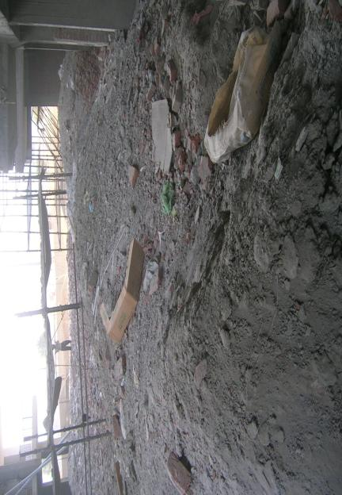
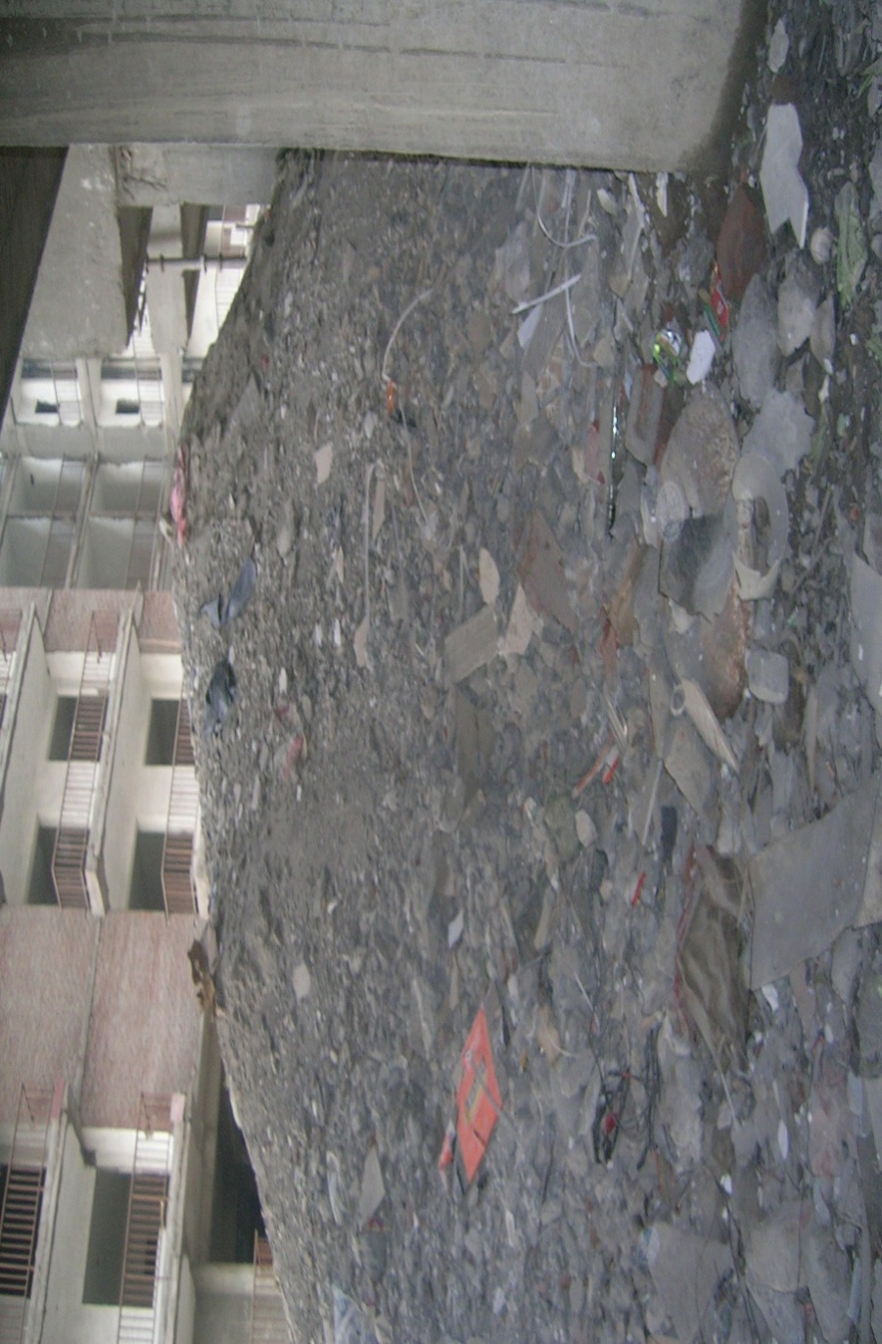
Picture: 1 The construction waste at Pachsheel Greens (Noida).

Picture: 2 The construction waste at Crossing Republic (Noida)

composting. The growing population in the country and requirement of land for other uses has reduced the availability of land for waste disposal. Re-utilization or recycling is an important strategy for management of waste.
Apart from mounting problems of waste management, other reasons which support adoption of reuse/ recycling strategy are- reduced extraction of raw materials, reduced transportation cost, improved profits and reduced environmental impact. Above all, the fast depleting reserves of conventional natural aggregate has necessitated the use of recycling/ re-use technology, in order to be able to conserve the conventional natural aggregate for other important works.
Concrete appears in two forms in the waste. Structural elements of building have reinforced concrete, while foundations have mass non-reinforced concrete.
Excavations produce topsoil, clay, sand, and gravel. This may be either re-used as filler at the same site after completion of excavation work or moved to another site.
Metal waste is generated during demolition in the form of pipes, conduits, and light sheet material used in ventilation system, wires, and sanitary fittings and as reinforcement in the concrete. Metals are recovered and recycled by re-melting.
Timber recovered in good condition from beams, window frames, doors, partitions and other fittings is reused. However, wood used in construction is often treated with chemicals to prevent termite infestation and warrants special care during disposal.
Bituminous material arises from road planning, water proofing compounds, breaking and digging of roads for services and utilities. Other miscellaneous materials that arise as waste include glass, plastic material, paper, etc

2. ESTIMATION OF CONSTRUCTION WASTE:
Contractor executes construction project on a labour contract basis or on turnkey basis. Small housing projects, executed by owners, are predominantly executed on labor contract basis and strict supervision is required to control waste generation during construction process. Typically, waste generation ranges between 5 to 7%. In larger projects, where execution is on turnkey basis or through one’s own team of professional, material wastage is 3%.
2.1 According to MoEF (Ministry of Environment Forest) report of the committee to evolve road map on management of wastes in India construction waste comprises of concrete, plaster, bricks, metal, wood, plastics etc. It is estimated that the construction industry in India generates about 10-12 million tons of waste annually. There is a huge demand of aggregates in the housing and road sectors but there is significant gap in demand and supply, which can be reduced by recycling construction and demolition waste to certain specifications. While some of the items like bricks, tiles, wood, metal etc. are re-used and recycled, concrete and masonry, constituting about 50% of the construction waste is not currently recycled in India. The fine dust like material (fines) from construction waste is presently not being used and thus wasted.
2.2 According to T.I.F.A.C. (Technology Information, Forecasting and Assessment Council) the total quantum of waste from construction industry is estimated to be 12 to 14.7 million tons per annum. Waste is generated at different stages of construction process. Waste during construction activity relates to excessive cement mix or concrete left after work is over, rejection/ demolition caused due to change in design or wrong workmanship etc. Estimated waste generation during construction is 40 to 60 Kg. per sq. m. Similarly, waste generation during renovation/ repair work is estimated to be 40 to 50 kg/sq. m.
Quantities of different constituents of waste that arise from construction industry in India are estimated as follows:
Table. 1 Quantity of different constituents of waste that arise from construction industry in India(according to T.I.F.A.C. [5])
Constituents | Quantity generated in million tons p.a. (Range)
Soil, Sand & gravel | 4.20 to 5.14
Bricks & Masonry | 3.60 to 4.40
Concrete | 2.40 to 3.67
Metals | 0.60 to 0.73
Bitumen | 0.25 to 0.30
Wood | 0.25 to 0.30
Others | 0.10 to 0.15
Others include plastics, paints, cardboards, etc.
The pie chart shows the percentage of construction waste on sites according to the data’s of T.I.F.A.C.

Fig.1 The pie chart representation of construction waste, from data’s of T.I.F.A.C [5].
2.3 According to C.P.C.B. (Central Pollution Control Board) has estimated current quantum of solid waste generation in India to the tune of 48 million tons per annum of which waste from Construction Industry accounts for 25%. Management of such high quantum of waste puts enormous pressure on solid waste management system.
2.4 According to report of W.B. (World Bank) on waste management in China: issues and recommendations May 2005. The solid waste generation in India will get approximately three fold increases till 2030 and we will leave behind USA in generation of solid waste.

Fig. 2 The comparative graph of solid waste for China, India, USA, from WB report [7].
This means that the construction waste which according to C.P.C.B account for 25% of total waste will also increase in three folds. Thus we require to reuse and recycling of construction waste.

3. PAPER review:
3.1 Margaret [9] discussed on the result of shear strength tests conducted on both crushed concrete and demolition debris using crushed limestone. Also includes an investigation in to the possibility of applying an analysis of shear strength parameters to the case of well graded aggregates. Paper also report the test conducted on samples, the test is conducted on different densities and by varying the vertical stress. It concluded that the critical angle of friction of aggregates were found to be between 40⁰ to 42⁰, but the difference between calculated and measured values using loose heap test varying between 2.5% to 4% .It is concluded therefore that the 1⁰ accuracy suggested could not be achieved for well graded aggregates unless very large quantities of the material were used for the loose heap test. Finally conclusion is made on the appropriateness of using such material as alternative to natural aggregate in situation where shear strength is an important factor.
3.2 Taesoon [11] reported about the test results of a laboratory and field study performed to investigate the characteristics and performance of dry and wet recycled concrete aggregate as base and subbase materials for concrete pavement. The physical properties of the recycled concrete aggregate were investigated in terms of the moisture-density relationship, particle index, and fine aggregate angularity. Performance concerns have focused on compactibility, stability, shear resistance, and particle breakage of the recycled concrete aggregate. These were evaluated in the laboratory using the U.S. Army Corps of Engineers Gyratory Testing Machine. The falling weight deflectometer was used to measure the deflection of pavement sections constructed with recycled concrete aggregate base and subbase in the subbase material and may be comparable to crushed stone aggregate. Based on the aggregate tests, the gyratory testing machine and field application of recycled concrete aggregate as base and subbase materials for concrete pavement system, the following conclusions can be drawn that the recycle concrete aggregate can be used as base and subbase materials, in place of crush stone aggregate, for supporting a concrete pavement system, the compactibility of recycle concrete aggregate is the same as that of crush stone aggregate and gravel the stability and the shear resistance of recycle concrete aggregate in dry conditions are higher than those of gravel and equal to or better than those of crush stone aggregate and the stability and the shear resistance of the recycle concrete aggregate in wet conditions are lower than in dry conditions, however, the reduction rate is comparable with that observed in crush stone aggregate and gravel.
3.3 Poon et al [8] reported about the study conducted at the Hong Kong Polytechnic University to investigate the possibility of using recycled concrete aggregates and crushed clay brick as aggregates in unbound subbase materials. The results showed that the use of 100% recycled concrete aggregates increased the optimum moisture content and decreased the maximum dry density of the subbase materials compared to those of natural subbase materials. Moreover, the replacement of recycled concrete aggregates by crushed clay brick further increased the optimum moisture content and decreased the maximum dry density. This was mainly attributed to the lower particle density and higher water absorption of crushed clay brick compared to those of recycled concrete aggregates. The C.B.R. values (unsoaked and soaked) of the subbase materials prepared with 100% recycled concrete aggregates were lower than those of natural subbase materials. The C.B.R. values further decreased as the replacement level of recycled concrete aggregates by crushed clay brick increased. Nevertheless, the soaked C.B.R. values for all recycled subbases were greater than 30%, which is a minimum strength requirement in Hong Kong. Furthermore, the recorded percentage swells for all subbases were less than 0.13% which can be considered negligible. All recycled subbases had a negligible swell after a 4-day soaked period. It finally conclude that the use of crushed clay brick lowered the C.B.R. value and The subbase using crushed clay brick as the fine aggregate had a lower C.B.R. value compared to the subbase using recycled concrete aggregate as the fine aggregate.
3.4 Melbouci [7] discussed mechanical response and mechanical characteristics of construction and demolition waste through the proctor test, the C.B.R. test and the shearing test. The result showed that their characteristics are lower than those of the natural aggregates. Then, he tried to improve them by the following additions (sand, cement and brick). The combination of these materials enabled to improve some of their physical and mechanical characteristics and bring them near to the natural aggregates. Finally it concludes that the mechanical properties influence by the additions on the recycled aggregates. By the characterization of mechanical properties, it concluded that waste cannot be regarded as inert and can influence the behavior of the roadway. The study of bearing pressure revealed a good resistance of the granular mixture (concrete aggregates + cement), which resulted in high values of immediate and after immersion C.B.R. indices due to the improvement of grain size distribution during the compaction.
3.5 Leite [10] discussed the results that show the composition and the compactive effort influence on the physical characteristics of the recycled construction and demolition waste aggregate. The compaction process has promoted a partial crushing and breakage of recycled construction and demolition waste particles, changing the grain-size distribution and increasing the percentage of cubic grains. This physical change contributes to a better densification of the recycled construction and demolition waste aggregate and consequently an improvement in bearing capacity, resilient modulus and resistance to permanent deformation. The results have shown that the recycled construction and demolition waste aggregate may be utilized as coarse base and sub-base layer for low-volume roads. It also reported that the water absorption varies greatly according to the nature of the materials. For large occurrence of highly porous ceramic materials, such as bricks and roof tiles, the water absorption of the recycled construction and demolition waste increases significantly. It is also possible to infer the grain shape based on the composition. The results show that cementitious materials have predominantly cubic grains, whereas less porous ceramic materials have mostly flat grains finally it conclude that the compactive effort also influences the resistance to permanent deformation of the recycled construction and demolition waste aggregate. For the same stress level, a slightly reduction in permanent deformation is observed, when the material is compacted at higher energy. Moreover, the permanent deformation of the recycled construction and demolition waste aggregate also depends on the stress levels.

4 EXPERIMENTAL PROGRAMMES:
4.1 GRAIN SIZE ANALYSIS
The grain size analysis is widely used in classification of soils. The grain size analysis is an attempt to determine the relative proportions of different grain sizes which make up a given soil mass. The data obtained from grain size distribution curves is used in the design of filters for earth dams and to determine suitability of soil for road construction, air field etc. Information obtained from grain size analysis can be used to predict soil water movement although permeability tests are more generally used.
The soil is generally divided in to four parts based on particle size the fraction of soil grater than 2mm size is called gravel, that between 2 mm and 0.06 mm is sand, between 0.06and 0.002 mm is silt and smaller than 0.002 mm is clay.
The test is conducted on the basis of IS 2720(part 4).

Picture.3 sieve arrangement for particle size distribution.

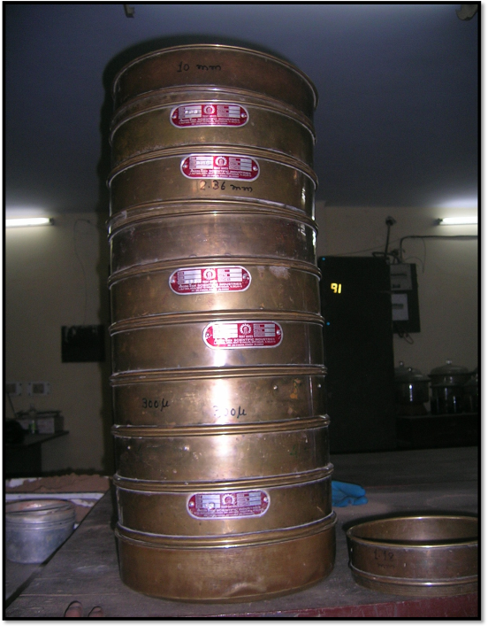

4.1.1 Particle size distribution for S1.
Fig.3 particle size distribution for S1.
4.1.2 Particle size distribution for A1

Fig.4 particle size distribution for A1.

4.2 DETERMINATION OF SPECIFIC GRAVITY
Specific gravity G is defined as the ratio of the weight of an equal volume of distilled water at that temperature both weights taken in air. The specific gravity found by pycnometer having volume of 0.9 liter .
Specific gravity of soil =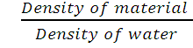
Specific gravity of soil = (𝑊2−𝑊1)/ (𝑊4−𝑊1) − (𝑊3−𝑊2)
The specific gravity of the soil particles lie with in the range of 2.65 to 2.85. Soils containing organic matter and porous particles may have specific gravity values below 2.0. Soils having heavy substances may have values above 3.0.
The test is conducted on the basis of IS 2720(part 3)

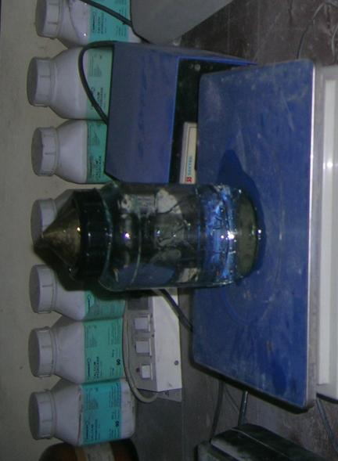
Picture 4 Pycnometer full of water (W4) .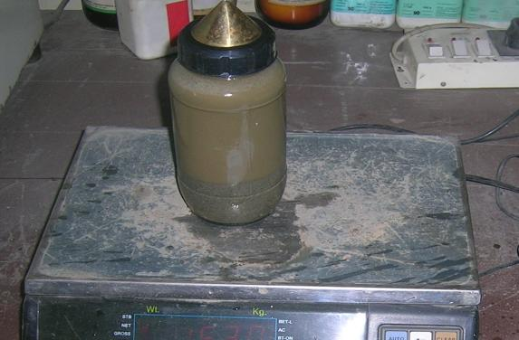
Picture.5 Pycnometer with water and sample (W3).

4.2.1 SPECIFIC GRAVITY OF S1:
Table.2 Specific gravity of S1.
Sample | Test 1 | Test 2 | Test 3 | Average of result
S1 | 2.59 | 2.55 | 2.55 | 2.56

4.2.2 SPECIFIC GRAVITY OF A1:
Table.3 Specific gravity of A1.
Sample | Test 1 | Test 2 | Test 3 | Average of result
A1 | 2.42 | 2.46 | 2.44 | 2.44

4.3 PROCTOR TEST
This method covers the determination of the relationship between the moisture content and density of soils compacted in a mould of a given size with a 2.5 kg rammer dropped from a height of 310 mm.
The compaction of soil by rolling etc. is best performed if we add certain amount of water during compaction less than or more than that quantity of water will not help us to achieve maximum compaction or Maximum Dry Density (M.D.D.) of compacted soil. The most beneficial water content is known as Optimum moisture Content (O.M.C.)

CALCULATION
Wet density gm/cc =weight of compacted soil / volume of cylinder.
Dry density = wet density/ (1+w)
Where, w is the moisture content of the soil.
Plot the dry density against moisture content and find out the maximum dry density and optimum moisture for the soil.
The test is conducted on the basis of IS 2720(part 7).

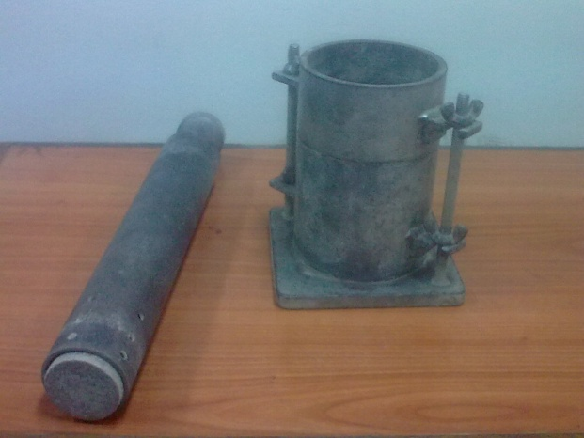Picture .6 Apparatus of Procter test.
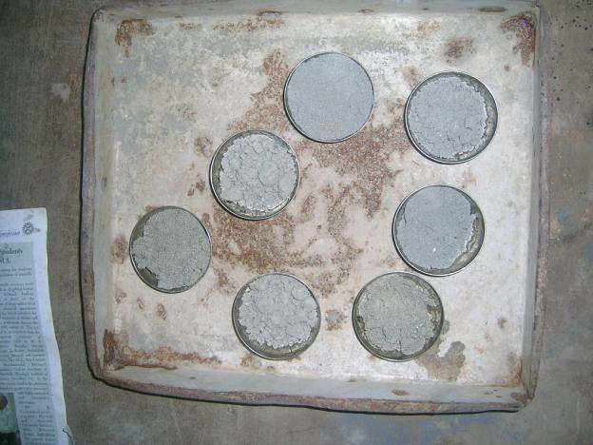Picture .7 Samples of material to find water content.
4.3.1 PROTOR TEST OF S1:

Fig.5 Moisture content and dry density relationship of S1.
4.3.2 PROTOR TEST OF A1:

Fig.6 Moisture content and dry density relationship of A1.

4.4 DIRECT SHEAR TEST
In many engineering problems such as design of foundation, retaining walls, slab bridges, pipes, sheet piling, the value of the angle of internal friction and cohesion of the soil involved are required for the design. Direct shear test is used to predict these parameters quickly. The test will give the value of internal friction angle for different materials.
Dimensions of shear box 60 x 60 mm
Least count of dial gauge 0.01mm
Proving ring constant is 0.18kg
General Remarks
- In the shear box test, the specimen is not failing along its weakest plane but along a predetermined or induced failure plane i.e. horizontal plane separating the two halves of the shear box. This is the main draw back of this test. Moreover, during loading, the state of stress cannot be evaluated. It can be evaluated only at failure condition i.e. Mohr’s circle can be drawn at the failure condition only.
- Failure is progressive in direct shear test.
- Direct shear test is simple and faster to operate. As thinner specimens are used in shear box, they facilitate drainage of pore water from a saturated sample in less time. This test is also useful to study friction between two materials one material in lower half of box and another material in the upper half of box.
- The angle of shearing resistance of sands depends on state of compaction, coarseness of grains, particle shape and roughness of grain surface and grading. It varies between 28º(uniformly graded sands with round grains in very loose state) to 46º(well graded sand with angular grains in dense state).
- The friction between sand particles is due to sliding and rolling friction and interlocking action.
The test is conducted on the basis of IS 2720(part 13).

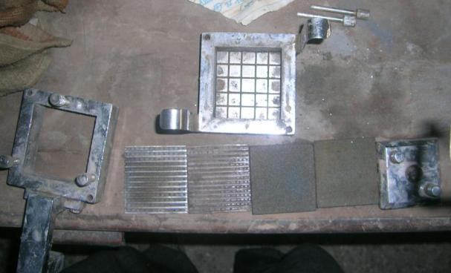
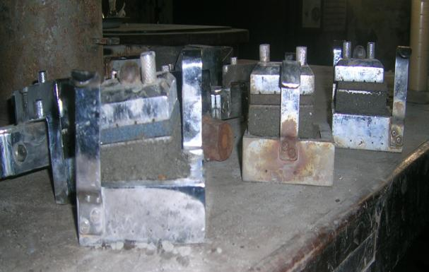
Picture 8 The apparatus for direct shear test
Picture.9 Failure specimen of samples in direct shear test.

4.4.1DIRECT SHEAR TEST OF S1:

Fig.7 Direct shear test of S1.
4.4.2 DIRECT SHEAR TEST OF A1:

Fig.8 Direct shear test of A1.

4.5 CALIFORNIA BEARING RATIO TEST

This is penetration test developed by the California Division of Highway as a method for evaluating the stability of soil subgrade and other flexible pavements material .The test results are correlated with flexible pavements thickness required for highway and air fields.
The results obtained by these tests are used with the empirical curves to determine the thickness of pavement and its component layers. This is the most widely used method for the design of flexible pavement.
Calculation
It is the ratio of force per unit area required to penetrate a soil mass with standard circular piston at the rate of 1.25 mm/min. to that required for the corresponding penetration of a standard material. The following table gives the standard loads adopted for different penetrations for the standard material with a C.B.R. value of 100%
Penetration of plunger in mm | Standard load in Kg
2.5 | 1370
5 | 2055
7.5 | 3180
12 | 3600

Observation and Recording
Calibration factor of the proving ring - 1 Division = 1.01 kg
Least count of penetration dial- 1 Division = 0.01 mm
If the initial portion of the curve is concave upwards, apply correction by drawing a tangent to the curve at the point of greatest slope and shift the origin Find and record the correct load reading corresponding to each penetration.
C.B.R. = (P_{T}/P_{S} ) 100
Where
P_{T} = Corrected test load corresponding to the chosen penetration from the load penetration curve.
P_{S} = Standard load for the same penetration taken from the table.
Interpretation and recording
C.B.R. of specimen at 2.5 mm penetration
C.B.R. of specimen at 5.0 mm penetration
The C.B.R. values are usually calculated for penetration of 2.5 mm and 5 mm. Generally the C.B.R. value at 2.5 mm will be greater that at 5 mm and in such a case/the former shall be taken as C.B.R. for design purpose. If C.B.R. for 5 mm exceeds that for 2.5 mm, the test should be repeated. If identical results follow, the C.B.R. corresponding to 5 mm penetration should be taken for design.
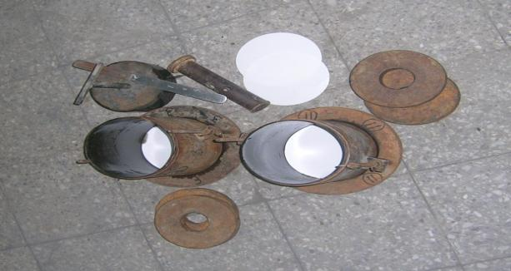
Picture.10 Apparatus of C.B.R. test

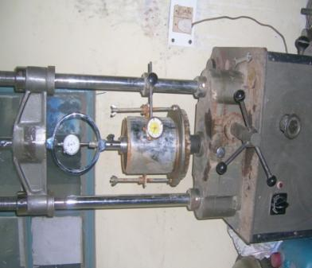
Picture.11 Loading frame of C.B.R. test

4.5.1 C.B.R. TEST OF S1 AT O.M.C. (UNSOAKED):

Fig.9 Penetration load curve for S1 at O.M.C.. (unsoaked).
Table .4 C.B.R. value of S1 at O.M.C (unsoaked).
Test no. | C.B.R. value at 2.5 mm penetration | C.B.R. value at 5 mm penetration | C.B.R. value
1 | 13.49 | 23.74 | 23.74
2 | 13.27 | 23.34 | 23.34

C.B.R. VALUE=23.34

4.5.2 C.B.R. TEST OF S1 AT 95 % O.M.C. (UNSOAKED):

Fig.10 Penetration load curve for S1 at 95% O.M.C.. (unsoaked).
Table. 5 C.B.R. value of S1 at 95% O.M.C (unsoaked).
Test no. | C.B.R. value at 2.5 mm penetration | C.B.R. value at 5 mm penetration | C.B.R. value
1 | 11.06 | 16.96 | 16.96
2 | 10.91 | 16.46 | 16.95

C.B.R. VALUE=16.95

4.5.3 C.B.R. TEST OF S1 AT 90 % O.M.C. (UNSOAKED):

Fig.11 Penetration load curve for S1 at 90% O.M.C.. (unsoaked).
Table . 6 C.B.R. value of S1 at 90% O.M.C (unsoaked).
Test no. | C.B.R. value at 2.5 mm penetration | C.B.R. value at 5 mm penetration | C.B.R. value
1 | 10.32 | 15.63 | 15.63
2 | 10.46 | 15.68 | 15.68

C.B.R. VALUE=15.68

4.5.4 C.B.R. TEST OF S1 AT 85 % O.M.C. (UNSOAKED):

Fig.12 Penetration load curve for S1 at 85% O.M.C.. (unsoaked).
Table . 7 C.B.R. value of S1 at 85% O.M.C (unsoaked).
Test no. | C.B.R. value at 2.5 mm penetration | C.B.R. value at 5 mm penetration | C.B.R. value
1 | 8.11 | 14.35 | 14.35
2 | 8.40 | 14.55 | 14.55

C.B.R. VALUE=14.55

4.5.5 C.B.R. TEST OF S1 AT 80% O.M.C. (UNSOAKED):

Fig.13 Penetration load curve for S1 at 80% O.M.C..
Table. 8 C.B.R. value of S1 at 80% O.M.C (unsoaked).
Test no. | C.B.R. value at 2.5 mm penetration | C.B.R. value at 5 mm penetration | C.B.R. value
1 | 7.30 | 12.93 | 12.93
2 | 7.59 | 13.12 | 13.12

C.B.R. VALUE=13.12

4.5.6 C.B.R. TEST OF A1 AT O.M.C. (UNSOAKED):

Fig.14 Penetration load curve for A1 at O.M.C.. (unsoaked).
Table .9 C.B.R. value of A1 at O.M.C (unsoaked).
Test no. | C.B.R. value at 2.5 mm penetration | C.B.R. value at 5 mm penetration | C.B.R. value
1 | 13.86 | 19.66 | 19.66
2 | 13.27 | 19.41 | 19.41

C.B.R. VALUE=19.41

4.5.7 C.B.R. TEST OF A1 AT 95% O.M.C. (UNSOAKED):

Fig. 15 Penetration load curve for A1 at 95% O.M.C.. (unsoaked).
Table .10 C.B.R. value of A1 at 95% O.M.C (unsoaked).
Test no. | C.B.R. value at 2.5 mm penetration | C.B.R. value at 5 mm penetration | C.B.R. value
1 | 13.64 | 18.04 | 18.04
2 | 19.66 | 17.89 | 17.89

C.B.R. VALUE=17.89

4.5.8 C.B.R. TEST OF A1 AT 90% O.M.C. (UNSOAKED):

Fig. 16 Penetration load curve for A1 at 90% O.M.C.. (unsoaked).
Table . 11 C.B.R. value of A1 at 90% O.M.C. (unsoaked).
Test no. | C.B.R. value at 2.5 mm penetration | C.B.R. value at 5 mm penetration | C.B.R. value
1 | 12.98 | 17.55 | 18.04
2 | 13.12 | 17.69 | 17.69

C.B.R. VALUE=17.69

4.5.9 C.B.R. TEST OF A1 AT 85 % O.M.C. (UNSOAKED): .

Fig 17. Penetration load curve for A1 at 85% O.M.C.(unsoaked).
Table . 12 C.B.R. value of A1 at 85% O.M.C (unsoaked).
Test no. | C.B.R. value at 2.5 mm penetration | C.B.R. value at 5 mm penetration | C.B.R. value
1 | 12.53 | 16.22 | 16.22
2 | 13.05 | 16.22 | 16.22

C.B.R. VALUE=16.22

4.5.10 C.B.R. TEST OF A1 AT 80 % O.M.C. (UNSOAKED):

Fig. 18 Penetration load curve for A1 at 80% O.M.C.. (unsoaked).
Table .13 C.B.R. value of A1 at 80% O.M.C (unsoaked).
Test no. | C.B.R. value at 2.5 mm penetration | C.B.R. value at 5 mm penetration | C.B.R. value
1 | 11.50 | 15.43 | 15.43
2 | 11.21 | 15.38 | 15.38

C.B.R. VALUE=15.38

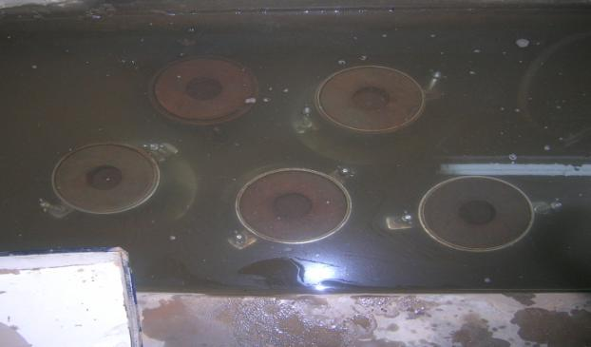
Picture.12 The specimen kept for soaking
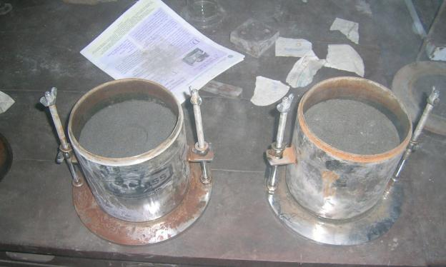
Picture .13 The samples after C.B.R. test.

4.5.11 C.B.R. TEST OF S1 AT O.M.C. (SOAKED):

Fig. 19 Penetration load curve for S1 at O.M.C.. (soaked).
Table . 14 C.B.R. value of S1 at O.M.C (soaked).
Test no. | C.B.R. value at 2.5 mm penetration | C.B.R. value at 5 mm penetration | C.B.R. value
1 | 12.98 | 18.77 | 18.77
2 | 13.12 | 19.12 | 19.12

C.B.R. VALUE=19.12

4.5.12 C.B.R. TEST OF S1 AT 95% O.M.C. (SOAKED):

Fig.20 Penetration load curve for S1 at 95% O.M.C.. (soaked).
Table .15 C.B.R. value of S1 at 95% O.M.C (soaked).
Test no. | C.B.R. value at 2.5 mm penetration | C.B.R. value at 5 mm penetration | C.B.R. value
1 | 11.80 | 16.76 | 16.76
2 | 10.91 | 16.61 | 16.61

C.B.R. VALUE=16.61

4.5.13 C.B.R. TEST OF S1 AT 90% O.M.C. (SOAKED):

Fig. 21 Penetration load curve for S1 at 90% O.M.C.. (soaked).
Table .16 C.B.R. value of S1 at 90% O.M.C (soaked).
Test no. | C.B.R. value at 2.5 mm penetration | C.B.R. value at 5 mm penetration | C.B.R. value
1 | 10.10 | 14.99 | 14.99
2 | 10.17 | 15.43 | 15.43

C.B.R. VALUE=15.43

4.5.14 C.B.R. TEST OF S1 AT 85% O.M.C. (SOAKED):

Fig. 22 Penetration load curve for S1 at 85% O.M.C.. (soaked).
Table .17 C.B.R. value of S1 at 85% O.M.C (soaked).
Test no. | C.B.R. value at 2.5 mm penetration | C.B.R. value at 5 mm penetration | C.B.R. value
1 | 6.78 | 13.42 | 13.42
2 | 7.15 | 13.52 | 13.52

C.B.R. VALUE=13.52

4.5.15 C.B.R. TEST OF S1 AT 80% O.M.C. (SOAKED):

Fig.23 Penetration load curve for S1 at 80% O.M.C.. (soaked).
Table . 18 C.B.R. value of S1 at 80% O.M.C. (soaked).
Test no. | C.B.R. value at 2.5 mm penetration | C.B.R. value at 5 mm penetration | C.B.R. value
1 | 5.31 | 8.36 | 8.36
2 | 5.09 | 8.26 | 8.26

C.B.R. VALUE=8.26

4.5.16 C.B.R. TEST OF A1 AT O.M.C. (SOAKED):

Fig. 24 Penetration load curve for A1 at O.M.C.. (soaked).
Table 19 . C.B.R. value of A1 at O.M.C. (soaked).
Test no. | C.B.R. value at 2.5 mm penetration | C.B.R. value at 5 mm penetration | C.B.R. value
1 | 12.68 | 17.30 | 17.30
2 | 12.90 | 17.45 | 17.45

C.B.R. VALUE=17.45

4.5.17 C.B.R. TEST OF A1 AT 95% O.M.C. (SOAKED):

Fig.25 penetration load curve for A1 at 95% O.M.C.. (soaked).
Table. 20 C.B.R. value of A1 at 95% O.M.C. (soaked).
Test no. | C.B.R. value at 2.5 mm penetration | C.B.R. value at 5 mm penetration | C.B.R. value
1 | 12.53 | 16.96 | 16.96
2 | 12.68 | 17.15 | 17.15

C.B.R. VALUE=17.15

4.5.18 C.B.R. TEST OF A1 AT 90% O.M.C. (SOAKED):

Fig.26 penetration load curve for A1 at 90% O.M.C.. (soaked).
Table . 21 C.B.R. value of A1 at 90% O.M.C. (soaked).
Test no. | C.B.R. value at 2.5 mm penetration | C.B.R. value at 5 mm penetration | C.B.R. value
1 | 12.16 | 16.71 | 16.71
2 | 11.65 | 16.42 | 16.42

C.B.R. VALUE=16.42

4.5.19 C.B.R. TEST OF A1 AT 85% O.M.C. (SOAKED):

Fig. 27 Penetration load curve for A1 at 85% O.M.C.(soaked).
Table .22 C.B.R. value of A1 at 85% O.M.C. (soaked).
Test no. | C.B.R. value at 2.5 mm penetration | C.B.R. value at 5 mm penetration | C.B.R. value
1 | 10.69 | 15.97 | 15.97
2 | 10.47 | 15.83 | 15.83

C.B.R. VALUE=15.83

4.5.20 C.B.R. TEST OF A1 AT 80% O.M.C. (SOAKED):

Fig. 28 Penetration load curve for A1 at 80% O.M.C.. (soaked).
Table . 23 C.B.R. value of A1 at 80% O.M.C. (soaked).
Test no. | C.B.R. value at 2.5 mm penetration | C.B.R. value at 5 mm penetration | C.B.R. value
1 | 9.95 | 15.24 | 15.24
2 | 10.10 | 14.94 | 14.94

C.B.R. VALUE=14.94

5. ANALYSIS OF RESULTS:
5.1 PARTICAL DISTRIBUTION RESULTS:

Fig.29 Comparative graph of particle distribution of S1 and A1.
Sample | D₁₀ | D₃₀ | D₆₀ | C_{U} | C_{C} | Type
S1 | 0.154 | 0.253 | 0.352 | 2.292 | 1.018 | SP
A1 | 0.162 | 0.240 | 0.349 | 2.292 | 1.177 | SP
The following table gives the similarity between the A1 and S1 on the basis of coefficient of curvature and coefficient of uniformity.
Table.24 Comparative particle size distribution data of S1 and A1.

5.1COMPARING PARTICAL DISTRIBUTION WITH STANDARD SOILS:

Fig. 30 Comparison of S1 and A1 with standard soils [25].
After comparing particle sizes for A1 ,S1 with well graded soil, dune sand, well graded sand, fat soil, gap grade soil its been observed that both the materials are uniformly graded.

5.3 COMPARING The particle size distribution that gives maximum dry density.

Fig.31 Comparison of particle size distribution of Al and S1 with maximum density material.
The particle size distribution that gives maximum dry density is generally aimed at theoretical gradation for maximum density given by
P = 100 (d/D) ^{n}
P = percent finer than diameter `d’ (mm) in the material
D = diameter of the largest particle in mm
n = gradation index which have values ranging from 0.5 to 0.3 depending upon the shape
For spherical shape the value of `n’ is 0.5.
For flaky and angular the value of `n’ is 0.3.
Table.25 Comparing the sizes of material with the size of material for best compaction.
Sample | D₁₀ | D₃₀ | D₆₀
S1 | 0.154 | 0.253 | 0.352
A1 | 0.162 | 0.240 | 0.349
Spherical material | 0.01 | 0.09 | 0.36
Flaky material | 0.000464 | 0.018 | 0.182

  - PROCTOR TEST RESULTS:
5.2.1 COMPARING A1 AND S1.

Fig. 32 Comparative graph for proctor test of S1 and A1.

Material | Optimum moisture content(O.M.C.) | Maximum dry density(M.D.D.)  (KN/m³)
S1 | 15.20 | 17.0
A1 | 17.24 | 16.02
Table.26 Comparative data for proctor test of S1 and A1.
.
After conducting the standard proctor test on samples of A1 and S1 it was being found that there is a slight variation in the optimum moisture content and maximum dry density of both the materials the optimum moisture content of A1 is grater than S1 and the maximum dry density of A1 is lower than S1.

5.2.2 COMPARING A1 AND S1 WITH STANDARD MATERIALS.

Fig.33 Comparison of S1 and A1 with some standard soil [40].
Table.27 Composition of soils which are compared with S1 and A1.
S.no | Description | Sand (%) | Silt (%) | Clay (%)
1 | Well graded loamy sand | 88 | 10 | 2
2 | Well graded sandy loam | 72 | 15 | 13
3 | Medium graded sandy loam | 73 | 9 | 18
4 | Lean sandy silty clay | 32 | 33 | 35
5 | Lean silty clay | 5 | 64 | 31
6 | Loessial silt | 5 | 85 | 10
7 | Heavy clay | 6 | 22 | 72
8 | Poorly graded sand | 92 | 6
9 | S1 | 99.37 | 0.63
10 | A1 | 99.45 | 0.55

All the above data from 1-8 is taken from Holtz, R.D. and Kovacs, W.D. The above graph shows the compaction graph of different soil and the table shows the particle distribution of the corresponding soils From the following data it is found that maximum dry density of A1 is very low as compare to well graded and medium graded soils and the A1 graph of proctor test is comparable to poorly graded sand .only its moisture content is grater than the poorly graded sand. But the dry density is comparable.

5.2.3 COMPARING A1 AND S1 WITH THE GRANITIC SOIL.

Fig.34 Comparison of S1 and A1 with granitic soil [13].
The above data is taken from an journal from Elsevier, “Experimental study of the effect of fines content on compaction in completely decomposed granite of Hong Kong”.
In the experimental work the granitic soil is mixed with the different proportion of fines and the compaction test is conduced on it. In the above graph the 1, 4,8,11,13,16,21 represent the percentage of fines is added to granitic soil.
It concludes that as the fines content increases, the dry density decreases, however the optimum water content increase .Similarly this effect is being observed on A1 as cement is acting as fines in it.

5.2.4 COMPARING A1 AND S1 WITH COAL ASH.

Fig.35 Comparison of S1 and A1 with the different samples of coal ash [14].
The above data is taken from an journal from ASCE which include, “Collapsible behavior of coal ash”
The A1 and S1 are compared with coal ash as coal ash is also an waste used for back fill in land pits and also an waste product similarly A1 is also an plaster waste can be used in back fills.
The paper describes an investigation carried out to examine the factors influencing collapse settlement of the compacted coal ash due to wetting. Coal ash is a waste product of the coal based thermal power plant an investigation was carried out to examine the factors influencing the collapse of compacted ash fill. In the graph F1–F7 are the 7 samples seven electrostatic precipitator. On comparing A1 with the coal ash it was found that the optimum moisture content of A1 and S1 is much lower than that of coal ash and maximum dry density is higher than that of coal ash.

5.2.5 COMPARING A1 AND S1 WITH OTHER CONSTRUCTION WASTES.

Fig.36 Comparison of S1 and A1 with the other construction and demolition waste[26].
All the above data is taken from the report “Construction and Demolition Waste as a Highway Material”
The A1 is compared with the waste which was collected from the two sites one from Rohtak and the other from Sarai kale khan.the comparison shows that the optimum moisture content of A1 is grater than that of both the construction ad demolish waste but the maximum dry density have the very slight difference. The following table gives the comparison between the A1 and construction and demolishes waste.

Table.28 Comparison of A1 and S1 with other construction and demolition waste.
Material | Optimum moisture content(O.M.C.) | Maximum dry density(M.D.D.)  (g/cc)
Rohtak | 20.71 | 15.58
Sarai kale khan | 21.73 | 17
S1 | 15.20 | 17
A1 | 17.24 | 16.02

From above comparison we find that the compaction graph of A1 is comparable to the results.

5.3 direct shear test results:
5.3.1.COMPARING A1 AND S1:
Table.29 Comparison of angle of friction of A1 and S1.
Material | Cohesion (Kg/cm²) | Angle of friction, degree (Φ) | moisture content=O.M.C. | Dry density=M.D.D. (KN/M³)
S1 | 0 | 30.37 | 15.2 | 17.0
A1 | 0 | 30.15 | 17.24 | 16.02

Fig.37 Comparison of direct shear plot of A1 and S1.

5.4C.B.R. TESt results:
5.4.1C.B.R. test of s1 soaked and unsoaked:

Fig.38 Comparing dry density of S1with proctor test density in soaked and unsoaked condition.
The graph shows the comparison dry density of sand at different moisture content in Procter and C.B.R. test.The various points on graph shows the 100%,95%,90%,85%,80% of optimum moisture content from the graph it is observed that the dry density observed during C.B.R. test is always lesser than the proctor test density at the same moisture content and the difference in dry density is approximately 0.5 kN/m³ .It is also observed that the dry density of soaked specimen have lower dry density as compared to unsoaked C.B.R. test specimen by approximately 0.67 kN/m³ .
O.M.C.=15.20
Fig. 39 Comparative bar chart for C.B.R. values of S1 at soaked and unsoaked condition test 1.
OMC=15.2
Fig.40 Comparative bar chart for C.B.R. values of S1 at soaked and unsoaked condition test 2
From the bar charts showing the C.B.R. value of sand at different moisture content in unsoaked and soaked condition .It is observed that the unsoaked C.B.R. values are always grater than the soaked sand specimen. The C.B.R. value in unsoaked specimen is highest at the optimum moisture content and there is sudden decrease in C.B.R. value at 95% of O.M.C. It is also observed that on decreasing the moisture content to the further 5 % results in decrease C.B.R. values in gradual pattern.
On analyzing the results of soaked C.B.R. test it is observed that the C.B.R. value at O.M.C. and 80% of O.M.C. there is a sudden decrease of C.B.R. values as compared to unsoaked values at the corresponding moisture content. It is also found that C.B.R. values corresponding to moisture content between 95% to 85% of O.M.C. shows the gradual decreasing trend of C.B.R. values.

5.4.2 C.B.R. test of A1 soaked and unsoaked:

Fig. 41 Comparing dry density of A1with proctor test density in soaked and unsoaked condition.
The graph shows the comparison dry density of plaster waste at different moisture content in Procter and C.B.R. test .The various points on graph shows the C.B.R. values corresponding different moisture content. From the graph it is observed that the dry density observed during C.B.R. test is always lesser than the proctor test density at the same moisture content and the difference in dry density is approximately 0.35 kN/m³.It is also observed that the dry density of soaked specimen have lower dry density as compared to unsoaked C.B.R. test specimen by approximately 0.46 kN/m³ .
O.M.C.=17.24
Fig. 42 Comparative bar chart for C.B.R. values of A1 at soaked and unsoaked condition test 1.
O.M.C.=17.24

Fig. 43 Comparative bar chart for C.B.R. values of S1 at soaked and unsoaked condition test 2.
From the bar charts showing the C.B.R. value of plaster waste at different moisture content in unsoaked and soaked condition it is observed that the unsoaked C.B.R. values are always grater than the soaked specimen. The C.B.R. value in unsoaked plaster waste specimen is highest at the optimum moisture content. There is gradual decrease in C.B.R. values on decrease the moisture content from O.M.C. to 85% of O.M.C., Thus it shows the different results as compared to sand which shows the sudden decrease in C.B.R. values at O.M.C. and85% of O.M.C.
On analyzing the results of soaked C.B.R. test of plaster waste it is observed that the C.B.R. value at different moisture content is lesser than the specimen of unsoaked condition. With the decrease in moisture content it is found that the difference between the C.B.R. values of soaked and unsoaked specimen decreases at the corresponding moisture contents, and there is no sudden decrease in C.B.R. value at any moisture content.

5.4.3 COMPARISON OF C.B.R. VALUES OF A1 AND S1 unsoaked condition:
O.M.C.=15.20(S1)
0MC=17.24(A1)
Fig.44 Comparative chart for C.B.R. values of S1 and A1 in unsoaked condition.
Above graph showing the C.B.R. values of sand and plaster waste at different moisture content at unsoaked condition. From above graph it is observed that the C.B.R. value of sand at its optimum moisture content is grater than the C.B.R. value of plaster waste at its corresponding optimum moisture content and the difference is about four units. But it is also observed that the C.B.R. value of plaster waste on decreasing the moisture content have higher values as compared to sand at its corresponding moisture content and the average difference is about 1.8 units.From above bar chart we can conclude that plaster waste will come out to be the better material at place where there is less quality control.

5.4.3 COMPARISON OF C.B.R. VALUES OF A1 AND S1 soaked condition:
O.M.C.=15.20(S1)
O.M.C.=17.24(A1)
Fig. 45 Comparative chart for C.B.R. values of S1 and A1 in soaked condition.
Above graph showing the C.B.R. values of sand and plaster waste at different moisture content at four day soaked condition. From above graph it is observed that the C.B.R. value of soaked sample of sand have higher value at its optimum moisture content as compared to plaster waste at its corresponding optimum moisture content. But it was found that on decreasing the moisture content the plaster waste specimen gives higher C.B.R. values, and the difference of C.B.R. values of both the materials get increased with the decrease in moisture content. Similarly as in the case of unsoaked specimen we can conclude that the plaster waste is better option on the sites where the quality control is poor.

6. CONCLUtION:
- The D₁₀ of S1 is 5.1 % smaller than A1, D₃₀ of S1 is 5.1% grater than A1and the D₆₀ of S1 is 0.8% grater than A1.this shows that there is slight difference in the particle size distribution of A1 and S1.
- After comparing particle sizes for A1 ,S1 with well graded soil, dune sand, well graded sand, fat soil, gap grade soil its been observed that both the materials are uniformly graded.
- Based on sieve analysis both the material A1 and S1 is can be classified as SP.
- The specific gravity of S1 is 4.9% grater than A1.The specific gravity of both the material is also comparable to the other construction waste observed[26].The specific gravity of A1 and S1 is 2.44 and 2.56 respectively and that of other construction and demolition waste [26] are 2.47 and 2.48 .
- The optimum moisture content of A1 is 13.42 % higher than the S1.The main difference of optimum moisture content of both the materials is due to the increase of fine material in A1,the cement in plaster waste is acting as a fines in A1and thus cause increase in optimum moisture content,
- The maximum dry density of A1 and S1 is comparable. The maximum dry density of S1 is 6.1% grater than the A1.the slight decrease of maximum dry density is due to the fine material in A1.
- Maximum dry density of A1 is very low as compare to well graded and medium graded soils and the graph of proctor test of A1 is comparable to poorly graded sand, the moisture content of A1 is grater than the poorly graded sand. But the dry density is comparable.
- On comparing A1 with the coal ash (F1 to F7) it is observed that the optimum moisture content of A1 is much lower than that of coal ash and maximum dry density is higher than that of coal ash.
- After observing the direct shear test of A1 and S1 it is found that the both the material are cohesion less the angle of friction of S1 is slightly grater than A1, the difference between the angle of friction of A1 and S1 is only 0.22⁰ .
- In case of sand the dry density observed during C.B.R. test is always lesser than the proctor test density at the same moisture content and the difference in dry density is approximately 0.5 kN/m³ in unsoaked condition and 0.67 kN/m³ in soaked condition.
- In case of plaster the difference in dry density of C.B.R. specimen as compared to proctor specimen is about 0.35 kN/m³ in unsoaked condition and 0.46 kN/m³ in soaked condition.
- The C.B.R. value of soaked specimen of sand and plaster waste is always lesser than the unsoaked specimen.
- In case of sand there is a sudden decrease of C.B.R. value on decrease of moisture content which is not found in plaster waste. In case of plaster waste there is gradual decrease of C.B.R. value.
- In both soaked and unsoaked condition plaster waste comes out to be better material at places where there is poor quality control.
- From above analysis it is clear that the plaster waste can be used as a replacement to sand in back fills and the places where the following tests where are the governing factor to use the material.

7. FUTURE SCOPE:
- The economical studies can be conducted on the basis of above test so that it will make us know the feasibility of use of this construction waste.
- The plaster waste can be added to different demolish materials in different percentage and the comparative study can be done on different properties of material.
- Preparation of specification for construction of pavements using plaster waste.
- Preparation of specifications for plaster waste suggesting maximum allowable values for impurities in plaster waste.
- Proper management studies can be conduct to store and transport chains to use the plaster waste more efficiently
- Finding uses of construction and demolition waste in other areas of construction.

- REFERENCE
- IS 2720: Part 3: Sec 1: 1980 Methods of test for soils: Part 3 Determination of specific gravity Section 1 fine grained soils .
- IS 2720: Part 4: 1985 Methods of test for soils - Part 4: Grain size analysis.
- IS 2720: Part 7: 1980 Methods of test for soils - Part VII: Determination of water content-dry density relation using light compaction .
- IS 2720: Part 13: 1986 Methods of test for soils - Part 13: Direct shear test
- http://www.tifac.org.in/index.php?option=com_content&view=article&id=710&Itemid=205
- http://moef.nic.in/downloads/public-information/Roadmap-Mgmt-Waste.pdf
- http://siteresources.worldbank.org/INTEAPREGTOPURBDEV/Resources/China-Waste-Management1.pdf
- B.Melbouci (2009). “Compaction and shearing behavior study of recycled aggregates ,science direct Construction and Building Materials” Journal of Construction and Building Materials, Elsevier, vol.23, 2723–2730.
- Poon.C.S. , Chan.D (2005). “Feasible use of recycled concrete aggregates and crushed clay brick as unbound road sub-base” Journal of Construction and Building Materials, Elsevier, vol.20 ,578–585.
- Margaret M.O’Mahony (1997). “An analysis of shear strength of recycle aggregates” Journal of material and structures, Springer, vol.30, 599-606.
- Leite.F.C. , .Motta.R.S , Vasconcelos.K.L , Bernucci.L (2010). “Laboratory evaluation of recycled construction and demolition waste for pavements”, ” Journal of Construction and Building Materials, Elsevier vol.25 ,2972–2979.
- Park.T (2003). “Application of Construction and Building Debris as Base and Subbase Materials in Rigid Pavement” Journal of transportation engineering, ASCE, vol.129(5) 558-563.
- Wang.S , Chan.D , Lam.K.C(2009). “Experimental study of the effect of fines content on dynamic compaction grouting in completely decomposed granite of Hong Kong”. Journal of Construction and Building Materials, Elsevier, vol.23, 1249–1264.
- Trivedi1 and Sud.V.K., (2004). “Collapse Behavior of Coal Ash” Journal of geotechnical and geoenvironmental engineering, ASCE, vol .130(4),403-415.
- Ashutosh Trivedi and Sundar Singh (2004),” Cone Resistance of Compacted Ash Fill” Journal of Testing and Evaluation, ASCE, Vol.32(6),429-437.
- Foster, C. R. (1962). ‘‘Field problems: Compaction.’’ Foundation engineering, G. A. Leonards, ed., McGraw-Hill, New York, 1000–1024.
- Barden, L., Madedor, A. O., and Sides, G. R. (1969). ‘‘Volume change characteristics of compacted clays.’’ Journal Soil Mech. Found. Div., 96(4), 33–39.
- Booth, A. R. (1975). ‘‘The factors influencing collapse settlement in compacted soils.’’ Proc., 6th Regional Conf. of Africa on SMFE, 57–64.
- Foster, C. R. (1962). ‘‘Field problems: Compaction.’’ Foundation engineering, G. A. Leonards, ed., McGraw-Hill, New York, 1000–1024
- Indraratana, B., Nutalaya, P., Koo, K. S., and Kuganenthira, N. (1991) ‘‘Engineering behavior of a low carbon, pozzolanic fly ash and its potential as construction fill.’’ Can. Geotech. J., 28, 524–555.
- Lutenegger, A. J., and Saber, R. T. (1988). ‘‘Determination of collapse potential of soils.’’ GTJ, 11(3), 173–178
- Moulton, K. L. (1978). ‘‘Technology and utilization of power plant ash in structural fill and embankments.’’ West Virginia Univ., Morgantown,W.V.
- Raymond, S. (1961). ‘‘Pulverized fuel ash as embankment material.’’ Inst. Civil Eng., 19, 515–535.
- Trivedi, A., and Sud, V. K. (2002). ‘‘Grain characteristics and engineering properties of coal ash.’’ Journal of Granular Matter,springer,vol.4(3),93-101.
- Rajiv Goel 2011 unpublished PHD work ,Dept. of Civil Engineering ,University of Delhi
- Trivedi.A, Gupta.A.K, Shrivistava.A.K, 2006, Report on testing of construction and demolition waste, Report No.DCE/CED/12/2005-06, Department of Civil Engineering,DCE,Delhi.
- Hansen TC, Angelo JW(1986).” Crushed concrete fines recycled for soil modification purposes”. ACI ,vol.;83(6):983–7.
- O’Mahony MM, Milligan GWE(1991). Use of recycled materials in subbase layers. Transport Res Record;vol.1310:73–80.
- Reznik, Y. M. (1993). ‘‘Plate-load tests on collapsible soils.’’ Journal of Geotechnical Engineering., 119(3), 608–615
- Trivedi, A. (1999). ‘‘Engineering behaviour of coal ash.’’ PhD thesis, Thapar Institute of Engineering and Technology, Patiala, India.
- Trivedi, A., Sood, V. K., Bajpai, P. K., and Singh, J. (1996). ‘‘Report on utilization of fly ash for filling low lying areas: phase-I, characterization and feasibility study.’’ Rep. Prepared for PSCST, Chandigarh
- Sood, V. K., Trivedi, A., and Dhillon, G. S., “Report on Dike Construction for the Disposal of Fly Ash at Ropar,” Department of Civil Engineering, Thapar Institute of Engineering and Technology, submitted to PSEB, Patiala, India, 1993.
- Sharma, M.,(1999) “Load Bearing Characteristics ofAsh Fill,”M. E. Thesis, Department of Civil Engineering, Thapar Institute of Engineering and Technology, Patiala, India,.
- McDowell GR, Bolton MD(1998). On the micromechanics of crushable aggregates. Geotechnique;vol.48(5):667–79.
- Ramamurthy T. Crushing(1969) phenomena in granular soils. J Ind Nat Soc Soil Mech Found Eng;vol.8,67–86.
- Nagaraj TS, Pandian NS, Narasimha Raju PSR (1993). Stress state permeability relationships for fine grained soils. Geotechnique,vol43(2):333–6.
- Khanna S.K. and Justo C.E.G. (2004))Highway material testing Part I.New chand and bros publication ,Roorkee.
- Gopal Ranjan and A.S.R.Rao (2005).Basic and applied soil Mechanics.New age publication,New Delhi.
- Punamia B.C. (2005). Soil mechenics and foundation.Laxmi publication ,New Delhi.
- Holtz, R.D. and Kovacs, W.D. (1981). An Introduction to Geotechnical Engineering, Prentice Hall.

