Appendix B: Decision Tree

1. Analysis of Algorithms using Training partition size 45 and Testing partition size 55
a. See5/C5.0

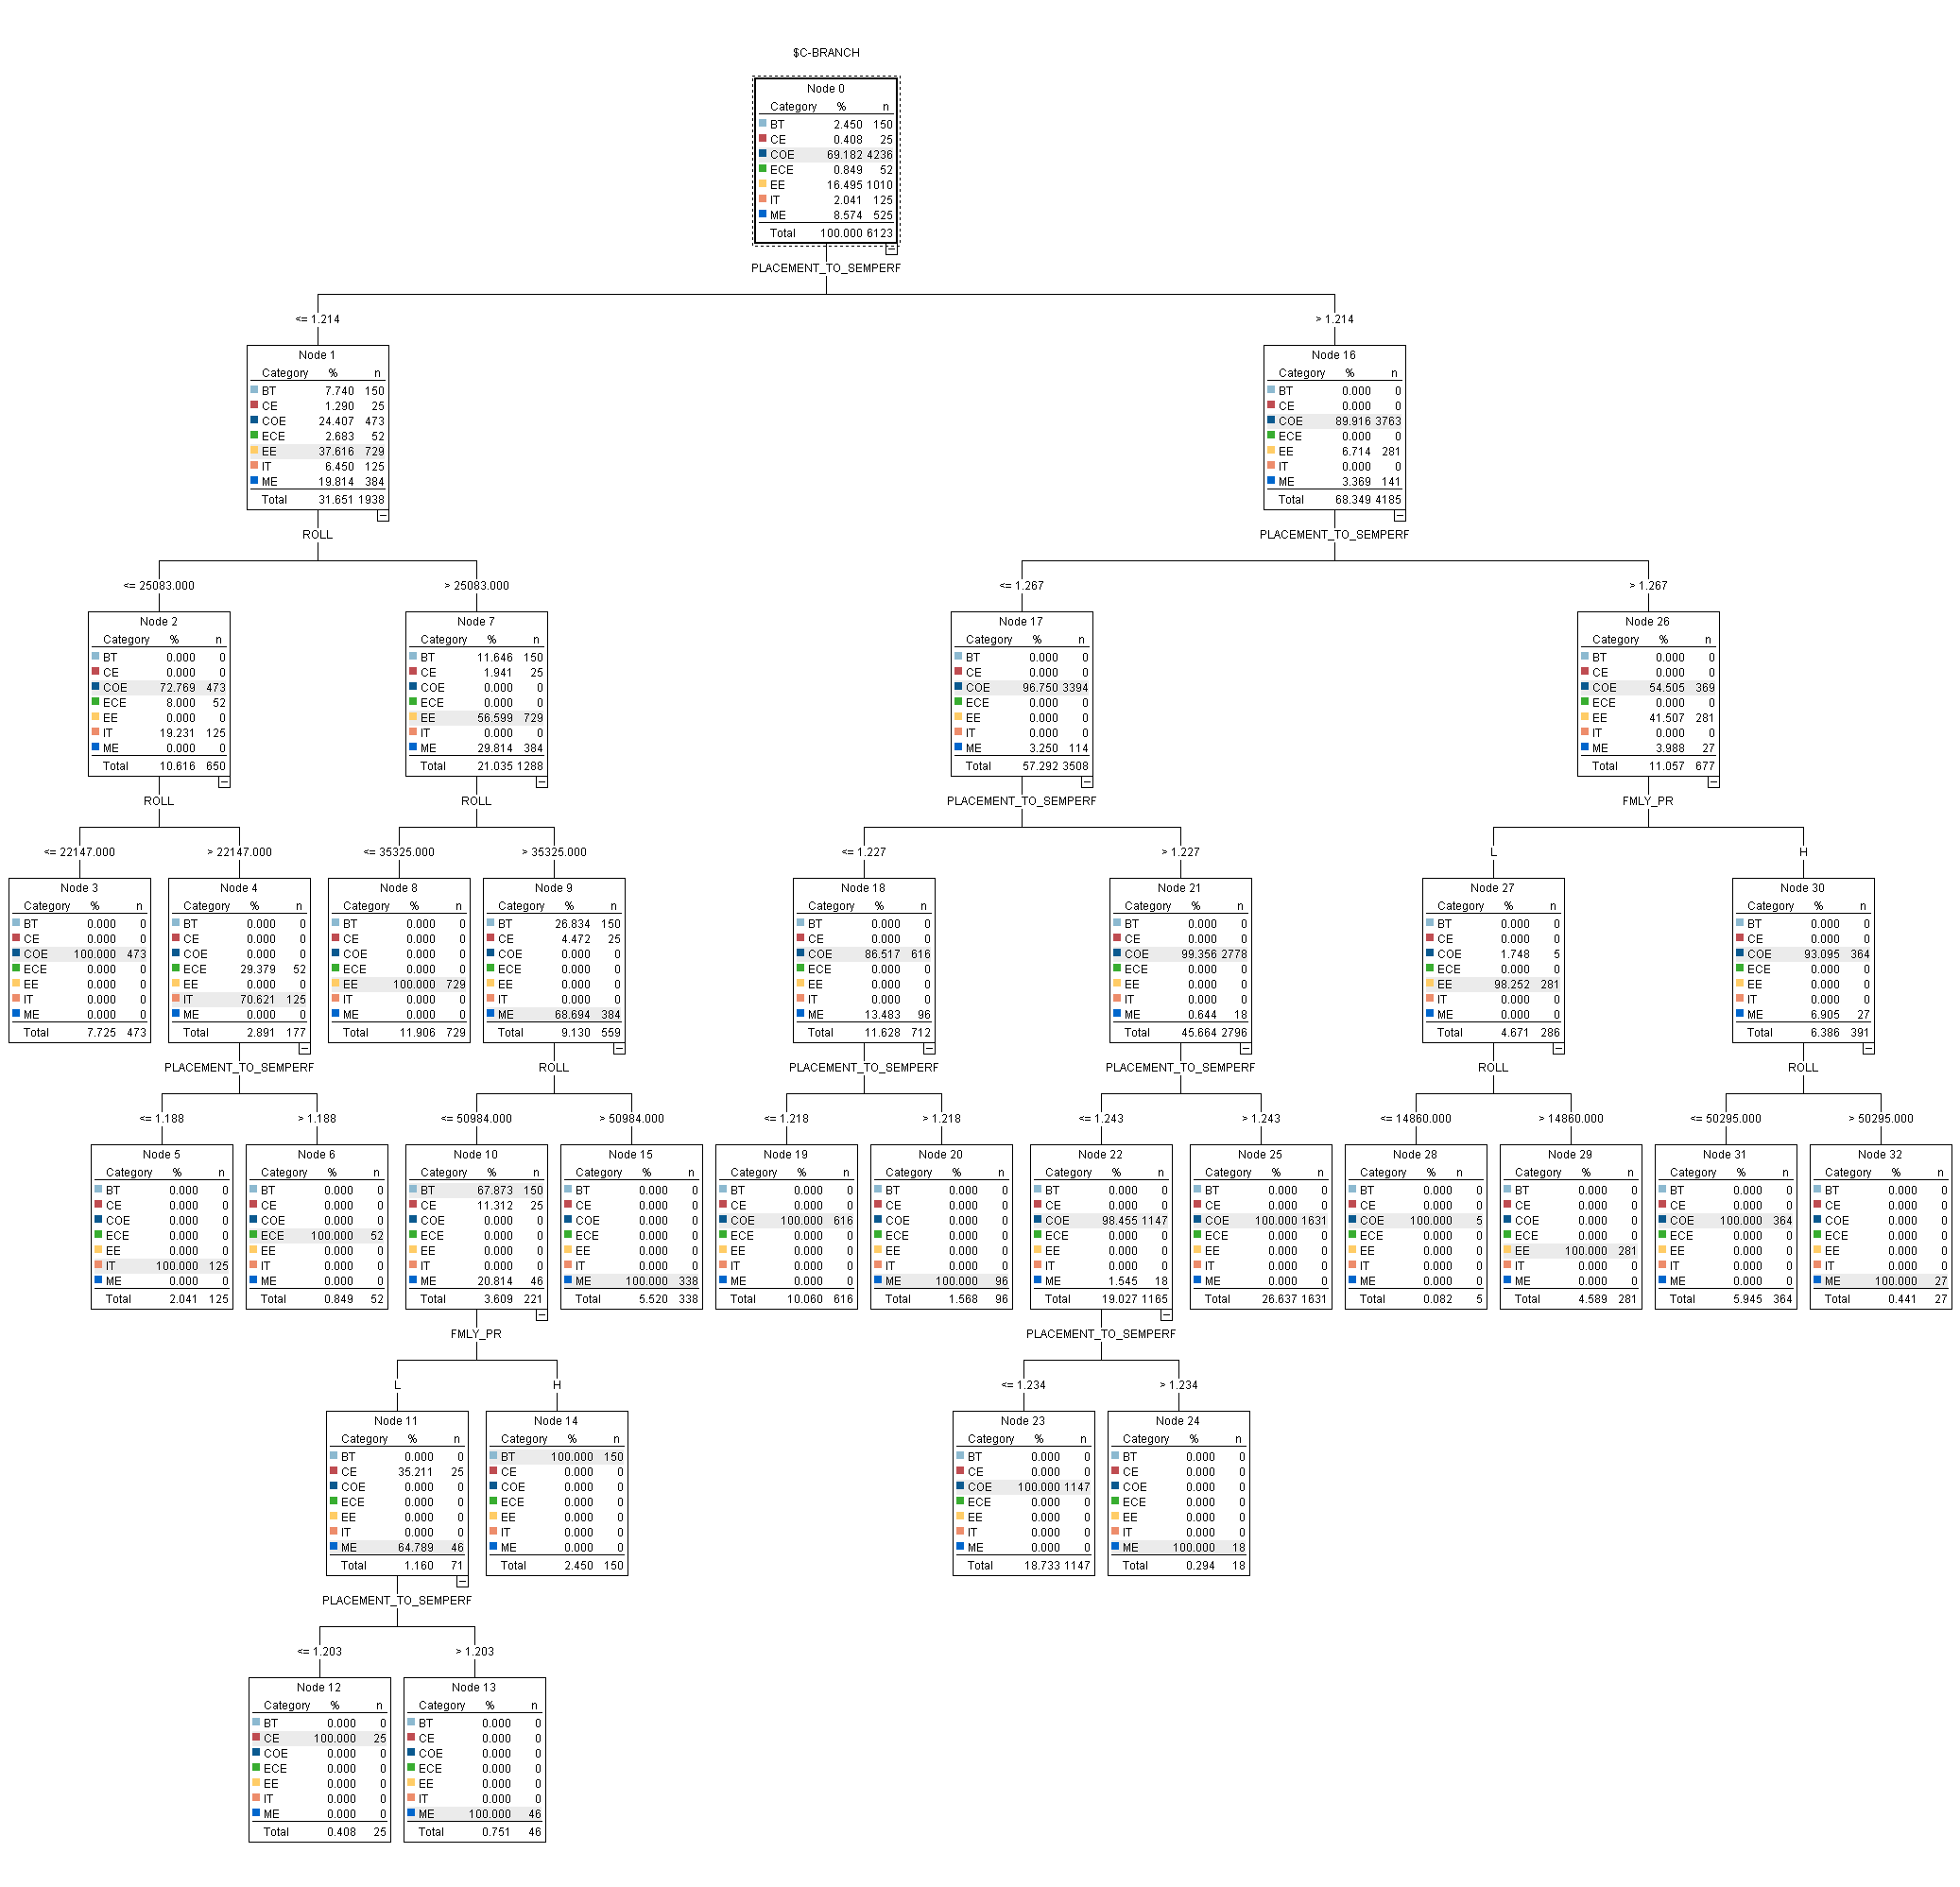

b. C & R Tree
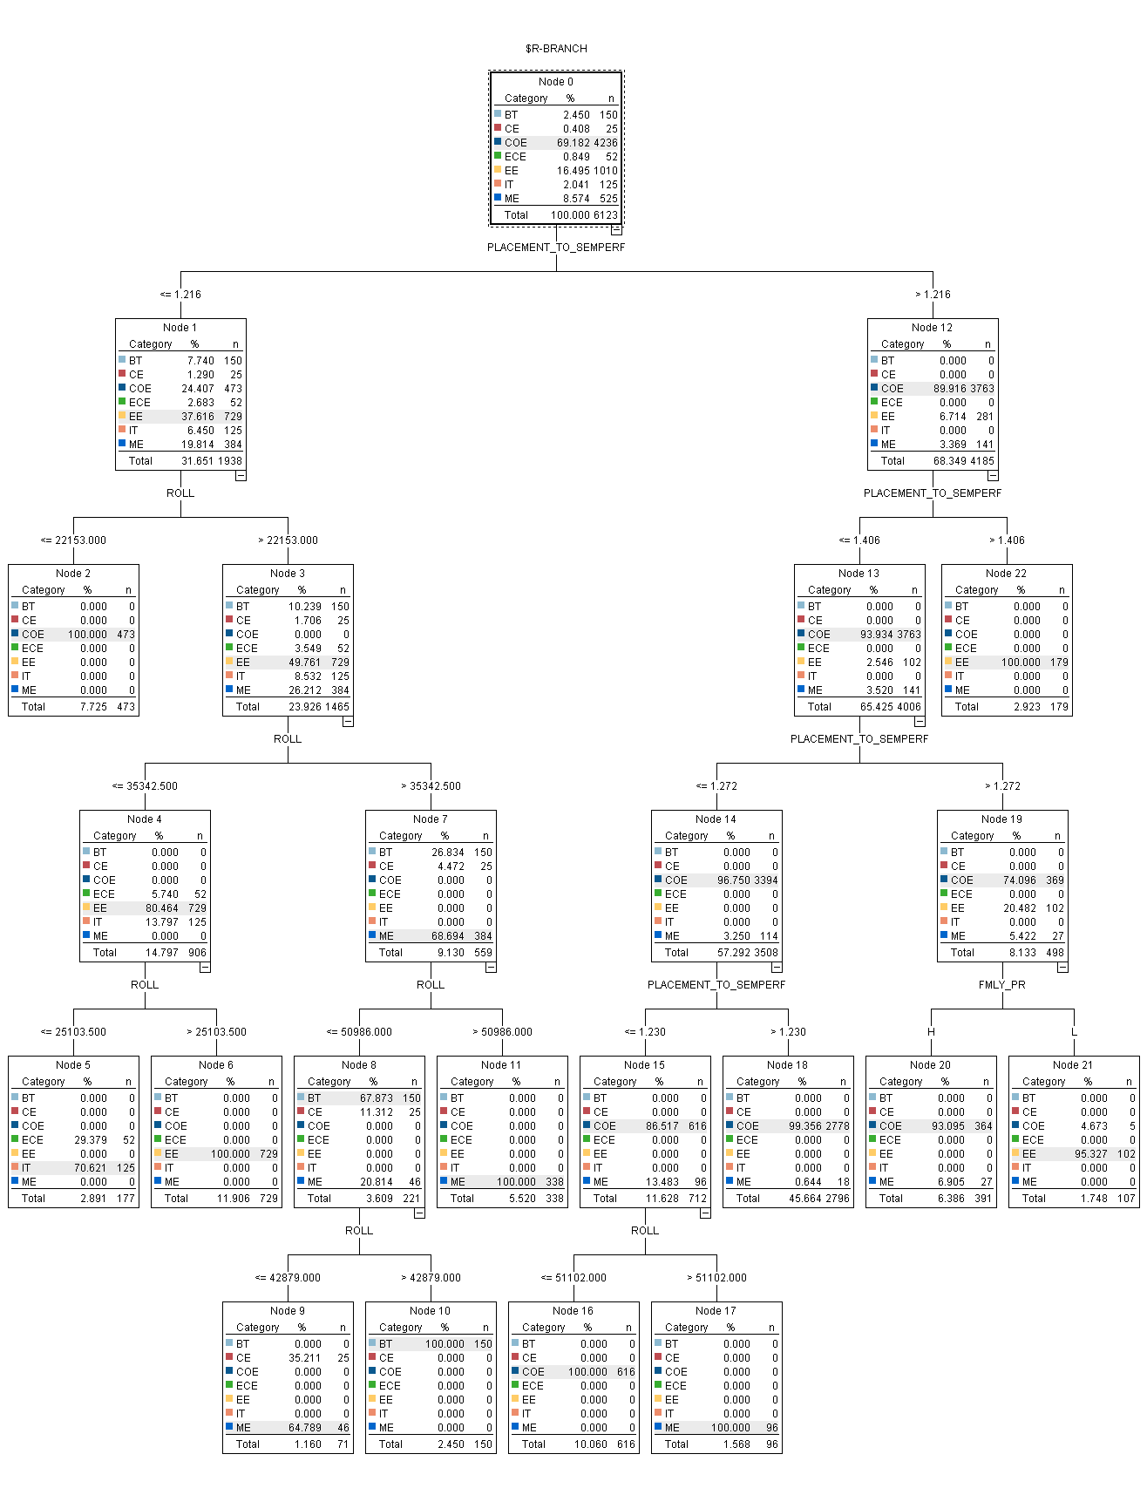

c.ANN
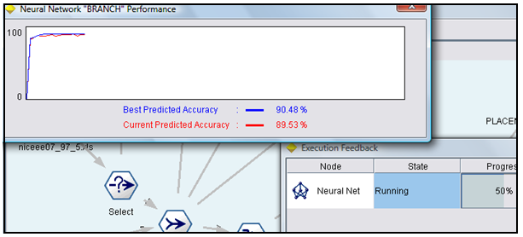

2.Analysis of Algorithms using Training partition size 70 and Testing partition size 30
a. See5/C5.
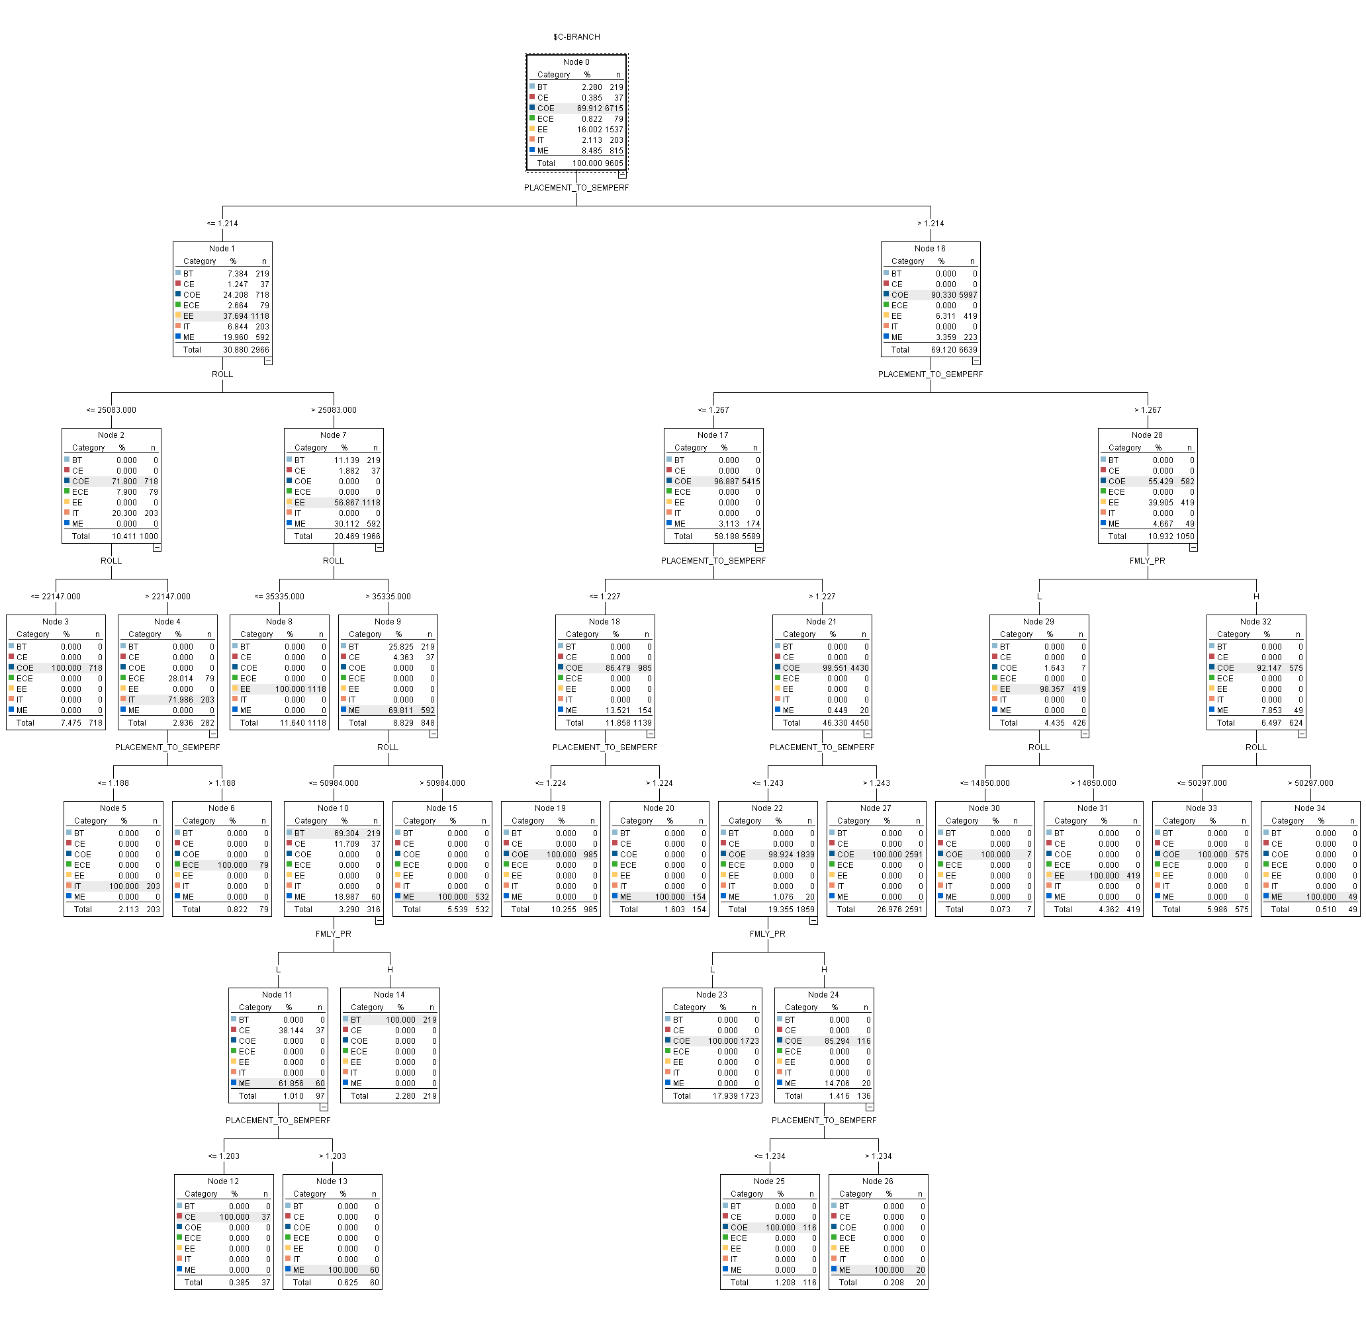

b. CRT
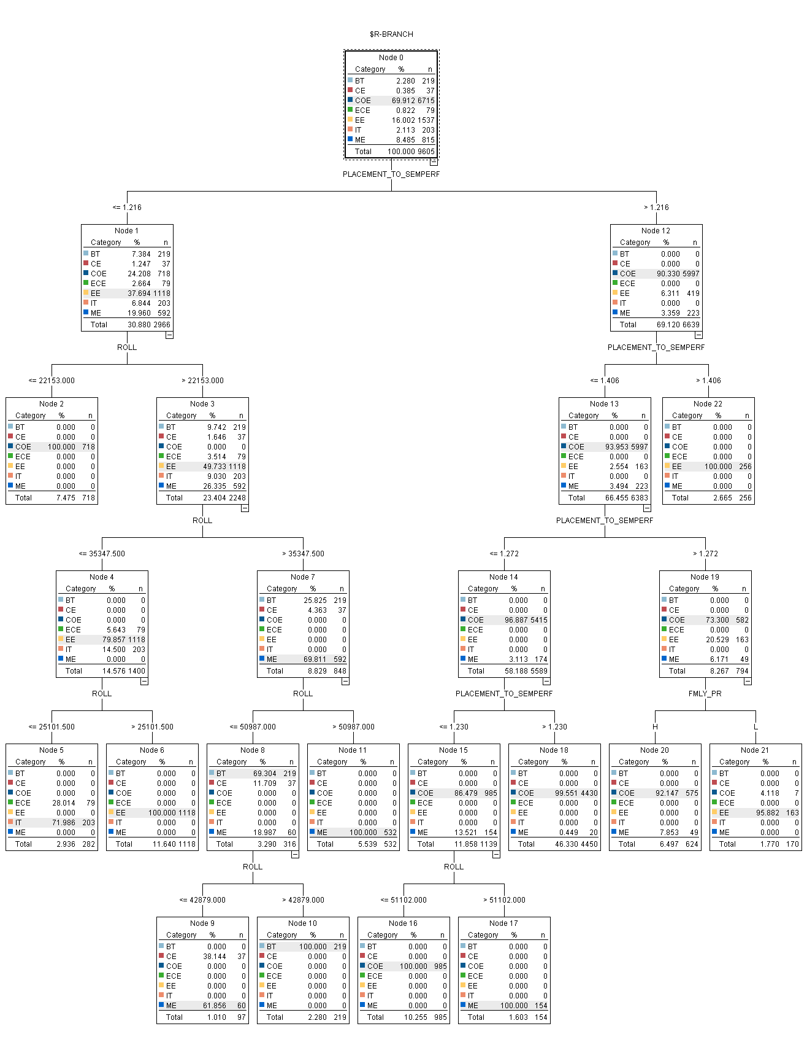

c. ANN
