**CHAPTER-1 Introduction**

**1.1 Sheet metal forming operations:**

Sheet metal is simply [metal](http://en.wikipedia.org/wiki/Metal) formed into thin and flat pieces. It is one of the fundamental forms used in [metalworking](http://en.wikipedia.org/wiki/Metalworking), and can be cut and bent into a variety of different shapes.

In forming operation, the stresses are below the ultimate strength of the metal. In this operation, there is no cutting of the metal but only the contour of the work piece is changed to get the desired product. The applied force stresses the metal beyond its yield strength, causing the material to plastically deform, but not to fail. By doing so, the sheet can be bent or stretched into a variety of complex shapes.

The forming operations include:

**a) Bending:**

Bending is a metal forming process in which the force is applied to a piece of sheet metal, causing it to bend at an angle and form the desired shape. The bending force strains material usually flat sheet or strip, by moving it around a straight axis which lies in the neutral plane. Metal flow takes place within the plastic range of metal, so that the bent part retains a permanent set after removal of applied stress.

## b) Roll forming:

It is a metal forming process in which sheet metal is progressively shaped through a series of bending operations. The process is performed on a roll forming line in which the sheet metal stock is fed through a series of roll stations.

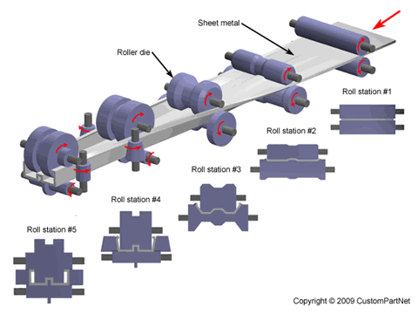

**Fig-1.1 Roll Forming( Ref: Scribd.com)**

## c) Spinning:

Spinning, sometimes called spin forming, is a metal forming process used to form cylindrical parts by rotating a piece of sheet metal while forces are applied to one side. A sheet metal disc is rotated at high speeds while rollers press the sheet against a tool, called a mandrel, to form the shape of the desired part.

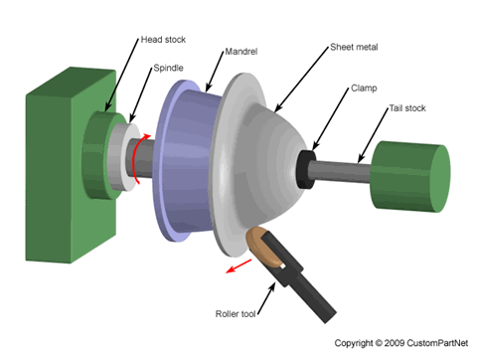

**Fig-1.2 Spinning (Ref: Scribd.com)**

## d) Deep Drawing:

Deep drawing is a metal forming process in which sheet metal is stretched into the desired part shape. A tool pushes downward on the sheet metal, forcing it into a die cavity in the shape of the desired part. Deep drawn parts are characterized by a depth equal to more than half of the diameter of the part.

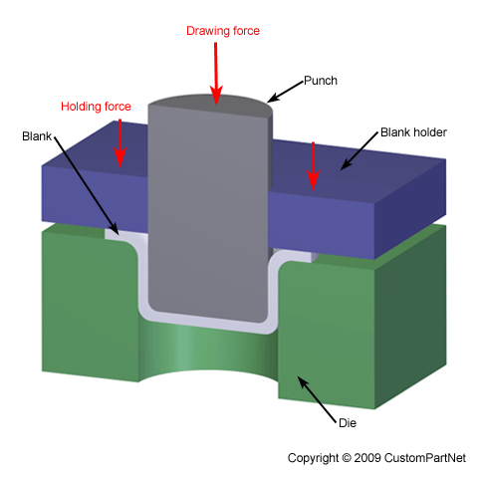

**Fig-1.3 Deep drawing( Ref: Scirbd.com)**

**e)Stretch Forming:**

Stretch forming is a metal forming process in which a piece of sheet metal is stretched and bent simultaneously over a die in order to form large contoured parts.

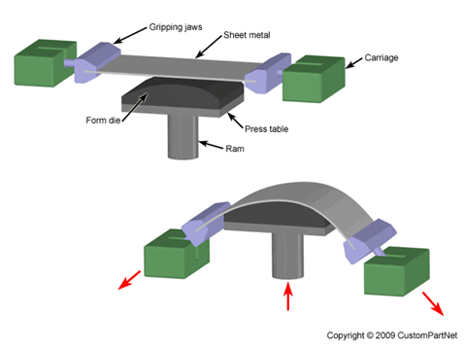

**Fig-1.4 Stretch Forming (ref: Scribd.com)**

**1.3 Bending Operation :**

**Bending** is a process by which metal can be deformed by plastically deforming the material and changing its shape. Bends are used to increase the rigidity of part . The material is stressed beyond the yield strength but below the ultimate tensile strength. The surface area of the material does not change much.

Bending usually refers to deformation about one axis. Bending is a metal forming process in which a force is applied to a piece of sheet metal, causing it to bend at an angle and form the desired shape.

Bending is a flexible process by which many different shapes can be produced. Standard die sets are used to produce a wide variety of shapes. The material is placed on the die, and positioned in place with stops and/or gages. It is held in place with hold-downs. The upper part of the press, the ram with the appropriately shaped punch descends and forms the v-shaped bend.

A bending operation causes deformation along one axis, but a sequence of several different operations can be performed to create a complex part.

Bent parts can be quite small, such as a bracket, or up to 20 feet in length, such as a large enclosure or chassis. A bend can be characterized by several different parameters,

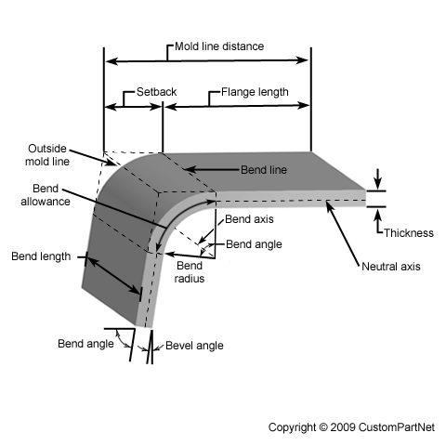

**Fig-1.5 Bending ( Ref: Scribd.com)**

**Bend line** - The straight line on the surface of the sheet, on either side of the bend, that defines the end of the level flange and the start of the bend.

**Outside mold line** - The straight line where the outside surfaces of the two flanges would meet, were they to continue. This line defines the edge of a mold that would bound the bent sheet metal.

**Flange length** - The length of either of the two flanges, extending from the edge of the sheet to the bend line.

**Mold line distance** - The distance from either end of the sheet to the outside mold line.

**Setback** - The distance from either bend line to the outside mold line. Also equal to the difference between the mold line distance and the flange length.

**Bend axis** - The straight line that defines the centre around which the sheet metal is bent.

**Bend length** - The length of the bend, measured along the bend axis.

**Bend radius** - The distance from the bend axis to the inside surface of the material, between the bend lines, sometimes specified as the inside bend radius. The outside bend radius is equal to the inside bend radius plus the sheet thickness.

**Bend angle** *-* The angle of the bend, measured between the bent flange and its original position, or as the included angle between perpendicular lines drawn from the bend lines.

**Bevel angle** - The complimentary angle to the bend angle.

The act of bending results in both tension and compression in the sheet metal. The outside portion of the sheet will undergo tension and stretch to a greater length, while the inside portion experiences compression and shortens.

The neutral axis is the boundary line inside the sheet metal, along which no tension or compression forces are present. As a result, the length of this axis remains constant. The changes in length to the outside and inside surfaces can be related to the original flat length by two parameters, the bend allowance and bend deduction, which are defined below:

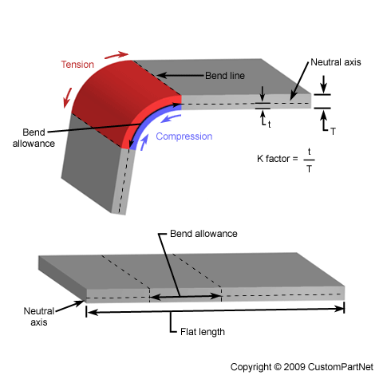

**Fig-1.6 Bending Stresses(Ref: Scribd.com)**

**Neutral axis** - The location in the sheet that is neither stretched nor compressed, and therefore remains at a constant length.

**K-factor** - The location of the neutral axis in the material, calculated as the ratio of the distance of the neutral axis (measured from the inside bend surface) to the material thickness. The K-factor is dependent upon several factors (material, bending operation, bend angle, etc.) and is typically greater than 0.25, but cannot exceed 0.50.

**Bend allowance** - The length of the neutral axis between the bend lines, or in other words, the arc length of the bend. The bend allowance added to the flange lengths is equal to the total flat length.

**Bend deduction** - Also called the bend compensation, the amount a piece of material has been stretched by bending. The value equals the difference between the mold line lengths and the total flat length.

The bend angle achieved is determined by the depth to which the punch forces the sheet into the die. This depth is precisely controlled to achieve the desired bend.

Standard tooling is often used for the punch and die, allowing a low initial cost and suitability for low volume production. Custom tooling can be used for specialized bending operations but will add to the cost. The tooling material is chosen based upon the production quantity, sheet metal material, and degree of bending.

Naturally, a stronger tool is required to endure larger quantities, harder sheet metal, and severe bending operations. In order of increasing strength, some common tooling materials include hardwood, low carbon steel, tool steel, and carbide steel.

Before commencing the bending operation, one should determine whether a particular sheet metal can be formed into the desired shape without failure and designer should follow below rules:

### 1.3.1 Design rules:

**Bend location** - A bend should be located where enough material is present, and preferably with straight edges, for the sheet to be secured without slipping. The width of this flange should be equal to at least 4 times the sheet thickness plus the bend radius.

**Bend radius**: Use a single bend radius for all bends to eliminate additional tooling or setups. Inside bend radius should equal at least the sheet thickness

**Bend direction** - Bending hard metals parallel to the rolling direction of the sheet may lead to fracture. Bending perpendicular to the rolling direction is recommended.

Any features, such as holes or slots, located too close to a bend may be distorted. The distance of such features from the bend should be equal to at least 3 times the sheet thickness plus the bending radius.

In the case of manual bending, if the design allows, a slot can be cut along the bend line to reduce the manual force required.

**1.3.2 TYPES OF BENDING:**

There are three basic types of bending on a press brake, each is defined by the relationship of the end tool position to the thickness of the material.

1. **Air Bending:**

Air bending is a bending process in which punch touches workpiece and work piece does not bottom in lower cavity.

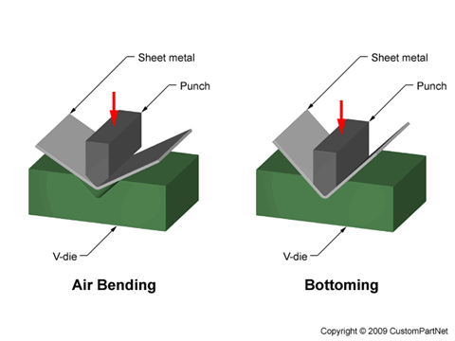

**Fig-1.7 Types of Bending( Ref: Scribd.com)**

In air bending there is no need to change any equipment or die to obtain different bend angles, as bend angles are determined by punch stroke. The force required to form parts are relatively small, but accurate control of punch stroke is necessary to obtain desire bend angle.

1. **Bottoming:**

Bottoming is a bending process where punch and the work piece bottom on die. This makes for controlled angle with little spring back.

In bottom bending, spring back is reduced by setting final position of punch such that clearance between punch and die is less than work piece thickness.

Bottom bending requires considerable more force than air bending.

1. **Coining:**

Coining is a bending process in which work piece and punch bottom on die and compressive stress is applied on bend area to increase the amount of plastic deformation. This reduces the amount of Springback.

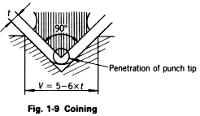

**Fig-1.7.1 coining(Ref: Scribd.com)**

Coining provides two advantages:

(1) Very high bending precision and

(2) The capability of reducing the inside radius to as small as possible.

Fig1.7.1 shows the work and tooling in the final stage of coining, from which you can see the punch tip is imbedded into the work. This penetration of the punch tip, together with a high pressure produced by the punch and die V-groove, eliminates Spring back. This is the reason coining requires a bending force 5 to 8 times greater than bottoming.

**1.4 V bending operation:**

V bending is used widely and in this process the clearance between the punch and die is constant.

While using a press brake and standard die sets, there are still a variety of techniques that can be used to bend the sheet. The most common method is known as V-bending, in which the punch and die are "V" shaped.

The punch pushes the sheet into the "V" shaped groove in the V-die, causing it to bend. In general, the width of the "V" shaped groove, or die opening, is typically 6 to 18 times the sheet thickness. This value is referred to as the die ratio and is equal to the die opening divided by the sheet thickness.

**1.5. Springback of Bended Sheet metal:**

When bending a piece of sheet metal, the residual stresses in the material will cause the sheet to springback slightly after the completion of bending operation. Due to this elastic recovery, it is necessary to over-bend the sheet a precise amount to achieve the desired bend radius and bend angle.

The final bend radius will be greater than initially formed and the final bend angle will be smaller.

During sheet metal bending, the interior radius of the bent metal is under compression and the exterior bend radius is in tension and stretched. Due to the metals’ elasticity, it tends to go back to its original shape after its being bent and this is know as spring back.

**1.5.1 Factors affecting spring back in sheet metal bending**:

1. The greater the yield strength of the material, the greater the spring back will be.

2. The thinner the raw material, the greater the spring back.

3. The larger the bend radius the greater the spring back.

The ratio of the final bend angle to the initial bend angle is defined as the **spring back factor**, **KS**. The amount of springback depends upon several factors, including the material, bending operation, and the initial bend angle and bend radius.

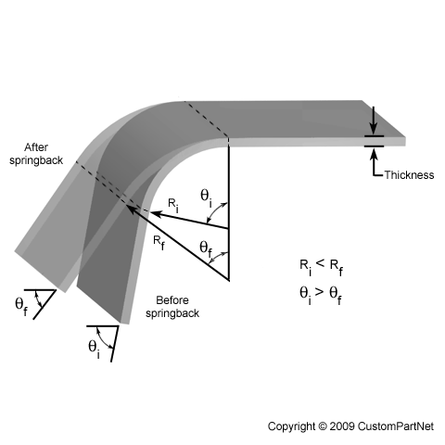

**Fig-1.7.2 Springback of bended sheet metal( Ref: SCribd.com)**

1.5.2. **Why Springback occurs**:

Let us examine Springback Phenomenon first. Fig 1.7.3 below shows a Springback in V-bending by which obtuse-angled, 90°, and acute angled bends are formed. In the figure, the solid lines indicate the angle during forming (Ø´), and the dotted lines indicate the angle after being formed (Ø).

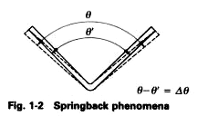

**Fig-1.7.3 Angle change after Springback**

Here we will consider what causes springback to occur from **two points of view**:

One view is springback considered from the stress-strain diagram, and the other view is considered from the displacement of the molecules inside the work.

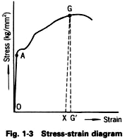

**Fig 1.7.4 Spring back Explanation byStress Strain Diagram**

In the stress-strain diagram shown in Fig 1.7.4, as the exerted external force at point G in the plastic region is reduced by low degrees, the amount of strain (deformation) in the work decreases gradually. When the work is totally removed from the external force, the strain reaches point X. This indicates that the work retains a certain amount of elasticity in the plastic region.

In the diagram, G'X shows the amount in which the work has returned to its former condition, and OX shows the amount of permanent deformation.

To summarize the above facts, the elasticity of the work material is not eliminated even after the stress produced in the work has exceeded the yield point .This is a cause of Springback.

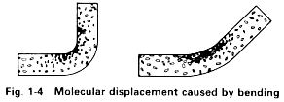

**Fig 1.7.5 Molecular Displacement illustration of Spring back**

The Fig 1.7.5 shown above is an exaggerated illustration of the molecular displacement in flat work when it is bent at an obtuse or 90 degree angle. This figure shows that the inner side of the work is compressed and the outer side is stretched. Between these sides, there is a plane which is neither compressed nor stretched. This plane is called a neutral plane or neutral axis.

When the work is bent, stresses which are opposed to each other act on the inner and outer sides of it. In general, the compressive strength of the material is far greater than its tensile strength.

Exerted pressure will permanently deform the outer side of the work, but the inner side stress does not reach the yield point. Therefore, the inner side tends to go back to the former condition. Since stress is a resisting force that acts in the opposition to the exertion of the external force, a compressive stress acts outward on the inner side. This compressive stress changes into Springback.

**1.5.3 Compensation of Springback:**

**Spring back may be reduced by:**

1. **Over bending**
2. 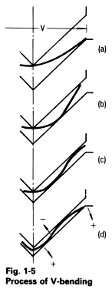**Plastic deformation at end of stroke**
3. **Subjecting the bend zone to compression by counter punch.**

**1.5.4 Positive and negative Springback :**

During V-bending, the work inserted between the punch and die changes its state from (a) to (b) and then to (c) under the bending force. The work at that time can be regarded as a continuum that contains positive factors (springback) and negative factors (spring-go).   
Additionally, it can be considered that (c) these positive and negative factors are not constant, but show their qualities of being positive or negative while changing in accordance to the force applied. Therefore, the (d) springback or the spring-go will occur on the work, depending on the way bending force is applied to the work.  Fig 1.7.6 shows Springback in V-bending

**1.6. Tailor welded Blank: Fig-1.7.6**

Tailor welded blanks are defined as two or more separate pieces of flat material, dissimilar thickness, and/or mechanical properties, jointed together before forming to provide customized and superior qualities in the finished stamping

Tailored welded blanks are useful means of reducing the weight of automotive structures because they enable parts to be designed economically with a good balance between

design stress and material strength.

The use of new manufacturing concepts and advanced materials is of interest to the major automotive manufacturers, who are continuously seeking means to reduce weight and cost. One such concept is the use of tailor-welded blanks (TWBs), which are used to replace multiple stampings that are formed separately, then assembled or joined to produce the final product.

With the improvement of the living standard, more and more people are using cars as their traffic tools, so more cars are manufactured in the world and as a result, a lot of problems are generated thereafter. Energy consumption is becoming the top one problem. The more weight of the car, the more energy is consumed. Therefore, the automotive industry is consistently striving for new ways to reduce the weight of car bodies but without weakening structural stability.

One of the most successful approaches to achieve significant weight reduction, while improving the structure safety, is the application of tailor welded blanks. During the period of 1993～1997, ULSAB (Ultra Light Steel Auto Body) project organized by 35 steel plants and automobile manufacturers just promoted the application of tailor welded blank in the BIW (body-in-white) structure parts. Tailor welded blanks have been widely used in the automobile structural parts such as rail, bumper, wheelhouse, door inner, floor panel, etc., and many car manufactures such as GM, VW, Ford, Toyota, Fiat have used tailor welded blanks in their automobile structural parts.

1.6.1 **Advantages of Tailor welded blanks:**

The traditional procedure in the automobile industry was to stamp the automobile parts with different thickness and different materials one by one, and then these stamped parts were welded together to form one piece of complete automobile part. With the application of tailor welded blank, the combination of different thickness and different materials is formed first by laser welding, then tailor welded blank is stamped into one piece of complete automobile part. Fig.1 shows the change of stamping procedure in the automobile industry because of using tailor welded blank.



1. **Traditional stamping procedure**



(b) **Stamping procedure using tailor welded blank**

**Fig.1.8 The change of stamping procedure**

**The advantages** of using TWBs in the automotive sector are:

1. weight reduction and hence savings in fuel consumption,
2. Distribution of material thickness and properties resulting in part consolidation which results in cost reduction and better quality, stiffness and tolerances,

(3) Greater flexibility in component design,

(4) Restage of scrap materials to have new stamped products and,

(5) Improved corrosion resistance and product quality etc.

**1.6.2. Application of TWB:**

Currently, tailor welded products are primarily used in the automotive industry. Popular applications include: side frames, doors, pillars and rails. Yet there are many more possibilities! Possibilities that: reduce steel costs, improve product quality and optimize your production processes.

Moreover, there are many potential applications, in a wide variety of industries, including: alternative energy, trucking, rail car manufacturing, shipbuilding, construction, tailor manufacturing, and furniture industries. In fact, tailor welded products can be applied, where ever steel is used

**1.6.3 Gauge of sheet metal:**

The sheet metal gauge (sometimes spelled *gage*) indicates the standard thickness of sheet metal for a specific material. For most materials, as the gauge number increases, the material thickness decreases.

Sheet metal thickness gauges for steel are based on the weight of steel, allowing more efficient calculation of the cost of material used. The weight of steel is 41.82 pounds per square foot per inch of thickness (8039 kg/m3); this is known as the Manufacturers' Standard Gage for Sheet Steel. For other materials, such as aluminium and brass, the thicknesses will be different.

In addition to the inconsistencies of the weight measurement weighing a square foot piece of steel is inconvenient in today’s manufacturing environment, therefore, the weight measure is converted to a more usable form- decimal thickness. According to AISI, a one-inch thick piece of bare steel weighs 41.82 pound (669.12 oz.) per square foot.In our example of 24 gauge material, (16 oz.) the thickness of the steel is .0239” (16/669.12). Galvanizing adds .0010inches for a total thickness of the galvanized steel of .0249”.

**1.8. Manufacturing of TWBs :**

**GTAW:**

Gas Tungsten Arc Welding (GTAW) is frequently referred to as TIG welding.  TIG welding is a commonly used high quality welding process.  TIG welding has become a popular choice of welding processes when high quality, precision welding is required.

In TIG welding an arc is formed between a non-consumable tungsten electrode and the metal being welded. Gas is fed through the torch to shield the electrode and molten weld pool.  If filler wire is used, it is added to the weld pool separately.

**The electrode, the arc and the area surrounding the molten weld puddle are protected from the atmosphere by an inert gas shield.**

TIG welding produces exceptionally clean, high quality welds. As no slag is produced, the chance of slag inclusions in the weld metal is eliminated and the finished weld requires virtually no cleaning. TIG welding may be used for welding almost all metals and the process lends itself to both manual and automatic operation. TIG welding is most extensively used for welding aluminium and stainless steel alloys where weld integrity is of the utmost importance. It is widely used for high quality joints in the nuclear, chemical, aircraft and food industries.

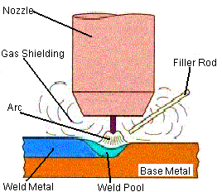

**Fig-1.8.1 GTAW( Ref: Google images)**

**1.8. 1 Laser welding:**

Laser Beam Welding (LBW) is a modern welding process; it is a high energy beam process that continues to expand into modern industries and new applications because of its many advantages like deep weld penetration and minimizing heat inputs. The focal spot is targeted on the workpiece surface which will be welded. At the surface the large concentration of light energy is converted into thermal energy. The surface of the workpiece starts melting and progresses through it by surface conductance. For welding, the beam energy is maintained below the vaporization temperature of the workpiece material, because hole drilling or cutting vaporization is required.

Because the penetration of the work-piece depends on conducted heat, the thickness of the materials to be welded is generally less than 0.80 inches if the ideal metallurgical and physical characteristics of laser welding must be realized.

Concentrated energy produces melting and coalescence before a heat affected zone is developed and when the materials to be welded are thick and have high thermal conductivity like for example aluminium the advantage of having a minimal heat affected zone can be seriously affected. Because the heat source in this type of welding process is the energy of light, the work piece will be welded purely which means the fatigue strength of the welded joint will be excellent.

There are many types of Laser Beam Welding (LBW) but the most popular types in the industry are:

1- Nd: YAG (neodymium-yttrium aluminium garnet) Laser: The Nd:YAG laser uses a man-made crystal as its active medium and produces light with a 1.06-micronwavelength.  
2- Carbon Dioxide Lasers: The CO2 laser uses a mixture of gases including CO2 as the active medium and produces light with a 10.6-micron wavelength.  
3- The Diode Laser: The diode laser uses a semi-conductor diode material as its active medium can be manufactured to produce one of several wavelengths

**1.8.2. HAZ:**

Adjacent to weld metal zone is Heat affected Zone (HAZ) that is composed of parent metal that did not melt but was heated to a high temp for a sufficient period that grain growth occurred.

HAZ is that portion of base metal whose mechanical properties and microstructure have been altered by heat of welding.

HAZ is subjected to a complex thermodynamic cycle (sudden heating followed by rapid cooling) in which all temperatures from melting range of steel down to comparatively much lower temperatures are involved and HAZ therefore consists of a series of graded structures ringing in weld bead.

HAZ usually consists of a variety of microstructures. In a plain carbon steel these structures may range from very narrow regions of hard Martensite to coarse Pearlite. This renders HAZ, the weakest area in weld. Most welding failures originate in HAZ. The heat affected zone is often defined by response of welded joint to hardness tests. The width of HAZ varies according to the welding process and technique.

The HAZ comprises 3 metallurgic ally distinct regions:

1. The Grain growth region, 2. The Grain refined region,

3. The transition region.

[250px-Welded_butt_joint_x-section](http://en.wikipedia.org/wiki/File:Welded_butt_joint_x-section.svg)

**Fig 1.8.2** shows the cross-section of a welded butt joint, with the darkest gray representing the **weld or fusion zone,** the medium gray the heat affected zone, and the lightest gray the base material.(Ref: Google images)

**Grain growth region:**

It is immediately adjacent to the weld metal zone. In this zone parent metal has been heated to a temperature above Upper critical ${(A}_{3}$) temperature. This resulted in grain growth or coarsening of structure.The max grain size and extent of grain growth increase as cooling rate decreases.

**Grain refined region:**

Adjacent to grain growth region is grain refined region. In this region , the parent metal has been heated to just above the $A_{3}$ temperature , where grain refinement is completed and finest grain structure exists.

**Transition Zone:**

In the transition zone, a temperature range exists between the $A_{1}$ and $A_{3}$ temperatures where partial allotropic recrystallization takes place.

**Chapter-2 Literature review**

**2.1. Bending theories:**

* Hill (1950) presented a complete solution for pure bending in which deformation of sheet metal is achieved by couple applied along its length. In this analysis , Hill predicted the **movement of neutral axis** but no change in thickness for rigid perfect plastic materials under plane strain bending.
* Lubahn and Sachs(1951) analyzed, in a manner similar to Hill’s, the bending of rigid perfectly plastic materials in case of both plane stress and plane strain, and they predicted no change in material thickness , including neutral surface would remain at fixed positions during small increments of bending curvature.
* Thinking of movement of neutral surface, Crafoord (2001) considered the Bauschinger effect by assuming the constant yield surface on reverse straining by fibres overtaken by neutral surface. He predicted obvious thickness thinning of strain hardening metal sheets.
* Tan et al. (1995) studied effect of anisotropy on pure bending of sheet metals. They proposed 2 model’s, one neglecting the Bauschinger effect and the other considering Bauschinger effect. The **model incorporating Bauschinger effect predicts greater thinning of thickness.** They also found that the effect of anisotropy on material thinning of bend is small but has a relatively large effect on bending moment.
* A rigorous solution for the elastic-plastic bending of wide sheets exhibiting normal anisotropy has been presented by Chakrabarty et al. (2001) assuming a state of plane strain for deformation mode. Such a solution is necessary for a critical evaluation of elementary theories of sheet bending in partially plastic state.

**2.2 Bending of tailor welded blanks:**

* S.M Chan & T.C. Lee studied the effect of thickness ratio on formability of TWB’s. They have taken TWB’s of same material but different thickness combinations and they predicted formability by using Swift test. They have identified that there are no significant difference between Tensile strengths of TWB’s and base metals. But formability of TWB,s was considerably reduced with increase in thickness ratio.
* R. Padmanabhan &, A.J. Baptista studied the effect of anisotropy in the tailor-welded blank and the orientation of blank sheets rolling direction during deep-drawing process.They have identified that Anisotropy in the blank sheets has moderate influence and its contribution to increased material flow depends on the mechanical properties of the blank sheets. Appropriate combination of the blank sheets rolling direction orientation can significantly improve the formability of the tailor-welded blank in the deep-drawing of square cup.
* K. Veera Babu a, R. Ganesh Narayanan have developed an artificial neural network model to predict deep drawing behaviour of welded blanks.By means of this model necessary to predict suitable TWB conditions for achieving better-stamped product made of welded blanks. The important deep drawing characteristics of TWB are predicted within chosen range of varied blank and weld conditions.
* H.R. Shakeri , A. Buste have investigated the microstructural evaluation of failure in multi-gauge aluminum alloy tailor welded blanks (TWBs).Different weld orientations have been considered: transverse and longitudinal. In general, TWBs show two different types of fracture: weld failure and failure of the thinner aluminum sheet. Interaction of several factors determines the type of failure occurring in a TWB specimen. These factors are weld orientation, morphology and distribution of weld defects as well as the degree of constraint imposed by the thicker sheet on the thin sheet.

* YOU-MIN HUANGand DAW-KWEI LEU have investigated the effect of process variables on V-Die bending process of steel sheet. It provides a model which predicts the correct punch load for bending.

The process variables are punch radius (*R*1), die radius (*R*$), punch width (¼1), punch speed (»1), friction coe¦cient (k), strain hardening exponent (*n*) and normal anisotropy (*R*). It was found that **punch load increases** as **punch radius** and punch speed **increase** or lubrication decreases.

**The punch load** for bending **is smaller** for materials with a **larger strain hardening exponent**. The effect of punch width on punch load is limited. The punch load decreases in the early stage and increases in the final stage of the bending process as the die radius increases. The influences of all of the process variables on the final bend angle of the bent parts of sheet after unloading were also evaluated.

* L C Zhang, G Lub and S C Leong have established a technique of sheet stamping by deformable forming tools. The deformation of the punch material during stamping alters the deformation mechanisms of the sheet and makes the springback ratio mainly negative.

**2.4. Springback in V-bending:**

The spring back was addressed by Gardiner(1957). Who proposed a mathematical formula for springback calculations based on elementary bending theory with ideal plasticity. Johnson and Yu(1981) further developed Gardiner’s work for linearly hardening materials and for bending with tension.

Li et al. (2002) found that material’s hardening model directly affects accuracy of springback calculation.The greater sccuracy of Hardening model , greater the springback accuracy.

**2.5. Springback of TWB’s in V-bending:**

* Sung Ho Chang& Jang Mo Shin have studied the Springback characteristics of the tailor-welded strips in U-bending. Two different welded strips, one was welded along the centerline of the strip-width and the other was welded along the centerline of strip-length, were adopted to compare the effects of weld-line locations on the springback.

In cases of the longitudinally welded strips, the springback was generated as much as the one generated in the non-welded strips, which are the same as the thicker side of the longitudinally welded strips. And, in the cases of the centrally welded strips, a significant reduction of the springback was observed in the thinner side compared with the same thickness of non-welded strip.

* **Daw-kwei leu** proposed a simplified approach for evaluating bending and Springback

in plastic bending of anisotropic sheets. The effects of the normal anisotropic value R and the strain hardening exponent in on the pure bending of sheet metal have been studied. A simple approach incorporating the normal anisotropic value R and the strain hardening exponent is developed to estimate springback, bendability and the maximum bending moment in pure bending.

It is concluded that (i) the springback is almost proportional to the normal anisotropic value R. (ii) it decreases sharply with respect to smaller strain-hardening n-values or smaller thickness ratio t/2ρ -values, and (iii) at large strain-hardening n-values or large thickness ratio t/ 2ρ-values, the springback will concentrate to a small range. The minimum bending radius is proportional to the sheet thickness :. decreases with the normal anisotropic value K, and decreases sharply with the strain hardening exponent n to a small range.

* K. Yilamua & R. Hino investigated the bending and springback phenomena of a stainless-steel clad aluminum sheet in V-shaped air bending. They have investigated the bending characteristics such as sheet thickness change and the bending angles of the sheet before/after Springback. It was found that the sheet-set condition, i.e. the relative position of the strong and the weak layers of the clad sheet, has a great influence on the bending behaviour, but its effect is rather minor on the Springback.

**2.6 Motivation and problem definition:**

In conventional fabrication of automobile body component assemblies, several stampings are formed individually and subsequently spot welded together in order to obtain material and strength requirements at various locations in assembly. Alternatively, the various materials can be welded together prior to forming process to produce what are known as TWBs.

Recently, in automotive industry many companies abroad are trying to form the body panels in single stamping operation while keeping the material costs and scrap down by using TWBs. The push for usage of Tailor welded blanks in auto industry results from need for fuel conservation, safety mandate , customer demands, and environmental concerns to design lighter automobiles that are more fuel efficient , produce lower emissions ,with improves handling and overall improvement of structure of vehicle.

A wide range of information is available about the formability and failure patterns of TWBs and Springback of non welded sheet metal parts has been presented by Hisashi (1997). However, Spring back characteristics of TWBs and effect of HAZ on its Springback has not been investigated widely and little information is available on it

**2.7 Objectives:**

In view of above mentioned facts the effect of HAZ on springback of TWBs has been analyzed in V-bending process with the following objectives:

1. To determine tensile properties of TWBs in longitudinal and transverse direction of weld with respect to bend axis in order to incorporate weld properties.

2. To determine spring back of TWBs with thickness combinations in V-bending operation.

3. To investigate effect of different punch profile radius on springback of transversely welded specimens.

4. Simulation of V-bending process using ABAQUS and to predict springback in above cases.

5. To investigate effect of HAZ on spring backs both experimentally and by simulation in above cases.

**Chapter-3 Methodology**

In present study, the effect of HAZ of weld and punch profile on spring back of tailor welded strips has been analyzed in V-bending operation. The methodology includes Experimental and finite element analysis.

**3.1 Material selections:**

In present study the material of sheet was CRCA steel.CRCA means "cold rolled close annealed". This means that after hot rolling and pickling, the steel is cold rolled to a reduced thickness (which makes it brittle and not too useful), which is then followed by annealing in a closed atmosphere of nitrogen or other non-oxidizing gases (which softens it back up while protecting it from oxidation).

The chemical composition was obtained by Spectro-analysis conducted at NARANG Laboratories.Test method used was: ASTME E 415-99a

The chemical composition of CRCA Steel (wt%) used was:

|  |  |  |  |  |  |  |  |  |  |
| --- | --- | --- | --- | --- | --- | --- | --- | --- | --- |
| **C** | **Si** | **Mn** | **P** | **S** | **Cr** | **Ni** | **Mo** | **V** | **Cu** |
| **0.05** | 0.006 | 0.102 | 0.017 | 0.014 | 0.039 | 0.04 | 0.015 | 0.012 | .022 |

|  |  |  |
| --- | --- | --- |
| **Al** | **TI** | **Fe** |
| **0.043** | 0.065 | 99.55 |

**Table 3.1 Chemical composition of sheet**

Here thickness combination of TWB was used to investigate effect of thickness ratio on springback in V bending. The thickness of sheets used was gauge 18(thick -1.2mm) and gauge 23(thick-0.7mm).so thickness ratio used was 1.714.

**3.2 Preparation of TWBs:**

CRCA sheets with different thickness are joined by both C $O_{2 }$ Laser welding and GTAW welding to investigate effect of HAZ on springback.

**Preparation of tailor welded blanks by laser welding:**

The quality of the weld in a TWB is critical for a successful forming operation. Although tailor welded blanks have been made using different types of welding techniques, the most common method currently in use is laser beam butt welding. Other types of welding techniques include resistance mash seam, high-frequency induction and electron beam welding. The monochromatic laser beam has three unique characteristics: high coherency, high brightness and low divergence. With low divergence, laser beam can travel large distances without significant loss of beam quality or energy and can be focused to a very small spot resulting in very high power density. This energy can cause melting of the interfaces to be joined and not the surrounding area. Laser beam butt welding is a full-penetration fusion welding process that results in a high depth-to-width ratio and therefore generally produces a narrow weld seam [Dawes, 1992; Duley, 1999].

CO2 lasers have been exploiting industrial laser welding, as they are available in higher output powers. This is a gaseous laser where the lasing medium is a combination of carbon dioxide, nitrogen and helium gases. Highly coherent and monochromatic light with low divergence is emitted from the lasing medium at a wavelength of 10.6µm. CO2 laser is operated in two modes pulsed and continuous wave (CW) mode. In continuous wave laser welding laser beam is moved continuously over the material to be welded.

Here the different thickness CRCA sheets were welded by 10kw CO2 laser welding facility integrated with a three axis CNC work station fig above. Before start of welding, the laser beam was aligned with the joint as shown in Fig. below, to ensure that proper welding will take place by melting equal amount of metal from both the sides. In all the cases, the laser beam was focused by a 150mm focal length lens. Co-axial argon gas was used as the shielding gas to control plasma formation and prevent oxidation. The CO2 laser was operated in continuous wave mode and the power density was adjusted for key hole (deep penetration) welding. In this process, the aspect ratio of weld bead is high and quality of weld is improved by vaporizing alloy components. While welding the galvanized and ungalvanized strips, coating on the galvanized strip was removed in the first pass by vaporizing the zinc layer by low power laser and this was achieved by defocusing the laser beam. As zinc has a low meting point, it vaporizes before welding and helps in getting sound weld without porosity.

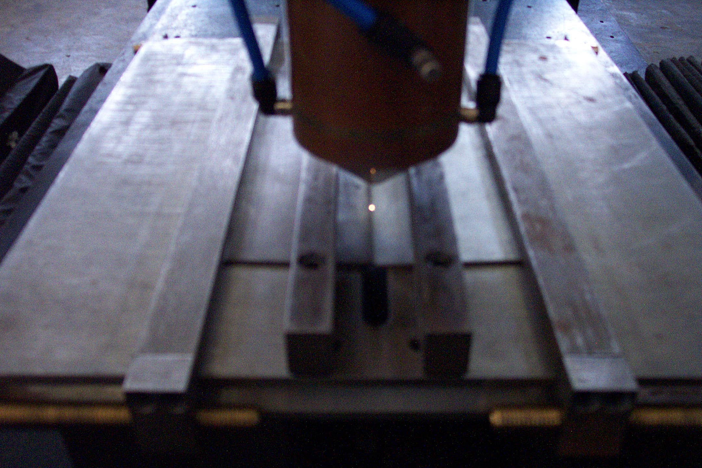

Welding jig

Side clamp

Top clamp

Nozzle

**Fig-3.1 Laser beam alignment before starting of welding**

The samples were held side by side and were clamped from the side and the top in the fixture. A 0.5 mm thick packing strip was placed below the thinner sheet so that the top surface could be aligned properly in thickness combination.

The process parameters used for **C $O_{2 }$ Laser welding** are:

Laser power -2.65kW

Welding speed - 1400mm/minute.

The process parameters used for GTAW welding are:

DC-GTAW process

Shielding gas- Argon

Time- 5min 5sec

Current - 20-30A

Voltage supply-240V

The Transversely Welded sheet was shown in Fig 3.1.1:

**Fig 3.1.1 Transversely welded specimen**

For V-Bending the size of sheet used was 100\*20mm.

For tension test of longitudinally welded TWB (both Laser and GTAW) a Sub-sized specimen was prepared according ASTM E8.

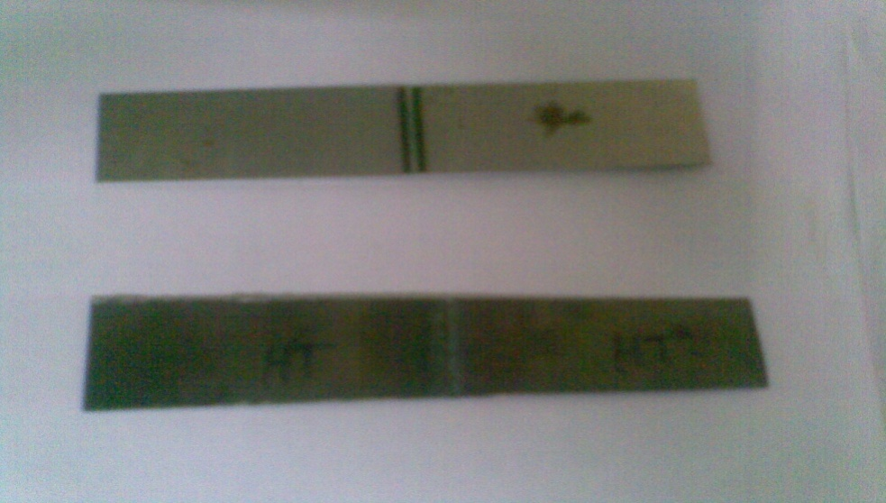

**Fig-3.1.2 Transverse specimens used in experiments**

**3.1.2 Stress relieving heat treatment:**

As these CRCA sheets are obtained by cold rolling and also during welding of these sheets ,some residual stresses gets embedded in it .so, in order to remove these stresses, Stress relieve annealing was required.

In this stress relieving, 4 sheets of GTAW corresponding to each die set and 4 sheets of laser welded are heated to a temperature of ${321}^{0}C$ slowly in an induction furnace and slowly cooled in furnace itself.

**3.1.3 Microstructure Analysis:**

The objective behind micro-structural analysis was to observe the microstructure changes that may affect the mechanical properties after welding of 2 sheets of different thickness by laser and GTAW process.

The microstructure observation was conducted on Micro hardness machine at 100X magnification. To do this first some portion around weld is mounted in Bakelite support and polished using silicon carbide emery papers(120,180,220,600,2/0,3/0)and then wet polished and cleaned using Nital(1%), then taken to Micro hardness tester.

The Microstructure of TWB (GTAW) was shown below at 100X magnification:

1. **Base Metal Microstructure**

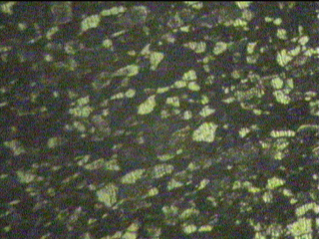

Ferrite

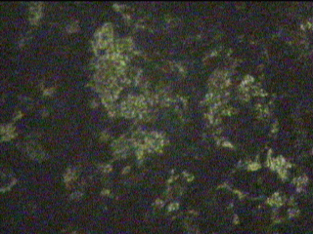

(b) Grain Refinement region

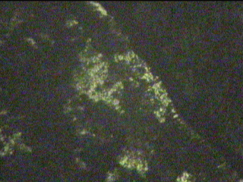

**(c )Weld zone**

**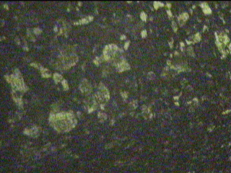**

**(d)Grain growth region**

**Fig-3.1.3 Microstructure of GTAW welded sheets**

**Fig 3.1.4 Laser welded specimen Microstructure** around weld zone at 1000X

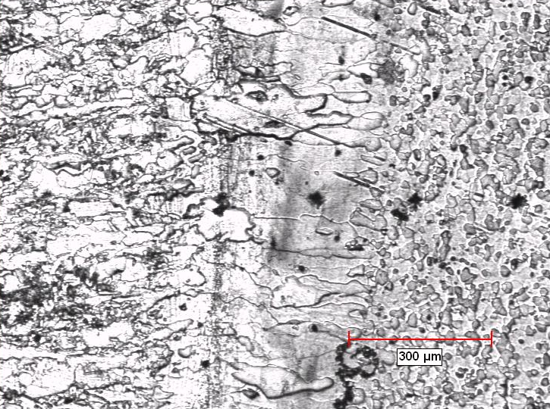

Weld zone

HAZ

parent material

Irregular grains in weld

Equiaxed grains

Grain growth in HAZ

**3.2 Determination of mechanical properties:**

The tensile test was carried out as per ASTM standard E8M-04( 2004) on Instron machine at DTU and at Narang Laboratories. Both parent metals as well as TWB’s were tested for mechanical properties. The Tension test for parent material was carried out with Standard size specimen while that for TWB’s was carried out with Sub-sized specimen as shown in Fig-3.2:

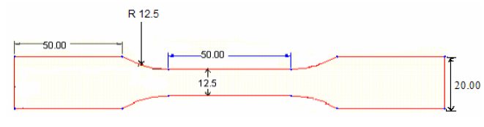

200

**Fig-3.2 Dimensions of the tensile specimen for parent metal (ASTM-E8M)**

For tension test of Longitudinally welded TWB(both Laser and GTAW) a subsized specimen was prepared according ASTM E8.Gauge length was 38mm.The Longitudinally welded Sub-sized specimen was shown below:

30mm

6mm

25 mm

Sheet 1

10mm

**Fig 3.2.1 Sub sized specimen**

The stress strain diagram for CRCA sheet of .7mm thick was shown in Fig 3.2.2 :

**Fig 3.2.2- Stress Strain diagram of Base metal**

The stress strain diagram for longitudinally welded TWB by GTAW process wass shown in Fig 3.2.3:

**Fig 3.2.3 Stress strain diagram of TWB**

**3.3 Experimental observation of springback:**

**3.3.1 Experimental setup:**

The experimental setup consists of a punch, die, base plate , attachment rod mounted on mechanical press brake , with attachment rod attached to 2 solid circular balls via an arm. The attachment rod is screwed so that when balls are turned about vertical axes, punch can be moved down and thereby bending sheet.

Four sets of punch and die with radius of 5.3mm, 8.65mm,11.95mm, 12mm were used for bending experiments. The die was fixed to base plate on the platform of press so that any movement of die can be arrested during bending of sheets.

**3.3.2 Fabrication of tools:**

As stated earlier Four sets of dies and punches of radius 5.3mm, 8.65mm, 11mm, 12mm were required for experimental setup of V-bending in addition to other accessories.

Some of components like locating pins, base plate, punch and die sets of 5.3mm,8.65mm,12mm required in experimental setup were Fabricated ,while others were available.

The base plate was Fabricated for holding die at fixed location while carrying out bending of sheet. Ensuring proper alignment of punch and die was main consideration while fabricating base plate. The required punch and die sets were modelled in Auto-Cad and NC program was generated .Punch and die were fabricated with this NC code by CNC .The included angle of all dies is ${90}^{0}$.

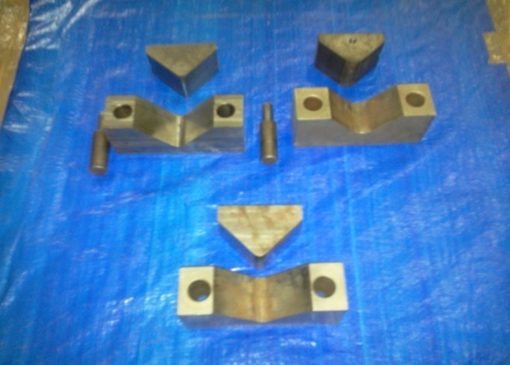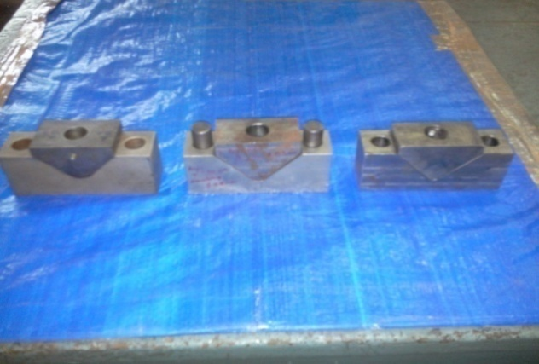

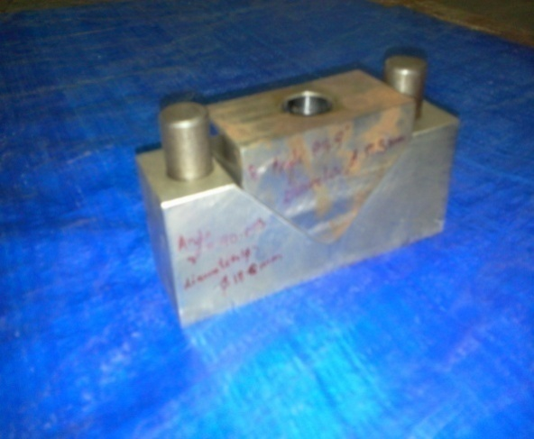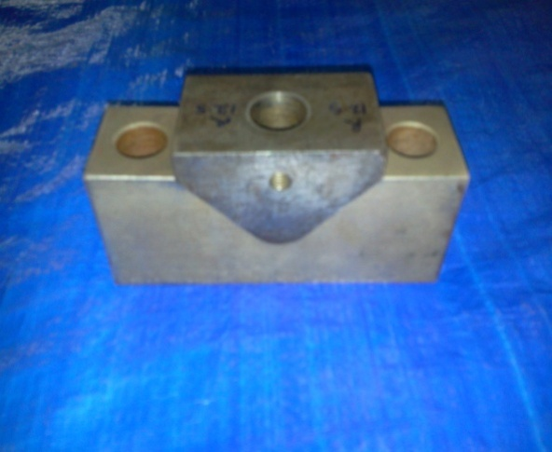

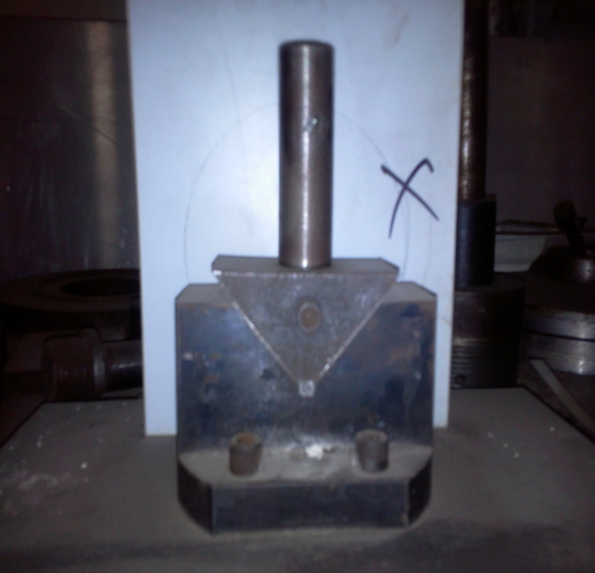

**Fig 3.3 Die and punch sets used in Experiment**

These Standard sets were Fabricated using CNC machine ,by generating M-codes from Geometry of parts. The Geometry of parts was drawn in AUTO-CAD. The Geometry of these sets drawn in Auto-cad was shown in Fig 3.3.1

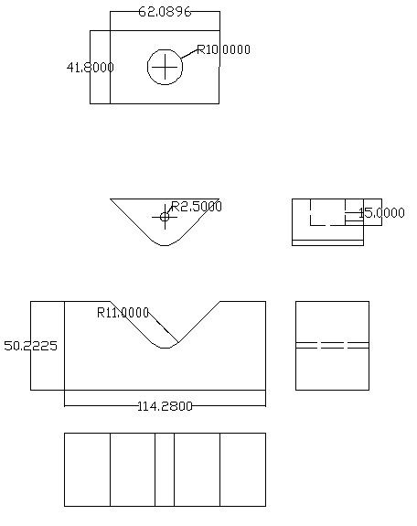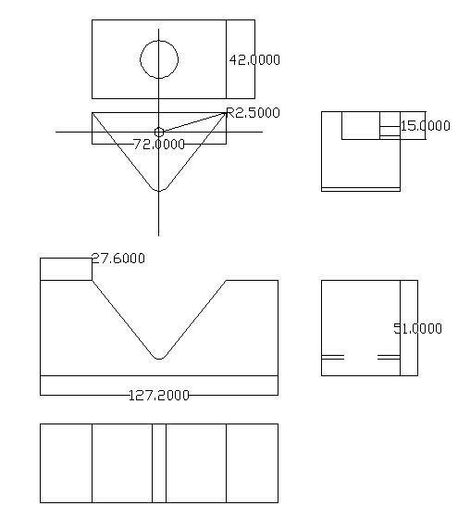

Punch radius R 11mm Punch radius R 5mm

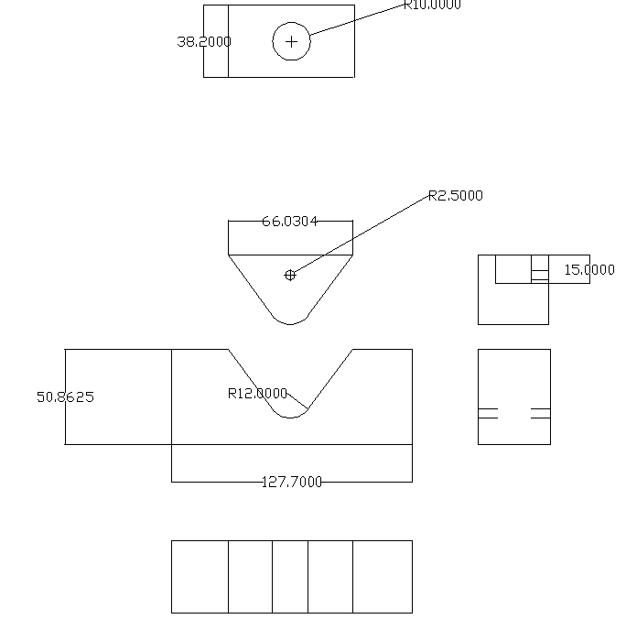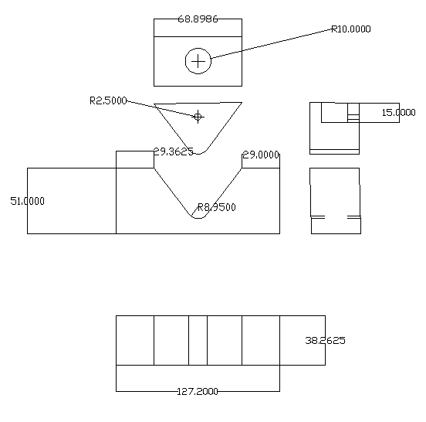

Punch Radius R 12mm Punch radius R 8.95mm

**Fig-3.3.1 Standard sets used in Experiments**

**3.4 Test procedure:**

The bending experiments were conducted on transversely welded TWB as well as parent materials on 11 mm punch profile radius. To study effect of punch profile radius on transversely welded strips three more radius 5.3mm, 8.65mm,12mm were used in addition to 11mm. Bending Experiments were conducted at Sheet metal shop of IIT DELHI

In case of transversely welded specimens the weld line was observed to be shifted from bend axis. To maintain weld line at centre of bent portion, blank holding force was needed to be applied on thinner metal. The punch was slowly moved down until sheet takes shape of die so that initial angle of sheet was same as included angle of die. Bending beyond this would cause over bending and hence leads to negative spring back. The precise stopping of punch at this moment plays a very important role and the spring back consistently depends on how precisely one stops at this position.

But since press operation is manual, it’s difficult to maintain consistency, stroke of punch was measured and same stroke was applied for all specimens when using particular die set.

So for each die and punch set combination, 2 sheets (HT and non HT) of Laser and 2 sheets of GTAW were bended. So a total of 16 TWB sheets were bended.

**3.4.1 Measurement of Spring back angle:**

**Initial angle:**

As stated earlier after bending , the specimen conforms to shape of die and therefore the initial angle of sheet after bending and before load is released is equal to angle of die.

**Final angle:**

After load is released spring back occurs in specimen due to elastic strain and hence angle of bend changes.

The final angle of bended sheet was measured on Coordinate measuring machine. The bent specimen was held on magnetic vice. The angle between 2 bended sides was measured by touching probe at three points on each side of specimen..2 measurements were taken for each specimen.

Measurement was done on CMM at RICO AUTO Guragoan.

CMM was shown below:

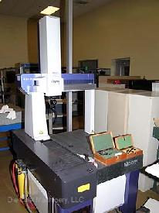

**Fig 3.4 CMM**

**3.5. Finite element analysis of V-bending:**

There are various engineering methods developed for deformation analysis of sheet metals in a variety of forming processes. Among these methods, the slip line fields method, slab method, upper and lower bound technique are commonly known techniques, and they have been used in calculation of forming loads, shape changes of deformed blank and in predicting optimal process conditions.

However an accurate analysis of effects of process and material parameters on deformation response has become possible when numerical methods , such as finite difference or finite elements have developed for these processes. Compared to numerical approximation techniques, the finite element method is presently the most frequently employed mathematical tool in Computer aided analysis of sheet metal forming processes.

In FE method , a set of algebraic equations are derived from space and time discretized form of virtual work expression using concept of finite elements. These finite element equations are solved using in order to determine the displacements at element nodal points, which are in turn input to element operator matrices to compute stress and strain tensors at element integration points. When a typical sheet forming operation is modelled with FE method, the developed finite element equation possesses strong non- lineartie’s because of large deformations of sheet metal. Consequently, irrespective of individual features of process under consideration, these finite element equations must be solved numerically using incremental procedures based on explicit time integration scheme or incremental iterative procedures based on an implicit time integration scheme. Due to this very nature of forming processes, the finite element simulations of forming processes consume a significant amount of computer resources in compuatation of time histories of nodal displacements and element stresses and strains.

Spring back is an important and decisive parameter in obtaining the desired geometry of part and design of corresponding tooling. In manufacturing industry , it is still a practical problem to predict the final geometry of part after springback and to design appropriate tooling in order to compensate for spring back. Conventional approaches, which involve using empirical formulae and several trail and error procedures, result in wastage of material, time and efforts. In recent years, FEA has been considered an effective way of simulating bending operations and predicting springback. FEA provides numerical trail and error procedures ,which lead to a less time consuming and more economical way of designing and producing dies. In particular some commercial available FEA programs provide effective and powerful tools and environments to model and simulate various operations. These programs include useful and user friendly graphical user interfaces, which facilitate pre and post processing stages.

* + 1. **FEM simulation of V-bending operation:**

In this study all simulations were performed using ABAQUS 6.9.3 version.

**Modeling:**

We can model the V-bending operation in Abaqus through a sequential no of modules. The modules in Abaqus which describe the complete model are:

1. Part module, 2. Property module, 3.Assembly module , 4. Step module, 5. Interaction module, 6.Load module, 7.Mesh module,8.job module.

Let us model the bending process through these modules by explaining each module

**3.5.1.1. Part module:**

In simulating V-bending operation first of all we have to create 3 basic parts:

1.Blank, 2. Punch, 3.die.

**Creating parts:**

Parts are the building blocks of an Abaqus/CAE model. You use the Part module to create each part, and you use the Assembly module to assemble instances of the parts.

When you create a new part or import a part from a file containing geometry stored in a third-party format, you must choose the part's type. The possible **types** are:

**Deformable** **Part:**

Any arbitrarily shaped axi-symmetric, two-dimensional, or three-dimensional part that you can create or import can be specified as a deformable part. A deformable part represents a part that can deform under load; the load can be mechanical, thermal, or electrical. By default, Abaqus/CAE creates parts that are deformable.

**Discrete rigid Part:**

A discrete rigid part is similar to a deformable part in that it can be any arbitrary shape. However, a discrete rigid part is assumed to be rigid and is used in contact analyses to model bodies that cannot deform.

**Analytical rigid** **Part:**

An analytical rigid part is similar to a discrete rigid part in that it is used to represent a rigid surface in a contact analysis. However, the shape of an analytical rigid part is not arbitrary and must be formed from a set of sketched lines, arcs, and parabolas.

**Feature of parts:**

After you select the type and shape of the part and sketch the two-dimensional profile of its base feature, you add additional features or modify existing features to create the finished part.

**Shell features:**

A shell feature is an idealization of a solid in which thickness is considered small compared to the width and depth. To create a shell feature, select **Shapehttp://ush-pc:2080/v6.9/books/usi/images/arrow.gifShell** from the main menu bar or select one of the shell tools in the Part module toolbox.

**Steps to create a new part:**

1. From the main menu bar, select **Parthttp://ush-pc:2080/v6.9/books/usi/images/arrow.gifCreate**.
2. Type a name for the part. You can rename a part after you create it.
3. Choose the new part's modeling space, type, base feature, and approximate size. To change a part's modeling space or type you must use the Model Tree to edit the part.
4. Click **Continue** to close the **Create Part** dialog box.

The Sketcher starts and the **Sketch** grid appear in the current viewport.

1. Use the Sketcher to sketch the two-dimensional profile of the base feature. If you are constructing a swept part, you must first sketch the sweep path and exit the Sketcher. The **Sketch** will then restart automatically, and you can sketch the profile to be swept.
2. When you have finished sketching the base feature, click mouse button 2 to exit the current **Sketch** tool.
3. In the prompt area, click **Done** to exit the Sketcher.

Abaqus/CAE exits the Sketcher and displays the new part in the current viewport.

So, First of all let us create Blank. So go to create part window and give modelling space as 2D and type as Deformable and Base feature as shell.

The geometry of blank is shown below:

Blank has length of 100mm, width 20mm. The sketch of Blank is shown below:

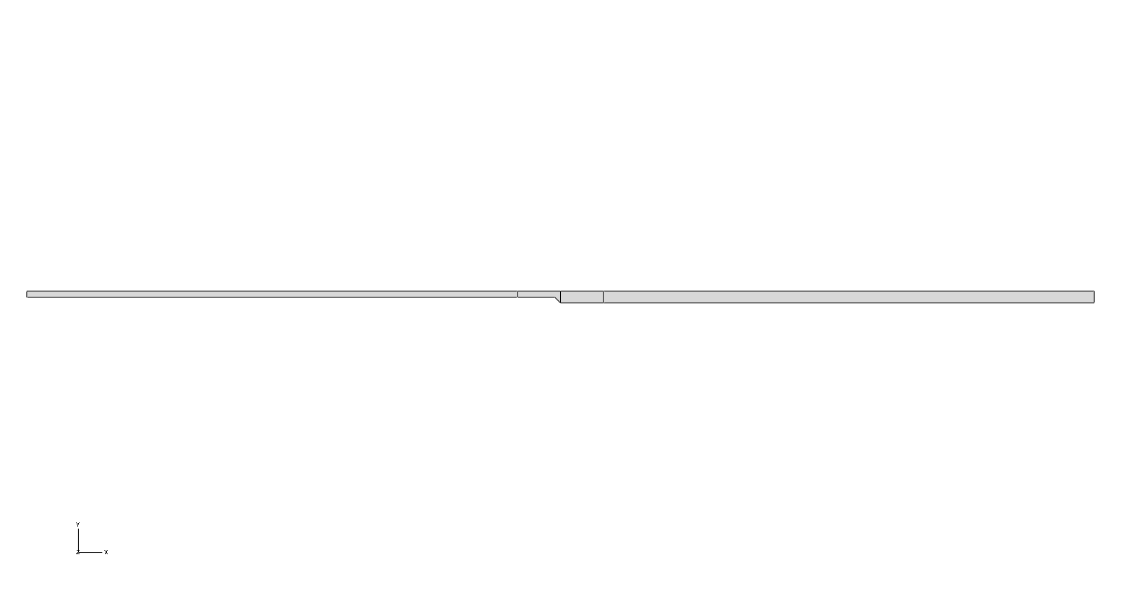

**Fig 3.5.1 Blank Geometry**

So, after creating blank we have to create Punch and die.

So to create punch and die, follow the same above said procedure.

The sketch of punch and die is shown below:

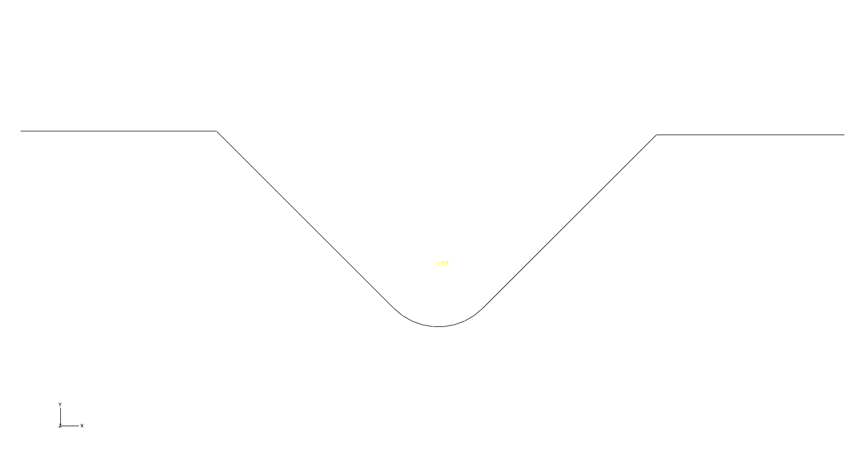

**Fig 3.5.2 Die Geometry**

You can use the Reference Point toolset to create a reference point that is associated with a part by selecting **Toolshttp://ush-pc:2080/v6.9/books/usi/images/arrow.gifReference Point** from the main menu bar. A part can include only one reference point, and Abaqus/CAE labels it **RP**. Abaqus/CAE asks you if you want to delete the original point if you try to create a second point. A reference point on a part appears on all instances of the part in the assembly. The assembly can include more than one reference point, and Abaqus/CAE labels them **RP-1**, **RP-2**, **RP-3**, etc

After creating parts we have to define material of sheet.

**3.5.1.2 Property module:**

In property module we can define material, sections, assigning section etc.

**Defining material:**

A material definition specifies all the property data relevant to a material. You specify a material definition by including a set of material behaviours, and you supply the property data with each material behaviour you include. You use the material editor to specify all the information that defines each material.

Abaqus/CAE assigns the properties of a material to a region of a part when you assign a section referring to that material to the region. Here material of blank is assigned by giving its density, elastic, plastic properties.

To create a material, select **Materialhttp://ush-pc:2080/v6.9/books/usi/images/arrow.gifCreate** from the main menu bar. An **Edit Material** dialog box appears in which you can enter a name for the material and create or edit material properties.To give elastic and plastic properties go to mechanical material behaviour.

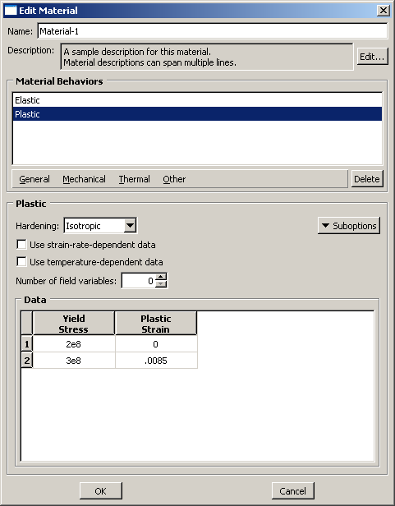

**Fig 3.5.3 Material Editor(Ref:Abaqus 6.9.3 help)**

### Defining sections:

A section contains information about the properties of a part or a region of a part. The information required in the definition of a section depends on the type of region in question. Most sections must refer to a material name. When you assign a section to a part, Abaqus/CAE automatically assigns that section to each instance of the part. As a result, the elements that are created when you mesh those part instances will have the properties specified in that section.

Sections are named and created independently of any particular region, part, or assembly. You can assign a single section to as many different regions as necessary. You can use the Property module to create solid sections, shell sections, beam sections, and other sections.

**Solid sections** :

Solid sections define the section properties of two-dimensional, three-dimensional, and axisymmetric solid regions.

**Homogeneous solid sections:**

Homogeneous solid sections consist of a material name. In addition, if the section will be used with a two-dimensional region, you must also specify the section thickness.

After you have created sections assign these sections to portions of blank geometry.

## 3.5.1.3. The Assembly module:

## You use the Assembly module to create and modify the assembly. The model contains only one assembly, which is composed of instances of parts from the model.

When you create a part, it exists in its own coordinate system, independent of other parts in the model. In contrast, you use the Assembly module to create instances of your parts and to position the instances relative to each other in a global coordinate system, thus creating the assembly. You position part instances by sequentially applying position constraints that align selected faces, edges, or vertices or by applying simple translations and rotations.

**To create a part instance:**

1. From the main menu bar, select **Instancehttp://ush-pc:2080/v6.9/books/usi/images/arrow.gifCreate** to create a part instance from the parts in the model.

Abaqus/CAE displays the **Create Instance** dialog box and a list of all the existing parts in the model.

1. By default, Abaqus/CAE creates a **Dependent** part instance. If desired, toggle on **Independent** to create an independent part instance.
2. If desired, toggle on **Auto-offset from other instances** to offset the new part instances.
3. If you are satisfied that you have selected the correct part instances, click **Apply** from the **Create Instance** dialog box.

Abaqus/CAE creates the part instances and applies an auto-offset if selected.

1. To create additional part instances, repeat this procedure from Step 2. When you have finished creating part instances, click **Cancel** to close the **Create Instance** dialog box. When you create a part instance, you can choose to create either a dependent part instance or an independent part instance. You can also edit an instance and change it from dependent to independent or vice versa.

**Dependent part instances** :

By default, Abaqus/CAE creates a dependent instance of a part. A dependent instance is only a pointer to the original part. In effect, a dependent instance shares the geometry and the mesh of the original part. As a result, you can mesh the original part, but you cannot mesh a dependent instance. When you mesh the original part, Abaqus/CAE applies the same mesh to all dependent instances of the part.

**Independent part instances:**

In contrast, an independent part instance is a copy of the geometry of the original part. You cannot mesh a part from which you created an independent part instance; however, you can mesh the independent instance. In addition to meshing, you can perform most other operations on an independent instance.After instancing parts we have to define relative position of parts in an assembly. This can be done by using position constraints tool box.

Use the **Constraint** menu to apply a constraint that does the following:

* [**Face to Face**](http://ush-pc:2080/v6.9/books/usi/pt03ch13s10hlb03.html). Positions a movable part instance so that a selected face is parallel to and a specified distance away from a selected face of a fixed part instance.
* [**Parallel Edge**](http://ush-pc:2080/v6.9/books/usi/pt03ch13s10hlb04.html). Positions a movable part instance so that a selected edge is parallel to a selected edge of a fixed part instance.
* [**Edge to Edge**](http://ush-pc:2080/v6.9/books/usi/pt03ch13s10hlb05.html). Positions a movable part instance so that a selected edge is parallel to and a specified distance away from a selected edge of a fixed part instance.

Constraints position one part instance relative to another; as a result, constraints cannot be applied until your assembly contains two or more part instances. After constraining parts , we can define surfaces of various parts to define interactions.

The assembly of simulated V-bending operation was shown in Fig below:

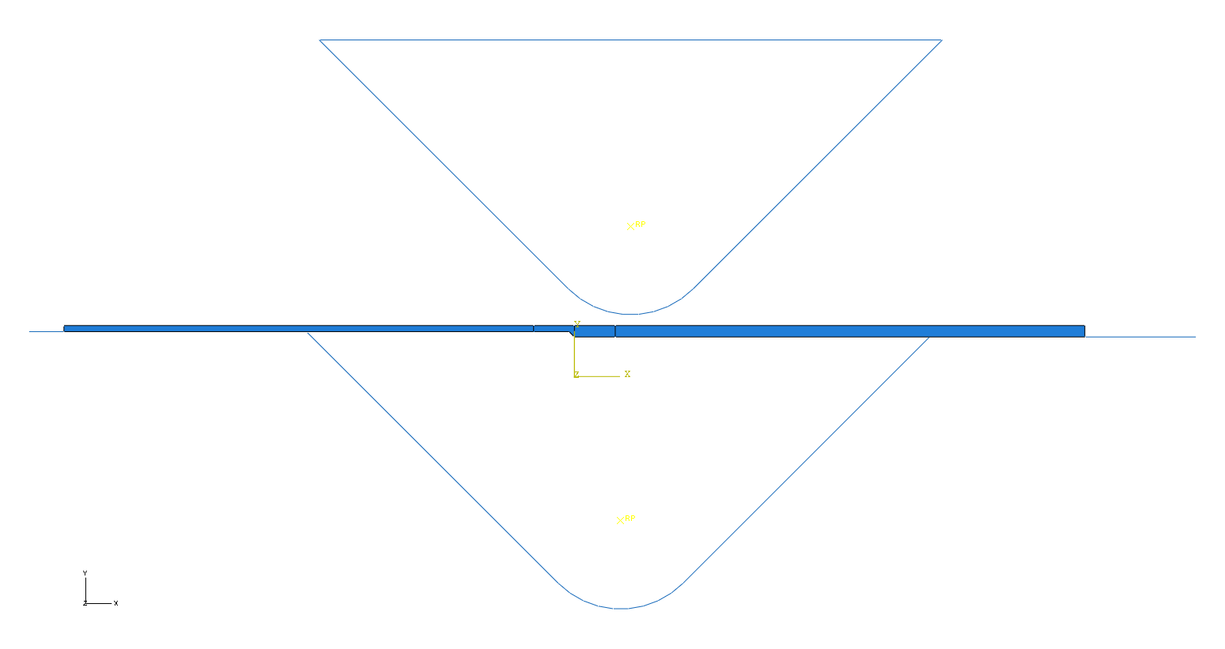

**Fig 3.5.4 V-bendingassembly**

### 3.5.1.4 Step Module:

**Role of step module**:

You can use the Step module to perform the following tasks:

**Creating analysis steps** :

Within a model you define a sequence of one or more analysis steps. The step sequence provides a convenient way to capture changes in the loading and boundary conditions of the model, changes in the way parts of the model interact with each other, the removal or addition of parts, and any other changes that may occur in the model during the course of the analysis

**Specify output requests:**

An output request defines which variables will be output during an analysis step, from which region of the model they will be output, and at what rate they will be output

An Abaqus/CAE model uses the following two types of steps:

**The initial step:**

Abaqus/CAE creates a special initial step at the beginning of the model's step sequence and names it Initial. Abaqus/CAE creates only one initial step for your model, and it cannot be renamed, edited, replaced, copied, or deleted.

The initial step allows you to define boundary conditions, predefined fields, and interactions that are applicable at the very beginning of the analysis.

**Analysis steps** :

The initial step is followed by one or more analysis steps. Each analysis step is associated with a specific procedure that defines the type of analysis to be performed during the step, such as a static stress analysis or a transient heat transfer analysis.

**To create a step:**

1. From the main menu bar, select **Stephttp://ush-pc:2080/v6.9/books/usi/images/arrow.gifCreate**.The **Create Step** dialog box appears. If desired, use the **Name** text field to change the name of the new step.

All steps must have unique names, and you cannot name a step "Initial".

1. From the list of existing steps, select the step after which the new step will be inserted.
2. Click the arrow next to the **Procedure type** field, and select either **General** or **Linear perturbation** from the list that appears.

The lower half of the dialog box displays a list of available procedures.

1. Select the desired procedure and click **Continue**.

The **Edit Step** dialog box appears.

1. Use the **Edit Step** dialog box to modify the settings from their default values and to provide values for optional settings
2. Click **OK**.

Abaqus/CAE closes the **Edit Step** dialog box, and the new step appears in the **Step Manager**.

**Step procedures:**

An analysis step during which the response can be either linear or nonlinear is called a *general* analysis step. An analysis step during which the response can be linear only is called a *linear perturbation* analysis step. General analysis steps can be included in an Abaqus/Standard or Abaqus/Explicit analysis; linear perturbation analysis steps are available only in Abaqus/Standard.

A general analysis step is one in which the effects of any nonlinearities present in the model can be included. The starting condition for each general step is the ending condition from the last general step, with the state of the model evolving throughout the history of general analysis steps as it responds to the history of loading

General nonlinear analysis steps define sequential events: the state of the model at the end of one general step provides the initial state for the start of the next general step. We can use the **Procedure type** field to choose between **General** and **Linear perturbation** steps when you select the procedure in the **Create Step** dialog box.

In cases where the loads on a model result in large displacements, nonlinear geometric effects can become important. The **Nlgeom** setting for a step determines whether Abaqus will account for geometric nonlinearity in that step.

### The step editor:

### When you create, edit, or replace a step, the step editor displays a set of tabbed pages that allow you to configure the settings for the procedure you selected. Abaqus stores the text that you enter in the Description field on the Basic tabbed page in the output database, and it is displayed in the state block by the Visualization module.

### The Incrementation tab:

### When you configure general procedures, you use the Basic tab in the step editor to enter the total time period for the step. You use the Incrementation tab to configure the approach that Abaqus will use to divide the total time period for the step into increments.

**Time incrementation:**

When you choose **Automatic** time incrementation, Abaqus starts the incrementation using the value entered for the initial increment size. The size of subsequent time increments are adjusted based on how quickly the solution converges. This option is the default selection.

When you choose **Fixed** time incrementation, Abaqus uses the value entered for the initial increment size throughout the step.

**Maximum number of increments:**

Abaqus limits the number of increments in a step to the value that you enter for the maximum number of increments.

**Initial increment size** :

Abaqus starts the step using the value entered for the initial increment size.

**Minimum increment size** :

Abaqus checks for the minimum increment size only when you analyze your model using automatic time incrementation. If Abaqus needs a smaller time increment than this value to reach a convergent solution, it terminates the analysis, reports to the Job module, and writes diagnostic information to the message file. If you do not enter a minimum increment size, Abaqus uses 10-5 times the total time period.

**Maximum increment size**

Abaqus checks for the maximum increment size only when you analyze your model using automatic time incrementation.

Here in this simulation 2 Dynamic Explicit steps were used for V-bending and 1 general static steps were used for spring back analysis.

For V-bending in first step punch is brought in contact with Blank, and in second step punch has been given some displacement in downward direction to bend sheet.

### 3.5.1.5. Interaction module

We can use the Interaction module to define Contact interactions, Rigid body constraints etc. Interactions are Step-dependent objects, which means that when you define them, you must indicate in which steps of the analysis they are active.

The Set and Surface toolsets in the Interaction module allow you to define and name regions of your model to which you would like interactions and constraints applied. Abaqus/CAE does not recognize mechanical contact between part instances or regions of an assembly unless that contact is specified in the Interaction module; the mere physical proximity of two surfaces in an assembly is not enough to indicate any type of interaction between the surfaces.

You can use the Interaction module to define the following types of interactions:

**General contact:**

General contact interactions allow you to define contact between many or all regions of the model with a single interaction. General contact is also used to define contact between Lagrangian bodies and Eulerian materials in a coupled Eulerian-Lagrangian analysis.

**Surface-to-surface contact and self-contact**

Surface-to-surface contact interactions describe contact between two deformable surfaces or between a deformable surface and a rigid surface. Self-contact interactions describe contact between different areas on a single surface

**Interaction editors:**

To create interactions, select **Interactionhttp://ush-pc:2080/v6.9/books/usi/images/arrow.gifCreate** from the main menu bar. A **Create Interaction** dialog box appears in which you can provide a name for the interaction, select the step in which the interaction will be created, and choose the type of the interaction.

Once you have selected the region or regions, an interaction editor appears in which you can specify additional information about the interaction, such as the interaction property that you want to associate with the interaction.

### Interaction property editors

To create interaction properties, select **Interactionhttp://ush-pc:2080/v6.9/books/usi/images/arrow.gifPropertyhttp://ush-pc:2080/v6.9/books/usi/images/arrow.gifCreate** from the main menu bar. A **Create Interaction Property** dialog box appears in which you can specify a name for the interaction property and the type of interaction property that you want to create. Once you have specified this information, click **Continue** in the **Create Interaction Property** dialog box to display the interaction property editor.

The format of the interaction property editor depends on the type of interaction property you are defining.

The contact property editor contains **Mechanical** and **Thermal** option menus.

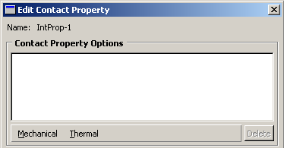

**Fig 3.5.5 Contact property(Abaqus 6.9.3 help)**

When you select an option from a menu, the name of the option appears in the Contact Property Options list at the top of the editor, and the option becomes part of your interaction property definition. In addition, the option definition area in the lower half of the editor changes to provide fields in which you can specify information for the currently selected option.

## 3.5.1.6 The Load module:

You use the Load module to define and manage the following prescribed conditions:

* Loads
* Boundary conditions
* Predefined fields
* Load cases

### Creating boundary conditions:

When you create a boundary condition, you must specify the name of the boundary condition, the step in which to activate the boundary condition, the type of boundary condition, and the region of the assembly to which you want to apply the boundary condition.

**To create a boundary condition:**

1. From the main menu bar, select **BChttp://ush-pc:2080/v6.9/books/usi/images/arrow.gifCreate**.

A **Create Boundary Condition** dialog box appears with a default name displayed in the **Name** text field.

1. Type a name for the boundary condition..
2. Select the step in which to activate the boundary condition. Click the arrow next to the **Step** text field, and select from the list that appears.
3. From the **Types for Selected Step** list, select the boundary condition type and click **Continue**.
4. Select the region to which you want to apply the boundary condition.

Click **Sets** or **Surfaces** on the right side of the prompt area. (The name of the button depends on the type of object you are creating. For example, if you are creating a pressure load, a **Surfaces** button appears.)Abaqus/CAE displays the **Region Selection** dialog box containing a list of available sets or surfaces.

Select the set or surface of interest and click **Continue**.

The boundary condition editor appears. The region to which you are applying the boundary condition is highlighted in the viewport.

Enter all of the data necessary to define the boundary condition and click **OK**.

**Using the boundary condition editors:**

1.**Defining a symmetry/antisymmetry/encastre boundary condition:**

You can define a boundary condition by selecting one of the common types listed in the symmetry/antisymmetry/encastre boundary condition editor.

**To create or edit a symmetry/antisymmetry/encastre boundary condition:**

Select one of the following options:

**XSYMM** Symmetry about a plane X = constant (U1 = UR2 = UR3 = 0).

**YSYMM** Symmetry about a plane Y = constant (U2 = UR1 = UR3 = 0).

**ZSYMM** Symmetry about a plane Z = constant (U3 = UR1 = UR2 = 0).

**PINNED** Pinned (U1 = U2 = U3 = 0).

**ENCASTRE** Fully built-in (U1 = U2 = U3 = UR1 = UR2 = UR3 = 0).

Here 3 types of boundary conditions are used in simulation( Symmetry, displacement, velocity). For Explicit steps we must define amplitudes.

**3.5.1.7 The Mesh module:**

The Mesh module allows you to generate meshes on parts and assemblies created within Abaqus/CAE.

### Meshing independent and dependent part instances:

The approach to meshing independent and dependent instances is different..

**Independent** **Part:**

To mesh an independent instance, use the context bar to change the **Object** to **Assembly** and mesh the instance directly. You cannot mesh a part that you have used to create an independent instance.

**Dependent Part:**

To mesh a dependent instance, use the context bar to change the **Object** to **Part** and select the part with which the dependent instance is associated. You can then mesh the part, and Abaqus/CAE applies the same mesh to each dependent instance in the assembly.

**Mesh seeds:**

Seeds are markers that you place along the edges of a region to specify the target mesh density in that region. Both the mesh density along the boundary of the region and the mesh density in the interior of the region are determined by the seeds along the edges of the region.Before meshing we have to select an element type.

The **Element Type** dialog box for a 2D region 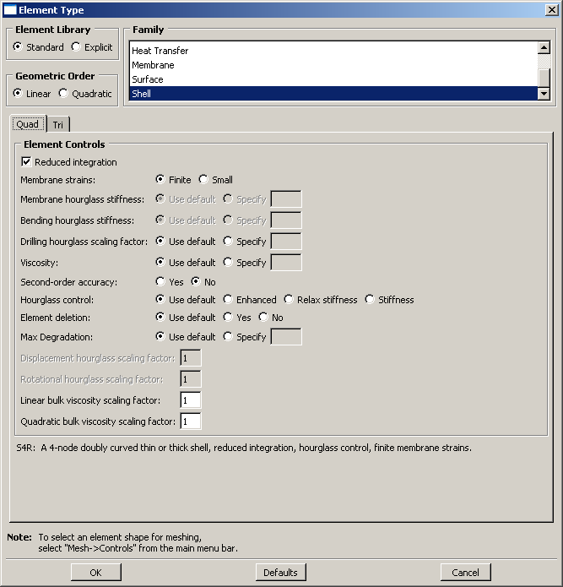

**Fig 3.5.6 Mesh Element Editor**

After seeding ,click mesh part instance icon.Then click ok. Here we have meshed Blank with Element Library - Explicit, Family- Plane strain, Element type: Quad

**The Job module:**

You can use the Job module to create and manage analysis jobs and to view a basic plot of the analysis results. You can also use the Job module to create and manage adaptivity analyses and co-executions

We can use visualization module to see the simulated bending process.In visualization module we can see the actual output, stresses induced etc.

In this way V-bending operation is simulated.

**3.6. HAZ determination:**

**3.6.1. Micro-hardness test:**

The term micro-hardness test usually refers to static indentations made with loads not exceeding 1kgf. The indenter is either Vickers diamond pyramid or the Knoop elongated diamond pyramid.

The procedure for testing is very similar to that of standard Vickers hardness test, except that it is done on a microscopic scale with high precision instruments.

The surface being tested generally requires metallographic finish. The smaller the load used ,the higher surface finish is required.

Precision Microscopes are used to measure indentations. These usually have a magnification of around X500 and measure to accuracy of ${}_{-}^{+}{0.5}$ micrometers. considerable care and accuracy are necessary to obtain this accuracy.

Micro hardness test can be done by 2 methods based on type of indenters and magnification:

1. Knoop hardness test,

2.Vickers hardness test.

**Vickers hardness test:**

The Vickers diamond pyramid hardness number is applied load(kgf) divided by surface area of indentation(${mm}^{2}).$

HV = $\frac{(2*F*sin⁡({\frac{136}{2}}^{0})}{d^{2}}$ (3.1)

= 1.854 $\frac{F}{d^{2}}$\* (app)

Where

F= load in kgf,

D=arithmetic mean of two diagonals, d1 and d2 in mm

HV= Vickers hardness.

The Vickers Diamond pyramid indenter is ground in form of squared pyramid with an angle of ${136}^{0}$ between faces. The depth of indentation is about 1/7 of the diagonal length. When calculating Vickers Diamond pyramid number both diagonals of indentation are measured and mean of these values is used in above formula with load used to determine the value of HV.

h

$d_{1}$

**Fig 3.6 Vickers pyramid Diamond Indenter Indentation**

**3.6.2 MVH-Auto:**

Model MVH-auto micro hardness tester is an integrated optical, mechanical and electrical device.

This tester adopts programming by computer software’s, high magnification optical measuring system and photoelectric sensor etc such technique . By means of input from touch screen , it may adjust the measurement of either strong or weak light source, preset the holding time for test force or load, cut and change either the Vickers or Knoop’s test method.

On the touch screen, the LCD display screen may display the form of test, test force( or load), measure the length of indentation, hardness value, holding time of test force, number of measurements by keys, and test results can be output by means of a printer.

The hardness tester is also equipped with photographic device (optionally) which may take photo for all measured indentation and metallographic formation of materials. It is suitable to measure micro-hardness of small, thin specimen , and superficial permeable coating layer etc such specimen, as well as to measure the micro hardness of glass, ceramics, agate and gem etc such brittle materials, hence it is an ideal hardness measuring and quality supervising department to carry out materials research and inspection, measurement.

**Technical specifications:**

|  |  |
| --- | --- |
| Test force or load | 5, 100, 200, 300, 500, 1000, 3000 gms |
| Magnification | 100X, 200X. 400X, 600X |
| Holding time of test force | 1-99 sec |
| The Maximum height of specimen | 65mm |
| The Maximum width of specimen | 85mm |
| Weight of main body | 45-50 kg( **app)** |
| Power supply | AC 230V/50 HZ( 5amp) |
| Dimensions | 480\*254\*600 mm (length\*width\*height) |

**Chapter-4 Results and discussion**

The results obtained from Experimental and simulation as explained in previous chapter are presented and discussed below:

**4.1. Mechanical properties of sheet metal:**

The accuracy of Springback simulation depends , besides the other factors like mesh size, contact properties etc on how accurately the properties of material were tested and supplied as input to simulation .As mentioned earlier in this study extra low carbon steel (CRCA) has been used .The material has very low carbon content(0.05%) and has very good formability.

At DTU the INSTRON machine is of 5Tonne capacity. Parent metals were tested here.

The tension test results for base material is shown in following table:

|  |  |  |  |  |
| --- | --- | --- | --- | --- |
| Material | Thickness | Yield strength | UTS | % elongation |
| CRCA | 0.7 | 241 | 278.7 | 51 |
| CRCA | 1.2 | 247.6 | 289 | 61 |

**Table 4.1 Mechanical properties of Base metal**

The tension test results of TWB is shown below:

The tension test for TWB was done at NARANG laboratories which has a load capacity of 400 kN. For TWB area can be calculated by product of width of reduced section and average of thickness of the 2 sheets. The UTM at Narang was also shown below:

The longitudinally welded specimen (GTAW) after tension test is shown in Fig 4.1:

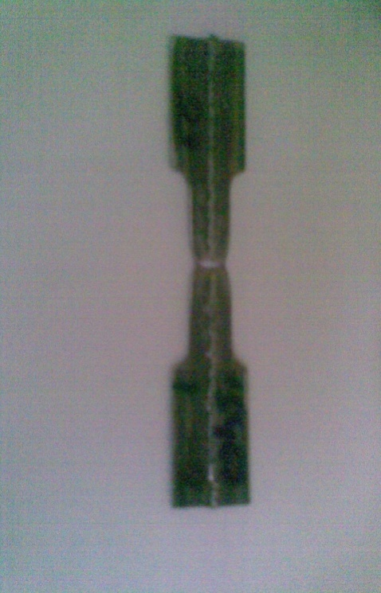(a)

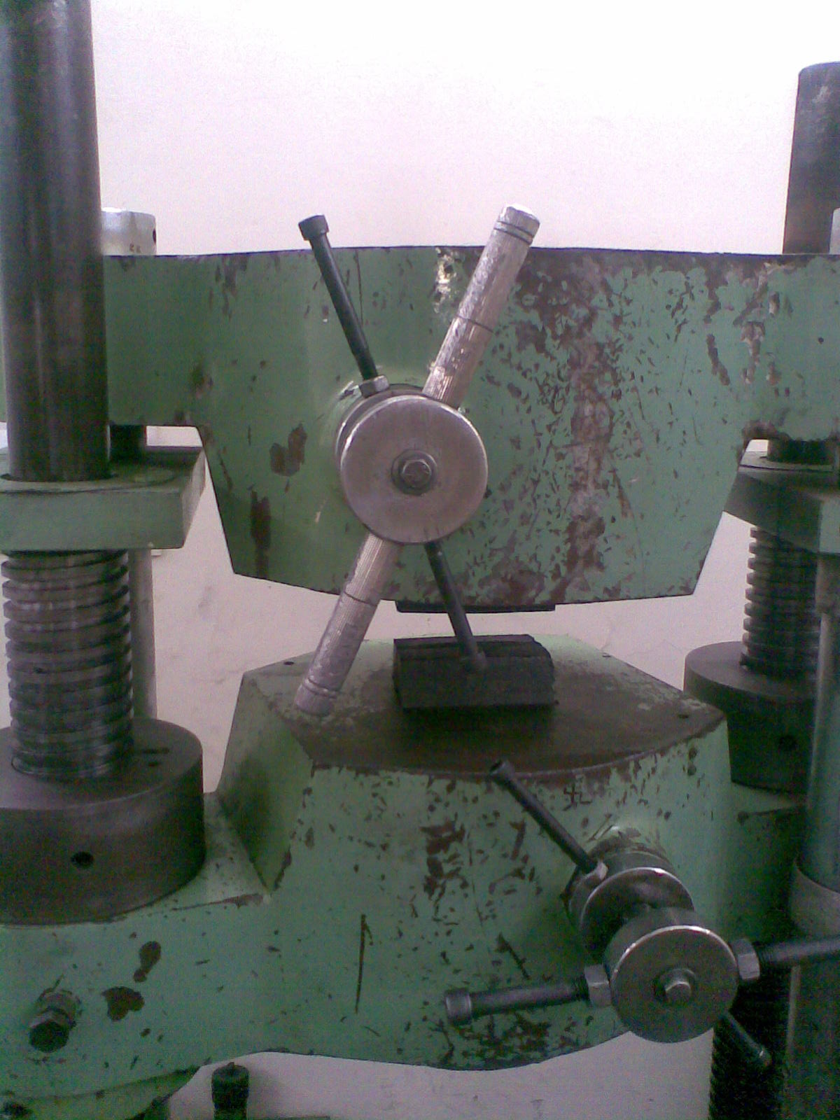(b)

**Fig 4.1 (a) Tensile tested specimen, (b) UTM**

**Table 4.2 Mechanical properties of TWB**

|  |  |  |  |
| --- | --- | --- | --- |
| Material | Yield strength | UTS | % elongation |
| TWB(Laser welded) | 246 | 347 | 21 |
| TWB(GTAW) | 247.7 | 386.9 | 18.4 |

From tension tests it is clear that both yield strength and ultimate tensile strength of TWB with thickness combination are higher than corresponding parent metals.

The increase in strength values may be due to higher hardness in weld region and composite nature of sheet.

However the elongation values of TWB are less than parent materials due to presence of hard weld in between. This shows the formability of TWB’s will be less than that of parent metals.

**4.2. Springback results:**

As stated earlier in methodology the experiments were performed in 2 stages:

1. To study the effect of Variation of punch profile radius on springback in bending of transversely welded specimens and parent materials. In this case it was difficult to keep weld line exactly at centre of bend in case of TWB.

The thinner metal in TWB was getting bent easily thus shifting weld line away from deformation zone. To keep weld line at center of bend the simplest way is to clamp end of thinner side. This however completely changes the geometry as well as deformation regions as compared to first case.

Results show that Higher the die profile radius/ punch profile radius more is the Spring back as the material is strain hardened to lesser extent while bending.

The TWB specimens after bending with 4 different punch radii are shown in fig below:

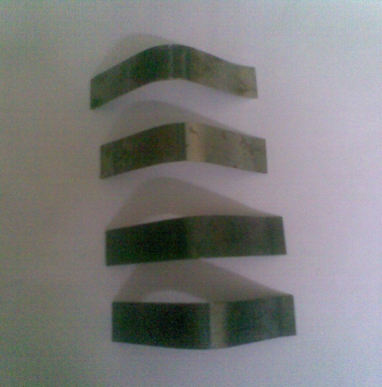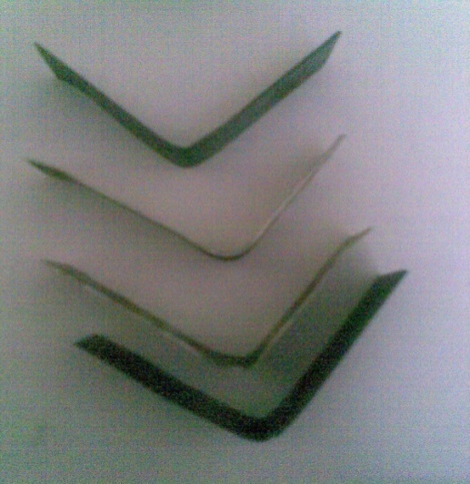

R12 R10.95

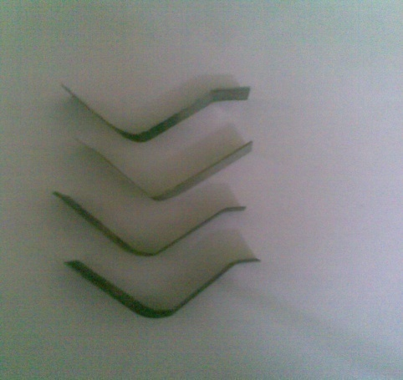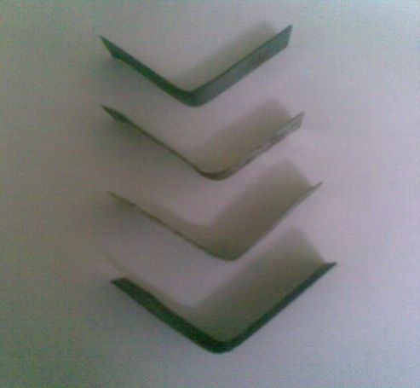

R5.3 R 8.65

**Fig 4.2 V-bent specimens**

1. To study the effect of Heat affected zone on Springback in V-bending of TWB.

For this TWB are welded by 2 types of welding process: ${CO}_{2}$ Laser welding and GTAW process.

Further due to welding some residual stresses remain in HAZ. So to remove these stresses, some sheets are subjected to **Stress relieve annealing**. So Spring back for these sheets are compared with non heat treated sheets.From results it can be concluded that as HAZ increases, Springback reduces as Flow stress reduces. Further stress relieving further reduces Springback.The included angle initially of all bend is ${90}^{0}$.

The V-Bended sheets are measured for angle in order to determine Spring back.This was done using CMM at M/S RICO AUTO LTD. We measured inside angle (included angle of die), so this should be corrected to take into account the sheet thickness in order to get final bend angle after Spring back.

This correction was shown below:

Correction Factor = $\frac{l*180}{R*π}$; (4.2)

Here R= 43.53mm (const for all bent radii) R

l=1.2+0.7=1.9mm; correction factor = ${2.5}^{0}$

ϴ

**Fig 4.3 Angle Measured**

ϴ - angle between inside surfaces measured in CMM after Spring back,

For Bend Radius – 5.3mm, the included angle of die is ${90.02}^{0}$

For Bend Radius – 8.65mm, the included angle of die is ${90.003}^{0}$

For Bend Radius – 10.95mm, the included angle of die is ${89.59}^{0}$

For Bend Radius - 12mm, the included angle of die is ${90.11}^{0}$

The Variation of Experimental springback values with punch profile radius is shown Table 4.3:

|  |  |  |  |  |
| --- | --- | --- | --- | --- |
| R 5.3mm | LW | LW(HT) | GTAW | GTAW(HT) |
| ϴ | $${ 88}^{0}{01}^{1}$$ | $${87}^{0}{42}^{1}$$ | $${87}^{0}{57}^{1}$$ | $${87}^{0}{55}^{1}$$ |
| **ϴ+** |  |  |  |  |

|  |  |  |  |  |
| --- | --- | --- | --- | --- |
| R 8.65mm | LW | LW(HT) | GTAW | GTAW(HT) |
| ϴ | $${ 88}^{0}{28}^{1}$$ | $${88}^{0}{19}^{1}$$ | $${88}^{0}{19}^{1}$$ | $${88}^{0}{16}^{1}$$ |
| **ϴ+** |  |  |  |  |

|  |  |  |  |  |
| --- | --- | --- | --- | --- |
| R 10.95mm | LW | LW(HT) | GTAW | GTAW(HT) |
| ϴ | $${ 89}^{0}{19}^{1}$$ | $${89}^{0}{06}^{1}$$ | $${89}^{0}{06}^{1}$$ | $${89}^{0}{04}^{1}$$ |
| **ϴ+** |  |  |  |  |

|  |  |  |  |  |
| --- | --- | --- | --- | --- |
| R 12 mm | LW | LW(HT) | GTAW | GTAW(HT) |
| ϴ | $${ 91}^{0}{56}^{1}$$ | $${91}^{0}{19}^{1}$$ | $${91}^{0}{41}^{1}$$ | $${91}^{0}{23}^{1}$$ |
| **ϴ+ ${2.5}^{0}$** | $${93}^{0}{26}^{1}$$ | $${92}^{0}{49}^{1}$$ | $${93}^{0}{11}^{1}$$ | $${92}^{0}{53}^{1}$$ |

The spring back values are shown in table 4.4:

|  |  |  |  |  |
| --- | --- | --- | --- | --- |
| Radius | LW | LW(HT) | GTAW | GTAW(HT) |
| R 5.3 | $${0.49}^{0}$$ | $${0.21}^{0}$$ | $${0.44}^{0}$$ | $${0.41}^{0}$$ |
| R 8.65 | $${0.97}^{0}$$ | $${0.81}^{0}$$ | $${0.81}^{0}$$ | $${0.78}^{0}$$ |
| R 10.95 | $${2.22}^{0}$$ | $${2.01}^{0}$$ | $${2.01}^{0}$$ | $${1.97}^{0}$$ |
| R12 | $${3.32}^{0}$$ | $${2.7}^{0}$$ | $${3.07}^{0}$$ | $${2.77}^{0}$$ |

Table 4.4 Spring Back values of V-bent specimens

**4.3. Finite element simulations:**

The finite element simulations were performed using ABAQUS analysis software as per procedure stated in Methodology. The properties obtained from tension test were given as input for simulations.

The assembly of punch, die, blank in V-bending simulation was shown in Fig 3.5.4.

The Springback of blank was shown from simulation output for punch of 5.3mm radius was shown in Fig 4.4.1

**Fig 4.4.1 Springback of bend radius R5.3mm**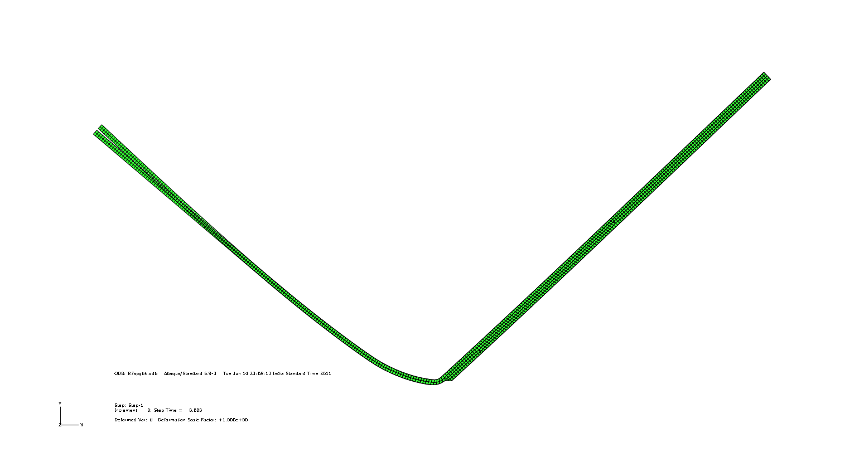

The springback of blank in V-bending operation for punch of 8.65 mm radius from simulation output was shown in fig 4.4.2:

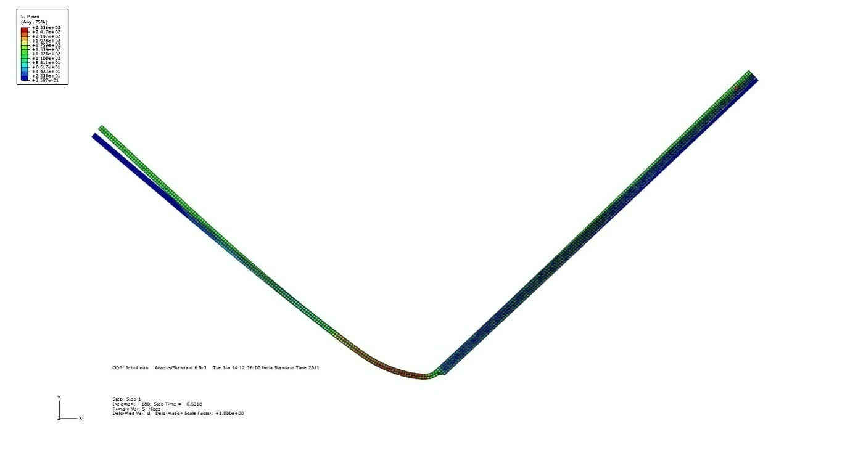

**Fig 4.4.2 Springback of bend radius 8.65mm**

The springback of blank in V-bending operation for punch of 10.95 mm radius from simulation output was shown in Fig 4.4.3:

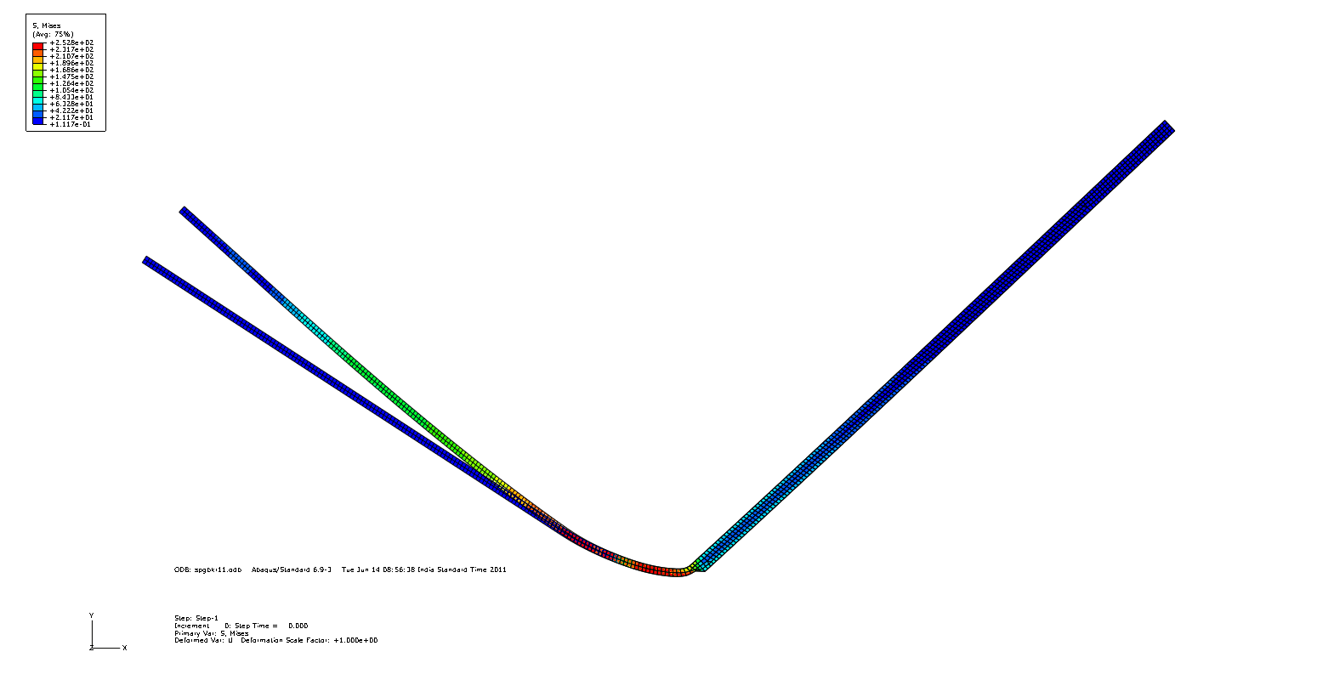

**Fig 4.4.3 Springback of Bend radius 10.95mm**

The springback of blank in V-bending operation for punch of 12 mm radius from simulation output was shown 4.4.4:

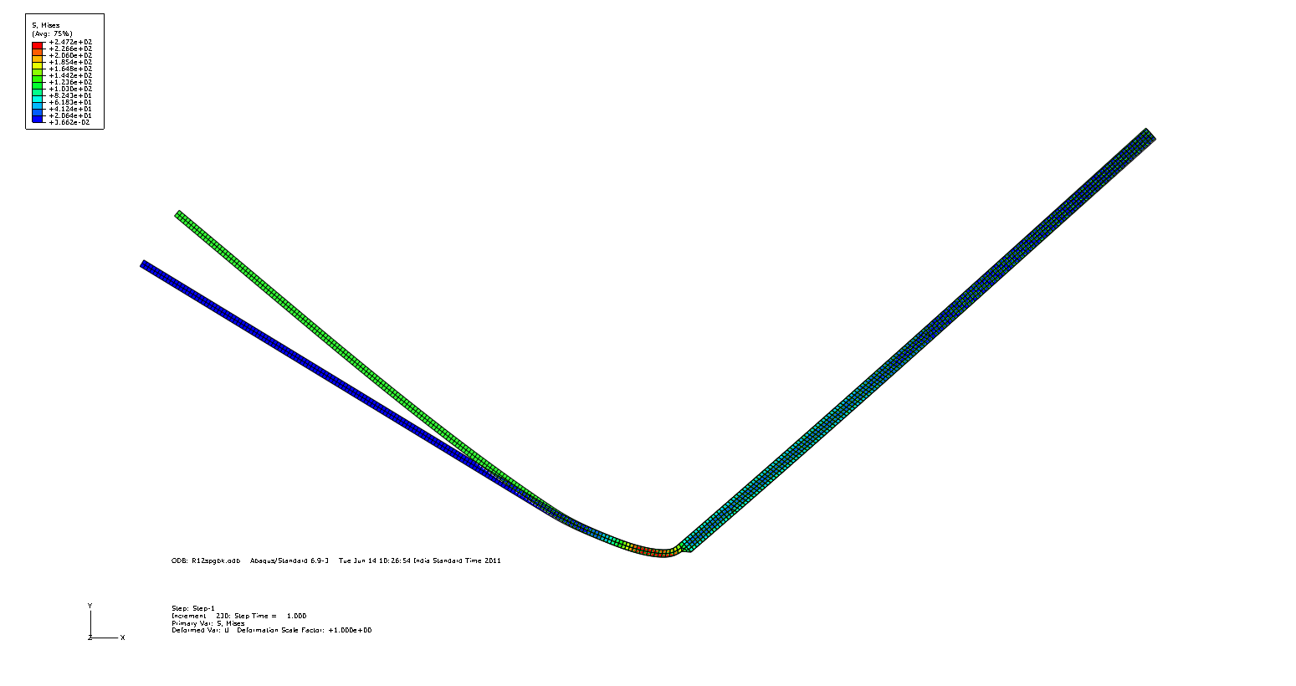

**Fig 4.4.4 Springback of bend radius R12mm**

The corresponding values of springback was shown in table 4.5.

**4.3.1 Comparison of springback from experimental and simulation methods:**

|  |  |  |  |  |
| --- | --- | --- | --- | --- |
| Material | Radius 5.3mm | | Radius 8.65mm | |
|  | Experimental  (degree) | Simulation(degree) | Experimental  (degree) | Simulation(degree) |
| CRCA 0.7mm | 1.42 | 0.68 | 1.82 | 0.87 |
| CRCA  1.2mm | 0.42 | 0.17 | 0.99 | 0.34 |
| TWB(Laser welded) | 0.49 | 0.8 | 0.97 | 2 |
| TWB(HT)LaserWelded | 0.21 | 0.8 | 0.81 | 2 |
| TWB  (GTAW) | 0.44 | 0.97 | 0.81 | 2.13 |
| TWB(HT)  GTAW | 0.41 | 0.86 | 0.78 | 2.13 |

|  |  |  |  |  |
| --- | --- | --- | --- | --- |
| Material | Radius 10.95mm | | Radius 12mm | |
|  | Experimental  (degree) | Simulation(degree) | Experimental  (degree) | Simulation(degree) |
| CRCA 0.7mm | 3.12 | 0.99 | 4.78 | 1.17 |
| CRCA  1.2mm | 1.93 | 0.57 | 3.44 | 0.87 |
| TWB(Laser welded) | 2.22 | 5.2 | 3.32 | 6 |
| TWB(HT)LaserWelded | 2.01 | 5.2 | 2.7 | 6 |
| TWB  (GTAW) | 2.01 | 5.45 | 3.07 | 6.23 |
| TWB GTAW(HT) | 1.97 | 5.45 | 2.77 | 6.23 |

**Table 4.5 Spring back values from Experimental and simulation methods**

For CRCA sheet of 0.7mm thick:

**Fig 4.5(a)**

For CRCA sheet of 1.2 mm thick:

**Fig 4.5(b)**

For TWB-Laser welded:

**Fig 4.5(c)**

For TWB –GTAW:

**Fig 4.5(d)**

**Fig 4.5 Comparison of Experimental and Simulation Springback Values**

**4.4. Analysis of Weld Region:**

Presence of Heat affected zone softens the metal in overall extent. This makes the metal to springback to more extent in case of bending. So we have to characterize this HAZ.

Tension test of TWB is done For Longitudinally welded Specimen, to incorporate weld properties. Then width of HAZ and Hardness distribution along HAZ was to be determined. So, in order to determine Hardness Micro Hardness tester is used.

For this first of all the transverse welded specimen is cut for some length around weld in. Abrasive cutter

Then the remaining piece was held vertically with cross section held upwards in Beuhler automatic mounting press .Then Bakelite( Phenol resin) powder was poured in it Then pressure is applied on top to make mould. The pressure used was 4200Psi. Then it is heated for 1min, followed by cooling with water for 3min.Then solid mould with cross-section of mould on top was removed.

Then this mounted specimen was polished using Silicon Carbide Emery papers(120,180,220,600,2/0,3/0), followed by wet polishing using water and alumina powder.Then it is cleaned by Nital soln(1%). Then specimen is taken to micro hardness tester and hardness is measured along length of specimen and hardness profile was determined.Vickers Hardness test was followed.

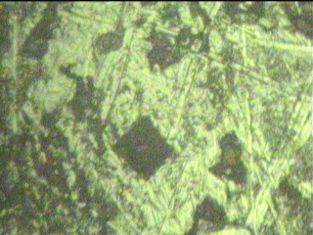

**Fig 4.6 Vickers pyramid indentation**

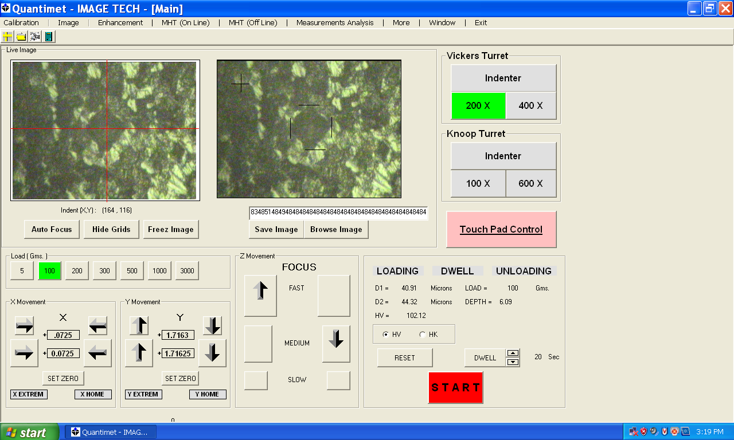

Fig 4.7 Vickers hardness measurement

At 200 X magnifications and at 100 gms Load, the following hardness profile was obtained:

Fig 4.8 Hardness variation

By observing this hardness variation width of HAZ was came around 6mm.

This can be validated by **Masubuchi** model.

According to the Masubuchi model, the peak temperature $T_{p}$ at any distance y from weld line is shown below:

$\frac{1}{T_{p}-T_{0}}$ = $\frac{(4.13*ρ*C*t)}{H}$\*y + $\frac{1}{(T_{m}-T_{0)}}$ (4.1)

Where $T_{0}$ =initial temperature of plate = ${25}^{0}c$

$T_{m}$ = Melting temp of steel ${1510}^{0}c$,

ρ = density($g/{{mm}^{3}}$)

c= specific heat of steel ($j/{g0_{C}}$)

ρ\*c= .0044 ($j/{{ mm}^{3}0_{C}}$)

t= plate thickness

H= heat input = ƞ\*V $\frac{I}{S}$

\*

ƞ = heat transfer efficiency=0.9

V-arc voltage

I-current

S-welding speed

So substituting all these values,

Here t $= \frac{ t_{1}+t_{2}}{2}$ = 0.95 mm

V=240v, I=25 amp,

S = $\frac{welding length}{time}$

= 5.5 ${mm}/{sec}$

H $= \frac{0.9*240*25}{5.5}$ =981.81 $j/{mm}$

We assume at boundary of HAZ the temperature $T_{p}$ was given by ${730}^{0}c$ i.e close to eutectic temperature for low carbon steels,So the width of HAZ will be

$\frac{1}{(730-25)}$ = $\frac{4.13*.0044*.95}{981.8}$\*y +.00067, i.e y= 4.25mm ,

i.e $y_{HAZ}$ =2\*y =8.5mm

**Chapter-5 Conclusion**

1. Theree is a overall increase in strength of TWB compared to parent metal, but Formability is considerably reduced.
2. The Springback values of transverse welded blank are closer to that of parent metal having lesser Springback in case of thickness combination.
3. The variation of Springback of Transversely welded blanks with punch profile radius shows same trend as in case of parent metal i.e. with increase in punch radius , Springback increases as the material is strain hardened to lesser extent while bending.
4. The Experimental predictions of Springback are validated by simulation results from Abaqus.
5. The effect of HAZ of welding on Springback was determined. i.e with increase in width of HAZ ,Spring back Decreases as Flow stress reduces.
6. Stress relieving reduces the flow stress further and hence spring back is reduced but the more pronounced effect is seen in GTAW- Tailored Blank. As the HAZ is more and width of the bead is also more.
7. In GTAW TB the height of the bead causes the displacement of the sheet more towards the thicker side and hence the weld line is getting shifted. Die design is extremely difficult.
8. Spring back is seen more on the thinner side sheet and almost negligible in thicker side.
9. Variation of Hardness was determined by Vickers Hardness test and width of HAZ was determined, which was validated from Masubuchi model.
10. GTAW should be automated while tailoring blanks of different thicknesses otherwise the weld width may not remain constant.
11. Laser welding seems to be a better option as compared to GTAW for making TWBs for high production rate and convenient die design.

**5.1 Scope for Future work:**

1. Anisotropic properties of the sheet metal can be incorporated in material model of FEA.
2. Springback analysis can be done for sheets welded longitudinally and effect of weld orientation can be further studied.
3. Springback analysis can be done for U-bending and U-draw bending operations which are very common in automobile industries.
4. 3D model simulation with biased mesh can be done for better accuracy.
5. Precise controls can be developed for press operation while experiments.

**REFERENCES**

1. Abaqus CAE 6.9.3 Help manual
2. A.L. Wenner , “On work hardening and Springback in plane strain draw forming”, journal of applied Metal working, volume 2,1983,pp.277
3. E8M-04 : Standard test methods for Tension testing of materials
4. F. Gardiner ,” The Springback of metals”, Transactions of ASME, volume 77,1957,pp.1-9
5. Hisashi Kusuda et al,” Formability of Tailor welded blanks”, Journal of Material processing technology, volume 71,1997,pp.136-140
6. H.R. Shakeri,” Study of damage initiation and fracture in aluminium tailor

welded blanks made via different welding techniques”, Journal of light metals volume 2,pp 95-110

1. J. Lubahn et al, “Bending of an ideal plastic metal”, Trans. ASME, volume 72,1950,pp.201-208
2. J.Tusek ,” welding of blanks of different materials” , Journal of material processing technology.vol 119(2001),pp.180-184
3. Mechanical Metallurgy by George E. Dieter, McGraw-Hill inc.
4. P. Dadras et al, “Plastic bending of work hardening materials”, Transactions of ASME, 104,1982
5. Rajashekhar S. Sharma,” Yb:YAG laser welding of TRIP780 steel with dual phase and mild steels for use in tailor welded blanks”, Journal of materials and design,vol- 30 (2009) 4146–4155
6. R. Hill ,”The Mathematical theory of plasticity”, Oxford, London, 1950.
7. R. Padmanabhan,” Effect of anisotropy on the deep-drawing of mild steel and dual-phase steel tailor-welded blanks”, Journal of material processing technology.vol- 184 (2007) ,pp.288–293
8. S.M. Chan et al,” Tailor-welded blanks of different thickness ratios effects on forming limit diagrams”, journal of Material processing and Technology volume 132 (2003),pp. 95–101
9. Sung Ho Chang,” Springback characteristics of the tailor-welded strips in U-bending”, Journal of material processing technology.vol-130(2002),pp.14-19
10. Welding Technology and design-V.M. Radhakrishnan, third edition 2010, New age publ, pp-464
11. W.F. Hosford et al,”Metal forming Mechanics and Metallurgy”, 2nd edition ,1993, PTR Prentice hall , pp.257-267
12. W.M. Chan,” Finite element analysis of spring-back of V-bending

sheet metal forming processes”, Journal of material processing technology.vol-148(2004),pp.15-24

1. YOU-MIN HUANG,” Effects of process variables on V-die bending process of Steel sheet”, Journal of material processing ,vol-40,

pp.631-650