M.E THESIS 2009
CHANDRAJEETMEENA
09/E&C/07
M.E THESIS 2009
AN ITERATIVE APPROXIMATE MAP SYMBOL ESTIMATORFOR UNCODED SYNCHRONOUS CDMA

An Iterative Approximate MAP Symbol Estimator
for Uncoded Synchronous CDMA
A DISSERTATION
SUBMITTED IN PARTIAL
FULFILLMENT OF THE REQUIREMENT FOR THE
AWARD OF THE DEGREE OF

MASTER OF ENGINEERING
IN
ELECTRONICS AND COMMUNICATION
BY
CHANDRAJEET MEENA
ROLL NO. 12268


DEPARTMENT OF ELECTRONICS AND COMMUNICATION
DELHI COLLEGE OF ENGINEERING
SHAHBAD DAULATPUR, BAWANA ROAD DELHI-110042
CERTIFICATE
This is to certify that the dissertation entitled “An Iterative Approximate MAP Symbol Estimator for Uncoded Synchronous CDMA ” submitted by CHANDRAJEET MEENA, ROLL NO. 09/E&C/07, is being submitted to the University of Delhi towards the partial fulfillment for the degree of Masters of Engineering in ELECTRONICS AND COMMUNICATION. To the best of my knowledge the work in this dissertation has not been submitted in part or full for any other degree or diploma in any other college or university.
Prof. P.R.CHADHA
Assistant Professor
Department of Electronics
& Communication Engineering
Delhi College of Engineering
Delhi-110042
Prof. Asok Bhattacharyya
Head of Department
Department of Electronics
& Communication Engineering
Delhi College of engineering
Delhi-110042

ACKNOWLEDGEMENT
This work was made possible by the kind supervision and guidance from Prof P.R. Chadha Assistant Professor in the Department of Electronics & Communication Engineering. I take this opportunity to express my sincere gratitude to him.
Prof Asok Bhattacharyya the Head of Department of Electronics and Communication Engineering has been constant source of inspiration. I owe special thanks to him.
I am also grateful to the kind support provided by other faculty members and non teaching staffs were very cooperative and helpful in providing support to complete the project.

CHANDRAJEET MEENA

ABSTRACT
This thesis proposes an iterative algorithm for multiuser detection in uncoded synchronous code division multiple access communication systems based upon an approximate maximum a posteriori (MAP) formulation. For symbol estimation in the continuous domain, direct use of the a priori symbol distribution in the estimation process is prohibited because it is not differentiable. The proposed algorithm approximates the discrete finite alphabet symbol distribution by a sum of continuous Gaussian distributions centered at the true values of the symbol constellation. This approximation allows the development of a gradient based iterative MAP estimator that employs the structure of the particular symbol constellation to improve estimation accuracy. Although iterative, the proposed method does not use a tentative solution from another multiuser detector. Simplifications of the proposed algorithm for constant modulus modulation and its special forms for M-ary phase-shift keying are given. Also, an optimum step size is derived to achieve fast convergence. The performance of the proposed algorithm is shown to outperform other well-known multiuser detectors such as minimum mean square error, the decorrelator, and the multistage hard-decision parallel interference canceller, especially for the near/far scenario.

Index Terms—Code division multiple access (CDMA), maximum a posteriori (MAP) estimation, multiuser communications, multiuser detection.

List of Contents
CERTIFICATE (i)
ACKNOWLEDGEMENT (ii)
ABSTRACT (iii)

CHAPTER-1 (1)
REVIEW OF CDMA SYSTEM

1.1 Introduction (2)
1.2. Vulnerabilities and Challenges (5)
1.2.1 Modeling the Discrete Symbol constellation (7)
CHAPTER-2 (11)
Leaving Optimality By Graceful Degradation
2.1 The Communications Channel (13)
2.2 Diversity (18)
2.3 Code Division Multiple-Access (20)
2.4 Transmitter Structure (24)
2.5 Transmission Models (26)
2.5.1 Model for Detection in Flat Fading Channel (26)
2.5.2 Model for Detection in Frequency Selective
Channel (27)
2.5.3 Model for Channel Estimation in Frequency
Selective Channels (29)
2.6 Definition of E_{b}/N₀ (31)
2.7 The Optimum Receiver (32)
2.8 Suboptimum Receivers (34)
2.8.1 Multi-User Efficiency (36)
2.8.2 Separation Theorem (37)
2.9 Iterative Multi-User Receiver (38)
2.9.1 Interpretation (39)
2.10 Decoding (40)
2.11 The MAP Decoding Algorithm (42)
2.11.1 Soft Decision Data (49)
2.11.2 Impact of Fading (50)

CHAPTER-3
Iterative Multi-User Detection (52)
3.1 Overview (53)
3.2 Optimum Multi-User Detection (54)
3.3 Linear Multi-User Detection (56)
3.4 Parallel Interference Cancellation (PIC) (57)
3.4.1 Single-User Matched Filter (SUMF) (58)
3.4.2 Matched and Mismatched Detectors (58)
3.4.3 Filter Output Distribution(59)
3.4.4 SINR of PIC-SUMF Detector in Flat Fading (59)
3.4.5 SINR of PIC-SUMF Detector in Frequency
Selective Fading (60)
3.4.6 Linear MMSE Filter (LMMSE) (61)
3.4.7 PIC-LMMSE Detector for Flat Fading (61)
3.4.8 PIC-LMMSE Detector for Frequency Selective
Fading (64)

3.4.9 Low Complexity Implementation of the PIC-
LMMSE Detector (65)
3.5 Successive Interference Cancellation (SIC) (67)
3.5.1 Single-User Matched Filter (SUMF) (68)
3.5.2 Linear MMSE Filter (LMMSE) (69)

Chapter 4
ANALYTICAL AND SIMULATION RESULTS (70)
4.1 Simulation (71)
4.2 Analysis (71)
4.3 Assumptions (74)
4.4 Innovation (74)
4.5 Conclusion (77)

ACRONYMS (78)
NOTATION (81)
VARIABL (84)
LIST OF FIGURE (86)

REFERENCES (88)
ABSTRACT
This thesis proposes an iterative algorithm for multiuser detection in uncoded synchronous code division multiple access communication systems based upon an approximate maximum a posteriori (MAP) formulation. For symbol estimation in the continuous domain, direct use of the a priori symbol distribution in the estimation process is prohibited because it is not differentiable. The proposed algorithm approximates the discrete finite alphabet symbol distribution by a sum of continuous Gaussian distributions centered at the true values of the symbol constellation. This approximation allows the development of a gradient based iterative MAP estimator that employs the structure of the particular symbol constellation to improve estimation accuracy. Although iterative, the proposed method does not use a tentative solution from another multiuser detector. Simplifications of the proposed algorithm for constant modulus modulation and its special forms for M-ary phase-shift keying are given. Also, an optimum step size is derived to achieve fast convergence. The performance of the proposed algorithm is shown to outperform other well-known multiuser detectors such as minimum mean square error, the decorrelator, and the multistage hard-decision parallel interference canceller, especially for the near/far scenario.

Index Terms—Code division multiple access (CDMA), maximum a posteriori (MAP) estimation, multiuser communications, multiuser detection.

CHAPTER-1
REVIEW OF CDMA
SYSTEM

1.1 INTRODUCTION

With ongoing integration of electronic circuits and growing computational power, mobile digital communication systems of the second generation became a mass product in the 1990s. GSM (Global System of Mobile Communications) and IS-95 (Interim Standard 95) are representatives of this generation. Typical net data rates are in the order of 13 kb/s and with the help of advanced techniques like EDGE (Enhanced Data Rate for Global Evolution) maximum theoretical data rates of 473.6 kb/s are possible. The advent of the Internet at around the same time triggered applications like MP3 file sharing, Voice over IP (VoIP), web browsing, video telephony, and mobile data services. The evolution of wireless technology as show in fig 1.1
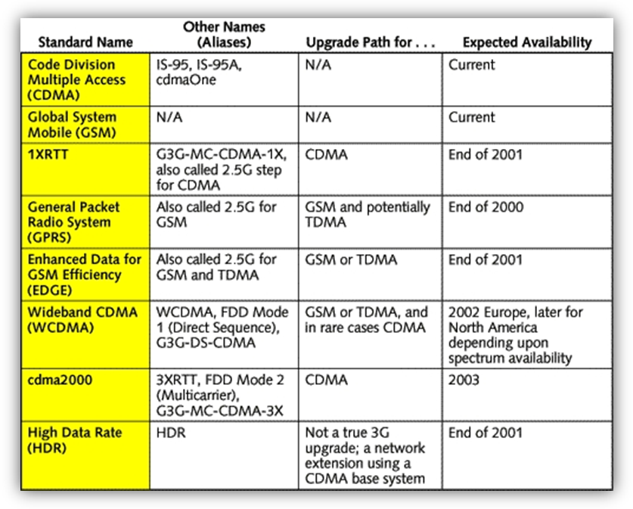
Figure1.1 Evolution Of Wireless TECHNOLOGY

These demands were considered in the design of the third generation of mobile communication systems including UMTS (Universal Mobile Telecommunication System) in Europe, CDMA2000 (Code Division Multiple-Access 2.000MHz) in the US, and TD-SCDMA (Time Duplex – Space CDMA) in China. UTMS is a commercial multi-user communication system based on CDMA allowing net-data rates up to 384 kb/s per user (Release 99). The basic limitations in the supportable data rates are imposed by multiple-access interference: every user causes noise for the reception of every other user. Since the computational complexity of systems of the third generation is several hundred times higher than those of the second generation [Sar03], system manufacturers are striving to implement the simplest solutions rather than those supporting highest system capacity. This currently casts the promise of high data rates in a multi-user scenario as an illusion rather than a reality. There are, however, sophisticated techniques that can change this situation. One of them is iterative receivers that are the topic of this thesis.
The challenge in mobile communications is the mitigation of interference and distortions that are introduced on the mobile radio link during transmission. These are path loss, shadowing, doppler shift, inter-symbol interference due to multipath propagation, multiple-access interference, and noise. The propagation medium represents a time-variant system that influences communications. In order to process information in an optimum way the parameters describing the channel are required at the receiver. To characterize the channel, so-called sounding or training sequences, known to the receiver, are sent together with the data. These enable estimation of the channel characteristics at moderate cost.
The system capacity in wireless communications is limited by multiple-access interference that is introduced by other users sharing the same resources. Classical receivers, based on the Rake concept, model the interference as a white Gaussian process and do not combat cross-correlation terms from other users. Rake reception is currently the most widely used technology in CDMA but far from the optimum. Interference has a structure and can be mitigated effectively in a receiver. This thesis is devoted to a promising concept based on an iterative receiver structure. In contrast to classical approaches, where detection and decoding are performed successively in a so-called one-shot manner [Ver98], iterative receivers exchange probabilistic quantities and approach the actually transmitted information gradually. Out this work we deal with the uplink, that is, the receiver in the base station, detecting individual user streams from a commonly received signal. iterative receivers are considered in connection with CDMA systems.
However, most concepts can equally be applied to other multiple-access schemes like OFDM, MC-CDMA, or TDMA. as show in fig 1.2
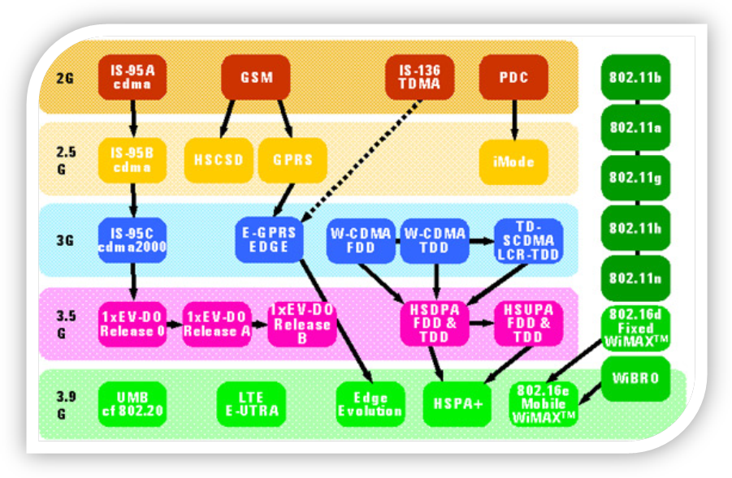
Figure1.2 Digital Wireless Evolution 1990 To 2010

In a code division multiple access (CDMA) communication system, the transmitted signals from different users simultaneously occupy the same frequency band and hence act as multiple access interference (MAI) to one another. The base station receiver is then required to separate the received user signals in order to determine the individual data transmitted by each user. This is accomplished by exploiting each user’s known signature code. This work considers the case of synchronous reception of user signals in which the received signature codes, each modulated by some data symbol, are aligned in time. The generalization of the proposed approach to asynchronous symbol reception can be made by direct extension.

1.2. Vulnerabilities and Challenges
IN a code division multiple access (CDMA) communication system, the transmitted signals from different users simultaneously occupy the same frequency band and hence act as multiple access interference (MAI) to one another. The base station receiver is then required to separate the received user signals by exploiting each user’s signature code in order to determine the transmitted symbol by each user Here we have assumed that it is a flat fading channel (single tap). Each user’s binary data is mapped into one of M predetermined complex symbols. The complex symbols are denoted as where iindicate the distinct symbol for each of the k = 1, 2, . . . , K users and n is the symbol time index. denotes the channel tap coefficient (between 0-1) for the user. is the signature code (length N) of the user. We consider an additive white Gaussian noise (AWGN) channel with frequency nonselective fading. z is a white Gaussian noise.
The received signal sampled over the chip rate in single symbol period is
$$r=\sum_{k=1}^{K}{λkdk\underline{s}}k+z=\left[S\right]\left[Λ\right]d+z$$
Here S is a code matrix as, Λ,
is the collection of all K users’ transmitted symbols that are in general complex.
The conventional approach or matched filter (MF) estimates received symbols as
$$\hat{d}\text{MF}=y={\left[s\right]}^{H}r$$
The MF performs poorly when the cross correlations between user signature codes are high, when there are a large number of simultaneous users.
As our algorithm performs the MAP detection hence it will do the differentiation over the a priori probability for maximization of a posteriori density function, hence for this purpose at the receiver we approximate the discrete symbol constellation by the symbol centered Gaussians whose variance depends on two factors one is the signal to noise ratio and other is distance of the received symbol from the actual value. Here we termed this variance as the user variance.
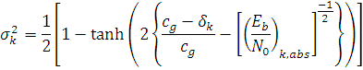
Where = and and is the kth users iterated value.

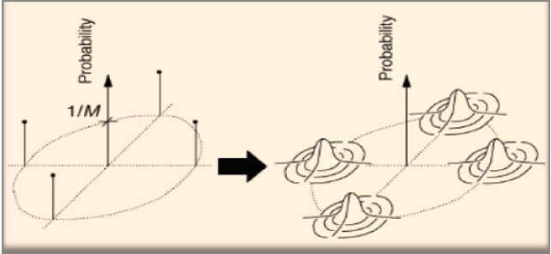
Figure 1.3: Approximating The Discrete Symbol Constellation With Symbol Centered Gaussians

Hence now the pdf of the constellation is differentiable and can be combined with the likelihood function.
$$p\left\langle r | d\right\rangle ={\left(\frac{1}{\text{πσ}z^{2}}\right)}^{{}^{N}}\text{exp}\left[\frac{−1}{{σz}^{2}}\left(r−\left[S\right]\left[Λ\right]d\right)\right]$$
to get the a posteriori density function

1.2.1 Modeling the Discrete Symbol Constellation
Here I am giving only those expressions which are used in the algorithm for the estimation of symbols. The complex Gaussian distribution centered at the symbol value for user k is
$$p\left\langle dk | gi\right\rangle =\frac{λ^{2}k}{\text{πσ}k^{2}}\text{exp}\left[\frac{−1}{σk^{2}}{\left(λkdk−λkgi\right)}^{}\left(λkdk−λkgi\right)\right]$$
Now assuming that all the symbols are equally likely and constellation is M-ary psk

the a priori pdf of the user is
$p\left\langle dk\right\rangle =\frac{1}{M}\sum_{i=1}^{M}{\frac{λ^{2}k}{\text{πσ}k^{2}}\text{exp}\left[\frac{−1}{σk^{2}}{\left(λkdk−λkgi\right)}^{}\left(λkdk−λkgi\right)\right]}$
Finally because symbols from different users are independent, the a priori pdf of the collection of all the K users is
$$p\left\langle d\right\rangle =\prod_{k=1}^{K}{p\left(dk\right)}$$
Now using the likelihood function given above we get the expression for the a posteriori density function as
$$\begin{aligned}J_{\text{MAP}}\left(d\right)=\text{exp}\left[\frac{−1}{σ^{2_{z}}}{\left(r−\left[\tilde{S}\right]d\right)}^{H}\left(r−\left[\tilde{S}\right]d\right)\right]×\prod_{k=1}^{K}{\left[\sum_{i=1}^{M}{h_{k}\left(g_{i}\right)}\right]} \\ \end{aligned}$$
where and $h_{k}\left(g_{i}\right)=\text{exp}\left[\frac{−λ_{k^{2}}}{σ_{k^{2}}}{\left(d_{k}−g_{i}\right)}^{}\left(d_{k}−g_{i}\right)\right]$
now the derivative of J_{map} is
$$∇J_{\text{MAP}}\left(d\right)=\frac{J_{\text{MAP}}\left(d\right)}{σ_{z^{2}}}\left(y−\left[Q\right]d+σ_{z^{2}}{\left[Σ\right]}^{−1}\left[Λ^{2}\right]β\right)$$
Where
$${\tilde{β}}_{k}=\frac{\sum{g_{i}h_{k}}\left(g_{i}\right)}{\sum{h_{k}}\left(g_{i}\right)}$$
$$\left[Σ\right]=\text{diag}\left(σ_{1^{2}},…,σ_{K^{2}}\right)$$

Now to get the maximum value of d we have to get the solution of the equation
This is not easy to calculate hence we use the steepest ascent structure to find the gradient and to maximize the approximate a posteriori density function.
The performance of this iterative method increases immensely when we use the adaptive step size
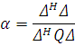
Where
Δ=
Multiuser detection approach based on MAP estimation in which the discrete pdf of the symbol constellation in the transmitter is approximated by a continuous pdf at the receiver that is comprised of complex Gaussians centered at the true symbol values. This continuous pdf is combined with the likelihood function under AWGN channel with frequency nonselective fading to generate a differentiable Approximate MAP cost function. The solution that maximizes the approximate MAP cost function is then attained iteratively to yield levels of BER that are dramatically lower than other standard techniques. The extension of the proposed algorithm to frequency selective fading is a subject for further study and will be reported elsewhere.
The proposed algorithm is based on gradient search and is applicable for any modulation constellation. Also, an optimum step size is derived to speed up convergence. The gradient component and the optimum step size are greatly simplified for constant modulus constellations such as M-PSK, and the specific forms of the MAP algorithm for BPSK, QPSK, and 8PSK are developed. For BPSK modulation at 14 dB and 8PSK at 16 dB E_{b}/N_{o}, and 33 users of the same power, the proposed algorithm reduces the bit error probability by more than an order of magnitude compared to the MS hard-decision PIC detector.

CHAPTER-2
Leaving Optimality
By
Graceful Degradation

This chapter is devoted to the development of iterative receivers as a suboptimal solution to the problem of optimum maximum a-posteriori (MAP) multi-user processing. We start with an introduction to the mobile wireless channel, illustrate the vital concept of diversity, and explain code division multiple-access (CDMA). Then, we present the transmission models and deal with channel decoding. The assumptions that hold for this work are summarized in the following - they are stated in detail in the remaining parts of this chapter.

1. Uplink of a multi-user CDMA system operating in burst mode.
2. Chip and symbol synchronous transmission model.
3. Pulse shaping filters of the chips are not considered.
4. Short random signature sequences for data spreading.
5. Perfect power control. Only small scale fading is considered.
6. Block Rayleigh fading channel with independent taps.
7. No frequency offsets due to Doppler or oscillator mismatch.
8. Perfect synchronization at the receiver.
9. Convolution encoding of information streams.
10. Random interleave.

2.1 The Communications Channel

The transmission of information through electromagnetic waves is influenced by large number of environmental effects that cause fading of the instantaneous received power. These effects can be classified into two categories: large-scale and small-scale effects. An example of fading, the variation in receive power, is shown in Fig. 2.1. The fading was generated by a geometry-based stochastic channel model [Hof04a] for an urban environment and carrier frequency
f_{C} = 2GHz. The received power is plotted versus the distance between the transmitter and the receiver. The smoothed curve corresponds roughly to large scale fading and the residual to small scale fading. We will treat aspects of large scale effects first and then draw our attention to the small scale effects. When waves propagate in free space their power is spread along a surface that has a distinct distance from the transmit point. The power density decreases inversely to the n^{-th} power of the distance
P(d) ∝ d^{−n}
Figure 2.1: A realization of received power as function of the distance between transmitter and receiver for an urban environment and carrier frequency f_{C} = 2GHz.

and we call this reduction in power path loss, where n is the path-loss coefficient. In free space, a transmit antenna with Omni-directional radiation pattern has the value n = 2. Due to reflections, refraction, and scattering in terrestrial communications, the path loss coefficient is typically between two and six.
Path loss is one component of large-scale fading; another is shadowing. This means that the receiver whose direct line of sight (LOS) is obstructed receives energy by reflection and refraction, which causes significant variation of receive power over a relatively long time period. Typically, large scale effects have slowly changing characteristics and can be counteracted in communication systems by means of power control. In this thesis it is assumed that the variations caused by large scale fading are compensated perfectly. Small scale fading is much more severe. It has fast varying characteristics and cannot be counteracted with power control. Small scale fading is the result of a multitude of impinging wavefronts that interact
Constructively as well as destructively. This causes an interference pattern with maxima and minima that are separated by a distance in the order of λ/2 from each other with λ denoting the wavelength of the carrier signal. The best known model for small-scale fading is the Rayleigh fading model. Imagine that the transmitter is located in one of the two focal points of an ellipse and the receiver is in the other focal point. Further we assume that there is no direct LOS component. All received wavefronts with the same propagation time are generated by scattering that lies on the ellipse. At the receiver they mingle together to one single concentration of effective receiver power. According to the central limit theorem the superposition of all these complex valued contributions has amplitude that is Rayleigh-distributed,
i.e., has the probability density function (pdf)

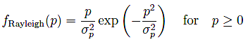

Scattering contributions that can be attributed to a larger ellipse cause an energy concentration at some later point. In general the contributions decay when they have longer delays. The temporal dispersion is characterized by either the distance between the first and the last contribution, the maximal delay, or the square root of the second central moment of the power delay profile, referred to as root mean square (rms) delay spread .The emerging small scale fading channel is described by its temporal impulse response
h(τ )¹. In the following we associate delay spread τ_{D} to the continuous representation and maximum delay L to the discrete case. The discrete version of the channel is obtained via sampling at period T_{C}

h[n] = h (nT_{C})

Where T_{C} denotes chip duration. The associated signal bandwidth is given through B = 1/T_{C}. The channel is described as a sequence of length L
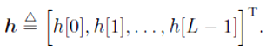
This allows a convenient representation of the received signal y[n] as the result of a finite convolution
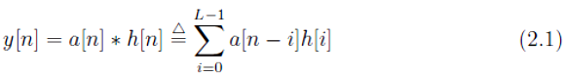
1In this section time indices in parentheses (·) indicate continuous time and brackets [·] imply discrete time.

Where * is the time discrete convolution and a[n] the transmit signal. Since the filtering (2.1) can be modeled by a tapped delay line, the individual weighting coefficients h[n] is called taps.
The statistical properties of the small scale fading can be expressed by its power delay profile (PDP) and its time-variation. The PDP reflects the strength of the arriving paths and is defined as

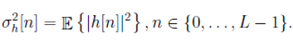

Contributions arriving at later time instances have less power in average due to the larger propagation distance. A model for a PDP with exponentially decaying power is presented in the COST259 initiative. Fig. 2.2 illustrates its PDP for rms delay spreads of 30, 9 ns and 154, 7 ns. The range of the corresponding maximum delays is up to 200 ns for indoor environments and typically up to 1 μs for outdoor environments.
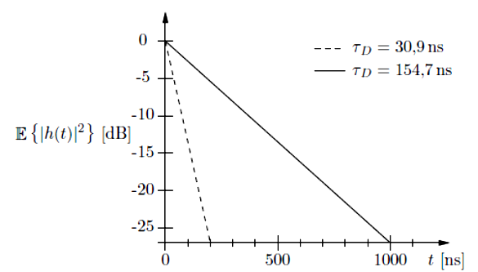
Figure 2.2: Exponentially decaying power delay profiles according to COST259 with different rms delay spreads τ_{D}.

To compare the average performance results over a set of fading channel realizations for different users we make use of the following normalization, formulated for a system with multiple receive antennas NR:
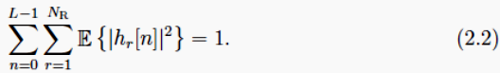

The time-variation of a channel is initiated by either a movement of the scattering, motion of the receiver, motion of the transmitter, or a combination of any of the three. When fixing the position of the transmitter and the scattering, we can view the variation of the channel as a motion through a pattern of standing waves.
This model uses h(τ, t) for the channel to reflect its variation in a second temporal variable t. Bello’s model assumes that the taps are
1. wide-sense stationary (WSS) with respect to t
2. And that scattering contributions attributed to different propagation paths are mutually uncorrelated (uncorrelated scattering – US) leading to independent realizations of each tap, modeled by complex Gaussian random variables.
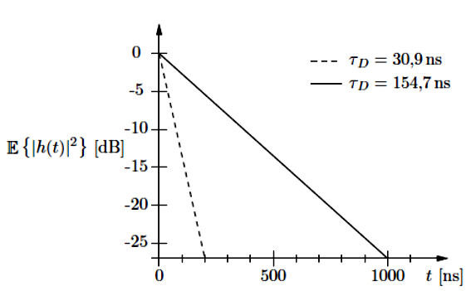E
Figure 2.2: Exponentially decaying power delay profiles according to COST259 with different rms delay spreads τ_{D}.

A widely used model for the resulting Doppler power spectrum from above conditions is the Jakes’ model [Jak75]. Its autocorrelation for transmitting in a plane is given by

With J₀(·) denoting the Bessel function of first kind and zero^{th} order. Particularizing to the interesting case τ₁ = τ₂ we obtain the characteristic U-shaped power spectral density
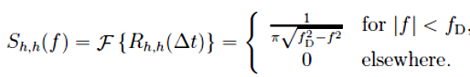
The variable f_{D} designates the Doppler frequency given by

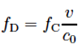

Where f_{C} is the carrier frequency, v the maximum relative speed between transmitter and receiver, and c₀ the speed of light.

2.2 Diversity

The ability to exploit information on transmitted data from more than one transmission path is called diversity. Employing diversity on a wireless link increases the reception quality. As we will see shortly, the concept of fading is instrumental to mobile communications. Instead of relying on rapid fading as it is the case in a flat fading environment, temporal replicas can be exploited to stabilize the receive power level. The same concept is feasible for combining spatially separated information sources like in multiple-antenna reception. Different information sources x_{l} are combined via the maximum ratio combining (MRC) criterion, maximizing the SNR of the joint information x [Bre59]:
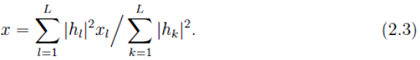
MRC implies that all sources are weighted by their SNR γ_{l} = |h_{l}|²/σ_{v}²
before combining. The random variable of power |h_{l}|² of one single Rayleigh fading tap with variance σ²_{h,l} is χ² (“chi-square”) distributed. An MRC-combination of L equal power paths has a χ²-distribution with 2L degrees of freedom. The corresponding pdf reads
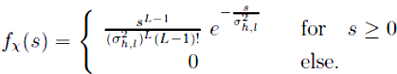
Using QPSK modulation and Gray coding we obtain the bit error rate (BER)
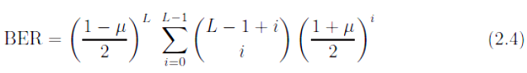
When L equal power Rayleigh taps are MRC combined with
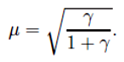
The variable γ is the SNR of a single path. A generalized expression for paths with unequal power can be found in [Alo99]. The lower bound for the BER of un coded transmission is given for the case of an additive white Gaussian noise (AWGN) channel. It reads
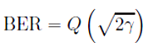
Where Marcum’s Q(x) function is given through
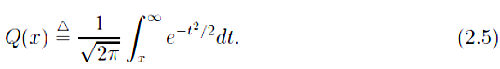

Fig. 2.4 shows BER curves for different orders of diversity. Two extreme cases can be identified. The first one is when no diversity is available where L = 1 and is considered as worst case. The best case is when L → ∞. This channel becomes an AWGN channel with diversity order infinity [Jak75]. The difference in terms of BER is tremendous. The worst case achieves a BER of 10⁻³ at an E_{b}/N₀ of 24 dB while for the best case the same BER is already earned at 7 dB. The implication is that the ability to transmit at low values of E_{b}/N₀ is made possible through exploitation of diversity. Diversity causes a steeper slope in the BER vs. E_{b}/N₀ curve. Increasing the diversity order by one causes an improvement in BER by a factor of ten over a segment of 10 dB in E_{b}/N₀ [Pau03]. However, this holds only for uncorrelated channels taps. In case of correlation among taps the diversity order is reduced.

2.3 Code Division Multiple-Access

This work deals with code-division multiple-access (CDMA). CDMA is the basic technology of the third and most likely also the fourth generation wireless communication system. It is a spread spectrum technology where narrow-band information with bandwidth B′ = 1/T_{S} is spread to a wider bandwidth B = 1/T_{C} by the factor N = B/B′ = T_{S}/T_{C}. The advantages that are brought in by spreading allow for the utilization of the following features:

1. Flexibility in the allocation of variant data rates.

2. Flexible support of different number of users with various data rates.

3. Means to resolve multi-path components and to exploit temporal diversity.

4. Facilitates support of macro diversity for receiving information from different sources.
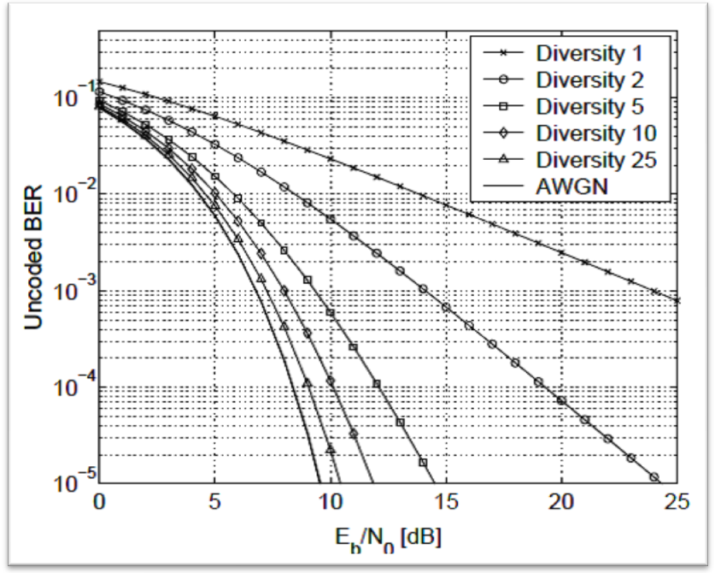
Figure 2.3: Influence of diversity on the bit error rate.

Users transmit data in the same frequency band simultaneously. Distinction between users is based on individually assigned sequences (signatures, codes) with which the transmitted information is spread in bandwidth. Users perceive other users as an increase in their noise floor. The more users are in a system, the higher is the multiple-access interference (MAI), i.e., the distortions introduced by other users due to cross-correlations between the signatures. The basic relation in the noiseless case is given by

With the matrix of signature sequences [Ver98]

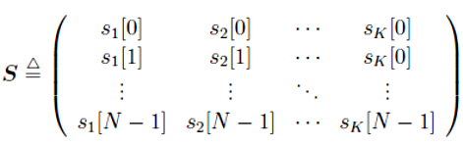

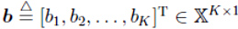
The matrix S is of dimension N ×K and has independent and identically distributed (i.i.d.) entries from the set {±1±j}/√2N. The number of users is K and N denotes the spreading factor. The k-^{th} column corresponds to the spreading sequences s_{k} ∈ C^{N×1} of user k and fulfils the energy constraint ||s||² = s_{k}^{H} s_{k} = 1. The transmitted symbols are stacked vertically in the vector
with X denoting the set of normalized QPSK symbols {±1±j}/√2. The symbols can be reconstructed by convolving the corresponding matched filter (0,…..N-1} with the receive signal y[n], n ∈ {0, . . . ,N − 1}. Practically, this operation is implemented as correlate performing chip-wise multiplication of the received signal y[n] and s_{k}*[n], n ∈ {0, . . . ,N−1}. For convenience the vector s_{k} is called the single-user matched filter in this work instead of the implementation of the single-user matched filter. In matrix notation symbol detection for all users is conveniently expressed as
and R ∈ C^{K×K} denoting the correlation matrix. With this detection method the transmitted information can be restored if R is diagonal. Off-diagonal terms in R indicate interference across users which can lead to errors. With a spreading factor of N one can select up to N orthogonal spreading sequences for which no errors are introduced in the noiseless case. In this context it is interesting to define the system load α denoting the ratio of users K to the spreading factor N
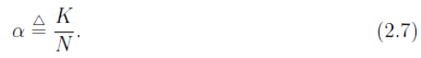
Hence, a maximal load of α = 1 can be supported by orthogonal spreading sequences. However, due to multi-path propagation, the orthogonality is lost during transmission. To demonstrate this, let us define the virtual spreading sequence as the convolution of spreading sequence and the true channel
It has length N + L − 1. Virtual underlines the idealization of perfect channel
Knowledge at the receiver. Practically, the channel is estimated and will be denoted by ĥ_{k}[n]. When the estimated channel is applied in the convolution (2.8) together with the known spreading sequence s_{k}[n], we obtain the effective spreading sequence
Concerning the influence of the channel for one single symbol transmission we notice that it is possible that
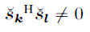
even when the associated sequences were orthogonal s_{k}^{H} s_{l} = 0 for at the transmit side.
2.4 Transmitter Structure
This thesis treats multi-user receiver for two transmitter structures: the first is a general setup that allows for a compact mathematical representation with freely chosen components and the second is compliant with the UMTS standard. The UMTS standard is revised and the adoptions to the standard are presented. The general transmitter structure is depicted in Fig. 2.4. It shows the signal generation for user k with the propagation channel from one transmit antenna to one receive antenna at the base-station. We stick to the following convention concerning discrete time indices: parentheses (·) indicate timing on a symbol level while brackets [·] refer to chip instances. We consider block transmission with M symbols, where the data symbols are QPSK modulated. The first J symbols b_{k}(m),m ∈ {0, . . . , J − 1} of each block are reserved for the pilot chip sequence uk[n] with length JN. The remaining M − J symbols b_{k}(m),
m ∈ {J, . . . ,M − 1} are data symbols. Pilot symbols are integrated in the transmitted block in order to conduct parametric channel estimation. In contrary, a non-parametric approach would not aim at directly estimating the channel but rather at using the pilots to train the equalizer. We will only consider parametric approaches. The channel can be estimated at the receiver with a known sequence of pilot symbols. The pilots are either a unique chip sequence or generated by a symbol sequence that is spread with the same signature sequence as the data.

A block is generated by encoding 2(M−J) R_{C} bits with equally likely information symbols d_{k}(m′′) ∈{0, 1}. The code of user k is denoted as C_{k} and its rate is R_{C}. Coding results in the code bit stream c_{k}(m′) ∈ {0, 1} of length 2(M − J) and is applied in order to introduce redundancy that allows forward error correction (FEC) on the receive side in case of erroneous transmissions.. After the encoder we pass on the code bit stream to a random interleaver. The interleaver is usually applied to alleviate the effect of burst errors that are introduced through fading on a time-variant channel or through bursty interferers. Interleaving is conducted by shuffling the encoded bits within the block prior to transmission. In case of block constant fading and encoding over a single block there is no gain to be expected due to the interleaver. Still, the interleaver is required to resolve the statistical dependencies among symbols that are introduced by the code. This will be a crucial property in the derivation of the interference suppression filters in Sections 3.4 and 3.5. The symbols are then mapped to a QPSK symbol constellation such that b_{k,code}(m) ∈ X. Let F be the set of binary symbols {0, 1}, then with the mapping
d_{k}(m′′) c_{k}(m′)
DATA
ENCODER
[n]

INTERL.
H_{K}[N]
S_{K}
MAPPER
MUX
b_{k}(m)
Other users

Figure 2.4: The transmitter modules and the channel for user k. rule
c ∈ F → c′ ∈ {−1,+1} : 0 → +1, 1 → −1
QPSK Gray labeling for the M − J data symbols reads

The pilot and data symbols b_{k}(m) are then spread with the sequence s_{k} before they are sent over the multi-path channel h_{k}. This transmission scheme resembles a serially concatenated convolution code, where the convolution code is the outer code and the multi-path channel takes on the role of an inner convolution code.

2.5 Transmission Models

In this section three transmission models for the uplink are presented. The first two models describe the transmission of one single symbol and they are used in the detector. They are devoted to the case when the channel is single path and multipath, respectively. The third model is used for channel estimation and represents the total observation vector in matrix form. We assume that symbol transmissions are synchronous. This is motivated in [Lam02, Tse00a] where it was shown that synchronous transmissions refer to worst case scenarios in terms of mutual interference. In other words, a general asynchronous transmission is expected to have a performance not worse the one that is achieved in the synchronous case.

2.5.1 Model for Detection in Flat Fading Channel

For a single path channel with L = 1 the transmitted signal of user k faces a
Stochastic, complex, multiplicative modulation due to the channel realization h_{k}. In the CDMA multi-user scenario the observation vector of length N that is associated with the m-^{th} symbol transmission reads

The symbols of the individual users are placed in the vector b(m) ∈ XK×1 as
[b¹(m), b²(m), . . . , b^{K}(m)]^{T}. They are modulated by the corresponding virtual
Spreading sequences š_{k}(m). The signatures are placed in the k-th column of the matrix š(m) ∈ C^{N×K}. The symbol index m reflects that the sequences can change from one symbol transmission to the next. When they change, they are called long spreading sequences, as in UMTS [TS25.213]. On the other hand if š(m) is constant for all symbols m, the sequences are termed short. The additive term v(m) ∈ C^{N×1} accounts for zero-mean noise with covariance matrix σ²_{v}I_{N}.

2.5.2 Model for Detection in Frequency Selective Channel

In case of multi-path propagation, characterized through a channel of length L, energy is spread over N + L − 1 chips. The observation vector y(m) needs to be extended to this length in order to capture all symbol energy and thus to achieve the best receiver performance. This observation vector is distorted by inter-symbol interference attributed to previous and future symbol transmissions. We restrict ourselves to the case 2 ≤ L ≤ N such that the number of previous as well as future symbols that affect the symbol of interest is one. The corresponding model for short sequences is formulated as
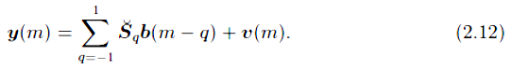

The partial influence of the last as well as the next symbol interval stretches over L−1 chips. Terms indexed by q = −1 in the sum above correspond to pre-cursor ISI caused by future symbols while terms indexed by q = +1 are related to post-cursor ISI. The matrices š_{q} ∈ C^{(N+L−1)×K} are attributed to previous, future, and current symbol transmissions. They are defined by

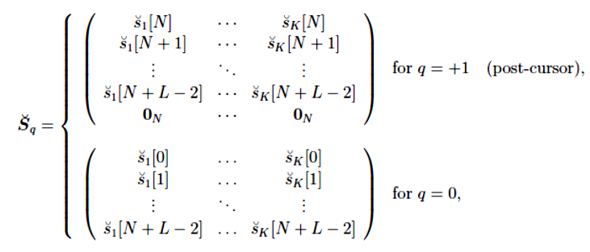

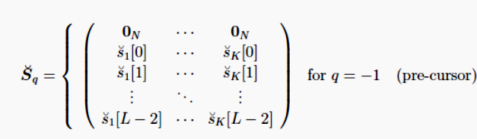
.
The additive term v(m) ∈ C^{(N+L−1)×1} denotes again the zero-mean complex noise with covariance matrix σ²_{v}I_{N}.

2.5.3 Model for Channel Estimation in Frequency Selective Channels

In contrast to detection where observation vectors are attributed to a symbol for time instance m we want to focus on a model that covers the samples of all symbols for a whole block. This is convenient for channel estimation since the estimate is retrieved from all the observation samples y∈C^{MN×1} together. Note that there is no explicit time dependency any longer like in (2.11) and (2.12) since all symbols are considered jointly now. The vector y is also used in the derivation of the optimum receiver in Section 2.7. A linear matrix model with an isolated channel vector h is given by
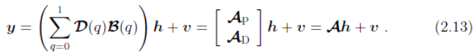
The middle expression with the matrices A_{P} and A_{D} stacked vertically reflects the contribution that is due to the dedicated pilot symbols A_{P}, typically at hand for the very first channel estimation. At the receiver the true data is not known. However, in an iterative receiver we can use the soft feedback symbols to replace the true A_{D}. In this way the quality of the channel estimates can be enhanced. The various quantities in the linear matrix model are described in the sequel:
- y ∈ C^{MN×1} contains samples in the chip-rate. The L − 1 chip samples after the block of MN samples are neglected in channel estimation.
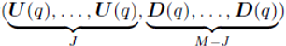
- D(q) ∈ C^{MN×MKL} is called the “delayed chip matrix”. It is block diagonal
and defined as diag where D(q) =
[D₁(q), . . . ,D_{K}(q)] ∈ C^{N×KL}. Let us define the following 2N ×L
Dimensional
auxiliary Toeplitz matrix
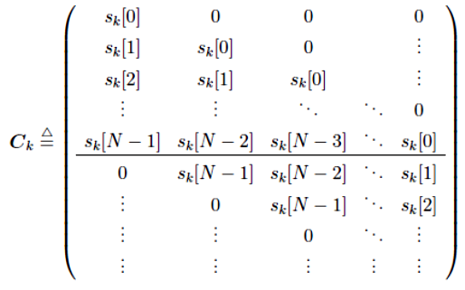

Where elements in C_{k} that are not covered by the shifted spreading sequence
are zero. The matrix D_{k}(q) contains the rows of C_{k} with number qN + 1 to
(q + 1)N. The construction of U(q) works correspondingly where instead of
the spreading sequences s_{k} the pilot sounding sequences uk are used.
- B(q) = [B(0−q),B(1−q), . . . ,B(M−1−q)]^{T} is an MKL×KL dimensional
vertically stacked matrix consisting of the KL × KL diagonal matrices
Where denotes the Kronecker product. Symbol vectors b(m) with 0 ≤ m < J
contain the random pilot symbols and symbols J ≤ m < M represent the
QPSK data symbols. The vector b(m = −1) is the zero vector 0_{K}.
• h ∈ C^{KL×1} is a vector obtained by vertically stacking the channel impulse
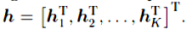
responses (CIRs) h_{k} ∈ C^{L×1} of all users’ channels, i.e .
• V ∈ C^{MN×1} is modeled as zero-mean spherically invariant complex Gaussian
random vector with covariance matrix σ²_{v}I_{NM}.

2.6 Definition of E_{b}/N₀

For the assessment of iterative receivers we will illustrate bit error rate curves versus E_{b}/N₀. In this work E_{b}/N₀ is understood as the received energy per information bit over the spectral noise density N₀. The signal to noise ratio is defined as the quotient of received signal power and noise power. It reads
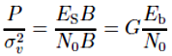
Where E_{S} is the energy per symbol, B = 1/T_{C} the signal bandwidth, and G the
number of bits per modulation symbol. This is easily recast to
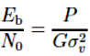
We keep the transmit power P = 1 and the modulation is QPSK, i.e., G = 2. When coding is considered, the energy per information bit becomes
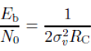
Where R_{C} denotes the code rate. The J pilot symbols per transmission block of length M. To stay consistent with our definition of E_{b}/N₀ we introduce a penalization for the energy loss in pilot symbols such that we arrive at
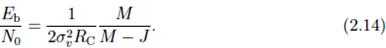

2.7 The Optimum Receiver

In this section, the optimum receiver is understood as the joint maximum a-posteriori (MAP) sequence detector that minimizes the error probability of all user information sequences. The optimal way of estimating the information symbols d_{k}(m′′) for all users k ∈ {1, . . . ,K} and time instances m′′ ∈ {2JR_{C}, . . . , 2MR_{C} − 1} from the receive vector y ∈ C^{MN×1} is a joint maximum a-posteriori approach over the transmitted code and pilot symbols b_{k}(m),m ∈ {0, . . . ,M − 1}, k ∈ {1, . . . ,K} and the channel impulse responses h ∈ C^{KL×1}. Let us denote B ∈ X^{M×K} the matrix with the symbols b_{k}(m) in the k-th column and m-th row. We consider the matrix transmission model (2.13) for the flat fading case. Then, the optimization problem reads:
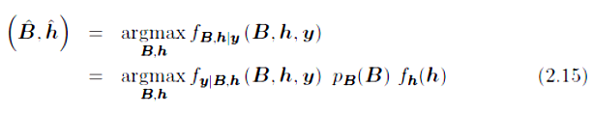
subject to
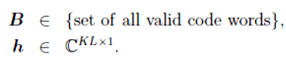

The last expression in (2.15) follows from the assumption that the code symbols B are independent of the channel vector h. With f(·) and p(·) we distinguish between the continuous probability density function (pdf) and the discrete probability mass function (pmf). With the elements of B placed in , according to Paragraph 2.5.3, the conditional density distribution of the received vector given the code symbols and the channel impulse responses is the complex Gaussian multi-variate distribution
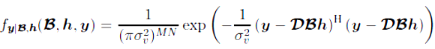
The joint pmf of the code symbols is denoted by p_{B}(B) and the pdf f_{h}(h) contains the knowledge of the channel statistics. The problem formulated in (2.15) is a mixed-alphabet optimization problem (the entries of B are from a finite alphabet and those of h from an infinite one) which is hard to solve. The only known exact solution to the optimization over the codeword’s requires an exhaustive search over 2^{2(M−J)RCK} symbol combinations in case of QPSK modulation and J pilot symbols, thus exponential complexity in M – J and K. Its structure is the same as the travelling-salesman problem and is known as NP-complete (nondeterministic polynomial) problem. This means that there is no known algorithm that is able to find a solution in a duration that can be expressed as a polynomial function of time. If a solution to any of the problems in the NP-complete class can be found, then there would also exist solutions to the other problems in this class [Man89]. Although the problem formulation (2.15) looks similar as problems in complex estimation, its particular difficulty is brought in by the restriction to discrete solutions and the size of the search space.
Additionally to the NP-complete code-word problem, a maximum-likelihood estimation of the continuous channel estimate is required. Since solely the task of detection becomes computational prohibitive, the approach of joint data detection and channel estimation exceeds the computational capabilities of current processing technologies, and is hence not feasible. Therefore, we are interested in the development of low-complexity approximations to the solution of (2.15).

2.8 Suboptimum Receivers
Practical receiver implementations separate the individual processing tasks. Typically a single-user matched filter is followed by a decoder in a one-shot manner. This is nowadays the state of the art. Comparisons to joint optimum symbol sequence processing illustrate that separate one-shot processing causes big losses in terms of system capacity.
In 1993 a coding scheme was presented that allows to approach the Shannon bound up to fractions of a dB [Ber93]. The underlying principle was a decoding system that has two independent decoders supporting each other by feeding back

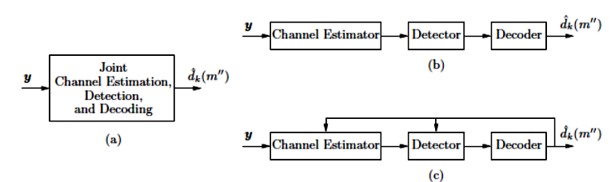
Figure 2.5: Receiver processing methods - (a) joint processing, (b) classical one-shot processing (c) iterative processing.

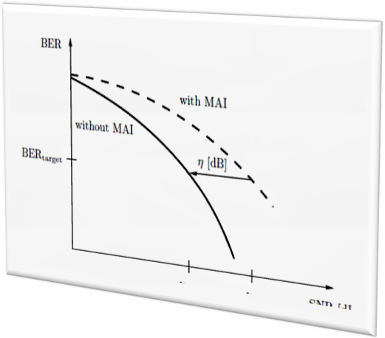
Information, similar to a Turbo engine. The latter is the reason for calling these systems Turbo decoders. Few years after this important discovery, the turbo structure was applied to equalize channels with inter-symbol interference [Dou95] and to perform multi-user detection and decoding [Ale98]. Instead of implementing the joint optimum sequence receiver, the system is translated into an iterative system consisting of a multi-user detector and a bank of single-user decoders. We adapt this scheme to deal with inter-symbol interference processing and extend it to include multi-path channel estimation in the iterative loop. The discussed receiver structures are illustrated as block-diagrams in Fig. 2.5. We recap that structure (a) is the joint approach including channel estimation, detection, and decoding and was identified as too complex for practical implementation. The type (b) receiver is the classical one-shot concept that allows only a very low system load. The multi-user receiver that can support high loads at moderate complexity is based on the iterative structure (c). This iterative receiver is the subject of interest in this thesis. Due to the separation of detection, decoding, and channel estimation the code symbols are detected individually regardless of their code constraints. This means that we perform symbol by symbol detection rather than joint sequence detection of M − J code symbols like in the optimum receiver. Chapter 3 will review symbol by symbol detection methods and detectors are developed that are suitable for iterative processing. Decoding happens individually for all users in a bank of single user decoders that receive user code symbols containing distortions from residual multiple-access interference and remaining noise that could not be resolved by the Detector in the previous processing stage. Finally, channel estimation is based on dedicated pilot symbols that are supported by soft decision data from the decoder output.
Figure 2.6: Schematic illustration of multi-user efficiency.
2.8.1 Multi-User Efficiency

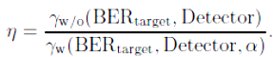
In order to compare different multi-user detectors introduced in the term multiuser efficiency (MUE) [Ver98]. We denote MUE as η and it is defined as the quotient.

Expression γ_{w/o} refers to the signal to noise ratio that is required to achieve a target bit error rate BER target without multiple-access interference, i.e., in the single-user case. The value γ_{w} in the denominator is the signal to noise ratio that is required to achieve a target bit error rate BER target with a certain multi-user detector in case when the system load is α. By definition MUE quantifies the efficiency of a multi-user detection scheme in mitigating multiple-access interference. In the worst case, η becomes zero, and in the best case η is one which refers to a total mitigation of multiple-access interference. In Fig. 2.6 the lower curve shows the BER versus SNR in case of the single-user setting while the upper dashed curve refers to the BER performance in the multiple-access scenario. The horizontal distance is the MUE expressed in dB. Its range is (−∞, 0] dB.
Figure 2.7: The iterative multi-user receiver.

2.8.2 Separation Theorem
A recent contribution [Mul04] is directed to the question on the loss in spectral efficiency that is brought in by separating detection and decoding compared to optimum joint detection and decoding. The paper reveals that for Gaussian as well as binary codes the loss on the AWGN channel is a mere function of the multi-user efficiency η of the detector and reads

The quantity C_{joint} denotes the spectral efficiency in case of joint detection and
decoding and Separate is the one when separate processing is applied. The loss C_{loss} is a monotonically decreasing function of η ∈ {0, . . . , 1}, from “∞” to 0. This means that the loss to optimum joint detection and decoding vanishes for η → 1. We will see in Section 3.7 that for a particular set of system parameters an iterative receiver is able to achieve η = 1 practically within a finite number of iterations.

2.9 Iterative Multi-User Receiver
The proposal for the iterative CDMA multi-user receiver is depicted in Fig. 2.7. It results from the arguments on the trade-off between complexity and performance that were discussed in Section 2.8. We will explain its operation principle and present an interpretation based on a graph representation.

Operation Principle

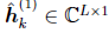
The receiver starts with estimating the channel impulse response (CIRs) of all users by using the chip pilot sequences u_{k} that cover the first J symbols in the transmitted data block of length M. The channel estimates
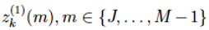
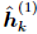
of each user k in the first iteration are then passed on to the multi-user detector to create the effective spreading sequence Note that in contrast to the virtual sequences (2.8), effective sequences are obtained via the estimated CIR . With these we obtain soft data estimates from the multi-user detector. The complex soft estimates are mapped to a real-valued symbol stream
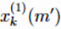
deinterleaved, and fed as to the input of the channel decoders. The decoders are so called soft-in soft-out (SISO) decoders that provide a-posteriori and extrinsic probabilities on code symbols, APP{c_{k}(m′)} and EXT{c_{k}(m′)}, respectively. The SISO decoder and its output quantities will be discussed in more detail in Section 2.10. For the moment let us consider these values to be probabilistic reliability values on code bits that are computed from the observations and the code dependencies between individual code bits. We use the probabilities to support the
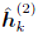
channel estimator to yield . In this sense the data symbols are exploited as additional pilot symbols. The iterative structure will use the decoder output values also to mitigate interference. The quantities EXT{c_{k}⁽¹⁾ (m′)} are mapped to soft decision symbols b _{k} ⁽¹⁾ (m). These are then used to generate an estimate of the interference by multiplication with the effective spreading sequence s_{k}⁽²⁾. The interference estimate is then subtracted from the received vector y prior to detection. We then obtain symbols z _{k}⁽²⁾(m) in the second iteration. This process is continued for several iterations. After the last iteration, the a-posteriori output probabilities on information symbols APP{d_{k}(m′′)} delivered from the decoders are utilized to decide on the transmitted information bits along the following rule:
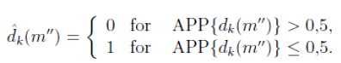
2.9.1 Interpretation
The flow of information in iterative detection and decoding systems can be described by graphs. If a graph is free of cycles, the corresponding system is an instance of the belief propagation (BP) algorithm that computes correct a-posteriori values on information symbols [Wick03]. This applies also to iterative receivers [Wor01]. Though iterative receivers have some sort of cycles and hence violate this rule, it was observed that, when cycles are large enough, the analysis based on BP still yields excellent results. A first systematic approach to study iterative receivers with graphs was reported in [Bou02]. This reference points out to use extrinsic information in the feedback-branch rather than a-posteriori information. It is not obvious which kind of information to use since a-posteriori information seems to increase the convergence speed as we will see in Paragraph 3.8.1. There, we will also resolve the issue of the usage of feedback information. A conceptual extension to the graph representation of an iterative receiver including channel estimation is given in [Cai01c,Wor01].
2.10 Decoding
In the following we explain decoding of information for one particular user. For notational convenience we omit the user index (·)k. At the transmitter single information bits d(m′′) are mapped to code bits c(m′) according to F F→ F^{1/RC} by applying the code C. In the receiver the symbols that are fed into the decoder are scaled and noisy versions of the bipolar mapped symbols c(m′). The BPSK-mapping goes along c′(m′) = 1 − 2c(m′) and the received values read

x(m′) = μ_{x} c′(m′) + w(m′). (2.17)

The variable w(m′) accounts for the residual noise contribution after the detector, blending system noise and multiple-access interference. It was shown in [Zha01] that for an LMMSE multi-user detector the residual noise is well modeled as Gaussian process. The detector output distribution was also modeled as Gaussian process in interference cancelling multi-user detectors
in. In other words, the influences to which the signal c′(m′) is exposed to during transmission are summarized in the scaling factor μ_{x} and the single additive noise component w(m′). The received value x(m′) has the conditional distribution N(μ_{x}, σ_{x}²) and w(m′) is zero-mean Gaussian distributed with variance σ_{x}². A practical method to estimate μ_{x} and σ_{x}² from the observations x(m′) is the decision directed estimator discussed in [Mec05].
The art of decoding is concerned with finding the most likely transmitted sequence of information bits d(m′′). This is made possible through mutual dependencies of code bits that are introduced in the encoder. Let p(·) denote a pmf,
The two most prominent optimization criteria for decoding are:
• Maximum-likelihood sequence decoding (Viterbi) for which the optimisation criterion reads
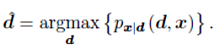
• Maximum a-posteriori (MAP) symbol-by-symbol decoding (BCJR [Bah74])
that is solving
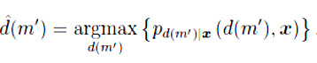
Viterbi sequence decoding is widely used in one-shot receivers and delivers hard output values on estimated information bits Ď(m′′). In iterative structures soft values are preferred since hard values cause the propagation of errors and eventually become unstable or reach an error floor. Symbol by- symbol MAP decoding generates probabilities as output quantities that can be mapped to soft decision symbols suitable for structures with feedback. The MAP algorithm minimizes the single bit error probabilities. The soft-output Viterbi algorithm (SOVA) [Hag89] and the max-log-MAP implementation [Koc90] have lower implementation complexity but cause higher bit error probabilities in general. For our purpose we need a MAP decoder with the input and output measures depicted. Since the input and all output variables are soft measures the MAP decoder is termed soft-input soft-output (SISO) decoder. The input are the noisy observations x(m′) and the output a-posteriori probability (APP) values on the information bits d(m′′) as well as their APP and EXT on the coded bits c(m′). In the following we stick to the definitions:
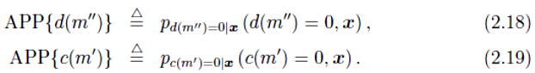
The conditional pmf for the symbol d(m′′) is normalized such that
and similarly for the pmf of c(m′). The gain in information between the received values and the APP on code bits is quantified as extrinsic information (EXT) probability. For an AWGN channel the extrinsic probability is given by

where denotes “proportional up to a constant factor”.

2.11 The MAP Decoding Algorithm
In Bayesian statistics, a maximum a posteriori (MAP) estimate is a mode of the posterior distribution. The MAP can be used to obtain a point estimate of an unobserved quantity on the basis of empirical data. It is closely related to Fisher's method of maximum likelihood (ML), but employs an augmented optimization objective which incorporates a prior distribution over the quantity one wants to estimate. MAP estimation can therefore be seen as a regularization of ML estimation.
Assume that we want to estimate an unobserved population parameter θ on the basis of observations x. Let f be the sampling distribution of x, so that f(x | θ) is the probability of x when the underlying population parameter is θ. Then the function
is known as the likelihood function and the estimate
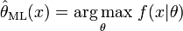
is the maximum likelihood estimate of θ.
Now assume that a prior distribution g over θ exists. This allows us to treat θ as a random variable as in Bayesian statistics. Then the posterior distribution of θ is as follows:
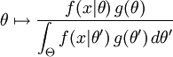
where g is density function of θ, Θ is the domain of g. This is a straightforward application of Bayes' theorem.
The method of maximum a posteriori estimation then estimates θ as the mode of the posterior distribution of this random variable:
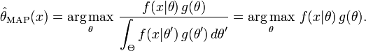
The denominator of the posterior distribution does not depend on θ and therefore plays no role in the optimization. Observe that the MAP estimate of θ coincides with the ML estimate when the prior g is uniform (that is, a constant function). The MAP estimate is the Bayes estimator under the uniform loss function.
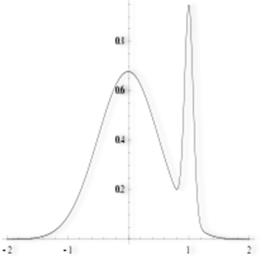
While MAP estimation is a Bayes estimator (under the 0-1 loss function), it is not very representative of Bayesian methods in general. This is because MAP estimates are point estimates, whereas Bayesian methods are characterized by the use of distributions to summarize data and draw inferences: thus, Bayesian methods tend to report the posterior mean or median instead, together with credible intervals. This is both because these estimators are optimal under squared-error and linear-error loss respectively - which are more representative of typical loss functions - and because the posterior distribution may not have a simple analytic form: in this case, the distribution can be simulated using Markov chain Monte Carlo techniques, while optimization to find its mode(s) may be difficult or impossible.
Figure2.8 An example of a density of a bimodal distribution in which the highest mode is uncharacteristic of the majority of the distribution
In many types of models, such as mixture models, the posterior may be multi-modal. In such a case, the usual recommendation is that one should choose the highest mode: this is not always feasible (global optimization is a difficult problem), or nor in some cases even possible (such as when identifiability issues arise). Furthermore, the highest mode may be uncharacteristic of the of the majority of the posterior. Finally, unlike ML estimators, the MAP estimate is not invariant under reparameterization.
As an example of the difference between Bayesian methods and using an MAP estimate, consider the case where we need to classify inputs x as either positive or negative (for example, loans as risky or safe). Suppose there are just three possible hypotheses about the correct method of classification h₁, h₂ and h₃ with posteriors 0.4, 0.3 and 0.3 respectively. Suppose given a new instance, x, h₁ classifies it as positive, whereas the other two classify it as negative. Using the MAP estimate for the correct classifier h₁, we classify x as positive, whereas the Bayesian would average over all hypotheses and classify x as negative.
Suppose that we are given a sequence of IID random variables and an a priori distribution of μ is given by . We wish to find the MAP estimate of μ.
The function to be maximized is then given by
which is equivalent to minimizing μ in the following
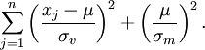
Thus, we see that the MAP estimator for μ is given by
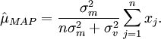
The case of is called a non-informative prior and leads to an ill-defined a priori probability distribution; in this case

Convolution codes can be represented by a trellis that shows all valid transitions from a particular state s(m′′) at time m′′ to the state s(m′′ + 1). An example of a trellis for a four-state convolution code with rate RC = 1/2 and memory length ι is depicted in Fig. D.1. There are 1/2 possible states denoted by {s₀, s₁, s₂, s₃}. For time m′′ = 0 we assume that the state of the code is S(m′′ = 0) = s0 in the trellis. From this initial state the trellis is built up according to the M′′ = 2(M − J)R_{C} information bits and the generator polynomials of the convolution code. At the end the trellis is forced to its initial state by appending ι terminating zero input symbols. From state each state s_{i}, i ∈ {0, . . . , 3} at time m′′ there are two outgoing edges: e₀ is associated with the information bit d = 0 and the output code word c = [c₀ c₁]. Similarly, this holds for the information bit d = 1 that is associated with edge e1. The conditional probability for a transition from state S_{i} to state S_{j} , assuming that the states are connected, calculates as
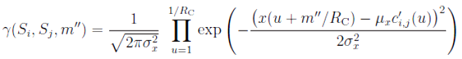

where μ_{x} and σ_{x}² correspond to the parameters of the AWGN model (2.17). The value c′ _{i,j}(u) is the BPSK mapped u-^{th} code bit that is associated with the transition from state Si to state S_{j} . The probability for being in a particular state Si is computed by means of the forward propagation probabilities α and the backward propagation probabilities β. They are expressed as
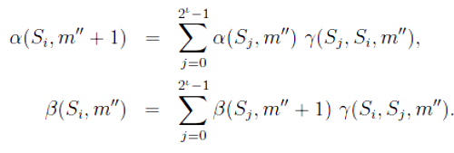
The initial values of α(S_{i}, 0) and β(S_{i},M′′ + ι) are
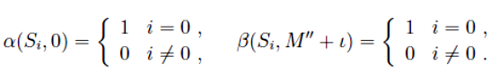
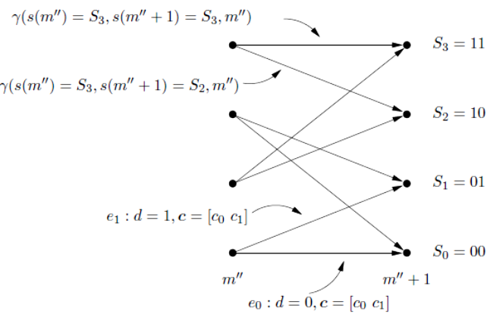
Figure 2.9: Example of a trellis for a four-state convolution code with rate RC =1/2.

The forward and backward state probabilities α(·) and β(·) are computed as products of probabilities. These quantities take on very small values after few stages and can cause errors due to overflows that are typically caused by the finite number representation capabilities of the hardware. The problem is removed when the following normalizations are applied at every stage
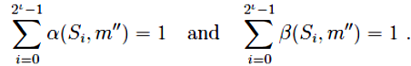
With a ∈ ₣ the APP on the information bits are computed from the state probabilities
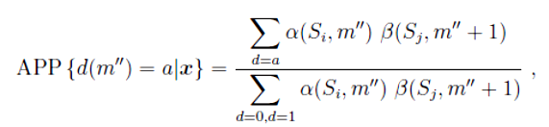
Where the sum over d = a concerns all transitions from state S_{i} to state S_{j} where the information symbol d has the value a. The APP on the code bits c_{l}, l ∈{0, 1}, are computed from the transition probabilities
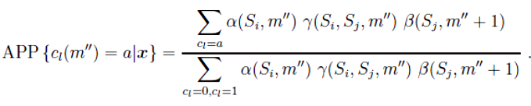
Similar as in above equation the sum over c_{l} = a includes all transitions for which the code bit c_{l} is a. For the implementation the following details turn out to be important. The relation between the APP and EXT values is given by
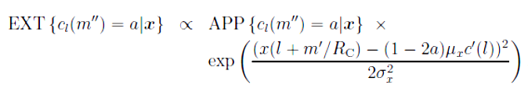_
This relation allows to compute the EXT values from the APP and the observations. For APP values that are very close to 0 or 1 the corresponding conversion into likelihoods casts a numerical problem. Expressions like “∞−∞” occur and provoke instabilities. The MAP algorithm offers an intrinsic way to compute the EXT values by reshaping expression in above equation to
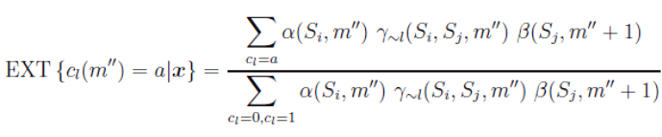
With
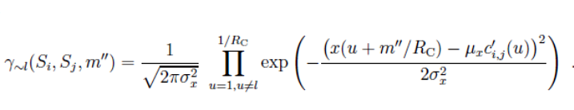

2.11.1 Soft Decision Data
After decoding, the a-posteriori and extrinsic probabilities are interleaved and used to produce a conditional soft mean estimate of the transmitted symbols, given the probabilities APP{c(m′)} or EXT{c(m′)}, respectively. With the definitions (2.19) and (2.21) the soft QPSK mapping for the APPs and the EXTs is given by
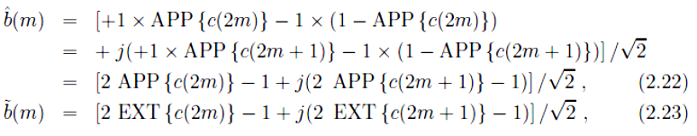With m ∈ {J, . . . ,M − 1}.

2.11.2 Impact of Fading
In this section we illuminate the impact of fading on coding. We assume that the receive amplitude is fading with L diversity branches that can all be maximum ratio combined. For such a channel there exist upper bounds on the coded bit error rate. The bounds depend on the free distance of the code. However, no exact analytical descriptions are known [Pro00]. Hence, we will study the impact of diversity on a coded system by numerical means. For this, we consider a four-state convolution code with rate R_{C} = 1/2 and generator polynomials (5, 7)8. Data is transmitted in blocks with M = 160 QPSK symbols that are Gray coded. The fading coefficients stay constant for the duration of a block. In Fig. 2.10 we plot the bit error rate curves for diversity orders L ∈ {1, 2, 5} for the uncoded and the coded system. Uncoded transmission is indicated by solid lines while coded transmission is marked by dashed lines. The uncoded curves were obtained through the analytical expression (2.4) and those of the coded system by Monte-Carlo simulations over 10.000 blocks. We learn that for a target bit error rate of 10⁻³ the gain due to coding is strongest for the AWGN channel and that it becomes less with decreasing diversity order. For L = 1 there is no gain, but rather a loss of 1 dB. For L = 2 the gain is roughly 0,5 dB, and finally for the AWGN channel, i.e., L → ∞, we achieve a gain of 3,1 dB. When codes are used in an iterative multi-user receiver, they have the purpose to accelerate the
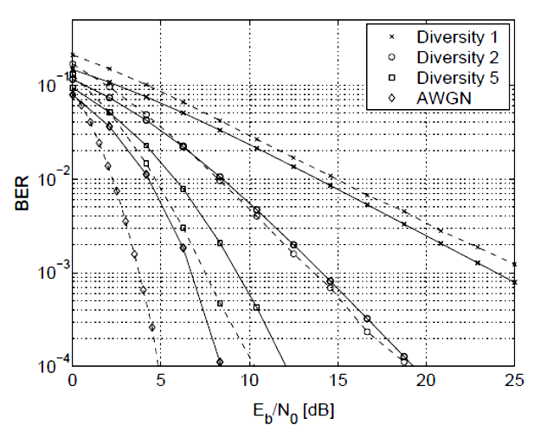
Figure 2.10: Impact of diversity combining on bit error rate for coded and uncoded transmission. Symbols are QPSK modulated with Gray mapping. For the coded case we apply a convolutional code with rate RC = 1/2 and generator polynomials (5, 7)8. Dashed lines (−−) refer to coded BERs and solid lines (−) to uncoded BERs.

Convergence towards lower bit error rates by combating multiple-access interference. For the extreme case with L = 1 the only purpose of codes is to combat multiple access interference but there is no gain with respect to the channel over the uncoded system.

CHAPTER-3
Iterative Multi-User Detection

This chapter is devoted to the development and analysis of detectors for the iterative multi-user receiver. Particular emphasis is directed to the processing of inter-symbol interference which plays an important role in medium data rate communications. Throughout, we assume to have perfect channel knowledge available - the aspect of channel estimation. We start off with a review of optimum and non-iterative multi-user detection techniques for single symbol processing. Note that the optimum receiver described in Section 2.7 searches for a codeword of length M. In the iterative receiver, the multi-user detector does not have any knowledge of the code constraints and the single-user decoders do not know the waveform of the signals. Hence, the multi-user detector performs single-symbol processing. We derive detectors based on interference cancellation and discuss an analysis method for AWGN channels based

3.1 Overview

Until around 1984 it was believed that multiple-access interference (MAI) in a multiuser communication system is best treated as white noise. If this was true the single user matched filter (SUMF) would be that receiver filter that maximizes the output signal to noise ratio. The seminal work of Verd´u in 1984 brought forth that multiple-access interference is structured and is hence not white, but colored. [Verd´u] derived the optimum detector which shows to be NP-complete, meaning that the computational effort cannot be given as a polynomial expression of the number of users. This was the starting point for the area of multi-user detection (MUD) that deals with suboptimum receiver structures having finite computational complexity.
Multi-user detection is obsolete if spreading sequences were perfectly orthogonal to each other. Due to multi-path propagation on the wireless link and due to the use of scrambling codes in systems like UMTS, orthogonality cannot be preserved. Furthermore, the number of orthogonal sequences is strongly limited by the length of the spreading sequences. For high capacity systems that operate in the overloaded mode there are more users present than orthogonal sequences are available. We show that the use of non-orthogonal signaling and coding allows for very low bit error rates when iterative receivers are employed.

3.2 Optimum Multi-User Detection
Let us consider the multi-user system model defined in (2.11) for the particular case of an AWGN channel and all users having power
∥S∥² = S_{k}^{H} S_{k} = 1. Omitting the symbol index m we can conceptually write for the chip level
with S ∈ C_{N×K} the spreading matrix and v ∈ C_{N×1} the additive white Gaussian
noise with covariance matrix σ_{v}² IN. The statistics on the symbol vector b ∈ X_{K×1} contained in y do not change if the observed vector y is passed through a single-user matched filter. Then, we obtain a model that is mapped into the symbol space as
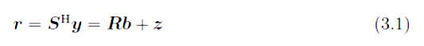

with R S^{H}S ∈ CK×K denoting the cross-correlation matrix and z is a K dimensional, zero-mean complex Gaussian random vector with covariance matrix σ_{v}² R. Hence, the output r forms a sufficient statistic for the estimation of the symbols b of all users. The conditional pdf of r given the symbol vector b is a Gaussian multi-variant distribution expressed as

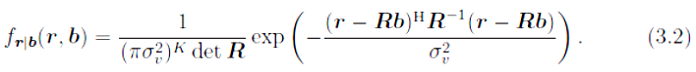

The optimum symbol detector, in the sense the bit error probability is minimized, is a maximum a-posteriori (MAP) detector. It can be formulated for either each user individually
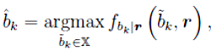
or for all users jointly
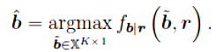
The bit error probability of the individually optimum detector is always lower or equals the one of the jointly optimum detector. The possible symbols b_{k} can take on values from the set X. The symbol vector of all users is ˜b ∈ X^{K×1}. Under the assumption that all symbol vectors appear equally likely, i.e.,
P(˜b)= 4^{−K}, the MAP detector reduces to a maximum likelihood (ML) detector via Bayes’ law. The individual ML estimate is
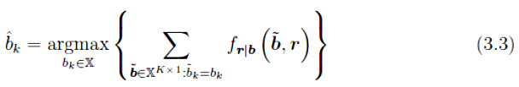
and the joint ML estimate of the data vector reads
Latter is equal to the minimization of the quadratic form
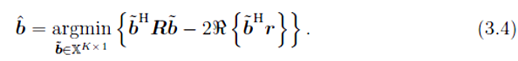
The individual ML detector (3.3) involves the evaluation of 4^{K} conditional likelihood functions (3.2) per user. The joint ML solution requires an exhaustive search over 4K symbol hypotheses. Therefore, the complexity of both detectors is exponential in the number of users (4^{K}) . This is the reason why they have limited practical importance, i.e., only in systems with few users.

3.3 Linear Multi-User Detection
This section reviews the most prominent linear detectors for an AWGN multiple access channel. The canonical model presented in (3.1) is used. The filter is applied on to the chip-matched receive vector and assigned to a decision region like
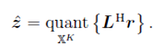
All succeeding linear operations work with the sufficient statistics of r. In this sense the single-user matched filter (SUMF) detector becomes
L = I_{K} (3.5)
that treats all user interference as white noise. A linear filter that exploits the cross correlation is the zero-forcer (ZF) also known as decorrelating detector. It simply neglects the noise and minimizes the multiple-access interference to zero. We obtain
L = R⁻¹.
The decorrelator has the disadvantage that it amplifies noise and in low SNR regions it performs even worse than the SUMF. A compromise in treating noise and MAI is achieved by the LMMSE detector that has its origin in signal estimation. It reads
L =(R + σ_{v}²)K (3.6)
and performs for low SNRs like the matched filter solution, while for high SNRs the LMMSE solution converges to the decorrelator performance. The performance of linear detectors is deteriorated in situations with unequal receive power levels caused by, e.g., the near-far effect .It was reported in that the equal power distribution maximizes the spectral efficiency for the SUMF, the decorrelator, and the LMMSE detector. For the decorrelator this result was already reported in [Lup89]. This is the main reason why commercial communication systems exercise power control [Sch04a]. However, we show in the subsequent sections that unequal power distributions are actually of benefit for interference-cancellation based detection schemes.

3.4 Parallel Interference Cancellation (PIC)

We map symbols obtained in previous iterations to soft information ˜b_{k}(m) in order to get an estimate of the total multiple-access interference (MAI) symbolized by ỹ(m). This estimate is used to lower the effective interference and is subtracted from the receive vector ỹ(m) prior to symbol detection. In mathematical notation interference cancellation for a general frequency selective channel (2.12) with short spreading sequences, i.e., S_{k}(m) = S_{k}, is expressed as
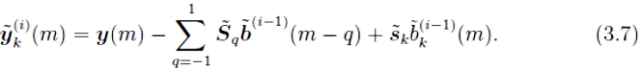
The index (·)^{(i)} designates iterations i > 0. After interference cancellation we apply a linear filter f _{k}^{(i)}(m) to the vector ỹ _{k}^{(i)}(m) to obtain an estimate of the transmitted symbol in the form ž_{k}^{(i)}(m) =(f _{k}^{(i)}(m))^{H} ỹ_{k}^{(i)}(m) . In the next two paragraphs we develop linear filters that are suitable for this task.

3.4.1 Single-User Matched Filter (SUMF)
The simplest linear detector for retrieving k-th user’s information is the single-user matched filter whose elements are given by
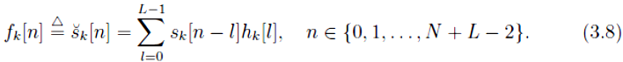
The filter reads as vector f_{k} = [f_{k}[0], f_{k}[1], . . . , f_{k}[N + L − 2]]^{T}. For a short code CDMA system and a block fading environment the time index m and iteration index i can be omitted, since the filter stays constant for all symbols and all iterations.

3.4.2 Matched and Mismatched Detectors
Precise channel state information (CSI) is practically never available at the receiver. It is rather obtained by estimation and associated with an error. Instead of the true channel h, its estimate ˆh is used in the detector. Such a detector is called a mismatched detector in contrast to a matched detector that has perfect CSI available. The mismatched detector requires the error covariance matrix of the channel taps. The error variance is only available, if the power delay profile and the statistical dependencies of the channel taps are known to the receiver. Since this is a strong requirement, we will use an approximation by neglecting the term including the error covariance matrix. Under this approximation, we can use the expressions for the matched detectors and replace the virtual by the effective spreading sequences. Subsequently, we restrict ourselves to the treatment of the detector filters in the matched case.
3.4.3 Filter Output Distribution
The filter output z_{k}^{(i)}(m) = f_{k}^{H}(m)ỹ_{k}^{(i)}(m) can be modelled by
as suggested in [Wan99]. The residual noise and multiple-access interference is jointly modeled as spherically invariant complex Gaussian process with
ν_{k}^{(i)} (m) ~ CN (0,(σ_{k}²(m))^{(i)}). The resulting signal to interference and noise ratio (SINR)Reads
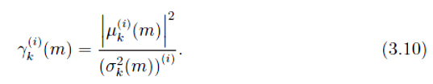
The upper index (·)(i) underlines that the statistical output values depend on the iteration i. In the subsequent treatment of this section we will omit the iteration index for notational convenience.
3.4.4 SINR of PIC-SUMF Detector in Flat Fading
First, let us consider the particular case of a frequency flat channel. The output of the matched filter is
The conditional mean of the output symbol z_{k}(m) (3.11) evaluates to
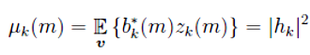
and the variance of the multiple access interference and noise reads
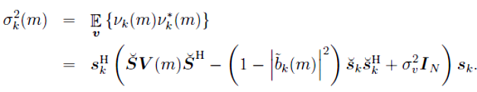
The covariance matrix of the soft decision symbol errors, or equivalently the residual power matrix, V (m) ∈ C^{K×K} is defined as
and the corresponding SINR is given through
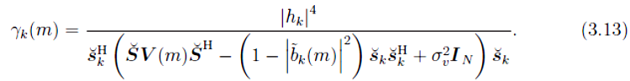
3.4.5 SINR of PIC-SUMF Detector in Frequency Selective Fading

The extension to the multi-path case is straightforward. The desired signal power is determined through the square of
and the variance is increased by the contributions of pre- and post-cursor ISI terms along
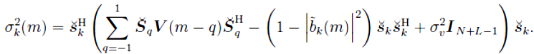
We highlight two particular cases for the SINR:
B˜ (m) = diag(0K) ∀ m: The feedback symbols are all unknown. This is the
case in the first iteration. The symbol variance matrices become diagonal
matrices V (m − q) = I_{K} and the SUMF output SINR becomes that of a
conventional SUMF detector (3.5) without feedback
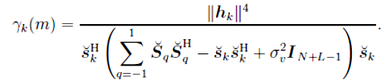
• ˜B (m) = diag(b(m)) ∈ m: This happens when all feedback symbols correspond to the actually transmitted symbols. The SINR becomes that of a single-user system and it reads
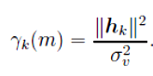
3.4.6 Linear MMSE Filter (LMMSE)
The second filter which is suitable after parallel interference cancellation is the linear minimum mean square error filter. We discuss first the flat fading case and explore then the properties in the frequency selective case.

3.4.7 PIC-LMMSE Detector for Flat Fading
The linear minimum mean square error (LMMSE) filter for the interference cancelled observation vector ỹ_{k(m)} (3.7) and the flat fading CDMA system model presented in Paragraph 2.5.1 is the solution to the Wiener-Hopf equations
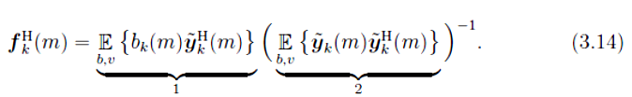
In the derivation of the LMMSE filter, expectation over b is understood as conditional expectation, given the extrinsic decoder output probability EXT{c(m′)} defined in (2.21). Let us elaborate on the two expectation terms separately.
1. The first term in (3.14) equates to
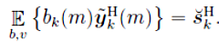
2. The second term expands to
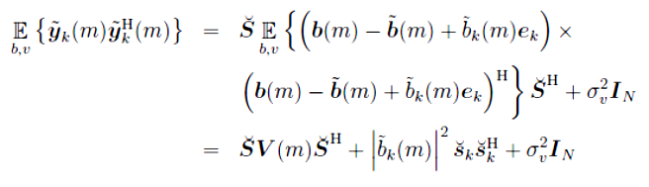
where e_{k} [0, . . . , 0, 1, 0, . . . , 0]^{T} denotes the standard basis unit vector with a one at the k-^{th} element and zero elsewhere.
Let us define the Hermitian matrix A ∈ C^{N×N} as
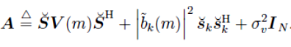
The matrix V (m) (3.12) is a covariance matrix that is always positive semi-definite Multiplying the matrix with from the left and š^{H} from the right leaves the product positive semi-definite. Hence, it has non-negative Eigen values. Since the second expression has non-negative Eigen values, and the last matrix N non-zero Eigen values, the sum has only positive Eigen values. Hence, the matrix is invertible. The LMMSE filter yields
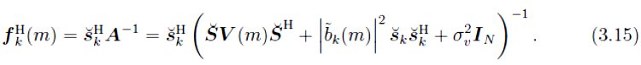
The filter output distribution conditioned on _{k(m)} is modeled as spherically invariant complex Gaussian process like in (3.9). The conditional mean of the filter output is given by
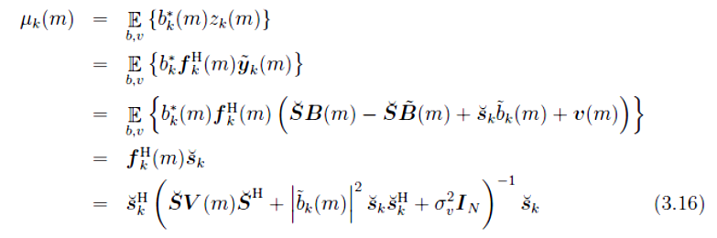
and its conditional variance computes as
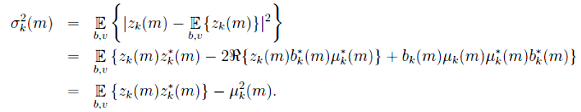
The variance evaluates to
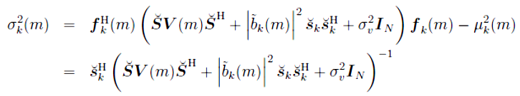
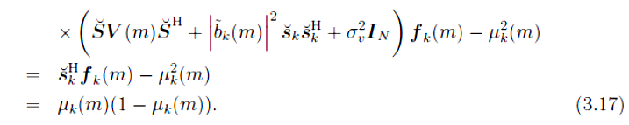

3.4.8 PIC-LMMSE Detector for Frequency Selective Fading

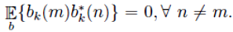
In the multi-path case, the LMMSE filter is computed as in (3.14). The computation assumes that adjacent symbols of a particular user are statistically independent, i.e., this is fulfilled when a random interleave with infinite length is used. The LMMSE filter that deals with ISI reads
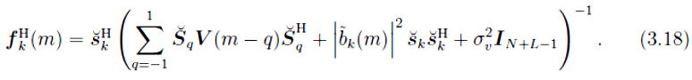
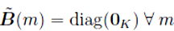
With the definition of the SINR in (3.10) and the expressions (3.16) for the mean and the variance (3.17), we obtain γ_{k}(m) = μ_{k}(m)/(1 − μ_{k}(m)) and the following special cases emerge:
: In this case the symbol variance matrices become diagonal matrices V(m)=I_{K} and the LMMSE detector becomes the conventional LMMSE multi-user detector, similar to (3.6) for the AWGN channel,
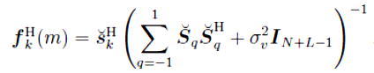
The corresponding SINR reads
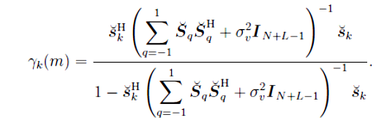
• : When the feedback symbols are completely known, the mean μ_{k}(m) becomes
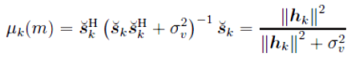
and the corresponding SINR is given through
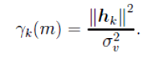
3.4.9 Low Complexity Implementation of the PIC-LMMSE Detector

In general the conditional mean μ_{k}(m) of the output of the LMMSE filter (3.16) is not equal to one. This implies that the output symbols (3.9) are biased. Dividing the filter by μ_{k}(m) yields the unbiased LMMSE filter
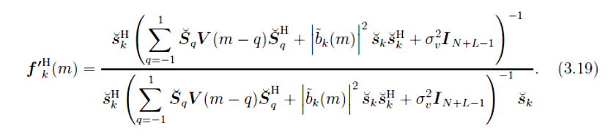
Expression (3.19) can be translated into the simple expression
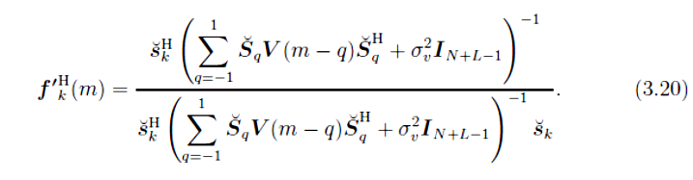
Comparing (3.18) and (3.20) shows that making the filter unbiased, causes a reduction in complexity. The inverse of (3.18) does not need to be computed for every user any longer but can be pre-computed for all users at a particular iteration. The filter output SINR does not change due to this scaling. The expression for the unbiased LMMSE filter was first used in [M¨ul02] for an AWGN channel and for multi-path channels causing inter-symbol interference in [Weh02].
A further reduction in complexity can be achieved when the covariance matrix of the soft symbol decision V (m) is computed as empirical average over all symbols instead of each symbol individually:

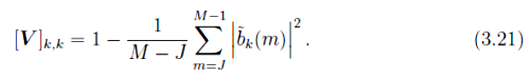

This idea was proposed in [Cai01a]. When the filter uses the average covariance matrix (3.21), the resulting filter is termed unconditional; otherwise, when the covariance matrix is computed for every symbol (3.12), it is called conditional. In the conditional case, the computation of the filter involves a matrix inversion for each symbol instance as it can be seen in (3.20). When the unconditional filter is used, an inverse of a matrix needs to be computed once for every user and every iteration only. The unconditional version of (3.20) is expressed as
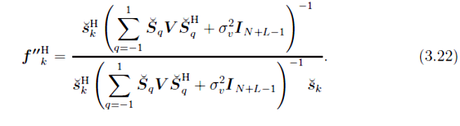

3.5 Successive Interference Cancellation (SIC)
In parallel interference cancellation that we have considered in the previous section there is no ordering of the users. For a system where users are received with large differences in their power due to fading, parallel interference cancellation might not be the best strategy. In this case it may be better to detect those users first that are the strongest. Let us exemplify this for a two user scenario with one single iteration. If first the stronger user is detected, it would result in a good detection probability since the weak user does not cause much interference. If the correctly detected signal is subtracted from the received signal, the user with low power can also be detected reliably. The worst case scenario occurs when both have the same power.
The strategy described above is called successive interference cancellation (SIC). Without loss of generality, users are ordered according to their instantaneous gain ∥h _{k}∥² such that the strongest user has index one, the second strongest index two and so forth. Then, SIC in the frequency selective case is formulated for k ∈ {1, 2, . . . ,K} as
The first sum accounts for all (k – 1) users that have already been detected in the current iteration i whereas the second sum accounts for those that still need to be detected. This is reflected in the upper index at the soft decision symbol .Under the assumption that previously detected symbols are correct; it was shown in [Var97] that SIC can attain the capacity bound.

3.5.1 Single-User Matched Filter(SUMF)

The single-user matched filter with perfect channel impulse response has length N + L − 1 and is defined as
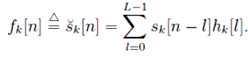
The corresponding detector output SINR at iteration i is given through
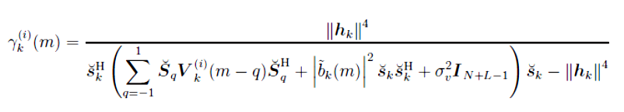
where the difference to the SINR of the PIC-SUMF (3.13) lies in the computation of the symbol covariance matrix V_{k}^{(i)}(m). Latter is now dependent on the scheduled user in the following way
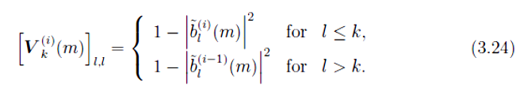

3.5.2 Linear MMSE Filter (LMMSE)
Similarly to the LMMSE for the PIC detector, an unbiased and unconditional low complexity filter can be developed for the SIC detector. The difference lies again in the definition of the symbol variance matrix which is caused by the successive interference cancellation. The unconditional symbol covariance matrix is computed along
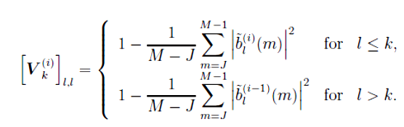
With this new definition of the symbol variance matrix we obtain the following expression for the (unbiased) unconditional filter in the frequency selective case:
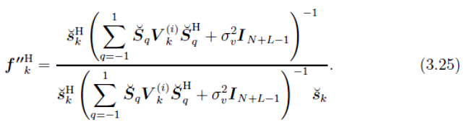
This filter needs to be computed for every user individually. Hence, the computational increase in complexity grows by a factor of K over the unbiased unconditional PIC-LMMSE filter (3.22).

Chapter 4
ANALYTICAL AND SIMULATION RESULTS

4.1 SIMULATION:
In simulation we have taken up to 33 users with signature codes derived from Gold Sequence of length N=31.We compares the performance of MAP detector with performance of Matched filter detector. Now in simulation part the code is asking for no of users (maximum limit is 33), type of modulation scheme (BPSK, QPSK, 8PSK) and the signal to noise ratio and the no of iterations. As a result it is giving the output i.e. detected data corresponding to MAP detection and the MATCHED FILTER detection and for comparison it is also giving the input data sequence. Channel has been taken as simple AWGN channel with noise variance as unity.
4.2 ANALYSIS:
Analysis curve has been plotted been plotted between BER vs. Eb/No (dB) for BPSK only because for showing the BER performance of this algorithm we need at least a data sequence 10000 symbols in case of BPSK because the map detector’s BER dropped down to nearly at the Eb/No=13 hence and at this order of the length symbol sequence and with 40 iterations roughly the min total no of iterations the compiler of matlab has to do is near about 17160000000, for this huge no of iterations the code is taking such a long time.
Another limitation of my code is that for the analysis part I generate random data for all the 33 users hence all the time data’s for all the users are not distinct hence for this reason also I am getting a suboptimum curves.
Gold sequence has been generated from SIMULINK.
Figure 1
Shows the performance of the iterative algorithm with constant step size and with adaptive step size, the rate of convergence is noticeable. As show in figure 4.1
Figure 2
This figure shows how the user variance function behaves according to Signal to noise ratio and the distance form exact value. as show in figure 4.2
Figure 3
This curve is evident for the result that how is normalized difference of the iterated value from the exact value convergence with iteration. We can see that within only 10 iteration it has dropped down to 0.1 for BSK. as show in figure 4.3
Figure 4
This is a curve which shows that how the bit error rate dropped down to near about as we increase our Signal To noise Ratio (E_{b}/No dB) and also compare it with bit error rate of MF.Because of the limitation of my system, every curve of type 4 for other type of modulation scheme is talking almost one day to plot. In this curve the bit error rate has been averaged ove 33 users with symbol sequence length of 4000000. as show in figure 4.4

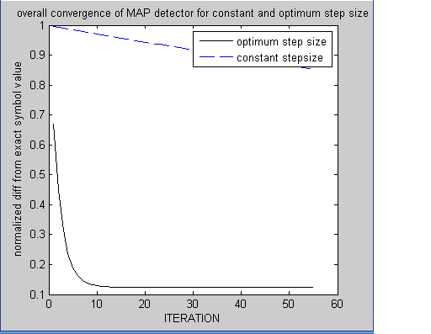
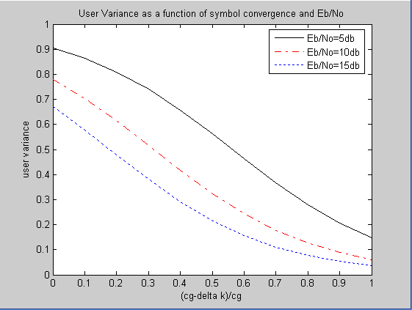
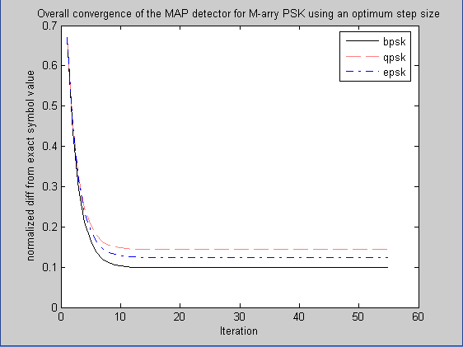
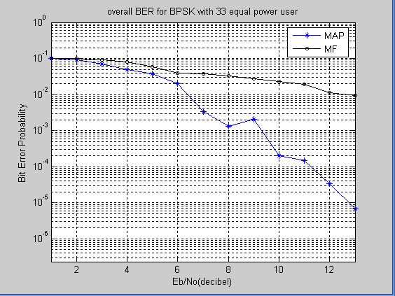
Figure 4.1 Overall convergence of MAP detector for constant and optimum step size

Figure 4.4 User variance as a function of symbol convergence and E_{b}/No
Figure 4.2 Overall convergence of the MAP detector for M-ary PSK using an optimum step size
Figure 4.3 Overall BER for BPSK with 33 equal power users (the bit error rate has been averaged over 4000000 symbols and 40 iterations)

4.3 ASSUMPTIONS:
- Simple AWGN channel.
- Frequency Non Selective Flat Fading Channel.
- Distinct data for each user.
- Chip rate N=31.
- Discrete constellation has been approximated by Gaussian.
- . should be slightly less than

4.4 INNOVATION
Towards the innovation I propose that we can achieve transmit diversity resulting from channel distortion and it may increase the accuracy of multi-user symbol estimation. Entire CDMA model has been kept same only the convolution of signature code of each user with the channel coefficients has been introduce and then dragging the whole mathematical treatment exactly as of the flat fading case as given above I reached up to certain results which may increase the performance of the MAP detector for symbol estimation.
Important point to notice is that each user will have different set of channel tap coefficients.
If is the signature code of kth user and is an L1 vector this is containing L tap channel coefficient with respect to kth user.
is the NL signature code matrix
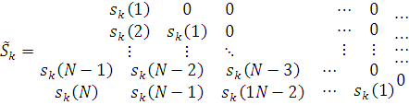
A=
Received signal will be assuming AWGN channel
Where z&r are N vector
And as we carry on with exactly same procedure we can easily get the following expressions , calculations are lengthy but not difficult.
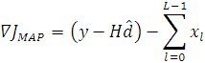
In which the kth element of the K vector is
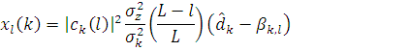

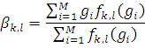
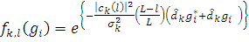

H=
Q=H+W
W=diag 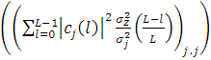
I am not able to implement the innovation properly because of mathematical complexity of following two equations:

4.5 CONCLUSION:
This algorithm is based on gradient search and is applicable for any modulation constellation. Also, an optimum step size is derived to speed up convergence. The gradient component and the optimum step size are greatly simplified for constant modulus constellations such as M-PSK, and the specific forms of the MAP algorithm for BPSK, QPSK, and 8PSK are developed. For BPSK modulation at 13 dB 33 users of the same power, this algorithm reduces the bit error probability by more than an order of magnitude compared to the MF detector.

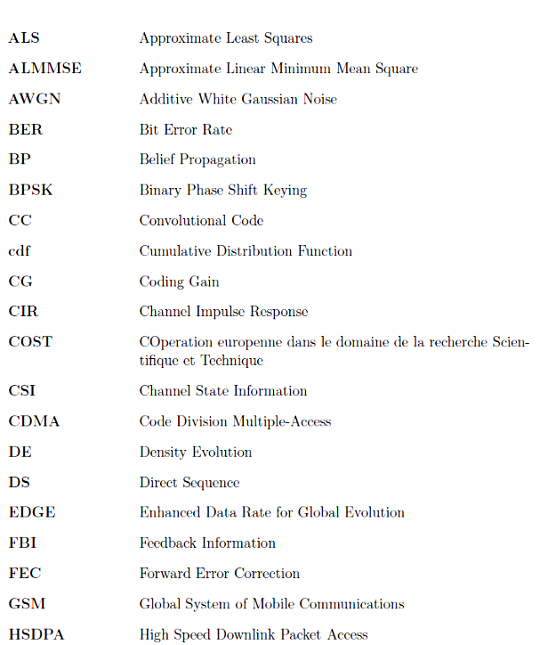
ACRONYMS
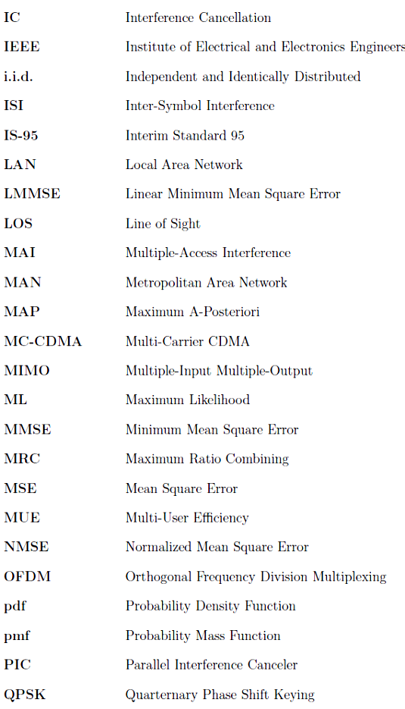

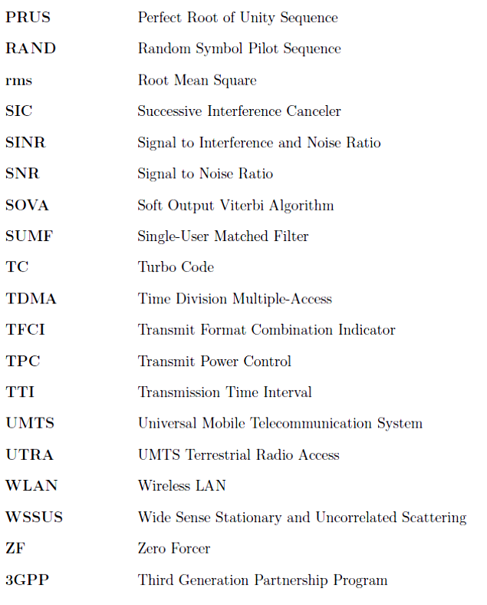

NOTATION

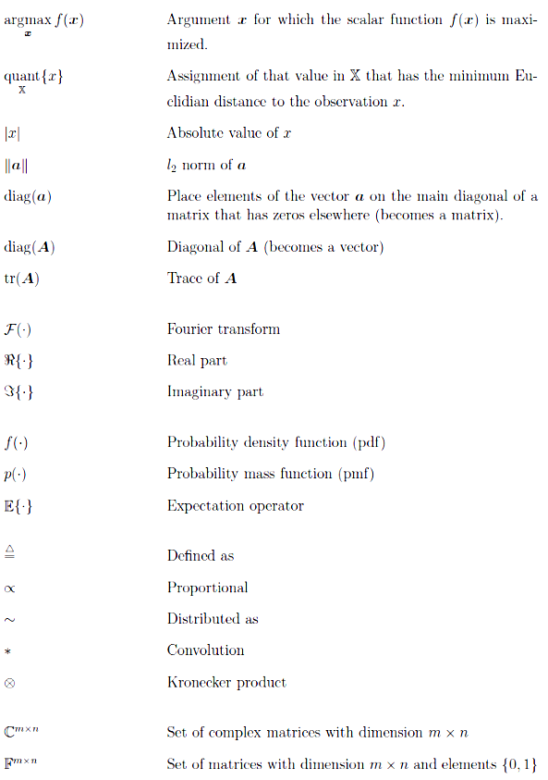
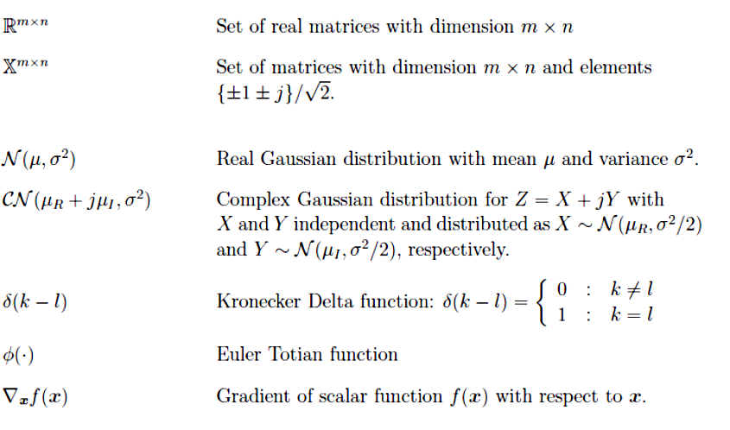

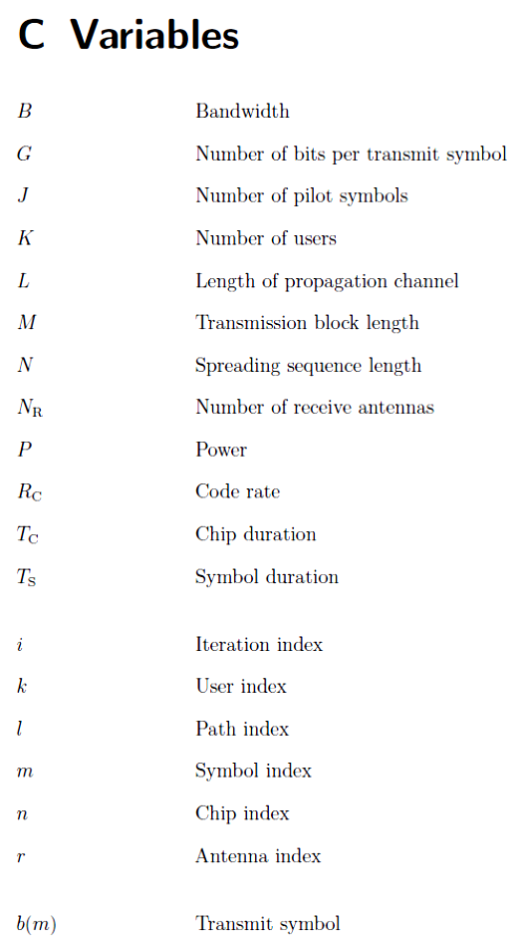
VARIABLE
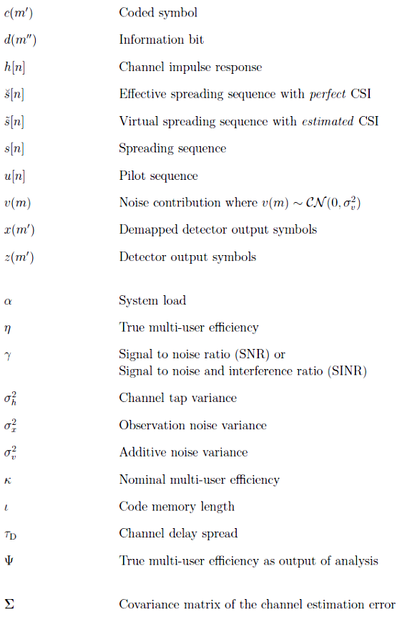
LIST OF FIGURE
Figure 1.1: Evolution Of Wireless (2)
Figure 1.2: Digital Wireless Evolution 1990 To 2010 (4)
Figure 1.3: Approximating the Discrete Symbol
Constellation with Symbol Centered
Gaussians (7)
Figure 2.1: A realization of received power as function
Of the distance between transmitter and
Receiver for an urban environment and
Carrier frequency f_{C} = 2GHz. (13)

Figure 2.2: Exponentially decaying power delay profiles
according to COST259 with different rms
delay spreads τ_{D}. (16)

Figure 2.2: Exponentially decaying power delay profiles
according to COST259 with different rms
delay spreads τ_{D}. (17)
Figure 2.3: Influence of diversity on the bit error rate().
Figure 2.4: The transmitter modules and the channel
for user k. rule (24)
Figure 2.5: Receiver processing methods - (a) joint pro-
cessing, b) classical one-shot processing
(c) iterative processing. (34)

Figure2.6: Schematic illustration of multi-user efficiency. (35)
Figure2.7: The iterative multi-user receiver. (36)
Figure2.8 An example of a density of a bimodal distribution …….. in which the highest mode is uncharacteristic of ……………the majority of the distribution (44)

Figure 2.9: Example of a trellis for a four-state convolution
code with rate RC =1/2. (47)

Figure 2.10: Impact of diversity combining on bit error
rate for coded and uncoded transmission.
Symbols are QPSK modulated with Gray
mapping. For the coded case we apply a
convolutional code with rate RC = 1/2 and
generator polynomials (5, 7)8. (51)
Figure 4.1 Overall convergence of MAP detector for
constant and optimum step size (73)

Figure 4.2 Overall convergence of the MAP detector for
M-ary PSK using an optimum step size (73)
Figure 4.3 Overall BER for BPSK with 33 equal power
users (the bit error rate has been averaged over
4000000 symbols and 40 iterations) (73)
Figure 4.4 User variance as a function of symbol convergence
and E_{b}/No (73)

REFERENCES:
- An Iterative Approximate MAP Symbol Estimator for Uncoded Synchronous CDMA, IEEE TRANSACTIONS ON WIRELESS COMMUNICATIONS, VOL. 4, NO. 4, JULY 2005

- Fundamentals of wireless communication by Pramod Vishwanath and David Tse.

- PHD Thesis on Iterative Multi-User Receivers for CDMA Systems BY Joachim Wehinger Wien, Juli 2005

- S. Verdu, “Minimum probability of error for asynchronous Gaussian multiple access channels,” IEEE Trans. Inf. Theory, vol. IT-32, no. 1, pp. 85– 96, Jan. 1986.

- L. Brunel and J. J. Boutros, “Lattice decoding for joint detection in direct-sequence CDMA systems,” IEEE Trans. Inf. Theory, vol. 49, no. 4, pp. 1030–1037, Apr. 2003.

- R. Lupas and S. Verdu, “Linear multiuser detectors for synchronous codedivision multiple-access channels,” IEEE Trans. Inf. Theory, vol. 35, no. 1, pp. 123–136, Jan. 1989.

- Z. Xie et al., “A family of suboptimum detectors for coherent multi-user communication,” IEEE J. Sel. Areas Commun., vol. 8, no. 4, pp. 683–690, May 1990.

- P. Patel and J. Holtzman, “Analysis of a simple successive interference cancellation scheme in a DS/CDMA system,” IEEE J. Sel. Areas Commun., vol. 12, no. 5, pp. 796–807, Jun. 1994.

- K.-C. Lai and J. J. Shynk, “Steady-state analysis of the adaptive successive interference canceller for DS/CDMA signals,” IEEE Trans. Signal Process., vol. 49, no. 10, pp. 2345–2362, Oct. 2001.

- L. B. Nelson and H. V. Poor, “Iterative multiuser receivers for CDMA channels: An EM-based approach,” IEEE Trans. Commun., vol. 44, no. 12, pp. 1700–1710, Dec. 1996.

- [Sar03] K. Sarrigeorgidis and J. M. Rabaey. Massively Parallel Wireless Reconfigurable Processor Architecture and Programming. In Proceedings Reconfigurable Architectures Workshop (RAW), Nice, France, Apr. 2003.

- [Ver98] S. Verd´u. Multiuser Detection. Cambridge University Press, 1st edition, Sept. 1998.
- [Hof04a] H. Hofstetter and G. Steinb¨ock. A Geometry based Stochastic Channel Model for MIMO, TD(04)060. In Proceedings COST273 meeting, Athens, Greece, Jan. 2004.

- [Jak75] W. C. Jakes. Microwave Mobile Communications. John Wiley & Sons, Ltd., Feb. 1975.

- [Bre59] D. G. Brennan. Linear Diversity Combining Techniques. Proceedings of the IRE, Vol. 47, pp. 1075–1102, June 1959.

- [Alo99] M.-S. Alouini and A. J. Goldsmith. A Unified Approach for Calculating Error Rates of Linearly Modulated Signals in Generalized Fading Channels. IEEE Transactions on Communications, Vol. 47, No. 9, pp. 1324–1334, Sept. 1999.

- [Pau03] A. Paulraj, R. Nabar and D. Gore. Introduction to Space-Time Wireless Communications. Cambridge University Press, 2003.

- [Lam02] A. Lampe. Iterative Multiuser Detection With Integrated Channel Estimation for Coded DS-CDMA. IEEE Transactions on Communications, Vol. 50, No. 8, pp. 1217–1223, Aug. 2002.

- [Tse00a] K. Tse and D. N. C. Tse. Effective Interference and Effective Bandwidth of Linear Multiuser Receivers in Asnchronous CDMA Systems. IEEE Transactions on Information Theory, Vol. 46, No. 4, pp. 1426–1447, July 2000.

- [TS25.213] Members of 3GPP. Technical Specification Group Radio Access Network; Spreading and modulation (FDD) (3GTS 25.213 Version 4.3.0). Standardization Document, 3GPP, June 2002.

- [Man89] U. Manber. Introduction to Algorithms. Addison Wesley, 1989

- [Ber93] C. Berrou, A. Glavieux and P. Thitimajshima. Near Shannon Limit Error- Correcting Coding and Decoding: Turbo-Codes. In Proceedings IEEE International Conference on Communications (ICC), pp. 1064–1070, Geneva, Switzerland, May 1993.

- [Dou95] C. Douillard, M. Jezequel, C. Berrou, A. Picart, P. Didier and A. Glavieux.Iterative Correction of Intersymbol Interference: Turbo Equalization. European Transactions on Telecommunications, pp. 507–511, Sept.–Oct. 1995.

- [Ale00b] P. D. Alexander and A. J. Grant. Iterative Channel and Information Sequence Estimation in CDMA. In Proceedings IEEE Symposium on Spread Spectrum Technology Applications (ISSTA), pp. 593–597, Parsippany (NJ), USA, Sept. 2000.
- [Mul04] R. R. M¨uller and W. Gerstacker. On the Capacity Loss Due to Separation of Detection and Decoding. IEEE Transactions on Information Theory, Vol. 50, No. 8, pp 1769–1777, Aug. 2004.

- [Bou02] J. Boutros and G. Caire. Iterative Multiuser Joint Decoding: Unified Framework and Asymptotic Analysis. IEEE Transactions on Information Theory, Vol. 48, No. 7, pp. 1772–1793, July 2002.

- [Bou02] J. Boutros and G. Caire. Iterative Multiuser Joint Decoding: Unified Framework and Asymptotic Analysis. IEEE Transactions on Information Theory, Vol. 48, No. 7, pp. 1772–1793, July 2002.

- [Wor01] A. P.Worthen andW. E. Stark. Unified Design of Iterative Receivers Using Factor Graphs. IEEE Transactions on Information Theory, Vol. 47, No. 2, pp. 843–849, Feb. 2001.

- [Cai01] G. Caire and U. Mitra. Structured Multiuser Channel Estimation for Block- Synchronous DS/CDMA. IEEE Transactions on Communications, Vol. 49, No. 9, pp. 1605–1617, Sept. 2001.

- [Zha01] J. Zhang, E. K. P. Chong and D. N. C. Tse. Output MAI Distributions of Linear MMSE Multiuser Receivers in DS-CDMA Systems. IEEE Transactions on Information Theory, Vol. 47, No. 3, pp. 1128–1144, Mar. 2001.

- [Mec05] C. F. Mecklenbr¨auker and S. Paul. On Estimating the Signal to Noise Ratio from BPSK Signals. In Proceedings IEEE International Conference on Acoustics, Speech and Signal Processing. (ICASSP), pp. 65–68, Philadelphia (PA), USA, Mar. 2005.

- [Pro00] J. G. Proakis. Digital Communications. McGraw Hill, 4th edition, Aug. 2000.

- [Lup89] R. Lupas and S. Verd´u. Linear Multiuser Detectors for Synchronous Code- Division Multiple-Access Channels. IEEE Transactions on Information Theory, Vol. 35, No. 1, pp. 123–136, Jan. 1989.

- [Sch04a] C. Schlegel. Iterative Joint Detection Using Recursive Signal Cancellation. In Proceedings International Conference on 3G Mobile Communications Technology, London, UK, Sept. 2004.

- [Wan99] X. Wang and H. V. Poor. Iterative (Turbo) Soft Interference Cancellation and Decoding for Coded CDMA. IEEE Transactions on Communications, Vol. 47, No. 7, pp. 1046–1061, July 1999.

- [Weh02] J. Wehinger, R. R. M¨uller, M. Lonˇcar and C. F. Mecklenbr¨auker. Performance of Iterative CDMA Receivers with Channel Estimation in Multipath Environments. In Proceedings 36th Asilomar Conf. on Sig., Sys. and Comp., pp. 1439–1443, Pacific Grove (CA), USA, Nov. 2002.

- [Cai01a] G. Caire and R. R. M¨uller. The Optimal Received Power Distribution for IC-based Iterative Multiuser Joint Decoders. In Proceedings Allerton Conference on Communications, Control and Computing, Monticello (IL), USA, Oct. 2001.

- [Var97] M. K. Varanasi and T. Guess. Optimum Decision Feedback Multiuser Equalization with Successive Decoding Achieves the Total Capacity of the Gaussian Multiple-Access Channel. In Proceedings 31st Asilomar Conf. on Sig., Sys. and Comp., Pacific Grove (CA), USA, Nov. 1997.

- [Bea00] N. C. Beaulieu, A. S. Toms and D. R. Pauluzzi. Comparison of Four SNR Estimators for QPSK Modulations. IEEE Transactions on Communications, Vol. 4, No. 2, pp. 43–45, Feb. 2000.

