Image Embedding using Same Size Visual Cryptography
A

DISSERTATION

Submitted as a course in partial fulfillment of the

requirements for the award of the degree of

MASTER OF ENGINEERING

in

COMPUTER TECHNOLOGY AND APLLICATION

By

Nitesh Yadav

Roll No. 08/CTA/07

University Roll No. 12205

Under the guidance of

Mr. Manoj Sethi
Head, Computer Center
Delhi College of Engineering



DEPATRTMENT OF COMPUTER SCIENCE & ENGINEERING
DELHI COLLEGE OF ENGINEERING
UNIVERSITY OF DELHI
DELHI-110042

JUNE 2009

Mr. Manoj Sethi
Head, Computer Center,
Delhi College of Engineering,
Delhi – 110042.

CERTIFICATE

It is certified that Nitesh Yadav, College Roll No. 08/CTA/07 and University Roll No. 12205, student of M.E. Computer Technology and Application, Delhi College of Engineering, has submitted the dissertation entitled “Image Embedding using Same Size Visual Cryptography” under my guidance towards partial fulfillment of the requirements for the award of the degree of Master of Engineering (Computer Technology and Application).

He has proposed and implemented the Image Embedding concept using Java language. His work is found to be satisfactory and his discipline impeccable during the course of the project. His enthusiasm, attitude and aptitude towards project are appreciated.

I wish him success in all his endeavors.

Mr. Manoj Sethi
Head, Computer Center,
Delhi College of Engineering,
Date: Delhi -110042.

Acknowledgement

Generally, individuals set aims, but more often then not, their conquest are by the efforts of not just one but many determined people. This complete project could be accomplished because of the contribution of a number of people. I take it as a privilege to appreciate and acknowledge the efforts of all those who have, directly or indirectly, helped me in achieving my aim.

I take great pride in expressing my unfeigned appreciation and gratitude to my guide "Mr. Manoj Sethi", Head, Computer Center, Delhi College of Engineering, for his invaluable inspiration, guidance and continuous encouragement throughout this project work.

I am also thankful to my teachers at DCE viz. Dr. Daya Gupta, Head of department, Computer Science and Engineering, Dr. S.K. Saxena and Mrs. Rajni Jindal for their support and encouragement.

Finally acknowledgements are due to all those who have directly or indirectly helped me in my project. Thank you all for your support.

Nitesh Yadav.
Roll No.-08/CTA/07
Univ. Roll No.-12205

Abstract

The visual cryptography is a process of splitting image in multiple shares or transparencies so that no one can identify the image from few shares. The image can be recovered only when the receiver has all the shares. When all the shares are stacked together the image is regenerated and can be identified by human eye. The visual cryptographic process can be used in applications where images are involved such as hiding other image information in the original image.
Image embedding is the process of putting hidden image information in the original image. Image embedding using same size VC uses image size invariant VC [2] for generating multiple shares of images and the multiple shares contain the information of the hidden image. The hidden image information is embedded at every second pixel or forth pixel depending upon the assumption that two or four consecutive pixel contains the same value.
Image embedding by assuming two consecutive pixels have same value contains the hidden image information at every alternate pixel position but the algorithm is designed to 25% pixel positions of multiple shares to store the hidden image information. Image embedding by assuming four consecutive pixels have same value also use the 25% pixel positions of multiple shares to store the hidden image information. Image embedding assuming 2 pixel and square arrangement assuming 4 pixel provides smooth edges than horizontal and vertical arrangement.
The original image and the hidden image can be recovered by using XOR operation and setting the pixel value according to XOR value.

Table of Contents

Abstract………………………………………………………………………………………iii

Table of Contents………………………………………………………………………….iv

List of Figures………………………………………………………………………………vi

- Introduction …………………………………………………………………………..1

  - Cryptography…………………………………………………………………1

  - Visual Cryptography…………………………………………………………2

  - Applications of Visual Cryptography……..………………………………..4

  - Problem Definition……………………………………………………………6

  - Proposed Work……………………………………………………………....7

  - Organization of Thesis……………………………………………………....7

- Literature Review………………….…..................................................................8

  - Visual Cryptography………….………………………………………………8

  - Image Size Invariant Visual Cryptography…………..……………………10

  - Data Hiding using same size VC…………………………………………..12

- Proposed Technique...………………………………………………………………14

3.1 Image Embedding Assuming 2 Pixel………………………………………14

  - Image Embedding Assuming 4 Pixel…………........................................16

    - Horizontal Arrangement……………………………………………..17
    - Vertical Arrangement………………………………………………...19
    - Square Arrangement…………………………………………………22

- Implementation of New Algorithm……..………………………………………….25

  - Requirements to Implement New Algorithm………………………………25

4.2 Method of Implementation…………………………………………………..25

- Results and Snapshots……..……………………………………………………….26

  - General Visual Cryptography……………………………………………….26
  - Image Size Invariant Visual Cryptography………………………………...27
  - Data Hiding using Same Size Visual Cryptography……………………...28
  - Image Embedding (Assuming 2 pixel)……………………………………..29
  - Image Embedding (Assuming 4 pixel)……………………………………..30
- Horizontal Arrangement……………………………………………..30
- Vertical Arrangement………………………………………………...31
- Square Arrangement…………………………………………………32
  - Snapshots……………………………………………………………………..33

- Conclusion and Future Work……………………………………………………….40

- References……………………………………………………………………………..41

Appendix……………………………………………………………………………………..43

List of Figures

Fig.1.1: Cryptographic Process
Fig.1.2: General visual cryptography
Fig.1.3: (a) Hologram (b) share1 (c) share2
Fig.1.4: Hiding card number (a) secret image (b) share1 (c) share2
(d) Decrypted image
Fig.1.5: (a) Secret image (b) Data image (c) Share1 (d) Share2
(e) Decrypted secret image (f) Decrypted data image
Fig.2.1: 2-out-of-2 Visual Cryptography
Fig.2.2: Same Size Visual Cryptography
Fig.2.3: Steps for data hiding
Fig.3.1 pixel mapping for image embedding assuming 2 pixel
Fig.3.2: Image Embedding Horizontal Arrangement
Fig.3.3: Image Embedding Vertical Arrangement
Fig.3.4: Image Embedding Square Arrangement
Fig.5.1: Home Window
Fig.5.2: General Visual Cryptography
Fig.5.3: Open Dialog Box
Fig.5.4: Image Size Invariant Visual Cryptography
Fig.5.5: Data Hiding using Same Size Visual Cryptography
Fig.5.6: Image Embedding Assuming 2 Pixels
Fig.5.7: Image Embedding Assuming 4 Pixels

Chapter 1

INTRODUCTION

This section provides introduction about cryptography, different methods of visual cryptography. It also discusses the applications of visual cryptography and problems of using visual cryptography.

1.1 Cryptography

Cryptography is the phenomenon of hiding the data from unauthorized access. The cryptographic algorithm must be strong enough so that it can not be decoded by any other process or algorithm. Good cryptosystems makes hackers chances of decoding the encrypted data difficult.
Encryption
Procedure
Decryption
Procedure
Key
Key
Plain Text
Plain Text
Cipher Text

Fig.1.1: Cryptographic Process

The basic cryptographic model accepts the plain text as the input and the plain text is converted into the cipher text. The cipher text is transmitted over the network and the receiver decrypts the cipher text to get the plain text. The basic cryptographic model is shown in fig.1.1. The cryptographic algorithms are designed with security, confidentiality and integrity in mind. A good cryptosystem is one in which all the security is inherent in the knowledge of the key and none is inherent in knowledge of algorithm.
Secret Keys - Symmetric System
The first method uses a secret key, such as the DES and AES algorithms. Both sender and receiver use the same key to encrypt and decrypt. This is the fastest computation method, but getting the secret key to the recipient in the first place is a problem that is often handled by the second method.
Public Keys - Asymmetric System
The second method uses a two-part key, such as RSA and El Gamal. Each recipient has a private key that is kept secret and a public key that is published for everyone. The sender looks up or is sent the recipient's public key and uses it to encrypt the message. The recipient uses the private key to decrypt the message and never publishes or transmits the private key to anyone. Thus, the private key is never in transit and remains invulnerable.

1.2 Visual cryptography

Visual cryptography is a cryptographic technique which allows visual information (pictures, text, etc.) to be encrypted in such a way that the decryption can be performed by the human visual system, without the aid of computers.
Visual cryptography was pioneered by Moni Naor and Adi Shamir in 1994[1]. They demonstrated a visual secret sharing scheme, where an image was broken up into n shares so that only someone with all n shares could decrypt the image, while any n-1 shares revealed no information about the original image[1][4]. Each share was printed on a separate transparency, and decryption was performed by overlaying the shares. When all n shares were overlaid, the original image would appear.

IMAGE
STACKED
IMAGE
MULTIPLE
SHARES

Fig.1.2: General visual cryptography.
In general visual cryptography the size of shares generated increases. Therefore the size of stacked images also increases. To overcome this problem the concept of image size invariant visual cryptography [2] comes. The multiple shares generated using image size invariant VC are of the same size that of the image. The stacked image generated from the multiple shares is darker in color than the original image [8]. Visual Cryptography possesses these characteristics:
- Good Security of image.
- Decryption can be done by human eye without the use of a computer.
- Less effect due to loss of bits during transfer of information on communication channel.
There are three main drawbacks in visual cryptography:
- It results in resolution change. The decrypted image has resolution lesser than that of the original image.
- VC can be used for black and white images.
- The stacking of two shares is difficult if alignment symbol is not given.
Visual cryptography is important technique for securely transmission of images from sender to receiver. The person who has all the shares can only decrypt the image.

1.3 Application of visual Cryptography

A) Computer generated Hologram
The hologram can be defined as the frequency pattern of an object. There are two ways of generating holograms, by using reference wave and object wave and other is computer generated hologram. The VC can be applicable on computer generated Hologram[3].The original concept of visual cryptography[1] is applicable for generating different shares of the hologram. The shares generated are shown in figure3.

(a)
(b) (c)
Fig.1.3 :(a) Hologram (b) share1 (c) share2
After splitting the hologram into shares it can be used securely. The shares can be used for transporting of the hologram from one place to other so that untrusted person can not use the hologram.

B) Secure Communication
In our day to day life we have to communicate with other person over untrusted network. During the transaction through credit cards , the personal information is open on the network. To hide these personal information we can use VC as the information shown on GUI device can be considered as image[11][12]. The credit card include private information about users, such as card number, validity date, identification etc. These information can be hidden by dividing them in multiple shares as shown in figure4. The information passed through the unsecured network in the form of shares and this information is not used by the hackers.

(a) (b) (c)

(d)
Fig.1.4 :Hiding card number (a) secret image (b) share1 (c) share2 (d) decrypted image
The person using your credit card can not access your personal information as the graphical user interface shows the encrypted shares not the exact data. The symmetric cryptosystem is used for the ease of generating shares of image.

C) Data Hiding
The data is present on the image which is encrypted and decrypted with the shares of the secret image. With the help of this application we can embed an image which contains data into other image. The height of the data image (W) is half of the height of the secret image(S). The encryption is done by hiding the information of data image in the alternative rows of the second share generated [5].

(a) (b) (c) (d)
(e) (f)
Fig.1.5 :(a) Secret image (b) Data image (c) Share1 (d) Share2 (e) Decrypted secret image (f) Decrypted data image.
This application can be used for sending secret message so that the message cannot be identified by the non-authenticate person. The secret message is so efficiently embedded that after stacking the shares or transparencies the hidden message is not identified.

D) Other Uses
The visual cryptography can be used in other applications in which images or printed media involved. Some other uses of VC as follows:
- Key Distribution: The general cryptographic concept involves either public key or private key for encrypting or decrypting the message. The public key must be distributed in a secure way to all the authenticate user. The Visual cryptography can be used in sending key securely. The key may be put in an image or on a document and the we can generate multiple shares of that document using VC. The shares are send to the authenticate user and user can regenerate key by stacking all the shares.
- Printed Document Transfer: The printed document or electronic document is also sent in the secure way using VC. The shares or transparencies are generated of the electronic document or printed document and they are transferred to the authenticate user either by post or fax.
- Blue print Distribution: The blue print of any new designed machine or architectural plan can be send to the authorized person using VC. The blue print can be converted into multiple shares either by conventional VC or image size invariant VC. These shares are transferred over the unsecured network and authorized person get all the shares and stack them to generate the blue print.

  - Problem definition
The various updates are provided by the researchers to improve the visual cryptographic process. The problems of the visual cryptographic process are regarding size of the multiple shares, contrast of the recovered image, the alignment of the multiple shares generated and hiding other image information in the original image. The main problem which is tried to resolve in this thesis is to embed the hidden image

information by using the minimum number of pixels of the multiple shares generated and also the size of the hidden image is equal to the size of original image. The image size invariant visual cryptography technique is used for generating multiple shares [2].

1.5 Proposed work
In this thesis, the work is proposed to optimize the data hiding using the same size visual cryptography. The previous research works provide the data hiding concept in which the hidden image is half of the size of the original image. The algorithm proposed in this thesis is used to embed the information of hidden image in the original image. The size of the hidden image is same as the size of the original image. The proposed algorithm stores the information of hidden image by using the 25 percent pixels of the shares. So, the stacked image is closer to the original image.

1.6 Organization of thesis
Chapter 1 deals with Introduction. It describes the basic idea about cryptography, visual cryptography, problem definition and proposed work.
Chapter 2 deals with the Literature survey about the techniques of visual cryptography and data hiding using visual cryptography.
Chapter 3 deals with the proposed algorithm to solve the image embedding problem.
Chapter 4 deals with implementation of the proposed algorithm using java. Chapter 5 deals with result and snapshot.
Chapter 6 describes the relevant conclusion drawn.

Chapter 2

LITERATURE REVIEW

The concept of visual cryptography was given by Naor and Shamir [1]. The VC is updated and modified various researchers so that it can be used in different applications. Therefore, literature review starts from visual cryptography than image size invariant VC and at last how it can be used for data hiding.
2.1 Visual Cryptography
In the visual cryptographic process the image is converted into multiple shares and image is recovered by stacking together all the shares. In VC[2,2] each pixel is converted into four sub-pixels. The blocks given in the figure are randomly selected for corresponding black and white pixel of image. In a black and white image with 1 value denoting the black and 0 value denoting the white of W×H size, each binary pixel x(i,j), where i=1,2,…,W and j=1,2,…,H is encrypted by using an encryption function f() into a b=(b1×b2) block of black and white subpixels in each of the n shares, with a resolution of (b1*W×b2*H) pixels. Figure 2 shows the basic block used in encryption and decryption of an image using VC[2,2] i,e. 2-out-of-2 visual cryptography [1][4]. The encryption for 2-out-of-2 VC is defined as follows:
[sw1 sw2] for x(i,j) =0
F(x(i,j)) =
[sb1 sb2] for x(i,j) =1
where sw1, sw2, sb1 and sb2 are the blocks containing subpixels. For a pixel at the position i,j in the image is represented by the block in the share having subpixels at the position (2i-1,2j-1), (2i-1,2j), (2i,2j-1), (2i,2j) [1][4][7] for a 2-out-of-2 VC. Since each pixel of image is represented by block of four subpixels ,therefore the size of each share is four times the size of the original image and hence the size of the decrypted image.
The figure2 shows the different arrangement of the subpixels in a block of 2*2. The user can randomly select any of the arrangement according to black and white pixel.

white pixel x(i,j)=0

sw1 sw2 sw1+sw2
Horizontal arrangement

Vertical arrangement

Diagonal arrangement

Black pixel x(i,j) =1

sb1 sb2 sb1+sb2
Horizontal arrangement

Vertical arrangement

Diagonal arrangement

Fig.2.1: 2-out-of-2 Visual Cryptography

It is clear from the figure 2.1 that both the shares are same when image contains white pixel and both the shares are different when image contains a black pixel. The image decrypted using visual cryptography contains the following properties:
- Contrast:- The decrypted image is darker than the original image.
- Pixel Expansion- The decrypted image is four times in size than original image using VC [2,2].

2.2 Image Size Invariant Visual Cryptography

Image size invariant visual cryptography is the extension of the visual cryptography concept. The size of the transparencies or share is larger than the size of original image in conventional visual cryptography. But in this scheme the size of the image remain same as the size of the original secret image.

Pixel
Share1
Share2
Stack
XOR

Fig.2.2: Same Size Visual Cryptography.

Now, consider an image I which has pixel value p(i,j) at the position i and j. The size of the image is m*n where m is the height of the image and n is the width of the image. The two shares are generated by the following steps:
- If the pixel p(i,j) is white i,e. p(i,j) =0 then set same pixel value in both the share.
If p(i,j)=0
then
s1(i,j)=0 AND s2(i,j)=0
OR
s1(i,j)=1 AND s2(i,j)=1
- If the pixel p(i,j) is black i,e. p(i,j) =1 then set same pixel value in both the share.
If p(i,j)=1
then
s1(i,j)=0 AND s2(i,j)=1
OR
s1(i,j)=1 AND s2(i,j)=0
- Now, XOR of the two shares provide the correct image.
Where s1(i,j) is the pixel value of share1 at the position i and j and s2(i,j) is the pixel value of share2 at the position i and j. The decrypted image using the above method contains the following properties:
- Contrast-The XOR decrypted image has the same contrast that of the original image.
- Pixel Expansion- The decrypted image is equal to the size of the secret image.
- This method provides less security than the conventional visual cryptography.

  - Data Hiding using Same Size VC

Visual Cryptography can be used for authentication, authorization, key management and handling print data or images in a secure way[8][10][11]. VC can be used for embedding information present in the image into other image.
Suppose the secret image I is an M×N halftone image and the hidden data W is an M×N/2 binary image. Obviously sizes of the two transparencies or share S1 and S2 are M×N. In this case 0 and 1 denote a black and a white pixel respectively, and (x, y) represents pixels coordinates [5]. The Fig.2.3 contains three steps and for embedding the information the order of steps is important.
First and second step is to set pixel of share2 and in the third step set the pixel of share1 [5]. The encryption and decryption process is given below.

S1
S2
S1(i,j)
S1(i,j+1)
S2(i,j)
S2(i,j+1)
2
1
3
Fig.2.3: Steps for data hiding.

A) Encrypting Hidden Image
For encrypting one pixel of hidden image W, the two pixel of each share involved. The encrypting process consists of the following steps [5]:
- if Hidden image (W) pixel is white i,e w(i,j)=1 then
S2(i,j+1)= 1-S1(i,j)
Else
S2(i,j+1)= S1(i,j)
- if secret image (S) pixel is white i,e s(i,j)=1 then
S2(i,j+1)= S1(i,j)
Else
S2(i,j+1)= 1-S1(i,j)
- if secret image (S) pixel at the next level is white i,e s(i,j+1)=1 then
S1(i,j+1)= S2(i,j+1)
Else
S1(i,j+1)= 1-S2(i,j+1)

B) Decrypting the Hidden Image
The secret image and the hidden data can be retrieved using simple exclusive-OR (XOR) operations, which are two independent processes [5].
- For decrypting the Hidden image
W(i,j) = XOR(S2(i,j+1) , S1(i,j))
- For decrypting Secret Image
S(i,j) = XOR(S1(i,j) , S2(i,j))

Using the above XOR operations on the two shares we can easily get both secret and hidden image. The above method of encryption and decrypting is efficient and effective for securing the information present in the image.

Chapter 3

PROPOSED TECHNIQUE

Image Embedding is the concept of hiding one image into the other image. Image Embedding using same size Visual Cryptography uses the image size invariant visual cryptography for generating shares of image and the hidden image information is embedded in the shares.
Now, consider containing image(I) and Hidden Image(H) of same size. The two shares generated are T1 and T2 having the size equal to the images as we are using same size visual cryptography.
The proposed image embedding technique has assumption that either two or four consecutive pixels of image have same value.
  - Image Embedding Assuming 2 pixel

The image embedding process generates the transparencies or shares of image (I) using the image size invariant visual cryptography [2] as the size of shares is same as the size of the image.
SHARE 1
SHARE 2
IMAGE
HIDDENIMAGE
i th
(i +1)th
i th
(i +1)th
Fig.3.1 pixel mapping for image embedding assuming 2 pixel

The hidden image(H) information is embedded every alternate pixels. The algorithm works well when there is white-white, white-black, black-black combination of pixels. The information is lost only when there is black-white combination of pixels. The algorithm uses the pixel mapping given in fig.3.1. The assumption and algorithm is given below:
Assumption:
The two consecutive pixels of image have the same value.
Algorithm:
- For Image Embedding:
  - if I[i] = 0 AND H[i] = 0 then
T1[i] =T1[i+1] = 0 OR 1 (randomly taken)
T2[i] = T2[i+1] = T1[i]
endif
2. if I[i] = 1 AND H[i] = 0 then
T1[i] = 0 OR 1 (randomly taken)
T2[i] = 1 – T1[i]
T1[i+1] =T2[i+1] = 0 OR 1 (randomly taken)
endif
3. if I[i] = 0 AND H[i] = 1 then
T1[i] =T2[i] = 0 OR 1 (randomly taken)
T1[i+1] = T2[i+1] = 1 - T1[i]
endif
4. if I[i] = 1 AND H[i] = 1 then
T1[i] =T1[i+1] = 0 OR 1 (randomly taken)
T2[i] = T2[i+1] = 1 - T1[i]
endif
- Regenerating Image and Hidden Image
1. if T1[i] = T2[i] then
if (T1[i] XOR T2[i] = 0) AND (T1[i+1] XOR T2[i+1] = 0)
then
I[i] = I[i+1] = 0

H[i] = H[i+1] = 0
endif
endif
2. if (T1[i] XOR T2[i] = 1) AND (T1[i+1] XOR T2[i+1] = 0)
then
I[i] = I[i+1] = 1
H[i] = H[i+1] = 0
endif
3. if T1[i] != T2[i] then
if (T1[i] XOR T2[i] = 0) AND (T1[i+1] XOR T2[i+1] = 0)
then
I[i] = I[i+1] = 0
H[i] = H[i+1] = 1
endif
endif
4. if (T1[i] XOR T2[i] = 1) AND (T1[i+1] XOR T2[i+1] = 1)
then
I[i] = I[i+1] = 1
H[i] = H[i+1] = 1
endif

  - Image Embedding Assuming 4 pixel
The image embedding process for assuming 4 pixel also uses the image size invariant visual cryptography [2] for generating multiple shares of the image (I). The hidden image information is embedded at every forth pixel location depending upon the arrangement. There are three different arrangements are proposed given below:
- Horizontal arrangement
- Vertical arrangement
- Square arrangement

    - Horizontal arrangement:
The hidden image information stored at every forth pixel present in every row and all other pixels contains the information of the image shown in fig.3.2.

IMAGE
HIDDEN IMAGE
SHARE
Hidden Image pixel value is used for every forth pixel horizontally
Image pixel value is used for MOD 4 pixel horizontally
Fig.3.2: Image Embedding Horizontal arrangement

Now, consider Image (I) and Hidden image (H) having the width w and height h. As the shares generated are of same size that of image therefore the size of shares is h * w. The assumption and proposed algorithm is shown below:
Assumption:
The four consecutive pixels in every row of image have the same value.
Algorithm:
- For Image Embedding
for(i = 0 ; i < h ; i++)
begin
for(j = 0 ; j < w ; j++)
begin
temp = i * w + j
if(temp.MOD(4) = 0) then
if(H[temp] = 0) then
T1[temp] = T2[temp] = 0 OR 1 (randomly)
else
T1[temp] = 0 OR 1 (randomly)
T2[temp] = 1 – T1[temp]
elif
else
if(I[temp] = 0) then
T1[temp] = T2[temp] = 0 OR 1 (randomly)
else
T1[temp] = 0 OR 1 (randomly)
T2[temp] = 1 – T1[temp]
elif
elif
end
end
- Regenerating Image and Hidden Image
for(i = 0 ; i < h ; i++)
begin
for(j = 0 ; j < w ; j++)
begin
temp = i * w + j
if(temp.MOD(4) = 0) then
if(T1[temp] XOR T2[temp] =1) then
H[temp] = 1
H[temp + 1] = 1
H[temp + 2] = 1
H[temp + 3] = 1
I[temp] = I[temp-1]
else
H[temp] = 0
H[temp + 1] = 0
H[temp + 2] = 0
H[temp + 3] = 0
I[temp] = I[temp-1]
elif
else
if(T1[temp] XOR T2[temp] =1) then
I[temp] = 1
else
I[temp] = 0
elif
elif
end
end

    - Vertical arrangement:
The hidden image information stored at every forth pixel present in every column and all other pixels contains the information of the image shown in fig.3.3.
Consider Image (I) and Hidden image (H) having the width w and height h. As the shares generated are of same size that of image therefore the size of shares is h*w. The multiple shares are generated using the same size visual cryptography. The information lost using the image embedding process is 25 percent in general cases. The assumption and proposed algorithm is shown below:

Assumption:
The four consecutive pixels at each column of image have the same value.

IMAGE
HIDDEN IMAGE
SHARE
Hidden Image pixel value is used for every forth pixel vertically
Image pixel value is used for MOD 4 pixel vertically

Fig.3.3: Image Embedding Vertical arrangement

Algorithm:
A) For Image Embedding
for(i = 0 ; i < h ; i++)
begin
for(j = 0 ; j < w ; j++)
begin
temp = i * w + j
if(j.MOD(4) = 0) then
if(H[temp] = 0) then
T1[temp] = T2[temp] = 0 OR 1 (randomly)
else
T1[temp] = 0 OR 1 (randomly)
T2[temp] = 1 – T1[temp]
elif
else
if(I[temp] = 0) then
T1[temp] = T2[temp] = 0 OR 1 (randomly)
else
T1[temp] = 0 OR 1 (randomly)
T2[temp] = 1 – T1[temp]
elif
elif
end
end
B) Regenerating Image and Hidden Image
for(i = 0 ; i < h ; i++)
begin
for(j = 0 ; j < w ; j++)
begin
temp = i * w + j
if(j.MOD(4) = 0) then
if(T1[temp] XOR T2[temp] =1) then
H[temp] = 1
H[temp + w] = 1
H[temp + 2 * w] = 1
H[temp + 3 * w] = 1
I[temp] = I[temp - w]
else
H[temp] = 0
H[temp + w] = 0
H[temp + 2 * w] = 0
H[temp + 3 * w] = 0
I[temp] = I[temp - w]

elif
else
if(T1[temp] XOR T2[temp] =1) then
I[temp] = 1
else
I[temp] = 0
elif
elif
end
end

    - Square arrangement:
The multiple shares are generated using the same size visual cryptography. The hidden image information is present at Mod(2) positions for each row and column as shown in fig.3.4.
IMAGE
HIDDEN IMAGE
SHARE
Hidden Image pixel value is used for every Divided by 2 pixel horizontally and vertically both.
Image pixel value is used for MOD 2 pixel horizontally
and vertically.

Fig.3.3: Image Embedding Square arrangement

Consider Image (I) and Hidden image (H) having the width w and height h. As the shares generated are of same size that of image therefore the size of shares is h*w. The assumption and proposed algorithm is shown below:
Assumption:
The four consecutive pixels of image have the same value.
Algorithm:
A) For Image Embedding
for(i = 0 ; i < h ; i++)
begin
for(j = 0 ; j < w ; j++)
begin
temp = i * w + j
if(i.MOD(2) = 0 AND j.MOD(2) = 0) then
if(H[temp] = 0) then
T1[temp] = T2[temp] = 0 OR 1 (randomly)
else
T1[temp] = 0 OR 1 (randomly)
T2[temp] = 1 – T1[temp]
elif
else
if(I[temp] = 0) then
T1[temp] = T2[temp] = 0 OR 1 (randomly)
else
T1[temp] = 0 OR 1 (randomly)
T2[temp] = 1 – T1[temp]
elif
elif
end
end
B) Regenerating Image and Hidden Image
for(i = 0 ; i < h ; i++)
begin
for(j = 0 ; j < w ; j++)
begin
temp = i * w + j
if(i.MOD(2) = 0 AND j.MOD(2) = 0) then
if(T1[temp] XOR T2[temp] =1) then
H[temp] = 1
H[temp + 1] = 1
H[temp + w] = 1
H[temp + w + 1] = 1
I[temp] = I[temp - 1]
else
H[temp] = 0
H[temp + 1] = 0
H[temp + w] = 0
H[temp + w + 1] = 0
I[temp] = I[temp - 1]

elif
else
if(T1[temp] XOR T2[temp] =1) then
I[temp] = 1
else
I[temp] = 0
elif
elif
end
end

Chapter 4

IMPLEMENTATION OF NEW ALGORITHM

This chapter describes how the new algorithms are implemented, what are the software required. The implementation process starts from designing of graphical user interface and ends with the implementation of the proposed algorithm.

  - Requirement to implement new algorithm
The new algorithm was implemented using JDK1.4. The algorithm is implemented using java language that’s why it can run on any operating system which has java runtime environment. The user can interact with the tool using mouse. The images used for generating multiple shares are having .gif extension.

  - Method of implementation
Firstly, The GUI is created by using javax.swing and java.awt packages of the java. The java.awt package provides basic GUI methods whereas javax.swing is the extension of the java.awt package. The menu driven programming is used for performing different functions. The Home window contains the radio buttons for different algorithms.
Secondly, The methods for reading the pixel value of the image, creating the image from pixel values are given in the java.awt.image package of jdk. The method for saving of image is given in javax.imageio package. The description of these packages is given in appendix.
The working on tool contains the following steps:
- Select the process from home window.
- Select the image whose shares are generated.
- Generate the transparencies.
- View regenerated images.

Chapter 5

RESULTS AND SNAPSHOTS

5.1 General Visual Cryptography



Input Image



Transparency 1 Transparency 2

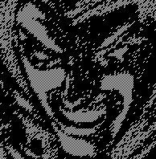

Stacked Image

5.2 Image Size invariant Visual Cryptography

Input Image

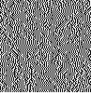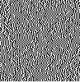

Share 1 Share2

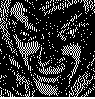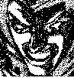

Stacked Image XOR Stacked image

5.3 Data Hiding using Same Size Visual Cryptography



Secret image Hidden Image

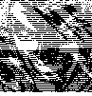

Share1 Share2

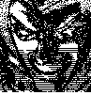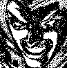

Stacked Image XOR Stacked Image Recovered Hidden Image

5.4 Image Embedding using same size VC(Assuming 2 pixel)


Image Hidden Image

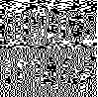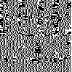
Share1 Share2


XOR Stacked Image Recovered Hidden Image

5.5 Image Embedding using same size VC(Assuming 4 pixel)

a) Horizontal Arrangement:

Image Hidden Image

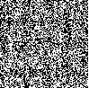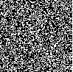
Share1 Share2


XOR Stacked Image Recovered Hidden Image

b) Vertical Arrangement:

Image Hidden Image

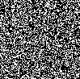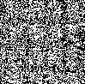
Share1 Share2


XOR Stacked Image Recovered Hidden Image

c) Square Arrangement:

Image Hidden Image

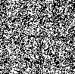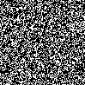
Share1 Share2

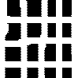
XOR Stacked Image Recovered Hidden Image

5.6 Snapshots

Home Window: The first window appears is the Home window which has the three options. The fist option is for General visual cryptography or the conventional visual cryptography. The second option is for generating shares or transparencies that are equal in size of the input image. The third option is for data hiding in the secret image.

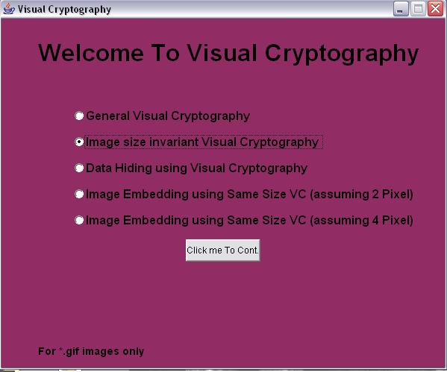

Fig.5.1: Home Window.

General Visual Cryptography: The General visual cryptography window is used for generating shares using conventional VC. First we have to select the secret image after that generate transparencies and to view the reconstructed image stack the transparencies.

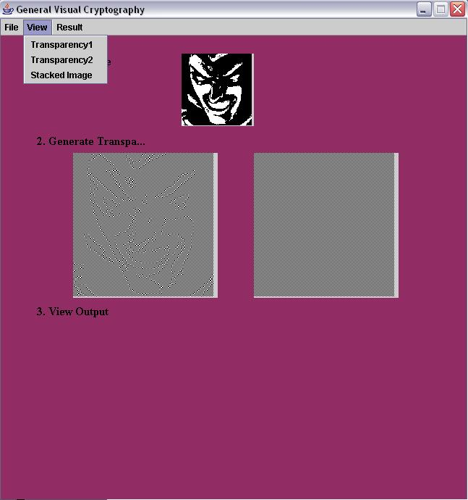

Fig.5.2: General Visual Cryptography

Open Dialog Box: The open dialog box is used to select the image for which transparencies or shares are generated.

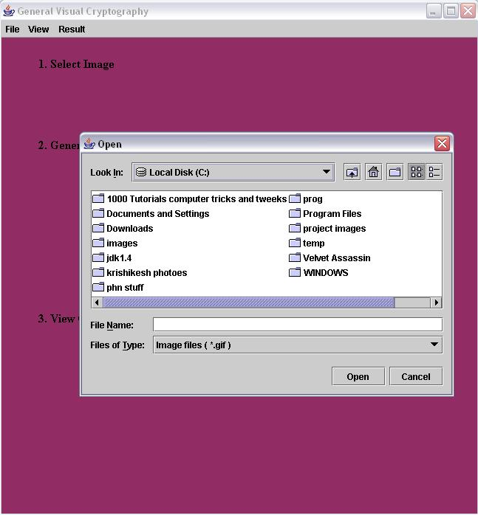

Fig.5.3: Open Dialog Box.

Image Size Invariant Visual Cryptography: This window is used for generating transparencies of the same size that of the secret image. The window shows the reconstructed image by stacking the transparencies as well as XOR of two transparencies.

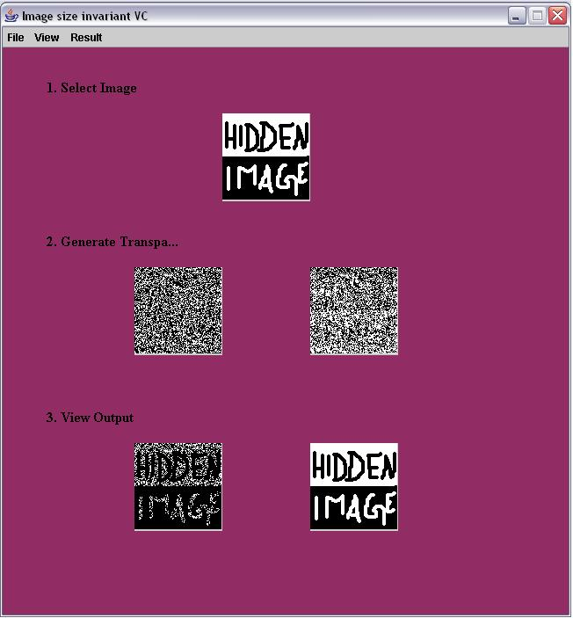

Fig.5.4: Image Size Invariant Visual Cryptography

Data Hiding: The Data Hiding window generates the two transparencies from the secret image and the hidden image. The transparencies generated are of the same size that of the secret image. The hidden image is having height half of the height of the secret image. The window also shows the reconstructed secret image as well as hidden image.

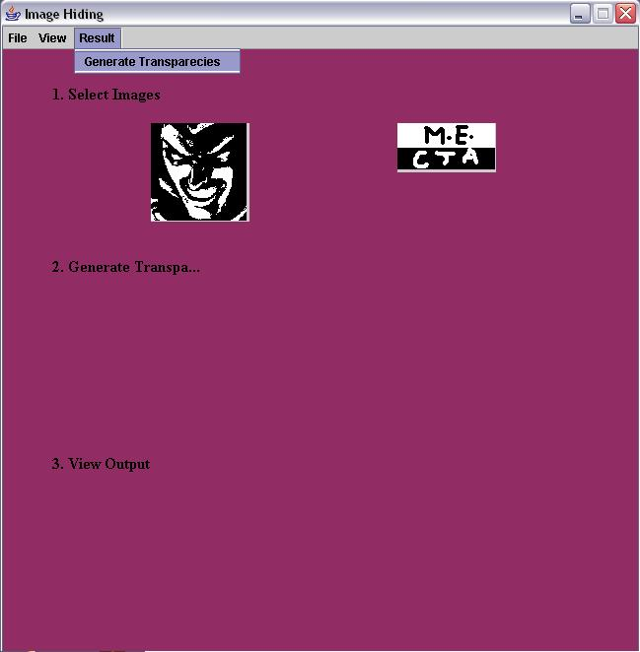

Fig.5.5: Data Hiding using Same Size VC

Image Embedding (Assuming 2 pixel): The image embedding assuming 2 pixel accept the images of same size and generates the shares of images. The window also shows the stacked image, xor stacked image and hidden image.

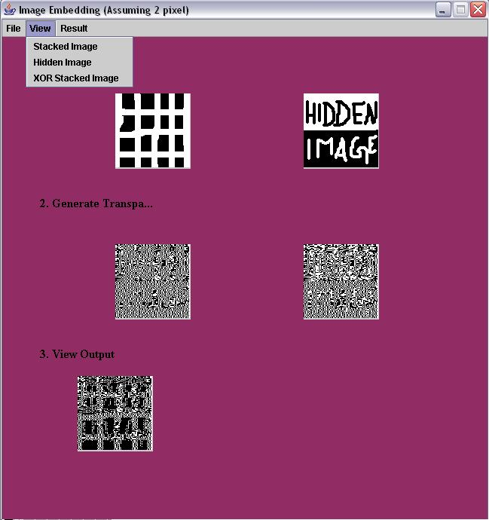

Fig.5.6: Image Embedding Assuming 2 pixel.

Image Embedding (Assuming 4 pixel): Image Embedding assuming 4 pixel accept the images of same size and generates the shares of images. The window has three modes for operating differently. The window also shows the stacked image, xor stacked image and hidden image.

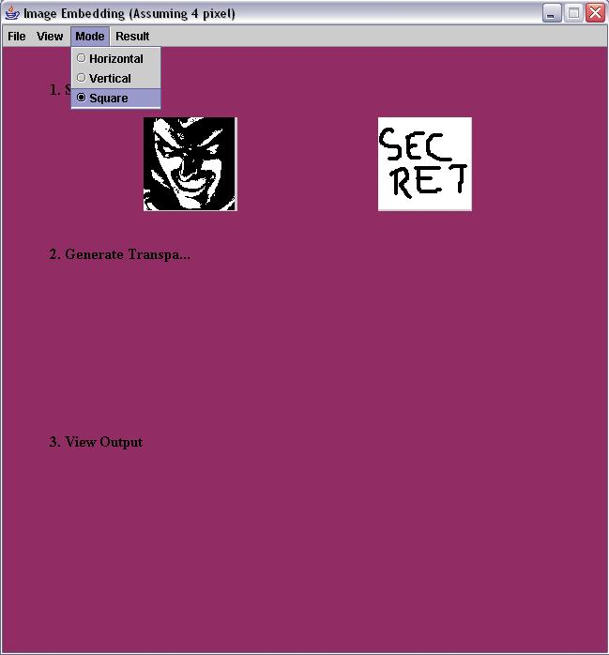

Fig.5.7: Image Embedding Assuming 4 pixel.

Chapter 6

CONCLUSION AND FUTURE WORK

Image Embedding is the effective and efficient way for hiding extra information in the multiple shares or transparencies generated by using image size invariant visual cryptography. The data hiding concept [5] uses the 50% pixel values of each share for storing the information of image which is half in the size of the original image. The result shows that the proposed image embedding algorithms (both assuming 2 pixel and assuming 4 pixel) uses the 25% of pixel values for storing the information of hidden image which is of the same size that of original image. The image embedding assuming 2 pixels provide better regenerated images than image embedding assuming 4 pixels. The regenerated images using horizontal and vertical arrangement of image embedding assuming 4 pixel produce regenerated images with sharp edges. So, images having more edges should use image embedding assuming 2 pixel and square arrangement of image embedding assuming 4 pixels. If original image contains more black pixel and hidden image contains more white pixel than image embedding assuming 4 pixel is better than image embedding assuming 2 pixel. The original image and the hidden image can be regenerated by using XOR operation at the particular pixel location. The regenerated images are almost similar to the respective images with small distortion of the edges. The user can easily identify the original images from regenerated images.

The Visual cryptographic technique works properly for the black and white images. The future research work related to VC can be done in the following areas:
- Improving the visual cryptographic technique so that it can be applicable for the colored images and
- Improving the image embedding concept for colored images.

REFERENCES

[1] M. Naor and A. Shamir, “Visual Cryptography,” Advances in Cryptography
Eurocrypt’94, Vol.950,pp. 1-12, 1995.
[2] Ryo ITO, Hidenori KuWakado, Hatsukazu Tanaka, “Image Size Invariant
Visual Cryptography” ,IEICE 99,pp.2172-2177,1999.
[3] Sang-Yi Yi, Kyo-Il Chung, Chung-Sang Ryu, Kwang-Hoon Cha, Seung-
Hyun Lee, and Eun-Soo kim, “Encryption of Cell-Oriented Computer
Generated Hologram by Using Visual Cryptography”, IEEE, pp. 817-
818,1999.
[4] C. Blundo, Santis A De. and M. Naor, “Visual cryptography for grey level
images”, Information Processing Letters, vol. 75(6), pp. 255-259, 2000.
[5] Hao Luo, Faxin Yu, “Data Hiding in Image Size Invariant Visual
Cryptography”,ICICIC’08,pp.978-981,2008.
[6] Wei-Qi Yan, Duo Jin and Mohan S Kankanhalli, “Visual Cryptography for
Print and Scan Applications”, ISCAS 04, pp.572-575, 2004.
[7] Sang-Su Lee, Jung-Chan Na, Sung-Won Sohn, Cheehang Park, Dong-Hoan
Seo and Soo-Joong Kim, “Visual Cryptography based on an Interferometric
Encryption Technique”, ETRI Journal, vol. 24, pp.373-380, Oct. 2002.
[8] Ming Sun Fu and Oscar C. Au, “Joint Visual Cryptography and
Watermarking”, IEEE, pp.975-978, 2004
[9] Sen-Jen Lin, Ja-Chen Lin and Wen-Pinn Fang, “Visual Cryptography (VC)
with Non-expanded Shadow Images: Hilbert-curve Approach”, IEEE,pp.271-
272,2008.
[10] Stefan Droste, “New Results on Visual Cryptography” Springer-Verlag,
pp.401-415, 1998.

[11] Pim Tuyls, Tom Kevenaar, Geert-Jan Schrijen, Toine Staring and Marten
van Dijk, “Visual Crypto Displays Enabling Secure Communication”,
Springer-Verlag, pp.271-284,2004.
[12] Chao-Wen Chan and Chih-hao Lin, “A New Credit Card Payment Scheme
using Mobile Phones Based on Visual Cryptography”, Springer-Verlag,
pp.467-476,2008.
[13] “The Complete Reference Java2” by H. Schildt.
[14] http://java.sun.com/j2se/1.3/doc
[15] http://javaworld.com

Appendix

Package java.awt.image

The java.awt.image package provides classes for creating and modifying images. Images are processed using a streaming framework that involves an image producer, optional image filters, and an image consumer. This framework makes it possible to progressively render an image while it is being fetched and generated. Moreover, the framework allows an application to discard the storage used by an image and to regenerate it at any time. This package provides a number of image producers, consumers, and filters that you can configure for your image processing needs.

Package javax.imageio

This is main package of the Java Image I/O API. Many common image I/O operations may be performed using the static methods of the ImageIO class. This package contains the basic classes and interfaces for describing the contents of image files, including metadata and thumbnails (IIOImage); for controlling the image reading process (ImageReader, ImageReadParam, and ImageTypeSpecifier) and image writing process (ImageWriter and ImageWriteParam); for performing transcoding between formats (ImageTranscoder), and for reporting errors (IIOException).

Package java.awt

This package contains all of the classes for creating user interfaces and for painting graphics and images. A user interface object such as a button or a scrollbar is called, in AWT terminology, a component. The Component class is the root of all AWT components.

Some components fire events when a user interacts with the components. The AWTEvent class and its subclasses are used to represent the events that AWT components can fire. See AWTEvent for a description of the AWT event model.

A container is a component that can contain components and other containers. A container can also have a layout manager that controls the visual placement of components in the container. The AWT package contains several layout manager classes and an interface for building your own layout manager.

