Chapter-1
INTRODUCTION
In the present time refrigeration is a fast growing industry, but refrigeration industry is facing two major problems namely global warming potential (GWP) and ozone depletion potential (ODP) due to refrigerant. These two problem are described below
1.1 Global Warming Potential (GWP)
GWP is a measure of how much a given mass of greenhouse gas is estimated to contribute to global warming. It is a relative scale which compares the gas in question to that of the same mass of carbon dioxide (whose GWP is 1).
The GWP depends on the following factors
- The absorption of infrared radiations by a given species
- The spectral location of its absorbing wavelengths
- The atmospheric lifetime of the species
1.2 Predicted effects of Global Warming include
- Higher sea level
- Higher temperatures
- Variable climatic conditions
- These changes are expected to cause a significant impact on agriculture and ecosystems.
1.3 Ozone Depletion Potential (ODP)
ODP the ozone depletion of a compound is simple measure of its ability to destroy stratospheric ozone. It is a relative measure of the ODP of CFC-11 is defined to be 1.0 and the ODP’s of other compound are calculated with respect to this reference point. Thus a compound with an ODP of 0.2 is roughly speaking one fifth as “bad” as CFC-11. Ozone can be destroyed by a number of free radical catalysts, the most important of which are the hydroxyl radical (OH⁻), the nitric oxide radical (NO⁻) and the atomic chlorine (Cl⁻) and bromine (Br⁻). All of these have both natural and anthropogenic (manmade) sources; at the present time, most of the OH⁻ and NO⁻ in the stratosphere is of natural origin, but human activity has dramatically increased the levels of chlorine and bromine. These elements are found in certain stable organic compounds, especially CFCs which may find their way to the stratosphere without being destroyed in the troposphere due to their low reactivity. Once in the stratosphere, Cl and Br atoms librated from the parent compounds by the action of ultraviolet light.
The Cl and Br atoms can destroy the ozone molecule by the following reaction
Cl + O₃ = ClO + O₂
ClO + O₃ = Cl + 2 O₂
The overall effect is a decrease in the amount of ozone. More complicated mechanisms have been discovered that lead to ozone destruction in the lower stratosphere as well.
The ODP and GWP of the CFCs refrigerant are given in table 1.1
Table no.1.1
Refrigerant | ODP | GWP (100 yr)
R-11(CFCl₃₎ | 1 | 3800
R-12(CF₂Cl₂) | 1 | 8100
R-22(CHF₂Cl) | 0.055 | 1500
R-134a(CF₃CH₂F) | 0 | 1300
1.4 Depleted Ozone levels cause the following impacts
- Increased penetration of UV light to earth
- Increased risks of skin cancer and eye diseases
- Damage to agricultural crops
- Disruption to marine food chains
By the following table it is clear that the GWP and ODP of CFCs refrigerant are very high and their use is very dangerous for our life. So that it becomes very necessary to find alternate of such type of refrigerant. Hence it is necessary to use hydrocarbons as refrigerants to avoid ozone layer depletion & global warming potential
Table no.1.2 The ODP and GWP of the HCs
Refrigerant | ODP | GWP (100 yr)
R-717(NH₃) | 0 | 0
R-600(Butane) | 0 | 3
R-170(Ethane) | 0 | 3
R-744(carbon dioxide) | 0 | 1
R-290(Propane) | 0 | 3
By the following table it is clear that the GWP and ODP of the HCs and natural refrigerants are very less. So the use of HCs and natural refrigerant is safe for our environment.
1.5 Advantages of Hydrocarbon as a Refrigerant
There are many advantages of using HCs as a refrigerant in vapour combined cycle:
- Global warming potentional is less.
- Ozone depletion potentional is less.
- The COP of the combined cycle is increases up to 21%.
1.6 Disadvantage of Vapour Compression Cycle
Due to throttling losses the COP of the vapour compression refrigeration cycle is less.
1.7 Throttling device
A throttling device in a refrigeration system normally serves two purposes. One is the thermodynamics function of expanding the liquid refrigerant from the condenser pressure to the evaporator pressure. The other is the control function which may involve the supply of the liquid to the evaporator at the rate at which it is evaporated. The later has an important role and determines the efficiency with which the evaporator surface is utilized.
A throttling device is essentially a restriction offering resistance to flow so that the pressure drops, resulting in a throttling process.
Throttling is expansion process in a zero work output device under adiabatic conditions. However the disadvantage of throttling process is increase in entropy and hence loss of COP in case of vapour compression cycle.
1.8 Method to Reduce the Throttling losses
In order to reduce the throttling losses of vapour compression cycle we replace the throttling device by ejector and turbine. Ejector and Turbine both is expander in which the process is isentropic. By using these two devices we are able to reduce the throttling looses and reduce the load on evaporator so that the COP of the combined compression refrigeration cycle is increases. The descriptions of ejector and turbine are as given below
1.8(a) Ejector
Ejector is an expander which uses an expansion device in vapour compression cycle and replaces the throttling loss by replacing throttling device in vapour compression cycle. The appropriate installation of the ejector in vapour compression cycle increases the COP of the refrigeration system by raising the compression suction pressure to a level higher than that in the evaporator and consequently, to reduce the load on the compressor and motor.
1.8(b) Turbine
Turbine is also an expander which is also use to reduce the throttling losses. The appropriate installation of turbine increases the COP of the vapour compression cycle.
But due to the following reason the uses of the turbine as an expander is limited:
- Turbine is very costly.
- Turbine uses only for high grade energy.
- Turbine is use only for a single phase refrigerant
- There is friction loss in the turbine
Fig.1.1-Cross-sectional view of the ejector with needle for high side Pressure control

Fig.1.2-cross-sectional view of ejector

1.9 Comparison between Ejector and Turbine
The comparison between ejector and turbine are as given below
- Ejector is more economical than turbine
- Turbine is uses high grade energy while ejector uses low grade energy.
- Turbine is use only for a single refrigerant while ejector can also be use for two phase refrigerant.
By the above comparison it is clear that the use of ejector is more beneficial than the turbine as an expander.
1.10 Energy conservation
Energy conservation is very important because of the limited amount of non-renewable energy sources on earth, it is important to conserve our current supply or to use renewable sources so that our natural resources will be available for future generations.
Energy conservation is also important because consumption of non-renewable sources impacts the environment. Specially, our use of fossil fuels contributes to air and water pollution. For example, carbon dioxide is produced when oil, coal, and gas combust in power stations, heating systems, and car engines. Carbon dioxide in the atmosphere acts as a transparent blanket, which contributes to the global warming of the earth, or “greenhouse effect.” It is possible that this trend could significantly alter our weather. Possible impacts include a threat to human health, environmental impacts such as rising sea level that can damage coastal areas, and major changes in vegetation growth patterns that could cause some plant and animal species to become extinct.
Sulphur dioxide is also emitted into air when coal is burned. The sulphur dioxide reacts with water and oxygen in the clouds to form precipitation known as “acid rain.” Acid rain can kill fish and trees and damage limestone buildings and statues.
In the U.S., the average family’s energy use generates over 11,200 pounds of air pollutants each year. Therefore, every unit (kilowatt) of electricity conserved reduces the environmental impact of energy use.

1.11 Scope of the project
In this project evaluation of ejector compression refrigeration system with propane as refrigerant is carried out and the effects of various operator parameters on the COP, exergy destruction and exergy efficiency are studied.

Chapter-2
LITERATURE REVIEW
Refrigeration is an extensive area of research. A lot of researches have already been carried out in ejector vapour-compression refrigeration cycle. The important works in this direction are explained below.

Kornhauser (1990) investigated the thermodynamic performance of the ejector-expansion refrigeration cycle using R-12 as a refrigerant. He found that a theoretical COP could be improved up to 21% over the standard cycle at the evaporator temperature of -15°C and the condenser temperature of 30°C. This result is based on ideal cycle components and constant mixing pressure in the ejector.

Harrell and Kornhauser (1995) tested a two-phase ejector and estimated the COP of the refrigeration cycle using R-134a as a refrigerant. It was found that the COP improvement ranged from 3.9% to 7.6%.

Menegay and Kornhauser (1996) used a bubbly flow tube to reduce the thermodynamic non equilibrium in the motive nozzle. An ejector using the bubbly flow tube, which was installed upstream of the motive nozzle, improved up to 3.8% of the COP over the conventional cycle under standard conditions with R-12 as the refrigerant. However, this result was not as good as they expected.

Nakagawa and Takeuchi (1998) concluded that the longer divergent part provided a longer period of time for the two-phase flow to achieve equilibrium. With this consequence, the longer length of the divergent part of the motive nozzle gave the higher motive nozzle efficiency.

Dorantes and Hernandez (2003) presented a study on the behaviour of a hybrid compressor and ejector refrigeration system with refrigerants 134a and 142b. A complete theoretical analysis on the thermodynamic behaviour of a Hybrid Compressor and Ejector Refrigeration System (HYCERS) is carried out. An ejector under optimum performance is employed. Two working fluids selected were refrigerant 142b (HCFC142b) which showed very good characteristics in air conditioning applications of ejector systems and refrigerant 134a (HFC134a) which is widely used in refrigeration applications and readily available in most countries. The variation of the generator and condenser temperatures as well as the intercooler pressure were considered for an evaporator temperature of) 10°C and a unitary cooling capacity of 1 kW. The ideal efficiency, the enthalpy-based coefficient of performance, the exergy efficiency and the supplied energy ratio are obtained. With this information, at a moderate condenser and generator temperature of 30 and 85ºC, respectively, the HYCERS working with R134a had the best operation with a highest coefficient of performance of 0.48 and an exergy efficiency of 0.25. On the other hand, if a higher condenser temperature is imposed, the HYCERS with R142b had its best performance at a higher generator temperature. In selecting a working fluid the ejector subsystem behaviour is determinant in system performance. If a working fluid is badly selected, despite having high Entrainment ratios, the system will not function properly. Therefore, the methodology here defined becomes an effective tool for selecting adequate working fluids and optimum system design conditions. Also, the employment of a unitary cooling load allows system scaling at any capacity as it increases linearly.

Wongwises and Disawas (2004) analysed the performance of the two-phase ejector expansion refrigeration cycle. They presented new experimental data of the system performance of the two-phase ejector refrigeration cycle (TPERC). The TPERC uses a two-phase ejector as an expansion device while the conventional refrigeration cycle (CRC) uses an expansion valve. The TPERC enables the evaporator to be flooded with refrigerant, resulting in a higher refrigerant-side heat transfer coefficient. The experimental study shows that the TPERC gives a higher cooling capacity and a higher coefficient of performance. Moreover, the pressure ratio and the discharge temperature of the compressor of the TPERC are lower than those of the CRC. The experimental results show that the TPERC has lower compressor pressure ratio, lower discharge temperature, higher cooling capacity and higher COP than those of the CRC. The COP of the TPERC shows a slight improvement above that of the CRC at low inlet cold water temperatures. The flow rates of heat transfer fluid (hot water) have significant effect on the relevant parameters, especially for the CRC.

Alexis (2005) carried out the analysis of a combined refrigeration and electrical power cogeneration system. In their study a steam power cycle (Rankine) produces electrical power 2 MW and steam is bleeded off from the turbine at 7 bars to warm a factory or units of buildings during the winter or to supply a steam ejector refrigeration cycle to air-conditioning the same area during the summer. In the summer this system can be as alternative solution instead of absorption. Certainly the ejector refrigeration unit is more economical than absorption unit. The ratio of electrical power/heat is varied into the region (0.1-0.4) and the evaporator temperature of the ejector cycle is varied into the region (10-16ºC). The steam-ejector refrigeration cycle has low coefficient of performance but low operation cost, environment friendly and can be used waste heat. Also this system would be used instead of absorption system for air-conditioning space. From the results, it is observed that when the ratio electrical power/heat transfer rate W_{G}=Q_{GER} is varied into the region (0.1-0.4) the ratio electrical power/refrigeration capacity W_{G} =Q_{E} is varied into the region (0.23-0.92) when the electrical power is constant 2 MW, the evaporator temperature ‘Te’ is varied into the region (10-16°C) and generator temperature, condenser temperature are Tg=150ºC, Tc=50°C, respectively. Also, when the energy utilization factor for electrical power and heat EUF_{COH} is varied into the region (0.54-.88), the energy utilization factor for electrical power and refrigeration EUF_{COC} is varied into the region (0.32-0.43) for above operation conditions. Similarly the energy utilization factor FESR_{COH} for cogeneration electrical power and heat is varied into the region (0.30-0.47) and the fuel energy savings ratio for cogeneration electrical and cooling power FESR_{COC} are varied into the region (0.15-0.28), respectively.

Huang and Lee (2005) present a study on development of an ejector cooling system with thermal pumping effect. They carried out a feasibility study of an ejector cooling system (ECS) that utilizes a multi-function generator (MFG) to eliminate the mechanical pump. The MFG serves as both a pump and a vapour generator. The MFG is designed based on the pressure equilibration between high and low pressures through heating and cooling process. A prototype using refrigerant R141b as working fluid was constructed and tested in the present study. The experimental results showed that the system coefficient of performance (COP)o was 0.218 and the cooling capacity was 0.786 kW at generating temperature (Tg) 90°C of condensing temperature of (Tc) 32.4ºC and evaporating temperature (Te) of 8.2°C. While taking into account the extra heat needed for the MFG operation, the total coefficient of performance (COP)t is 0.185. It is shown that a continuous operation for the generation of cooling effect in an ECS with MFG can be achieved. This cooling machine can be very reliable since there is no moving part.
Some important results from experiment are obtained and summarized as follows:
(1)The design of an ECS/MFG is feasible. A continuous operation for the generation of cooling effect can be attainable. This machine can be very reliable since there is no moving part.
(2) (COP)o of the ECS/MFG is 0.218 and the average cooling capacity is 0.786 kW at generating temperature 90ºC, condensing temperature 32.4°C and evaporating temperature 8.2ºC. (COP)t is 0.185 while taking into account the extra heat needed for liquid return to vapour generator. The (COP)o here is 0.218 which is lower than 0.54, Huang et al. [1,2], at generator temperature 84°C, condensing temperature 28ºC, and evaporating temperature 8°C. According to the performance characteristic, for a given constant evaporator temperature, Increasing the generator temperature resulted in worse COP, but the cycle could be operated at higher critical condenser pressure and would therefore be less susceptible to changing condenser conditions in practical applications. Due to the high heat sink temperatures during summer time in Taiwan, condensing temperature higher than 30ºC is inevitable and this will sacrifice the performance of the system.
(3) The design of MFG in the present study shows that the time for vapour discharge phase is longer than the total time for the depressurizing, liquid intake, and pressurizing phases. This can assure the continuous operation have higher COP as well. Thus, the system is purely heat operated cycle.

Li and Groll (2005) investigated theoretically the performance of transcritical CO₂ refrigeration cycle with ejector-expansion device. It was found that the ejector-expansion cycle improves the COP by more than 16% compared to the basic cycle for typical Air-conditioning applications.

Elbel and Hrnjak (2006) carried out an experimental study of a prototype ejector designed to reduce throttling losses encountered in transcritical R744 system operation. They obtained result with the help of a transcrictical R744 system using a refrigerant ejector and this result were compared to that of a conventional system with an expansion valve. They found the cooling capacity and COP simultaneously Improved by up to 8% and 7%, respectively. Experiments were also analyzed to quantitatively assess the effects on system performance as a result of changes in basic ejector dimensions such as motive nozzle and diffuser sizing. Small angles of 5° yielded best results for the static pressure recovery of the high-speed two-phase flow entering the diffuser. Experiments confirmed that like in a conventional transcritical R744 system with expansion valve, the high-side pressure control integrated into the ejector could be used to maximize the system performance. According to this definition, the prototype ejector was able to recover up to 14.5% of the throttling losses. The study also revealed that the work rate recovery potential increased for higher outdoor temperatures and for (internal heat exchanger) IHX having lower effectiveness, even though the ejector efficiency was not much affected by a change in these parameters. It was found that the maximum system performance was achieved with a highly effective IHX integrated into the ejector system. However, the experiments carried out also revealed that the ejector system could have a reduced IHX effectiveness and still achieve capacities and COP_{s} that are comparable to that of the conventional expansion valve system.

Deng et al. (2007) present a theoretical analysis of a transcritical CO₂ ejector-expansion refrigeration cycle that uses an ejector as the main expansion device instead of an expansion valve. It is found that for the working conditions described in their paper, the ejector improves the maximum COP by 18.6% compared to the internal heat exchanger system and 22% compared to the conventional system.

Nehdi et al. (2007) investigated the performance of the vapour compression cycle using ejector as an expander. According to the results of simulation in their work, it has been shown that the geometric parameters of the ejector design have considerable effects on the system performance. The maximum COP is obtained for optimum geometric area ratio, whose value is around 10.

Yari and Siriousazar (2007) investigated the performance of transcritical CO₂refrigeration cycle with ejector-expansion based on second law of thermodynamics. It was found that, the ejector improves the optimum second-law efficiency by 24.8% compared to conventional system and 16% compared to internal heat exchanger system.

Dai and Wang (2008) presented a research on exergy analysis, parametric analysis and optimization for a novel combined power and ejector refrigeration cycle. They proposed a new combined power and refrigeration cycle, which combines the Rankine cycle and the ejector refrigeration cycle. This combined cycle produces both power output and refrigeration output simultaneously. It can be driven by the flue gas of gas turbine or engine, solar energy, geothermal energy and industrial waste heats. An exergy analysis is performed to guide the thermodynamic improvement for this cycle and a parametric analysis is conducted to evaluate the effects of the key thermodynamic parameters on the performance of the combined cycle From the result, it can be concluded that the amounts of exergy loss in the boiler and ejector account for large percentage through exergy analysis. Therefore, it is significant to employ methods for reducing exergy losses of these components. Thus the performance for this combined cycle could be improved greatly. In addition, the parametric study shows that turbine inlet pressure, turbine back pressure, condenser temperature and evaporate or temperature have significant effects on the turbine power output, refrigeration output and exergy efficiency. It is also found that the combined cycle has a maximum exergy efficiency of 27.10% when turbine inlet pressure, turbine inlet temperature and turbine back pressure are 0.7852 MPa, 118.9°C and 0.1462 MPa, respectively.

2.1 Conclusion of literature review
From the above literature review it is concluded that by using ejector as an expansion device the COP of the vapour compression system is increased up to 22%. Nehdi (2007) and Yari (2008) carried out the performance analysis of the combined ejector-compression refrigeration cycle. They did work on refrigerant R-134a whose global warming potential is very high.

2.2 Problem formulation
All the research on combined ejector-compression is done only for HFCs (hydrofluorocarbons), We know that the global warming potential of HCFs refrigerant is very high (as given in table-1.1). In order to reduce the global warming potential, it is proposed to use propane as a refrigerant in combined ejector-compression refrigeration cycle and evaluate the effects of various parameters such

Chapter-3
THERMODYNAMICS MODELLING
In this chapter ejector-compression system is analyzed using mass and energy, exergy balances. Methodology adopted to find solution is also specified. In order to validate the present model, the simulation results have been compared with the available numerical data in the literature for combined ejector-compression cycle.
  - System description
Figs 3.1& 3.2 shows the schematic diagrams and p-h diagram of an ejector-compression refrigeration cycle.
Fig3.1 Schematic of the improved system cycle
Fig 3.2 the log P-h diagram of the improved cycle
Combined Ejector-Compression refrigeration cycle comprises of the following ejector, evaporator, compressor, condenser, ejector, separator etc.
Fig 3.3 shows the configuration of ejector. Ejector is an expression device which replaces the throttling valve in order to reduce the irreversibility of expansion device.
The ejector is installed at the outlet of the condenser, and the motive fluid (liquid from the condenser) enters into the nozzle at a relatively high pressure. Reduction of the pressure of the liquid in the nozzle provides the potential energy for conversion to kinetic energy of the liquid. The driving flow entrains vapour out of the evaporator. The two phases are mixed in mixing chamber and leave it after a recovery of pressure in the diffuser part of the ejector. The liquid portion is directed to the evaporator through a small pressure-drop expansion device while the vapour portion enters the compressor suction. The lines from points 4 to 6 is a series process in the compressor and the condenser. The lines from points 7 to 9 is a series process in the expander and the evaporator. Points 1 and 2 are the state of the flow at the exit of the primary nozzle and in the mixing area of the ejector while point 2–3 is a compression process.
The appropriate installation of the ejector increases COP of the refrigeration system by raising the compression suction pressure to a level higher than that in the evaporator and consequently, to reduce the load on the compressor and motor.
In the ejector geometry there are three section of ejector
- Nozzle
- Mixing chamber
- Diffuser section
Fig 3.3 shows the configuration the ejector, fig 3.4 shows the pressure variation in ejector.
Fig.3.3 Configuration of ejector
Fig3.4 Variation of pressure in ejector
3.2 Energy analysis of the Ejector-Compression cycle the mass and energy balances in an ejector compression cycle are given below
3.2.1 Flow nozzle
The exit velocity from the nozzle is calculated from
(3.1)
h₁ is the enthalpy, at the outlet of the motive nozzle
(3.2)
For an isentropic process
(3.3)
The density, at the outlet of the motive nozzle
(3.4)
The mass flow rate, at the outlet of nozzle
(3.5)
3.2.2 Flow in the mixing tube
Using the continuity equation, the total mass flow through the mixing tube is computed as
(3.6)
A momentum balance of the mixing tube yields
(3.7)
The density ratio, can be approximated by Chen (1988) as
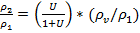+ (1/ (1+U)) (3.8)
Where U = represents the flow entrainment ratio
is the refrigerant’s vapour density at the evaporator outlet
The mixing velocity is defined as
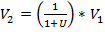 (3.9)
The enthalpy, at the outlet of the mixing section
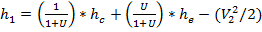 (3.10)
The entropy, at the outlet of the mixing section
(3.11)
3.2.3 Diffuser flow
The enthalpy, at the outlet of the diffuser, by conservation of energy
(3.12)
The exit diffuser actual enthalpy is computed as
(3.13)

The exit diffuser pressure is defined as
(3.14)
The isentropic compressor efficiency, proposed by Brunin et al. (1997)
(3.15)
Where R= compressor ratio
The cooling capacity is defined by
(3.16)
Where = saturated vapour enthalpy at
= saturated liquid enthalpy at
The coefficient of the performance of the improved cycle system,, is determined by the following definition
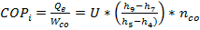 (3.18)
The relative performance of the ejector expansion cycle to the basic cycle is defined as
(3.19)
Where =COP of simple vapour compression cycle
    - Computational procedure
By using P₃, h_{3,} the vapour quality, at the diffuser outlet is computed. Then the value of X is compared by as given below
(3.20)
This computation process is repeated till Equation (3.20) is satisfied.
3.3 Exergy analysis
Exergy analysis is usually aimed to determine the maximum performance of the system and identify the locations of exergy destruction and to show the direction for potential improvements.
Exergy destruction in compressor
(3.21)
Exergy destruction in condenser
(3.22)
Exergy destruction in expansion valve
(3.23)
Exergy destruction in evaporator
(3.24)
Exegy destruction in ejector
(3.25)
Total exegy destruction
(3.26)
Reversible work
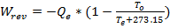 (3.27)
Second law efficiency
(3.28)
Based on the above analysis, a steady-state simulation program for the vapour compression refrigeration cycle with ejector as an expander device using EES software (Klein and Alvarda (2006)) is developed.

3.4 Simulation study
Simulation was performed to evaluate the combined ejector compression cycle with the following assumptions
1. The refrigerant was at all times in thermodynamic quasi-equilibrium.
2. Characteristics and velocities were constant over cross section (one-dimensional model).
3. All fluid characteristics are uniform over the cross section after complete mixing at the exit of the mixing tube.
4. There is no external heat transfer to the system.
5. There is no wall friction.
6. Negligible pressure drop.
7. The processes in compressor, expansion valve and ejector area assumed to be adiabatic.
8. Saturated state at the evaporator and the condenser outlet.
9. One dimensional flow in the ejector.

  - Flow chart for energy analysis
Start

Input parameter T_{c}, T_{e}, m, n_{n}, n_{d}

Calculate P_{c}, h₆, s₆, P_{1,}

Calculate h₁, h_{1a}, T₁, D_{v}, T₉
X_{check}, V1, D_{1a}, V₂, h₉

Calculate X_{check}, V₁, D_{1a}, V₂, h₉

Calculate D₂₁, P₂, h₂, s₂, h_{3,} s₃, P₃

Calculate D, D₂, m₂/m₁, A, W_{c}, Q_{e}

Calculate COP and COPr

3.6 Flow chart: for exergy analysis
Calculate I_{C} by using T_{0,} s₅ , S₄

Calculate I_{CO} by using T_{0,} s₅, s_{6,} h₅, h₆

Calculate I_{EV} by using T_{0,} s₇, s₈, U

Calculate I_{E} by using T_{0,} s₈, s₈, h₈, h₉, U

Calculate I_{ej} by using T_{0,} s₃, s₆ s₉, U

Calculate I_{t}=I_{C}+I_{CO}+I_{EV}+I_{ej}+I_{E}

Calculate second-law efficiency

Print output

Stop
3.7 Solution methodology in engineering equation solver (EES) (Klein and Alvarado (2007))
EES is a software package developed by Dr. Sanford Klein of the University of Wisconsin. EES incorporates the programming structure of C and FORTRAN with a built-in iterate, thermodynamics and transport property relations, graphical capacities, numerical integration, and many others useful mathematical functions. By grouping equations there are to be solved simultaneously, EES is able to function at a high rate of computational speed. Ammonia-water mixture properties are calculated in EES using the correlation developed by Ibrahim and Klein (1993). There are two major differences between EES and exiting numerical equations solving programs. First, EES automatically identifies and groups equations that must be solved simultaneously. This feature simplifies the process for the users and ensures that the solver will always operate at optimum efficiency. Second, EES provides many built in mathematical and thermo physical property functions useful for engineering calculations. The basic function provided by the engineering equation solver (EES) is the numerical solution of the non-linear algebraic and differentials equations, EES provides built in thermodynamics and transport property functions for many fluids including water, dry and moist air. Included in the property database are thermodynamics properties for H₂O-LiBr and NH₃-H₂O mixture. Any information between quotation marks [“] or [{}] is an optional comment. Variable names must start with a letter.
A code containing a good library of working fluid properties suitable for heat pumps is the Engineering Equations Solver (EES). Here the user must write the equations governing the cycle and make sure the set is well-defined. In the case of a non-linear set of equations, the user must check the results to make sure that the mathematical solutions are also a physical One. In one form or another, the users have to do a fair amount of programming to lead the simulator toward convergence to the correct solutions.

3.8 Input parameters for simulation
- Evaporator temperature () -15 to 15°C with a
Step of 5°C
- Condenser temperature () 30-40°C
- Nozzle of the ejector efficiency () 85%
- Diffuser of the ejector efficiency () 85%
- Reference environment temperature () 300K
- Refrigerant Propane
- T_{r} = T_{e} + 5
- Reference environment pressure () 1.01325 bar

Chapter -4
RESULTS AND DISCUSSION
A computer program has been developed using Engineering Equation Solver (EES) software (Klein and Alvarado (2007)) (version 7.441), for carrying out the energy and exergy analysis of the combined ejector-compression refrigeration cycle.
4.1 Validation of the simulation
The COP of the combined ejector-compression cycle by using R134a as a refrigerant is compared with the results of Nehdi et al. (2007). The table (4.1) has given below shows the comparison between present results and the results of the reference paper:
Table no.4.1 Comparison of results with Nehdi et al. (2007) Parameters (Tc=30°C, Te= -15°C, m=1, n_{n}=.85, n_{d}=.85)
Refrigerant used | COP of the reference paper | Calculated COP | % difference
R134a | 4.611 | 4.514 | 2.15

Table 4.2 given by Yari (2008)
Operating conditions for the ejector-compression refrigeration cycle parameter (Te=5°C, Tc=40°C, m=1, n_{n}=0.85, n_{d}=0.85)
i | T_{i} (°C) | P_{i} (Kpa) | h_{i} (kJ/kg) | s_{i} (kJ/kgK) | ṁ_{i} (kg/sec)
1 | 5 | 349.901 | 105.3 | 0.3967 | 1
2 | 6.711 | 371.193 | 170.7 | 0.6292 | 1
3 | 8.694 | 397.089 | 171.6 | 0.6292 | 1
4 | 8.694 | 397.089 | 255.4 | 0.927 | 0.5617
5 | 46.6 | 1017.00 | 278.7 | 0.9387 | 0.5617
6 | 40 | 1017.00 | 108.3 | 0.3949 | 0.5617
7 | 8.694 | 397.089 | 63.64 | 0.2466 | 0.4283
8 | 5 | 349.901 | 63.64 | 0.2468 | 0.4283
9 | 5 | 349.901 | 253.3 | 0.9288 | 0.4283
The operating conditions of combined ejector-compression refrigeration cycle, given by computer program is presented in Table 4.3

Table 4.3 Operating conditions for the ejector-compression refrigeration cycle parameter (Te=5°C, Tc=40°C, m=1, n_{n}=0.85, n_{d}=0.85)
i | T_{i} (°C) | P_{i} (Kpa) | h_{i} (kJ/kg) | s_{i} (kJ/kgK) | ṁ_{i} (kg/sec)
1 | 5 | 349.9 | 104.8 | 0.3949 | 1
2 | 6.652 | 370.4 | 170.9 | 0.6301 | 1
3 | 8.887 | 406.5 | 171.8 | 0.6301 | 1
4 | 8.887 | 406.5 | 255.8 | 0.9267 | 0.5617
5 | 43.15 | 1017 | 274.8 | 0.9267 | 0.5617
6 | 40 | 1017 | 108.3 | 0.3949 | 0.5617
7 | 9.387 | 406.5 | 64.59 | 0.2499 | 0.4283
8 | 5 | 349.9 | 64.59 | 0.2502 | 0.4283
9 | 5 | 349.9 | 253.3 | 0.9288 | 0.4283

Table 4.4 summaries the performance of the two cycles based on the first and second laws of thermodynamics. The COP and second-law efficiency of the ejector-compression are about 18% higher than that for the vapour compression cycle. The total exergy destruction of the vapour compression cycle is about 45% higher than that for ejector compression cycle.
Table 4.4 performance comparisons of the cycles based on first and second laws of thermodynamics (T_{e}=5°C, T_{c}=40°C, m=1, n_{n}=.85, n_{d}=.85, A_{r}=8)
 | Exergy destruction of simple VCR cycle (kJ/kg) | Exergy destruction of ejector cycle(kJ/kg)
Compressor | 7.052 | 6.241
Condenser | 13.69 | 7.613
Expansion valve | 7.761 | .122
Evaporator | 5.519 | 2.967
Ejector | - | 1.399
Total exegy | 33.69 | 18.34
COP | 5.547 | 6.513
n11(%) | 42.87 | 51.16

4.2 Effect of variation in area ratio
Fig 4.1 and 4.2 show the effect of area ratio on the coefficient of performance (COP) for propane and R-134a refrigerant. With the increase in area ratio the COP increased for both the refrigerant. With the increase in area ratio (area ratio = area at the inlet of the diffuser/area at the outlet of nozzle) the area at the outlet of nozzle is decreased. Due to this, the pressure of the primary refrigerant (refrigerant coming out from the nozzle) is increase and the pressure of the refrigerant at the suction of compressor is increased. Due to increased in suction pressure the load on the compressor is decreased and COP of the combined cycle is increased. With the further increase in area ratio the pressure of the primary refrigerant is increased and some of the refrigerant is condensed. Due to this condensation the suction pressure of the compressor is decreased and the COP is also decreased. It is also concluded from the fig 4.1 and 4.2 that COP is maximum for propane refrigerant under the same working conditions. The COP of propane is 1.73% more than that of R-134a under same working conditions.
Fig 4.3 and 4.4 show the effect of area ratio on relative COP (COP of the combined cycle/COP of vapour compression refrigeration cycle). When the COP is increases the relative COP is also increase and vice versa.
Fig 4.5 and 4.6 show the effect of area ratio on pressure ratio (pressure at the outlet of compressor/pressure at the inlet of compressor). With the increase in area ratio up to optimum level the suction pressure of the compressor is increased so that the pressure ratio is increased. After the optimum level any increase in area ratio the suction pressure is decrease but the pressure ratio increases.
Fig 4.7 shows that the combined effect of area ratio on the COP and pressure ratio. It is concluded from the fig 4.7 that at a particular optimum area ratio COP is and pressure ratio is minimum.
Fig 4.8 shows the comparison of COP between the calculated COP and Nehdi et al. (2007) for R-134a refrigerant. It is concluded from fig 4.8 that the reference paper COP is 2.15% more than the calculated COP.
Fig 4.9 to 4.24 shows the combined effect of area ratio on COP and exergetic efficiency. From these figure it is concluded that COP and exergetic efficiency is maximum at one area ratio (this area ratio is called as optimum area ratio) for the same conditions.
4.3 Effect of variation in evaporator and condenser temperature
Fig 4.25 shows the combined effect of evaporator and condenser temperatures on the optimum area ratio. The optimum area ratio increases by increasing of the evaporator and condenser temperature. It is seen that ejector with higher area ratio, capable of inducting more secondary vapour, can create suction in the ejector at lower evaporating temperature also. But ejector with lower area ratio necessitates higher
evaporating temperature to entrain secondary vapour at the given condenser temperatures. Fig 4.25 also shows the effect of condenser temperature on area ratio. The optimum area ratio is decreased with increase in condenser temperature. Because of increase in condenser temperature the pressure ratio is increased and the load on compressor is increased due to that the area ratio is decreased.
Fig 4.26 shows the combined effect of evaporator and condenser temperatures on the compressor efficiency. Compressor efficiency is increased with the increase in evaporator temperature because the suction pressure of compressor is decreased and compressor efficiency decrease with increase in condenser temperature due to increase in pressure ratio.
Fig 4.27 to 4.31 show the combined effect of evaporator and condenser temperatures on COP of the combined cycle. As discussed earlier that with increase in evaporator temperature the suction pressure is reduced so that the COP of the combined ejector cycle increases. Pressure ratio increases with increase in condenser temperature and the COP of the cycle is decreased.
Fig 4.37 to 4.42 show the effect of evaporator, condenser temperatures and area ratio on the total exergy destruction. It is concluded from the figure that total exergy destruction increases with increase in condenser temperature and total exergy destruction decreases with increase in evaporator temperature and area ratio.
4.4 Comparison of result
Fig 4.43 shows the comparison between the ejector cycle and vapour compression cycle. it is concluded from the figure that the COP of ejector cycle is 24% more than the VCR cycle. Fig 4.44 to 4.48 shows the comparison between the COP of the ejector cycle with the VCR cycle under different area ratio.
Fig 4.49 shows the comparison between exergetic efficiency of ejector cycle and VCR cycle. It is found that the exergetic efficiency is 24% more than the VCR cycle. Fig 4.50 to 4.53 shows the comparison between exergetic efficiency and VCR when the area ratio of the cycle is increase.
Fig 4.54 shows the comparison between the total exergy destruction in ejector cycle and vapour compression cycle. It is found that the total exergy destruction in ejector cycle is 45-47% less than in comparison of vapour compression cycle.
Fig 4.55 and 4.46 shows the exergy destruction in individual component of the VCR cycle and ejector cycle. It is found that exergy destruction in compressor is 19%, in condenser 44%, in evaporator 43% and in expansion valve 98% reduced in comparison of VCR. The exergy destruction in ejector is 1.395%.

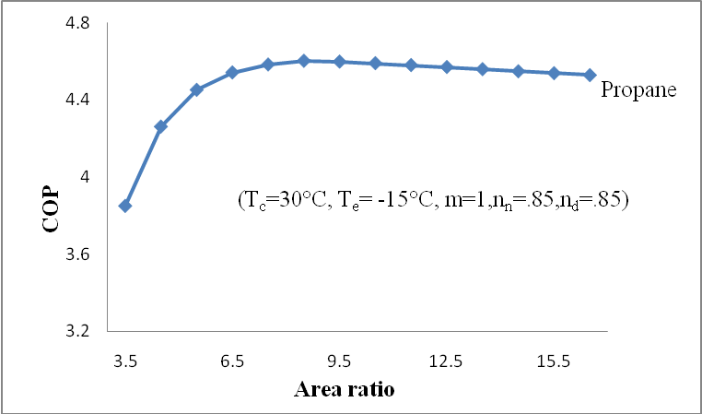
Fig4.1 Variation of COP, versus area ratio for Propane

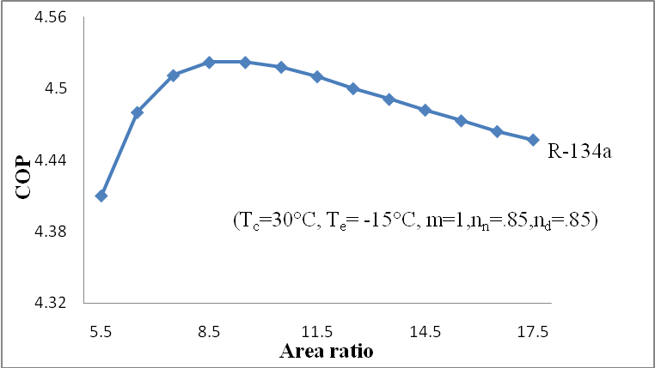
Fig4.2 Variation of COP, versus area ratio for R-134a
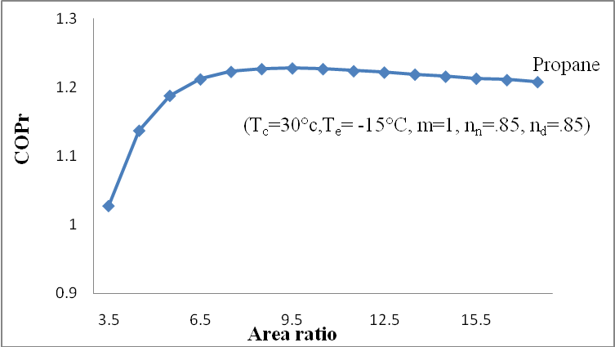
Fig 4.3 Variation of relative COP, versus area ratio for Propane

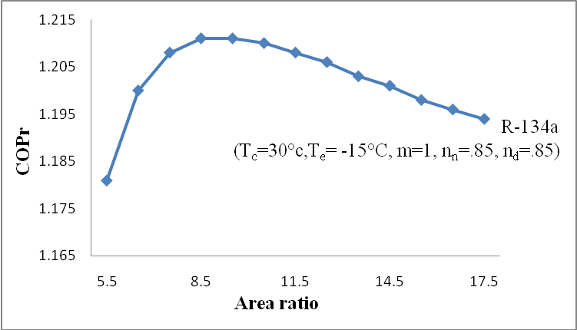
Fig 4.4 Variation of relative COP, versus area ratio for R-134a
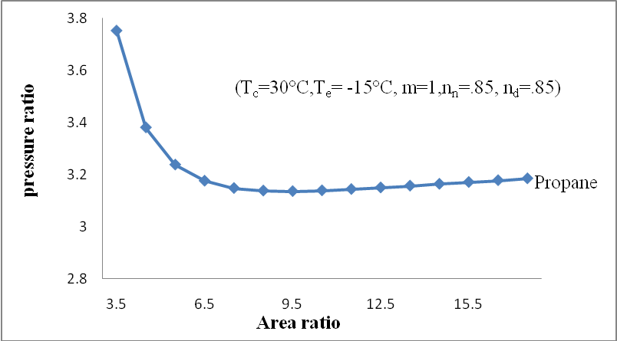
Fig4.5 Variation of pressure ratio, versus area ratio for Propane

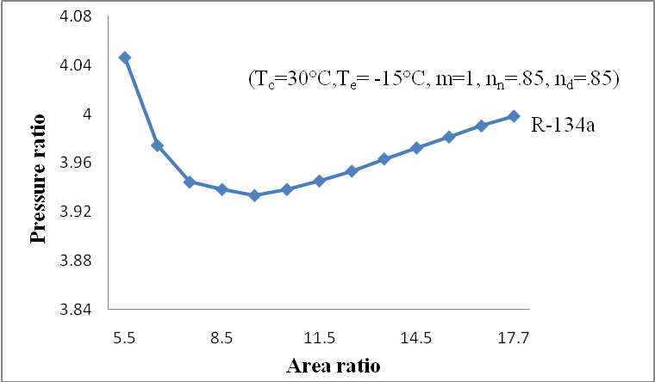
Fig 4.6 Variation of pressure ratio, versus area ratio for R-134a
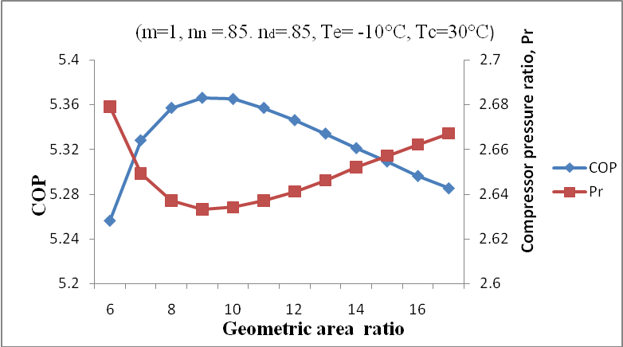
Fig4.7 Variation of COP and pressure ratio with area ratio

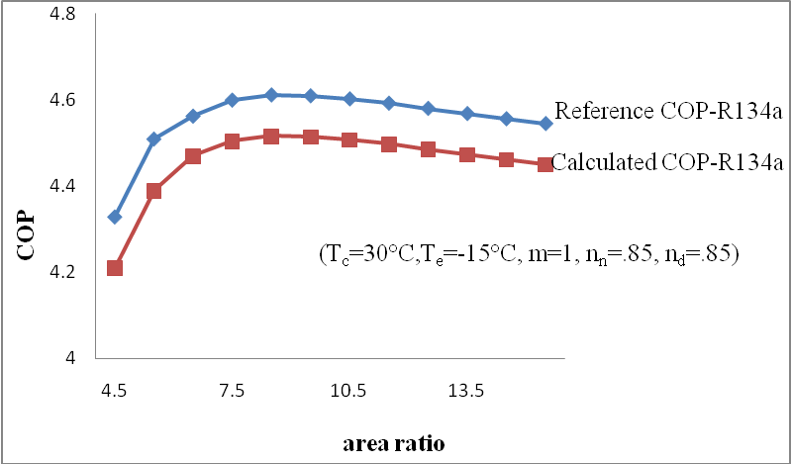
Fig 4.8 Comparison between reference paper [Nehdi et. Al (2007)] COP versus calculated COP
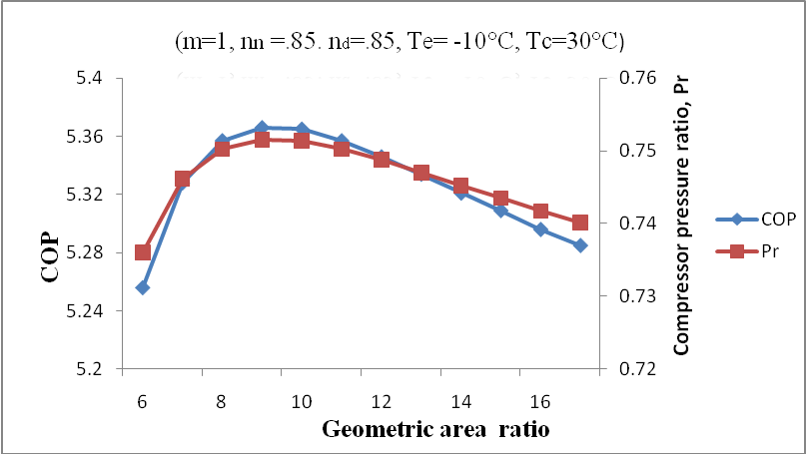
Fig4.9 Variation of COP and pressure ratio with area ratio

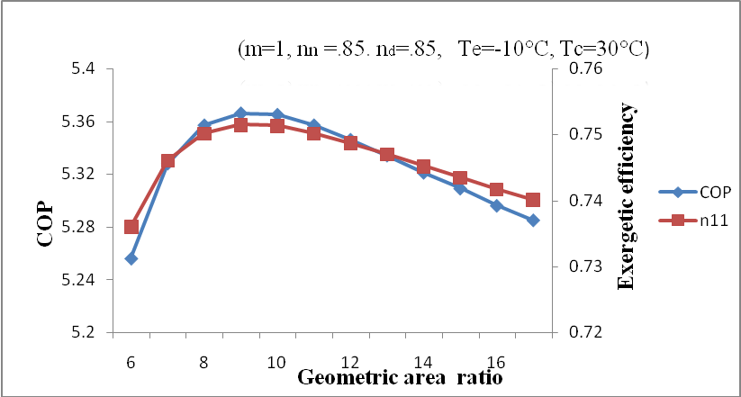
Fig4.10 Variation of COP and exergetic efficiency with area ratio
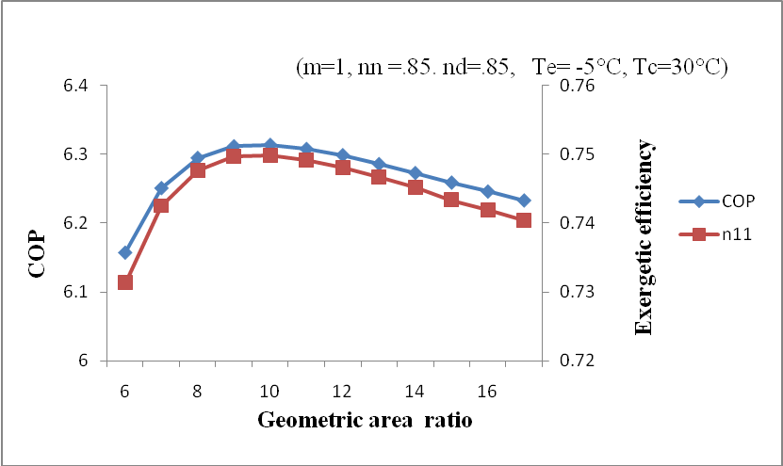
Fig4.11 Variation of COP and exergetic efficiency with area ratio

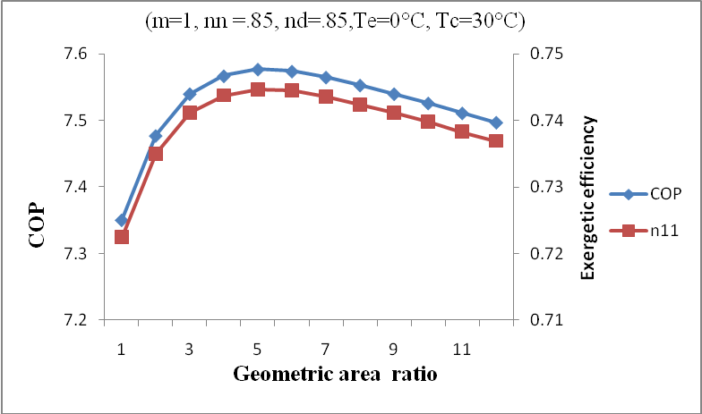
Fig4.12 Variation of COP and exergetic efficiency with area ratio
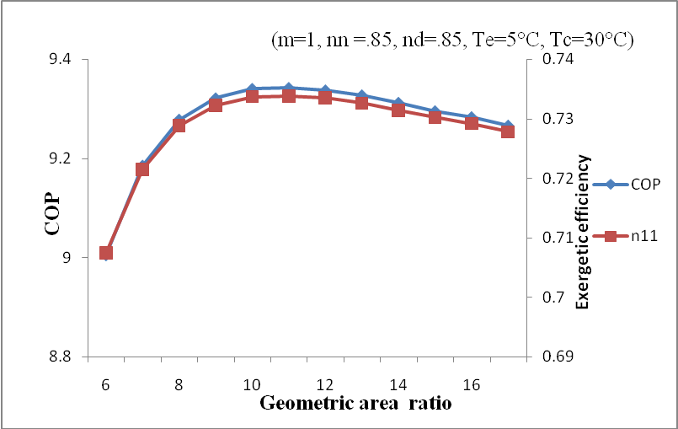
Fig4.13 Variation of COP and exergetic efficiency with area ratio

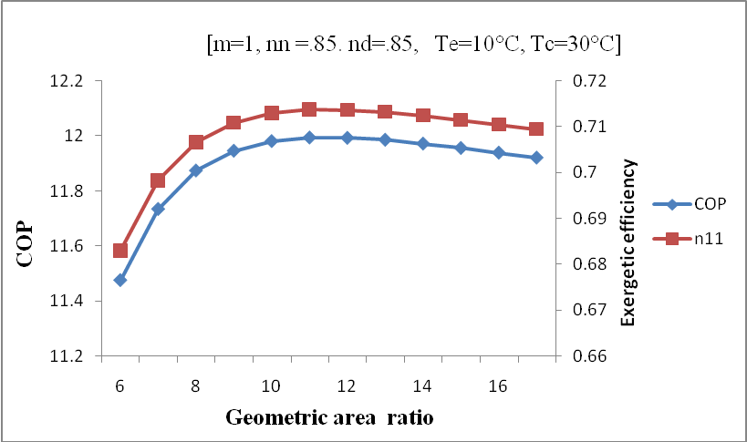
Fig4.14 Variation of COP and exergetic efficiency with area ratio

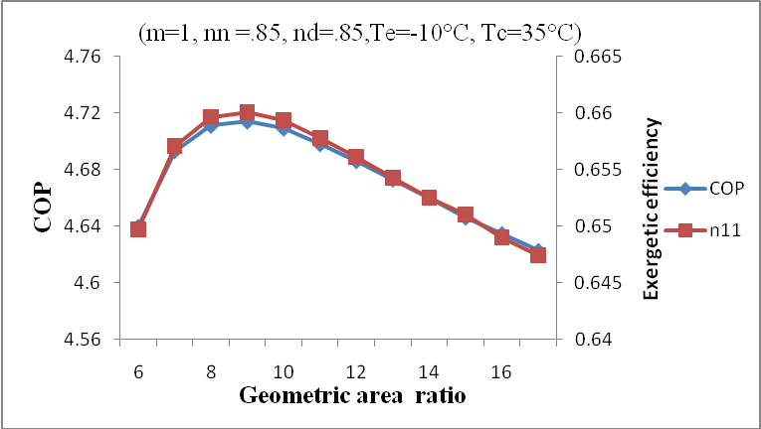
Fig4.15 Variation of COP and exergetic efficiency with area ratio

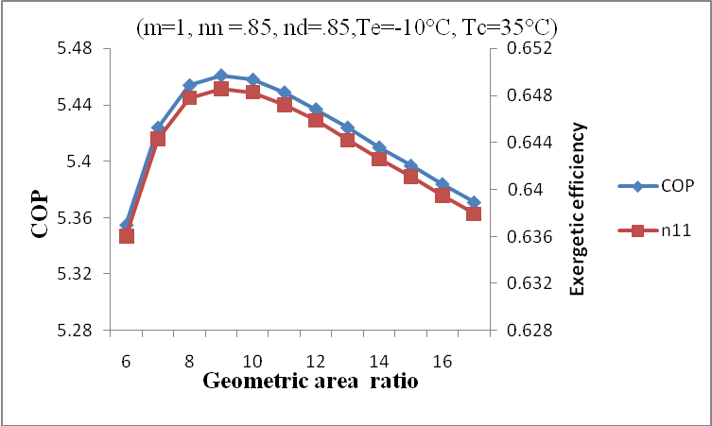
Fig4.16 Variation of COP and exergetic efficiency with area ratio
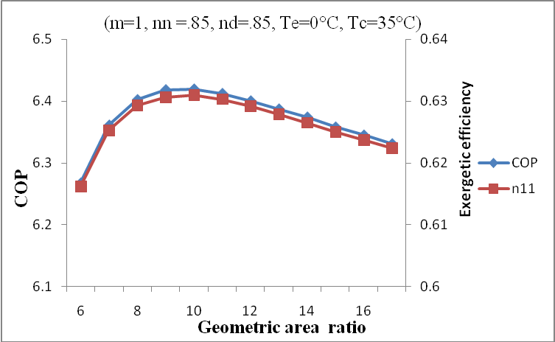
Fig4.17 Variation of COP and exergetic efficiency with area ratio

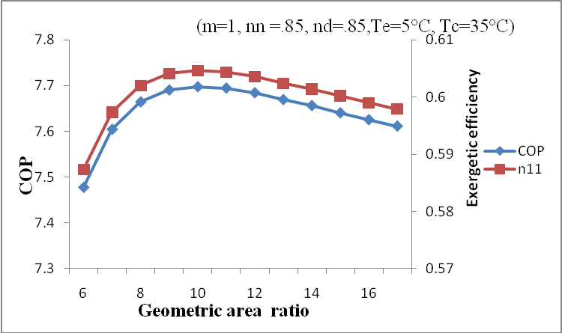
Fig4.18 Variation of COP and exergetic efficiency with area ratio
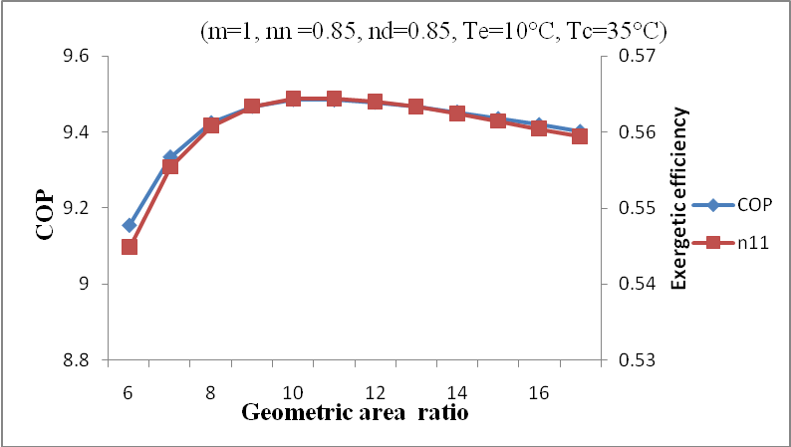
Fig4.19 Variation of COP and exergetic efficiency with area ratio

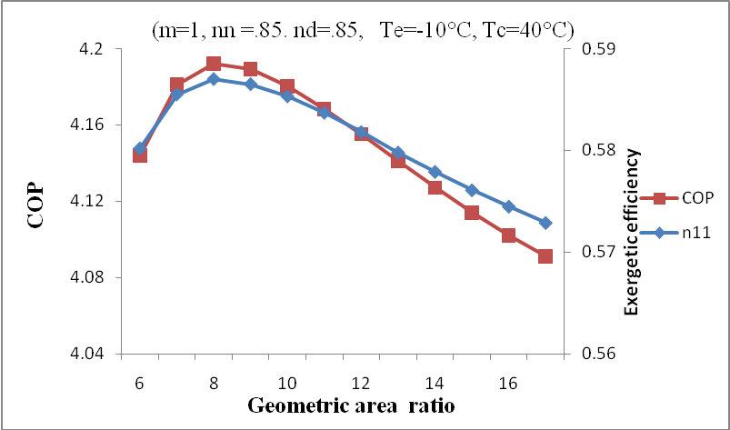
Fig4.20 Variation of COP and exergetic efficiency with area ratio
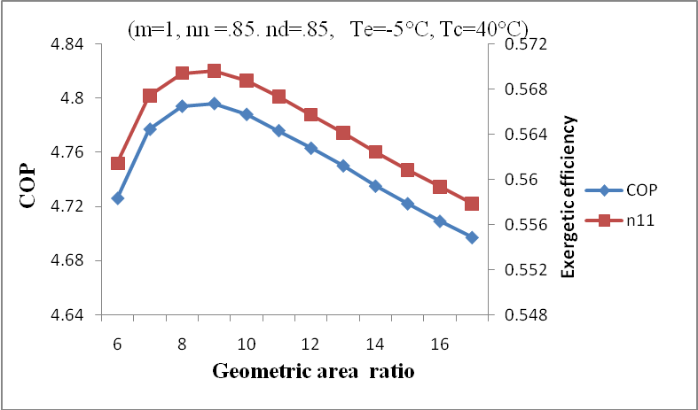
Fig4.21 Variation of COP and exergetic efficiency with area ratio

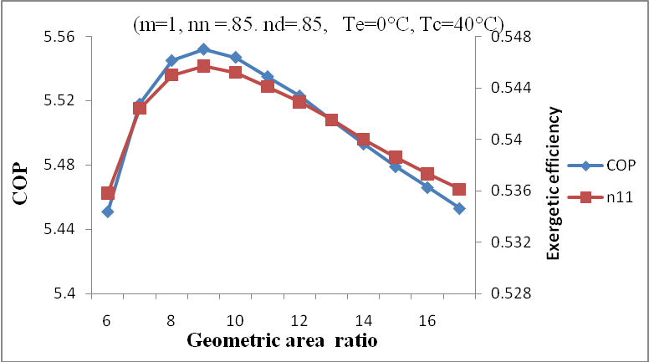
Fig4.22 Variation of COP and exergetic efficiency with area ratio
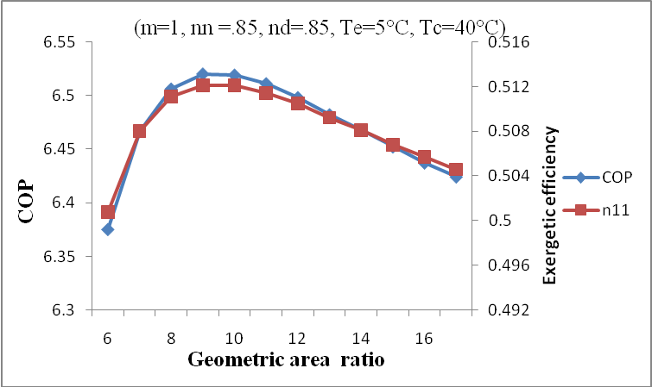
Fig4.23 Variation of COP and exergetic efficiency with area ratio

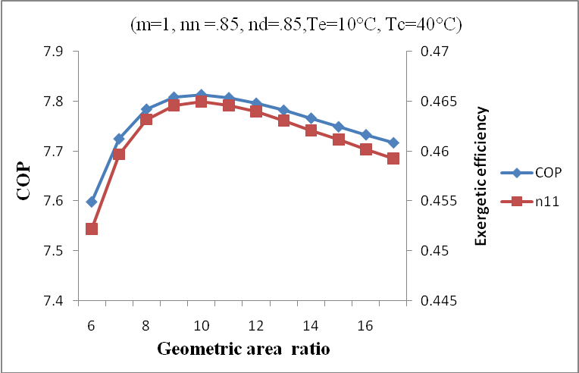
Fig4.24 Variation of COP and exergetic efficiency with area ratio
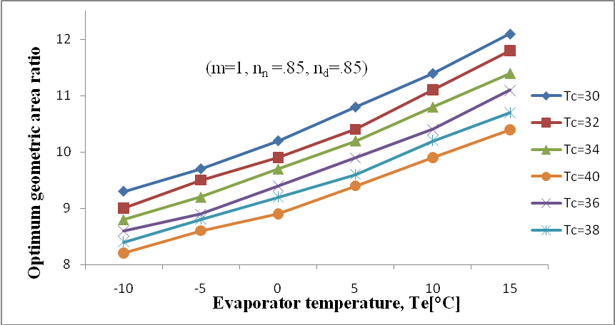
Fig 4.25 Optimum area ratio versus Evaporator temperature under different condenser temperature

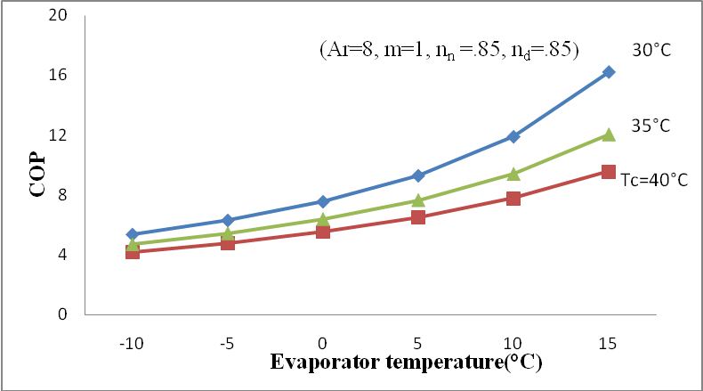
Fig 4.26 COP versus Evaporator temperature under different Condenser temperature
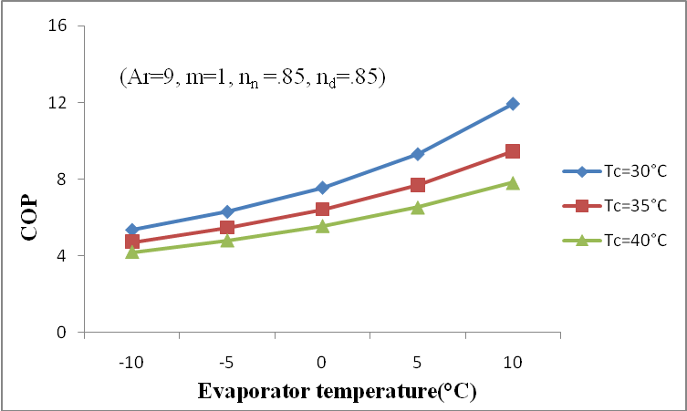
Fig 4.27 COP versus Evaporator temperature under different Condenser temperature

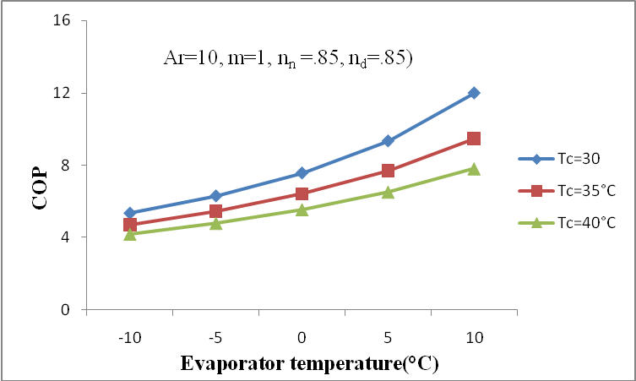
Fig 4.28 COP versus Evaporator temperature under different Condenser temperature
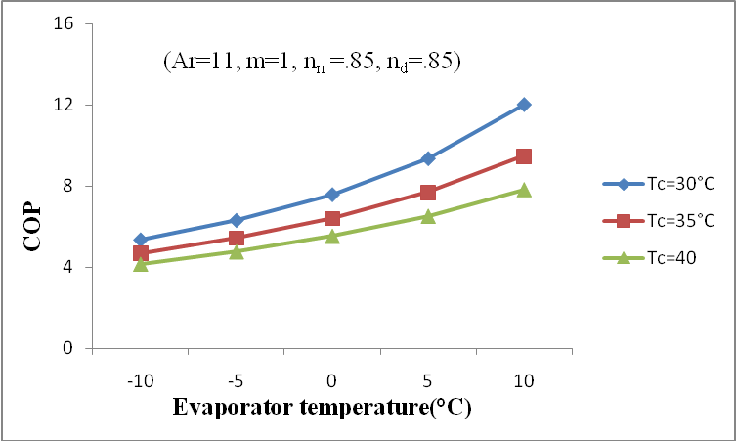
Fig 4.29 COP versus Evaporator temperature under different Condenser temperature

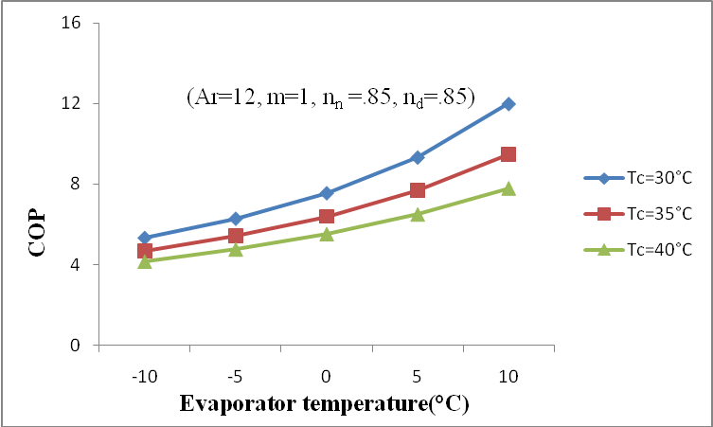
Fig 4.30 COP versus Evaporator temperature under different Condenser temperature
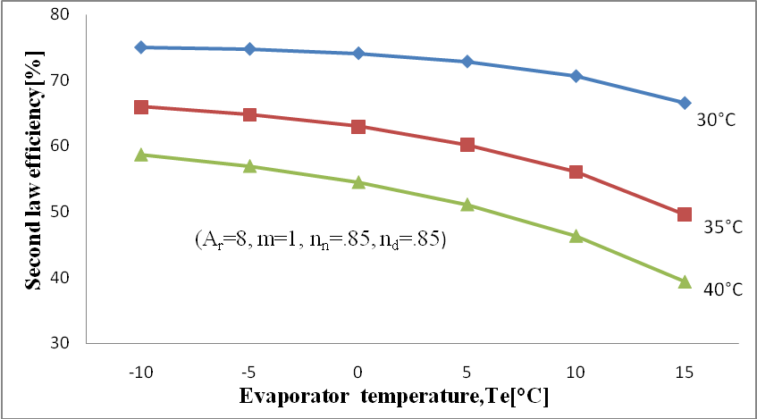
Fig 4.31 The second-law efficiency versus Evaporator temperature under different condenser temperature

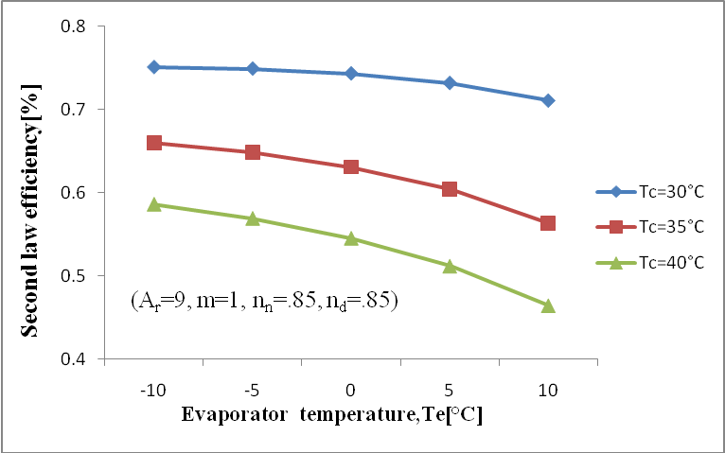
Fig 4.32 The second-law efficiency versus Evaporator temperature under different condenser temperature
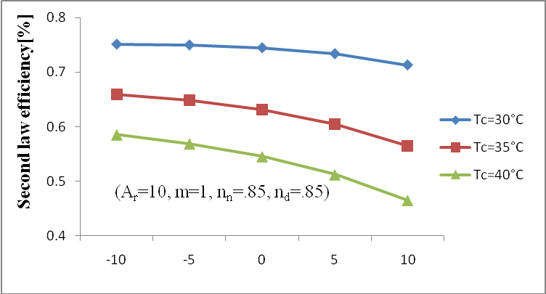
Fig 4.33 The second-law efficiency versus Evaporator temperature under different condenser temperature

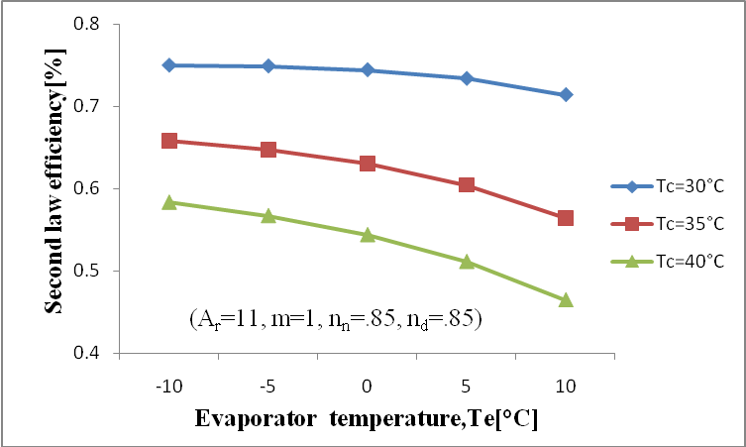
Fig 4.34 The second-law efficiency versus Evaporator temperature under different condenser temperature
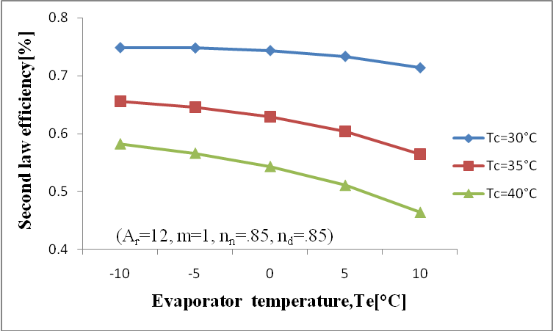
Fig 4.35 The second-law efficiency versus Evaporator temperature under different condenser temperature

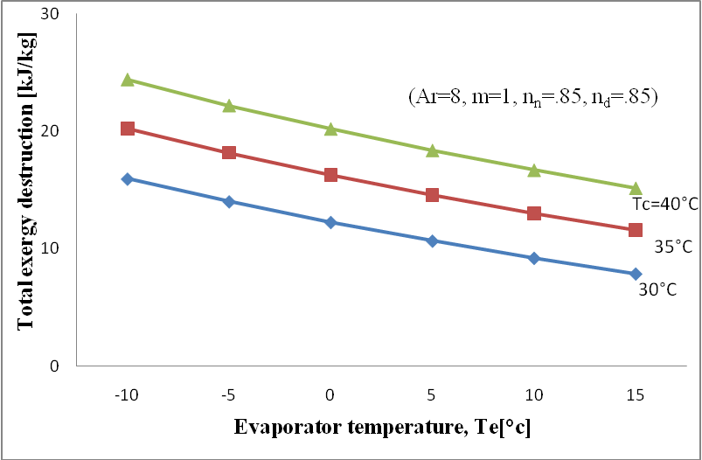
Fig 4.36 Total Exergy destruction versus Evaporator temperature under different condenser temperature
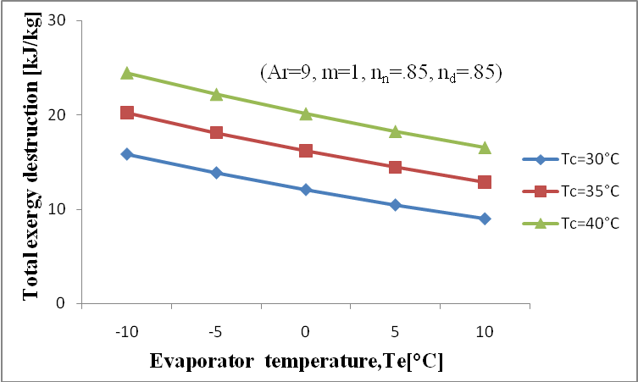
Fig 4.37 Total Exergy destruction versus Evaporator temperature under different condenser temperature

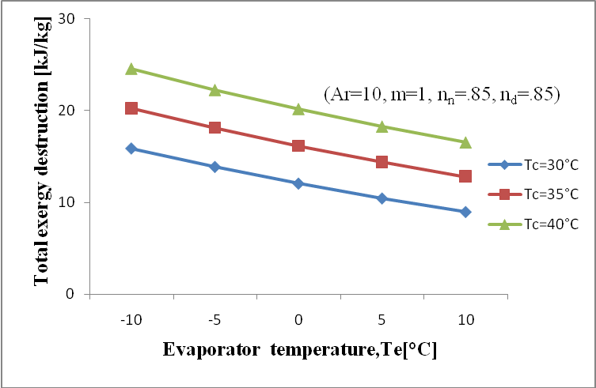
Fig 4.38 Total Exergy destruction versus Evaporator temperature under different condenser temperature
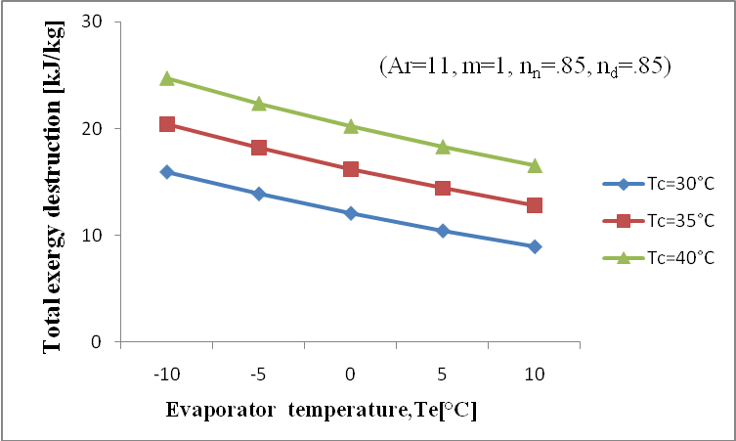
Fig 4.39 Total Exergy destruction versus Evaporator temperature under different condenser temperature

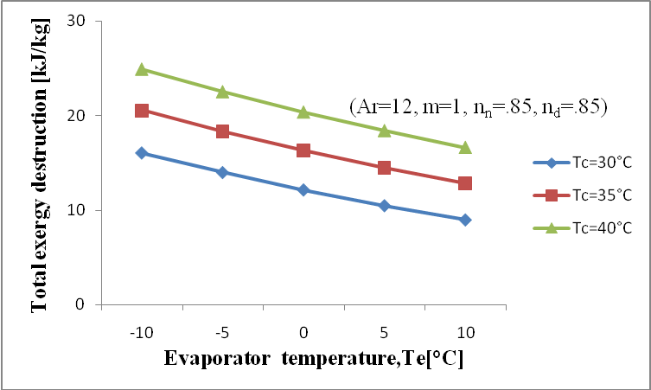
Fig 4.40 Total Exergy destruction versus Evaporator temperature under different condenser temperature
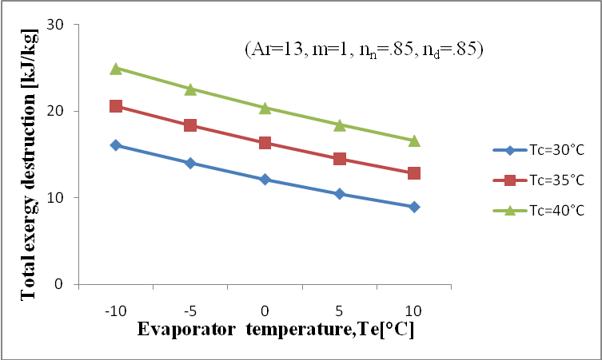
Fig 4.41 Total Exergy destruction versus Evaporator temperature under different condenser temperature

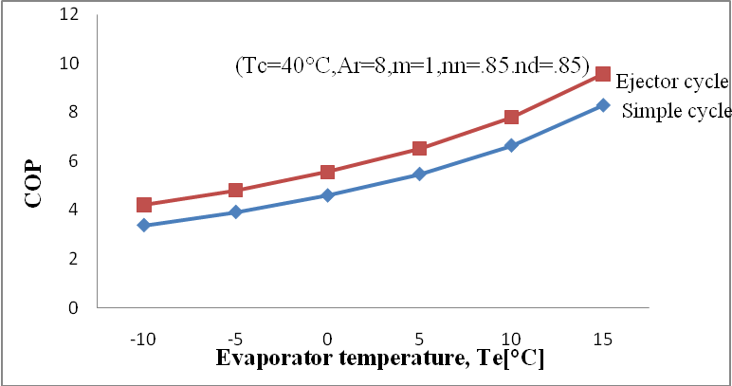
Fig 4.42 COP comparison between the vapour compression and ejector-compression cycles
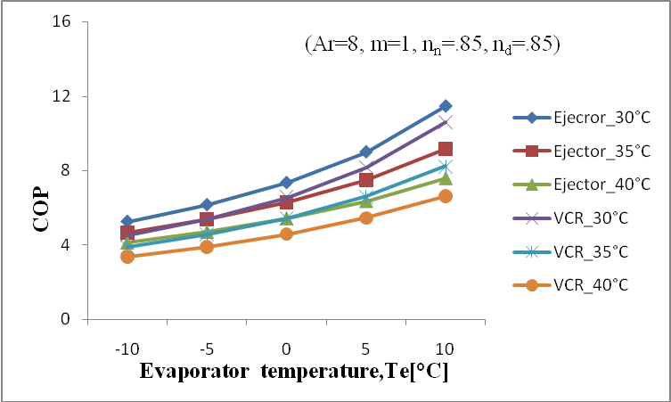
Fig 4.43 Comparison between the ejector cycle and the vapour compression cycle

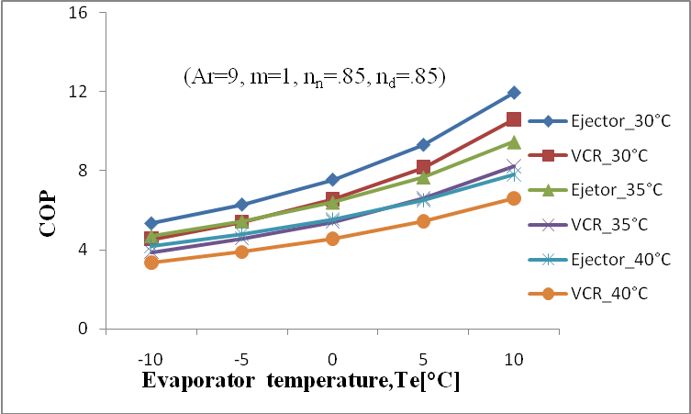
Fig 4.44 Comparison between the ejector cycle and the vapour compression cycle
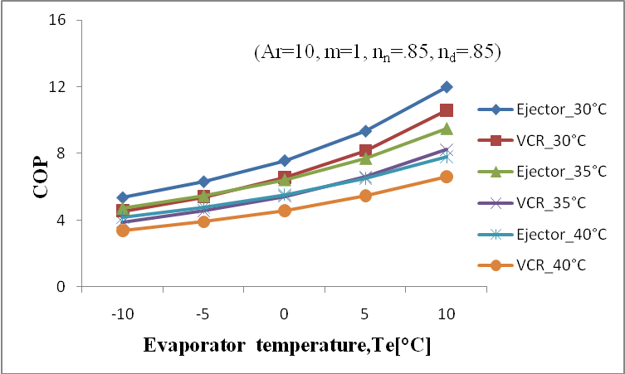
Fig 4.45 Comparison between the ejector cycle and the vapour compression cycle

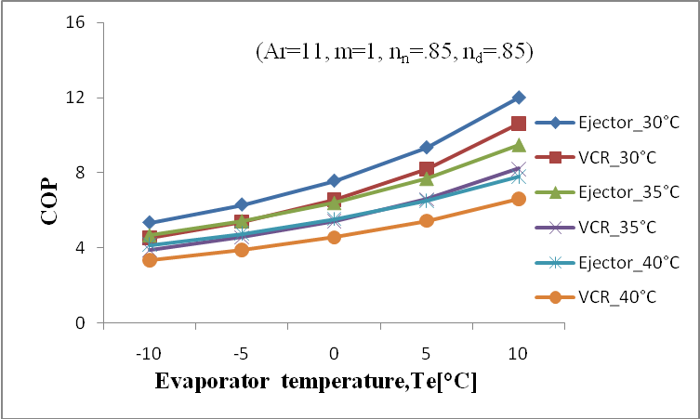
Fig 4.46 Comparison between the ejector cycle and the vapour compression cycle
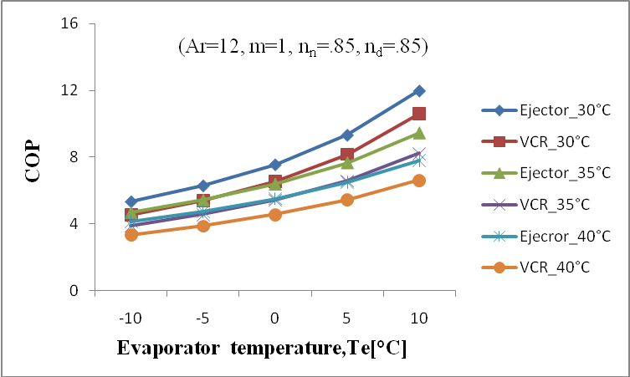
Fig 4.47 Comparison between the ejector cycle and the vapour compression cycle

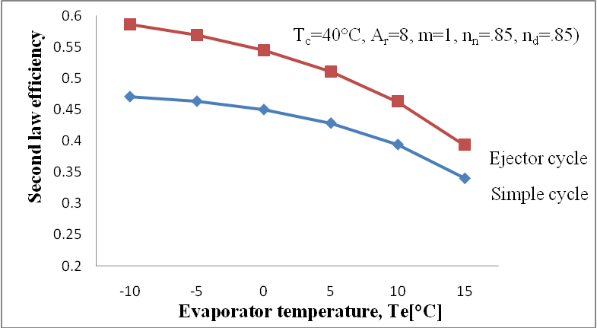
Fig4.48 Second-law efficiency comparison between the vapour compression and ejector cycles
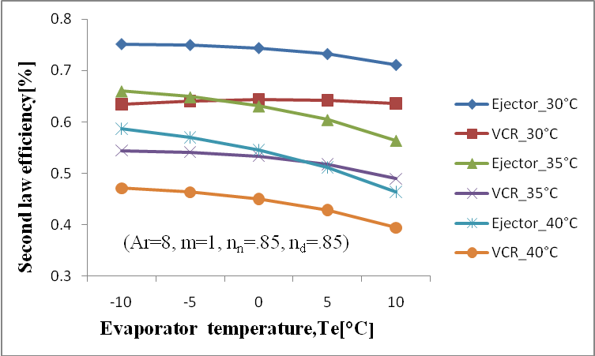
Fig 4.49 Comparison between the second law efficiency of the ejector cycle and VCR cycle

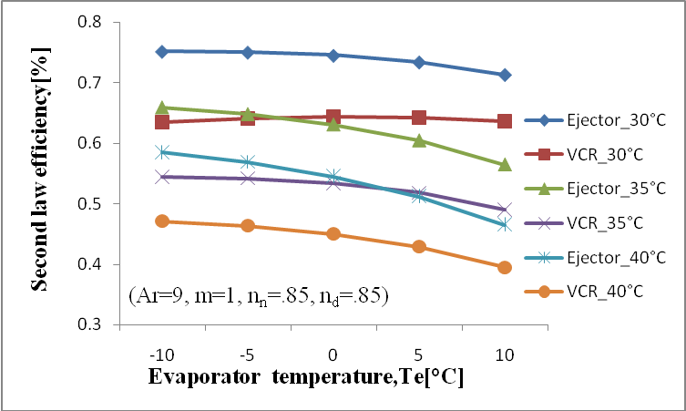
Fig 4.50 Comparison between the second law efficiency of the ejector cycle and VCR cycle
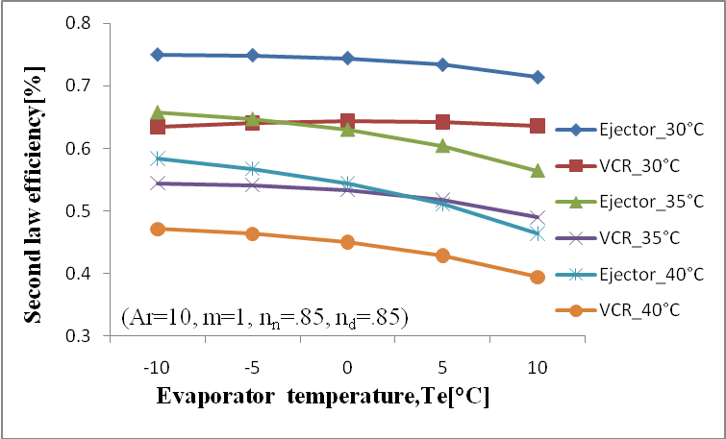
Fig 4.51 Comparison between the second law efficiency of the ejector cycle and VCR cycle

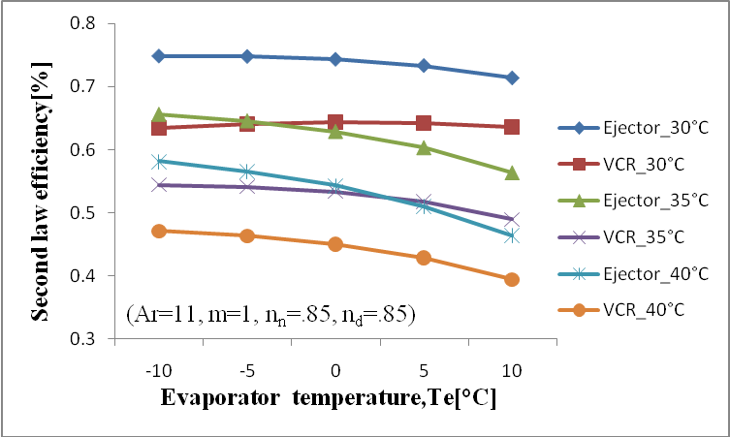
Fig 4.52 Comparison between the second law efficiency of the ejector cycle and VCR cycle
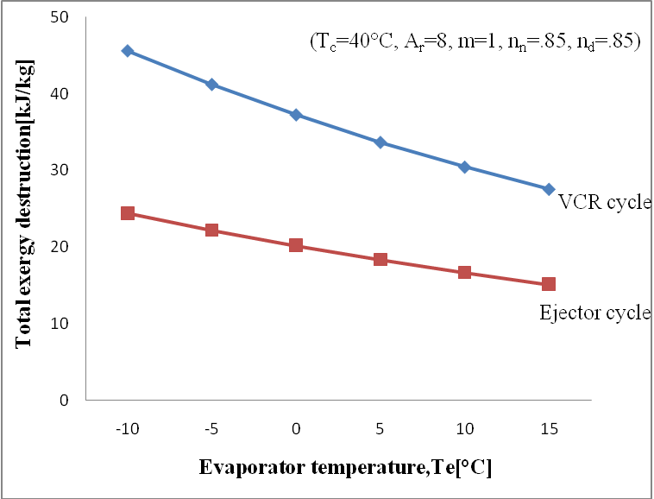
Fig 4.53 Total exergy destruction comparison between the vapour compression and ejector cycles

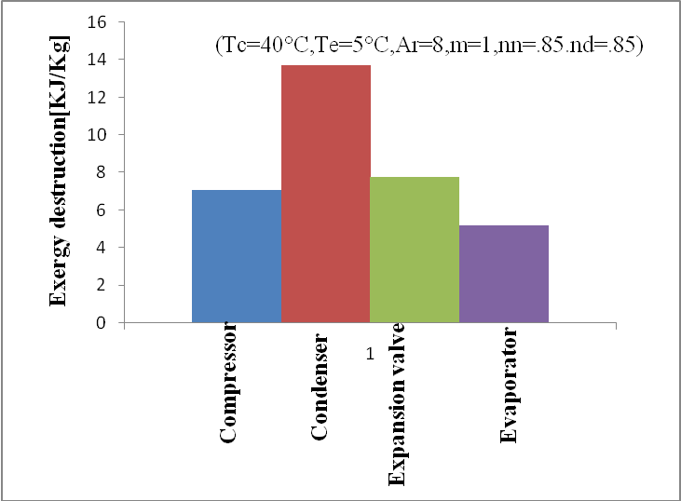
Figv4.54 Exergy destruction rate distribution in vapour compression refrigeration cycle
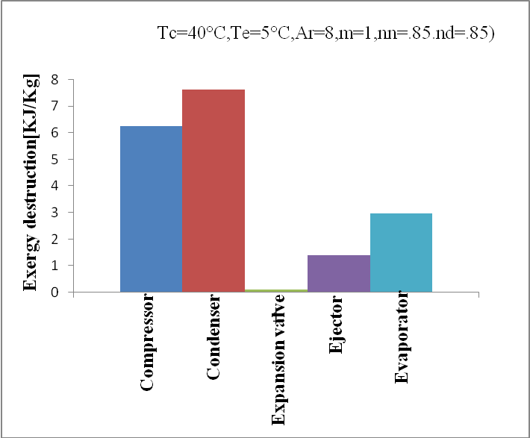
Fig 4.55 Exergy destruction rate distribution in Ejector cycle

Chapter-5
CONCLUSIONS AND FUTURE SCOPE
In the present study a new refrigeration cycle that combines an ejector cycle and compression cycle was described. Results have been computed for standard and improved cycle and compared with results given in Nehdi (2007) and Yari (2008).
The effect of the geometry of the ejector section ratio and the refrigerants134a, propane has been studied. It appears that the geometric parameters of the ejector design have considerable effects on the system’s performance. The maximum COP is obtained for optimum area ratio whose value is around 9.0 for both R134a and Propane at the parameter (Tc=30°C, Te= -15°C, m=1, n_{n}=.85, n_{d}=.85)
For the considered refrigerants, it has been observed at optimum area ratio and for given operating conditions that the best performances are obtained with Propane (COP=4.6) and R134a (4.522) at the parameter (Tc=30°C, Te= -15°C, m=1, n_{n}=.85, n_{d}=.85) respectively.
Also the study shows that for a given evaporator temperature, the COP of the standard cycle Decreases much more than that of the improved cycle, when the condenser temperature Increases, and conversely.
Exergy analysis is used as a tool to analyse the performance of the ejector-compression cycle. The effects of various operating parameters on the performance of the cycles were investigated. The main conclusions from the study are as follows:
- The COP and second-law efficiency values of the ejector-compression cycle are about 24% higher than that for the vapour compression cycle
- The COP of the ejector-compression increases with increasing the evaporator temperature and decreasing condenser temperature
- The second-law efficiency of the ejector-compression cycle increases with decreasing evaporator temperature and condenser temperature.
- The total exergy destruction of the ejector-compression cycle increases with increasing condenser temperature and decreasing evaporator temperature
- The total exergy destruction of the vapour compression cycle is about45-47% higher than that for the ejector-compression cycle.
- The exergy destruction in compressor is reduced up to 19%, in condenser it is reduced up to 44%, in evaporator 43% and in expansion valve it is reduced up to 98%.
- The exergy destruction in ejector is only 1.3-1.5[kJ/kg].

Future Scope
In the present work propane is used as a refrigerant in combined ejector-compression cycle. In future we can use different hydrocarbon as a refrigerants and energy and exergy analysis of the combined cycle can be calculate for different refrigerant. On the basis of energy and exergy analysis the most suitable refrigerant can selected.

REFERENCES
Alexis, G.K. (2007) ‘Performance parameters for the design of a combined refrigeration and electrical power cogeneration system’ International journal of refrigeration, Vol.30, pp.1097-1103.
Chen, LT. (1988) ‘A new ejector–absorber cycle to improve the COP of an absorption refrigeration system’, Applied Energy, Vol.30, pp.37–51.
Deng, J.Q., Jiang, P.X., Lu, T. and Lu, W. (2007) ‘Particular characteristics of transcritical CO₂ refrigeration cycle with an ejector’, Applied Thermal Engineering, Vol. 27, pp.381–388.
Disawas, S., Wongwises, S. (2004) ‘Experimental investigation on the performance of the refrigeration cycle using a two-phase ejector as an expansion device’, International Journal of Refrigeration, Vol.27, pp.587–594.
Elbel, S., Hrnjak, P. (2006) ‘Experimental validation of a prototype ejector
Designed to reduce throttling losses encountered in transcritical R744 system operation’ International journal of refrigeration, Vol.32, pp.411-412.

Harrell, G.S., Kornhauser, A.A. (1995) ‘Performance tests of a two-phase ejector’, intersociety Energy Conversion Engineering Conference, Orlando, FL, pp.49–53.
Huang, B.J., Hu, S.S., Lee, S.H. (2005) ‘Development of an ejector cooling system with thermal pumping effect’ International journal of refrigeration, Vol.29, pp.476-484.
Klein, S.A., Alvarda, F., (2005) Engineering Equation Solver, Version 7.441. F-chart software, Middleton, WI.
Kornhauser, A.A. (1990) ‘The use of an ejector as a refrigerant expander’, USNC/IIR-Perdue refrigeration Conference, Purdue University, U.S.A., pp.10–19.
Li, D., Groll, A. (2005) ‘Transcritical CO₂ refrigeration cycle with ejector expansion device’, International Journal of Refrigeration, Vol. 28, pp.766–773.
Menegay, P., Kornhauser, A.A. (1996) ‘Improvements to the ejector expansion refrigeration cycle’, Intersociety Energy Conversion Engineering, Vol.31, pp.702–706.
Nakagawa, M., Takeuchi, H. (1998) ‘Performance of two-phase ejector in refrigeration cycle’, International Conference on Multiphase flow, Vol.3, pp.1–8.

Nehdi, E., Kairouani, L., Bouzaina, M. (2007) ‘Performance analysis of the vapour compression cycle using ejector as an expander’, International Journal of Energy Research, Vol. 31, pp.364–375.

Yari, M., Sirousazar, M. (2007) ‘Thermodynamic analysis on transcritical CO2 refrigeration cycle with ejector-expansion device’, ISME, pp.1–12.

APPENDIX
Program used to analysis the performance of the Ejector cycle using Propane as a refrigerant
Te=5
Tc=40
m=1
nn=.85
nd= .85
U=0.780236
Ar=8.0
To=300
Tr=Te+5

{CONDENSER}

P6=Pressure(Propane,T=Tc,x=0)

h6=Enthalpy(Propane,P=P6,x=0)

s6=Entropy(Propane,P=P6,x=0)

{ EVAPORATOR}

P8=Pressure(Propane,T=Te,x=1)

Pe=Pressure(Propane,T=Te,x=1)

h9=Enthalpy(Propane,P=Pe,x=1)

s9=Entropy(Propane,P=Pe,x=1)

d1=Density(Propane,P=Pe,x=1)

X3_check=1/(1+U)

{EJECTOR}

s6=s1

h1=Enthalpy(Propane,P=Pe,s=s1)

hf1=Enthalpy(Propane,P=Pe,x=0)

hg1=Enthalpy(Propane,P=Pe,x=1)

h1a=h6-nn*(h6-h1)

d1a=Density(Propane,T=Te,h=h1a)

D21= (((U/(1+U))*(d1/d1a))+(1/(1+U)))

V1=(2*nn*(h6-h1)*1000)^0.5

V2= (1/(1+U))*V1

D21=d1a/d2

h2= (( 1/(1+U))*h6)+(( U/(1+U))*h9)-0.0005*V2^2

h3 = h2+0.0005* V2^2

h3a = h2+0.0005* V2^2/nd

m=m1+m2

U=m2/m1

m1= d1a*A1*V1

Ar= A2/A1

((P2-Pe)/(0.0005*d1a*V1^2 )) = (2*(1/Ar)-2*((1+U)^2) *(1/D21)*(1/Ar)^2)

s2=Entropy(Propane,P=P2,h=h2)

P3=Pressure(Propane,h=h3a,s=s2)

hf3=Enthalpy(Propane,P=P3,x=0)

sf3=Entropy(Propane,P=P3,x=0)

hg3=Enthalpy(Propane,P=P3,x=1)

sg3=Entropy(Propane,P=P3,x=1)

h3a=hf3+x3a*(hg3-hf3)

s3a=sf3+x3a*(sg3-sf3)

h4=Enthalpy(Propane,P=P3,x=1)

s4=Entropy(Propane,P=P3,x=1)

s5s=s4

Pr=P6/P3
nc=0.874-0.0135*(p6/p3)

h5s=Enthalpy(Propane,s=s5s,P=P6)

Wc= (m1*(h5s-h4))/nc

nc=(h5s-h4)/(h5-h4)

h5=Enthalpy(Propane,T=T5,P=P6)

s5=Entropy(Propane,T=T5,P=P6)

h7=Enthalpy(Propane,P=P3,x=0)
s7=Entropy(Propane,P=P3,x=0)

h8=h7
x8=Quality(Propane,T=Te,h=h8)
s8=Entropy(Propane,T=Te,x=x8)

Qe = m2*(h9-h7)

COP= Qe/Wc

d=X3_check-x3a

Iej1=To*((1+u)*s3a-s6-u*s9)

Icon=m1*((h5-h6)-To*(s5-s6))

Ievp=To*(m2*(s9-s8)-Qe/(Tr+273.15))
{Ievp= m2*((h8-h9)-(To*(s8-s9)))}

Iexp=m2*((h7-h8)-(To*(s7-s8)))

Icomp=To*(s5-s4)

It=Iej1+Icon+Ievp+Icomp+Iexp

Ep=-Qe*(1-To/(Te+273.15))

n11=Ep/Wc

