PERFORMANCE ANALYSIS OF AN EJECTOR-COMPRESSION CYCLE
A MAJOR Project thesis
Submitted in partial fulfillment
For the requirement of the degree of

Masters of Engineering

In

Thermal Engineering

By
MUKESH KUMAR

UNIVERSITY ROLL NO. 12298

Under the guidance of
MR. A. ARORA

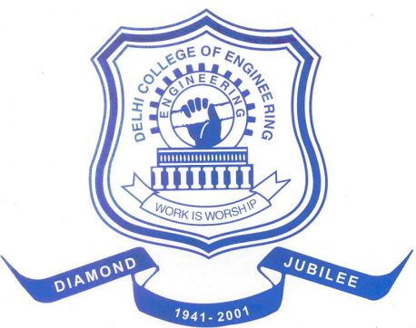

DEPARTMENT OF MECHANICAL ENGINEERING
DELHI COLLEGE OF ENGINEERING
DELHI UNIVERSITY, DELHI-110042
2009

