CERTIFICATE


DELHI COLLEGE OF ENGINEERING
(Govt. of National Capital Territory of Delhi)
BAWANA ROAD, DELHI - 110042

Date: ___________

This is certified that the work contained in this dissertation entitled “PERFORMANCE ANALYSIS OF AN EJECTOR-COMPRESSION REFRIGERATION CYCLE” by MUKESH KUMAR is the requirement for the partial fulfillment for the award of degree of Master of Engineering in thermal engineering at Delhi College of Engineering. This work was completed under my direct supervision and guidance. He has completed his work with utmost sincerity and diligence.

The work embodied in this major project has not been submitted for the award of any other degree to the best of my knowledge.

Mr. Akhilesh Arora
Lecturer
Mechanical Engg. Deptt

PERFORMANCE ANALYSIS OF AN EJECTOR-COMPRESSION CYCLE
A MAJOR Project thesis
Submitted in partial fulfillment
For the requirement of the degree of

Masters of Engineering

In

Thermal Engineering

By
MUKESH KUMAR

UNIVERSITY ROLL NO. 12298

Under the guidance of
MR. A. ARORA

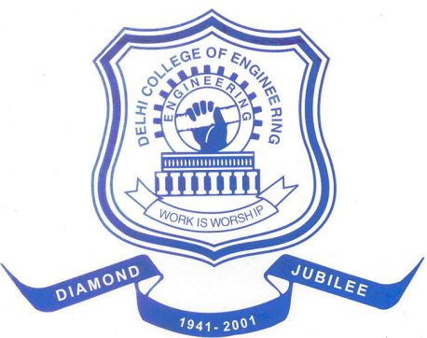

DEPARTMENT OF MECHANICAL ENGINEERING
DELHI COLLEGE OF ENGINEERING
DELHI UNIVERSITY, DELHI-110042
2009

