The Performance Analysis of A SI Engine using Gasoline, LPG and Blend of Gasoline and LPG
A major thesis submitted
In partial fulfillment of the requirements for the award of the degree of

Master of Engineering
In
Thermal Engineering

By

Manoj Kumar Mittal

Roll No. 8566
Session 2004-06

Under the Guidance of

Mr. Amit Pal Dr. S.Maji
Sr. Lecturer Professor


Department of Mechanical Engineering,
Delhi College of Engineering,
University of Delhi
Delhi

CANDIDATE’S DECLARATION

I hereby declare that the work which is being presented in this project report entitled, “The Performance Analysis of A SI Engine using Gasoline, LPG and Blend of Gasoline and LPG” submitted as major project towards the fulfillment of the requirements for the award of the degree of Master of Engineering with specialization in Thermal Engineering, D.C.E. Delhi, is an authentic record of my own work carried out under the supervision of Sr. Lect. Mr. Amit Pal, Mechanical Engineering Department and Prof. S. Maji, Head Mechanical Engg. Deptt. at Delhi College of Engineering, Delhi.
The matter embodied in this dissertation report has not been submitted by me for the award of any other degree.

Manoj Kumar Mittal
08/THR/04
University Roll No …8566

CERTIFICATE
This is to certify that the above statement made by the candidate is correct to the best of our knowledge.

Mr. Amit Pal Dr. S.Maji
Sr.Lecturer Professor and Head
Mechanical Engg. Deptt, Mechanical. Engg. Deptt
College of Engineering, Delhi College of Engineering
Delhi. Delhi.

Acknowledgement

It is distinct pleasure to express my deep sense of gratitude and indebtedness to my learned supervisor Mr. Amit Pal, Sr. Lecturer in the Department of Mechanical Engineering, and Dr. S. Maji, Professor and Head of the department of Mechanical Engineering at Delhi College of Engineering, for his invaluable guidance, encouragement and patient review. His continuous inspiration only has made me complete this project work.

I am also thankful to Prof. P.B.Sharma, Principal Delhi College Of Engineering, for his keen interest in the project and giving approval for the requisite infrastructure support.

I would also like to take this opportunity to present my sincere regards to shri Manmohan ji and Chintaram ji for their kind support and encouragement. It is a great pleasure to have the opportunity to extent my heartiest felt gratitude to my friends and everybody else concerned with this project for their unconditional support and motivation during this project.

Manoj Kumar Mittal
08/THR/04
University Roll No …8566

ABSTRACT

Conventional fuels such as gasoline and diesel are causing serious environmental issue due to their high amount of pollutants. Moreover, emissions such as nitrogen oxides (NOx), Carbon monoxides (CO), sulphur oxides (SO₂), and so on have an adverse impact on the human body. Therefore, alternative fuels such as LPG are being considered to replace the role of conventional fuels in order to reduce harmful emissions to a safer level. LPG is commonly used as a cooking fuel in India and is widely available commercially in small sized portable cylinders. Recently a large number of SI Engines have been converted to run on LPG mode, which gives significant reduction in exhaust pollutants. It is also found more economical but in most of the cases it results in about
10 -15% power loss.

In this work a study was conducted on the use of LPG in conventional four stroke gasoline engines. The engine was tested using LPG, gasoline and with gasoline and LPG-air mixture; so that comparative study of the emissions of pollutants gases and engine performance can be made. The results of the experiments showed improvement in power (With reference to LPG mode) and simultaneous reduction in NOx, HC and CO emissions (With reference to Gasoline mode). On the other hand, the LPG fuel system showed a tremendous reduction in emissions, delivered a comparable torque and higher engine efficiency as compared to gasoline. The results of this research show the high potential of LPG as an alternative fuel for spark ignition engine.

INDEX
Chapter 1
Introduction
  - Project background
  - Objectives
  - Methodology
Chapter 2
Literature review
2.1 Internal Combustion Engine: An Overview
2.1.1 Introduction
2.1.2 The Otto Cycle
2.1.3 Working of SI Engine
2.2 Engine Performance Parameters
2.2.1 Input Power
2.2.2 Brake Power
2.2.3 Specific Fuel Consumption
2.2.4 Engine Efficiency
2.3 Engine Emissions
2.3.1 Carbon Monoxides
2.3.2 Oxides of Nitrogen
2.3.3 Unburnt Hydrocarbon (UHC) Emission
2.3.4 PM Emissions from SI Engines
2.3.5 Carbon Dioxides (CO₂)
2.3.6 Sulphur Dioxide (SO₂)
2.4 Fuels used in SI Engine
2.4.1 Gasolineas Fuel
2.4.2 Liquid Petroleum Gas (LPG)
2.4.3 Compressed Natural Gas (CNG)
2.4.4 Methanol
2.4.5 Ethanol
2.4.6 Hydrogen
2.4.7 Electricity
2.5 Liquefied Petroleum Gas
2.5.1Introduction To Liquefied Petroleum Gas(LPG)
2.5.2 History Of Liquefied Petroleum Gas
2.5.3 Physical and Chemical Properties Of LPG
2.5.4 Advantages of LPG
2.5.5 Limitations of LPG
2.5.6 Comparison between Gasoline and LPG
CHAPTER 3
EXPERIMENTAL SETUP

3.1 Introduction
3.2 Engine Specifications
3.3 LPG Kit
3.3.1 LPG Storage Cylinder
3.3.2 Pressure Regulator
3.3.3 Air Fuel Mixer And Air Filter
3.4 Ancillary Components
3.4.1 Battery
3.4.2 Ammeter
3.4.3 Voltmeter
3.4.4 Alternator
3.4.5 Load Bank
3.4.6 Rota-Meter
3.5 Gas Analyzer
Chapter 4
Performance Evaluation Test
4.1 Pure gasoline mode
4.2 Pure LPG mode
4.3 Mix of LPG and gasoline
Chapter 5
Results and discussion
chapter 6
conclusion and SCOPE FOR future WORK
references
CHAPTER I

INTRODUCTION

1.1 Project Background
Environmental issues regarding the emission of conventional fuels such as -gasoline and diesel are of serious concern worldwide. The standard emission from conventional fuel vehicles are Unburnt hydrocarbon (HC), carbon dioxide (C0₂), carbon monoxide (CO), nitrogen oxides (NOx) and particulate matter (PM) etc. These emissions are harmful gases which can have adverse impact on human body and destroy the environment by playing an important role in formation of the greenhouse effect, acid rain and global warming. Therefore, alternative fuels such as natural gas, liquefied petroleum gas (LPG), Alcohols are being considered to replace the role of conventional fuels in order to reduce these harmful emissions from being released to the atmosphere. These alternative fuels may possibly contribute to a significant reduction in vehicular emission worldwide.

Natural gas had long been introduced to the market where application of cleanliness is emphasized. Liquefied petroleum gas (LPG) is one of the members of natural gases and has been declared as the "cleaner fuel" (Nett Technologies, (2004). LPG is increasingly chosen as the preferred burning fuel for all types of vehicles due to its advantageous fuel properties. According to Murray et al. (2000). LPG is proven to have lower emission of pollutants such as hydrocarbon (HC), carbon dioxide (C0₂), carbon monoxide (CO) and nitrogen oxides (NOx) if compared to the conventional fuels. For examples, CO is reduced by over 20%, NOx by over 30 %,( as compared to petrol), total hydrocarbon (THCs) by over 40% and NOx by over 30% (as compared to petrol) in light-duty vehicles. Whereas for heavy duty engines, CO is reduced by Over 90%, total hydrocarbon (THCs) by over 80% and NOx by about 60% (compared to compared to diesel). Furthermore, particulate matter (PMs) is virtually eliminated from LPG vehicle emissions (Murray et al., 2000).

A lot of researches have been done to prove that vehicles using LPG as the burning fuel shows no decrease in efficiency as compared to the conventional fuel operating vehicles along with its advantage of reduction in emission gases from the exhaust of an engine (Murray et al., 2000). Besides that, LPG has the capability to reduce the noise from a running engine, helping to effectively increase noise pollution in urban areas especially during the traffic congestion period. LPG offers a reduction of around 50% perceived noise levels as a LPG operated bus shows a record of at least 2-3 dB reduction in comparison to a diesel operated bus (AEGPL 1998). There are currently over 4 million road vehicles using LPG in countries such as Italy, Holland, Japan, the USA, and Australia due to the vast advantages of LPG usage (Murray, et al., 2000). On the other hand, the popularity of LPG is increasing in our daily usage; it can also be used as a cooking and heating fuel, in flame weeding and other activities. This is the reason why LPG has being claimed to be the world's most multi-purpose fuel (world LP Gas Association, undated).

The selling price for consumer-grade of LPG is low compared to other Hydrocarbons fuels such as gasoline and diesel. Even the Alternative Fuels Data center (2004) has agreed that the cost of LPG in fleets is less than those of gasoline for a range of 5% to 30%. Moreover, the fueling station cost is either equivalent to, or lower than, that for a comparably sized gasoline dispensing system (Alternative Fuels Data Center 2004). Due to the abundance of LPG and important energy and environmental advantages, LPG can be promoted for usage in vehicles.

However the use of LPG requires fueling, maintenance and storage facilities to be upgraded to a certain standards to ensure the operational safety of its Users (Clean Air Technologies Information Pool, 2005). Clean Air Technologies information Pool (2005) showed that LPG storage and distribution location must meet a certain distance requirement to isolate it from residential properties and underground storage tanks. Maintenance facilities must include the detector to sense LPG leakage to prevent explosion due to leaks.

1.2 Objectives
The main aim of this research project is to analyze the various performance parameters and emissions using liquefied petroleum gas in spark ignition engine. This research can be further divided into the sub-objectives listed below:

1. Conduct a detailed study on the history, properties and usage of LPG as an alternate fuel for SI engines.
2. Measure the performance parameters of a four-stroke engine using both the gasoline and LPG as the main fuel.
3. Measure the concentration of emission gases such as NOx, CO, CO and. Hydrocarbons from the four-stroke engine using both the gasoline and LPG as the main fuel.
4. Evaluate the data collected from the experiment conducted for both gasoline and LPG in the four-stroke engine for different set of load conditions and engine speeds.
5. Comparative study of the use of LPG and gasoline in term of performance, pollutants and feasibility of using LPG fuel as a suitable alternative in SI engines.

1.3 Methodology
First, a literature review of liquefied petroleum gas (LPG) was performed. The literature survey was undertaken from various resources such as journals, conference articles, online sources, and reference books. All relevant information were analyzed to construct a precise summary of background information which included the history of LPG, advantages and limitations of LPG, physical and chemical properties of LPG and safety issues of LPG. At the same time, comparisons between gasoline and LPG were also noted.

Next, a review of the crucial engine performances such as engine efficiency, brake power and specific fuel consumption was done. The emission from the tailpipe of the engine such as hydrocarbon (HC), carbon dioxide (C02), carbon monoxide (CO), oxides of nitrogen (NOx) and particulate matter (PM) was also studied.

On the practical side, experiments were conducted on a modified gasoline engine in IC engines laboratory, DCE to collect engine performance data and emission data from the exhaust of the engine. The experiments were conducted using different loads to collect the data. All the data was analyzed to make comparisons between gasoline and LPG system. A conclusion was made after analyzing the data collected from the experiments.

CHAPTER 2
LITERATURE OVERVIEW

2.1 Internal Combustion Engine: An Overview

2.1.1 Introduction
The internal combustion engine converts chemical energy into useful mechanical energy by burning fuel. Chemical energy is released when the fuel mixture is ignited by the spark in the combustion chamber. The gas produced in this reaction rapidly expands forcing the piston down the cylinder on the power.

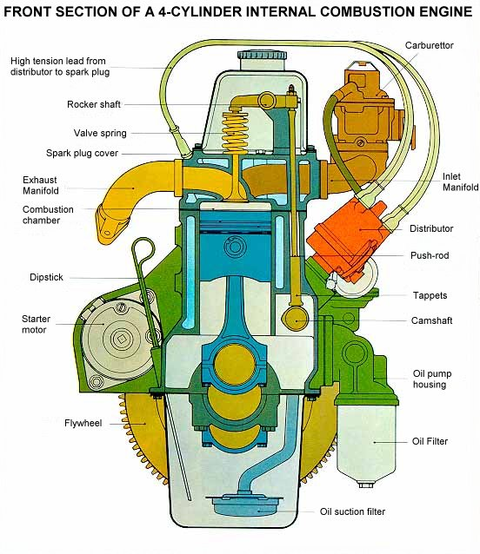
Figure 2.1: A 4- Cylinder Internal Combustion Engine

The basic components for a combustion cycle in a four stroke engine are combustion chamber (cylinder), piston, intake port and outlet or exhaust port. The pistons reciprocate inside the cylinder, exhaust and intake ports open and close during various stages of the cycle. The movement of the piston up or down the cylinder makes up one stroke of the four stroke cycle (Otto cycle). The linear motion is then converted to rotary motion by the crankshaft. The crankshaft is shaped to balance the pistons which are fired in a particular order to reduce the vibration (typically for a 4-cylinder engine, 1-2-4-3 or 1-3-4-2). The flywheel then helps smoothen out the linear movement of the pistons.

2.1.2 The Otto Cycle
Each movement of the cylinder up or down the cylinder is one stroke of the four stroke combustion cycle or Otto cycle. Most modern internal combustion engines use the four stroke cycle. The four stroke cycle consists of an induction stroke where air and fuel are taken into the cylinder as the piston moves downwards, a compression stroke where the air and fuel are compressed by the upstroke of the cylinder, the ignition or power stroke where the compressed mixture is ignited and the expansion forces the cylinder downwards, and an exhaust stroke where the waste gases are forced out of the cylinder. The intake and outlet ports open and close to allow air to be drawn into the cylinder and exhaust gases to be expelled.

During the intake stroke the inlet valve opens at the top of the cylinder, as the piston moves down air and fuel are drawn into the cylinder. As the piston reaches its lowest position the inlet valve closes and the piston travels upwards compressing the air-fuel mixture. As the piston reaches its highest position at maximum compression a spark ignites the mixture causing a rapid expansion of gas raising the pressure in the cylinder and forcing the piston downwards. Once the cylinder has reached its lowest position the outlet port opens and as the piston rises up the cylinder the exhaust gases are forced out. The valves which open and close the port are sprung to make them naturally close. The valves are opened by a system of rotating cams and pushrods driven by a camshaft which in turn is timed and driven from the crankshaft. The valve timings vary between engines depending on the setup; generally there is some overlap to speed the flow of gases as shown below.

Named after Nikolaus Otto (1832-1891), the Otto cycle used as an ideal approximation for the spark-ignition engine. The Otto cycle consists of four idealized processes:

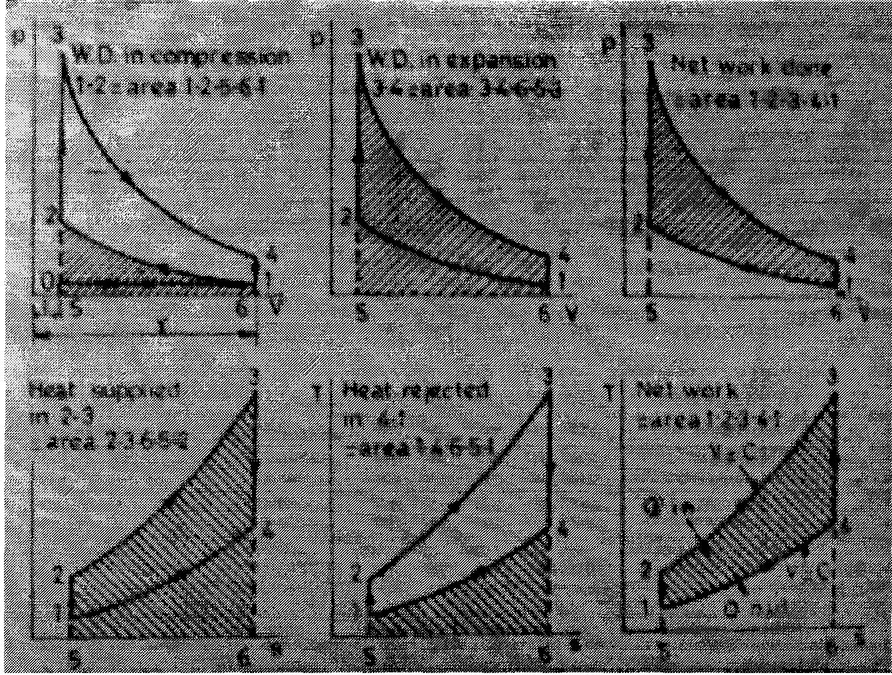

Fig 2.2 Theoretical air standard cycle of gasoline engine

1 to 2 adiabatic (no heat transfer) and reversible compression
2 to 3 heat addition, Q₂₃; at constant volume i.e. combustion is assumed to be so rapid that the piston does not move during the combustion event
3 to 4 adiabatic and reversible expansion
4 to 1 heat rejection, Qa1, at constant volume to complete the cycle

The Otto cycle's thermal efficiency η_{otto} is given by:
η_{otto} = Wnet /Q23 (2.1)
From the 1st Law of thermodynamics for a complete cycle
ΔU=Q-W=0

Wnet = Qnet = Q23 - Q41 (2.2)

Substituting (2.2) into (2.1) we have

η_{otto} = Q23 - Q41

Q23 = 1- Q41 /Q23 (2. 3)

Assuming air to be a perfect gas we have constant specific heat capacities; thus, for a fixed mass of air we have
Q23 = mCv (T3-T2)
Q41 = mCv (T4 –T1)
Thus
η_{otto} = 1 –(T4 - Tl)/ (T3 - T2) (2.4)

The heat addition and rejection processes are both isentropic, PV is a constant.
Thus:
T3 = T4 (V1/ V2) ^{y-1}
T2 = T1 (V1/V2)^{Y-1}
Where
Y is the ratio of gas specific heats
V1 /V2 is the compression ratio, r of the engine.
Substituting into equation (2.4) we have
η_{otto} = 1 - (1/r-1)

2.1.3 Working of SI Engine
Intake Stroke:
The intake stroke of the combustion cycle is when the piston travels down the cylinder with the intake port/ports open. A mixture of air and explosive fuel are drawn into the cylinder, the proportions of which are called the air-fuel ratio. Both the air-fuel ratio and the quality of the mixture (dispersion, droplet size etc.) is important for an efficient combustion process. There are two methods of mixing air and fuel in a combustion engine, using a carburetor or fuel injection system.

In a carbureted engine, during the intake stroke of the piston a vacuum is created in the inlet manifold. With a multi cylinder engine the vacuum is almost constant. The carburetor is located at the top of the manifold and air is drawn through it by the vacuum created in the manifold. The carburetor has a small fuel chamber supplied from the fuel tank by a pump, fuel passes through the carburetor to small fuel jets positioned in the air flow. The flow of air past the jets creates a pressure difference causing the fuel to be drawn out. The fuel vaporizes in the air flow and passes through the manifold and into cylinders on their intake stroke. The diagram below shows the basic operation of a fixed jet carburetor.

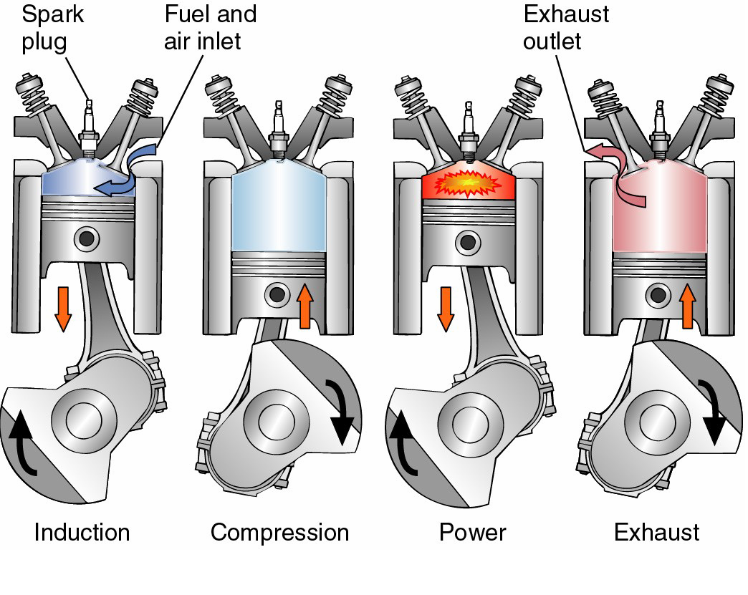
Figure 2.3: Figure showing the four strokes of the SI Engine

Electronic fuel injection system sprays fuel at high pressure either directly into the combustion chamber or into the intake port of the cylinder during the intake stroke. Using fuel injection enables improved control over the air-fuel mixture and reduces the power required to draw fuel from the jets. The diagram below shows a typical electronic fuel injection system.

Compression Stroke:

The compression stroke is the upwards movement of the piston in the cylinder with the valves closed following the intake stroke. This upwards motion compresses the fuel air mixture inside the combustion chamber raising the pressure. The difference between the initial volume of the cylinder and the final volume at the top of the compression stroke is known as the compression ratio. Typically this is approximately 9:1 in spark ignition engines and 15:1 for diesel engines. The compression ratio is particularly important in compression fired engines such as diesel engines. The fuel-air mix and compression ratio is critical to avoid pre-ignition which is the abnormal ignition of fuel in the combustion chamber before the combustion stroke. In diesel engines the fuel is injected under high pressure towards the top of the compression stroke. The distribution of fuel before combustion is also of interest because it affects the efficiency of combustion.

Combustion Stroke:

Spark plugs are used to generate the spark which ignites the compressed fuel and air mixture in the spark ignition engine. To generate the spark a high voltage of around 20, 000 Volts is applied. Low voltage current is fed through the primary winding of an inductor coil generating a magnetic field. The high voltage is generated when the low voltage supply is interrupted and the magnetic field breaks down generating a high voltage in the secondary winding which has a much larger number of coils. The low voltage supply to the coil is controlled by the distributor which also controls the spark plug that the high voltage surge is sent to. The distributor timing is critical and usually is timed mechanically from the engine. The diagram below shows the typical set-up of an ignition system for a spark ignition engine.

Compression ignition engines such as the diesel engine do not use spark plugs to ignite the fuel-air mix. When the piston reaches the top of the compression stroke the temperature and pressure in the combustion chamber is sufficient to ignite the mixture. Controlled ignition in both spark ignition and diesel engines is essential for efficient combustion and avoid uncontrolled combustion effects such as pre-ignition, auto-ignition and engine knock.

Exhaust Stroke:

Exhaust gases are pushed out of the cylinder by the upwards motion of the piston following the ignition stroke. The exhaust gases are passed into the exhaust manifold and channeled into the exhaust pipe where they are released into the atmosphere. The exhaust system may contain a smoke box to trap the larger soot particles; it may also be fitted with a catalytic converter which removes some of the harmful components from the exhaust gases. On newer cars some of the exhaust gases are recycled back into the inlet system (typically at the manifold or air filter), this is known as exhaust gas re-circulation EGR.

The efficiency of the combustion process and the design of the engine determine the exhaust constituents. Typically exhaust gases contain oxygen, nitrogen, water vapor, carbon dioxide, carbon monoxide, hydrogen, nitrous oxides, particulates and unburned hydrocarbons. The diagram below shows the effects of the air-fuel ratio on exhaust constituents in a typical engine.

2.2 Engine Performance Parameters

Engine performance is a major concern in this research project alongside the main aim of analyzing the reduction in the emission of nitrogen oxides using liquefied petroleum gas in spark ignition engine. Some indicators of engine performance such as input power, brake power, specific fuel consumption and engine efficiency are calculated to compare the engine performance between gasoline and LPG.

2.2.1 Input Power:
The input power of an engine refers to the maximum energy that can be put into the engine, and is given by:

Where:
IP = Input power (kW)
Q _{HV} = Lower calorific value of fuel (MJ/kg)
m _{f}= Mass flow rate of fuel (kg/s)
Q _{HV} (Gasoline) = 44.5 MJ/kg
Q _{HV} (LPG) = 50 MJ/kg

2.2.2 Brake Power:

Brake power refers to the power delivered by the engine. During internal combustion, chemical energy from the fuel is converted to generate heat to do work. However, the heat generated cannot be fully converted to work, and some of that are lost to the exhaust flow and to the surroundings by heat transfer. Indicated power (IP), which is used to push the piston to do the work, is used to subtract the friction power to obtain the brake power of an engine. Greater power can be generated by increasing displacement and speed.
Brake power is given by
BP= IP-FP
BP =2πNT/60*10³
Where:
BP = Brake power (kW)
Π= 3.142
N = Engine speed (rpm)
T= Torque (N.m)
Torque is usually used as a measure of an engine's ability to do useful work, and it has the unit of Nm or Ibs-ft. Apart from that, torque also refers to the measure of the work done per unit rotation (radians) of crank. The magnitude of the torque acting on a body is equal to the product of the force acting on the body and the distance from its point of application to the axis around which the body is free to rotate. It should be noted that only the force component that lies on the rotation plane and perpendicular to the radius from the axis of rotation to the point of application contributes to the value of torque. Torque is given by:
T=60P/2ΠN
Where:
T= Torque (Nm)
P=Power Developed by the Engine (W)
Π= 3.142
N = Engine speed (rpm)
In this research project, the brake power generated is converted to electrical power (EP), which is used to supply electricity to light the electric bulbs. Therefore, the brake power is measured as follows:

BP=EP=V*I
BP = Brake power (kW)
EP = Electric power (kW)
N = Engine speed (rpm)
V = Voltage (V)
I= Current (A)

2.2.3 Specific Fuel Consumption (sfc):
Specific fuel consumption measures the amount of fuel needed to provide a given power to an engine for a given period. It is an important parameter to compare gasoline and LPG in terms of economic aspect. Sfc is largely dependent on engine design, for example, a typical gasoline engine has a sfc of about 0.3 kg/kWh. However, sfc is inversely related with engine efficiency - a lower value of sfc shows better engine performance. The sfc is defined as:

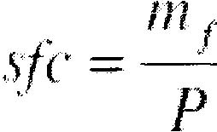
Where:
sfc = Specific fuel consumption (kg/kWh)
m _{f} = Mass flow rate of fuel (kg/h)
P = Power output (kW)

And Brake specific fuel consumption (bsfc) is given by:
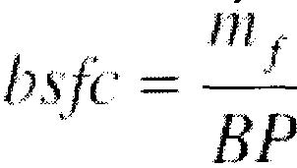
Where:
bsfc = Brake specific fuel consumption (kg/kWh)
m _{f} = Mass flow rate of fuel (kg/h)
BP=Brake Power (kW)

There are several factors which affect the value of bsfc. For instance, higher compression ratio delivers a greater bsfc as it extracts more power from the fuel. On the other hand, the value of bsfc will decrease if the combustion occurs with a fuel with equivalence ratio near to unity (Ф = 1). Bsfc will be of greater value at high speed as the friction losses are increased.

2.2.4 Engine Efficiency:
Engine efficiency is defined as the ratio of the effective or useful output to the total input in an engine. It also accounts for the fraction of fuel that burns during combustion. For any engine:
Power Generated = Wshaft+Wacc+Qexhaust+Qloss

Where:
Wshaft = brake Power to run engine accessories
Qexhaust = Energy lost in the exhaust flow
Qloss = other energy lost to the surroundings by Heat transfer

For one engine cycle in a single cylinder, the fuel conversion efficiency η_{f} is given by:

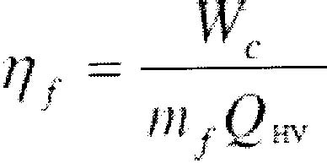
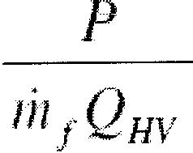
and it can be presented in the form of:

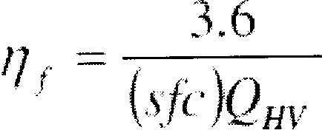

Where:
η_{f} = Engine efficiency
P = Output power produced per cycle (kW)
m _{f} = Mass flow rate of fuel per cycle (kg/s)
Q _{HV} = Lower calorific value of fuel (MJ/kg)

2.3 Engine Emissions
When considering the exhaust emissions from Spark Ignition engines, it is important to recall that we are dealing with premixed combustion. A flame, initiated at a fixed point within the cylinder (the spark plug), propagates through the in-cylinder charge. Although, under ideal circumstances, the in-cylinder charge will be a homogeneous mixture of fuel and air this is not always the case. Therefore, the flame front will often `see' significant variations in air fuel ratio. As you know, the products of rich combustion differ from those of lean combustion. Recall also that combustion is an extremely complex multi-step process. Thus, there are chemical reactions that occur both before and after passing of the flame. Typically, the rate of these reactions is highly temperature dependent. Flame temperature is a strong function of air fuel ratio; accordingly, local air fuel ratio has a significant influence on the composition of the engine out exhaust gases as is shown in figure 2.3:
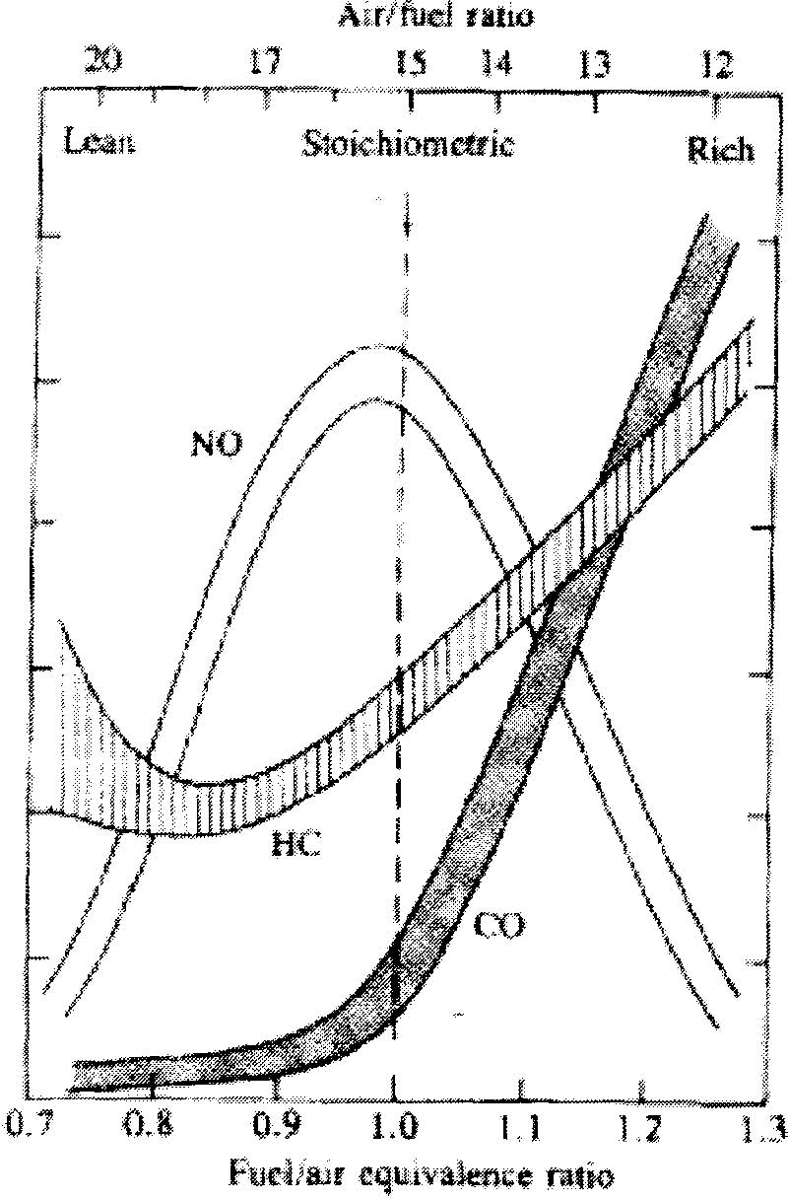

Figure 2.4: Variation of NO, CO and HC emissions with fuel-air ratio
For the ideal combustion of a hydrocarbon fuel we would have only carbon dioxide (more later) and water vapor in the exhaust. However, as you are no doubt all well aware, in a real application the exhaust gas contains a number of less desirable pollutant species. Concern over the negative environmental and health effects of this noxious cocktail of gases has prompted the introduction of strict emissions legislation in much of the world. The internal combustion process of spark ignition (SI) engines using liquefied petroleum gas produces undesirable emissions such as oxides of nitrogen (NOx), carbon monoxide (CO), carbon dioxide (CO), sulphur dioxide (SO₂) and hydrocarbons (HC). These emissions pollute the environment and contribute to global warming, acid rain, smog, odors, and respiratory and other health problem. Let us now consider some of these emissions in more detail; in particular, we will consider the source of these emissions within an SI engine, their potential impact, and methods for their control.

2.3.1 Carbon Monoxide (CO):

Carbon monoxide (CO) is a colorless, odorless, flammable and highly poisonous gas which is less dense than air. Inhalation of carbon monoxide can be fatal to humans since a small concentration as little as 0.1% will cause toxicities in the blood due to its high affinity to oxygen carrying hemoglobin. Exposure levels must be kept below 30 ppm to ensure safety (Environmental Centre, undated). Apart from that, carbon monoxide also helps in the formation of greenhouse gases and global warming by encouraging the formation of NOx.

Formation of CO
Carbon monoxide forms in internal combustion engines as a result of incomplete combustion when a carbon based fuel undergoes combustion with insufficient air. The carbon fuel is not oxidized completely to form carbon dioxide and water. This effect is obvious in cold weathers or when an engine is first started since more fuel is needed.

Carbon monoxide emission from internal combustion engines depend primarily on the fuel/air equivalence ratio (λ). Figure 2.5 (a) shows the variation of CO emission for eleven fuels with different hydrocarbon contents. A single curve may be used to represent the data when using the relative air/fuel or equivalence ratio as represented in Figure2.5 (b).

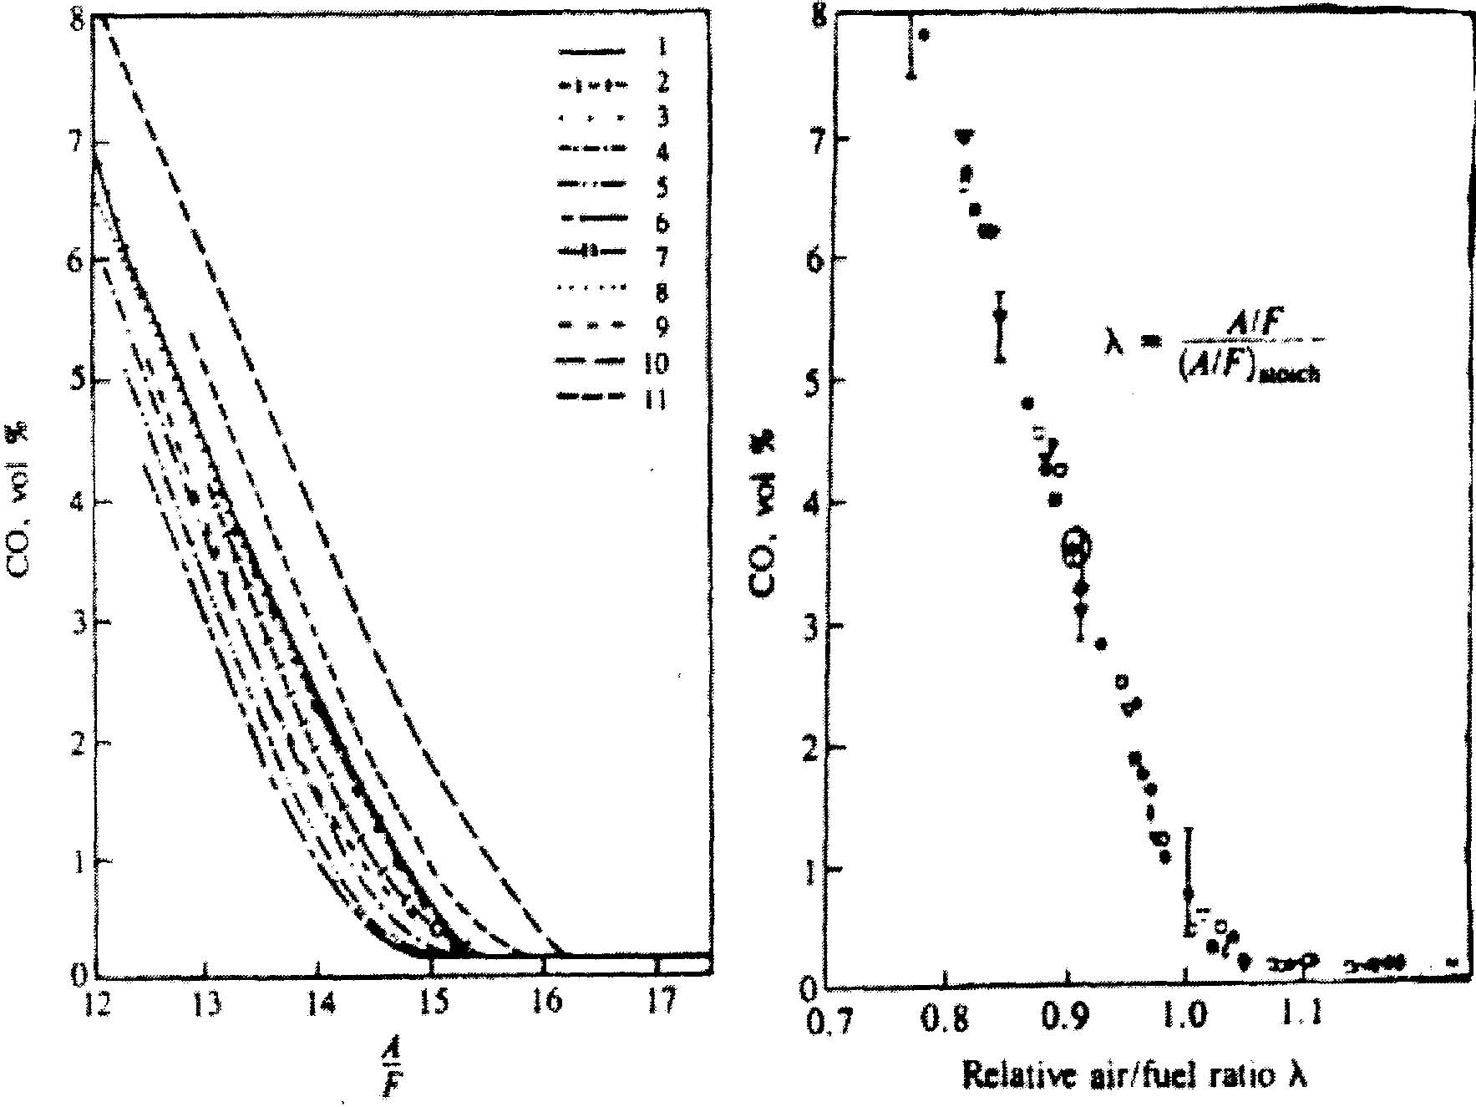

Figure 2.5: Variation of SI engine CO emissions with various fuels (a) with air/fuel ratio; (b) with relative air/fuel ratio (λ)

Both the graphs clearly show that the amount of CO emitted increases with decreasing air to fuel ratio. Spark ignition gasoline engines which normally run on a stoichiometric mixture at normal loads and fuel-rich mixtures at full load shows significant CO emissions. On the other hand, diesel engines which run on a lean mixture only emit a very small amount of CO which can be ignored. Ferguson (1986) researched that additional CO may be produced in lean-running engines through the flame-fuel interaction with cylinder walls, oil films and deposits. Direct injection diesel engines also emit more CO than indirect-injection engines. However, the CO gas emission increases with increasing engine power output for both engines.

CO formation is one of the principle reaction steps in the hydrocarbon combustion mechanism, which may be summarized by
RH----› R----› R0₂----› RCHO----› RCO----› CO
Where ‘R’ stands for the hydrocarbon radical.
The CO formed from hydrocarbon radicals can be oxidized to form carbon dioxide in an oxidation reaction, in an equilibrium condition:
CO +OH=C0₂+H
The emission of CO is a kinetically-controlled reaction since the measured emission level is higher than equilibrium condition for the exhaust. Three-body radical recombination reactions such as:
H+H+M=H₂+M H+OH+M=H₂0+M H+0₂+M=H₂0+M
are found to be rate-controlling reactions for emission of CO gas.
Reduction of carbon monoxide in internal combustion engines can be achieved by improving the efficiency of combustion process or utilization of oxidation catalysts to oxidize carbon monoxide to carbon dioxide. Engine modifications such as improved cylinder head design, controlled air intake and electronic fuel injection can help to maintain a lean air/fuel mixture which is favorable.

2.3.2 Oxides of Nitrogen (NOx):

NOx is the collective term for nitric oxide (NO) and nitrogen dioxide (N02) which are extremely toxic gases for humans.

Formation of NOx
Basically, NOx, as the name implies, are generated from reaction between nitrogen and oxygen under high temperature and pressure conditions during the combustion process in an engine cylinder. Normally it takes place at the pre combustion, combustion and post-flame regions where sufficient concentrations of oxygen and nitrogen are present. The formation of NOx depends enormously on the temperature as the rate of dissociation of nitrogen is directly proportional to the temperature increase. Therefore, the higher the combustion reaction temperature, the more NOx will be produced. The chemical reactions of nitrogen and oxygen are as follows (Zeldovich Mechanism):

N+O₂ = N0+O
O+N₂ = NO+N
OH+N = NO+H
There are three different mechanisms of formation of NOx:
(i) Thermal NOx
It is formed by the stabilization of atmospheric nitrogen in oxidizing atmospheres at a high flame temperature exceeding 1573K or 1300 °C. Thermal NOx is generally produced during the combustion of both gases and fuel oils. The following chemical reactions were classified as an atom shuttle reaction (Zeldovich et al., 1947)

N2+0=NO+N
N+0₂=NO+O

When the combustion is under fuel-lean conditions (with less air) and there is a rise in temperature, this will lead to an increase of NOx emissions due to increased oxygen radicals forming in the combustion process. However, when the combustion is under fuel-rich condition (with excess air) the oxidation reaction will involve the OH and H radicals (Szczepanski. D 1998):

N+OH=NO+H
H + N₂=N₂H
N₂H+O=NO +NH
High activation energies are required for the dissociation of oxygen molecules and the disengagement of the triple bond of nitrogen. This phenomenon causes the formation of thermal NOx to be largely dependent on the temperature, the degree of air to fuel mixing, the oxygen and nitrogen in the flame and duration of reaction occurred.

(ii) Fuel NOx
It is formed by the reaction of coal-bound nitrogen compounds with oxygen at temperature exceeding 1123K or 850 °C. The formation of fuel NOx is mainly dependent on the availability of oxygen and the combustion method. Under low oxygen conditions, hydrogen cyanide (HCN) reacts with oxygen atoms to form oxycyanogen and amine intermediates and NO is formed as the oxidization product.
On the other hand, under excess oxygen conditions, the formation of N₂ is more favorable as the result of additional hydrogenated amine species and the chemical reactions between amine intermediates, hydrocarbon radicals and NO are as follows (Szczepanski. D 1998):

NH₂ + NO= N₂ +H₂V
CH + NO =HCN + O

(iii) Prompt NOx
It is formed by the stabilization of atmospheric nitrogen in reducing atmospheres by the particles of hydrocarbon under fuel-rich conditions. Prompt NOx is of great significance under the condition of very fuel-rich flames and nonessential to be compared with the influence of thermal and fuel NOx.

Concentration of NOx
The concentration of NOx found in the emission of engines is dependent on the combustion temperature, the length of combustion time and the concentration of the nitrogen and oxygen in the engine. The measurement unit of NOx is generally in parts per million (PPM) due to the dilution of NOx percentage with the excess air level in the flue gases. NOx value tends to peak at an air-fuel ratio of approximately 1.1 times stoichiometric with the condition of excess oxygen present.

Effects of NOx towards the Environment
The environmental problems caused by NOx are now worldwide issues due to the seriousness of ozone reactivity and the amount of formation of smog. NOx combines with water vapor in clouds to produce acid rain which pollutes clean water sources and corrodes metals used in our daily life. Acid rain also harms the growth of organisms in the lake and disturbs the balance of the ecosystem both on land and at sea. Apart from that, acidified soil is the also the result of acid rain and it causes damage to the root system of trees, disabling the nutrient absorption process and disrupting the natural process of photosynthesis. (Turns, 1996)
When NOx react chemically with other atmospheric gaseous compounds such as "volatile organic compounds" (VOCs) under the sunlight, it will form smog. Smog is forefront to our environmental concerns as it reduces the visibility of surroundings and poses a health hazard to humans which includes irritation of eyes, respiratory and cardiovascular problems such as asthma and headaches.
Greenhouse effect is a global-warming phenomenon when heat energy from the sunlight is trapped by gases such as NOx. This increases the average temperature of our planet and acts as a great threat to the life of crops, humans and the environment. The increased temperature will speed up the melting rate of the icebergs in north and south poles and there will be an increased risk of flooding in lower-terrain countries.
Next, ozone depletion is also related to the excessive emission of NOx. Nitrogen oxides formed will allow more penetration of harmful ultraviolet solar radiation to the earth and lead to skin irritation for humans (Turns, 1996). The reaction mechanisms are listed below (Turns, 1996):

NO + 0₃ = N0₂ + 02
NO₂+O= N0+0₂

Ozone (0₃) is destroyed in the first reaction to form nitrogen dioxide (NO_{Z}), and then the nitric oxide (NO) is regenerated in the second reaction to repeat the ozone depletion step. These processes will continue and will only stop when the whole ozone layer is consumed (Turns, 1996).

Factors Affecting NOx Emissions
There are several factors which affect the formation of NOx in the engine and they are listed below:

(i) The air-fuel ratio (λ) plays a major role in determining the amount of emission of NOx as oxides of nitrogen are formed by the reaction of nitrogen in the fuel with oxygen in the combustion air. When the air to fuel ratio is greater than one which indicates that the combustion is in the lean condition, the fuel mixture has considerably less amount of fuel and excess amount of air. Engines designed for lean burning can achieve higher compression ratios and hence produce better performance. However, it will generate high amount of NOx due to the excess oxygen present in the air.

(ii) Combustion temperature is also one of the primary factors that influence the formation of NOx. The formation of NOx is directly proportional to the peak combustion temperature, with higher temperatures producing higher NOx emissions from the exhaust.

(iii) The amount of nitrogen in the fuel determines the level of NOx emissions as fuels containing more nitrogen compounds result in higher levels of NOx emissions. Choices of fuel type alter the formation of both the theoretical flame temperature reached and rate of radioactive heat transfer.

(iv) The firing and quenching rates also influence the rate of NOx formation where a high firing rate is associated with the higher peak temperatures and thus increases the NOx emission. On the other hand, a high rate of thermal quenching results in lower peak temperatures and contributes to the reduction of NOx emission.

(v) Engine parameters such as load and speed of engine also influence the NOx emissions from the exhaust. When the engine is running under lean conditions, it emits less NOx. However the nitric oxide (NO) emissions will consequently increase as the engine load increases. The effect of load becomes less significant when the engine is running close to stoichiometric air to fuel ratio. On the other hand, engine speed may increase or decrease the NO emissions as higher engine speed increases the burned gas mass fraction and thus offsets the peak temperature, depending on the exact engine conditions (Bauza, and Caserta, 1997).

2.3.3 Unburbt Hydrocarbons (UHC) Emissions

Total hydrocarbon (THC) is used to measure the level of formation of unburnt hydrocarbons caused by incomplete combustion in the engine. The hydrocarbons emitted may be inert such as methane gas or reactive to the environment by playing a major role in the formation of smog. The types hydrocarbons emitted from the exhaust greatly depend on the type and composition of fuel used. Heywood (1988) added that fuels with a greater concentration of aromatics and olefins compounds will result in a higher percentage of reactive hydrocarbons.

Formation of HC Emissions
HC emissions rise rapidly as the mixture becomes substantially richer than stoichiometric. When combustion quality deteriorates, e.g., with very lean mixtures, HC emissions can rise rapidly due to incomplete combustion or misfire in a fraction of the engine's operating cycles.
The possible HC emission formation mechanisms for spark-ignition engines (where fuel-air mixture is essentially premixed) have been proposed:
1. Crevice flows: The crevice mechanism where crevices in the combustion chamber are filled with a mixture of fuel and air. This mixture remains unburned after flame passage since the flame cannot propagate into the crevices. When the exhaust valve opens and the pressure drops in the combustion chamber the fuel in crevices is driven out in hot bulk gasses and are being partly oxidized. The UHC emissions from SI engines will normally increase with increasing compression ratio.
2. Flame quenching: As the flame approaches the combustion walls it is extinguished (due to Heat Transfer to walls). Thus, leaving a layer of unburned fuel-air mixture adjacent to the wall.
3. Absorption/desorption in oil films: Hydrocarbons can be absorbed into the oil film on the cylinder bore during compression. These hydrocarbons are released again during expansion and often escape oxidation as a result. Absorption/desorption from in-cylinder deposits may also be considered as a reason for the UHC.
4. Incomplete combustion: Incomplete combustion in a fraction of the engine's operating cycle (either partial burning or complete misfire), occurring when combustion quality is poor (e.g. during engine transients when A/F, EGR, and spark timing may not be adequately controlled).

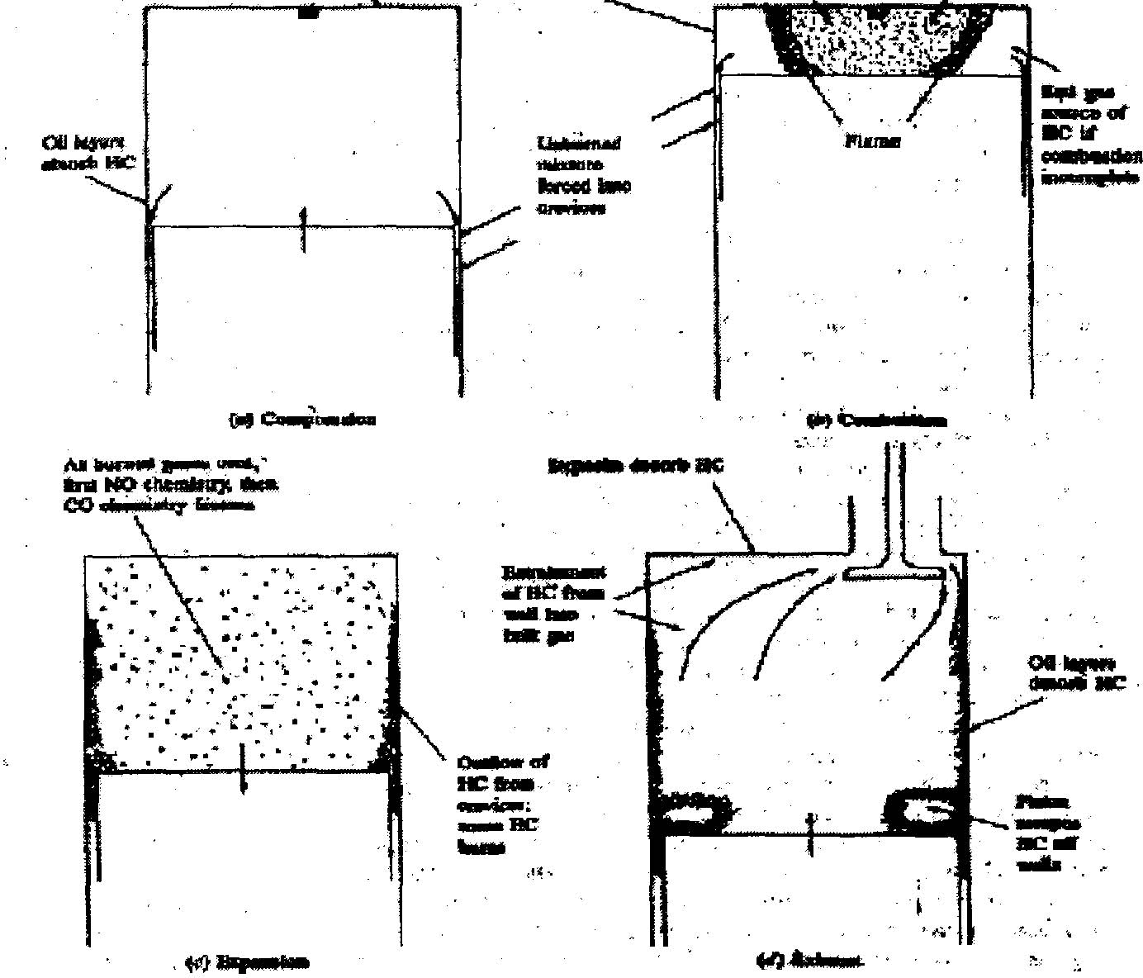
Figure 2.6: Summary of HC, CO and NO pollutant formation mechanisms in SI engine

Hydrocarbons from LPG emission contain only short chain hydrocarbons and are not likely to consist of toxic components which can be found in gasoline hydrocarbons emissions. However, LPG hydrocarbons emissions often causes nuisance when LPG engines operate indoors (Nett Technologies, undated).

2.3.4 PM Emissions from SI Engines

Although the emission of particulate matter is usually associated with the diesel engine, there is increasing evidence to suggest that PM emissions from SI engines pose a significant threat to health. In particular, PM emissions pose a significant problem for Stratified Charge, Direct- Injection Gasoline engines. In order to understand the reasons for this concern, we must first consider the formation and composition of PM.

PM Formation in SI Engines:
• Particulates are principally SOOT which has absorbed other organic compounds i.e. hydrocarbon compounds.
• Soot is describes as a carbonaceous material not just carbon
• PM is formed in fuel-rich regions of flames (both pre-mixed and diffusion flames)
With respect to the Direct-Injection Spark-Ignition (DISI) engine, particularly in stratified charge mode, it is extremely difficult to achieve good charge homogeneity. Accordingly, there are proportionally a larger number of fuel-rich regions within the cylinder of a DISI engine, which provide potential sites for PM formation, than is the case for a similar Port-Fuel-Injected (PFI) engine. The literature suggests that PM emissions from DISI engines are an order of magnitude greater than an equivalent PFI engine.

Harmful Effects of PM Emissions:
There is an increasing body of evidence to suggest that aerodynamic size is a significant factor determining the health effect of particulate emissions from engines. The adverse health effects of very small (nano) particles are thought to be particularly severe:
• Sub-micron particles remain airborne for a substantially greater time than do larger particles
• Nano-particles are easily ingested and absorbed into the bloodstream, etc.

Spark-Ignition engines are prone to produce sub-micron PM prompting authorities to consider moving from existing mass based PM emissions regulations to size-based regulations for future standards.

2.3.5 Carbon Dioxides (CO₂)

Carbon dioxide is considered as the major greenhouse gas, and it can cause death by suffocation if inhaled in large amounts (Southern Technologies, undated). CO has the tendency to absorb heat radiation of the sun, thus creating a thermal radiation shield which reduces the amount of thermal radiation energy allowed to escape from the Earth. As a result of this, the temperature of Earth rises and accelerates the melting rate of polar ice caps and expansion of oceans into low lying areas (Southern Technologies, undated).
To reduce the emission of C0₂ efficiently, engines with higher thermal efficiency that are able to operate at the lowest level of excess air are used (Southern Technologies, undated).

2.3.6 Sulphur Dioxide (SO₂)
Sulfur dioxide (SO) belongs to the family of sulfur oxide gases (SOx). These gases dissolve easily in water and are produced when sulfur or fuels containing sulfur are oxidized:

S + 0₂ = SO₂

S0₂ dissolves in water vapors to form acid, and interacts with other gases and particles in the air to form sulfates and other products that can be harmful to the people and environment. Moreover, oxidation of SO₂ will further produce S0₃ in the atmosphere under the influence of sunlight:
2S0₂ + 0₂ = 2S0₃
Some of the S0₃ will also be introduced directly from the combustion processes alongside SO₂. S0₃ will react rapidly with moisture from the atmosphere to form sulphuric acid, which is the main element in acid rain:
S0₃ + H₂0 = H₂S0₄
It had been proven that even with sophisticated combustion techniques; there had been no significant improvement of reduction in the emission of sulphur dioxide. Therefore the best way to solve this problem is the selection of low sulphur content fuels such as LPG.

2.4 Fuels used in SI Engine

2.4.1 Gasoline

Production
Early refineries used a simple distillation process to separate crude oil into its components according to their boiling points. The gasoline produced by this method was only that naturally occurring in the crude oil. As demand for motor spirit grew, engineers and chemists found that more severe heating of the higher boiling points hydrocarbons broke them down, or 'cracked' them, into smaller, lower boiling hydrocarbons more suitable for gasoline production. From 1913, thermal cracking was used to increase gasoline production. Substances known as 'catalysts' were later found to do a better job of cracking hydrocarbons than heat alone, by speeding up the reaction and producing a greater yield of higher octane petrol. Chemistry
Gasoline is a derivative of petroleum refining. It is essentially a complex mixture of hydrocarbons that boils below 180⁰C. The hydrocarbon constituents are those that have 4 - 12 carbon atoms in their structure and fall into three general types:
• Paraffins, such as hexane (C₆H1₄), and octane (C₈H₁₈)
• Olefins, such as hexane (C₆H₁₂)
•Aromatics such as benzene (CH) and toluene
Gasoline consists of a blend of more than 200 such hydrocarbons either occurring naturally in petroleum or manufactured from it. Gasoline can vary considerably in composition, depending upon the source of the original crude oil, and the processes used in production. When there is enough oxygen, hydrocarbons can be burnt to form C0₂ and water vapor, releasing heat.
The equation for the complete combustion of hexane is:

For hexane: 2C₅H₁₄ + 190₂ = 12C0₂ + 14H₂0

For octane: 20₁₈ + 250₂ = 16C0₂ + 18H₂0

For hexane: 2C₆H₁₂ + 180₂ = 12CO_{Z} + 12H20

For benzene: 2C₅H₆ + 150₂ = 12C0₂ + 6H₂0
If insufficient oxygen is available, incomplete combustion occurs, forming carbon monoxide CO, nitrogen oxides and carbon, as well as carbon dioxide and water.

Environmental considerations:

Exhaust emissions from petrol-driven cars include, in addition to C0₂ and water vapor, hydrocarbons, nitrogen oxides and CO. These latter emissions may be effectively reduced by fitting a three-way catalytic converter that converts these three types of exhaust components into less reactive substances.

Volatile organic compounds are also emitted into the atmosphere through evaporation from fuel tanks, carburetors and refueling stations. These emissions can be reduced by using carbon canisters containing activated charcoal which absorbs these vapors. Evaporation can also be controlled during manufacturing and distribution with double tank roofs, improved tank seals and vapor recovery units.

An important element in the efficiency of gasoline combustion is the octane number. This indicates the ability of the fuel to resist detonation, which is referred to as engine pinging or knocking. Such detonation is caused by the spontaneous igniting of the fuel and air in the engine cylinders before the spark is fired. Higher octane fuels are less susceptible to detonation and thus prevent engine knock and in turn maintain engine power.
Lead has traditionally been added to gasoline as an effective and economic method of boosting octane quality. However, concerns have recently arisen about the possible health effects of lead in vehicle exhaust emissions. Concerns also about atmospheric 'smog' pollution have led to the desire to remove up to 90% of the smog precursors present in engine exhaust gases by the use of catalytic converters. This in turn requires that the gasoline be lead free if the catalyst is to function properly. In Australia this resulted in a decision to change to cars which operate on unleaded gasoline with a lower octane than previously used, so that changes to refinery configurations, to make up for the octane loss upon the removal of the lead, would not be too extensive.

This change is not without its disadvantages, since a lower octane fuel results in a less efficient engine, and an overall increase in carbon dioxide emissions. Some additional C0₂ emissions also arise from the changed refining processes. Thus, although the move to unleaded gasoline may be successful on a local level from a smog point of view, it is likely to have an increased impact upon global air quality in terms of C0₂.

Economic considerations:
Most cars today run on gasoline because it is a relatively cheap, convenient, safe and reliable fuel that yields good vehicle performance complete with a good vehicle range capability. It can also be stored and handled easily.

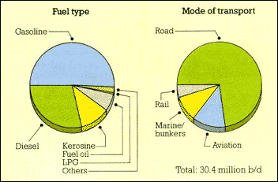
Figure 2.8: World Transportation Fuels Demand

2.4.2 Liquid petroleum gas (LPG)

Production:

LPG is a by-product of two sources: natural gas processing and crude oil refining. When natural gas is produced, it contains methane and other light hydrocarbons that are separated in a gas processing plant. Because propane boils at -44⁰F and ethane boils at -127⁰F, separation from methane is accomplished by combining increasing pressure and decreasing temperature. The natural gas liquid components recovered during processing include ethane, propane and butane and other heavier hydrocarbons. Propane and butane along with other gases are also produced during crude refining as a by-product of the process that rearrange or break down the molecular structure to obtain more desirable petroleum compounds.

Chemistry:

LPG is a mixture of light hydrocarbons which are gaseous at normal temperatures and pressures, and which liquefy readily at moderate pressures or reduced temperature. It is odorless and so, for safety reasons, a pungent compound, mercaptan, is added to make any leaks easily detectable.
The main component gases of LPG are.
- Propane (C₃H₈)
- Propylene (C₃H₆)
- Butane (C₄H₁₀ )

Each gas undergoes a reaction during combustion:

Propane:
C₃H₈+ 50₂=3C02+4H20
Propylene: 2C₃H₆+ 90₂= 6C02+6H₂0
Butane: 2C₄H₁₀+ 130₂= 8C0₂+10H₂0

Environmental considerations:

Estimates are that exhaust and evaporative greenhouse emissions are approximately 15 per cent lower from LPG than from gasoline vehicles. It does not need lead or other additives to boost its octane rating.
Comparisons of the levels of noxious gas emissions from LPG and gasoline vehicles are inconclusive, with test results indicating both higher and lower levels that gasoline vehicles. Some recent tests suggest that noxious emissions are worse from LPG vehicles. LPG is a non-renewable resource.

Economic considerations:

LPG in the liquid form -- which is easily achieved -- is a very efficient way of carrying large amounts of gas. In general economic terms it is unattractive, requiring a subsidy, in the form of an excise exemption as an incentive to consumers who must cover the costs of conversion of the vehicle to operate on LPG.

2.4.3 Compressed natural gas (CNG)
Natural gas is a mixture of hydrocarbons-mainly methane (CH₄)-and is produced either from gas wells or in conjunction with crude oil production. Natural gas is consumed in the residential, commercial, industrial, and utility markets.

The interest in natural gas as an alternative fuel stems mainly from its clean burning qualities, its domestic resource base, and its commercial availability to end users. Because of the gaseous nature of this fuel, it must be stored onboard a vehicle in either a compressed gaseous state (CNG) or in a liquefied state (LNG).

Chemical Properties:
The main constituent of natural gas is methane, which is a relatively un-reactive hydrocarbon. Natural gas as delivered through the pipeline system also contains hydrocarbons such as ethane and propane; and other gases such as nitrogen, helium, carbon dioxide, hydrogen sulfide, and water vapor.

Production
Natural gas is comprised of a mixture of gases, mainly hydrocarbons, found in geological formations. Methane is the principal component, generally comprising from 87 per cent to 97 per cent by volume of the hydrocarbons depending on the source of the gas.

Chemistry
In addition to methane (CH₄), natural gas also contains small percentages of:
• Ethane (C₂H₆)
• Propane (C³H₈)
• Butane (C⁴H₁₀)
• Pentane (C⁵H¹²)
It can be compressed and used as an automotive fuel.
Its combustion is given by:
CH⁴+20² =C0₂+2H₂0
Environmental considerations
Because of its high octane number, CNG is an excellent fuel for spark ignition engines. Older cars are not difficult to convert from gasoline to CNG. However, as engine management systems become more complicated, conversions are becoming more difficult or involve non-optimal engine operation. As a gas it can pose safety hazards during necessarily frequent refueling operations. Although when properly operated and maintained, leakage of CNG is minimal it should be noted that methane is an even more active greenhouse gas than CO₂.
Emissions from CNG-powered vehicles depend on the quality of the vehicle's conversion. In older cars without catalytic converters, non-methane hydrocarbon, CO and nitrogen oxides in exhausts from CNG-fuelled cars are much less than from petrol-driven vehicles. There is less difference between emissions from gasoline and CNG in cars with catalytic converters -- in both instances emissions are greatly reduced. CO emissions are the same while nitrogen oxide emissions may be slightly higher from CNG. Overall there appears to be slightly less greenhouse gas emission from CNG vehicles compared to gasoline vehicles. Use of CNG substantially reduces particulate emissions, particularly from the new, dedicated CNG engines now available for buses and trucks. These new engines reduce particulate emissions to very low levels and are expected to rapidly penetrate the city bus fleet sector because of their cleaner image. Many new CNG buses are in operation or on order for several Australian capital cities.

Economic considerations
The benefits of CNG are thus greatly reduced, because the compression ratio and engine efficiency of dual-fuelled cars cannot be increased to take advantage of CNG's high octane number. Storage of CNG is also a problem. Because of its low boiling point, natural gas must be stored in high pressure tanks. These are heavy, reducing payload and space in smaller vehicles. A CNG-fuelled car with a 75 liter tank is about 150kg. heavier than a petrol-driven car of the same size. This is not such a problem with large vehicles such as buses. Natural gas is lighter than air, and will dissipate into the atmosphere if leakage occurs. Like LPG, it is usually odorized to make it detectable. It is non-toxic and non-reactive.

The major problems with CNG are that it is uneconomic because the cost of converting cars is high and the short range between refueling is inconvenient.

2.4.4 Methanol

Methanol (CH₃0H), also known as wood alcohol, is an alcohol fuel and it can be used as an alternative fuel in flexible fuel vehicles that run on M85 (a blend of 85% methanol and 15% gasoline). However, it is not commonly used because automakers are no longer supplying methanol-powered vehicles.

Methanol can be used to make methyl tertiary-butyl ether (MTBE), an oxygenate which is blended with gasoline to enhance octane and create cleaner burning fuel. MTBE production and use has declined because it has been found to contaminate ground water. In the future, methanol could possibly be the fuel of choice for providing the hydrogen necessary to power fuel cell vehicles.

Chemical Properties
As engine fuels, ethanol and methanol have similar chemical and physical characteristics. Methanol is methane with one hydrogen molecule replaced by a hydroxyl radical (OH).

Production
Methanol (CH₃0H) is a clear liquid alcohol that can be produced from natural gas, coal, crude oil and biomass crops such as wood and wood residues as well as directly from catalytic synthesis:
C0+2H₂ =CH₃0H

At present, however, natural gas itself is the most economically and environmentally viable source.

Chemistry
Methanol is the simplest alcohol. It is a clear, colorless liquid.

Combustion of methanol:
2CH₃0H+ 30₂ =2C0₂ + 4H₂0

Currently, pure methanol can be used in purpose-designed engines such as some racing cars, since its very high octane rating allows for the use of very high compression engines producing significantly more power than an equivalent gasoline engine.

Pure methanol can be mixed with gasoline for use in flexible-fuelled vehicles (FFV) capable of measuring the methanol: gasoline ratio being delivered to the engine. This is so that the engine management system can adjust the air: fuel ratio and timing to match the requirements of whatever mixture is being used.

The water solubility of methanol poses a problem. Methanol cannot be used in blends with gasoline above 5% in normal cars, and then only with co-solvents, because of the fear of phase separation.

Environmental considerations
Methanol has the potential to reduce greenhouse gas emissions but would need to be produced from biomass to make a possible contribution. Methanol derived from natural gas using current technology offers at best only a small greenhouse gas emission benefit over petrol.

Although the emissions of CO, hydrocarbons and nitrogen oxides are lower in methanol-dedicated cars, the exhaust of these vehicles contains more formaldehyde, a known carcinogen. Methanol can also lead to greater unburnt fuel emissions of methanol and methane which, however, are usually more readily degraded than unburnt hydrocarbons. Methane is a major greenhouse gas. Under combustion, methanol produces neither soot particles nor sulphur oxides. It also yields less nitrogen oxides than any other fuel.

Economic considerations
Methanol is a high cost fuel compared with petrol, but relatively cheap compared with other options.

Methanol is extremely toxic and therefore hazardous to handle. It is also corrosive requiring modification of a conventional vehicle's fuel system.
It has only half the energy content of petrol, which results in greater fuel consumption per unit volume and shorter traveling range -- compensated to some extent by its suitability for use at a higher compression ratio and its ability to deliver more power.

2.4.5 Ethanol

Ethanol (ethyl alcohol, grain alcohol, EtOH) is a clear, colorless liquid. In dilute aqueous solution, it has a somewhat sweet flavor, but in more concentrated solutions it has a burning taste. Ethanol (C₂H₅0H) is made up of a group of chemical compounds whose molecules contain a hydroxyl group, -OH, bonded to a carbon atom. Ethanol made from cellulosic biomass materials instead of traditional feedstock (starch crops) is called bio-ethanol.

Ethanol is an alcohol-based alternative fuel produced by fermenting and distilling starch crops that have been converted into simple sugars. Feed stocks for this fuel include corn, barley, and wheat. Ethanol can also be produced from "cellulosic biomass" such as trees and grasses and is called bio-ethanol. Ethanol is most commonly used to increase octane and improve the emissions quality of gasoline.

Ethanol can be blended with gasoline to create E85, a blend of 85% ethanol and 15% gasoline.

Production
Ethanol is presently the most widely used alternative fuel in the world. It is mostly produced from crops which contain sugar (e.g. sugar cane or sugar beet), or by pretreatment of starch crops (e.g. corn or wheat) or cellulose to produce sugars. The fermentation process uses the conversion of sugars by yeast into ethanol and CO:

C₆H₁₂0H= 2C²H⁵0H + 2C0₂

Chemistry
Like methanol, ethanol requires less oxygen for combustion than petrol:

C²H⁵0H +30²=2C0₂+3H₂

Ethanol can be used straight but, since both ethanol and methanol have a higher heat of vaporization than petrol, cold starting an engine can be a problem. However, this does not appear to be a problem using gasoline blended with up to 20% ethanol.

Ethanol has about two-thirds the energy and heat value of gasoline(21.2 MJ/L), but exhibits different burning characteristics to petrol, which may be more efficient. It is less toxic and corrosive than methanol, although its technical performance and emission levels are similar.

Environmental considerations
A positive environmental aspect is that ethanol is a renewable resource, unlike oil, gas or coal, and in some cases may even be produced from waste material.

However, there are drawbacks:

• As an alcohol, ethanol contains the hydroxyl group (OH), giving it a high affinity with water and making it more difficult to separate from water. This can cause environmental problems, e.g. if an ethanol/gasoline blend is spilt in a small watercourse or drain, the gasoline may be able to be skimmed off the top but the ethanol will dissolve and be almost impossible to recover. Ethanol is however, more easily biodegraded or diluted to non-toxic concentrations than is petrol.

• Because ethanol is produced from crops, large areas of land are be required for its production. In Australia, for example, it has been estimated that the amount of land readily available would provide only 10% of our fuel needs.

• While CO emissions are reduced with alcohol fuels, aldehydes, which irritate the eyes, are increased.

• As with methanol, the potential greenhouse gas savings depend on the feedstock and process used for production. Ethanol's full fuel cycle greenhouse gas emissions are said to range from 30 - 180% from maize and 0 - 115% from wood, of the emissions from the gasoline. It replaces C0₂ from the combustion process alone is similar for alcohol fuels and gasoline on an energy equivalent level.

Economic considerations

To be able to achieve any significant reductions in emissions of greenhouse gas by using alcohol fuels, the ethanol or methanol will need to be produced from the lignocelluloses fractions of biomass. However, it has yet to be demonstrated that large-scale production of this type is technically or economically viable.

At present ethanol production is 2-3 times more expensive than gasoline production. Australian production costs are usually estimated to be 50 to 65 c/L, making it an uneconomic proposition. Currently, ethanol use in Australia is being supported by both a production bounty payment and total relief from excise.

2.4.6 Hydrogen

The simplest and lightest fuel is hydrogen gas (H_{Z}). Hydrogen is in a gaseous state at atmospheric pressure and ambient temperatures. Hydrogen may contain low levels of carbon monoxide and carbon dioxide, depending on the source.

Hydrogen is being explored for use in combustion engines and fuel cell electric vehicles. On a volumetric basis, the energy density of hydrogen is very low under ambient conditions. This presents greater transportation and storage hurdles than for liquid fuels. Storage systems being developed include compressed hydrogen, liquid hydrogen, and physical or chemical bonding between hydrogen and a storage material (for example, metal hydrides).

The ability to create hydrogen from a variety of resources and its clean-burning properties make it a desirable alternative fuel. Although there is no significant transportation distribution system currently for hydrogen transportation use, we can transport and deliver hydrogen for early market penetration using the established hydrogen infrastructure; for significant market penetration, the infrastructure will need further development.

Widespread use of hydrogen as an energy source could help address concerns about energy security, global climate change, and air quality. Fuel cells are an important enabling technology for the hydrogen future and have the potential to revolutionize the way we power our nation, offering cleaner, more efficient alternatives to the combustion of gasoline and other fossil fuels.

Hydrogen's main benefits are
• Stronger national energy security
• Reduced greenhouse gas emissions
• Improved air quality
• Increased energy efficiency

Production
There are two common feed stocks for hydrogen production -- water and hydrocarbons such as methane.

1. Hydrogen is produced from water by hydrolysis, using electricity. The major positive aspect of hydrogen is that there is an almost limitless supply of it in water (if the supply of electricity is limitless), and that it is non-toxic.

2. Hydrogen is produced when hydrocarbons react with steam. While this is a very simple process, it relies upon the earth's finite reserves of hydrocarbons, making hydrogen, in this case, not a true non-fossil alternative. If, however, vegetable oils/plants are used as a source of hydrocarbons, hydrogen becomes a renewable, if expensive, alternative.

Chemistry
Hydrogen is the lightest element in the universe. Under normal conditions, it is a colorless, odorless and tasteless gas. The complete combustion of hydrogen is very clean, provided the peak temperature is limited:

2H₂ + 0₂ = 2H₂0

If it burns at high temperatures, nitrogen in the air is also heated, forming nitrogen oxides. However, the temperature can be controlled by introducing water to the hydrogen/air mixture while still obtaining good combustion. It is also possible to cool the combustion by using excess air since hydrogen will burn even in dilute mixtures.

Environmental considerations

Because hydrogen produced by electrolysis is an indirect user of electricity, which is most often derived from fossil fuel-powered stations, the complete production process may indirectly involve considerable C0₂ emissions. For the total environmental effect of hydrogen to be positive, the electricity used in its production should be generated from renewable sources such as solar, wind or hydro-power.

Economic considerations
Currently hydrogen is used as a fuel only in space rockets. However, some vehicle manufacturers are developing hydrogen powered engines which may be tested as prototypes in about three years' time.
The main technical difficulty with hydrogen is storage. In compressed or liquid form, it needs a heavy and expensive tank. Another alternative is to utilize the ability of metal hydrides to absorb hydrogen, and to desorb it when it is needed.

Liquefying it is costly in terms of energy use. Safety is a major concern, in use and distribution. Hydrogen is very flammable over a wide range of air: fuel ratios, and it burns rapidly with a high temperature, colorlessflame.

2.4.7 Electricity

Electricity can be used as a transportation fuel to power battery electric and fuel cell vehicles. When used to power electric vehicles or EVs, electricity is stored in an energy storage device such as a battery. EV batteries have a limited storage capacity and their electricity must be replenished by plugging the vehicle into an electrical source. The electricity for recharging the batteries can come from the existing power grid, or from distributed renewable sources such as solar or wind energy.

Fuel cell vehicles use electricity produced from an electrochemical reaction that takes place when hydrogen and oxygen are combined in the fuel cell "stack." The production of electricity using fuel cells takes place without combustion or pollution and leaves only two byproducts, heat and water.

Electricity is unique among the alternative fuels in that mechanical power is derived directly from it, whereas the other alternative fuels release stored chemical energy through combustion to provide mechanical power. Motive power is produced from electricity by an electric motor. Electricity used to power vehicles is commonly provided by batteries, but fuel cells are also being explored. Batteries are energy storage devices, but unlike batteries, fuel cells convert chemical energy to electricity.

Production
Electricity is produced from power plants throughout the country, transmitted to substations through high voltage transmission systems, stepped down to lower voltages, and carried to homes and businesses through local distribution systems. This electricity is charged and stored in the onboard rechargeable batteries, which power the motor of the vehicles.
Like battery powered vehicles fuel cell vehicles use on-board electric motor. But while drivers must periodically recharge battery powered vehicles with electricity generated elsewhere, fuel-cell vehicles make their own power from on board supply of hydrogen, or a hydrogen-rich fuel such as natural gas, methanol, ethanol or gasoline. This enables drivers to fill up at a service station, rather than recharge the car, making it a more practical solution for today's automobiles.

There are six basic types of fuel cells, solid oxide, phosphoric acid, alkaline, molten carbonate, direct methanol and Proton-Exchange Membrane (PEM).

The PEM fuel cell has several advantages for transportation use:

- High power density
- Relatively quick start up - Compact size
- Low operating temperature - Low noise levels.

Environmental Considerations

Electric vehicles (EVs) do not undergo any combustion process. Mechanical power is directly derived from electricity. There are no tailpipe emissions. Water is the only emission when hydrogen is used as the fuel in fuel cells. But the process of commercial hydrogen production to feed the fuel cell is associated with some C0₂ emissions. Emissions that can be attributed to EVs are generated in the electricity production process at the power plant.

Economical Considerations

EVs have lower "fuel" and maintenance costs than gasoline-powered vehicles. The cost of an equivalent amount of fuel for EVs costs less than the price of gasoline. Also, maintenance for EVs is less-EVs have fewer moving parts to service and replace, although the batteries must be replaced every three to six years.

2.5 Liquefied Petroleum Gas

2.5.1 Introduction to Liquefied Petroleum Gas (LPG)

Liquefied Petroleum Gas (LPG) is a petroleum derived, colorless Gas, typically comprised of mainly propane, butane, or a combination of these two constituents.
According to Clean Air Technologies Information Pool (2005), LPG fuel for vehicles is actually a mixture of various hydrocarbons which are gases at atmospheric pressure and temperature but which liquefy at higher pressure like less than 200 psi. LPG is produced as a by-product of natural gas processing or crude oil refining. Approximately 30% of the LPG produced from oil refining and another 70% is generated from the natural gas processing. United States Department of Energy’s Alternative Fuel Data Centre shows that LPG is most widely used alternative fuel in the world, with about 5.7 million vehicles running on it or using it.

Gasoline shows a little change over a normal temperature and pressure range. Propane, however, is a gas at ambient conditions. Its physical properties mainly depend on the temperature and pressure at which they are stored. There must be space left in a LPG storage tank. As the temperature rises, the volume of liquid increases significantly, especially Propane. Due to this Propane system has some kind of safety fill stop to prevent tank fills to no more than 80% to 85%. This provides room for liquid expansion if the temperature increases after the tank is filled. Due to low viscosity of propane and its storage under pressure, it may leak through small cracks, pumps, seals and gaskets more readily than gasoline.

Moreover pressure in the LPG cylinder must be higher than the surrounding in order to ensure steady supply at constant pressure. Thus, regulator is to release any extreme pressure build up. Latent heat of vaporization of LPG is consumed when transforming LPG from liquid to gas state. Therefore Exterior surface of the container is cold when the liquid boils as it obtains energy from the surrounding.

Commercially three different grades of LPG are available, Table 1. shows the various types of LPG available in market. Standard HD5 requires minimum propane content of 90 % and propylene content of less than 5 % (volume basis).

Components | HD-5 Propane | Commercial Propane | Commercial B/P Mixture
Propane | 90 % liquid volume (min) | Propane and/or Propylene | Butane and/or butylenes with
Butane or heavier HC | 2.5% Liquid | 2.5%Liquid | -
Moisture Content | Dryness Test of NGPA | Dryness Test of NGPA | -
Residual Matter | 0.05% ml | 0.05ml | -
Pentane and Heavier HC | - | - | 2% liquid volume
Total Sulphur | 123PPMW | 185PPMW | 140 PPMW
Table 2.1 various types of LPG and their constituents
2.5.2 History of Liquefied Petroleum Gas

According to National Propane Gas Association (2005), LPG began its history in the year of 1904 when it was discovered by a young chemist named Herman Blau in Germany. It was first given the name "Blaugas" and was mainly used for street lighting and home cooking closely surrounding the production plant. Blaugas was expensive to handle at that time as each pound of the gas is roughly 10 cents. EduGreen reported that in the year of 1912, an American scientist, Dr. Walter O. Snelling recognized that this gaseous fuel can be changed into the liquid state by applying moderate pressure, and this discovery eased the storage of LPG. American Gasol Co. was the first company to bottle liquefied petroleum gas in steel cylinders and sell it commercially. The product was not widely used by the public due to the weight of the steel container. In the year of 1928, the weight of the steel cylinder tank had been improved through design and the two-stage regulator system was also upgraded to single regulator control. The usage of LPG was on the rise since then and was sold commercially (National Propane Gas Association, 2005).

2.5.3 Physical and Chemical Properties of LPG

LPG has been and continued to be the most widely used alternative burning fuel. Listed below are some characteristics of LPG:

i. LPG is a colorless gas regardless of its state. Chilled water vapor condensed from the surrounding air will appear as white cloud around the LPG leakage point.

ii. LPG is odorless or has no smell. Stench agent such as Mercaptan is added before delivery to detect leakage. Mercaptan additive has an unpleasant and foul smelling so that leak can be easily detected.

iii. LPG is chemically reactive and will cause natural rubber and some plastics to deteriorate. Hence, it is advisable to use equipment specifically designed for LPG.

iv. LPG is highly volatile and flammable. Thus, it must be stored in a high ventilation rate area and kept away from any sources of ignition (EduGreen, undated).

v. LPG is a high performance fuel. LPG will only burn when the fuel to air ratio is between 1:10 and 1:50 range (Shell Gas LPG UK, 2004).

vi. LPG vapor is denser than air. Propane is about one and a half times as heavy as air. Any leakage of LPG will sink to the ground and accumulate in low lying areas due to its high density property. Hence, LPG is not advisable to be stored in basements.

vii. Although LPG is non-toxic, it has an anesthetics effect when present in high concentrations. Therefore, LPG should always be kept away from children whenever possible (EduGreen).

viii. Octane number (rating) of LPG is better than pure gasolinefuel. It allows higher compression ratio to be achieved. Propane in the LPG has the highest octane number thus more the Propane content more will be octane rating of fuel with in the prescribed limits of fuel. Here a table attached to show the octane rating of various contents of fuel:

Component | Formula | Research octane Number | Motor Octane Num. | Est. max. compr. ratio
PROPANE | C3H8 | 111.5 | 100 | 11.01
N-BUTANE | C4H10 | 95 | 92 | 8:01
ISOBUTANE | C4H10 | 100.4 | 99 | 9.01
PROPYLENE | C3H6 | 100.2 | 85 | 7.5:1
N-BUTANE-1 | C4H10 | 100 | 80 | 6.5:1
N-BUTANE-2 | C4H10 | 101 | 83 | 7:01
REGULAR GASOLINE | C8H18 | 92.95 | 83-85 | 9;01

Table 2.2 Constituents of LPG and their octane rating

ix. Photochemical activity of Propylene is more than that of propane and it is present in every LPG cylinder obtained from petroleum refining operation but not in LPG obtained from natural gas processing plant.
x. A minimum propane requirement is necessary in every cylinder to develop sufficient vapor pressure in order to deliver fuel to the engine, even at very low temperature. Vapor pressure of butane is considerably less than that of propane at any given temperature and will not provide adequate pressure for proper equipment operation below about 18-19⁰C ( a minimum of about 0.2 Mpa absolute pressure is required for satisfactory operation of delivery system)

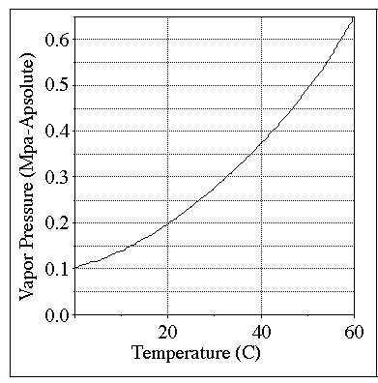
Figure 2.9. Vapor Pressure of Butane

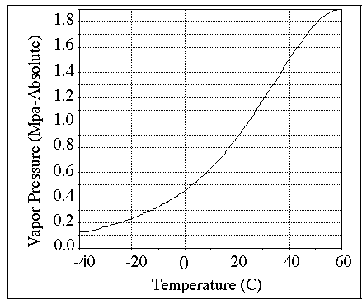

Figure 2.10 Vapor Pressure of Propane

2.5.4 Advantages of LPG

LPG is the most commonly used alternative fuel and it is increasingly chosen as the preferred fuel due to its great number of benefits towards the society as follows

i. The amount of readily available LPG is aplenty in the market and its supply is estimated to last for at least another 75 years.

ii. The price of LPG is cheaper than other conventional fuels. The LPG prices are found to increase slower than gasoline in the past and in the near future.

iii. LPG has a comparable performance if compared to the conventional fuels with lower pollutant emission.

iv. LPG is friendly to the environment. It produces less pollutant to the atmosphere with virtually no particulate matters (PM), low level of carbon monoxide (CO), hydrocarbons (HC), and oxides of nitrogen (NOX). LPG emits less greenhouse gases (GHG) compared to any other fossil fuel when measured through the total fuel cycle (World LP Gas Association, 2004).
v. For LPG that is used in commercial and domestic heating, it is portable because it is stored in steel tanks which are easily transferred to other places. LPG is sometimes referred to as the "pipeline on wheel" due to it portability (World LP Gas Association, 2004).

vi. LPG has a very good safety record over the years. The conversion kits readily available in the market enable LPG to continue being a widely used road fuel.

2.5.5 Limitations of LPG
Although LPG has a great deal of advantages, it has some limitations too as listed below:

LPG is a non-renewable fossil fuel. If we use LPG faster than the rate of its generation, it will begin to deplete.

ii. LPG is denser than air, and may pose a risk when leakage occurs as it will accumulate in low-lying areas.

iii. A bulky storage tank is needed to store LPG. Hence, larger boot area is required to place the storage tank in place. The heavier storage tank also reduces the cargo capacity of fleet vehicles and may cause inconvenience as more journeys have to be taken.

2.5.6 Comparison between Gasoline and LPG

Volumetric Efficiency and Power Loss:

Volumetric efficiency determines the maximum power that can be developed by the four stroke cycle engines due to their distinct induction process. Volumetric efficiency of propane is worse than gasoline. Low density of propane causes approximately 4 % power loss (which is the ratio of the volume of fuel to the volume of fuel / air mixture) compared with only the value of 1.72 % with gasoline powered engine. Another loss off volumetric efficiency and power is related to alternative fuel conversion hardware itself. Most engines converted to burn LPG or CNG suffer an additional 10-20 % power loss due to obstruction of air flow [4]. This explains the difference between theoretical power loss and actual power loss.

Although propane and methane have higher heat of vaporization value, they are already in gaseous state when inducted into the intake manifold and they do not provide this cooling effect. Development of liquid fuel injection systems for LPG engines should provide better performance and efficiency, besides this liquid fuel injection provides better A/F ratio control.

Anti-knock characteristic:
Octane rating of LPG is much more than its compatriot gasoline so the anti-knock characteristics.

Thermal Efficiency:
With higher octane number it is possible to use higher compression ratio. Higher compression ratio improves thermal efficiency and provides more power that can be produced by the engine. Higher octane rating of propane compared to gasoline allows higher compression ratio for the engine.
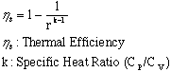
Engine Maintenance and wear: Natural gas and LPG are generally considered to reduce engine maintenance and wear in spark-ignited engines. The most commonly cited benefits are extended oil change intervals, increased spark plug life, and extended engine life. Natural gas and LPG both exhibit reduced soot formation over gasoline. Reduced soot concentration in the engine oil is believed to reduce abrasiveness and chemical degradation of the oil. Gasoline fueled engines particularly carbureted engines) require very rich operation during cold starting and warm up. Some of the excess fuel collects on the cylinder walls, “washing " lubricating oil off walls and contributing to accelerated wear during engine warm up [12]. Gaseous fuels do not interfere with cylinder lubrication.
Cold Start: Engines powered by gaseous fuels are generally considered easier to start than gasoline engines in cold weather. Because gaseous fuels are already vaporized before inducted into engine. However, under very cold temperatures, cold-start difficulty occurs for propane and natural gas. This is probably due to ignition failure caused by very difficult ionization conditions, sluggishness of mechanical components.
Hot Start: Hot starting can cause difficulties for gaseous fueled vehicles, especially in warm weathers. After an engine is shut down, the engine coolant continues to draw heat from the engine, raising its temperature. If the vehicle is restarted within a critical period after shutdown, (long enough for the coolant temperature to rise, but before the entire system cools), the elevated coolant temperature will heat the gas more than normal, lowering its volumetric heating value and density. This would cause mixture enleanment.
Safety: Gasoline shows very little change over the normal temperature or pressure range. Propane, however, is gas at ambient conditions. Its physical properties depend mainly on the temperature and pressure at which they are being stored. There must be space left in a propane fuel tank. As the temperature rises, the volume of liquid increases significantly. Due to this, propane system has some kind of safety fill stop device to prevent tank fills to no more than 80 % to 85 % .This provides room for liquid expansion if the temperature increases after the tank is filled. Due to the low viscosity of propane and its storage under pressure, it may leak through small cracks, pumps, seals and gaskets more readily than gasoline [11].

Table 2.3 Properties of Gasoline and LPG
Properties | Propane | Gasoline
Formula | C3H8 | C8 H18
Research Octane Number | 112 | 91-98
Motor Octane Number | 97 | 83-90
Cetane Number | 5-10 | 8-14
Density of Liquid Fuel(kg/lt) | 0.509 | 0.746
Density of Gas (kg/m3) | 0.508 | 4.4
Boiling Point (C) | -42 | 27-240
Lower Heating Value (MJ/kg) | 50 | 44.5
Energy Compared to Gasoline | 72% | 100%
Stoichometric A/F Ratio (mass) | 15.7 | 14.7
Energy of Stoich. Mixture (Vapor) | 3.79 | 3.55
Auto ignition Temperature (C) | 482 | 257
Peak Flame Temperature (C) | 1990 | 1977
Flammability Limits (vol %) | 2.1- 10.4 | 1.4- 7.6
Max. Burning Velocity in NTP air (cm/s) | 43-52 | 37-43
Specific Gravity at NTP (60 deg F) | 1.52 | 2-4
Reid Vapor Pressure (psi) | 208 | 8-15
Flame Visibility, relative | 0.6 | 1
Flash Point (F) | -100 to -150 | -45

CHAPTER 3

EXPERIMENTAL SETUP

3.1 Introduction

The main objective of the experiment is to investigate the effects of pure LPG in SI engine and blending of LPG with Petrol with gasoline fuel in spark ignition engine. A Briggs and Stratton 305cc engine was employed as the test engine in the analysis.

An electrical power load circuit was attached to the test engine to allow variation of the engine power using the bulb switches. Combinations of different values of engine loads were used in the experiment to evaluate the performance and pollutant emissions of the engine to compare the gasoline with pure LPG and A blend of LPG and Petrol.

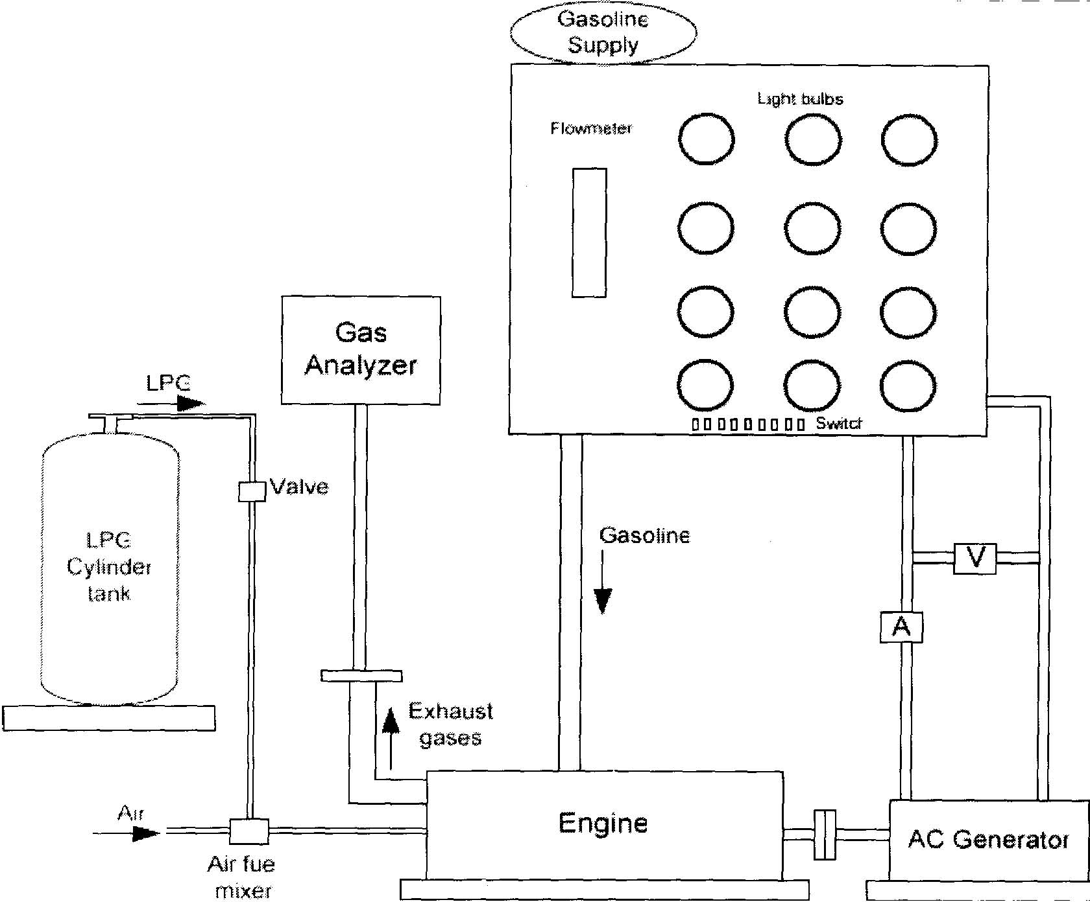

Figure 3.1 Experimental Set Up/ Arrangement

Control Panel:
A control panel as shown in Figure 3.1 consists of the following components:

i. Direct current ammeter

ii. Electric bulbs which act as load bank

iii Flow meters

iv. Direct voltmeter

3.2 Engine Specifications :



Figure 3.2 Briggs & Stratton Model 20 INTEK

Description INTEK T"' IIC Model 202400 Model 205400

Displacement 18.6 cu. In. (305cc)

Bore 3.120 in. (79.25mm)

Stroke 243 8in (6167mm)

Compression Ratio 8.0:1

Horsepower 8.0 (5.96 Kw))/ 10.0 (7.46 Kw)
Torque 14.5 ft. lb. (19.66 Nm) @ 2800 RPM Emissions Certified

Valve Design Overhead Valve

Cylinder ': 30 degree slant

Bore Type ' Dura-Bore TM, Cast Iron Sleeve

Carburetor ' Side-Draft, _ in. (19.0 mm)
Ignition ' Magnetron®
Low-Mount (Panel) A/C Dual Element Air Filter (Oval
Air Cleaner Optional
Lubrication Dipper/Splash
Bearings DU Magneto DU PTO (Ball Bearing optional)

Controls 3 in 1, Manual/Fixed Speed

Fuel Tank (3.785 Liters) Polymer

Muffler Lo-Tone Small (Super Lo-Tone optional)

Oil Capacity 26 Fl. Oz. (0.7 Liters)

Oil Fill (High Oil Fill Optional)

Oil Sensor (Low Oil Sensor, Rocker Stop switch Optional)

3.3 LPG Kit

3.3.1 LPG Storage Cylinder

LPG is stored under pressure at 800 kPa in a steel tank. Due to the fact that LPG is highly volatile and flammable, it is stored in a high ventilation rate area and kept away from any sources of ignition in the experiment lab. Moreover, the LPG steel tank is equipped with pressure relief valves to prevent the release of LPG vapors to the atmosphere.

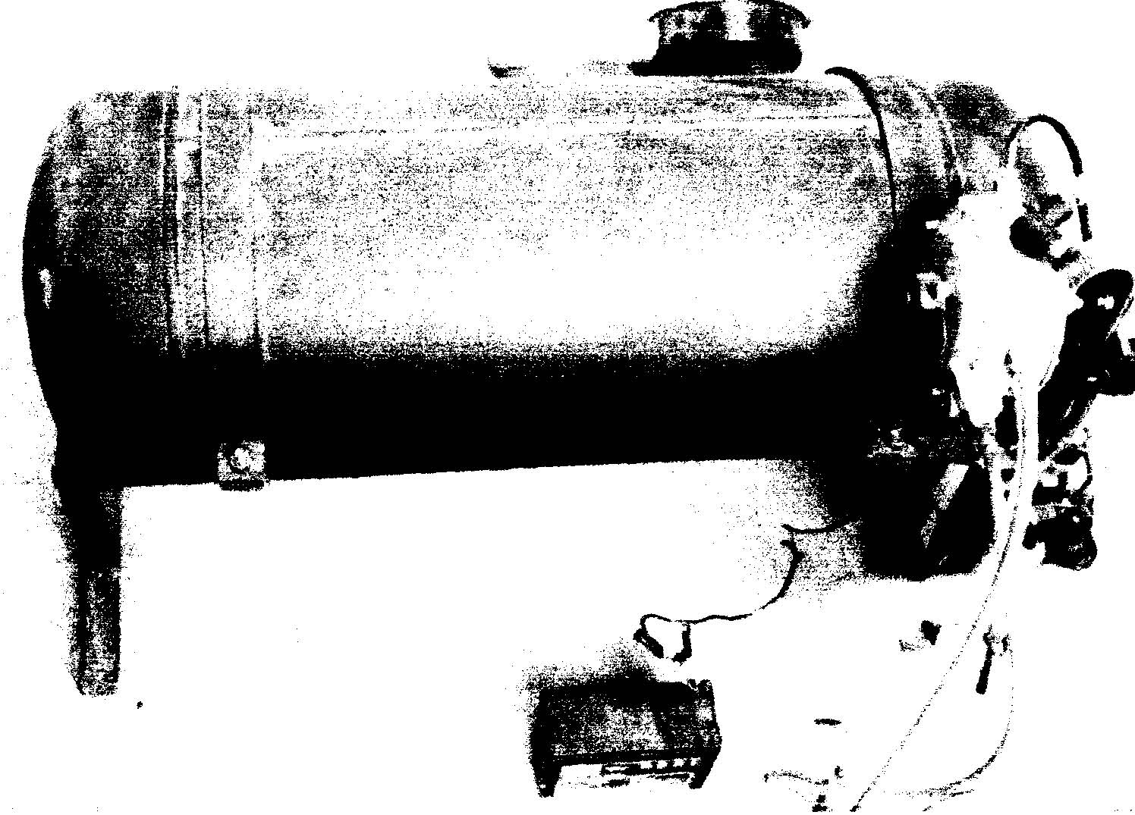

Figure 3.3 LPG Storage Tank
3.3.2 Pressure Regulator

The main function of the pressure regulator is to provide precise fuel pressure regulation to the air and fuel mixer (Hofmann, undated). It is used to reduce the high pressure in the LPG storage tank to a level close to the atmospheric pressure and hence ensure the safe transforming of liquid state of LPG to the vapor state. The pressure regulator will allow higher flow of LPG when the demand on the regulator increases with the engine toad, and vice-versa.

3.3.3 Air Fuel Mixer and Air Filter

The air fuel mixer was used to ensure the mixing of LPG and air at the precise air to fuel control ratio for combustion while the air filter was used to deliver high airflow and dirt protection to the engine.

3.3.4 Pressure Regulator

The main function of the pressure regulator is to provide precise fuel pressure regulation to the air and fuel mixer (Hofmann, undated). It is used to reduce the high pressure in the LPG storage tank to a level close to the atmospheric pressure and hence ensure the safe transforming of liquid state of LPG to the vapor state. The pressure regulator will allow higher flow of LPG when the demand on the regulator increases with the engine toad, and vice-versa.

3.3.5 Air Fuel Mixer and Air Filter

The air fuel mixer was used to ensure the mixing of LPG and air at the precise air to fuel control ratio for combustion while the air filter was used to deliver high airflow and dirt protection to the engine.

3.4 Ancillary Components

3.4.1 Battery

Battery is the power source which provides the motive force for the working of the pressure regulator. In the pressure regulator the pressure regulation is done by the movement of a piston for this battery act as source.
Specifications: 12 V, 35 A

3.4.2 Ammeter

The ammeter used is a Crompton Parkinson make of the following specifications
Range: 0 - 30 A a.c,
Least Count -1 A

3.4.3 Voltmeter

The voltmeter used is a Crompton Parkinson make of the following specifications
Range: 0 - 250 V
Least Count - 5V

3.4.4 Alternator

Alternator is an electrical device used to convert mechanical energy into electrical energy. It is coupled with the engine's flywheel and its output wires are connected to load panel. The alternator used for the experiment is a Kirloskar make.

Specifications: 220 V, 50 A, 60 Hz

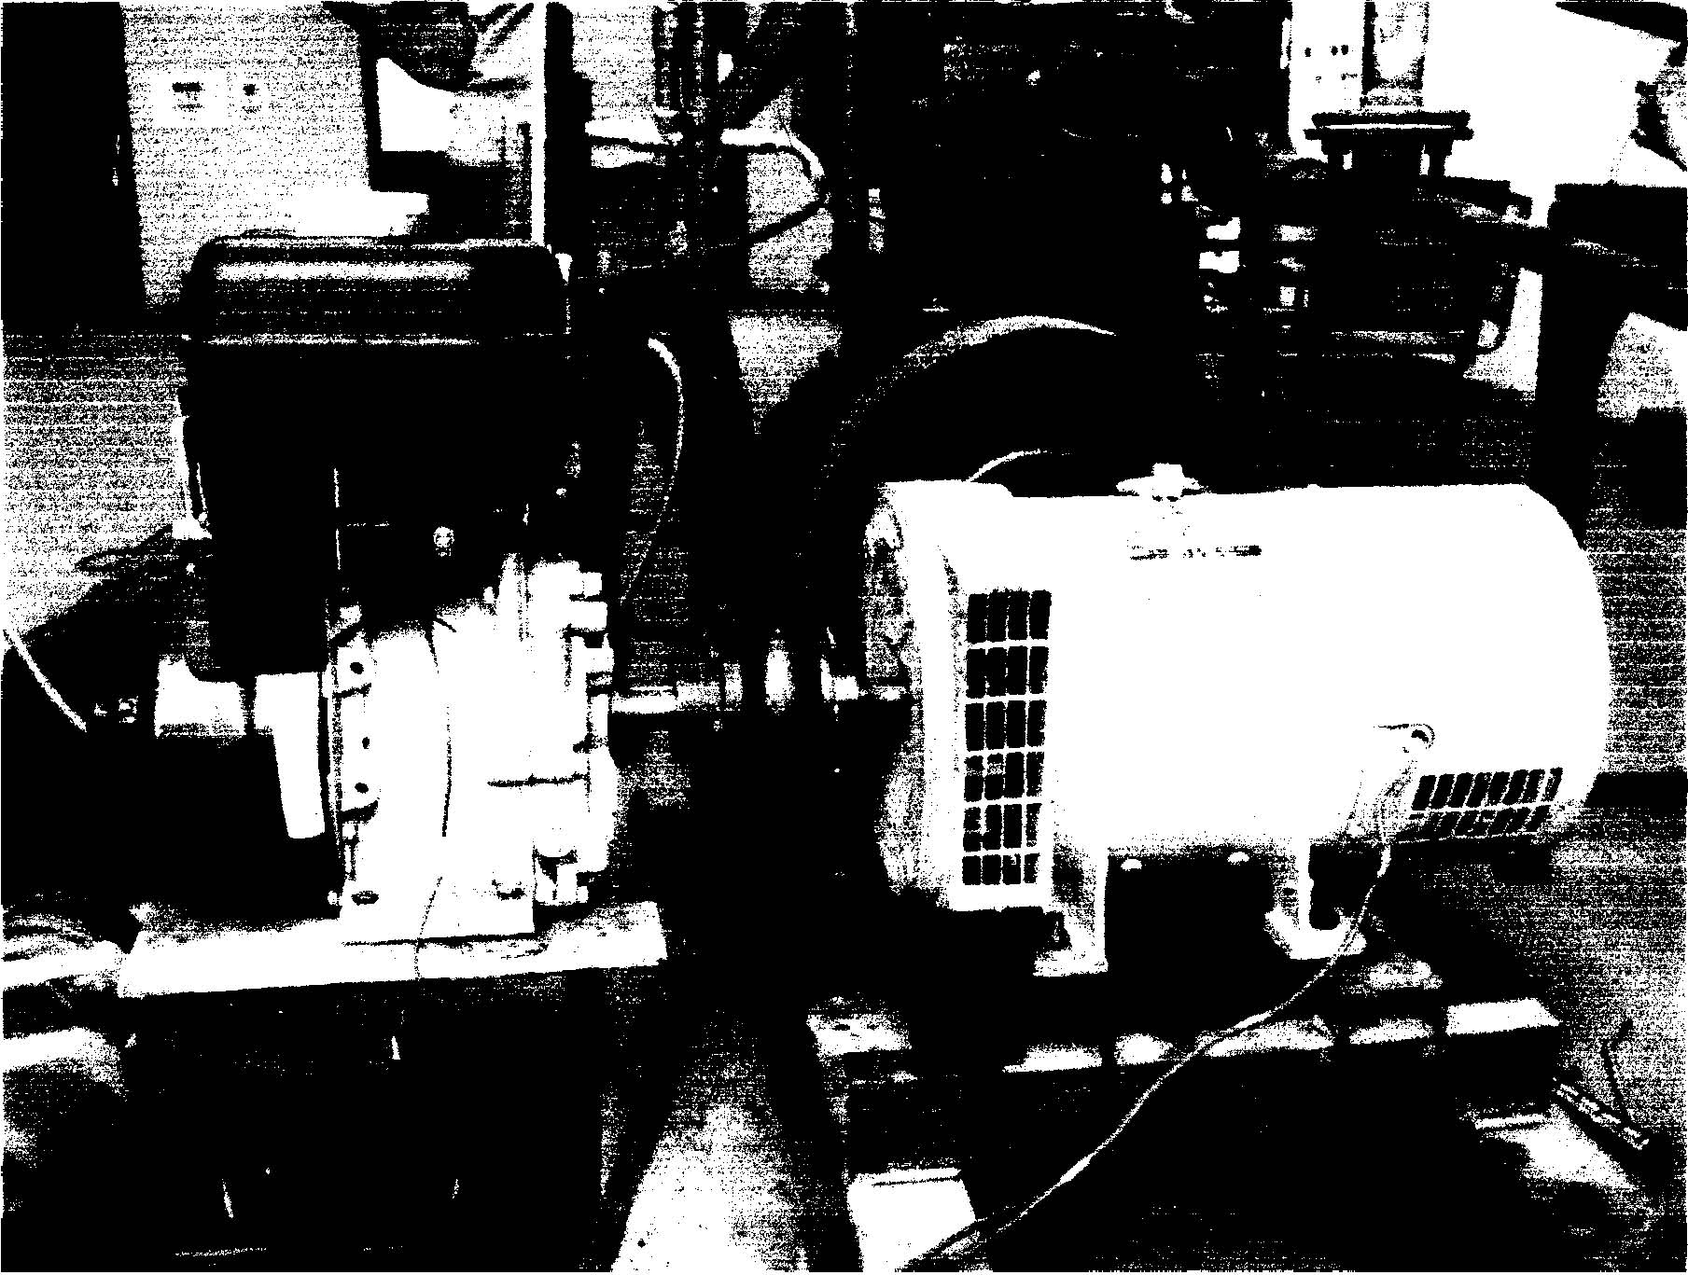

Figure 3.4 the Alternator Used

3.5 Load Bank

The load bank consists of 36 electrical bulbs which are arranged in rows and columns of six. Each bulb consumes 200W of power and each row is controlled by an ON-OFF switch.

An electrical power load circuit is attached to the engine control panel to provide the engine with output loads used to power the electric bulbs.

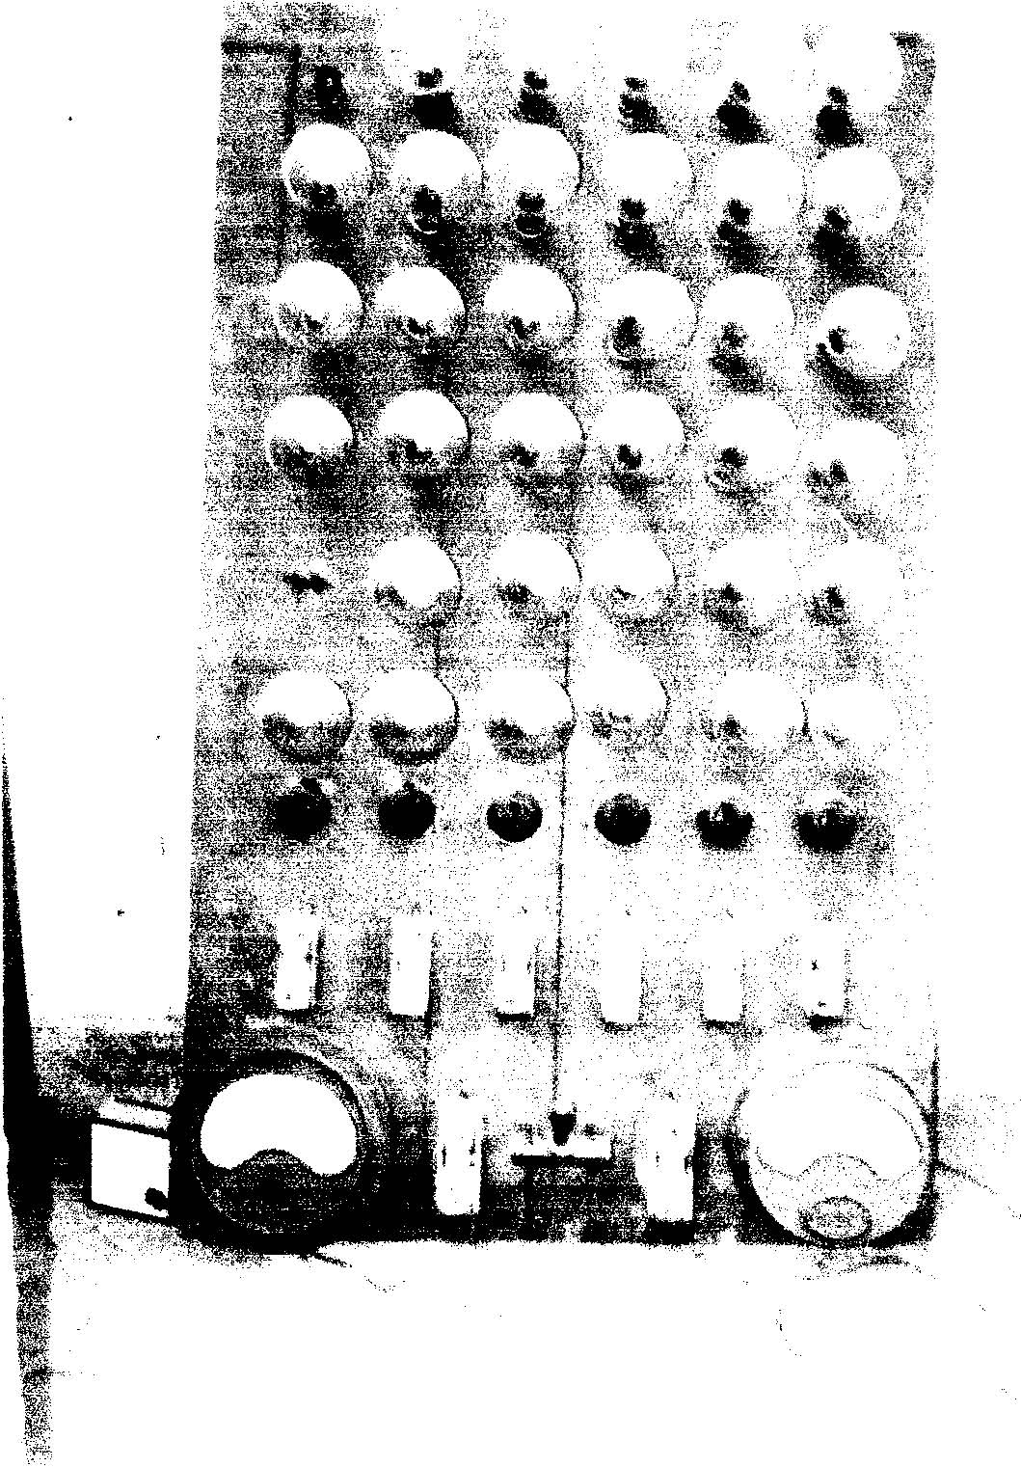

Figure 3.5 the Load Bank

3.6 Rota-meter
Rota-meter is device used to measure the flow rate of the fluid being passed.

Specifications
Petrol Rota-meter: 100 ml/min (max)

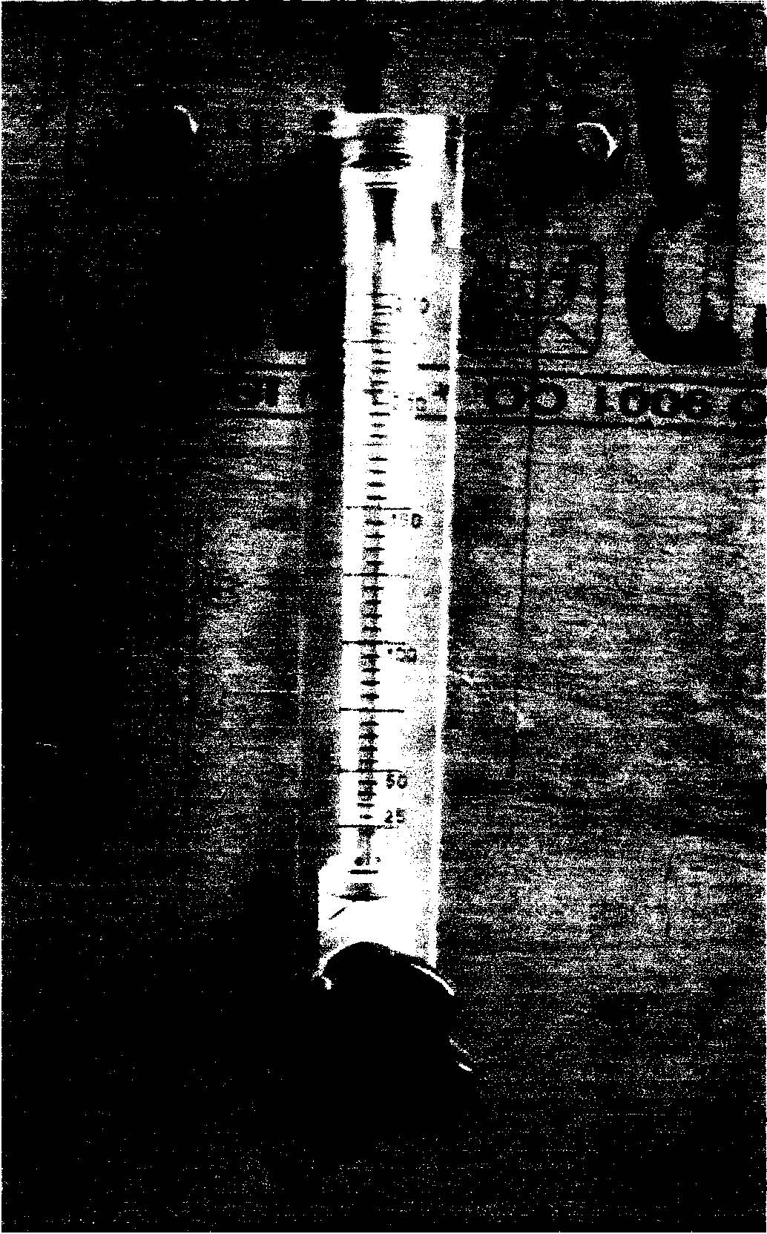

Figure 3.6 The flow meter used

Chapter 4
Performance Evaluation Test
Pure Gasoline Mode
Performance evaluation at 1406 RPM
Table 4.1 Variation in various parameters with the load for Gasoline Mode

Load  (Watt) | Mass flow  Rate (m_{f})  (Kg/sec*10⁻⁶) | V  (volt) | I  (Amp.) | P=(VI*  0.8)  (watt) | Q_{CV} =  (m_{f *CV})  kJ/sec | η_{th} | BSFC  (Kg/Kwh) | CO  (%) | HC  (ppm)
400 | 121.97 | 160 | 5 | 640 | 7239.71 | 8.84 | .686 | 1.217 | 88
600 | 174.10 | 165 | 7 | 990 | 7758.58 | 12.76 | .633 | .95 | 79
800 | 203.5 | 170 | 10 | 1350 | 9642.71 | 14 | .542 | .47 | 70
1000 | 264.28 | 200 | 12.5 | 2000 | 12307.81 | 16.25 | .475 | .20 | 69
1600 | 311 | 218 | 16.5 | 2877.5 | 14972.03 | 19.22 | .389 | .18 | 64
2000 | 325 | 220 | 19 | 3344 | 16115.68 | 20.75 | .350 | .10 | 45

Pure LPG Mode
Performance evaluation at 1406 RPM
Table 4.2 Variation in various parameters with the load for Pure LPG Mode

Load  (Watt) | Mass flow  rate (m_{f})  (Kg/sec*10⁻⁶) | V  (volt) | I  (amp) | P=(VI*  0.8)  (watt) | Q_{CV}  (m_{f *CV})  (kJ/kg) | η_{th} | BSFC  (Kg/Kwh) | CO  (%) | HC  (ppm)
400 | 113.41 | 155 | 4.75 | 590 | 5130 | 11.5 | .692 | .015 | 22
600 | 163.04 | 162 | 7.02 | 910 | 6408.5 | 14.2 | .645 | .012 | 21
800 | 196.78 | 173 | 9 | 1245 | 7981 | 15.6 | .569 | .009 | 18
1000 | 251.47 | 200 | 11.5 | 1840 | 10337 | 17.8 | .492 | .005 | 18
1600 | 301.07 | 215 | 15.4 | 2650 | 12470.5 | 21.25 | .409 | .005 | 18
2000 | 314.48 | 220 | 17.48 | 3076.48 | 12557 | 24.5 | .390 | .005 | 17.5

Mix OF These (Gasoline +LPG)
Performance evaluation at 1406 RPM
Table 4.3 Variation in various parameters with the load for MIX (Gasoline+LPG) Mode

Load  (watt) | Mass flow  Rate (m_{f})  (Kg/sec*10⁻⁶)  PETROL | Mass flow  Rate (m_{f})  (Kg/sec*10⁻⁶)  LPG | P=(VI*0.8)  (watt) | Q_{CV}  (m_{f *CV})  (kJ/kg) | η_{th} | CO  (%) | HC  (ppm)
400 | 106.47 | 20.93 | 627.5 | 5784.415 | 10.85 | .412 | 31
600 | 123.33 | 28.879 | 970 | 6932.185 | 13.89 | .369 | 29
800 | 154.17 | 34.925 | 1323.75 | 8606.88 | 15.38 | .257 | 25
1000 | 211.43 | 45.356 | 1960 | 11676.64 | 16.78 | .220 | 20
1600 | 246.67 | 53.37 | 2820.63 | 13645.32 | 20.67 | .183 | 20
2000 | 264.28 | 55.78 | 3277.12 | 14549.46 | 22.52 | .180 | 19.5

Chapter 5
Results and discussion

5.1 Thermal Efficiency (Pure Gasoline v/s Pure LPG):
Error! Not a valid link.
Thermal efficiency is defined as the ratio of output power to that of the chemical energy input. From the graph it is clear that as the load on the engine increases combustion efficiency increases because at part load cylinder temperature is less with the increase in load on the system, cylinder temperature and pressures both increases simultaneously.
On comparing the Petrol with the Pure LPG Fuel we find that the Thermal Efficiency of LPG is better than that of petrol because of the following reasons:
- Higher octane rating of the gaseous fuel allows higher compression ratio in comparison to pure gasoline mode.
- Since LPG enters the cylinder in a gaseous state it allows more proper mixing of fuel and air. Proper mixing means proper combustion and less fuel goes unburnt into exhaust, giving more thermal efficiency.

  - Brake Specific Fuel Consumption (Pure Gasoline v/s Pure LPG):
Error! Not a valid link.
Graph above gives variation of BSFC with the Load and comparison between LPG and Petrol. Though the BSFC continuously decreases with the load but fuel consumption rate is higher in case of LPG fuel because:
i) LPG is a gaseous fuel its volume is more thus in the induction stroke less quantity of LPG is drawn. In other words it reduces the volumetric efficiency. Lower the volumetric efficiency lower the power output or we can say for the same power output fuel consumption is increased.

  - Thermal Efficiency (Pure Gasoline v/s (Gasoline+LPG)Mix):
Error! Not a valid link.
It is quite clear now that with LPG fuel thermal efficiency increases. When we mix the LPG with the Gasoline the thermal efficiency of the mixture always remain more as compared to pure Gasoline mode.

Chapter 6
conclusion and work for future

Small utility engines that are used frequently in India consume gasoline as the main fuel generates power for different applications. The main aim of this research project is to analyze the emissions characteristics while using LPG in spark ignition engineers. The data for various emission gases are collected and compared.
Besides that, this project also intends to investigate the engine performance for both gasoline and LPG fuel system for a four stroke engine from the result obtained in the experiments, it was found that the feasibility of the LPG fuel to replace gasoline fuels very high as it reduces the major pollutant emission gases such as nitrogen oxides, carbon mono oxide and carbon dioxide. Carbon dioxide which is a strong greenhouse gas and acts as the main contributor to the global warming effect is reduced by using the LPG fuel system from 1.217 in gasoline to .015 gm/kg against the prescribed standard of 4.5 gm/kg of fuel. The level of emissions for HC was also reduced by 75% When compared to gasoline.
The performance of LPG operated engine is also comparable to gasoline operated engine as proven by experiments. Although the results showed that the thermal efficiency of lpg is slightly higher. Fuel consumption plays an important role in terms of cost to the consumers.
The research indicated that the fuel combustion the rate of gasoline fuel system is slightly lower compared to LPG fuel system. However, LPG is more economical where its costs par liter equivalent is much lower compared with the price of gasoline. The world’s crude oil prices have increased at a rapid rate and are as high as US$ 75 par barrel. In India, fuel prices had also gone up to curb the increase in subsidies paid by the Indian govt. in the face of protracted soaring crude oil prices. With the newly announce prices, the price of LPG was fixed at Rs. 500 compared to gasoline at Rs. 700 for the same amount of fuel used , which offered a great a saving in fuel costs of around 50%.
As a conclusion, LPG proves to be a competitive alternative fuel to replaced gasoline in spark ignition engines since the price of LPG is around half the price of gasoline and LPG produces less pollutants emissions including oxides of nitrogen (NOx) which are investigated in this research. Although this experiment produced encouraging results the use of LPG has not gained popularity among consumers due to the lack of LPG dedicated engines and lack of publicity in the Indian market to create awareness among vehicle consumers in India.

Recommendation and Future work

This project researches on the potential of LPG to replace the pole of conventional gasoline fuel and the data obtained from experiments yielded an encouraging a promising results. However, more research has to be done to improve the design of the LPG fueled gasoline engine to gain better engine performance. We could make a few numbers of trials which were very much encouraging but more number of trials are required to make a final conclusion.
Simultaneously it is very much required to develop an electronic fuel injection system that could inject LPG with Gasoline in an appropriate blend ratio so as to take advantage of high latent heat of LPG.
It will not only improve the power but thermal efficiency of the (LPG+Gasoline) dual fuel engine.
Also advanced studies in the field of LPG dedicated engines have to be done in India, to harness the usefulness of LPG in the day to day life for commuting and other applications.
As shown in figures the thermal efficiency of engine running on LPG fuel is only slightly higher than gasoline operated engine.

references
- Colin R. Ferguson, 1986, “Internal Combustion Engines”, John Willey & Sons, Inc.
- Algas Carburetion, Handbook
- Science Applications International Corporation, Introduction to Alternative Fuel Vehicles
- Timothy T. Maxwell and Jesse C. jones, Alternative Fuels, SAE Inc., 1995
- .E Sinor Consultants Inc, The Clean Fuels Report, November 1992, Volume 4, No. 5
- Sinor, J.E, “Technical Evaluation and Assessment of CNG / LPG Bi-Fuel and Flex-Fuel Vehicle Viability”, Consultants, Inc Niwot.
- G.A.Karim, "Some Considerations of the Safety of Methane, (CNG), as an Automotive Fuel-Comparison with Gasoline, Propane and Hydrogen operation, " S.A.E Paper N. 830267
- G.A.Karim and I. Wierzba, "Comparative Studies of Methane and Propane as Fuels for Spark Ignition and Compression Ignition Engines," S.A.E Paper N. 831196
- W. A Goetz, D. Pethric and T. Topaloglu, " Performance and Emissions of Propane, Natural Gas, and Methanol Fuelled Bus Engines, " SAE Paper N. 880494
- R.L.Furley, A.M.Horowitz, and N.J.Schroder, Automotive Gasoline. C.H.Jewitt, S.R.Westbrook, D.L.Ripley, and R.H.Thornton, Fuels for Land and Marine Diesel Engines and for Nonaviation Gas Turbines.
- Roberta J. Nichols, The Challange of Change in The Auto Industry: Why Alternative Fuels?.
- James.S. Wallace," Assessment of" First Generation Propane Conservation Equipment," S.A.E Paper N. 892144
- Fred Hendren, "Propane power for Light Duty Vehicles: An Overview," S.A.E Paper N. 830383
- Bernie W. Rice, "Evaluation of Automotive Stop Fill Valves for Propane Vehicles, " S.A.E Paper No. 861576
- NPGA # 1331, Commercial / Industrial Propane Guide
- B Wilson, Evaluation of Aftermarkets Fuel Delivery Systems for Natural Gas and LPG Vehicles
- JEnoch J. Durbin, Understanding emissions levels from vehicle engines fueled with gaseous fuels.
- Andrea Unich, Reda M. Bata, Donald W. Lyons," Natural Gas: A Promising Fuel for I.C Engines," SAE paper N. 930929
- American Gas Association, Natural Gas Vehicles.
- John B Heywood, Internal Combustion Engine Fundamentals, Mc Graw-Hill Inc., 1988
- Herbert Aly and Gunter Siemer," Experimental Investigation of Gaseous Hydrogen Utilization in a Dual Fuel Engine For Stationary Power Plants," ICE-Vol.20
- K.S Varde, " Propane Fumigation in a Direct Injection Type Diesel Engine," SAE Paper N. 831354
- Ulrich Oester, James S. Wallace, " Liquid Propane Injection for Diesel Engines" SAE Paper N. 872095
- Fred Hendren, " Propane Power for Light Duty Vehicles: An Overview," SAE Paper N. 830383
- Nils-Olof Nylund and Matti Kyto " Propane Fueled Heavy-Duty Vehicles," SAE Paper N. 932817

