Department of Civil & Environmental Engineering
Delhi College of Engineering,
Delhi-110042



CERTIFICATE

This is to certify that the project entitled “Liquefaction Analysis of Few Sand by Cyclic Simple Shera Tests ”, which is being submitted by Purnima Bajpai, is a bonafide record of the student’s own work carried by her under our guidance and supervision in partial fulfillment of requirement for the award of the Degree of Master of Engineering in Structural Engineering, Department of Civil and Environmental Engineering, Delhi College of Engineering, Delhi, University of Delhi.

The matter embodied in this project has not been submitted for the award of any other degree.

Dr. A. Trivedi (Professor)
Department of Civil &
Environmental Engineering
University of Delhi

ACKNOWLEDGEMENTS

I would like to avail this opportunity to humbly thank and appreciate the contribution and support, which various individuals have provided for the successful completion of this dissertation. My heartfelt thanks to my mentor and guide Dr. A. Trivedi, Professor, Department of Civil and Environmental Engineering, Delhi College of Engineering, who provided me an opportunity to work under his able guidance. His valuable guidance and motivation has helped me to complete my project successfully.
I also express my grateful thanks to Prof. P.B. Sharma, Principal, Dr. Mrs. P. R. Bose, Professor & Head, and all the Faculty Members of Civil & Environmental Engineering Department, Delhi College of Engineering, for their valuable suggestions and help, wherever needed.
I also wish to express my sincere thanks to Dr. S. K. Singh, Professor & Head, Department of Civil and Environmental Engineering, University of Delhi, for his valuable support and suggestions throughout the study.
Thanks are too small a word to acknowledge the contribution of my friends, Shahid, Nidhi and Nupur in my dissertation.
I would like to extend my sincere appreciation to Ms. Vidya Gupta, Ms. Renuka and Mr. Ravi for being my sounding boards throughout this project and providing valuable comments and thoughtful criticism.
I am indebted to my parents and family for their constant encouragement, love and prayers. Lastly, I thank Almighty GOD for his countless blessings.

Purnima Bajpai

ABSTRACT
The extensive and immense damages caused by soil liquefaction induced due to earthquakes have focused the attention of geotechnical engineers towards the systematic study of earthquake induced liquefaction of cohesion less soils. Cyclic liquefaction of saturated loose sand is associated with reduced cyclic shear strength and decreased stiffness of the sand due to excess pore water pressure generated by shocks such as earthquakes. The resulting ground failure generally takes the form of excess settlement,
bearing capacity failure, sand blow, flow slide or similar phenomenon. Such ground failure induced by liquefaction due to earthquake can cause catastrophic failure to earth dams, nuclear power plants, water front structures and off-shore structures etc. Any sandy soil can develop cyclic mobility, if cyclic stresses are large enough. However, liquefaction is most likely in saturated fine, clean, loose, uniform sand.
To improve our understanding of the liquefaction characteristics of soil deposits and to mitigate earthquake hazards, it is essential that the nature and extent of the failure could be reliably assessed/predicted using some analytical approach and/or field and laboratory experimental techniques. The study reported herein aims at evaluating the liquefaction potential of some cohesion less soils using results of cyclic simple shear tests.
The results of the investigation indicate that Fineness Modulus (FM) and grain size and gradation factor R (defined as D₅₀ x (D30 x D₉₀/ D₁₀ x D₆₀)) are two important parameters significantly affecting the liquefaction potential.
.

CONTENTS

TITLE Page No.
CERTIFICATE --------------------------------------------------------------------- i ACKNOWLEDGEMENTS------------------------------------------------------- ii
ABSTRACT-------------------------------------------------------------------------- iii
CONTENTS------------------------------------------------------------------------- iv
LIST OF FIGURES--------------------------------------------------------------- v
LIST OF TABLES---------------------------------------------------------------- vi
LIST OF SYMBOLS------------------------------------------------------------- vii

CHAPTER 1: INTRODUCTION 1
1.1 General------------------------------------------------------ 1
1.2 Purpose----------------------------------------------------- 1
1.3 Objective and scope--------------------------------------- 2
  - Presentation of report------------------------------------- 3
CHAPTER 2: LITERATURE REVIEW 4
2.1 Behaviour of saturated sands under dynamic loads----- 4
2.2 Necessity of research on liquefaction.-------------------- 5
2.3 Factors affecting liquefaction potential ---------------- 6
2.3.1 Relative Density ------------------------------------------ 6
2.3.2 Grain size and gradation characteristics--------------- 6
2.3.3 Effect of consolidation pressure------------------------ 6
  - Liquefaction susceptibility of in-situ ------------------- 7
soil due to earthquake
2.4.1 Simplified procedure------------------------------------- 8
2.4.2 Ground response analysis------------------------------- 8
2.4.3 Empirical methods--------------------------------------- 9

Page No.
2.5 Experimental methods for evaluating------------------ 9
liquefaction potential
2.5.1 Cyclic triaxial test ------------------------------------- 10
2.5.2 Cyclic simple shear test------------------------------- 10
2.5.3 Torsional shear test------------------------------------ 11
    - Shake table test---------------------------------------- 12

CHAPTER 3: CYCLIC SIMPLE SHEAR TEST 16
3.1 General----------------------------------------------------- 16
3.2 Test equipment------------------------------------------- 17

CHAPTER 4: TEST MATERIALS, TEST PROGRAMME 23
AND TEST PROCEDURE
4.1 Test materials----------------------------------------------- 23
4.2 Test programme------------------------------------------- 24
4.3 Test procedure-------------------------------------------- 24
4.3.1 Sample preparation------------------------------------- 25
4.3.2 Saturation of specimen -------------------------------- 28
4.3.3 Specimen consolidation------------------------------- 29
4.3.4 Applying cyclic shear load---------------------------- 30

CHAPTER 5: TEST RESULTS AND DISCUSSIONS 34
5.1 Test results--------------------------------------------- 34
5.2 Discussions-------------------------------------------- 35
Appendix 5.1 36

CHAPTER 6: CONCLUSIONS, RECOMMENDTIONS AND 75
SUGGESTIONS FOR FUTURE WORK
6.1 Conclusions----------------------------------------- 75
  - Recommendations and suggestions for-------- 76
Future work
6.2.1 Recommendations--------------------------------- 76
6.2.2 Suggestions----------------------------------------- 76

REFERENCES 78

LIST OF FIGURES

FIGURE Page No.
Fig 2.1 Typical test results of an isotropically consolidated ---------------------13
cyclic triaxial strength test.
Fig 2.2 Factors affecting liquefaction potential. -----------------------------------14
Fig 2.3 Method of evaluating liquefaction potential.------------------------------15
Fig 3.1 Stress conditions on modelled soil element under static---------------- 20
and earthquake induced stress.
Fig 3.2 Cyclic simple shear test apparatus.---------------------------------------- 21
Fig 3.3 Mode of application of pneumatic sinusoidal loading.---------------- 22
Fig 4.1 Grain size distribution curves of all the sands used.-------------------- 33
Fig 5.1 Peak shear stress versus number of cycles to initial liquefaction------ 59
( σ₀ = 0.75 kg/cm2 )
Fig 5.2 Peak shear stress versus number of cycles to initial liquefaction------ 60
(σ₀ = 1.50 kg/cm2)
Fig 5.3 Peak shear stress versus number of cycles to initial liquefaction----- 61
(σ₀ = 2.25 kg/cm2)
Fig 5.4 Effect of confining pressure on resistance to liquefaction ----------- 62
of selected sands in 10 cycles.
Fig 5.5 Effect of confining pressure on resistance to liquefaction------------ 63
of selected sands in 30 cycles.
Fig 5.6 Effect of confining pressure on resistance to liquefaction------------ 64
of selected sands in 100 cycles.
Fig 5.7 Liquefaction potential curve (average) of fine sand (A) .------------- 65
Fig5.8 Liquefaction potential curve (average) of medium sand (B).--------- 66
Fig5.9 Liquefaction potential curve (average) of (fine + med.) sand (D).---67
Fig 5.10 Liquefaction potential curve (average) of (fine + med. + coarse)----68
sand (E).
Fig 5.11 Liquefaction potential curve (average) of Badarpur sand (E)----------69
Fig 5.12 Summary liquefaction potential curves of all sands.--------------------70
Fig5.13 Peak shear stress versus fineness modulus for all initial--------------- 71
effective confining pressures.
Fig 5.14 Peak shear stress versus grain size and gradation factor-------------- 72
R for all initial effective confining pressures.
Fig. 5.15 Liquefaction Potential Curve of NIIGATA EASTERN HARBOR---73
SAND
Fig. 5.16 Relation between Stress Ratio and No. of Cycles --------------------- 74

LIST OF TABLES

TABLE Page No.
4.1 Physical properties of sands used. ----------------------------------------- 32
5.1 Summary of test results for fine sand (A)----------------------------------- 47
5.2 Summary of test results for medium sand (B).----------------------------- 48
5.3 Summary of test results for coarse sand (C).------------------------------- 49
5.4 Summary of test results for (fine + med.) sand (D).----------------------- 50
5.5 Summary of test results for (fine +med.+ coarse) sand (E).-------------- 51
5.6 Summary of test results for Badarpur sand (F).---------------------------- 52
5.7 Calculations for fineness modulus of fine sand (A).----------------------- 53
5.8 Calculations for fineness modulus of medium sand (B).------------------ 54
5.9 Calculations for fineness modulus of coarse sand (C).-------------------- 55
5.10 Calculations for fineness modulus of (fine + med.) sand (D).----------- 56
5.11 Calculations for fineness modulus of (fine +med.+ coarse) sand (E).-- 57
  - Calculations for fineness modulus of Badarpur sand (F).---------------- 58

LIST OF SYMBOLS

σ_{d} : Alternating deviator stress.
SR : Cyclic stress ratio.
Δ : Denotes increments of parameters.
−,/ : Denotes that parameters are effective stress related.
γd : Dry unit weight.
k₀ : Earth pressure coefficient at rest.
FM : Fineness Modulus.
σ₀ : Initial confining pressure.
σ_{v} : Initial vertical stress.
(γ_{d})_{min}. : Minimum dry unit weight.
(γ_{d})_{max}. : Maximum dry unit weight.
σ₃ : Minor principal stress.
Ni : Number of cycles to initial liquefaction.
N : Number of loading cycles.
B : Pore water pressure coefficient.
u : Pore water pressure.
RD : Relative Density.
π : Shear stress
π_{h} : Shear stress on horizontal plane.
γ : Shear strain.
G : Specific gravity.
γ_{t} : Threshold shear strain.
e : void ratio.
R-factor: D₅₀ x D₃₀ x D₉₀
D₁₀ x D₆₀
μ : 10⁻³ mm.
Ksc. : Kg/cm²
D₅₀ : 50% grain size.

CHAPTER 1

INTRODUCTION

1.1 General
The earthquake induced liquefaction of cohesion less soils because of its disastrous effects has caught the attention of the researches in the field of soil dynamics to properly understand the behaviour of the saturated cohesionless soils under cyclic loading conditions. This helps greatly in mitigation of hazards caused by liquefaction.

1.2 Purpose
Cohesion less soil grains when loose and subjected to cyclic stresses tend to compact and reorient. If drainage is restricted, this causes generation of pore water pressures. This transfer of load from soil grains to pore water results in the reduction of effective stresses. When such soil is subjected to sufficient number of stress cycles, the pore water pressure may become equal to the initial effective confining pressure on the soil. At this time the soil has very less shear strength and will undergo excessive deformations and is said to have liquefied.
The liquefaction potential of a granular soil is strongly dependent on its relative density, void ratio, mean effective stress and cyclic deviator stress amplitude. The effects of all these factors have been extensively studied abroad. But there is very little information available on Indian soils. The purpose of this study is to develop liquefaction potential curves for Ennore sands .Three fractions of Ennore sand and two combinations there of have been used to study the liquefaction behaviour in cyclic simple shear tests. All these fractions when blended together in equal Proportions is referred to as standard sand. The purpose of choosing Ennore Sand for this study is that it is consistent in quality and that liquifaction curve developed can serve as a reference for study on officer granular Material.

Objective and Scope
The objective of this study is two fold:
- To critically examine the response of saturated sands of different gradations to undrained cyclic loading
- To study their behaviour under different initial effective confining pressures;

To obtain the, liquefaction potential curves of different sands having different gradation characteristics, cyclic simple shear tests were performed. Sands used were first tested to determine their index properties such as grain size distribution, specific gravity and minimum and maximum densities. The specimens for each sand were reconstituted at a relative density of 50% and tested under simple shear condition at three different initial effective confining pressures of 0.75, 1.5 and 2.25 kg/ cm².

All the tests were performed using a sinusoidal wave form loading at a frequency of 0.5 Hz. The lower frequency was chosen to have better resolution of the recording of deformations and pore water pressure and also because the effect of frequency on cyclic strength is negligible for the frequency range of 0.1 to 16 Hz. (Drnevich, 1972; Lee and Focht, 1975; Yohimi and Oh-Oka, 1970). The results of the tests conducted are compiled in the form of a graph showing cyclic shear stress Vs. number of cycles causing initial liquefaction for all the five materials tested. From the curves so developed, different sets of curves have been plotted between FM (Fineness Modulus) and shear stress and R-Factor
R = (D₅₀ x D ₃₀ D₉₀ ) Vs. shear stress causing
D₁₀ x D₆₀
liquefaction in 10, 30 and 100 cycles for all the five sands.

1.4 Presentation of report
A brief literature review is presented in Chapter 2. The review includes (i) Behaviour of saturated granular soils under cyclic loads (ii) Necessity of research on cyclic liquefaction (iii) Factors affecting liquefaction potential and (iv) Liquefaction susceptibility of in-situ soils due to earthquakes. Details of cyclic simple shear test are presented in Chapter 3. Test materials, test programme, sample preparation and experimental procedures have been detailed in Chapter 4. Chapter 5 presentes test results and discussions. Conclusions, recommendations and suggestions for future work have been presented in Chapter 6.

CHAPTER 2

LITERATURE REVIEW

2.1 Behaviour of Saturated Sand Under Dynamic Loads
One of the most important and critical phenomenon of saturated sands under cyclic loads is liquefaction. Liquefaction is a term which is used to include all phenomenons giving rise to a loss of shearing resistance or development of excessive strains as a result of transient or repeated disturbance of saturated cohesion less soils. Liquefaction represents a complex situation. Engineers are concerned primarily with circumstances that cause excessive deformations, deformations large enough to render buildings, dams, transportation systems or any other facility unusable either temporarily or permanently. Excess pore water pressures are a symptom of possible failure and in some cases may be said to cause failure. Thinking in terms of pore water pressure and effective stresses always aids in understanding of a problem. A loose saturated sand if subjected to vibrations, tends to compact and decrease in volume. If the drainage line is closed, then the tendency to decrease in volume results in an increase of pore water pressure. If the pore water pressure in the sand is allowed to build up by continuous vibration, a condition will be reached when the pore water pressure will become equal to initial effective confining pressure and the sand will behave like water with no shear strength. In terms of effective stress principle.
σ′ = σ − u
where σ′ is the effective stress.
σ = total overburden pressure
u = pore water pressure
If u equals σ , then σ′= 0 Under this condition the sand looses its strength completely and is in a liquefied state.

A quantitative approach to the prediction of onset of liquefaction was presented by Seed and Lee (1966). In this approach, the liquefaction potential was evaluated by the results of the cyclic triaxial shear tests. The main conclusion derived from this approach was that the larger the cyclic stress ratio (defined as deviatoric maximum shear stress normalised to the effective confining stress i.e. ) and looser the samples, the smaller the number of cycles of cyclic stress required to cause liquefaction. Test results by Seed and Lee (1966) showed that the liquefction can be produced by cyclic loading also in dense sands and were not limited to loose sands. This behaviour contradicts the behaviour implied by critical void ratio concept, which states that dense sands will only dilate under shearing. Cassagrande (1975), Castro and Poulous (1977) introduced the following terms to describe the behaviour of sand under cyclic loads (i) The "Liquefaction of a loose sand" and (ii) The "Cyclic mobility" of a dense sand. In general the liquefaction can take place in sand looser than its critical state either under a static or cyclic load. The cyclic mobility is the term used for dense sands. Liquefaction signifies a loss in shear strength and cyclic mobility indicates gradually increasing cyclic strains but does not entail a loss in shear strength.

Typical test results of an isotropically consolidated cyclic triaxial strength test (Fig. 2.1) show that the accumulated strain during cyclic loads prior to liquefaction is small compared with strains after liquefaction where as pore water pressure increases rapidly prior to liquefaction. The other important behaviour is that liquefaction takes place suddenly during the test.

2.2 Necessity of Research on liquefaction
The catastrophic earthquake damages to foundations in earth structures in the past few decades have demonstrated the urgent research need on cyclic liquefaction. Many authors, Seed (1970) and Steinbrugge (1970) have summarized the earthquake hazards for soils and foundations and for structures respectively. Many of those damages were due to liquefaction or ground failure due to an earthquake. Recently failure due to sea wave induced slides and liquefaction of sea floors which affect the safety of offshore structures have been reported (Finn, 1980). The research in this study aims at evaluation and prediction of liouefaction behaviour of such soils as are prone to liquefaction.

2.3 Factors Affecting Liquefaction Potential
The factors influencing liquefaction potential are:
    - Relative Density:
Seed and Lee (1967) first reported the significant effect of density on liquefaction. They concluded that initial liquefaction (when pore water pressure equals effective consolidation stress) and complete liquefaction (when deformations become excessive) occured almost simultaneously at relative density below approximately 50%. However at relative densities above approximately 70%, a considerable number of stress cycles were required after the initial liquefaction to develop a large strain amplitude. In general, the higher relative density required more number of cyclic stress cycles for liquefaction than the sand packed at lower relative density. Sudhindra et al. (1988) have demonstrated this in their study on "Liquefaction Behaviour of Ennore sand in Cyclic Simple Shear tests".

2.3.2 Grain Size and Gradation Characteristics:
It has been found that fine cohesionless soils have more susceptibility to liquefaction than the medium and coarse soils. Ishihara et al. (1978) also examined the effect of grain size and percentage of fines in the reconstituted and undisturbed samples. They concluded that pore water pressure does not build up so much to become as equal to the effective confining pressure, for soils containing a large percentage of*fines, even though considerable strain may develop~3urIng cyclic loading. The maximum pore water pressure that developed as a result of the application of an infinite number of loading cycles will decrease with decreasing mean grain size. Chang et al. (1982) have reported that for more or less uniform soils mean grain size (D ₅₀ ) affects the liquefaction potential significantly.

    - Effect of Consolidation Pressure:
In the 1964 Nigata earthquake, field observations showed that liquefied zones were usually located at fairly shallow depths. Only in a few cases the zones were below 15 to 18 m. Kishida (1969) also reported that in this earthquake, liquefaction did not occur wherever the effective over burden stress exceeded 2.0 2 kg/cm² .
The effect of consolidation pressure was compiled by Peacock et al. (1968) and Finn et al.(1971) from the earlier studies by Seed and Lee (1966,1967). They reported that the shear stress required to cause liquefaction in remoulded sand specimen at relative density less than 80% varies linearly with consolidation pressure.

Other factors which affect the liquefaction potential include anisotropy, over consolidation, strain history and effect of reconstitution of specimens. Fig. 2.2 -lists the factors affecting liquefaction potential.

2.4 Liquefaction Susceptibility on In-situ Soil due to Earthquake
The process of evaluation of liquefaction is an art considerable skill, judgement and experience. While enormous advances have been made during the past two decades in understanding liquefaction and developing aids to help engineers and designers in assessing safety against liquefaction, many aspects of the problem still remain uncertain. Evaluation of likelihood of liquefaction involves combining together of three parts of the problem namely (i) Evaluation of likelihood that various intensities of ground shaking occur or assigning a specific intensity that is required as a basis for design. (ii) Evaluation of the likelihood that liquefaction will occur given that earthquake shakings of various intensities take place and (iii) Will occurrence of liquefaction result in failure?

Emphasis in this section is on second aspect. Various researchers have enumerated different ways of evaluating liquefaction potential. Youd and Parkin (1978) suggested use of mapping based on geological criteria. Seed et. al. (1966) based their findings on simple geotechnical criteria of grain size characteristics. Grain size has little influence on pore water pressure response for loose fine sands with D₂₀<0.2 mm but can have a major effect upon dissipation of pore water pressure for coarse sands with D₂₀ > 0.6 mm. They concluded that it was unlikely that soils with D₂₀ > 0.7 mm would ever develop a condition of initial liquefaction provided that there were no overlying or intervening layers of low permeability to inhibit drainage.

Current literature indicates that most practical and broadly used methos of evaluating liquefaction potential are:
2.4.1 Simplified Procedure :
The basic evaluation procedure by Seed and Idriss involves (i) A determination of the cyclic shear stresses induced by the earthquake ground motions at different depths in the deposit and conversion of the irregular stress histories to equivalent number of uniform stress cycles. By this means the intensity of ground shaking, the duration of shaking and variations of induced shear stresses with depth are taken into account. The determination may be made by simplified computational procedure. This will yield a plot of the induced equivalent uniform stress level as a function of depth as shown in Fig. 2.3.
(ii) A determination, by means of laboratory cyclic loading tests on representative undisturbed sample at different confining pressures, of the cyclic shear stresses that would have to be developed at various depths in order to cause liquefaction to occur in the same number of stress cycles as that determined in step 1 to be representative of the particular earthquake under consideration. Either cyclic load simple shear tests or cyclic load triaxial compression 'tests may be used for this purpose, provided the test results are appropriately corrected to be representative of field loading conditions. The stresses required to cause liquefaction can then be plotted as a function of depth as shown in Fig.2.3.
(iii) A comparison of the shear stresses induced by the earthquake with those required to cause liquefaction, to determine whether any zone exists within the deposit where liquefaction can be expected to occur, that is where induced stresses exceed those required to cause liquefaction.

2.4.2 Ground Response Analysis : It is based on one dimensional wave propagation theory used to obtain the induced dynamic shear stresses and their distribution variations with time (Seed and Idriss, 1977). In this method the potential for liquefaction can be estimated by comparing the equivalent uniform cyclic shear stress obtained from the ground response analysis to the laboratory test strength.

2.4.3 Empirical Methods :
These involve the estimation of liquefaction potential based on histories of sites where liquefaction did or didn't occur during earthquakes. The SPT value of soil is used to differentiate between liquefiable and non-liquefiable soils. This method was first developed in Japan and is very common in China.

Seed and Peacock (1977) presented the condition of various sites and their liquefaction histories and formed the most useful and empirical correlation for prediction of liquefaction potential of saturated sands.

One of the convenient alternatives to dependence on SPT value is a method based on use of threshold strain. This gives a slightly conservative evaluation but is very useful.
Laboratory tests have shown that there is a level of cyclic shear strain below which straining does not cause build up of excess pore water pressures. Thus if it can be shown that cyclic strains in a particular soil as a result of earthquake don't exceed this thresholed strain γ_{t} (typically 10⁻² %), liquefaction cannot occur during that earthquake. Dobry et al. (1981) have presented charts based on threshold strain and shear wave velocities to assess the susceptibility of soils to liquefaction. If the strain (γ) computed for any depth in a cohesionless soil is less than threshold strain, then there is safety against liquefaction.

2.5 Experimental Methods for Evaluating Liquefaction Potential
Under conditions where in-situ evaluation of liquefaction potential is difficult, it becomes necessary to use a laboratory equipment and simulate field conditions in the laboratory. Currently the following four experimental devices are available to investigate liquefaction in the laboratory.
1. Cyclic triaxial test
2. Cyclic simple shear test
3. Torsional shear test
4. Shake table test

    - Cyclic Triaxial Test:
The stress controlled cyclic shear test is the most common and widely used test for evaluating the liquefaction potential of saturated soils (Seed and Lee - 1966; Seed and Idriss, 1972).
In this test a cylinderical soil specimen is sealed in a watertight rubber membrane and enclosed in a chamber where it is subjected to a constant confining pressure. Axial cyclic load is applied with the help of an pneumatic or hydraulic actuator. The amplitude of load corresponds to the stress ratio at which the soil sample is tested. Connections to top and bottom specimen plattens permit drainage of water and permit measurement of pore water pressure under conditions of no drainage.

For this test, specimens are commonly consolidated isotropically to simulate field conditions which occur under a horizontal ground surface and anisotropicaly for stress conditions under sloping ground during an earthquake. After saturation and consolidation, the specimen which is still subjected to a desired confining pressure is subjected to a constant amplitude periodic axial load inducing a stress reversal from compression to extension while specimen deformation and pore water pressure changes with time are monitored. In this test, the failure is defined as a limiting effective confining stress such as when the pore water pressure equals the consolidation confining pressure. This condition refers to initial liquefaction or 100% pore water pressure response. A few specimens are tested with different deviatoric stresses and liquefaction potential curve is developed.

    - Cyclic Simple Shear Test
Cyclic simple shear test earthquake field loading conditions more closely than a cyclic triaxial shear test which has other limitations and deficiencies. In this test a cyclic horizontal shear stress is applied with the help of an actuator at a desired amplitude and frequency. The sample is saturated and consolidated under predetermined confining pressure representing field conditions in a similar way as in cyclic triaxial test. While constant amplitude shear stress is applied, horizontal displacement and pore water pressure are monitored on a receding system and when pore water pressure equals initial effective consolidation confining stress, liquefaction is reached and the number of cycles for this stage is recorded.

Although cyclic simple shear test can more closely simulate in-situ conditions, it is not readily available. It has other difficulties like preparation of representative sample and avoidance of stress concentrations. This test is described in more detail in Chapter 3.

2.5.3 Torsional Shear Test:
A torsional simple shear device was introduced by Ishibashi and Sherif (1974). From their experience, this torisonal simple shear device has the following advantages:-
1. It Introduces a uniform shear stress and strain throughout the soil sample.
2. It is possible to apply vertical and horizontal stresses independently.
3. Lateral strain during a test can be prevented.
4. It closely simulates the in-situ stress-strain conditions during an earthquake.

A comparison was also made between the conventional simple shear test and the torisonal shear test. It was concluded that the torsional simple shear test can reduce the frictional stresses along the sides of a conventional simple shear device. And, thus, it appears to give a lower cyclic strength than a cyclic simple shear apparatus.

    - Shake Table Test:
Shake table test provides a direct method for creating liquefaction under simple shear loading. It is widely used in Japan and Europe. However, such factors as sample placement, sample confinement, realistic over burden pressure and deformation charcteristics of the container do complicate the procedure. The problem of simulation of gravitational stress in the shake table can be overcome by using centrifuge model test which is mostly used for advanced research and important projects.

The choice of a particular test equipment mainly depends on the availability of equipment, strain ranges encountered and the problem under consideration. In the present study, cyclic simple shear apparatus developed by Seiken Inc. of Japan .

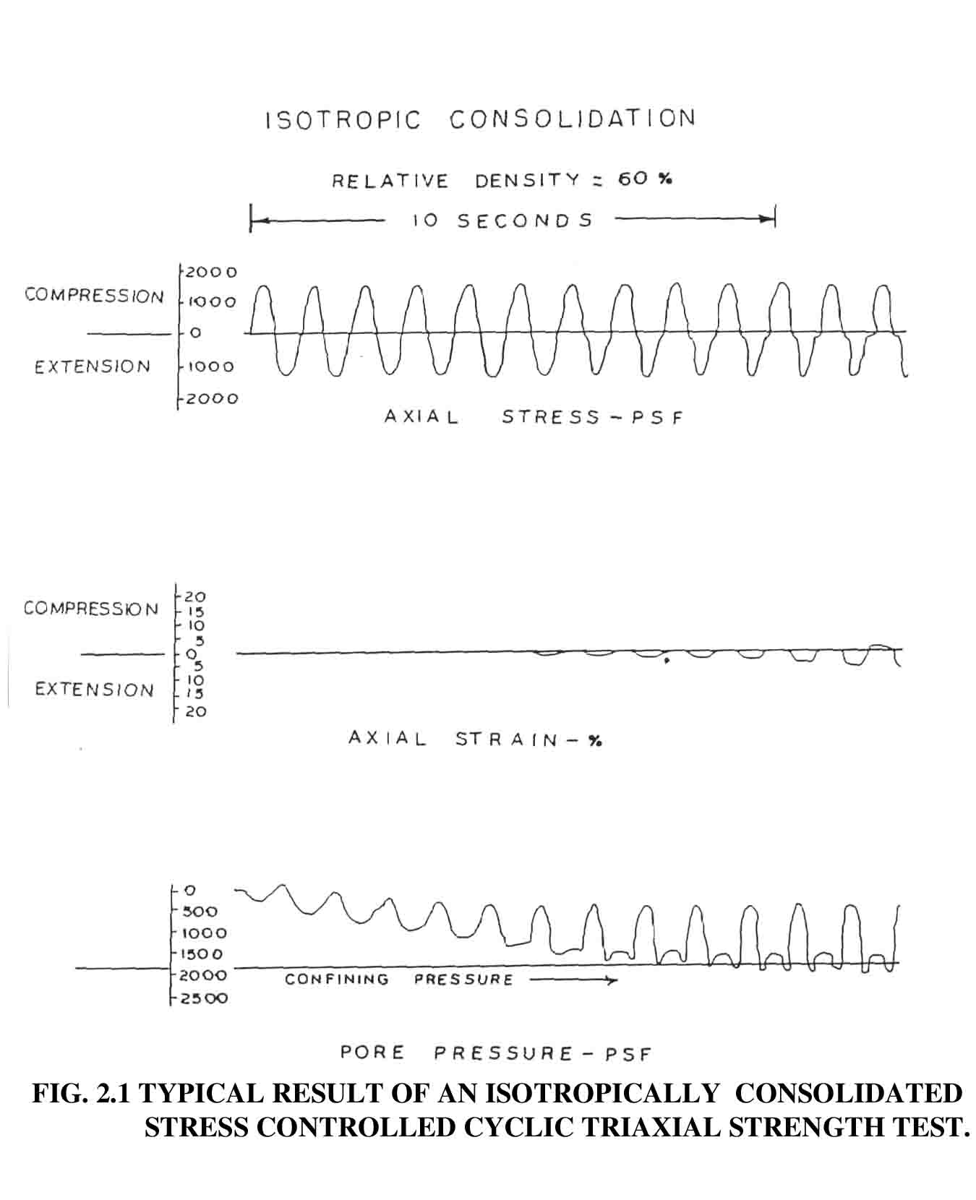

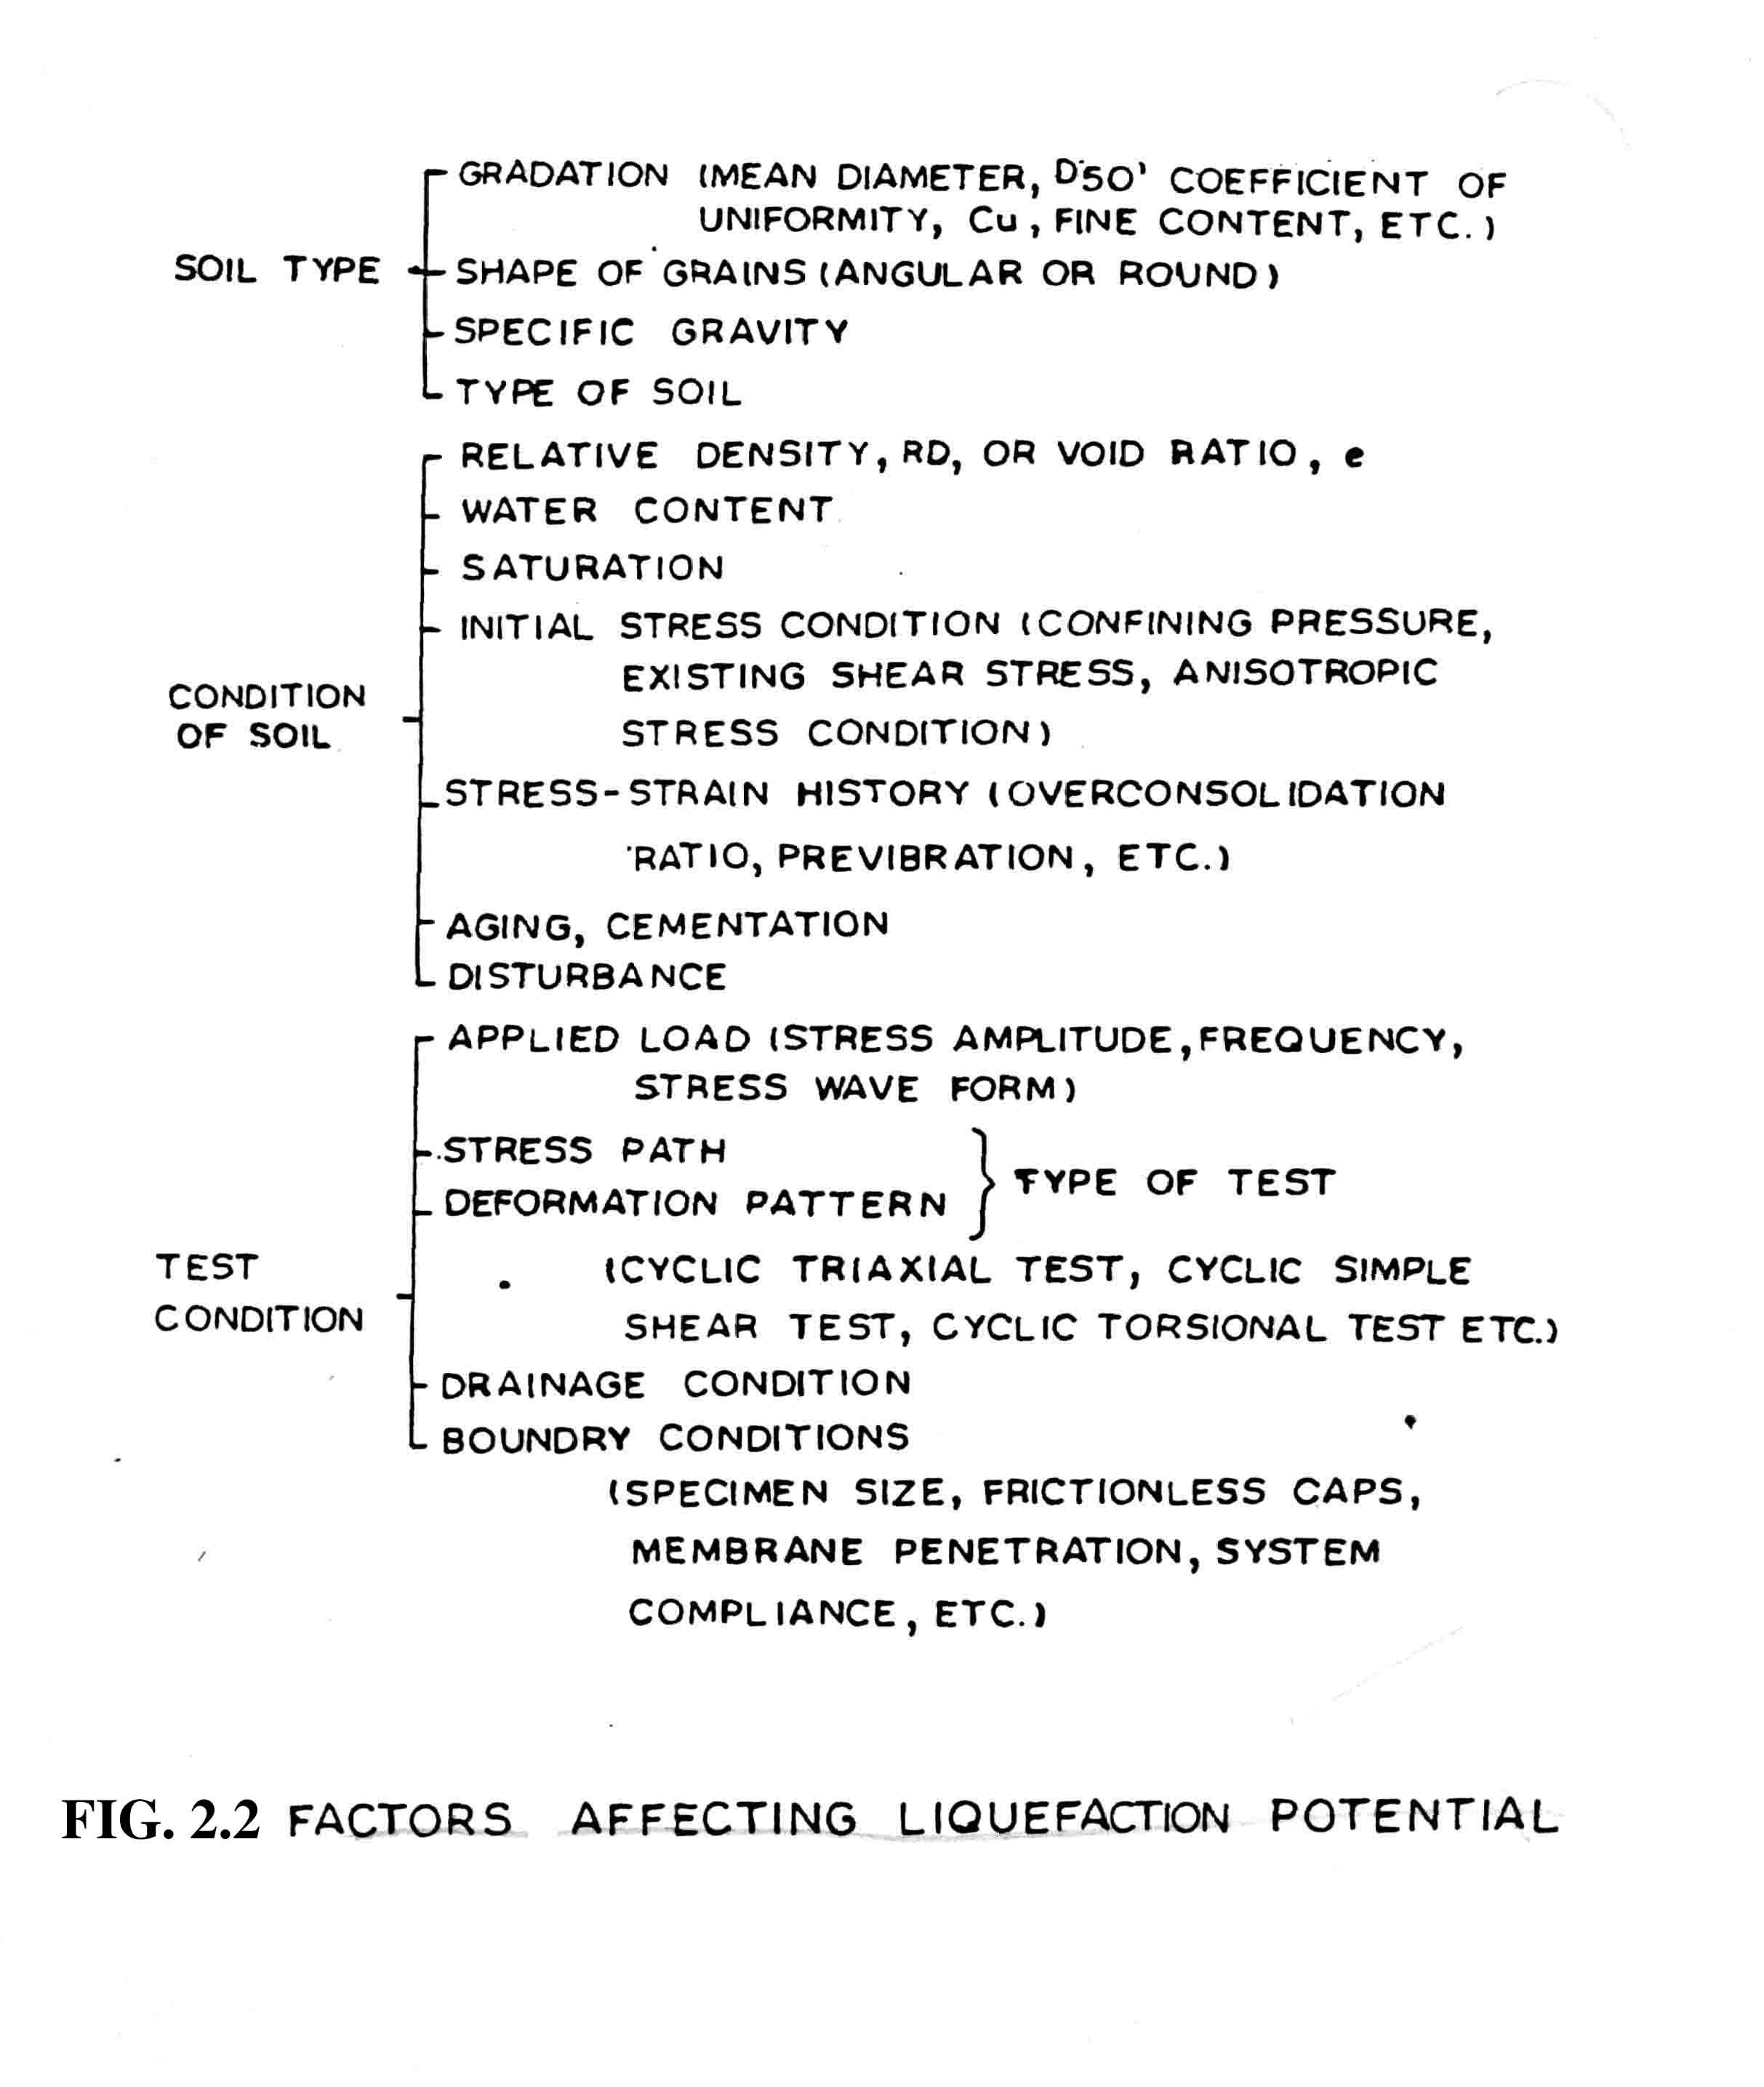

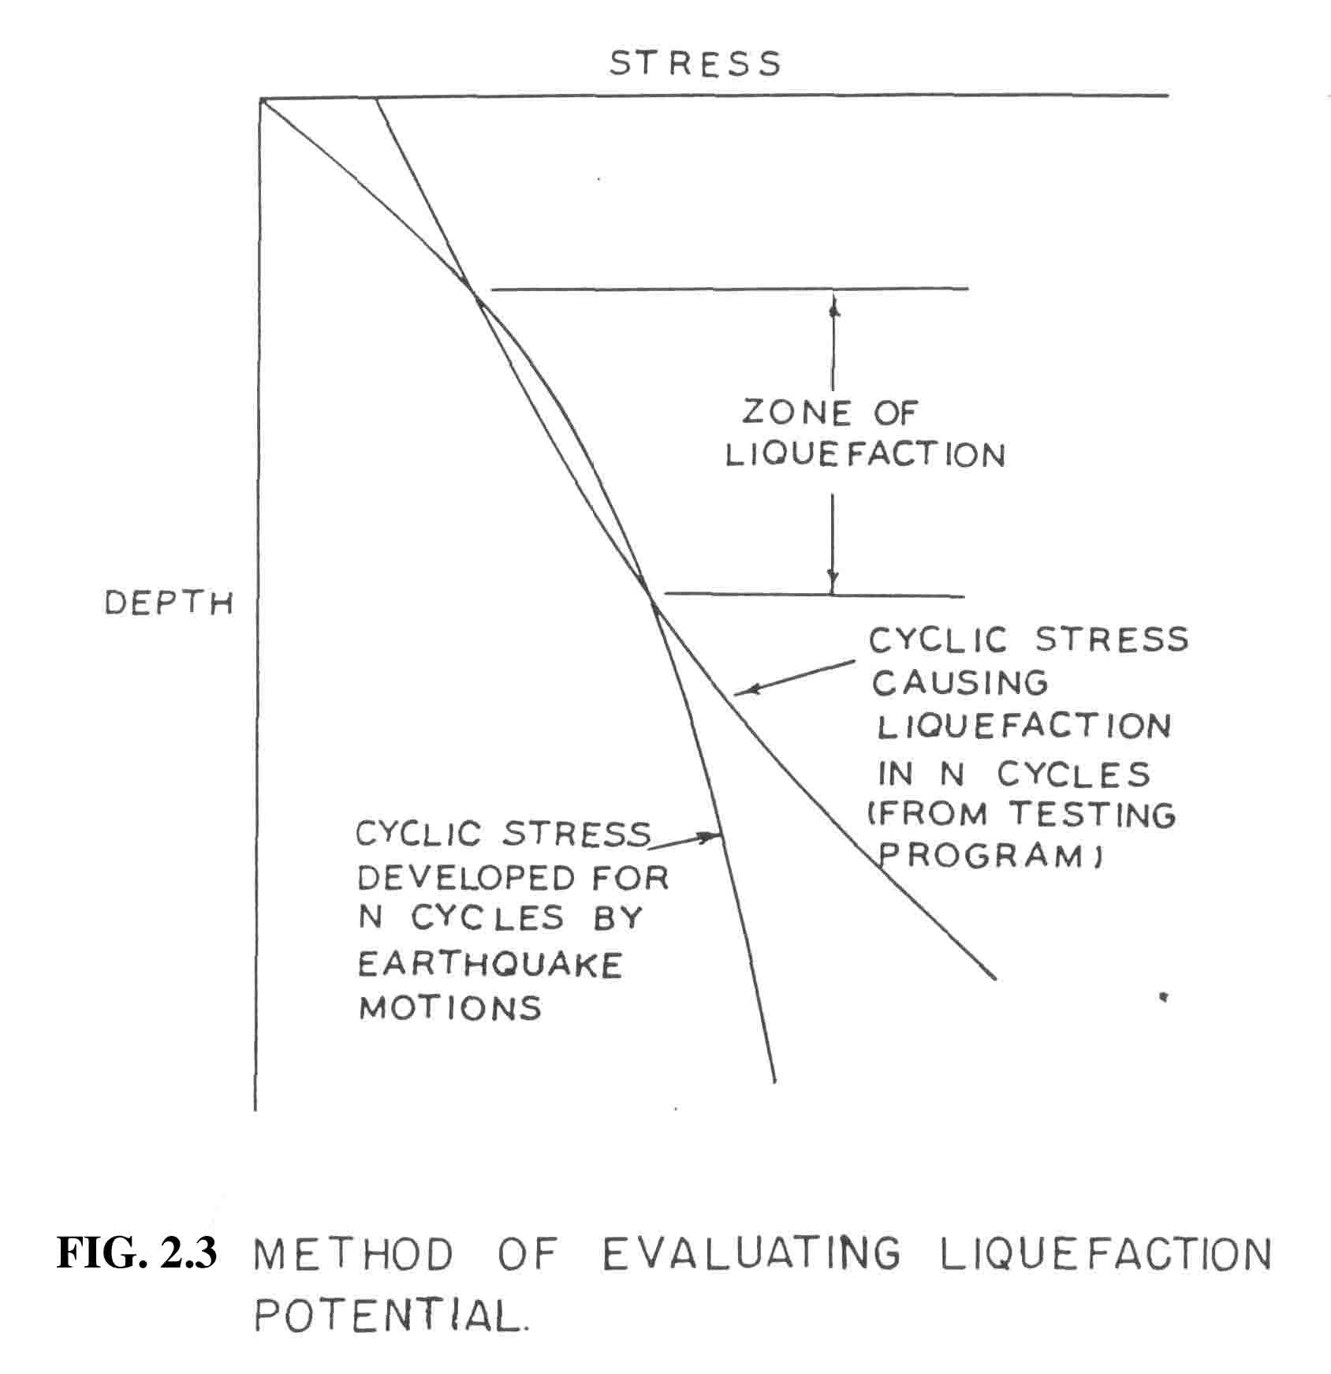

CHAPTER 3

CYCLIC SIMPLE SHEAR TEST

3.1 General

In the field, for horizontal soil deposits, an element of soil is at rest condition where the major principal stress is equal to the effective vertical overburden pressure σ_{V} and the effective horizontal stress equals k₀σ_{V} where k₀ is the coefficient of earth pressure at rest. This condition is shown in fig 3.1 (a). Strong ground shaking such as caused by an earthquake will induce cyclic shear stresses that reverse direction many times during the earthquake such as shown in fig 3.1 (b). This state of stress corresponds approximately to a simple shear condition. It would, therefore, seem appropriate to use a laboratory simple shear test to evaluate the cyclic strength of soil under earthquake loading. Although cyclic simple shear test simulates field conditions, yet cyclic triaxial shear test is more commonly used in the profession because of its easy availablity. Some researchers have established a correlation between the results of these two tests by comparing them at equivalent levels of shear stresses and confining pressures. Cyclic triaxial shear test though most commonly used for evaluation of cyclic strength, has the following limitations :

1. In the field there is a cyclic reorientation of principal stess direction - the major principal stress is initially vertical and rotates through some angle θ to the right and left of its initial position. In triaxial compressin test, the major principal stresses act only in vertical or horizontal direction; no reorientation, other than the full reorientation through 90⁰ is possible.
2. In field, the soil element is initially consolidated under K₀ condition, that is the effective minor principal stress is equal to K₀ times the effective major principal stress. In triaxial shear test, the soil sample is initially consolidated under isotropic stress conditions.
3. In the field, the deformations are presumed to occur under plane strain conditons, where as deformations occur in all three principal stress directions in the triaxial shear test.
4. In the field, cyclic stress conditions are reasonably symmetric; in a typical triaxial compression test, however, the intermediate principal stress is equal to the major principal stress during lateral compression.

In view of the above differences between the idealized field conditions and the conditions reproduced in a triaxial shear test, cyclic simple shear conditions provide a better evaluation of the liquefaction phenomenon.
However, the cyclic simple shear test has the following discrepencies/difficulties encountered while testing.

1. The preparation of representative samples and
2. The development of uniform shear stress and correspnding shear strains throughout the sample.

3.2 Test Equipment
In cyclic simple shear test apparatus (Fig 3.2) specimen is prepared on the bottom platten which is assigned to be rigidly fixed in horizontal direction and enable to move in vertical direction. A vertical load is applied to the specimen by means of a pneumatic actuator pushing through a belieframe seal. A horizontal load is applied to the specimen by a pneumatic actuator pushing a drive train which is in the chamber. This drive train can be moved horizontally and provides less friction.

The equipment is provided with an air and water control panel. It is used to apply confining pressure (pneumatic), vertical load, back pressure and vacuum to the sample during various stages of specimen preparation, saturation, consolidation and testing. It has arrangements for preparing de-aired water which is used for flushing through the sample to aid/accelerate saturation process.

Two load cells are used in the simple shear device. One of them is connected between the top platten and the drive train for measuring the vertical load. The other one is connected horizontally between the drive train and horizontal loading rod. Both of them are located inside the head and are placed inside the chamber. A hoist has been mounted on the table to lift the head and keep it on the perspex cylinder and this forms a closed chamber enclosing the specimen. One transducer for the confining pressure and
another for measurement of both back pressure and pore water pressure are provided on the outside of the chamber. In order to measure the displacements during shear, two LVDT's; one for small displacement which is connected to a plate inside the chamber and another outside the chamber for large displacement, have been provided. For vertical displacements, the LVDT is fixed by the side of the vertical actuator.

All the transducers and load cells are connected to a eight channel digital recording system. The eight channels give _{r} individual output in the form of a digital display for vertical load, horizontal load, vertical displacement, horizontal displacements (large and small), confining pressure, pore water or back pressure and volume change respectively. A paper chart recorder which uses light sensitive paper and uses a light beam has been provided to give a record of the output in form of traces for the desired channels. Prior to testing, the calibration of the load cells is done by means of accurate dead weights, the pressure transducers against an accurate metric gauge and the displacement transducers with gauge blocks of known exact thickness. The calibration is periodically verified.

The cyclic loading is provided by a cyclic stress controlled pneumatic loader. It has been provided with function generator, primary pressure gauge, static and dynamic pressure regulators. Fig 3.3 shows the mode of application of penumatic sinusoidal loading. A uniform sinusoidal cyclic load is applied to the top of undrained sample with bottom cap being fixed. By clamping the top platten with help of a nut on the top of head (so that load is not applied to specimen), the load amplitude can be adjusted to the desired value. The clamp is released before starting the test. At this stage, the paper recorder is adjusted and calibrated. The desired frequency of the load and the number of cycle upto which one wants to test the sample can be set on the function generator and dynamicloader respectively.

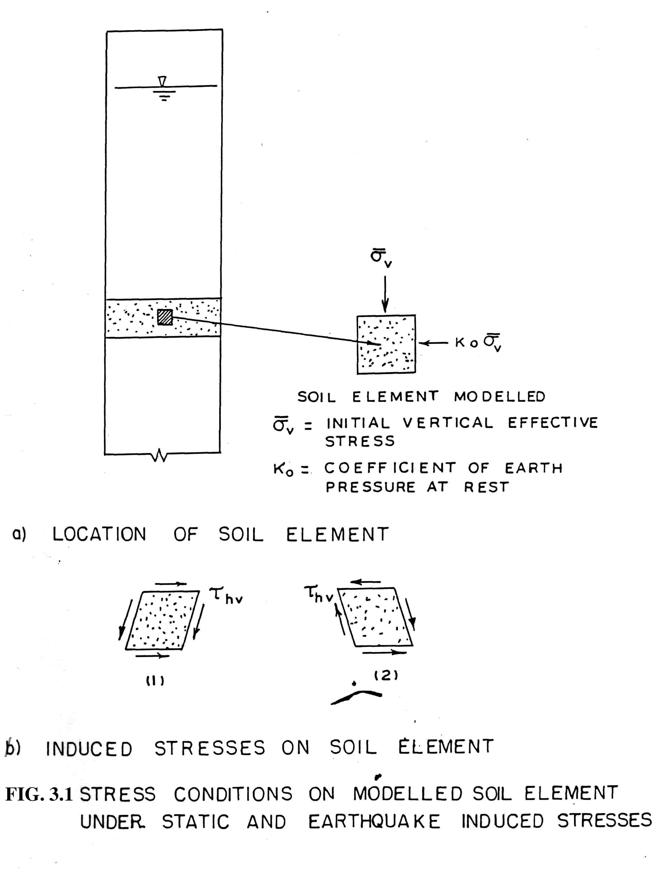

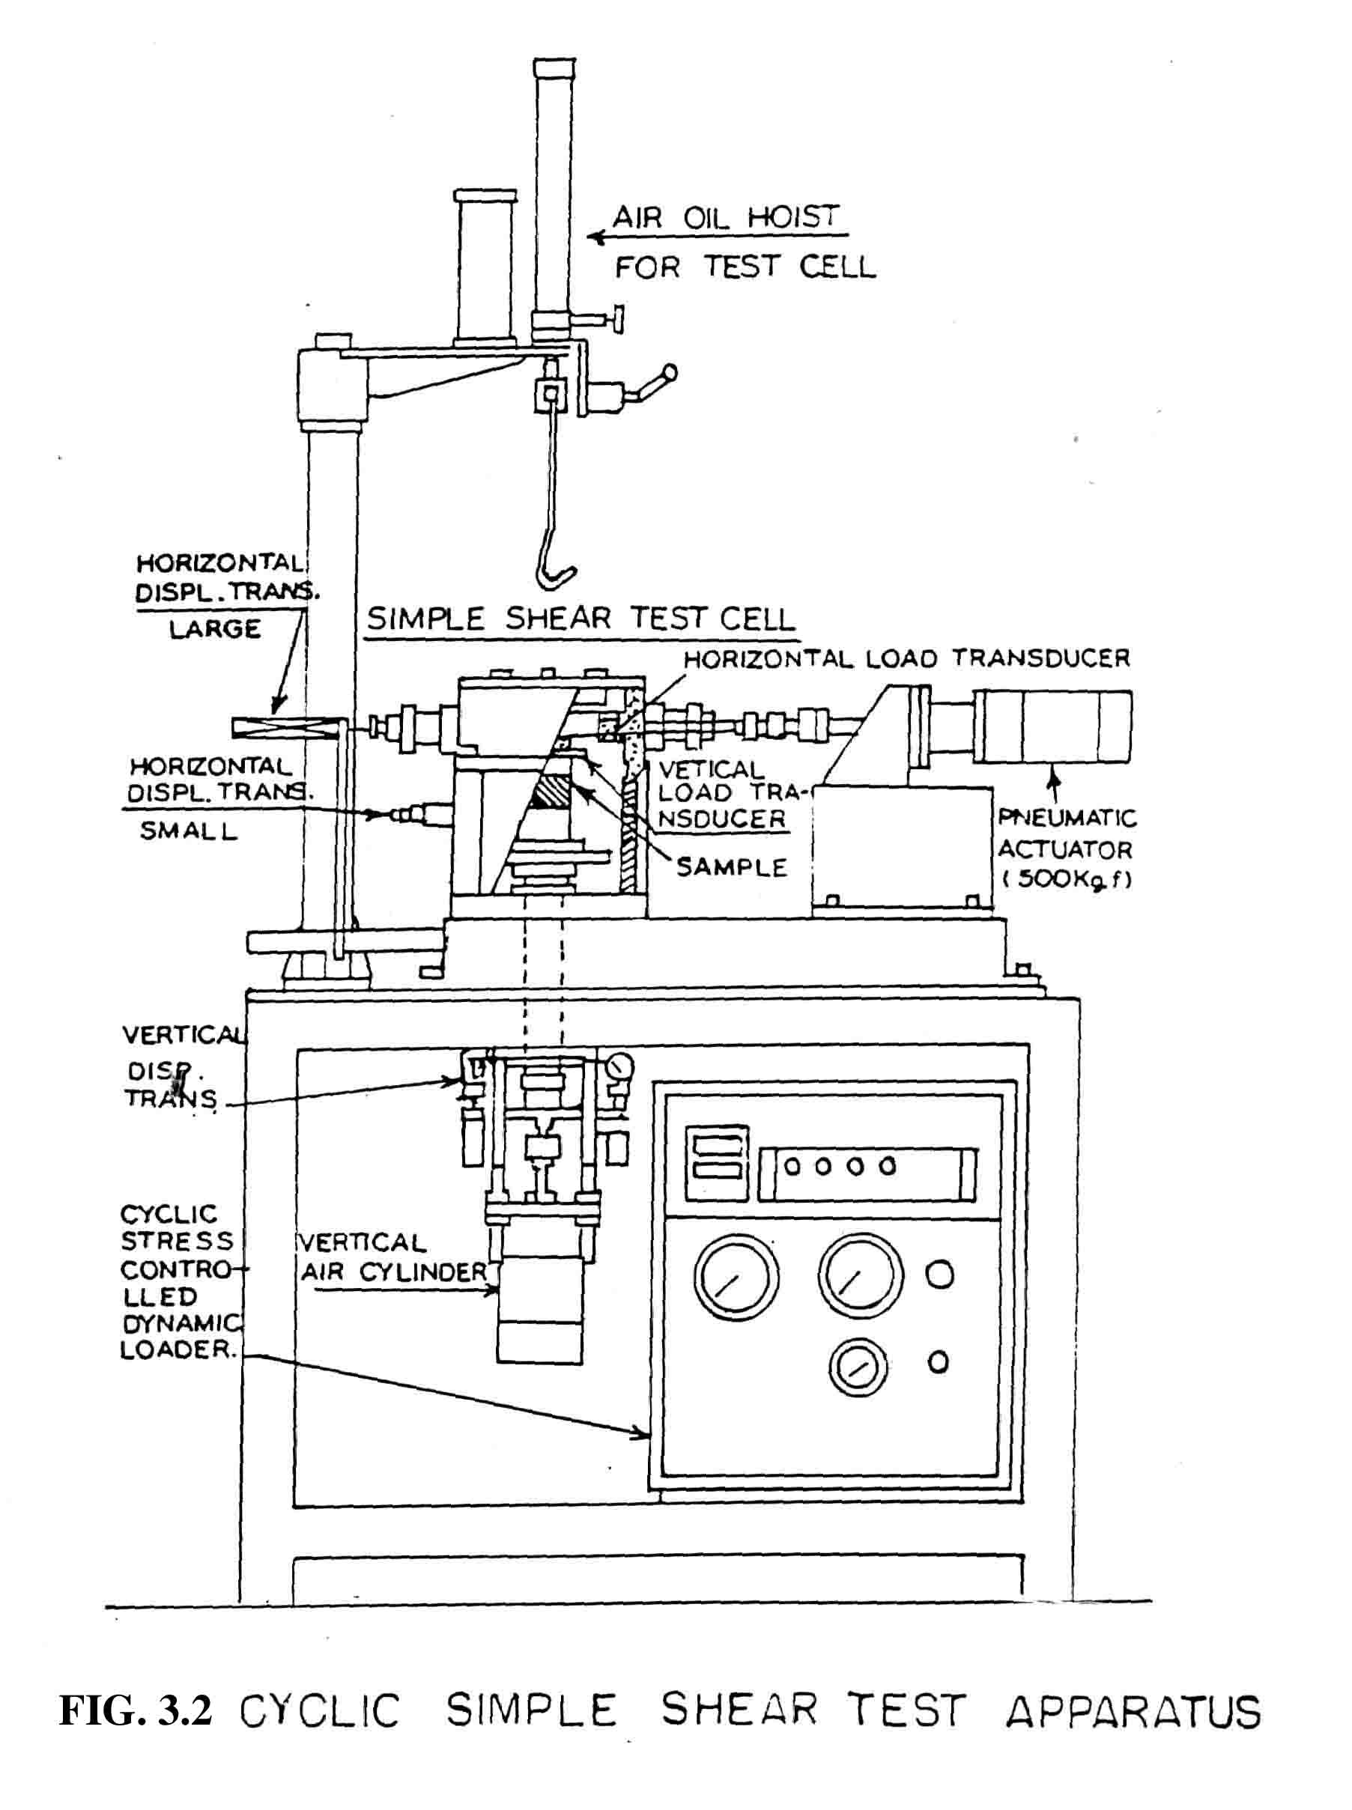

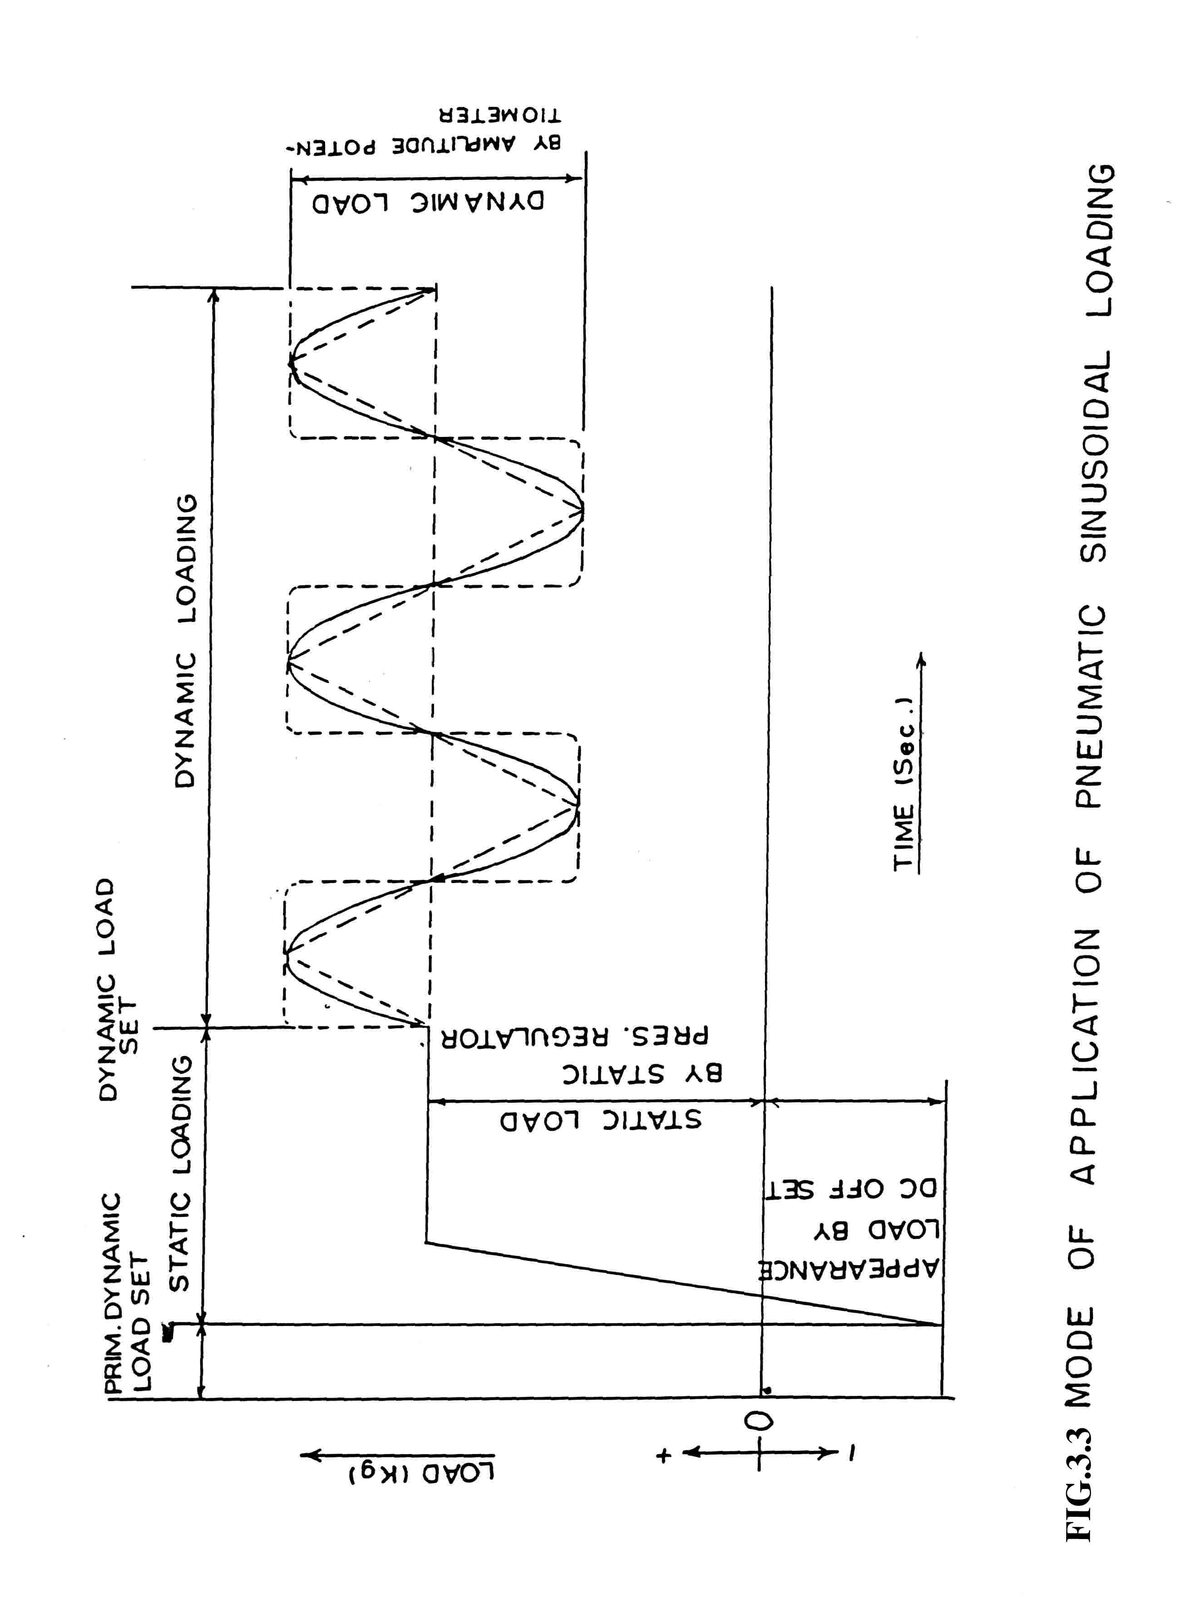

CHAPTER 4

TEST MATERIAL, TEST PROGRAMME AND

TEST PROCEDURE

4.1 Test Material

Ennore sand is available in three fractions viz. fine, medium and coarse. These three fractions and two combinations of these fractions were selected for this study. The five materials thus consisted of the following and are designated as under for reference in the subsequent discussions :

1. Fine fraction of Ennore sand - referred to as fine sand (Designation A).
2. Medium fraction of Ennore sand - referred to as Med. sand (Designation B).
3. Coarse fraction of Ennore sand - referred to as Coarse sand (Designation C).
4. (Fine + Med.) fractions of Ennore sand - referred to as (Fine +Med.) sand
(Designation D)
5. (Fine + Med.+ Coarse) fractions of Ennore sand -referred to as (Fine +Med+ Coarse) sand (Designation E).

All the five materials have different gradation characteristics in terms of Fineness Modulus (FM) , Mean Particle Size (D₅₀ ) and grain size and gradation factor R. The grain size Distribution curves for all the above materials are shown in Fig. 4.1. Table 4.1 gives the physical properties of these materials.

Liquefaction potential curves were established for the above materials for the specified initial effective confining stresses. Badarpur sand having characteristics as detailed in Table 4.1 and grain size distribution curve as shown in Fig. 4.1. Badarpur sand is designated as F.

4. 2 Test Programme

Test Programme comprised of evaluating the liquefaction potential of all the designated sands at a relative density of 50%. Sand specimens 75 mm diameter and 20 mm high reconstituted at the desired relative density by dry pluviation method were tested at different stress ratios, applying sinusoidal loading wave form at a frequency of 0.5 Hz. Each desigation sand was tested at initial effective confining pressures of 0.75, 1.5 and 2.25 kg/cm² . This was done to study the effect of confining pressure on the liquefaction susceptibility. The number of cycles for initial liquefaction in each case was recorded. A minimum of three specimens for each sand designation were planned to be tested for each confining pressure. As such total number of tests worked out to be 45. Additional tests were carried out for verification of predicted behaviour of the Badarpur Sand. In all 66 specimens were tested in cyclic simple shear tests.

4.3 Test Procedure

Test procedure in conducting a cyclic simple shear strength test consisted essentially of the following four operations:
(a) Sample preparation
(b) Saturation of sample
(c) Consolidation
(d) Applying cyclic shear load

The detailed procedures, the various observations and calculations made during each of the four operations are explained in the following sections.

4.3.1 Sample Preparation:

1. All the necessary equipment to be used in preparing the specimen was assembled and checked.
2 . The dry weight of the material required for the required relative density was calculated. Knowing minimum and maximum dry densities, the dry density for the required relative density was found out by using' the relationship

The weight of the material was calculated by taking diameter of the sample =75 mm and height =20 mm.

3. The 75 mm diameter pedestal with blades or fins was installed.

4. The two extension columns were screwed on to the opposing columns and the specimen placer with the top cap was attached. The gauge block with grooves to accomodate fins between top and bottom plattens was placed on the bottom platten. The shaft of the placer was released and dial gauge was zeroed. The position of the dial was noted down. The shaft with top platten was raised and clamped. The placer was then removed leaving the extension columns in place.

5. A thin layer of vacuum grease was applied around the body section of the specimen pedastal and the membrane was placed on it. Two O-rings were put around the membrane to seal it.

6. The split mould was placed outside the membrane by resting the lower ends of the mould on the water tank base plate and the two halves were clamped together.

7. The projected portion of the membrane was turned down at the top of the mould after placing two O-rings onthe outside of the split mould at top.

8. The vacuum -tube from the mould to the mould suction system of the air and water control unit was connected to expand the membrane by suction.

9. The mould was charged with pre-weighed amount of sand.

10. The specimen leveller tooling was attached and the height of the shaft of the specimen leveller adjusted to the surface of the specimen and the shaft was carefully rotated to smoothen the surface of the specimen. When this operation was complete, the specimen leveller was removed.

11. The specimen cap placer with the top cap was attached on to the extended two columns. The shaft retaining screw was loosened and the shaft was lowered until the specimen cap touched the specimen top surface. The mould was tapped, if necessary, till the dial gauge showed the required reading as in step (4).

12. While the specimen cap palcer was still in place, the turned down membrane was straightened on to the specimen cap after applying a thin layer of vacuum grease on the outside of specimen top cap and the membrane was sealed by moving the rings over the membrane. The specimen cap placer was removed after noting down the dial reading.

13. The tubing connections to the top section of the specimen were made for water drainage. A slight vacuum was applied inside the specimen by operating the air and water control unit so that the specimen stands by itself. This was accomplished by turning knob on specimen manipulation system of the pressure panel on "Specimen top connected to vacuum" and slightly (partially) opening the valve for top cap on outside of chamber to get the desired value of vacumm and closing back the value.

14. The suction to split mould was removed and mould was detached.

15. The diameter of the specimen was measured using a Pi tape. Pi tape was wrapped around the circumference at the centre height of the specimen and reading of the Vernier gave the diameter. The vacuum inside the specimen was observed on the recording system and it was ensured that it did not fall indicating there is no leakage.

16. The true diameter of the specimen was calculated by subtracting from the average diameter of the specimen, the average twice membrane thickness. Knowing the true diameterof the specimen and the measured specimen height (observed from the dial gauge on top cap placer), the specimen vol. was calculated after subtracting the vol. of fins. The unit weight was calculated by dividing the weight of the sand placed within the mould by—specimean volume. The RD of the specimen was calculated by using the relation given in Step 2.

17. There are two connectors, one each in front and back of the pedastal base. Pipes from the two connectors from the pedastal base were connected to the two connectorsat the right on the cell base plate.

18. The acrylic cylinder was then placed on the base. The two transduces attaching bosses are to be located near the top on the left. The hydraulic operted hoist was used to bring the head above the acrylic cylinder.

19. The head was lowered slowly on to the cylinder by operating the hoist and the head was screwed to the supporting columns by four bolts. It was ensured that extended columns had been removed before the head is lowered with the help of hoist.

20. The four cap screws on the top of the head were removed. The vertical loading piston was raised slowly by operating the air and water control panel until the specimen cap touched the horizontal loading shaft. The specimen cap was then fixed to the horizontal loading shaft with a wrench through each of the four holes in the head and the four cap screws were replaced on the top of the head.

21. There are two horizontal displacement transducers with 25mm and 20mm capacities. In this study larger capacity transducer which is attached to the outside of the cylinder was used since in liquefaction studies larger displacements were expected.

22. The vertical displacement transducer was screwed/upward on an attachment plate located at the side of the air cylinder under the confining cell. The spindle should contact the vertical arm attached to the vertical shaft.

    - Saturation of Sample :

After the specimen was placed and the chamber closed, a small confining pressure was applied (0.25 kg/cm² ). From the bottom drainage line, CO₂ at 0.08 to 0.10 kg/cm² was applied for about 20-25 minutes. Flushing of water through the specimen was then started. This was done to dissovle all CO₂ filling the voids in the specimen under an effective confining pressure of 0.25 kg/cm² .Care was taken, however, to ensure that hydraulic gradient of flushing water was not high to ensure that fines were not washed out of the specimen. Since CO₂ is soluble in water, flushing water will dissolve CO₂ and it will be filled in the voids, thus accelerating/aiding the saturation process. Back pressure saturation is another good way of accelerating saturation. Back pressure was applied in increments of 0.25 kg/cm² , simultaneously increasing the confining pressure by the equal amount.

Specimen saturation was checked using Skempton's pore pressure parameter B, in the following manner:
1. With drainage lines closed, the confining pressure was increased by an amount equal to or less than 0.25 kg/ cm² but less than the final effective consolidation stress.

2. The pore water pressure increase was observed and factor B was calculated
3. If value was less than about 0.95, steps 1 to 3 were repeated after increasing both the total confining pressure and the back pressure by equal amounts, until saturation was reached. Between each B-check step, the specimen was kept under back pressure to compress and dissolve CO₂ /air in Voids.

4.3.3 Specimen Consolidation:

1. After the specimen was saturated, the confining stress was increased to the desired effective consolidation stress with top drainage lines open to the volume meter (a graduated burrette) which must be under the back pressure upto which the specimen has been subjected to during saturation process. At this stage it was ensured that the valve of back pressure line was closed.

2. The change in volume due to consolidation was noted (the difference in burette reading before and after consolidation) along with the change in vertical height from channel 3 on electronic display.

3. From the values of height change and initial specimen geometry, the post-consolidation area A_{c} was calculated. This was achieved by assuming that under isotropic consolidation percent strain in diameter would the same as per cent strain in the vertical height.

The procedure of doing these operations have been given in the observation and data sheets which have been included in Apendix 5.1. Also included are the typical records for some of the tests.

4.3.4 Application of Cyclic Shear Load :

1. After consolidation, the horizontal load shaft of the confining cell head "and actuator piston were connected through the universal joint.

2. The air pressure of the dynamic loader was set and balanced before operation. There is a clmap bolt on the top centre surface of the head. When the bolt is loosened, the horizontal load shaft is released and it receives power from the pneumatic actuator. Loosening of clamp bolt was done before applying the horizontal load. For the choosen stress ratio and the area of specimen after consolidation A_{c} and effective confining stress, horizontal load was calculated using the relation
Stress Ratio

where π_{h} is average single amplitude cyclic shear stress and σ ₀′ is the effective confining stress applied to the sample.

3. The frequency was set on function generator and load wave shape was selected . Gate switch of function generator was pushed and amplitude on the vernier was set to give the desired cyclic load. Number of cycles at which the load n need to be stopped can also be set on the counter.

4. All the valves leading to specimen except the one for the pore water pressure were closed. Clamping bolt was loosened and the dynamic loading was started. The test was stopped when the pore water pressure reached the confining pressure value indicating that intial liquefaction had occured.

5. The number of cycles required to reach this stage that is initial liquefaction, were recorded. Load was then removed and horizontal loading shaft disconnected.

6. The sample was removed and the appratus was cleaned for subsequent use.

TABLE 4.1 : Physical Properties of Sands Used

Sl.. Material Desig- Size Fine- Grain Size and (_{d} ) _{max} (_{d} )_{min}
No. nation ness Gradation Factor (gm/cc)
D₁₀ D₃₀ D₅₀ D₆₀ D₉₀ Modu- R=D50*D₃₀*D₉₀ (gm/cc)
lus D₁₀*D₆₀

1 2 3 4 5 6 7 8 9 10 11 12
1. Fine Fraction
of Ennore Sand A 0.18 0.23 0.30 0.32 0.43 2.46 0.52 1.60 1.427
(Referred to as
Fine Sand )

2 Medium Fraction B 0.33 0.40 0.45 0.48 0.60 3.06 0.68 1.693 1.38
of Ennore Sand
(Referred to as
Medium Sand)

3 Coarse Fraction C 1.8 2.5 2.7 2.75 3.3 5.80 4.5 1.693 1.475
of Ennore Sand

- Fine and Medium D 0.23 0.32 0.39 0.43 0.60 2.87 0.76 1.711 1.545
Fraction of Ennore
Sand Mixed in
Equal Propertatiom

- Fine,Medium & E 0.25 0.38 0.49 0.56 1.70 3.45 2.26 1.80 1.603
CoarseFraction of
Ennore Sand Mixed
Together

6 Badarpur Sand F 0.20 0.36 0.40 0.47 1.46 3.01 1.46 1.635 1.348

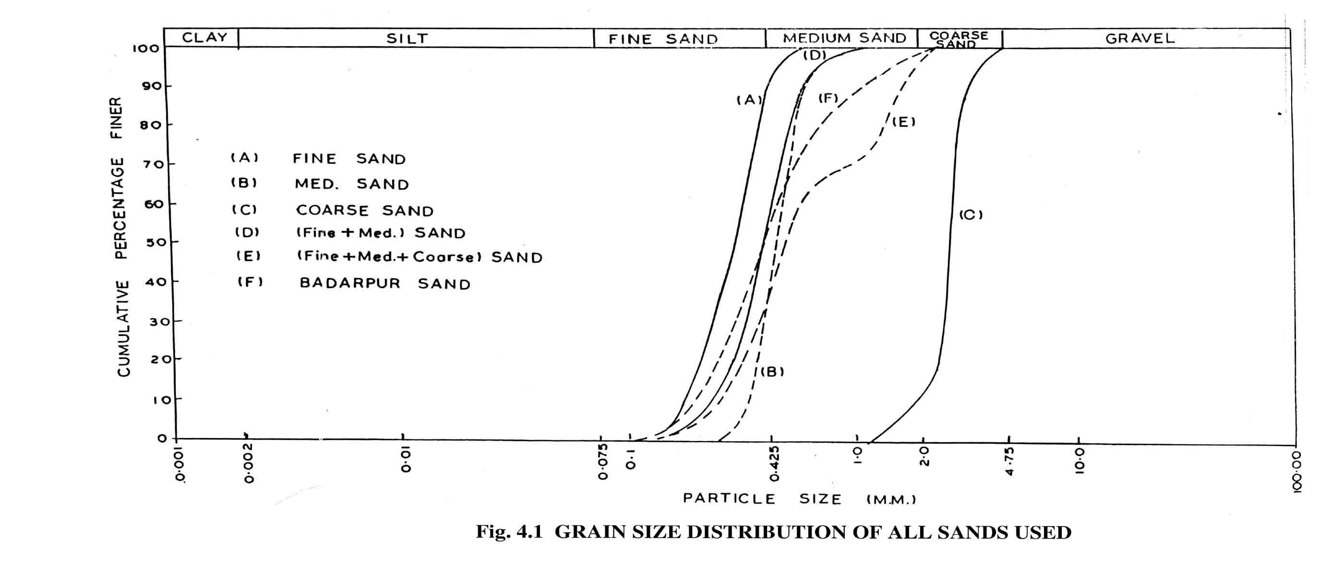

CHAPTER 5

TEST RESULTS AND DISCUSSIONS

  - Test Results
A total of 66 specimens were tested for liquefaction susceptibility, 56 of them were using Ennore sands and 10 using Badarpur sand. Tables 5.1 to 5.6 give the summary of test results for sand designations A to F respectively. The summary tables include initial and post consolidation relative densities, initial effective confining pressures (σ_{o}’)Peak pulsating shear stresses (π_{h}), Stress Ratio (SR) and number of cycles to initial liquefaction. Data sheets for some specimens showing specimen details, test sequence, B-parameter and labeled traces for horizontal load, displacement and pore water pressure have been enclosed in Appendix 5.1. All the specimens were tested at 0.5 Hz frequency. Figures 5.1 to 5.3 show the liquefaction potential curves (in terms of relationship between peak shear stress and number of cycles to initial liquefaction) for all the sands at initial effective confining pressures of 0.75 kg/cm², 1.5 kg/cm² and 2.25 kg/cm² respectively. Coarse sand (designation C) was tested for liquefaction at 0.75 kg/cm² and since it required very high shear stress for liquefaction even at small confining pressures. The testing programme using this particular sand fraction was deferred.

All the specimens were planned to be reconstituted at 50% relative density. The packing densities achieved, however, varied from 46% to 63%. Post-consolidation relative density variation was found to be between 50 to 75% depending on the initial effective confining pressure (σ_{o}’).

All the specimens were saturated until pore water pressure coefficient B reached a value of 0.96. For liquefaction studies (i.e. cyclic strength tests) a B factor 0.95 has been reported to be acceptable.

  - Discussions
Figure 5.1 to 5.3 indicate that increases in initial effective confining pressure increases liquefaction resistance. In order to show the effect of confining pressure, from Figs. 5.1 to 5.3 the relationships between peak pulsating stress causing liquefaction in 10, 30 and 100 cycles and initial effective confining pressures has been obtained for all sands, and are presented in Figs. 5.4 to 5.6. These figures indicate a linear relationship between peak alternating shear stress causing liquefaction in a given number of cycles and initial effective confining pressures. This is in conformity with the results presented by Seed and Lee (1967) for a wide range of confining pressures for cyclic triaxial tests. Finn, Pickering and Bransby (1971) have reported similar relationship for cyclic simple shear shear tests. This, then means that an undrained saturated sand at a give n void ratio e (or relative density) will always reach initial liquefaction in cyclic loading tests in the same number of cycles if the tests are conducted at the same initial effective stress ratio (SR =π_{h}/σ_{o}’) irrespective of the particular values of π_{h} or σ_{o}’ provided the crushing of grains does not occur. In other words the SR and the cycles to initial liquefaction are uniquely related for a given sand at a given void ratio.

Figures 5.7 to 5.11 show this unique relationship between Stress Ratio n(SR) and number of cycles to initial liquefaction (Ni). These figures have been obtained by interpreting data shown in Tables 5.1 to 5.6. Figure 5.12 shows the averate liquefaction potential curves of all the sands. These curves are at post-consolidation relative density varying from 50% to 75% with most values falling in the range of 60 ± 2%. The liquefaction curves indicate that the number of cycles required for initial liquefaction increases with decrease in cyclic stress ratio. This is in conformity with results of other researchers.

APPENDIX 5.1

Cyclic Simple Shear Test – Summary Data Sheet
Soil Type : Fine sand (A) Moudling Water Content : Nil
Required γd : 1.509 gms/cc σ_{c} = 5.00 Kg/cm² , u = 2.75 Kg/cm² ,
Saturated : Yes σ_{c} = 2.25 Kg/cm²

Consolidation : Isotropic
Diameter : 76.85 mm
Membrane Thickness x (2) : 0.98 mm
(γd) min. : 1.427 g/cc
(γd) max. : 1.60 g/cc

 | Initial Specimen | Consolidated specimen
Average diameter (without membrane)  Area  Height  Volume (excluding vol. Of fins=0.436 cc)  Weight  Unit Weight  Dry Unit Weight  Relative density | 75.87 mm  45.21 sq. cm.  19.47 mm  87.59cc  133.33g  1.522 g/cc  1.522 g/cc  57.7% | 75.36 mm  44.60 sq. cm.  19.34 mm  85.83cc  133.33g  1.553 g/cc  1.553 g/cc  75.0%

Test Notes:
Sample Preparation Technique : Dry pluviation.
Seating Load Required : 4.00 Kg.
Preparation, Satuaration : Nil.
And Testing Problems, if any

Soil Type: Fine sand (A)

σ_{c} | U | σc | Δσc | Δu | B Value | Vert. Load kg | Vert. Disp. mm | Vol. CC | Notes
0.00 | -0.25 | 0.25 |  |  |  |  |  |  | Sample preparation under vacuum.
0.25 | 0.00 | 0.25 |  |  |  |  | 8.70 |  | CO₂ flushing @ 0.08 kg/cm for 20 min.
0.50 | 0.25 | 0.25 |  |  |  |  |  |  | Water flushing
0.75 | 0.42 |  | 0.25 | 0.17 | .68 | 0.00 | 8.72 |  | B-check.
0.75 | 0.50 | 0.25 |  |  |  | 3.00 |  |  | Under back pressure (B.P.)
1.00 | 0.69 |  | 0.25 | 0.19 | 0.76 | 0.00 | 8.73 |  | B-check
1.00 | 0.75 | 0.25 |  |  |  | 3.00 |  |  | Under B.P.
1.25 | 0.94 |  | 0.25 | 0.19 | 0.76 | 0.00 | 8.73 |  | B-check
1.25 | 1.00 | 0.25 |  |  |  | 3.00 |  |  | Under B.P.
1.50 | 1.21 |  | 0.25 | 0.21 | 0.84 | 0.00 | 8.73 |  | B-check
1.50 | 1.25 | 0.25 |  |  |  | 3.00 |  |  | Under B.P.
2.00 | 1.69 |  | 0.50 | 0.44 | 0.88 | 0.00 | 8.74 |  | B-check
2.00 | 1.75 | 0.25 |  |  |  | 2.00 |  |  | Under B.P.
2.50 | 2.10 |  | 0.50 | 0.46 | 0.92 | 0.00 | 8.74 |  | B-check
2.50 | 2.25 | 0.25 |  |  |  | 2.00 |  |  | Under B.P.
3.00 | 2.73 |  | 0.50 | 0.48 | 0.96 | 0.00 | 8.75 |  | B-check
3.00 | 2.75 | 0.25 |  |  |  | 0.00 | 8.75 | 3.80
5.00 | 2.75 | 2.25 |  |  |  | 0.13 | 8.83  0.50 | 3.33 | Consolidation

Load = ± 19.6 Kg.; SR = 0.195; Ni = 20

Cyclic Simple Shear Test – Summary Data Sheet
Soil Type : Medium sand (B) Moudling Water Content : Nil
Required γd : 1.521 gms/cc σ_{c} = 3.75 Kg/cm² , u = 1.5 Kg/cm² ,
Saturated : Yes σ_{c} = 2.25 Kg/cm²

Consolidation :Isotropic
Diameter : 77.00mm
Membrane Thickness x (2) : 0.98 mm
(γd) min. : 1.38 g/cc
(γd) max. :1.693 g/cc

 | Initial Specimen | Consolidated specimen
Average diameter (without membrane)  Area  Height  Volume (excluding vol. Of fins=0.436 cc) Weight  Unit Weight  Dry Unit Weight  Relative density | 76.02 mm  45.39 sq. cm.  19.69 mm  88.93 cc  134.37 g  1.511 g/cc  1.511 g/cc  46.9% | 75.71 mm  45.02 sq. cm.  19.61 mm  88.28 cc  134.37 g  1.522 g/cc  1.522 g/cc  50.5%
Test Notes:
Sample Preparation Technique : Dry pluviation.
Seating Load Required : 3.00 Kg.
Preparation, Satuaration : Nil.
And Testing Problems, if any

Soil Type: Medium Sand (B)

σ_{c} | U | σc | Δσc | Δu | B Value | Vert. Load kg | Vert. Disp. mm | Vol. CC | Notes
0.00 | -0.25 | 0.25 |  |  |  |  |  |  | Sample preparation under vacuum.
0.25 | 0.00 | 0.25 |  |  |  |  |  |  | CO₂ flushing @ 0.06 kg/cm² for 25 min.
0.50 | 0.25 | 0.25 |  |  |  |  |  |  | Water flushing
0.75 | 0.42 |  | 0.25 | 0.17 | 0.68 | 0.00 | 8.00 |  | B-check.
0.75 | 0.50 | 0.25 |  |  |  | 2.00 |  |  | Under back pressure (B.P.)
1.00 | 0.70 |  | 0.25 | 0.20 | 0.80 | 0.00 | 8.01 |  | B-check
1.00 | 0.75 | 0.25 |  |  |  | 1.00 |  |  | Under B.P.
1.50 | 1.21 |  | 0.50 | 0.46 | 0.92 | 0.00 | 8.02 |  | B-check
1.50 | 1.25 | 0.25 |  |  |  | 2.00 |  |  | Under B.P.
1.75 | 1.49 |  | 0.25 | 0.24 | 0.96 | 0.00 | 8.02 |  | B-check
1.75 | 1.50 | 0.25 |  |  |  |  | 8.02 | 7.40
3.75 | 1.50 | 2.25 |  |  |  |  | 8.08 | 6.80 | Consolidation.
 |  |  |  |  |  |  | 0.08 | 0.60

Load = ± 29.0 Kg.; SR = 0.286; Ni = 42

Cyclic Simple Shear Test – Summary Data Sheet
Soil Type : (Fine + Med) sand (D) Moudling Water Content : Nil
Required γd : 1.624g,s/cc σ_{c} = 3.25 Kg/cm² , u = 1.75 Kg/cm² Saturated : Yes σ_{c} = 1.50 Kg/cm²

Consolidation : Isotropic
Diameter : 76.98 mm
Membrane Thickness x (2): 0.98 mm
(γd) min. : 1.545 g/cc
(γd) max. : 1.711 g/cc
 | Initial Specimen | Consolidated specimen
Average diameter (without membrane)  Area  Height  Volume (excluding vol. Of fins=0.436 cc)  Weight  Unit Weight  Dry Unit Weight  Relative density | 76 mm  45.36 sq. cm  19.55 mm  : 88.71 cc  143.46 g  1.625 g/cc  1.625 g/cc  50.7% | 75.69 mm  44.99 sq. cm.  19.47 mm  87.17 cc  143.46 g  1.646 g/cc  1.646 g/cc  63.2%

Test Notes:
Sample Preparation Technique : Dry pluviation.
Seating Load Required : 4.0 Kg.
Preparation, Satuaration : Nil.
And Testing Problems, if any
Soil Type :(Fine + Med.) Sand (D)

σ_{c} | U | σc | Δσc | Δu | B Value | Vert. Load kg | Vert. Disp. mm | Vol. CC | Notes
0.00 | -0.25 | 0.25 |  |  |  |  |  |  | Sample preparation under vacuum.
0.25 | 0.00 | 0.25 |  |  |  |  |  |  | CO₂ flushing @ 0.06 kg/cm for 25 min.
0.50 | 0.25 | 0.25 |  |  |  |  |  |  | Water flushing
0.75 | 0.45 |  | 0.25 | 0.20 | 0.80 | 0.00 | 8.09 |  | B-check.
0.75 | 0.50 | 0.25 |  |  |  | 3.00 |  |  | Under back pressure (B.P.)
1.25 | 0.94 |  | 0.50 | 0.44 | 0.88 | 0.00 | 8.11 |  | B-check
1.25 | 1.00 | 0.25 |  |  |  | 2.00 |  |  | Under B.P.
1.75 | 1.46 |  | 0.50 | 0.46 | 0.92 | 0.00 | 8.12 |  | B-check
1.75 | 1.50 | 0.25 |  |  |  | 2.00 |  |  | Under B.P.
2.00 | 1.74 |  | 0.25 | 0.24 | 0.96 | 0.00 | 8.12 |  | B-check
2.00 | 1.75 | 0.25 |  |  |  |  | 8.12 | 1.10
3.25 | 1.75 | 1.50 |  |  |  | 2.00 | 8.17 | 0.60 | Consolidation.
 |  |  |  |  |  |  | 0.08 | 0.50

Load = ± 21.0 Kg.; SR = 0.31; Ni = 14

Cyclic Simple Shear Test – Summary Data Sheet
Soil Type : (Fine + Med .+Coarse) sand (E) Moudling Water Content Nil
Required γd : 1.696 gms/cc σ_{c} = 4.25 Kg/cm² , u = 2.75 Kg/cm²
Saturated : Yes σ_{c} = 1.50 Kg/cm²
Consolidation : Isotropic
Diameter : 77.00 mm
Membrane Thickness x (2 : 0.98 mm
(γd) min. : 1.603 g/cc
(γd) max. : 1.80 g/cc
 | Initial Specimen | Consolidated specimen
Average diameter (without membrane)  Area  Height : Volume (excluding vol. Of fins=0.436 cc)  Weight  Unit Weight  Dry Unit Weight  Relative density | 76.02 MM  45.39 sq. cm.  19.57 mm  88.39 cc  149.82 g  1.695 g/cc  1.695 g/cc  49.6% | 75.83 MM  45.16 sq. cm  19.52 mm  87.71 cc  149.82 g  1.708 g/cc  1.708 g/cc  56.2%
Test Notes:
Sample Preparation Technique : Dry pluviation.
Seating Load Required : 3.0 Kg.
Preparation, Saturation : Nil.
And Testing Problems, if any

Soil Type: (Fine + Med. + Coarse) Sand (E)

σ_{c} | U | σ_{c} | Δσ_{c} | Δu | B Value | Vert. Load kg | Vert. Disp. mm | Vol. CC | Notes
0.00 | -0.25 | 0.25 |  |  |  |  |  |  | Sample preparation under vacuum.
0.25 | 0.00 | 0.25 |  |  |  |  | 8.71 |  | CO₂ flushing @ 0.08 kg/cm² for 25 min.
0.50 | 0.25 | 0.25 |  |  |  |  |  |  | Water flushing
0.75 | 0.39 |  | 0.25 | 0.14 | 0.56 | 0.00 | 8.73 |  | B-check.
0.75 | 0.50 | 0.25 |  |  |  | 3.00 |  |  | Under back pressure (B.P.)
1.25 | 0.90 |  | 0.50 | 0.40 | 0.80 | 0.00 | 8.73 |  | B-check
1.25 | 1.00 | 0.25 |  |  |  | 2.00 |  |  | Under B.P.
1.75 | 1.44 |  | 0.50 | 0.44 | 0.88 | 0.00 | 8.74 |  | B-check
1.75 | 1.50 | 0.25 |  |  |  | 2.00 |  |  | Under B.P.
2.25 | 1.94 |  | 0.50 | 0.44 | 0.88 | 0.00 | 8.75 |  | B-check
2.25 | 2.00 | 0.25 |  |  |  | 2.00 |  |  | Under B.P.
2.75 | 2.46 |  | 0.50 | 0.46 | 0.92 | 0.00 | 8.76 |  | B-check
2.75 | 2.50 | 0.25 |  |  |  | 3.00 |  |  | Under B.P.
3.00 | 2.74 |  | 0.25 | 0.24 | 0.96 | 0.00 | 8.76 |  | B-check
3.00 | 2.75 | 0.25 |  |  |  |  | 8.76 | 3.90
4.25 | 2.75 | 1.50 |  |  |  |  | 8.81 | 3.60 | Consolidation
 |  |  |  |  |  |  | 0.10 | 0.30

Load = ± 23.0 Kg.; SR = 0.34; Ni = 16

Cyclic Simple Shear Test – Summary Data Sheet

Soil Type : Badarpur sand (F) Moudling Water Content : Nil
Required γd : 1.478gm/cc σ_{c} = 4.00 Kg/cm² , u = 1.75 Kg/cm² ,
Saturated : Yes σ_{c} = 2.25 Kg/cm²

Consolidation : Isotropic
Diameter : 76.86 mm
Membrane Thickness x (2): 0.98 mm
(γd) min. :1.348 g/cc
(γd) max. : 1.635 g/cc
 | Initial Specimen | Consolidated specimen
Average diameter (without membrane)  Area  Height  Volume (excluding vol. Of fins=0.436 cc)  Weight  Unit Weight  Dry Unit Weight  Relative density | 75.88 mm  45.22 sq. cm.  19.99 mm  89.96 cc  133.5 g  1.484 g/cc  1.484 g/cc  52.2% | 75.35 mm  44.59 sq. cm.  19.85 mm  88.08 cc  133.5 g  1.516 g/cc  1.516 g/cc  63.1%

Test Notes:
Sample Preparation Technique : Dry pluviation.
Seating Load Required : 2.0 Kg.
Preparation, Saturation : Nil.
And Testing Problems, if any

Soil Type:Badarpur Sand (F)

σ_{c} | U | σ_{c} | Δσ_{c} | Δu | B Value | Vert. Load kg | Vert. Disp. mm | Vol. CC | Notes
0.00 | -0.25 | 0.25 |  |  |  |  |  |  | Sample preparation under vacuum.
0.25 | 0.00 | 0.25 |  |  |  |  | 8.16 |  | CO₂ flushing @ 0.08 kg/cm for 15 min.
0.50 | 0.25 | 0.25 |  |  |  |  |  |  | Water flushing
0.75 | 0.43 |  | 0.25 | 0.18 | 0.72 | 0.00 | 8.18 |  | B-check.
0.75 | 0.50 | 0.25 |  |  |  | 2.00 |  |  | Under back pressure (B.P.)
1.25 | 0.94 |  | 0.50 | 0.44 | 0.88 | 0.00 | 8.19 |  | B-check
1.25 | 1.00 | 0.25 |  |  |  | 2.00 |  |  | Under B.P.
1.75 | 1.46 |  | 0.50 | 0.46 | 0.92 | 0.00 | 8.20 |  | B-check
1.75 | 1.50 |  |  |  |  | 3.00 |  |  | Under B.P.
2.00 | 1.74 |  | 0.25 | 0.24 | 0.96 | 0.00 | 8.20 |  | B-check
2.00 | 1.75 | 0.25 |  |  |  | 2.00 | 8.20 | 13.00
4.00 | 1.75 | 2.25 |  |  |  |  | 8.30 | 12.30 | Consolidation.
 |  |  |  |  |  |  | 0.14 | 0.70

Load = ± 15.2 Kg.; SR = 0.156; Ni = 54

TABLE 5.1 : Summary of Test Results for Fine Sand. (A)

S.No. | Relative Density (%) |  | Initial Effective confining stress (σ₀’) kg/cm² | Peak Pulsating shear stress (τ_{h}) kg/cm² | . τ_{h}  S.R = σ₀’ | No. of Cycles for initial liquefaction
S.No. | Initial | Post- Consolidation
1 | 2 | 3 | 4 | 5 | 6 | 7
1. | 48 | 57 | 0.75 | 0.22 | 0.30 | 3
2. | 52 | 66 | 0.75 | 0.18 | 0.24 | 6
3. | 52 | 56 | 0.75 | 0.15 | 0.20 | 44
4. | 55 | 66 | 0.75 | 0.11 | 0.15 | 89
5. | 55 | 66 | 1.50 | 0.34 | 0.23 | 3
6. | 63 | 75 | 1.50 | 0.31 | 0.21 | 16
7. | 54 | 71 | 1.50 | 0.16 | 0.11 | 30
8. | 57 | 74 | 1.50 | 0.25 | 0.17 | 35
9. | 49 | 71 | 2.25 | 0.36 | 0.16 | 2
10. | 50 | 67 | 2.25 | 0.30 | 0.14 | 9
11. | 58 | 75 | 2.25 | 0.44 | 0.20 | 20
12. | 50 | 66 | 2.25 | 0.36 | 0.16 | 112
13. | 50 | 64 | 2.25 | 0.28 | 0.12 | 411

TABLE 5.2 : Summary of Test Results for Medium Sand. (B)

S.No. | Relative Density (%) |  | Initial Effective confining stress (σ₀’) kg/cm² | Peak Pulsating shear stress (τ_{h}) kg/cm² | τ_{h}  S.R =  σ₀’ | No. of Cycles for initial liquefaction
S.No. | Initial | Post- Consolidation
1 | 2 | 3 | 4 | 5 | 6 | 7
1. | 46 | 51 | 0.75 | 0.31 | 0.41 | 10
2. | 46 | 50 | 0.75 | 0.26 | 0.35 | 23
3. | 46 | 50 | 0.75 | 0.23 | 0.31 | 178
4. | 50 | 56 | 1.50 | 0.44 | 0.29 | 8
5. | 49 | 53 | 1.50 | 0.43 | 0.28 | 12
6. | 51 | 58 | 1.50 | 0.42 | 0.22 | 13
7. | 49 | 57 | 1.50 | 0.38 | 0.26 | 385
8. | 51 | 55 | 2.25 | 0.62 | 0.28 | 26
9. | 50 | 55 | 2.25 | 0.51 | 0.23 | 29
10. | 47 | 50 | 2.25 | 0.64 | 0.29 | 42
11. | 47 | 55 | 2.25 | 0.50 | 0.22 | 81
12. | 47 | 55 | 2.25 | 0.44 | 0.19 | 482
13. | 50 | 57 | 2.25 | 0.44 | 0.20 | 1000

TABLE 5.3 : Summary of Test Results for Coarse Sand. (C)

S.No. | Relative Density (%) |  | Initial Effective confining stress (σ₀’) kg/cm² | Peak Pulsating shear stress (τ_{h}) kg/cm² | . τ_{h}  S.R =  σ₀’ | No. of Cycles for initial liquefaction
S.No. | Initial | Post- Consolidation
1 | 2 | 3 | 4 | 5 | 6 | 7
1. | 50 | 56 | 0.75 | 0.60 | 0.80 | 46
2. | 50 | 56 | 0.75 | 0.44 | 0.58 | 62
3. | 52 | 56 | 0.75 | 0.36 | 0.48 | 75
4. | 49 | 56 | 1.50 | 0.24 | 0.37 | 400
5. | 49 | 56 | 1.50 | 0.32 | 0.48 | 165

Testing programme abandoned

because of very high shear
stresses for liquefaction.

TABLE 5.4 : Summary of Test Results for Medium Sand. (D)

S.No. | Relative Density (%) |  | Initial Effective confining stress (σ₀’) kg/cm² | Peak Pulsating shear stress (τ_{h}) kg/cm² | . τ_{h}  S.R = σ₀’ | No. of Cycles for initial liquefaction
S.No. | Initial | Post- Consolidation
1 | 2 | 3 | 4 | 5 | 6 | 7
1. | 51 | 59 | 0.75 | 0.22 | 0.29 | 13
2. | 50 | 60 | 0.75 | 0.33 | 0.44 | 15
3. | 45 | 57 | 0.75 | 0.34 | 0.46 | 16
4. | 50 | 59 | 0.75 | 0.27 | 0.35 | 32
5. | 50 | 60 | 0.75 | 0.36 | 0.47 | 40
6. | 50 | 60 | 0.75 | 0.18 | 0.24 | 1000
7. | 51 | 63 | 1.50 | 0.47 | 0.31 | 14
8. | 51 | 53 | 1.50 | 0.40 | 0.27 | 35
9. | 50 | 67 | 1.50 | 0.37 | 0.25 | 39
10. | 48 | 63 | 1.50 | 0.34 | 0.23 | 39
11. | 50 | 59 | 1.50 | 0.27 | 0.18 | 1000
12. | 50 | 67 | 2.25 | 0.67 | 0.30 | 26
13.  14  15 | 50  50  47 | 65  69  64 | 2.25  2.25  2.25 | 0.60  0.54  0.44 | 0.27  0.24  0.20 | 73  79  760

TABLE 5.5: Summary of Test Results for (Fine+Medium+Coarse) Sand. (E)

S.No. | Relative Density (%) |  | Initial Effective confining stress (σ₀’) kg/cm² | Peak Pulsating shear stress (τ_{h}) kg/cm² | . τ_{h}  S.R = σ₀’ | No. of Cycles for initial liquefaction
S.No. | Initial | Post- Consolidation
1 | 2 | 3 | 4 | 5 | 6 | 7
1. | 51 | 59 | 0.75 | 0.42 | 0.56 | 6
2. | 51 | 61 | 0.75 | 0.33 | 0.44 | 9
3. | 49 | 57 | 0.75 | 0.23 | 0.30 | 28
4. | 50 | 56 | 1.50 | 0.51 | 0.34 | 16
5. | 49 | 52 | 1.50 | 0.43 | 0.29 | 67
6. | 50 | 55 | 1.50 | 0.41 | 0.27 | 176
7. | 49 | 61 | 2.25 | 0.69 | 0.31 | 40
8. | 50 | 62 | 2.25 | 0.78 | 0.35 | 48
9. | 54 | 66 | 2.25 | 0.75 | 0.33 | 50
10. | 49 | 61 | 2.25 | 0.56 | 0.25 | 393

TABLE 5.6 : Summary of Test Results for Badarpur Sand. (F)

S.No. | Relative Density (%) |  | Initial Effective confining stress (σ₀’) kg/cm² | Peak Pulsating shear stress (τ_{h}) kg/cm² | . τ_{h}  S.R = σ₀’ | No. of Cycles for initial liquefaction
S.No. | Initial | Post- Consolidation
1 | 2 | 3 | 4 | 5 | 6 | 7
1. | 51 | 57 | 0.75 | 0.195 | 0.26 | 5
2. | 53 | 59 | 0.75 | 0.13 | 0.18 | 47
3. | 58 | 61 | 0.75 | 0.11 | 0.15 | 115
4. | 50 | 57 | 1.50 | 0.39 | 0.26 | 10
5. | 53 | 65 | 1.50 | 0.32 | 0.22 | 11
6. | 50 | 61 | 1.50 | 0.44 | 0.29 | 15
7. | 50 | 60 | 1.50 | 0.30 | 0.20 | 108
8. | 52 | 63 | 2.25 | 0.48 | 0.20 | 13
9. | 52 | 63 | 2.25 | 0.34 | 0.16 | 54
10. | 52 | 61 | 2.25 | 0.28 | 0.12 | 310

Table-5.7: Fineness Modulus of Fine Sand(A)

Material : Fine Fraction

Desigation : A

Seive Size | Weight Retained | % Wt. Ret. | Cum. % Wt. Ret. | % Cum. Finer
4.75 mm  2.36 mm  118 mm  600 µ  300µ  150µ  Pan (75µ) | -  -  -  -  483  492  25 | -  -  -  -  48.3  49.2  2.5 | -  -  -  -  48.3  97.5  100.0 | 100.00  100.00  100.00  100.00  51.7  2.5  -

Fineness Modulus.:-
F. M.= 245.8/100 =2.45

Table5.8: Fineness Modulus of Medium Sand(B)

Material : Medium Fraction

Desigation : B

Seive Size | Weight Retained | % Wt. Ret. | Cum. % Wt. Ret. | % Cum. Finer
4.75 mm  2.36 mm  118 mm  600 µ  300µ  150µ  Pan (75µ) | -  -  -  93  875  32  - | -  -  -  9.3  87.5  3.2  - | -  -  -  9.3  96.8  100  100 | 100.00  100.00  100.00  90.70  3.20  -  -

Fineness Modulus.:-
F. M.= 306.1/100= 3.06

Table5.9: Fineness Modulus of Coarse Sand(C)

Material : Coarse Fraction

Desigation : C

Seive Size | Weight Retained | % Wt. Ret. | Cum. % Wt. Ret. | % Cum. Finer
4.75 mm  2.36 mm  118 mm  600 µ  300µ  150µ  Pan (75µ) | -  800  200  -  -  -  - | -  80.0  20.0  -  -  -  - | -  80.0  100.0  100.0  100.0  100.0  100.0 | 100.00  20.0  -  -  -  -  -

Fineness Modulus.:-
F. M.= 580/100= 5.8

Table5.10: Fineness Modulus of (Fine + Medium ) Sand(D)

Material : (Fine + Medium) Fraction

Desigation : D

Seive Size | Weight Retained | % Wt. Ret. | Cum. % Wt. Ret. | % Cum. Finer
4.75 mm  2.36 mm  118 mm  600 µ  300µ  150µ  Pan (75µ) | -  -  -  96.0  681.0  219.0  4.0 | -  -  -  9.6  68.1  21.9  0.4 | -  -  -  9.6  77.7  99.6  100.0 | 100.00  100.00  100.00  90.4  22.3  0.4  -

Fineness Modulus.:-
F. M.= 286.9/100= 2.86

Table5.11: Fineness Modulus of (Fine + Medium +Coarse)
Sand(E)

Material : (Fine + Medium + Coarse) Fraction

Desigation : E

Seive Size | Weight Retained | % Wt. Ret. | Cum. % Wt. Ret. | % Cum. Finer
4.75 mm  2.36 mm  118 mm  600 µ  300µ  150µ  Pan (75µ) | -  -  274  104  432  180  10 | -  -  27.4  10.4  43.2  18.0  1.0 | -  0  27.4  37.8  81.0  99.0  100.0 | 100.00  100.00  72.6  62.2  19.0  1.0  -

Fineness Modulus.:-
F. M.= 345.2/100= 3.45

Table5.12:Fineness Modulus of Badarpur Sand(F)

Material : Badarpur Fraction

Desigation : F

Seive Size | Weight Retained | % Wt. Ret. | Cum. % Wt. Ret. | % Cum. Finer
4.75 mm  2.36 mm  118 mm  600 µ  300µ  150µ  Pan (75µ) | -  -  97  150  450  278  25 | -  -  9.7  15.0  45.0  27.8  2.5 | -  -  9.7  24.7  69.7  97.5  100.0 | 100.00  100.00  90.3  75.3  30.3  2.5  -

Fineness Modulus.:-
F. M.= 301.6/100= 3.01

CHAPTER 6
CONCLUSIONS, RECOMMENDATIONS AND SUGGESTIONS
FOR FUTURE WORK
  - Conclusions

1 It was found in general that in cyclic simple shear tests under a constant cyclic horizontal load, the pore water pressure increases steadily until it reaches about 75% of the effective confining stress while the deformation is still very small. As cyclic loading continues, the pore water pressure continues to increase, but the deformation of the specimen becomes very large. This behaviour was observed in almost all the tests.

- For the same stress ratio, liquefaction resistance increased with increase in fineness modulus of the soil.

- A grain size and gradation factor R, has been defined as follows:

For the same stress ratio, SS increase with R the liquefaction resistance increases as R increases.

- The liquefaction resistance of a granular soil is directly proportional to the initial effective confining pressure. The more the confining pressure, the more is the stiffness of the specimen and as such it required more number of cycles for initial liquefaction.

6.2 Recommendations and suggestions for future work

On the basis of the tests conducted and analysis of test results, the following recommendations and suggestions for future work are made:

6.2.1 Recommendations:

- As the cyclic simple shear test involves many steps, it is recommended to prepare a check list involving all major steps to eliminate any chances of omission/error.

- Use of CO₂ aid saturation along with flushing and back pressure technique was found to be very effective and is recommended.

- The load cells and the transducers should be calibrated at the beginning of a test programme and also when the equipment is being used after a long idle period. Calibration should be checked at the time of each and every test.

    - Suggestion for future study:

- Many factors have various degrees of effect on the liquefaction potential of sands. For example, a actual sand deposit frequently is not clean but contains some fines. Therefore, it is suggested that the study for prediction be continued by extending the testing programme to cover more variables like relative density, particle shape, fines content etc.

- The testing programme and prediction approaches presented are based on results of cyclic simple shear tests under isotropic conditions which fine use in evaluation of liquefaction potential for level grounds. For sloping grounds, the tests need to be carried out by consolidating the specimens anisotropically. The effect of anisotropic consolidation could also be studied.

- The cyclic simple shear test uses uniform cyclic stress cycles but in actual earthquakes, the cyclic load is irregular. It is, therefore, suggested that the liquefaction potential of some sands may be evaluated using some actual earthquake records available on magnetic tapes which could be run on a cassette recorder and the load fed to the actuator through function generator.

REFERENCES

Dobry,R.,et al. (1981). “ Liquefaction Susceptibility from S-wave Velocity.” ASCE National Convention, Session NO. 24, In-situ Testing to Evaluate Liquefaction Susceptibility, Preprint 81-544.

Drnevich,V.P. (1972). “ Undrained Cyclic Strength of Saturated Sand. “ Journal of the Soil Mechanical and Foundations Division, ASCE, 98 (SM 8).

Liquifaction and Flow failure during earthquake geotechnical volume43 ,issue-3,1993

Handbook On Liquifaction Remediation of Reclaimed Land by A.A. BALKEMA/ROTTERDAM/BROOKFIELD?1997

Finn,W.D.L., Pickering, D.J. and Bransby. P.L. (1971). “ Sand Liquefaction in Triaxial and Simple Shear Tests.” Journal of the Soil Mechanics and Foundation Division, ASCE, 97 (SM 4), PP 639-659.

Finn,W.D.L., Siddharthan, R. and Martin, G.L (1983) “ Response of Sea floor to Ocean Waves.” Journal of Geotechnical Engineering Division, ASCE, 109 (GT 4), PP 556-572.

Ishibashi,I and Sherif, A. (1974). “Soil Liquefaction by Torsional Simple Shear Device.” Journal of the Geo- Technical Testing, ASTM, STP 654.

Ishihara,K., et al. (1978). “Effect of Consolidation on Liquefaction Characteristics of Sand Containing Fines.” Dynamic Geo- Technical Testing, ASTM, STP 654.

Kishida,H. (1969). “ Characteristics of Liquefied sands during Mino-Owari, Tohnankai and Kikui Earthquake.” Soils and Foundation, Japanese Society of Soil Mechanics and Foundation Engineering, Vol.9 No.1.

Lee,K.L. and Focht, J.A. (1975). “ Liquefaction Potential of Ekofisk Tank in the Noirth Sea. “ Journal of the Geo- Technical Engineering Division, ASCE, 101 (G T 1).

Peacock,W.H. and Seed, H.B. (1968). “ Sand Liquefaction under Cyclic Loading Simple Shear Conditions. “ Journal of the Soil Mechanics and Foundations Division, ASCE, 5957.

Seed, H.B. and Idriss, I.M. (1972). “ A Simplified Procedure for Evaluating Soil Liquefaction Potential. “ Journal of the Soil Mechanics and Foundations Division, ASCE, 97 (SM 9).

Seed,H.B. and Idriss, I.M. (1982). “ Ground Motions and Soil Liquefaction during Earthquakes. “ Monograph of Earthquake Engineering Research Institute, U.S.A.

Sudhindra,C., Kuberan, R., Nakul Dev and Prasad K.K. (1988). “ Liquefaction Behaviour of Ennore Sand in Cyclic Simple Shear Tests. “ Indian Geo-Technical Conference – 88, Allahabad, Vol. I.

Yodhim,Y. and Oh-oka, H. (1970). “ Liquefaction of Saturated Sand during Vibration Under Plane Strain Conditions.” Proc. Third Japan Earthquake Engineering Symposium, Japan.

Youd, T.L. and Parkins, M. (1978). “ Mapping Liquefaction Induced Ground Failure Potential. “ Journal of the Geo-Technical Engineering Division, ASCE, 104 (GT 4), PP 433- 446.
Earthhquake Liquifaction and Cyclic Mobility ASCE Geotech Engineer div. volume 103, Issue 6, June 1977 .

Castro,G. and Polous, S.J. (1977). “ Factors Affecting Liquefaction and Cyclin Mobility”. Journal of Geotechnical Engineering Division, ASCE, 103 (GT 6), Proc. Paper 12994.

Casagrande,A. (1975). “Liquefaction and Cyclin Deformation of Sand – A Critical Review.” Harvard Soil Mechanics Series, No. 88, Harvard University, Cambridge, Massachusetts.
Chang,N.Y. and Hin-Yim-Ko (1982). “ Effect of Grain Size Distribution on Dynamic Properties and Liquefaction Potential of Granular Soils. “ Research Report R 82-103 for National Science Foundation by University of Colorado, Denver, U.S.A.

Yamazaki, H., Zen, K. & Kagaya, H. 1992. Liquefaction characteristics of over
consolidated sand 27th Japan National Conference on Soil Mechanics and
Foundation Engg. PP.845-846.

Japanese Society of Soil Mechanics and Fonudation Engg. 1988. Soft ground
improvement methods from investigation, design of construction PP.
59-83

