VERILOG VERIFICATION METHODOLOGY FOR SERIAL PROTOCOLS

A Dissertation
Submitted in partial fulfillment of
Masters of Engineering (M.E) degree program in
Computer Technology and Applications
(CTA)

by
Dolly Khan
Class Roll No. – 07 / CTA / 06
University Roll No. – 10186

Under the Supervision of
Dr. D.Roy Choudhury
And
Mrs Rajni Jindal
Department of Computer Engineering



DEPARTMENT OF COMPUTER ENGINEERING
DELHI COLLEGE OF ENGINEERING
DELHI UNIVERSITY
(2006 – 2008)
CERTIFICATE

This is to certify that the Dissertation entitled “Verilog Verification Methodology for Serial Protocols” and submitted by Dolly Khan (07/CTA/06), University Roll No. 10186 for the partial fulfillment of the requirements of M.E. (CTA) degree of Delhi College of Engineering, embodies the bonafide work done by her under my supervision.

Dr. D.Roy Choudhury Mrs. Rajni Jindal

Department of Computer Engineering
Delhi College of Engineering

ACKNOWLEDGEMENT

I would like to extend my sincere gratitude to my guide Dr. D.Roy Choudhury, for his assistance and invaluable guidance towards the progress of this project. His continuous inspiration has made me complete this project. I would also like to thank Mrs. Rajni Jindal for her help and guidance.

I would also like to take this opportunity to present my sincere regards to the Head of Department Dr. Daya Gupta for her support and encouragement.

I would also like to thank all the people at nSys Design Systems for allowing me to work on their project, in particular, my sincere thanks to my project team leader, Mrs. Monika Talwar for her invaluable guidance.

Dolly Khan

M.E. (Computer Technology and Application)
College Roll No. – 07/CTA/06
University Roll No. – 10186

ABSTRACT

Serial SCSI (SAS) in a very short duration has become a topic of great interest due to its significant advantages over other competing technologies. The significant increase in SAS products requires stringent techniques to verify the first generation SAS products. Verification IP (VIP) plays an important role in validating the functionality of design, by providing enhanced productivity to the system and by significantly reducing the time to create the verification infrastructure and test bench environment. This Project “Verilog Verification of Serial Protocols” involves design of SAS Monitor and Protocol Checker for the interface between Link layer and PHY (Physical) layer. The SAS Monitor displays the traffic on the bus interface between Link layer and PHY layer. The Checker checks for any protocol violation on bus and flashes any error encountered during transaction. The SAS Monitor and the SAS Checker combined together are independent modules and can be used with any SAS Bus Functional Model (BFM).

TABLE OF CONTENTS

1. INTRODUCTION 8
SCSI Introduction 8
SAS Introduction 8
SAS in the beginning 9
SAS v/s Parallel SCSI 10
Why Serial Attached SCSI? 10
SAS System Topology 11
SAS Protocol 13
SAS Architecture 14
Architecture Overview 14
Physical Links and PHYS 14
SAS Devices 15
Service Delivery Subsystem 16
Domains 16
SAS Layered Architecture 16
SAS Physical Layer 17
SAS Phy Layer 17
8b10b coding 18
Out of band (OOB) signals 18
Phy reset sequences 20
SAS speed negotiation sequence 22
Speed negotiation window (SNW) definitions 23
SAS Link Layer 27
Link layer overview 27
Primitives 27
Physical link rate tolerance management 31
CRC 32
Address frames 33
Identification and hard reset sequence 34
SAS Port Layer 35
Port Layer State Machine 35
SAS Transport Layer 40
SAS Application Layer 41

2. Verification IP 42
Introduction 42
SAS nVS (nSYS Vérification Suite) 43
Features 43
Architecture Overview 43
SAS BFM 44
SAS checker 45
SAS Monitor 46
Test Suites 46

3. Design 51
User Test Suite 52

4. Results and Discussion 62
Results 62
Output Waveforms 62
Transmitter’s output waveform 62
Receiver’s output waveform 62
Combined output waveform 63
Identification Sequence as an Example 64
Identification Sequence 64
Virsim Hierarchy 65
Transmitter’s output 66
Receiver’s output 67
Monitor’s Output 68
Checker’s Output 69
Log File 70
Output Log File 71
Discussion 83
Scope for Future Work 83

5. List of Publications 84
6. Bibliography 85

INTRODUCTION

SCSI Introduction
SCSI (Small Computer System Interface) [1] is a set of standards for physically connecting and transferring data between computers and peripheral devices. The SCSI standards define commands, protocols, and electrical and optical interfaces. SCSI is most commonly used for hard disks and tape drives, but it can connect a wide range of other devices, including scanners and CD drives. The SCSI standard defines command sets for specific peripheral device types; the presence of "unknown" as one of these types means that in theory it can be used as an interface to almost any device, but the standard is highly pragmatic and addressed toward commercial requirements.
SCSI is an intelligent interface: it hides the complexity of physical format. Every device attaches to the SCSI bus in a similar manner. SCSI is a peripheral interface: up to 8 or 16 devices can be attached to a single bus. There can be any number of hosts and peripheral devices but there should be at least one host. SCSI is a buffered interface: it uses hand shake signals between devices; it can transfer only real data and does no error checking and correction. All those are done in a buffer. SCSI is a peer to peer interface: communication can be from host to host, host to a peripheral device, and peripheral device to a peripheral device.

SAS Introduction
Serial Attached SCSI (SAS) is a computer bus technology primarily designed for transfer of data to and from devices like hard drives, CD-ROM drives and so on. SAS is a serial communication protocol [2] for direct attached storage (DAS) devices. It is designed for the corporate and enterprise market as a replacement for parallel SCSI, allowing for much higher speed data transfers than previously available, and is backwards-compatible with SATA drives. SATA drives may be connected to SAS controllers, but SAS drives may not be connected to SATA controllers. Though SAS uses serial communication instead of the parallel method found in traditional SCSI devices, it still uses SCSI commands for interacting with SAS End devices.
Serial Attached SCSI (SAS) is a standardized, next-generation I/O interface that provides an evolutionary growth path from the existing SCSI bus. SCSI stands for “Small Computer System Interface” (pronounced "scuzzy") and is a hardware interface that allows for the connection of up to 15 peripheral devices [3] to a single PCI board called a "SCSI host adapter" that plugs into the motherboard.
SAS is a point-to-point architecture that uses a disk controller (host bus adapter) with four or more channels that operate simultaneously. Each full-duplex channel, known as a SAS port, transfers data at 3 Gbps (300 MBps) [3] in each direction with 6 Gbps scheduled for the next version. SAS provides much larger configuration sizes and greater configuration flexibility than existing bus-based environments through the use of inexpensive switching devices called expanders [4]. Whereas the SCSI bus is limited to a maximum of 16 total devices, a SAS configuration could theoretically have up to 16,384 devices.
Unlike the SCSI bus, where all devices share use of a common bus, SAS devices are connected using switched point-to-point links. This has many benefits, including improved signal integrity, no stubs, integrated terminators and the ability to have simultaneous communications between multiple devices at the same time. This can greatly improve performance in multi-initiator configurations or when doing device-to-device operations such as outboard copy.
Most SAS initiators and expanders are compatible with Serial ATA (SATA) devices. This means, that for the first time, a single storage enclosure or subsystem can include high-performance SAS devices for primary storage and lower cost SATA devices for secondary or bulk storage. This enables the storage designer or user to efficiently address the need to store different kinds of data within the same storage environment (or upgrade the storage environment from SATA devices to higher-performance and higher-reliability SAS devices when the need arises).
SAS provides all of these benefits while preserving much of the existing investment in firmware and software and enables developers to build upon the experience and development work previously done for SCSI bus-based devices.

SAS in the beginning
In mid-2001, after more than 20 years of regular increases in performance on the parallel SCSI bus, an end was in sight. At a maximum burst transfer rate of 320 MB/sec, Ultra320 SCSI had achieved a transfer rate beyond which heroic (and cost-prohibitive) efforts would be required in order to continue the historical rate of performance increases [5].

As work on Ultra320 SCSI was nearing completion, a group of storage industry leaders (including representatives from system, controller, and hard drive companies) met to define goals for a new interface that would become known as Serial Attached SCSI, or SAS. The group agreed that its goal should be to describe a new physical interface providing a roadmap for future performance improvements, while maintaining the elements of SCSI that worked well. Today’s SCSI systems and devices offer maximum performance for data storage, and provide maximum reliability, availability and data integrity. The group wanted to keep the best features of the parallel SCSI bus while adding new features, as customers had come to expect.
A key goal of the group was to outline the general architecture and features of the interface and then move the detailed development of the document describing the interface to an open and unencumbered forum. After preliminary work was completed, the SAS project was submitted to the ANSI INCITS T10 technical committee for development as a national (and later, international) standard [1]. The project was approved and, after significant work by the technical commit-tee, a version of the draft standard passed letter ballot at the end of 2002 for completion of processing so that the draft would become an ANSI standard in 2003.

SAS v/s Parallel SCSI
- The SAS bus is point-to-point while the SCSI bus is multidrop. Each device is connected by a dedicated link to the initiator, unless an expander is used. If one initiator is connected to one target, there is no opportunity for contention; with parallel SCSI, even this situation could cause contention.
- SAS has no termination issues and does not require terminator packs like parallel SCSI.
- SAS eliminates clock skew.
- SAS supports up to 16,384 devices through the use of expanders while Parallel SCSI is limited to 8, 16, or 32 devices on a single channel [6].
- SAS supports a higher transfer speed (1.5, 3.0 or 6.0 Gbit/s) than most parallel SCSI standards. The speed is realized on each initiator-target connection, hence higher throughput whereas in parallel SCSI the speed is shared across the entire multidrop bus.
- SAS controllers are required by the standard to support SATA devices.
- Both SAS and parallel SCSI use the SCSI command-set.

Why Serial Attached SCSI?
There are numerous technical and marketing reasons behind the development of Serial Attached SCSI (SAS). Among the technical reasons for developing a new interface are:

- The need to provide a faster interface with a roadmap for future growth
- The need to attach more than the 16 devices that are possible with the SCSI bus
- The need to support longer distances than are possible with the SCSI bus
- The need to provide better fault isolation (if a device on the SCSI bus fails, it may cause the entire bus to fail)
- The need to reduce cable and connector costs. The 68-pin cable and connector used for the SCSI buses are expensive
- The need for smaller cables and connectors in order to support smaller form factor devices such as 2.5” disk drives
- The need to provide dual-port capabilities for alternate, or redundant paths, even with smaller devices
- The need to reduce the number of I/O pins on controller and device ASICs

In addition to the technical reasons for developing a new interface, there are a number of market-driven goals as well.

- The desire to provide downward compatibility with lower-cost SATA devices for secondary storage applications [6]. Because existing SCSI and Fiber Channel devices are designed for high-performance and high-reliability, they come at a price premium. SATA devices are high-volume devices designed for lower cost and applications that can tolerate higher failure rates and lower-duty cycles in order to provide the most cost-effective disk storage in terms of dollars per megabyte and capacity.
- The desire to accommodate both classes of disk drives in the same subsystem and en-closure. This means that the SAS physical interface must be compatible with the SATA physical interface, even to the point of providing compatible connectors.
- Provide a mid-tier storage option that can be priced between the low-end SATA devices and the high-end Fiber Channel devices.

SAS System Topology
The Serial Attached SCSI system consists of 3 basic components:
- Initiators (the hosts which will use the system),
- Expanders, and
- Targets (disk arrays).

Initiators may be provided as an on board component of the motherboard (as is the case with many server-oriented motherboards) or through the use of an add-on host bus adapter.

Figure 1.1 SAS System

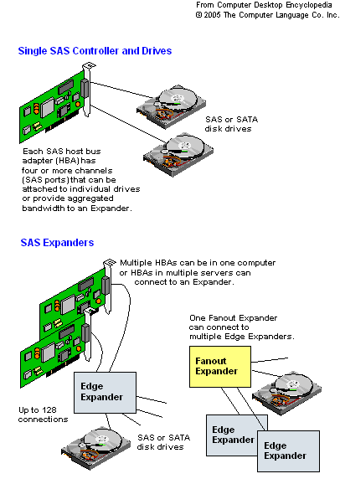
The sum of all devices used in an SAS implementation is known as the "SAS Domain". This is merely a term to refer to the network of devices and their corresponding "World Wide Names" (WWN). The World Wide Name is a globally unique identifier assigned to a device assigned by the manufacturer.

Point-to-point configurations provide for high bandwidth, but require intermediary devices between initiator devices (or hosts) and target devices (or peripheral devices) to provide a topology where there may be more than two devices in a system. Inexpensive expanders are the intermediary devices defined for SAS. SAS expanders allow for systems in which more than one initiator may have a connection to more than one target (as is allowed by parallel SCSI).

Another of the original goals for the SAS effort was to maintain or expand the maximum number of devices beyond the maximum number (16) that could exist in a parallel SCSI domain. A SAS system with expanders may address up to 16,256 devices in a single SAS domain. SAS expanders are also defined so that end devices connecting to expanders may be either SAS devices or SATA devices, satisfying the goal of allowing heterogeneous system configurations.

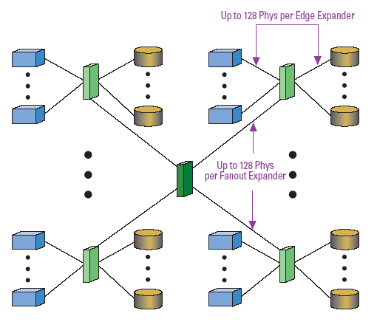
Figure 1.2 A Maximum SAS Domain

Figure 1.2 shows an example of a maximum SAS system configuration. The rectangular box in the center of the figure represents a fan out expander. There may be one fan out expander per SAS domain (effectively, a SAS system). A fan out expander may connect to a maximum of 128 SAS devices. These may be any combination of edge expanders, initiators, or storage devices. The rectangular boxes connected to the fan out expander represent edge expanders. An edge expander may connect to a maximum of 128 SAS devices. This includes no more that one other expander, with the rest of the connected devices being either initiators or storage devices. The rectangular boxes connected to the edge expanders represent initiators. The cylinders connected to the edge expanders represent storage devices. These may be either SAS or SATA devices.

SAS Protocol
Serial Attached SCSI supports three transport protocols:
- Serial SCSI Protocol (SSP) - Supporting SAS disk drives.
- Serial ATA Tunneling Protocol (STP) - Supporting SATA disks.
- Serial Management Protocol (SMP) - for managing SAS Expanders

One of the biggest challenges for the SAS working group was to define a method to address all of the possible ports that could be in a SAS domain. This is a simple task in parallel SCSI, where devices have addresses pre-assigned in hardware. The key to the solution for SAS is to use globally unique, worldwide name (WWN) identifiers for all SAS devices (almost every type of SCSI device today has a WWN).
During power-on, all of the devices in a SAS system establish connections with each other and exchange WWNs so that the number and types of devices connected to the SAS domain can be determined. When a new device is added to a SAS system that is in operation (i.e., the device is hot plugged), or when a device is removed from an operating SAS system, notification of the event is sent to each initiator so it may adjust to the new configuration. Expanders provide WWNs for SATA devices for both power-on and hot plugging events. Once system initialization and discovery are complete, SATA protocol is used to communicate with SATA devices and SAS protocol is used to communicate with SAS devices.
For SATA devices, the protocol is defined by the SATA working groups. For SAS devices, the protocol highly leverages protocols described in other SCSI standards (such as the SCSI Parallel Interface, or SPI, standard). Transfer of commands, data, status, and other information for SAS devices is accomplished using packets very similar to the packets used for information unit transfers for parallel SCSI (as defined in SPI) and the packets defined for Fiber Channel. The format of SAS packets (called "frames") is almost identical to Fiber Channel packets. The payload of the packets consists of command descriptor blocks (CDBs) and other SCSI constructs defined in other SCSI standards (such as the SCSI Primary Command Set and SCSI Block Commands). Using SCSI protocol and architecture, it is possible to bridge from a SAS system to other systems using Infiniband, iSCSI, or Fiber Channel, which also use the same SCSI objects. Leveraging elements of the SCSI protocol, including Fiber Channel where appropriate, was another of the initial goals for SAS, as there was a strong desire on the part of all of the members of the working group to provide maximum compatibility with current infrastructure and minimize the risk and cost of transition to the new interface.

SAS Architecture

Architecture Overview
A SAS domain contains one or more SAS devices and a service delivery subsystem. A SAS domain may be a SCSI domain. A SAS device contains one or more SAS ports. A SAS device may be a SCSI device. A SAS port contains one or more phys. A SAS port may be a SCSI port. The service delivery subsystem in a SAS domain may contain expander devices. Expander devices contain expander ports and one SMP port. An expander port contains one or more phys. An expander device shares its phys with the SAS device(s) contained within the expander device.

Physical Links and PHYS
A physical link is a set of four wires used as two differential signal pairs. One differential signal transmits in one direction while the other differential signal transmits in the opposite direction. Data may be transmitted in both directions simultaneously.
A physical phy contains a transceiver which electrically interfaces to a physical link, which attaches to another physical phy. Phys are contained in ports. Phys interface to the service delivery subsystem. Figure 1.3 shows two phys attached with a physical link.

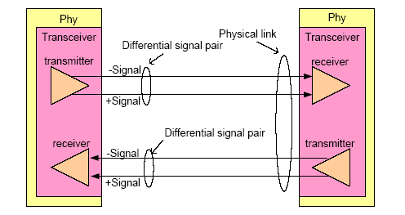
Figure 1.3 Physical Link and Phy

An attached phy is the phy to which a phy is attached over a physical link. A device (i.e., a SAS device or expander device) contains one or more phys.

SAS Devices
A SAS device contains one or more SAS ports, each containing one or more phys (i.e., a SAS port may be a narrow port or a wide port). Figure 1.4 shows examples of SAS devices with different port and phy configurations.

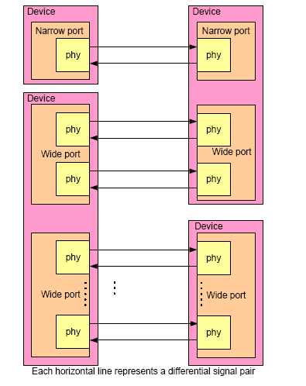

Figure1.4 SAS devices

An end device is a SAS device that is not contained in an expander device.

Service Delivery Subsystem
The service delivery subsystem is either:
- a set of physical links between a SAS initiator port and a SAS target port; or
- a set of physical links and expander devices, supporting more than two SAS ports.

Domains
Figure 1.5 shows a SAS domain.

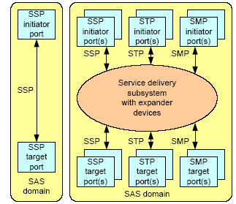

Figure 1.5 SAS Domain

SAS Layered Architecture
The SAS standard divides the SAS architecture into six layers and defines the function of each layer. From lowest to highest in the SAS architecture, these layers are: the physical layer, the phy layer, the link layer, the port layer, the transport layer, and the application layer. Figure 1.6 shows the SAS architecture layers and the relationships between them. The SAS physical layer includes definitions for hardware such as cables, connectors, and transceivers. The SAS phy layer includes description of the lowest level protocol including the encoding scheme and power on/reset sequence. The SAS link layer describes how the phy layer connection management is controlled. The SAS port layer describes the interface between the link layer and the transport layer, including how requests from the transport layer are received and interpreted, and how link layers are selected to establish connections to service the requests. The SAS transport layer describes how commands, data, status, etc., are encapsulated into SAS frames and how received SAS frames are disassembled. The SAS application layer describes specific details for the types of applications that may be used for SAS: SCSI, ATA, and SAS management functions.

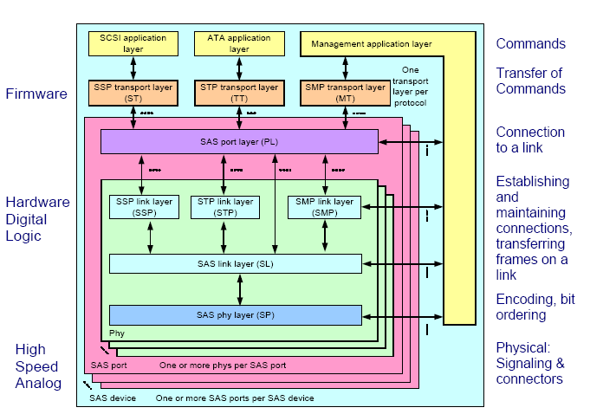

Figure 1.6 Serial Attached SCSI Multi-protocol Connection Support

SAS Physical Layer
The physical layer is the lowest layer of the architecture defined in the SAS standard. The description of the physical layer in the SAS standard includes specifications for the SAS cables and connectors, and the electrical characteristics and test conditions for the SAS transmitter and receiver circuitry in the SAS phy.

The physical layer defines:
a) Passive interconnect (e.g., connectors and cable assemblies); and
b) Transmitter and receiver device electrical characteristics.
Within this standard, references to connector gender use the terms plug and receptacle as equivalent to the terms free and fixed, respectively, that may be used in the references that define the connectors. Fixed and free terminology has no relationship to the application of the connector.

SAS Phy Layer
The phy layer is the second lowest layer of the SAS architecture defined in the SAS standard. The SAS phy layer is contained in the SAS phy, along with the SAS physical layer and the SAS link layer. The phy layer defines 8b10b coding and OOB signals. Phy layer state machines interface between the link layer and the physical layer to perform the phy reset sequence and keeps track of dword synchronization.

8b10b coding

8b10b coding overview
All information transferred in SAS is encoded into 10-bit characters using 8b10b encoding. Information includes data bytes (e.g., representing data in a frame) and control bytes (e.g., used for frame delimiters).Running disparity (RD) shall be maintained separately on each physical link in each direction. During a connection (see 4.1.12), expander devices shall convert incoming 10-bit characters to 8-bit bytes and generate the 10-bit character with correct disparity for the output physical link. Phys within a device may or may not begin operation with the same disparity after the reset sequence.

8b10b coding introduction
Information to be transmitted across a physical link shall be encoded eight bits at a time into a 10-bit character and then transmitted serially bit-by-bit across the physical link. Information received over the physical link shall be collected ten bits at a time, and those characters that are used for data, called data characters, shall be decoded into the correct 8-bit data bytes. The 10-bit characters support all 256 8-bit combinations. Some of the remaining 10-bit characters, referred to as control characters, are used for functions that are to be distinguishable from the contents of a frame. The rest of the 10-bit characters are invalid characters. 8b10b coding ensures that sufficient transitions are present in the serial bit stream to make clock recovery possible at the receiver. Such encoding also greatly increases the likelihood of detecting any single or multiple bit errors that may occur during transmission and reception of information. In addition, some of the control characters of the transmission code contain a distinct and easily recognizable bit pattern called a comma pattern which assists a receiver in achieving character and dword alignment on the incoming bit stream.

Out of band (OOB) signals

OOB signals overview
Out of band (OOB) signals are low-speed signal patterns that do not appear in normal data streams. OOB signals consist of defined amounts of idle time followed by defined amounts of burst time. During the idle time, the physical link carries D.C. idle (see 3.1.45). During the burst time, the physical link carries signal transitions. The signals are differentiated by the length of idle time between the burst times. SATA defines two OOB signals: COMINIT/COMRESET and COMWAKE. COMINIT and COMRESET are used in this standard interchangeably. Phys compliant with this standard identify themselves with an additional SAS-specific OOB signal called COMSAS.

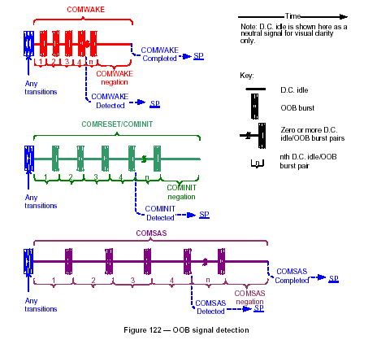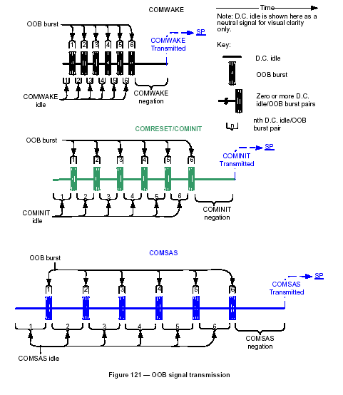

Phy reset sequences

Phy reset sequences overview
The phy reset sequence consists of:
1) an OOB sequence;
2) a speed negotiation sequence; and
3) if the physical link is a SAS physical link and multiplexing is enabled, a multiplexing sequence. The phy reset sequence shall only affect the phy, not the port or device containing the phy or other phys in the same port or device.

A phy shall originate a phy reset sequence after:
a) power on;
b) hard reset (i.e., receiving a HARD_RESET primitive sequence before an IDENTIFY address frame);
c) management application layer request;
d) losing dword synchronization and not attempting to re-acquire dword synchronization;
e) Receive Identify Timeout timer expires; and
f) for expander phys, after a hot-plug timeout .

A SAS phy may originate a phy reset sequence after a hot-plug timeout.
After receiving a HARD_RESET primitive sequence before an IDENTIFY address frame, a phy should start the phy reset sequence within 250 ms.

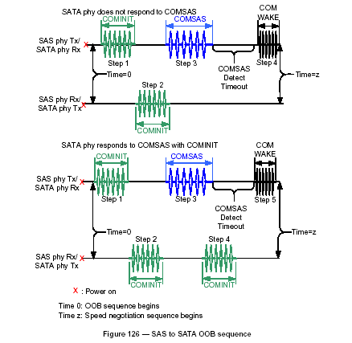

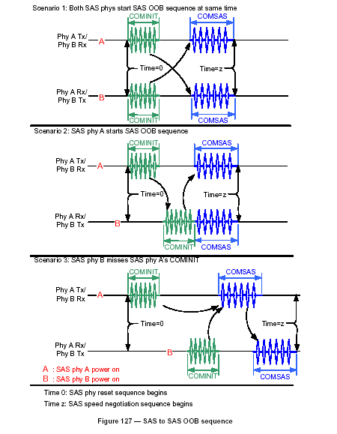

SAS speed negotiation sequence

SAS speed negotiation sequence overview

The SAS speed negotiation sequence establishes communications between the two phys of a physical link at the highest possible transmission rate. The SAS speed negotiation sequence is a peer-to-peer negotiation technique that does not assume initiator and target (i.e., host and device) roles. The rules for speed negotiation are the same for both participating phys. The SAS speed negotiation sequence consists of a set of speed negotiation windows (SNWs). Each SNW is identified by a name (e.g., Speed Negotiation Window-1 or SNW-1).
SNWs conform to one of three defined types:
a) Speed negotiation without training: SNW-1, SNW-2 and Final-SNW;
b) Phy capabilities exchange: SNW-3; and
c) Speed negotiation with training: Train-SN).
Many of the timing parameters used for defining the SNWs are common to multiple SNW types. A SAS speed negotiation sequence may or may not include all three types of SNWs. Phys may implement a subset of SNWs provided that the subset implements a valid speed negotiation sequence. The transmitter device shall use SAS signal output levels during the SAS speed negotiation sequence.

Speed negotiation window (SNW) definitions

SNW definitions overview

During each SNW, a phy shall either:
a) if it supports the SNW, transmit and receive as defined for the SNW; or
b) if it does not support the SNW, transmit D.C. idle and not receive.
If a phy supports the SNW and receives the expected transmission, then the SNW is valid. If a phy does not receive the expected transmission from the attached phy, then the SNW is invalid.

SNW-1, SNW-2, and Final-SNW

Figure below defines SNW-1, SNW-2, and Final-SNW, including:
a) SNW time (SNWT);
b) rate change delay time (RCDT);
c) speed negotiation transmit time (SNTT);
d) speed negotiation lock time (SNLT); and
e) actual lock time (ALT).

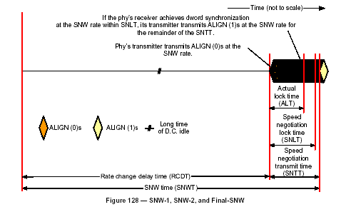

SAS speed negotiation sequence

The SAS speed negotiation sequence consists of a set of SNWs in the order shown in.

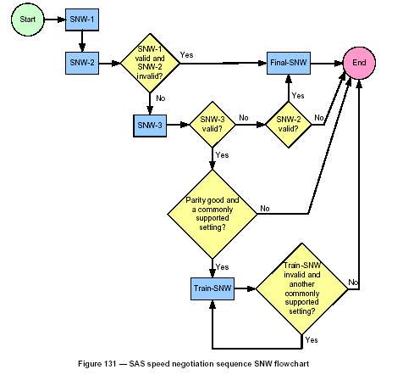

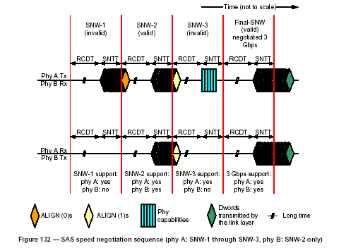

Multiplexing sequence

If SNW-3 indicates multiplexing is enabled, the phy shall transmit the multiplexing sequence immediately after the speed negotiation sequence.
The multiplexing sequence is:
1) MUX (LOGICAL LINK 0);
2) MUX (LOGICAL LINK 1);
3) MUX (LOGICAL LINK 0);
4) MUX (LOGICAL LINK 1);
5) MUX (LOGICAL LINK 0); and
6) MUX (LOGICAL LINK 1).
The phy shall not transmit deletable primitives for physical link rate tolerance management during the multiplexing sequence. If SNW-3 indicates multiplexing is not enabled, the phy shall not transmit the multiplexing sequence. The phy shall assign the incoming logical links to its logical phys based on the first MUX primitive it receives:
a) MUX (LOGICAL LINK 0) indicates the position of logical link 0 and indicates the next dword is in logical link 1; or
b) MUX (LOGICAL LINK 1) indicates the position of logical link 1 and indicates the next dword is in logical link 0.
The phy shall process MUX primitives in logic running off the received clock without using an elasticity buffer, because they are not accompanied by additional deletable primitives (e.g., ALIGNs and/or NOTIFYs).

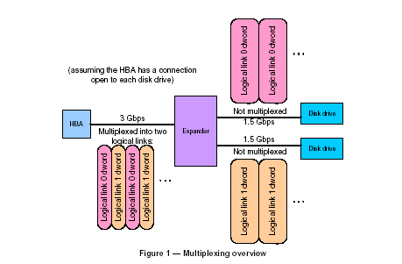

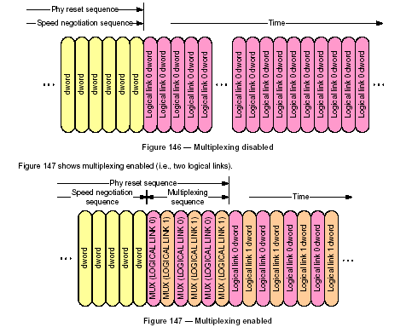

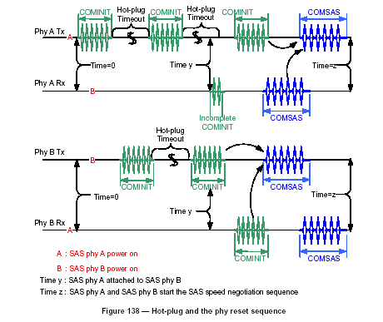

SAS Link Layer

Link layer overview
The link layer defines primitives, address frames, and connections. Link layer state machines interface to the port layer and the phy layer and perform the identification and hard reset sequences, connection management, and SSP, STP, and SMP specific frame transmission and reception.

Primitives

Primitive’s overview
Primitives are dwords whose first character is a K28.3 or K28.5. Primitives are not considered big-endian or little-endian; they are just interpreted as first, second, third, and last characters. Table below defines the primitive format.
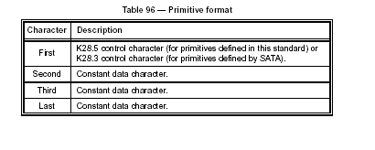

Primitive sequences
Table below summarizes the type of Primitive Sequences.

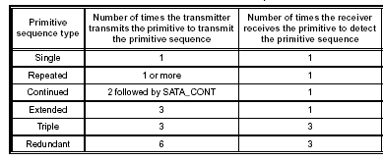

Single primitive sequence
Primitives labeled as single primitive sequences (e.g., RRDY, SATA_SOF) shall be transmitted one time to form a single primitive sequence. Receivers count each primitive received that is labeled as a single primitive sequence as a distinct single primitive sequence. ALIGNs, NOTIFYs, and MUXs are called deletable primitives.

Repeated primitive sequence
Primitives that form repeated primitive sequences (e.g., SATA_PMACK) shall be transmitted one or more times. Only STP primitives form repeated primitive sequences. Any number of deletable primitives may be sent inside repeated primitive sequences. Receivers do not count the number of times a repeated primitive is received (i.e., receivers are simply in the state of receiving the primitive). An expander device forwarding a repeated primitive sequence may transmit more repeated primitives than it receives (i.e., expand) or transmit fewer repeated primitives than it receives (i.e., contract).

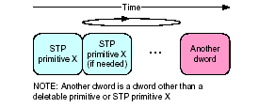
Repeated Primitive Sequence

Continued primitive sequence
Primitives that form continued primitive sequence shall be transmitted two or more times. Any number of deletable may be sent inside continued primitive sequences.

Extended primitive sequence
Primitives that form extended primitive sequences (e.g. AIP) shall be transmitted three times consecutively. Any number of deletable primitives may be sent inside extended primitive sequences. A receiver shall detect an extended primitive sequence after the primitive is received one time. The receiver shall process an extended primitive sequence the same as a single primitive sequence.

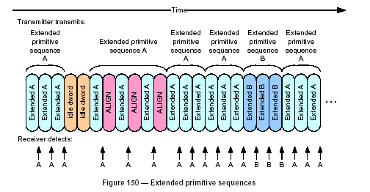

Triple primitive sequence
Primitives that form triple primitive sequences (e.g. CLOSE (NORMAL)) shall be transmitted three times consecutively. Any number of deletable primitives may be sent inside triple primitive sequences.
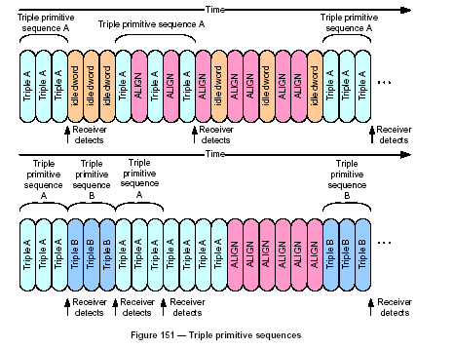

Redundant primitive sequence
Primitives that form redundant primitive sequences (e.g., BROADCAST (CHANGE)) shall be sent six times consecutively. Any number of deletable primitives may be sent inside primitive sequences as described.

A receiver shall detect a redundant primitive sequence after the identical primitive is received in any three of six consecutive dwords. After detecting a redundant primitive sequence, a receiver shall not detect a second instance of the same redundant primitive sequence until it has received six consecutive dwords that are not any of the following:

- the original primitive; or
- a deletable primitive.

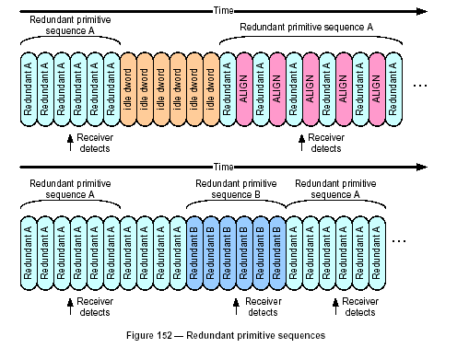

Physical link rate tolerance management

Physical link rate tolerance management overview
The internal clock for a device is typically based on a PLL with its own clock generator and is used when transmitting dwords on the logical link. When receiving, however, dwords need to be latched based on a clock derived from the input bit stream itself. Although the input clock is nominally a fixed frequency, it may differ slightly from the internal clock frequency up to the physical link rate tolerance defined.
Over time, if the input clock is faster than the internal clock, the phy receiver may receive a dword and not be able to forward it to an internal buffer; this is called an overrun. If the input clock is slower than the internal clock, the phy receiver may not have a dword when needed in an internal buffer; this is called an underrun. To solve this problem, phy transmitters insert deletable primitives in the dword stream. Phy receivers may pass deletable primitives through to their internal buffers, or may strip them out when an overrun occurs. Phy receivers add deletable primitives when an underrun occurs. The internal logic shall ignore all deletable primitives that arrive in the internal buffers. Elasticity buffer circuitry, as shown in figure below, is required to absorb the slight differences in frequencies between the phys. The depth of the elasticity buffer is vendor-specific but shall accommodate the physical link rate tolerance management deletable primitive insertion requirements.

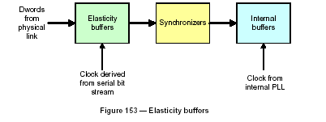

CRC

CRC overview
All frames include cyclic redundancy check (CRC) values to help detect transmission errors.

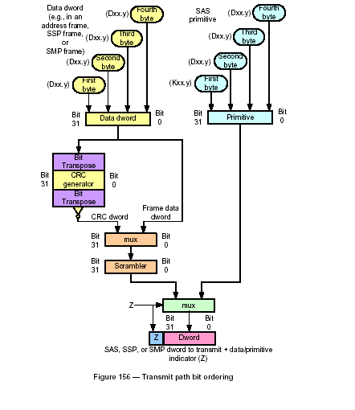
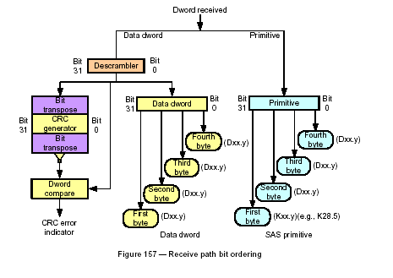

Address frames

Address frames overview
Address frames are used for the identification sequence and for connection requests. Address frames are preceded by SOAF and followed by EOAF as shows in figure below. Address frames shall only be sent outside connections. Address frames shall not be terminated early. All data dwords in an address frame shall be scrambled.

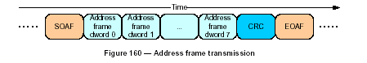

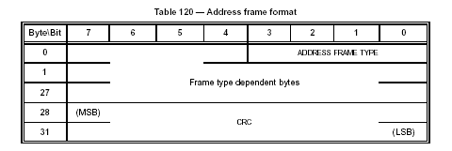

Identification and hard reset sequence

Identification and hard reset sequence overview
After the phy reset sequence has been completed indicating the physical link is using SAS rather than SATA, each logical phy either:
a) Performs and identification sequence by transmitting an IDENTIFY address frame; or
b) Performs a hard reset sequence by transmitting a HARD_RESET primitive sequence If multiplexing is enabled, the identification sequence and hard reset sequence begin with a multiplexing sequence.

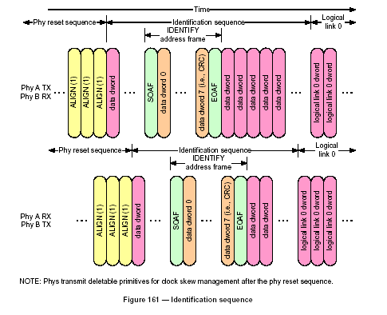
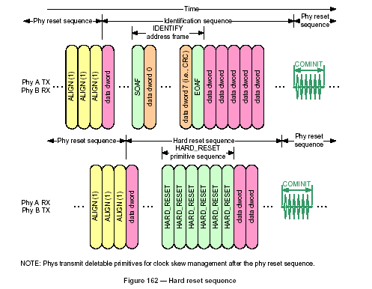

SAS Port Layer
The port layer (PL) state machines interface with one or more SAS link layer state machines and one or more SSP, SMP, and STP transport layer state machines to establish port connections and disconnections. The port layer state machines also interpret or pass transmit data, receive data, commands, and confirmations between the link and transport layers.

Port Layer State Machine
Figure below shows the Port Layer Examples and the State Machine of Port Layer.

Port Layer Examples

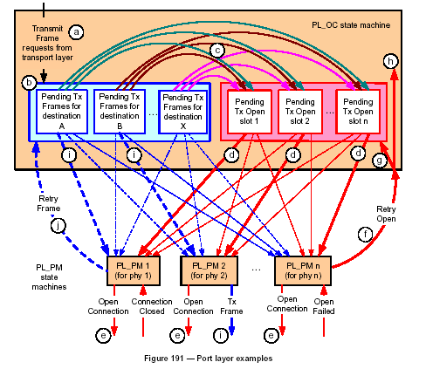

Port Layer Manager State Machine (Part 1)

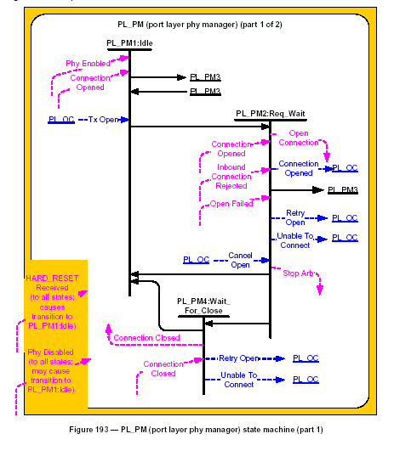

Port Layer Manager State Machine (Part2)

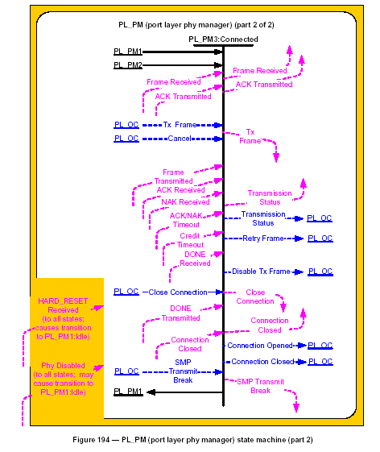

Port Layer Overall Control State Machine

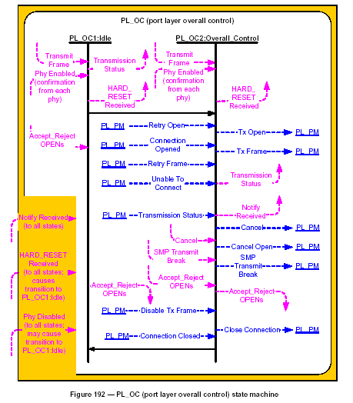

SAS Transport Layer
The transport layer defines frame formats. Transport layer state machines interface to the application layer and port layer and construct and parses frame contents. For SSP, the transport layer only receives frames from the port layer for which an ACK is going to be transmitted by the link layer.

Let us take as an example the write and read command sequence for SSP frames. Figure below shows the write and read command sequences for SSP frames.

Write command sequence

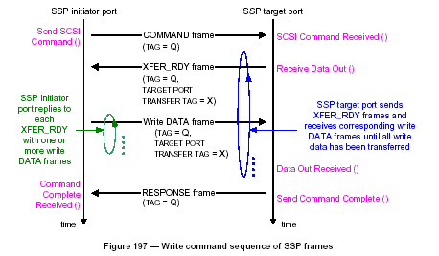

Read command sequence

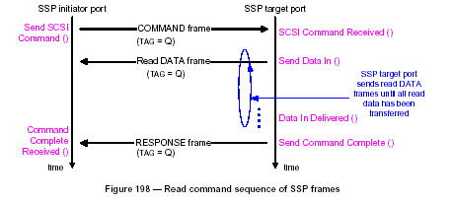

Bidirectional command sequence

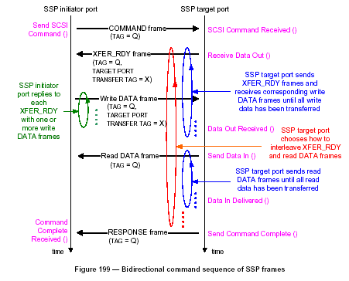

SAS Application Layer
The application layer is the highest layer of the SAS architecture defined in the SAS standard. The application layer is the only layer that is not contained in a SAS port. There may be up to three application layers contained in a SAS device: a SCSI application layer, an ATA application layer, and a management application layer. The application layers interface with their associated transport layers in each SAS port implemented by the device.
An application layer generates requests and sends the requests to its associated transport layer (for example, the SCSI application layer sends a request to an SSP initiator transport layer to transmit a SCSI command to an SSP target port), and receives responses to the requests from the associated transport layer. The application layer defines SCSI, ATA, and management specific features.

Verification IP

Introduction
The Verification Intellectual Property (Verification IP) is the verification model and overall environment, which aids designers and verification engineers in the task of validating the functionality of their design. The Verification IP (VIP) is used in all levels of simulation-based verification. The Verification Intellectual Properties are based on standard protocols used in Networking, computer and system designs, such as PCI/PCIx, USB, and Ethernet. These components are pre-verified to the standard protocols and contain the necessary infrastructure for test bench generation and checking mechanisms as well as all the appropriate routines to create individual protocols, commonly known as Bus Functional Models (BFM).

Verification IP components provide enhanced productivity to the system and ASIC designers by reducing the time to create the verification infrastructure and test bench environment including the required models. The verification IP allows verification and design teams to quickly and easily create random scenarios. They also allow users to easily create directed test scenarios and test sequences for their designs. These test cases greatly aid users in finding functional bugs early in design cycle, hence reducing the overall verification time. A typical SoC and verification IP with representation of test bench environments is shown in Figure 2.1.

Figure 2.1 Verification IP, Test Bench environment

SAS nVS (nSYS Vérification Suite)
SAS nVS is the overall environment, which aids designers and verification engineers in the task of verifying the functionality of a SAS DUT. The basic purpose of the SAS nVS is to provide a complete verification solution for functional verification of a SAS DUT. The SAS nVS transmits/receives data to/from a SAS DUT. The received data is checked against expected data.

The SAS nVS consists of:
- SAS BFM
- SAS Monitor
- SAS Assertion Checker
- Test Suites

Features
The SAS nVS has the following features:
- Generates and drives bus traffic as SAS Initiator.
- Responds to transactions as SAS Target
- Supports SAS specifications Rev 2
- Supports Multiple Ports per SAS Device
- Supports Multiple Phy per Port
- Supports Narrow ports as well as Wide ports
- Supports all the three protocols, namely SSP,SMP and STP
- Supports 1-bit serial, 10-bit parallel, 40-bit parallel interface
- Simple and flexible BFM tasks

Architecture Overview
The SAS nVS consists of:
- SAS Host BFM
- SAS Device BFM
- SAS Monitor
- SAS Checker
- Test Suites

The block diagram of the SAS Verification IP is as follows:

SAS Requester/Completer BFM
SAS Checker
SAS Monitor

Test Suites
DUT
Test bench
Figure 2.2 Block Diagram of SAS Verification IP

The SAS Monitor & the SAS Assertion Checker combined together are independent modules and can be used with any BFM. They are both enabled by default.

SAS BFM
BFM (Bus Functional Model) is an independent module. The top level task of the BFM should have the following tasks:

- task do_cmd()
- task do_cfg()
- task do_cfg_rd()
- task do_err()

Although do_pkt is a top level task for the BFM, it should be re-used from the nVM library.

do_cmd
The objective of the do_cmd is to allow all possible commands in the protocol/standard to be executed by the BFM.

Syntax do_cmd (cmd, pvalue);
The do_cmd has command features such as:
- send any legal or error injected Transport Layer frames,
- send any legal or error injected Link Layer frames,
- send primitives directly to the Link Layer of the BFM, bypassing the higher abstracted Transport and port layer,
- Send Phy layer OOB sequences directly to the physical layer of the BFM, bypassing the higher abstracted Transport layer and Link layers.

do_cfg
The objective of the do_cfg is to allow all possible parameters in the protocol/standard to be configured. There are a number of standard do_cfg that would be used in all nVS.

Syntax do_cfg (parameter, pvalue);
The do_cfg configures BFM parameters with features such as:
- ability to specify any byte in a frame or between frames to a specific value,
- ability to send raw user defined Frames, Primitives,
- Ability to configure parameters to expedite testing of cases requiring large number of transaction such as replay timeout etc.
- parameter to configure Response for specified frame count,
- ability to carry over parameters across transactions,
- SAS_MODE_RANDOM_RESPONSE mode to generate random responses as Target.

do_cfg_rd
This task reads the value of a BFM parameter.

Syntax do_cfg_rd (parameter, pvalue);

do_err
Provides the ability to inject different types of errors,

Syntax do_err (err_name, pvalue);
do_err injects errors with features such as:
- ability to inject approx. 180 different types of errors,
- ability to inject errors for frames being generated,
- ability to inject error in any byte in a frame or between frames,
- ability to add multiple errors in a frame,
- ability to inject errors either in a directed way or randomly

do_pkt ()
The task do_pkt creates a data packet in the BFM based upon the data specified by the user. This task is used for passing the data to be sent by the initiator in case of write commands and for passing the expected data in case of a read command.

Syntax do_pkt (index, data);

SAS checker
The Protocol Checker is a Verification Component, which can be used to check the Compliance to a Protocol. Main aim of the Protocol Checker is to catch bugs in the DUT. Protocol checker should be designed and implemented in such a way that it can perform exhaustive checking.
The function of protocol checker is to ensure that the logical activities on the I/O bus comply with the standard protocol definition for the bus architecture. The checkers would be able to flag any violation from the protocol standards.

SAS Monitor
Monitor is a component of the SAS nVS. The SAS Monitor & the SAS Assertion Checker combined together are independent modules and can be used with any BFM. Monitor is enabled by default.It allows the debugging of complex scenarios and has many features like:
- Flexible, user configurable display options
- Performance analysis like timeouts, latency etc.
- Functional coverage.

Test Suites
Exhaustive built-in tests (with ability to replay failed tests): The SAS Verification IP allows user to carry out the following in-built tests:
- Basic Test: Consists of tests designed to verify the basic functionality of a SAS based SoC.
- Directed Test: Consists of exhaustive tests designed to test combination of parameters and commands
- Error Test: Consists of injecting approximately 180 possible errors
- Random Test: Consists of exhaustive random tests designed to test combination of parameters and commands including error injections.
- User Test: Allows user to include own tests

  - Different Configuration OF SAS Verification Environment

DUT as an initiator: This configuration is designed for development of DUT that is an Initiator

TX
RX
RX
TX
SAS Checker
SAS Monitor
User BFM
SAS BFM (Target)
Test Suites
Log
DUT(Initiator)

DUT as a target: This configuration is designed for development of DUT that is Target.

TX
RX
RX
TX
SAS Checker
SAS Monitor
User BFM
SAS BFM (Initiator)
Test Suites
Log
DUT(Target)

DUT as target/initiator: This configuration is designed for development of DUT that is Target as well as initiator

SAS Monitor

SAS Monitor

User BFM

User BFM

SAS BFM

Test Suites

Test Suites

Log

DUT

TP

IP

TP

IP

SAS Checker

TX

RX

RX

TX

RX

RX

RX

TX

RX

RX

TX

DUT as an expander device: This configuration is designed for development of DUT that is an Expander. The example below shows environment for a 2-port Expander

SAS Monitor2
SAS BFM
(Target)
SAS BFM
(Target)
SAS Checker2
SAS Monitor1
SAS Checker1
SAS BFM
(Initiator)

DUT
(Expander)

SAS Checker
SAS Monitor
Test suites
Log

VERILOG VERIFICATION OF SERIAL PROTOCOLS

SAS BFM connected back-to-back: This configuration is essentially used for testing of BFMs as well as the Test environment. It consists of a BFM instantiated as Initiator and Target and an instance of Monitor & Checker as shown in the sample test bench.

TX
RX
RX
TX
SAS Checker
SAS Monitor
SAS BFM (Initiator Port)
SAS BFM (target Port)
Test Suites
Log

Design

3. Design
SAS Requester/Completer BFM
SAS Checker
SAS Monitor

Test Suites
DUT
Test bench

Figure 4.1 Block Diagram of SAS Verification IP

User Test Suite

// --------------------------------------------------------------------
// This confidential and proprietary software may be used only as
// authorized by a licensing agreement from nSys
// In the event of publication, the following notice is applicable:
//
// (C) Copyright 2007 nSys
// All rights reserved
//
// The entire notice above must be reproduced on all authorized
// copies
//
// $Source:
// /server/local/root/nsys_cvsroot_apex/nvs_cg/src/include/cg_file_fun.c,v
// $
// $Author: dolly $
// $Date: 2008/01/11 10:59:37 $
// $Revision: 1.14 $
//
// Project Name : nvs_sas
// Module : nvs_sas_test
// Abstract : This file contains the User Test suit for nVS SAS
// Tasks : user_test
//
// --------------------------------------------------------------------
// --------------------------------------------------------------------
// Task user_test
// --------------------------------------------------------------------
task user_test;
input [31:0] firstcase; // case no of first test case to be simulated
input [31:0] lastcase ; // case no of last test case to be simulated
integer caseno;
reg align_notify_freq;
reg [31:0] rcv_identify_timer;
reg open_timeout_timer;
reg close_timeout_timer;

begin
for(caseno = firstcase; caseno <= lastcase; caseno = caseno + 1)
begin
case(caseno)
//------------------------------------------------------------------------
// Case 1: SAS_TL_CMD_CHG_ALS
// Description: Send the command SAS_TL_CMD_CHG_ALS from Initiator
// with do_cfg SAS_TL_RETRANSMIT set to 1'b0
// & do_cfg SAS_TL_CHGING_DATA_PTR set to 1'b
// Expected Result: The Target will send the XFER_READY frame
// to initiate Data transmission
//------------------------------------------------------------------------
1:
begin
`m0.print_start_case("USER ","Case 1:SAS_TL_CMD_CHG_ALS");
`p0.max_iu_size=32;
//`p0.do_cfg(`SAS_TL_HASH_SRC_ADDR, 24'h0d0d0d);
`p0.do_cfg(`SAS_TL_RETRANSMIT,1'b0);
`p0.do_cfg(`SAS_TL_CHGING_DATA_PTR,1'b0);
`p0.do_cmd(`SAS_TL_CMD_CHG_ALS, 64'h0000_0000_0000_0002, 320);
@(`SAS_TB.event_bus_idle);
`p0.max_iu_size=512;
end // case: 1
//------------------------------------------------------------------------
// Case 2: SAS_TL_CMD_CHG_ALS
// Description: Send the command SAS_TL_CMD_CHG_ALS from Initiator
// with do_cfg SAS_TL_TAG set to 16'h0001,
// do_cfg SAS_TL_LUN set to 64'h00d2_0000_00d2_0000
// & do_cfg SAS_TL_EN_FIRST_BST set to 1'b1.
// Expected Result: The Target will send the XFER_READY frame
// to initiate Data transmission
//------------------------------------------------------------------------
2:
begin
`m0.print_start_case("USER ","Case 2:SAS_TL_CMD_CHG_ALS");
`p0.max_iu_size=32;
`p0.do_cfg(`SAS_TL_TAG, 16'h0001);
`p0.do_cfg(`SAS_TL_LUN, 64'h00d2_0000_00d2_0000);
`p0.do_cfg(`SAS_TL_EN_FIRST_BST, 1'b1);
`p0.do_cmd(`SAS_TL_CMD_CHG_ALS, 64'h0000_0000_0000_0002, 320);
@(`SAS_TB.event_bus_idle);
`p0.max_iu_size=512;
end // case: 2
//------------------------------------------------------------------------
// Case 3: SAS_TL_CMD_INQUIRY
// Description: Send the command SAS_TL_CMD_INQUIRY from Initiator
// with do_cfg SAS_TL_TASK_PRIORITY set to 4'b1010
// & do_cfg SAS_TL_TASK_ATTR set to 3'b010
// Expected Result: The Target will send the DATA frame in
// response to the command
//------------------------------------------------------------------------
3:
begin
`m0.print_start_case("USER ","Case 3: SAS_TL_CMD_INQUIRY");
`p0.do_cfg(`SAS_TL_TASK_PRIORITY,4'b1010);
`p0.do_cfg(`SAS_TL_TASK_ATTR, 3'b010);
`p0.do_cmd(`SAS_TL_CMD_INQUIRY, 64'h0000_0000_0000_0002, 3200);
@(`SAS_TB.event_bus_idle);
end // case: 3
//------------------------------------------------------------------------
// Case 4: SAS_TL_CMD_LOG_SEL
// Description: Send the command SAS_TL_CMD_LOG_SEL from Initiator
// with do_cfg SAS_TL_EN_FIRST_BST set to 1'b1,
// do_cfg SAS_TL_TASK_PRIORITY set to 4'b1010
// & do_cfg SAS_TL_TASK_ATTR set to 3'b010
// Expected Result: The Target will send the XFER_READY frame
// in response to the command
//------------------------------------------------------------------------
4:
begin
`m0.print_start_case("USER ","Case 4:SAS_TL_CMD_LOG_SEL");
`p0.do_cfg(`SAS_TL_EN_FIRST_BST, 1'b1);
`p0.do_cfg(`SAS_TL_TASK_PRIORITY,4'b1010);
`p0.do_cfg(`SAS_TL_TASK_ATTR, 3'b010);
`p0.do_cmd(`SAS_TL_CMD_LOG_SEL, 64'h0000_0000_0000_0002, 32);
@(`SAS_TB.event_bus_idle);
end // case: 4
//------------------------------------------------------------------------
// Case 5: SAS_TL_CMD_LOG_SNS
// Description: Send the command SAS_TL_CMD_LOG_SNS from Initiator
// with do_cfg SAS_TL_HASH_SRC_ADDR set to 24'h0d0d0d ,
// do_cfg SAS_TL_TAG set to 16'h0001
// & do_cfg SAS_TL_LUN set to 64'h00d2_0000_00d2_0000
// Expected Result: The Target will send the DATA frame in
// response to the command
//------------------------------------------------------------------------
5:
begin
`m0.print_start_case("USER ","Case 5:SAS_TL_CMD_LOG_SNS");
//`p0.do_cfg(`SAS_TL_HASH_SRC_ADDR, 24'h0d0d0d);
`p0.do_cfg(`SAS_TL_TAG, 16'h0001);
`p0.do_cfg(`SAS_TL_LUN, 64'h00d2_0000_00d2_0000);
`p0.do_cmd(`SAS_TL_CMD_LOG_SNS, 64'h0000_0000_0000_0002, 32);
@(`SAS_TB.event_bus_idle);
end // case: 5
//------------------------------------------------------------------------
// Case 6: SAS_TL_CMD_MOD_SEL_6
// Description: Send the command SAS_TL_CMD_MOD_SEL_6 from
// Initiator with do_cfg `SAS_TL_TASK_PRIORITY set to 4'b1010,
// do_cfg SAS_TL_TASK_ATTR set to 3'b010
// & do_cfg SAS_TL_NACA_CTRL set to 1'b0
// Expected Result: The Target will send the XFER_READY frame in
// response to the command
//------------------------------------------------------------------------
6:
begin
`m0.print_start_case("USER ","Case 6:SAS_TL_CMD_MOD_SEL_6");
`p0.do_cfg(`SAS_TL_TASK_PRIORITY,4'b1010);
`p0.do_cfg(`SAS_TL_TASK_ATTR, 3'b010);
`p0.do_cfg(`SAS_TL_NACA_CTRL, 1'b0);
`p0.do_cmd(`SAS_TL_CMD_MOD_SEL_6, 64'h0000_0000_0000_0002, 32);
@(`SAS_TB.event_bus_idle);
end // case: 6
//------------------------------------------------------------------------
// Case 7: SAS_TL_CMD_MOD_SEL_10
// Description: Send the command SAS_TL_CMD_MOD_SEL_10 from
// Initiator with do_cfg SAS_TL_LUN set to 64'h00d2_0000_00d2_0000
// do_cfg `SAS_TL_TASK_PRIORITY set to 4'b1010,
// do_cfg SAS_TL_TASK_ATTR set to 3'b010
// Expected Result: The Target will send the XFER_READY frame in
// response to the command
//------------------------------------------------------------------------
7:
begin
`m0.print_start_case("USER ","Case 7: Case:SAS_TL_CMD_MOD_SEL_10");
`p0.do_cfg(`SAS_TL_LUN, 64'h00d2_0000_00d2_0000);
`p0.do_cfg(`SAS_TL_TASK_PRIORITY,4'b1010);
`p0.do_cfg(`SAS_TL_TASK_ATTR, 3'b010);
`p0.do_cmd(`SAS_TL_CMD_MOD_SEL_10, 64'h0000_0000_0000_0002, 32);
@(`SAS_TB.event_bus_idle);
end // case: 7
//------------------------------------------------------------------------
// Case 8: SAS_TL_CMD_MOD_SNS_6
// Description: Send the command SAS_TL_CMD_MOD_SNS_6 from
// Initiator with do_cfg SAS_TL_HASH_SRC_ADDR set to 24'h0d0d0d,
// do_cfg SAS_TL_TAG set to 16'h0001
// & do_cfg SAS_TL_TASK_ATTR set to 3'b010
// Expected Result: The Target will send the DATA frame in
// response to the command
//------------------------------------------------------------------------
8:
begin
`m0.print_start_case("USER "," Case 8: SAS_TL_CMD_MOD_SNS_6");
//`p0.do_cfg(`SAS_TL_HASH_SRC_ADDR, 24'h0d0d0d);
`p0.do_cfg(`SAS_TL_TAG, 16'h0001);
`p0.do_cfg(`SAS_TL_TASK_ATTR, 3'b101);
`p0.do_cmd(`SAS_TL_CMD_MOD_SNS_6, 64'h0000_0000_0000_0002, 32);
@(`SAS_TB.event_bus_idle);
end // case: 8
//------------------------------------------------------------------------
// Case 9: SAS_TL_CMD_MOD_SNS_10
// Description: Send the command SAS_TL_CMD_MOD_SNS_10 from
// Initiator with do_cfg SAS_TL_LUN set to 64'h00d2_0000_00d2_0000
// do_cfg SAS_TL_TASK_PRIORITY set to 4'b1010,
// & do_cfg SAS_TL_TASK_ATTR set to 3'b010
// Expected Result: The Target will send the DATA frame in
// response to the command
//------------------------------------------------------------------------
9:
begin
`m0.print_start_case("USER "," Case 9: SAS_TL_CMD_MOD_SNS_10");
`p0.do_cfg(`SAS_TL_LUN, 64'h00d2_0000_00d2_0000);
`p0.do_cfg(`SAS_TL_TASK_PRIORITY,4'b1010);
`p0.do_cfg(`SAS_TL_TASK_ATTR, 3'b101);
`p0.do_cmd(`SAS_TL_CMD_MOD_SNS_10, 64'h0000_0000_0000_0002, 32);
@(`SAS_TB.event_bus_idle);
end // case: 9
//------------------------------------------------------------------------
// Case 10: SAS_TL_CMD_PRST_RSV_I
// Description: Send the command SAS_TL_CMD_PRST_RSV_I from
// Initiator with do_cfg SAS_TL_TAG set to 16'h0001,
// do_cfg SAS_TL_LUN set to 64'h00d2_0000_00d2_0000
// & do_cfg SAS_TL_EN_FIRST_BST set to 1'b1
// Expected Result: The Target will send the DATA frame in
// response to the command
//------------------------------------------------------------------------
10:
begin
`m0.print_start_case("USER "," Case 10: SAS_TL_CMD_PRST_RSV_I");
`p0.do_cfg(`SAS_TL_TAG, 16'h0001);
`p0.do_cfg(`SAS_TL_LUN, 64'h00d2_0000_00d2_0000);
`p0.do_cfg(`SAS_TL_EN_FIRST_BST, 1'b1);
`p0.do_cmd(`SAS_TL_CMD_PRST_RSV_I, 64'h0000_0000_0000_0002, 32);
@(`SAS_TB.event_bus_idle);
end // case: 10
//------------------------------------------------------------------------
// Case 11: SAS_TL_CMD_PRST_RSV_O
// Description: Send the command SAS_TL_CMD_PRST_RSV_0 from
// Initiator with do_cfg SAS_TL_RETRANSMIT set to 1'b0,
// do_cfg SAS_TL_CHGING_DATA_PTR set to 1'b0
// & do_cfg SAS_TL_EN_FIRST_BST set to 1'b1
// Expected Result: The Target will send the XFER_READY frame in
// response to the command
//------------------------------------------------------------------------
11:
begin
`m0.print_start_case("USER "," Case 11: SAS_TL_CMD_PRST_RSV_O");
`p0.do_cfg(`SAS_TL_RETRANSMIT,1'b0);
`p0.do_cfg(`SAS_TL_CHGING_DATA_PTR,1'b0);
`p0.do_cfg(`SAS_TL_EN_FIRST_BST, 1'b0);
`p0.do_cmd(`SAS_TL_CMD_PRST_RSV_O, 64'h0000_0000_0000_0002, 32);
@(`SAS_TB.event_bus_idle);
end // case: 11
//------------------------------------------------------------------------
// Case 12: SAS_TL_CMD_PRVT_MED_RM
// Description: Send the command SAS_TL_CMD_PRVT_MED_RM from
// Initiator with do_cfg SAS_TL_HASH_SRC_ADDR set to 24'h0d0d0d,
// do_cfg SAS_TL_TAG set to 16'h0001
// & do_cfg SAS_TL_LUN set to 64'h00d2_0000_00d2_0000
// Expected Result: The Target will send the RESPONSE frame in
// response to the command
//------------------------------------------------------------------------
12:
begin
`m0.print_start_case("USER "," Case 12: SAS_TL_CMD_PRVT_MED_RM");
//`p0.do_cfg(`SAS_TL_HASH_SRC_ADDR, 24'h0d0d0d);
`p0.do_cfg(`SAS_TL_TAG, 16'h0001);
`p0.do_cfg(`SAS_TL_LUN, 64'h00d2_0000_00d2_0000);
`p0.do_cmd(`SAS_TL_CMD_PRVT_MED_RM, 64'h0000_0000_0000_0002, 32);
@(`SAS_TB.event_bus_idle);
end // case: 12
//------------------------------------------------------------------------
// Case 13: SAS_TL_CMD_RD_ATTR
// Description: Send the command SAS_TL_CMD_RD_ATTR from Initiator
// with do_cfg SAS_TL_EN_FIRST_BST set to 1'b1,
// do_cfg SAS_TL_TASK_PRIORITY set to 4'b1010
// & do_cfg SAS_TL_TASK_ATTR set to 3'b010
// Expected Result: The Target will send the DATA frame in
// response to the command
//------------------------------------------------------------------------
13:
begin
`m0.print_start_case("USER "," Case 13: SAS_TL_CMD_RD_ATTR");
`p0.do_cfg(`SAS_TL_EN_FIRST_BST, 1'b1);
`p0.do_cfg(`SAS_TL_TASK_PRIORITY,4'b1010);
`p0.do_cfg(`SAS_TL_TASK_ATTR, 3'b010);
`p0.do_cmd(`SAS_TL_CMD_RD_ATTR, 64'h0000_0000_0000_0002, 32);
@(`SAS_TB.event_bus_idle);
end // case: 13
//------------------------------------------------------------------------
// Case 14: SAS_TL_CMD_RD_BUF
// Description: Send the command SAS_TL_CMD_RD_BUF from Initiator
// with do_cfg SAS_TL_LUN set to 64'h00d2_0000_00d2_0000,
// do_cfg SAS_TL_EN_FIRST_BST set to 1'b1
// & do_cfg SAS_TL_TASK_PRIORITY set to 4'b1010
// Expected Result: The Target will send the DATA frame in
// response to the command
//------------------------------------------------------------------------
14:
begin
`m0.print_start_case("USER "," Case 14: SAS_TL_CMD_RD_BUF");
`p0.do_cfg(`SAS_TL_LUN, 64'h00d2_0000_00d2_0000);
`p0.do_cfg(`SAS_TL_EN_FIRST_BST, 1'b1);
`p0.do_cfg(`SAS_TL_TASK_PRIORITY,4'b1010);
`p0.do_cmd(`SAS_TL_CMD_RD_BUF, 64'h0000_0000_0000_0002, 32);
@(`SAS_TB.event_bus_idle);
end // case: 14
//------------------------------------------------------------------------
// Case 15: SAS_TL_CMD_RD_MED
// Description: Send the command SAS_TL_CMD_RD_MED from Initiator
// with do_cfg SAS_TL_LUN set to 64'h00d2_0000_00d2_0000,
// do_cfg SAS_TL_TASK_PRIORITY set to 4'b1010
// & do_cfg SAS_TL_TASK_ATTR set to 3'b010
// Expected Result: The Target will send the DATA frame in
// response to the command
//------------------------------------------------------------------------
15:
begin
`m0.print_start_case("USER "," Case 15: SAS_TL_CMD_RD_MED");
`p0.do_cfg(`SAS_TL_TAG, 16'h0001);
`p0.do_cfg(`SAS_TL_TASK_PRIORITY,4'b1010);
`p0.do_cfg(`SAS_TL_TASK_ATTR, 3'b101);
`p0.do_cmd(`SAS_TL_CMD_RD_MED, 64'h0000_0000_0000_0002, 32);
@(`SAS_TB.event_bus_idle);
end // case: 15
//------------------------------------------------------------------------
// Case 16: SAS_TL_CMD_RCV_CP_RES
// Description: Send the command SAS_TL_CMD_RCV_CP_RES from
// Initiator with do_cfg SAS_TL_HASH_SRC_ADDR set to 24'h0d0d0d,
// do_cfg SAS_TL_TAG set to 16'h0001
// & do_cfg SAS_TL_LUN set to 64'h00d2_0000_00d2_0000
// Expected Result: The Target will send the DATA frame in
// response to the command
//------------------------------------------------------------------------
16:
begin
`m0.print_start_case("USER ","Case 16:SAS_TL_CMD_RCV_CP_RES");
//`p0.do_cfg(`SAS_TL_HASH_SRC_ADDR, 24'h0d0d0d);
`p0.do_cfg(`SAS_TL_TAG, 16'h0001);
`p0.do_cfg(`SAS_TL_LUN, 64'h00d2_0000_00d2_0000);
`p0.do_cmd(`SAS_TL_CMD_RCV_CP_RES, 64'h0000_0000_0000_0002, 32);
@(`SAS_TB.event_bus_idle);
end // case: 16
//------------------------------------------------------------------------
// Case 17: SAS_TL_CMD_RCV_DIAG_RES
// Description: Send the command SAS_TL_CMD_RCV_DIAG_RES from
// Initiator with do_cfg SAS_TL_EN_FIRST_BST set to 1'b1,
// do_cfg SAS_TL_TASK_PRIORITY set to 4'b1010
// & do_cfg SAS_TL_TASK_ATTR set to 3'b010
// Expected Result: The Target will send the DATA frame in
// response to the command
//------------------------------------------------------------------------
17:
begin
`m0.print_start_case("USER ","Case 17:SAS_TL_CMD_RCV_DIAG_RES");
`p0.do_cfg(`SAS_TL_EN_FIRST_BST, 1'b1);
`p0.do_cfg(`SAS_TL_TASK_PRIORITY,4'b1010);
`p0.do_cfg(`SAS_TL_TASK_ATTR, 3'b101);
`p0.do_cmd(`SAS_TL_CMD_RCV_DIAG_RES, 64'h0000_0000_0000_0002, 32);
@(`SAS_TB.event_bus_idle);
end // case: 17
//------------------------------------------------------------------------
// Case 18: SAS_TL_CMD_RPT_ALS
// Description: Send the command SAS_TL_CMD_RPT_ALSS from
// Initiator with do_cfg SAS_TL_HASH_SRC_ADDR set to 24'h0d0d0d,
// do_cfg SAS_TL_TAG set to 16'h0001
// & do_cfg SAS_TL_LUN set to 64'h00d2_0000_00d2_0000
// Expected Result: The Target will send the DATA frame in
// response to the command
//------------------------------------------------------------------------
18:
begin
`m0.print_start_case("USER "," Case18: SAS_TL_CMD_RPT_ALS");
//`p0.do_cfg(`SAS_TL_HASH_SRC_ADDR, 24'h0d0d0d);
`p0.do_cfg(`SAS_TL_TAG, 16'h0001);
`p0.do_cfg(`SAS_TL_LUN, 64'h00d2_0000_00d2_0000);
`p0.do_cmd(`SAS_TL_CMD_RPT_ALS, 64'h0000_0000_0000_0002, 32);
@(`SAS_TB.event_bus_idle);
end // case: 18
//------------------------------------------------------------------------
// Case 19: SAS_TL_CMD_RPT_DEV_ID
// Description: Send the command SAS_TL_CMD_RPT_DEV_ID from
// Initiator with do_cfg SAS_TL_HASH_SRC_ADDR set to 24'h0d0d0d,
// do_cfg SAS_TL_TASK_PRIORITY set to 4'b1010
// & do_cfg SAS_TL_TASK_ATTR set to 3'b010
// Expected Result: The Target will send the DATA frame in
// response to the command
//------------------------------------------------------------------------
19:
begin
`m0.print_start_case("USER "," Case19 : SAS_TL_CMD_RPT_DEV_ID");
//`p0.do_cfg(`SAS_TL_HASH_SRC_ADDR, 24'h0d0d0d);
`p0.do_cfg(`SAS_TL_TASK_PRIORITY,4'b1010);
`p0.do_cfg(`SAS_TL_TASK_ATTR, 3'b101);
`p0.do_cmd(`SAS_TL_CMD_RPT_DEV_ID, 64'h0000_0000_0000_0002, 32);
@(`SAS_TB.event_bus_idle);
end // case: 19
//------------------------------------------------------------------------
// Case 20: SAS_TL_CMD_RPT_LUNS
// Description: Send the command SAS_TL_CMD_RPT_LUNS from
// Initiator with do_cfg SAS_TL_TAG set to 16'h0001,
// do_cfg SAS_TL_LUN set to 64'h00d2_0000_00d2_0000
// & do_cfg SAS_TL_EN_FIRST_BST set to 1'b1
// Expected Result: The Target will send the DATA frame in
// response to the command
//------------------------------------------------------------------------
20:
begin
`m0.print_start_case("USER "," Case 20 : SAS_TL_CMD_RPT_LUNS");
`p0.do_cfg(`SAS_TL_TAG, 16'h0001);
`p0.do_cfg(`SAS_TL_LUN, 64'h00d2_0000_00d2_0000);
`p0.do_cfg(`SAS_TL_EN_FIRST_BST, 1'b1);
`p0.do_cmd(`SAS_TL_CMD_RPT_LUNS, 64'h0000_0000_0000_0002, 32);
@(`SAS_TB.event_bus_idle);
end // case: 20
//------------------------------------------------------------------------
endcase // case(caseno)
end // for (caseno = firstcase; caseno <= lastcase; caseno = caseno + 1)
end
endtask // user_test

//------------------------------------------------------------------------
// ************************ END OF FILE ******************************
// $Log:
// Revision
//------------------------------------------------------------------------

Results and Discussion

Results

Output Waveforms

Transmitter’s output waveform

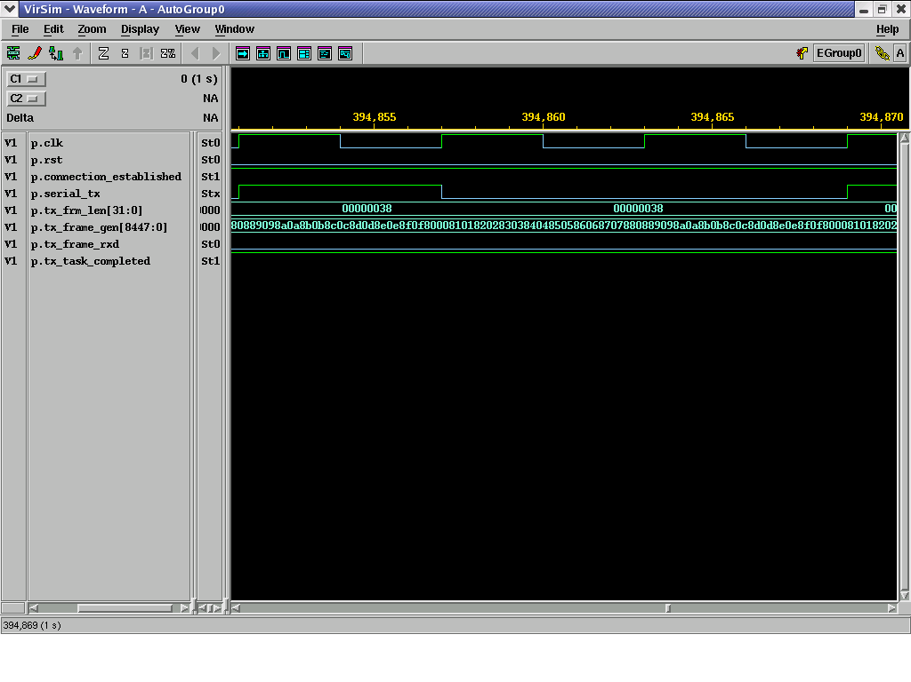
Fig 5.1 Transmitter’s output waveform

Receiver’s output waveform

Fig 5.2 Receiver’s output waveform

Combined output waveform

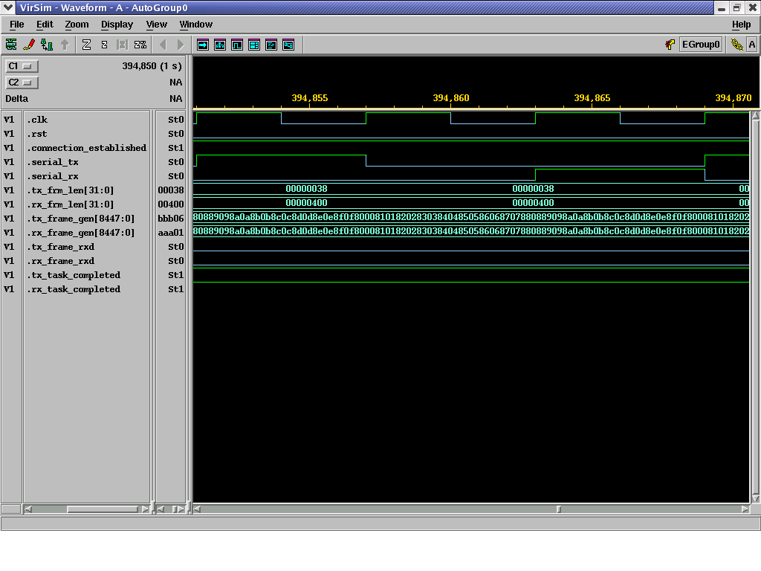
Figure 5.3: Combined waveform

Identification Sequence as an Example
Let us consider Identification as an example to understand the results and output waveform. Figure 5.4 shows the Identification sequence. While the next few figures display the output of Initiator, Target, Monitor, Checker and the Log file.

Identification Sequence

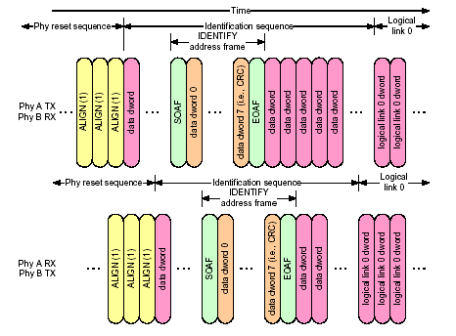

Fig 5.4 Identification Sequence

Virsim Hierarchy

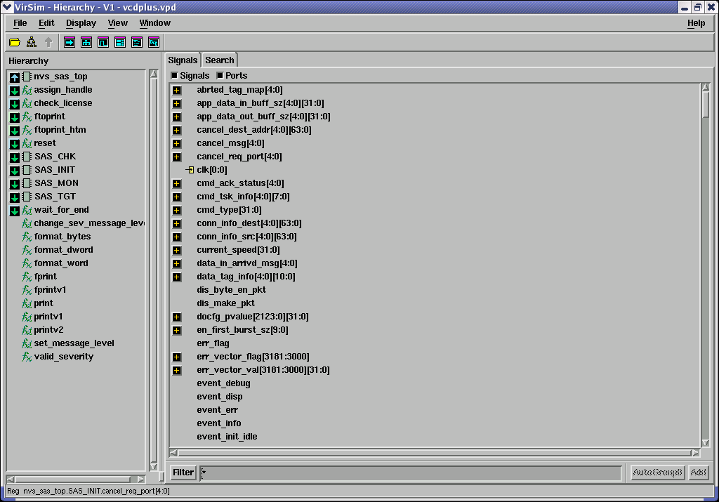

Fig 5.5 Virsim Hierarchy

Transmitter’s output

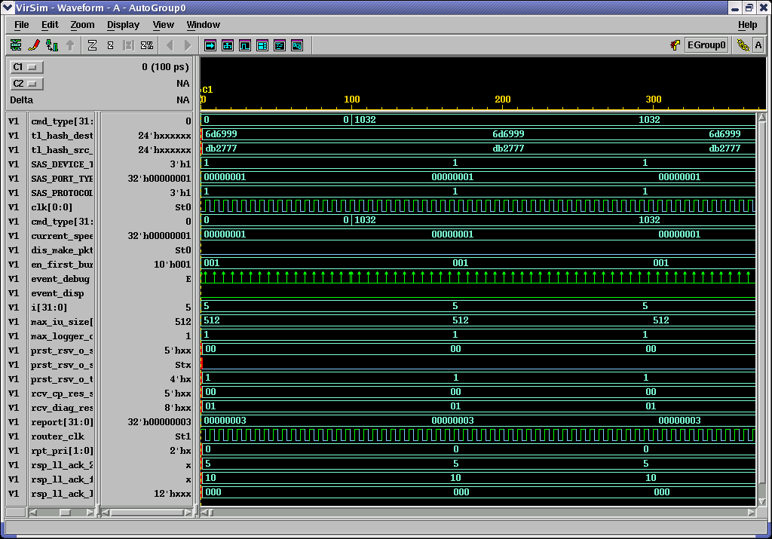

Fig 5.6 Transmitter’s Output

Receiver’s output

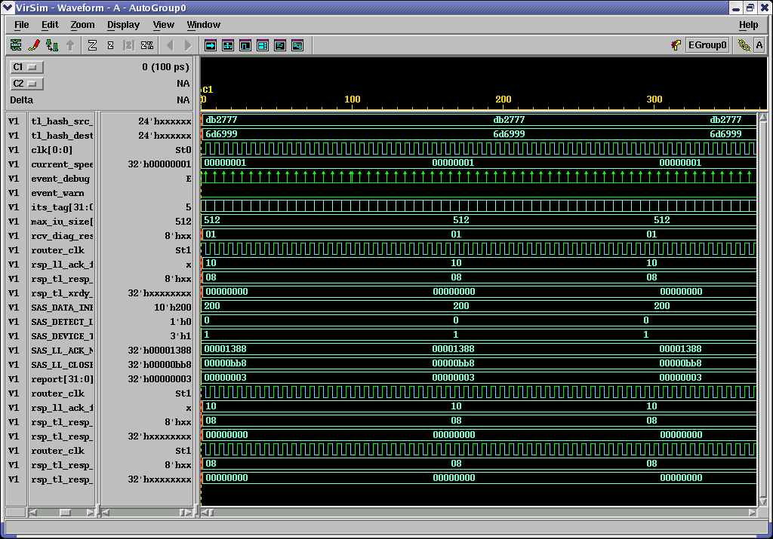

Fig 5.7 Receiver’s Output

Monitor’s Output

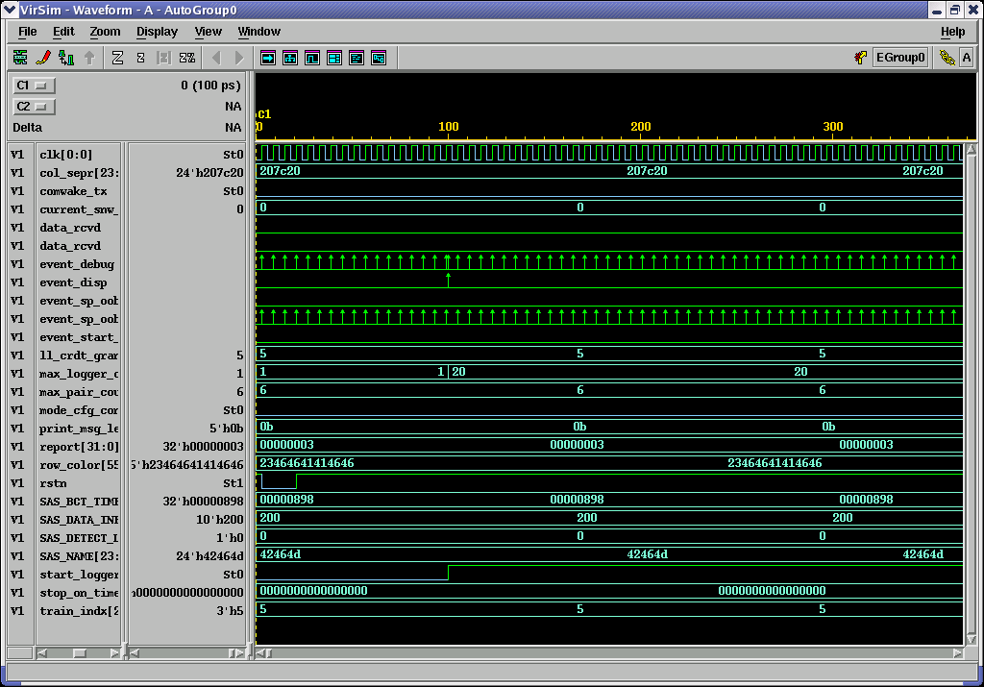

Fig 5.8 Monitor’s Output

Checker’s Output

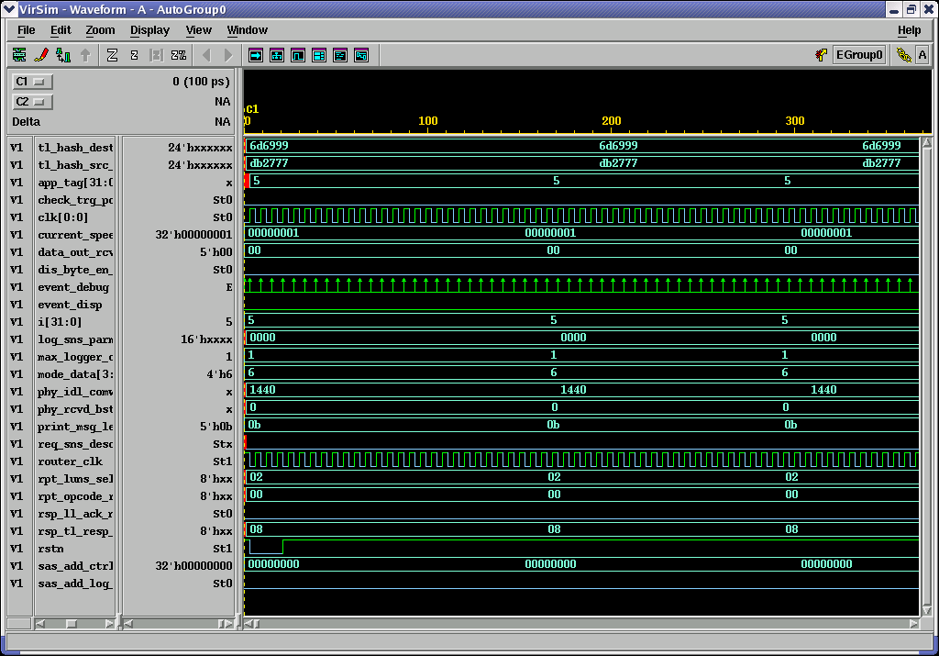

Fig 5.9 Checker’s Output

Log File

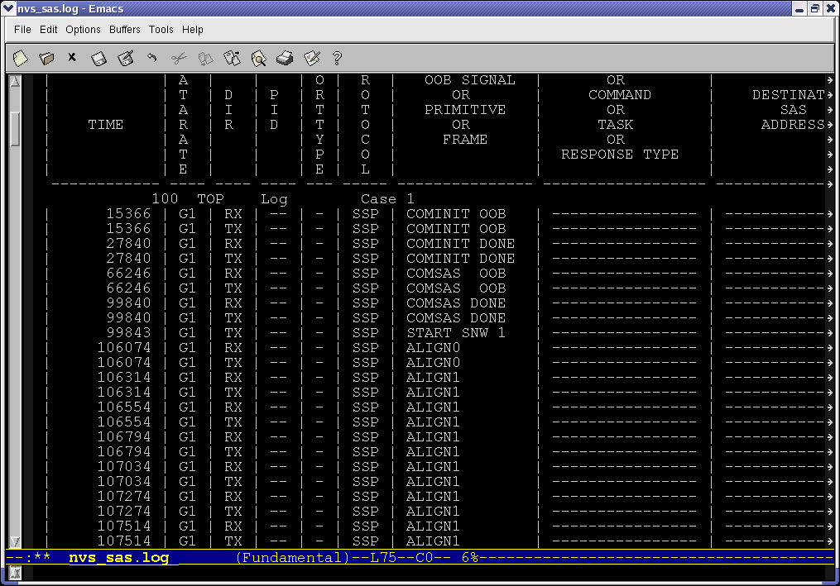

Fig 5.10 Log File

Output Log File

----------------------------------------------------------
SAS nVS
Copyright C 2001-2007 nSys Design Systems Pvt. Ltd.
All Rights Reserved

For support, http://www.nsysinc.com/support.htm

This program is proprietary & confidential information of
nSys and may be used and disclosed only as authorized in
a license agreement controlling such use and disclosure.
-----------------------------------------------------------
Version : 2006.05.02
-----------------------------------------------------------
Setting nVS Test Parameters
-----------------------------------------------------------
Setting Message Level to : LOG (NVS_LOG)
Setting Error Count to : 50
Setting Warning Count to : 100
Setting Time Count to : 0
Setting Transaction Count to : 1000
Setting Test Mode to : DIRECTED
Setting Checker to : OFF
Setting Monitor to : ON
-----------------------------------------------------------
LEGEND:
+--------------------------+-----------------------------------------------------------+
| Output field | Description |
+--------------------------+-----------------------------------------------------------+
| TIME | Simulation time (unit - 100 ps) |
| DEV | Device Identifier |
| DIR | Direction of transaction (I=From Initiator,T=From Target) |
| PRT | Protocol of the Connection( SSP / STP / SMP) |
| PRIMITIVE / FRAME TYPE | Type of the Primitive /Type of Frame |
| COMMAND / TASK TYPE | Type of the Command / Type of Task |
| CNT / TAG | Count of symbol / Tag of Frame |
| HASHED DEST ADDRESS | Hashed Destination Address |
| HASHED SOURCE ADDRESS | Hashed Source Address |
| FRAME CONTENTS | Contents of the Frame |
| | LO - Lower DWORD |
| | HI - Higher DWORD |
| CRC | CRC of FRAME |
+--------------------------+-----------------------------------------------------------+
------------------------------------------------------------------------------ -----------------
D D PRIMITIVE COMMAND CNT HASHED HASHED
E I / / TASK / DEST SOURCE FRAME CONTENTS
TIME (100 ps) V R PRT FRAME TYPE TAG ADDRESS ADDRESS LO HI CRC
------------------------------------------------------------------------------ -----------------
3 Log Case # 119
3375 D1 - SSP ALIGN_0 -------- ---- -------- -------- -------- -------- --------
3615 D1 - SSP ALIGN_0 -------- ---- -------- -------- -------- -------- --------
3855 D1 - SSP ALIGN_0 -------- ---- -------- -------- -------- -------- --------
4095 D1 - SSP ALIGN_0 -------- ---- -------- -------- -------- -------- --------
7215 D1 - SSP ALIGN_0 -------- ---- -------- -------- -------- -------- --------
7455 D1 - SSP ALIGN_0 -------- ---- -------- -------- -------- -------- --------
7695 D1 - SSP ALIGN_0 -------- ---- -------- -------- -------- -------- --------
7935 D1 - SSP ALIGN_0 -------- ---- -------- -------- -------- -------- --------
11055 D1 - SSP ALIGN_0 -------- ---- -------- -------- -------- -------- --------
11295 D1 - SSP ALIGN_0 -------- ---- -------- -------- -------- -------- --------
11535 D1 - SSP ALIGN_0 -------- ---- -------- -------- -------- -------- --------
11775 D1 - SSP ALIGN_0 -------- ---- -------- -------- -------- -------- --------
14895 D1 - SSP ALIGN_0 -------- ---- -------- -------- -------- -------- --------
15135 D1 - SSP ALIGN_0 -------- ---- -------- -------- -------- -------- --------
15375 D1 - SSP ALIGN_0 -------- ---- -------- -------- -------- -------- --------
15615 D1 - SSP ALIGN_0 -------- ---- -------- -------- -------- -------- --------
17535 D0 - SSP ALIGN_0 -------- ---- -------- -------- -------- -------- --------
17775 D0 - SSP ALIGN_0 -------- ---- -------- -------- -------- -------- --------
18015 D0 - SSP ALIGN_0 -------- ---- -------- -------- -------- -------- --------
18255 D0 - SSP ALIGN_0 -------- ---- -------- -------- -------- -------- --------
18735 D1 - SSP ALIGN_0 -------- ---- -------- -------- -------- -------- --------
18975 D1 - SSP ALIGN_0 -------- ---- -------- -------- -------- -------- --------
19215 D1 - SSP ALIGN_0 -------- ---- -------- -------- -------- -------- --------
19455 D1 - SSP ALIGN_0 -------- ---- -------- -------- -------- -------- --------
21375 D0 - SSP ALIGN_0 -------- ---- -------- -------- -------- -------- --------
21615 D0 - SSP ALIGN_0 -------- ---- -------- -------- -------- -------- --------
21855 D0 - SSP ALIGN_0 -------- ---- -------- -------- -------- -------- --------
22095 D0 - SSP ALIGN_0 -------- ---- -------- -------- -------- -------- --------
22575 D1 - SSP ALIGN_0 -------- ---- -------- -------- -------- -------- --------
22815 D1 - SSP ALIGN_0 -------- ---- -------- -------- -------- -------- --------
23055 D1 - SSP ALIGN_0 -------- ---- -------- -------- -------- -------- --------
23295 D1 - SSP ALIGN_0 -------- ---- -------- -------- -------- -------- --------
25215 D0 - SSP ALIGN_0 -------- ---- -------- -------- -------- -------- --------
25455 D0 - SSP ALIGN_0 -------- ---- -------- -------- -------- -------- --------
25695 D0 - SSP ALIGN_0 -------- ---- -------- -------- -------- -------- --------
25935 D0 - SSP ALIGN_0 -------- ---- -------- -------- -------- -------- --------
28083 D1 - SSP COMINIT -------- ---- -------- -------- -------- -------- --------
29055 D0 - SSP ALIGN_0 -------- ---- -------- -------- -------- -------- --------
29295 D0 - SSP ALIGN_0 -------- ---- -------- -------- -------- -------- --------
29535 D0 - SSP ALIGN_0 -------- ---- -------- -------- -------- -------- --------
29775 D0 - SSP ALIGN_0 -------- ---- -------- -------- -------- -------- --------
32895 D0 - SSP ALIGN_0 -------- ---- -------- -------- -------- -------- --------
33135 D0 - SSP ALIGN_0 -------- ---- -------- -------- -------- -------- --------
33375 D0 - SSP ALIGN_0 -------- ---- -------- -------- -------- -------- --------
33615 D0 - SSP ALIGN_0 -------- ---- -------- -------- -------- -------- --------
36735 D0 - SSP ALIGN_0 -------- ---- -------- -------- -------- -------- --------
36975 D1 - SSP ALIGN_0 -------- ---- -------- -------- -------- -------- --------
36975 D0 - SSP ALIGN_0 -------- ---- -------- -------- -------- -------- --------
37215 D1 - SSP ALIGN_0 -------- ---- -------- -------- -------- -------- --------
37215 D0 - SSP ALIGN_0 -------- ---- -------- -------- -------- -------- --------
37455 D1 - SSP ALIGN_0 -------- ---- -------- -------- -------- -------- --------
37455 D0 - SSP ALIGN_0 -------- ---- -------- -------- -------- -------- --------
37695 D1 - SSP ALIGN_0 -------- ---- -------- -------- -------- -------- --------
42243 D0 - SSP COMINIT -------- ---- -------- -------- -------- -------- --------
46575 D1 - SSP ALIGN_0 -------- ---- -------- -------- -------- -------- --------
46815 D1 - SSP ALIGN_0 -------- ---- -------- -------- -------- -------- --------
47055 D1 - SSP ALIGN_0 -------- ---- -------- -------- -------- -------- --------
47295 D1 - SSP ALIGN_0 -------- ---- -------- -------- -------- -------- --------
51135 D0 - SSP ALIGN_0 -------- ---- -------- -------- -------- -------- --------
51375 D0 - SSP ALIGN_0 -------- ---- -------- -------- -------- -------- --------
51615 D0 - SSP ALIGN_0 -------- ---- -------- -------- -------- -------- --------
51855 D0 - SSP ALIGN_0 -------- ---- -------- -------- -------- -------- --------
56175 D1 - SSP ALIGN_0 -------- ---- -------- -------- -------- -------- --------
56415 D1 - SSP ALIGN_0 -------- ---- -------- -------- -------- -------- --------
56655 D1 - SSP ALIGN_0 -------- ---- -------- -------- -------- -------- --------
56895 D1 - SSP ALIGN_0 -------- ---- -------- -------- -------- -------- --------
60735 D0 - SSP ALIGN_0 -------- ---- -------- -------- -------- -------- --------
60975 D0 - SSP ALIGN_0 -------- ---- -------- -------- -------- -------- --------
61215 D0 - SSP ALIGN_0 -------- ---- -------- -------- -------- -------- --------
61455 D0 - SSP ALIGN_0 -------- ---- -------- -------- -------- -------- --------
65775 D1 - SSP ALIGN_0 -------- ---- -------- -------- -------- -------- --------
66015 D1 - SSP ALIGN_0 -------- ---- -------- -------- -------- -------- --------
66255 D1 - SSP ALIGN_0 -------- ---- -------- -------- -------- -------- --------
66495 D1 - SSP ALIGN_0 -------- ---- -------- -------- -------- -------- --------
70335 D0 - SSP ALIGN_0 -------- ---- -------- -------- -------- -------- --------
70575 D0 - SSP ALIGN_0 -------- ---- -------- -------- -------- -------- --------
70815 D0 - SSP ALIGN_0 -------- ---- -------- -------- -------- -------- --------
71055 D0 - SSP ALIGN_0 -------- ---- -------- -------- -------- -------- --------
75375 D1 - SSP ALIGN_0 -------- ---- -------- -------- -------- -------- --------
75615 D1 - SSP ALIGN_0 -------- ---- -------- -------- -------- -------- --------
75855 D1 - SSP ALIGN_0 -------- ---- -------- -------- -------- -------- --------
76095 D1 - SSP ALIGN_0 -------- ---- -------- -------- -------- -------- --------
79935 D0 - SSP ALIGN_0 -------- ---- -------- -------- -------- -------- --------
80175 D0 - SSP ALIGN_0 -------- ---- -------- -------- -------- -------- --------
80415 D0 - SSP ALIGN_0 -------- ---- -------- -------- -------- -------- --------
80655 D0 - SSP ALIGN_0 -------- ---- -------- -------- -------- -------- --------
84975 D1 - SSP ALIGN_0 -------- ---- -------- -------- -------- -------- --------
85215 D1 - SSP ALIGN_0 -------- ---- -------- -------- -------- -------- --------
85455 D1 - SSP ALIGN_0 -------- ---- -------- -------- -------- -------- --------
85695 D1 - SSP ALIGN_0 -------- ---- -------- -------- -------- -------- --------
89535 D0 - SSP ALIGN_0 -------- ---- -------- -------- -------- -------- --------
89775 D0 - SSP ALIGN_0 -------- ---- -------- -------- -------- -------- --------
90015 D0 - SSP ALIGN_0 -------- ---- -------- -------- -------- -------- --------
90255 D0 - SSP ALIGN_0 -------- ---- -------- -------- -------- -------- --------
99135 D0 - SSP ALIGN_0 -------- ---- -------- -------- -------- -------- --------
99375 D0 - SSP ALIGN_0 -------- ---- -------- -------- -------- -------- --------
99615 D0 - SSP ALIGN_0 -------- ---- -------- -------- -------- -------- --------
99855 D0 - SSP ALIGN_0 -------- ---- -------- -------- -------- -------- --------
100083 D1 - SSP COMSAS -------- ---- -------- -------- -------- -------- --------
114243 D0 - SSP COMSAS -------- ---- -------- -------- -------- -------- --------
160095 D0 - SSP ALIGN_0 -------- ---- -------- -------- -------- -------- --------
160335 D0 - SSP ALIGN_0 -------- ---- -------- -------- -------- -------- --------
160575 D0 - SSP ALIGN_0 -------- ---- -------- -------- -------- -------- --------
160815 D1 - SSP ALIGN_0 -------- ---- -------- -------- -------- -------- --------
160815 D0 - SSP ALIGN_0 -------- ---- -------- -------- -------- -------- --------
161055 D1 - SSP ALIGN_0 -------- ---- -------- -------- -------- -------- --------
161055 D0 - SSP ALIGN_1 -------- ---- -------- -------- -------- -------- --------
161295 D1 - SSP ALIGN_0 -------- ---- -------- -------- -------- -------- --------
161295 D0 - SSP ALIGN_1 -------- ---- -------- -------- -------- -------- --------
161535 D1 - SSP ALIGN_0 -------- ---- -------- -------- -------- -------- --------
161535 D0 - SSP ALIGN_1 -------- ---- -------- -------- -------- -------- --------
161775 D1 - SSP ALIGN_0 -------- ---- -------- -------- -------- -------- --------
161775 D0 - SSP ALIGN_1 -------- ---- -------- -------- -------- -------- --------
162015 D1 - SSP ALIGN_0 -------- ---- -------- -------- -------- -------- --------
162015 D0 - SSP ALIGN_1 -------- ---- -------- -------- -------- -------- --------
162255 D1 - SSP ALIGN_0 -------- ---- -------- -------- -------- -------- --------
162255 D0 - SSP ALIGN_1 -------- ---- -------- -------- -------- -------- --------
162495 D1 - SSP ALIGN_0 -------- ---- -------- -------- -------- -------- --------
162495 D0 - SSP ALIGN_1 -------- ---- -------- -------- -------- -------- --------
162735 D1 - SSP ALIGN_0 -------- ---- -------- -------- -------- -------- --------
162735 D0 - SSP ALIGN_1 -------- ---- -------- -------- -------- -------- --------
162975 D1 - SSP ALIGN_0 -------- ---- -------- -------- -------- -------- --------
162975 D0 - SSP ALIGN_1 -------- ---- -------- -------- -------- -------- --------
163215 D1 - SSP ALIGN_0 -------- ---- -------- -------- -------- -------- --------
163215 D0 - SSP ALIGN_1 -------- ---- -------- -------- -------- -------- --------
163455 D1 - SSP ALIGN_0 -------- ---- -------- -------- -------- -------- --------
163455 D0 - SSP ALIGN_1 -------- ---- -------- -------- -------- -------- --------
163695 D1 - SSP ALIGN_0 -------- ---- -------- -------- -------- -------- --------
163695 D0 - SSP ALIGN_1 -------- ---- -------- -------- -------- -------- --------
163935 D1 - SSP ALIGN_0 -------- ---- -------- -------- -------- -------- --------
163935 D0 - SSP ALIGN_1 -------- ---- -------- -------- -------- -------- --------
164175 D1 - SSP ALIGN_0 -------- ---- -------- -------- -------- -------- --------
164175 D0 - SSP ALIGN_1 -------- ---- -------- -------- -------- -------- --------
164415 D1 - SSP ALIGN_0 -------- ---- -------- -------- -------- -------- --------
164415 D0 - SSP ALIGN_1 -------- ---- -------- -------- -------- -------- --------
164655 D1 - SSP ALIGN_0 -------- ---- -------- -------- -------- -------- --------
164655 D0 - SSP ALIGN_1 -------- ---- -------- -------- -------- -------- --------
164895 D1 - SSP ALIGN_1 -------- ---- -------- -------- -------- -------- --------
164895 D0 - SSP ALIGN_1 -------- ---- -------- -------- -------- -------- --------
165135 D1 - SSP ALIGN_1 -------- ---- -------- -------- -------- -------- --------
165135 D0 - SSP ALIGN_1 -------- ---- -------- -------- -------- -------- --------
165375 D1 - SSP ALIGN_1 -------- ---- -------- -------- -------- -------- --------
165375 D0 - SSP ALIGN_1 -------- ---- -------- -------- -------- -------- --------
165615 D1 - SSP ALIGN_1 -------- ---- -------- -------- -------- -------- --------
165615 D0 - SSP ALIGN_1 -------- ---- -------- -------- -------- -------- --------
165855 D1 - SSP ALIGN_1 -------- ---- -------- -------- -------- -------- --------
165855 D0 - SSP ALIGN_1 -------- ---- -------- -------- -------- -------- --------
166095 D1 - SSP ALIGN_1 -------- ---- -------- -------- -------- -------- --------
166095 D0 - SSP ALIGN_1 -------- ---- -------- -------- -------- -------- --------
166335 D1 - SSP ALIGN_1 -------- ---- -------- -------- -------- -------- --------
166335 D0 - SSP ALIGN_1 -------- ---- -------- -------- -------- -------- --------
166575 D1 - SSP ALIGN_1 -------- ---- -------- -------- -------- -------- --------
166575 D0 - SSP ALIGN_1 -------- ---- -------- -------- -------- -------- --------
166815 D1 - SSP ALIGN_1 -------- ---- -------- -------- -------- -------- --------
166815 D0 - SSP ALIGN_1 -------- ---- -------- -------- -------- -------- --------
167055 D1 - SSP ALIGN_1 -------- ---- -------- -------- -------- -------- --------
167055 D0 - SSP ALIGN_1 -------- ---- -------- -------- -------- -------- --------
167295 D1 - SSP ALIGN_1 -------- ---- -------- -------- -------- -------- --------
167295 D0 - SSP ALIGN_1 -------- ---- -------- -------- -------- -------- --------
167535 D1 - SSP ALIGN_1 -------- ---- -------- -------- -------- -------- --------
167535 D0 - SSP ALIGN_1 -------- ---- -------- -------- -------- -------- --------
167775 D1 - SSP ALIGN_1 -------- ---- -------- -------- -------- -------- --------
167775 D0 - SSP ALIGN_1 -------- ---- -------- -------- -------- -------- --------
168015 D1 - SSP ALIGN_1 -------- ---- -------- -------- -------- -------- --------
168015 D0 - SSP ALIGN_1 -------- ---- -------- -------- -------- -------- --------
168255 D1 - SSP ALIGN_1 -------- ---- -------- -------- -------- -------- --------
168255 D0 - SSP ALIGN_1 -------- ---- -------- -------- -------- -------- --------
168495 D1 - SSP ALIGN_1 -------- ---- -------- -------- -------- -------- --------
168495 D0 - SSP ALIGN_1 -------- ---- -------- -------- -------- -------- --------
168735 D1 - SSP ALIGN_1 -------- ---- -------- -------- -------- -------- --------
168735 D0 - SSP ALIGN_1 -------- ---- -------- -------- -------- -------- --------
168975 D1 - SSP ALIGN_1 -------- ---- -------- -------- -------- -------- --------
168975 D0 - SSP ALIGN_1 -------- ---- -------- -------- -------- -------- --------
169215 D1 - SSP ALIGN_1 -------- ---- -------- -------- -------- -------- --------
169215 D0 - SSP ALIGN_1 -------- ---- -------- -------- -------- -------- --------
169455 D1 - SSP ALIGN_1 -------- ---- -------- -------- -------- -------- --------
169455 D0 - SSP ALIGN_1 -------- ---- -------- -------- -------- -------- --------
325695 D0 - SSP ALIGN_0 -------- ---- -------- -------- -------- -------- --------
325935 D0 - SSP ALIGN_0 -------- ---- -------- -------- -------- -------- --------
326175 D0 - SSP ALIGN_0 -------- ---- -------- -------- -------- -------- --------
326415 D1 - SSP ALIGN_0 -------- ---- -------- -------- -------- -------- --------
326415 D0 - SSP ALIGN_0 -------- ---- -------- -------- -------- -------- --------
326655 D1 - SSP ALIGN_0 -------- ---- -------- -------- -------- -------- --------
326655 D0 - SSP ALIGN_1 -------- ---- -------- -------- -------- -------- --------
326895 D1 - SSP ALIGN_0 -------- ---- -------- -------- -------- -------- --------
326895 D0 - SSP ALIGN_1 -------- ---- -------- -------- -------- -------- --------
327135 D1 - SSP ALIGN_0 -------- ---- -------- -------- -------- -------- --------
327135 D0 - SSP ALIGN_1 -------- ---- -------- -------- -------- -------- --------
327375 D1 - SSP ALIGN_0 -------- ---- -------- -------- -------- -------- --------
327375 D0 - SSP ALIGN_1 -------- ---- -------- -------- -------- -------- --------
327615 D1 - SSP ALIGN_0 -------- ---- -------- -------- -------- -------- --------
327615 D0 - SSP ALIGN_1 -------- ---- -------- -------- -------- -------- --------
327855 D1 - SSP ALIGN_0 -------- ---- -------- -------- -------- -------- --------
327855 D0 - SSP ALIGN_1 -------- ---- -------- -------- -------- -------- --------
328095 D1 - SSP ALIGN_0 -------- ---- -------- -------- -------- -------- --------
328095 D0 - SSP ALIGN_1 -------- ---- -------- -------- -------- -------- --------
328335 D1 - SSP ALIGN_0 -------- ---- -------- -------- -------- -------- --------
328335 D0 - SSP ALIGN_1 -------- ---- -------- -------- -------- -------- --------
328575 D1 - SSP ALIGN_0 -------- ---- -------- -------- -------- -------- --------
328575 D0 - SSP ALIGN_1 -------- ---- -------- -------- -------- -------- --------
328815 D1 - SSP ALIGN_0 -------- ---- -------- -------- -------- -------- --------
328815 D0 - SSP ALIGN_1 -------- ---- -------- -------- -------- -------- --------
329055 D1 - SSP ALIGN_0 -------- ---- -------- -------- -------- -------- --------
329055 D0 - SSP ALIGN_1 -------- ---- -------- -------- -------- -------- --------
329295 D1 - SSP ALIGN_0 -------- ---- -------- -------- -------- -------- --------
329295 D0 - SSP ALIGN_1 -------- ---- -------- -------- -------- -------- --------
329535 D1 - SSP ALIGN_0 -------- ---- -------- -------- -------- -------- --------
329535 D0 - SSP ALIGN_1 -------- ---- -------- -------- -------- -------- --------
329775 D1 - SSP ALIGN_0 -------- ---- -------- -------- -------- -------- --------
329775 D0 - SSP ALIGN_1 -------- ---- -------- -------- -------- -------- --------
330015 D1 - SSP ALIGN_0 -------- ---- -------- -------- -------- -------- --------
330015 D0 - SSP ALIGN_1 -------- ---- -------- -------- -------- -------- --------
330255 D1 - SSP ALIGN_0 -------- ---- -------- -------- -------- -------- --------
330255 D0 - SSP ALIGN_1 -------- ---- -------- -------- -------- -------- --------
330495 D1 - SSP ALIGN_1 -------- ---- -------- -------- -------- -------- --------
330495 D0 - SSP ALIGN_1 -------- ---- -------- -------- -------- -------- --------
330735 D1 - SSP ALIGN_1 -------- ---- -------- -------- -------- -------- --------
330735 D0 - SSP ALIGN_1 -------- ---- -------- -------- -------- -------- --------
330975 D1 - SSP ALIGN_1 -------- ---- -------- -------- -------- -------- --------
330975 D0 - SSP ALIGN_1 -------- ---- -------- -------- -------- -------- --------
331215 D1 - SSP ALIGN_1 -------- ---- -------- -------- -------- -------- --------
331215 D0 - SSP ALIGN_1 -------- ---- -------- -------- -------- -------- --------
331455 D1 - SSP ALIGN_1 -------- ---- -------- -------- -------- -------- --------
331455 D0 - SSP ALIGN_1 -------- ---- -------- -------- -------- -------- --------
331695 D1 - SSP ALIGN_1 -------- ---- -------- -------- -------- -------- --------
331695 D0 - SSP ALIGN_1 -------- ---- -------- -------- -------- -------- --------
331935 D1 - SSP ALIGN_1 -------- ---- -------- -------- -------- -------- --------
331935 D0 - SSP ALIGN_1 -------- ---- -------- -------- -------- -------- --------
332175 D1 - SSP ALIGN_1 -------- ---- -------- -------- -------- -------- --------
332175 D0 - SSP ALIGN_1 -------- ---- -------- -------- -------- -------- --------
332415 D1 - SSP ALIGN_1 -------- ---- -------- -------- -------- -------- --------
332415 D0 - SSP ALIGN_1 -------- ---- -------- -------- -------- -------- --------
332655 D1 - SSP ALIGN_1 -------- ---- -------- -------- -------- -------- --------
332655 D0 - SSP ALIGN_1 -------- ---- -------- -------- -------- -------- --------
332895 D1 - SSP ALIGN_1 -------- ---- -------- -------- -------- -------- --------
332895 D0 - SSP ALIGN_1 -------- ---- -------- -------- -------- -------- --------
333135 D1 - SSP ALIGN_1 -------- ---- -------- -------- -------- -------- --------
333135 D0 - SSP ALIGN_1 -------- ---- -------- -------- -------- -------- --------
333375 D1 - SSP ALIGN_1 -------- ---- -------- -------- -------- -------- --------
333375 D0 - SSP ALIGN_1 -------- ---- -------- -------- -------- -------- --------
333615 D1 - SSP ALIGN_1 -------- ---- -------- -------- -------- -------- --------
333615 D0 - SSP ALIGN_1 -------- ---- -------- -------- -------- -------- --------
333855 D1 - SSP ALIGN_1 -------- ---- -------- -------- -------- -------- --------
333855 D0 - SSP ALIGN_1 -------- ---- -------- -------- -------- -------- --------
334095 D1 - SSP ALIGN_1 -------- ---- -------- -------- -------- -------- --------
334095 D0 - SSP ALIGN_1 -------- ---- -------- -------- -------- -------- --------
334335 D1 - SSP ALIGN_1 -------- ---- -------- -------- -------- -------- --------
334335 D0 - SSP ALIGN_1 -------- ---- -------- -------- -------- -------- --------
334575 D1 - SSP ALIGN_1 -------- ---- -------- -------- -------- -------- --------
334575 D0 - SSP ALIGN_1 -------- ---- -------- -------- -------- -------- --------
334815 D1 - SSP ALIGN_1 -------- ---- -------- -------- -------- -------- --------
334815 D0 - SSP ALIGN_1 -------- ---- -------- -------- -------- -------- --------
335055 D1 - SSP ALIGN_1 -------- ---- -------- -------- -------- -------- --------
335055 D0 - SSP ALIGN_1 -------- ---- -------- -------- -------- -------- --------
335535 D1 - SSP IDLE -------- 0001 -------- -------- -------- -------- --------
335535 D0 - SSP IDLE -------- 0001 -------- -------- -------- -------- --------
337695 D1 - SSP IDENTIFY_AF -------- ---- -------- -------- 10000008 00000000 d15ddc81
00000000 50011111
10111213 00000000
00000000 d15ddc81
337695 D0 - SSP IDENTIFY_AF -------- ---- -------- -------- 10000008 00000000 d15ddc81
00000000 50011111
10111213 00000000
00000000 d15ddc81
338175 D0 - SSP IDLE -------- 0001 -------- -------- -------- -------- --------
340335 D0 I SSP OPEN_AF -------- ---- -------- -------- 91080008 50011111 fc4314a1
10111213 50011111
10111213 00000000
00000000 fc4314a1
340575 D1 T SSP IDLE -------- 0011 -------- -------- -------- -------- --------
340575 D1 T SSP OPEN_ACPT -------- ---- -------- -------- -------- -------- --------
340815 D1 T SSP RRDY-NORML -------- ---- -------- -------- -------- -------- --------
340815 D0 I SSP IDLE -------- 0001 -------- -------- -------- -------- --------
340815 D0 I SSP RRDY-NORML -------- ---- -------- -------- -------- -------- --------
341055 D1 T SSP RRDY-NORML -------- ---- -------- -------- -------- -------- --------
341055 D0 I SSP RRDY-NORML -------- ---- -------- -------- -------- -------- --------
341295 D1 T SSP RRDY-NORML -------- ---- -------- -------- -------- -------- --------
341295 D0 I SSP RRDY-NORML -------- ---- -------- -------- -------- -------- --------
341535 D1 T SSP RRDY-NORML -------- ---- -------- -------- -------- -------- --------
341535 D0 I SSP RRDY-NORML -------- ---- -------- -------- -------- -------- --------
341775 D1 T SSP RRDY-NORML -------- ---- -------- -------- -------- -------- --------
341775 D0 I SSP RRDY-NORML -------- ---- -------- -------- -------- -------- --------
342015 D1 T SSP RRDY-NORML -------- ---- -------- -------- -------- -------- --------
342015 D0 I SSP RRDY-NORML -------- ---- -------- -------- -------- -------- --------
345855 D0 I SSP COMMAND T_U_RDY 0100 bbbb00 aaaa00 06bbbb00 d8aaaa00 bf4e715b
b8b0a8a0 98908880
0100ffff 58504840
00000000 00000000
f8f2e8e0 00d0c8c0
b8b0a8a0 98908880
78706860 bf4e715b
346335 D1 T SSP IDLE -------- 0017 -------- -------- -------- -------- --------
349695 D1 T SSP RESPONSE -------- 0100 aaaa00 bbbb00 07aaaa00 d8bbbb00 817be024
b8b0aaa1 98908880
0100ffff 00004000
11111111 00000000
f8f4e8e0 d8d0c8c0
b8b0a8a0 98908880
817be024 --------
349695 Log Case # 120
350175 D1 T SSP IDLE -------- 0001 -------- -------- -------- -------- --------
350175 D1 T SSP ACK -------- ---- -------- -------- -------- -------- --------
350175 D0 I SSP IDLE -------- 0017 -------- -------- -------- -------- --------
353775 D0 I SSP COMMAND INQUIRY 0100 bbbb00 aaaa00 06bbbb00 d8aaaa00 4255f63a
b8b0a8a0 98908880
0100ffff 58504840
00000000 00000000
f8f2e8e0 12d0c8c0
b8b0a8a0 98908880
78706860 4255f63a
354255 D1 T SSP IDLE -------- 0016 -------- -------- -------- -------- --------
415935 D1 T SSP DATA -------- 0100 aaaa00 bbbb00 01aaaa00 d8bbbb00 3ff403e3
b8b0aaa1 98908880
0100ffff 00004000
11111111 00000000
f8f4e8e0 d8d0c8c0
b8b0a8a0 98908880
78706860 58504840
38302820 18100800
f8f0e8e0 d8d0c8c0
b8b0a8a0 98908880
78706860 58504840
38302820 18100800
f8f0e8e0 d8d0c8c0
b8b0a8a0 98908880
78706860 58504840
38302820 18100800
f8f0e8e0 d8d0c8c0
b8b0a8a0 98908880
78706860 58504840
38302820 18100800
f8f0e8e0 d8d0c8c0
b8b0a8a0 98908880
78706860 58504840
38302820 18100800
f8f0e8e0 d8d0c8c0
b8b0a8a0 98908880
78706860 58504840
38302820 18100800
f8f0e8e0 d8d0c8c0
b8b0a8a0 98908880
78706860 58504840
38302820 18100800
f8f0e8e0 d8d0c8c0
b8b0a8a0 98908880
78706860 58504840
38302820 18100800
f8f0e8e0 d8d0c8c0
b8b0a8a0 98908880
78706860 58504840
38302820 18100800
f8f0e8e0 d8d0c8c0
b8b0a8a0 98908880
78706860 58504840
38302820 18100800
f8f0e8e0 d8d0c8c0
b8b0a8a0 98908880
78706860 58504840
38302820 18100800
f8f0e8e0 d8d0c8c0
b8b0a8a0 98908880
78706860 58504840
38302820 18100800
f8f0e8e0 d8d0c8c0
b8b0a8a0 98908880
78706860 58504840
38302820 18100800
f8f0e8e0 d8d0c8c0
b8b0a8a0 98908880
78706860 58504840
38302820 18100800
f8f0e8e0 d8d0c8c0
b8b0a8a0 98908880
78706860 58504840
38302820 18100800
f8f0e8e0 d8d0c8c0
b8b0a8a0 98908880
78706860 58504840
38302820 18100800
f8f0e8e0 d8d0c8c0
b8b0a8a0 98908880
78706860 58504840
38302820 18100800
f8f0e8e0 d8d0c8c0
b8b0a8a0 98908880
78706860 58504840
38302820 18100800
f8f0e8e0 d8d0c8c0
b8b0a8a0 98908880
78706860 58504840
38302820 18100800
f8f0e8e0 d8d0c8c0
b8b0a8a0 98908880
78706860 58504840
38302820 18100800
f8f0e8e0 d8d0c8c0
b8b0a8a0 98908880
78706860 58504840
38302820 18100800
f8f0e8e0 d8d0c8c0
b8b0a8a0 98908880
78706860 58504840
38302820 18100800
f8f0e8e0 d8d0c8c0
b8b0a8a0 98908880
78706860 58504840
38302820 18100800
f8f0e8e0 d8d0c8c0
b8b0a8a0 98908880
78706860 58504840
38302820 18100800
f8f0e8e0 d8d0c8c0
b8b0a8a0 98908880
78706860 58504840
38302820 18100800
f8f0e8e0 d8d0c8c0
b8b0a8a0 98908880
78706860 58504840
38302820 18100800
f8f0e8e0 d8d0c8c0
b8b0a8a0 98908880
78706860 58504840
38302820 18100800
f8f0e8e0 d8d0c8c0
b8b0a8a0 98908880
78706860 58504840
38302820 18100800
f8f0e8e0 d8d0c8c0
b8b0a8a0 98908880
78706860 58504840
38302820 18100800
f8f0e8e0 d8d0c8c0
b8b0a8a0 98908880
78706860 58504840
38302820 18100800
f8f0e8e0 d8d0c8c0
b8b0a8a0 98908880
78706860 58504840
38302820 3ff403e3
415935 Log Case # 121
416415 D1 T SSP IDLE -------- 0001 -------- -------- -------- -------- --------
416415 D1 T SSP ACK -------- ---- -------- -------- -------- -------- --------
416415 D0 I SSP IDLE -------- 0260 -------- -------- -------- -------- --------
420015 D0 I SSP COMMAND T_U_RDY 0100 bbbb00 aaaa00 06bbbb00 d8aaaa00 bf4e715b
b8b0a8a0 98908880
0100ffff 58504840
00000000 00000000
f8f2e8e0 00d0c8c0
b8b0a8a0 98908880
78706860 bf4e715b
420495 D1 T SSP IDLE -------- 0016 -------- -------- -------- -------- --------
423855 D1 T SSP RESPONSE -------- 0100 aaaa00 bbbb00 07aaaa00 d8bbbb00 817be024
b8b0aaa1 98908880
0100ffff 00004000
11111111 00000000
f8f4e8e0 d8d0c8c0
b8b0a8a0 98908880
817be024 --------
424335 D1 T SSP IDLE -------- 0001 -------- -------- -------- -------- --------
424335 D1 T SSP ACK -------- ---- -------- -------- -------- -------- --------
424335 D0 I SSP IDLE -------- 0017 -------- -------- -------- -------- --------
427935 D0 I SSP COMMAND T_U_RDY 0100 bbbb00 aaaa00 06bbbb00 d8aaaa00 bf4e715b
b8b0a8a0 98908880
0100ffff 58504840
00000000 00000000
f8f2e8e0 00d0c8c0
b8b0a8a0 98908880
78706860 bf4e715b
428415 D1 T SSP IDLE -------- 0016 -------- -------- -------- -------- --------
431775 D1 T SSP RESPONSE -------- 0100 aaaa00 bbbb00 07aaaa00 d8bbbb00 817be024
b8b0aaa1 98908880
0100ffff 00004000
11111111 00000000
f8f4e8e0 d8d0c8c0
b8b0a8a0 98908880
817be024 --------
431775 Log Case # 122
432255 D1 T SSP IDLE -------- 0001 -------- -------- -------- -------- --------
432255 D1 T SSP ACK -------- ---- -------- -------- -------- -------- --------
432255 D0 I SSP IDLE -------- 0017 -------- -------- -------- -------- --------
438495 D0 I SSP COMMAND LOG_SNS 0100 bbbb00 aaaa00 06bbbb00 d8aaaa00 e56f7536
b8b0a8a0 98908880
0100ffff 58504840
00000000 00000000
f8f2e8e0 4cd0c8c0
b8b0a8a0 98908880
78706860 58504840
38302820 18100800
f8f0e8e0 d8d0c8c0
b8b0a8a0 98908880
78706860 58504840
38302820 18100800
e56f7536 --------
438975 D1 T SSP IDLE -------- 0027 -------- -------- -------- -------- --------
500655 D1 T SSP DATA -------- 0100 aaaa00 bbbb00 01aaaa00 d8bbbb00 3ff403e3
b8b0aaa1 98908880
0100ffff 00004000
11111111 00000000
f8f4e8e0 d8d0c8c0
b8b0a8a0 98908880
78706860 58504840
38302820 18100800
f8f0e8e0 d8d0c8c0
b8b0a8a0 98908880
78706860 58504840
38302820 18100800
f8f0e8e0 d8d0c8c0
b8b0a8a0 98908880
78706860 58504840
38302820 18100800
f8f0e8e0 d8d0c8c0
b8b0a8a0 98908880
78706860 58504840
38302820 18100800
f8f0e8e0 d8d0c8c0
b8b0a8a0 98908880
78706860 58504840
38302820 18100800
f8f0e8e0 d8d0c8c0
b8b0a8a0 98908880
78706860 58504840
38302820 18100800
f8f0e8e0 d8d0c8c0
b8b0a8a0 98908880
78706860 58504840
38302820 18100800
f8f0e8e0 d8d0c8c0
b8b0a8a0 98908880
78706860 58504840
38302820 18100800
f8f0e8e0 d8d0c8c0
b8b0a8a0 98908880
78706860 58504840
38302820 18100800
f8f0e8e0 d8d0c8c0
b8b0a8a0 98908880
78706860 58504840
38302820 18100800
f8f0e8e0 d8d0c8c0
b8b0a8a0 98908880
78706860 58504840
38302820 18100800
f8f0e8e0 d8d0c8c0
b8b0a8a0 98908880
78706860 58504840
38302820 18100800
f8f0e8e0 d8d0c8c0
b8b0a8a0 98908880
78706860 58504840
38302820 18100800
f8f0e8e0 d8d0c8c0
b8b0a8a0 98908880
78706860 58504840
38302820 18100800
f8f0e8e0 d8d0c8c0
b8b0a8a0 98908880
78706860 58504840
38302820 18100800
f8f0e8e0 d8d0c8c0
b8b0a8a0 98908880
78706860 58504840
38302820 18100800
f8f0e8e0 d8d0c8c0
b8b0a8a0 98908880
78706860 58504840
38302820 18100800
f8f0e8e0 d8d0c8c0
b8b0a8a0 98908880
78706860 58504840
38302820 18100800
f8f0e8e0 d8d0c8c0
b8b0a8a0 98908880
78706860 58504840
38302820 18100800
f8f0e8e0 d8d0c8c0
b8b0a8a0 98908880
78706860 58504840
38302820 18100800
f8f0e8e0 d8d0c8c0
b8b0a8a0 98908880
78706860 58504840
38302820 18100800
f8f0e8e0 d8d0c8c0
b8b0a8a0 98908880
78706860 58504840
38302820 18100800
f8f0e8e0 d8d0c8c0
b8b0a8a0 98908880
78706860 58504840
38302820 18100800
f8f0e8e0 d8d0c8c0
b8b0a8a0 98908880
78706860 58504840
38302820 18100800
f8f0e8e0 d8d0c8c0
b8b0a8a0 98908880
78706860 58504840
38302820 18100800
f8f0e8e0 d8d0c8c0
b8b0a8a0 98908880
78706860 58504840
38302820 18100800
f8f0e8e0 d8d0c8c0
b8b0a8a0 98908880
78706860 58504840
38302820 18100800
f8f0e8e0 d8d0c8c0
b8b0a8a0 98908880
78706860 58504840
38302820 18100800
f8f0e8e0 d8d0c8c0
b8b0a8a0 98908880
78706860 58504840
38302820 18100800
f8f0e8e0 d8d0c8c0
b8b0a8a0 98908880
78706860 58504840
38302820 18100800
f8f0e8e0 d8d0c8c0
b8b0a8a0 98908880
78706860 58504840
38302820 3ff403e3
501135 D1 T SSP IDLE -------- 0001 -------- -------- -------- -------- --------
504495 D1 T SSP RESPONSE -------- 0100 aaaa00 bbbb00 07aaaa00 d8bbbb00 817be024
b8b0aaa1 98908880
0100ffff 00004000
11111111 00000000
f8f4e8e0 d8d0c8c0
b8b0a8a0 98908880
817be024 --------
504975 D1 T SSP IDLE -------- 0001 -------- -------- -------- -------- --------
504975 D1 T SSP ACK -------- ---- -------- -------- -------- -------- --------
-----------------------------------------------
Summary SAS nVS
-----------------------------------------------
Total Frames Transmitted : 10
Errors in Transactions : 0
Warnings in Transactions : 0
Finished at Simulation Time : 505495
-----------------------------------------------
End of File
-----------------------------------------------
$finish at simulation time 505495
V C S S i m u l a t i o n R e p o r t

Discussion
In this major project various IP Verification Methodologies are been designed and implemented in verilog. SAS BFMs are been checked to functionally work on SSP and SMP protocols and to operate at 3Gbps transmission rate with Full Duplex Operation. The SAS output waveforms and the output Log file is attached with the document.

Scope for Future Work
IP Verification can be planned and designed with the following enhancement in existing BFMs.
- The next transfer rate target for SAS is 6.0Gbps per pathway with complete backward compatibility with first generation SAS devices.
- For connecting maximum of 16,256 devices in a single SAS domain, expander devices must be used. SAS expanders are also defined so that end devices connecting to the expanders may be either SAS devices or SATA devices, satisfying the goal of allowing heterogeneous system configurations.
- Mapping of Serial ATA expanded to support multiple initiators and targets is achieved by implementing Serial ATA Tunneled Protocol (STP).

List of Publications

Accepted at:-

- Dolly Khan, Dr. D Roy Choudhury, Dr. Daya Gupta, “ Verification Tool for SAS based SoC using System Verilog”, 12th WSEAS International Conference on Circuits, DATICS(Design, Analysis and Tools for Integrated Circuits and Systems), Heraklion, Crete Island, Greece.

- Dolly Khan, Dr. D Roy Choudhury, “ Verilog Verification Methodologies for Serial Protocols”, 4th International Conference on Chalenges and Developments in IT, ICCDIT, Ludhiana, Punjab, India.

Bibliography

- INCITS, SAS Specification Rev.11, 23 July 2007.

- Faisal I.Haque, Khizar A.Khan, The Art of Verification with Vera, California: 2001: 2-15.

- www.enterprisestorageforum.com

- Janick Bergeron, Eduard Cerny, Alan Hunter, et al., Verification Methodology Manual for System Verilog, Synopsys Inc., 2006: 407-417.

- G.J. Holtzmann, Design and Validation of Computer Protocols, Printice Hall 1991.

- www.maxtor.com

- F. Schmidt, The SCSI BUS and IDE Interface. Protocols, Applications and Programming, Addison Wesley, 1995.

- Elfriede Dustin, Effective Software Testing, 50 Specific ways to improve your Testing, Pearson Education.

- Louise Tamres, Introducing Software Testing, Pearson Education.

- www.storagesearch.com

- Samir Palnitkar – “Verilog HDL – A Guide to Digital Design and Synthesis”, Second Edition, LPE Publication.

- Han Ke Deng Zhongliang, Verification of AMBA Bus Model Using System Verilog, The Eighth International Conference on Electronics Measurement and Instruments.
- www.iol.unh.edu/service/testing/sas/testsuites

- Slawwomir Zielski, Janusz Sosnowski, The SCSI interface conformance tests generations, 2nd International Conference on Dependability of Computer Systems.

- Bernd Stohr, Michael Simmons, and Joachim Geishauser, FlexBench: Reuse of Verification IP to increase Productivity, Proceedings of the 2002 Design, Automation and Test in Europe Conference and Exhibition.

- www.scsita.org

- Mark Evans, “Maxtor WHITE PAPER: Serial Attached SCSI Architecture: Introduction, the SAS Physical Layer and the SAS Phy Layer”, December 2007.

- C. Rowen. Reducing SoC simulation and development time. Computer, 2002, 18:32-45.

- Rajsuman, Rajsuman. System-on-a-chip: design and test, Santa Clara: Advantest America R & D Center, 2000:5-27.

- Janick Bergeron, Eduard Cerny, Alan Hunter, et al., Verification Methodology Manual for System Verilog, Synopsys Inc., 2006: 407-417.

- AIC-7870 PCI bus master single chip SCSI host adapter data book, Adaptec Inc., 1995.

