VARIATIONAL APPROACH FOR BRACHISTOCHRONE
AND OPTIMAL CONTROL PROBLEMS
A Dissertation
submitted in partial fulfillment of
the requirement for the
award of the degree of
MASTER OF ENGINEERING
(CONTROL & INSTRUMENTATION)
BY
SHYAMA KANT JHA
(UNIV ROLL NO: 9073)
Under the guidance of
Dr. Narendra Kumar
(Asstt.Professor)



DEPARTMENT OF ELECTRICAL ENGINEERING
DELHI COLLEGE OF ENGINEERING
UNIVERSITY OF DELHI
(2005-2006)
CERTIFICATE

This is to certify that the dissertation entitled “VARIATIONAL APPROACH FOR BRACHISTOCHRONE AND OPTIMAL CONTROL PROBLEMS” which is submitted by SHYAMA KANT JHA in partial fulfillment for the degree of “MASTER OF ENGINEERING” in CONTROL AND INSTRUMENTATION of Electrical Engineering Department of the Delhi College of Engineering, Delhi, is a bona fide record of the work he has carried out under my guidance and supervision.

Dr. Narendra Kumar
Assistant Professor
Department of Electrical Engineering
Delhi college of Engineering

ACKNOWLEDGEMENT

I express sincere thanks and deep sense of gratitude to my project guide Dr. Narendra Kumar, Professor, Electrical Engineering Department, D.C.E. for his boundless motivation and able guidance, without which project work wouldn’t have been possible.

I express my sincere gratitude to Dr. Parmod Kumar, Professor & Head, Electrical Engineering Department, Delhi College of Engineering, Delhi for his constant encouragement throughout the course of this work.

I express my sincere gratitude to Dr. H. Parthasarathy, Assistant Professor, Department of E.C.E, N.S.I.T, for his immense inspiration and encouragement throughout the course of this work.

I would thank my wife Manisha for her constant encouragement, and my two and a half year old son vasu who suffered some alienation and negligence during the course of this work. I acknowledge the support and contribution of my colleagues Mr. Y.V. Hote, Mr. S.K.Singh of NSIT, Mr. B.K. Sahoo, Mr. Aditya and other students of DCE, who believe in the collective pursuit of knowledge and were ever ready to help us with information and suggestions.

SHYAMA KANT JHA
M.E. ( Control & Instrumentation )
UNIV ROLL NO-9073

CONTENTS

1. INTRODUCTION 1
Classical versus optimal control 1
Why optimal control? 4
2. LITERATURE REVIEW 9
3. REVOLUTIONARY EVOLUTION OF VARIATIONAL APPROACH
Some simple examples to the application of variational approach 21
4. VARIATIONAL APPROACH FOR THE SOLUTION OF
BRACHISTOCHRONE PROBLEM 25
Solution of the Brachistochrone problem 25
Verification of Brachistochrone curve by MATLAB simulation 28
Output 32
Result & Conclusion 34
5. VARIATIONAL APPROACH TO OPTIMAL CONTROLPROB 35
6. VARIATIONAL APPROACH TO LQR PROBLEMS 39
Analysis of the Dynamics of the Aircraft 49
7. POLE PLACEMENT VERSUS QUADRATIC OPTIMAL
REGULATOR APPROACH 52
Inverted Pendulum Control System 53
Conclusion 60
8. VARIATIONAL APPROACH FOR LINEAR TRACKINGPROBLEMS 61
Tracking Control of an Aircraft 64
9. TWO SPECTACULAR CONTRIBUTION OF MATHEMATICS
IN CONTROL SYSTEM 73
10. CONCLUSIONS & SCOPE FOR FURTHUR WORK 75
APPENDIX (A) 77
APPENDIX (B) 79
REFERENCES 85

ABSTRACT

In this project work a review of the salient features of classical control system design are elegantly discussed along with the limitations which necessitated the evolution of modern optimal control system. Design of classical control system generally requires meeting the desired specifications in time and frequency domain approach e.g. rise time, peak overshoot, settling time, steady state error etc in time domain and gain margin, phase margin, bandwidth, resonant frequency, resonant peak magnitude etc in frequency domain respectively. Minimization of performance measure which is building block of optimal control problem has been explained in a juxtaposed manner by variational and dynamic programming method. Brachistochrone problem which is said to be the mother of variational approach for optimal control problem has been heuristically delved into. Analogical evolution of variational calculus from differential calculus has been meticulously expatiated in a coherent and well organized manner. The famous Brachistochrone problem has been solved by variational method and its MATLAB simulation has been pictorially delineated. Variational approach has been applied for the solution of linear regulator and tracking kind of optimal control problem. The superiority of Quadratic Optimal Regulator over the Pole Placement method has been shown by taking the design example of inverted pendulum control system. We have taken an example of unstable model of an aircraft which has been analyzed by LQR tracking control method and the result shows that the open loop unstable system becomes stable and the dynamics has improved.

1

INTRODUCTION

1.1 CLASSICAL VERSUS OPTIMAL CONTROL

Classical control system design is generally a trial and error process in which various methods of analysis are used iteratively to determine the design parameters of an “acceptable system”. Acceptable performance is generally defined in terms of time and frequency domain criteria such as rise time, settling time, peak overshoot, and gain and phase margin.
Radically different performance criteria must be satisfied, however by the complex, MIMO systems required to meet the demands of Modern Control Technologies. For example the design of spacecraft attitude control system that minimizes fuel expenditure is not amenable to solution by classical methods. A new and direct approach to the synthesis of these complex systems, called optimal control theory, has been made feasible by the development of the digital computer [17]. The objective of optimal control theory is to determine the control signals that will cause a process to satisfy the physical constraints and at the same time minimize (or maximize) some performance criterion.
While dealing with the design of classical control system we take into cognizance the transient and steady state response specifications. Whether a given system will exhibit steady state error for a given type of input depends upon the type of open loop transfer function of the system. As the type number is increased, accuracy is improved; however increasing the type number aggravates the stability problem. A compromise between steady state accuracy and relative stability is always necessary.
From the time response analysis of control system we know that the design and stability of the control system are completely dictated by the locations of the poles hence Routh stability criterion and root locus technique plays very important role. In frequency domain analysis Nyquist criterion and Bode diagram are used for the stability of the system and relative stability is often measured in terms of gain margin, phase margin and bandwidth. Classical control system are designed to perform specific task, hence specifications of a control system must be given before a design process begins which is not the case with optimal control system[7].

ROOT LOCUS APPROACH

Since the relative stability and the transient performance of a closed loop control system are directly related to the locations of closed loop roots of the characteristic of equation in the s plane, hence it is frequently necessary to adjust one or more system parameters in order to obtain suitable root locations.

The design by the root locus method is based on reshaping the root locus of the system by adding poles and zeros to the system’s open loop transfer function and forcing the root loci to pass through desired closed loop poles in the s plane, for we know that in many practical cases the adjustment of the gain alone may not provide sufficient alteration of the system behavior to meet the given specifications. As is frequently the case, increasing the gain will improve the steady state behavior but may lead to instability. Hence in such cases or in the cases where the plants are fixed, the system is redesigned by incorporating some compensators to alter the overall behavior so that the system will behave as desired [16].

FREQUENCY DOMAIN APPROACH OF CONTROL SYSTEM STABILITY AND DESIGN

In the frequency response approach, we specify the transient response in an indirect manner (correlation between time and frequency domain is tenuous) i.e., it is specified in terms of phase margin, gain margin, resonant peak amplitude (they give rough estimate of the system damping); the gain Crossover frequency, resonant frequency, bandwidth (they give rough estimate of the speed of transient response); and static error constants (which gives steady state accuracy). Although the correlation between the transient and frequency response is indirect, the frequency response specifications can be conveniently met in Bode diagram approach. After the design, the transient response characteristics must be checked to see whether the designed system satisfies the requirements in the time domain. If it doesn’t then the compensator must be modified and the analysis repeated until a satisfactory result is obtained[4]. We might say that in many practical cases, compensation is essentially a compromise between steady- state accuracy and relative stability.
As we have seen that classical control system design requires satisfying some specified performance criterion which is somehow or the other related to the damping ratio. Here we can see below in the figure.1.1 that how by changing the values of damping ratio the step response of prototype second order system is changed. Supportive MATLAB script 1 is given in appendix.

Figure. 1.1 Step response of standard second order system

1.2 WHY OPTIMAL CONTROL SYSTEM?

Throughout the design of classical control system we have closely watched that the specifications of control system were necessarily to be known before the outset of design process i.e. classical control systems are designed to perform specific tasks, but when we take the example of the design of modern sophisticated spacecraft attitude control problem that minimizes fuel expenditure, we see that it is not amenable to solution by classical methods. In the design of classical control system we were least bothered whether the system designed were the best system to do the job, which clearly contrasts the design of optimal control theory, which is concerned with obtaining a system, which is best possible with respect to a standard against which we can measure real performance. We denote this standard as performance criterion. The task of designing control systems that are optimal, in one sense, is one of the most important and complex problem being faced by control engineers today. The objective of optimal control theory is to determine the control signals that will cause a process to satisfy the physical constraints and at the same time minimize (or maximize) the performance criterion.

1.3 FORMULATION of an optimal control problem

The formulation of an optimal control problem requires:

- A mathematical description (model) of process to be controlled
- A statement of the physical constraints.
- Specification of a performance criterion

Performance measure:
In order to evaluate the performance of a system quantitavely, the designer selects a performance measure. An optimal control is defined as one that minimizes or maximizes the performance measure. In all that follows it will be assumed that the performance of a system is evaluated by measure of the form.

The optimal control problems:

The optimal control problem is to find an admissible control u* Є U which causes the system
To follow an admissible trajectory x* Є X that minimizes the performance measure

1.4 TYPES OF PERFORMANCE MEASURE
Having already considered the modeling of system and the determination of the state and control constants, we are now to discuss performance measure used in control problems. Classical design technique have been successfully applied to LTI, SISO systems with zero initial conditions, however we wish to consider the system of more general nature with performance objective not readily described in classical terms.

1. Minimum time problem: To transfer a system from an arbitrary initial state x(t₀) = x₀ to a specified target set S in minimum time. The performance measure to be minimized is

or

Typical examples are the automobile example (already discussed), the interception of attacking aircraft and missile, and the slewing mode operation of radar or gun system.

2. Minimum control effort problem (minimum fuel problem):

To transfer a system from an arbitrary initial state x₀ to a specified target set S, with a minimum expenditure of control effort e.g. the thrust of the rocket engine of a spacecraft on an interplanetary exploration is proportional to the rate of fuel consumption. Hence performance measure will take the form

or

Where R = real symmetric positive definite weighing matrix.

3. Tracking problem:

To maintain the system state x(t) as close as possible to the desired state r(t) in the interval [t₀, tf]. As a performance measure, we select

Where Q(t) is real symmetric n x n positive semi definite matrix. If the set of admissible control is bounded, then the previous performance measure is reasonable, however if the controls are not bounded, we use the modified performance measure

Where R(t) is real symmetric positive definite m x m matrix for all t Є (to, tf).

It may be especially important that the states be close to their desire values at the final time. In this case, the performance measure

Could be used where, H is real symmetric positive semidefintie n x n matrix.

4. Regulator Problem:

A regulator problem is the special case of tracking problem, which results when the desired state values are zero ( r(t)=0 for all t belong to [t₀, t_{f}] )

1.4 MINIMIZATION OF PERFORMANCE MEASURE

Once the performance measure for a system has been chosen, the next task is to determine a control functions that minimizes this criterion. There are basically two types of methods of accomplishing the task of minimization:

- Dynamic programming approach
- Calculus of variational approach

Dynamic Programming Approach
The main advantage of dynamic programming is that, it leads to a functional equation that is amenable to solution by use of digital computer. In dynamic programming method, an optimal policy is found by employing the intuitively appealing concept called the principle of optimality.

Form of Optimum Control
If a functional relationship of the form
u*(t) = f(x(t), t) (1.1)
can be found for the optimal control at time t then the function f is called the optimal control law, or optimal policy.
Notice that equation (4.1) implies that f is a rule, which determines the optimal control at time t for any (admissible) state value at time t. for example
If
u*(t) = Fx(t) (1.2)
where F is m x n matrix of real constants, then we would say that the optimal control law is LTI feedback of the states.
Note that the presence of t as an argument of f indicates that the optimal control law may be time varying.

The Principle of Optimality
An optimal policy has the property that whatever the initial state and initial decisions are, the remaining decisions must constitute an optimal policy with regard to the state resulting from the first decision.

J*_{ae} = J_{ab}+J_{be} (1.3)
i.e. if a-b-e is the optimal path from a to e, then b-e is the optimal path from b to e. Hence in general, principle of optimality implies that
C*_{αx i h} = J_{αx i} + J*_{x i h} (1.4)
And, as the optimal decision at α, u*(α) is the decision that leads to
J*_{αh} = min{C* _{αx1h} , C* _{α x2 h},……., C* _{αxi h},……}. (1.5)
Where C*_{α xi h} is the minimum cost to go from α to h via xi.
J*_{αh} is the minimum cost to go from α to h (by any allowable path).
Equation (4.3) and (4.4) define the algorithm called dynamic programming.
Note: To apply dynamic programming to a continuously operating system it is necessary to use discrete approximations to the state differential equations and the performance measure.
If the problem is segmented into more than two stages, the procedure must simply be extended by repeating the calculations for each preceding stage. In general, to determine the optimal control applied at t = kΔt in N stage process the appropriate forms for above two equations are:

C_{kN}*(x(k),u(k)) = J_{k,k+1}(x(k),u(k)) + J_{k+1},_{N}*(x(k+1)), (4.6)
J_{kN}*(x(k)) = ^{min}_{u(k)} [ C_{kN}*(x(k),u(k))] (4.7)

Taken together, equation (4.6) & (4.7) form functional equation of dynamic programming. In more practical problems, a digital computer would normally be needed, and it often becomes important to minimize the amount of storage required for the retention of intermediate results.

SUMMARY:

The central theme in this chapter has been the overview of classical control system and their limitation and the evolution of optimal control strategy which mainly optimizes some performance measure by using variational approach and dynamic programming.

2

LITERATURE REVIEW

A detailed literature survey shows that there has been a lot of work done in the field of variational approach and optimal control problem. As the thesis of my project work completely revolves around the Brachistochrone Problem, variational approach and optimal control problem, a lot of surveys were done around this topic. The reason behind selecting this topic for my thesis work is that while going through the book “optimal control theory an introduction by Donald.E.Kirk”[17] meticulously, I found the mention of Brachistochrone problem envisaged and posed by Bernoulli to all the contemporary mathematicians and scientists. It was mentioned that this problem could be solved by variational approach. Since then I got tempted to find the solution of the said problem which culminated in the form of this project.

Other related topic of my interest is “The Brachistochrone Problem and Modern Control Theory” [2] by H.J.Sussman. and J.C.willems who have tried meticulously to intertwine Brachistochrone problem with the Modern Control Theory and succeeded in doing so.

Mechatronic systems are expected to play an important role in space applications, e.g. in the servicing, construction, and maintenance of space structures in orbit. For instance, robotic systems may be used to inspect, capture, and repair or refuel damaged satellites. Due to maneuver time limitations in space, the optimal control with a time minimization constraint is of main concern. In the paper “Minimum- Time Optimal Control of Flexible Spacecraft for Rotational Maneuvering” [3], a minimum time optimal control law for a flexible spacecraft during an orientating maneuver with large angle of rotation is developed. The developed control law is applied on an Iranian satellite during a slewing maneuver, and the simulation result shows that the control input with just few switching times can significantly lessen the vibrating motion of the flexible appendage, which reveals the merits of the developed control law.

The problem of designing feedback gains which shifts the poles of a given linear multivariable system to specified locations has been studied extensively in the past decade. Several design methods have been proposed to perform pole placement in a region but most of them have the drawback that they are not anatycal.In the paper “ DESIGN OF OPTIMAL CONTROL SYSTEMS WITH EIGENVALUE PLACEMENT IN A SPECIFIED REGION”[8] a new method which places the closed loop poles within a vertical strip in the left half plane is presented. This method combines the advantages of both pole placement and linear quadratic design. It is in this perspective that in my thesis work I have taken an inverted pendulum control system to have been analyzed by both, pole placement as well as LQR approach and the superiority of LQR over pole placement has been established thereat.

Optimal control is one of several applications and extensions of the calculus of variations (CV), it deals with finding control time functions(histories) or control feedback gains that minimize a performance index with differential equation constraints. In the book “Optimal Control-1950 to 1985 by Arthur E.bryson Jr.”[19] the author has elaborated the different phases the optimal control went through in the said period. He writes about the roots of optimal control in classical control theory. Classical controls are based largely on cut and try methods of synthesis. A type of feedback control compensation was postulated such as PID, lead, or lag, and the gains were adjusted until the performance of the closed-loop system was “satisfactory”. He went on to elaborate about the fact of optimal control system having roots in Random Processes too.

In the paper “1696:THE BIRTH OF OPTIMAL CONTROL”[18] which appeared in the proceedings of the35th conference on Decision and Control Kobe, Japan, December 1996,The author J.C.Willems has completely elaborated about the birth of optimal control. According to him the history of optimal control started in 1696 in Groningen, A university town in the north of Netherlands, with the story of brachistochrone and Johann Bernoulli. He was Professor of Mathematics at the University of Groningen from 1695 to 1705.Here the Author has conclusively viewed the Brachistochrone problem to be the first problem of optimal control. Johann Bernoulli called the fastest path brachistochrone (from the Greek words which meant shortest time). As if time has stood still, it were also minimum time problem that propelled the development of optimal control in the early 1960.Two outstanding features characterize the story of the solution of Bernoulli’s problem: the beauty of the solution , and the eminence of the personalities who took up Bernoulli’s challenge and solved the problem. The brachistochrone turns out to be a cycloid, the unique cycloid generated by a circle that rolls on the horizontal line. Bernoulli was extremely enthusiastic about the fact that the brachistochrone was a cycloid. This curve had been introduced by Galileo who gave it its name: related to circle.

Huygens had discovered that the cycloid has a remarkable property: it is the only curve with the property that a body falling under its own weight is guided by this curve in such a way that it will oscillate with a period that is independent of the initial point where the body is released from [18]. Contrary to what Galileo thought, the circle has this property only approximately: the period of oscillation of a pendulum is a function of its amplitude. Huygens therefore named this curve (the cycloid) as tautochrone (which meant equal time). Bernoulli was amazed and somewhat puzzled, it seems, by the fact that the same curve had these two remarkable properties related to the time traveled on it by a body falling under its own weight: the cycloid is both the brachistochrone and the tautochrone.In fact from this Johann concluded the nature always acts in the simplest possible way.

If we accept the brachistochrone problem as the birth of optimal control, the field made a spectacular start, involving Johann and Jacob(elder one) Bernoulli, Wilhelm Gottfried Leibniz, the Marquis de l’HOPITAL, Isaac Newton, and Galileo Galilei.[18]

In the paper “A Brief Survey of the History of the Calculus of Variations and its Applications authored by James Ferguson, University of Victoria” [20] the author traces the development of the theory of the calculus of variations from its roots in the work of Greek thinkers and continuing through to the Renaissance and opines that the advances in physics serve as a catalyst for developments in the mathematical theory. He has started by making a brief tour of some applications of the variational theory to diverse problems. In introduction he has taken three basic spectacular problems:

- What plane curve connecting two given points has the shortest length?

- Given two points A and B in a vertical plane, find the path AMB which the movable particle M will traverse in shortest time, assuming that its acceleration is due only to gravity.

- Find the minimum surface of revolution passing through two given fixed points, A(x1,y1)and B(x2,y2)

All three of these problems can be solved by the calculus of variations. A field developed primarily in the eighteenth and nineteenth centuries, the calculus of variations has been applied to a myriad of physical and mathematical problems since its inception. In a sense it is a generalization of calculus. The variety and the diversity of the theory’s practical applications are quite astonishing. In fact at least two modern areas of research can claim the calculus of variations as a common ancestor; namely Morse theory and optimal control theory. Through this paper the author has traced the historical development of the calculus of variations.

3

REVOLUTIONARY EVOLUTION OF VARIATIONAL APPROACH

A branch of mathematics that is extremely useful in solving optimization problems is the calculus of variations. Queen Dido of Carthage was apparently the first person to attack a problem that can readily be solved by using variational calculus. Dido, having been promised all the land she could enclose with a bull’s hide, cleverly cut the hide into many lengths and tied the end together. Having done this, her problem was to find the closed curve with a fixed perimeter that encloses the maximum area. We know that she should have chosen a circle. The calculus of variations enables us to prove this fact and, in addition, other results that are more useful, since real estate transactions are performed somewhat differently today.

Although the history of the calculus of variations dates back to the ancient Greeks, it was not until the seventeenth century in Western Europe that substantial progress was made. Sir Isaac Newton used variational principles to determine the shape of a body moving in air that encounters the least resistance. Another problem of historical interest is the brachistochrone problem shown in fig. Posed by Johann Bernoulli in 1696. Under the influence of gravity, the bead slides along a frictionless wire with fixed end points A and B. The problem is to find the shape of the wire that causes the bead to move form A to B in minimum time. The solution, a cycloid lying in the vertical plane, is credited to Johann and Jacob Bernoulli, Newton and L’Hospital.

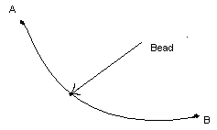

Fig. The Brachistochrone Problem

In Dido’s problem, and in the brachistochrone problem, curves are sought which cause some criterion to assume extreme values. The connection with the optimal control problem, wherein we seek a control function that minimizes a performance measure, should be apparent.

FUNDAMENTAL CONCEPTS
In optimal control problems, the objective is to determine a function that minimizes a specified functional-the performance measure. The analogous problem in calculus is to determine a point that yields the minimum value of a function. In this section we shall introduce some new concepts concerning functionals by appealing to some familiar results from the theory of functions.

DEFINITION OF FUNCTION
A function f is a rule of correspondence that assigns to each element q in a certain set D a unique element in set R. D is called the domain of f & R is called the RANGE.
DEFINITION OF FUNCTIONAL
A functional J is a rule of correspondence that assigns to each function x in a certain class Ω a unique real number. Ω is called the domain of the functional & the set of real number associated with the functions in Ω is called the Range of the functional. Intuitively we might say that a functional is a “function of a function”

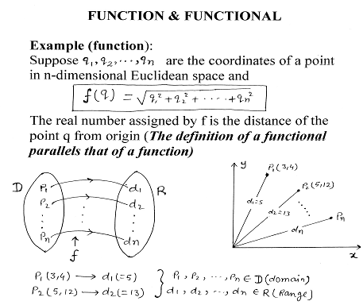

2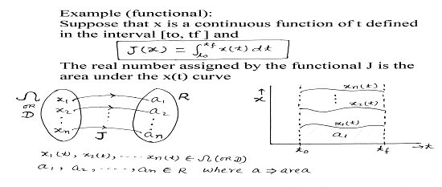

INCREMENT OF A FUNCTION/FUNCTIONAL

In order to consider extreme value of a function, let us now define the concept of an increment

∆f(q, ∆q) = f(q + ∆q) – f(q)

In an analogous manner, we next define the increment of a functional.
Increment of J, denoted by ΔJ is

∆J(x, δx) = J(x + δx) – J(x)

Where δx is called the variation of the function x.

DIFFERNTIAL AND VARIATION
The preceding definitions have laid the foundation for considering variation of a functional. The variation plays the same role in determining extreme values of a functional as the differential does in finding maxima and minima of functions. As review, we next state the definition of the differential of a function.

DEFINITION OF DIFFERENTIAL AND ANALOGICAL DESCRIPTION OF VARIATION:

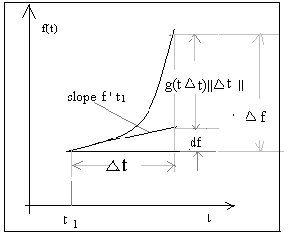

Figure: Geometrical interpretation of ∆f , df , f ‘

The increment of a function of n variable can be written as

and for one variable can be written as

Where df is linear function of , if

then f is said to be differentiable at t , and df is the differential of f at point t and the differential can be written as

Figure above gives a geometrical interpretation of the increment , df and the derivative f ‘. Hence from above we can define and write the differential as

In particular, if f is a differentiable function of n variables, the differential df is given by

We shall also find it convenient to develop a formal procedure for finding the variation of a functional rather than starting each time from the definition which follows

- The increment of a functional can be written as

Where is linear in . Now if

Then J is said to be differentiable on x and is the variation of J evaluated for the function x.
Taking analogy from the definition and formal procedure of differential we can develop the analogical formal procedure for finding the variation as follows.

It is important to keep in mind that is the linear approximation to the difference in the functional J caused by to comparison curve. If the comparison curves are close then the variation should be a good approximation to the increment. The analogy in calculus is illustrated in the above figure, where it is seen that df is good approximation to for small.

THE FUNDAMENTAL THEOREM OF THE CALCULUS OF VARIATION

The fundamental theorem used in finding extreme values of functions requires that the differential vanish at an extreme point. In variational problems the analogous theorem is that the variation must be zero on an extremal curve. Let x be a vector function of t in the class Ω, and J(x) be a differentiable functional of x. The fundamental theorem of calculus of variation is
If x* is an extremal, the variation of J must vanish on x*; that is

FUNCTIONAL OF A SINGLE FUNCTION

Here fundamental theorem is used to determine extrema of functionals depending on a single function. To relate our discussion to the ‘optimal control problem’, we shall think in term of finding state trajectories that minimize performance measures.

THE SIMPLEST VARIATIONAL PROBLEM
Let x be a scalar function in the class of functions with continuous first derivatives. It is desired to find the function x* for which the functional
$J(x)=\int_{\text{to}}^{\text{tf}}{g(x(t),\overset{\text{.}}{x}(t),t)\text{dt}}$

has a relative

extremum. Here end points are fixed that is x₀, t0 and x_{f} are specified.
Solution: - Applying the fundamental theorem we find a necessary condition for x* to be an extremal is
but
since x(t₀) and x(t_{f}) are specified,all admissible curves must pass through these points ; therefore, δx(t₀) = 0 , δx(t_{f}) = 0, and the terms outside the integral vanish.
If we now consider an extremal curve, applying the fundamental theorem yields
which converges to

for all t belong to [to, tf] and called the Euler Equation. In summary the Euler equation for problem 1 is generally a nonlinear, ordinary, time varying, hard to solve, second order differential equation. In the next section we are going to take up some important problems to be solved by Euler equation.

SOME SIMPLE EXAMPLES TO THE APPLICATION OF EULER EQUATION [20]

1. Shortest distance between two points in a plane

An element of arc length ds in a plane is

and the total length of any curve going between points 1 & 2 is

Now for J(y) to be minimum, using Euler equation

where
Now

= 0 ; =
and
=

or = 0

which is an equation of a straight line.

2. Minimum surface of revolution
Suppose we form a surface of revolution by taking some curve passing between two fixed end points (x1,y1) and (x2,y2) and revolving it about the y axis. The problem is then to find that curve for which the surface area is minimum.
The area of a strip of the surface is

and the total area is

Applying Euler’s equation again where

and

= 0 ,

Hence the Euler equation

or

which is the equation of a catenary

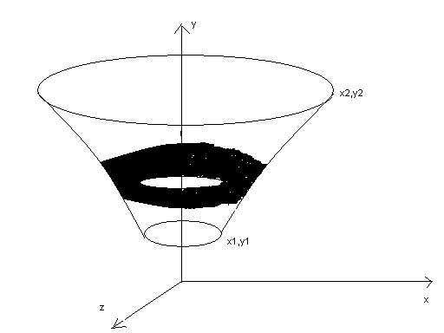

Figure. Minimum surface of revolution

3. THE BRACHISTOCHRONE PROBLEM
Another problem of historical importance and interest is the brachistochrone problem posed by Johann Bernoulli in 1696.
Problem: Under the influence of gravity, the bead slides along a frictionless wire with fixed end points A and B.The problem is to find the shape of the wire that causes the bead to move from A to B in minimum time.
Solution:
If v is the speed along the curve, then the time required to fall an arc length ds is ds/v , and the problem is to find a minimum of the integral

If y is measured down from the initial point of release, the conversation theorem of energy of the particle can be written as
and f is identified as

The solution by Euler equation is a cycloid lying in the vertical plane is credited to Bernoulli and Newton and are solved by variational method in the next section.

SUMMARY
In this chapter we have elegantly tried to portray the concept of variational approach taking analogy from the classical differential calculus. Different problem has been solved by variational method. The Brachistochrone problem is famous in the history of mathematics for it was the analysis of this problem by Bernoulli that led to the formal foundation or evolution of the calculus of variation will be discussed in the next chapter.

4

R
VARIATIONAL APPROACH FOR THE SOLUTION OF BRACHISTOCHRONE PROBLEM

4.1 SOLUTION OF BRACHISTOCHRONE PROBLEM

The Brachistochrone problem is famous in the history of mathematics for it was the analysis of this problem by Bernoulli that led to the formal foundation of the calculus of variation.
Problem: Under the influence of gravity, the bead slides along a frictionless wire with fixed end points A & B. The problem is to find the shape of the wire that causes the bead to move from A to B in minimum time

Figure-4.1 Brachistochrone

Solution: If v is the speed along the curve then the time required to fall an arc length ds is ds/v, and the problem is to find a minimum of the integral

If y is measured from the initial point of release, the conservation theorem for the energy of the particle can be written as

$\frac{1}{2}{\text{mv}}^{2}=\text{mgy}$ which implies that $v=\sqrt{2\text{gy}}$

hence

The curve that minimizes this time interval is thus obtained as the solution to the Euler-Lagrange equation

$\frac{d}{\text{dx}}\left(\frac{∂f}{∂y'}\right)=\frac{∂f}{∂y}$

where f is identified as

It can be shown that the solution to these equations is a cycloid lying in the vertical plane is credited to Bernoulli & Newton. This problem was first posed by one of the Bernoulli Brothers to all contemporary mathematicians of Europe and within a week of its posting the solution was mailed in an unsigned letter by Newton to Bernoulli. Looking at the solution Bernoulli exclaimed “It is not difficult to recognize the lion by its paws” meaning that none other than Newton could have solved the problem.

Then,
$\frac{∂f}{∂y'}=\frac{y'}{\sqrt{y}\sqrt{1+y'^{2}}}$

$\frac{d}{\text{dx}}\left(\frac{∂f}{∂y'}\right)=\frac{y\text{''}}{\sqrt{y}\sqrt{1+y'^{2}}}−\frac{y'^{2}}{2y^{3/2}\sqrt{1+y'^{2}}}−\frac{y'^{2}y\text{''}}{\sqrt{y}(1+y'^{2})^{3/2}}$

$\frac{∂f}{∂y}=−\frac{(1+y'^{2})^{1/2}}{2y^{3/2}}$

So the Euler-Lagrange equation

$\frac{d}{\text{dx}}\left(\frac{∂f}{∂y'}\right)=\frac{∂f}{∂y}$
gives us

$\frac{y\text{''}}{\sqrt{y}\sqrt{1+y'^{2}}}−\frac{y'^{2}}{2y^{3/2}\sqrt{1+y'^{2}}}−\frac{y'^{2}y\text{''}}{\sqrt{y}(1+y'^{2})^{3/2}}+$$\frac{(1+y'^{2})^{1/2}}{2y^{3/2}}$ = 0

Multiplying this equation by $2(1+y'^{2})^{3/2}y^{3/2}$ gives
$2\text{yy}\text{''}(1+y'^{2})−y'^{2}(1+y'^{2})−2\text{yy}\text{''}y'^{2}+(1+y'^{2})^{2}=0$

This further expands to

$2\text{yy}\text{''}+2\text{yy}\text{''}y'^{2}−y'^{2}−y'^{4}−2\text{yy}\text{''}y'^{2}+1+2y'^{2}+y'^{4}=0$

This simplifies to
$1+y'^{2}+2\text{yy}\text{''}=0$

This equation can be rearranged as

$\frac{2y'y\text{''}}{1+y'^{2}}=−\frac{y'}{y}$

which after integration implies

$\text{log}(1+y'^{2})=−\text{log}y+K$
or
or
$y'=[(K/y)−1]^{1/2}$
or
$\int{}\text{dy}[y/(K−y)]^{1/2}=x+C$ let
$y=K{\text{sin}}^{2}θ,\text{dy}=2K\text{sin}θ\text{cos}θdθ$
so that
$x+C=2K\int{{\text{sin}}^{2}(θ)dθ}=K\int{(1−\text{cos}2θ)dθ=K[θ−\text{sin}(2θ)/2]}$

Letting $2θ=α,$we get the solution in parametric form as

$x=−C+\frac{K}{2}(α−\text{sin}α),y=\frac{K}{2}(1−\text{cos}α)$

This represents the equation of cycloid in parametric form. In fact I separated this brachistochrone problem from the other very simple and elegant example to have been solved by variational approach and put it in separate section because of giving it special emphasis as it was this problem which necessitated the evolution of variational principle which later on proved to be panacea for the solution of optimal control problem.

4.2 VERIFICATION OF BRACHISTOCHRONE CURVE BY MATLAB
SIMULATION
As we have seen that the solution of brachistochrone problem by variational approach leads to the curve of a cycloid which is also known as brachistochrone curve. Here at this point of time we shall verify the exactness of the brachistochrone curve by MATLAB simulation taking into cognizance different other curves viz straight line and parabola and computing the time taken by the bead in traversing from A to B under gravity along all the abovementioned shape of the wire. In due course of time we shall see that after computation and comparison time taken along the cycloid curve is minimum.

BRACHISTOCHRONE PROBLEM
This problem is of historical interest posed by Johann Bernoulli in 1696.
Under the influence of gravity, the bead slides along a frictionless wire with ends fixed at A and B. the problem is to find the shape of wire along which the bead will slide in minimum time. The solution a cycloid is credited to Sir Isaac Newton.

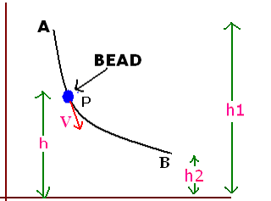

We will solve this problem using MATLAB. However the logic involved will be mathematical.
Let h₁ be the height of point A above datum.
h₂ be the height of point A above datum.
h is the height at any point P in between.
V is the velocity at point P.
M is the mass of bead.
T is the time taken by the bead to move from A to B

Applying energy conservation:

Energy at A = Energy at P

Mgh₁ = MV²/2 + Mgh

ds
dh

dx
Also ds² = dx²+dh² and

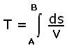

Taking height h along the y axis and solving the above equation the expression for the time taken in traversing from A to B may be written as

or

As far as calculating the time for the quickest path is concerned incorporation of any sort of constant inside the integral is immaterial, so we could write the simplest form for the expression of time as

We will evaluate the integration for three basic curves straight line, parabola & cycloid obviously. The points A and B will be selected suitably so that they are common to all the three curves. We will choose the standard equation for cycloid and take two points on it & according to thee two points trace the equation for the other two curves.
By taking equation of cycloid in parametric form i.e,

and putting the values of we will be getting two corresponding points as A (Л, 2) and B(Л/2 +1,1).
From these two points equation of straight line and parabola by taking the general equation of parabola i.e. and straight line i.e. where m is the slope of the straight line. All the equations so evaluated along with the two points are distinctly written in the box below.

Equation for cycloid x = (φ+sin φ) and y = (1-cos φ)

POINTS: A(Л,2) and B(Л/2 +1,1)

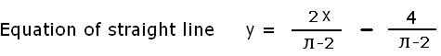

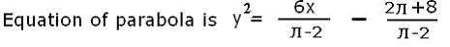

CODING FOR SIMULATION

Here we have done MATLAB coding. All the three defined curves i.e. straight line, parabola and cycloid has been taken into consideration and corresponding MATLAB coding for finding out the time taken by the bead in traversing a path from A to B for each case has been developed.

In the above coding we have used mathematical symbolic toolbox. This provides the facility of differentiation, integration & solving equations in their variable form and substituting values in the variable equation using subs.

The animated visual simulation of the output in all the three cases has been pictorially depicted in the next page onward which speaks volume about the fact that the time taken along the Cycladic curve is minimum among all three curves taken.

OUTPUT

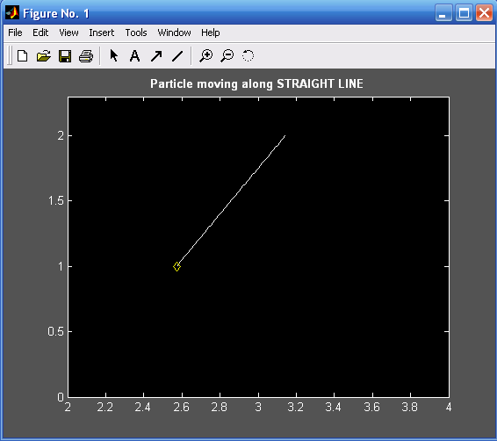

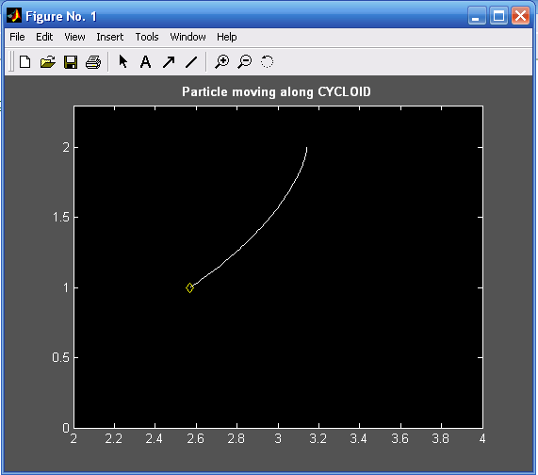

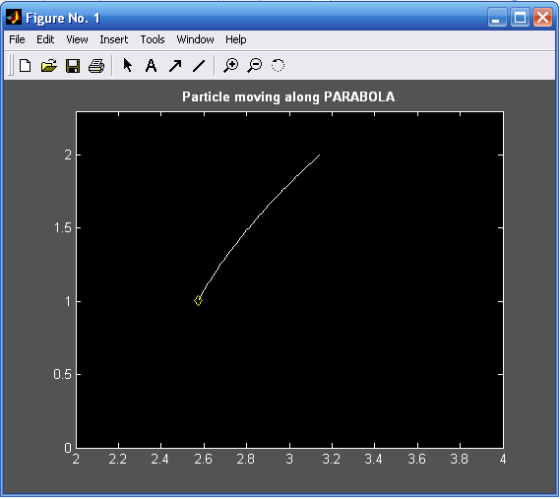

RESULT & CONCLUSION

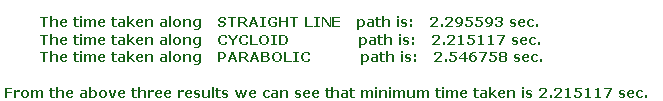

Hence we have thus verified that the Brachistochrone curve is cycloid.

END OF OUTPUT

5

VARIATIONAL APPROACH
TO OPTIMAL CONTROL PROBLEMS

Here we shall apply variational methods to optimum control problems, and derive necessary condition for optimum control assuming that admissible controls are not bounded. These necessary conditions are then employed to find optimal control law for important linear regulator problem [17].

5.1 NECESSARY CONDITIONS TO THE SOLUTION OF OPTIMAL CONTROL PROBLEMS VIA CALCULUS OF VARIATIONAL PRINCIPLE AND THE HJB EQUATION
1. Variational Approach
Here we shall first derive necessary conditions for optimal control assuming that the admissible controls are not bounded. These necessary conditions are then employed to find the optimal control law for the important linear regulator problem.
Here the problem is to find an admissible control u* that causes the system
(5.1)

to follow an admissible trajectory x* that minimizes the performance measure
(5.2)

We shall initially assume that initial condition x₀ and initial time t₀ are specified.

implies that

(5.3a)
(5.3b)
(5.3c)

and
(5.4)

Equations (5.3a), and (5.3b) are state and costate equations respectively and λ(t) the costate. Equations (5.3) are important equations; we shall be using them throughout the remainder of this chapter. We shall see that even when the admissible controls are bounded, only eq.(5.3c) is modified.
We can get the above state equation, costate equation, and other equation by defining the Hamiltonian as

Using this notation we can write the abovementioned necessary conditions (5.3) through (5.4) as follows:

(5.5a)
(5.5b)
(5.5c)

and
(5.6)

Equations (5.3) are the necessary conditions we set out to determine. Notice that these necessary conditions consist of a set of 2n, first order differential equations-the state and costate equations(5.3a) and (5.3b)- and a set of m algebraic relation (5.3c) - which must be satisfied throughout the interval [t₀ ,t_{f} ].

2. HJB EQUATION APPROACH
In our initial exposure to dynamic programming, we approximate continuously operating systems by discrete systems which lead to a recurrence relation that is ideally suited for digital computer solution.
But here in this section we shall consider an alternative approach which leads to a nonlinear partial differential equation – the Hamilton-Jacobi-Bellman (H-J-B) equation.
Here the process described by the state equation

Is to be controlled to minimize the performance measure

Where h and g are specified functions, t₀ and t_{f} are fixed

=

Which further implies after cancellation from both sides that
u(t)

Boundary condition:

Now let us define the Hamiltonian

This implies that
u(t) (5.7)

This is referred to as HJB equation.

conclusion:

Here we have derived necessary conditions for optimal control problems by variational as well as HJB equation method. Equations (5.3) and (5.7) are the necessary conditions we set out to determine. Notice that these necessary conditions consist of a set of 2n, first order differential equations-the state and costate equations(5.3a) and (5.3b)- and a set of m algebraic relation (5.3c) - which must be satisfied throughout the interval [t₀ ,t_{f} ].

6

VARIATIONAL APPROACH
TO
LINEAR QUADRATIC REGULATOR PROBLEMS

6.1 VARIATIONAL AND HJB EQUATION APPROACH FOR LQR PROBLEM (DERIVATION OF RICCATI EQUATION BY HJB EQUATION AND CALCULUS OF VARIATIONAL APPROACH)

(a) HJB equation approach
Here we shall consider an important class of optimal control problems known as linear regulator systems. Any problems having linear plant dynamics and quadratic performance criteria are referred to as linear regulator problem. We shall show that for linear regulator problems the optimal control law can be found as a linear time varying function of the system states.
The process to be controlled is described by the state equations
(6.1)

and the performance measure to be minimized is

(6.2)

S and Q are real symmetric positive semi definite matrices, R is real symmetric positive matrix, the initial time t0 and final time tf are specified, and u(t) and x(t) are not constrained by any boundaries.
To use the HJB equation we first form the Hamiltonian:

(6.3)
(6.4)
Since the matrix is positive definite and H is a quadratic form in u, the control that satisfies equation (6.4) does minimize H globally.
Equation (6.4) implies that

(6.5)

Plugging this equation with eqn (6.3) we get

(6.6)

Applying HJB equation we get

(6.7)

From equation (6.2) the boundary condition is

(6.8)

Let us guess a solution of the form

(6.9)

Putting this assumed solution in equation (6.7) we get

(6.10)
Now since
(6.11)

Taking into account only the symmetrical part and plugging this with eqn (6.10) we get

(6.12)
or (6.13)

And the boundary condition from eqn (6.8) and (6.9) is

(6.14)

Once P(t) has been determined, the optimal control law is given by

(6.15)

(6.16)

Thus by assuming a solution of the form (6.9) the optimal control law is linear, time varying state feedback. Our approach in this section leads to eqn (6.13) which is a differential eqn of the Riccati type, and thus is referred to as “Riccati equation”. Later on the same eqn is developed by variational methods.

(b) VARIATIONAL APPROACH

Here we shall consider an important class of optimal control problems known as linear regulator systems. Any problems having linear plant dynamics and quadratic performance criteria are referred to as linear regulator problem. We shall show that for linear regulator problems the optimal control law can be found as a linear time varying function of the system states.
The process to be controlled is described by the state equations
(6.17)

And the performance measure to be minimized is

(6.18)

S and Q are real symmetric positive semi definite matrices; R is real symmetric positive matrix. It is assumed that the states and controls are not bounded and x(tf) is free, whereby we attach the following physical interpretation to this performance measure: It is desired to maintain the state vector close to origin without an excessive expenditure of control effort.
Here the Hamiltonian is

(6.19)

Application of the variational principle requires that, for an optimum control,

(6.20)
and
(6.21)

with the terminal condition

(6.22)
Thus we require that
(6.23)

And we shall enquire whether we may convert this to a closed-loop control by assuming that the solution for the adjoint is similar to eq. (6.22)

(6.24)

Clubbing this eq with eq (6.17) and (6.23) we require that

(6.25)

Also from eq (6.24) and (6.21) we require

(6.26)

By combining eq (6.25) and (6.26) we have

(6.27)

Since this must hold for all non zero x(t), the term premultiplying x(t) must be zero. Thus the P matrix, which is an nxn symmetric matrix, must satisfy the matrix Riccati equation:

(6.28)

With a terminal condition given by eqs.(6.22) and (6.24)

(6.29)

Thus we may solve the matrix Riccati eq. backward in time from to ,store the matrix

(6.30)

And then obtain a closed control form

(6.31)

This indicates that the optimal control law is a linear time varying function of the system states hence the measurement of all of the state variables must be available to implement the optimal control law. Fig below shows the plant and its optimal controller.

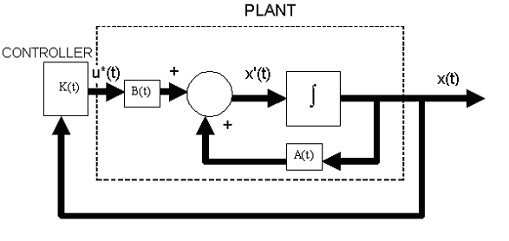

Figure. Plant and optimal feedback controller for linear regulator problems

As has been seen earlier the linear control law given by equation u = Kx is the optimal control law. Therefore, if the unknown elements of the matrix K are determined so as to minimize the performance index, then u(t) = Kx(t) is optimal for any initial state x(0).

6.2 SAMPLE PROBLEM :
Here we take a sample example where we wish to find the optimal control and trajectory which minimize the performance measure for the system (plant) with the initial state x(0)=1 and terminal state x(1)=0

Solution Sample problem:
The Hamiltonian for this simple system is

(1)

The optimality condition yields

(2)

The optimal value of H becomes, after substituting Eq.(2) into Eq.(1),

Now

(3)

From Eq. (3) we have

P= -2(D+1)x (4)

Therefore,

(D+1)(D-1)x=0,

This implies

Using the boundary conditions and solving for K₁ and K₂ we obtain

x(t)= -0.15652 exp(t) + 1.1562 exp(-t)
u*(t) = -0.31304 exp(t)

The state feedback is given by

The state and optimal control are plotted in figure below

Supporting MATLAB Script
%.....state diagram plot...........
clc,clear;t=0:0.05:1;x=-0.15652*exp(t)+1.1562*exp(-t);
plot(t,x);xlabel('Time,(sec)');ylabel('state x(t)');
gtext('x(t)=-0.15652exp(t)+1.1562exp(-t)');grid;
title('state diagram plot')
%.....optimal control plot........
t=-0.2:0.05:1.2;u=-0.31304*exp(t);
plot(t,u);xlabel('time,(sec)');
ylabel('optimal control u*(t)');
gtext('u*(t)=-0.31304exp(t)');grid;
title('optimal control plot')

Figure: State and optimal control plots

6.3 Solving Quadratic Optimal Regulator Problems with MATLAB

In MATLAB the command lqr(A,B,Q,R) solves the continuous-time, linear quadratic regulator problem and the associated Riccati equation. This command calculates the optimal feedback gain matrix K such that the feedback control law
u = - Kx
minimizes the performance index

Subject to the constraint equation

Another command [K,P,E] = lqr(A,B,Q,R) returns the gain matrix K, eigenvalue vector E, and matrix P, the unique positive definite solution to the associated matrix Riccati equation:
PA + A*P –PBR⁻¹B*P + Q = 0

If matrix A-BK is stable matrix, such a positive solution P always exists. The eigenvalue vector E gives the closed poles of A-BK.
It is important to note that for certain systems matrix A-BK can not be made a stable matrix, whatever K is chosen. In such a case, there does not exist a positive definite matrix P for the matrix Riccati equation. For such a case, the commands K = lqr(A,B,Q,R) and [K,P,E] = lqr(A,B,Q,R) do not give the solution. Next we are taking a sample problem to illustrate the fact.

6.4 SAMPLE PROBLEM:

Consider the system given by where

The performance index J is given by

Where

We have to obtain the positive definite solution matrix P of the Riccati equation, the optimal feedback gain matrix K, and the eigenvalues of the matrix A-BK. In addition to this we shall obtain the response x(t) of the regulator system to the initial condition x(0), where

SOLUTION:
With the state feedback u = Kx, the state equation for the system becomes

Then the system, or sys, can be given by

The following MATLAB script-2 given in appendix solves the problem and produces the response to the given initial condition. The response curves are also shown in the following figure.
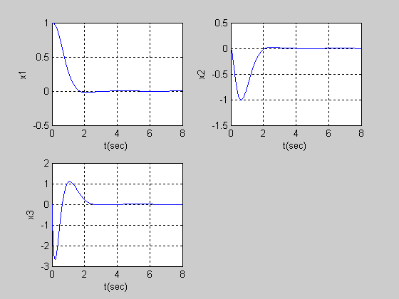
Figure: Response curves to initial conditions

6.5 Analysis of the Dynamics of the Aircraft:

Consider the linearized aircraft equations in the longitudinal axis

and the output equation is

Let us find the control law minimizing the quadratic performance functional

where the weighing matrices assigned by the designer are

and

which implies that

The feedback control algorithm is written as

Let us find the feedback gain matrix ,the return function matrix K, and the eigenvalues of the closed system studying Also, as the control law is derived, the dynamics should be analyzed. For all these purposes following m-file MATLAB SCRIPT-3 is written in appendix.
The feedback gain matrix K_{F} ,The return function matrix K, and the eigenvalues of the(A-BG⁻¹ B^{T} K) = (A-BK_{F}) are found. In particular, using the results displayed
eigenvalues.A
-2.9923e+000
1.3033e+000
-2.1009e-002 +5.5401e-002i
-2.1009e-002 -5.5401e-002i

Kfeedback
2.9982e-001 -2.0342e-001 -1.2836e+000 -3.5156e+000
2.6051e-002 -4.9135e-002 -1.6430e-001 -4.1638e-001

K
1.1373e+000 2.0581e+000 -1.2195e+000 -6.4757e+000
2.0581e+000 6.8339e+000 -1.5567e+000 -1.3729e+001
-1.2195e+000 -1.5567e+000 3.3183e+000 1.1851e+001
-6.4757e+000 -1.3729e+001 1.1851e+001 5.5207e+001

eigenvalues A-BKfeedback
-1.1887e+000 +1.6544e+000i
-1.1887e+000 -1.6544e+000i
-3.1399e+000
-2.3681e+000

we have

and

The eigenvalues of closed-loop system are -1.21.7j, -3.1 and -2.4. That is, the system is stable whereas it should be observed that the open loop system was unstable because the eigenvalues were found to be 2.9, 1.3 and -0.0210.055j.
Using the control algorithm obtained
one has

The transient dynamics of the state variable for

are plotted in figure below

Figure: Evolution of the state variables
7

POLE PLACEMENT VERSUS QUADRATIC OPTIMAL REGULATOR APPROACH

This section discusses state space design methods based on the pole placement method and the quadratic optimal regulator method. Note that the state feedback gain matrix K can be obtained by both the pole placement method and the quadratic optimal control method.
An advantage of quadratic optimal control method over the pole placement method is that the former provides a systemic way of computing state feedback control gain matrix. In pole placement method, the lack of the existence of a definite guideline of where to place the eigenvalues makes the design procedure a rather difficult one in practice. A designer has to use his or her own intuition of how to use the freedom of choosing the eigenvalues to achieve the design objective.
It is therefore desirable to have a design method that can be used as an initial design process while the designer develops his or her own insight.
A compromise is often made in practice to obtain such an initial design process. Instead of trying to place the eigenvalues at desired locations, the system is stabilized while satisfying some performance criterion.
As has been seen earlier the linear control law given by equation u = Kx is the optimal control law. Therefore, if the unknown elements of the matrix K are determined so as to minimize the performance index, then u(t) = Kx(t) is optimal for any initial state x(0). In the following we will be discussing the inverted pendulum control system mechanism from the pole placement and quadratic optimal regulator method.

INVRTED PENDULUM CONTROL SYSTEM

An inverted pendulum mounted on a motor driven cart is shown in fig. This is a model of attitude control of a space booster on takeoff. (The objective of the attitude control problem is to keep the space booster in a vertical position.) The inverted pendulum is unstable in the sense hat it may fall over any time in any direction unless a suitable control force is applied. Here we consider only a two dimensional problem in which the pendulum moves only in the plane of the page. The control force u is applied to the cart.

It is desired to keep the inverted pendulum upright as much as possible and yet control the position of the cart, for instance, move the cart in a step fashion. To control the position of the cart, we need to build a type 1 servo system. The inverted pendulum system mounted on a cart does not have an integrator therefore we feed the position signal y (which indicates the position of the cart) back to the input and insert an integrator in the feedforward path, as shown in the figure

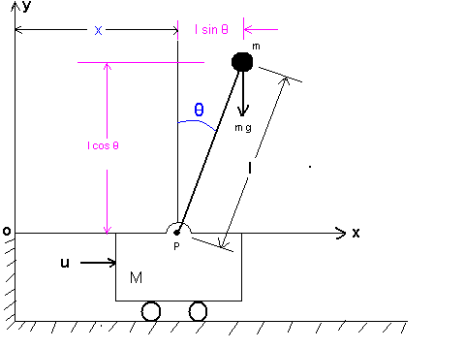

Figure-7.1. Inverted pendulum system

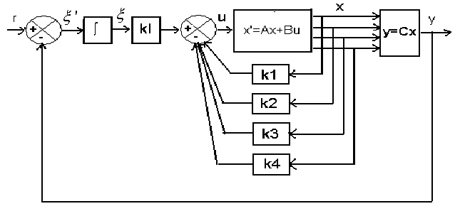
Figure-7.2 Inverted pendulum control system

The mathematical model for this system is given by

(7.1)

whence we obtain the plant transfer function as

(7.2)

The inverted pendulum plant has one pole on the negative real axis and another on the positive real axis; hence the plant is open loop unstable. We assume that the numerical values for M, m, and l are given as
M = 2 Kg, m = 0.1 Kg, l = 0.5 m
When the given numerical values are substituted eqn.(7.1) becomes

(7.3)

Let us define the state variables and as
and output variable as

so that

Then referring to eqn.(7.3)and figure 7.2 and considering the cart position x as the output of the system, we obtain the equation for the system as follows:

(7.4)

where

for the type 1 servo system, we have the state error equation as

(7.5)

where

and the control signal is given by the equation

where

1. Pole Placement Approach:

Desired location for closed loop poles
To obtain a reasonable speed and damping in the response of the designed system(for example the settling time of approximately 4-5 sec and the maximum overshoot of 15% to 16% in the step response of the cart), let us choose the desired closed loop poles at

we shall determine the necessary state feedback gain matrix by use of MATLAB.
MATLAB script 4 of appendix produces the state feedback gain matrix Khat.
Khat=
-157.6336 -35.3733 -56.0652 -36.7466 50.9684

Thus we get

K = [k1 k2 k3 k4] = [-157.6336 -35.3733 -56.0652 -36.7466]

and
ki = -50.9684

Unit Step-Response Characteristics of the Designed System:

Once we determine feedback gain matrix K and the integral gain constant ki, the step response in the cart position can be easily obtained by using the MATLAB script 5 of appendix.
Figure 10.3 shows the response curves to a unit step input. Notice that y(t)[= x3(t)]has approximately 15% overshoot and the settling time is approximately 4.5 sec.ξ(t)[= x5(t)] approaches 1.1. This result could also be theoretically derived.

Figure 7.3 Response curves to a unit-step input
[x1 ~ t, x2 ~ t, x3(= output y) ~ t, x4 ~ t, x5( = ξ ) ~ t]

It is noted that, as in any design problem, if the speed and damping are not quite satisfactory, then we must modify the desired characteristic equation and determine a new matrix Khat. Computer simulations must be repeated until a satisfactory result is obtained.

2. Quadratic Optimal Regulator Approach

Here we will be taking up Quadratic Optimal Regulator Approach for the design of same Inverted Pendulum Control System. We will see in due course of time that the system designed by use of quadratic optimal regulators approach generally gives better characteristics-less oscillatory and well damped.
Let us take the following performance index J to be minimized for the quadratic optimal regulator problem:

(7.6)

where

Using MATLAB we will be determining the state feedback gain matrix Khat such that the performance index (7.6) may be minimized. In addition to that we have to obtain the unit-step response of the system designed.
A MATLAB program to determine Khat is given in MATLAB script 6 of appendix.
The result is

Hence

Unit Step Response Characteristics of the Designed System:

Once we have determined the feedback gain matrix K and the integral gain constant ki, we can determine the unit-step response of the designed system. The system equation is

(7.7)

since

Equation (7.7)can be written as follows:

(7.8)

The MATLAB SCRIPT-7 given in appendix gives the unit step response of the system given by equation (7.8). The resulting response curves are presented in figure (7.4). All initial conditions are set equal to zero.

Figure 7.4 Response curves to a unit-step input
[x1 ~ t, x2 ~ t, x3(= output y) ~ t, x4 ~ t, x5( = ξ ) ~ t]

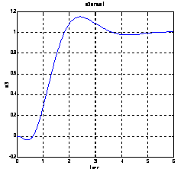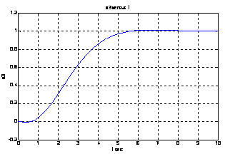

Fig 10-5. (a) y(=x3)versus t (b) y(=x3)versus t
Pole Placement Approach. LQR Approach.

Conclusion:
An enlarged version of the cart position y[=x3(t)] versus t for both pole placement and LQR design method has been presented separately in figure 10-5.Comparing the step response characteristics of this system by both the methods we notice that the response corresponding to quadratic optimal regulator system is less oscillatory and exhibits less maximum overshoot in the position response(x3 versus t).the system designed by quadratic optimal regulator approach generally gives such characteristics i.e. less oscillatory and well damped.

8

VARIATIONAL APPROACH
FOR
LINEAR TRACKING PROBLEM

Next let us generalize the results obtained for the linear regulator problem to the tracking problem that is the desired value of the state vector is not the origin.
The state equations are

(8.1)

and the performance measure to be minimized is

(8.2)

where r(t)is the desired or reference value of the state vector, the final time tf is fixed and x(tf) is free, and the states and control are not bounded. H and Q are real symmetric positive semi-definite matrices, and R is real symmetric and positive definite.
The Hamiltonian is given by

(8.3)

Application of the variational principle requires that, for an optimum control,

(8.4)
and
(8.5)

with the terminal condition

(8.6)

Thus we require that

(8.7)

and we shall enquire whether we may convert this to a closed-loop control by assuming that the solution for the adjoint is similar to eq. (8.6)

(8.8)

Clubbing this eq with eq (8.1) and (8.7) we require that

(8.9)

also from eq (8.8) and (8.5) we require

(8.10)

By combining eq (8.9) and (8.10) we have

(8.11)

Since this must hold for all non zero x(t), the term premultiplying x(t) must be zero. Thus the P matrix, which is an nxn symmetric matrix must satisfy the matrix Riccati equation:

This can be separately written as

(8.12)

and

(8.13)

With a terminal condition given by eqs.(8.6) and (8.8)

From equation (8.7) we obtain a closed control form

or

(8.14)

Where

and (8.15)

Where K(t) is feedback gain matrix and v(t) is the command signal. Notice that v(t) depends upon the system parameter and on the reference signal r(t).In fact v(t) depends upon the future values of the reference signal, so we might say that the optimal control has an anticipatory quality which is reinforced by physical reasoning , which tells us that we must determine our present strategy on the basis of where we are now and where we intend to go.(Actually same sort of situation was present, though in a more subtle way, in regulator problems, where we utilized our desire to be at the origin.)
A diagram of the plant and the controller is shown in figure-(8.1). Note that just like regulator problem we must be able to measure all of the states in order to synthesize the optimal control law. This indicates that the optimal control law is a linear time varying function of the system states hence the measurement of all of the state variables must be available to implement

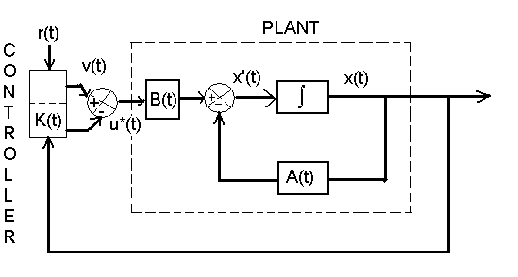
Figure 8-1 Plant and optimal feedback controller for linear tracking problems.

Tracking Control of an Aircraft

We study the tracking control problem for an unstable model of an aircraft. Beginning with the state space equations, the states are

Where v is the forward velocity [m/sec], is the angle of attack[rad], q is the pitch rate [rad/sec], is the pitch angle [rad], p is the roll rate[rad/sec], r is the yaw rate[rad/sec], is the roll angle[rad], and is the yaw angle [rad].
Six control inputs are

Where and are the deflections of the right and left horizontal stabilizers [rad],
and are the deflections of the right and left flaps[rad], and and are the
canard and rudder deflections [rad].
The longitudinal-lateral dynamics is studied applying the state-space model in
where

The eigenvalues of A can be found using the characteristic equation. This gives us the following eigenvalues of an open loop system:

Thus, the studied longitudinal-lateral open-loop dynamics of the fighter is unstable. The tracking problem has to be solved and the output equation should be used.
Let us express the error vector in terms of the reference inputs and the output vector (Euler angle of the aircraft) as

and

To find the unknown matrix K, we obtain the feedback coefficients of the tracking controller, and model the fighter dynamics. The m-file MATLAB SCRIPT-8 is written in appendix.
The following matrices and are found.
The real parts of eigenvalues of the closed-loop system are found to be negative. Hence the closed loop system is stable.
The tracking controller is verified through the simulations. The fighter outputs (Euler angles) and the evolution of the state variables in the longitudinal and lateral axes are also documented and illustrated in the following figures.

0
0.5
1
1.5
2
2.5
3
3.5
4
4.5
5
-0.5
0
0.5
1
1.5
2
Lateral dynamics

Time,seconds

9

TWO SPECTACULAR CONTRIBUTION OF MATHEMATICS IN CONTROL SYSTEM

EVOLUTION OF NYQUIST STABILITY CRITERIAN AND OPTIMAL CONTROL SYSTEM FROM CAUCHY’S MAPPING THEOREM AND CALCULUS OF VARIATION RESPECTIVELY

Though history is replete with numerous examples showing symbiotic relation between mathematics and engineering science yet the two important branch of control engineering viz Nyquist Stability criterion and Optimal Control system are but the direct extension of pure mathematics i.e. Cauchy’s mapping theorem and calculus of variation respectively.
Cauchy’s mapping theorem which is pure mathematical concept states that if s-plane contour in clock wise direction encloses Z zeros and P poles of q(s) then corresponding q(s) plane contour will encircle its origin
Z-P times in clockwise direction. The maxim – “Necessity is the mother of invention” holds good here in the sense that Nyquist in the pursuit of finding the stability criterion of control system got tip-off from mapping theorem and took q(s) as the denominator polynomial of closed loop transfer function and thinking the left half s-plane to be immaterial as far as stability of feedback control system is concerned, took into cognizance only the infinite right half s-plane contour enclosing all the zeros and poles of q(s) known by his name as Nyquist contour. If corresponding q(s) plane contour encloses its origin as many as N no of times then Cauchy’s mapping theorem (or principle of argument) implies that N=Z-P. Since the roots of characteristics equation q(s) is the poles of closed loop transfer function it should never lie in the right half s-plane which makes Z=0 for stable system. Hence for stable system N = - P which is Nyquist stability criterion. Hence based upon above analysis Nyquist stability criterion may be stated as: If the q(s) plane contour encloses its origin as many times as the total no of right half s-plane pole of q(s) then the system is stable otherwise the system is unstable.
So here we saw that how the Cauchy’s mapping theorem became genesis of Nyquist stability criterion and in the similar manner we will see that other pure mathematical tool, the calculus of variation evolved and opened the floodgates for the solution of optimal control problems.
The credit for the evolution of the concept of calculus of variation and hence the solution of optimal control problem mostly goes to John Bernoulli and Newton et.al. It so happened that once a nagging problem sprang up in the mind of Bernoulli which by its kind of nature known as brachistochrone problem states like this: There are two points A and B in a vertical plane lying one above the other in such a way that a bead slides from A to B along a frictionless wire under gravity then the problem is to find the shape of the wire that causes the bead to slide from A to B in quickest time. The endeavors made by all the contemporary mathematician led to the birth of calculus of variation which eventually solved the brachistochrone problem and solution resulted as Cycladic shape of the wire.
The idea of calculus of variation was intuitively thought to be analogous to that of differential calculus and hence the common feature of brachistochrone problem or any optimal control problem, where the objective is to find a function that minimizes a functional (the performance measure), culminated to Euler-Lagrange equation which paved the way for the solution of innumerous optimal control problem. Hence we saw that how the two pure mathematical concepts opened the floodgates for the design of classical as well as modern control system hence found to be quite spectacular in my view.

10
CONCLUSIONS
&
SCOPE FOR FURTHUR WORK

CONCLUSIONS:

Having taken the reference and cognizance to the literature review, and becoming enthralled to see the ecstatic beauty of the progenitor of optimal control problems i.e. brachistochrone problem and variational approach, we decided to dig up the topic: “VARIATIONAL METHOD FOR OPTIMAL CONTROL PROBLEMS”.

We have started from the method of analysis for the design and stability of classical control system, their limitations for the design of modern control systems and then adoption of the indispensable optimal control system. In classical control system we were least bothered about the fact that whether the system designed was best to use whereas in optimal control system design the system designed is inevitable to be the best.

As it was brachistochrone problem which laid the formal foundation of variational approach and optimal control we have commenced with the solution of brachistochrone problem applying variational approach and then taken recourse to MATLAB simulation to verify the veracity of the brachistochrone curve to be cycloidal. It has been shown that traversal of the bead along cycloidal curve takes minimum time in comparison to the other curves under consideration: straight line and parabola.

Then we have taken two important classes of optimal control problems: Linear Quadratic Regulator and linear tracking problems. We have solved these problems by both the methods i.e. variational approach and HJB equation approach and strikingly both methods converged to same results: optimal control law is linear time varying function of the system states i.e. proved the veracity of the fact that all roads lead to the same destination.

We have taken different kinds of sample problems falling under the gamut of LQR and linear tracking problems and tried to see pragmatically the manifestation of the benefits of the optimal control design methodologies. We have seen that how an unstable system whose eigenvalues were lying in the right half s plane transformed to stable system with least amount of overshoot by incorporating the optimal control strategy.

Last but not the least we have taken the famous inverted pendulum control system which we know is inherently unstable, was designed by classical pole placement method and modern LQR method and consequently it was observed that LQR method is quite superior to the pole placement method. Eventually as a conclusion we can give the sweeping statement with conviction that the system designed by linear quadratic optimal regulator approach is less oscillatory and well damped.

Having delved deep into the retrospective details of the history of control system: classical and modern, we found striking similarity in the evolution of two important branch of control system: Nyquist stability criterion and optimal control engineering. We see that these two topics evolved spectacularly from pure mathematics, one from the Cauchy’s Mapping Theorem and other one from calculus of variation. These two topics are just an extension of Cauchy’s Mapping theorem and Calculus of Variation.

SCOPE FOR FURTHUR WORK:

While solving the brachistochrone problem by variational approach we have not taken into consideration the frictional force etc hence further scope may be to solve the same problem by taking the frictional force into account. This is equivalent to determining minimum time paths in a uniform gravitational field with coulomb friction resisting the motion. A very interesting application of calculus of variation may be in the derivation of ray equation, which determines the path of rays in a medium of varying refractive index. Now, in geometrical optics, the path of rays can be determined using Fermat’s principle according to which the ray will correspond to that path for which the time taken is an extremum in comparison to nearly path. Variational approach may also be used to find the optimal control that will minimize the fuel consumption in throwing a satellite into space via a rocket. That is, it may be used for different kind of minimum time and minimum fuel optimal control problem. Thus the basic rudimental work done in this dissertation may be extended for the said problems.

APPENDIX(A)

QUADRATIC FORMS

Some of the techniques used in determining stability of control systems and for optimizing their response utilize scalar functions expressed in quadratic form.

BILINEAR FORM: A scalar homogeneous expression containing the product of the elements of vectors x and y is called a bilinear form in the variables and when they are both of order n. The most general bilinear form in x and y is

This can be written more compactly as

=

= = (1)

The matrix A is called the coefficient matrix of the bilinear form, and the rank of A is called the rank of the bilinear form. A bilinear form is called symmetric if the matrix A is symmetric.

QUADRATIC FORM: A quadratic form V is a real homogeneous polynomial in the real variables of the form

Where all are real. This is the special case of equation (1) where x = y. The quadratic form V can be expressed as the inner product

Script 1
clc
num=[1]
den1=[1 0 1]
den2=[1 0.4 1]
den3=[1 0.8 1]
den4=[1 1.6 1]
den5=[1 2 1]
den6=[1 2.4 1]
sys1=tf(num,den1)
sys2=tf(num,den2)
sys3=tf(num,den3)
sys4=tf(num,den4)
sys5=tf(num,den5)
sys6=tf(num,den6)
step(sys1,sys2,sys3,sys4,sys5,sys6)
gtext('zeta=0')
gtext('zeta=0.2')
gtext('zeta=0.4')
gtext('zeta=0.8')
gtext('zeta=1')
gtext('zeta=1.2')

Script 2

Script 3

echo off;clc;
clear all;
format short e;
% constant-coefficient matrices A and B
A=[-0.041 5.8 -0.6 -9.6;
-0.0003 -.74 1 -.0002;
-.00007 4.6 -.95 -.0005;
0 0 1 0 ];
disp('eigenvalues.A'); disp(eig(A)); % Eigenvalues of the
% matrix A
B=[.74 -.11;
-1.5 -.18;
-4.3 -.62;
0 0 ];
% weighting matrices Q and G
Q=[1 0 0 0;
0 1 0 0;
0 0 1 0;
0 0 0 1];
G=[10 0 ;
0 10];
%Feedback and return function coefficients, eigenvalues
[Kfeedback,K,Eigenvalues]=lqr(A,B,Q,G);
disp('Kfeedback');disp(Kfeedback);
disp('K');disp(K);
disp('eigenvalues A-BKfeedback'); disp(Eigenvalues);
% Matrix of the closed loop system
A.closed.loop=A-B*Kfeedback;
% Longitudinal Aircraft Dyanamics
t=0:0.02:4;
% Deflections of control surfaces
uu=[0.5*ones(max(size(t)),4)];
C=[0 0 0 1]; D=[0 0 0 0];
[Y,X]=lsim(A.closed.loop,B*Kfeedback,C,D,uu,t);
plot(t,X);
title('Aircraft Dyanamics,x1,x2,x3,x4');
xlabel('time[seconds]');
pause;
plot(t,y);
pause;
plot(t,X(:,1),'-',t,X(:,2),'-',t,X(:,3),'-',t,X(:,4),'-');
pause;
plot(t,X(:,1),'-');pause;
plot(t,X(:,2),'-');pause;
plot(t,X(:,3),'-');pause;
plot(t,X(:,4),'-');pause;
disp('End')

Script 4

Script 5

A=[0 1 0 0;20.601 0 0 0;0 0 0 1;-0.4905 0 0 0];
B=[0;-1;0;0.5];
C=[0 0 1 0];
D=[0];
K=[-157.6336 -35.3733 -56.0652 -36.7466];
KI=-50.9684;
AA=[A-B*K B*KI;-C 0];
BB=[0;0;0;0;1];
CC=[C 0];
DD=[0];
t=0:0.02:10;
[y,x,t]=step(AA,BB,CC,DD,1,t);
x1=[1 0 0 0 0]*x';
x2=[0 1 0 0 0]*x';
x3=[0 0 1 0 0]*x';
x4=[0 0 0 1 0]*x';
x5=[0 0 0 0 1]*x';
subplot(3,2,1);plot(t,x1);grid
title('x1 versus t')
xlabel('t sec');ylabel('x1')
subplot(3,2,2);plot(t,x2);grid
title('x2 versus t')
xlabel('t sec');ylabel('x2')
subplot(3,2,3);plot(t,x3);grid
title('x3 versus t')
xlabel('t sec');ylabel('x3')
subplot(3,2,4);plot(t,x4);grid
title('x4 versus t')
xlabel('t sec');ylabel('x4')
subplot(3,2,5);plot(t,x5);grid
title('x5 versus t')
xlabel('t sec');ylabel('x5')

Script 7

A=[0 1 0 0;20.601 0 0 0;0 0 0 1;-0.4905 0 0 0];
B=[0;-1;0;0.5];
C=[0 0 1 0];
D=[0];
K=[-188.0799 -37.0738 -26.6767 -30.5824];
KI=-10.0000;
AA=[A-B*K B*KI;-C 0];
BB=[0;0;0;0;1];
CC=[C 0];
DD=[0];
t=0:0.01:10;
[y,x,t]=step(AA,BB,CC,DD,1,t);
x1=[1 0 0 0 0]*x';
x2=[0 1 0 0 0]*x';
x3=[0 0 1 0 0]*x';
x4=[0 0 0 1 0]*x';
x5=[0 0 0 0 1]*x';
subplot(3,2,1);plot(t,x1);grid
title('x1 versus t')
xlabel('t sec');ylabel('x1')
subplot(3,2,2);plot(t,x2);grid
title('x2 versus t')
xlabel('t sec');ylabel('x2')
subplot(3,2,3);plot(t,x3);grid
title('x3 versus t')
xlabel('t sec');ylabel('x3')
subplot(3,2,4);plot(t,x4);grid
title('x4 versus t')
xlabel('t sec');ylabel('x4')
subplot(3,2,5);plot(t,x5);grid
title('x5 versus t')
xlabel('t sec');ylabel('x5')

Script 8

clear all
clc
a=[-0.016 8.40 -.90 -9.6 -1.5 -.27 -.086 0 0;
-.003 -1.2 1.0 0 .080 .062 .009 0 0;
-0.0001 3.90 -.85 0 .017 .0038 .040 0 0;
0 0 1.00 0 0 0 0 0 0 ;
-.003 .15 .02 .97 -.560 .130 -.910 0 0;
-.00001 .71 0.03 .010 -48.00 -3.5 .22 0 0;
.00001 -.94 .06 .005 9.2 -.028 -.510 0 0;
0 0 0 0 0 1 0 0 0;
0 0 0 0 0 0 1 0 0]
b=[.120 .120 -.38 -.38 0 0;
-0.160 -.160 -.270 -.270 0 0;
-9.5 -9.5 -2.5 -2.5 0 0;
0 0 0 0 0 0;
.019 -.019 -.001 .001 .42 .053;
-2.9 2.9 -3.1 3.1 .73 .920;
3.1 -3.1 .78 -.78 .61 -.45;
0 0 0 0 0 0 ;
0 0 0 0 0 0]
h=[0 0 0 1 0 0 0 0 0;
0 0 0 0 0 0 0 1 0;
0 0 0 0 0 0 0 0 1]
d=zeros(3,3);`
A=[a zeros(9,3);-h zeros(3,3)];
B=[b;zeros(3,6)];
q=eye(size(A));
q(10,10)=5000;q(11,11)=5000;q(12,12)=5000;
r=25*eye(size(B,2));
[Kcont,k,eigenvalues]=lqr(A,B,q,r);
ra=1;rb=1;rc=1;
eulerangles=[ra;rb;rc];
t=0:0.01:5;
ua=ra*ones(size(t'));
ub=rb*ones(size(t'));
uc=rc*ones(size(t'));
ub=rb*ones(size(t'));
ur=[ua ub uc];
N=eye(3,3);
inputmatrixB=[zeros(9,3);N]*[0 ra 0; 0 rb 0; 0 0 rc];
H=h; H(3,12)=0;
D=d; D(3,3)=0;
lsim(A-B*Kcont,inputmatrixB,H,D,ur,t)
[v,x]=lsim(A-B*Kcont,inputmatrixB,H,D,ur,t);
%fighter outputs
figure, plot(t,v) ,title('Fighter outputs:euler angles'),
grid, xlabel('Time,seconds'),pause,
%longitudinal dynamics
figure,plot(t,0.05*x(:,1),t,x(:,2),t,x(:,3),t,x(:,4)),
grid, title('Longitudinal Dynamics'),
xlabel('Time,seconds'), pause
%lateral dynamics
figure,plot(t,x(:,5),t,x(:,6),t,x(:,7),t,x(:,8),t,x(:,9)),
grid,title('lateral dynamics'),
xlabel('Time,seconds'),pause
figure,plot(t,v(:,1)),title('output: theta'),
xlabel('Time,seconds'),pause
%figure,plot(t,v(:,2)),title('output: phi'),
%xlabel('Time,seconds'),pause
%figure,plot(t,v(:,3)),title('output: psi'),
%xlabel('Time,seconds'),pause
%plotting statement for the states x
figure,plot(t,x),title('state evolution: x1 to x12'),
grid,xlabel('time,seconds'),pause,
disp('end')

REFERENCES:

1. Herbert Goldstein, “Classical Mechanics”, 2002, 2nd Edition, Narosa Publication.

2. H.J.Sussmann and J.C.Willems, “the Brachistochrone Problem and Modern Control Theory”, 2002 downloaded from internet.

3. A.Ebrahimi and Mehran Mirshams, “Minimum Time Optimal Control of Flexible Spacecraft for Rotational Maneuvering”, Proceedings of the 2004 IEEE International Conference on Control Applications Taipei,Taiwan,September 2-4,2004.

4. K. Ogata, Modern Control Engineering, 4th Edition, Pearson education

5. S.C. Clipp, “Brachistochrone with coulomb friction”, SIAM. .OPTIMAL CONTROLS vol 35, no-2.pp. 562-584, 1997.

6. S.A.Dadebo and K.B.McAuley, “Iterative Dynamic Programming for minimum energy control problems with time delay”, optimal control application and methods, vol 16, 217-227 (1995).

7. R.C.Dorf and R.H.Bishop, “Modern Control Systems”. Addison-Wesley, 1998.

8. A.R.Arar, M.E.Sawan and R.A.Rob, “Design of optimum control systems with Eigen value placement in a specified region”, Optimal Control Applications and methods, vol-16, 149-154 (2005).

9. B.C. Kuo, “Automatic Control System”, 8th edition, John Wiley & Sons, 2003.

10. S. M.Shinners, “Modern Control System Theory and Design”, John Wiley and
sons.1992.

11. G.M.Siouris, “An engineering approach to optimal control and estimation theory”, John Wiley and Sons,1996.

12. Brian D.O.Anderson and John B. Moore, “Optimal Control-linear Quadratic Methods”, Phi, Eastern Economy Edition, 1991.

13. S.C.Clipp, “singular control methods for the coulomb friction Brachistochrone”, Proceedings of the 35th conference on Decision and Control, Kobe, Japan, Dec 1996.

14. S. E. Lyshevski, “Control Systems Theory with Engineering Applications”. Jaico
publishing House, Mumbai.2003.

15. D.M.Etter, “Engineering Problem Solving with MATLAB”. Second Edition,
1997,Phi.

16. P.H.Lewis, C. Yang. “ Basic Control Systems Engineering”, International Edition,
Phi-1997.

17. DONALD E. KIRK, “Optimal Control Theory”, AN INTRODUCTION, Prentice-
Hall Electrical Engineering Series.Prentice Hall, 1970.

18. J.C.Willems, 1696: “THE BIRTH OF OPTIMAL CONTROL”, Proceedings of the
35th conference on Decision and control Kobe, Japan. December 1996.

19. Arthur E. Bryson Jr, “Optimal Control-1950 to 1985”, IEEE Control Systems,
Internet resources

20. James Ferguson, “A Brief Survey of the History of the Calculus of Variations and
its Applications”. Internet resource.

21. M Desaix, D Anderson and M lisak., “The brachistochrone problem-an introduction
to variational calculus” European Journal of Physics, 24 may 2005.

