Transformation of UML model into Performance model using ATL
A thesis submitted in partial fulfillment of the requirements
for the award of the degree of
MASTER OF ENGINEERING
(Computer Technology & Application)

By
Okstynn Rodrigues
College Roll No: 12/CTA/2007
Delhi University Roll No: 12209
Under the guidance of
Mrs. Rajni Jindal


Department Of Computer Engineering
Delhi College of Engineering
University of Delhi
JUNE - 2009

Certificate

This is to certify that Miss Okstynn Rodrigues has carried out her Major Project work entitled “Transformation of UML model into performance model using ATL” as a partial requirement for the award of Master of Engineering degree in Computer Technology and Application by Delhi College of Engineering, Delhi University, New Delhi and is a record of her work carried out and completed under my supervision and guidance during the academic session 2008-2009.

Mrs. Rajni Jindal
(Supervisor)
Assistant Professor
Department of Computer Engineering
Delhi College of Engineering
Delhi - 110042

Acknowledgment

I would like to thank Mrs. Rajni Jindal, my guide in this project, for permitting me to work on this thesis, for having faith in me that I could venture into a new field of research and for never doubting my capabilities. Her valuable suggestions, encouragement, guidance and patient reviews has helped me in the successful completion of this thesis. It is my privilege and honor to have worked under her supervision.
I would like to thank Dr. Daya Gupta, HOD of Computer Engineering Department, Delhi College Of Engineering, Delhi.
I am thankful to Mr. Ramrao Wagh, lecturer at the Goa University, for introducing me to this new field of research and constantly guiding me.
I cannot fail to mention both the teaching and the non-teaching staff of this college for being kind, understanding and never hesitating to support and help me during the entire duration of the project.
I would especially like to thank my hostel room-mate Miss Gouseya Shahnaaz for enduring the late night hours I spent working on the project with the tube-light on, my absence in the room during the day-time as I spent time in implementing this project and for all her care and support.
I am grateful to Miss Melissa Rodrigues, Mr. Antonio Paes, Mr. Kiran Kumar for the help provided to me.
I am greatly indebted to Ms. Sara Di Gregorio, author of “Transformations of UML Architectural Models into Performance Models based on ATLAS Transformation Language,” for all the time she spent to quickly reply to every query and the patience for going through my detailed e-mails. The guidance she gave me was of great help to initially understand this new research concept.
I am extremely grateful to Mr. Jean bezivin, ATL Project Manager, CEA LIST, MDE for RTES- France, for his valuable advice.
I am greatly indebted to Mr. Sébastien Gerard, Co-coordinator, CEA LIST, MDE for RTES - France, for answering all the queries.
I am obliged to Mr. Frédéric Jouault , ATL Developer , CEA LIST, MDE for RTES- France, for providing his expert advice.
I am thankful to Mr. Huascar Espinoza, CEA LIST, MDE for RTES for clearing my doubts, providing me links to his research work for my reference and for offering me to pursue PhD at the University of Nantes - France.
I appreciate the quick feedback that Mr. Yann Tanguy, CEA LIST Papyrus, France , gave me when I had reported the bugs I came across while working on Papyrus.
I am thankful to Mr. Antonio Cicchetti, Mälardalen University, School of Innovation, Design and Engineering, Sweden, for replying to my queries.
I am very much thankful to Mr. Helder Castro (Spain), Mr. Eramo Romina and Mr. José Merseguer (Portugal) for lending their expert advice to me whenever I needed it.
I am extremely grateful to Mr.Umesh, Mr. Mohan Prabhudessai, Miss Reyna Fernandes, Mr.Khighan Fernandes, Mr. Kevin Fernandes and Miss Orlynny Rodrigues for contributing for my M.E admission fees and flight fare, without whose help I would not have secured admission at the Delhi College of Engineering.

I am grateful to my parents, because of whom I am here today. At the time of implementing this project though I was miles away from home, they have been my constant motivation, support and encouragement.

I would like to thank the Lord God Almighty for blessing me to successfully implement this project.
And last but not the least, I would like to thank all those whose names have not been mentioned here, who have helped me directly or indirectly in implementing this thesis.

Okstynn Rodrigues
M.E. (Computer Technology & Application)
College Roll No. 12/CTA/2007
Delhi University Roll No. 12209

Abstract

Performance analysis at an early stage of the design process is advantageous to cut down cost and improve the performance of the software. The papyrus for Modeling and Analysis of Real-Time and Embedded systems (MARTE) implements the OMG specification of the UML profile for MARTE. In this project a UML model has been annotated with the non-functional properties using the MARTE profile. Here an ATL based approach is used for transforming this UML model into a Performance model. The performance model used here is the Layered Queueing Network (LQN) model.

Table of Contents

Certificate 1
Acknowledgment 2
Abstract 5
Table of Contents 6
List of Abbreviations 8
List of Figures 10
1 Introduction 11
1.1 Previous work 12
1.1.1 Software Performance Models from System Scenarios in Use Case Maps 12
1.1.2 Graph Grammar based derivation of LQNS models from specifications 13
1.1.3 Performance by Unified Model Analysis 13
1.1.4 UML based performance modeling framework for Object Oriented Systems 14
2 Papyrus UML2 Modeler 15
2.1 Papyrus UML2 15
2.2 UML Profile for MARTE 15
3 MARTE 17
3.1 Users of MARTE Specification 17
3.1.1 Model Designer 18
3.1.2 RT/E Systems Architect 18
3.1.3 Hardware Modeler 18
3.1.4 Hardware Architect 18
3.1.5 Software Modeler 18
3.1.6 Software Architect 18
3.1.7 Model Analyst 19
3.1.8 Execution Platform Provider 19
3.2 Architecture Description 19
3.2.1 Non-functional Properties 20
3.2.2 Time 20
3.2.3 Resource 21
3.2.4 Allocation Modeling 21
4 Source Model Creation 22
4.1 Model Creation 22
4.2 Creation of the deployment diagram 24
4.2.1 Creation of Nodes 25
4.2.2 Creation of Communication links 26
4.3 Applying the MARTE Profile to the diagram 27
4.4 Import Library from Repository 28
4.5 Applying stereotypes to the node 30
4.6 Applying Constraints to a node 31
4.7 Source Model Code 33
5 Transformation from source model to target model 41
5.1 Model-Driven Engineering 42
5.2 The Model-Driven Architecture 42
5.3 Model Transformation 44
5.4 ATL Transformation 45
6 Target Model Generation 48
6.1 The Representation of a LQN Model 48
6.2 Target Metamodel 49
6.3 Experimental work 51
7 Problems Encountered 55
7.1 Compatibility 55
7.2 Documentation 56
7.3 Papyrus Tool 56
7.3.1 Component Diagram 56
7.3.2 Sequence Diagram 57
7.3.3 Use Case Diagram 57
7.4 ATL Tool 58
7.5 ATL Language 58
8 Conclusion and Future Work 59
8.1 Conclusion 59
8.2 Future Work 59
References 61

List of Abbreviations

Alloc Allocation modeling
ATL ATLAS Transformation Language
CSM Core Scenario Model
GCM Generic Component Model
GQAM Generic Quantitative Analysis Modeling
GRM Generic Resource Modeling
HRM Hardware Resource Modeling
INRIA Institute National de Recherche en Informatique et en Automatique

LINA Laboratoire Informatique de Nantes Atlantique
LQN Layered Queueing Network
MARTE Modeling and Analysis of Real Time Embedded systems
MDE Model-Driven Engineering
MOF Meta Object Facilities
NFPs Non-Functional Properties
OCL Object Constraint Language
OMG Object Management Group
PAM Performance Analysis Modeling
PUMA Performance by Unified Model Analysis
QN Queueing Network
QVT Query View Transformation
RFP Request For Proposal
RSM Repetitive Structure Modeling
RT/E Real-Time and Embedded
S2P Scenario to Performance
SAM Schedulability Analysis Modeling
SD Sequence Diagrams
SPT Schedulability , Performance and Time
SRM Software Resource Modeling
UCM Use Case Maps
UML Unified Modeling Language
URN User Requirements Notation
VSL Value Specification Language

List of Figures

Figure 3.1: Possible actors using the MARTE specification 17
Figure 3.2: MARTE’s Architecture Description 20
Figure 4.1: Model Creation in Papyrus 23
Figure 4.2: Create a new empty model 24
Figure 4.3: Creation of a new Deployment diagram 25
Figure 4.4: Creation of a node 25
Figure 4.5: Three nodes created 26
Figure 4.6: Communication between nodes 26
Figure 4.7: Apply Profile 27
Figure 4.8: Choose profiles to apply 28
Figure 4.9: Import Library from repository 29
Figure 4.10: Libraries to import 29
Figure 4.11: Select from the MARTE library 30
Figure 4.12: Applicable Stereotypes 30
Figure 4.13: Applied Stereotypes 31
Figure 4.14: Stereotyped nodes 31
Figure 4.15: selecting the stereotypes 32
Figure 4.16: Data Type Valuation 32
Figure 4.17: Annotated deployment diagram 33
Figure 4.18: Annotated component diagram 33
Figure 5.1: The model-driven architecture 43
Figure 5.2: An overview of model transformation 44
Figure 5.3: The ATL Transformation overview 45
Figure 6.1: A LQN Model 49
Figure 6.2: The Target Metamodel 50
Figure 6.3: The Performance Metamodel 51
Figure 6.4: The Target Model 52
Figure 6.5: The Tools used and Model created 52
Figure 6.6: Run Configuration 53
Figure 7.1: Use case diagram created in Papyrus 58

Chapter 1

Introduction

The focus of this thesis was mainly on the transformation from the source model to the target model. In this thesis the source model is the UML model and the target model is the Performance model. The work was carried out for the deployment diagram and the component diagram of the UML model. The limitation of the previous methods has been the manual construction of performance model [1]. This thesis proposes a novel method to automatically transform the deployment and component diagram of the UML model to the Performance model using Atlas Transformation Language (ATL). ATL was the language that was used for the transformation. ATL was used because it gives developers a means to specify the way to create target models from source models. This thesis describes a new approach using Papyrus with MARTE. Till date there is no literature available with work carried using Papyrus with MARTE. Every software developer cannot do performance modeling, as special domain knowledge is required and only a professional can handle it.
This thesis is structured as follows. In section 2, a brief description will be given of the tool used to create the source model. Section 3 will give what profile is applied to the input model. The section 4 will tell about the source model. The language used to write the rules for transformation will be given in Section 5. The target model generation will be covered by section 6. The various problems encountered during the work on this thesis will be in section 7. Conclusion and Future work will be dealt with in section 8.

Previous work

Earlier research work was carried out by researchers, for transformations from UML models into performance models, where the performance model was layered queueing model the work was carried out as follows. The research work was carried out using System scenarios in use case maps [2], based on Graph Grammar [3] and from Core Scenario Model to layered queueing model [4]. Conversion of UML Collaboration models into layered queues has previously been described by Kahkipuro [5]. A brief description of each of the above is given.

Software Performance Models from System Scenarios in Use Case Maps

In this research work the performance models were created from scenarios. This was done so as to allow the analysis of potential performance issues at an early stage. The suitable forms of scenario models are Unified Modeling Language (UML) Activity or Sequence Diagrams (SD), and Use Case Maps (UCM) from the User Requirements Notation (URN) standard. They capture the causal flow of the intended execution. They also capture the responsibilities or activities, operations which may be allocated to the components, with their expected resource demands. The Scenario to Performance (S2P) algorithm which the researchers have described, automatically transforms scenario models into performance models. The LQN Generator tool implements S2P for the conversion of UCM scenario models into layered queueing performance models. The S2P algorithm can create models from SDs, but since there are many details that has to be worked on, it does not give a complete solution.
This research work was funded by the Natural Sciences and Engineering Research Council of Canada (NSERC), through its program of Research Grants and its University Industry Program, from Mitel, from Nortel Networks, and from Communications and Information Technology Ontario (CITO).

Graph Grammar based derivation of LQNS models from specifications
In this research work the authors have proposed a graph-grammar based method for transforming a UML model into a Layered Queueing Network (LQN) automatically. This UML model is annotated with performance information. The input to the transformation algorithm is an XML file that contains the UML model in XML format. The output is the LQN model description file. This file can be read directly by an LQN solver. The LQN model structure is generated from the high-level software architecture and also from the deployment diagrams. The deployment diagrams indicate the allocation of software components to the hardware devices. The parameters for the LQN model are obtained from the detailed models of key performance scenarios which are represented as UML interaction or activity diagrams.
This research work was partially supported by grants from the Natural Sciences and Engineering Research Council of Canada (NSERC) and from Communications and Information Technology Ontario (CITO).

Performance by Unified Model Analysis
Some of the non-functional properties of a design are performance, dependability and security. The evaluation of these properties can be enabled by the design annotations that are specific to the property to be evaluated. The performance properties can be annotated on the UML designs by using the UML Profile for Schedulability, Performance and Time (SPT). The communication between the design description in UML and the tools used for non-functional properties evaluation needs support. The support for performance is required where there are many alternative performance analysis tools that might be applied. Here a tool architecture called PUMA is described. This provides a unified interface between different models. The models can be queues, layered queues, Markov models, stochastic Petri nets and process algebra. The unified interface of PUMA is centered on an intermediate model which is called as Core Scenario Model (CSM). The Core Scenario Model is extracted from the annotated design model.
This research work was supported by a grant from the Natural Sciences and Engineering Research Council of Canada (NSERC).

UML based performance modeling framework for Object Oriented Systems

This paper describes a framework that allows UML diagrams to be used for building performance models for such systems. The researcher has proposed a mapping from the high-level UML notation to queueing network with simultaneous resource possessions, so that the models can be solved for the relevant performance metrics. The main goal of the framework is to support performance engineering and thus, flexibility and ease of use have been emphasized.
This work was carried out in the CORBA-FORTE project funded by Sonera Ltd, Tellabs Oy, Tietotekniikkayhtiö Tieturi Oy, Tieto Corporation Oyj, and the National Technology Agency under contracts 40032/98 and 40910/98.

Chapter 2

Papyrus UML2 Modeler

A new version of Unified Modeling Language (UML) has been adopted by the OMG which is the UML2. This is of benefit to the embedded system developers [6]. Papyrus is a dedicated tool for modeling with UML2. It is an open source tool and is based on the eclipse platform.
The eclipse platform has been designed to be used in building integrated development environments (IDEs.) It is used for diverse end-to-end computing solutions in multiple execution environments [7].

2.1 Papyrus UML2

The key features of papyrus are: It is compliant with the Eclipse UML2 [8]. It is in full respect to the UML2 standard as defined by the OMG. It is in full respect to the DI2 standard. It has an extendable architecture that allows users to add new diagrams, new code generators and so on. It provides support facilities for profile development of UML2 profiles and it provides Object Constraint Language (OCL) constraints in profile descriptions.

2.2 UML Profile for MARTE

The papyrus plug-in implements the OMG specification of the UML profile for Modeling and analysis of real-time and embedded systems (MARTE.) This specification supports the specification, design and validation or verification stages. This profile will replace the UML profile for Schedulability, Performance and Time [9]. The current Papyrus implementation is based on the OMG specification of the UML Profile for MARTE beta2 (June 2008.) This implementation provides the profile, the model library and a beta version of the VSL [10].

Chapter 3

MARTE

The Modeling and Analysis of Real Time Embedded systems (MARTE) profile intends to replace the existing profile for Schedulability, Performance and Time [11]. The MARTE profile is intended for model-based development of real-time and embedded systems. This profile is presently in the beta2 stage. The version 1.0 is expected to be available in the first quarter of 2009. This work was carried out with the presently available beta2 version. MARTE should make it possible to provide a common way of modeling both hardware and software aspects of real-time and embedded systems. This will enable the improvement of communication between developers.

3.1 Users of MARTE Specification
Figure 3.1: Possible actors using the MARTE specification
The Figure 3.1 describes a set of potential actors that may use this specification for designing RT/E systems.

3.1.1 Model Designer

The Model designer plays the role of a modeler. They design models dedicated to be applied in the context of the development process of RT/E systems. Models may not only be used for the usual specification, design or implementation stages but also for analyzing in order to determine whether they will meet their performance and schedulability requirements.

3.1.2 RT/E Systems Architect

The RT/E Systems Architects are specific modelers concerned with the overall architecture. They have to usually make trade-offs between implementing functionality in hardware, software, or both.

3.1.3 Hardware Modeler

The Hardware Modelers are the modelers that are specifically dedicated to the hardware aspects of the RT/E systems development.

3.1.4 Hardware Architect

The Hardware Architects are modelers concerned with designing the hardware architecture.

3.1.5 Software Modeler

The Software Modelers are those modelers who are specifically dedicated to the software aspects of the RT/E systems development.

3.1.6 Software Architect

The Software Architects are those modelers who are concerned with designing the software architecture.

3.1.7 Model Analyst

The Model Analysts are the modelers who are concerned with annotating the system models in order to perform analysis methodologies.

3.1.8 Execution Platform Provider

The Execution Platform Providers are the developers and the vendors of run-time technologies. This technology can be hardware based platforms, software based platforms or hardware and software based platforms. The technologies can be Real-Time CORBA, real-time operating systems and specific hardware components [11].

3.2 Architecture Description

MARTE contains of a set of domain-specific extensions of appropriate general UML concepts providing UML modelers with first class language constructs for modeling Real-Time and Embedded (RTE) applications. Several of these extensions pertain to the non-functional aspects of RTE applications. Non-functional aspects of these applications can be classified into qualitative aspects and quantitative aspects. These aspects may be available at different level of abstraction. They may also be defined to support analysis, modeling, or both. MARTE is structured as a hierarchy of sub-profiles. This is shown in the UML package diagram as shown in the Figure 3.2 [12].

Figure 3.2: MARTE’s Architecture Description
It has four main sections. The topmost package which is the MARTE foundations package is the foundation on which other parts of MARTE is constructed. They consist of four basic sets of UML extensions or sub-profiles.

3.2.1 Non-functional Properties

The Non-functional Properties (NFP) sub-profile provides modeling constructs for declaring, qualifying and applying semantically well formed non-functional aspects of UML models. It is complemented by the Value Specification Language (VSL.) It is a textual language for specifying algebraic expressions. This sub-profile supports the declaration of the non-functional properties as the UML data types. VSL is used to specify the values of those types and their potential functional relationship.

3.2.2 Time

The Time sub-profile consists of concepts for defining time in the application. It also consists of concepts for manipulating the underlying time representation. The time extension defined in MARTE provides support for three quantitatively different models of time: Chronometric, Logical and Synchronous.
3.2.3 Resource
One important requirement with respect to RTE system modeling is to represent the set of resources underlying an application and how the system used them. The Generic Resource Modeling (GRM) sub-profile consists of a set of resources on top of which an application may be allocated to be completed and high level concepts for specifying resource usage.
3.2.4 Allocation Modeling
The Allocation Modeling sub-profile of the foundation layer provides a set of general concepts pertaining to the allocation of functionality to the entities that are responsible for its realization. It handles the abstract issue of refinement between models at different levels of abstraction. It may be either Time-related allocation or space allocation.
Starting from these foundational concepts MARTE is then split into two different categories of extension: MARTE design model and MARTE analysis model. MARTE design model is dedicated to support the activities of the model based design. The MARTE analysis model is designed to provide support for model-based analysis of RTE applications [12].

Chapter 4

Source Model Creation

The source model was created in the papyrus UML2 modeler. The latest version that was available at the time of this work being carried out was used. The latest version available was the papyrus UML2 modeler 1.11. The UML model that was created was the deployment diagram and the component diagram. It was then annotated with non-functional properties of the UML MARTE profile. Once this was created the papyrus model was derived. A papyrus model gets saved under two separate files, one with the extensions .di2 and another with a .uml extension. The .di2 represents the graphical part of the model that was created. The .uml file contains the model itself. This file is fully compliant with any UML tool based on eclipse UML2 implementation. Generally the .di2 file is not used as all the necessary information is captured in the model itself, which is in the .uml file.
This .uml file was used as the source model. This file was given as an input to the ATL transformation.

4.1 Model Creation

To create a Papyrus model -right click -> New-> create an empty model, see figure 4.1

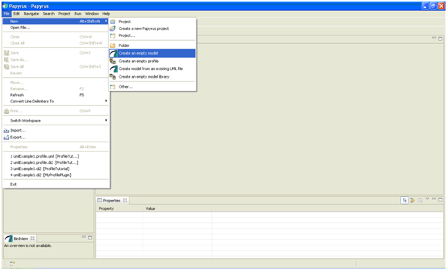
Figure 4.3: Model Creation in Papyrus

Once you select the create an empty model option, then a popup window will appear as shown in figure 4.2.
When the popup window opens, the following two important things have to be done
1) Enter the name of the parent folder you want the model to be saved or select it from the list given.
2) Write the name of the model you would like to give in the File name text box.
Once you enter the name of the file, click on the Finish button.

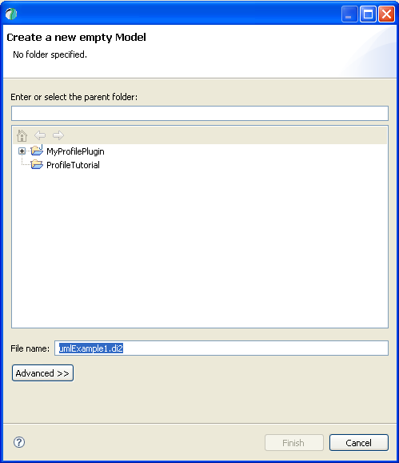
Figure 4.4: Create a new empty model

The file with the name that was entered in the file name text box, opens.

4.2 Creation of the deployment diagram

To create a new deployment diagram, in the outline window right click on the file name and select the Add a diagram option then click on the Create a new Deployment Diagram drop-down menu item. Figure 4.3 illustrates the creation of a new deployment diagram.
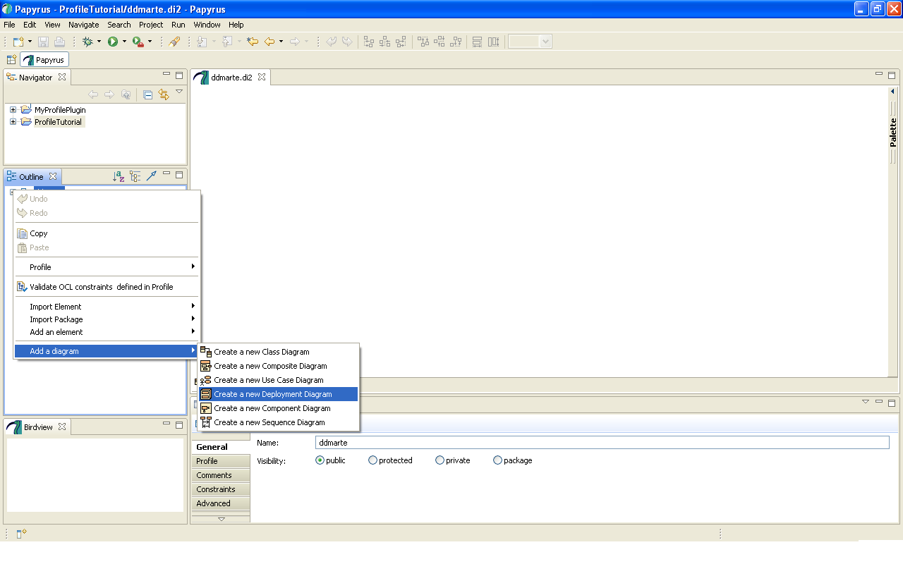
Figure 4.5: Creation of a new Deployment diagram

4.2.1 Creation of Nodes

On the right hand side of the window there is a Palette option. Keep the cursor on it so that it opens. You will see the list of available options to create the diagram. From this palette select the nodes and communication paths and drag it on to the window. See the figure 4.4 for the creation of a node. Once the node is visible in the window, click on it. In the properties window, give the node a name in the name textbox. Similarly you can drag as many nodes as you need, drop it in the window and name it. The figure 4.5 displays the three nodes that were created.
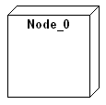
Figure 4.6: Creation of a node
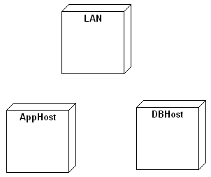
Figure 4.7: Three nodes created

4.2.2 Creation of Communication links

To create communication links between nodes, click on the Palette on the right hand side of the window. Select the communication link option and drag it from one node to the other. Figure 4.6 depicts the links between the nodes that were created in figure 4.5.
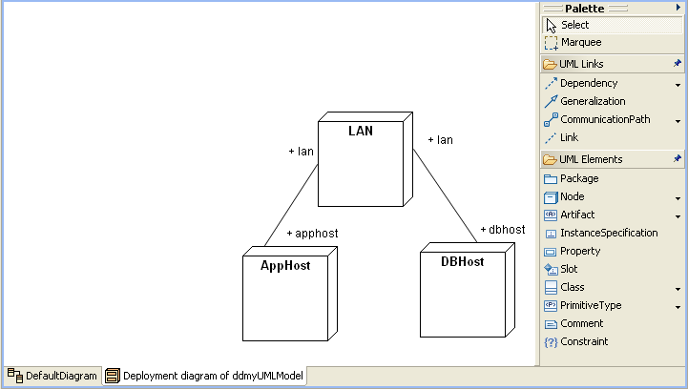
Figure 4.8: Communication between nodes

4.3 Applying the MARTE Profile to the diagram

To apply the MARTE Profile, in the outline window click on the file name. In the properties window, under the Profile option click on the plug-in button. A pop-up window will appear titled Apply profiles from Papyrus repository, see figure 4.7.

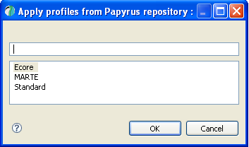
Figure 4.9: Apply Profile

Select the MARTE option and click on the OK button. Another window choose profile(s) to apply appears as shown in figure 4.8. Click on the + sign. Four more drop-down options which are the MARTE_Foundations, MARTE_DesignModel, MARTE_AnalysisModel and the MARTE_Annexes appears. Check the MARTE_Foundations and the MARTE_AnalysisModel. Click the OK button.

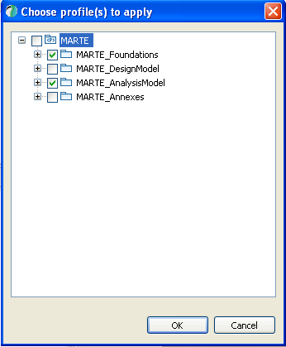
Figure 4.10: Choose profiles to apply

4.4 Import Library from Repository

To import library from repository, select the name of the file which is shown in the outline window. Next, a drop-down menu will appear. Keep the cursor on the Import Package menu. Now, another drop-down menu will appear. Click on the option Import Library from repository. This process is illustrated in figure 4.9. Once this is done a pop-up window libraries to import will appear. From among the list, select MARTE_Library option and click on the OK button as illustrated in figure 4.10. Next, another pop-up window will appear as illustrated in figure 4.11. Tick on the options shown in figure 4.11 and click on the OK button.

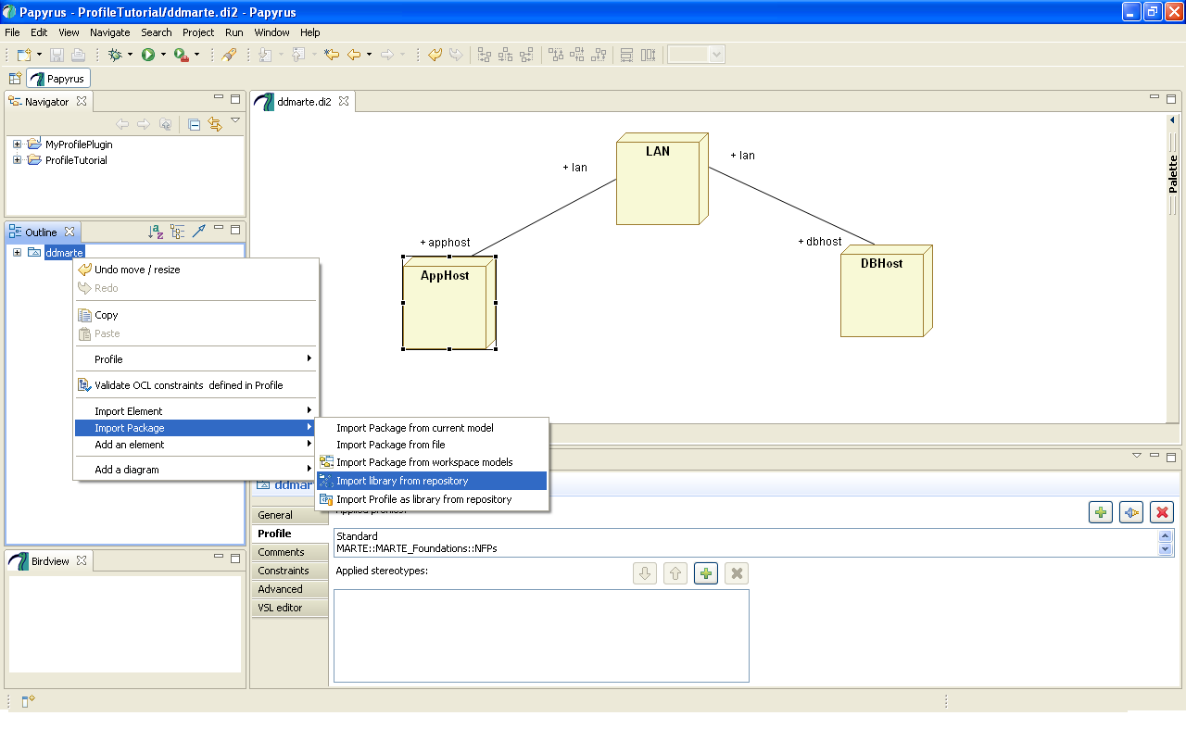
Figure 4.11: Import Library from repository

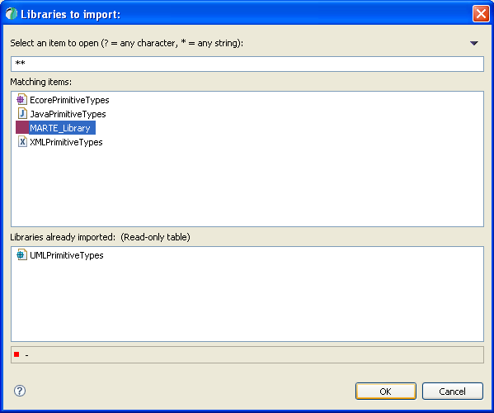
Figure 4.12: Libraries to import
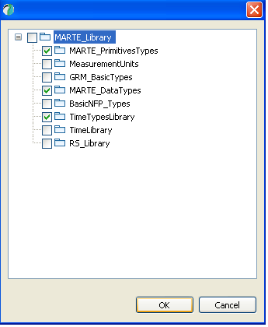
Figure 4.13: Select from the MARTE library

4.5 Applying stereotypes to the node

To apply stereotype to a node, first select the node. In the properties window, under the profile window click on the + sign. The window as shown in figure 4.12 opens.
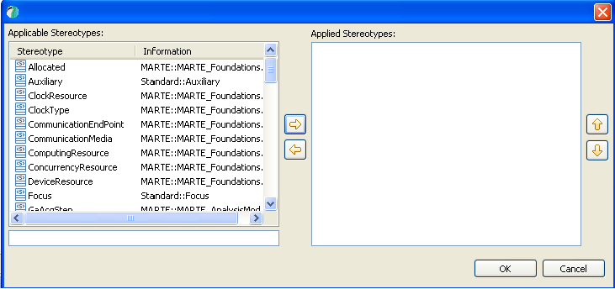
Figure 4.14: Applicable Stereotypes
Under Applicable Stereotypes select any of your choice. Click on the right arrow so that what is selected goes in the Applied Stereotypes window. This process is illustrated in figure 4.13. Then click on the OK button.
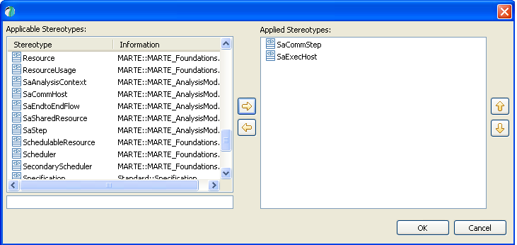
Figure 4.15: Applied Stereotypes
Figure 4.14 shows the stereotyped nodes.

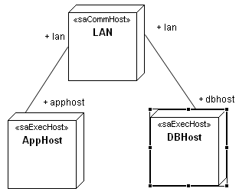
Figure 4.16: Stereotyped nodes

4.6 Applying Constraints to a node

Select the desired node to apply constraint. In the properties window, select the profile menu. Select the type of stereotype to apply under Applied Stereotypes window as illustrated in figure 4.15.
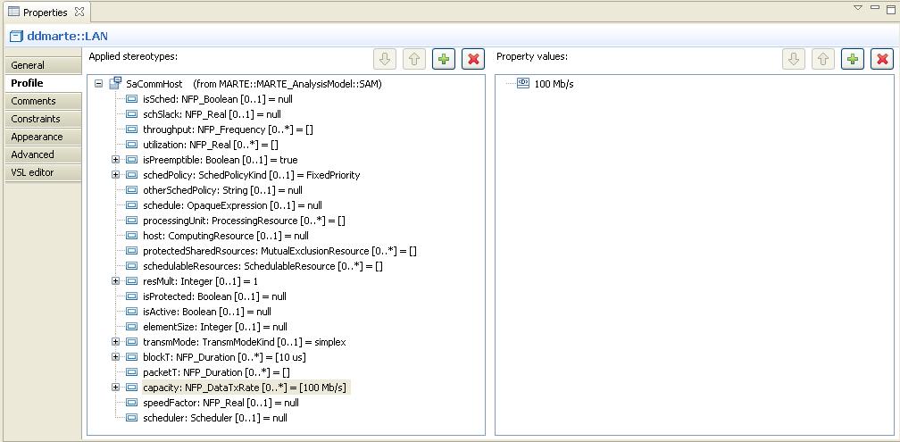
Figure 4.17: selecting the stereotypes

Under Property Value, window click on the + button. A Data Type Valuation window will pop-up, as illustrated in figure 4.16. Enter the value in the text box, and then click the OK button.

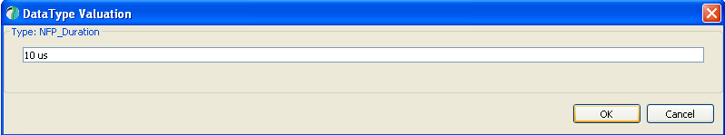
Figure 4.18: Data Type Valuation

If you want to display the selected stereotype for the selected element in the diagram then open the VSL editor in the properties window, select the value and click on the display icon. The deployment diagram appears as shown in figure 4.17 and the component diagram appears as shown in figure 4.18.

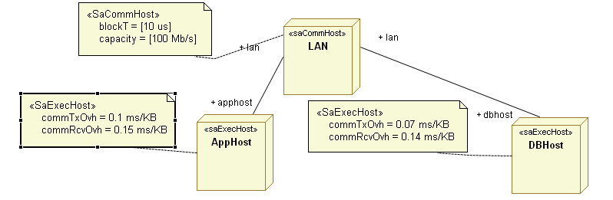
Figure 4.19: Annotated deployment diagram
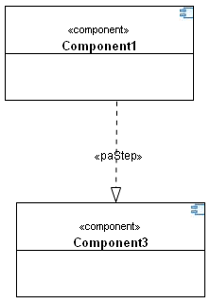
Figure 4.20: Annotated component diagram
The figure 4.17 and 4.18 displays the source model. They are the papyrus model. A papyrus model is saved under two separate files. The.di2 and.uml file. The file with the .di2 extension is the graphical part of the model that has been created.

4.7 Source Model Code

The following is the code generated by the papyrus UML modeler with respect to figure 4.17. This is given as input for the ATL transformation.
<?xml version="1.0" encoding="UTF-8"?>
<xmi:XMI xmi:version="2.1" xmlns:xmi="http://schema.omg.org/spec/XMI/2.1" xmlns:xsi="http://www.w3.org/2001/XMLSchema-instance" xmlns:SAM="http://MARTE.MARTE_AnalysisModel/schemas/SAM/_kc1EQHKiEd2xwtZ516zmfg/11" xmlns:ecore="http://www.eclipse.org/emf/2002/Ecore" xmlns:uml="http://www.eclipse.org/uml2/2.1.0/UML" xsi:schemaLocation="http://MARTE.MARTE_AnalysisModel/schemas/SAM/_kc1EQHKiEd2xwtZ516zmfg/11 pathmap://Papyrus_PROFILES/MARTE.profile.uml#_keUSAHKiEd2xwtZ516zmfg">
<uml:Model xmi:id="_BHoXoPaAEd2p5o-HsLFyzQ" name="ddmarte">
<package Import xmi:id="_BHoXofaAEd2p5o-HsLFyzQ">
<importedPackage xmi:type="uml:Model" href="pathmap://UML_LIBRARIES/UMLPrimitiveTypes.library.uml#_0"/>
</packageImport>
<packageImport xmi:id="_7FvFoPaKEd2p5o-HsLFyzQ">
<importedPackage href="pathmap://Papyrus_PROFILES/MARTE_Library.library.uml#_dDxjEAeNEdytasR0-Ec7ew"/>
</packageImport>
<packageImport xmi:id="_7IHrQPaKEd2p5o-HsLFyzQ">
<importedPackage href="pathmap://Papyrus_PROFILES/MARTE_Library.library.uml#_g2qR8A74EdyML4mHwjNDrw"/>
</packageImport>
<packageImport xmi:id="_7J5z8PaKEd2p5o-HsLFyzQ">
<importedPackage href="pathmap://Papyrus_PROFILES/MARTE_Library.library.uml#_x9l9sA74EdyML4mHwjNDrw"/>
</packageImport>
<packagedElement xmi:type="uml:Node" xmi:id="_j6Ew8PaCEd2p5o-HsLFyzQ" name="LAN"/>
<packagedElement xmi:type="uml:Node" xmi:id="_fGZKEPaDEd2p5o-HsLFyzQ" name="AppHost"/>
<packagedElement xmi:type="uml:Node" xmi:id="_hZxh8PaDEd2p5o-HsLFyzQ" name="DBHost"/>
<packagedElement xmi:type="uml:CommunicationPath" xmi:id="_blRXQPaEEd2p5o-HsLFyzQ" name="CommunicationPath_LAN_AppHost" memberEnd="_blRXQfaEEd2p5o-HsLFyzQ _blbIQvaEEd2p5o-HsLFyzQ">
<ownedEnd xmi:id="_blRXQfaEEd2p5o-HsLFyzQ" name="apphost" type="_fGZKEPaDEd2p5o-HsLFyzQ" isUnique="false" association="_blRXQPaEEd2p5o-HsLFyzQ">
<upperValue xmi:type="uml:LiteralUnlimitedNatural" xmi:id="_blbIQfaEEd2p5o-HsLFyzQ" value="1"/>
<lowerValue xmi:type="uml:LiteralInteger" xmi:id="_blbIQPaEEd2p5o-HsLFyzQ" value="1"/>
</ownedEnd>
<ownedEnd xmi:id="_blbIQvaEEd2p5o-HsLFyzQ" name="lan" type="_j6Ew8PaCEd2p5o-HsLFyzQ" isUnique="false" association="_blRXQPaEEd2p5o-HsLFyzQ">
<upperValue xmi:type="uml:LiteralUnlimitedNatural" xmi:id="_blkSMPaEEd2p5o-HsLFyzQ" value="1"/>
<lowerValue xmi:type="uml:LiteralInteger" xmi:id="_blkSMfaEEd2p5o-HsLFyzQ" value="1"/>
</ownedEnd>
</packagedElement>
<packagedElement xmi:type="uml:CommunicationPath" xmi:id="_ehnzoPaEEd2p5o-HsLFyzQ" name="CommunicationPath_LAN_DBHost" memberEnd="_ehnzofaEEd2p5o-HsLFyzQ _ehxkovaEEd2p5o-HsLFyzQ">
<ownedEnd xmi:id="_ehnzofaEEd2p5o-HsLFyzQ" name="dbhost" type="_hZxh8PaDEd2p5o-HsLFyzQ" isUnique="false" association="_ehnzoPaEEd2p5o-HsLFyzQ">
<upperValue xmi:type="uml:LiteralUnlimitedNatural" xmi:id="_ehxkofaEEd2p5o-HsLFyzQ" value="1"/>
<lowerValue xmi:type="uml:LiteralInteger" xmi:id="_ehxkoPaEEd2p5o-HsLFyzQ" value="1"/>
</ownedEnd>
<ownedEnd xmi:id="_ehxkovaEEd2p5o-HsLFyzQ" name="lan" type="_j6Ew8PaCEd2p5o-HsLFyzQ" isUnique="false" association="_ehnzoPaEEd2p5o-HsLFyzQ">
<upperValue xmi:type="uml:LiteralUnlimitedNatural" xmi:id="_eh6ukPaEEd2p5o-HsLFyzQ" value="1"/>
<lowerValue xmi:type="uml:LiteralInteger" xmi:id="_eh6ukfaEEd2p5o-HsLFyzQ" value="1"/>
</ownedEnd>
</packagedElement>
<profileApplication xmi:id="_BHoXovaAEd2p5o-HsLFyzQ">
<eAnnotations xmi:id="_BHoXo_aAEd2p5o-HsLFyzQ" source="http://www.eclipse.org/uml2/2.0.0/UML">
<references xmi:type="ecore:EPackage" href="http://www.eclipse.org/uml2/schemas/Standard/1#/"/>
</eAnnotations>
<appliedProfile href="pathmap://UML_PROFILES/Standard.profile.uml#_0"/>
</profileApplication>
<profileApplication xmi:id="_HAbdYPaIEd2p5o-HsLFyzQ">
<eAnnotations xmi:id="_HAlOYPaIEd2p5o-HsLFyzQ" source="http://www.eclipse.org/uml2/2.0.0/UML">
<references xmi:type="ecore:EPackage" href="pathmap://Papyrus_PROFILES/MARTE.profile.uml#_kBQikHKiEd2xwtZ516zmfg"/>
</eAnnotations>
<appliedProfile href="pathmap://Papyrus_PROFILES/MARTE.profile.uml#_U_GAoAPMEdyuUt-4qHuVvQ"/>
</profileApplication>
<profileApplication xmi:id="_HAlOYfaIEd2p5o-HsLFyzQ">
<eAnnotations xmi:id="_HAu_YPaIEd2p5o-HsLFyzQ" source="http://www.eclipse.org/uml2/2.0.0/UML">
<references xmi:type="ecore:EPackage" href="pathmap://Papyrus_PROFILES/MARTE.profile.uml#_kCAJcHKiEd2xwtZ516zmfg"/>
</eAnnotations>
<appliedProfile href="pathmap://Papyrus_PROFILES/MARTE.profile.uml#_WStkoAPMEdyuUt-4qHuVvQ"/>
</profileApplication>
<profileApplication xmi:id="_HAu_YfaIEd2p5o-HsLFyzQ">
<eAnnotations xmi:id="_HBB6UPaIEd2p5o-HsLFyzQ" source="http://www.eclipse.org/uml2/2.0.0/UML">
<references xmi:type="ecore:EPackage" href="pathmap://Papyrus_PROFILES/MARTE.profile.uml#_kDpIMHKiEd2xwtZ516zmfg"/>
</eAnnotations>
<appliedProfile href="pathmap://Papyrus_PROFILES/MARTE.profile.uml#_XVWGUAPMEdyuUt-4qHuVvQ"/>
</profileApplication>
<profileApplication xmi:id="_HBB6UfaIEd2p5o-HsLFyzQ">
<eAnnotations xmi:id="_HBU1QPaIEd2p5o-HsLFyzQ" source="http://www.eclipse.org/uml2/2.0.0/UML">
<references xmi:type="ecore:EPackage" href="pathmap://Papyrus_PROFILES/MARTE.profile.uml#_kD8DIHKiEd2xwtZ516zmfg"/>
</eAnnotations>
<appliedProfile href="pathmap://Papyrus_PROFILES/MARTE.profile.uml#_ar8OsAPMEdyuUt-4qHuVvQ"/>
</profileApplication>
<profileApplication xmi:id="_HBU1QfaIEd2p5o-HsLFyzQ">
<eAnnotations xmi:id="_HBemQPaIEd2p5o-HsLFyzQ" source="http://www.eclipse.org/uml2/2.0.0/UML">
<references xmi:type="ecore:EPackage" href="pathmap://Papyrus_PROFILES/MARTE.profile.uml#_kcrTQHKiEd2xwtZ516zmfg"/>
</eAnnotations>
<appliedProfile href="pathmap://Papyrus_PROFILES/MARTE.profile.uml#_4bV20APMEdyuUt-4qHuVvQ"/>
</profileApplication>
<profileApplication xmi:id="_HBemQfaIEd2p5o-HsLFyzQ">
<eAnnotations xmi:id="_HBnwMPaIEd2p5o-HsLFyzQ" source="http://www.eclipse.org/uml2/2.0.0/UML">
<references xmi:type="ecore:EPackage" href="pathmap://Papyrus_PROFILES/MARTE.profile.uml#_keUSAHKiEd2xwtZ516zmfg"/>
</eAnnotations>
<appliedProfile href="pathmap://Papyrus_PROFILES/MARTE.profile.uml#_5ZCOIAPMEdyuUt-4qHuVvQ"/>
</profileApplication>
<profileApplication xmi:id="_HBnwMfaIEd2p5o-HsLFyzQ">
<eAnnotations xmi:id="_HBxhMPaIEd2p5o-HsLFyzQ" source="http://www.eclipse.org/uml2/2.0.0/UML">
<references xmi:type="ecore:EPackage" href="pathmap://Papyrus_PROFILES/MARTE.profile.uml#_kgQLsHKiEd2xwtZ516zmfg"/>
</eAnnotations>
<appliedProfile href="pathmap://Papyrus_PROFILES/MARTE.profile.uml#_6c2bkAPMEdyuUt-4qHuVvQ"/>
</profileApplication>
</uml:Model>
<SAM:SaCommHost xmi:id="_opz1gPaNEd2p5o-HsLFyzQ" base_Classifier="_j6Ew8PaCEd2p5o-HsLFyzQ">
<blockT>10 us</blockT>
<capacity>100 Mb/s</capacity>
</SAM:SaCommHost>
<SAM:SaExecHost xmi:id="_qpNhcPaNEd2p5o-HsLFyzQ" base_Classifier="_fGZKEPaDEd2p5o-HsLFyzQ" commTxOvh="0.1 ms/KB" commRcvOvh="0.15 ms/KB"/>
<SAM:SaExecHost xmi:id="_sZ2_sPaNEd2p5o-HsLFyzQ" base_Classifier="_hZxh8PaDEd2p5o-HsLFyzQ" commTxOvh="0.07 ms/KB" commRcvOvh="0.14 ms/KB"/>
</xmi:XMI>
The following is the code with respect to the component diagram of figure 4.18.
<?xml version="1.0" encoding="UTF-8"?>
<xmi:XMI xmi:version="2.1" xmlns:xmi="http://schema.omg.org/spec/XMI/2.1" xmlns:xsi="http://www.w3.org/2001/XMLSchema-instance" xmlns:PAM="http://MARTE.MARTE_AnalysisModel/schemas/PAM/_keeEHHKiEd2xwtZ516zmfg/11" xmlns:ecore="http://www.eclipse.org/emf/2002/Ecore" xmlns:uml="http://www.eclipse.org/uml2/2.1.0/UML" xsi:schemaLocation="http://MARTE.MARTE_AnalysisModel/schemas/PAM/_keeEHHKiEd2xwtZ516zmfg/11 pathmap://Papyrus_PROFILES/MARTE.profile.uml#_kgQLsHKiEd2xwtZ516zmfg">
<uml:Model xmi:id="_ifWukFLIEd6_4veQsG5RQg" name="st414">
<packageImport xmi:id="_ifWukVLIEd6_4veQsG5RQg">
<importedPackage xmi:type="uml:Model" href="pathmap://UML_LIBRARIES/UMLPrimitiveTypes.library.uml#_0"/>
</packageImport>
<packageImport xmi:id="_HZ8LAFLJEd6_4veQsG5RQg">
<importedPackage href="pathmap://Papyrus_PROFILES/MARTE_Library.library.uml#_dDxjEAeNEdytasR0-Ec7ew"/>
</packageImport>
<packageImport xmi:id="_HblJwFLJEd6_4veQsG5RQg">
<importedPackage href="pathmap://Papyrus_PROFILES/MARTE_Library.library.uml#_g2qR8A74EdyML4mHwjNDrw"/>
</packageImport>
<packageImport xmi:id="_HdOIgFLJEd6_4veQsG5RQg">
<importedPackage href="pathmap://Papyrus_PROFILES/MARTE_Library.library.uml#_x9l9sA74EdyML4mHwjNDrw"/>
</packageImport>
<packagedElement xmi:type="uml:Component" xmi:id="_nKbWkFLIEd6_4veQsG5RQg" name="Component1" clientDependency="_8X7PEFLIEd6_4veQsG5RQg"/>
<packagedElement xmi:type="uml:Component" xmi:id="_pSnyIFLIEd6_4veQsG5RQg" name="Component3"/>
<packagedElement xmi:type="uml:Realization" xmi:id="_8X7PEFLIEd6_4veQsG5RQg" name="FromComponent1toComponent3" supplier="_pSnyIFLIEd6_4veQsG5RQg" client="_nKbWkFLIEd6_4veQsG5RQg"/>
<profileApplication xmi:id="_ifWuklLIEd6_4veQsG5RQg">
<eAnnotations xmi:id="_ifWuk1LIEd6_4veQsG5RQg" source="http://www.eclipse.org/uml2/2.0.0/UML">
<references xmi:type="ecore:EPackage" href="http://www.eclipse.org/uml2/schemas/Standard/1#/"/>
</eAnnotations>
<appliedProfile href="pathmap://UML_PROFILES/Standard.profile.uml#_0"/>
</profileApplication>
<profileApplication xmi:id="_EV_R0FLJEd6_4veQsG5RQg">
<eAnnotations xmi:id="_EWJC0FLJEd6_4veQsG5RQg" source="http://www.eclipse.org/uml2/2.0.0/UML">
<references xmi:type="ecore:EPackage" href="pathmap://Papyrus_PROFILES/MARTE.profile.uml#_kBQikHKiEd2xwtZ516zmfg"/>
</eAnnotations>
<appliedProfile href="pathmap://Papyrus_PROFILES/MARTE.profile.uml#_U_GAoAPMEdyuUt-4qHuVvQ"/>
</profileApplication>
<profileApplication xmi:id="_EWJC0VLJEd6_4veQsG5RQg">
<eAnnotations xmi:id="_EWSMwFLJEd6_4veQsG5RQg" source="http://www.eclipse.org/uml2/2.0.0/UML">
<references xmi:type="ecore:EPackage" href="pathmap://Papyrus_PROFILES/MARTE.profile.uml#_kCAJcHKiEd2xwtZ516zmfg"/>
</eAnnotations>
<appliedProfile href="pathmap://Papyrus_PROFILES/MARTE.profile.uml#_WStkoAPMEdyuUt-4qHuVvQ"/>
</profileApplication>
<profileApplication xmi:id="_EWSMwVLJEd6_4veQsG5RQg">
<eAnnotations xmi:id="_EWb9wFLJEd6_4veQsG5RQg" source="http://www.eclipse.org/uml2/2.0.0/UML">
<references xmi:type="ecore:EPackage" href="pathmap://Papyrus_PROFILES/MARTE.profile.uml#_kDpIMHKiEd2xwtZ516zmfg"/>
</eAnnotations>
<appliedProfile href="pathmap://Papyrus_PROFILES/MARTE.profile.uml#_XVWGUAPMEdyuUt-4qHuVvQ"/>
</profileApplication>
<profileApplication xmi:id="_EWlHsFLJEd6_4veQsG5RQg">
<eAnnotations xmi:id="_EWu4sFLJEd6_4veQsG5RQg" source="http://www.eclipse.org/uml2/2.0.0/UML">
<references xmi:type="ecore:EPackage" href="pathmap://Papyrus_PROFILES/MARTE.profile.uml#_kD8DIHKiEd2xwtZ516zmfg"/>
</eAnnotations>
<appliedProfile href="pathmap://Papyrus_PROFILES/MARTE.profile.uml#_ar8OsAPMEdyuUt-4qHuVvQ"/>
</profileApplication>
<profileApplication xmi:id="_EWu4sVLJEd6_4veQsG5RQg">
<eAnnotations xmi:id="_EXBzoFLJEd6_4veQsG5RQg" source="http://www.eclipse.org/uml2/2.0.0/UML">
<references xmi:type="ecore:EPackage" href="pathmap://Papyrus_PROFILES/MARTE.profile.uml#_kcrTQHKiEd2xwtZ516zmfg"/>
</eAnnotations>
<appliedProfile href="pathmap://Papyrus_PROFILES/MARTE.profile.uml#_4bV20APMEdyuUt-4qHuVvQ"/>
</profileApplication>
<profileApplication xmi:id="_EXBzoVLJEd6_4veQsG5RQg">
<eAnnotations xmi:id="_EXLkoFLJEd6_4veQsG5RQg" source="http://www.eclipse.org/uml2/2.0.0/UML">
<references xmi:type="ecore:EPackage" href="pathmap://Papyrus_PROFILES/MARTE.profile.uml#_keUSAHKiEd2xwtZ516zmfg"/>
</eAnnotations>
<appliedProfile href="pathmap://Papyrus_PROFILES/MARTE.profile.uml#_5ZCOIAPMEdyuUt-4qHuVvQ"/>
</profileApplication>
<profileApplication xmi:id="_EXLkoVLJEd6_4veQsG5RQg">
<eAnnotations xmi:id="_EXVVoFLJEd6_4veQsG5RQg" source="http://www.eclipse.org/uml2/2.0.0/UML">
<references xmi:type="ecore:EPackage" href="pathmap://Papyrus_PROFILES/MARTE.profile.uml#_kgQLsHKiEd2xwtZ516zmfg"/>
</eAnnotations>
<appliedProfile href="pathmap://Papyrus_PROFILES/MARTE.profile.uml#_6c2bkAPMEdyuUt-4qHuVvQ"/>
</profileApplication>
</uml:Model>
<PAM:PaStep xmi:id="_yFvucFLlEd6R7P-eVnFviA" base_NamedElement="_8X7PEFLIEd6_4veQsG5RQg"/>
</xmi:XMI>

Chapter 5

Transformation from source model to target model

ATL, is the Atlas Transformation Language. It is a model transformation language specified as both a metamodel and a textual concrete syntax. In the scope of Model-Driven Engineering (MDE), ATL helps developers to get a set of target models from a set of source models.
The ATL language is a hybrid of both the declarative and imperative programming. The style of transformation writing that is preferred is the declarative one. The declarative style enables to simply express mappings between the source and target model elements. The ATL also provides imperative constructs so as to ease the specification of mappings that cannot be expressed declaratively.
An ATL transformation program is made up of rules that define how source model elements should be matched and navigated to create and initialize the elements of the target models. Besides basic model transformations, ATL defines an additional model querying facility that enables to specify requests onto models. ATL also allows code factorization through the definition of ATL libraries.
Developed over the Eclipse platform, the ATL Integrated Development Environment (IDE) provides a number of standard development tools that aim to ease the design of ATL transformations. The ATL development environment also offers a number of additional facilities dedicated to models and metamodels handling. ATL is the ATLAS INRIA & LINA research group’s answer to the OMG MOF/QVT RFP.

5.1 Model-Driven Engineering

Models are now becoming a part of an increasing number of engineering processes. In most cases they still play simple documentation role instead of being actively integrated into the engineering process. As opposed to this passive approach, the field of MDE aims to consider models as first class entities and it also considers that the different kinds of handled items can be viewed and represented as models. The different kinds of handled items are the tools, the repositories, etc. The model-driven approach is supposed to provide model designers and developers with a set of operations dedicated to the manipulation of models. In the scope of the MDE, it is assumed that model transformations, like any other model-based tool, can be modeled, which means that they have to be considered themselves as models.

5.2 The Model-Driven Architecture

Models make up the basic pieces of model-driven architecture. In the area of MDE, a model is defined according to the semantics of a model of models, this is also called a metamodel. A model that respects the semantics defined by a metamodel is said to conform to this metamodel. Just as a model conforms to its metamodel, there exists a relation between the elements of a model and those of its metamodel. This relation is called as meta. It associates each of the element of a model with the metamodel element it instantiates. Before being a metamodel, a metamodel is a model. This implies for it to conform to its own metamodel. The model-driven architecture defines a third modeling level which corresponds to the metametamodel, as it is illustrated in the Figure 5.1.
Figure 5.21: The model-driven architecture

As a model with its metamodel, a metamodel conforms to the metametamodel. A metametamodel is usually self-defined. In cases such as this, it can be specified by means of its own semantics. In such a case, a metametamodel conforms to itself. Many metametamodel technologies are available. The ATL transformation engine presently provides support for two of the existing technologies. The technologies are the Meta Object Facilities that is defined by the OMG and the Ecore metametamodel that is defined by the Eclipse Modelling Framework. This means that ATL is able to handle metamodels that have been specified according to either the MOF or the Ecore semantics.

5.3 Model Transformation

In the scope of MDE, model transformation aims to give a means to specify the way to produce target models from several source models. For this purpose, it should allow developers to define the way the source model elements must be matched and navigated in order to initialize the target model elements. Figure 5.2 illustrates the overview of a model transformation. A simple model transformation has to define the way for generating a model M_{b}, that conforms to a metamodel MM_{b,} from a model M_{a}, that conforms to a metamodel MM_{a.}
Figure 5.22: An overview of model transformation
A major feature in model engineering is to consider all the handled items as models. Therefore the model transformation itself has to be defined as a model. This transformation model has to conform to a transformation metamodel that defines the model transformation semantics. As other metamodels, the transformation metamodel has to conform to the considered metametamodel. Figure 5.2 summarizes the entire model transformation process. A model M_{a}, conforming to a metamodel MM_{a,} is transformed into a model M_{b} in this case, that conforms to a metamodel MM_{b.} The transformation is defined by the model transformation model M_{t} which itself conforms to a model transformation metamodel MM_{t}. This last metamodel, with MM_{a} and MM_{b} metamodels, has to conform to a metametamodel MMM [13].

5.4 ATL Transformation

ATL is a model transformation language that helps to specify how the target model or target models can be produced from a set of source models. Figure 5.3 provides an overview of the ATL transformation (UML2LQN) that enables to generate a LQN model, conforming to the metamodel LQN metamodel, from an UML model that conforms to the UML2 metamodel. The ATL file has the .atl extension.
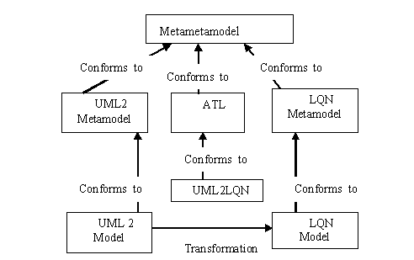
Figure 5.23: The ATL Transformation overview
The figure 5.3 provides an overview of the ATL transformation that was carried out in this thesis. The ATL code used to transform the source model into the target model is as shown below
module DD2LQN; -- Module Template
create OUT : LQN from IN : DD;
-- Select all CommunicationPath instances in the Deployment Diagram
helper def : allClassesDeployment_CommunicationPath : Sequence (DD!CommunicationPath) = DD!CommunicationPath.allInstances()->asSequence();
-- Select all Component instances in the Deployment Diagram
helper def : allClassesDeployment_Component : Sequence (DD!Component) = DD!Component.allInstances()->asSequence();
-- Select all Node instances in the Deployment Diagram
helper def : allClassesDeployment_Node : Sequence (DD!Node) = DD!Node.allInstances()->asSequence();
-- For each Node in the Deployment Diagram we have to create a Processor
lazy rule node2Processor{
from
IN : DD!Node
to
OUT : LQN!Processor(name<-IN.name)}
-- For each Component in the Deployment Diagram we have to create a Task
lazy rule component2Task{
from
IN : DD!Component
to
OUT : LQN!Task(name<-IN.name)}
--For each CommunicationPath in the deployment diagram we have to create a link
lazy rule CommunicationPath2Link{
from
IN : DD!CommunicationPath
to
OUT : LQN!Link(name<-IN.name)}
-- This is the main rule, where I first create the LQN Model with all its information.
-- Next, I call all lazy rules which perform the actual Transformation.
entrypoint rule start () {do{for(e in thisModule.allClassesDeployment_Node){
thisModule.node2Processor(e);}
for(e in thisModule.allClassesDeployment_Component){
thisModule.component2Task(e); }for(e in thisModule.allClassesDeployment_CommunicationPath){
thisModule.CommunicationPath2Link(e); }}}

Chapter 6

Target Model Generation

Layered Queuing Networks (LQN) is used to model software servers that request from other software servers [3]. LQN was developed as an extension of the QN model. The main difference with respect to QN is that the LQN can easily represent nested services: a server which receives client request and also serves client request, may in turn become a client to other servers from which it requires nested services while serving its own clients [4].

6.1 The Representation of a LQN Model

A LQN model is represented as an acyclic graph. The nodes of the acyclic graph represent hardware devices and software entities. The arcs denote service requests. The software entities are called as tasks. Tasks are drawn as parallelogram and the hardware devices are drawn as circles. The nodes that have outgoing arcs but no incoming arcs, play the role of clients. The intermediate nodes that have both incoming and outgoing arcs are usually software servers and the leaf nodes are hardware servers. They can be input output devices, communication network, processors, etc. A software or hardware server node can be either a single-server or a multi-server. Figure 6.1 shows a simple example of a LQN model of a web server. There is a customer class at the top, it has a given number of stochastical identical clients. Each of the client sends demands for different services of the webserver. Each kind of service offered by a LQN task is modeled as a so-called entry. A task is represented as a parallelogram “slice” in the figure 6.1. Every entry has its own execution times and demands for other services, given as model parameters. In this case, the Web Server entries require services from different entries of the database task. Each software task is running on a processor shown as a circle. The disk device used by the database and the communication network delays are also shown as circles [4].
Figure 6.24: A LQN Model

6.2 Target Metamodel

The figure 6.2 illustrates how the target metamodel is linked to the target model. In this figure we can see that the target metamodel is the performance metamodel as shown in figure 6.3. According to figure 6.3, a LQN object is composed of Task objects and Processor objects. A Task object has attributes that describe its type, an optional priority, the degree of multiplicity and the number of replicas.
MOF

Source Metamodel
ATL
Target Metamodel
s
Conforms to
Conforms to
UML2LQN.atl
Source Model
Target Model
source target

Figure 6.25: The Target Metamodel

A Processor object is characterized by the scheduling discipline, the degree of multiplicity, the number of replicas and the operating speed, or the number of work units that can be processed in a unit of time.
Entries are associated to each software tasks, denoting the part of a server task that provides a certain service to a client task. Thus, each Task object contains one or more Entry objects. The execution demands of a task’s entry are grouped in phases. The client task is blocked for the first phase and is released for the remaining phases that denote asynchronous operations of the server task, after completion of a service to a client task.
The phase concept is modeled by use of Phase objects that are associated to Entry objects and have attributes denoting the number, the execution demand and the coefficient of variation (COV).
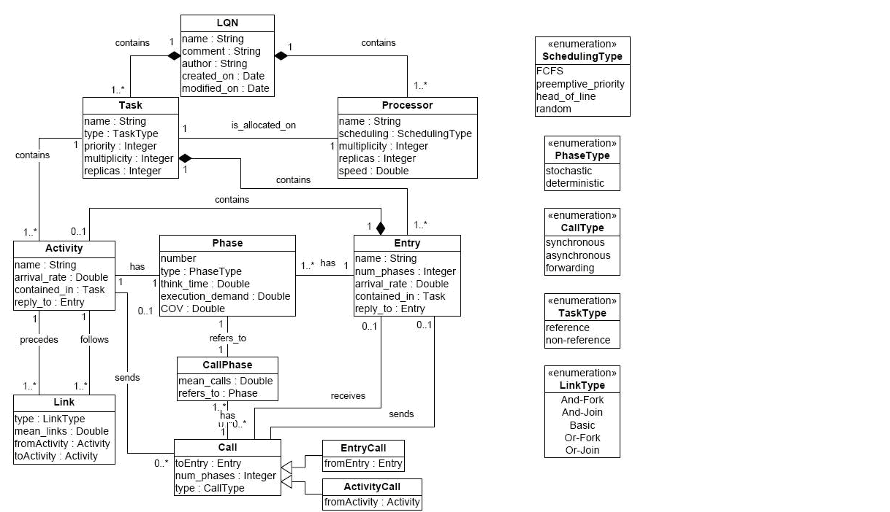
Figure 6.26: The Performance Metamodel

Task-to-task interactions are modeled by use of Call objects associated to the sender Entry or Activity object and to the receiver Entry object. The type attribute defines the call interaction paradigm and can assume synchronous, asynchronous or forwarding values. The mean number of calls, between two entries or from an activity to an entry, is specified by use of a Call Phase object. To distinguish between the two types of call sender, Call objects are specialized into Entry Call objects, associated to the sender Entry object, and Activity Call objects, associated to the sender Activity object [14].

6.3 Experimental work

The result of the transformation is the target model. The figure 6.4 illustrates how the target model is created. In this thesis the target model is the performance model as illustrated in figure 6.5.
MOF

Source Metamodel
ATL
Target Metamodel

Conforms to
Conforms to
UML2LQN.atl
Source Model
Target Model
source target

Figure 6.27: The Target Model
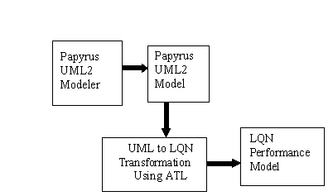
Figure 6.28: The Tools used and Model created

Select the DD2LQN.atl file->right click ->Run As->Open Dialog Box. Enter the name of the file. Under the ATL Configuration window select the name of the project and the name of the atl file from the dropdown menu. Under the metamodels section, click on the EMF Registry and select the UML metamodel from among the list. Enter the name of the file containing the LQN metamodel. Under source models enter the name of the source model file. Under target models enter the name of the target model file you wish to give.
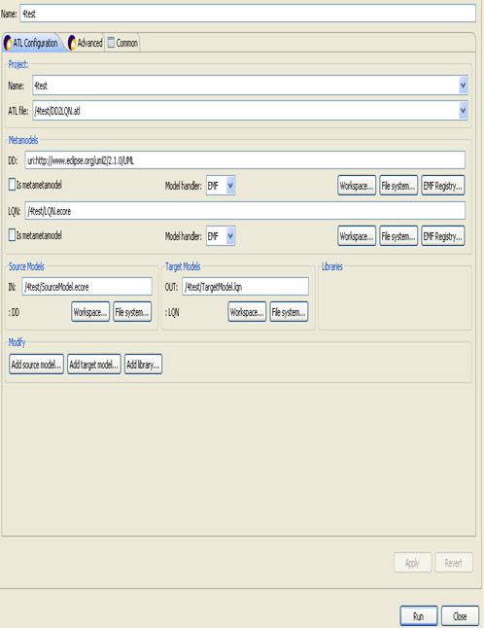
Figure 6.29: Run Configuration

Once all the entries have been filled then click on the Run button as shown in figure 6.6. The output of the ATL transformation file for the deployment diagram in figure 4.17 is as follows:
<?xml version="1.0" encoding="ISO-8859-1"?>
<xmi:XMI xmi:version="2.0" xmlns:xmi="http://www.omg.org/XMI" xmlns:LQN="http://LQN">
<LQN:Processor name="LAN"/>
<LQN:Processor name="AppHost"/>
<LQN:Processor name="DBHost"/>
<LQN:Link name="CommunicationPath_AppHost_LAN"/>
<LQN:Link name="CommunicationPath_DBHost_LAN"/>
</xmi:XMI>
The output of the ATL transformation file for the component diagram in figure 4.18 is as follows:
<?xml version="1.0" encoding="ISO-8859-1"?>
<xmi:XMI xmi:version="2.0" xmlns:xmi="http://www.omg.org/XMI" xmlns:LQN="http://LQN">
<LQN:Task name="Component1"/>
<LQN:Task name="Component3"/>
</xmi:XMI>

Chapter 7

Problems Encountered

At the time of the beginning of this work there was no research material available in which research work was carried out for the transformation of models from papyrus UML2 modeler to the LQN Performance model. Due to the lack of any reference material in literature, it was a very difficult and challenging task. However, this thesis was a valuable learning experience. There were several difficulties that had to be faced with respect to the resource, time and effort dedicated to this work. Here a brief description is given of the problems faced during the implementation of this work.

7.1 Compatibility

As the research work began it was decided that the latest available tools will be used in the implementation. At that time Eclipse 3.4 was available. The work began with collecting the related research material, installing the software and executing code as mentioned in the user manual. The user manual available was not compatible with the latest version of the ATL available. So the forms were updated and various operational features were modified in the latest version. Such as the operation for injection of ATL file to the ATL model. There was a lot of time consumed in switching between the old version and the new version to work on the operations required for successful transformation using ATL. In the Run form the names of the input and output metamodel and the input and output models were also changed. In the Run form where the names of the input and output metamodel have to be entered, input and output models were also updated in the latest version. Since the user manual referred to the old version, it was initially difficult to work with. Therefore the interoperability issue of the tools still needs to be resolved.

7.2 Documentation

The documentation for ATL tool and Papyrus tool if updated would be of great help to the developers working on this domain. Due to lack of documentation a considerable amount of research time is consumed in only trying to search if any other related material is available that will help to execute the work successfully.

7.3 Papyrus Tool

The Papyrus is an open source UML editor with extension for MARTE. Since this work was on MARTE, work was done only on the MARTE profile of papyrus. During the course of this work it has been improving considerably. There have been several changes taking place on their website. Before using this tool, an extensive study of the MARTE profile is required, without which nobody can proceed with work on it. There is an option on the website to report a bug. This was of immense help as the feedback provided was quick and it was a valuable learning experience. In the help section, there is no information that can help a first time papyrus user with any of the problems that will come across. The features required to create all the aspects of certain diagram were not functioning properly. They are as follows.

7.3.1 Component Diagram

- It is not possible to connect the same interface on itself when it is both provided and required.
- Moving the port with apparent interface does not function well.
- Cannot show an interface directly linked to a component.
- An interface must be linked to a port.
With respect to the figure 4.14 in [15], the following problems were faced
- Cannot give interface between one component and another
- No option to apply PAhost, hostDemand, numDemand and timeDemand.

7.3.2 Sequence Diagram

With respect to the figure 17.10 in [11], I tried to create the sequence diagram. The following were the problems faced
- Cannot annotate web lifeline with instance, message is displayed ”no element stereotyped schedulable resource was found in the model”
- Cannot annotate database lifeline with instance , message is displayed ”no element stereotyped schedulable resource was found in the model”
- For message 1, cannot assign stereotype <<paWorkiloadEvent>>, as there is no such option given in the list.
- There is no option to assign a value for interArrT under Pastep or GaWorkloadEvent stereotype.

7.3.3 Use Case Diagram

With respect to figure 4.11 in [15], I tried to draw the use case diagrams. The following were the problems faced:
- There was no option to apply the stereotype PAclosedWorkload, PAextDelay, population, source, num and time.
- Since the stereotypes were not available it was not possible to give values for these attributes.
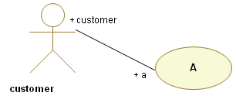
Figure 7.30: Use case diagram created in Papyrus

The use case diagram without annotations is as shown in figure 7.1. At the time of this work this tool was not so user friendly. It is presently under development.
7.4 ATL Tool
The use of this tool required a detailed study of its user manual, related research material and the ATL zoo. Once the basic concepts were understood, only then I could start with the actual coding and execution. Therefore the start up time is longer compared to if I had to use a language which was part of my curriculum. Since this is a new field of research there are not many research materials available for reference on this domain.

7.5 ATL Language
The source model has to conform to its own metamodel. Similarly the target model has to conform to its metamodel. ATL rules are written depending on the metamodels. So if there is another transformation code then the rules of one transformation code cannot be used for the other transformation code unless they have the same source and target metamodels. Therefore the rules cannot be reused always.

Chapter 8

Conclusion and Future Work

8.1 Conclusion

The first experiments using the UML profile MARTE was published in the year 2008 as described in [2]. This was just a year ago. During the course of this one year several changes took place with the extension and improvement of this profile. However, it is still undergoing several updates and new additions are being introduced. Therefore in this thesis the work was done using only two different kinds of source diagram. Since the MARTE profile used in this work was the beta2 version, it was not fully complete. The version 1.0 was expected to be available in the first quarter of 2009. There is some functionality left to be created, due to which it was not possible at the time of implementation of this thesis, to annotate certain diagrams completely. For example, when an attempt was made to create the figure 17.10 as illustrated in [11] there were several bugs and the creation of the sequence diagram was possible only partially. Hopefully, once the version 1.0 is released many problems that were faced in the past will be solved with ease.

8.2 Future Work

The focus of this thesis was mainly on the transformation from the source model to the target model. The work was carried out for the deployment diagram and the component diagram of the UML model. The other diagrams which could not be included in this thesis are still under development.
Till date, there is no LQN editor that has been created to represent the output in a graphical form, which was generated in this thesis.
A comparative study between the usage of MARTE and SPT profile with respect to the work carried out by researchers in the past would benefit the software and performance engineers, which would help them in the evaluation of software design.
A complete document containing updated mapping between SPT and MARTE will be valuable for those looking at past research work which was done in SPT. This will benefit them to experiment on the same using MARTE.
In further developments, many intermediate transformations can be created. The following transformations can take place. The source model would be the LQN model to the generation of the input file for the LQN solver tool. The source model would be the output obtained from the LQN solver to the LQN model.
As described in [2], the very first experiments using UML profile MARTE were published just a year ago in 2008. This very fact supports the view that there is immense scope for further research in this domain. This is a domain, which is presently known only by highly specialized researchers. At the present time, it is practically being implemented in very few countries over the world. As said most appropriately in an e-mail by the author [15], “we are few in the world to study this particular subject".

References

[1] Ramrao Wagh, Umesh Bellur and Bernard Menezes, “Transformation of UML Design Model into Performance Model – A Model-Driven Framework,” in the Eighth International Conference on Enterprise Information Systems, 2006, pp. 576-580.
[2] D.B.Petriu and M.Woodside, “Software Performance Models from System Scenarios,” Performance Evaluation, vol. 61, 2005, pp. 65-89.
[3] D.C.Petriu and H. Shen, “Applying the UML Performance Profile: Graph Grammar based derivation of LQN models from UML specifications,” in Proceedings of the 12th International Conference on Computer Performance Evaluation, Modelling Techniques and Tools, 2002, pp. 159 – 177.
[4] Murray Woodside, Dorina C. Petriu, Hui Shen, Toqeer Isar and Jose Merseguer, “Performance by Unified Model Analysis (PUMA),” in Proceedings of the Fifth International Workshop on Software and Performance, 2005, pp. 1-12.
[5] P. Kahkipuro, UML based performance modeling framework for Object Oriented Systems, in: UML99. The Unified Modeling Language, Beyond the Standard. LNCS 1723. Springer- Verlag, Berlin 1999, pp. 356-371.
[6] Demathieu S, Thomas F, Andre C and Gerard S, “First experiments using the UML profile for MARTE,” in the Eleventh IEEE Symposium on Object Oriented Real-Time Distributed Computing, 2008, pp. 50-57.

[7] ”What is Eclipse, and how do I use it?,” Nov. 01, 2001. [Online] Available: http://www.ibm.com/developerworks/opensource/library/os-eclipse.html. [Accessed: August 20, 2009]
[8] Object Management Group, UML 2.0 OCL Specification, 2003.
[9] Object Management Group, UML Profile for Schedulability, Performance, and Time Specification, 2003.
[10] ”Papyrus for MARTE,” Dec. 15, 2008. [Online] Available:
http://www.papyrusuml.org. [Accessed: June 6, 2009]
[11] Object Management Group, UML Profile for MARTE, Modeling and Analysis of Real-Time Embedded systems, 2008.
[12] Object Management Group, MARTE, The UML standard extension for real-time embedded systems.
[13] ATLAS Group, ATL User Manual, LINA & INRIA, 2006.
[14] D’Ambrogio, “A Model Transformation Framework for the Automated Building of Performance Models from UML Models,” in Proceeding of the Fifth International Workshop on Software and Performance, 2005, pp. 75 – 86.
[15] S. di Gregorio, “Transformations of UML Architectural Models into Performance Models based on ATLAS Transformation Language”, Master Thesis, University of L'Aquila, L'Aquila, Italy, 2007.

