A
Dissertation
On

Tool Based Estimation of Object Oriented Software Metrics.

Submitted in Partial fulfillment of the requirements
For the award of Degree of

MASTER OF ENGINEERING
(Computer Technology and Application)
Delhi University, Delhi

Submitted By:
SATYAPAL JEE KAUSHAL
(University Roll No. 10194)

Under the Guidance of:
Dr. Daya Gupta
Head Of Department
Department Of Computer Engineering
Delhi College of Engineering, Delhi



DEPARTMENT OF COMPUTER ENGINEERING
DELHI COLLEGE OF ENGINEERING
DELHI UNIVERSITY
(2007-2008)

CERTIFICATE
DELHI COLLEGE OF ENGINEERING
(Govt. of National Capital Territory of Delhi)
BAWANA ROAD, DELHI - 110042

Date:___________

This is certified that the work contained in this dissertation entitled “Tool Based Estimation of Object Oriented Software Metrics.” by Satyapal Jee Kaushal is the requirement of the partial fulfilment for the award of degree of Master of Engineering in Computer Technology & Application at Delhi College of Engineering. This work was completed under my direct supervision and guidance. He has completed his work with utmost sincerity and diligence.

The work embodied in this major project has not been submitted for the award of any other degree to the best of my knowledge.

Dr.Daya Gupta
Head Of Department
Department of Computer Engineering
Delhi College of Engineering

ACKNOWLEDGEMENT

“If brain is the nucleus of thoughts, teacher is the source of energy to run the operation of solving cross puzzles of doubts that often poise the mind of students.”
I am thankful to the Almighty because without his blessings this work was not possible. It is a great pleasure to have the opportunity to extent my heartfelt gratitude to everybody who helped me throughout the course of this project.

It is distinct pleasure to express my deep sense of gratitude and indebtedness to my learned supervisor Dr. Daya Gupta for his invaluable guidance, encouragement and patient reviews.
His continuous inspiration has made me complete this dissertation. He kept on boosting me time and again for putting an extra ounce of effort to realize his work.

I would also like to take this opportunity to present my sincere regards to my teachers Prof. D Roy Choudhary , Mrs. Rajni Jindal, Mr. Manoj Sethi and Mr. Rajeev Kumar for their support and encouragement.

I am thankful to Computer Center Head Dr. Rajeev Kapoor and other staff members for providing me unconditional and anytime access to the resources.

I am grateful to my parents, brother and sister for their moral support all the time, they have been always around on the phone to cheer me up in the odd times of this work.

I am also thankful to my classmates for their unconditional support and motivation during this work.

Satyapal Jee Kaushal
M.E.(Computer Technology and Application)
Department of Computer Engineering
Delhi College of Engineering, Delhi-42

Table of Content
CERTIFICATE 2
ACKNOWLEDGEMENT 3
Table of Content 4
LIST OF FIGURE 6
LIST OF TABLE 7
LIST OF ABBREVIATIONS 9
ABSTRACT 10
1. Introduction 11
1.1General Concept 11
1.2 Motivation 12
1.3 Related Work 12
1.4 Proposed Work 13
1.5 Organization 14
2. Software Metrics 15
2.1 Basic Metrics 15
2.1.1Brief History of Function Point 15
2.1.2 IFPUG Function Points 16
2.1.3 Object Oriented Design Function Point 27
2.1.4 Kusumoto’s Dynamic approach 29
2.1.5 Harput’s Transformation Model 30
2.2 General Software Metrics 32
2.2.1 COCOMO 32
2.2.2 COCOMO II 38
2.3 Advanced Software Metrics 42
2.3.1 Software Maintenance Models 42
2.3.2 Impact Analysis 43
2.3.3 Measuring the Impact domain 44
3. Backfiring Technique 45
3.1 Using FP to define language generations and levels 45
3.2 Converting FP to LOC 46
4. Tool Architecture and Design 48
4.1 Tool Architecture 48
4.2 Design Approach 50
4.2.1 First Level Design 50
4.2.2 Middle Level Design 52
4.3 Case Study 53
5. Evaluation of Tool 56
6. Functional Design Details 58
6.1 Primary Mode Implementation 58
6.1.1 Altova UModel Tool 58
6.1.2 Software Metrics Estimation Tool 60
6.2 Secondary Mode Implementation 63
7. Conclusion & Future Work 65
8. Publication From Thesis 66
9. References 67

LIST OF FIGURE

Figure 2.1 Evolution Of FPA Method 16
Figure 2.2 EI Updation 18
Figure 2.3 EO with 2 FTR's 21
Figure 2.4 EQ with two ILF's 23
Figure 4.1 Architecture Of Tool 48
Figure 4.2 Software Metrics Model 49
Figure 4.3 Size estimation in Primary mode 51
Figure 4.4 Size Estimation with kusumoto approach 52
Figure 4.5 Middle level design 53
Figure 4.6 Simple example to measure the OOFP 54
Figure 6.1 Altova UModel Tool 58
Figure 6.2 Code generation Component 59
Figure 6.3 Code synchronization setting 60
Figure 6.4 Functional diagram of Tool 60
Figure 6.5 Main Screen of Tool 62
Figure 6.6 Estimated Size of Project 62
Figure 6.7 Estimated Middle layer Metrics 63
Figure 6.8 Address book software 64
Figure 6.9 Measured FP of example software 64

LIST OF TABLE

Table 2.1. EI Complexity Table 20
Table 2.2. EI Complexity Value 20
Table 2.3. EO Complexity Table 21
Table 2.4. EO Complexity Value 22
Table 2.5. EQ input Complexity Table 23
Table 2.6.EQ output Complexity Table 24
Table 2.7. EQ Complexity Value 24
Table 2.8. AFP counting table 25
Table 2.9. General System Characteristic Table 25
Table 2.10.Complexity value of class 28
Table 2.11.Complexity value of class 34
Table 2.12.Cost Driver 35
Table 2.13.Coefficient value 37
Table 2.14.COCOMO Phase 37
Table 2.15.Rating Scheme for the COCOMO 2.0 Scale Factors 40
Table 2.16.Early Design and Post-Architecture Cost Drivers 41
Table 3.1.LOC per FP for languages 46
Table 4.1. DETs and RETs/FTRs of the example 54
Table 4.2. Estimated Metrics of the example 55
Table 5.1.Comparison of Tool 56

LIST OF ABBREVIATIONS

FP……………………………Function Point
FPA………………………… Function Point Analysis
LOC…………………………Lines of Codes
OOFP………………………. Object Oriented Function Point
OODFP……………………. Object Oriented Design Function Point
OO………………………… . Object Oriented
IFPUG……………………. ..International Function Point User Group
SDLC………………………. Software Development Life Cycle
CPM……………………… .. Counting Process Manual
RET………………………… Record Element Type
DET………………………… Data Element Type
FTR………………………. ...File Type reference
UFP………………………. ..Unadjusted Function Point
AFP…………………………Adjusted Function Point
ACAP ………………………Analyst Capability
AEXP……………………. ..Applications Experience
CPLX………………..….. .. .Product Complexity
DOCU……………. ……. ....Documentation to match lifecycle needs
FCIL……………………. … Facilities
LTEX……………………… Language and Tool Experience
PCAP……………… ………Programmer Capability
PCON……………… …….. Personnel Continuity
PDIF………………. ….. ….Platform Difficulty
PERS………………. …. ….Personnel Capability
PEXP……………….. ... …..Platform Experience
PREX……………….. ……. Personnel Experience
PVOL……………….. …….Platform Volatility
RCPX……………….. …….Product Reliability and Complexity
RELY……………….. …….Required Software Reliability
RUSE……………….. …….Required Reusability
SCED……………….. …….Required Development Schedule

ABSTRACT

In practice, it is very important to determine the size of a proposed software system yet to be built based on its requirements, i.e., early in the software development life cycle. Size of software system determines the effort, cost, time and quality. There are various techniques for measuring size of traditional software like Lines of codes, function point etc. These methods are not suitable for world of Object Oriented System. As Lines of codes is not considered to be effective as it is very vague and depends on programming languages. Also techniques like function point count for traditional software are not directly applicable to Object Oriented application due to change in technical environment and it is not suitable to capture specific object-oriented features, such as classes, inheritance, encapsulation, and message passing. Here the architecture of tool is proposed to calculate various Object Oriented software metrics and a unifying framework is presented that captures all the fundamental of software metrics.
This thesis also presents an effort estimation technique for maintaining a large-scale object oriented application by measuring and tracking the size and complexity of the Object oriented system.

1. Introduction

1.1General Concept

Today market is floated with developing object oriented software in the domain of e-commerce, banking, investments etc. Due to increased size and complexities of these software, developing high- quality, cost-effective software within a specified period is a big challenge. This requires effective project planning. Therefore software development process should include correct estimation of various software metrics like size, effort invested, development time, quality, risks and resources of software. Many Researchers feel that size estimation should be done in the early phase of the development life cycle that is on the transformation model [4]. There are various models for effort, cost, quality estimation used by software practitioners. Still recent statistics [3] show that there are enormous losses annually due to cost overrun or cancellation of project.
Another issue for Object oriented (OO) applications which are spread over globe are the maintenance proposals. The maintenance is large scale for these applications as small change may have large impact on domain as beside other issues one has to maintain security criterions also. Project manager may like to outsource maintenance activities to different sites where software is installed. Maintenance can be corrective, adaptive and perfective. In web application to carry out maintenance task cost effectively one must estimate time spent in correcting error and impact domain of these errors number of changes and their impact domain [1].
Also for advancement of process model used by the organization, it is required to calculate of other project process metric like reliability and quality. Reliability is the ability of a system or component to perform its required functions under stated conditions for a specified period of time while quality is defined as the conformance to requirement, fitness for the purpose and level of the satisfaction .Defect rate, mean time between failure [MTBF], mean time to change [MTTC], and mean time to failure [MTTF], mean time to repair [MTTR] are important quality and reliability metrics.

1.2 Motivation

Despite the importance of the software metrics in software development, there is no articulated technique or unifying framework available which can guide the developer for this purpose. Till now their calculation is done on need basis or ad hoc approach is used. As the calculation of these software metrics is not independent on the technical environment i.e. type of database used, data communication system, client server system, monolithic main frame system or web based system. Hence there cannot be common architecture which can be uniformly applicable to all Information technology projects. As well as it is very important to determine the size of a proposed software system yet to be built based on its requirements, i.e., early in the development life cycle. Given a size estimate, it is usually possible to estimate the effort that will be needed to build this system. The most widely used approach to size estimation is Function Point Analysis (FPA). It is not clear, however, how function points can be reasonably counted for object-oriented requirements specifications. This thesis presents a unifying framework that captures the fundamental of object oriented software metrics within a unifying framework along with the support of tool that have been constructed to automate the metrics estimation.

1.3 Related Work

There are various techniques for measuring size of traditional software like LOC, function point etc. As LOC is not considered to be effective as it is very vague and does not apply to programming languages where code generation is automated. Also techniques like function point count for traditional software are not directly applicable to OO application due to change in technical environment and use of many Object oriented languages like C++, Java etc. Commonly used techniques are function count, object point and statement count. Some of the early approaches used for Objet Oriented Programming (OOP) are Function Point Count for OO system [18], Object Point Count [30], application Point and Multimedia Point [33] and Object Oriented Design Function Points [5]. Recent approaches for size estimation of OOP are web object [34], statement count [36], automated function count for OOP [6] and class point , rule based function point calculation from transformation Model [4]. Early approaches were centered on function point measures such as Albrech method[7],IFPUG method[9], Mark II method[10],COSMIC full function point method[11], IBM German point Method[12]. Problem with these approaches were that (i) it is very difficult to choose appropriate technique from jungle of proposals available (ii) they are independent of technical environment which is important for correct estimation. The proposals from Sneed etc. were calculating weighted object count object point based on object model by counting the number of classes, interfaces, attributes, association and methods. Problem with this approaches were that they required judgment on the part of measurer, hence they were not accurate. Recent proposal from Kusumoto measured function point from source code by counting the data and transaction function based on static and dynamic information collected by execution of set of test cases [6]. They have framed certain rules that automatically determine transaction classes and data functions classes from the sequence design Model. This approach is not suitable for project planning but can be used only for maintenance metrics when coding and implementation part have completed. We find approach of Harput appropriate as it can estimate size in the early phase which is our requirement. To estimate other metrics like cost, effort, time and productivity, we apply the approach of COCOMO II. This will be done in layer two.

1.4 Proposed Work

In this thesis we concentrate on Object Oriented System and present a unifying framework for capturing all the fundamental of software metrics. We also proposed architecture and design of the tool that will calculate different kind of software metrics like size, cost, time, effort, productivity and then maintenance metrics, quality metrics. This is done in three layers. As size of software is base for calculation of different metrics, this is calculated in first or lowest layer. In the middle layer, size is used to calculate, cost, effort, productivity metrics etc. Finally maintenance and quality metrics are calculated. As all metrics use size as the parameter, this thesis focuses on calculation of this metric. The novel features of our approach are that we consider all the basic concepts of Object Oriented System such as inheritance, aggregation, association and polymorphism.

1.5 Organization

The remainder of thesis is organized as follows:
Chapter 2 provides an overview of Software Metrics that covers all the fundamental of software metrics within a unifying framework. It discusses the first layer & middle layer of the metrics model and provides available size and cost estimation techniques for traditional and object oriented system. It also describes the available maintenance model and maintenance metrics estimation using Impact analysis.
Chapter 3 describes Backfiring technique to convert lines of codes to function point and vice versa.
Chapter 4 presents the Architecture of the tool (Software Metrics Estimation tool) with its design approach which I have used for building the tool.

Chapter 5 describes the evaluation of tool.

Chapter 6 covers the functional design details with the block diagram and different classes which I have implemented in JAVA & HTML. It shows how various modules communicate with each other.

During the period of working over this project we interacted with professionals in the field of Software Metrics we incorporated their reviews. We communicated our approach for Software Metrics estimation methods and tool with some International conferences; couple of our papers are published. Chapter 7 describes the papers we have published.

Chapter 8 covers the conclusion of the work done by us. We finally culminate thesis showing different references including research papers, web sites and books that I had gone through during my project.

2. Software Metrics

This chapter provides a general introduction to software metrics and its estimation technique. Function Point that describes the software size is the important metric because all other metrics are based on this metric.

2.1 Basic Metrics
Size of software system is considered as the basic metrics in software metrics model. Size can be estimated in Lines of code or function point. Lines of code cannot be estimated correctly before software completion because it varies due to language complexities of different language. While Function points are technologically independent, consistent, repeatable, help normalize data, enable comparisons and set project scope and client expectation. So here size is estimated in terms of function point.

2.1.1Brief History of Function Point
Function Point Analysis was developed first by Allan J. Albrecht in the mid 1970s. It was an attempt to overcome difficulties associated with lines of code as a measure of software size, and to assist in developing a mechanism to predict effort associated with software development. The method was first published in 1979, then later in 1983. In 1984 Albrecht refined the method and since 1986, when the International Function Point User Group (IFPUG) was set up, several versions of the Function Point Counting Practices Manual have been published by IFPUG. The current version of the IFPUG Manual is 4.11
FPA variants and evolutions
Several variants to the original Albrecht's method have been developed during years, but the most relevant ones remains mainly (in order of appearance):
- Feature Points (1985) by Capers Jones, extending the FPs counting to real-time and TLC environments (the general and recognised FPA flaw) but with few industrial adoptions and no more news about it from years.
- Mk II (1988) by Charles Symons, where main changes beside in the growing number of complexity factors, the introduction of a series of environmental factors and a different sets of weights. The current version (1.3.1, dated September 1998) is freely available at the UKSMA website.
- 3D Function Points (1992) by Scott Whitmire, trying to capture the three dimensions of a software (data, controls and functions), but a proprietary internal method for the Boeing Company.
The following figure 2.1 shows the evolution of FPA methods along these years.
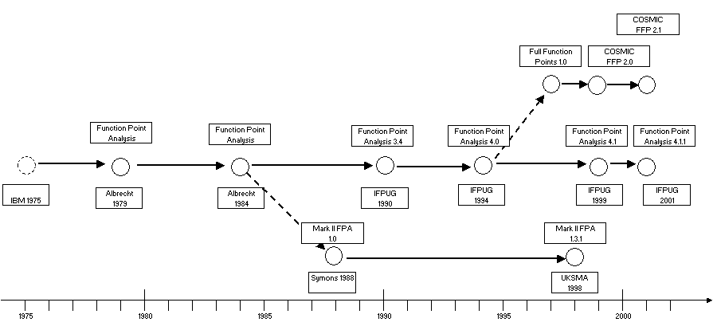
Fig. 2.1 Evolution of FPA Method

2.1.2 IFPUG Function Points
International Function Point User Group(IFPUG) method measures functional size independent of any development tool or technology [16].The procedure of counting function points(FP) promoted by the IFPUG and described in the Counting Practices Manual (CPM) [17] has seven steps, described below:
1-Determine type of count: It can be Development project function point count, enhancement project function point count or application function point count.
2-Identify counting scope and application boundary: The counting scope defines the functionality that will be included in a particular function point counting. The application boundary indicates the border between the software being measured and the user.
3-Count Data Function type
The data functions are:
a. Internal Logical File (ILF): An internal logical file (ILF) is a user identifiable group of related data maintained within the boundary of the application:
• An ILF must be a group of data that is maintained within the application and satisfies specific user requirement. It include backups specifically requested by the customer but not backups done as part of information services disaster recovery requirements or automatic backup facilities provided by the technology.
• Data stores (files, database table etc) that were created for technical reasons or for storage of intermediate values (e.g. sort files, summary files) are not counted.
• Extra capabilities automatically provided are not counted unless the customer specifically requests them.
b. External Interface File (EIF): An External Interface File (EIF) is a user identifiable group of logically related data maintained outside the boundary of the application. One example of an EIF is a file or table containing names of codes (e.g. a table of department codes, product codes) read by the system being counted but maintained by some other application.
The following are guidelines for counting the number of EIF:
• The group of data is logical and user identifiable, and satisfies a specific user requirement.
• The group of data is referenced by the application.
• The group of data is not maintained by the application.
• The group of data is an ILF in another application.
ILF and EIF Complexity
Each ILF and EIF contributes to the unadjusted function point count (UFPC). The number of UFPCs contributed by each ILF or EIF depends upon its complexity. Complexity of an ILF or EIF depends on the number of data element types (DET) and record element types (RET).
A data element type (DET) is a unique user recognizable field on an ILF or EIF. Some guidelines for counting data element types are:
• Count all foreign keys to other ILFs or EIFs.
• Ignore fields introduced during normalization of the ILF or EIF.
• Repeating fields (identical in format and meaning), which exist to allow multiple
occurrences, are counted as a single data element type.
A record element type (RET) is a user recognizable sub-group of data elements within an ILF or EIF.
4- Count Transactional Function type
The transactional functions are classified in the following manner:
a. External Input (EI): An external input (EI) processes data that come from outside the application boundary. An external input is the facility provided to the customer to insert, update, and delete records (occurrences, rows) of an ILF. It may maintain one or more ILFs . For example, an external input may maintain department and employee information. The information entered will be stored in one or more ILFs. Another example may be the maintenance of system parameters, which will be used by the processes of the software system being developed. The figure 2.2 represents a simple EI that updates 2 ILF's (FTR's).
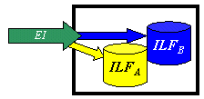
Fig 2.2 EI Updation
The following are some of the guidelines for identifying the external input for a system:
• Data are received from outside the application boundary.
• The input maintains at least one ILF.
• The input is the smallest business transaction as seen by the user.
• The input is comprehensive and self contained.
External input complexity
Each external input contributes to the unadjusted function point count. The number of counts contributed by each external input depends upon its complexity, which includes the number of data element types (DETs) and file types referenced (FTRs) in the external input.
A file type referenced (FTR) is an ILF maintained or read for completing the external input or an EIF read for completing it:
• Count a FTR for each ILF maintained or read by the external input.
• Count a FTR for each EIF read by the external input.
A data element type (DET) is a unique, user recognizable field maintained on an ILF by external input. The following are some of the guidelines for counting the data element types:
• Count system generated data elements (voucher number) as data element types if the user recognizes them as part of the business input.
• Multiple physical storage is counted as a single data element type.
• Do not count screen prompts, field legends, or error messages.
The following table displays the complexity matrix for an external input of data element types:
Table 2.1. EI Complexity Table
The following table displays the unaltered function point count (UFPC) contribution by an external input:
Table 2.2. EI Complexity Value
b. External Output (EO): An external output (EO) is a process that generates data sent outside the application boundary, for example, the external output the customer views in the form of reports, messages, etc. External outputs also include the files the application generates to be used as transactions by another application. An external output may be generated using one or more ILFs or EIFs.
The following are guidelines for identifying the external output for a system:
• Data are sent outside the application boundary.
• The output is meaningful to the customer's business.
• The output is comprehensive and self contained.
• Data in the ILF or EIF is not changed by the external output.
• Count only unique (different formats and processing) external output.
• Do not count extra capabilities provided unless the customer specifically requested them.
External output complexity
Each external output contributes to the unadjusted function point count (UFPC). The number of UFPCs contributed by each external output depends on its complexity, which depends on the number of data element type (DETs) and file types referenced (FTRs) in the external output.
A file type referenced (FTR) is an ILF read for completing the external output or an EIF read for completing it.The following figure 2.3 represents on EO with 2 FTR's there is derived information (green) that has been derived from the ILF's
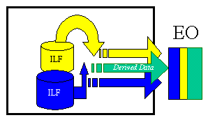
Fig 2.3 EO with 2 FTR's
Count a file type referenced for each ILF and EIF read by the external Output.
A data element type (DET) is a unique user-recognizable field that appears on the external output.
The following are guidelines for counting them:
• Fields combined for output and recognized by the user as a single field should be counted as a single data element type.
• Do not count report titles, screen identifications, column headings, or field titles.
• Do not count page numbers or date and time of printing.
The following table displays the complexity matrix for an external output for data element types:
Table 2.3. EO Complexity Table
The following table displays the unaltered function point count (UFPC) contribution by an external output:
Table 2.4. EO Complexity Value
.
External Inquiry (EQ): An external query is a process made up of an input-output combination that results in data retrieval. It has two parts, the screen on which the customer specifies the request (search criteria) and the resulting display.
Count each unique request and display combination. The external query is unique if it has a format different from other external queries in either the request or display parts, or if the customer requests processing logic different from other external queries with the same format. On an external query, the customer enters data for control purposes to direct the search. An external query differs from an external input since it does not modify an ILF. Though it reflects the immediate retrieval of current data for display, it differs from external output in that external output reflects the manipulation and reformatting of data (usually in report form). The media (screen or paper) is not the basis for distinguishing external queries from external output since external output can also be displayed on a terminal. An external output may be generated using one or more ILFs or EIFs.
The following are guidelines for identifying the external query for a system:
• The output is comprehensive, self contained and immediately required for the customer's business.
• When there is a one-to-one relationship between requests and displays, count only displays. Also, count just the displays if one request results in multiple displays. In either case, the count of the displays will equal the external query count. If several unique request panels result in the same display, count the requests instead of the display, for example, a display of customer information that results from completing a screen of name information, a screen of address information, or information about a specific purchase. In these cases there is one display but three external queries, since there are three different processes that get the same display. The figure 2.4 below represents an EQ with two ILF's and no derived data.
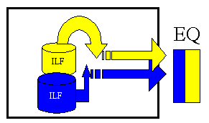
Fig. 2.4 EQ with two ILF's
External query complexity
Each external query contributes to the unadjusted function point count (UFPC). The number of UFPCs contributed by each external query depends upon the complexity of its input and output sides. The higher complexity of the two is taken as the complexity of the external query, which depends on the number of data element types (DETs) and file types referenced (FTRs) in the external query input or output.
A file type referenced (FTR) is an ILF or EIF read for completing the external query. Count the FTRs for the input side and output side separately.
A data element type (DET) is a unique user-recognizable field that appears in the external query. The following table displays the input complexity matrix for an external query:
Table 2.5. EQ input Complexity Table

The following table displays the output complexity matrix for an external query:

Table 2.6.EQ output Complexity Table
The higher complexity of input or output will be taken as the external query complexity. The following table displays the unaltered function point count (UFPC) contribution by an external query:
Table 2.7. EQ Complexity Value
5- Determine UFP
The counts for each level of complexity for each type of component can be entered into a table such as the following one. Each count is multiplied by the numerical rating shown to determine the rated value. The rated values on each row are summed across the table, giving a total value for each type of component. These totals are then summed across the table, giving a total value for each type of component. These totals are then summoned down to arrive at the Total Number of Unadjusted Function Points.

Table 2.8.AFP counting table
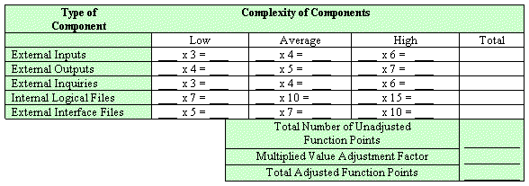

6-Determine VAF
The Value Adjustment Factor indicates the general functionality provided to the user of the application. The VAF is derived from the sum of the degree of influence (DI) of the 14 general system characteristics (GSCs). The DI of each one of these characteristics ranges from 0 to 5 as follows: (i) 0 – no influence; (ii) 1 – incidental influence; (iii) 2 – moderate influence; (iv) 3 – average influence; (v) 4 – significant influence; and (vi) 5 – strong influence. The IFPUG Counting Practices Manual provides detailed evaluation criteria for each of the GSC'S, the table below is intended to provide an overview of each GSC.
Table 2.9.General System Characteristic Table
General System Characteristic |  | Brief Description
1. | Data communications | How many communication facilities are there to aid in the transfer or exchange of information with the application or system?
2. | Distributed data processing | How are distributed data and processing functions handled?
3. | Performance | Was response time or throughput required by the user?
4. | Heavily used configuration | How heavily used is the current hardware platform where the application will be executed?
5. | Transaction rate | How frequently are transactions executed daily, weekly, monthly, etc.?
6. | On-Line data entry | What percentage of the information is entered On-Line?
7. | End-user efficiency | Was the application designed for end-user efficiency?
8. | On-Line update | How many ILF’s are updated by On-Line transaction?
9. | Complex processing | Does the application have extensive logical or mathematical processing?
10. | Reusability | Was the application developed to meet one or many user’s needs?
11. | Installation ease | How difficult is conversion and installation?
12. | Operational ease | How effective and/or automated are start-up, back-up, and recovery procedures?
13. | Multiple sites | Was the application specifically designed, developed, and supported to be installed at multiple sites for multiple organizations?
14. | Facilitate change | Was the application specifically designed, developed, and supported to facilitate change?

VAF= [0.65+0.01*Σ (DI)] (1)

7-Calculate AFP
The final adjusted function point count is calculated using a special formula for a development project, enhancement project or application function point count. To compute the AFP the following relationship is used [36].
AFP=UFP* VAF (2)

2.1.3 Object Oriented Design Function Point

This approach is based on proposal by D. J Ram [5].Here size is estimated based on all information available in design phase. It is the modified version of Caldiera’s method[18].
Data Function Count:
Classes are mapped into data functions. Data function within the application boundary is known as ILF and outside the application boundary is known as EIF. The complexity of data functions depends on the number of DETs and RETs. Data type such as integer, float and boolean etc. will be counted as DET. Object reference, a complex data type, is considered as a RET.

Transaction Function Count:
Method of class is mapped into transaction function count. Every method in logical file is examined. The data within a class is already considered as a ILF/EIF, it can be avoided while calculating the complexity of a method. The method’s complexity depends on the DETs and FTRs in its signature. While examining the methods, we consider following points:
1. Concrete methods are counted only once, even if they are inherited by several subclasses because they are coded once.
2. An abstract method is declared in a base class and defined in its derived classes. Abstract method’s complexity should be considered only for derived classes.
3. If a method does not have any arguments and return type, then its complexity is considered as one DET. The method complexity is rated according to IFPUG table described in chapter 2.1.2.
Class Complexity
They also calculate the complexity of each class because it is not necessary that all of derived class use all inherited data. Some of derived classes may not provide any functionality to abstract class.
The complexity of a class is classified low if a class processes less than 50% of data that is visible to it, average if a class processes 51 % to 70% of data that is visible to it and high if a class processes more than 70% of data that is visible to it.
Table 2.10. Complexity Value Of Class
 | Complexity Value
LOW | .3
AVERAGE | .6
HIGH | .9
The complexities are mapped to a numerical value based on observations across different projects. These values are presented in Table 2.10.

Unadjusted Function Point
Now Unadjusted Function point (UFP) of the OO system is calculated as described here:
1. Calculate the function points for each class in the design. It is obtained by adding the function points of its data function and transactional function.
2. Estimate Complexity Value of Class.
3. UFP of a class is obtained by multiplying its function points with Complexity Value of Class.
4. Add UFP of each class to the get the UFP of the OO system.
After calculation of Unadjusted Function Points, value Adjustment Factor is calculated as defined in the chapter 2.1.2.

2.1.4 Kusumoto’s Dynamic approach

Dynamic approach is proposed by Kusumoto [6]. This approach is applied on complete running source code. They collect static information from source code and dynamic information from the program execution based on test cases. In order to measure function point, it is necessary to extract the logical file and transaction function from the target program. Complexity of logical file based on the number of data element type (DET) and the record element type (RET). They also define DET as simple variables (Float, Char, Boolean) in the class and RET as a class type variable. Method of the identified class is mapped into transaction function. Complexity of the Transaction function is based on the number of data element type (DET) and the file type reference (FTR). For External Input, DET will be the total number of arguments of the methods called by the boundary class and for External output/ External Inquiry, DET will be total number of the return values of the methods called by boundary class. During test cases of program execution log file is maintained .This file maintains information about method calling sequence of different classes.

2.1.5 Harput’s Transformation Model

Harput [4] has developed a tool to count Object Oriented Function Point (OOFP) early in the software development cycle. For applying FPA to object-oriented requirement specification, he proposed 18 rules for Data function count and 9 rules for transaction function count that specify a semi-automated transformation from an object-oriented requirement model to an FPA model. In addition, he also proposed a mapping from non-functional (quality) requirement to FPA’s general system characteristics.
Rules for data function types
Rule 1 Classes or groups of classes in the information model are mapped to internal logical files (ILFs). If there is no information model available, then classes or groups of classes in the domain model are mapped to ILFs. In this case, however, only those classes are to be mapped to ILFs which represent entities the system to be built is required to maintain information about.
Rule 2 Some of the classes or groups of classes in the domain model are mapped to external interface files (EIFs). Classes which have already been mapped to ILFs according to Rule 1 for data function types may not be mapped to EIFs.
Rule 3 A single class can be mapped to one file.
Rule 4 All classes in a subtree of a generalization hierarchy can be mapped together to one file.
Rule 5 Leaf classes can be mapped together with all their ancestors to one file.
Rule 6 Classes which are connected through an aggregation can be mapped together to one file.
Rule 7 Attributes of classes represent the data element types (DETs) of the files.
Rule 8 Regardless of the number of the attributes in the mapped classes, every file has at least one DET.
Rule 9 Every file has at least one record element type (RET).
Rule 10 Some of the classes mapped to a function point file represent the RETs of this file. Which of the mapped classes represent RETs depends on the mapping method as given in the following rules, and they are to be determined by the FPA expert.
Rule 11 If a single class is mapped to a file, then one RET is counted for this file.
Since there is only one class being mapped in this case, it is the only one which can be counted as a RET.
Rule 12 If the classes in a generalization hierarchy are mapped as a group to one file, then a RET can be counted for each leaf class or, alternatively, a RET can be counted for each class in the hierarchy.
Rule 13 If a leaf class together with all its ancestors is mapped to a file, then a RET can be counted for the leaf class only or, alternatively, a RET can be counted for each class from leaf to root.
Rule 14 If classes which are connected through an aggregation are mapped together to one file, then a RET is counted for the aggregating class and for each aggregated class.
Rule 15 n-ary associations (with n > 2) can be decomposed into binary associations. If an n-ary association found in the domain or information model is to be mapped to function point files, it needs to be decomposed to binary associations first
Rule 16 Binary associations between classes can be mapped to files.
Rule 17 Associations and aggregations can increase the DET counts of those files by one which have been created by mapping the connected classes.
Such relations which are not mapped to files can increase the DET count of files.
Rule 18 Files that were created by mapping associations to them, have at least two DETs.

Rules for transactional function types

Rule 1 Use cases with given pre- and post conditions can be viewed as functional requirements for the composite system.
Rule 2 Messages in UML sequence diagrams can be viewed as functional requirements for the system to be built.
Rule 3 Functional requirements for the composite system consisting of the system to be built and the users can be mapped to transactions. Functional requirements for the system to be built can also be mapped to transactions.
Rule 4 Several functional requirements for the system to be built can be mapped together as a group to a transaction.
Rule 5 If a functional requirement for the composite system is mapped to a transaction, the related functional requirements for the system to be built must not be mapped to transactions, and vice versa.
Rule 6 The FPA expert has to determine the type of the transactions.
Rule 7 The file types referenced (FTRs) of the transactions are determined through the classes in the domain or information model that have been mapped to files. These classes can be explicitly referenced from the functional requirements or from messages in sequence diagrams, respectively. The files which these classes have been mapped to are the FTRs of those transactions which the corresponding functional requirements or messages have been mapped to.
Rule 8 For each transaction identified and for each message in a UML sequence diagram corresponding to this transaction that contains an object as a parameter, DETs can be counted as follows: for each attribute of such an object in a UML class diagram, one DET can be counted for each field according to its data type, if this attribute crosses the system boundary (but it may be counted only once).
Rule 9 For each transaction identified, if at least one corresponding message in a UML sequence diagram exists for a system response message, a confirmation or verification, then count one additional DET for this transaction.

2.2 General Software Metrics

Effort, Development time, cost and productivity are considered as a general software metrics. COCOMO II model is adopted for estimating these metrics. COCOMO II requires software size in terms of LOC .In first layer we estimate size in FP. This FP is converted into LOC using backfiring technique described in Chapter 3.

2.2.1 COCOMO
COCOMO was first published in 1981 Barry J. Boehm's Book Software engineering economics as a model for estimating effort, cost, and schedule for software projects. It drew on a study of 63 projects at TRW Aerospace where Barry Boehm was Director of Software Research and Technology in 1981. The study examined projects ranging in size from 2000 to 100,000 lines of code, and programming languages ranging from assembly to PL/I. These projects were based on the waterfall model of software development which was the prevalent software development process in 1981.
References to this model typically call it COCOMO 81. In 1997 COCOMO II was developed and finally published in 2001 in the book Software Cost Estimation with COCOMO II. COCOMO II is the successor of COCOMO 81 and is better suited for estimating modern software development projects. It provides more support for modern software development processes and an updated project database. The need for the new model came as software development technology moved from mainframe and overnight batch processing to desktop development, code reusability and the use of off-the-shelf software components. This article refers to COCOMO 81.
COCOMO consists of a hierarchy of three increasingly detailed and accurate forms. The first level, Basic COCOMO is good for quick, early, rough order of magnitude estimates of software costs, but its accuracy is limited due to its lack of factors to account for difference in project attributes (Cost Drivers). Intermediate COCOMO takes these Cost Drivers into account and Detailed COCOMO additionally accounts for the influence of individual project phases.

BASIC COCOMO:
Basic COCOMO is a static, single-valued model that computes software development effort (and cost) as a function of program size expressed in estimated lines of code. COCOMO applies to three classes of software projects:
- Organic projects - are relatively small, simple software projects in which small teams with good application experience work to a set of less than rigid requirements.
- Semi-detached projects - are intermediate (in size and complexity) software projects in which teams with mixed experience levels must meet a mix of rigid and less than rigid requirements.
- Embedded projects - are software projects that must be developed within a set of tight hardware, software, and operational constraints.
The basic COCOMO equations take the form
E=a_{b}(KLOC)^{b}_{b}
D=c_{b}(E)^{d}_{b}
P=E/D
where E is the effort applied in person-months, D is the development time in chronological months, KLOC is the estimated number of delivered lines of code for the project (expressed in thousands), and P is the number of people required. The coefficients a_{b}, b_{b}, c_{b} and d_{b} are given in the following table.
Table 2.11 Coefficients Table
Software project | a_{b} | b_{b} | c_{b} | d_{b}
Organic | 2.4 | 1.05 | 2.5 | 0.38
Semi-detached | 3.0 | 1.12 | 2.5 | 0.35
Embedded | 3.6 | 1.20 | 2.5 | 0.32

Basic COCOMO is good for quick, early, rough order of magnitude estimates of software costs, but it does not account for differences in hardware constraints, personnel quality and experience, use of modern tools and techniques, and other project attributes known to have a significant influence on software costs, which limits its accuracy.
INTERMEDIATE COCOMO:
Intermediate COCOMO computes software development effort as function of program size and a set of "cost drivers" that include subjective assessment of product, hardware, personnel and project attributes. This extension considers a set of four "cost drivers", each with a number of subsidiary attributes:

- Product attributes
  - Required software reliability
  - Size of application database
  - Complexity of the product
- Hardware attributes
  - Run-time performance constraints
  - Memory constraints
  - Volatility of the virtual machine environment
  - Required turnabout time
- Personnel attributes
  - Analyst capability
  - Software engineering capability
  - Applications experience
  - Virtual machine experience
  - Programming language experience
- Project attributes
  - Use of software tools
  - Application of software engineering methods
  - Required development schedule
Each of the 15 attributes receives a rating on a six-point scale that ranges from "very low" to "extra high" (in importance or value). An effort multiplier from the table 2.12 below applies to the rating. The product of all effort multipliers results in an effort adjustment factor (EAF). Typical values for EAF range from 0.9 to 1.4.
Table 2.12 Cost driver
Cost Drivers | Ratings
Cost Drivers | Very Low | Low | Nominal | High | Very High | Extra High
Product attributes
Required software reliability | 0.75 | 0.88 | 1.00 | 1.15 | 1.40
Size of application database |  | 0.94 | 1.00 | 1.08 | 1.16
Complexity of the product | 0.70 | 0.85 | 1.00 | 1.15 | 1.30 | 1.65
Hardware attributes
Run-time performance constraints |  |  | 1.00 | 1.11 | 1.30 | 1.66
Memory constraints |  |  | 1.00 | 1.06 | 1.21 | 1.56
Volatility of the virtual machine environment |  | 0.87 | 1.00 | 1.15 | 1.30
Required turnabout time |  | 0.87 | 1.00 | 1.07 | 1.15
Personnel attributes
Analyst capability | 1.46 | 1.19 | 1.00 | 0.86 | 0.71
Applications experience | 1.29 | 1.13 | 1.00 | 0.91 | 0.82
Software engineer capability | 1.42 | 1.17 | 1.00 | 0.86 | 0.70
Virtual machine experience | 1.21 | 1.10 | 1.00 | 0.90
Programming language experience | 1.14 | 1.07 | 1.00 | 0.95
Project attributes
Use of software tools | 1.24 | 1.10 | 1.00 | 0.91 | 0.82
Application of software engineering methods | 1.24 | 1.10 | 1.00 | 0.91 | 0.83
Required development schedule | 1.23 | 1.08 | 1.00 | 1.04 | 1.10

The Intermediate Cocomo formula now takes the form:
E=a_{i}(KLoC)^{(b}_{i}⁾.EAF
where E is the effort applied in person-months, KLOC is the estimated number of thousands of delivered lines of code for the project, and EAF is the factor calculated above. The coefficient a_{i} and the exponent b_{i} are given in the next table 2.13.
Table 2.13 Coefficient Table
Software project | a_{i} | b_{i}
Organic | 3.2 | 1.05
Semi-detached | 3.0 | 1.12
Embedded | 2.8 | 1.20
The Development time D calculation uses E in the same way as in the Basic COCOMO.
DETAILED COCOMO MODEL:
The detailed model differs from the Intermediate model in only one major aspect: the Detailed model uses different Effort Multipliers for each phase of a project. These phase dependent Effort Multipliers yield better estimates than the Intermediate model. the six phases COCOMO defines are:
Table 2.14 COCOMO phases
Abbreviation | Phase
RQ | Requirements
PD | Product Design
DD | Detailed Design
CT | Code & Unit Test
IT | Integrate & Test
MN | Maintenance
The phases from Product Design through Integrate & Test are called the Development phases. Estimates for the Requirements phase and for the Maintenance phase are performed in a different way than estimates for the four Development phases.
The Programmer Capability cost driver is a good example of a phase dependent cost driver. The Very High rating for the Programmer Capability Cost Driver corresponds to an Effort Multiplier of 1.00 (no influence) for the Product Design phase of a project, but an Effort Multiplier of 0.65 is used for the Detailed Design phase. These ratings indicate that good programmers can save time and money on the later phases of the project, but they don't have an impact on the Product Design phase because they aren't involved.

2.2.2 COCOMO II
COCOMO II is tuned to modern software life cycles. The original COCOMO model has been very successful, but it doesn't apply to newer software development practices as well as it does to traditional practices. COCOMO II targets the software projects of the 1990s and 2000s, and will continue to evolve over the next few years.
The primary objectives of the COCOMO II effort are:
- To develop a software cost and schedule estimation model tuned to the life cycle practices of the 1990's and 2000's.
- To develop software cost database and tool support capabilities for continuous model improvement.
- To provide a quantitative analytic framework, and set of tools and techniques for evaluating the effects of software technology improvements on software life cycle costs and schedules.

COCOMO II is really three different models:
- The Application Composition Model
Suitable for projects built with modern GUI-builder tools. Based on new Object Points.
- The Early Design Model
You can use this model to get rough estimates of a project's cost and duration before you've determined it's entire architecture. It uses a small set of new Cost Drivers, and new estimating equations. Based on Unadjusted Function Points or KSLOC.
- The Post-Architecture Model
This is the most detailed COCOMO II model. You'll use it after you've developed your project's overall architecture. It has new cost drivers, new line counting rules, and new equations.
Here we use the early design model.
Development Effort Estimates
In COCOMO II effort is expressed as Person Months (PM). Person month is the amount of time one person spends working on the software development project for one month.
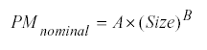
The inputs are the Size of software development, a constant, A, and a scale factor, B. The size is in units of thousands of source lines of code (KSLOC).
The constant, A, is used to capture the multiplicative effects on effort with projects of increasing size.
The scale (or exponential) factor, B, accounts for the relative economies or diseconomies of scale encountered for software projects of different sizes.
If B < 1.0, the project exhibits economies of scale. If the product's size is doubled, the project effort is less than doubled. The project's productivity increases as the product size is increased. Some project economies of scale can be achieved via project-specific tools (e.g., simulations, test beds) but in general these are difficult to achieve. For small projects, fixed start-up costs such as tool tailoring and setup of standards and administrative reports are often a source of economies of scale.
If B = 1.0, the economies and diseconomies of scale are in balance. This linear model is often used for cost estimation of small projects. It is used for the COCOMO II Applications Composition model.
If B > 1.0, the project exhibits diseconomies of scale. This is generally due to two main factors: growth of interpersonal communications overhead and growth of large-system integration overhead. Larger projects will have more personnel, and thus more interpersonal communications paths consuming overhead. Integrating a small product as part of a larger product requires not only the effort to develop the small product, but also the additional overhead effort to design, maintain, integrate, and test its interfaces with the remainder of the product.
A project's numerical ratings W are summed across all of the factors, and used to determine a scale exponent B via the following formula:
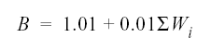
Table 2.15.Rating Scheme for the COCOMO II Scale Factors
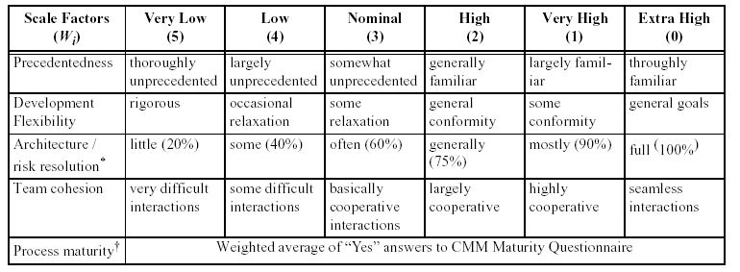
The form of the Process Maturity scale is being resolved in coordination with the SEI. The intent is to produce a process maturity rating as a weighted average of the project's percentage compliance levels to the 18 Key Process Areas in Version 1.1 of the Capability Maturity Model-based rather than to use the previous 1-to-5 maturity levels. The weights to be applied to the Key Process Areas are still being determined.

Cost Factors: Effort-Multiplier Cost Drivers
COCOMO II uses a set of effort multipliers to adjust the nominal person-month estimate obtained from the project’s size and exponent drivers:
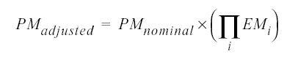
Table 2.16 Early Design and Post-Architecture Cost Drivers
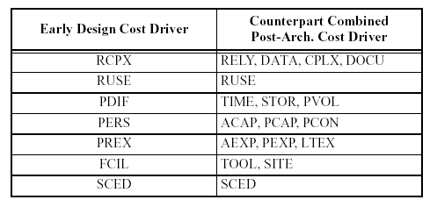

Development Schedule Estimates
The initial baseline schedule equation for all three COCOMO II models is:
where TDEV is the calendar time in months from the determination of its requirements baseline to the completion of an acceptance activity certifying that the product satisfies its requirements. PM is the estimated person-months excluding the SCED effort multiplier, and SCEDPercentage is the schedule compression / expansion percentage in the SCED cost driver rating. Future versions of COCOMO II will have a more extensive schedule estimation model, reflecting the different classes of process model a project can use; the effects of reusable and COTS software; and the effects of applications composition capabilities.

2.3 Advanced Software Metrics

Maintenance and quality metrics are advanced software Metrics. Impact analysis [13][14] is used to calculate maintenance metrics , while quality metrics is estimated by software tester on the basis of different quality parameter. Impact analysis estimates the maintenance size of project. This Chapter concentrates on maintenance metrics.

2.3.1 Software Maintenance Models

Over the years, several software maintenance models have been proposed, often to emphasize particular aspects of software maintenance. Among these models, there are common activities. The following is a brief summary of software maintenance models reported in the literature. Boehm’s maintenance model [19] consists of three major phases: understanding the software, modifying the software, and revalidating the software. The Martin- McClure model is similar, [20], consisting of program understanding, program modification, and program revalidation. Parikh [21] has formulated a description of maintenance that emphasizes the identification of objectives before understanding the software, modifying the code, and validating the modified program. Shapley’s model [22] has a different focus; it highlights the corrective maintenance activities through problem verification, problem diagnosis, reprogramming, and baseline reverification. Osborne’s model of software maintenance [23] concentrates on managing the maintenance activities and determining appropriate measurements applied for visibility, but not into impacts of changes. The Yau and Patkow models are useful in evaluating the effects of change on the system to be maintained. Yau [24] focuses on software stability through analysis of the ripple-effect of software changes. A distinctive feature of this model is the post-change impact analysis provided by the evaluation of ripple-effect. This model of software maintenance involves:
- determining the maintenance objective, 2) understanding the program, 3) generating a maintenance change proposal, 4) accounting for the ripple effect, and 5) regression testing the program. The Patkow model [25] concentrates on front-end maintenance activities of identifying and specifying the maintenance requirements. This model addresses change through diagnosis of the change followed by change localization. Then, the modification is designed and implemented, and the new system is validated. An important feature of this model is its emphasis on specification and localization of the change. Rombach and Ulery [26] propose a method of software maintenance improvement that focuses on goals, questions, and specific measurements associated with activities in a software maintenance organization. However, their method does not specify a framework that supports impact analysis in the software maintenance process. Lewis and Henry [27] have addressed the need for metrics during development to help make the resulting product more maintainable, but their work has not been extended to the actual maintenance process. Heisler, Tsaim and Powell [28] present an interesting object-oriented model of software that is derived from maintaining software. They convincingly use ripple effect analysis as well as program slicing to extract views of software to assist in making software changes.

2.3.2 Impact Analysis

Impact analysis identifies the consequences or ripple effects of proposed software changes. Year 2000 (Y2K) date situation is a good example of why impact analysis is needed to identify impacts of software change. While systems have evolved, legacy software has not been modified to address date requirements of the new century. While on the surface, it appears that date fields only need to be extended to accommodate the two additional digits for the century, there is considerably more work to the Y2K effort. As it turns out, there are many variables associated with “date” that may not be readily apparent (e.g., age, appointment, date-timetag), Impact analysis is integral to software release planning and the software maintenance process [29] . Impact analysis supports release planning by identifying software life-cycle objects (SLOs) that are likely to change for each software change proposed in a set of change requests. Knowing these SLOs enables project managers to make more precise effort and cost estimates of the software changes [31]. These estimates support planning for software releases by providing necessary information to determine what can be reasonably included in a software release over a given period of time [32]. Basic software change activities summarized from the other models are: understanding software with respect to the change, implementing the change within the existing system, and retesting the newly modified system. Each of these activities has some element of impact determination. To understand the software with respect to the change, we must ascertain parts of the system that will be affected by the change and examine them for possible further impacts. While implementing the change within the existing system, we need to be aware of ripple-effects caused by the change and record them so that nothing is overlooked. Once the change has been designed and implemented, we need to find existing test cases for regression testing and test cases that may need to be re-examined for redesign based on new requirements.

2.3.3 Measuring the Impact domain

To validate the estimation of a maintenance task, these tasks were selected and estimated:
Each of these tasks is briefly described below.
Measuring the Impact Size of an Error Correction In the case of the first maintenance task, it was necessary to link the error report to the target GUI. The GUI was then linked to the classes that processed the GUI, the classes inheriting from these classes, and the classes associated with them. The size of those classes and the size of the GUI were added together to give the total size of the impact domain for the error correction.
Measuring the Impact Size of an Interface Change In the case of the second maintenance task, the export file was connected to the class that wrote it, which in turn was connected to the inherited and associated classes. The web service sizes were as pointed out above, included in the classes using those web services.

Measuring the Impact of a Database Change In the case of the third maintenance task, the data base table was linked via the access relationships to the C++ classes that accessed it. These were then linked to the inherited and associated classes and their sizes added to the sizes of the data base table itself to give the size of the domain impacted by the database change.

3. Backfiring Technique

The availability of empirical data from projects that use both LOC and FP metric has led to a useful technique called backfiring. Backfiring is the direct mathematical conversion of LOC data into equivalent FP data. Because the backfiring equations are bidirectional, they also provide a powerful way of sizing or predicting, source code volumes for any known programming languages or combination of languages. This technique is proposed by Capers Jones [15].

3.1 Using FP to define language generations and levels

For many years, software engineers and computer scientists have used phrases as “high level language” and “low level language” without precisely defining a terms. Now with reasonable good justification ,language can classify according to the number of statements they require to encode one function point:
High level language , less than 50
Mid level language, 51-99 and
Low level language, more than 100
The word generation is also ambiguous as it applied to languages. It can refer to either the chronological period when a language was deployed or more vaguely, to its all power. Here too we can assign somewhat arbitraly points to delineate the generation concept. For each generation , the number of statements required to encode one function point are
First generation language , more than 200;
Second generation language , 100-199;
Third generation language ,50-99;
Fourth generation language ,15-49;
Fifth generation language , less than 49
These assumption are based on logical source code statements, physical source code lines, which are subject to severe and random variation, are not suitable for backfiring or really for any , serious economic, productivity or quality analysis.
The assumptions are also based on IFPUG function point version 3.0 counting rules.

3.2 Converting FP to LOC

Since an application’s function point total is known at least roughly by the end of the requirement phase and in some details by middle of the specification phase, size can be estimate accurately for any application.
For early sizing we can multiply the number of function points in the application by the average number of statement required to encode one function point. Thus for application containing 1000 function point and the using java language , which requires an average of 32 statement per function point , the probable the quantity of code would be 1000 times 32- that is 32000 statements.
The concept of backfiring , pioneered by function point inventor Albrecht, simply reverse the direction of the equation used to predict source code size from function point. Table 3.1 shows LOC per FP of different programming language. The first commercial software estimation tool to support backfiring was SPQR/20, which came out in 1985 and supported by directional sizing foe 30 languages. Today backfiring is standard function for many software estimation tools.
Table 3.1.LOC per FP for languages
Programming Language | LOC/FP
Assembly Language | 320
C | 128
COBOL | 106
FORTRAN | 106
PASCAL | 90
C++ | 64
ADA 95 | 53
VB | 32
SMALLTALK | 22
POWERBUILDER(CODE GENERATOR) | 16
SQL | 12
JAVA | 31
4GLS | 20
Code GENERATOR | 15
SPREADS SHEET (EXCEL PROG.) | 6
ADA | 70
PHP | 67
GRAPHICAL LANGUAGE | 4

4. Tool Architecture and Design

4.1 Tool Architecture

This chapter describes the overall architecture of tool [36] that provides early size estimation and other important software metrics in a uniform and consistent manner. The architecture of tool is shown in figure 4.1. Three layer software metrics model is proposed to capture fundamental of software metrics within a unifying framework as given in figure 4.2. First Layer presents the object oriented FP. FP is calculated from object oriented approach. This FP will be converted into LOC using backfiring technique [15]. Next higher layer is General Software Metrics that is based on size Metrics .This Layer uses the COCOMO II that is tuned to modern software life cycles. The most fundamental calculation in the COCOMO II model is the use of the Effort Equation to estimate the number of Person-Months required developing a project .Most of the other COCOMO II results are derived from this quantity. In this model, some of the most important factors contributing to a project's duration and cost are the Scale Drivers.
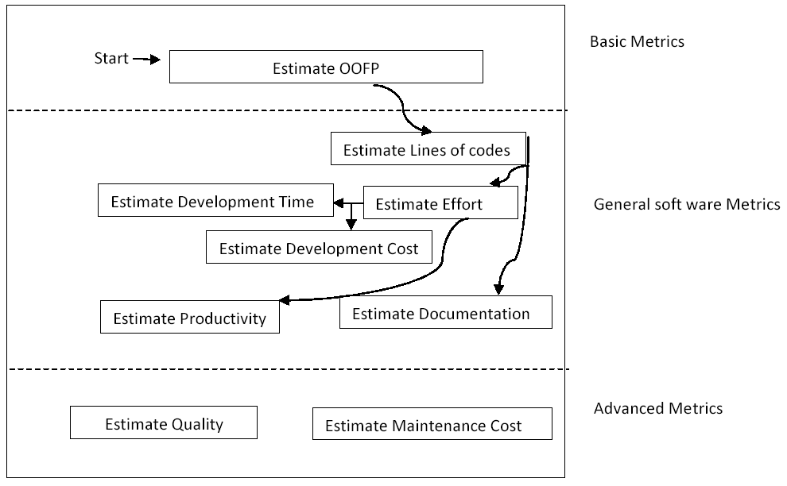
Fig. 4.1 Architecture Of Tool
By using COCOMO II we can estimate effort in person month and development time. Now other metrics can be converted to by means of the following techniques:
- PM to Dollars – On the basis of hourly salary
- Productivity = FP/PM
- Productivity = KLOC/PM
- Development Cost = $/FP
- Development Cost = $/LOC
- Documentation=pages-of-documentation/FP
- Documentation = pages-of-documentation/KLOC
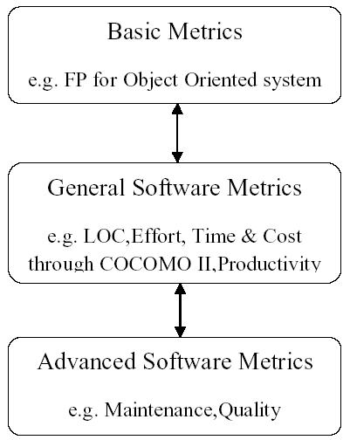
Fig 4.2 Software Metrics Model

Quality and maintenance of project is considered as an advanced software metrics. Both metrics are calculated after implementation phase of software development life cycle (SDLC) when actual coding is done. Maintenance cost is estimated by measuring and tracking the size and complexity of the OO system. Combination of impact analysis [13][14] and function points is used to trace the change request to different component of OO system and then measuring their size and complexity to aid the cost estimation for that particular change request based on function point productivity measurement. This layer is not considered by our tool. In this thesis we concentrate only first and middle layer.

4.2 Design Approach

4.2.1 First Level Design

In this level we have to design tool for size estimation of object oriented software. Size can be estimated in terms of Function Point. We estimate size either using Transformation model or Object oriented design function point model (OODFD) as shown in figure 4.3.
This tool works in two modes.
- Primary or Early size estimation mode
- Secondary mode

Primary or Early size estimation mode
a. Using Transformation Model:
Design of early size estimation mode is based on Harput‘s transformation. This model is used to estimate the size of proposed system in early development phase. The object-modeling Technique (OMT) is an object modeling language for software modeling and designing. UML tool like Alltovo UModel is used for designing sequence diagram, class diagram and use cases that is essential input for Harput‘s transformation model. Data functions are computed by class diagram and Transaction function are computed by use case and sequence diagram. User will have to select object(s) for mapping and appropriate rule for applying. OOFP counter counts the function point by class diagram, sequence diagram and use case. Now OOFP is converted to LOC in the implementation language. This LOC will be input for COCOMO II to estimate other metrics.

b. Using OODFP Model:
Another approach for software size estimation is OODFP model. For applying this model, Use case and Class diagram are used to produce the code prototype with the help of UML tool (Altova UModel is used as a UML tool). Data functions are computed by classes and Transaction function are computed by methods of classes. OOFP counter counts the function point by classes and methods. Now OOFP is converted to LOC in the implementation language. This LOC will be input for COCOMO II to estimate other metrics.
Fig. 4.3 Size estimation in Primary mode
Secondary mode
In secondary mode, kusumoto approach is applied on complete source code. This mode is used when project is completed and project size is required in term of function point. In this mode we execute the source code and collect dynamic information before estimating the size. In order to measure function point, it is necessary to extract the logical file and transaction function from the target program. Complexity of logical file based on the number of data element type (DET) and the record element type (RET). They also define DET as simple variables (Float, Char, Boolean) in the class and RET as a class type variable. Method of the identified class is mapped into transaction function. Complexity of the Transaction function is based on the number of data element type (DET) and the file type reference (FTR). For External Input, DET will be the total number of arguments of the methods called by the boundary class and for External output/ External Inquiry, DET will be total number of the return values of the methods called by boundary class. During test cases of program execution log file is maintained .This file maintains information about method calling sequence of different classes.

Fig. 4.4 Size Estimation with kusumoto approach

4.2.2 Middle Level Design

In this level we estimate the project cost, effort, completion time etc. For this purpose we adopt the approach of COCOMO II. We know that COCOMO II takes Lines of codes as input but first layer estimate software size in function point so we convert this FP into LOC using backfiring technique. Now we set scale driver and cost driver according to project requirement. Finally we apply COCOMO II formula for estimation of middle layer metrics.
Fig.4.5 Middle level design

4.3 Case Study

Here the bank application example is taken for estimation of size and other software metrices. Object Oriented function point is calculated by transformation model for an example shown in figure 4.6.This figure is drawn according to object modeling technique notation. According to transformation model classes and association will be mapped into data function types and use cases and functional requirement will be mapped into transactional data types. The DETs and RETs/FTRs of each logical file and method are tabulated in table 4.1.
Bank class and Account class are considered into one logical file due to aggregation relationship. This logical file contain five DETs(3 for bank class and 2 for account class) and two RETs(one for each class). Account class is inherited by Saving Account class and Credit Card Account class. So here two more logical file is possible one for saving account and other for credit card account. Both derived class will be associated with their base class.The method get_balance has 2 FTRs(one due to the bank class reference and other due to the multivalued association with bank).The method withdraw and deposit have 2 DETs because both have two signature. The total unadjusted function point estimated for the OO design as shown in figure 4.6 is 48 FPs.

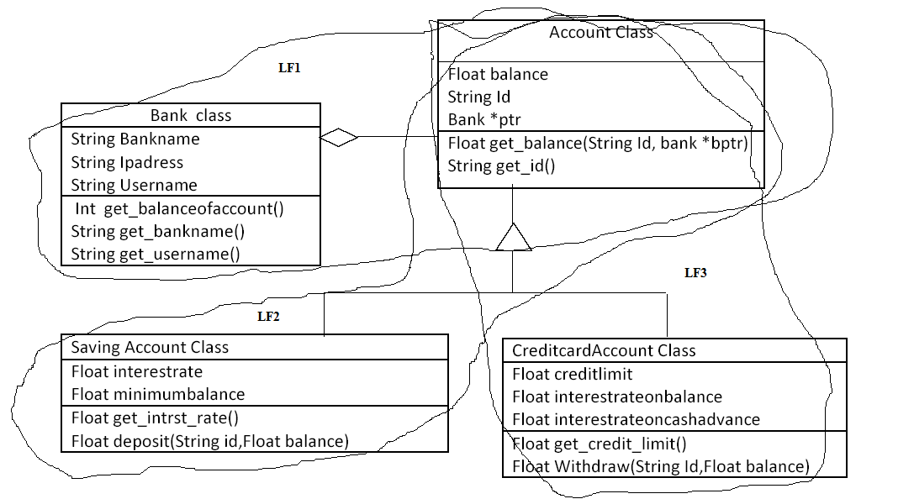
Figure 4.6 A simple example to measure the OOFP
Table 4.1. DETs and RETs/FTRs of the example shown in figure 4.6
Logical file/Transaction Function | DETs | RETs/FTRs
Logical File 1(ILF)  Logical File 2(ILF)  Logical File 3(ILF) | 5  4  5 | 2  2  2
get_balanceof acount  get_bankname  get_username  get_balance  get_id  get_intrst_rate  deposit  get_credit_limit  withdraw | 1  1  1  1  1  1  2  1  2 | 0  0  0  2  0  0  0  0  0

Adjusted OOFP can be estimated by using the Quality requirement and GSC table as specified in [9].Suppose we are developing software in Java so for 48 FPs the proximately LOC will be 1600. Now using this LOC tool calculate effort, development time, productivity etc. with the help of COCOMO II .Table 4.2 list all estimated metrices of the example shown in figure 4.6.
Table 4.2. Estimated Metrics of the example shown in figure 4.6
OOFP | 48
LOC(proximately) | ~1600
Effort adjusted | 7 Person Month
Development Time | 5.1 Month
Average Staffing | 1.4 people
Productivity (FP/PM) | 6.85

5. Evaluation of Tool

Till now we have studied mainly three approaches that are D.J Ram’s OODFP approach[5] , Kusumoto’s Dynamic approach[6 ]and Harput’s Transformation approach[4]. They also designed their corresponding tool.By Adopting these approaches we designed our Software Estimation Tool (SET) based on software metrics model. Table 5.1 shows comparison of these tools.

Table 5.1 Comparison of Tool
OODFP Tool | Kusumoto ‘s Tool | Harput’s Tool | SET Tool
This tool estimates the size of OO system at the design phase from a designer’s perspective.  Advantage:  1. It consider the functionality of OO software .  2. Complexity of class which depends on the design of the problem is also considered by this tool .  Disadvantage:  1. Cost and effort estimation is not considered by this tool.  2. Size depends upon different development phases . | This tool is designed for the measurement of function point automatically from complete source code version.  Advantage:  1. FPA expert’s judgement is not required.  2. The estimated size can be used for maintenance purposes.  3. The functions that are not existed in requirement /design specification but existed in implementation are also considered.  Disadvantage:  1. Cost and effort estimation is not considered by this tool.  2. Not applicable for early size estimation. | This tool is based on semiautomatic transformation from object oriented requirement model to FPA model.  Advantage:  1. It provides early size estimation.  2. It considered the quality requirement during Value Adjustment Factor calculation.  Disadvantage:  1. Cost and effort estimation is not considered by this tool.  2. FPA experts need to apply defined rule according to their understanding of the given OO Model.  3. Tool is not fully automated. | Software Estimation Tool (SET) is based on three layer model is designed for the measurement of different software metrics from source code prototype.  This code prototype is obtained from UML tool using class diagram of requirement model.  Advantage:  1. This tool is capable of estimating all the essential metrics that is required by Project Manager in early size estimation.  2. No need for FPA expert’s judgement.

6. Functional Design Details

6.1 Primary Mode Implementation
Primary mode estimates Software Metrics early in the development cycle. This estimation is done in two steps with the help of Altova UModel Tool. In first step we use Altova UModel tool for designing of class diagram, sequence diagram, use case diagram and generating source code prototype. While in second step we use Software metrics estimation tool designed by us.

6.1.1 Altova UModel Tool
UModel is a 32-bit Windows application that runs on Windows 2000 / 2003, Windows XP and Windows Vista. The UML is a complete modeling language but does not discuss, or prescribe, the methodology for the development, code generation and round-trip engineering processes. UModel has therefore been designed to allow complete flexibility during the modeling process. After making class diagram and sequence diagram of project, we convert it into source code prototype using forward engineering method of UModel tool. Figure 6.1 shows the Class diagram of Account type example using UModel tool.
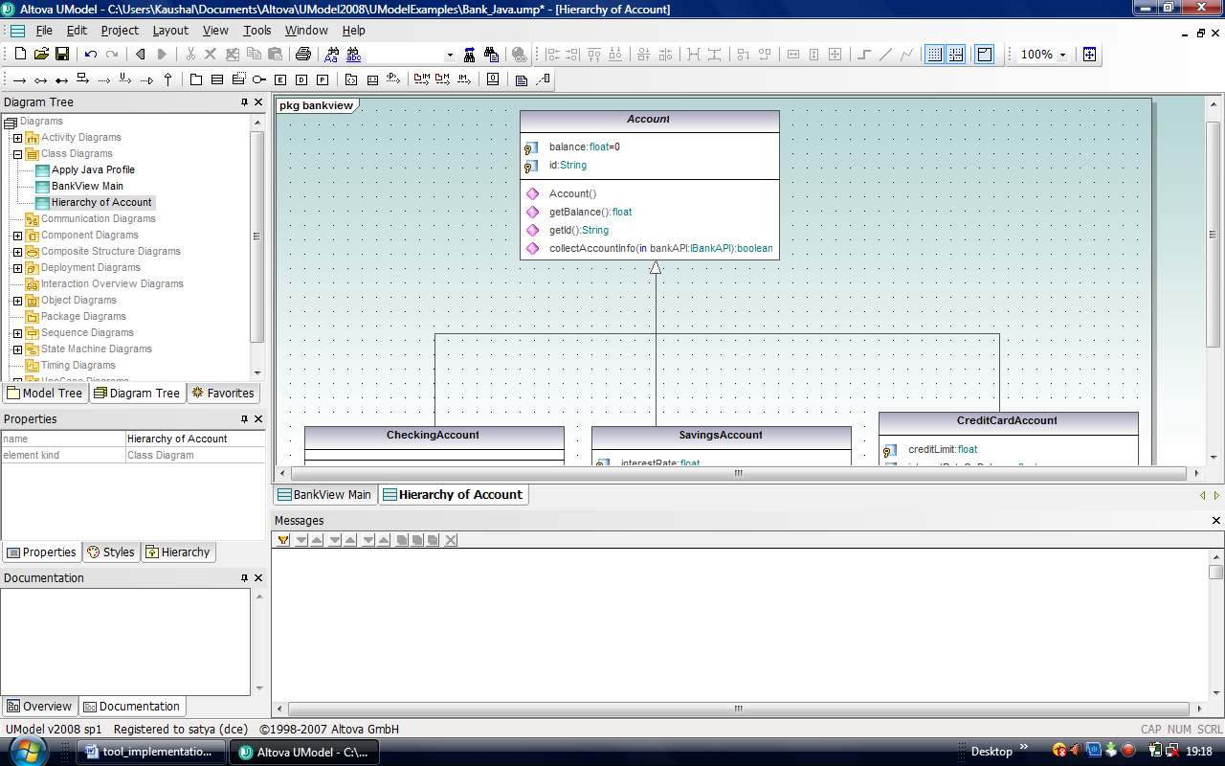
Fig. 6.1 Altova UModel Tool
Step for Getting Source code Prototype using UModel tool
1. Make class diagram, Use case diagram and sequence diagram of targeted project.
2. Define Code generation target directory.
3. Include /Exclude components from code generation.
Uncheck the "use for code engineering" check box (if not already unchecked).
Fig . 6.2 Code generation Component
4. Check project syntax.
Select the menu option Project | Check project syntax
5. Generate Project code
Select the menu option Project | Merge Program Code from UModel project.
Select your synchronization options from the dialog box, and press OK to proceed.
Fig 6.3 code synchronization setting
Now finally we get .java files in our targeted folder.

6.1.2 Software Metrics Estimation Tool

In Second part we take the source code prototype from UML tool. This source code is used as an input for estimation of different software metrics by our Software Metrics Estimation tool. Size estimator is the main module of our tool. It provides the input for other module like COCOMO II estimator and Graph drawing. The Figure 6.4 given show the functional diagram of tool.
Size Estimator
Html, Java Applet User Interface
Graph Drawing
COCOMO II Estimator

Fig.6.4 Functional diagram of tool
Size Estimator
It has been implemented as a single Size_Estimtor.Java class. It use the Harput’s transformational technique for estimation of object oriented function point of software project. It provides the input for other module like COCOMO II estimator and Graph drawing.
COCOMO II Estimator
It has been implemented as another single Cocomo_estimator class. It adopt the cocomo II technique to estimate other metrics defined in middle layer. As we know that COCOMO II model needs the lines of codes as a input so we convert function point into lines of codes using backfiring technique.
Graph Drawing
This Java applet file is implemented as draw_graph.java class. It take size from Size Estimator class and effort from COCOMO II Estimator class and draw graph between Effort and Size.
Graphical User Interface
Main screen of tool is shown in figure 6.5.Our tool take source directory of code prototype as a input and we also have to select the platform language from combo box option on which project is developed. After estimating the metrics of project, tool can also draw graph between Effort and size.
There are two output screens in our tool that show the layer wise result of estimated metrics. First output screen shows only size of project in FP and LOC as in figure 6.6. Second output screen needs the number of page documentation during execution by project manager and it shows middle layer metrics as in figure 6.7.

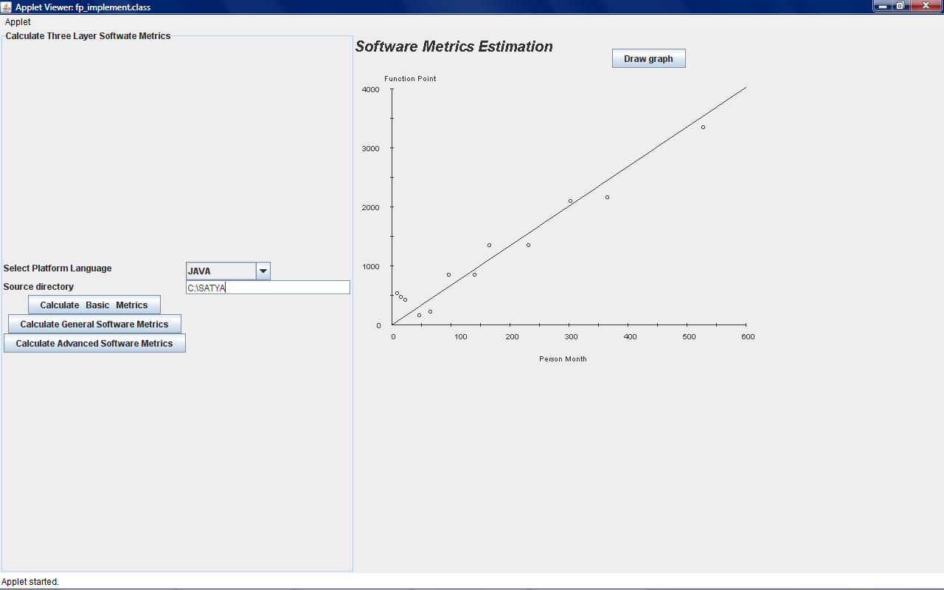
Fig. 6.5 Main Screen of Tool

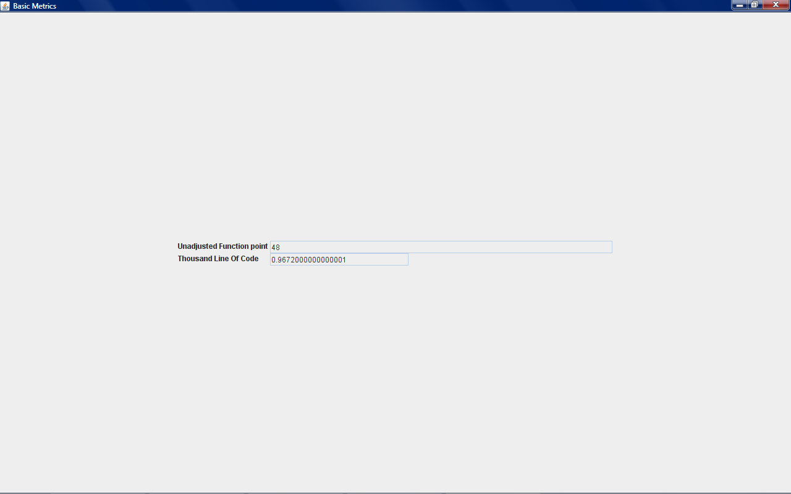
Fig.6.6 Estimated Size of project
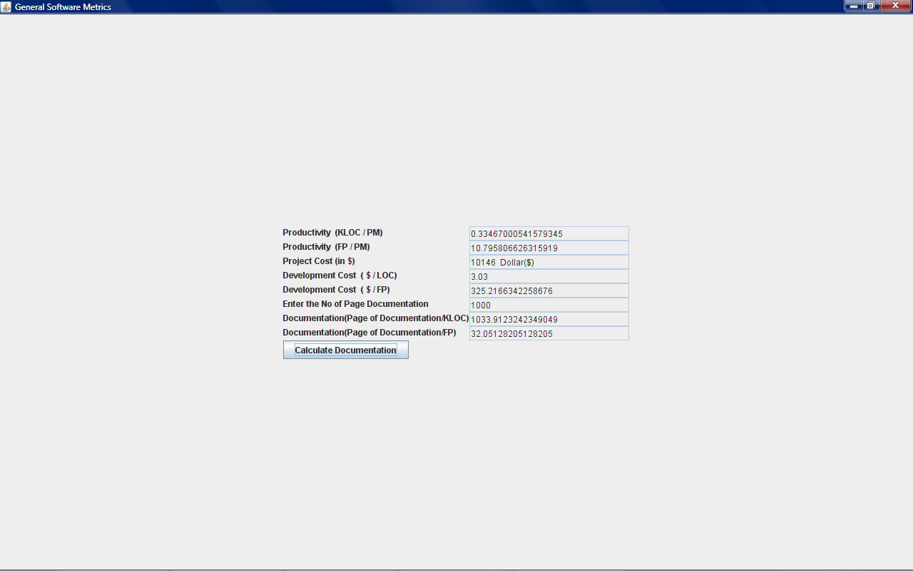
Fig. 6.7 Estimated Middle layer Metrics

6.2 Secondary Mode Implementation

We design another tool for secondary mode .In this mode the complete java source code is taken by tool and it estimates its size in terms of function point. This tool is based on Kusumoto approach. This tool will be initial step for maintenance metrics estimation. As we Know for maintenance metrics estimation we need two steps, first is to calculate size of running project and second step is to estimate the effected source code size in terms of function point during maintenance. So here we are calculating only the size of running project that is the first step for maintenance estimation.
Here the “Address Book”, small software implemented in java, is taken for measuring the size. This Address book can add, delete search, sort and view contacts. Figure 6.8 shows the software. Now our tool takes source code of this software and also takes test cases by running its all provided functions like add contact, delete contact etc. Tool shows the result of measured FP of given address book software, as in figure 6.9. The total unadjusted function point estimated for the address book is 19 FPs.

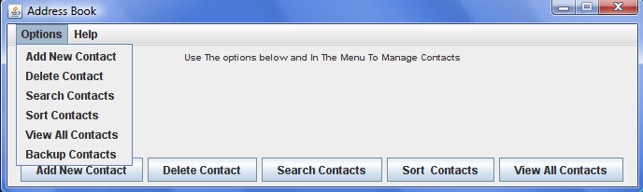 Fig. 6.8 Address book software
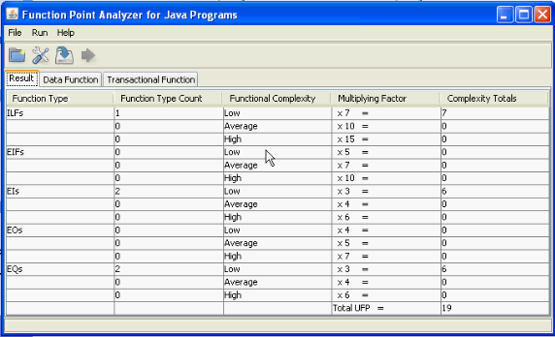
Fig. 6.9 Measured FP of example software

7. Conclusion & Future Work

This thesis presents the architecture and design of tool to calculate different software metrics. This tool is designed for Object oriented Software. We conjecture that by applying this tool, estimate can be much improved in the following respects:
1. This tool can be used as a method to examine things underestimated by project managers. Compared with FPA, the estimation error range will decreased as we are accounting for the complexities of generalization and aggregation which are not considered in traditional FPA. Also the dynamic calculation will have better measure of quality which is need of the day. Additionally accurate maintenance measure will help for better maintenance planning.
2. Currently we are working to calculate the size dynamically from the requirement model so that estimation is independent of measurer, thus increasing the accuracy.
The process of applying this tool to real word project is ongoing with the data collected from National Informatics Centre, India, which executes software projects at National Level.
Many issues regarding metrics estimations are yet to be addressed. Below is a list for possible future extensions for this project.

Future Work
1. Maintenance metrics estimation.
2. Complexity computation of Use Case diagram and class diagram.
3. Reliability and quality metrics estimation.
4. Size estimation using Class point approach.

8. Publication From Thesis

During the period of working over this project we interacted with International Conferences
working on Software Engineering. Two research papers have been accepted in International conferences for presentation and will be published in their proceedings. Also we have communicated a journal paper, so that our work can be recognised and validated.
The details of publications are as follows:
1. Conference Name: “4th IEEE International Conference on Management of Innovation and Technology” ICMIT 2008
URL: http://www.icmit2008.org/
Paper Title: “Software Estimation Tool Based On Three Layer Model For Software Engineering Metrics”
Authors: Daya Gupta, Satyapal Jee Kaushal, Mohd. Sadiq
Location: Bangkok, Thailand .
Conference Date: Sept 21-24 2008.
.
2. Conference Name: “International Conference on challenge and development in IT” ICCDIT 2008.
Paper Title: “Applying Function Point To The Effort And Duration Estimation Of Software Projects”
Authors: Daya Gupta, Satyapal Jee Kaushal, Mohd. Sadiq
Location: Ludhiana, India.
Conference Date: May 30, 2008.
3. Journal Details: We have also worked on the comments and reviews received from
different conferences and written a journal paper titled” Estimation of Object Oriented Software Metrics” which has been communicated to the journal of Software Measurement. This journal paper describes the complete approach for the object oriented software Metrics estimation.

9. References

[1]M.Ruhe,R.Jeffery,I.Wieczorek,”Cost Estimation for Web Application”,Proc of the 25th International Conference on Software Engineering(ICSE ’03) 0270-5257/03 2003 IEEE.
[2]J.A.Pow-Sang,E J. Vasquez,”An approach of a technique for effort estimation of iteration in Software Projects”, 13th Asia pacific Software Engineering Conference(APSEC’ 06)0 -7695-2685-3/06 2006 IEEE.
[3] Klein G., Jiang J., and Tesch D.,”Wanted: Project teams with a Blend of IS Professional Orientations”, Communications of the ACM,Vol 45,#6,june 2002.
[4]Harput V,Kaindl H,Kramer S.,”Extending Function Point Analysis to Object-Oriented Requirements Specifications “,procceding on 11th IEEE International Software Metrics Symposium (METRICS 2005).
[5] D.J Ram, S.V.G.K Raju,” Object Oriented Design Function Points”, -7695-0825-1/00 2000 IEEE.
[6] Kusumoto S.,Imagawa K.,Inoue K.,Morimoto S.,”Function Point Measurement from Java Program” Proceedings of the ICSE’2002,florida ,USA.
[7] A.J. Albrecht, “Measuring Application Development Productivity”, Proc. IBM Applications Development Symp., Monterey, Calif. ,Oct 14-17, 1979.
[8] A.J. Albrecht and Gaffney J.E., “Software Function, Source Lines of Code and development Effort Prediction: A software Science Validation”, IEEE Trans. Software Engineering, November 1983, pp.639-648, November 1983.
[9] International Function Point User Group (IFPUG), Function Point Counting Practices Manual, Release 4.0, IFPUG, Westerville, Ohio, April 1990.
[10]Symons,C.:“Function-Point Analysis: Difficulties and Improvements.” IEEE Transactions on Software Engineering, Vol. 14, Nr. 1, January 1988, pp. 2-11.
[11]Common software Measurement International Consortium, COSMIC–FFP version 2.0(2000).http:// www.cosmicon.com/
[12] Poensgen, B. and Bock, B. Function-Point An]alyse, dpunkt.verlag, Heidelberg, 2005.
[13] Sneed, H.: “Impact Analysis of Maintenance Tasks for A Distributed Object-Oriented System” Proceedings of 17th International Conference on Software Maintenance(ICSM 2001: Florence, Italy, November 7-9, 2001) IEEE CS Press, pp. 180-189.
[14] Sneed H.M, Huang S,” Sizing Maintenance Tasks for Web Applications”, procceding on 11th European Conference on Software Maintenance and Reengineering (CSMR'07) 2007.
[15] Jones C., “Backfiring Converting Lines of Codes to function Point” ,Software Productivity Research.
[16] G.C.Low and D.R.Jeffery, “Function Point in the Estimation and Evaluation of the Software Process”, IEEE Trans Software Engineering, Vol.16, no.1, January 1990.
[17] International Function Point User Group (IFPUG), Function Point Counting Practices Manual, Release 4.0, IFPUG, Westerville, Ohio, April 1990.
[18] G. Caldiera, G. Antoniol, R. Fiutem, and C. Lokan. “Definition and experimental evaluation of function points for object-oriented systems”In Proc. of the 5‘h InternationalSymposium on Software Metrics, pages 167-178, November 1998.
[19] Boehm, B., "Software Engineering," IEEE Trans. On Computers, No. 25, Vol. 12, Dec. 1976, pp. 1226-1242.

[20] Martin, J. and McClure C., "Software Maintenance: The Problem and Its Solutions," Prentice-Hall,London, 1983.
[21] Parikh, G., "Some Tips, Techniques, and Guidelines for Program and System Maintenance," Techniques of Program and System Maintenance, Winthrop Publishers, Cambridge, Mass., 1982, pp. 65-70.

[22] Sharpley, W. K., "Software Maintenance Planning for Embedded Computer Systems," Proceedings of the IEEE COMPSAC, NOV. 1977, pp. 520-526.

[23] Osborne W. M., "Building and Sustaining Software Maintainability," Proceedings of Conference on Software Maintenance, October 1987, pp. 13-23.

[24] Yau, S.S. and Collofello, J.S., "Some Stability Measures for Software Maintenance." IEEE Trans. on Software Engineering, Vol. SE-6, No. 6, Nov. 1980, pp. 545-552.

[25] Patkau, B.H., "A Foundation for Software Maintenance," Ph.D. Thesis, Department of Computer Science, University of Toronto, December 1983.

[26] Rombach, H.D. and Ulery, B.T., "Improving Software Maintenance through Measurement," Proceedings of the IEEE, No. 4, Vol. 77, April 1989, pp. 581-595.

[27] Lewis, J. and Henry, S., "A Methodology for Integrating Maintainability Using Software Metrics," Proc. of Conference on Software Maint., Oct. 1989, pp. 32-39.

[28] Heisler K.G., Tsai W.T. and Powell P.A., "An Object-Oriented Maintenance-Oriented Model for Software," IEEE Spring COMPCON, pp. 248-53, February 1989.

[29] Arthur, L. J., Software Evolution. John Wiley and Sons, 1988.

[30] Sneed, H.M.: “Estimating the Development Costs of Object-Oriented Software.” Proceedings of 7th European Software Control and Metrics Conference, Wilmslow,UK, 1996, p. 135.
[31] Bohner, S. A. and Amold, R. S., "Software Change Impact Analysis," IEEE Computer Society Tutorial, IEEE Computer Society Press,1996.

[32] Vallabhaneni S.R., "Auditing the Maintenance of Software," Prentice-Hall, Inc. Publishing, 1987.

[33] Cowderoy, A.J.C. “Size and Quality Measures for Multimedia and Web-site Production.” Proceedings of the 14th International Cocomo Forum, 1999.

[34] Reifer, D.: “Web Development: Estimating Quick-to-Market Software.” IEEE Softeware, November/December 2000.

[35] El Emam, K.; Benlarbi, S.; Goel, N.; Rai, S.: “The Confounding Effect of Class Size on the Validity of Object-Oriented Metrics.” IEEE Transactions on Software Engineering, 27(7), July, 2001, pp. 630 – 650.

[36] M. Sadiq., Shabbir Ahmed, “Computation of Function Point of a Software on the basis of average complexity”, International Conference on Advanced Computing and Communication Technologies,( ICACCT 07),Panipat, Haryana, India, 2007.

[37] Gupta D.,Kaushal S.,Sadiq M.,”software Estimation tool based on three layer model for software engineering metrics” , ICMIT 2008.

