CONTENTS

Certificate
Acknowledgement
Abstract

CHAPTER –1 INTRODUCTION 1-17
- Introduction …………………………………………………………. 1
  - History and definition of hydrogels ………………………………………. 2
  - Classification of hydrogels……………………………………………........ 4
  - Preparation of hydrogel……………………………………………………. 6
  - Characterization of hydrogels……………………………………………... 7
    - Water-Content and Swelling Ratio………………………….... 7
    - Cross linking Analysis………………………………………… 8
      - Gel Content Analysis………………………………………..... 8
1.4.2.2 Crosslink density Analysis ………………………………....... 8
    - Water vapour transmission rate ………………………………. 9
    - Permeability ……………………………………………….. … 10
    - Mechanical properties ………………………………………… 11
    - Surface properties …………………………………………….. 11
  - Advantages……………………………………………………………….. 12
  - Disadvantages……………………………………………………………. 13
  - Applications of hydrogel…………………………………………………. 14
  - Hydrogels as chelating polymers…………………………………………. 16
1.9 Objective and Plan of work………………………………………………. 17

CHAPTER –2 EXPERIMENTAL TECHNIQUES 18-28

2. Introduction ………………………………………………………… 18
2.1 Materials ……………………………………………………….. 18
2.2 Preparation of glycol based macromer …………………………… 19
2.3 Preparation of crosslinked poly (acrylic acid) (XPAA) …………… 19
2.4 Structural Characterisation …………………………………………. 21
2.5 Thermal Characterisation …………………………………………… 21
2.6 Swelling Ratio………………………………………………………. 21
2.7 Analytical Procedure……………………………………………….. 22
2.7.1 Preparation of Stock Solutions…………………………… 22
    - Batch equilibration technique …………………………. 22
  - Analytical Characterisation …………………………………….. 23
2.8.1 Principle of ICP-OES………………………………….. 24
2.8.2 ICP Discharge…………………………………………. 25
2.9 Optimum pH of Metal Ion Uptake………………………………. 26
2.10 Adsorption Isotherms…………………………………………… 26
  - Total Sorption Capacity………………………………………… 27
  - Recovery and Hydrogel Stability………………………………. 27
  - Effect of Interfering ions ……………………………………… 27
  - Effect of Flow rate…………………………………………….. 28

CHAPTER –3 RESULTS AND DISCUSSION 29-51

3.1. Structural Characterisation ………………………………………… 29
3.2. Thermal Characterisation …………………………………………. 31
3.3. Swelling studies …………………………………………………… 32
3.4 Evaluation of hydrogel (XPAA-10) as sorbents …………………. 36
3.4.1 Metal sorption as a function of pH………………………. 36. 3.4.1.1 Lead……………………………………………. 37
3.4.1.2 Copper………………………………………….... 38 3.4.1.3 Nickel……………………………………………. 40 3.4.1.4 Chromium……………………………………….. 41
3.5. Total Sorption Capacity…………………………………………….. 43
3.6. Adsorption Isotherm……………………………………………….. 44
3.6.1 Langmuir Isotherm………………………………………... 44.
3.6.2 Freundlich Isotherm………………………………………. 46
3.7. Monovalent-Divalent cation exchange process……………………. 47
3.8. Regeneration and Hydrogel stability tests………………………… 49
3.9. Effect of Interfering ions…………………………………………. 50
3.10 Effect of flow rate……………………………………………… 51

CHAPTER - 4 SUMMARY AND CONCLUSION 52-53
References ……………………………………………………… 54-56
List of tables ………………………………………………………. 57
List of figures……………………………………………………… 58

CERTIFICATE

This is to certify that Mr. Vikas Swami has carried out his major project entitled “Synthesis, Characterisation and Evaluation of Hydrogels for chelation of metal ions” under joint supervision and guidance during session 2009-2010. To the best of our knowledge and belief, this work has not been submitted to any other university or institution for the award of any degree or diploma.

Dr. D. KUMAR
Asstt. Professor,
Department of Applied chemistry & Polymer Technology
Delhi College of Engineering
University of Delhi, Delhi

Dr. P. K. ROY
Scientist ‘D’,
Centre for Fire, Explosive & Environment Safety
DRDO, Delhi

Dr. G. L. VERMA
Head
Department of Applied chemistry & Polymer Technology
Delhi College of Engineering
University of Delhi, Delhi

ACKNOWLEDGEMENT

It is a great pleasure to have the opportunity to extend my heartiest felt gratitude to everybody who helped me throughout the course of this project.
It is distinct pleasure to express my deep sense of gratitude and indebtedness to my project supervisor Dr. D. Kumar, for his constant encouragement throughout the course of my project.
I wish to convey my sincere thanks to Dr. Chitra Rajagopal, Head, Explosive Safety Group, CFEES, DRDO to carry out this project work and providing the necessary facilities. I am extremely grateful to Dr. P. K. Roy, Scientist ‘D’, CFEES for his valuable guidance, constant inspiration and invaluable suggestions for carrying out this work. The discussions held with him very enlightening and always motivated me to work with greater zeal and enthusiasm.
I take this opportunity to thank Dr. G. L. Verma, Dr. A. P. Gupta, Dr. R. C. Sharma, for the knowledge I have gained from them.
I was fortunate to have an excellent work environment in the laboratory, which facilitated my work to a great deal. I must thank Ms. Arti Bhatt, Ms. Ila Dharmasuktu, Mr. Rajesh Chopra, Mr. Navin Saxena and Ms. Surekha Parthasarathy for their constant help in every possible way to carry my project work.
I will be indebted to my parents for helping me realize my goals.

Vikas Swami
M.E(Polymer Technology)
09/poly/08
Department of Applied Chemistry & Polymer Technology
Delhi College of Engineering
University of Delhi, Delhi

ABSTRACT

Superabsorbent anionic polyelectrolytic hydrogels have been prepared by redox polymerization of acrylic acid in the presence of polyethylene glycol diacrylate as the cross linker. Although the linear analog of polyacrylate has been reported to form metal complexes with divalent metal ions, its use for removal of heavy metals from aqueous solutions for practical purposes is restricted, because of its inherent water solubility. To address this issue, crosslinking of this polymer has been attempted to synthesize hydrogel, which has an advantage of being stable in aqueous medium over a wide range of pH. The synthesized hydrogel was characterised by swelling studies, FTIR, elemental analysis and thermal analysis. This chelating hydrogel bearing O, O donor groups was found to exhibit high hydrogel capacity of 41.1, 58.2, 43.1 and 81.2 mg/g for metal ions such as Cr⁶⁺, Ni²⁺, Cu²⁺ and Pb²⁺ respectively under optimum conditions. Various physicochemical parameters like pH, concentration and interference of common ions on metal uptake have been investigated. The Langmuir and Freundlich adsorption isotherms were used to validate the metal uptake data. A high recovery (>97%) was obtained for all the metal ions with 1 N HCl as eluting agent.

CHAPTER-2
EXPERIMENTAL TECHNIQUES

2 Introduction
The experimental work was carried out in two different stages. The first stage deals with the synthesis of crosslinked poly (acrylic acid). This was achieved by redox-polymerization of acrylic acid in the presence of polyethylglycol-diacrylate (PEGDA) as a crosslinker. The diacrylate was prepared by a reaction of sodium salt of polyethylglycoal (PEG) with acryloyl chloride. The various techniques used for the characterisation of the hydrogel are also described in this chapter.
The second parts deals with the applicability of this hydrogel in removing heavy metal toxicity from contaminated water. The effect of crosslinking of polyacrylic acid on the metal uptake has also been investigated.

2.1 Materials
Acrylic acid monomer was distilled under reduced pressure, prior to use. Potassium persulphate was purified by recrystallization from 66 wt.% ethanol/water solution. Polyethyleneglycol-200, sodium, acryloyl chloride and sodium metabisulphite were of 'AR' grade of E.Merck or Qualigens (Glaxo). Standard 1000 μg/mL aqueous stock solutions of chromium (VI), nickel (II), copper (II), lead (II) and calcium (II) were prepared by dissolving requisite amounts of potassium dichromate, nickel nitrate, copper nitrate, lead nitrate and calcium chloride separately in 0.1 M of the corresponding acid [21]. These were diluted accordingly to prepare solutions of requisite concentration. Milli Q ultrapure water was used throughout the course of this work.

2.2 Preparation of glycol based macromer
Polyethylene glycol-200 was reacted with excess sodium metal, cut in small pieces, under nitrogen atmosphere to synthesise its sodium salt (Na-PEG) [22]. The reaction was allowed to proceed for 24 h, after which it turned dark brown and viscous. The reaction mixture was transferred to a separating funnel, and the lower fraction, excluding the solid sodium pieces was collected, weighed, solubilised in dichloromethane and purged with nitrogen to remove dissolved oxygen. Stoichiometric quantity of acryloyl chloride was subsequently added to the solution and the reaction was allowed to proceed at 50-55ºC for 8 h. The solvent was removed under vacuum in a rotary evaporator, and the diacrylate (PEGDA) was collected.

2.3 Preparation of crosslinked poly (acrylic acid) (XPAA)
For preparation of XPAA, an oxygen free aqueous solution of acrylic acid (3 mol/L) was polymerized in the presence of different amount of PEGDA (1.1 -5.0 mol%) as the crosslinking agent in glass tubes (5 mm diameter). For polymerisation, a redox initiator, comprising of an equimolar solution of potassium persulphate (0.1 mol%) and sodium metabisulphite (0.1 mol%) was used. The reaction was allowed to proceed for 30 min at 70⁰C, after which the stable gels were dried, subjected to soxhlet extraction with acetone to remove unreacted monomer. For comparison purposes, the polymerization of acrylic acid was also carried out in the absence of crosslinking agent to prepare linear poly (acrylic acid) (PAA). The reaction scheme depicting the entire process, has been presented in Scheme 2.1, and the various formulations prepared have been listed in Table 2.1. For each of the formulation, crosslinking ratio (χ) has also been reported, which has been defined as the ratio of the moles of crosslinking agent to moles of PAA repeating unit [23].

Scheme 2.1 Representation of reaction sequence.

Table 2.1 Sample designations of various formulations prepared
Sample  designation | Moles (PEGDA) | Crosslinking ratio  (χ) / (10⁻²) *
PAA | - | 0
XPAA-5 | 8.0 x 10⁻⁴ | 1.1
XPAA-10 | 1.6 x 10⁻³ | 2.3
XPAA-15 | 2.4 x 10⁻³ | 3.4
XPAA-20 | 3.2 x 10⁻³ | 4.6
*Moles of AAc: 6.0 x 10⁻²

2.4 Structural Characterisation
The FTIR spectrum was recorded in the wavelength range 400-4000cm⁻¹ on Thermoscientific Nicolet spectrophotometer (Model 380). The C and H content was determined by elemental analyzer (Elementar, Vario EL). Carboxyl content in the polymer was determined chemically. For this purpose, a known amount (~0.5 g) of the dry polymer was swelled in excess water. Thereafter, the solution was titrated against previously standardised NaOH, in the presence of phenolphthalein as indicator. The accessible carboxyl-content was then calculated using the following equation:
$$\text{Carboxyl content}=\frac{(V1−V2)×N1}{W×\text{1000}}$$
Where V₁ and V₂ are the volume (mL) of NaOH consumed by polymer and blank respectively, N₁ is the normality of NaOH and W is the mass (g) of the polymer used [24].

2.5 Thermal Characterisation
The thermal behavior of the polymer was investigated using Perkin Elmer Diamond SDTA in N₂ atmosphere (200 mL/min) in the temperature range of 50-600 ⁰C. A heating rate of 10 ⁰C/min and sample mass of 10 ± 0.5 mg was used for this purpose. The deswelling behaviour of the swollen hydrogel was studied isothermally, for which, 10 ± 0.5 mg of the equilibrated swollen hydrogel was placed in ceramic crucibles at three different temperatures (30, 40 and 50⁰C) under flowing nitrogen atmosphere (200 mL/min).

2.6 Swelling Ratio
Since all the chelation experiments were perfomed in aqueous medium, the swelling behaviour of all the formulation was studied over the entire pH range. For this purpose, weighed amounts of dried hydrogels were dipped in distilled water of pH varying between 2-10, which was adjusted by adding requisite amounts of acid or alkali. The pH measurements were made with Labindia pH analyzer having glass electrode (Toshniwal, India), calibrated with Titrisol buffers. At different intervals, the swollen gels were lifted, patted dry and weighed. The swelling studies were carried out until equilibrium swelling was achieved. The swelling ratio (SR) was calculated as per the following equation [25]:
$\text{SR }\text{\%}= \left(\frac{M_{s}{\text{-M}}_{d}}{M_{d}}\right)× \text{100}\text{\%}$
Where M_{s} is the mass of the swollen polymer, and M_{d} is the initial mass of the dry polymer. The kinetics of water uptake was also investigated for all the prepared formulations at a pH of 5.

2.7 Analytical Procedure
2.7.1 Preparation of Stock Solutions

Standard stock solutions of copper (II), lead (II), nickel (II), chromium (VI) having a concentration of 1000 μg/mL were prepared by dissolving reagent grade copper nitrate, lead nitrate, nickel nitrate, potassium dichromate in 0.1 M of their respective acids. The required concentration of the metal ion was prepared by diluting the standard stock solution as and when required.

2.7.2 Batch equilibration technique
Batch equilibration technique was used to determine the sorption capacity of the sorbent and optimum sorption conditions like pH. The chelating hydrogel was equilibrated with a known volume of metal ion solution. Post-equilibration, the hydrogel was filtered and the metal concentration in the filtrate was quantified. The amount of metal ions sorbed on the hydrogel was determined by the equation [9,10]:-
$$Nf=\frac{(X−Y)}{Z}$$
where X = initial amount of metal ion (mg), Y = amount of metal ions in the supernatant (mg), N_{f} = amount of metal ion adsorbed (mg/g) and Z = amount of chelating hydrogel (g).
2.8 Analytical Characterisation
The total concentration of metal ions, such as Ni²⁺, Cu²⁺, Pb²⁺, Cr⁶⁺ and Ca²⁺ in water, both before and after chelation, was determined using Inductively Coupled Plasma Optical Emission Spectroscopy (ICP-OES) (Perkin Elmer Optima 2100) operated using WINLAB 32 software (Figure 2.1). The standard conditions used for operating Inductively coupled plasma-optical emission spectroscopy (ICP-OES optima 2100DV) are presented in Table 2.2.

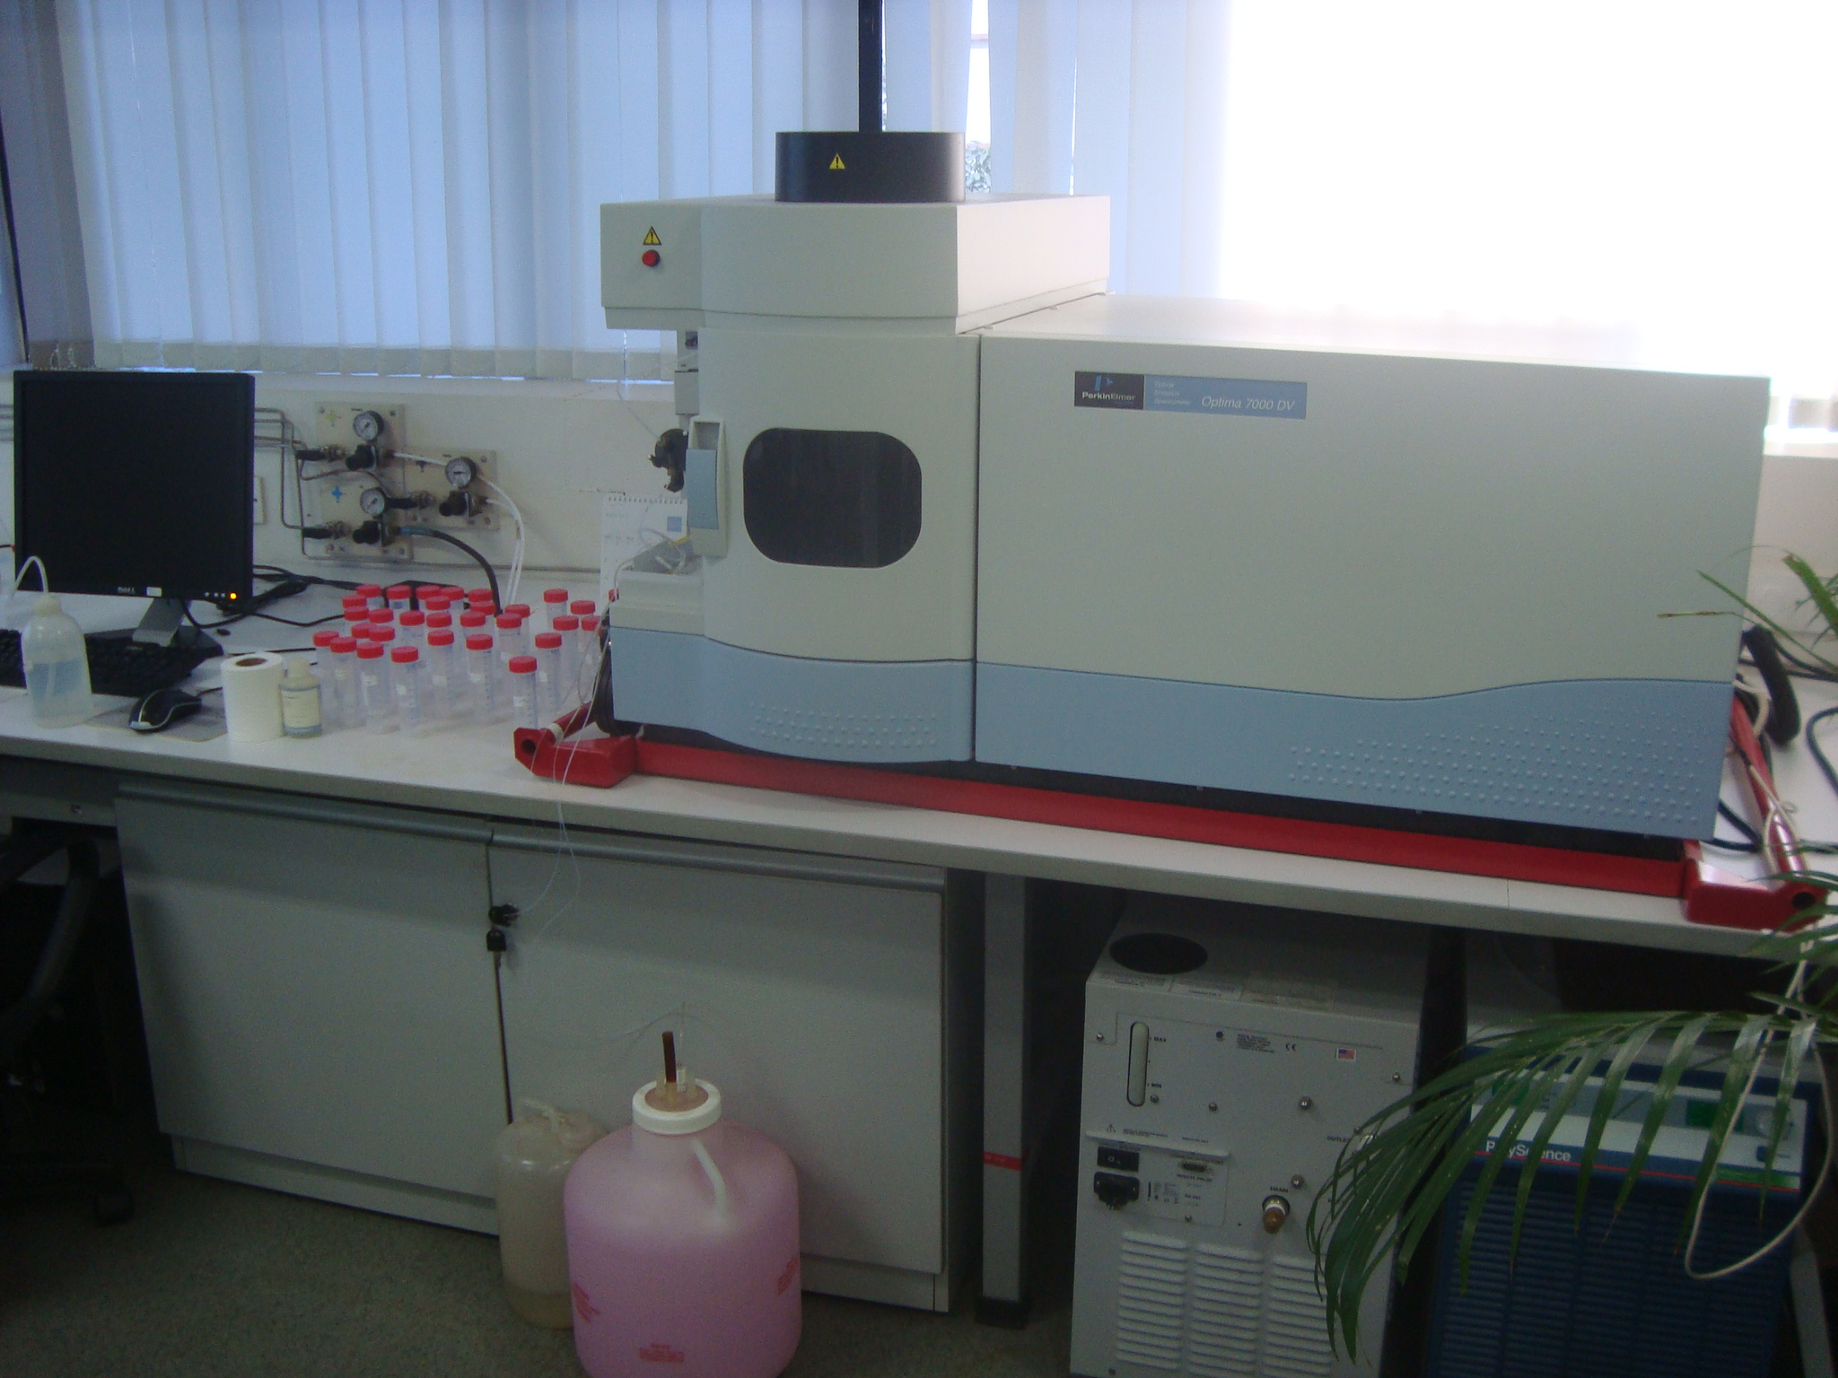
Figure 2.2 Photograph of ICP-OES used for determination of metal ions

Table 2.2 Operating parameters used for recording Inductively coupled plasma- optical emission spectroscopy for different metal ions
Metal | Wavelength( nm)
Ni(II) | 231.60
Cu(II) | 224.70
Cr (VI) | 267.71
Pb(II) | 220.35
Ca(II) | 317.93

Plasma Gas Flow (L/min): This is the flow rate which is required to generate a plasma (15 L/min).
Auxillary Gas Flow (L/min): this is the flow rate of argon gas, which is contained between the intermediate and center injector tubes in the torch (0.5 L/min).
Nebulizer Gas Flow (L/min): This is the flow rate argon gas, which is require to carry sample aerosol into the plasma (0.75 L/min).
RF Power (Watts): This is power in watts transmitted from the RF (Radio Frequency) generator to create a plasma (1450 W).
Sample Flow Rate (mL/min): This is the flow rate of the solution pumped into the nebulizer by the peristaltic pump (1.5 mL/min).

2.8.1 Principle of ICP-OES
In optical emission spectrometry (OES), the sample is subjected to temperatures high enough to cause not only dissociation into atoms but to cause significant amounts of collisional excitation (and ionization) of the sample atoms to take place. Once the atoms or ions are in their excited states, they can decay to lower states through thermal or radiative (emission) energy transitions. In OES, the intensity of the light emitted at specific wavelengths is measured and used to determine the concentrations of the elements of interest.

2.8.2 ICP DISCHARGE
Argon gas is directed through a torch consisting of three concentric tubes made of quartz or some other suitable material, as shown in Figure 2.2. A copper coil called the load coil, surrounds the top end of the torch and is connected to a radio frequency (RF) generator.
When RF power (typically 700-1500 watts) is applied to the load coil, an alternating current moves back and forth within the coil or oscillates at a rate corresponding to the frequency of the generator. In the most ICP instruments this frequency is either 27 or 40 megahertz (MHz). this RF oscillation of the current in the coil causes RF electric and magnetic fields to be set up in the area at the top of the torch. With argon gas being swirled through the torch, a spark is applied to the gas causing some electrons to be stripped from their argon atoms. These electrons are then caught up in the magnetic field and accelerated by them. Adding energy to the electrons by the use of a coil in this manner is known as inductive coupling. These high-energy electrons in turn collide with other argon atoms, stripping off still more electrons. This collisional ionization of the argon gas continues in a chain reaction, breaking down the gas into a plasma consisting of argon atoms, electrons and argon ions forming what is known as an inductively coupled plasma (ICP) discharge. The ICP discharge is then sustained within the torch and load coil as RF energy is continually transferred to it through the inductive coupling process.

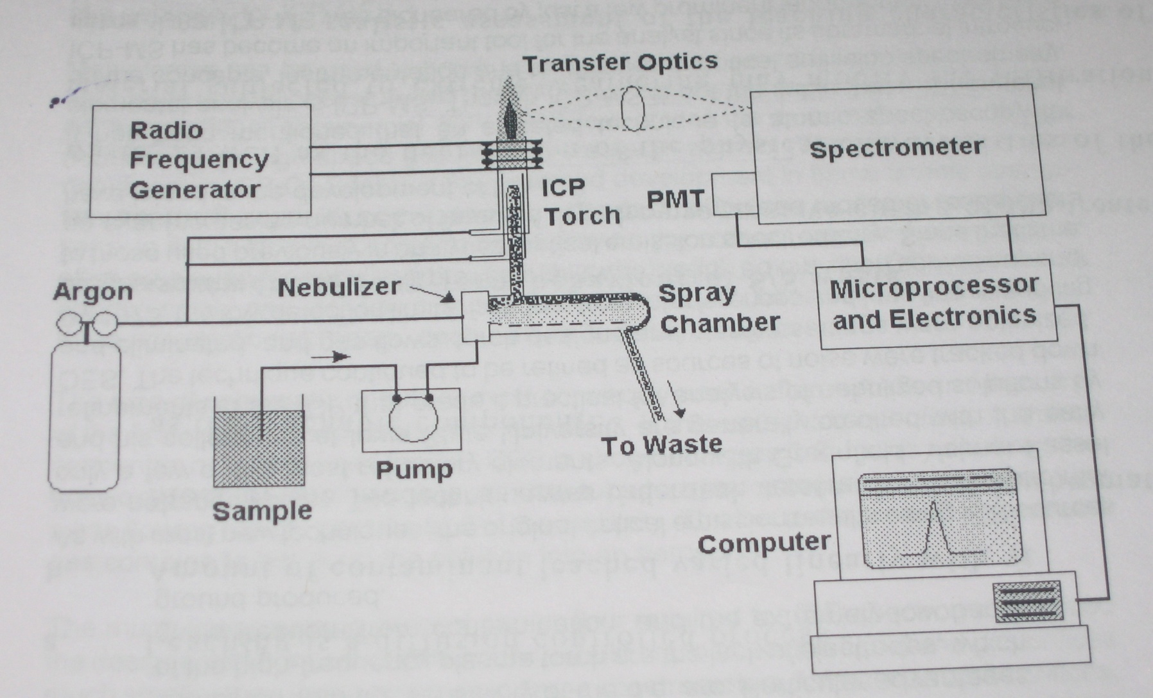
Figure 2.3: Schematic showing the working of ICP-OES

  - Optimum pH of Metal Ion Uptake
Optimum pH of metal ion uptake was determined by batch equilibration technique. Excess metal ion solution (50 mL, 100 μg/mL) was shaken with 50 mg of dried hydrogel for 2 h. The pH of the solution was adjusted prior to equilibration with buffer solution. The hydrogel was filtered off and the amount of metal ion remaining in the filtrate was determined. The sorption experiments were carried out in triplicate to determine the precision of the method.

2.10 Adsorption Isotherms
The adsorption isotherm studies were carried out by shaking 50 mg of hydrogel in the presence of different concentration of metal ion solution of Ni²⁺, Cu²⁺, Pb²⁺ and Cr⁶⁺ at 30⁰C for 24 h. The solution was then filtered and the concentration of the metal in the filtrate was determined.
  - Total Sorption Capacity
Total sorption capacity of the hydrogel was determined by shaking an excess of metal ion solution (100 mL, 100 μg/mL) with 50 mg hydrogel for 24 h at optimum pH at 30⁰C in a mechanical shaker to ensure complete equilibration. The hydrogel was filtered off and the concentration of metal ion in the filtrate was determined.

  - Recovery and Hydrogel Stability
For establishing the stability of the hydrogel, 50 mg of the hydrogel was stirred with 100 mL of 50 μg/mL solution of 24 h at 30⁰C. The elution operation was carried out by shaking the hydrogel with 20 mL of the 1 N HCl for 4h to ensure complete regeneration. The regenerated hydrogel was again stirred with 100 mL of 50 μg/mL solution and eluted with 1 N HCl as described previously. This adsorption-desorption cycle was repeated for 10 times and the metal content in the filtrate and eluent was determined to establish the stability of the hydrogel.

  - Effect of Interfering ions
The effect of a representative interfering ion (Ca²⁺) on the sorption behaviour of Pb²⁺ was investigated at its optimum pH. For this purpose, 50mg of the dried hydrogel was shaken with different metal ion solution in which the concentration of Pb²⁺ was maintained at 100 μg/mL and the concentration of Ca²⁺ was increased from 10 μg/mL to as high as 200 μg/mL. The pH of the solution was maintained at the optimum pH of 5.

  - Effect of Flow rate
The effect of flow rate on the sorption of metal ion was determined in a glass column, 5 mm in diameter. The column was packed with 50 mg of the chelating resin. 50 μg/mL of lead solution was passed through the packed bed at different flow rates (1-3 mL/ min) which was maintained by a peristaltic pump. At different time intervals, the concentration of the metal in the effluent was determined by ICP-OES.

CHAPTER 3
RESULTS AND DISCUSSION

3.1 Structural Characterisation
The data obtained from C, H elemental analysis of the formulations prepared are presented in Table 3.1. It can be seen, that the results compare well with the theoretical values, the slight difference being attributed to hydration of the polymer because of its affinity towards water. The carboxyl content of all the formulations as determined by titration with alkali, was found to be 1.35 – 1.45 meq/g (~ 54.5-58 mg of NaOH/g), which is far lower than the expected value of 1.38 x 10⁻² eq/g (~555.5 mg of NaOH/g) assuming complete neutralisation. This can be attributed to the fact, that interaction with base results in neutralisation of only a fraction of the carboxylic acid groups due to extensive hydrogen bonding between carboxyl groups of neighboring polymer chains [26]. The characteristic peaks observed in the FTIR spectrum of PEG were at 3463 cm⁻¹ (–OH stretch), 2917 cm⁻¹ (alkyl -CH stretch), and 1099.3 cm⁻¹ for the ether (-C-O-C-) group (Figure 3.1). Whereas, in the spectrum of the synthesized PEGDA, no absorption was observed in the range of 3200-3600 cm⁻¹, (characteristic of –OH stretch), which indicated the conversion of the hydroxyl groups to ester. Another characteristic peak because of ester linkage was observed at 1199.3 cm⁻¹. The FTIR spectra of PAA and XPAA-10 exhibited characteristic peaks at 1694 cm⁻¹ (C=O stretching band) and 1449 cm⁻¹ (symmetric stretching of COO⁻). Asymmetrical and symmetrical stretching band of C-H was observed at 2921 cm⁻¹ and 2362 cm⁻¹, respectively.

Table 3.1 Result of elemental Analysis of formulations

Sample name | Experimental.(%) |  |  | Calculated.(%)
Sample name | C | H | O | C | H | O
PAA | 49.51 | 5.61 | 44.88 | 50.01 | 5.55 | 44.44
XPAA-5 | 49.91 | 5.48 | 44.61 | 50.01 | 5.55 | 44.44
XPAA-10 | 49.89 | 5.58 | 44.83 | 50.01 | 5.55 | 44.44
XPAA-20 | 49.93 | 5.58 | 44.49 | 50.01 | 5.55 | 44.44

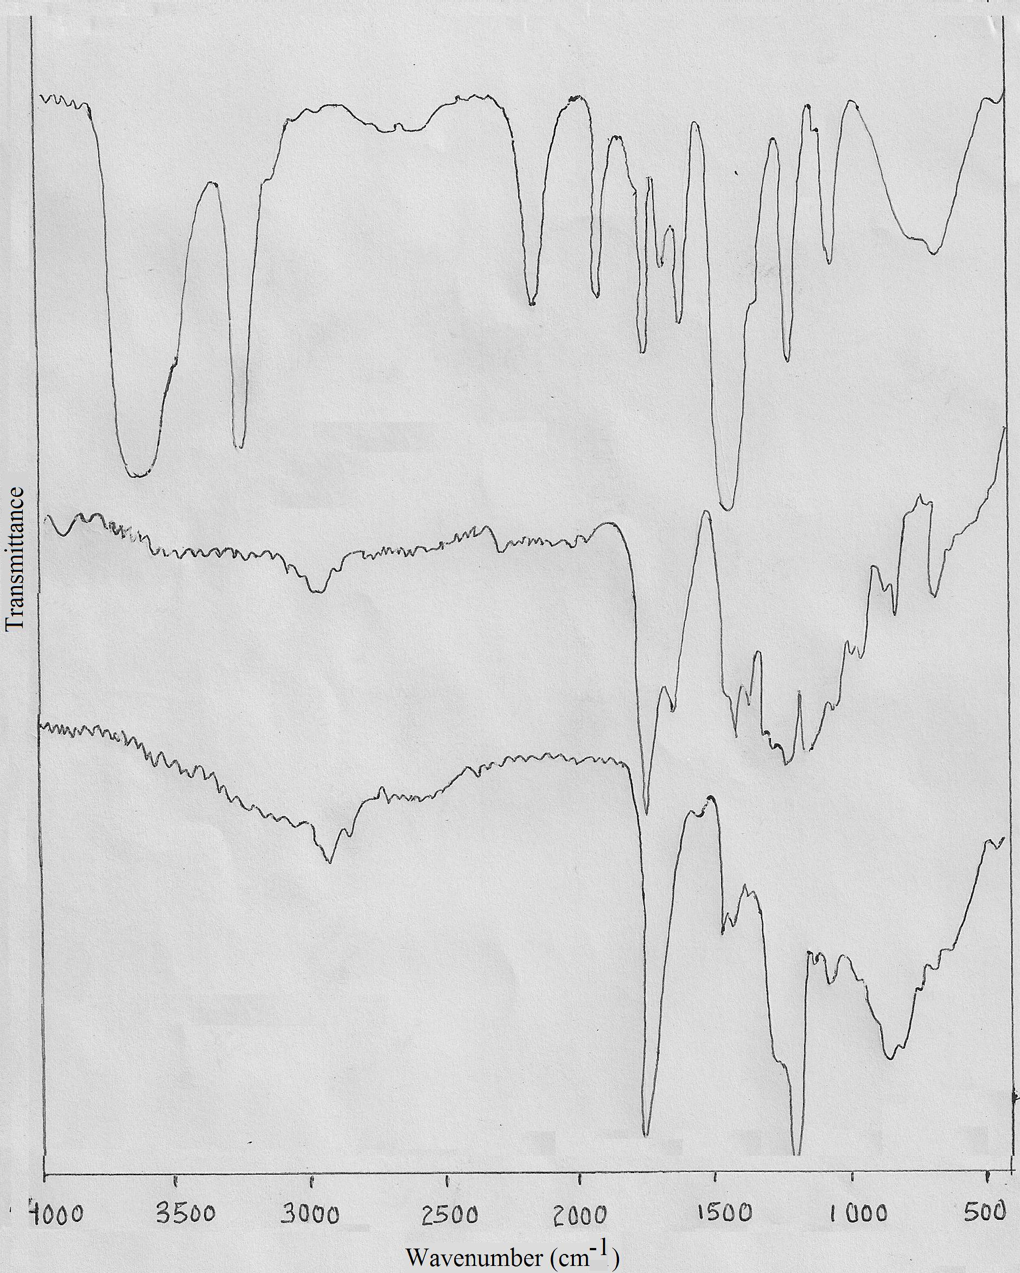
b
c
a

Figure 3.1 FTIR spectra a) PEG 200, b) PEGDA, c) XPAA-10

3.2 Thermal Characterisation
The thermal degradation of samples was investigated and the thermogravimetric traces of all the formulations prepared are presented in Figure 3.2. Double step decomposition was observed in all samples, the first loss being the loss of water molecules from adjacent carboxylic moieties to form anhydride and the second step being the loss of CO₂, which coincides, with the decomposition of the main chain [27]. The thermal stability was evaluated by comparing the T_{i} (initial temperature of degradation), T_{max} (temperature of maximum rate of weight loss), T_{f} (final temperature of degradation) and char yield at 600⁰C, which are presented in Table 3.2.

Table 3.2 Results of Thermogravimetric Analysis of formulations
Sample | T_{i} ( ºC ) | T_{max} ( ºC ) | T_{f} ( ºC ) | % Weight Loss | % Char Yield at 600 ºC
PAA | 256  355 | 292  400 | 338  501 | 39  48 | 9.8
XPAA-10 | 251  317 | 284  418 | 317  559 | 38  48 | 12.1
XPAA-15 | 242  318 | 283  417 | 318  549 | 39  45 | 14.3
XPAA-20 | 256  310 | 276  420 | 305  550 | 35  47 | 16.6

Figure 3.2 TG traces of formulations

3.3 Swelling studies
Linear poly(acrylic acid) (PAA) is completely soluble in common solvents such as water, methanol and DMSO. This inherent solubility of PAA in water, limits its ability to be used for metal removal from aqueous solutions. As expected, crosslinking of PAA with PEGDA results in its insolubility in all solvents. The increase in the swelling ratio of the formulations in water as a function of pH is presented in Table 3.3 and Figure 3.3. As can be seen, the swelling ratio increases with increase in pH and is inversely proportional to the crosslink ratio. The pK_{a} value of poly (acrylic acid) has been reported 4.28, therefore at lower pH, poly(acrylic acid) chains are in the collapsed state, thus reducing the swelling ratio. As the pH increases, the polymeric network gets charged due to deprotonation of carboxylic protons, which sets up repulsive forces between the adjacent groups. This results in an expansion of the polymer chain conformation, thereby significantly increasing the swelling ratio resulting in the observed rapid increase in SR.
The kinetics of water uptake for the hydrogels has been studied at a pH of 5. The increase in mass due to sorption of water as a function of time has been presented in Table 3.4 and Figure 3.4. It can be seen, that rapid swelling takes place initially which levels off subsequently. Highly crosslinked samples (crosslinking ratio > 2.3x 10⁻²) reached equilibrium within 5 h of immersion, while samples with lower degree of crosslinking (cross linking ratio < 2.3x 10⁻²) require much longer time periods i.e 18-19 h to reach > 95% swelling. However, when the swelling investigations are done at higher pH, the water uptake took place instantaneously, and the samples reached equilibrium within 5 minutes of immersion. The deswelling behaviour of the gels was investigated under isothermal conditions under flowing nitrogen atmosphere and the results are presented in Figure 3.5. It can be seen that the release of water from the gel is strongly dependent on the temperature and at high temperatures (50 ⁰C), the gel becomes completely dry within 50 min of exposure to flowing nitrogen gas.

Table 3.3 Result of swelling ratio at different pH
Sample designation | pH
Sample designation | 2 | 4 | 6 | 7 | 8 | 13
XPAA- 5 | 346.5 | 3538.1 | 10005.4 | 12983 | 14804.5 | 26066.2
XPAA-10 | 159.4 | 1098.2 | 4321.3 | 5456.5 | 6789.4 | 20986.6
XPAA-15 | 123.5 | 879.1 | 3030.7 | 3090.7 | 4449.8 | 17594.5
XPAA-20 | 109.3 | 225.1 | 2120.1 | 2404.6 | 3702.4 | 7226.53

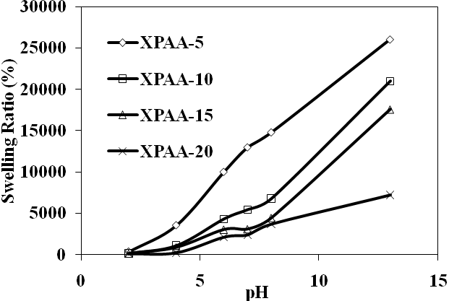
Figure 3.3 Effect of pH on the swelling behavior of the hydrogel

Table 3.4 Result of swelling ratio at different time intervals
Time (hr) | XPAA-5 | XPAA-10 | XPAA-15 | XPAA-20
0 | 0 | 0 | 0 | 0
1 | 986 | 678.8321 | 430 | 230
2 | 1600 | 981.7518 | 698 | 289
3 | 2000 | 1066.302 | 804 | 297
4 | 3098 | 1207.421 | 943 | 290
5 | 3200 | 1304.745 | 1000 | 310
18 | 3450 | 1507.299 | 1038 | 318
36 | 3539 | 1689.781 | 1039 | 320

Figure 3.4 Kinetics of water uptake for different formulations

a
b
c

Figure 3.5 Isothermal TG traces indicating deswelling of hydrogel a) 30ºC, b) 40ºC, c) 50ºC

3.4 Evaluation of hydrogel (XPAA-10) as sorbents
To investigate the effect of crosslinking ratio on the sorption of metal ions, 50 mg of the dried sample was dipped in 50 mL of aqueous solution containing 100 μg/mL of a represented toxic metal ion (Pb²⁺) at a pH of 5. The studies revealed that with increase in crosslinking ratio, the sorption of metal decreases from 83.2 mg/g, 81.2 mg/g, 75.5 mg/g and 70.2 mg/g for XPAA-10, XPAA-15 and XPAA-20 respectively. All sorption processes, including metal sorption is a surface phenomenon and is therefore limited by the number of adsorbing sites available on the surface. In the case of hydrogels, owing to their hydrophilic nature, metal ions can enter the polymeric network and hence, are expected to exhibit a higher sorption capacity. The only disadvantage of using hydrogel for removal of metal ions is their low mechanical strength.
Although XPAA-5 exhibited highest sorption capacity, its mechanical strength was extremely low, which disintegrated during handling. All further sorption investigations were performed on XPAA-10, as it was mechanically stable and maintained its integrity over the entire pH range. The decrease in the sorption capacity with increase in crosslinking ratio could be attributed to the increased hindrance offered by the network to the binding of metal ions.

3.4.1 Metal Sorption as a Function of pH.

The sorption behaviour of metal ions such as Ni (II), Cu(II), Pb(II), Cr (VI), by the crosslinked polyacrylic acid (XPAA-10) was investigated using batch equilibration techniques. The metal ion concentration before and after chelation was determined using Inductively Coupled Plasma Optical Emission Spectroscopy (ICP-OES). Sorption behaviour of the metal ions by the hydrogel was investigated as a function of pH. Experiments were carried out in the pH range of 2-9 where most of the metals did not show any visible precipitates except copper, which precipitated out at alkaline pH. The experiments were performed separately with each metal salt solution at different pH and the results are given in the following text.
3.4.1.1 Lead

Lead is a poison by ingestion. Human systemic effects by inhalation and ingestion include loss of appetite, anemia, malaise, insomnia, headache, irritability, muscle and joint pain, gastritis and liver changes. The major organ systems affected are the central nervous system, blood system and kidney. Very heavy intoxication leads to the formation of a dark line on the gum margin, forming the so-called “gum line”.

Toxicity data.
ihl-man TCL_{o} :10 µg/m³ :GIT:LIV

Studies regarding the uptake of lead from water were carried out on 50 mL of 100 μg/mL solution. The solution remained clear over the entire range of pH i.e. 2-9. There was no visible formation of precipitate over this pH range. The results of chelation are reported in the Table 3.5. Figure 3.6 show the effect of pH on the sorption of lead by crosslinked polyacrylic acid (XPAA-10). Maximum sorption was observed over the pH range of 5.6-9.2.

Table 3.5 Concentration of lead before and after chelation

Amt. of  XPAA-10  hydrogel  (g ) | pH | Conc. before chelation  (mg/L) | Conc. after chelation  (mg/L) | Loading  (mg/g)
0.05 | 2.3 | 100.01 | 89.28 | 10.50
0.05 | 3.1 | 100.05 | 69.38 | 30.31
0.05 | 4.0 | 100.03 | 28.07 | 68.93
0.05 | 5.6 | 100.09 | 14.01 | 82.205
0.05 | 6.8 | 100.01 | 16.09 | 81.37
0.04 | 8.0 | 100.02 | 16.08 | 84.69
0.04 | 9.1 | 100.05 | 14.05 | 87.26

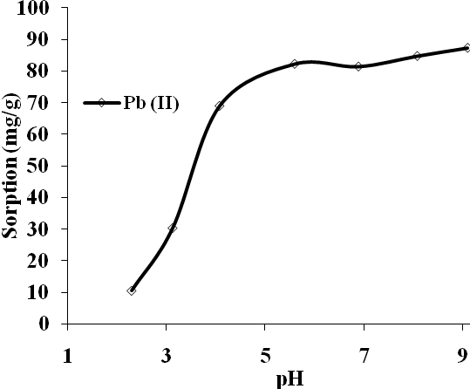

Figure 3.6 Effect of pH on lead sorption by XPAA-10

3.4.1.2 Copper
Copper is a questionable carcinogen with experimental tumerigenic data. Excessive intake of copper by ingestion leads to nausea and vomiting. Copper also has detrimental reproductive effects.
Toxicity data.
orl-man TDL_{o} :120 µg/kg :GIT
50 mL of copper solution (50 μg/mL) was used for the sorption studies. 50 mg of the resin was shaken with the metal ion and the concentration before and after chelation was studied using ICP-OES. Copper formed a blue precipitate in the alkaline pH range therefore the studies were restricted to the pH in the range of 2-9. The results are shown in Table 3.6.

Table 3.6 Concentration of copper before and after chelation

Amt. of  XPAA-10  hydrogel  (g ) | pH | Conc. before chelation  (mg/L) | Conc. after chelation  (mg/L) | Loading  (mg/g)
0.05 | 2 | 41.63 | 33.48 | 8.15
0.05 | 3 | 41.60 | 26.03 | 15.32
0.05 | 4 | 41.69 | 9.94 | 31.63
0.05 | 5.8 | 41.68 | 2.95 | 38.63
0.05 | 6.8 | 41.66 | 1.97 | 38.85
0.05 | 7.9 | 41.64 | 1.99 | 38.10

Fig. 3.7 shows the effect of pH on the copper sorption by the hydrogel (XPAA-10). A significant increase in adsorption of copper was observed as the pH was changed from 3 to 7. Further increase in pH resulted in a decrease in the adsorption of copper.
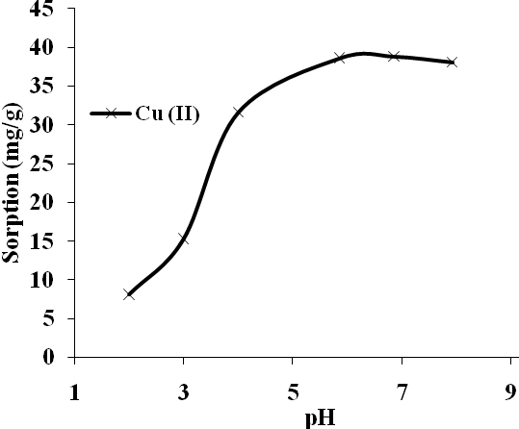
Figure 3.7 Effect of pH on copper sorption by XPAA-10

3.4.1.3 Nickel

The uptake studies were carried out on 50 mL of 100 μg/mL solutions of nickel. Nickel was clear over the entire pH range studied and the concentration of nickel before and after chelation was studied by ICP-OES. The results of chelation are summarised in Table 3.7. Metal sorption increased as the pH was increased from 2 to pH 7 whereas further increase in the pH of medium resulted in the decrease of metal sorption.

Toxicity data.
TLV : .05 mg/mg³

Table 3.7 Concentration of nickel before and after chelation

Amt. of  XPAA-10  hydrogel  (g ) | pH | Conc. before chelation  (mg/L) | Conc. after chelation  (mg/L) | Loading  (mg/g)
0.05 | 2.0 | 78.56 | 76.0 |  | 2.56
0.05 | 3.0 | 78.59 | 42.97 |  | 35.56
0.05 | 4.0 | 78.60 | 31.96 |  | 44.94
0.05 | 5.0 | 78.55 | 26.01 |  | 52.56
0.05 | 6.0 | 78.57 | 20.0 |  | 58.56
0.04 | 7.0 | 78.58 | 21.98 |  | 59.28
0.05 | 8.1 | 78.56 | 20.0 |  | 53.82
0.05 | 9.0 | 78.54 | 20.02 |  | 56.96

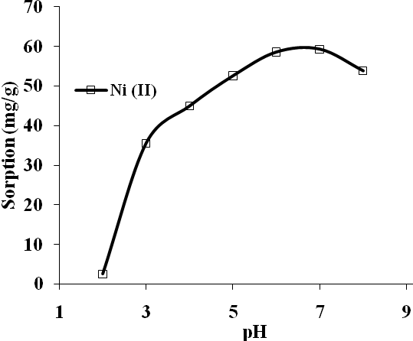
Figure 3.8 Effect of pH on nickel sorption by XPAA-10

3.4.1.4 Chromium
Chromium is a human carcinogen. Excessive intake of chromium causes irritation to the nose, ulcers and holes in the nasal septum. Ingestion chromium cause stomach upsets and ulcers, convulsions, kidney and liver damage, lung cancer and even death.
Toxicity data.
Subchronic and Chronic oral RfD value :1 mg/kg/day
50 mL of chromium solution (100 μg/mL) was used for the sorption studies. 50 mg of the resin was shaken with the metal ion and the concentration before and after chelation was studied using ICP-OES. The results are shown in Table 3.8.

Table 3.8 Concentration of chromium before and after chelation

Amt. of  XPAA-10  hydrogel  (g ) | pH | Conc. before chelation  (mg/L) | Conc. after chelation  (mg/L) | Loading  (mg/g)
0.05 | 2 | 112.06 | 110.0 | 1.99
0.04 | 3 | 112.04 | 87.98 | 25.80
0.05 | 4.8 | 112.08 | 78.98 | 32.53
0.05 | 5.7 | 112.06 | 74.0 | 34.10
0.05 | 6.8 | 112.09 | 77.97 | 33.52
0.05 | 7.8 | 112.07 | 75.99 | 35.49
0.04 | 8.8 | 112.05 | 75.01 | 39.17

Figure 3.9 shows the effect of pH on the chromium sorption by the hydrogel (XPAA-10). A significant increase in adsorption of chromium was observed as the pH was changed from 3 to 5.
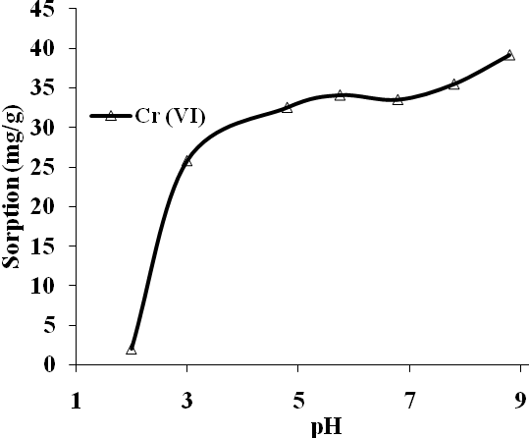
Figure 3.9 Effect of pH on chromium sorption by XPAA-10

3.5 Total Sorption Capacity
The capacity of the hydrogel is an important factor to determine the amount of hydrogel required for complete removal of a specific metal ion from the solution. In order to determine the total sorption capacity of the hydrogel, the amount of metal ions sorbed per unit gram of the hydrogel was determined by immersing a known amount of the hydrogel in the metal solution at optimum pH at a temperature of 30⁰C. The mixture was stirred using a mechanical shaker for 24 h followed by filtration. The metal ion concentration in the filtrate was determined by ICP-OES. From the carboxyl content determination, the hydrogel is expected to have a maximum capacity of 6.75 – 7.25 meq/g on the basis of monovalent – divalent exchange process. However, the experimental loading capacity of the hydrogel was found to much lesser (Table 3.9), which can again be attributed to the hindrance offered by the network to binding complexation process.

Experimental conditions;

Hydrogel (XPAA-10) ~50 mg
Ni(II) = 100 μg/mL, 100 mL.
Cu(II) = 100 μg/mL, 100 mL
Pb(II) = 100 μg/mL,100 mL.
Cr(VI) = 100 μg/mL, 100 mL

Table 3.9 Sorption Capacity of the chelating hydrogels at optimum pH
Metal | Optimum pH | Loading capacity of XPAA10 (mg/g) | Loading capacity of XPAA10 (mmol/g)
Copper | 5-6 | 43.1 | 0.67
Nickel | 5-6 | 58.2 | 0.98
Lead | 5-6 | 81.2 | 0.39
Chromium | 5-6 | 41.1 | 0.78

Loading capacity of lead was observed to be 81.2 mg/g and the capacity for other metal ions was found to be in the range of 40-60 mg/g.

3.6 Adsorption Isotherm
The adsorption data for Cr⁶⁺, Ni²⁺, Cu²⁺ and Pb²⁺ metal ions were analysed by a regression analysis to fit the Freundlich and Langmuir isotherm model. These data were plotted as a function of the amount of metal ion sorbed on the hydrogel at equilibrium versus the heavy metal concentration of the solution at equilibrium. The coefficients of these two models were computed using linear least square curve fitting.

3.6.1 Langmuir Isotherm
The Langmuir model was used to explain the observed sorption behaviour. The equilibrium data was analysed using the following linearised equation:
$$\frac{C_{e}}{q_{e}}=\frac{1}{\text{kb}}+\frac{C_{e}}{b}$$
where C_{e} is the equilibrium concentration (mg/L), q_{e} is the amount adsorbed at equilibrium (mg/g) and k and b are the Langmuir constants related to adsorption capacity and the energy of adsorption respectively. The linear plot (Figure 3.10) for the four metal ions reveals that the adsorption obeys the Langmuir model. The Langmuir constants were evaluated and have been reported in Table 3.10.

Table 3.10 Langmuir Coefficients for metals
Metal | Langmuir Equation | K | B | R²
Cu | C_{e}/q_{e}=0.33 + 0.01C_{e} | 0.043 | 68.96 | 0.94
Ni | C_{e}/q_{e}=0.18 + 0.009C_{e} | 0.049 | 111.11 | 0.97
Pb | C_{e}/q_{e}=0.25 + 0.01C_{e} | 0.040 | 99.00 | 0.97
Cr | C_{e}/q_{e}=0.47 + 0.02C_{e} | 0.041 | 50.00 | 0.97

Figure 3.10 Langmuir isotherms for adsorption of metals

3.6.2 Freundlich Isotherm
The adsorption behaviour was also fitted into the Freundlich model:
$$\text{log}q_{e}=\text{log}k_{f}+\frac{1}{n}\text{log}c_{e}$$
where c_{e} is the equilibrium concentration (mg/L) and q_{e} is the amount of metal adsorbed (mg/g). A linear plot (Figure 8) of log q_{e} versus log c_{e} shows the applicability of the Freundlich model. The Freundlich constants k_{f} and n were calculated and are reported in Table 3.11. It can be seen that for all the metals under investigation, the value of coefficient n is greater than 1, which confirms positive sorption of metal [28]. Correlation indices (R²) were determined to compare the two models and our investigation revealed that the adsorption data fitted well into both the models.

Table 3.11 Freundlich Coefficients for metals
Metal | Freundlich Equation | K | N | R²
Cu | logq_{e}=0.80 + 0.39 logC_{e} | 6.42 | 2.51 | 0.75
Ni | logq_{e}=0.80 + 0.49 logC_{e} | 6.35 | 2.02 | 0.93
Pb | logq_{e}=0.57 + 0.52 logC_{e} | 14.12 | 2.68 | 0.89
Cr | logq_{e}=0.950 + 0.32 logC_{e} | 8.912 | 3.10 | 0.73

Figure 3.11 Freundlich isotherm for adsorption of metals

3.7 Monovalent-Divalent cation exchange process
This study was undertaken with the objective of removing multivalent toxic ions from aqueous solution by ion exchange with monovalent protons/sodium ions, present in the hydrogel network. For this purpose, XPAA-10 sample was equilibrated in distilled water and then allowed to contract in solutions of Cu(NO₃)₂, Ni(NO₃)_{2,} Pb(NO₃)₂ and K₂Cr₂O₇ of varying molar concentrations, at a pH of 4. The results have been depicted in Table 3.12 and Figure 9. The investigation revealed that there was decrease in the swelling ratio of the hydrogel as the ionic strength of the solution was increased in all the metal ions. This can be attributed to the additional interaction between the negatively charged networks with the positively charged cations, which doesn’t allow the network to swell further thereby leading to the observed decrease in the SR [20]. The greatest deswelling was observed in the case of Pb²⁺, followed by Cu²⁺, Ni²⁺, Ca²⁺ and Cr₂O₇²⁻, Which gives an indication of the binding affinity of the polymer towards the metal ion species.
Transition metal ions like Pb²⁺, Cu²⁺ and Ni²⁺ have a stronger complex forming tendency with polyanions as compared to the alkaline earth metal ions like Ca²⁺. The lower deswelling in the case of Cr⁶⁺ is due to the presence of a large fraction of the metal ion being present in the anionic form, as Cr₂O₇²⁻ . Due to the repulsion between the negative charge of the polymer and the oxoanion species, the deswelling is reduced.

Table 3.12 Result of increasing Ionic strength trend on the swelling ratio
Molar conc. | Mass swelling (%)
Molar conc. | Pb | Ni | Cr | Cu | Ca
0 | 1102 | 1109 | 1123 | 1098 | 1132
2 | 60 | 98 | 945 | 100 | 654
5 | 61 | 94 | 946.15 | 74.07 | 654
10 | 64 | 93 | 954 | 70.46 | 643

Figure 3.12 Effect of increasing ionic strength on the swelling ratio

3.8 Regeneration and Hydrogel stability tests
To test the hydrogel stability, the hydrogel was subjected to several loading and elution cycles. The tests revealed that the sorbent is stable and can be used repeatedly for atleast 10 cycles as shown in Table 3.13 and Figure 3.13. The metal loaded on the hydrogel could be easily eluted using 1 N HCl. For all the metal ions under investigation, more than 97% recovery could be obtained at pH < 2. The role of acid is to increase the hydrogen ion concentration, which in turn protonates the carboxylic acid groups. This leads to a reduction in the ionic attraction between the anionic groups of carboxylate and the metal ions, thereby leading to the regeneration of the hydrogel.

Table 3.13: Effect of regeneration cycle on the sorption capacity of the hydrogel

No. of cycles |  | Sorption Capacity (mg/g)
No. of cycles |  | Cr(VI) | Cu(II) | Ni(II) | Pb(II)
1 |  | 41.1 | 44.1 | 58.9 | 81.3
2 |  | 40.3 | 44.5 | 58.3 | 81.3
3 |  | 40.2 | 42.1 | 58.0 | 81.3
4 |  | 41.1 | 43.1 | 58.2 | 81.3
5 |  | 41.1 | 43.1 | 58.2 | 81.3
6 |  | 40.5 | 42.1 | 58.2 | 81.3
7 |  | 39.5 | 43.1 | 58.5 | 81.3
8 |  | 37.4 | 43.4 | 58.2 | 81.3
9 |  | 38.6 | 43.1 | 57.4 | 81.3
10 |  | 36.6 | 41.1 | 56.0 | 81.3

Figure 3.13 Effect of regeneration cycle on the sorption capacity of the hydrogel

3.9 Effect of Interfering ions
The effect of a representative interfering ion (Ca²⁺) on the sorption behavior of Pb²⁺ was investigated by batch equilibration technique. It was observed that even when the concentration of interfering alkali metal ion (Ca²⁺) was increased from 10 μg/mL to 200 μg/mL in the presence of 100 μg/mL Pb²⁺, the sorption capacity for Pb²⁺ remained unaltered at 81-82 mg/g. It can be concluded that due to the stronger interaction of hydrogel with Pb²⁺ ions, the complexation with Pb²⁺ is more favorable and preferred even in presence of Ca²⁺. Since industrial effluents contain large amount of such interfering ions, this study confirms that the hydrogel can be used for selective removal of Pb²⁺.

3.10 Effect of flow rate
The dependance of uptake of the metal on the flow rate was studied for Pb(II) at optimum pH, the flow rate of the solution being varied from 1 to 3 mL/min. The results are presented in Figure 3.14. It was observed that as the flow rate was increased from 1 to 3 mL/min, there was no change in percentage sorption.

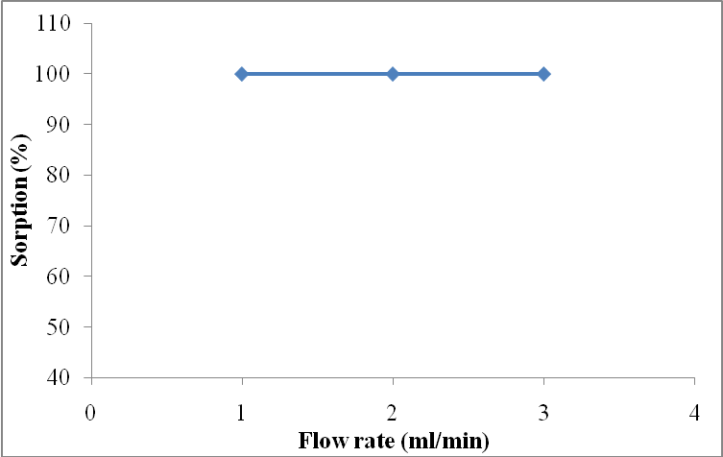

Figure 3.14 Effect of flow rate on metal sorption

CHAPTER-4
SUMMARY AND CONCLUSIONS
- Poly(acrylic acid) (PAA) was prepared by polymerisation of acrylic acid using potassium persulphate and sodium metabisulphite as redox initiators.
- Crosslinked poly(acrylic acid) of varying degree of crosslinking (Crosslinking ratio (χ) = 1.1 - 4.6 x 10⁻²) was also prepared in a similar manner in the presence of poly(ethylene glycol diacrylate) as crosslinker.
- The crosslinked polymer was found to be stable over the entire pH range as compared to its linear analog, which is soluble in aqueous solutions.
- The synthesized hydrogels were characterised by swelling studies, FTIR, elemental analysis and thermal analysis.
- The carboxyl content of all the formulations as determined by titration with alkali, was found to be 1.35 – 1.45 meq/g (~ 54.5-58 mg of NaOH/g), which is lower than the expected value of 1.38 x 10⁻² eq/g (~555.5 mg of NaOH/g) assuming complete neutralisation.
- The swelling ratio for all the samples was found to increase with increase in pH and was inversely proportional to the crosslink ratio.
- The use of hydrogel for metal uptake was studied by batch equilibration technique. The studies revealed that with increase in crosslinking ratio, the sorption of metal decreases from 83.2 mg/g, 81.2 mg/g, 75.5 mg/g and 70.2 mg/g for XPAA-10, XPAA-15 and XPAA-20 respectively.
- Metal sorption by the hydrogel was evaluated as a function of pH of the medium. The effect of pH on sorption of different metals by XPAA-10 hydrogel is shown in Fig. 4.1.
- The pH of the metal test solution was monitored during the sorption tenure and it was observed that during the equilibration process, a decrease in the pH of the solution was observed, which could be attributed to the release of protons from the sorbent during the sorption process.
Figure 4.1 Effect of pH on metal sorption
- A significant increase in the sorption was observed as the pH of the solution was raised from 2 to 4 for all the metals under investigation. This can be related to the ionisation and conformational behaviour of the poly (acrylic acid). In general, the extent of sorption of metal ions increases with increase in pH, reaching a limiting value in each instance.
- This chelating hydrogel bearing O, O donor groups was found to exhibit high hydrogel capacity of 41.1, 58.2, 43.1 and 81.2 mg/g for metal ions such as Cr⁶⁺, Ni²⁺, Cu²⁺ and Pb²⁺ respectively under optimum conditions.
- The Langmuir and Freundlich adsorption isotherms were used to validate the metal uptake data. The metal uptake data was found to fit well into both Langmuir and Freundlich adsorption models.
- The sorbed metal can be readily eluted by 1 N HCl. A high recovery (>97%) was obtained for all the metal ions with 1 N HCl as eluting agent.
- The hydrogel was stable and could be reused for at least 10 times without its efficiency being adversely affected.

REFERENCES
- B.S. Garg, R.K. Sharma, N. Bhojak, S. Mittal, Chelating resins and their applications in the analysis of trace metal ions, J. Microchem. 61 (1999) 94-114.
- N.N. Sauer, D.S. Ehler, B.L. Duran, Lead extraction from contaminated soil using water soluble polymers, J. Enviro. Eng. 130 (2004) 585-588.
- J. Goel, K. Kadirvelu, C. Rajagopal, Competitive adsorption of Cu(II), Pb(II) and Hg(II) ions from aqueous solution using coconut shell-based activated carbon, Adsorp. Sci. Technol. 3 22 (2004) 257-273.
- C.K. Ahn, D. Park, S.H. Woo, J.M. Park, Removal of cationic heavy metal from aqueous solution by activated carbon impregnated with anionic surfactants, J. Hazard. Mater. 164 (2009) 1130-1136.
- M. Micioi, A. Albu, C. Mateescu, G. Voicu, E. Rusen, B. Marculescu, L. Mutihac, New polymeric structures designed for removal of Cu(II) ions from aqueous solution, J. Appl. Polym. Sci. 103 (2007) 1397–1405.
- F. Fu, R. Chen, Y. Xiong, Application of a novel strategy-coordination polymerization precipitation to the treatment of Cu²⁺ containing waste waters, Sep. Purif. Technol. 52 (2006) 388–393.
- L. Lebrun, F. Vallee, B. Alexandre, Q. Nguyen, Preparation of chelating membranes to remove metal cations from aqueous solution, Desalination. 207 (2007) 9–23.
- K.H. Choo, S.C. Han, S.J. Choi, J.H. Jung, D. Chang, J.H. Ahn, M. M. Benjamin, Use of chelating polymers to enhance manganese removal in ultrafiltration for drinking water treatment, J. Indus. Eng. Chem. 13 (2007) 163-169.
- P.K. Roy, A.S. Rawat, V. Choudhary, P.K. Rai, Synthesis and analytical application of chelating resin based on crosslinked styrenemaleic acid copolymer for extraction of trace metal ions, J. Appl. Polym. Sci. 94 (2004) 1771-1779.
- P.K. Roy, A.S. Rawat, P.K. Rai, Synthesis, characterisation and evaluation of polydithiocarbamate resin supported on macroreticular styrene-divinylbenzene copolymer for the removal of trace and heavy metal ions, Talanta. 59 (2003) 239 – 246.
- O. Wichterle, D. Lim, Hydrophilic gels for biological use, Nature. 185 (1960) 117-118.
- S. Dumitriu, Review of Polymeric materials, Marcel Dekker, NY. 2nd edition 2002.
- P.J. Flory, Principles of polymer chemistry, Comell University Press, NY. 1953.
- ASTM Standard E 96-00, Standard test methods for WVT of materials, 4.06 (2000).
- S.H. Gehrke, M. Palasis, M.E Lund, J.P. Fisher, Factors determining hydrogel permeability, Ann. Ny. Acad. Sci. 831 (1997) 179-184.
- G.S. Chauhan, H. Lal, Novel grafted cellulose-based hydrogels for water technologies, Desalination. 159 (2003) 131-138.
- G.S. Chauhan, L.K. Guleria, S. Mahajan, A study in sorption of some metal ions on novel hydrogels based on modified cellulosics and 2-acrylamido-2-methyl propane sulphonic acid, Desalination. 141 (2001) 325-329.
- P.V. Dadhaniya, M.P. Patel, R.G. Patel, Copper and nickel removal from aqueous solutions using new chelating poly [Acrylamide/N-vinyl pyrrolidone/3-(2-hydroxyethyl carbamoyl)acrylic acid] hydrogels, J. Macro. Sci. A 44 (2007) 769-777.
- Q. Tang, X. Sun, Q. Li, J. Wu, J. Lin, Synthesis of polyacrylate/polyethylene glycol interpenetrating network hydrogel and its sorption of heavy-metal ions, Sci. Technol. Adv. Mater. 10 (2009) 015002-015009.
- S.K. Bajpai, S. Johnson, Superabsorbent hydogels for removal of divalent toxic ions. Part I: Synthesis and swelling characterization, React. Func. Polym. 62 (2005) 271-283.
- A.I. Vogel, A Text Book of Quantitative Inorganic Analysis, Longmans, London, 3rd ed. 1973.
- L.L. Pytlewski, K. Krevitz, Method of recovering metals from metal containing materials, U. S. Patent. 4349380 (1982).
- R. Hernandez, D. Lopez, C. Mijangos, Preparation and characterization of poly acrylic acid-poly (vinyl alcohol) based interpenetrating hydrogels, J. Appl. Polm. Sci. 102 (2006) 5789-5794.
- E.A. Collins, J. Bares, F.W. Billmeyer, Experiments in Polymer Science, Wiley-Interscience Publication, 305 (1973) 365.
- A. Gupta, R. Kumar, N.K. Upadhyay, P. Surekha, P.K. Roy, Synthesis, characterization and efficacy of chemically crosslinked PVA hydrogels for dermal wound healing in experimental animals, J. Appl. Polym. Sci. 111 (2008) 1400-1408.
- M. Furukawa, R.S. Farinato, E. Kokufuta, Potentiometric titration behavior of poly(acrylic acid) within a cross-linked polymer network having amide groups , Coll. Polym. Sci. 286 (2008) 1425-1434.
- K. Burugapalli, D. Bhatia, V. Koul, V. Choudhary, Interpenetrating polymer networks based on polyacrylic acid and gelatin. I: Swelling and Thermal behavior, J. Appl. Polm. Sci. 82 (2002) 217-227.
- G. Mckay, H.S. Blair, J.R. Gardner, Adsorption of dyes on chitin, 1. Equilibrium studies, J. Appl. Polym. Sci. 27 (1982) 3043-3057.

LIST OF TABLES
Table 1.1 Classifications of Hydrogels………………………………………... 4
Table 1.2 Classification of hydrogels on the basis of water content…………… 6
Table 2.1 Sample designations of various formulations prepared…………….. 20
Table 2.2 Operating parameters used for recording Inductively coupled
plasma- optical emission spectroscopy for different metal ions………… 24

Table 3.1 Result of elemental Analysis of formulations…………………….... 30
Table 3.2 Results of Thermogravimetric Analysis of formulations………….. 31
Table 3.3 Result of swelling ratio at different pH…………………………… 33
Table 3.4 Result of swelling ratio at different time intervals………………... 34
Table 3.5 Concentration of lead before and after chelation………………… 37
Table 3.6 Concentration of copper before and after chelation……………… 39
Table 3.7 Concentration of nickel before and after chelation………………… 40
Table 3.8 Concentration of chromium before and after chelation…………….. 42
Table 3.9 Sorption Capacity of the chelating hydrogels at optimum pH…….... 44
Table 3.10 Langmuir Coefficients for metals………………………………….. 45
Table 3.11 Freundlich Coefficients for metals………………………………… 46
Table 3.12 Result of increasing Ionic strength trend on the swelling ratio…….. 48
Table 3.13 Effect of regeneration cycle on the sorption capacity of the hydrogel… 49

LIST OF FIGURES AND SCHEME
Scheme 2.1 Representation of reactions sequence…………………………………… 20
Figure 2.2 Photograph of ICP-OES used for determination of metal ions…………. 23
Figure 2.3 Schematic showing the working of ICP-OES………………………….. 26
Figure 3.1 FTIR spectra a) PEG 200, b) PEGDA, c) XPAA-10…………………… 30
Figure 3.2 TG traces of formulations………………………………………………. 32
Figure 3.3 Effect of pH on the swelling behavior of the hydrogel…………………. 34.
Figure 3.4 Kinetics of water uptake for different formulations…………………… 35
Figure 3.5 Isothermal TG traces indicating deswelling of hydrogel a) 30ºC, b) 40ºC, c) 50ºC……………………………………………… 35
Figure 3.6 Effect of pH on lead sorption by XPAA-10…………………............. 38
Figure 3.7 Effect of pH on copper sorption by XPAA-10……………………….. 39
Figure 3.8 Effect of pH on nickel sorption by XPAA-10………………………... 41
Figure 3.9 Effect of pH on chromium sorption by XPAA-10…………………… 42
Figure 3.10 Langmuir isotherms for adsorption of metals………………………… 45.
Figure 3.11 Freundlich isotherm for adsorption of metals………………………… 47
Figure 3.12 Effect of increasing ionic strength on the swelling ratio…………….. 48
Figure 3.13 Effect of regeneration cycle on the sorption capacity of the hydrogel………………………………………………………………. 50
Figure 3.14 Effect of flow rate on metal sorption………………………………… 51
Figure 4.1 Effect of pH on metal sorption………………

