STUDY OF BOILER DRUM LEVEL CONTROL SYSTEM USING DCS AND PLC

Project Report

submitted FOR THE partial fulfilment for

REQUIREMENTS OF THE

Degree
Of

MASTER OF ENGINEERING
In
CONTROL & INSTRUMENTATION

UNDER the guidance of

Mr. RAM BHAGAT
Lecturer of Electrical Engineering Department

SUBMITTED BY
ASHISH PATHAK
09/C&I/05



Department of Electrical Engineering
DELHI COLLEGE OF ENGINEERING

CERTIFICATE

This is to certify that the project entitled “STUDY OF BOILER DRUM LEVEL CONTROL SYSTEM USING DCS AND PLC” being submitted in partial fulfillment for the award of degree of Master of Engineering of DELHI COLLEGE OF ENGINEERING is a record of the project work carried out by ASHISH PATHAK under my supervision and guidance.
The matter embodied in this project report has not been submitted for the award of any other degree or diploma.

Mr. RAM BHAGAT

Department of Electrical Engineering
DELHI COLLEGE OF ENGINEERING

ACKNOWLEDGEMENT

I am very much indebted to the project guide Mr. RAM BHAGAT(Lecturer of Electrical Engineering Department) for his kind cooperation during the course of my project.

I hereby avail the opportunity to express my deep sense of gratitude to Mr. RAM BHAGAT sir for his efforts in bringing out this project expeditiously and in an excellent form. I wish to express some heartfelt words for him, because his prospective comments, thoughtful criticism, suggestions along with expert guidance and support at various stages of my project development, inspired us to work to the best of our ability and achievement of desired goals.

ASHISH PATHAK
09/C&I/05

Department of Electrical Engineering
DELHI COLLEGE OF ENGINEERING

ABSTRACT

A boiler system is an integral component of a process plant, and control of the water level in the drum of the boiler system is a critical operational consideration.The major dynamics of boiler water level includes nonlinearities,nonminimum phase behaviour,instabilities,time delay and load disturbances. A low water level in the drum will cause loss of flow of water to tubes and causes its overheating leading to susequent failure,A high water level will cause water to be carried over into the turbines and causing it failure due to thermal stress problem. Due to interaction of the steam flow and changing pressure in the drum, the water level can be difficult to control and typically requires sophisticated control techniques.Therefore accurate water level measurement must be made and transmitted to the control system.This paper present the control system on water level of drum boiler using PID controller.

CONTENTS

Page no.
- List of Symbols iii

Chapter-1: Introduction 1

1.1 Single Element Drum Level Control 1
1.2 Two Element Drum Level Control 2
1.3 Three Element Drum Level Control 4

Chapter-2: Process Description 6
2.1 Model Equation Of Boiler Drum 6
2.2 Shrink/Swell Effect. 7

Chapter-3: Sub System Communication 10
3.1 Mod Bus Protocol 11
3.2 Serial Transmission Modes 14
3.3 Serial Communication 15
3.4 Handshaking 23
3.5 Distributed Control System 24
3.6 Programmable Logic Controller 30

Chapter-4:Pid Controller 35
4.1 Introduction 35
4.2 Pid Controller Theory 36
4.3 Loop Tuning 37

Chapter-5:Boiler Drum Level Control Instrumentation 40
5.1 Introduction 40
5.2 Principle Of Transmitter 41

Chapter-6: Result And Discussions 46
6.1 Introduction 46
6.2 Plc Interlock 47
6.3 Dcs Control Strategy 48
Chapter-7: Conclusion And Future Scope Of Work 55

References 56

LIST OF SYMBOLS

Symbols Quantity

SH Scale High Limit(Process Value).
SL Scale Low Limit(Process Value).
MSH Scale High Limit Of Manipulated Value.
MSL Scale Low Limit Of Manipulated Value.
VL Velocity Alarm Set Point.
PH Process High Limit Set Point Value.
DV Deviated Value.
DL Deviation Alarm Set Point Value.
CPV Calculated Output Value.
RV Calculated Input Value.
P Proportional Controller.
I Integral Controller.
D Derivative Controller.
K_{P} Proportional Gain.
M Amplitude Ratio.
K_{U} Ultimate Gain.
P_{u} Ultimate Period Of Sustaining Cycling.
ω_{co} Cross Over Frequency.
T_{I} Integral Time.
T_{d} Derivative Time.
K_{I} Integral Gain.
K_{d} Derivative Gain.
W_{d} Drum steam velocity.
W_{D} Drum steam volume.
P_{D} Drum steam pressure.
T_{d} Drum temperature.
₯ Density of water at drum conditions
h_{dw} Enthalpy of water at drum condition
V_{D} Total drum volume
C_{d} Discharge Coefficient
C_{f} Flow Coefficient
LT Level Transmitter
FT Flow Transmitter

CHAPTER 1
INTRODUCTION
Boiler drum level control is critical for both plant protection and equipment safety and applies equally to high and low levels of water within the boiler drum. The purpose of the drum level controller is to bring the drum up to level at boiler start-up and maintain the level at constant steam load.A dramatic decrease in this level may uncover boiler tubes allowing them to become overheated and damaged. An increase in this level may interfere with the process of separating moisture from steam within the drum thus reducing boiler efficiency and carrying moisture into the process. The function of this control model is the adjustment of setpoint for Compensation of the shrink & swell effects.
1.1 SINGLE ELEMENT DRUM LEVEL CONTROL.
This consists of proportional signal or process variable (PV) coming from the drum level transmitter as shown in figure 1.1. This signal is compared to a setpoint and the difference is a deviation value This signal is acted upon by the controller which generates corrective action in the form of a proportional output. The output is then passed to the boiler feedwater valve, which then adjusts the level of feedwater flow into the boiler drum.

The single-element drum level strategy is only effective for smaller boilers with relatively steady demands and slow to very moderate load changes. This is because the shrink and swell effect causes an incorrect initial control reaction, which can lead to over/under filling of the drum.As steam demand increases, there is an initial lowering of the drum pressure resulting in an artificial rise in drum level as the steam bubbles expand and swell the drum water level. This phenomenon sends a false control signal to reduce feedwater flow, when in fact the feedwater flow should be increasing to maintain mass balance.Conversely on a loss of steam demand there is an initial rising of steam drum pressure which acts to lower the drum level by compressing the steam bubbles and shrinking the drum water level. This sends a false signal to increase feedwater flow when in fact it should be decreasing to maintain mass balance.Processes experienceing sudden or large load changes can result in phasing of the shrink and swell effect causing the water level controller to lose control of the drum level and result in nuisance low water trips or high water,priming and carry-over.

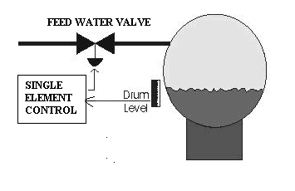
fig.1.1 single element drum level control

1.2 TWO ELEMENT DRUM LEVEL CONTROL.
The two-element drum level controller as shown in figure 1.2 can best be applied to a single drum boiler where the feedwater is at a constant pressure.
The two elements are made up of the following:
- Level Element : a proportional signal or process variable (PV) coming from the drum level transmitter. This signal is compared to a setpoint and the resultant is a deviation value. This signal is acted upon by the controller which generates corrective action in the form of a proportional value.
- Steam Flow Element: a mass flow rate signal is used to control the feedwater flow, giving immediate corrections to feedwater demand in response to load changes.
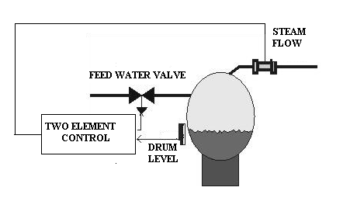
fig.1.2 Two element drum level control
Any imbalance between steam mass flow out and feedwater mass flow into the drum is corrected by the level controller. This imbalance can arise from the Blowdown variations due to changes in dissolved solid Variations in feedwater supply pressure Leaks in the steam circuits.
This strategy has two drawbacks which should be considered.

1.The two-element control can not adjust for pressure or load

disturbances in the feedwater supply, as this is not a measured

variable in this strategy.
2.The two-element control cannot eliminate phasing interaction between feedwater flow and drum level because only the relatively slow process of the drum level is controlled. This second issue can lead to sub-cooled drum water on a large increase in demand by allowing excessive feedwater to enter the drum without consideration to the boilers thermal dynamic capabilities.
1.3 THREE-ELEMENT DRUM LEVEL CONTROL.
The three-element mode is used during high steam demand. The three-element drum level control as shown in figure 1.3 is ideally suited where a boiler plant consists of multiple boilers and multiple feedwater pumps or where the feedwater has variations in pressure or flow.
The three-elements are made up of the following
- Level Element & Steam Flow Element: It corrects for unmeasured disturbances within the system such as Boiler blow down,Boiler and superheater tube leaks.
- Feedwater Flow element: It responds rapidly to variations in feedwater demand, either from the Steam flow rate feedforward signal or flow fluctuations.
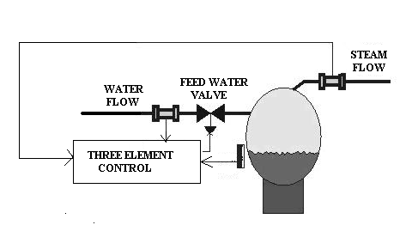

fig 1.3 three element drum level control
The three-element control strategy can easily handle large and rapid load changes because it is matching the mass balance between the steam flow from the boiler and the feedwater flow to it. This strategy is a must on multiple boilers sharing the same feedwater header and supply system, due to the variations in the available feedwater flow to any one boiler, while two or more boilers are on line. This is irrespective to boiler size. Additionally if the boilers are subjected to sudden or unpredictable demand changes such as in a batching process, this strategy is capable of matching these demands without operator trim corrections or supervision.

CHAPTER 2
PROCESS DESCRIPTION
A boiler drum is a vessel where water is converted to steam by the application of heat.For proper boiler control there must always be sufficient water present in the drum to produce steam and prevent damage to the drum and at the same time the water level must not be too high a condition that would prevent the formation of steam in the drum.As the demand for steam increases,the feed water flow rate into the drum must also increase to maintain the water level within acceptable limits.The boiler system consists of a combustion chamber where combustion of fuel takes place. The burning gases pass around a group of vertical tubes. These tubes called risers carry a mixture of water and steam. At the top of the risers is the drum which is a horizontal cylinder kept about half full of water. The upper part of the drum contains steam. The tubes that leave the bottom of the drum (the down comers) are insulated from the combustion chamber and carry the water down to a mud drum where mud is separated from the water. Heating the riser tubes with hot flue gas causes the water to circulate and steam to be released in the steam drum. This principle is shown in Fig 2.1 The steam that is produced passes from the drum to the super heaters, which are also located in the combustion chamber. The superheated product steam is then sent to the process where the energy is removed. After preheating, the liquid condensate is returned to the drum where it begins the cycle again.
2.1 MODEL EQUATIONS OF THE BOILER DRUM.

2.1.1Mass balance equation is given by equation

W_{E}=W_{d}+d/dt(V_{D} - V_{DW} )*₯ +V_{DW}*₯_{W}

2.1.2Energy balance equation is given by equation

W_{D} (h_{d} - h_{dw})+W_{E}*h_{dw}- W_{D*} h_{d}= d/dt(V_{D} - V_{DW} )* ₯ *h_{dw}

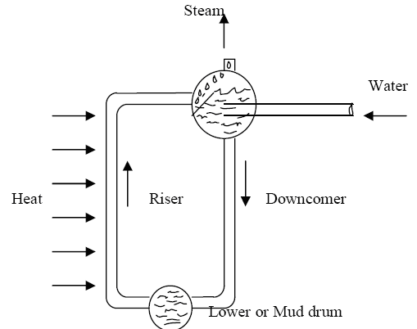

fig.2.1 boiler drum

2.2 SHRINK/SWELL EFFECT.
Dynamic shrink/swell is a phenomenon that produces variations in the level of the liquid surface in the steam drum whenever boiler load occur. This behavior is strongly influenced by the actual arrangement of steam generating tubes in the boiler.During operation, the tubes exposed to the radiant heat from the flame are always producing steam. As the steam rises in the tubes, boiler water is also carried upward and discharged into the steam drum. Tubes that are not producing significant steam flow have a net downward flow of boiler water from the steam drum to the mud drum.
The tubes producing large quantities of steam are termed risers and those principally carrying water down to the mud drum from the steam drum are termed downcomers. Excluding the tubes subject to radiant heat input from the firebox flame, a given tube will serve as a riser at some firing rates and a downcomer at other firing rates.
The mechanics of the natural convection circulation of boiler water within the steam generator is the origin of the dynamic shrink/swell phenomenon.A sudden steam load increase will naturally produce a drop in the pressure in the steam drum, because, initially at least, the firing rate cannot increase fast enough to match the steam production rate at the new demand level. When the pressure in the drum drops, it has a dramatic effect on the natural convection within the boiler. The drop in pressure causes a small fraction of the saturated water in the boiler to immediately vaporize, producing a large amount of boil-up from most of the tubes in the boiler. During the transient, most of the tubes temporarily become risers. The result is that the level in the steam drum above the combustion chamber rises. this rise in level is actually an inverse response to the load change. Since, the net steam draw rate has gone up, the net flow of water to the boiler needs to increase, because the total mass of water in the boiler is falling. However, the level controller senses a rise in the level of the steam drum and calls for a reduction in the flow of feedwater to the boiler.This inverse response to a sudden load increase is dynamic swell. Dynamic shrink is also observed when a sudden load decrease occurs. However, the dynamic shrink phenomenon does not disrupt the natural convection circulation of the boiler as completely as the dynamic swell effect. Consequently, the reduction in level produced by a sudden decrease in load is typically much smaller and of shorter duration than the effect produced by dynamic swell.

CHAPTER 3

SUBSYSTEM COMMUNICATION

Subsystem Communication is used mainly for establishment of PLC-DCS communication.The main emphasis of serial communication link is to gather all the data from subsystem which is required for the normal operation of the process,posting of alarms,events and messages pertaining to the process unit. The communication could be either read only or read-write type In case of read-write type, DCS is able to write on PLC program. For safety critical applications read only communication is used for maintaining the integrity of the system. For PLC-DCS communication industry standard MODBUS-RTU protocol is used. It uses RS-232 or 422/485 serial converters for interfacing. All PLC tags are mapped in DCS for monitoring, indications as well as display and historization of events.Serial communication is also used for connectivity with programming terminal engineering stations. In such case, engineering station and PLC systems form a master-slave combination. The communication specification for subsystem communication is given in table 3

S.NO. | ITEM | DETAILS
1. | INTERFACE | RS-422/RS-485
2. | MASTER OF COMMUNICATION | COMMUNICATION CARD
3. | SLAVE OF COMMUNICATION | SUBSYSTEM
4. | COMMUNICATION SPEED | 1200/2400/4800/9600/19200BPS
5. | SYNCHRONIZATION | START-STOP SYSTEM  (ASYNCHRONOUS)
6. | TRANSMISSION PROTOCOL | MODBUS PROTOCOL
7. | DATA FORMAT | 8 BITS,1 START BIT,1 STOP BIT, 1 PARITY BIT
8. | ERROR CHECK | CRC-16
9. | COMMUNICATION NETWORK | POINT TO POINT

Table 3. subsystem communication specifications

3.1 MODBUS PROTOCOL

Modbus is a serial communications protocol published by Modicon in 1979 for use with its programmable logic controllers (PLCs). The main reasons for the extensive use of Modbus over other communications protocols are:
- It is openly published and royalty-free.
- Relatively easy industrial network to deploy.
- It moves raw bits or words.
Modicon programmable controllers can communicate with each other and with other devices over a variety of networks. Supported networks include the Modicon Modbus and Modbus Plus industrial networks, and standard networks such as MAP and Ethernet. Networks are accessed by built–in ports in the controllers or by network adapters, option modules, and gateways that are available from Modicon.Modicon ModConnect partner’ programs are available for closely integrating networks like Modbus Plus into proprietary product designs. The common language used by all Modicon controllers is the Modbus protocol.This protocol defines a message structure that controllers will recognize and use,regardless of the type of networks over which they communicate. It describes the process a controller uses to request access to another device, how it will respond to requests from the other devices, and how errors will be detected and reported. It establishes a common format for the layout and contents of message fields.The Modbus protocol provides the internal standard that the Modicon controllers use for parsing messages. During communications on a Modbus network, the protocol determines how each controller will know its device address, recognize a message addressed to it, determine the kind of action to be taken, and extract any data or other information contained in the message. If a reply is required, the controller will construct the reply message and send it using Modbus protocol.

Standard Modbus ports on Modicon controllers use an RS–232C compatible serial interface that defines connector pinouts, cabling, signal levels, transmission baud rates,and parity checking.Controllers can be networked directly or via modems. Controllers communicate using a master–slave technique, in which only one device (the master) can initiate transactions (called ‘queries’). The other devices (the slaves) respond by supplying the requested data to the master or by taking the action requested in the query. Typical master devices include host processors and programming panels. Typical slaves include programmable controllers.
The master can address individual slaves, or can initiate a broadcast message to all slaves. Slaves return a message (called a ‘response’) to queries that are addressed to them individually. Responses are not returned to broadcast queries from the master.The Modbus protocol establishes the format for the master’s query by placing into it the device (or broadcast) address, a function code defining the requested action, any data to be sent, and an error–checking field. The slave’s response message is also constructed using Modbus protocol. It contains fields confirming the action taken, any data to be returned, and an error–checking field. If an error occurred in receipt of the message, or if the slave is unable to perform the requested action,the slave will construct an error message and send it as its response.

3.1.1 MASTER–SLAVE QUERY–RESPONSE CYCLE

The Query: The function code in the query tells the addressed slave device what kind of action to perform. The data bytes contain any additional information that the slave will need to perform the function.Function code will query the slave to read holding registers and respond with their contents. The data field must contain the information telling the slave which register to start at and how many registers to read. The error check field provides a method for the slave to validate the integrity of the message contents.

The Response: If the slave makes a normal response, the function code in the response is an echo of the function code in the query. The data bytes contain the data collected by the slave, such as register values or status. If an error occurs,the function code is modified to indicate that the response is an error response, and the data bytes contain a code that describes the error. The error check fieldallows the master to confirm that the message contents are valid.

3.2 SERIAL TRANSMISSION MODES

Controllers can be setup to communicate on standard Modbus networks using either of ASCII or RTU transmission. The selection of ASCII or RTU mode pertains only to standard Modbus networks.It defines the bit contents of message fields transmitted serially on those networks.It determines how information will be packed into the message fields and decoded.On other networks like MAP and Modbus Plus, Modbus messages are placed into frames that are not related to serial transmission.

3.2.1 ASCII MODE:

When controllers are setup to communicate on a Modbus network using ASCII (American Standard Code for Information Interchange) mode, each 8–bit byte in a message is sent as two ASCII characters. The main advantage of this mode is that it allows time intervals of up to one second to occur between characters without causing an error.
The format for each byte in ASCII mode is:

Coding System: Hexadecimal, ASCII characters 0–9, A–F One hexadecimal character contained in each ASCII character of the message.
Bits per Byte: 1 start bit,7 data bits, least significant bit sent first 1 bit for even/odd parity; no bit for no parity,1 stop bit if parity is used; 2 bits if no parity.
Error Check Field: Longitudinal Redundancy Check (LRC)

3.2.2 RTU MODE:

When controllers are setup to communicate on a Modbus network using RTU (Remote Terminal Unit) mode, each 8–bit byte in a message contains two 4–bit hexadecimal characters. The main advantage of this mode is that its greater character density allows better data throughput than ASCII for the same baud rate.
The format for each byte in RTU mode is:

Coding System: 8–bit binary, hexadecimal 0–9, A–F,Two hexadecimal characters contained in each,8–bit field of the message
Bits per Byte: 1 start bit,8 data bits, least significant bit sent first,1 bit for even/odd parity; no bit for no parity,1 stop bit if parity is used; 2 bits if no parity
Error Check Field: Cyclical Redundancy Check (CRC)

3.3 SERIAL COMMUNICATION
Serial is a very common protocol for device communication that comes standard on just about every PC. Most computers include two RS-232 based serial ports. Serial is also a common communication protocol that is used by many devices as shown in figure 3.3.The concept of serial communication is simple. The serial port sends and receives bytes of information one bit at a time. this is slower than parallel communication, which allows the transmission of an entire byte at once, it is simpler and can be used over longer distances. serial is used to transmit ASCII data. Communication is completed using 3 transmission lines: (1) Ground, (2) Transmit, and (3) Receive. Since serial is asynchronous, the port is able to transmit data on one line while receiving data on another.The important serial characteristics are baud rate,data bits,stop bits,and parity.For two ports to communicate these parameters must match they are explained as:
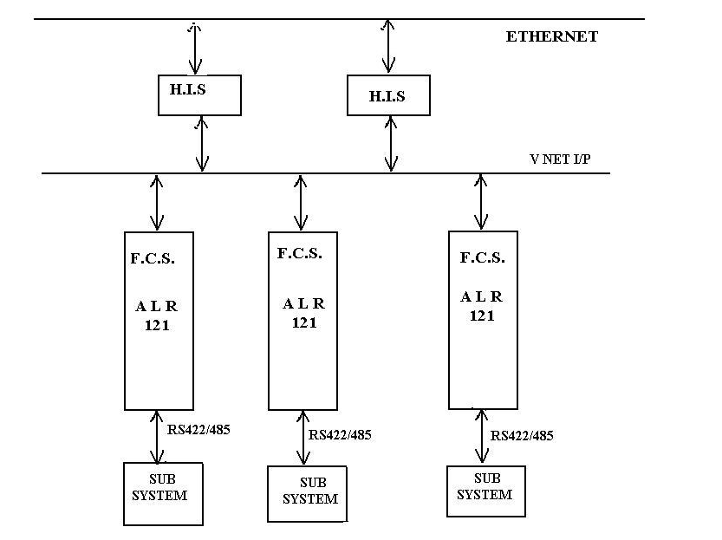
fig 3.3 Serial communication.
- BAUD RATE: A speed of measurement for communication.It indicates the number of bits transfers per second.Common baud rates for Dcs Plc communication are 1200/2400/4800/9600/bps.
- DATA BITS: A measurement of the actual data bits in transmission,when the processor sents a packet of information,the amount of actual data may not be a full 8 bits.A packet refers to a single byte transfer,including start/stop bits ,data bits and parity.
- STOP BITS: These are used to signal the end of communication for a single packet,the stop bits not only indicates the end of transmission but also give the processor to check for error in the clock speeds.
- PARITY BITS: A simple form of error checking that is used in serial communication there are four types of parity even,odd,marked and spaced.for even and odd parity,the serial port will set the parity bit to a value to ensure that the transmission has an even or odd number of logic high bits.Marked and spaced parity does not actually takes the data bits,but simply sets the parity bit high for marked or low for spaced parity.This allows the receiving device to know the stste of a bit so as to enable the to enable the device to determine if noise is corrupting the data.
3.3.1 VNET/IP
Vnet/IP achieves a high speed control network while confirms to the IEEE802.3 and TCP/IP communication standard.It is designed as a duplexed network.it conducts open communication using two communication systems of bus 1 and bus 2 and various standard protocols of control communication and ethernet.Vnet/ip supports a transmission speed of 1Gbps or 100Mbps.It has two independent communication paths,control communication and open communication.Control communication is the communication for transferring control data.Open communication is the communication conducted by using the various the various standard protocols of ethernet.Vnet/IP is designed as a duplexed network. In Vnet/IP a duplexed bus is configured with independent subnets of bus 1 and bus 2.if both the buses are normal,bus 1 is used for control communication and bus 2 is used for open communication.if bus 1 fails control communication is performed using bus 2.since open communication is performed is also performed using bus 2 control communication and open communication coexists.

3.3.2 ETHERNET

Ethernet is a family of frame-based computer networking technologies for local area networks (LANs). The name comes from the physical concept of the ether. It defines a number of wiring and signaling standards for the physical layer, through means of network access at the Media Access Control (MAC)/Data Link Layer, and a common addressing format.Ethernet is standardized as IEEE 802.3. The combination of the twisted pair versions of Ethernet for connecting end systems to the network, along with the fiber optic versions for site backbones, is the most widespread wired LAN technology. Ethernet was originally based on the idea of computers communicating over a shared coaxial cable acting as a broadcast transmission medium. The methods used show some similarities to radio systems, although there are fundamental differences, such as the fact that it is much easier to detect collisions in a cable broadcast system than a radio broadcast. The common cable providing the communication channel was likened to the ether and it was from this reference that the name "Ethernet" was derived. The coaxial cable was replaced with point-to-point links connected by Ethernet hubs and/or switches to reduce installation costs, increase reliability, and enable point-to-point management and troubleshooting. Ethernet stations communicate by sending each other data packets, blocks of data that are individually sent and delivered. As with other IEEE 802 LANs, each Ethernet station is given a single 48-bit MAC address, which is used both to specify the destination and the source of each data packet. Network interface cards (NICs) or chips normally do not accept packets addressed to other Ethernet stations.
Ethernet is an information network.Ethernet links the entire human interface units,engineering workstation and pervisory systems.Ethernet is essential for DCS system.Ethernet is used according to the world standard interface protocol for transmitting large amount of data,file transfer and file sharing.It supports the transmission speed of 1Gbps

3.3.3. RS-232
RS-232 is a standard for serial binary data signals connecting between a DTE (Data terminal equipment) and a DCE (Data Circuit-terminating Equipment). It is commonly used in computer serial ports. RS-232 is the serial connection found on IBM-compatible PCs. It is used for many purposes, such as connecting a mouse, printer, or modem, as well as industrial instrumentation. Because of improvements in line drivers and cables, applications often increase the performance of RS-232 beyond the distance and speed listed in the standard. RS-232 is limited to point-to-point connections between PC serial ports and devices. RS-232 hardware can be used for serial communication up to distances of 50 feet. The RS-232 standard defines the voltage levels that correspond to logical one and logical zero levels. Valid signals are plus or minus 3 to 15 volts. The range near zero volts is not a valid RS-232 level; logic one is defined as a negative voltage, the signal condition is called marking, and has the functional significance of OFF. Logic zero is positive, the signal condition is spacing, and has the function ON. The standard specifies a maximum open-circuit voltage of 25 volts; signal levels of ±5 V,±10 V,±12 V, and ±15 V are all commonly seen depending on the power supplies available within a device. RS-232 drivers and receivers must be able to withstand indefinite short circuit to ground or to any voltage level up to +/-25 volts. The slew rate, or how fast the signal changes between levels, is also controlled.
Because the voltage levels are higher than logic levels used by integrated circuits, special intervening circuits are required to translate logic levels, and to protect circuitry internal to the device from short circuits or transients that may appear on the RS-232 interface. RS-232 devices may be classified as Data Terminal Equipment (DTE) or Data Communications Equipment (DCE); this defines at each device which wires will be sending and receiving each signal. The standard recommended but did not make mandatory the D-subminiature 25 pin connector.Terminals have male connectors with DTE pin functions, and modems have female connectors with DCE pin functions. Other devices may have any combination of connector gender and pin definitions.Presence of a 25 pin D-sub connector does not necessarily indicate an RS-232C compliant interface.

SIGNALS
Commonly-used signals are:
- Transmitted Data (TxD)
Data sent from DTE to DCE.
- Received Data (RxD)
Data sent from DCE to DTE.
- Request To Send (RTS)
Asserted (set to 0) by DTE to prepare DCE to receive data. This may require action on the part of the DCE, e.g. transmitting a carrier or reversing the direction
- Clear To Send (CTS)
Asserted by DCE to acknowledge RTS and allow DTE to transmit.
- Data Terminal Ready (DTR)
Asserted by DTE to indicate that it is ready to be connected. If the DCE is a modem, this may "wake up" the modem, bringing it out of a power saving mode. This behaviour is seen quite often in modern PSTN and GSM modems. When this signal is de-asserted, the modem may return to its standby mode, immediately hanging up any calls in progress.
- Data Set Ready (DSR)
Asserted by DCE to indicate an active connection. If DCE is not a modem (e.g. a null modem cable or other equipment), this signal should be permanently asserted (set to 0), possibly by a jumper to another signal.
- Data Carrier Detect (DCD)
Asserted by DCE when a connection has been established with remote equipment.
- Ring Indicator (RI)
Asserted by DCE when it detects a ring signal from the telephone line.

3.3.4 RS-422
RS-422 is the serial connection used on Apple Macintosh computers. RS-422 uses a differential electrical signal, as opposed to unbalanced signals referenced to ground with the RS-232. Differential transmission, which uses two lines each for transmit and receive signals, results in greater noise immunity and longer distances as compared to the RS-232. The greater noise immunity and distance are big advantages in industrial environments.
3.3.5 RS-485
RS-485 is an improvement over RS-422, because it increases the number of devices from 10 to 32 and defines the electrical characteristics necessary to ensure adequate signal voltages under maximum load.The noise immunity and multi drop capability make RS-485 the serial connection of choice in industrial applications requiring many distributed devices networked to a PC or other controller for data collection, HMI, or other operations. RS-485 is a superset of RS-422; thus, all RS-422 devices may be controlled by RS-485. RS485 is an OSI model physical layer electrical specification of a two-wire half-duplex, multipoint serial connection. The standard specifies a differential form of signalling. The difference between the wires’ voltages is what conveys the data. One polarity of voltage indicates a logic 1 level, the reverse polarity indicates logic 0. The difference of potential must be at least 0.2 volts for valid operation, but any applied voltages between +12 V and -7 volts will allow correct operation of the receiver.
RS-485 only specifies electrical characteristics of the driver and the receiver. It does not specify or recommend any data protocol. RS-485 enables the configuration of inexpensive local networks and multidrop communications links. It offers high data transmission speeds (35 Mbit/s up to 10 m and 100 kbit/s at 1200 m). Since it uses a differential balanced line over twisted pair (like EIA-422), it can span relatively large distances (up to 4000 feet or just over 1200 metres). The recommended arrangement of the wires is as a connected series of point-to-point (multidropped) nodes, a line or bus, not a star, ring, or multiply-connected network. The two ends of the cable will have a termination resistor connected across the two wires. Without termination resistors, reflections of fast driver edges can cause multiple data edges that can cause data corruption. Termination resistors also reduce electrical noise sensitivity due to the lower impedance, and bias resistors (see below) are required. The value of each termination resistor should be equal to the cable impedance (typically, 120 ohms for twisted pairs). Star and ring topologies are not recommended because of signal reflections or excessively low or high termination impedance.
Often in a master-slave arrangement when one device dubbed "the master" initiates all communication activity, the master device itself provides the bias and not the slave devices. In this configuration, the master device is typically centrally located along the set of EIA-485 wires, so it would be two slave devices located at the physical end of the wires that would provide the termination. The master device would provide termination if it itself was located at a physical end of the wires, but that is often a bad design as the master would be better located at a halfway point between the slave devices. Note that it is not a good idea to apply the bias at multiple node locations, because, by doing so, the effective bias resistance is lowered, which could possibly cause a violation of the EIA-485 specification and cause communications to malfunction. By keeping the biasing with the master, slave device design is simplified and this situation is avoided.RS-485 can be used to communicate with remote devices at distances up to 4000 ft at speeds of up to 100 kbit/s at this distance. Converters between RS232 and RS485, USB and RS485, Ethernet and RS485 are available to allow HIS to communicate with remote devices. By using "Repeaters" and "Multi-Repeaters" very large RS485 networks can be formed.

3.4 HANDSHAKING
The method used by RS-232 for communication allow for a simple connection of three lines:Tx,Rx,and Ground.For data to be transmitted ,both sides have to be clocking the data at the same baud rate,this method is sufficient for most of the application ,it is limited in being respond to problems sush as the receiver overloading.This is where serial handshaking occurs,the most popular form of handshaking with RS-232 are,
- SOFTWARE HANDSHAKING:It uses actual data bytes as control characters,the lines necessary are three line set of Tx,Rx and Ground since the control characters are sent over the transmission line like the regular data.
- HARDWARE HANDSHAKING:It uses the Tx and Rx lines,the RTS/CTS and DTR/DSR lines work together with one being the inputand other as the output.The first set of lines are RTS and CTS.When a receiver is ready for data,it will assert the RTS line indicating it is ready to receive the data.This is then read by the sender at the CTS input,indicating it is clear to send the data.The next set of lines are DTR and DSR.These lines are used mainly for modem communication.They allow serial port and modem to communicate their status.
3.5 DISTRIBUTED CONTROL SYSTEM.

Distributed control system(D.C.S) is an integral production control system used to manage and control operation of plants in wide variety of process industries.Dcs provides open environment for optimizing the whole process plant requirement.at the same time it minimizes the total cost of ownership and thereby increasing profits.

The DCS system consists of the following three major component they are as follows:

HIS:HUMAN INTERFACE STATION.

FCS: FIELD CONTROL STATION.

EWS:ENGINEERING WORK STATION.

The function of each component can be explained as:

3.5.1 HUMAN INTERFACE STATION

Operator workstation defined as HIS shown in figure 3.5.1,
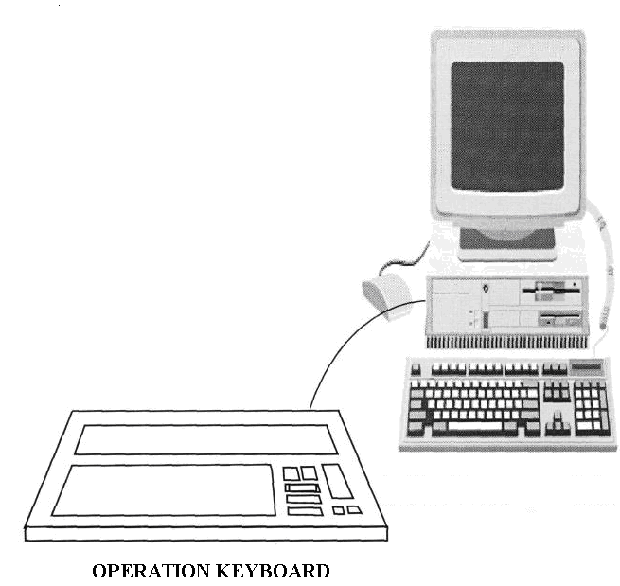

Fig.3.5.1 human interface station

Human interface station is mainly used for operation and monitoring.HIS displays process variables, control parameters and alarms necessary to control and monitor the process.It also incorporates open interfaces so that supervisory can access real time process data,trend data and messages.Operator workstations are provided with monitor.Each operator workstation sits as a node on the control data highway the V Net/IP with a dedicated address. All operator workstation have ethernet connectivity.ethernet is used by the system for connectivity with other operator stations.

3.5.2 FIELD CONTROL STATION.

The field control station control the process.FCS is the main component which connects to process,data accuracy and reliability.

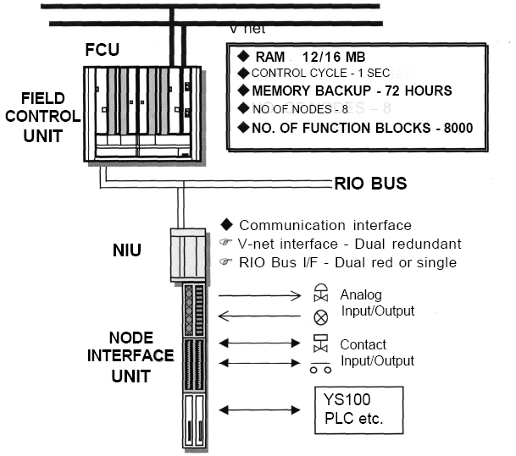

fig.3.5.2.1 field control station

The fcs are used for process and connectivity to other plc's as shown in figure 3.5.2.1 .The fcs is suitable for control system with larger amount of I/O data fcs supports two different kind of node units,the local node units that can be connected directly and the remote node units.The local node unit is mounted on the fcs cabinet and the remote node can be mounted in a cabinet or enclosure to the plant equipment.Fcs is suitable for high speed and complex control.each fcs sits as a node on the control data highway(V-Net/IP) with a dedicated unique address:one control network can have a maximum of 48 fcs.

The FCS has functional blocks for performing the basic control as shown in fig 3.5.2.2. A functional block performs the control calculations functional blocks process signals that are input from a field device to the fcs and processing results are output to other functional blocks or any field devices.

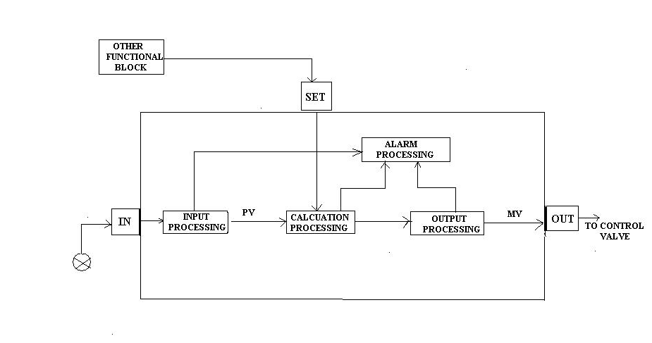
fig. 3.5.2.2 functional block diagram.

A functional block consist of the following components;

- Input and output terminals that exchange data with devices outside of external function block.The functional block displays an input signal from the I/O modules or from another block as process variable.It can also out the process value from the out terminal.
- Four processing functions-input processing,calculation processing,output processing and alarm processing.The calculation block receive analog signals or digital signals as input values,and perform calculation according to set parameters.The result of calculation is outputted as the calculated output value(CPV).
- Constant and variable data used to execute processing functions. processing in sequence for an input signal read from the input terminal and writes an output signal to the output terminal.The input processing functions process the input signal from the connection destination of the input terminal of the function block into data that is suitable for calculation processing(control calculation,numeric calculation etc).After the processing the signal becomes the pv.The calculation block performs the arithmetic calculation and logic operation on the process value.The value obtained from the control computation undergoes the output processing then outputs the signal as manipulated value.

3.5.3 ENGINEERING WORK STATION

The engineering workstation as shown in figure 3.5.3 is similar to the operator workstation with all functions and with the same environment.in addition ,it provides the environment to perform the engineering functions for configuration and maintenance of DCS system.the engineering workstation sits as one of the nodes on the control data highway ,v-net/ip with a dedicated bus.Ethernet connectivity is also extended;downlaod to the operator workstation is through the ethernet and printer for connectivity.
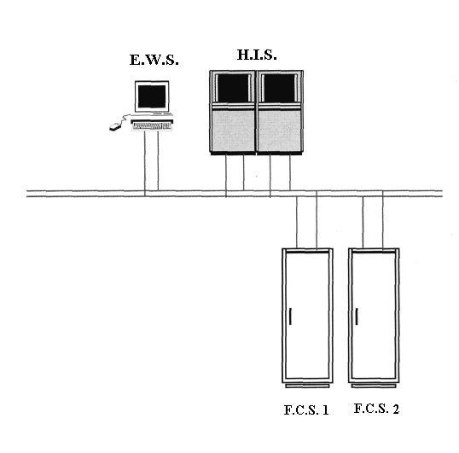
fig. 3.5.3. engineering work station

3.5.4 SYSTEM CONFIGURATION

Maximum number of stations : 256/System
Maximum number of domains : 16/System
Numbering of domains : 1 to 64
Domain number for CS domain(V-net domain) : 1 to 16
Domain number for Virtual Domain (Non V-net domain) : 17 to 64
Maximum number of stations per domain : 64
Maximum number of HIS per domain : 16
Station number for HIS : 1 to 64 in descending order
Station number for FCS : 1 to 64 in ascending order
Maximum number of Node Interface Units (NIU) per FCS : 8
Maximum number of Input /Output Units (IOU) per NIU : 5
Maximum number of Input /Output Units (IOU) per FCS : 40 (8*5)
Maximum length of V-net (YCB111/YCB141) :500m/185m
Maximum length of V-net with optical adapters :20 Km
Maximum length of Remote IO (RIO) bus : 750m

3.6 PROGRAMMABLE LOGIC CONTROLLERS

PLC is a general purpose computer with central processing unit (CPU), power supply, programming environment, inputs and outputs. It also provides support to remote I/O’s, I/O housing, connecting cables, communication links. etc. The PLC was devised to allow an easy migration from conventional electro-mechanical relay based safety system with additional features. The minimum features of a PLC based system for use in safety related applications are as follows:
- Real time response of the PLC should match operating speeds of electro-mechanical relays.
- Logic ground is isolated from enclosure ground.Hence, single point ground is not required.
- Power supplies should be provided with line noise rejection features thus not requiring line conditioning.
- It should have high electrical noise rejection threshold compared to other programmable devices.

PLC’s are used in non-critical as well as critical apllications depending upon the process requirement. Therefore, reliability aspect of PLC operation is directly related to application functions. Accordingly, the users define the critical technical attributes of the system during selection process.

The basic requirement for selection of safety related PLC is classified by the 5 possible states and transisions from one state to other.Therefore, PLC must have the features to ensure that these conditions are adequately addressed and under any circumstances should not lead to undesirable and undetected failures causing poetntial risk to plant and personnel.Implementation of all process & trip logics & interlock.Interlock is the cause and effect matrix/ logic for process safety. The plc acquires the input data, executes cause & effect logic and produces outputs as required for the safe operation of the process.The structure of the plc is shown in fig.3.5

POWER SUPPLY
PROGRAMMING TOOLS

MAN MACHINE INTERFACE

COMMUNICATION

SIGNAL PROCESSING

INTERFACE TO SENSORS & ACTUATORS

PROCESS

fig.3.6 plc structure

The structure of the programmable logic controller can be described as:
- SIGNAL PROCESSING – It consists of operating system, application program and data storage and execution of application program. It processes signals from the field sensors and data obtained from internal storage to generate signals for the final control elements i.e. actuators and the new state of internal data storage.
- INTERFACE TO THE FIELD DEVICES – Field signals (digital, analog & discrete) are translated to suitable internal representation and vice versa for actuators.
- COMMUNICATION – Provides supports for inter-action between controller with the sensors, actuators and man machine interface. It also provides connectivity with other systems.

- MAN MACHINE INTERFACE - Provides inter-action between PLC and human operator.

- PROGRAMMING TOOLS – This is used for application program generation and loading, monitoring, testing, debugging, documentation and archiving.

- POWER SUPPLY – Used for conversion and isolation of the PLC power supply from the main source supply.

3.6.1 SCAN TIME

Scan time of a PLC is the total time taken by the system for reading the status the input, execute the program and generate the output as shown in fig.3.6.1. Overall scan is dependent on five elements.

- Application execution period.
- Central element modules related scan period i.e. processor, stand-by processors and communication interfaces.
- Input Scan
- Output Scan
- System Overhead.

Input and output related scans are influenced by the number of input and output modules

fig.3.6.1.logic execution by plc

3.6.2 SEQUENCE OF EVENTS

The functionality of the system is to trace a series of events and operator’s actions to interpret the logged messages for analysis. PLC’s provide pre-configured high-speed event sequence recording by capturing the process events for failure analysis of any process disruptions and sequence associated with it.Sequence of event available from plc comprise of system specific alarm and diagnostic message and configurable process signals.This is a powerful tool for maintenance as well as operation group to carry out their task.PLC’s provide sequence reporting as per the actual occurrence with out any segregation of system alarms with process related events.PLC are provided with inbuilt redundancy features and system diagnostics that are specific to PLC functioning.Only critical parameters are required by the operational for failure analysis and that may include other parameters (pre-trip alarms) not processed by PLC.

CHAPTER 4
PID CONTROLLER
4.1 INTRODUCTION
A proportional-integral-derivative controller is a generic control loop feedback mechanism widely used in industrial control systems. A PID controller as shown in fig 4.1 attempts to correct the error between a measured process variable and a desired setpoint by calculating and then outputing a corrective action that can adjust the process accordingly.
The PID controller calculation algorithm involves three separate parameters; the Proportional, the Integral and Derivative values. The Proportional value determines the reaction to the current error, the Integral determines the reaction based on the sum of recent errors and the Derivative determines the reaction to the rate at which the error has been changing. The weighted sum of these three actions is used to adjust the process via a control element such as the position of a control valve or the power supply of a heating element.
By tuning the three constants in the PID controller algorithm the PID can provide control action designed for specific process requirements. The response of the controller can be described in terms of the responsiveness of the controller to an error, the degree to which the controller overshoots the setpoint and the degree of system oscillation. A PID controller will be called a PI, PD, P or I controller in the absence of the respective control actions. PI controllers are particularly common, since derivative action is very sensitive to measurement noise and the absence of an integral value prevents the system from reaching its target value due to the control action.
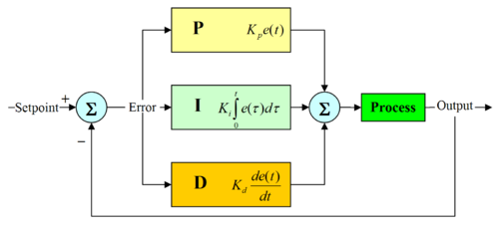

fig 4.1 block diagram of a pid controller

4.2 PID CONTROLLER THEORY
The PID control scheme is named after its three correcting terms, whose sum constitutes the manipulated variable (MV).
where P_{out}, I_{out}, and D_{out} are the contributions to the output from the PID controller.The output from the three terms, the proportional, the integral and the derivative terms are summed to calculate the output of the PID controller. Defining u(t) as the controller output, the final form of the PID algorithm is:
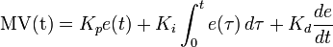
and the tuning parameters are
- K_{p}: Proportional Gain - Larger K_{[p} typically means faster response since the larger the error, the larger the feedback to compensate. An excessively large proportional gain will lead to process instability.
- K_{i}: Integral Gain - Larger K_{i} implies steady state errors are eliminated quicker. The trade-off is larger overshoot: any negative error integrated during transient response must be integrated away by positive error before we reach steady state.
- K_{d}: Derivative Gain - Larger K_{d} decreases overshoot, but slows down transient response and may lead to instability.

4.3 LOOP TUNING
If the PID controller parameters (the gains of the proportional, integral and derivative terms) are chosen incorrectly, the controlled process input can be unstable, i.e. its output diverges, with or without oscillation.Tuning a control loop is the adjustment of its control parameters (gain/proportional band, integral gain/reset, derivative gain/rate) to the optimum values for the desired control response.
There are several methods for tuning a PID loop as given in table 4.3(a). The most effective methods generally involve the development of some form of process model, then choosing P, I, and D based on the dynamic model parameters. The choice of method will depend largely on whether or not the loop can be taken "offline" for tuning, and the response time of the system. If the system can be taken offline, the best tuning method often involves subjecting the system to a step change in input, measuring the output as a function of time, and using this response to determine the control parameters. If the system must remain online, one tuning method is to first set the I and D values to zero. Increase the P until the output of the loop oscillates, then the P should be left set to be approximately half of that value for a "quarter amplitude decay" type response.

Method | Advantages | Disadvantages
Ziegler-Nichols | Proven Method. Online method. | Process upset, some trial-and-error, very aggressive tuning
Tune By Feel | No math required. Online method. | Erratic, not repeatable
Software Tools | Consistent tuning. Online or offline method. May include valve and sensor analysis. Allow simulation before downloading. | Some cost and training involved.
Cohen-Coon | Good process models. | Some math. Offline method. Only good for first-order processes.
Table 4.3(a)Choosing a Tuning Method
Then increase I until any offset is correct in sufficient time for the process. However, too much I will cause instability. Finally, increase D, if required, until the loop is acceptably quick to reach its reference after a load disturbance. However, too much D will cause excessive response and overshoot. A fast PID loop tuning usually overshoots slightly to reach the setpoint more quickly; however, some systems cannot accept overshoot, in which case an "over damped" tune is required, which will require a P setting significantly less than half that of the P setting causing oscillation.

4.3.2 ZIEGLER-NICHOLS METHOD
The Zieglar-Nichols tuning method is based on frequency response analysis,the Zieglar-Nichols tuning method is a closed loop procedure.Using proportional control only and with feedback loop closed,introduce a set point change and vary the proportional gain until the system oscillates continuosly.The frequency of oscillation is the cross over frequency ω_{co} and M be the amplitude ratio of the system response at the cross over frequency.Then,
K_{U}=1/M
P_{u}=2∏/ ω_{co} min/cycle
Using the value of KU and Pu , Zieglar and Nichols recommended the following setting for PID controllers is shown in table
TYPE OF CONTROLLER | K_{C} | T_{I} | T_{D}
PROPORTIONAL | K_{U} /2 | -------- | ----------
PROPORTIONAL INTEGRAL | K_{U} /2.2 | P_{u} /1.2 | ------------
PROPORTIONAL INTEGRAL-DERIVATIVE | K_{U} /1.7 | P_{u} /2 | P_{u} /8
Table 4.3(b) zieglar-nichols tuning method

CHAPTER 5

BOILER DRUM LEVEL CONTROL INSTRUMENTATION

5.1 INTRODUCTION

Modulating control of the water/steam interface level is normally addressed in one of the three principal strategies,single element,two element or three element control.The application of any one of these strategies depend upon specific boiler size and load variation.The main aim is control the level inside the drum under variations.the instrumentation involved in the boiler drum level control as shown in figure 5.1 includes:

1. level transmitter.
2. steam/ feed water flow transmitter.
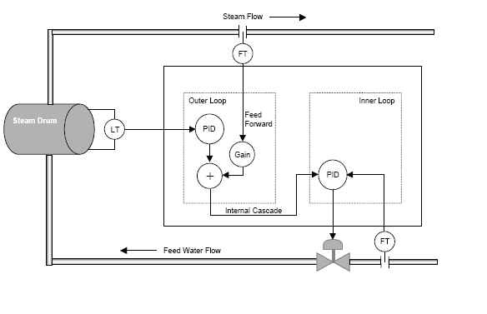

Fig5.1 Instrumentation diagram for boiler drum level control.

5.2 PRINCIPLE OF TRANSMITTER

5.2.1 LEVEL TRANSMITTER
The differential pressure (∆P) detector method of liquid level measurement uses a ∆P detector connected to the bottom of the tank being monitored as shown in figure 5.2.1. The higher pressure, caused by the fluid in the tank, is compared to a lower reference pressure (usually atmospheric). This comparison takes place in the ∆P detector, Not all tanks or vessels are open to the atmosphere. Many are totally enclosed to prevent vapors or steam from escaping, or to allow pressurizing the contents of the tank. When measuring the level in a tank that is pressurized or the level that can become pressurized by vapor pressure from the liquid both the high pressure and low pressure sides of the ∆P transmitter must be connected.

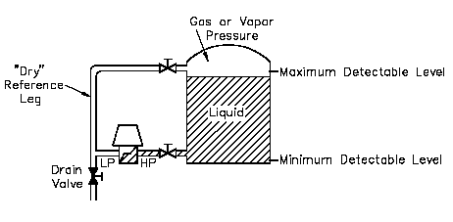

fig.5.2.1 principle of level measurement

The high pressure connection is connected to the tank at or below the lower range value to be measured. The low pressure side is connected to a "reference leg" that is connected at or above the upper range value to be measured. The reference leg is pressurized by the gas or vapor pressure, but no liquid is permitted to remain in the reference leg. The reference leg must be maintained dry so that there is no liquid head pressure on the low pressure side of the transmitter. The high pressure side is exposed to the hydrostatic head of the liquid plus the gas or vapor pressure exerted on the liquid’s surface. The gas or vapor pressure is equally applied to the low and high pressure sides. Therefore, the output of the ∆P transmitter is directly proportional to the hydrostatic head pressure, that is, the level in the tank. As high pressure boilers ramp up to operating temperature and pressure, the volume of a given amount of saturated water in the drum can expand by as much as 30%. The expansion or more precisely, decrease in density of water during start-up of the boiler poses a problem if a differential pressure or displacer instrument is used for level measurement. Such a level transmitter calibrated for saturated water service at will indicate higher than the true level when the drum is filled with relatively cool boiler feedwater at a low start-up pressure.If left uncompensated at low pressure conditions, the higher than true level indication will cause the controller to maintain a lower than desired liquid level in the drum during the start-up period. If the low level trip device is actually sensitive to the interface low level trip events become very likely during start-up.This variation in the sensitivity of the level transmitter with operating conditions can be corrected by using the drum pressure to compensate for the output of the level transmitter. The compensation can be accomplished with great accuracy using steam table data. The compensation has no dynamic significance and can be used independent of boiler load or operating pressure.
5.2.2 STEAM/WATER FLOW TRANSMITTER

Orifice plates contain a hole or orifice through which liquid passes as shown in figure 5.2.2. Upstream and downstream piping are required to condition the flow and provide for accurate measurement.A fluid passing though an orifice constriction will experience a drop in pressure across the orifice. This change can be used to measure the flowrate of the fluid.
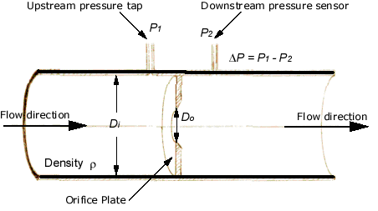
fig.5.2.2 principle of flow measurement
of the horizontal tube gives, Pressure is measured upstream and downstream from the orifice plate with a DP transmitter, which then calculates the flow rate.The highest performing Flowmeters as shown in figure 5.2.3 which arrive assembled, calibrated, pressure tested, and ready to install in the desired application is achieved by integrating the pressure transmitters with the Orifice as primary element.As long as the fluid speed is sufficiently subsonic (V < mach 0.3), the incompressible Bernoulli's equation describes the flow reasonably well. Applying this equation to a streamline traveling down the axis
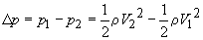
where location 1 is upstream of the orifice, and location 2 is slightly behind the orifice. It is recommended that location 1 be positioned one pipe diameter upstream of the orifice, and location 2 be positioned one-half pipe diameter downstream of the orifice. Since the pressure at 1 will be higher than the pressure at 2 (for flow moving from 1 to 2), the pressure difference as defined will be a positive quantity.
From continuity, the velocities can be replaced by cross-sectional areas of the flow and the volumetric flowrate Q,
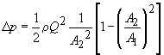
Solving for the volumetric flowrate Q gives,
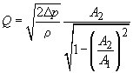
The above equation applies only to perfectly laminar, inviscid flows. For real flows (such as water or air), viscosity and turbulence are present and act to convert kinetic flow energy into heat. To account for this effect, a discharge coefficient C_{d} is introduced into the above equation to marginally reduce the flowrate Q,
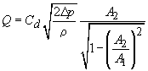
Since the actual flow profile at location 2 downstream of the orifice is quite complex, thereby making the effective value of A₂ uncertain, the following substitution
introducing a flow coefficient C_{f} is made,
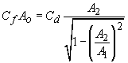
where A_{o} is the area of the orifice. As a result, the volumetric flowrate Q for real flows,
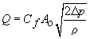
The flow coefficient C_{f} is found from experiments and is tabulated in reference books; it ranges from 0.6 to 0.9 for most orifices. Since it depends on the orifice and pipe diameters (as well as the Reynolds Number), one will often find C_{f} tabulated versus the ratio of orifice diameter to inlet diameter, sometimes defined as β,
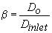
The mass flowrate can be found by multiplying Q with the fluid density,

The sharp (square) edged concentric orifice plate is the most frequently used element because of its low cost and adaptability and the availability of established coefficients. For mosts services, orifice plates are made of corrosion-resistant materials, usually Type 304 or 316 stainless steel.

CHAPTER 6

RESULTS AND DISCUSSIONS

6.1 INTRODUCTION

The three elements or signals in the system are level,steam and feedwater flow.The level and steam elements correct for unmeasured disturbances.The feedwater flow element responds rapidly to variations in feedwater demand that arise from the steam flow-rate feed-forward signal and feedwater pressure or flow fluctuations.Feedwater enters the drum through a feedwater valve. The heat energy converts water in the drum into steam. The steam drives the turbine and the generator coupled to the turbine produces electricity. The major considerations is to keep the level of water in the drum at a desired set point. There are two types of disturbances affecting the equilibrium in the drum the change in the set point and steam flow demand change. When the Steam Flow Demand is changed depending upon the electricity demand to be met,the desired set point is changed.Under such conditions PID controller take the control action to achieve the desired water level in the drum. The objective is to keep the measured drum level as close to Set point as possible inspite of disturbances. The 3-element PID control scheme is shown in figure 6.1

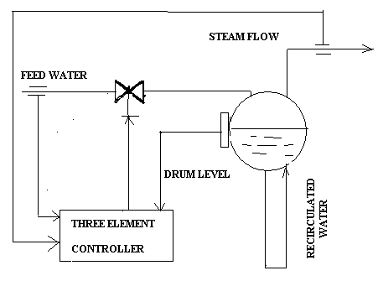

fig.6.1 Three Element PID Control Scheme.

6.2 PLC INTERLOCK

Boiler drum level control parameters are controlled by DCS.The parameters which are critical are implemented as interlock in the PLC for fail/safe operation of the process plant.The water level inside the drum is interlocked in the PLC.When the water level inside the drum is lower then 30% of the entire drum level,then the PLC take safe shutdown as shown in fig.6.2(a) and when the water level inside the drum is greater then 70% of the entire drum level,then the PLC take safe shutdown of the plant as shown in figure 6.2(b),

fig 6.2(a) low level trip interlock in plc

fig 6.2(b) high level trip interlock in plc

6.3 DCS CONTROL STRATEGY

The control strategy for the boiler drum level control is implemented in the DCS as shown in figure 6.3.1.Drum level is measured and the error between the desired setpoint and the actual control point is sent to a math summer as one of two process variables. Steam flow is measured and added to the math summer as the second process variable.The result of the math summer is the new set point to the feedwater controller. The feedwater controller is a fast acting flow controller which uses feedwater flow as its process variable.Thus for every pound of steam flow leaving the boiler a pound of feedwater is added. This loop has final control on the feedwater valve. As the remote setpoint from the two element level control changes with steam flow and drum level variations due to blowdown or other minor losses, the feedwater controller modulates its output to regulate the necessary feedwater flow to keep the drum level in a mass/heat balanced and level state. Independent tuning of each controller allows for very precise control of the drum level regardless of steam demand and feedwater influences.

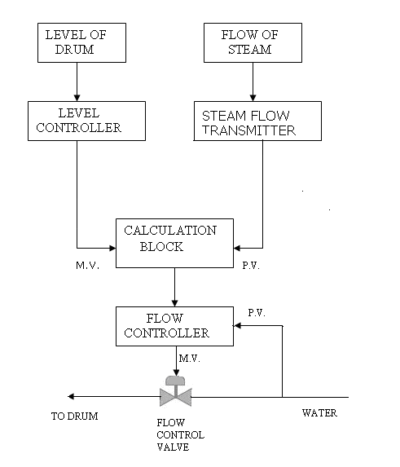
fig.6.3.1 boiler drum level control strategy.

The applicatiion of boiler drum level in a process plant is shown in the figure6.3.2. The level measurement,steam flow and feed water flow input are the process variables for the boiler drum level control strategy.The feed water flow and level of the drum are two manipulated variables.As the steam flow demand changes the feed water flow rate should be adjusted accordingly.the present process value(level) of the drum are adjusted by the controller and the manipulated value is summed with the stem flow variable in order to provide the new setpoint for the flow controller.The flow controller compares the new setpoint with the process value to adjust the feed water valve to maintain the level inside the drum strategy. The steam flow signal is applied to anticipate changes in the steam demand and adjust the feed water flow rate accordingly.

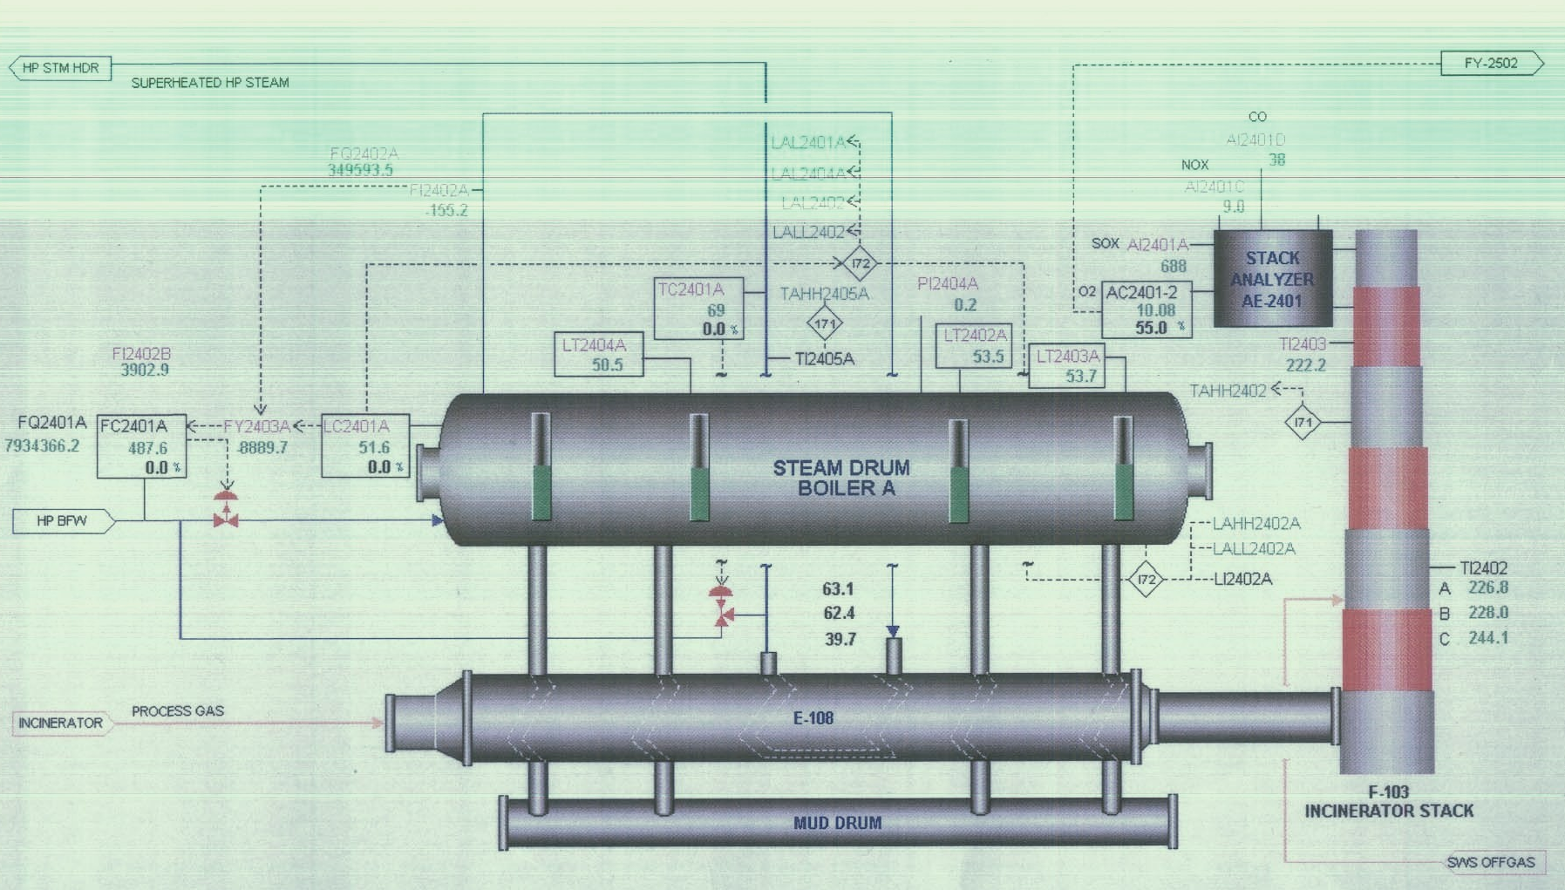
fig. 6.3.2 Boiler drum level control

The process variables are sensed by the transmitters in the field and transmited to the Distributed control system for monitoring and control.The level and flow controller resides in the DCS which by means of PID control algorithm compares the measured process value with the set point given by operator through Human Interface Station.The manipulated variable generated by the controller acts on the final control element.The tuning window for the flow,level and steam controller is shown in the table 6.3(a),6.3(b),6.3(c). and there trend is shown in fig.6.3(a), 6.3(b),6.3(c).

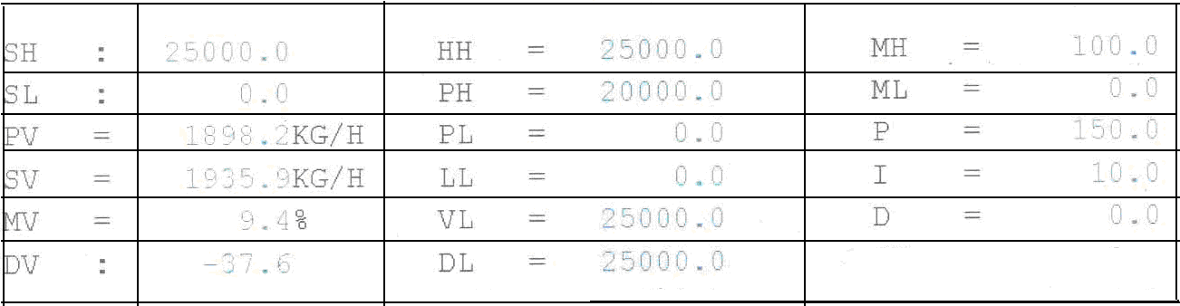

Table 6.3(a) Feed water flow controller tuning window.

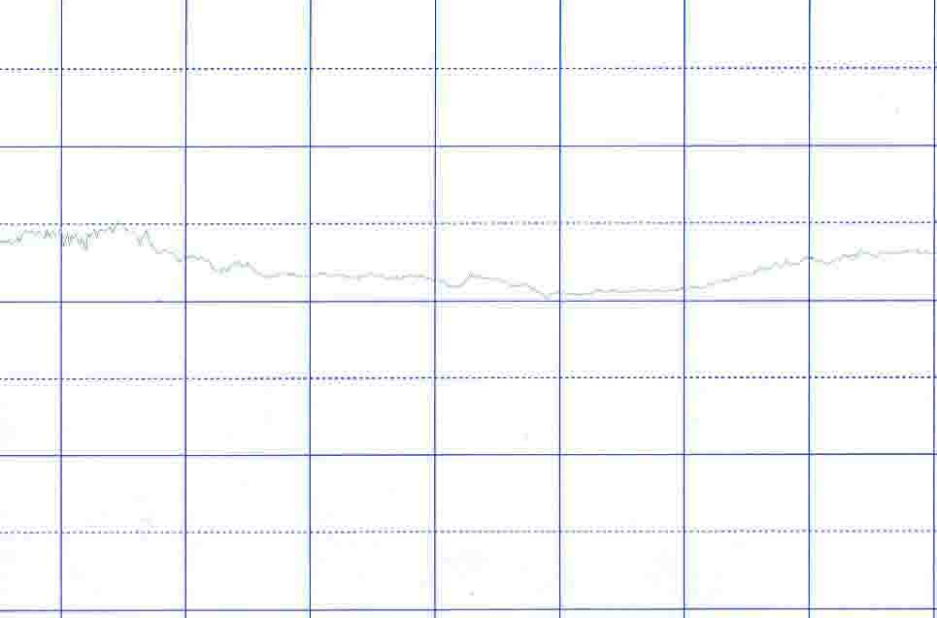
01 02 03
Time in seconds

fig 6.3(a) trend of flow controller.

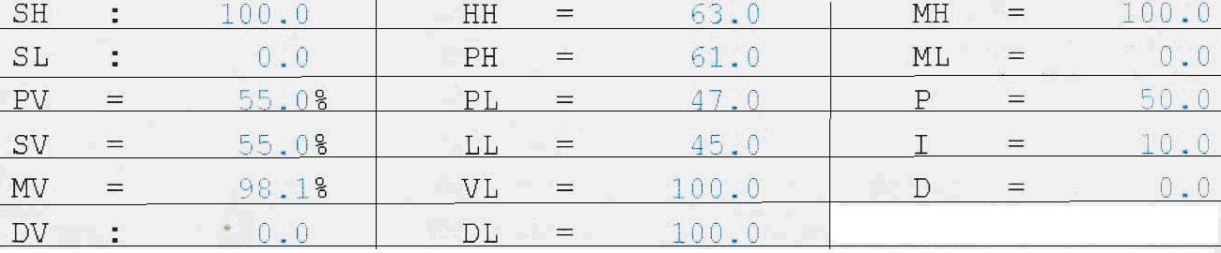

Table 6.3(b) Level controller tuning window.

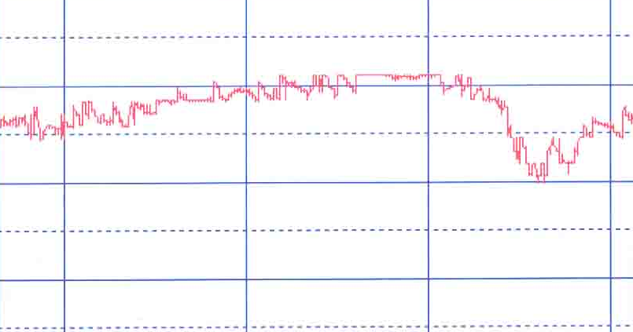
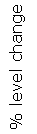
01 02 03

Time in seconds

fig 6.3(b) trend of Level controller.

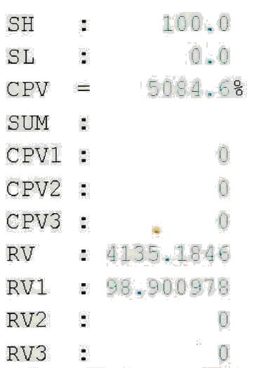

Table 6.3(c) steam flow table

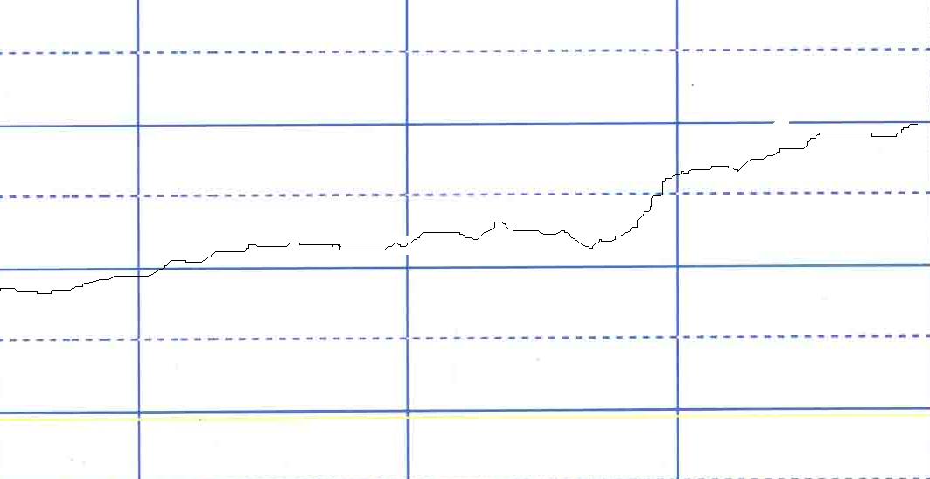
01 02 03
Time in seconds

Fig 6.3(c) trend of steam flow variable

The combined effect of three element controller is shown in fig.6.3(d),

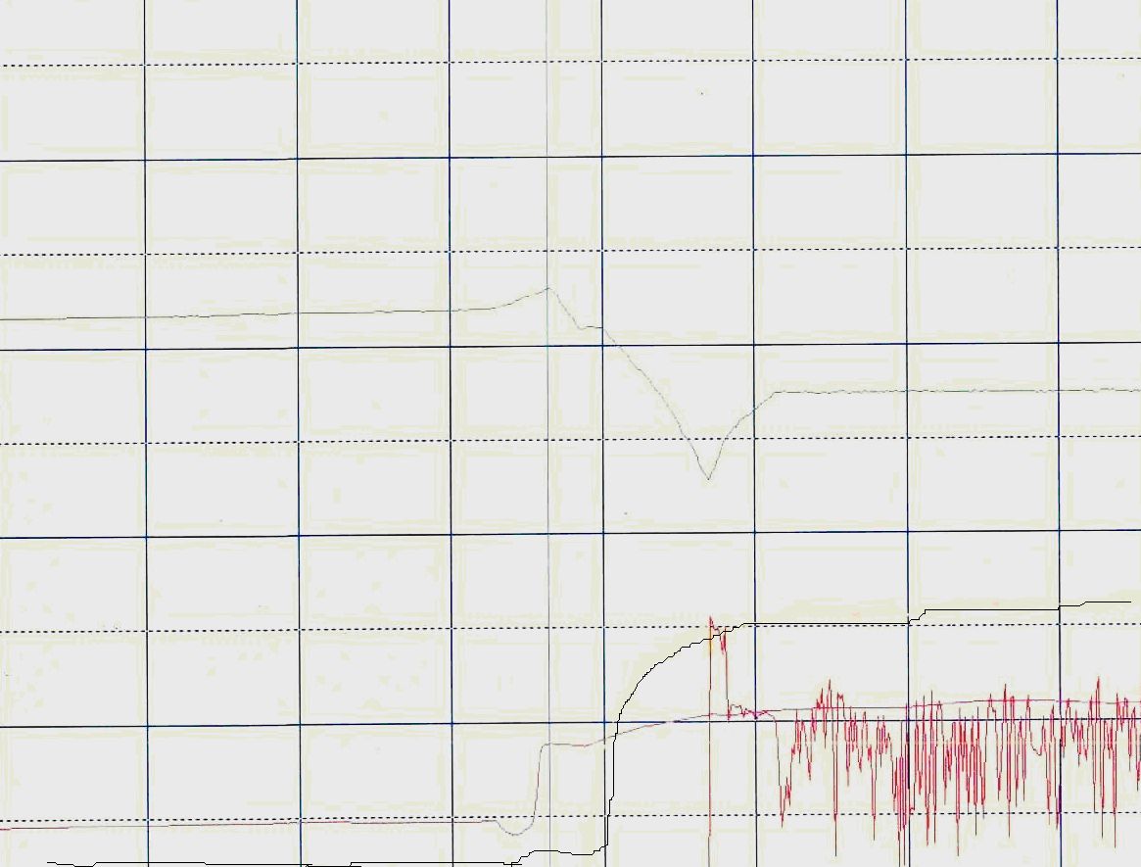
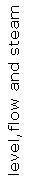

time

Fig6.3(d) combined effect ot three element controller

Level
Flow
Steam

CHAPTER 7
CONCLUSION AND FUTURE SCOPE OF WORK

The conventional three-element PID controller works satisfactorily in the absence of significant process disturbances. However when there are severe process disturbances, the three-element PID control scheme does not perform well because of lack of knowledge of proper controller gains to cope with such disturbances,the PID control scheme suffers from the risk of being detuned. The idea of error-based tuning can be extended to a more general class of problems currently using PID controllers. The performance of the existing PID control scheme is observed and collected data is used to gain knowledge about the process,Based on this process knowledge,an intelligent control technique, fuzzy logic controller (FLC) is developed for boiler drum level control system.

REFERENCES

1.Hogg,B.W. And N.M. El-Rabaie."Generalized Predictive Control Of Steam Pressure In A Drum Boiler,"IEEE Trans. On Energy Conversion Vol.5 NO.3 ,PP.485-492,September 1990.

2.Nomura,M. And Y.Sato."Adaptive Optimal Control Of Steam Temperature For Thermal Power Plants",IEEE Trans. On Energy Conversion Vol. 4 No.1, pp. 25-33,MARCH 1989.

3.Yonghong Huang,Nianping Li,Yangchun Shi,Yixun Yi."Genetic Adaptive Control For Drum Level Of A Powwer Plant Boiler",Imacs Multiconference On "Computational Engineering In System Applications"(Cesa),October 2006.

4.Process/Industrial Instruments & Controls Hand Book 5th Ed Mc Millan Gregory K.

5.Instrument Engineers Hand Book Vol 1 & Vol 2 Process Measurment & Analysis Liptak Bela G.

6.Applied Instrumentation In The Process Industries Vol.IV Andrew & H.B. Willams.

7.Process Modelling, Simulation & Control for Chemical Engineers Luyben W.L. 2nd Ed.

8.Enhancing drum level measurement for boiler control,jonathan Rowe.

9.Modicon modbus protocol guide.

10.Chemical process control, An introduction to theory and practice,george stephanopoulos.

11.Measurement and control applications for practicing Engineers,j.o.Houghen.

