STUDIES OF MONOLAYER AND MULTILAYER PACKAGING FILMS

A MAJOR REPORT SUBMITTED IN THE PARTIAL
FULFILMENT OF THE REQUIREMENT FOR THE DEGREE OF

MASTER OF ENGINEERING

IN

POLYMER TECHNOLOGY

IN THE FACULTY OF TECHNOLOGY,

UNIVERSITY OF DELHI

BY

MAHENDER PAL SINGH
(University Roll No-10293)
(College Roll No-03/poly/06)
Under the guidance of
Prof. R.C. Sharma



Department of Applied Chemistry & Polymer Technology
Delhi College of Engineering, Delhi-110042

ACKNOWLEDGEMENT

I feel honored in expressing my profound sense of gratitude to Prof. R.C. Sharma, Applied Chemistry & Polymer Technology, Delhi College of Engineering, Delhi for giving me the opportunity to work on such a practical problem, under his expert guidance. He constantly guided and helped me throughout the project. Words cannot express the support and motivation provided by him.
I also express my thanks to Prof. G.L.Verma (HOD), Dr. A. P. Gupta, Dr. D. Kumar, Dr. Archana Rani, and Mr. S.G. Warker.

Place : Delhi
Date : 31/7/08 (Mahender Pal Singh)

TABLE OF CONTENTS
Page no.
ABBREVIATIONS i
CHAPTER 1: INTRODUCTION 1
CHAPTER 2: HISTORY OFFLEXIBLE PACKAGING 5
CHAPTER 3: CLASSIFICATION OF PACKAGING 9
3.1 rigid packaging 10
3.2 semi rigid packaging 10
3.3 flexible packaging 11
CHAPTER 4 : MONOLAYER PACKAGING FILMS 12
4.1 BOPP(biaxially oriented PP) film 13
4.11 plain film 14
4.111 application
4.12 coextruded film 14
4.121 application
4.13 pearlised film 15
4.131 application
4.14 metalized film
4.41 application
4.2 CPP(cast PP) 15
4.21 properties and application
4.3 PVC film 17
4.31 properties and application
4.4 PET film 18
4.41 properties and application 19
CHAPTER 5: MULTILAYER PACKAGING FILMS 20
5.1 outer layer 21
5.2 middle layer 21
5.3 Inner layer 22
CHAPTER 6: ELEMENTS OF PACKAGING FILMS 23
6.1 metalized film 24
6.2 pellet sheet cover or top sheet 24
6.3 reclosable zip lock bags 25
6.4 shrink films 27
6.5 stretch films 29
6.6 skin packaging films 30
6.7 Stamping foil 31 CHAPTER 7: EFFECT OF CARBON BLACK ON LDPE FILM AND
Na-DHA in HDPE film 32
7.1 carbon black LDPE film 33
7.11 compositions 33
7.12 appearance of film 33
7.13 properties of film 34
(Tensile strength, burst strength, dielectric strength, % elongation etc.)
7.14 Result and discussion 35
7.15 application of carbon black-film 35
7.2 Na-DHA containing HDPE film 36
7.2.1 Composition 36
7.2.2 Appearance of film 36
7.2.3 Salient features of enhanced HDPE film
7.2.4 Comparison b/w HDPE Vs enhanced HDPE film 37
7.2.5 Result and discussion 38
7.2.6 Applications 38

CHAPTER8 : TESTING OF MONOLAYER MULTILAYER FILMS
(Testing of dielectric strength, weight/sq.m, burst strength, tensile strength, % elongation, opacity etc.)
8.1 monolayer film
8.1.1 LDPE film 40
8.1.2 HDPE film 44
8.1.3 BOPP film 46
8.1.4 PVC film 48
8.1.4 Met- PET film 50
8.2 multilayer films 51
8.2.1 Milk pouch 53
8.2.2 Tea pouch 53
8.2.3 Vanaspati Ghee 55
APPLICATION OF FLEXIBLE FILMS 57
FUTURE PROSPECTUS OF FLEXIBLE PACKAGING 59
SCOPE OF THE PROJECT 61
REFERENCES 62

ABBREVIATIONS

LDPE Low density polyethylene
LLDPE Linear low density polyethylene
HDPE High density polyethylene
BOPP Biaxially oriented polypropylene
PP Polypropylene
CPP Cast- polypropylene
PVC Polyvinylchloride
Met-PET Metallised polyethylene terephthalate (PET)or
Polyester
NA-DHA Sodium salt of dehydroacetic acid
DHA Dedydroacetic acid
DIOP Di-iso-octyl phthalate
BA Barrier (adhesive layer)

CHAPTER -1
INTRODUCTION

1
“Improvements and innovations have created opportunities for flexible packaging at the expense of rigid packaging. This development has been the most important factor driving growth and profitability in the industry.” ……by Robert N Castellano

Packaging:-

Packaging is defined as the processes (such as cleaning, drying, preserving) and materials (such as glass, metal, paper or paperboard, plastic) employed to contain, handle, protect, and/or transport an article.
Packaging is the way by which goods are wrapped either by the manufacturer or by the distributer before being sold or handed over to the consumers/end users. A good packaging should keep the product clean, should prevent losses, contaminations, chemical and physical damages and must provide identification and instruction.

Necessity of Packaging:-

- For extending the shelf life of the product to be packed.
- To prevent the product from physical changes i.e. non-enzymatic browning, discoloration.
- To save from Biological deterioration i.e. from micro-organisms, enzymatic activities, insect infection, rodent infestation.
- For cost saving in storage and transportation.
- It gives aesthetic look to the product.
- Easy handling.
- For transportation and storing of products.
- To carry information and colorful designs that makes attractive displays.

2
When selecting a packaging Material for a particular application, following Parameters are taken into accounts:

- economy
- protection of the product to be packed
- Life of the package, i.e. life of the package must exceed the life of the product.

- The package must give protection prior to use and in many cases during the use of the product.

Protection offered By the Packaging:-there are two types of protection offered by the packaging.
1) Active Protection
2) Passive Protection

1)Active Protection:- In Active protection, packaging is designed for a particular preservation such as
a) Aseptic packaging as in tetra packs
b) Sterilization using tinplate cans and sealed bottling Jars.
c) Preservation under modified atmosphere.
d) Special packaging e.g. bags with a valve for release of external pressure.

2) Passive Packaging:- The serves mainly as a barrier between the product and the external medium. It is independent of the food stuff preparation and preservation techniques. Passive packaging gives protection against
1) Light
2) Heat
3) Mechanical damage
4) Protection from micro organisms in the atmosphere.
5) Also protection from gas and water vapour.

3
Aseptic packaging:- A method of heating foods without destruction of proteins. In this process a very high temp. of about 121o c is applied for a very short period -2 seconds to destroy micro-organisms without causing any change in the proteins. e.g. is long life milk is a typical example of this method.

Modified atmosphere packaging:- It involves storage of fruits or vegetables in a modified atmosphere. For this purpose three gases are used.
  - CO2
  - N2
  - O2
-CO2 is largely used because of its retard ness of growth f micro organisms.
- N2 is largely used to displace oxygen and delay oxygen. It is also used as a filler gas to prevent vacuum to occur.
-O2 should be as low as possible. It is used mainly meat like product where co lour retention is desired.

Advantages of the Map:-

- It increases the shelf life of product by a few days to few weeks.
- It does not change the taste of the product and is safe.
- Reduces the loss of moisture & texture.
- Reduce the rate oxidation
- Reduce the growth of micro organisms
- Avoids weight loss.
- Improves the colour.

4

Disadvantages:-
- visibly added cost
- Variable product requirements i.e. different gas formulations needed for each product types.
- Not universally effective.
- Temp. controlled necessary
- Atmosphere maintenance
- Special equipment and training.

5

CHAPTER-2

HISTORY OF FLEXIBLE PACKAGING

6
From the very earliest times, humans consumed food where it was found. Families and villages made or caught what they used. They were also self-sufficient, so there was little need for packaging of goods, either for storage or transportation. When containers were needed, nature provided gourds, shells, and leaves. Later, containers were fashioned from natural materials, such as hollowed logs, woven grasses and animal organs. As ores and chemical compounds were discovered, metals and pottery were developed, leading to other packaging forms. Packaging is used for several purposes:
• Contain products, defining the amount the consumer will purchase.
• Protects products from contamination, from environmental damage and from theft.
• Facilitate transportation and storing of products.
• Carry information and colorful designs that make attractive displays.
Flexible packaging is the most "source-reduced" form of packaging that means that a flexible package has the least amount of material compared to other forms of packages that would hold the product. This also means that flexible packaging adds very little weight to the overall product, and there is very little to discard when the package is empty. Flexible packaging includes the paper sacks that dog food comes in, the plastic bags that hold potato chips and the paper or plastic sacks in which we carry home our purchases. Cloth or paper may be the oldest forms of flexible packaging. Flexible packaging is the most "source-reduced" form of packaging, that means that a flexible package has the least amount of material compared to other forms of packages that would hold the product. This also means that flexible packaging adds very little weight to the overall product, and there is very little to discard when the package is empty.
7
The use of flexible packaging materials began with the Chinese, They used
sheets of treated mulberry bark to wrap foods as early as the first or second
century B.C. During the following centuries, the Chinese also developed and refined the techniques of paper making. Knowledge of how to make paper gradually moved west across Asia and into Europe. In 1310, paper making was introduced to England. The technique arrived in America in Germantown, Pennsylvania, in 1690.
Plastic is the newest packaging material in comparison with metal, glass, and paper. Although discovered in the 19th century, most plastics were reserved for military and wartime use. Plastics have become very important materials and a wide variety of plastics have been developed over the past 170 years. Several plastics were discovered in the nineteenth century: styrene in 1831, vinyl chloride in 1835, and celluloid in the late 1860s. However, none of these materials became practical for packaging until the twentieth century. Styrene was first distilled from a balsam tree in 1831, but the early products were brittle and shattered easily. Germany refined the process in 1933 and by the 1950s styrofoam was available worldwide. Insulation and cushioning materials as well as foam boxes, cups and meat trays for the food industry became popular. Vinyl chloride, discovered in 1835, provided for the further development of rubber chemistry. For packaging, molded deodorant squeeze bottles were introduced in 1947 and in 1958, heat shrinkable films were developed from blending styrene with synthetic rubber. Today some water and vegetable oil containers are made from vinyl chloride. commercially used for packaging until the late 1950s and early 1960s. In the interim, polyethylene film wraps were reserved for the military. In 1933 films protected submarine telephone cables and later were important for World War II radar cables and
Drug tablet packaging. Other cellophanes and transparent films
8
have been refined as outer wrappings that maintain their shape when folded. Originally clear, such films can now be made opaque, colored or embossed with patterns.

Labels and Trademarks

It now seems obvious that product containers will bear the identification of the maker alongside pictures, nutritional information, ingredients, etc. However, this seemingly obvious feature of packaging has its own history. In the 1660s, imports into England often cheated the public and the phrase "let the buyer beware" became popular. Inferior quality and impure products were disguised and sold to uninformed customers. Honest merchants, unhappy with this deception, began to mark their wares with their identification to alert potential buyers. Official trademarks were pioneered in 1866 by Smith Brothers for their cough drops marketed in large glass jars. This was a new idea - using the package to "brand" a product for the benefit of the consumer.
In 1870, the first registered U.S. trademark was awarded to the Eagle-Arwill Chemical Paint Company. Today, there are nearly three-quarters of a million (750,000) registered trademarks in the United States alone. Labels now contain a great deal of information intended to protect and instruct the public.

9

CHAPTER-3
CLASSIFICATION OF PACKAGING

10
Packaging can be broadly classified into three categories: Rigid, Semi Rigid and Flexible packaging

3.1) Rigid Packaging:
Rigid Packaging’s are solid plastic containers of various types including bottles, cans and plastic jars. High pressure is required to deform the rigid packaging. Demand for rigid Packaging is growing at 20% per annum.

3.2) Semi rigid Packaging:
They lie in between the rigid and flexible packaging for example toothpaste and cosmetic tubes. They can be deformed by using small pressure. A distinguishing factor of these products is that they are thermoformed rather than injection or blow molded.

3.3) Flexible Packaging:-
Flexible packaging is material such as paper or foil used to form packaging for items such as bags, pouches, envelopes, etc. Flexible packaging can be deformed by negligible or very less pressure. They can be readily changed in shape .These are of two types Monolayer and Multilayer Flexible Packaging Films.
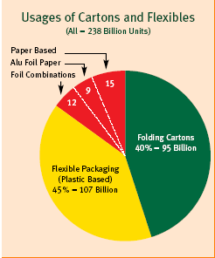
11
Film Packaging’s have Following Advantages:-

- Light weight
- Excellent barrier and functional properties.
- Easy to handle & convenient for retailers and customers.
- Acquire the shape of the product to be packed.
- Cost saving in storage and transport due to its light weight and small size.

12

CHAPTER-4
MONOLAYER PACKAGING FILM

13
Monolayer flexible film contains only one layer. There are various polymers used to make monolayer flexible films. some films are as:
4.1. BOPP (biaxially oriented polypropylene):-
BOPP film (biaxially oriented polypropylene), in recent years has become one of the most popular, high growth films in the world market. BOPP film a prominent product line, with a wide range of film variations from around the globe, targeting the packaging, pressure sensitive tape, label, stationery, metalizing and decorative markets.
Biaxially oriented PP enhances the various properties over conventional cast or tubular quenched PP films. The mechanical strength, dimensional stability, stiffness, non -tearability, optical properties, barrier properties, etc are greatly improved owing to biaxial orienting process.
BOPP films have following features:-
a) It provides higher surface area per unit weight which makes it cost effective.
b) It has low transmission rate than other packaging films which improves the shelf life and retains freshness of the food products sensitive to moisture.
c) The high gloss and excellent clarity provides good aesthetic appeal.
d) Its high tensile strength, low elongation and thermal shrinkage makes it suitable for processing on high speed printing, coating/laminating and other converting machines.
These films can be divided in different categories as:-

14
(4.1.1)Plain Film
(1) These film are available in the range from 12 to 50 microns.
(2) It has Excellent mechanical and optical properties, clear, matte, brown and white.
Application:
Printing & Lamination
Pressure Sensitive Tape
Stationery (photo albums, page protectors)
Metalizing
Flower Sleeves and Wrap
Cable Wrap and Insulation

(4.12)Coextruded Films:
(1)These films are available in the range from 15 to 40 microns.
(2) They are heat sealable one or two sides, wide heat seal range, used as single web or laminated.
Application:
(i)Overwrap
(ii)Packaging
(iii)Printing & Lamination
(iv)Metalizing

15

(4.13) Pearlized Films
(1)These films are available in the range 30, 35, 40 micron in coex or plain.
(2) They are available in white, ivory or opaque.
Applications:-
These films are widely used for packaging chocolates, biscuits, biscuit wafers, toffees etc.

(4.14)Metalized Film
(1) These films are available in the range 20 or 30 micron,
(2) These are one side metalized with sealable layer designed for high barrier-flexible packaging applications.
(3) These films contain thin aluminum layer on one side of the film.
Applications:-
These films are popularly used for packing of cream biscuits, stuffed biscuits, panmasala, scented supari etc.

4.2. CPP(cast polypropylene):
PP has the lowest density of 0.905 g/cc of all the plastics available. Owing to its lowest density of PP the yield of the film is more than other films and hence economical.

16
CPP film (cast polypropylene) has been known in the packaging field to be the more "elegant" brother of polyethylene film, with higher gloss, greater transparency and better heat resistance. In the stationery industry, CPP film has developed the reputation for being the cost effective alternative to PVC film. What is not widely known about CPP film is its versatility. This film category is available in a variety of types and for multiple applications. CPP film is widely used in the packaging industry for textiles, food and flowers; in the stationery industry for photo albums and page protectors, as a lamination layer (both as sealant and as a heat resistant layer), and in the pressure sensitive industry for adhesive coating, diaper closures and more.
APPLICATIONS
(i)Stationery
In the stationary thickness Range: 60-1,500 microns. are used.

(ii)Packaging
(iii)Textiles
(Hosiery, Socks, Underwear, Shirts).
(iv)Food
(Bread, Vegetables, Candies)
(v)Floral Wraps
(Sleeves & Sheets for Cut Flowers, Pots, Dried Flowers)
(vi)For Laminates

Thickness Range: 18-120 Microns are used.

17

(vii)Pressure Sensitive Labels & Tape

(a) In these films are used in Self Adhesive Tapes.

(viii)Typical Values
(a)The Widths up to 1500mm. is used for valves.
(b)Thicknesses from 18-1500 microns are used for this purpose.

4.3. PVC(polyvinyl chloride):

PVC film (polyvinyl chloride) can be produced with an extraordinary range of characteristics and qualities, from rigid PVC (in thin and thick gauges) to semi-rigid PVC, to plasticized; from polished, clear, highly transparent film to matte finished (in many embossed patterns) . PVC films have the tensile strength range 480-700 Kg/sq.cm. and Density in the range of 1.20-1.50 g/cc.
- PVC film is clear or colored, transparent or opaque.
- PVC films are available in the range from 30 microns to 650 micron thickness.
Applications:-
(1) These films are used for lamination on credit card stock.
(2) PVC films are also used in Industrial adhesive tapes.
(3) Also used on battery wrap and packing candy twist.

18
4.4. PET FILM:-
Polyester film is a high-performance biaxially oriented film made from polyethylene terephthalate (PET) resin. PET, in turn, is produced from dimethyl terephthalate (DMT) or terephthalic acid (TPA) and ethylene glycol. The vast majority of PET film is made from DMT. The PET resin usedto film formation is of higher purity.
PET film is one of the most widely used plastic films in the world. It is highly diversified in its applications -- from industrial, such as pressure sensitive labels and tapes, cable wrapping or insulation laminates, through packaging, graphic arts, metalizing or decorative, to the high-tech applications of audio, video and computer tape. Polyester film contains properties that make it ideal for the packaging market.
- Easy machineability
- High strength
- Dimensional stability over a broad temperature range
- Surface treatability
- Crystal clarity
- Tear resistance
- Excellent adhesion and release
- Superior printability
- Moisture and solvent resistance
- Barrier against oxygen and water vapor

19
Applications :
(1)Graphic Arts/Decorative
(2)Metalizing
(3)Pressure Sensitive Labels and Tapes
(4)Cable Wrap
(5)Packaging
(6)Electrical/Insulation
(7)UL approved
(8)Audio, Video, Computer Tape-Base Films
(9)Stamping Foil

20

CHAPTER-5

MULTILAYER PACKAGING FILM

21
Today, potato chips and innumerable other products can be shipped long distances and stored for months because the properties of many materials can be combined into the multilayer structure that provide characteristics of flexible packaging to the right degree; protection against flavour, microbial protection and extension of shelf life etc.
Multi-layer structures generally consist of three functional components.
5.1. Outer layer:
- This layer Provides resistance against abrasion and scuffing during processing and packaging operations.
- It must be resistant of temperature required to melt the sealant, yet with food product,. Typical materials include polyamides (nylon) or polyesters.
- In cook-in film, the outer layer is sometimes protected against heat by an additional outer layer of polypropylene.
5.2. Middle layer:
Provides the barrier to gas permeation. Polyvinylidene chloride (PVDC), commonly known as Saran, ethylene vinyl alcohol (EVOH) are generally key components of
high-barrier films.
5.3. Inner layer:
Provides a hermetic seal by melting at moderate temperatures. The sealants in common use are polyethylene’s, ethylene vinyl acetates (EVA) and ionomers.

A typical example of multilayer laminate structure is as follows-

• Outer layer | Nylon, Polypropylene or Polyethylene
Adhesive layer | Adhesive polyolefin
Barrier layer | EVOH or Nylon
Adhesive layer | Adhesive polyolefin
Seal layer | Polyethylene, EVA or Surlyn etc.

22

23

CHAPTER-6

ELEMENTS OF PACKAGING FILMS

24
Packaging is done with the different types which are wholly dependent on the product which is to be pack.
Different types of packaging films normally used in flexible packaging are as follows-
6.1. METALLIZED FILM:
The advantages of both metal and plastic films have been incorporated into metallized film, offering consumers much more versatility in application.Metallized films have excellent properties of gas barrier, decoration ,light barrier and light reflectors, heat insulator, moisture barrier and electric conductor etc.
Application of Metallized Film:
- Packaging : Food, Medicine
- Fiber : Metallic Yarn
- Decoration : Ribbon
- Printing : Stamping Foil, Heat reflection, insulation duct, Construction
- Electrical : Cable wrap insulation tape
- Electronics : Shielding Bag
- ETC : Baloon, Camping sheet

6.2. PELLET COVER OR TOP SHEET
A top sheet is a thin (typically 1 to 4 mil thick) plastic film applied to the top of a pallet load for protection. A plastic top sheet is much more economical than a comparable corrugated top cap.
Applying a layer of plastic film (or top sheet) to the top of a pallet load can make sense for a number of different reasons:-
25

(i)Dust Protection

A layer of film on the top protects your product from dirt, dust and other elements that may affect the look or damage your product both during transit and storage at your facility and your customer’s location.

(ii)Tamper Resistant

By locking the top sheet film with the stretch wrap on the sides you effectively prevent easy access to the product inside. Although the top sheet film can be removed to allow access, it will be noticeable.

(iii)Water Resistance

Having a layer of top sheet plastic film provides a level of water resistance. This allows for the product load to be protected from the elements for a period of time without the moisture damaging the product within. The quality of resistance depends on the application.

(iv)UV Resistance

Plastic Top sheet can have UVI (Ultra Violet Inhibitor) added to the film. This provides protection from the sun’s rays that can damage the product load. Without UV protection most packaging print on boxes or bags will fade, and some product packaging will deteriorate to the point of failure. The application of a UVI top sheet film will protect most products that require outdoor storage from the elements.

6.3. RECLOSABLE ZIP LOCK BAGS:
There are dozens of choices when it comes to reclosable zip lock bags. Flexible Packaging can get you any type you need, from the common, every-
26
day bag to the highly specialized. We carry all the well-known brand names, including Minigrip with its "Red-Line" in the resealable top.
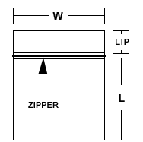
Flexible packaging can get you any thickness for your needs from .002 (2 Mil) to .006 (Mil) The most popular thickness are:
- .002 (2 Mil) bags are used for protecting delicate items from dust, dirt, oil scratches and moisture, making them ideal for hardware, cosmetics and light, manufactured goods.
- .004 (4 Mil) bags are tougher, reducing the possibility of tears or punctures and able to handle heavier and bulkier items
- .006 (6 Mil) bags are the strongest reclosable bags you'll find on the market
Zip lock bags come in many sizes with various combinations of the following features:
- Clear, Amber, Black and Your Choice of Colors
- Write-On Blocks in White (accept marker, rubber stamp, grease pencil or pen)
- Anti-static
- Static Shielding
- UV Protection (amber) .003 (3 Mil) stock gauge.
- FDA and USDA approved for food contact.
27
- Tamper-Evident
- Press-On (adhesive back, holds shipping documents)
- Tie-On
- Metal Grommets/Metal Reinforced Eyelets
- Hang Holes
- In Dispenser Box
- Stand-up
- Slider Zipper Bags

6.4. Shrink Films:
Films which have gone through an orientation step in manufacturing process, which shrink significantly with application of heat.
Shrink films possess characteristics which are as follows-
(a)Optics
The visual properties of a material, such as clarity, haze and gloss, that are first noticed by an end-user and the point-of-purchase customer. These visual properties distinguish premium shrink films from commodity shrink poly. Good optical properties display the custom
(b)ColdTemperature Flex (Low Temperature)
Ability of a film to perform at low temperature without fracture or failure.

28
(c)Modulus of Elasticity-Stiffness
The stiffness or resistance to bending of a packaging film. The higher the modulus value, the stiffer the material. Typically, a film with a higher modulus machines best on a high-speed wrapper.
(d)Slip
That quality of a film that permits it to move easily over metal or against another piece of film (See Coefficient of Friction).
(e)Cold-Slip
The amount of force required to slide two cold surfaces of film against themselves.
(f)Hot-Slip
The amount of force required to slide two heated surfaces of film against themselves.
(g)Tack
A property of a film that is characterized by its adherence to metals and/or another sheet of similar film (See Coefficient of Friction).
(8)Oriented
The stretching and aligning of a material's molecules at temperatures below its melting points.

29
(h)Balanced (Biaxial) Equal orientation in both LD (longitudinal direction) and TD (transverse direction), i.e., 3 x 3 or 5 x 5.
(i)Monoaxial
A film which is oriented to shrink in one direction (longitudinal or transverse) only.
(j)Preferential Shrink
The characteristics of a shrink film which enable it to shrink more in on direction (longitudinal or transverse) than the other. Longitudinal orientation is accomplished by a device which stretches the film in the machine direction. Transverse orientation is induced by a process such as tentering which applies across the web stretching.
(k)Dimensional Stability
Capability of a roll of material to maintain slit width during typical storage and distribution conditions.

6.5. STRETCH FILMS:
Stretch films are made from linear low-density polyethylene resins. Since its early introduction in the early 70’s, stretch film has become the most important method of unitizing product loads for transport.
There are a number of key features for this including:
- The uniform and relatively high holding force that stretch film applies to a load.

30
- The protection from dust and damage it provides versus other unitizing methods.
- It is the most economical method of unitizing
6.6. SKIN PACKAGING FILMS:
Skin film is widely accepted for packaging hardware items, automotive and other spare parts, medical items and all other goods where customer appeal
and secure packaging are essential. Skin film will adhere to untreated cardboard which can be printed with ordinary printing inks, reducing packaging costs. Skin packaging is extremely versatile because one piece of plastic can be drawn down around almost any shape, size or weight product. The plastic protects the product and the card backing from wear and tear. And since the product is immobilized, it cannot shift and multi-component products will not lose any of its pieces.
The key features of skin packaging are as follows-
(a) Adhesion: Specially developed for the uncoated board
(b) Puncture Resistant: harp edges and protuberances will not damage the tough skin-film
(c) Drawability: Skin packaging film has excellent drawability following the contours of the packaged product. Deep draw and hollow spaces present no problems.
(d) Crystal Clear Transparency: Maximum sales appeal through sparkling colors
(e) Oil and Greaseproof: This property is especially important for technical items which may be grease protected: ball bearings, gears, etc.
(f) Permanency: Skin Packaging film is unaffected by temperature variations and will not yellow with age.
31
6.7. STAMPING FOIL:
Stamping foil creates that classy look for graphics, packaging and promotional materials. Stamping foil line is available in various golds, silvers and other fantastic metallic colors. The variety and versatility of colors into infinite substrates offers designers the flexibility and creativity in selecting just the right materials for their masterpieces.
Applications of Stamping Foil:
*Graphic
Stamping Foil can be applied to coated, laminated and non-coated paper, as well as to different types of film. Stamping Foil's easy release and elasticity works best with embossed graphics using high-speed cylinders.
(b)Plastic
Stamping Foil's excellent abrasive and chemical resistant properties make this the best stamping foil for cosmetic containers and their accompanying plastic pencils and brushes. With their easy release and definition, stamping foils can be used for fine lettering as well as medium-sized graphics.
(c)Textile
Stamping Foil offers great resistance to dry-cleaning and washing--whether with hot or cold water. It is fast becoming a favorite among textile designers who use stamping foil to create various effects on dresses, scarves--even doll costumes. Because of its clean and soft release, our stamping foil can accommodate fine computerized patterns over a wide stamping area

32

CHAPTER-7
EFFECT OF
CARBON BLACK IN LDPE FILM AS AN ADDITIVE
&
NA-DHA IN HDPE FILM AS AN
PRESERVASTIVE

33

7.1BLACK-LDPE FILM

To manufacture 20 micron black- LDPE film following materials are used.
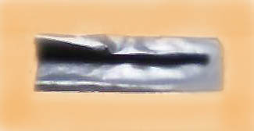

7.1.1.Composition:-
LDPE resin - 90.3%
Vaseline oil - 7.7%
Sorbic acid - 0.5%
Carbon black - 1.5% ( manufacture by sham colour mart)
Antioxidant, slip agent may be added in the resin as per demand.
Plasticizers:- Vaseline, mustard , vacuum oil BM-1 and other oils.
Preservatives:- coriander oil, sorbic acid etc.
Filler and colorant : - carbon black
The above given materials are compounded and film is furnished in the form of flat sheets or rolls. The film is formed by using calendaring rolls or by blowing film.
7.1.2. Appearance of film: - black
7.1.3. Weight per square meter: - 106 gram
7.1.4. Resistance to oil and fats: - very good

34
7.1.5. Dielectric strength:-
Dielectric strength = Breakdown voltage (Volt)
Thickness of the film (mil)
Breakdown voltage = 14KV, thickness of film = 20 micrometer
Dielectric strength = 14000 V / 20 micrometer = 14000 / 20/25.4 V/mil
(1 mil = 25.4 micron)
= 17780V/mil = 17.780V/mil
Dielectric strength is tremendously increased on addition of 1.5% carbon black.
7.1.6. Burst strength:- - It is defined as the ability of a plastic film to resist rupturing when it is pressurized for a short period of time. It is based on hydraulic pressure system.
Burst strength = 42 Kg/sq.cm.
Burst strength of black-LDPE film is higher than LDPE transparent film.
7.1.7. Tensile strength: - it is defined as the maximum stress or tension that a material can endure before it breaks. Test speed is 5mm/min.
Size of the rectangular strip of carbon black film = 50mmx25mm
Tensile strength = 176 N/sq.mm
Tensile strength of film is increases at a large extent on addition of carbon black.
7.1.8. %Elongation at break :-
Initial reading = 50mm, final length after breaking =85mm
%Elongation at break = 85-50/50x100 = 70%
% Elongation reduces on addition of carbon black.
35

Comparison between black LDPE and transparent LDPE films

Properties | Black LDPE film | Transparent LDPE film
Appearance | Black | Transparent
Weight per square meter | 106 gm. | 70 gm.
Resistance to oil and fats | Very good | Good
Dielectric strength | 17.780KV/mil | 11.430KV/mil
Burst strength | 42 Kg/sq.cm. | 22Kg/sq.cm
Tensile strength | 176 N/sq.mm | 150N/sq.mm
%Elongation at break | 70% | 212%

Result and discussion:-
Carbon black markedly increases the resistance to oil and fats. The dielectric strength, burst strength, tensile strength, increases markedly. Elongation at break reduces on addition of carbon black.

Uses of black LDPE film:-
- It is used in meat shop due to its high opacity value.
- It is used at hardware shop for handling heavy items like screws, nut bolts because of its high tensile strength.
- These films are also used for construction work for protection of roof against leakage.
- Due to high tear strength, tensile strength it is used in transportation.
- These films are also applied on car window for protection against sunlight.
- These films are also used for packaging to protect the goods which are sensitive to light.

36
7.2MODIFIED HDPE FILM
7.2.1 Composition:- such film consists the following composition
HDPE resin - 69.0%
Vegetable oil - 30.0%
Dehydroacetic acid (DHA)- 0.6%(manufactured by fine chem. India)
or
Na-salt of dehydroacetic acid- 0.4% (manufactured by fine chem. India)
Plasticizer:- vegetable oils e.g. mustard oil, Vaseline, mustard , vacuum oil BM-1
Preservatives:- DHA, Na-DHA
Salient features of Enhanced HDPE :-
- DHA in packaging does not change the property of film but products in this film can be stored for much longer period of time.
S. No. | Product | Storage Temp. | Preservative | Storage days in film  Without Na- DHA or DHA Modified
1. | Hard Cheese | 10-12 oC  (Approx) | Na- DHA | 8 21
 | Hard Cheese | 30 oC (Approx) | DHA | 3-4 12
2. | Carrot | 10-12 oC (Approx) | Na- DHA | 8 18
 | Carrot | 10-12 oC (Approx) | DHA | 8 21

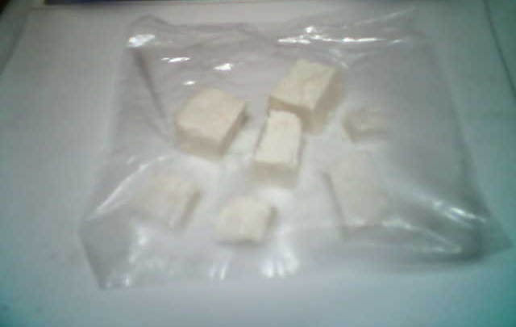

After 8 days at temp.10-12 oC foul smell

Transparent HDPE film without Na-DHA
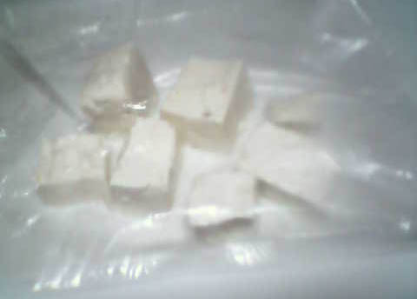

Freshness upto 21 days
Enhanced film (with Na-DHA)

- Na-DHA also increases the elasticity of the film .

%Elongation at break :-
Initial reading = 50mm, final length after breaking =124mm
%Elongation at break = 124-50/50x100 = 148%
By using vacuum oil as plasticizer, highest modulus of elasticity is 1300 Mpa only.
By using Na-DHA ,value of modulus of elasticity reaches as high as 1900 Mpa.
7.2.3 .Comparison between HDPE and enhanced HDPE films
Properties | enhanced HDPE film with Na-DHA | Transparent HDPE film
Appearance | White fairly transparent | Transparent
Weight per square meter | 120gm. | 100 gm.
Resistance to oil and fats | Very good | Good
Dielectric strength | 11.78KV/mil | 11.176KV/mil
Burst strength | 18 Kg/sq.cm. | 16Kg/sq.cm
Tensile strength | 255N/sq.mm | 250N/sq.mm
%Elongation at break | 148% | 52%
Opacity | 1.455 | 1.977

38
Result and discussion:-
i) The preservation strength of enhanced HDPE film increases tremendously.
ii) %elongation increases at a high value.
iii) There is no change in the property of the film which shows adverse affect on the product.

Application:-
This enhanced film can be used for product preservation for a longer time. And also where demand of high elasticity. As this film is harmless it can be largely used in food preservation.

39

CHAPTER-8
TESTING OF
MONOLAYER AND MULTILAYER FILMS

40

8.MONOLAYER FILMS

POLYETHYLENE FILMS

8.1 Low density polyethylene (LDPE)film:- To manufacturing the General purpose LDPE film following materials are used,
(8.1.1) Composition:-
LDPE - 92.6%
Vaseline oil - 7.0%
Cariander oil - 1.2%
Or
LDPE - 90.5%
Vaseline oil - 9.0%
Sorbic acid - 0.5%
Plasticizers:- Vaseline, mustard , vacuum oil BM-1 and other oils.
Preservatives:- coriander oil, sorbic acid etc.

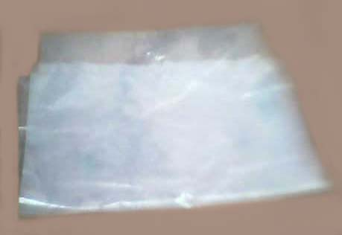

41
(8.1.2) Apprearance of film = transparent
(3) Weight/sq.m = 70gm
(8.1.3) Dielectric strength:-The dielectric strength of insulating material is defined as the maximum voltage required to produce a dielectric breakdown. It is expressed in volts per unit of thickness such as V/mil.

Dielectric strength = Breakdown voltage (Volt)
Thickness of the film (mil)

LDPE Film (20 micrometer), breakdown voltage = 9KV, thickness of film = 20 micrometer
Dielectric strength = 9000 V / 20 micrometer = 9000 / 20/25.4 V/mil (1 mil = 25.4 micron)
= 11430V/mil = 11.430KV/mil

(8.1.4)Burst strength: - It is defined as the ability of a plastic film to resist rupturing when it is pressurized for a short period of time. It is based on hydraulic pressure system.
42
20 micrometer film:- 22 Kg/sq.cm

(8.1.5) Tensile strength:- I is defined as the maximum stress or tension that a material can endure before it breaks . Test speed is 5mm/min.

Size of rectangular film strip = 50mmx25mm
Tensile strength = 150N/sq.mm
(8.1.6) % Elongation at break:-
Initial length = 50mm , final length after breaking = 156mm
% Elongation at break = 156-50/50 x 100 = 212%
43
(8.1.7) Opacity: - It is defined as the non transparency of the film.
Opacity value = log (transparency)

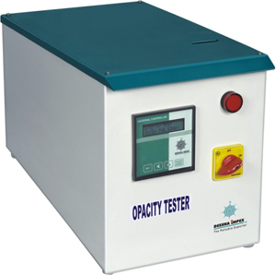
Transparency reading = 96
Optical transparency = log (96) = 1.982

44
(8.2)High density polyethylene (HDPE) film: - To manufacturing general purpose HDPE film following additives are used,
8.2.1Composition:-
HDPE - 90%
Onion- 3%
Vacuum oil BM-1- 7%
Plasticizers:- Vacuum oil BM-1 and other oils.
Preservatives:- Coriander oil, Sorbic acid, Onion juice etc.
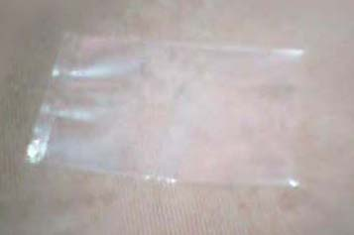

(8.2.2)Apprearance of film = transparent
(8.2.3) Weight/sq.m = 100 gram/sq.m
(8.2.4)Dielectric strength:-The dielectric strength of insulating material is defined as the maximum voltage required to produce a dielectric breakdown. It is expressed in volts per unit of thickness such as V/mil.

45
Dielectric strength = Breakdown voltage (Volt)
Thickness of the film (mil)

25 micrometer film, breakdown voltage = 11 KV, thickness of film = 25 micron
Dielectric strength = 11000/25/25.4 V/mil = 11176.59 V/mil = 11.176 V/mil

(8.2.5)Burst strength: - It is defined as the ability of a plastic film to resist rupturing when it is pressurized for a short period of time. It is based on hydraulic pressure system.
Burst strength = 16 Kg/sq.cm

(8.2.6) Tensile strength:- it is defined as the maximum stre3ss or tension that a material can endure before it breaks . Test speed is 5mm/min.
Size of rectangular film strip = 50mmx25mm
Tensile strength = 250 N/sq.mm
(8.2.5) % Elongation at break :-
Initial length = 50mm, final length after breaking = 76mm
%Elongation at break = 76-50/50 x 100 =52%

(8.2.7) Opacity: - It is defined as the non transparency of the film.
Opacity value = log (transparency)
Transparency reading = 95
Opacity log(95) = 1.977
46
8.3BOPP(bioxially polypropylene)

(8.3.1)(Composition):-
(a) Homopolymer polypropylene - 84%
(b) Amides or ethoxylated amines or stearates - 2%
(c) Talc, or calcium carbonate - 12%
(d) Titanium dioxide - not greater than 4%
Coefficient of friction reducing agent :- Amides or ethoxylated amines or stearates.
Fillers:- Talc, calcium carbonate
Pigment :- Titanium dioxide


(8.3.2) appeareance of film = milky white fairly transparent
(8.3.3) Wt./sq.m. = 86 gram
(8.3.4) Resistance to oils and fats: - Good
(8.3.5) Dielectric strength = breakdown Voltage (V) /thickness of the film (mil)
47
Reading = 12 KV, thickness of the film = 20 micro meter = 20/25.4mil = 0.7874
Dielectric strength = 12,000 /0.7874 = 15240 V/mil = 15.240 KV/mil

(8.3.6) Burst strength: - It is the strength of the film at a given temp. and hydraulic pressure to resist rupturing .
Burst strength = 10 Kg/sq.cm
It has poor burst strength.

(8.3.7) Tensile strength: - A maximum stress that a material can endure before it breaks.
Size of rectangular film strip = 50mmx25mm
Tensile strength = 400N/sq.mm

(8.3.8) Elongation at break: - The maximum increase in the length of the film due to tensile load before breaking.
Initial length reading = 50mm, final length after breaking = 54mm
% Elongation at break = 54-50/50x100=8%

(8.3.9) Opacity = Log (transparency)
Transparency reading = 36
Opacity = log (36) = 1.556

48
8.4 Polyvinyl chloride (PVC) film
(8.4.1)Composition:-
PVC resin – 81%
DIOP - 4.5%
China clay, calcium carbonate – 13%
Stearic acid – 0.6%
Tribasic lead sulphate – 0.8%
Plasticizer :- DIOP ( di-iso-octylphalate), dinonly phthalate (DNP)
Filler :- china clay, calcium carbonate, magnesium carbonate,
Lubricant:- stearic acid, Wax etc.
Stabilizer :- tribasic lead sulphate

(8.4.2) weight/sq. m. = 96 gram
(8.4.3) Resistance to oils and fats :- Very good
(8.4.4) Elongation at break:- The maximum increase in the length of the film due to tensile load before braking.
Initial length reading = 50mm, final lenth after breaking =59mm
% Elongation at break = 59-50/50 x 100= 18%
(8.4.5) Burst strength:-
20 micron film = 9 Kg/sq. cm
49
(8.4.6)Tensile strength =
Size of rectangular film strip = 50mmx25mm
Tensile strength = 750N/sq.mm

(8.4.7) Opacity = log (transparency)
Transparency reading = 95
Opacity = log (95) = 1.977

(8.4.8) Dielectric Strength: - for 20 micron film
Reading = 7 KV, thickness of the film = 20 micron = 20/25.4 mil =0.7874
Dielectric strength = breakdown Voltage (V)/thickness (mil)
= 7,000/0.7874 V/mil = 8890 V/mil = 8.89KV/mil

50
  - Metallized Polyester(Met-PET) film
(8.5.1) Composition:-
Polypropylene resin – 83.5%
Hydrogenated castro oil or paraffin wax – not exceed 0.5%
Calcium carbonate – 12%
Calcium stearate – 2%
Titanium dioxide -2%
Plasticizers:- hydrogenated castor oil, paraffin wax,
Filler :- Calcium carbonate
Lubricant:- calcium stearate
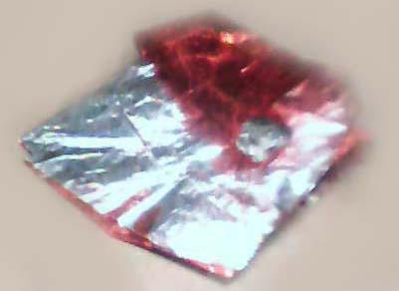
(8.5.2) Weight per square meter:- 95 gram
(8.5.3) Resistance to oil and fats:- very good
(8.5.4) Burst strength:- 23 kg/sq. cm
(8.5.5) Opacity:- log(transparency)
Transparency reading = 18
Opacity log (18) = 1.255

51

(8.5.6)Tensile strength:-
Size of rectangular film strip = 50mmx25mm
Tensile strength = 1700N/sq.mm

(8.5.7)Elongation at break:-
Initial length 50mm, final length = 68mm
% elongation at break = 59-50/50x100 = 18%

(8.5.8) Dielectric strength: - for 25 micron film
Reading = 20 KV, thickness of film = 25 micron= 25/25.4=0.9842mil
Dielectric strength = breakdown Voltage (V)/thickness (mil)
= 20,000/0.9842 V/mil = 20321 V/mil
=20.321 KV/mil

52
Multilayer film pouches

Milk pouch: - 1 liter pouch (parag)
Packaging requirements for milk include retention of flavor, texture, colour and barrier to oxygen, light, with excellent mechanical and printing properties
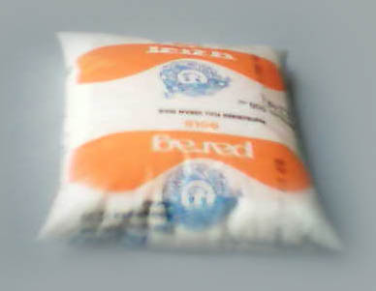
1.Film structure:- LLDPE + LDPE
2.Film thickness: - 50 micron
3. Appearance of film: - white transparent film
4. Weight: - 14 gram
5. Dielectric strength:-

Dielectric strength = Breakdown voltage (Volt)
Thickness of the film (mil)
Breakdown voltage = 12KV, thickness of film = 50micrometer
Dielectric strength = 12000 V / 50micrometer = 12000 / 50/25.4 V/mil
(1 mil = 25.4 micron)
= 6096V/mil = 6.096KV/mil

53
6. Burst strength:- - It is defined as the ability of a plastic film to resist rupturing when it is pressurized for a short period of time. It is based on hydraulic pressure system.
Burst strength = 44Kg/sq.cm.

7. Tensile strength: - it is defined as the maximum stress or tension that a material can endure before it breaks. Test speed is 5mm/min.
Size of the rectangular strip milk pouch= 50mmx25mm
Tensile strength = 182 N/sq.mm

8. %Elongation at break :-
Initial reading = 50mm, final length after breaking =118mm
%Elongation at break = 118-50/50x100 = 136%

54
Tea pouch(Tata tea)

Packaging requirements for tea include retention of flavor, aroma, texture, colour and barrier to oxygen, moisture, and nitrogen with excellent mechanical and printing properties.
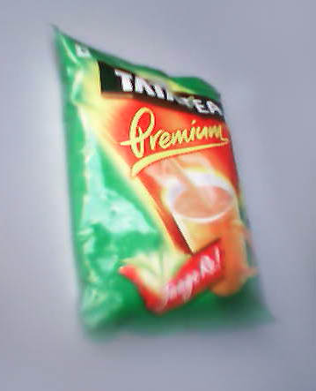

1.Film structure:- PET /BA/Al foil/BA/LLDPE
2.Film thickness: - 75 micron
3. Appearance of film: - coloured film
4. Weight: - 20 gram
5. Dielectric strength:-

Dielectric strength = Breakdown voltage (Volt)
Thickness of the film (mil)

Breakdown voltage = 36 KV, thickness of film = 75 micrometer
Dielectric strength = 36000 V / 75micrometer = 26000 / 75/25.4 V/mil
(1 mil = 25.4 micron)
= 8807V/mil = 8.807KV/mil

55
6. Burst strength:- - It is defined as the ability of a plastic film to resist rupturing when it is pressurized for a short period of time. It is based on hydraulic pressure system.
Burst strength = 75 Kg/sq.cm.

7. Tensile strength: - it is defined as the maximum stress or tension that a material can endure before it breaks. Test speed is 5mm/min.
Size of the rectangular strip milk pouch= 50mmx25mm
Tensile strength = 250 N/sq.mm

8. %Elongation at break:-
Initial reading = 50mm, final length after breaking =58mm
%Elongation at break = 58-50/50x100 = 16%

56
Vanaspati ghee(Rath)

Packaging requirements for vanaspati oil include retention of flavor, colour and barrier to oxygen, moisture, and heat and light.

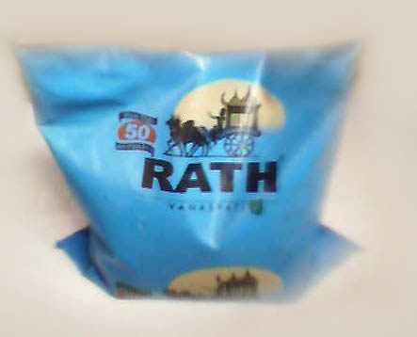

1.Film structure:- LDPE+HDPE+LLDPE
2.Film thickness: - 100 micron
3. Appearance of film: - white fairly transparent film
4. Weight: - 25 gram
5. Dielectric strength:-

Dielectric strength = Breakdown voltage (Volt)
Thickness of the film (mil)

Breakdown voltage = 14KV, thickness of film = 75 micrometer
Dielectric strength = 18000 V / 75micrometer = 18000 / 75/25.4 V/mil
(1 mil = 25.4 micron)
= 6101V/mil = 6.101KV/mil

57

6. Burst strength:- - It is defined as the ability of a plastic film to resist rupturing when it is pressurized for a short period of time. It is based on hydraulic pressure system.
Burst strength = 58 Kg/sq.cm.

7. Tensile strength: - it is defined as the maximum stress or tension that a material can endure before it breaks. Test speed is 5mm/min.
Size of the rectangular strip milk pouch= 50mmx25mm
Tensile strength = 190 N/sq.mm

8. %Elongation at break :-
Initial reading = 50mm, final length after breaking =100mm
%Elongation at break = 100-50/50x100 = 100%

58
Application Fields Of Flexible Packaging
Packaging films are used mainly for-
- Processed meats (cooked meat, frankfurters, bacon, sausages etc.)
- Fresh red meat in prime cuts or sub-prime cuts
- Cheese, Ketchup, Mayonnaise, Sauce
- Seafood, Peanuts, Sanitary articles, coffee, snack food or detergents etc.
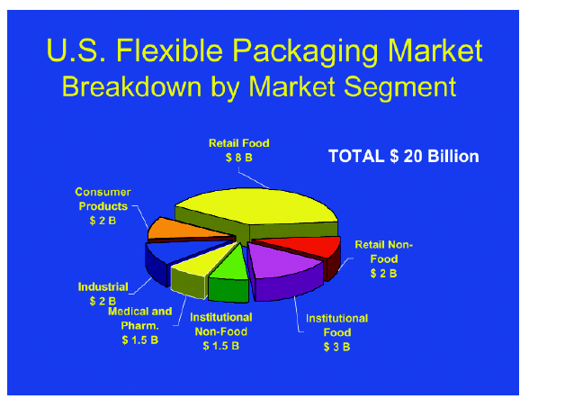
The past decade in flexible medical packaging has been marked by better-performing products at lower cost, increased attention to quality, and new options in automation. Cost-reduction pressures have prompted many medical device manufacturers to convert from rigid to flexible packaging for their products, fueling tremendous growth.

59
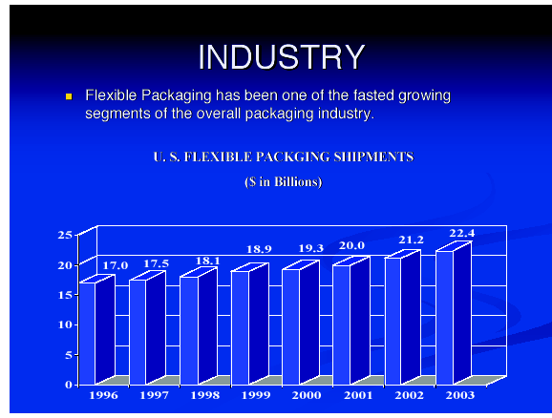

60
FUTURE PROSPECTS OF FLEXIBLE PACKAGING
Advances in flexible materials and packaging equipment should continue as technologies improve. And as medical device manufacturers consolidate, and cost-reduction pressures increase, Oliver’s Murak says that customers are more inclined to embrace these advances. “The technology is really the place to reduce costs,” he says.
By 2007, the U.S. market for flexible plastic packaging is expected to grow to 13 billion lb, according to a report from Business Communications Company, Inc. Medical packaging will no doubt have a sizable slice of this pie. A recent study by The Freedonia Group (Cleveland) projects that demand for sterile pouches will grow 5.5% by 2006.
Demand like that generates enthusiasm. “Both on the materials and equipment side, you see investment,” says Bennish. “And they’re going to keep investing. It’s a segment that’s exciting to be in.”
US demand to top $14 billion in 2009
Converted flexible packaging demand in the US is forecast to exceed $14 billion in 2009. Advances will be driven by steady growth in manufacturing along with cost, performance and source reduction advantages over rigid packaging alternatives. However, competition from single serving and other novel rigid containers in markets such as snacks and candy will restrain growth to some degree.
Stand-up pouches to grow the fastest
Fastest growth is anticipated for stand-up pouches based on advantages of excellent visual appeal, product differentiation, convenience, portability, reliability and freshness protection, all of which have led to strong consumer

61
acceptance. Bag demand will increase more slowly based on maturity of many applications as well as competition from pouches.
Food packaging to remain dominant
Food packaging will remain the leading market based on diverse applications, suitability for portable and single serving applications, and heightened requirements for improved barrier structures at lower costs. Fastest gains are anticipated for meat and related products and produce applications, resulting from rapid sales growth of convenience- oriented products that require value-added packaging materials for extended shelf life. Among nonfood markets, medical and pharmaceutical applications will present the best opportunities based on advantages of versatility, low cost and material improvements, which will broaden the range of applications. Trends toward the use of higher-value pouches with greater barrier properties and single-unit dose applications will support value gains
Polypropylene to outpace polyethylene
While polyethylene will remain the leading film type, faster growth is anticipated for polypropylene. Polypropylene advances will be predicated on the materials cost competitiveness, heat sealability, high moisture barrier qualities and excellent optical properties (low haze and high gloss). Ethylene vinyl alcohol (EVOH) films will provide the fastest growth prospects due to increasing barrier requirements in food markets. Volumes will remain low, however, due to the high cost and specialized nature of the material Despite slower advances for paper and foil, paper packaging will remain an important player due to its low cost, environmental compatibility and use in laminations, while foil will maintain important niche applications where light, moisture and other barrier properties are mandated, along with excellent aesthetics.

62
SCOPE OF THE PROJECT

The flexible plastic packaging industry is a very dynamic industry, despite the rather staid general impression of snack bags and other everyday flexible plastic packaging products. New products and applications are constantly coming on the market, ranging from new packages for new products to new resins and packaging structures. This is a very competitive industry, and a new innovation, such as a thinner let stronger packaging structure or a better barrier, can change packaging (and consumer) choices.
Major changes have taken place in the past few years and continue to take place today (and probably for the foreseeable future) as both newer and older materials compete for places in the flexible plastic packaging market. The major competitive factors in the market are those between materials and different packaging methods and technologies. Inter-material competition is a way of life in a technologically advancing society, and plastic packaging is no exception. For example, metallocene and other single-site catalysts are producing new polyolefins with enhanced properties such as better strength and clarity; incorporating these new resins in flexible plastic packaging films allows significant down gauging with no loss of properties.

63
REFERENCES
- The Changing Flexible Packaging Industry , Published By : J. Charles Foreman
- Modern food packaging , Published By J.F.D’Cunha, Secretary, IIP
- Encyclopedia Of Packaging Technology
- http://www.devicelink.com/pmpn/archive/03/11/007.html
- http://www.devicelink.com/expo/canondesignshows/
- http://www.devicelink.com/newcc/
- http://www.cancom.com/production/pm/web_profiles/s
- http://www.the-infoshop.com/study/fd35470-flexible-packaging.html
- http://www.gii.co.jp/index_en.shtml
- http://www.americanpackage.com/requestbid.html
- http://www.w3.org/TR/html4/loose.dtd
- http://www.flexpack.com/flexible-packaging-plastic-bags-about-us.htm
- http://www.mdapackaging.com/packaging-links.html

64

